

Magazine Business Plan

Your Source of Insight

Business Plan

2023

John Doe

10200 Bolsa Ave, Westminster, CA, 92683

- 359-3153 info@example.com http://www.example.com

Information provided in this business plan is unique to this business and confidential; therefore, anyone reading this plan agrees not to disclose any of the information in this business plan without prior written permission of the company.
Table of Contents

Executive Summary | 6
Market opportunity | 6
Services Offered | 6
Marketing & Sales Strategies | 7
Financial Highlights | 7
Units Sold v/s Revenue | 8

Company Overview | 9
Ownership | 9
Business Owners | 9
Mission statement | 10
Business history | 10
Future goals | 10

Market Analysis | 11
Target Market | 11
Market size and growth potential | 11
Market Size | 12
Competitive analysis | 12
Vogue | 12
National Geographic | 13
Cosmopolitan | 13
Market trends | 13
Regulatory environment | 14

Products and Services | 15
Content List | 15
Articles | 15
Interviews | 16
Features | 16
Editorials | 16
Interactive Infographics | 17
Quizzes | 17
Audio Content | 17
Video Content | 18
Any interactive features | 18
Frequency & distribution | 18
Additional Services | 19

Sales And Marketing Strategies | 20
Unique Selling Proposition (USP) | 20
Pricing Strategy | 20
Marketing strategies | 21
Online | 21
Sales strategies | 22
Customer retention | 23

Operations Plan | 24
Staffing & Training | 24
Operational Process | 24
Equipment & Software | 25

Management Team | 26
Key managers | 26
John Doe | 26
Jane Doe | 27
Alice Brown | 27
Robert Brown | 27
Emily Smith | 28
Organizational structure | 28
Organization chart | 29
Compensation plan | 29
Advisors/Consultants | 30
Dr. Lucy White | 30
Mr. Michael Green | 30
Financial Plan | 31
Profit & loss statement | 31
Cash flow statement | 34
Balance sheet | 36
Break-even Analysis | 38
Financing needs | 40
Appendix
Appendix | 42
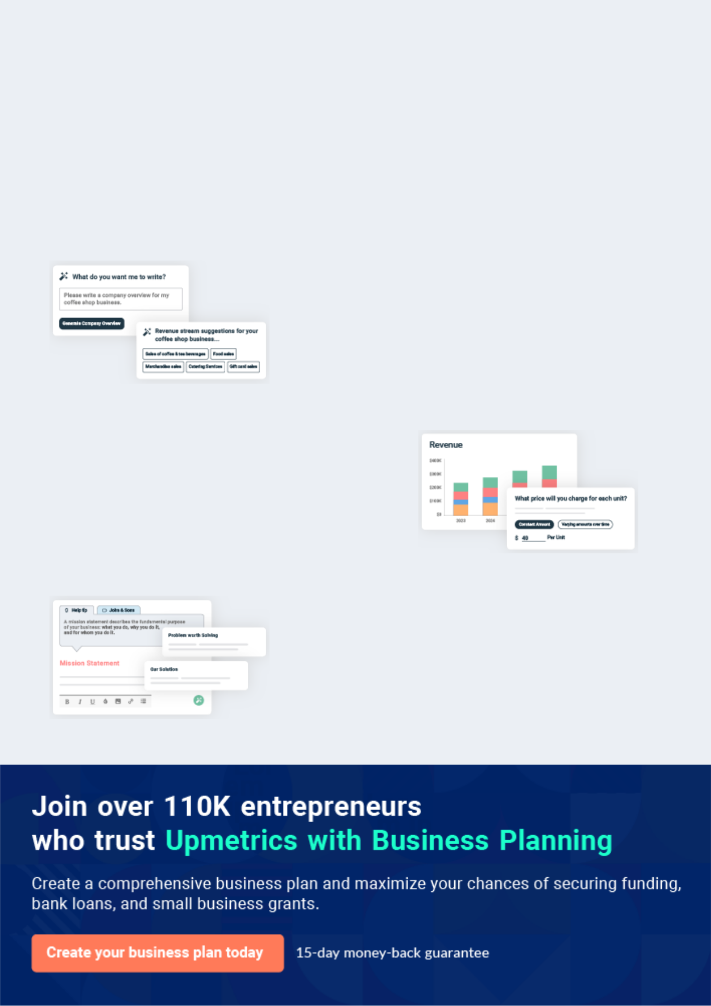
Business planning that’s simpler and faster than you think

Creating a business plan using Upmetrics to start and grow a business is literally the easiest thing in the World. Simply read the instructions and fill in the blanks. It’s as simple as that.

❛ | Upmetrics has everything you need to create a | ❜
❛ | comprehensive business plan. | ❜

AI-powered Upmetrics Assistant

AI-powered insights to streamline your plan

Not sure where to start? Upmetrics’ AI Assistant will automatically generate ideas for each section of your plan and offer improved versions of your writing, adjusting for tone, voice, and grammar or spelling errors.

Financial Forecasting Tool

All the financials are calculated for you

Forget the complex formulas and clumsy spreadsheets — with automatic financials and drag-and-drop forecasting, you can finish your plan faster and be confident that your numbers are accurate.

Business Plan Builder

Guides you like a business mentor

Upmetrics’ step-by-step instructions, prompts, and the library of 400+ sample business plans will guide you through each section of your plan as a business mentor.
Executive Summary


An executive summary is the first section of the business plan intended to provide an overview of the whole business plan.
To unlock help try Upmetrics! 

 Help tip  Magazine Business Plan


Start your executive summary by briefly introducing your business to your readers.

This section may include the name of your magazine business, its location, when it was
To unlock help try Upmetrics! 

Start writing here..

Market opportunity

 Help tip  Magazine Business Plan

Summarize your market research, including market size, growth potential, and marketing trends. Highlight the opportunities in the market and how your business will fit in to fill the gap.
To unlock help try Upmetrics! 

Start writing here..

Services Offered

 Help tip  Magazine Business Plan

Highlight the magazine services you offer your clients. The USPs and differentiators you offer are always a plus.
To unlock help try Upmetrics! 

Start writing here..

Marketing & Sales Strategies
To unlock help try Upmetrics!

 Help tip  Magazine Business Plan

Outline your sales and marketing strategies—what marketing platforms you use, how you plan on acquiring customers, etc.
To unlock help try Upmetrics! 

Start writing here..

Financial Highlights

 Help tip  Magazine Business Plan

Briefly summarize your financial projections for the initial years of business operations. Include any capital or investment requirements, associated startup costs, projected revenues, and profit forecasts.



Start writing here..
Units Sold v/s Revenue

 |  | Units Sold | Revenue
15.00k
10.00k
5.00k
0
Year 1 | Year 2 | Year 3


Financial Year |  |  | Units Sold | Revenue
Year 1 | 1,550 |  |  | $10,000
Year 2 | 1,800 |  |  | $12,000
Year 3 | 2,050 |  |  | $14,000
 Help tip |  |  Magazine Business Plan


Summarize your executive summary section with a clear CTA, for example, inviting angel investors to discuss the potential business investment.
To unlock help try Upmetrics! 

Write a call to action for your business plan.
Company Overview

Depending on what details of your business are essential, you’ll need different elements in your business overview.
To unlock help try Upmetrics! 

 Help tip  Magazine Business Plan

Describe your business in this section by providing all the basic information.

Describe what kind of magazine business you run and the name of it. You may specialize in one
To unlock help try Upmetrics! 

Start writing here..

Ownership

 Help tip  Magazine Business Plan

List the names of your magazine business’s founders or owners. Describe what shares they own and their responsibilities for efficiently managing the business.
To unlock help try Upmetrics! 

Start writing here..

Business Owners



60% John Doe



25% Jane Doe



15% Alice Brown

Mission statement

 Help tip  Magazine Business Plan

Summarize your business’ objective, core principles, and values in your mission statement. This statement needs to be memorable, clear, and brief.
To unlock help try Upmetrics! 

❛ At [Modern Insights Magazine], our mission is to illuminate the richness of contemporary life, providing our readers with thought-provoking content that not only informs but also inspires.

We are committed to maintaining the highest standards of journalism, marrying aesthetic excellence with insightful narratives that capture the pulse of today's vibrant lifestyle.

❜

Business history

 Help tip  Magazine Business Plan

If you’re an established magazine service provider, briefly describe your business history, like— when it was founded, how it evolved over time, etc.
To unlock help try Upmetrics! 

Start writing here..

Future goals

 Help tip  Magazine Business Plan

It’s crucial to convey your aspirations and vision. Mention your short-term and long-term goals; they can be specific targets for revenue, market share, or expanding your services.
To unlock help try Upmetrics! 

Start writing here..

Market Analysis
To unlock help try Upmetrics!


 |  | Market analysis provides a clear understanding of the market in which your
 |  | printing business will run along with the target market, competitors, and
 |  | growth opportunities.
 |  |  |  | To unlock help try Upmetrics! 
 Help tip |  |  Magazine Business Plan

To write the introduction section of your market analysis, start by clearly identifying your primary target market.
To unlock help try Upmetrics! 

Start writing here..

Target Market

 Help tip  Magazine Business Plan

Start this section by describing your target market. Define your ideal customer and explain what types of services they prefer. Creating a buyer persona will help you easily define your target market to your readers.



Start writing here..

Market size and growth potential

 Help tip  Magazine Business Plan

Describe your market size and growth potential and whether you will target a niche or a much broader market.
To unlock help try Upmetrics! 

Start writing here..

Market Size

Available Market

Global readers interested in various 100M magazine genres.

Served Market
Global readers interested in lifestyle 35M and culture magazines.

Target Market
Young adults in the US interested in 5M pop culture and fashion.

 Help tip  Magazine Business Plan

Identify and analyze your direct and indirect competitors. Identify their strengths and weaknesses, and describe what differentiates your magazine from them.
To unlock help try Upmetrics! 

Competitive analysis

Vogue

Vogue is a renowned fashion and lifestyle magazine that has been a major player in the industry for decades. The magazine covers a range of topics including fashion, beauty, culture, and lifestyle.

Features | Strengths | Weaknesses
Extensive coverage of fashion | Strong brand recognition and | Primarily focused on high-end
and beauty trends | loyal readership | fashion, potentially alienating
Celebrity features and | Established relationships with | some readers
interviews | fashion and beauty industry | Limited coverage of men's
High-quality photography and | stakeholders | fashion
editorial content | Expert editorial team and high-
Online and print editions | quality content
available

National Geographic

National Geographic is a globally recognized magazine that focuses on geography, science, history, and world cultures. The magazine is known for its in-depth articles, stunning photography, and commitment to education.

Features

In-depth coverage of geography, science, history, and world cultures

High-quality photography and visuals

Online and print editions available

Educational resources and programs

Cosmopolitan

Strengths

Strong brand recognition and global presence

High-quality content and expert contributors

Wide range of topics covered

Weaknesses

Some readers may find the content too academic or technical

The magazine may not appeal to younger audiences

Cosmopolitan is a popular women's magazine that covers topics such as relationships, beauty, fashion, and lifestyle. The magazine is known for its fun and relatable content that appeals to a younger demographic.

Features | Strengths | Weaknesses
Coverage of relationships, | Strong brand recognition and | Limited coverage of men's
beauty, fashion, and lifestyle | large readership | interests
Celebrity features and | Appeals to a younger | Some readers may find the
interviews | demographic | content too focused on
Online and print editions | Engaging and relatable content | relationships and beauty
available | that resonates with readers
Engaging and relatable content

Market trends

 Help tip  Magazine Business Plan

Analyze emerging trends in the industry, such as changes in customer behavior or preferences, etc. Explain how your business will cope with all the trends.
To unlock help try Upmetrics! 

Start writing here..

Regulatory environment
To unlock help try Upmetrics!

 Help tip  Magazine Business Plan

List regulations and licensing requirements that may affect your magazine business, such as copyright & intellectual property laws, press freedom & freedom of speech, data protection & privacy, taxation & financial regulations, etc.



Start writing here..
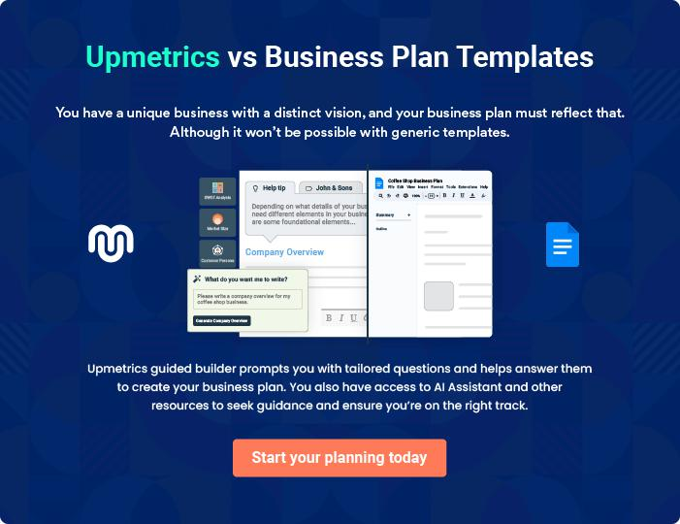
Products and Services
To unlock help try Upmetrics!

The product and services section of a magazine business plan should describe the specific services and products that will be offered to customers. To write this section should include the following:



 Help tip  Magazine Business Plan

To craft the introduction for your "Products and Services" chapter, begin by positioning your business within its industry, emphasizing its unique strengths or value proposition.
To unlock help try Upmetrics! 

Start writing here..

 Help tip


Mention the magazine content your business will offer. This list may include content like,

• Articles
To unlock help try Upmetrics! 

Content List

Articles


Price: Included in the subscription, [$X] per month

In-depth written content covering a range of topics including current events, lifestyle, fashion, and more.

Specifications

Ranges from 500 to 2,000 words, includes high-quality images and references.
Interviews

Price: Included in the subscription, [$X] per month

Exclusive interviews with industry leaders, celebrities, and influencers providing unique insights and perspectives.

Specifications

Approximately 1,000 to 1,500 words, includes high-quality images and video clips from the interview.

Features

Price: Included in the subscription, [$X] per month

Comprehensive features and investigative reports on hot topics and pressing issues.

Specifications

2,000 to 5,000 words, includes high-quality images, videos, and interactive elements.

Editorials

Price: Included in the subscription, [$X] per month

Our magazine's viewpoint on current events and pressing issues, reflecting our values and principles.

Specifications

Approximately 1,000 words, includes high-quality images and references.
Interactive Infographics

Price: Included in the subscription, [$X] per month

Visually engaging graphics that provide in-depth insights into specific topics, allowing readers to interact with the data.

Specifications

High-quality images and interactive elements that enhance the reader's understanding of the topic.

Quizzes

Price: Included in the subscription, [$X] per month

Fun and informative quizzes that engage the readers and test their knowledge on various topics.

Specifications

Multiple-choice questions with instant feedback, includes high-quality images and references.

Audio Content

Price: Included in the subscription, [$X] per month

Accompanying podcasts or voiceovers that provide an alternative way for readers to consume our content.

Specifications

High-quality audio, ranges from 10 to 30 minutes.
Video Content
To unlock help try Upmetrics!

Price: Included in the subscription, [$X] per month

Multimedia elements that complement our written content, offering a more rounded understanding of specific topics.

Specifications

High-quality video, ranges from 5 to 20 minutes.

Any interactive features

 Help tip  Magazine Business Plan

Describe any multimedia components or interactive features your magazine includes, such as interactive infographics, quizzes, audio content, or videos.
To unlock help try Upmetrics! 

Start writing here..

Frequency & distribution

 Help tip  Magazine Business Plan

Indicate the publication schedule (monthly, bi-monthly, quarterly, etc.) and describe the distribution strategy for your magazine. Talk about the various print and digital distribution methods, such as websites, mobile apps, and subscriptions.



Start writing here..
Additional Services
To unlock help try Upmetrics!

 Help tip  Magazine Business Plan

Mention these as part of your product and service offerings if your magazine business offers extra services or products beyond the primary journal, such as events, online forums, webinars, or merchandise.



Start writing here..
Sales And Marketing Strategies

Writing the sales and marketing strategies section means a list of strategies you will use to attract and retain your clients.
To unlock help try Upmetrics! 

 Help Tip  Magazine Business Plan


To create an effective introduction for your "Sales and Marketing Strategies" chapter, start by setting the stage within your specific industry or market.
To unlock help try Upmetrics! 

Start writing here..

Unique Selling Proposition (USP)

 Help tip  Magazine Business Plan

Define your business’s USPs depending on the market you serve, the equipment you use, and the unique services you provide. Identifying USPs will help you plan your marketing strategies.
To unlock help try Upmetrics! 

Start writing here..

Pricing Strategy

 Help tip  Magazine Business Plan

Describe your pricing strategy—how you plan to price your magazine and stay competitive in the local market. You can mention any discounts you plan on offering to attract new readers.
To unlock help try Upmetrics! 

Start writing here..

 Help tip  Magazine Business Plan
To unlock help try Upmetrics!

Discuss your marketing strategies to market your services. You may include some of these marketing strategies in your business plan—social media marketing, Google ads, email marketing, content marketing, etc.



Marketing strategies

Online


Social Media

Regular updates, behind-the-scenes looks, and engagement campaigns on platforms like Facebook, Instagram, and Twitter.

Content Marketing

Collaborations with bloggers and influencers to expand our reach and provide diverse content.

Email Marketing

Weekly newsletters with sneak peeks, exclusive offers, and highlights to keep our readers engaged.

Google Ads

Targeted ads to reach potential subscribers who search for magazine subscriptions or related content.

 Help tip
To unlock help try Upmetrics!

Outline the strategies you’ll implement to maximize your sales. Your sales strategies may include direct sales calls, subscription offers and promotions, affiliate marketing, offering referral programs, etc.



Sales strategies

Direct Sales Calls

Engage potential bulk subscribers like libraries, institutions, and corporates.

Affiliate Marketing

Collaborate with complementary brands where both can benefit from shared marketing efforts.

Subscription Offers and Promotions

Seasonal offers and special discounts for festive occasions.

Referral Programs

Offering current subscribers incentives for every successful referral.

 Help tip  Magazine Business Plan

Describe your customer retention strategies and how you plan to execute them. For instance, introducing renewal discounts, early subscriptions, personalized service, etc.
To unlock help try Upmetrics! 

Customer retention

Renewal Discounts

Early Subscriptions

Offering discounts on renewing subscriptions to incentivize continuity.

Exclusive content and offers for subscribers who renew their subscription before expiry.

Personalized Service

Ensuring that our subscribers feel

valued with curated content

suggestions and responsive

customer service.

Operations Plan
To unlock help try Upmetrics!

 |  | When writing the operations plan section, it’s important to consider the
 |  | various aspects of your business operations.
 |  |  |  | To unlock help try Upmetrics! 
 Help tip |  |  Magazine Business Plan


To create an effective introduction for your "Operational Plan" chapter, start by emphasizing the
pivotal role of efficient operations in the success of your business, underscoring how they
directly impact the quality of services delivered.
 |  |  |  | To unlock help try Upmetrics! 
Start writing here..
Staffing & Training
 Help tip |  |  Magazine Business Plan

Mention your business’s staffing requirements, including the number of employees or writers &
editors needed. Include their qualifications, the training required, and the duties they will
perform.
 |  |  |  | To unlock help try Upmetrics! 
Start writing here..
Operational Process
 Help tip |  |  Magazine Business Plan

Outline the processes and procedures you will use to run your magazine business. Your operational processes may include content creation, printing, distribution, marketing & promotion, etc.



Start writing here..

Equipment & Software
To unlock help try Upmetrics!

 Help tip  Magazine Business Plan

Include the list of equipment and software required for the magazine business, such as computers, print production equipment, videography equipment & software, online publishing & digital equipment, etc.



Start writing here..
Management Team

The management team section provides an overview of the individuals responsible for running your business plan.
To unlock help try Upmetrics! 

 Help tip  Magazine Business Plan

To craft an introduction for your "Management Team" chapter, begin by emphasizing the crucial role of leadership in the success of any business.
To unlock help try Upmetrics! 

Start writing here..

Key managers

 Help tip  Magazine Business Plan

Introduce your management and key members of your team, and explain their roles and responsibilities.
To unlock help try Upmetrics! 

Start writing here..


JOHN DOE

CEO & Founder - john.doe@example.com

John, with a B.A. in Journalism from the prestigious [University Name], has honed his expertise in the magazine industry over the past [X] years.

His career has seen him occupy various roles, from a junior editor to a senior managing editor, before founding [Modern Insights Magazine].


At [Modern Insights Magazine], John is responsible for setting the strategic direction, overseeing content creation, and ensuring operational excellence.

His relentless drive for quality and innovation has been a cornerstone in the magazine's success.

JANE DOE

Chief Operating Officer (COO) - jane.doe@example.com

Jane holds an M.B.A. from [University Name] and brings over [X] years of operational management experience to [Modern Insights Magazine].

Prior to joining our team, she worked with [Previous Company Name] as an operations manager, honing her skills in process optimization and team management.


At [Modern Insights Magazine], Jane is responsible for ensuring all operations, from content creation to distribution, run seamlessly and efficiently.


ALICE BROWN

CMO - alice.brown@example.com

Alice completed her B.S. in Marketing from [University Name] and has a rich professional background with over [X] years of experience in marketing roles, including a senior marketing manager position at [Previous Company Name].

Her expertise lies in developing effective marketing strategies that boost brand awareness and increase readership.

As the CMO of [Modern Insights Magazine], Alice is the driving force behind our promotional efforts, ensuring our magazine reaches its target audience effectively.


ROBERT BROWN

Managing Editor - robert.brown@example.com

Robert has a M.A. in English Literature from [University Name] and over [X] years of editorial experience in the magazine industry.

Before joining [Modern Insights Magazine], he was a senior editor at [Previous Company Name], where he developed a keen eye for compelling storytelling and content curation.

As the managing editor at [Modern Insights Magazine], Robert ensures all content aligns with our brand voice and appeals to our readership.

EMILY SMITH

Digital Content Manager - emily.smith@example.com

Emily holds a degree in [Relevant Degree, e.g., "Digital Media"] from [University Name] and has over [X] years of experience in digital content creation and management.

Her previous role as a digital strategist at [Previous Company Name] equipped her with the skills to transition traditional content into engaging digital formats.

At [Modern Insights Magazine], Emily is in charge of our online presence, ensuring our digital content is as compelling and immersive as our print offerings.

Organizational structure

 Help tip  Magazine Business Plan

Explain the organizational structure of your management team. Include the reporting line and decision-making hierarchy.
To unlock help try Upmetrics! 

Start writing here..
Organization chart


John Doe

CEO & Founder


Alice Brown Jane Doe

CMO COO


Emily Smith

Digital Content Manager Robert Brown

Managing Editor




Luke Wilson Sarah White

Editorial Assistant Digital Media Specialist

Compensation plan

 Help tip  Magazine Business Plan

Describe your compensation plan for the management and staff. Include their salaries, incentives, and other benefits.
To unlock help try Upmetrics! 

Start writing here..

 Help tip

Mentioning advisors or consultants in your business plans adds credibility to your business idea.
To unlock help try Upmetrics! 

Advisors/Consultants


DR. LUCY WHITE

Magazine Content Advisor

With over [X] years in the magazine industry, Dr. White provides invaluable insights into content strategy and audience engagement.


MR. MICHAEL GREEN

Business Strategy Consultant

Michael, with [X] years of experience in business development and strategy, offers guidance on growth and expansion opportunities for [Modern Insights Magazine].
Financial Plan

When writing the financial plan section of a business plan, it’s important to provide a comprehensive overview of your financial projections for the first few years of your business, You may provide the following:
To unlock help try Upmetrics! 

 Help tip  Magazine Business Plan


To create an effective introduction for your "Financial Plan" chapter, begin by stressing the critical role of a well-structured financial plan in the success of your venture.
To unlock help try Upmetrics! 

Start writing here..

 Help tip  Magazine Business Plan

Describe details such as projected revenue, operational costs, and service costs in your projected profit and loss statement. Make sure to include your business’s expected net profit or loss.
To unlock help try Upmetrics! 

Profit & loss statement

Revenue

Cost Of Sales

General Costs

Revenue Specific Costs

Personnel Costs (Direct

Labor)

Gross Margin

Gross Margin (%)

Operating Expense

Payroll Expense

(Indirect Labor)

General Expense

Bad Debt

Amortization of Current

Assets

2023-24 | 2024-25 | 2025-26 | 2026-27 | 2027-28
$0 | $0 | $0 | $0 | $0

$0 | $0 | $0 | $0 | $0
$0 | $0 | $0 | $0 | $0
$0 | $0 | $0 | $0 | $0
$0 | $0 | $0 | $0 | $0

$0 | $0 | $0 | $0 | $0
0% | 0% | 0% | 0% | 0%

$0 | $0 | $0 | $0 | $0
$0 | $0 | $0 | $0 | $0
$0 | $0 | $0 | $0 | $0
$0 | $0 | $0 | $0 | $0
$0 | $0 | $0 | $0 | $0

EBITDA

Additional Expense

Long Term

Depreciation

Gain or loss from Sale

of Assets

EBIT

Interest Expenses

EBT

Income Tax Expense

Total Expense

Net Income

Net Income (%)

2023-24 | 2024-25 | 2025-26 | 2026-27 | 2027-28
$0 | $0 | $0 | $0 | $0
$0 | $0 | $0 | $0 | $0
$0 | $0 | $0 | $0 | $0
$0 | $0 | $0 | $0 | $0
$0 | $0 | $0 | $0 | $0
$0 | $0 | $0 | $0 | $0
$0 | $0 | $0 | $0 | $0
$0 | $0 | $0 | $0 | $0
$0 | $0 | $0 | $0 | $0
$0 | $0 | $0 | $0 | $0
0% | 0% | 0% | 0% | 0%

 |  |  | 2023-24 |  | 2024-25 | 2025-26
Retained Earning |  |  | $0 |  | $0 | $0
Opening |  |  |  |  | $0 | $0
Owner's Distribution |  |  | $0 |  | $0 | $0
Retained Earning |  |  | $0 |  | $0 | $0
Closing |  |  |  |  | $0 | $0
 Help tip |  |  |  Magazine Business Plan


The cash flow for the first few years of your operation should be estimated and described in this section.

This may include billing invoices, payment receipts, loan payments, and any other cash flow statements.
2026-27 2027-28

$0 $0

$0 $0

$0 $0

To unlock help try Upmetrics! 

Cash flow statement

 | 2023-24 | 2024-25 | 2025-26 | 2026-27 | 2027-28
Cash Received | $0 | $0 | $0 | $0 | $0
Cash Paid | $0 | $0 | $0 | $0 | $0
COS & General Expenses | $0 | $0 | $0 | $0 | $0
Salary & Wages | $0 | $0 | $0 | $0 | $0
Interest | $0 | $0 | $0 | $0 | $0

Sales Tax

Income Tax

Net Cash From

Operations

Assets Sell

Assets Purchase

Net Cash From

Investments

Amount Received

Loan Received

Common Stock

Preferred Stock

Owner's Contribution

Amount Paid

2023-24 | 2024-25 | 2025-26 | 2026-27 | 2027-28
$0 | $0 | $0 | $0 | $0
$0 | $0 | $0 | $0 | $0
$0 | $0 | $0 | $0 | $0

$0 | $0 | $0 | $0 | $0
$0 | $0 | $0 | $0 | $0
$0 | $0 | $0 | $0 | $0

$0 | $0 | $0 | $0 | $0
$0 | $0 | $0 | $0 | $0

$0 | $0 | $0 | $0 | $0
$0 | $0 | $0 | $0 | $0
$0 | $0 | $0 | $0 | $0

Loan Capital $0 $0 $0 $0 $0

 |  |  | 2023-24 | 2024-25 | 2025-26 | 2026-27 | 2027-28
Dividends & Distributions |  |  | $0 | $0 | $0 | $0 | $0
Net Cash From |  |  | $0 | $0 | $0 | $0 | $0
Financing
Summary
Starting Cash |  |  | $0 | $0 | $0 | $0 | $0
Cash In |  |  | $0 | $0 | $0 | $0 | $0
Cash Out |  |  | $0 | $0 | $0 | $0 | $0
Change in Cash |  |  | $0 | $0 | $0 | $0 | $0
Ending Cash |  |  | $0 | $0 | $0 | $0 | $0
 Help tip |  |  Magazine Business Plan

Create a projected balance sheet documenting your magazine business’s assets, liabilities, and equity.

To unlock help try Upmetrics! 

Balance sheet

 | 2023-24 | 2024-25 | 2025-26 | 2026-27 | 2027-28
Assets | $0 | $0 | $0 | $0 | $0
Current Assets | $0 | $0 | $0 | $0 | $0
Cash | $0 | $0 | $0 | $0 | $0
Accounts Receivable | $0 | $0 | $0 | $0 | $0
Inventory | $0 | $0 | $0 | $0 | $0
Other Current Assets | $0 | $0 | $0 | $0 | $0
Long Term Assets | $0 | $0 | $0 | $0 | $0
Gross Long Term Assets | $0 | $0 | $0 | $0 | $0
Accumulated Depreciation | $0 | $0 | $0 | $0 | $0

Liabilities & Equity | $0 | $0 | $0 | $0 | $0
Liabilities | $0 | $0 | $0 | $0 | $0
Current Liabilities | $0 | $0 | $0 | $0 | $0
Accounts Payable | $0 | $0 | $0 | $0 | $0
Income Tax Payable | $0 | $0 | $0 | $0 | $0
Sales Tax Payable | $0 | $0 | $0 | $0 | $0
Short Term Debt | $0 | $0 | $0 | $0 | $0
 | 2023-24 | 2024-25 | 2025-26 | 2026-27 | 2027-28
Long Term Liabilities | $0 | $0 | $0 | $0 | $0
Long Term Debt | $0 | $0 | $0 | $0 | $0
Equity | $0 | $0 | $0 | $0 | $0
Paid-in Capital | $0 | $0 | $0 | $0 | $0
Common Stock | $0 | $0 | $0 | $0 | $0
Preferred Stock | $0 | $0 | $0 | $0 | $0
Owner's Contribution | $0 | $0 | $0 | $0 | $0
Retained Earnings | $0 | $0 | $0 | $0 | $0

Check | $0 |  |  | $0 | $0 | $0 | $0
 Help tip |  |  Magazine Business Plan

Determine and mention your business’s break-even point—the point at which your business costs and revenue will be equal.

This exercise will help you understand how much revenue you need to generate to sustain or be profitable.
To unlock help try Upmetrics! 

Break-even Analysis

 | 2023-24 | 2024-25 | 2025-26 | 2026-27 | 2027-28
Starting Revenue | $0 | $0 | $0 | $0 | $0
Net Revenue | $0 | $0 | $0 | $0 | $0
Closing Revenue | $0 | $0 | $0 | $0 | $0

Starting Expense | $0 | $0 | $0 | $0 | $0
Net Expense | $0 | $0 | $0 | $0 | $0
Closing Expense | $0 | $0 | $0 | $0 | $0

Is Break Even? | 0 | 0 | 0 | 0 | 0
Break Even Month | 0 | 0 | 0 | 0 | 0
Days Required | 0 | 0 | 0 | 0 | 0
Break Even Revenue | $0 | $0 | $0 | $0 | $0
Break Even Units
Financing needs

 Help tip  Magazine Business Plan

Calculate costs associated with starting a magazine business, and estimate your financing needs and how much capital you need to raise to operate your business.
To unlock help try Upmetrics! 

Start writing here..
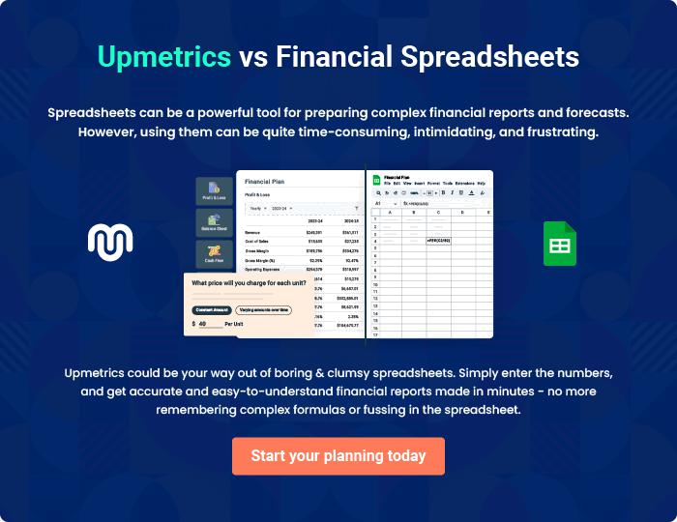
Appendix

When writing the appendix section, you should include any additional information that supports the main content of your plan. This may include financial statements, market research data, legal documents, and other
To unlock help try Upmetrics! 

Create a winning business plan that gets you funded

Creating a stunning and investment-ready plan requires no writing, graphic designing, or financial planning expertise.

Upmetrics has all the features required to help you create a comprehensive business plan—from start to finish. Make no mistakes, it’s the modern way of planning to structure ideas, make plans, and create stunning pitch decks to awe investors.

Pitch decks that impress investors

Create pitch decks that provide a visual representation of your business, engage investors, and make them want to invest in your business idea.

Interactive plans in no time

Import business plan sections like—SWOT analysis, comparison tables, and others to create an interactive business plan. No designing skills are required.

Stunning cover page designs

With Upmetrics, you have the liberty to choose from multiple stunning cover page designs. Choose a creative design and make your plan stand out.

Online sharing made simple

Upmetrics makes online sharing quick and easier for users. Easily share your business plans with a link while tracking reader activity.

500+ sample business plans

Simply import a template from our library of sample plans into the editor and start customizing it to make it yours. It takes only a few clicks to get started.

Collaborate with team in real-time

Invite team members, initiate conversations, discuss ideas & strategies, share feedback, and work on a business plan in real-time.

