
Logistics Business Plan

Delivering Solutions, Connecting Worlds

BUSINESS PLAN

2023

John Doe | 10200 Bolsa Ave, Westminster, CA, 92683 | (650) 359-3153 | info@example.com
http://www.example.com

Information provided in this business plan is unique to this business and confidential; therefore, anyone reading this plan agrees not to disclose any of the information in this business plan without prior written permission of the company.
Table of Contents

Executive Summary | 6
Market opportunity | 6
Services Offered | 6
Management Team & Sales Strategies | 7
Financial Highlights | 7
Units Sold v/s Revenue | 8

Company Overview | 9
Ownership | 9
Mission statement | 10
Business history | 10
Future goals | 11

Market Analysis | 12
Target Market | 12
Market size and growth potential | 12
Market Size | 13
Competitive analysis | 13
AlphaLog Solutions | 14
BetaMove Logistics | 14
GammaExpress Inc. | 15
Market trends | 15
Regulatory environment | 15

Products and Services | 17
Services | 17
Transportation Services | 17
Warehousing Facilities | 18
Distribution Solutions | 18
Freight Forwarding | 19
Customs Brokerage | 19
Packaging and Crating | 20
Quality Control | 20

Sales And Marketing Strategies | 21
Unique Selling Proposition (USP) | 21
Pricing Strategy | 21
Marketing strategies | 22
Online | 22
Offline | 22
Sales strategies | 23
Customer retention | 24

Operations Plan | 25
Staffing & Training | 25
Operational Process | 25
Equipment & Machinery | 26

Management Team | 27
Key managers | 27
John Doe | 28
Jane Doe | 28
Alice Brown | 29
Robert Brown | 29
Organizational structure | 29
Organization chart | 29
Compensation plan | 31
Advisors/Consultants | 31
[ADVISOR NAME] | 31
[CONSULTANT NAME] | 31

Financial Plan | 32
Profit & loss statement | 32
Cash flow statement | 35
Balance sheet | 37
Break-even Analysis | 39
Financing needs | 41
Appendix
Appendix | 43
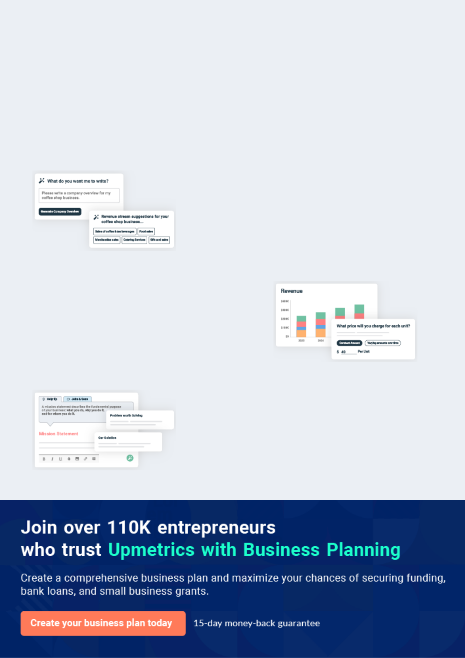
Business planning that’s simpler and faster than you think

Creating a business plan using Upmetrics to start and grow a business is literally the easiest thing in the World. Simply read the instructions and fill in the blanks. It’s as simple as that.

❛ | Upmetrics has everything you need to create a | ❜
❛ | comprehensive business plan. | ❜

AI-powered Upmetrics Assistant

AI-powered insights to streamline your plan

Not sure where to start? Upmetrics’ AI Assistant will automatically generate ideas for each section of your plan and offer improved versions of your writing, adjusting for tone, voice, and grammar or spelling errors.

Financial Forecasting Tool

All the financials are calculated for you

Forget the complex formulas and clumsy spreadsheets — with automatic financials and drag-and-drop forecasting, you can finish your plan faster and be confident that your numbers are accurate.

Business Plan Builder

Guides you like a business mentor

Upmetrics’ step-by-step instructions, prompts, and the library of 400+ sample business plans will guide you through each section of your plan as a business mentor.
Executive Summary


 |  | An executive summary is the first section of the business plan intended to
 |  | provide an overview of the whole business plan.
 |  |  |  | To unlock help try Upmetrics! 
 Help tip |  |  Logistics Business Plan


Start your executive summary section by briefly introducing your business to your readers.
This section may include the name of your logistics business, its location, when it was founded,
etc.
 |  |  |  | To unlock help try Upmetrics! 
Start writing here..
Market opportunity
 Help tip |  |  Logistics Business Plan


Summarize your market research, including market size, growth potential, and marketing trends. Highlight the opportunities in the market and how your business will fit in to fill the gap.
To unlock help try Upmetrics! 

Start writing here..

Services Offered

 Help tip  Logistics Business Plan


Highlight the logistics services you offer your clients. The USPs and differentiators you offer are always a plus.
To unlock help try Upmetrics! 

Start writing here..

Management Team & Sales Strategies
To unlock help try Upmetrics!

 Help tip  Logistics Business Plan

Outline your sales and marketing strategies—what marketing platforms you use, how you plan on acquiring customers, etc.
To unlock help try Upmetrics! 

Start writing here..

Financial Highlights

 Help tip  Logistics Business Plan

Briefly summarize your financial projections for the initial years of business operations. Include any capital or investment requirements, associated startup costs, projected revenues, and profit forecasts.



Start writing here..
Units Sold v/s Revenue

 |  | Units Sold | Revenue
15.00k
10.00k
5.00k
0
Year 1 | Year 2 | Year 3


Financial Year |  |  | Units Sold | Revenue
Year 1 | 1,550 |  |  | $10,000
Year 2 | 1,800 |  |  | $12,000
Year 3 | 2,050 |  |  | $14,000
 Help tip |  |  Logistics Business Plan

Summarize your executive summary section with a clear CTA, for example, inviting angel investors to discuss the potential business investment.
To unlock help try Upmetrics! 

Write a call to action for your business plan.
Company Overview


Depending on what details of your business are essential, you’ll need different elements in your business overview.
To unlock help try Upmetrics! 

 Help tip  Logistics Business Plan

Describe your business in this section by providing all the basic information:

Describe what kind of logistics company you run and the name of it. You may specialize in one
To unlock help try Upmetrics! 

Start writing here..

Ownership

 Help tip  Logistics Business Plan

List the names of your logistics company’s founders or owners. Describe what shares they own and their responsibilities for efficiently managing the business.
To unlock help try Upmetrics! 

Start writing here..
Mission statement

 Help tip  Logistics Business Plan

Summarize your business’ objective, core principles, and values in your mission statement. This statement needs to be memorable, clear, and brief.
To unlock help try Upmetrics! 

❛ At [XYZ Logistics], our mission is to [Clear and Brief Statement, e.g., "deliver excellence, ensuring every package's journey is swift, secure, and seamless"].

Rooted in our core principles of [Core Principle 1, e.g., "integrity"], [Core Principle 2, e.g., "innovation"], and [Core Principle 3, e.g., "customer focus"], we are dedicated to exceeding expectations and setting new industry benchmarks.

❜

Business history

 Help tip  Logistics Business Plan

If you’re an established logistics service provider, briefly describe your business history, like— when it was founded, how it evolved over time, etc.
To unlock help try Upmetrics! 

Start writing here..
Future goals

 Help tip  Logistics Business Plan

It’s crucial to convey your aspirations and vision. Mention your short-term and long-term goals; they can be specific targets for revenue, market share, or expanding your services.
To unlock help try Upmetrics! 

Start writing here..
Market Analysis
To unlock help try Upmetrics!

 |  | Market analysis provides a clear understanding of the market in which your
 |  | printing business will run along with the target market, competitors, and
 |  | growth opportunities.
 |  |  |  | To unlock help try Upmetrics! 
 Help tip |  |  Logistics Business Plan

To write the introduction section of your market analysis, start by clearly identifying your primary target market.
To unlock help try Upmetrics! 

Start writing here..

Target Market

 Help tip  Logistics Business Plan

Start this section by describing your target market. Define your ideal customer and explain what types of services they prefer. Creating a buyer persona will help you easily define your target market to your readers.



Start writing here..

Market size and growth potential

 Help tip  Logistics Business Plan

Describe your market size and growth potential and whether you will target a niche or a much broader market.
To unlock help try Upmetrics! 

Start writing here..

Market Size

Available Market | 5B
Total sales revenue from all logistics | 5B
services in the region. | 5B
Served Market | 2B
Revenue from logistics firms offering | 2B
both domestic & international | 2B
solutions
Target Market | 750M
Revenue potential from medium to | 750M
large e-commerce businesses | 750M

requiring reverse logistics.

 Help tip  Logistics Business Plan

Identify and analyze your direct and indirect competitors. Identify their strengths and weaknesses, and describe what differentiates your logistics services from them.
To unlock help try Upmetrics! 

Competitive analysis
AlphaLog Solutions

Established in 1998, AlphaLog Solutions has steadily grown to become one of the industry leaders in the logistics sector. With a presence in over 50 countries, they cater to a global clientele, spanning multiple industry verticals.

Features

Global Freight Forwarding Warehousing & Distribution E-commerce Return Solutions Custom Clearance Services Advanced Tracking & Reporting

BetaMove Logistics

Strengths

Global Presence: AlphaLog boasts an extensive network, ensuring timely deliveries across continents.

Custom Clearance Expertise: Their in-house team is renowned for expediting clearances, reducing potential delays.

E-commerce Integration: Seamless integration with major e-commerce platforms makes their return solutions particularly attractive to online retailers.

Weaknesses

Pricing: With a premium positioning, smaller businesses often find their services cost-prohibitive.

Lack of Personalization: Given their vast clientele, personalized solutions or bespoke services are limited.

BetaMove Logistics, founded in 2010, focuses primarily on domestic logistics solutions. Their rapid rise can be attributed to their tech-driven approach and a keen understanding of local market dynamics.

Features | Strengths
Domestic Transportation | Technology Integration:
Real-time Shipment Tracking | BetaMove's real-time tracking
Real-time Shipment Tracking | and smart inventory
Warehousing Solutions with | management stand out in the
Smart Inventory Management | sector.
Eco-friendly Logistics Solutions | Sustainable Solutions: Their
 | eco-friendly approach
 | resonates with environmentally
 | conscious businesses.
 | Local Market Expertise: Being
 | domestic-focused, they
 | understand regional nuances
 | better than most.

Weaknesses

Limited Global Reach: Their operations are primarily domestic, limiting their appeal to businesses seeking international logistics solutions

Capacity Constraints: During peak seasons, they have been reported to face capacity issues, leading to potential delays.

GammaExpress Inc.

A relative newcomer, GammaExpress Inc. was founded in 2015. They have quickly carved a niche in the express courier and delivery segment, serving both businesses and individuals.

Features | Strengths
Express Courier Services | Speed: Their express solutions,
Same-day Delivery | especially the same-day
Same-day Delivery | delivery, set them apart in the
Return and Exchange Services | market.
Package Insurance Options | Flexible Options: The variety of
 | delivery options, coupled with
 | insurance, adds layers of
 | convenience for customers.
 | Customer Service: Being a
 | newer entrant, they prioritize
 | customer satisfaction, often
 | going the extra mile.

Weaknesses

Limited Service Spectrum: They primarily focus on courier services, lacking the comprehensive logistics solutions that larger enterprises might require.

Operational Teething Issues: As a newer player, occasional operational hiccups have been reported.

Market trends

 Help tip  Logistics Business Plan

Analyze emerging trends in the industry, such as technology disruptions, changes in customer behavior or preferences, etc. Explain how your business will cope with all the trends.
To unlock help try Upmetrics! 

Start writing here..

Regulatory environment

 Help tip  Logistics Business Plan

List regulations and licensing requirements that may affect your logistics company, such as business registration, insurance, environmental regulations, state and federal regulations, etc.
To unlock help try Upmetrics! 

Start writing here..

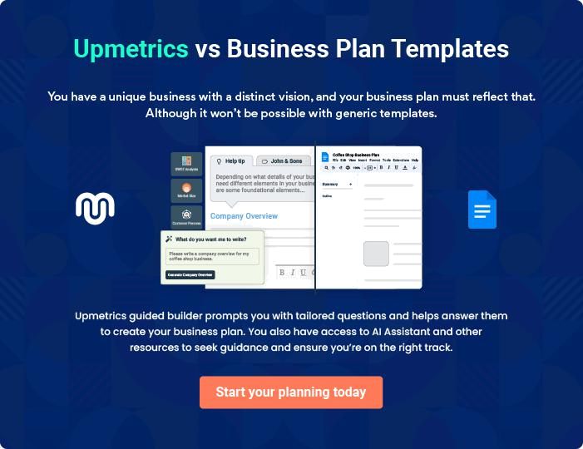
Products and Services
To unlock help try Upmetrics!

The product and services section of a logistics business plan should describe the specific services and products that will be offered to customers. To write this section should include the following:



 Help tip  Logistics Business Plan

To craft the introduction for your "Products and Services" chapter, begin by positioning your business within its industry, emphasizing its unique strengths or value proposition.
To unlock help try Upmetrics! 

Start writing here..

 Help tip


Mention the logistics services your business will offer. This list may include services like.

• Transportation
To unlock help try Upmetrics! 

Services

Transportation Services


Price: $[XXX] per mile for standard loads, with customized quotes for specialized transportation needs.

Our transportation services ensure that goods are efficiently moved from point A to B, be it intra-city or cross-country. We utilize a range of vehicles, from trucks to vans, catering to diverse client requirements.

Specifications

- Vehicle Type: Trucks (16-ton, 24-ton), Vans, Refrigerated Vans

- Delivery Timeframes: Express (24-48 hours), Standard (3-5 days)

- Coverage: [XYZ regions/countries]
Warehousing Facilities

Price: $[XX] per square foot/month; discounted rates for long-term storage.

State-of-the-art warehousing facilities equipped with climate-controlled zones and segmented storage spaces to handle varied product types.

Specifications

- Total Area: [XXX,000] square feet

- Climate Control: Yes (Temperature range: [XX]°C to [XX]°C)

- Security: 24/7 Surveillance, Biometric Access

Distribution Solutions

Price: Starting from $[XXX] per package, varying based on volume and distance.

Comprehensive distribution services covering everything from goods reception to the final delivery point, leveraging route optimization for efficiency.

Specifications

- Delivery Radius: Up to [XXX] miles

- Service Tiers: Standard, Priority, Express

- Tracking: Real-time
Freight Forwarding

Price: $[XXXX] for up to [XXX] kg; variable pricing for larger consignments.

Hassle-free freight forwarding solutions, managing shipments from origin to destination through a vast network of carriers.

Specifications

- Modes: Air, Sea, Land

- Coverage: [XXX] countries

- Insurance Options: Basic, Premium

Customs Brokerage

Price: $[XXX] per clearance; package deals available for bulk transactions.

Expert customs solutions, ensuring quick, compliant, and smooth cross-border transactions

Specifications

- Service Speed: Express (1-2 days), Standard (3-5 days)

- Documentation Support: Yes

- Customs Duty Estimation: Available
Packaging and Crating
- To unlock help try Upmetrics!

Price: Starting from $[XX] per package, based on size and material.

Specialized packaging solutions prioritizing product safety, with options tailored for fragility and specific product needs.

Specifications

- Material Options: Wood, Reinforced Cardboard, Bubble-wrap

- Custom Crating: Available on request

- Packaging Design Assistance: Available

Quality Control

 Help tip  Logistics Business Plan

To ensure that products are handled safely and effectively, describe your quality control methods. Indicate how you’ll uphold quality standards for inventory management, shipping, and storage as part of the logistics process.



Start writing here..
Sales And Marketing Strategies
To unlock help try Upmetrics!

Writing the sales and marketing strategies section means a list of strategies you will use to attract and retain your clients.
To unlock help try Upmetrics! 

 Help Tip  Logistics Business Plan


To create an effective introduction for your "Sales and Marketing Strategies" chapter, start by setting the stage within your specific industry or market.
To unlock help try Upmetrics! 

Start writing here..

Unique Selling Proposition (USP)

 Help tip  Logistics Business Plan

Define your business’s USPs depending on the market you serve, the equipment you use, and the unique services you provide. Identifying USPs will help you plan your marketing strategies.
To unlock help try Upmetrics! 

Start writing here..

Pricing Strategy

 Help tip  Logistics Business Plan

Describe your pricing strategy—how you plan to price your logistics services and stay competitive in the local market. You can mention any discounts you plan on offering to attract new customers to your service.



Start writing here..

 Help tip  XYZ 3D Printing
To unlock help try Upmetrics!


Discuss your marketing strategies to market your services. You may include some of these marketing strategies in your business plan—social media marketing, brochures, email marketing, and print marketing.



Marketing strategies

Online


Social Media

Utilizing platforms such as Facebook, LinkedIn, and Twitter to engage with potential clients, showcase our success stories, and highlight our USPs

Email Marketing

Regular newsletters and updates sent to our subscribers, offering insights, company updates, and special promotions.

Offline

Brochures

Detailed brochures showcasing our services, distributed at industry events, offices, and via direct mail.

Print Marketing

Strategic placement of ads in industry journals, newspapers, and magazines

 Help tip  Logistics Business Plan

Outline the strategies you’ll implement to maximize your sales. Your sales strategies may include how to generate leads, qualify prospects, and close deals.
To unlock help try Upmetrics! 

Sales strategies

Lead Generation

Utilizing platforms such as [LeadGen platform] and industry events to gather potential client details.

Closing Deals

Our sales team is trained in negotiation strategies, ensuring that we can provide customized solutions that appeal to clients while remaining profitable.

Qualifying Prospects

A dedicated team evaluates the viability of each lead, ensuring effort is directed towards promising opportunities.

 Help tip  Logistics Business Plan

Describe your customer retention strategies and how you plan to execute them. For instance, introducing discounts on annual membership, personalized service, etc.
To unlock help try Upmetrics! 

Customer retention

Annual Membership Discounts

Providing cost-effective packages for clients looking for long-term collaborations.

Feedback Loop

Regularly soliciting feedback and acting on it, letting our clients know their voice matters.

Personalized Service

Offering dedicated account

managers for high-volume clients,

ensuring personalized, prompt

service.

Operations Plan
To unlock help try Upmetrics!

 |  | When writing the operations plan section, it’s important to consider the
 |  | various aspects of your business operations.
 |  |  |  | To unlock help try Upmetrics! 
 Help tip |  |  Logistics Business Plan

To create an effective introduction for your "Operational Plan" chapter, start by emphasizing the
pivotal role of efficient operations in the success of your business, underscoring how they
directly impact the quality of services delivered.
 |  |  |  | To unlock help try Upmetrics! 
Start writing here..
Staffing & Training
 Help tip |  |  Logistics Business Plan

Mention your business’s staffing requirements, including the number of employees like
operations manager, driver, dispatcher, etc. Include their qualifications, the training required,
and the duties they will perform.
 |  |  |  | To unlock help try Upmetrics! 
Start writing here..
Operational Process
 Help tip |  |  Logistics Business Plan

Outline the processes and procedures you will use to run your logistics business. Your operational processes may include sending quotations, scheduling appointments, transportation, handling deliveries, etc.



Start writing here..

Equipment & Machinery

 Help tip  Logistics Business Plan

Describe the hardware and software needed, such as logistics software systems, warehouse equipment, and vehicles, to carry out your logistics activities.
To unlock help try Upmetrics! 

Start writing here..
Management Team

The management team section provides an overview of the individuals responsible for running your business plan.
To unlock help try Upmetrics! 

 Help tip  Logistics Business Plan

To craft an introduction for your "Management Team" chapter, begin by emphasizing the crucial role of leadership in the success of any business.
To unlock help try Upmetrics! 

Start writing here..

Key managers

 Help tip  Logistics Business Plan

Introduce your management and key members of your team, and explain their roles and responsibilities.
To unlock help try Upmetrics! 

Start writing here..

JOHN DOE

CEO - john.doe@example.com

John Doe, the visionary behind [XYZ Logistics] Business, provides strategic direction and leadership.

With his profound industry knowledge and dynamic leadership style, John ensures our business remains at the forefront of logistics innovations.


His primary responsibilities encompass overall leadership, financial oversight, and ensuring the firm's alignment with industry trends.

- Educational Background: John holds an MBA from Harvard Business School with a specialization in Supply Chain Management.

- Professional Background: Before founding [XYZ Logistics], John worked as a Senior Operations Manager at GlobalLogistics Corp, where he spearheaded multiple high-value projects and was known for his problem-solving capabilities.


JANE DOE

Chief Operating Officer (COO) - jane.doe@example.com

Jane Doe stands at the helm of day-to-day operations, ensuring that processes run efficiently and service quality remains impeccable.

Her acute attention to detail and vast experience make her indispensable to our operational excellence.

- Educational Background: Jane graduated with a Bachelor's in Logistics and Supply Chain Management from Stanford University.

- Professional Background: With over 15 years in the logistics industry, Jane served as the Regional Operations Director at FastTrack Logistics before joining XYZ.

ALICE BROWN

CMO - alice.brown@example.com

Alice, with her marketing acumen and industry insights, is responsible for positioning [XYZ Logistics] in the market.

She shapes our brand narrative and drives initiatives to boost visibility and engagement.

- Educational Background: Alice earned her Master's in Marketing from the University of Chicago's Booth School of Business.

- Professional Background: Previously, she was the Vice President of Marketing at ShipItRight, where she played a pivotal role in their market expansion.


ROBERT BROWN

Operations Manager - robert.brown@example.com

Robert oversees the distribution strategy for [XYZ Logistics]. His expertise lies in optimizing distribution channels, ensuring timely deliveries, and enhancing client satisfaction.

- Educational Background: Robert has a Bachelor’s degree in Business Administration from New York University.

- Professional Background: Prior to joining us, Robert served as a Distribution Lead at SwiftlyMove Logistics, managing a team of over 50 and handling a portfolio of premium clients.

Organizational structure

 Help tip  Logistics Business Plan

Explain the organizational structure of your management team. Include the reporting line and decision-making hierarchy.
To unlock help try Upmetrics! 

Start writing here..

Organization chart


John Doe

CEO


Alice Brown

Jane Doe

CMO


COO

Emily White

Marketing Manager Robert Brown Operations Manager




Michael Johnson

Lucy Gray

Logistics Coordinator

Digital Marketing Specialist

Compensation plan

 Help tip  Logistics Business Plan

Describe your compensation plan for the management and staff. Include their salaries, incentives, and other benefits.
To unlock help try Upmetrics! 

Start writing here..

 Help tip  Logistics Business Plan

Mentioning advisors or consultants in your business plans adds credibility to your business idea.
To unlock help try Upmetrics! 

Advisors/Consultants


[ADVISOR NAME]

Advisor

A renowned figure in the logistics industry, [Advisor's Name] brings [X years] of experience and provides strategic advice on market trends and expansion opportunities.


[CONSULTANT NAME]

Consultant

Specializing in [specific area, e.g., "supply chain optimization"], [Consultant's Name] has been instrumental in refining our operational processes.
Financial Plan

When writing the financial plan section of a business plan, it’s important to provide a comprehensive overview of your financial projections for the first few years of your business, You may provide the following:
To unlock help try Upmetrics! 

 Help tip  Logistics Business Plan


To create an effective introduction for your "Financial Plan" chapter, begin by stressing the critical role of a well-structured financial plan in the success of your venture.
To unlock help try Upmetrics! 

Start writing here..

 Help tip


Create a projected profit & loss statement that describes the expected revenue, cost of products sold, and operational costs. Your spa’s anticipated net profit or loss should be computed and included.
To unlock help try Upmetrics! 

Profit & loss statement

Revenue

Cost Of Sales

General Costs

Revenue Specific Costs

Personnel Costs (Direct

Labor)

Gross Margin

Gross Margin (%)

Operating Expense

Payroll Expense

(Indirect Labor)

General Expense

Bad Debt

Amortization of Current

Assets

2023-24 | 2024-25 | 2025-26 | 2026-27 | 2027-28
$0 | $0 | $0 | $0 | $0

$0 | $0 | $0 | $0 | $0
$0 | $0 | $0 | $0 | $0
$0 | $0 | $0 | $0 | $0
$0 | $0 | $0 | $0 | $0

$0 | $0 | $0 | $0 | $0
0% | 0% | 0% | 0% | 0%

$0 | $0 | $0 | $0 | $0
$0 | $0 | $0 | $0 | $0
$0 | $0 | $0 | $0 | $0
$0 | $0 | $0 | $0 | $0
$0 | $0 | $0 | $0 | $0

EBITDA

Additional Expense

Long Term

Depreciation

Gain or loss from Sale

of Assets

EBIT

Interest Expenses

EBT

Income Tax Expense

Total Expense

Net Income

Net Income (%)

2023-24 | 2024-25 | 2025-26 | 2026-27 | 2027-28
$0 | $0 | $0 | $0 | $0
$0 | $0 | $0 | $0 | $0
$0 | $0 | $0 | $0 | $0
$0 | $0 | $0 | $0 | $0
$0 | $0 | $0 | $0 | $0
$0 | $0 | $0 | $0 | $0
$0 | $0 | $0 | $0 | $0
$0 | $0 | $0 | $0 | $0
$0 | $0 | $0 | $0 | $0
$0 | $0 | $0 | $0 | $0
0% | 0% | 0% | 0% | 0%
 | 2023-24 | 2024-25 | 2025-26 | 2026-27 | 2027-28
Retained Earning | $0 | $0 | $0 | $0 | $0
Opening
Owner's Distribution | $0 | $0 | $0 | $0 | $0
Retained Earning | $0 | $0 | $0 | $0 | $0
Closing

 Help tip

The cash flow for the first few years of your operation should be estimated and described in this section. This may include billing invoices, payment receipts, loan payments, and any other cash flow statements.
To unlock help try Upmetrics! 

Cash flow statement

 | 2023-24 | 2024-25 | 2025-26 | 2026-27 | 2027-28
Cash Received | $0 | $0 | $0 | $0 | $0
Cash Paid | $0 | $0 | $0 | $0 | $0
COS & General Expenses | $0 | $0 | $0 | $0 | $0
Salary & Wages | $0 | $0 | $0 | $0 | $0
Interest | $0 | $0 | $0 | $0 | $0

Sales Tax

Income Tax

Net Cash From

Operations

Assets Sell

Assets Purchase

Net Cash From

Investments

Amount Received

Loan Received

Common Stock

Preferred Stock

Owner's Contribution

Amount Paid

2023-24 | 2024-25 | 2025-26 | 2026-27 | 2027-28
$0 | $0 | $0 | $0 | $0
$0 | $0 | $0 | $0 | $0
$0 | $0 | $0 | $0 | $0

$0 | $0 | $0 | $0 | $0
$0 | $0 | $0 | $0 | $0
$0 | $0 | $0 | $0 | $0

$0 | $0 | $0 | $0 | $0
$0 | $0 | $0 | $0 | $0

$0 | $0 | $0 | $0 | $0
$0 | $0 | $0 | $0 | $0
$0 | $0 | $0 | $0 | $0

Loan Capital $0 $0 $0 $0 $0

 | 2023-24 | 2024-25 | 2025-26 | 2026-27 | 2027-28
Dividends & Distributions | $0 | $0 | $0 | $0 | $0
Net Cash From | $0 | $0 | $0 | $0 | $0
Financing

Summary
Starting Cash | $0 | $0 | $0 | $0 | $0
Cash In | $0 | $0 | $0 | $0 | $0
Cash Out | $0 | $0 | $0 | $0 | $0
Change in Cash | $0 | $0 | $0 | $0 | $0
Ending Cash | $0 | $0 | $0 | $0 | $0

 Help tip

Create a projected balance sheet documenting your business’s assets, liabilities, and equity.

To unlock help try Upmetrics! 

Balance sheet

 | 2023-24 | 2024-25 | 2025-26 | 2026-27 | 2027-28
Assets | $0 | $0 | $0 | $0 | $0
Current Assets | $0 | $0 | $0 | $0 | $0
Cash | $0 | $0 | $0 | $0 | $0
Accounts Receivable | $0 | $0 | $0 | $0 | $0
Inventory | $0 | $0 | $0 | $0 | $0
Other Current Assets | $0 | $0 | $0 | $0 | $0
Long Term Assets | $0 | $0 | $0 | $0 | $0
Gross Long Term Assets | $0 | $0 | $0 | $0 | $0
Accumulated Depreciation | $0 | $0 | $0 | $0 | $0

Liabilities & Equity | $0 | $0 | $0 | $0 | $0
Liabilities | $0 | $0 | $0 | $0 | $0
Current Liabilities | $0 | $0 | $0 | $0 | $0
Accounts Payable | $0 | $0 | $0 | $0 | $0
Income Tax Payable | $0 | $0 | $0 | $0 | $0
Sales Tax Payable | $0 | $0 | $0 | $0 | $0
Short Term Debt | $0 | $0 | $0 | $0 | $0
 | 2023-24 | 2024-25 | 2025-26 | 2026-27 | 2027-28
Long Term Liabilities | $0 | $0 | $0 | $0 | $0
Long Term Debt | $0 | $0 | $0 | $0 | $0
Equity | $0 | $0 | $0 | $0 | $0
Paid-in Capital | $0 | $0 | $0 | $0 | $0
Common Stock | $0 | $0 | $0 | $0 | $0
Preferred Stock | $0 | $0 | $0 | $0 | $0
Owner's Contribution | $0 | $0 | $0 | $0 | $0
Retained Earnings | $0 | $0 | $0 | $0 | $0

Check | $0 |  |  | $0 | $0 | $0 | $0
 Help tip |  |  Logistics Business Plan


Determine and mention your business’s break-even point—the point at which your business costs and revenue will be equal.

This exercise will help you understand how much revenue you need to generate to sustain or be profitable.
To unlock help try Upmetrics! 

Break-even Analysis

 | 2023-24 | 2024-25 | 2025-26 | 2026-27 | 2027-28
Starting Revenue | $0 | $0 | $0 | $0 | $0
Net Revenue | $0 | $0 | $0 | $0 | $0
Closing Revenue | $0 | $0 | $0 | $0 | $0

Starting Expense | $0 | $0 | $0 | $0 | $0
Net Expense | $0 | $0 | $0 | $0 | $0
Closing Expense | $0 | $0 | $0 | $0 | $0

Is Break Even? | 0 | 0 | 0 | 0 | 0
Break Even Month | 0 | 0 | 0 | 0 | 0
Days Required | 0 | 0 | 0 | 0 | 0
Break Even Revenue | $0 | $0 | $0 | $0 | $0
Break Even Units
Financing needs

 Help tip  Logistics Business Plan

Calculate costs associated with starting a logistics business, and estimate your financing needs and how much capital you need to raise to operate your business.
To unlock help try Upmetrics! 

Start writing here..
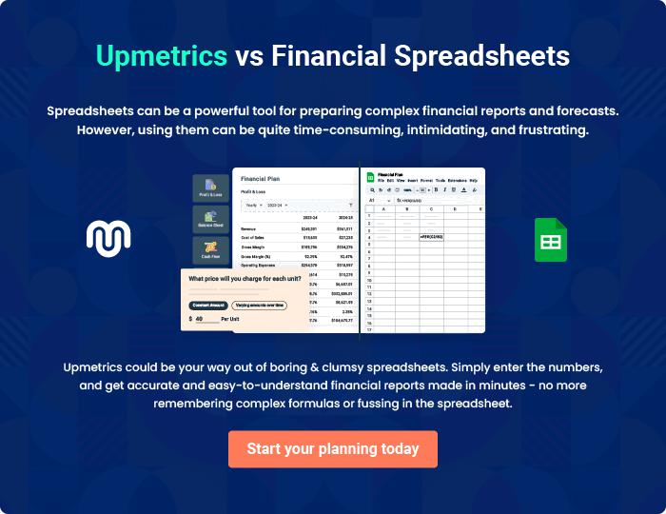
Appendix

When writing the appendix section, you should include any additional information that supports the main content of your plan. This may include financial statements, market research data, legal documents, and other
To unlock help try Upmetrics! 
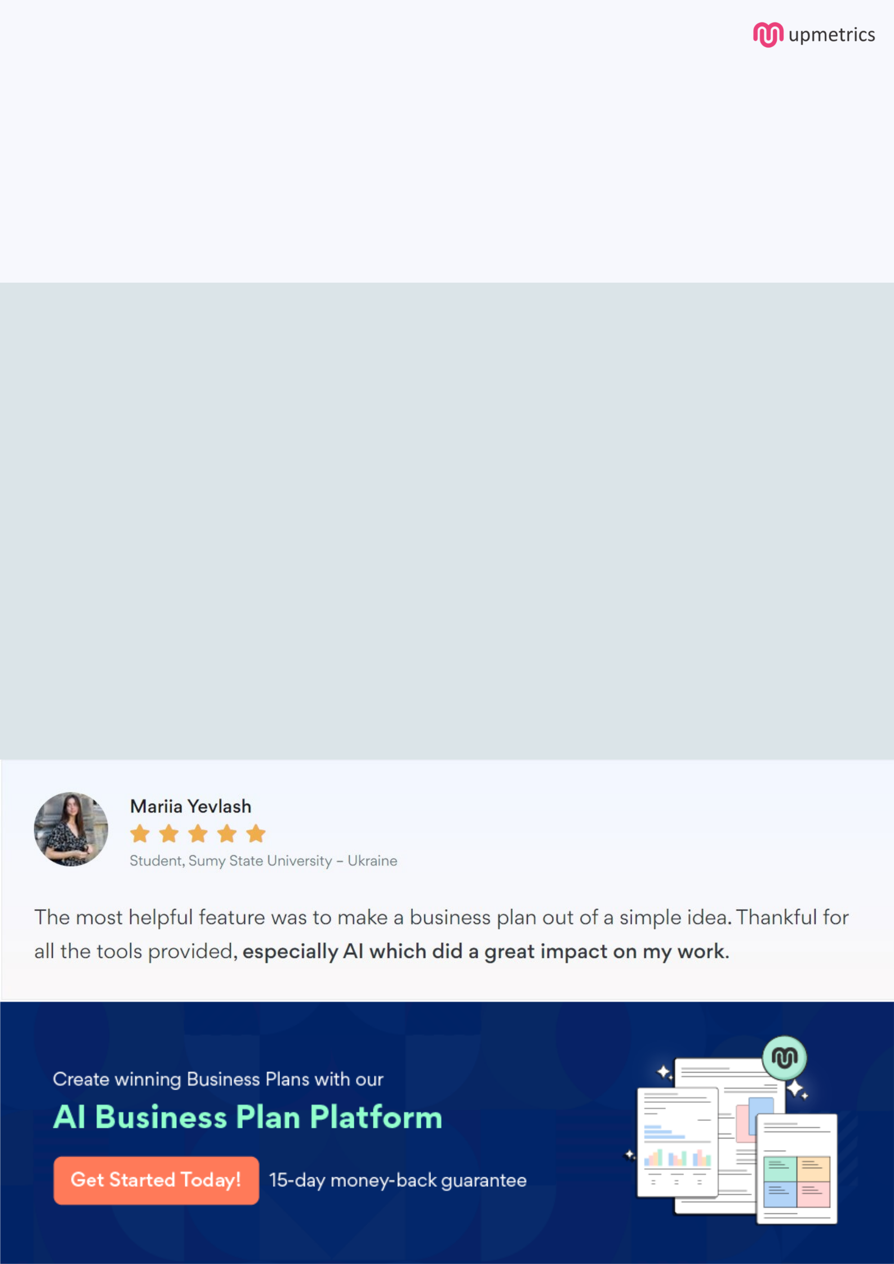
Create a winning business plan that gets you funded

Creating a stunning and investment-ready plan requires no writing, graphic designing, or financial planning expertise.

Upmetrics has all the features required to help you create a comprehensive business plan—from start to finish. Make no mistakes, it’s the modern way of planning to structure ideas, make plans, and create stunning pitch decks to awe investors.

Pitch decks that impress investors

Create pitch decks that provide a visual representation of your business, engage investors, and make them want to invest in your business idea.

Interactive plans in no time

Import business plan sections like—SWOT analysis, comparison tables, and others to create an interactive business plan. No designing skills are required.

Stunning cover page designs

With Upmetrics, you have the liberty to choose from multiple stunning cover page designs. Choose a creative design and make your plan stand out.

Online sharing made simple

Upmetrics makes online sharing quick and easier for users. Easily share your business plans with a link while tracking reader activity.

500+ sample business plans

Simply import a template from our library of sample plans into the editor and start customizing it to make it yours. It takes only a few clicks to get started.

Collaborate with team in real-time

Invite team members, initiate conversations, discuss ideas & strategies, share feedback, and work on a business plan in real-time.

