
BUSINESS PLAN

2023


Loan Officer Business Plan

Navigating Finance, Creating Futures

John Doe

10200 Bolsa Ave, Westminster, CA, 92683

- 359-3153 info@example.com http://www.example.com

Information provided in this business plan is unique to this business and confidential; therefore, anyone reading this plan agrees not to disclose any of the information in this business plan without prior written permission of the company.
Table of Contents

Executive Summary | 6
Market opportunity | 6
Services Offered | 6
Marketing & Sales Strategies | 7
Financial Highlights | 7
Units Sold v/s Revenue | 8

Company Overview | 9
Ownership | 9
Mission statement | 10
Business history | 10
Future goals | 10

Market Analysis | 11
Target Market | 11
Market size and growth potential | 11
Market Size | 12
Competitive analysis | 12
QuickMortgage Co. | 12
HomeSecure Lending | 13
DigitalFirst Loans | 13
Market trends | 13
Regulatory environment | 14

Products and Services | 15
Services | 15
Loan Application Assistance | 15
Financial Assessment & Analysis | 16
Personal Loans | 16
Mortgages | 17
Loan Portfolio Management | 17
Financial Consultancy | 18
Specialized service | 18
Additional services | 18

Sales And Marketing Strategies | 19
Unique Selling Proposition (USP) | 19
Pricing Strategy | 19
Marketing strategies | 20
Online | 20
Offline | 20
Sales strategies | 21
Customer retention | 22

Operations Plan | 23
Staffing & Training | 23
Operational Process | 23
Equipment and Software | 24

Management Team | 25
Key managers | 25
John Doe | 26
Jane Doe | 27
Alice Brown | 27
Robert Brown | 27
Organizational structure | 28
Organization chart | 28
Compensation plan | 29
Advisors/Consultants | 29
Emily Thompson | 29
Michael Johnson | 29
Financial Plan
Financial Plan | 30

Profit & loss statement 30

Cash flow statement | 33
Balance sheet | 35
Break-even Analysis | 37
Financing needs | 39
Appendix
Appendix | 41
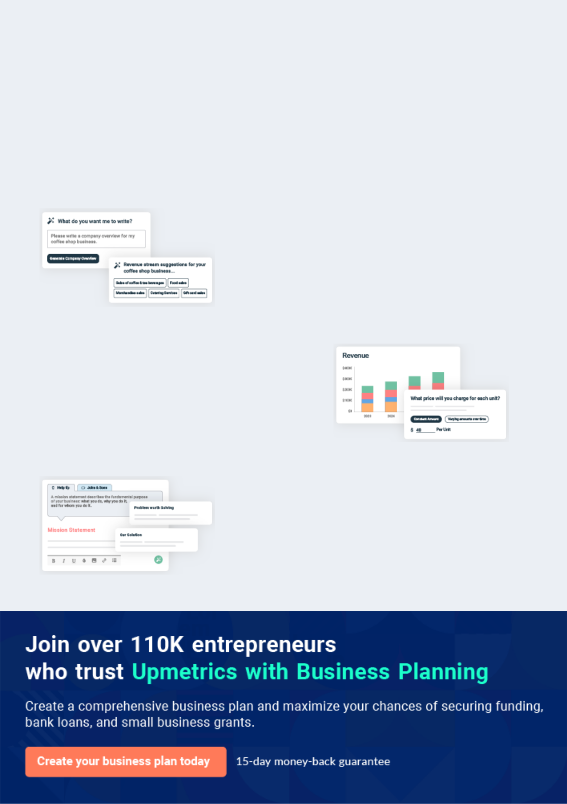
Business planning that’s simpler and faster than you think

Creating a business plan using Upmetrics to start and grow a business is literally the easiest thing in the World. Simply read the instructions and fill in the blanks. It’s as simple as that.

❛ | Upmetrics has everything you need to create a | ❜
❛ | comprehensive business plan. | ❜

AI-powered Upmetrics Assistant

AI-powered insights to streamline your plan

Not sure where to start? Upmetrics’ AI Assistant will automatically generate ideas for each section of your plan and offer improved versions of your writing, adjusting for tone, voice, and grammar or spelling errors.

Financial Forecasting Tool

All the financials are calculated for you

Forget the complex formulas and clumsy spreadsheets — with automatic financials and drag-and-drop forecasting, you can finish your plan faster and be confident that your numbers are accurate.

Business Plan Builder

Guides you like a business mentor

Upmetrics’ step-by-step instructions, prompts, and the library of 400+ sample business plans will guide you through each section of your plan as a business mentor.
Executive Summary


An executive summary is the first section of the business plan intended to provide an overview of the whole business plan.
To unlock help try Upmetrics! 

 Help tip  Loan Officer Business Plan


Start your executive summary by briefly introducing your business to your readers.

This section may include the name of your loan officer business, its location, when it was
To unlock help try Upmetrics! 

Start writing here..

Market opportunity

 Help tip  Loan Officer Business Plan

Summarize your market research, including market size, growth potential, and marketing trends. Highlight the opportunities in the market and how your business will fit in to fill the gap.
To unlock help try Upmetrics! 

Start writing here..

Services Offered

 Help tip  Loan Officer Business Plan

Highlight the loan officer services you offer your clients. The USPs and differentiators you offer are always a plus.
To unlock help try Upmetrics! 

Start writing here..

Marketing & Sales Strategies
To unlock help try Upmetrics!

 Help tip  Loan Officer Business Plan

Outline your sales and marketing strategies—what marketing platforms you use, how you plan on acquiring customers, etc.
To unlock help try Upmetrics! 

Start writing here..

Financial Highlights

 Help tip  Loan Officer Business Plan

Briefly summarize your financial projections for the initial years of business operations. Include any capital or investment requirements, associated startup costs, projected revenues, and profit forecasts.



Start writing here..
Units Sold v/s Revenue

 |  | Units Sold | Revenue
15.00k
10.00k
5.00k
0
Year 1 | Year 2 | Year 3


Financial Year |  |  | Units Sold | Revenue
Year 1 | 1,550 |  |  | $10,000
Year 2 | 1,800 |  |  | $12,000
Year 3 | 2,050 |  |  | $14,000
 Help tip |  |  Loan Officer Business Plan


Summarize your executive summary section with a clear CTA, for example, inviting angel investors to discuss the potential business investment.
To unlock help try Upmetrics! 

Write a call to action for your business plan.
Company Overview

Depending on what details of your business are essential, you’ll need different elements in your business overview.
To unlock help try Upmetrics! 

 Help tip  Loan Officer Business Plan

Describe your business in this section by providing all the basic information:

Describe what kind of loan officer company you have and the name of it. You may specialize in
To unlock help try Upmetrics! 

Start writing here..

Ownership

 Help tip  Loan Officer Business Plan

List the names of your loan officer company’s founders or owners. Describe what shares they own and their responsibilities for efficiently managing the business.
To unlock help try Upmetrics! 

Start writing here..
Mission statement

 Help tip  Loan Officer Business Plan

Summarize your business’ objective, core principles, and values in your mission statement. This statement needs to be memorable, clear, and brief.
To unlock help try Upmetrics! 

❛ Empowering Financial Dreams, One Loan at a Time." At [Premier Lending Solutions], our mission is steadfast – to pave financial paths for our clients with clarity, integrity, and dedication.

Our core principles revolve around transparency, commitment, and fostering enduring client relationships.

❜

Business history

 Help tip  Loan Officer Business Plan

If you’re an established loan officer service provider, briefly describe your business history, like— when it was founded, how it evolved over time, etc.
To unlock help try Upmetrics! 

Start writing here..

Future goals

 Help tip  Loan Officer Business Plan

It’s crucial to convey your aspirations and vision. Mention your short-term and long-term goals; they can be specific targets for revenue, market share, or expanding your services.
To unlock help try Upmetrics! 

Start writing here..

Market Analysis
To unlock help try Upmetrics!


 |  | Market analysis provides a clear understanding of the market in which your
 |  | printing business will run along with the target market, competitors, and
 |  | growth opportunities.
 |  |  |  | To unlock help try Upmetrics! 
 Help tip |  |  Loan Officer Business Plan

To write the introduction section of your market analysis, start by clearly identifying your primary target market.
To unlock help try Upmetrics! 

Start writing here..

Target Market

 Help tip  Loan Officer Business Plan

Start this section by describing your target market. Define your ideal customer and explain what types of services they prefer. Creating a buyer persona will help you easily define your target market to your readers.



Start writing here..

Market size and growth potential

 Help tip  Loan Officer Business Plan

Describe your market size and growth potential and whether you will target a niche or a much broader market.
To unlock help try Upmetrics! 

Start writing here..

Market Size


Available Market | 10M
Total potential borrowers in the region. | 10M

Served Market
Borrowers accessible via current 7M channels & services.

Target Market
Focus segment: urban professionals aged 1M 30-50.

 Help tip  Loan Officer Business Plan

Identify and analyze your direct and indirect competitors. Identify their strengths and weaknesses, and describe what differentiates your loan officer services from them.
To unlock help try Upmetrics! 

Competitive analysis

QuickMortgage Co.

Founded in 2015, QuickMortgage Co. has swiftly gained traction in the market, largely owing to its emphasis on speedy loan approvals.

Catering predominantly to the urban clientele, their digital platforms have been a significant catalyst for growth.

Features

Strengths Weaknesses

Online mortgage calculator Instant loan approval feature

Mobile app with e-signing capabilities

Dedicated customer support chatbot

Robust digital presence with a user-friendly interface

Quick turnaround times for loan processing

Strong market visibility backed by aggressive marketing

Limited loan options catering predominantly to a younger demographic

Reported customer service challenges during peak hours

Lack of personalized service, with a focus on automation

HomeSecure Lending

A veteran in the industry, HomeSecure Lending boasts over two decades of experience. With a vast network of physical branches, they've been a go-to choice for those preferring face-to-face consultations.

Features

Comprehensive range of loan products, from first-time mortgages to refinancing

Personalized loan consulting Home valuation services

Online portal for document submission

Strengths

Strong reputation and trust built over years

Wide range of loan options catering to diverse needs

Expertise in offering tailored advice based on individual financial situations

Weaknesses

Slower adoption of digital trends, leading to lengthier processing times

Limited online resources and tools for potential borrowers

Higher overhead due to extensive branch network, potentially leading to slightly elevated rates

DigitalFirst Loans

A disruptor in the traditional lending space, DigitalFirst Loans operates purely on an online model.

Established in 2018, they target tech-savvy individuals seeking seamless borrowing experiences.

Features Strengths Weaknesses

AI-powered loan recommendation engine

Virtual reality property tours for prospective homebuyers

Digital-first documentation and verification processes

Cutting-edge technology ensuring minimal human intervention

Round-the-clock service availability

Competitive rates due to low overhead costs

Absence of physical presence can deter a segment of borrowers

Over-reliance on technology, leading to occasional system glitches

Limited track record and brand history in the market

Market trends

 Help tip  Loan Officer Business Plan

Analyse emerging trends in the industry, such as technology disruptions, changes in customer behavior or preferences, etc. Explain how your business will cope with all the trends.
To unlock help try Upmetrics! 

Start writing here..

Regulatory environment
To unlock help try Upmetrics!

 Help tip  Loan Officer Business Plan

List regulations and licensing requirements that may affect your loan officer business, such as Equal Credit Opportunity Act (ECOA), Fair Credit Reporting Act (FCRA), Anti-money laundering (AML), etc.



Start writing here..
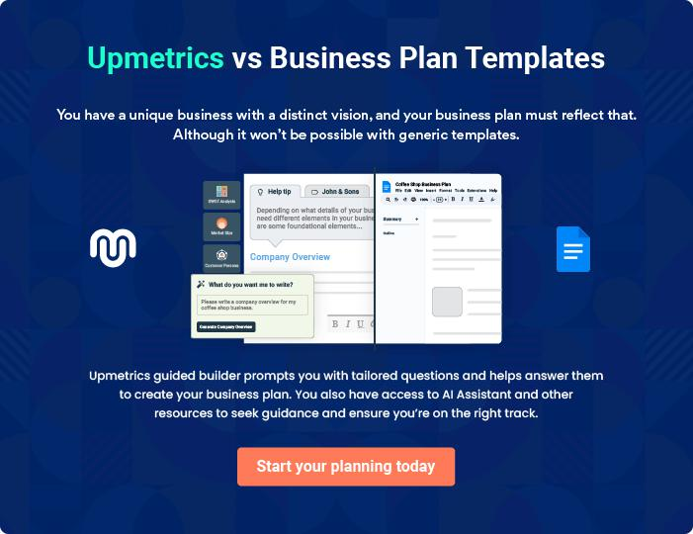
Products and Services
To unlock help try Upmetrics!

The product and services section of a loan officer business plan should describe the specific services and products that will be offered to customers. To write this section should include the following:



 Help tip  Loan Officer Business Plan

To craft the introduction for your "Products and Services" chapter, begin by positioning your business within its industry, emphasizing its unique strengths or value proposition.
To unlock help try Upmetrics! 

Start writing here..

 Help tip


Mention the loan officer services your business will offer. This list may include services like

• Loan application assistance
To unlock help try Upmetrics! 

Services

Loan Application Assistance


Price: [$100] per consultation

Expert guidance through the loan application process, ensuring all data is correctly provided and enhancing the likelihood of approval.

Specifications

- Personalized consultation (up to 2 hours)

- Application checklist

- Document review

- Submission guidelines
Financial Assessment & Analysis

Price: [$250] per assessment

Comprehensive financial evaluation to ascertain borrowing capacity, risk profile, and optimal loan structure.

Specifications

- Detailed credit history check

- Income and liability analysis

- Financial health score and report

- Recommendations for credit improvement

Personal Loans

Price: Interest rates starting at [6.99% p.a.]

Flexible personal loans designed to cater to a myriad of individual needs, be it for medical emergencies, travel, or other personal expenses.

Specifications

- Loan amount range: [$5,000 - $50,000]

- Loan tenure: 1 - 5 years

- No hidden fees

- Quick approval process
Mortgages

Price: Interest rates from [3.5% p.a.]

Diverse mortgage solutions to help clients purchase, refinance, or invest in real estate properties.

Specifications

- Residential, commercial, and investment property options

- Fixed and adjustable-rate mortgages available

- Loan-to-value ratio up to 90%

- Tenure range: 15 - 30 years

Loan Portfolio Management

Price: Starting at [$500] annually or [0.5%] of the total loan portfolio

Comprehensive management of multiple loans, ensuring timely repayments and optimal interest rate management.

Specifications

- Monthly loan status updates

- Interest rate monitoring

- Penalty alerts

- Refinancing recommendations as market conditions change
Financial Consultancy

Price: [$150] per hour

In-depth insights into market trends, investment avenues, and financial planning, ensuring clients make informed financial decisions.

Specifications

- Tailored financial strategies

- Market analysis reports

- Investment portfolio reviews

- Risk assessment and management guidance

Specialized service

 Help tip  Loan Officer Business Plan

Highlight any specialized services your loan officer company provides, such as catering to a particular sector or niche market.
To unlock help try Upmetrics! 

Start writing here..

Additional services

 Help tip  Loan Officer Business Plan

Mention if your loan officer company offers any additional services. You may include services like loan application preparation or financial consultancy.
To unlock help try Upmetrics! 

Start writing here..

Sales And Marketing Strategies

Writing the sales and marketing strategies section means a list of strategies you will use to attract and retain your clients.
To unlock help try Upmetrics! 

 Help Tip  Loan Officer Business Plan


To create an effective introduction for your "Sales and Marketing Strategies" chapter, start by setting the stage within your specific industry or market.
To unlock help try Upmetrics! 

Start writing here..

Unique Selling Proposition (USP)

 Help tip  Loan Officer Business Plan

Define your business’s USPs depending on the market you serve, the equipment you use, and the unique services you provide. Identifying USPs will help you plan your marketing strategies.
To unlock help try Upmetrics! 

Start writing here..

Pricing Strategy

 Help tip  Loan Officer Business Plan

Describe your pricing strategy—how you plan to price your services and stay competitive in the local market. You can mention any discounts you plan on offering to attract new customers.
To unlock help try Upmetrics! 

Start writing here..

 Help tip  Loan Officer Business Plan
To unlock help try Upmetrics!

Discuss your marketing strategies to market your services. You may include some of these marketing strategies in your business plan—social media marketing, brochures, email marketing, content marketing, and print marketing.



Marketing strategies

Online


Social Media

Platforms such as [Facebook, LinkedIn, and Instagram] will be utilized to engage potential clients and keep them informed about our services and industry insights.

Content Marketing

Informative articles and blogs will be posted on our website, providing valuable information and drawing organic traffic through search engines.

Offline

Brochures

High-quality printed brochures detailing our services will be available at our office and strategic partner locations.

Email Marketing

Periodic newsletters, updates, and promotional offers will be dispatched to our client list, keeping them engaged and informed.

Print Marketing

Local newspaper ads and magazine features will be used to target a more traditional client base.

 Help tip  Loan Officer Business Plan

Outline the strategies you’ll implement to maximize your sales. Your sales strategies may include direct sales calls, partnering with other businesses, offering referral programs, etc.
To unlock help try Upmetrics! 

Sales strategies

Partner with Businesses

Collaborative efforts with real estate agencies, financial consultants, and other related businesses to refer clients in need of lending solutions.

Referral Programs

Encouraging our satisfied clients to refer others by offering them incentives or discounts for each successful referral.

Direct Sales Calls

Regular outreach to potential leads through phone calls, ensuring a personal touch and direct communication.

 Help tip  Loan Officer Business Plan

Describe your customer retention strategies and how you plan to execute them. For instance, providing personalized service is one of the customer retention methods.
To unlock help try Upmetrics! 

Customer retention

Loyalty Programs

Frequent clients will be rewarded with discounted rates or value-added services.

Personalized Service

Each client will have a dedicated representative ensuring consistent and familiar communication.

Feedback & Improvements

Regular feedback will be sought, and the insights will be used to constantly enhance our service offerings.

Operations Plan
To unlock help try Upmetrics!

 |  | When writing the operations plan section, it’s important to consider the
 |  | various aspects of your business operations.
 |  |  |  | To unlock help try Upmetrics! 
 Help tip |  |  Loan Officer Business Plan


To create an effective introduction for your "Operational Plan" chapter, start by emphasizing the
pivotal role of efficient operations in the success of your business, underscoring how they
directly impact the quality of services delivered.
 |  |  |  | To unlock help try Upmetrics! 
Start writing here..
Staffing & Training
 Help tip |  |  Loan Officer Business Plan

Mention your cleaning business’s staffing requirements, including the number of employees, loan officers, or credit analysts needed.
To unlock help try Upmetrics! 

Start writing here..

Operational Process

 Help tip  Loan Officer Business Plan

Outline the processes and procedures you will use to run your loan officer business. Your operational processes may include client inquiry & initial contact, loan application & documentation, loan analysis & underwriting, etc.



Start writing here..

Equipment and Software
To unlock help try Upmetrics!

 Help tip  Loan Officer Business Plan

Include the list of equipment and software required for a loan officer, such as customer relationship management (CRM) software, office furniture & supplies, loan origination software, etc.



Start writing here..
Management Team

The management team section provides an overview of the individuals responsible for running your business plan.
To unlock help try Upmetrics! 

 Help tip  Loan Officer Business Plan

To craft an introduction for your "Management Team" chapter, begin by emphasizing the crucial role of leadership in the success of any business.
To unlock help try Upmetrics! 

Start writing here..

Key managers

 Help tip  Loan Officer Business Plan

Introduce your management and key members of your team, and explain their roles and responsibilities.
To unlock help try Upmetrics! 

Start writing here..

JOHN DOE

CEO - john.doe@example.com

John, the visionary force behind [Premier Lending Solutions], has dedicated over 20 years to the financial sector.

With a master’s degree in Finance from the University of Prestige, he has successfully maneuvered various roles within the finance domain, finally establishing [Premier Lending Solutions] to bring forth his vision of ethical and client-centric lending services.


- Education: MSc in Finance, University of Prestige.

- Professional Background: Prior to founding [Premier Lending Solutions], John served as the Vice President of MegaBank Corp, where he led a team of over 200 finance professionals and was responsible for a loan portfolio of over $500 million.

JANE DOE

Chief Operating Officer (COO) - jane.doe@example.com

Jane steers the daily operations of [Premier Lending Solutions] with meticulous attention to detail.

With a bachelor’s degree in Business Management from the Ivy League University, she brings to the table an extensive 15-year professional journey in operational roles across leading financial institutions.

- Education: BA in Business Management, Ivy League University.

- Professional Background: Jane previously served as the Operations Director at FinanceElite Ltd, where she played a pivotal role in streamlining operations and enhancing efficiency.


ALICE BROWN

CMO - alice.brown@example.com

Alice helms the marketing division with a blend of creativity and strategic insight. She holds an MBA in Marketing from Metro Business School.

With over 12 years in the marketing landscape of the finance industry, Alice crafts campaigns that resonate with our target audience.

- Education: MBA in Marketing, Metro Business School.

- Professional Background: Prior to joining [Premier Lending Solutions], Alice was the Marketing Head at CapitalFortune, where she led several successful marketing campaigns that significantly boosted the company's brand presence.


ROBERT BROWN

Loan Officer Manager - robert.brown@example.com

Robert, with his sharp financial acumen, manages our team of dedicated loan officers.

A graduate in Economics from State University, his 10 years in the lending industry equips him with the expertise to ensure clients receive the best advice and solutions.

- Education: BSc in Economics, State University.

- Professional Background: Robert has served in senior loan officer roles at TopLend Corp and TrustyFinance, where he curated tailored loan solutions for diverse clientele.
Organizational structure

 Help tip  Loan Officer Business Plan

Explain the organizational structure of your management team. Include the reporting line and decision-making hierarchy.
To unlock help try Upmetrics! 

Start writing here..

Organization chart


John Doe

CEO


Alice Brown

Jane Doe

CMO


COO


Emily Smith

Robert Brown

Customer Service Manager



Loan Officer Manager


Peter Clark

Laura White

Senior Loan Officer

Client Relations Lead

Compensation plan

 Help tip  Loan Officer Business Plan

Describe your compensation plan for the management and staff. Include their salaries, incentives, and other benefits.
To unlock help try Upmetrics! 

Start writing here..

 Help tip  Loan Officer Business Plan

Mentioning advisors or consultants in your business plans adds credibility to your business idea.
To unlock help try Upmetrics! 

Advisors/Consultants


EMILY THOMPSON

Financial Advisor

Emily holds a Master’s degree in Finance and has over 15 years of experience in financial consulting, specializing in loan structuring and risk management.

Emily assists in developing robust financial models, advising on risk management strategies, and ensuring that our loan products are competitive and tailored to meet our clients' need


MICHAEL JOHNSON

Legal Consultant

A seasoned attorney with a specialization in financial laws and regulations, Michael brings over 20 years of legal expertise to the table.

He ensures that all our operations are in compliance with the prevailing laws and regulations, and provides legal counsel on contracts, agreements, and other legal matters.
Financial Plan

When writing the financial plan section of a business plan, it’s important to provide a comprehensive overview of your financial projections for the first few years of your business, You may provide the following:
To unlock help try Upmetrics! 

 Help tip  Loan Officer Business Plan


To create an effective introduction for your "Financial Plan" chapter, begin by stressing the critical role of a well-structured financial plan in the success of your venture.
To unlock help try Upmetrics! 

Start writing here..

 Help tip


Describe details such as projected revenue, operational costs, and service costs in your projected profit and loss statement. Make sure to include your business’s expected net profit or loss.
To unlock help try Upmetrics! 

Profit & loss statement

Revenue

Cost Of Sales

General Costs

Revenue Specific Costs

Personnel Costs (Direct

Labor)

Gross Margin

Gross Margin (%)

Operating Expense

Payroll Expense

(Indirect Labor)

General Expense

Bad Debt

Amortization of Current

Assets

2023-24 | 2024-25 | 2025-26 | 2026-27 | 2027-28
$0 | $0 | $0 | $0 | $0

$0 | $0 | $0 | $0 | $0
$0 | $0 | $0 | $0 | $0
$0 | $0 | $0 | $0 | $0
$0 | $0 | $0 | $0 | $0

$0 | $0 | $0 | $0 | $0
0% | 0% | 0% | 0% | 0%

$0 | $0 | $0 | $0 | $0
$0 | $0 | $0 | $0 | $0
$0 | $0 | $0 | $0 | $0
$0 | $0 | $0 | $0 | $0
$0 | $0 | $0 | $0 | $0

EBITDA

Additional Expense

Long Term

Depreciation

Gain or loss from Sale

of Assets

EBIT

Interest Expenses

EBT

Income Tax Expense

Total Expense

Net Income

Net Income (%)

2023-24 | 2024-25 | 2025-26 | 2026-27 | 2027-28
$0 | $0 | $0 | $0 | $0
$0 | $0 | $0 | $0 | $0
$0 | $0 | $0 | $0 | $0
$0 | $0 | $0 | $0 | $0
$0 | $0 | $0 | $0 | $0
$0 | $0 | $0 | $0 | $0
$0 | $0 | $0 | $0 | $0
$0 | $0 | $0 | $0 | $0
$0 | $0 | $0 | $0 | $0
$0 | $0 | $0 | $0 | $0
0% | 0% | 0% | 0% | 0%
 | 2023-24 | 2024-25 | 2025-26 | 2026-27 | 2027-28
Retained Earning | $0 | $0 | $0 | $0 | $0
Opening
Owner's Distribution | $0 | $0 | $0 | $0 | $0
Retained Earning | $0 | $0 | $0 | $0 | $0
Closing

 Help tip

The cash flow for the first few years of your operation should be estimated and described in this section. This may include billing invoices, payment receipts, loan payments, and any other cash flow statements.
To unlock help try Upmetrics! 

Cash flow statement

 | 2023-24 | 2024-25 | 2025-26 | 2026-27 | 2027-28
Cash Received | $0 | $0 | $0 | $0 | $0
Cash Paid | $0 | $0 | $0 | $0 | $0
COS & General Expenses | $0 | $0 | $0 | $0 | $0
Salary & Wages | $0 | $0 | $0 | $0 | $0
Interest | $0 | $0 | $0 | $0 | $0

Sales Tax

Income Tax

Net Cash From

Operations

Assets Sell

Assets Purchase

Net Cash From

Investments

Amount Received

Loan Received

Common Stock

Preferred Stock

Owner's Contribution

Amount Paid

2023-24 | 2024-25 | 2025-26 | 2026-27 | 2027-28
$0 | $0 | $0 | $0 | $0
$0 | $0 | $0 | $0 | $0
$0 | $0 | $0 | $0 | $0

$0 | $0 | $0 | $0 | $0
$0 | $0 | $0 | $0 | $0
$0 | $0 | $0 | $0 | $0

$0 | $0 | $0 | $0 | $0
$0 | $0 | $0 | $0 | $0

$0 | $0 | $0 | $0 | $0
$0 | $0 | $0 | $0 | $0
$0 | $0 | $0 | $0 | $0

Loan Capital $0 $0 $0 $0 $0

 | 2023-24 | 2024-25 | 2025-26 | 2026-27 | 2027-28
Dividends & Distributions | $0 | $0 | $0 | $0 | $0
Net Cash From | $0 | $0 | $0 | $0 | $0
Financing

Summary
Starting Cash | $0 | $0 | $0 | $0 | $0
Cash In | $0 | $0 | $0 | $0 | $0
Cash Out | $0 | $0 | $0 | $0 | $0
Change in Cash | $0 | $0 | $0 | $0 | $0
Ending Cash | $0 | $0 | $0 | $0 | $0

 Help tip

Create a projected balance sheet documenting your loan officer business’s assets, liabilities, and equity.

To unlock help try Upmetrics! 

Balance sheet

 | 2023-24 | 2024-25 | 2025-26 | 2026-27 | 2027-28
Assets | $0 | $0 | $0 | $0 | $0
Current Assets | $0 | $0 | $0 | $0 | $0
Cash | $0 | $0 | $0 | $0 | $0
Accounts Receivable | $0 | $0 | $0 | $0 | $0
Inventory | $0 | $0 | $0 | $0 | $0
Other Current Assets | $0 | $0 | $0 | $0 | $0
Long Term Assets | $0 | $0 | $0 | $0 | $0
Gross Long Term Assets | $0 | $0 | $0 | $0 | $0
Accumulated Depreciation | $0 | $0 | $0 | $0 | $0

Liabilities & Equity | $0 | $0 | $0 | $0 | $0
Liabilities | $0 | $0 | $0 | $0 | $0
Current Liabilities | $0 | $0 | $0 | $0 | $0
Accounts Payable | $0 | $0 | $0 | $0 | $0
Income Tax Payable | $0 | $0 | $0 | $0 | $0
Sales Tax Payable | $0 | $0 | $0 | $0 | $0
Short Term Debt | $0 | $0 | $0 | $0 | $0
 | 2023-24 | 2024-25 | 2025-26 | 2026-27 | 2027-28
Long Term Liabilities | $0 | $0 | $0 | $0 | $0
Long Term Debt | $0 | $0 | $0 | $0 | $0
Equity | $0 | $0 | $0 | $0 | $0
Paid-in Capital | $0 | $0 | $0 | $0 | $0
Common Stock | $0 | $0 | $0 | $0 | $0
Preferred Stock | $0 | $0 | $0 | $0 | $0
Owner's Contribution | $0 | $0 | $0 | $0 | $0
Retained Earnings | $0 | $0 | $0 | $0 | $0

Check | $0 |  |  | $0 | $0 | $0 | $0
 Help tip |  |  Loan Officer Business Plan


Determine and mention your business’s break-even point—the point at which your business costs and revenue will be equal. This exercise will help you understand how much revenue you need to generate to sustain or be profitable
To unlock help try Upmetrics! 

Break-even Analysis

 | 2023-24 | 2024-25 | 2025-26 | 2026-27 | 2027-28
Starting Revenue | $0 | $0 | $0 | $0 | $0
Net Revenue | $0 | $0 | $0 | $0 | $0
Closing Revenue | $0 | $0 | $0 | $0 | $0

Starting Expense | $0 | $0 | $0 | $0 | $0
Net Expense | $0 | $0 | $0 | $0 | $0
Closing Expense | $0 | $0 | $0 | $0 | $0

Is Break Even? | 0 | 0 | 0 | 0 | 0
Break Even Month | 0 | 0 | 0 | 0 | 0
Days Required | 0 | 0 | 0 | 0 | 0
Break Even Revenue | $0 | $0 | $0 | $0 | $0
Break Even Units
Financing needs

 Help tip  Loan Officer Business Plan

Calculate costs associated with starting a loan officer business, and estimate your financing needs and how much capital you need to raise to operate your business.
To unlock help try Upmetrics! 

Start writing here..
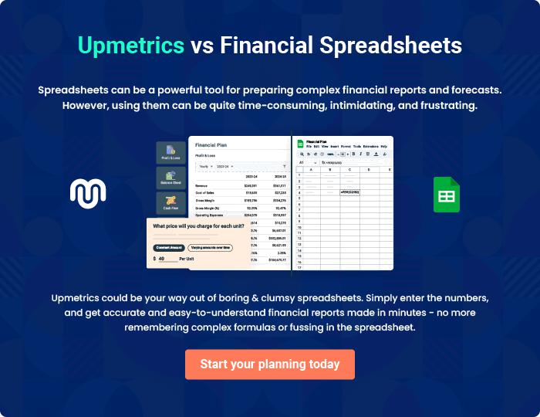
Appendix

When writing the appendix section, you should include any additional information that supports the main content of your plan. This may include financial statements, market research data, legal documents, and other
To unlock help try Upmetrics! 
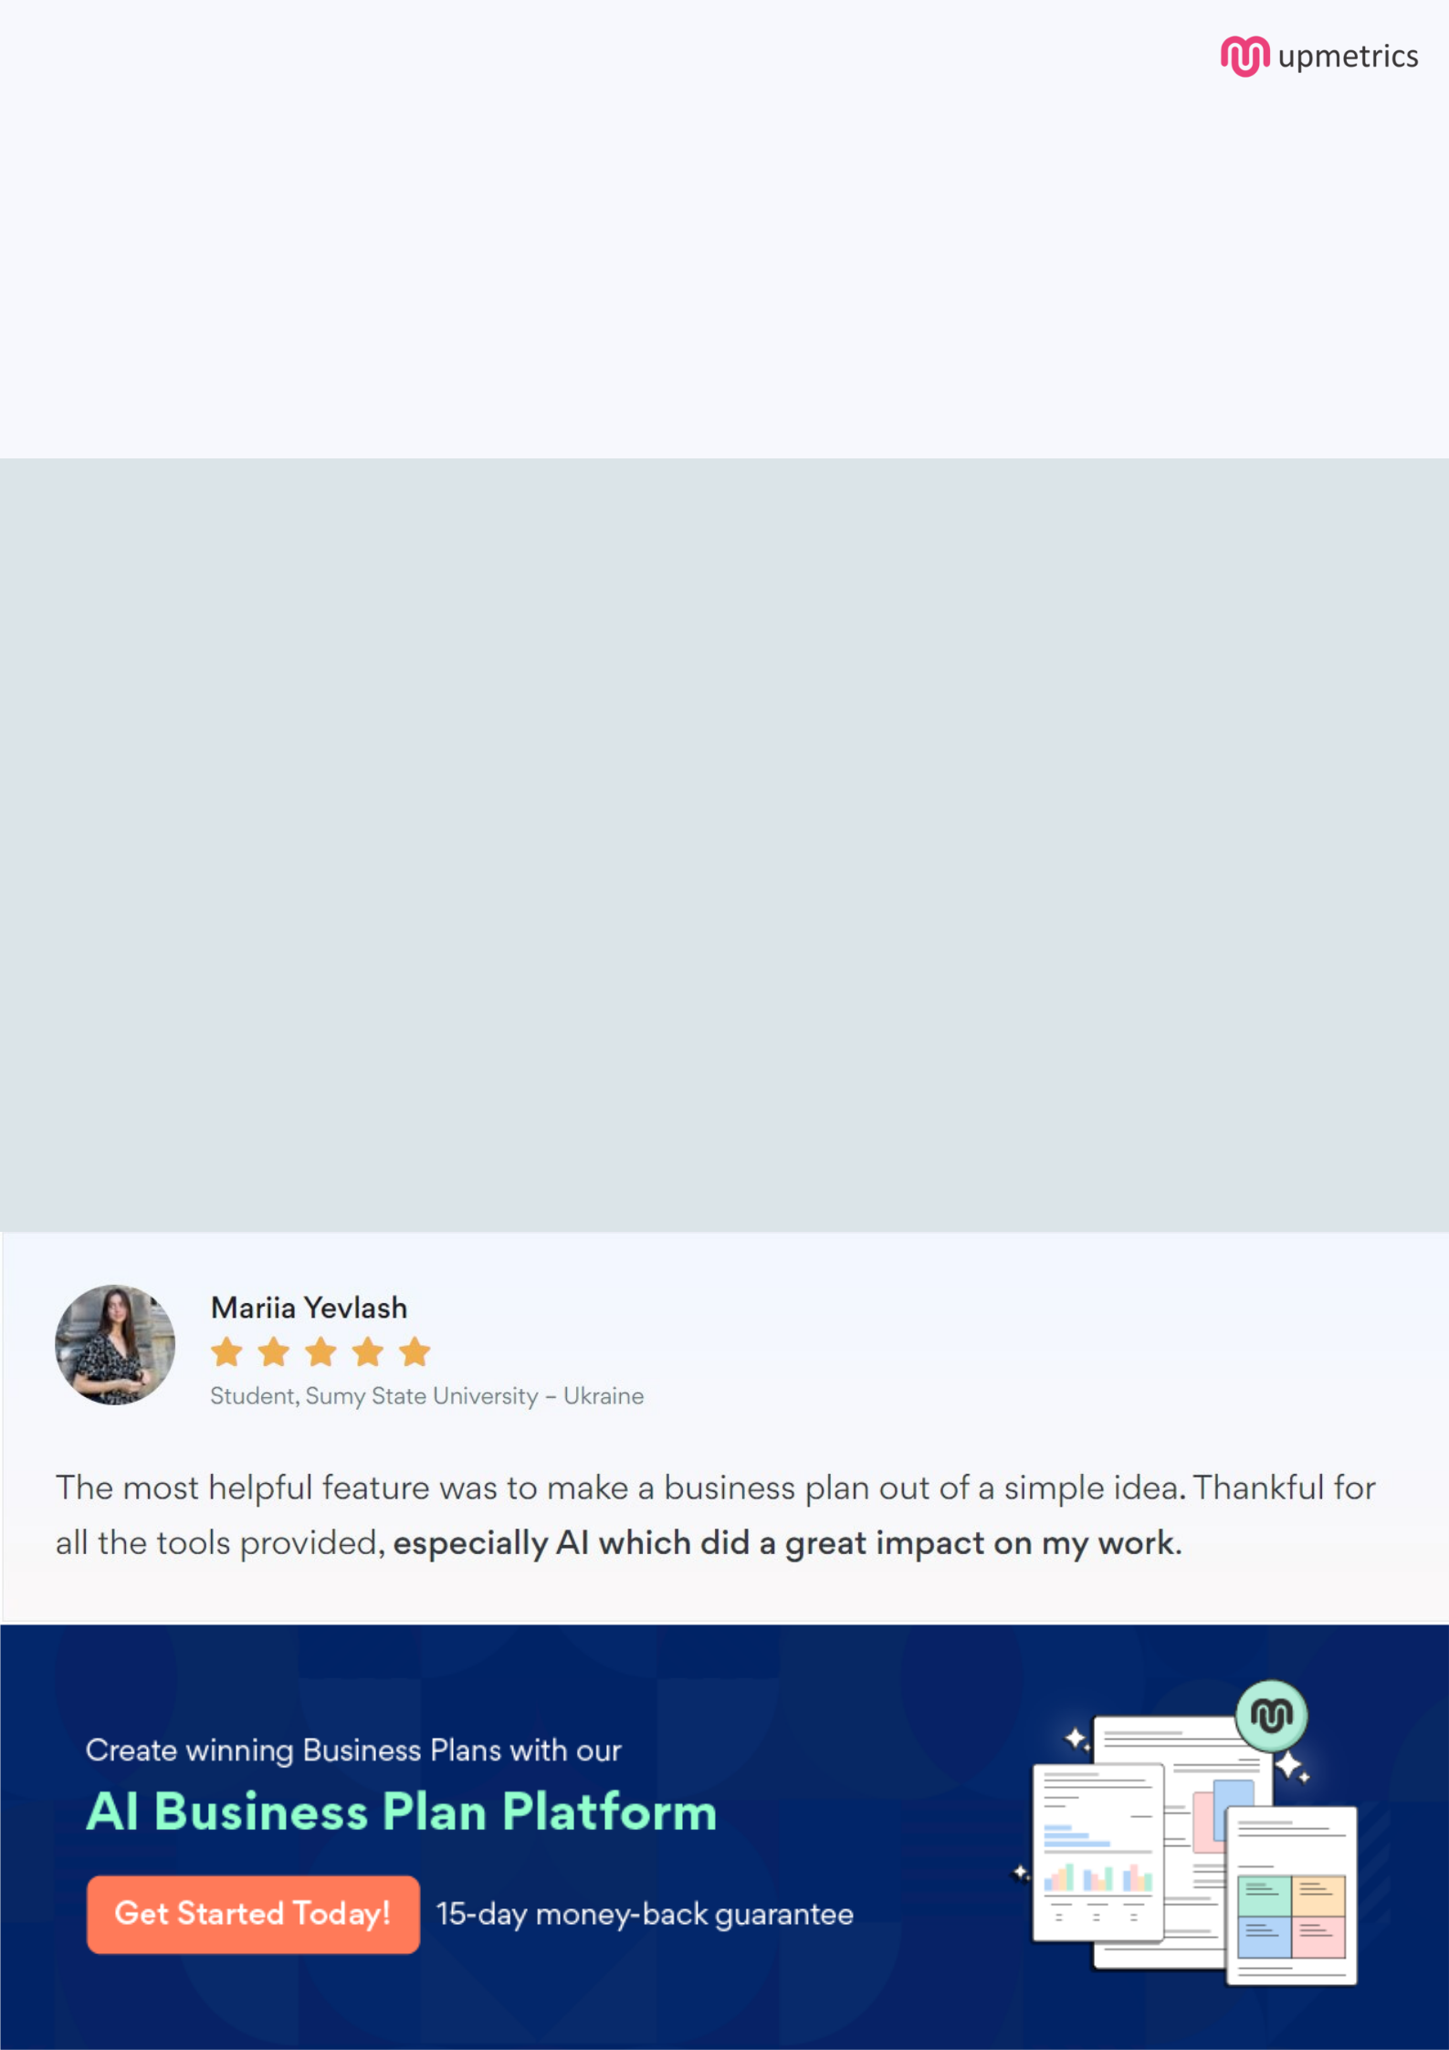
Create a winning business plan that gets you funded

Creating a stunning and investment-ready plan requires no writing, graphic designing, or financial planning expertise.

Upmetrics has all the features required to help you create a comprehensive business plan—from start to finish. Make no mistakes, it’s the modern way of planning to structure ideas, make plans, and create stunning pitch decks to awe investors.

Pitch decks that impress investors

Create pitch decks that provide a visual representation of your business, engage investors, and make them want to invest in your business idea.

Interactive plans in no time

Import business plan sections like—SWOT analysis, comparison tables, and others to create an interactive business plan. No designing skills are required.

Stunning cover page designs

With Upmetrics, you have the liberty to choose from multiple stunning cover page designs. Choose a creative design and make your plan stand out.

Online sharing made simple

Upmetrics makes online sharing quick and easier for users. Easily share your business plans with a link while tracking reader activity.

500+ sample business plans

Simply import a template from our library of sample plans into the editor and start customizing it to make it yours. It takes only a few clicks to get started.

Collaborate with team in real-time

Invite team members, initiate conversations, discuss ideas & strategies, share feedback, and work on a business plan in real-time.

