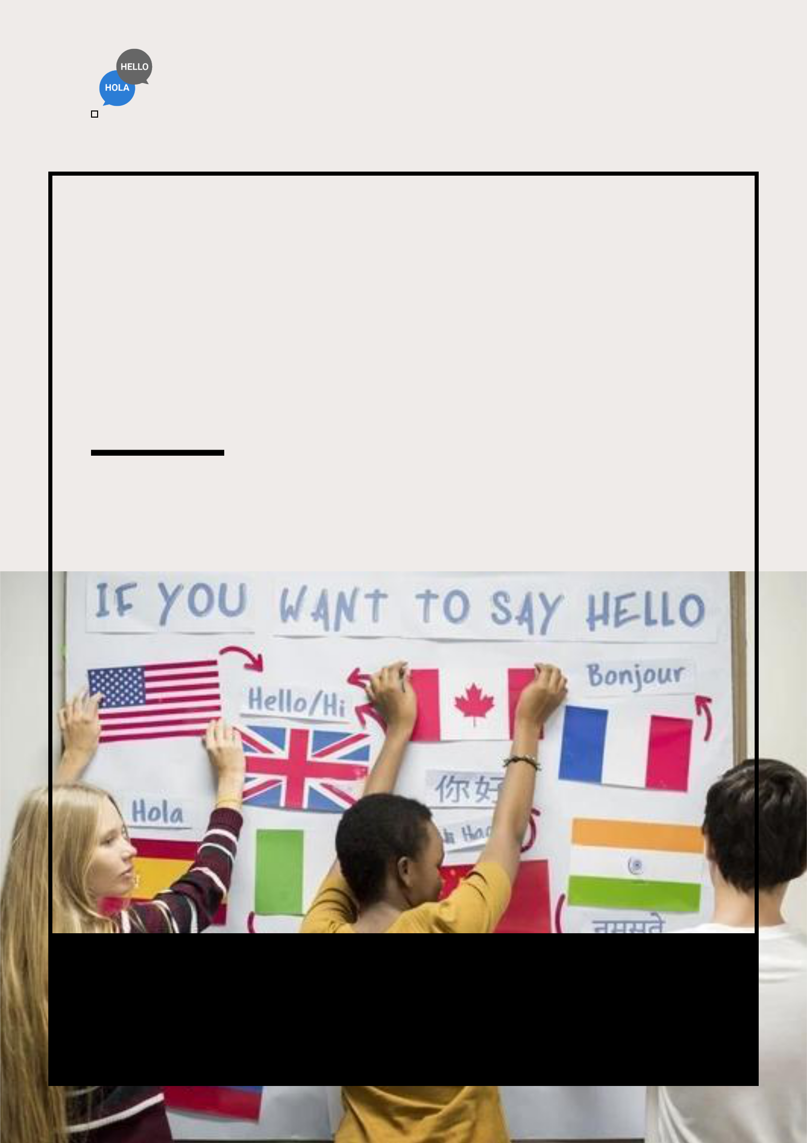
Language School Business Plan

BUSINESS PLAN

Learn, Speak, Flourish

Prepared By

John Doe

10200 Bolsa Ave, Westminster, CA, 92683

info@example.com

(650) 359-3153 http://www.example.com

Table of Contents

Executive Summary | 6
Market opportunity | 6
Services Offered | 6
Marketing & Sales Strategies | 7
Financial Highlights | 7
Units Sold v/s Revenue | 8

Company Overview | 9
Ownership | 9
Business Owners | 9
Mission statement | 10
Business history | 10
Future goals | 10

Market Analysis | 11
Target Market | 11
Market size and growth potential | 11
Market Size | 12
Competitive analysis | 12
Linguistic Leaders Academy | 12
Digital Dialects Online School | 13
Business Bridges Language Institute | 13
Market trends | 13
Regulatory environment | 14

Products and Services | 15
Program Offerings | 15
Beginner's Language Course | 15
Intermediate Language Course | 17
Advanced Language Course | 17
Business Language Module | 18
Online Learning Subscription | 18
Language Exchange Program | 19
Course Structure | 19
Café Menu | 19
Teaching Methodologies | 20
Additional Services | 20

Sales And Marketing Strategies | 21
Unique Selling Proposition (USP) | 21
Pricing Strategy | 21
Marketing strategies | 22
Online | 22
Offline | 22
Sales strategies | 23
Customer retention | 23

Operations Plan | 24
Staffing & Training | 24
Operational Process | 24
Equipment & Machinery | 25

Management Team | 26
Key managers | 26
John Doe | 27
Jane Doe | 28
Alice Brown | 28
Robert Brown | 28
Organizational structure | 29
Organization chart | 29
Compensation plan | 30
Advisors/Consultants | 30
[ADVISOR NAME] | 30
[CONSULTANT NAME] | 30
Financial Plan | 31
Profit & loss statement | 31
Cash flow statement | 34
Balance sheet | 36
Break-even Analysis | 38
Financing needs | 40
Appendix
Appendix | 42
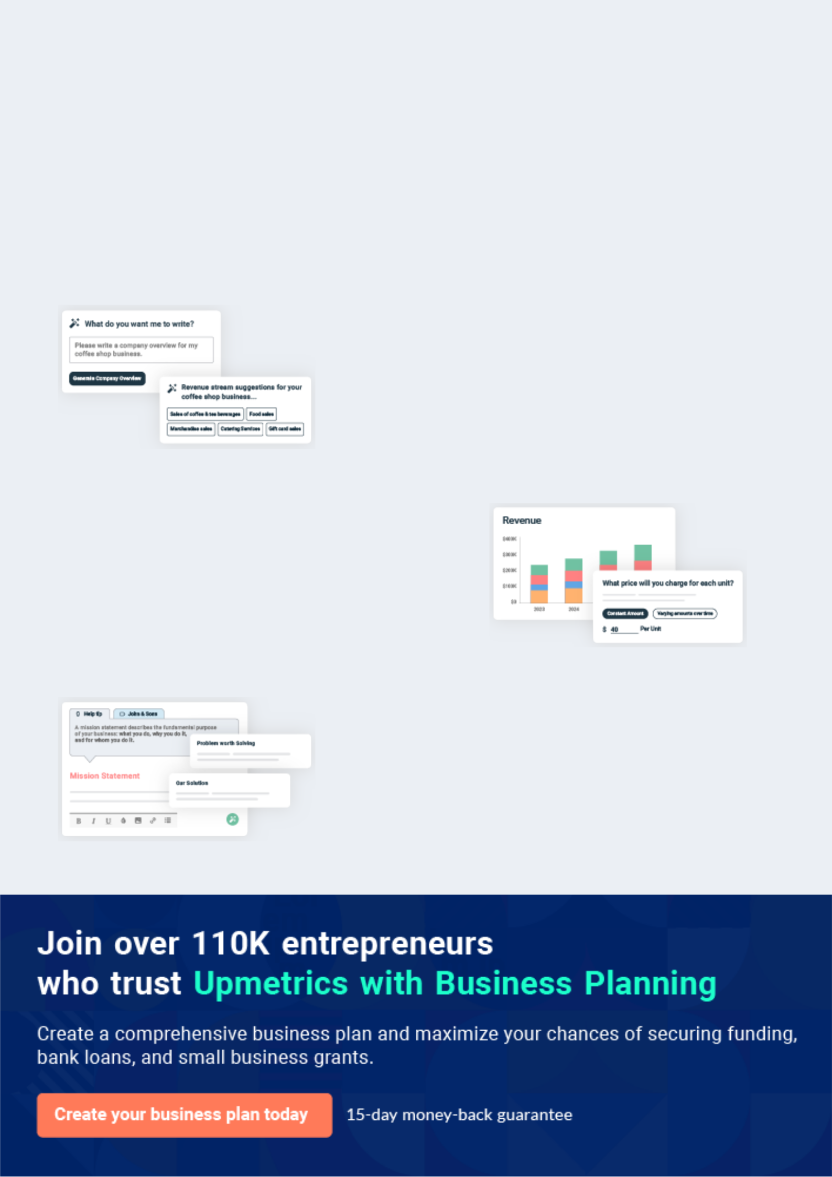
Business planning that’s simpler and faster than you think

Creating a business plan using Upmetrics to start and grow a business is literally the easiest thing in the World. Simply read the instructions and fill in the blanks. It’s as simple as that.

❛ | Upmetrics has everything you need to create a | ❜
❛ | comprehensive business plan. | ❜

AI-powered Upmetrics Assistant

AI-powered insights to streamline your plan

Not sure where to start? Upmetrics’ AI Assistant will automatically generate ideas for each section of your plan and offer improved versions of your writing, adjusting for tone, voice, and grammar or spelling errors.

Financial Forecasting Tool

All the financials are calculated for you

Forget the complex formulas and clumsy spreadsheets — with automatic financials and drag-and-drop forecasting, you can finish your plan faster and be confident that your numbers are accurate.

Business Plan Builder

Guides you like a business mentor

Upmetrics’ step-by-step instructions, prompts, and the library of 400+ sample business plans will guide you through each section of your plan as a business mentor.
Executive Summary


An executive summary is the first section of the business plan intended to provide an overview of the whole business plan.
To unlock help try Upmetrics! 

 Help tip  Language School Business Plan


Start your executive summary by briefly introducing your business to your readers.

This section may include the name of your language school business, its location, when it was
To unlock help try Upmetrics! 

Start writing here..

Market opportunity

 Help tip  Language School Business Plan

Summarize your market research, including market size, growth potential, and marketing trends. Highlight the opportunities in the market and how your business will fit in to fill the gap.
To unlock help try Upmetrics! 

Start writing here..

Services Offered

 Help tip  Language School Business Plan

Highlight the language school services you offer your clients. The USPs and differentiators you offer are always a plus.
To unlock help try Upmetrics! 

Start writing here..

Marketing & Sales Strategies
To unlock help try Upmetrics!

 Help tip  Language School Business Plan

Outline your sales and marketing strategies—what marketing platforms you use, how you plan on acquiring customers, etc.
To unlock help try Upmetrics! 

Start writing here..

Financial Highlights

 Help tip  Language School Business Plan

Briefly summarize your financial projections for the initial years of business operations. Include any capital or investment requirements, associated startup costs, projected revenues, and profit forecasts.



Start writing here..
Units Sold v/s Revenue

 |  | Units Sold | Revenue
15.00k
10.00k
5.00k
0
Year 1 | Year 2 | Year 3


Financial Year |  |  | Units Sold | Revenue
Year 1 | 1,550 |  |  | $10,000
Year 2 | 1,800 |  |  | $12,000
Year 3 | 2,050 |  |  | $14,000
 Help tip |  |  Language School Business Plan


Summarize your executive summary section with a clear CTA, for example, inviting angel investors to discuss the potential business investment.
To unlock help try Upmetrics! 

Write a call to action for your business plan.
Company Overview

Depending on what details of your business are essential, you’ll need different elements in your business overview.
To unlock help try Upmetrics! 

 Help tip  Language School Business Plan

Describe your business in this section by providing all the basic information:

Describe what kind of language school business you run and the name of it. You may specialize
To unlock help try Upmetrics! 

Start writing here..

Ownership

 Help tip  Language School Business Plan

List the names of your language school’s founders or owners. Describe what shares they own and their responsibilities for efficiently managing the business.
To unlock help try Upmetrics! 

Start writing here..

Business Owners



40% John Doe



40% Jane Doe



20% Alice Brown

Mission statement

 Help tip  Language School Business Plan

Summarize your business’ objective, core principles, and values in your mission statement. This statement needs to be memorable, clear, and brief.
To unlock help try Upmetrics! 

- At [Global Linguistics Academy], we transcend borders through the power of language. We are committed to fostering global communicators, equipped with linguistic prowess and cultural insights. Our dedication lies in bridging gaps, one word at a time. ❜

Business history

 Help tip  Language School Business Plan

If you’re an established language school business, briefly describe your business history, like— when it was founded, how it evolved over time, etc.
To unlock help try Upmetrics! 

Start writing here..

Future goals

 Help tip  Language School Business Plan

It’s crucial to convey your aspirations and vision. Mention your short-term and long-term goals; they can be specific targets for revenue, market share, or expanding your services.
To unlock help try Upmetrics! 

Start writing here..

Market Analysis
To unlock help try Upmetrics!


 |  | Market analysis provides a clear understanding of the market in which your
 |  | printing business will run along with the target market, competitors, and
 |  | growth opportunities.
 |  |  |  | To unlock help try Upmetrics! 
 Help tip |  |  Language School Business Plan

To write the introduction section of your market analysis, start by clearly identifying your primary target market.
To unlock help try Upmetrics! 

Start writing here..

Target Market

 Help tip  Language School Business Plan

Start this section by describing your target market. Define your ideal customer and explain what types of services they prefer. Creating a buyer persona will help you easily define your target market to your readers.



Start writing here..

Market size and growth potential

 Help tip  Language School Business Plan

Describe your market size and growth potential and whether you will target a niche or a much broader market.
To unlock help try Upmetrics! 

Start writing here..

Market Size

Available Market | 5B
Total potential market for language | 5B
education worldwide. | 5B
Served Market | 2B
Total market within the USA for | 2B
language education. | 2B
Target Market | 500M
Professionals, adults, and students in | 500M
the USA seeking tailored language | 500M

courses.

 Help tip  Language School Business Plan

Identify and analyze your direct and indirect competitors. Identify their strengths and weaknesses, and describe what differentiates your language school from them.
To unlock help try Upmetrics! 

Competitive analysis

Linguistic Leaders Academy

Established in [Year], the Linguistic Leaders Academy has burgeoned into a household name, known for its traditional classroom-style teachings coupled with online resources. Catering predominantly to [adult learners], they have centers in over [50 cities] across the USA.

Features | Strengths | Weaknesses
Extensive course catalog | Wide physical presence with a | Limited innovation in course
encompassing over [20 | legacy of [X years]. | delivery and teaching methods.
languages]. | Comprehensive language | E-learning platform often
On-site immersion programs in | offerings catering to diverse | criticized for being clunky and
select cities. | needs. | non-intuitive.
Proprietary e-learning platform | Strong brand recall due to | Higher price points compared to
with [mobile app integration]. | extensive marketing | newer market entrants.
Certification programs aligned | campaigns.
with [CEFR standards].

Digital Dialects Online School

A contemporary entrant, Digital Dialects, founded in [Year], is a purely online language learning platform. Their target demographic skews towards [young adults and professionals], providing flexible, self-paced modules.

Features

AI-powered lessons tailored to individual learner's pace.

Gamified learning experiences with badges, leaderboards, etc.

Collaborative features allowing peer-to-peer interactions.

Mobile app for on-the-go learning.

Strengths

Innovative use of technology making lessons engaging.

Innovative use of technology making lessons engaging. Affordability with a variety of subscription models.

Flexibility of learning anytime, anywhere.

Weaknesses

Absence of human touch; no real-time instructor-led sessions.

Limited to only [10 languages] currently.

Some critiques on the depth and rigor of advanced modules.

Business Bridges Language Institute

Carving a niche, Business Bridges, founded in [Year], exclusively serves corporate professionals. With a blend of online and offline offerings, their focus is on business language proficiency and etiquette.

Features Strengths Weaknesses

Tailored courses for industries like finance, IT, healthcare, etc.

Corporate workshops and seminars.

Virtual reality (VR) sessions for immersive business scenarios.

Networking events for learners.

Specialized content making it a go-to for professionals.

Strong ties with corporations for bulk enrollments.

Integration of modern tech like VR for unique experiences.

Narrow target market; not catering to general language enthusiasts.

Pricier than most competitors due to niche offerings.

Limited global cultural immersion opportunities.

Market trends

 Help tip  Language School Business Plan

Analyze emerging trends in the industry, such as technology disruptions, changes in customer behavior or preferences, etc. Explain how your business will cope with all the trends.
To unlock help try Upmetrics! 

Start writing here..

Regulatory environment
To unlock help try Upmetrics!

 Help tip  Language School Business Plan

List regulations and licensing requirements that may affect your language school business, such as business registration, education licensing & accreditation, compliance with consumer protection laws, health & safety regulations, etc.



Start writing here..
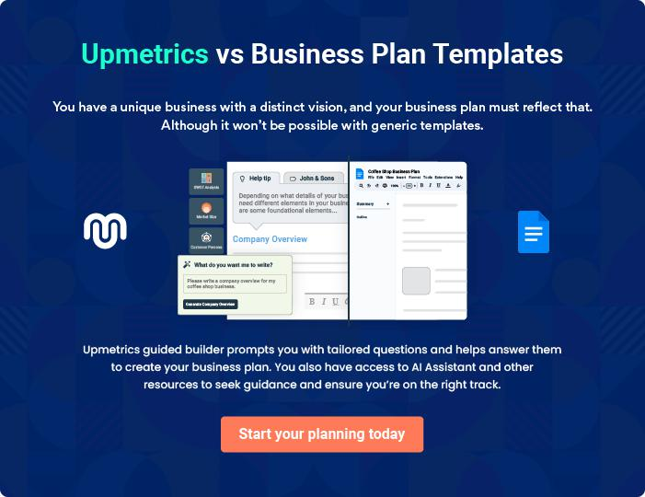
Products and Services
To unlock help try Upmetrics!

The product and services section of a language school business plan should describe the specific services and products that will be offered to customers. To write this section should include the following:



 Help tip  Language School Business Plan

To craft the introduction for your "Products and Services" chapter, begin by positioning your business within its industry, emphasizing its unique strengths or value proposition.
To unlock help try Upmetrics! 

Start writing here..

 Help tip


An overview of the languages taught and the competency levels they are geared towards (such as beginner, intermediate, and advanced) should be mentioned.
To unlock help try Upmetrics! 

Program Offerings

Beginner's Language Course


Price: [$500]

A comprehensive foundational course designed for individuals starting their linguistic journey. The program covers essential phrases, basic grammar, and introduces cultural nuances.
Specifications

- Duration: 8 weeks.

- Frequency: 3 classes per week.

- Class Size: Maximum of 15 students.

- Materials: Provided textbooks, audio samples, and workbook.

- Assessment: Bi-weekly tests and a final evaluation.
Intermediate Language Course

Price: [$650]

Building on foundational knowledge, this course delves into more complex grammatical structures, vocabulary expansion, and cultural immersion.

Specifications

- Duration: 10 weeks.

- Frequency: 4 classes per week.

- Class Size: Maximum of 12 students.

- Materials: Advanced textbooks, real-world audio samples, and interactive workbook.

- Assessment: Weekly quizzes, projects, and a comprehensive final exam.

Advanced Language Course

Price: [$750]

For those aiming for fluency, this program emphasizes nuanced language usage, idiomatic expressions, and in-depth cultural understanding.

Specifications

- Duration: 12 weeks.

- Frequency: 5 classes per week.

- Class Size: Maximum of 10 students.

- Materials: Expert-level textbooks, diverse audio-visual materials, and specialized workbook.

- Assessment: Continuous evaluations, oral presentations, and a proficiency final test.
Business Language Module

Price: [$300] (add-on module)

Tailored for corporate professionals, this module focuses on business jargon, corporate communication norms, and industry-specific vocabulary.

Specifications

- Duration: 4 weeks.

- Frequency: 2 classes per week.

- Class Size: Maximum of 8 students.

- Materials: Business-centric resources, case studies, and role-play scenarios.

- Assessment: Practical business simulations and a final presentation.

Online Learning Subscription

Price: [$25/month]

24/7 access to our digital learning platform, containing a plethora of video lessons, interactive exercises, and resources catering to diverse language levels.

Specifications

- Access: Unlimited.

- Materials: Video lessons, interactive quizzes, downloadable resources.

- Support: Online tutor support available on weekdays.

- Extras: Monthly webinars, guest lectures, and cultural deep dives.
Language Exchange Program

Price: [$150] for pairing and initial guidance.

A unique opportunity to pair with a native speaker for mutual linguistic and cultural exchange, enhancing real-world language usage and understanding.

Specifications

- Duration: Depends on paired individuals.

- Meetings: Recommended twice a week.

- Support: Initial guidance, monitoring, and feedback by our academy's experts.

- Materials: Suggested topics, scenarios, and guidelines for effective exchange.

Course Structure

 Help tip  Language School Business Plan


Discuss the balance between speaking, listening, reading, and writing. Emphasize any
specialized programs or modules you provide, like business language instruction, test
preparation, or conversational practice.
 |  |  |  | To unlock help try Upmetrics! 
Start writing here..
Café Menu
 Help tip |  |  Language School Business Plan

Mention the food and beverage services you will offer at your gaming cafe. Extensively list down the items on your food menu. This may include fries, burgers, cold drinks, coffee, etc.
To unlock help try Upmetrics! 

Start writing here..

Teaching Methodologies

 Help tip  Language School Business Plan

Describe how your teachers encourage student participation, engagement, and active learning.

Talk about any cutting-edge or technologically advanced teaching techniques, including
To unlock help try Upmetrics! 

Start writing here..

Additional Services

 Help tip  Language School Business Plan

Mention if your language school business offers any additional services. You may include services like access to language learning resources and materials, language competence tests, language exchange programs, practice conversations, online learning platforms, etc.
To unlock help try Upmetrics! 

Start writing here..
Sales And Marketing Strategies

Writing the sales and marketing strategies section means a list of strategies you will use to attract and retain your clients.
To unlock help try Upmetrics! 

 Help Tip  Language School Business Plan


To create an effective introduction for your "Sales and Marketing Strategies" chapter, start by setting the stage within your specific industry or market.
To unlock help try Upmetrics! 

Start writing here..

Unique Selling Proposition (USP)

 Help tip  Language School Business Plan

Define your business’s USPs depending on the market you serve, the equipment you use, and the unique services you provide. Identifying USPs will help you plan your marketing strategies.
To unlock help try Upmetrics! 

Start writing here..

Pricing Strategy

 Help tip  Language School Business Plan

Describe your pricing strategy—how you plan to price your services and stay competitive in the local market. You can mention any discounts you plan on offering to attract new customers.
To unlock help try Upmetrics! 

Start writing here..

 Help tip  Language School Business Plan
To unlock help try Upmetrics!

Discuss your marketing strategies to market your services. You may include some of these marketing strategies in your business plan—social media marketing, brochures, email marketing, content marketing, and print marketing.



Marketing strategies

Online


Social Media

Regular updates, success stories, and interactive language challenges on platforms like [Facebook, Instagram, and LinkedIn].

Email Marketing

Monthly newsletters, course announcements, and special offers delivered directly to our subscribers.

Content Marketing

Engaging blog posts and articles

on language learning tips, cultural

insights, and more

Offline

Brochures Print Marketing

Informative brochures available Advertisements in [local

both in digital format and at local newspapers, educational

educational institutions and magazines, and community

business hubs. bulletins].

 Help tip  Language School Business Plan

Outline the strategies you’ll implement to maximize your sales. Your sales strategies may include partnering with other businesses, offering referral programs, etc.
To unlock help try Upmetrics! 

Sales strategies

Partner with Businesses

Collaborating with [local businesses, universities, and cultural centers] to offer exclusive language workshops and seminars.

Referral Programs

Incentivizing our current students to refer friends and family, further expanding our student base.

 Help tip  Language School Business Plan

Describe your customer retention strategies and how you plan to execute them. For instance, introducing loyalty programs, discounts & offers, personalized service, etc.
To unlock help try Upmetrics! 

Customer retention

Loyalty Programs

Graduates are eligible for advanced courses at discounted rates, ensuring their linguistic journey continues.

Personalized Service

Regular Offers

Special discounts and exclusive access to workshops and seminars for our alumni.

Tailored course recommendations

based on individual progress and

feedback.

Operations Plan
To unlock help try Upmetrics!

 |  | When writing the operations plan section, it’s important to consider the
 |  | various aspects of your business operations.
 |  |  |  | To unlock help try Upmetrics! 
 Help tip |  |  Language School Business Plan


To create an effective introduction for your "Operational Plan" chapter, start by emphasizing the
pivotal role of efficient operations in the success of your business, underscoring how they
directly impact the quality of services delivered.
 |  |  |  | To unlock help try Upmetrics! 
Start writing here..
Staffing & Training
 Help tip |  |  Language School Business Plan

Mention your cleaning business’s staffing requirements, including the number of employees or
coaches needed. Include their qualifications, the training required, and the duties they will
perform.
 |  |  |  | To unlock help try Upmetrics! 
Start writing here..
Operational Process
 Help tip |  |  Language School Business Plan

Outline the processes and procedures you will use to run your language school business. Your operational processes may include curriculum development, class scheduling & enrolment, classroom management, etc.



Start writing here..

Equipment & Machinery
To unlock help try Upmetrics!

 Help tip  Language School Business Plan

Include the list of equipment and machinery required for language school, such as language learning software, classroom technology, computers & laptops, language lab equipment, textbooks & teaching materials, etc.



Start writing here..
Management Team

The management team section provides an overview of the individuals responsible for running your business plan.
To unlock help try Upmetrics! 

 Help tip  Language School Business Plan

To craft an introduction for your "Management Team" chapter, begin by emphasizing the crucial role of leadership in the success of any business.
To unlock help try Upmetrics! 

Start writing here..

Key managers

 Help tip  Language School Business Plan

Introduce your management and key members of your team, and explain their roles and responsibilities.
To unlock help try Upmetrics! 

Start writing here..

JOHN DOE

CEO - john.doe@example.com

John Doe is the visionary and driving force behind the [Global Linguistics Academy].

With a deep passion for bridging communication gaps globally, John established the academy with an aim to provide world-class linguistic education.


- Educational Background: John holds a Master's Degree in Linguistics from Harvard University and an MBA from Stanford Graduate School of Business.

- Professional Background: John spent over a decade in leadership roles at prominent language schools and EdTech firms, ensuring operational excellence and educational innovation.

JANE DOE

Operations Manager - jane.doe@example.com

As the Operations Manager, Jane streamlines administrative processes, manages academy logistics, and ensures the seamless daily operations of the institution.

Her methodical approach and attention to detail are vital in maintaining the academy's high operational standards.

- Educational Background: Jane graduated with a Bachelor's Degree in Business Administration from Yale University.

- Professional Background: Jane brings in over 15 years of operational experience, having managed operations for top-tier educational institutions and startups.


ALICE BROWN

Customer Service Manager - alice.brown@example.com

Alice is committed to ensuring a superior student experience.

She oversees all student relations, feedback mechanisms, and upholds service quality standards, making sure that each student feels valued and heard.

- Educational Background: Alice earned a Bachelor's in Communication Studies from the University of California, Los Angeles.

- Professional Background: Prior to joining the [Global Linguistics Academy], Alice served as a Customer Relations Head at a leading EdTech firm for over a decade.


ROBERT BROWN

Academic Manager - robert.brown@example.com

Entrusted with academic excellence, Robert leads curriculum development, instructor training, and the integration of cutting-edge educational technology.

He ensures that the academy remains at the forefront of modern linguistic education.

- Educational Background: Robert holds a Ph.D. in Linguistic Studies from Princeton University.

- Professional Background: Robert's expertise stems from 20 years in academic leadership roles across various esteemed institutions worldwide.
Organizational structure

 Help tip  Language School Business Plan

Explain the organizational structure of your management team. Include the reporting line and decision-making hierarchy.
To unlock help try Upmetrics! 

Start writing here..

Organization chart


John Doe

CEO


Alice Brown
Customer Service | Jane Doe |  | Robert Brown
Manager | Operations Manager |  | Academic Manager




Eva Green | William Black
Eva Green | Lead Curriculum
Lead Instructor | Lead Curriculum
Lead Instructor | Developer

Compensation plan

 Help tip  Language School Business Plan

Describe your compensation plan for the management and staff. Include their salaries, incentives, and other benefits.
To unlock help try Upmetrics! 

Start writing here..

 Help tip  Language School Business Plan

Mentioning advisors or consultants in your business plans adds credibility to your business idea.
To unlock help try Upmetrics! 

Advisors/Consultants


[ADVISOR NAME]

Advisor

A luminary in modern linguistic studies and former [position at a renowned institution], [Advisor Name]'s insights are invaluable to our curriculum development.


[CONSULTANT NAME]

Consultant

Specializing in educational technology integration, [Consultant Name] guides our adoption of cutting-edge teaching tools and platforms.
Financial Plan

When writing the financial plan section of a business plan, it’s important to provide a comprehensive overview of your financial projections for the first few years of your business, You may provide the following:
To unlock help try Upmetrics! 

 Help tip  Language School Business Plan


To create an effective introduction for your "Financial Plan" chapter, begin by stressing the critical role of a well-structured financial plan in the success of your venture.
To unlock help try Upmetrics! 

Start writing here..

 Help tip


Describe details such as projected revenue, operational costs, and service costs in your projected profit and loss statement. Make sure to include your business’s expected net profit or loss.
To unlock help try Upmetrics! 

Profit & loss statement

Revenue

Cost Of Sales

General Costs

Revenue Specific Costs

Personnel Costs (Direct

Labor)

Gross Margin

Gross Margin (%)

Operating Expense

Payroll Expense

(Indirect Labor)

General Expense

Bad Debt

Amortization of Current

Assets

2023-24 | 2024-25 | 2025-26 | 2026-27 | 2027-28
$0 | $0 | $0 | $0 | $0

$0 | $0 | $0 | $0 | $0
$0 | $0 | $0 | $0 | $0
$0 | $0 | $0 | $0 | $0
$0 | $0 | $0 | $0 | $0

$0 | $0 | $0 | $0 | $0
0% | 0% | 0% | 0% | 0%

$0 | $0 | $0 | $0 | $0
$0 | $0 | $0 | $0 | $0
$0 | $0 | $0 | $0 | $0
$0 | $0 | $0 | $0 | $0
$0 | $0 | $0 | $0 | $0

EBITDA

Additional Expense

Long Term

Depreciation

Gain or loss from Sale

of Assets

EBIT

Interest Expenses

EBT

Income Tax Expense

Total Expense

Net Income

Net Income (%)

2023-24 | 2024-25 | 2025-26 | 2026-27 | 2027-28
$0 | $0 | $0 | $0 | $0
$0 | $0 | $0 | $0 | $0
$0 | $0 | $0 | $0 | $0
$0 | $0 | $0 | $0 | $0
$0 | $0 | $0 | $0 | $0
$0 | $0 | $0 | $0 | $0
$0 | $0 | $0 | $0 | $0
$0 | $0 | $0 | $0 | $0
$0 | $0 | $0 | $0 | $0
$0 | $0 | $0 | $0 | $0
0% | 0% | 0% | 0% | 0%
 | 2023-24 | 2024-25 | 2025-26 | 2026-27 | 2027-28
Retained Earning | $0 | $0 | $0 | $0 | $0
Opening
Owner's Distribution | $0 | $0 | $0 | $0 | $0
Retained Earning | $0 | $0 | $0 | $0 | $0
Closing

 Help tip

The cash flow for the first few years of your operation should be estimated and described in this section. This may include billing invoices, payment receipts, loan payments, and any other cash flow statements.
To unlock help try Upmetrics! 

Cash flow statement

 | 2023-24 | 2024-25 | 2025-26 | 2026-27 | 2027-28
Cash Received | $0 | $0 | $0 | $0 | $0
Cash Paid | $0 | $0 | $0 | $0 | $0
COS & General Expenses | $0 | $0 | $0 | $0 | $0
Salary & Wages | $0 | $0 | $0 | $0 | $0
Interest | $0 | $0 | $0 | $0 | $0

Sales Tax

Income Tax

Net Cash From

Operations

Assets Sell

Assets Purchase

Net Cash From

Investments

Amount Received

Loan Received

Common Stock

Preferred Stock

Owner's Contribution

Amount Paid

2023-24 | 2024-25 | 2025-26 | 2026-27 | 2027-28
$0 | $0 | $0 | $0 | $0
$0 | $0 | $0 | $0 | $0
$0 | $0 | $0 | $0 | $0

$0 | $0 | $0 | $0 | $0
$0 | $0 | $0 | $0 | $0
$0 | $0 | $0 | $0 | $0

$0 | $0 | $0 | $0 | $0
$0 | $0 | $0 | $0 | $0

$0 | $0 | $0 | $0 | $0
$0 | $0 | $0 | $0 | $0
$0 | $0 | $0 | $0 | $0

Loan Capital $0 $0 $0 $0 $0

 | 2023-24 | 2024-25 | 2025-26 | 2026-27 | 2027-28
Dividends & Distributions | $0 | $0 | $0 | $0 | $0
Net Cash From | $0 | $0 | $0 | $0 | $0
Financing

Summary
Starting Cash | $0 | $0 | $0 | $0 | $0
Cash In | $0 | $0 | $0 | $0 | $0
Cash Out | $0 | $0 | $0 | $0 | $0
Change in Cash | $0 | $0 | $0 | $0 | $0
Ending Cash | $0 | $0 | $0 | $0 | $0

 Help tip

Create a projected balance sheet documenting your language school business’s assets, liabilities, and equity.

To unlock help try Upmetrics! 

Balance sheet

 | 2023-24 | 2024-25 | 2025-26 | 2026-27 | 2027-28
Assets | $0 | $0 | $0 | $0 | $0
Current Assets | $0 | $0 | $0 | $0 | $0
Cash | $0 | $0 | $0 | $0 | $0
Accounts Receivable | $0 | $0 | $0 | $0 | $0
Inventory | $0 | $0 | $0 | $0 | $0
Other Current Assets | $0 | $0 | $0 | $0 | $0
Long Term Assets | $0 | $0 | $0 | $0 | $0
Gross Long Term Assets | $0 | $0 | $0 | $0 | $0
Accumulated Depreciation | $0 | $0 | $0 | $0 | $0

Liabilities & Equity | $0 | $0 | $0 | $0 | $0
Liabilities | $0 | $0 | $0 | $0 | $0
Current Liabilities | $0 | $0 | $0 | $0 | $0
Accounts Payable | $0 | $0 | $0 | $0 | $0
Income Tax Payable | $0 | $0 | $0 | $0 | $0
Sales Tax Payable | $0 | $0 | $0 | $0 | $0
Short Term Debt | $0 | $0 | $0 | $0 | $0
 | 2023-24 | 2024-25 | 2025-26 | 2026-27 | 2027-28
Long Term Liabilities | $0 | $0 | $0 | $0 | $0
Long Term Debt | $0 | $0 | $0 | $0 | $0
Equity | $0 | $0 | $0 | $0 | $0
Paid-in Capital | $0 | $0 | $0 | $0 | $0
Common Stock | $0 | $0 | $0 | $0 | $0
Preferred Stock | $0 | $0 | $0 | $0 | $0
Owner's Contribution | $0 | $0 | $0 | $0 | $0
Retained Earnings | $0 | $0 | $0 | $0 | $0

Check | $0 |  |  | $0 | $0 | $0 | $0
 Help tip |  |  Language School Business Plan


Determine and mention your business’s break-even point—the point at which your business costs and revenue will be equal.

This exercise will help you understand how much revenue you need to generate to sustain or be profitable.
To unlock help try Upmetrics! 

Break-even Analysis

 | 2023-24 | 2024-25 | 2025-26 | 2026-27 | 2027-28
Starting Revenue | $0 | $0 | $0 | $0 | $0
Net Revenue | $0 | $0 | $0 | $0 | $0
Closing Revenue | $0 | $0 | $0 | $0 | $0

Starting Expense | $0 | $0 | $0 | $0 | $0
Net Expense | $0 | $0 | $0 | $0 | $0
Closing Expense | $0 | $0 | $0 | $0 | $0

Is Break Even? | 0 | 0 | 0 | 0 | 0
Break Even Month | 0 | 0 | 0 | 0 | 0
Days Required | 0 | 0 | 0 | 0 | 0
Break Even Revenue | $0 | $0 | $0 | $0 | $0
Break Even Units
Financing needs

 Help tip  Language School Business Plan

Calculate costs associated with starting a language school business, and estimate your financing needs and how much capital you need to raise to operate your business.
To unlock help try Upmetrics! 

Start writing here..
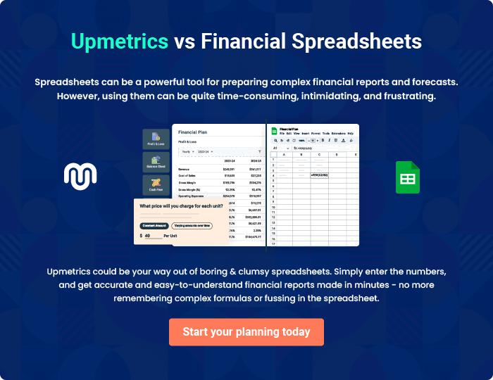
Appendix

When writing the appendix section, you should include any additional information that supports the main content of your plan. This may include financial statements, market research data, legal documents, and other
To unlock help try Upmetrics! 
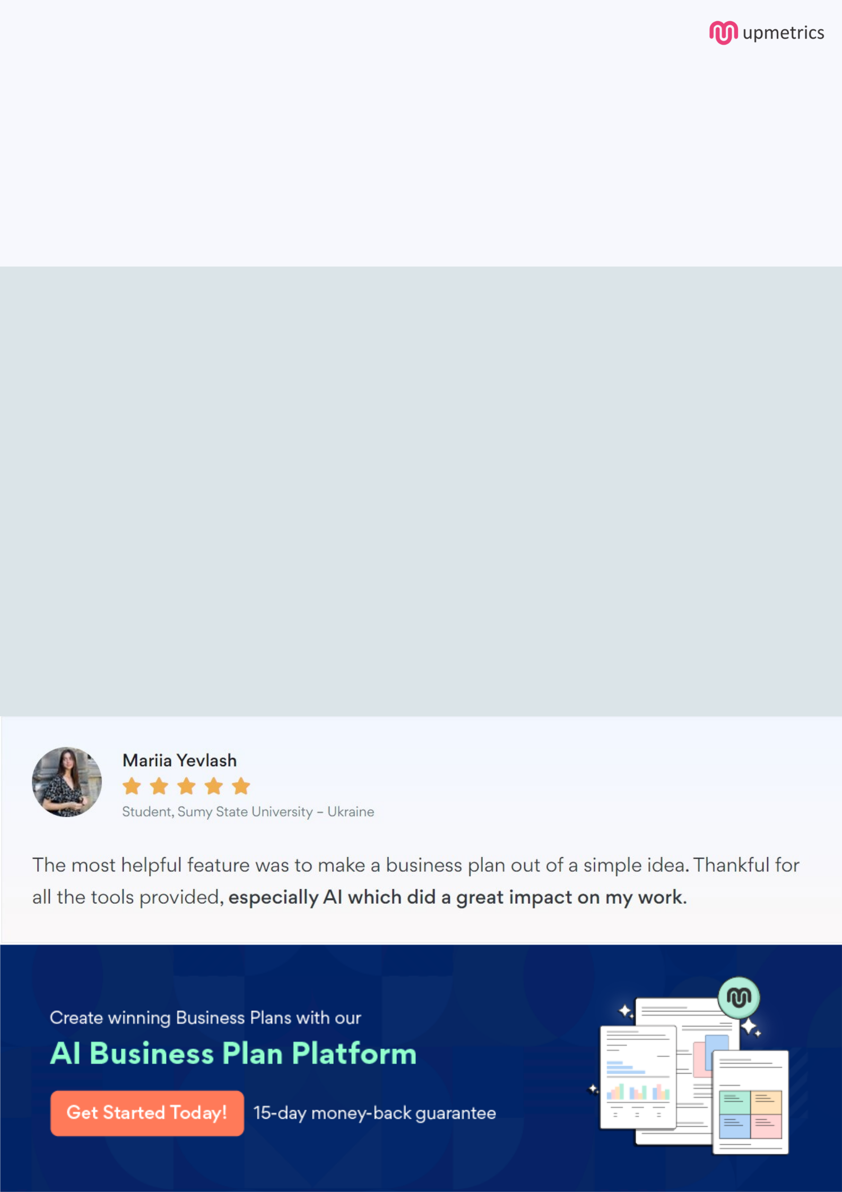
Create a winning business plan that gets you funded

Creating a stunning and investment-ready plan requires no writing, graphic designing, or financial planning expertise.

Upmetrics has all the features required to help you create a comprehensive business plan—from start to finish. Make no mistakes, it’s the modern way of planning to structure ideas, make plans, and create stunning pitch decks to awe investors.

Pitch decks that impress investors

Create pitch decks that provide a visual representation of your business, engage investors, and make them want to invest in your business idea.

Interactive plans in no time

Import business plan sections like—SWOT analysis, comparison tables, and others to create an interactive business plan. No designing skills are required.

Stunning cover page designs

With Upmetrics, you have the liberty to choose from multiple stunning cover page designs. Choose a creative design and make your plan stand out.

Online sharing made simple

Upmetrics makes online sharing quick and easier for users. Easily share your business plans with a link while tracking reader activity.

500+ sample business plans

Simply import a template from our library of sample plans into the editor and start customizing it to make it yours. It takes only a few clicks to get started.

Collaborate with team in real-time

Invite team members, initiate conversations, discuss ideas & strategies, share feedback, and work on a business plan in real-time.

