
IT Consulting Business Plan

BUSINESS PLAN

Navigating Tech, Guiding Success

Prepared By

John Doe

10200 Bolsa Ave, Westminster, CA, 92683

info@example.com

(650) 359-3153 http://www.example.com

Table of Contents

Executive Summary | 6
Market opportunity | 6
Services Offered | 6
Marketing & Sales Strategies | 7
Financial Highlights | 7
Units Sold v/s Revenue | 8

Company Overview | 9
Ownership | 9
Mission statement | 10
Business history | 10
Future goals | 11

Market Analysis | 12
Target Market | 12
Market size and growth potential | 12
Market Size | 13
Competitive analysis | 13
TechMasters Consulting Inc. | 14
NextGen IT Solutions | 14
Cloudburst Consulting Group | 15
Market trends | 15
Regulatory environment | 15

Products and Services | 17
Services | 17
IT Outsourcing and Vendor Management | 17
Digital Transformation Services | 18
IT Project Management | 18
Software Development & Integration | 19
IT Infrastructure Services | 19
Cloud Computing Services | 20
Partnerships & Alliances | 20
Additional Services | 20

Sales And Marketing Strategies | 21
Unique Selling Proposition (USP) | 21
Pricing Strategy | 21
Marketing strategies | 22
Online | 22
Offline | 22
Sales strategies | 23
Customer retention | 23

Operations Plan | 24
Staffing & Training | 24
Operational Process | 24
Quality Assurance | 25

Management Team | 26
Key managers | 26
John Doe | 27
Jane Doe | 27
Alice Brown | 28
Robert Brown | 29
Organizational structure | 29
Organization chart | 30
Compensation plan | 30
Advisors/Consultants | 31
Dr. Emily Thompson | 31
Mr. Raymond Clark | 31
Financial Plan
Financial Plan | 32

Profit & loss statement 32

Cash flow statement | 35
Balance sheet | 37
Break-even Analysis | 39
Financing needs | 41
Appendix
Appendix | 43
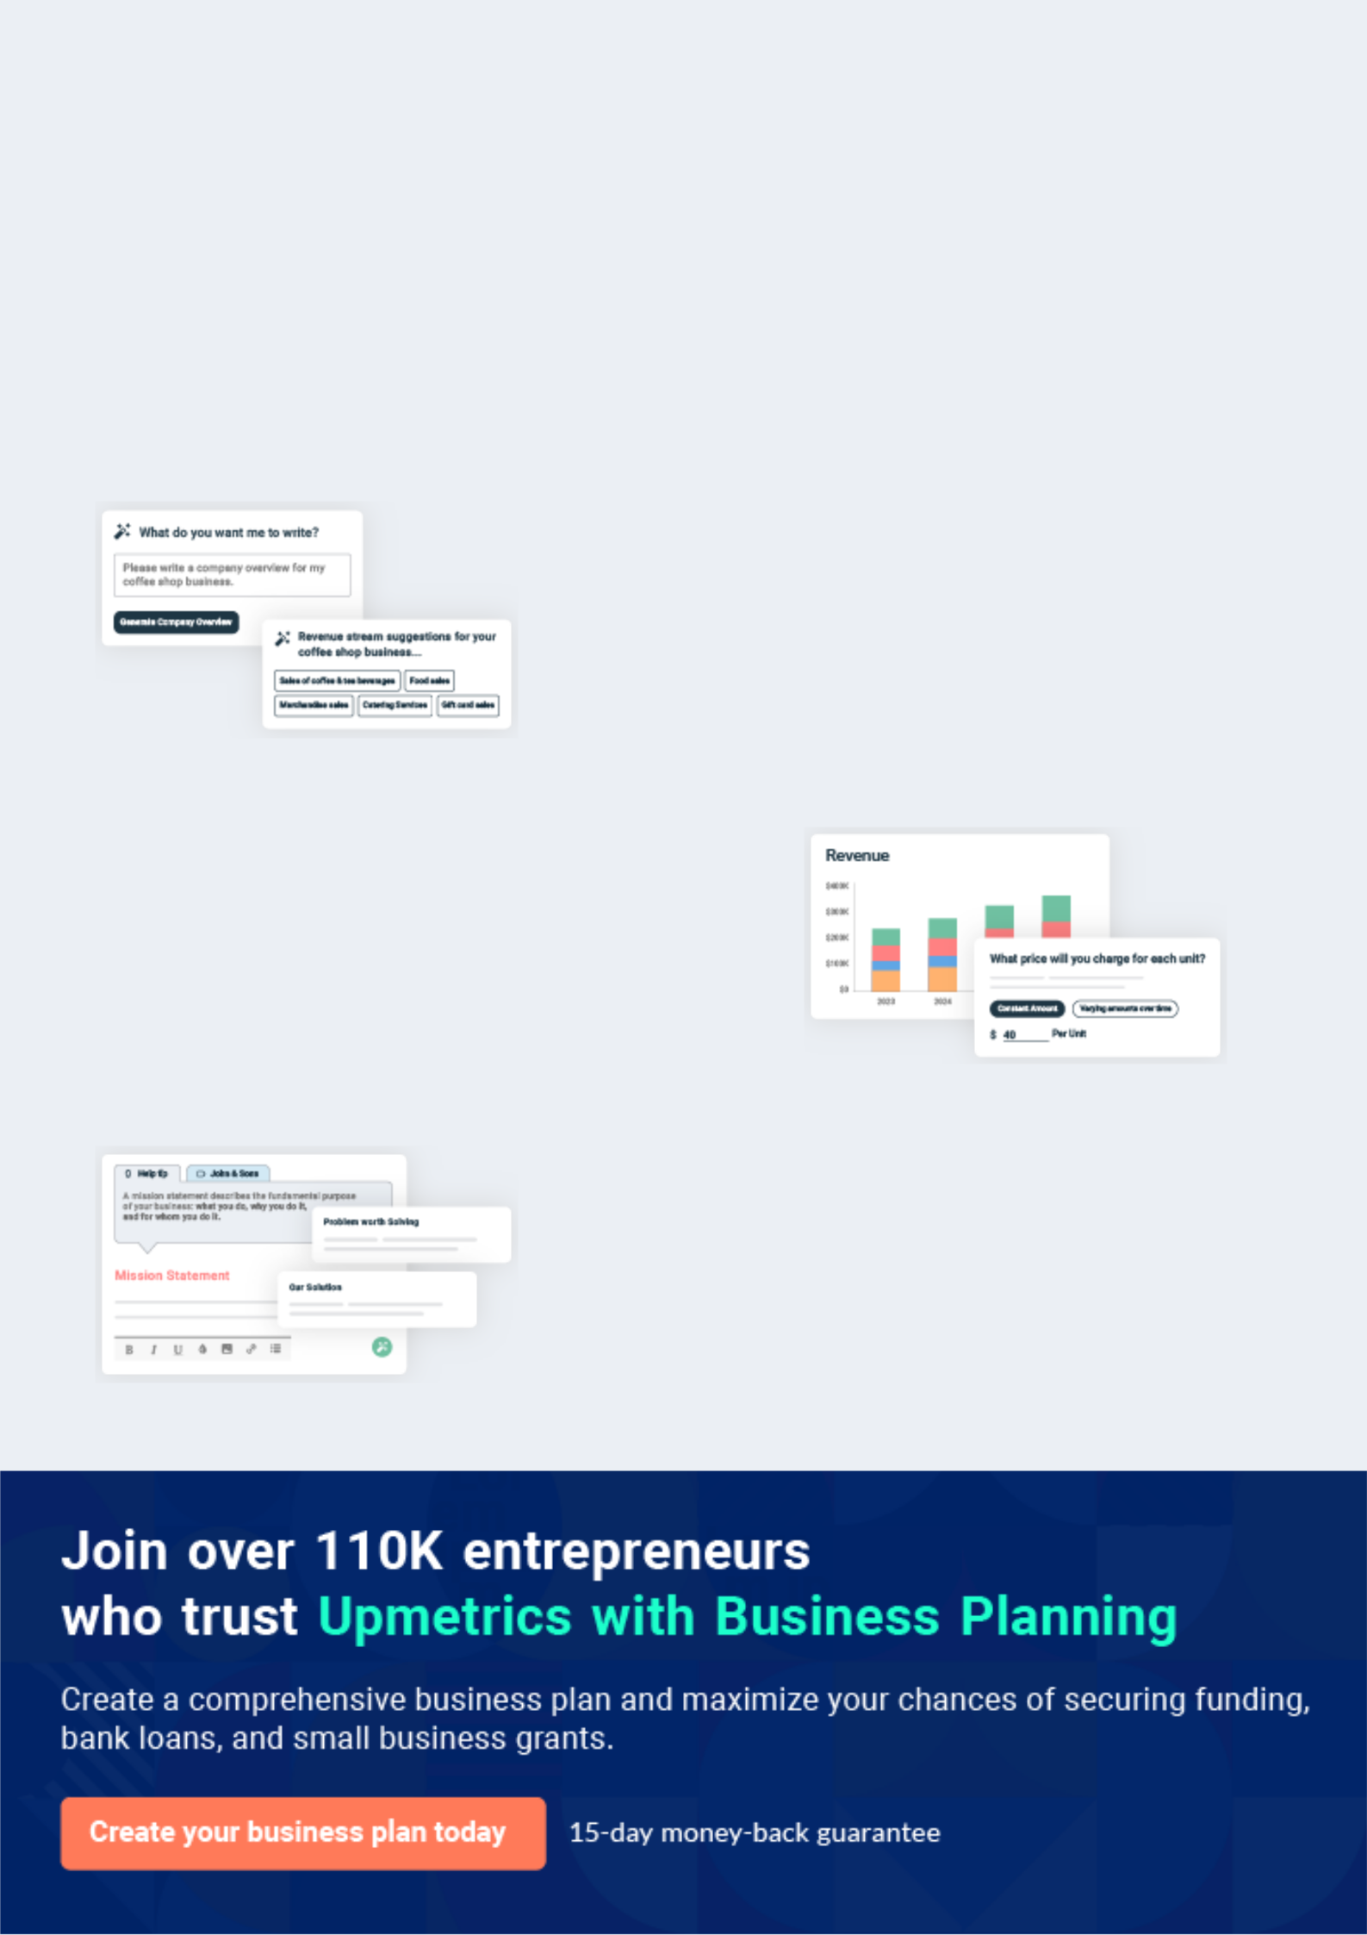
Business planning that’s simpler and faster than you think

Creating a business plan using Upmetrics to start and grow a business is literally the easiest thing in the World. Simply read the instructions and fill in the blanks. It’s as simple as that.

❛ | Upmetrics has everything you need to create a | ❜
❛ | comprehensive business plan. | ❜

AI-powered Upmetrics Assistant

AI-powered insights to streamline your plan

Not sure where to start? Upmetrics’ AI Assistant will automatically generate ideas for each section of your plan and offer improved versions of your writing, adjusting for tone, voice, and grammar or spelling errors.

Financial Forecasting Tool

All the financials are calculated for you

Forget the complex formulas and clumsy spreadsheets — with automatic financials and drag-and-drop forecasting, you can finish your plan faster and be confident that your numbers are accurate.

Business Plan Builder

Guides you like a business mentor

Upmetrics’ step-by-step instructions, prompts, and the library of 400+ sample business plans will guide you through each section of your plan as a business mentor.
Executive Summary


An executive summary is the first section of the business plan intended to provide an overview of the whole business plan.
To unlock help try Upmetrics! 

 Help tip  IT Consulting Business Plan


Start your executive summary section by briefly introducing your IT consulting business to your readers.
To unlock help try Upmetrics! 

Start writing here..

Market opportunity

 Help tip  IT Consulting Business Plan

Summarize your market research, including market size, growth potential, and marketing trends. Highlight the opportunities in the market and how your business will fit in to fill the gap.
To unlock help try Upmetrics! 

Start writing here..

Services Offered

 Help tip  IT Consulting Business Plan

Provide a description of the IT consulting services you provide to your clients. Include any additional or value-added services you offer that may differentiate you from the competition.
To unlock help try Upmetrics! 

Start writing here..

Marketing & Sales Strategies
To unlock help try Upmetrics!

 Help tip  IT Consulting Business Plan

Outline your sales and marketing strategies—what marketing platforms you use, how you plan on acquiring customers, etc.
To unlock help try Upmetrics! 

Start writing here..

Financial Highlights

 Help tip  IT Consulting Business Plan

Briefly summarize your financial projections for the initial years of business operations. Include any capital or investment requirements, associated startup costs, projected revenues, and profit forecasts.



Start writing here..
Units Sold v/s Revenue

 |  | Units Sold | Revenue
15.00k
10.00k
5.00k
0
Year 1 | Year 2 | Year 3


Financial Year |  |  | Units Sold | Revenue
Year 1 | 1,550 |  |  | $10,000
Year 2 | 1,800 |  |  | $12,000
Year 3 | 2,050 |  |  | $14,000
 Help tip |  |  IT Consulting Business Plan


Summarize your executive summary section with a clear CTA, for example, inviting angel investors to discuss the potential business investment.
To unlock help try Upmetrics! 

Write a call to action for your business plan.
Company Overview

Depending on what details of your business are essential, you’ll need different elements in your business overview.
To unlock help try Upmetrics! 

 Help tip  IT Consulting Business Plan

Describe your business in this section by providing all the basic information:

Describe what kind of IT consulting business you operate and the name of it. Here are some of
To unlock help try Upmetrics! 

Start writing here..

Ownership

 Help tip  IT Consulting Business Plan

List the names of the founders or owners of your company. Describe what shares they own and their responsibilities for efficiently managing the business.
To unlock help try Upmetrics! 

Start writing here..
Mission statement

 Help tip  IT Consulting Business Plan

Summarize your business’ objective, core principles, and values in your mission statement. This statement needs to be memorable, clear, and brief.
To unlock help try Upmetrics! 

❛ At [IT ProSolutions Consulting], our mission is to [empower businesses with cutting-edge IT solutions, ensuring growth, security, and innovation].

Rooted in our core principles of [integrity, excellence, and collaboration], we envision a world where technology is seamlessly integrated into every business facet, driving success and sustainability.

❜

Business history

 Help tip  IT Consulting Business Plan

If you’re an established IT consulting service provider, briefly describe your business history, like —when it was founded, how it evolved over time, etc.
To unlock help try Upmetrics! 

Start writing here..
Future goals

 Help tip  IT Consulting Business Plan

It’s crucial to convey your aspirations and vision. Mention your short-term and long-term goals; they can be specific targets for revenue, market share, or expanding your services.
To unlock help try Upmetrics! 

Start writing here..
Market Analysis
To unlock help try Upmetrics!


 |  | Market analysis provides a clear understanding of the market in which your
 |  | printing business will run along with the target market, competitors, and
 |  | growth opportunities.
 |  |  |  | To unlock help try Upmetrics! 
 Help tip |  |  IT Consulting Business Plan

To write the introduction section of your market analysis, start by clearly identifying your primary target market.
To unlock help try Upmetrics! 

Start writing here..

Target Market

 Help tip  IT Consulting Business Plan

Start this section by describing your target market. Define your ideal customer and explain what types of services they prefer. Creating a buyer persona will help you easily define your target market to your readers.



Start writing here..

Market size and growth potential

 Help tip  IT Consulting Business Plan

Describe your market size and growth potential and whether you will target a niche or a much broader market.
To unlock help try Upmetrics! 

Start writing here..

Market Size

Available Market

All businesses with an online presence 10M or IT infrastructure.

Served Market
Businesses actively seeking IT 2M consulting services.

Target Market
SMEs needing cloud, cybersecurity, and 500k IT strategy services.

 Help tip  IT Consulting Business Plan

Identify and analyze your direct and indirect competitors. Identify their strengths and weaknesses, and describe what differentiates your consulting services from them.
To unlock help try Upmetrics! 

Competitive analysis
TechMasters Consulting Inc.

Founded in [2005], TechMasters Consulting Inc. has established itself as a force to be reckoned with in the IT consulting domain.

With a presence in over [20 countries], they have serviced over [500 clients] and have specialized teams for different IT needs, ranging from cybersecurity to cloud migration.

Features

End-to-end cybersecurity consultation

Customized IT solutions for startups

Data management and analytics

Cloud infrastructure setup and migration

Strengths

Global Presence: Their vast network allows them to cater to a diverse clientele across different regions

Specialized Teams: Having dedicated teams for distinct IT needs ensures expertise in each domain.

Extensive Experience: With over [15 years] in the industry, they have a wealth of experience to draw upon.

Weaknesses

Less Personalized Service: Given their vast client base, there have been concerns about less personalized solutions.

Higher Pricing: Their services come at a premium, which might be out of reach for some smaller businesses.

NextGen IT Solutions

NextGen IT Solutions, founded in [2010], focuses heavily on integrating the latest technologies into their consultation services.

They have been at the forefront of advocating and implementing AI-driven IT solutions and have a stronghold in the [North American] market.

Features

AI-driven data analytics consultation

Digital transformation strategies

IT project management

Tech-driven business process optimization

Strengths

Innovation-Centric: Their focus on emerging technologies ensures their solutions are cutting-edge.

Robust Training Programs: They invest heavily in training their consultants, ensuring up-to-date expertise.

Weaknesses

Limited Global Reach: Primarily centered in North America, they lack a widespread global presence.

Niche Focus: Their heavy emphasis on AI might alienate potential clients seeking more traditional IT solutions.

Cloudburst Consulting Group
To unlock help try Upmetrics!

Cloudburst Consulting Group, established in [2015], specializes exclusively in cloud computing solutions.

With partnerships with major cloud service providers, they have quickly risen through the ranks in the IT consulting hierarchy.

Features

Cloud migration strategies

Multi-cloud management solutions

Cloud security and risk management

Custom cloud infrastructure design

Strengths

Deep Specialization: Their sole focus on cloud solutions ensures unparalleled expertise in that domain.

Strong Partnerships: Collaborations with major cloud service providers give them an edge in delivering top-tier solutions.

Weaknesses

Limited Service Range: Their exclusive focus on cloud solutions might deter potential clients seeking a broader range of IT services.

Younger in the Industry: With just over [8 years] in the market, they might lack the extensive experience of older firms.

Market trends

 Help tip  IT Consulting Business Plan

Analyse emerging trends in the industry, such as technology disruptions, changes in customer behavior or preferences, etc. Explain how your business will cope with these trends.
To unlock help try Upmetrics! 

Start writing here..

Regulatory environment

 Help tip  IT Consulting Business Plan

List regulations and licensing requirements that may affect your IT consulting company, such as business registration, professional licenses, data privacy and security regulations, local business regulations, etc.



Start writing here..

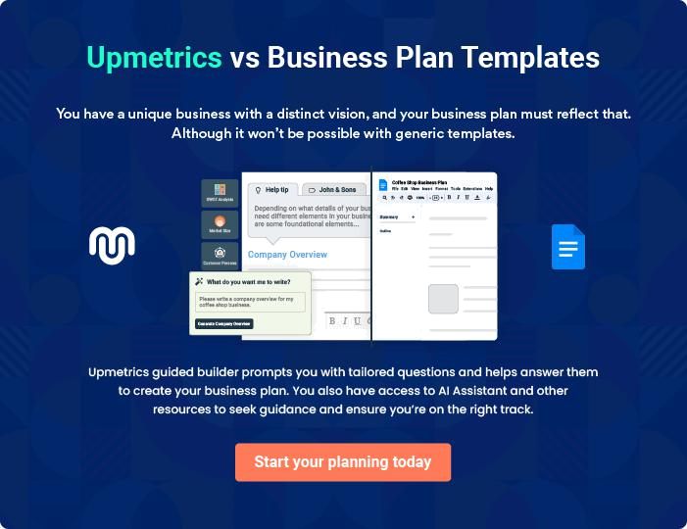
Products and Services
To unlock help try Upmetrics!

The product and services section of an IT consulting business plan should describe the specific services and products that will be offered to customers. To write this section should include the following:



 Help tip  IT Consulting Business Plan

To craft the introduction for your "Products and Services" chapter, begin by positioning your business within its industry, emphasizing its unique strengths or value proposition.
To unlock help try Upmetrics! 

Start writing here..

 Help tip


Mention the consulting services your business will offer. This list may include services like,

• IT outsourcing and vendor management
To unlock help try Upmetrics! 

Services

IT Outsourcing and Vendor Management
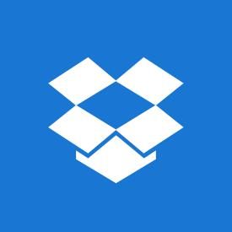

Price: $[5,000] per month

Streamlined IT operations with optimal vendor performance oversight, tailored to business-specific requirements.

Specifications

- Vendor matching through [ABC Analysis]

- Performance tracking using [XYZ Benchmarking]

- Monthly vendor performance reports

- Cost optimization strategies
Digital Transformation Services

Price: $[7,500] per project

Modernizing and innovating business processes to enhance competitiveness in the digital realm.

Specifications

- Use of tools like [AI Analytics] and [Machine Learning]

- Implementation of [Latest Digital Tools]

- End-to-end project management

- Post-project support for [3 months]

IT Project Management

Price: $[4,000] per project

Comprehensive oversight of IT projects ensuring timely completion, adherence to budget, and desired outcomes.

Specifications

- Methodologies: [Agile and Scrum]

- Tools: [MS Project, Trello]

- Weekly progress reporting

- Risk management and mitigation
Software Development & Integration

Price: Starting at $[10,000] (Varies based on project complexity)

Custom software solutions and integration, tailored to unique business needs.

Specifications

- Technologies: [Java, Python, .NET]

- Seamless [API Integration Methods]

- Quality assurance testing

- Post-launch support and updates for [6 months]

IT Infrastructure Services

Price: $[6,500] per month

Robust IT backbone development and maintenance to support evolving business demands.

Specifications

- Tools: [Network Analysis Tools, Infrastructure Monitoring]

- On-site and remote support options

- Periodic infrastructure assessment

- Scalable solutions to match growth
Cloud Computing Services
- To unlock help try Upmetrics!

Price: $[4,500] per month

Comprehensive cloud solutions including migration strategies and daily management.

Specifications

- Platforms: [AWS, Google Cloud, Azure]

- Security and backup solutions

- Monthly performance analytics

- 24/7 support

Partnerships & Alliances

 Help tip  IT Consulting Business Plan

Mention any strategic partnerships or alliances your business has with other companies or vendors to deliver your services efficiently.
To unlock help try Upmetrics! 

Start writing here..

Additional Services

 Help tip  IT Consulting Business Plan

Mention if your IT consulting company offers any additional services. You may include services like IT staff augmentation, BPO services, IT audits and assignments, and IT vendor management.



Start writing here..

Sales And Marketing Strategies
To unlock help try Upmetrics!

Writing the sales and marketing strategies section means a list of strategies you will use to attract and retain your clients.
To unlock help try Upmetrics! 

 Help Tip  IT Consulting Business Plan


To create an effective introduction for your "Sales and Marketing Strategies" chapter, start by setting the stage within your specific industry or market.
To unlock help try Upmetrics! 

Start writing here..

Unique Selling Proposition (USP)

 Help tip  IT Consulting Business Plan

Define your business’s USPs depending on the market you serve and the unique consulting services you provide. Identifying USPs will help you to plan your marketing strategies.
To unlock help try Upmetrics! 

Start writing here..

Pricing Strategy

 Help tip  IT Consulting Business Plan

Describe your pricing strategy—how you plan to price your consulting services and stay competitive in the local market. You can mention any discounts you plan on offering to attract new clients to your IT consulting service.



Start writing here..

 Help tip  IT Consulting Business Plan
To unlock help try Upmetrics!

Discuss your marketing strategies to market your services. You may include some of these marketing strategies in your business plan—SEO content marketing, social media marketing, Google ads, brochures, email marketing, and print marketing.



Marketing strategies

Online


Social Media

Active engagement on platforms like LinkedIn, Twitter, and Facebook, sharing case studies, testimonials, and industry insights.

Content Marketing

Crafting high-quality, relevant content to improve organic search rankings and draw potential clients to our website.

Email Marketing

Sending out monthly newsletters, updates, and exclusive offers to our mailing list.

Google Ads

Running targeted campaigns to attract businesses actively seeking IT consulting services.

Offline

Brochures & Print Marketing

Creating visually appealing and information-rich brochures for distribution at industry events and corporate meetings.

 Help tip  IT Consulting Business Plan
To unlock help try Upmetrics!

Outline your strategies to sell your IT consulting services. Your sales strategies may include direct sales calls, partnering with other companies and vendors, lead generation practices, prospecting, and closing deals.



Sales strategies

Partner with Businesses

Collaborating with industry peers, vendors, and tech companies to tap into a wider client base.

Lead Generation

Utilizing tools like [LeadGen Tool] and participating in industry forums to identify potential leads.

Prospecting & Closing Sales Training

Adopting a consultative selling approach, understanding client needs thoroughly before proposing solutions.

Regular workshops, conducted every [quarter], to equip our sales team with the latest industry insights and selling techniques.

 Help tip  IT Consulting Business Plan

Describe your customer relationship management process, including necessary information like your customer retention strategies, communication plans, and client feedback procedure.
To unlock help try Upmetrics! 

Customer retention

Retention Strategies

Offering periodic IT audits, feedback sessions, and exclusive offers for retained clients.

Feedback Procedure

Adopting a 360-degree feedback mechanism, encouraging clients to provide feedback after project completion.

Communication Plans

Regular check-ins, quarterly reviews, and an open line of communication ensure clients are always in the loop.

Operations Plan

 |  | When writing the operations plan section, it’s important to consider the
 |  | various aspects of your business operations.
 |  |  |  | To unlock help try Upmetrics! 
 Help tip |  |  IT Consulting Business Plan


To create an effective introduction for your "Operational Plan" chapter, start by emphasizing the
pivotal role of efficient operations in the success of your business, underscoring how they
directly impact the quality of services delivered.
 |  |  |  | To unlock help try Upmetrics! 
Start writing here..
Staffing & Training
 Help tip |  |  IT Consulting Business Plan

Mention your consulting business’s staffing requirements, including the number of employees needed, such as IT consultants, project managers, administrative staff, etc.
To unlock help try Upmetrics! 

Start writing here..

Operational Process

 Help tip  IT Consulting Business Plan

Outline the processes and procedures you will use to run your IT consulting business.

Your operational processes may include customer relationship management, project
To unlock help try Upmetrics! 

Start writing here..

Quality Assurance

 Help tip  IT Consulting Business Plan

Describe how you ensure the quality and reliability of your IT consulting services. This may involve conducting quality checks, addressing client feedback, validating solutions, and continuously improving service delivery processes to exceed client expectations.
To unlock help try Upmetrics! 

Start writing here..
Management Team

The management team section provides an overview of the individuals responsible for running your business plan.
To unlock help try Upmetrics! 

 Help tip  IT Consulting Business Plan

To craft an introduction for your "Management Team" chapter, begin by emphasizing the crucial role of leadership in the success of any business.
To unlock help try Upmetrics! 

Start writing here..

Key managers

 Help tip  IT Consulting Business Plan

Introduce your management and key members of your team, and explain their roles and responsibilities.
To unlock help try Upmetrics! 

Start writing here..

JOHN DOE

CEO - john.doe@example.com

John is the driving force behind [IT ProSolutions Consulting].

With over 15 years of experience in IT consultancy and business management, he brings a wealth of knowledge and leadership to the team.


John's visionary approach has been pivotal in shaping the company's strategic direction and operational excellence.

- Educational Background:

  - MBA from Harvard Business School

  - Bachelor's in Computer Science from MIT

- Professional Background:

  - Senior IT Consultant at TechElite Solutions for 7 years

  - IT Project Manager at GlobalTech Innovations for 4 years


JANE DOE

CTO - jane.doe@example.com

Jane possesses a sharp technical acumen and an innate ability to stay abreast of the latest IT trends.

She oversees the technological trajectory of the company, ensuring the adoption of cutting-edge tools and methodologies.

- Educational Background:

  - Master's in Information Systems from Stanford University

  - Bachelor's in Software Engineering from Caltech

- Professional Background:

  - Lead Software Developer at NetTech Solutions for 5 years

  - IT Systems Analyst at SoftForge Inc. for 3 years

ALICE BROWN

Director of Business Development - alice.brown@example.com

Alice is an adept strategist, spearheading the company's business development initiatives.

Her analytical skills and industry connections have been instrumental in acquiring high-profile clients and expanding the company's market reach.

- Educational Background:

  - MBA from Wharton School of Business

  - Bachelor's in Marketing from UCLA

- Professional Background:

  - Business Development Manager at ConnectTech Industries for 6 years

  - Market Analyst at Insightful Corp. for 4 years

ROBERT BROWN

Head of Client Services - robert.brown@example.com

Robert ensures impeccable service delivery and client satisfaction.

His interpersonal skills and client-centric approach have resulted in maintaining long-term relationships and generating repeat business.

- Educational Background:

  - Master's in Client Relations from Duke University

  - Bachelor's in Communication from Boston University

- Professional Background:

  - Client Services Manager at ServeTech Solutions for 6 years

  - Relationship Manager at ClientFirst Corp. for 5 years

Organizational structure

 Help tip  IT Consulting Business Plan

Explain the organizational structure of your management team. Include the reporting line and decision-making hierarchy.
To unlock help try Upmetrics! 

Start writing here..
Organization chart


John Doe

CEO


Alice Brown |  |  | Robert Brown
Director of Business | Jane Doe |  | Head of Client
Development | CTO |  | Services




Paul Black

Emily Grey

Lead Developer

IT Consultant

Compensation plan

 Help tip  IT Consulting Business Plan

Describe your compensation plan for the management and staff. Include their salaries, incentives, and other benefits.
To unlock help try Upmetrics! 

Start writing here..

 Help tip

Mentioning advisors or consultants in your business plans adds credibility to your business idea.
To unlock help try Upmetrics! 

Advisors/Consultants


DR. EMILY THOMPSON

Advisor

A seasoned IT consultant with over [XX] years in the industry, Dr. Thompson acts as an advisor, guiding our strategic direction.


MR. RAYMOND CLARK

Consultant

With a rich history in business development in the IT sector, Mr. Clark offers invaluable advice on market expansion and client acquisition.
Financial Plan

When writing the financial plan section of a business plan, it’s important to provide a comprehensive overview of your financial projections for the first few years of your business, You may provide the following:
To unlock help try Upmetrics! 

 Help tip  IT Consulting Business Plan


To create an effective introduction for your "Financial Plan" chapter, begin by stressing the critical role of a well-structured financial plan in the success of your venture.
To unlock help try Upmetrics! 

Start writing here..

 Help tip


Describe details such as projected revenue, operational costs, and service costs in your projected profit and loss statement. Make sure to include your business’s expected net profit or loss.
To unlock help try Upmetrics! 

Profit & loss statement

Revenue

Cost Of Sales

General Costs

Revenue Specific Costs

Personnel Costs (Direct

Labor)

Gross Margin

Gross Margin (%)

Operating Expense

Payroll Expense

(Indirect Labor)

General Expense

Bad Debt

Amortization of Current

Assets

2023-24 | 2024-25 | 2025-26 | 2026-27 | 2027-28
$0 | $0 | $0 | $0 | $0

$0 | $0 | $0 | $0 | $0
$0 | $0 | $0 | $0 | $0
$0 | $0 | $0 | $0 | $0
$0 | $0 | $0 | $0 | $0

$0 | $0 | $0 | $0 | $0
0% | 0% | 0% | 0% | 0%

$0 | $0 | $0 | $0 | $0
$0 | $0 | $0 | $0 | $0
$0 | $0 | $0 | $0 | $0
$0 | $0 | $0 | $0 | $0
$0 | $0 | $0 | $0 | $0

EBITDA

Additional Expense

Long Term

Depreciation

Gain or loss from Sale

of Assets

EBIT

Interest Expenses

EBT

Income Tax Expense

Total Expense

Net Income

Net Income (%)

2023-24 | 2024-25 | 2025-26 | 2026-27 | 2027-28
$0 | $0 | $0 | $0 | $0
$0 | $0 | $0 | $0 | $0
$0 | $0 | $0 | $0 | $0
$0 | $0 | $0 | $0 | $0
$0 | $0 | $0 | $0 | $0
$0 | $0 | $0 | $0 | $0
$0 | $0 | $0 | $0 | $0
$0 | $0 | $0 | $0 | $0
$0 | $0 | $0 | $0 | $0
$0 | $0 | $0 | $0 | $0
0% | 0% | 0% | 0% | 0%
 | 2023-24 | 2024-25 | 2025-26 | 2026-27 | 2027-28
Retained Earning | $0 | $0 | $0 | $0 | $0
Opening
Owner's Distribution | $0 | $0 | $0 | $0 | $0
Retained Earning | $0 | $0 | $0 | $0 | $0
Closing

 Help tip

This section should estimate and describe the cash flow for the first few years of your operation. This may include billing invoices, payment receipts, loan payments, and any other cash flow statements.
To unlock help try Upmetrics! 

Cash flow statement

 | 2023-24 | 2024-25 | 2025-26 | 2026-27 | 2027-28
Cash Received | $0 | $0 | $0 | $0 | $0
Cash Paid | $0 | $0 | $0 | $0 | $0
COS & General Expenses | $0 | $0 | $0 | $0 | $0
Salary & Wages | $0 | $0 | $0 | $0 | $0
Interest | $0 | $0 | $0 | $0 | $0

Sales Tax

Income Tax

Net Cash From

Operations

Assets Sell

Assets Purchase

Net Cash From

Investments

Amount Received

Loan Received

Common Stock

Preferred Stock

Owner's Contribution

Amount Paid

2023-24 | 2024-25 | 2025-26 | 2026-27 | 2027-28
$0 | $0 | $0 | $0 | $0
$0 | $0 | $0 | $0 | $0
$0 | $0 | $0 | $0 | $0

$0 | $0 | $0 | $0 | $0
$0 | $0 | $0 | $0 | $0
$0 | $0 | $0 | $0 | $0

$0 | $0 | $0 | $0 | $0
$0 | $0 | $0 | $0 | $0

$0 | $0 | $0 | $0 | $0
$0 | $0 | $0 | $0 | $0
$0 | $0 | $0 | $0 | $0

Loan Capital $0 $0 $0 $0 $0

 | 2023-24 | 2024-25 | 2025-26 | 2026-27 | 2027-28
Dividends & Distributions | $0 | $0 | $0 | $0 | $0
Net Cash From | $0 | $0 | $0 | $0 | $0
Financing

Summary
Starting Cash | $0 | $0 | $0 | $0 | $0
Cash In | $0 | $0 | $0 | $0 | $0
Cash Out | $0 | $0 | $0 | $0 | $0
Change in Cash | $0 | $0 | $0 | $0 | $0
Ending Cash | $0 | $0 | $0 | $0 | $0

 Help tip

Create a projected balance sheet documenting your IT consulting business’s assets, liabilities, and equity.

To unlock help try Upmetrics! 

Balance sheet

 | 2023-24 | 2024-25 | 2025-26 | 2026-27 | 2027-28
Assets | $0 | $0 | $0 | $0 | $0
Current Assets | $0 | $0 | $0 | $0 | $0
Cash | $0 | $0 | $0 | $0 | $0
Accounts Receivable | $0 | $0 | $0 | $0 | $0
Inventory | $0 | $0 | $0 | $0 | $0
Other Current Assets | $0 | $0 | $0 | $0 | $0
Long Term Assets | $0 | $0 | $0 | $0 | $0
Gross Long Term Assets | $0 | $0 | $0 | $0 | $0
Accumulated Depreciation | $0 | $0 | $0 | $0 | $0

Liabilities & Equity | $0 | $0 | $0 | $0 | $0
Liabilities | $0 | $0 | $0 | $0 | $0
Current Liabilities | $0 | $0 | $0 | $0 | $0
Accounts Payable | $0 | $0 | $0 | $0 | $0
Income Tax Payable | $0 | $0 | $0 | $0 | $0
Sales Tax Payable | $0 | $0 | $0 | $0 | $0
Short Term Debt | $0 | $0 | $0 | $0 | $0
 | 2023-24 | 2024-25 | 2025-26 | 2026-27 | 2027-28
Long Term Liabilities | $0 | $0 | $0 | $0 | $0
Long Term Debt | $0 | $0 | $0 | $0 | $0
Equity | $0 | $0 | $0 | $0 | $0
Paid-in Capital | $0 | $0 | $0 | $0 | $0
Common Stock | $0 | $0 | $0 | $0 | $0
Preferred Stock | $0 | $0 | $0 | $0 | $0
Owner's Contribution | $0 | $0 | $0 | $0 | $0
Retained Earnings | $0 | $0 | $0 | $0 | $0

Check | $0 |  |  | $0 | $0 | $0 | $0
 Help tip |  |  IT Consulting Business Plan


Determine and mention your business’s break-even point—the point at which your business costs and revenue will be equal.

This exercise will help you understand how much revenue you need to generate to sustain or be profitable.
To unlock help try Upmetrics! 

Break-even Analysis

 | 2023-24 | 2024-25 | 2025-26 | 2026-27 | 2027-28
Starting Revenue | $0 | $0 | $0 | $0 | $0
Net Revenue | $0 | $0 | $0 | $0 | $0
Closing Revenue | $0 | $0 | $0 | $0 | $0

Starting Expense | $0 | $0 | $0 | $0 | $0
Net Expense | $0 | $0 | $0 | $0 | $0
Closing Expense | $0 | $0 | $0 | $0 | $0

Is Break Even? | 0 | 0 | 0 | 0 | 0
Break Even Month | 0 | 0 | 0 | 0 | 0
Days Required | 0 | 0 | 0 | 0 | 0
Break Even Revenue | $0 | $0 | $0 | $0 | $0
Break Even Units
Financing needs

 Help tip  IT Consulting Business Plan

Calculate costs associated with starting an IT consulting business, and estimate your financing needs and how much capital you need to raise to operate your business.
To unlock help try Upmetrics! 

Start writing here..
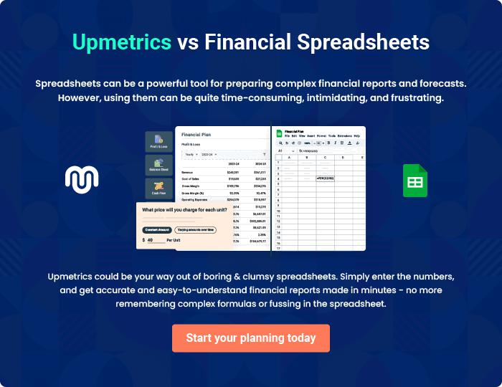
Appendix

When writing the appendix section, you should include any additional information that supports the main content of your plan. This may include financial statements, market research data, legal documents, and other
To unlock help try Upmetrics! 
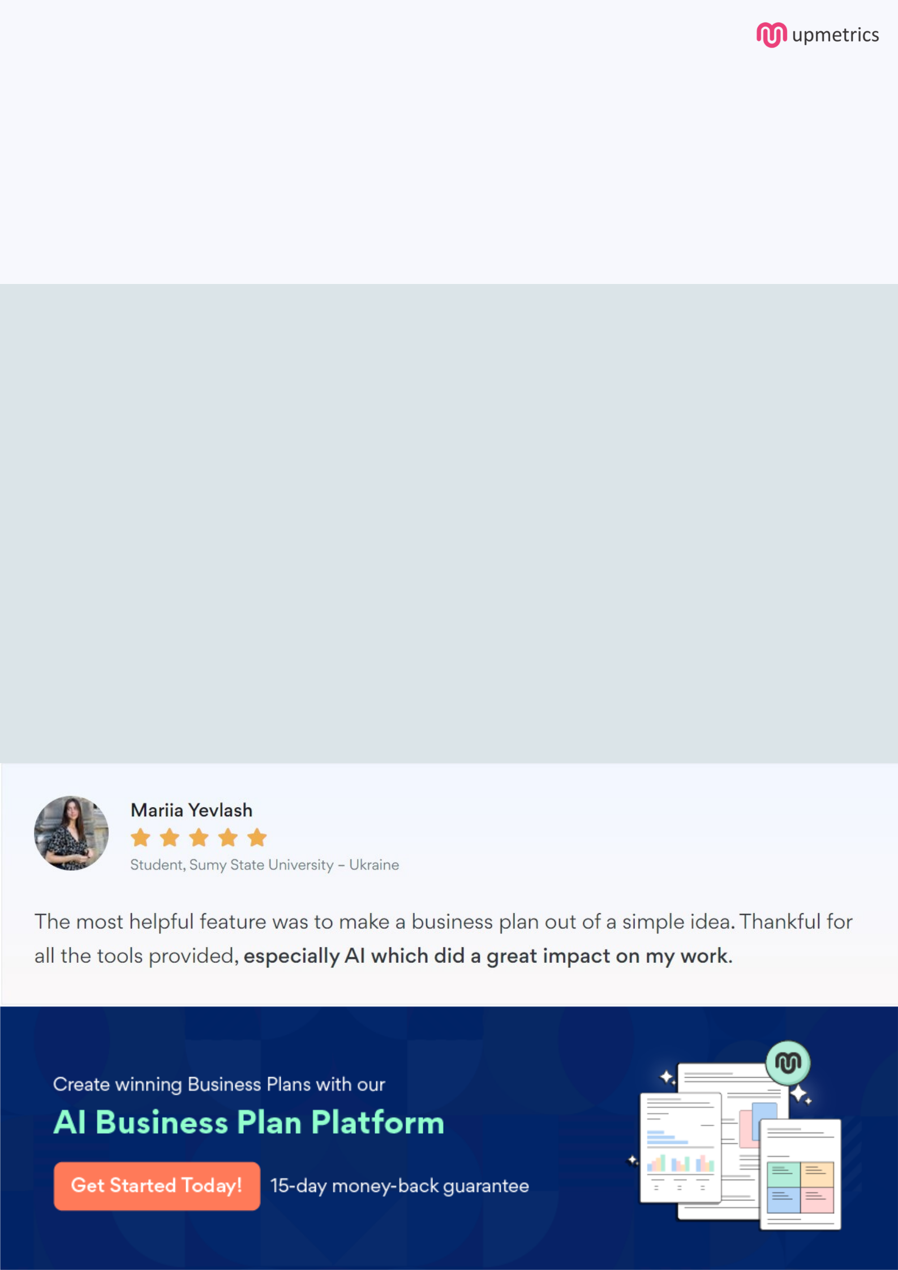
Create a winning business plan that gets you funded

Creating a stunning and investment-ready plan requires no writing, graphic designing, or financial planning expertise.

Upmetrics has all the features required to help you create a comprehensive business plan—from start to finish. Make no mistakes, it’s the modern way of planning to structure ideas, make plans, and create stunning pitch decks to awe investors.

Pitch decks that impress investors

Create pitch decks that provide a visual representation of your business, engage investors, and make them want to invest in your business idea.

Interactive plans in no time

Import business plan sections like—SWOT analysis, comparison tables, and others to create an interactive business plan. No designing skills are required.

Stunning cover page designs

With Upmetrics, you have the liberty to choose from multiple stunning cover page designs. Choose a creative design and make your plan stand out.

Online sharing made simple

Upmetrics makes online sharing quick and easier for users. Easily share your business plans with a link while tracking reader activity.

500+ sample business plans

Simply import a template from our library of sample plans into the editor and start customizing it to make it yours. It takes only a few clicks to get started.

Collaborate with team in real-time

Invite team members, initiate conversations, discuss ideas & strategies, share feedback, and work on a business plan in real-time.

