
Internet Service Provider Business Plan

ADDRESS CONTACT

10200 Bolsa Ave, Westminster, CA, 92683 (650) 359-3153

http://www.example.com info@example.com


Business Plan

2023

Prepared By

John Doe


Fast, Reliable, Online

Information provided in this business plan is unique to this business and confidential; therefore, anyone reading this plan agrees not to disclose any of the information in this business plan without prior written permission of the company.

Table of Contents

Executive Summary | 6
Market opportunity | 6
Services Offered | 6
Marketing & Sales Strategies | 7
Financial Highlights | 7
Units Sold v/s Revenue | 8

Company Overview | 9
Ownership | 9
Business Owners | 9
Mission statement | 10
Business history | 10
Future goals | 10

Market Analysis | 11
Target Market | 11
Market size and growth potential | 11
Market Size | 12
Competitive analysis | 12
NetFusion Corp | 12
WaveLink Technologies | 13
TerraNet Global | 13
Market trends | 13
Regulatory environment | 14

Products and Services | 15
Services | 15
Broadband Service | 15
DSL Service | 16
Cable Service | 16
Fiber Optic Service | 16
Satellite Service | 17
Digital Phone Services | 17
Security Solutions Package | 17
Cloud Storage Solution | 18
Technical Support | 18
Service Level Agreements (SLAs) | 18
Value-added Services | 19

Sales And Marketing Strategies | 20
Unique Selling Proposition (USP) | 20
Pricing Strategy | 20
Marketing strategies | 21
Online | 21
Offline | 21
Sales strategies | 22
Customer retention | 22

Operations Plan | 23
Staffing & Training | 23
Operational Process | 23
Equipment & Machinery | 24

Management Team | 25
Key managers | 25
John Doe | 26
Jane Doe | 26
Alice Brown | 27
Robert Brown | 28
Organizational structure | 28
Organization chart | 29
Compensation plan | 29
Advisors/Consultants | 30
[ADVISOR NAME] | 30
[CONSULTANT NAME] | 30
Financial Plan | 31
Profit & loss statement | 31
Cash flow statement | 34
Balance sheet | 36
Break-even Analysis | 38
Financing needs | 40
Appendix
Appendix | 42
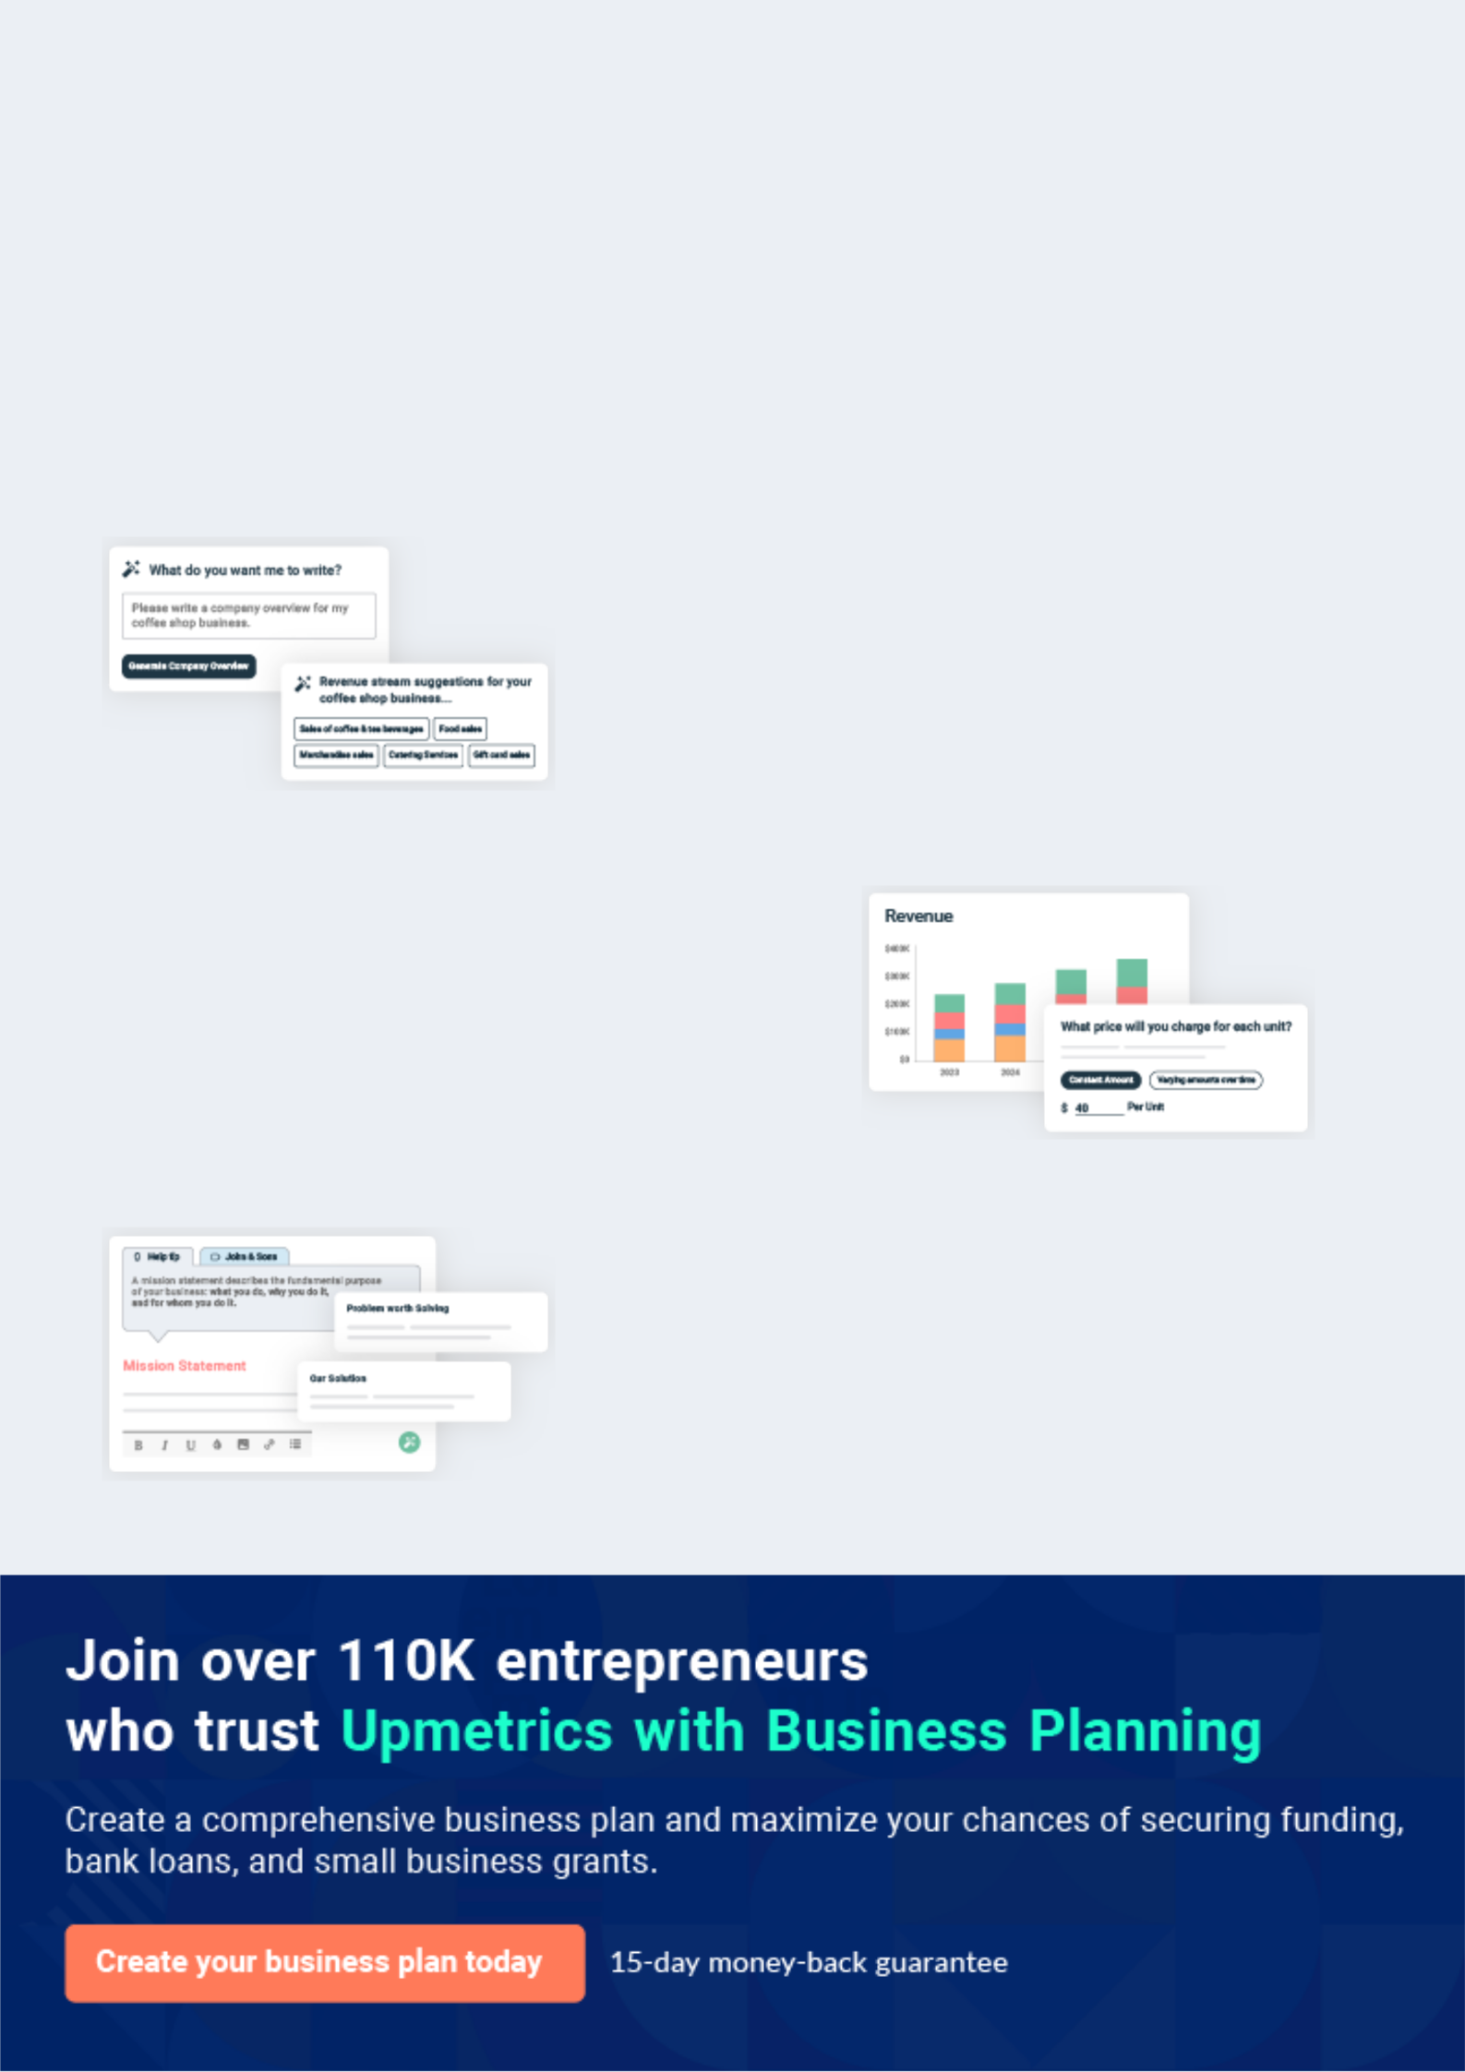
Business planning that’s simpler and faster than you think

Creating a business plan using Upmetrics to start and grow a business is literally the easiest thing in the World. Simply read the instructions and fill in the blanks. It’s as simple as that.

❛ | Upmetrics has everything you need to create a | ❜
❛ | comprehensive business plan. | ❜

AI-powered Upmetrics Assistant

AI-powered insights to streamline your plan

Not sure where to start? Upmetrics’ AI Assistant will automatically generate ideas for each section of your plan and offer improved versions of your writing, adjusting for tone, voice, and grammar or spelling errors.

Financial Forecasting Tool

All the financials are calculated for you

Forget the complex formulas and clumsy spreadsheets — with automatic financials and drag-and-drop forecasting, you can finish your plan faster and be confident that your numbers are accurate.

Business Plan Builder

Guides you like a business mentor

Upmetrics’ step-by-step instructions, prompts, and the library of 400+ sample business plans will guide you through each section of your plan as a business mentor.
Executive Summary


An executive summary is the first section of the business plan intended to provide an overview of the whole business plan.
To unlock help try Upmetrics! 

 Help tip  Internet Service Provider Business Plan


Start your executive summary by briefly introducing your business to your readers.

This section may include the name of your internet service business, its location, when it was
To unlock help try Upmetrics! 

Start writing here..

Market opportunity

 Help tip  Internet Service Provider Business Plan

Summarize your market research, including market size, growth potential, and marketing trends. Highlight the opportunities in the market and how your business will fit in to fill the gap.
To unlock help try Upmetrics! 

Start writing here..

Services Offered

 Help tip  Internet Service Provider Business Plan

Highlight the internet service provider services you offer your clients. The USPs and differentiators you offer are always a plus.
To unlock help try Upmetrics! 

Start writing here..

Marketing & Sales Strategies
To unlock help try Upmetrics!

 Help tip  Marketing & Sales Strategies:


Outline your sales and marketing strategies—what marketing platforms you use, how you plan on acquiring customers, etc.
To unlock help try Upmetrics! 

Start writing here..

Financial Highlights

 Help tip  Internet Service Provider Business Plan

Briefly summarize your financial projections for the initial years of business operations. Include any capital or investment requirements, associated startup costs, projected revenues, and profit forecasts.



Start writing here..
Units Sold v/s Revenue

 |  | Units Sold | Revenue
15.00k
10.00k
5.00k
0
Year 1 | Year 2 | Year 3


Financial Year |  | Units Sold |  | Revenue
Year 1 | 1,550 |  |  | $10,000
Year 2 | 1,800 |  |  | $12,000
Year 3 | 2,050 |  |  | $14,000
 Help tip |  |  Internet Service Provider Business Plan


Summarize your executive summary section with a clear CTA, for example, inviting angel investors to discuss the potential business investment.
To unlock help try Upmetrics! 

Write a call to action for your business plan.
Company Overview

Depending on what details of your business are essential, you’ll need different elements in your business overview.
To unlock help try Upmetrics! 

 Help tip  Internet Service Provider Business Plan

Describe your business in this section by providing all the basic information:

Describe what kind of internet service company you run and the name of it. You may specialize
To unlock help try Upmetrics! 

Start writing here..

Ownership

 Help tip  Internet Service Provider Business Plan

List the names of your internet service company’s founders or owners. Describe what shares they own and their responsibilities for efficiently managing the business.
To unlock help try Upmetrics! 

Start writing here..

Business Owners



60% John Doe



40% Jane Doe
Mission statement

 Help tip  Internet Service Provider Business Plan

Summarize your business’ objective, core principles, and values in your mission statement. This statement needs to be memorable, clear, and brief.
To unlock help try Upmetrics! 

❛ At [XYZ Internet Solutions], our mission is to empower communities by bridging digital divides. We pledge to deliver unparalleled connectivity, uphold the highest standards of service reliability, and champion the principles of integrity, innovation,

and inclusivity in all we do.
❜

Business history

 Help tip  Internet Service Provider Business Plan

If you’re an established internet service provider, briefly describe your business history, like— when it was founded, how it evolved over time, etc.
To unlock help try Upmetrics! 

Start writing here..

Future goals

 Help tip  Internet Service Provider Business Plan

It’s crucial to convey your aspirations and vision. Mention your short-term and long-term goals; they can be specific targets for revenue, market share, or expanding your services.
To unlock help try Upmetrics! 

Start writing here..

Market Analysis
To unlock help try Upmetrics!


 |  | Market analysis provides a clear understanding of the market in which your
 |  | printing business will run along with the target market, competitors, and
 |  | growth opportunities.
 |  |  |  | To unlock help try Upmetrics! 
 Help tip |  |  Internet Service Provider Business Plan

To write the introduction section of your market analysis, start by clearly identifying your primary target market.
To unlock help try Upmetrics! 

Start writing here..

Target Market

 Help tip  Internet Service Provider Business Plan

Start this section by describing your target market. Define your ideal customer and explain what types of services they prefer. Creating a buyer persona will help you easily define your target market to your readers.



Start writing here..

Market size and growth potential

 Help tip  Internet Service Provider Business Plan

Describe your market size and growth potential and whether you will target a niche or a much broader market.
To unlock help try Upmetrics! 

Start writing here..

Market Size
To unlock help try Upmetrics!

Available Market

All consumers need internet connectivity 50M in the country.

Served Market
Those accessing internet services 35M through established ISPs.

Target Market
SMBs and urban residents prioritise high- 7M speed, reliable connectivity.

 Help tip  Internet Service Provider Business Plan

Identify and analyze your direct and indirect competitors. Identify their strengths and weaknesses, and describe what differentiates your internet service provider services from them.



Competitive analysis

NetFusion Corp

Established in 2005, NetFusion Corp has steadily grown its footprint in the eastern region, boasting an impressive client roster spanning both residential and commercial sectors.

Features | Strengths | Weaknesses
Residential broadband | Strong brand recognition in the | Limited penetration in the rural
packages with speeds up to 1 | eastern region | markets.
Gbps. | Diverse product range catering | Occasional network congestion
Dedicated enterprise solutions | to a broad spectrum of | during peak hours.
with scalable bandwidth | customers. | Relatively higher pricing for basic
options. |  | Relatively higher pricing for basic
options. | Emphasis on cybersecurity, | packages.
Complementary cybersecurity | sets them apart in the market.
suite for premium subscribers.
24/7 customer helpline.

WaveLink Technologies

A newer entrant, WaveLink Technologies commenced operations in 2015 and has made significant inroads in the urban markets, particularly among the tech-savvy millennial demographic.

Features | Strengths | Weaknesses
Wireless internet solutions with | Strong appeal among younger | Limited experience in the
city-wide hotspots. | consumers. | industry compared to older
Customized packages for start- | Innovative product solutions | players.
ups and digital nomads. | tapping into modern tech | Over-reliance on urban markets,
Integrated smart home | trends. | with negligible rural presence.
solutions for advanced users. | Competitive pricing, especially | Some reported issues with
 | for bundled packages. | connectivity consistency.

TerraNet Global

TerraNet Global, operating since 2000, is a global behemoth with a vast network spanning multiple continents. They have a substantial market share but face challenges adapting to local market nuances.

Features Strengths Weaknesses

Fibre optic broadband with up to 5 Gbps speed options.

Cloud hosting and digital storage solutions.

Enterprise-grade VoIP services.

Vast resources and capital for R&D.

Wide-reaching global network ensuring robust connectivity.

Diverse service range beyond traditional ISP offerings.

Often perceived as too corporate, lacking a personal touch in customer service.

Slower to adapt to region-specific needs and trends.

Premium pricing, is often out of reach for smaller businesses and individual consumers.

Market trends

 Help tip  Internet Service Provider Business Plan

Analyze emerging trends in the industry, such as technology disruptions, changes in customer behavior or preferences, etc. Explain how your business will cope with all the trends.
To unlock help try Upmetrics! 

Start writing here..

Regulatory environment
To unlock help try Upmetrics!

 Help tip  Internet Service Provider Business Plan

List regulations and licensing requirements that may affect your internet services company, such as business registration, data protection, and privacy guidelines, content regulations, insurance, environmental regulations, state and federal regulations, etc.

Start writing here..
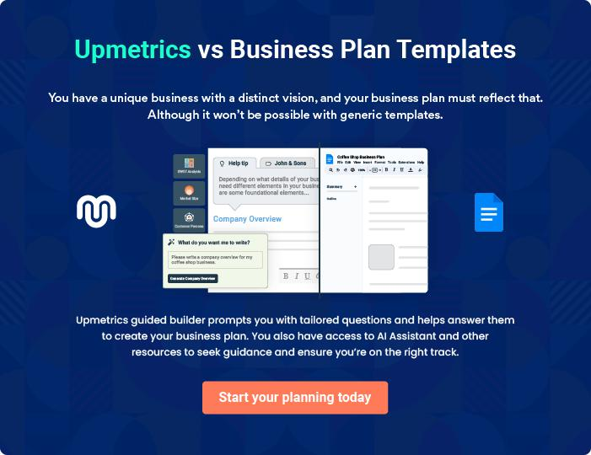


Products and Services

The product and services section of an internet service provider business plan should describe the specific services and products that will be offered to customers. To write this section should include the following:
To unlock help try Upmetrics! 

 Help tip  Internet Service Provider Business Plan

To craft the introduction for your "Products and Services" chapter, begin by positioning your business within its industry, emphasizing its unique strengths or value proposition.
To unlock help try Upmetrics! 

Start writing here..

 Help tip


Mention the internet service provider services your business will offer. This list may include services like,
To unlock help try Upmetrics! 

Services

Broadband Service


Price: $[XX.XX] per month

Offering fast and reliable connectivity, our Broadband Service is designed for seamless browsing, streaming, and gaming experiences.

Specifications

- Speed: Up to [XX Mbps]

- Data Limit: [XX GB] per month, with unlimited options available

- Modem: Dual-band Wi-Fi router included
DSL Service

Price: $[XX.XX] per month

Our DSL Service ensures stable internet connectivity in areas with limited high-speed options.

Specifications

- Speed: Up to [XX Mbps]

- Data Limit: [XX GB] per month

- Modem: Standard DSL router included

Cable Service

Price: $[XX.XX] per month

With advanced cable technology, this service is tailored for users who engage in high-bandwidth activities.

Specifications

- Speed: Up to [XX Mbps]

- Data Limit: [XX GB] per month, with premium plans offering unlimited data

- Modem: High-performance cable modem with Wi-Fi capabilities

Fiber Optic Service

Price: $[XX.XX] per month

Dive into the future of connectivity with lightning-fast speeds, perfect for businesses and tech-savvy households.

Specifications

- Speed: Up to [XX Gbps]

- Data Limit: Unlimited

- Modem: Advanced fiber-compatible router
Satellite Service

Price: $[XX.XX] per month

Specially designed for areas lacking terrestrial connectivity, ensuring consistent and reliable internet access.

Specifications

- Speed: Up to [XX Mbps]

- Data Limit: [XX GB] per month

- Equipment: Satellite dish and modem combo

Digital Phone Services

Price: $[XX.XX] per month

Crystal-clear digital phone service with features like voicemail, caller ID, and call forwarding.

Specifications

- Unlimited local and national calls

- [XX] international minutes included

- Voicemail-to-email feature

Security Solutions Package

Price: $[XX.XX] per month

Comprehensive protection for your devices, ensuring a safe browsing experience.

Specifications

- Antivirus

- Firewall protection

- Anti-phishing tools

- Parental controls
Cloud Storage Solution
- To unlock help try Upmetrics!

Price: $[XX.XX] per month

Keep your data safe and accessible with our encrypted cloud storage solutions.

Specifications

- Storage: [XX TB]

- File versioning and recovery

- Multi-device sync

Technical Support

 Help tip  Internet Service Provider Business Plan

Outline the customer support services you will offer to your customers. This includes 24*7 support options, self-help resources, phone, email, and live chat solutions.
To unlock help try Upmetrics! 

Start writing here..

Service Level Agreements (SLAs)

 Help tip  Internet Service Provider Business Plan

Describe the service level guarantees you will offer your business customers. This will include uptime guarantees, response time for technical support, and compensation in case of service disruption.



Start writing here..
Value-added Services

 Help tip  Internet Service Provider Business Plan

Mention if your internet service company offers any additional services. You may include services like digital phone services, security solutions, cloud storage, etc.
To unlock help try Upmetrics! 

Start writing here..
Sales And Marketing Strategies
To unlock help try Upmetrics!

Writing the sales and marketing strategies section means a list of strategies you will use to attract and retain your clients.
To unlock help try Upmetrics! 

 Help Tip  Internet Service Provider Business Plan


To create an effective introduction for your "Sales and Marketing Strategies" chapter, start by setting the stage within your specific industry or market.
To unlock help try Upmetrics! 

Start writing here..

Unique Selling Proposition (USP)

 Help tip  Internet Service Provider Business Plan

Define your business’s USPs depending on the market you serve, the equipment you use, and the unique services you provide. Identifying USPs will help you plan your marketing strategies.
To unlock help try Upmetrics! 

Start writing here..

Pricing Strategy

 Help tip  Internet Service Provider Business Plan

Describe your pricing strategy—how you plan to price your internet services and stay competitive in the local market. You can mention any limited-time offers you plan on offering to attract new customers to your internet service.



Start writing here..

 Help tip  Internet Service Provider Business Plan
To unlock help try Upmetrics!

Discuss your marketing strategies to market your services. You may include some of these marketing strategies in your business plan—social media marketing, Google ads, brochures, email marketing, content marketing, and print marketing.



Marketing strategies

Online


Social Media

Engaging content and targeted campaigns across platforms such as Facebook, Instagram, and LinkedIn.

Content Marketing

Blog posts, articles, and resources that establish us as industry thought leaders.

Email Marketing

Periodic newsletters, offers, and updates to our subscriber base.

Google Ads

Tailored ads to capture individuals and businesses searching for reliable internet solutions.

Offline

Brochures Print Marketing

Detailed informational brochures Strategic placements in local

available both digitally and newspapers, magazines, and

physically. billboards.

 Help tip  Internet Service Provider Business Plan
To unlock help try Upmetrics!

Outline the strategies you’ll implement to maximize your sales. Your sales strategies may include direct sales calls, partnering with residential complexes and corporate houses, offering referral programs, etc.



Sales strategies

Partner with Businesses

Collaborative efforts with residential complexes and corporate entities to provide exclusive service packages.

Direct Sales Calls

A dedicated team reaching out to potential customers and businesses.

Referral Programs

Rewarding loyal customers who

refer our services to friends, family,

and acquaintances.

 Help tip  Internet Service Provider Business Plan

Describe your customer retention strategies and how you plan to execute them. For instance, introducing loyalty programs, discounts on membership plans, value-added services, etc.
To unlock help try Upmetrics! 

Customer retention

Loyalty Programs

Points-based systems that reward regular customers with exclusive benefits.

Membership Discount

Special prices and offers for long-term subscription packages.

Personalized Service

Periodic introductions of

complementary services,

enhancing the overall user

experience.

Operations Plan
To unlock help try Upmetrics!

 |  | When writing the operations plan section, it’s important to consider the
 |  | various aspects of your business operations.
 |  |  |  | To unlock help try Upmetrics! 
 Help tip |  |  Internet Service Provider Business Plan


To create an effective introduction for your "Operational Plan" chapter, start by emphasizing the
pivotal role of efficient operations in the success of your business, underscoring how they
directly impact the quality of services delivered.
 |  |  |  | To unlock help try Upmetrics! 
Start writing here..
Staffing & Training
 Help tip |  |  Internet Service Provider Business Plan

Mention your Internet business’s staffing requirements, including the number of technicians, test engineers, sales and marketing employees, and customer service staff needed. Include their qualifications, the training required, and the duties they will perform.
To unlock help try Upmetrics! 

Start writing here..

Operational Process

 Help tip  Internet Service Provider Business Plan

Outline the processes and procedures you will use to run your internet service business. Your operational processes may include offering internet connectivity, technical support, onboarding new clients, creating network infrastructure, billing, and training staff.



Start writing here..

Equipment & Machinery

 Help tip  Internet Service Provider Business Plan

Include the list of equipment and machinery required for an internet services business, such as routers, switches, firewalls, modems, DNS and web servers, cable testers, power meters, etc.
To unlock help try Upmetrics! 

Start writing here..
Management Team

The management team section provides an overview of the individuals responsible for running your business plan.
To unlock help try Upmetrics! 

 Help tip  Internet Service Provider Business Plan

To craft an introduction for your "Management Team" chapter, begin by emphasizing the crucial role of leadership in the success of any business.
To unlock help try Upmetrics! 

Start writing here..

Key managers

 Help tip  Internet Service Provider Business Plan

Introduce your management and key members of your team, and explain their roles and responsibilities.
To unlock help try Upmetrics! 

Start writing here..

JOHN DOE

CEO - john.doe@example.com

As the dynamic CEO of [XYZ Internet Solutions], John oversees the overall strategy formation, business expansion initiatives, and stakeholder communication.


He embodies the values and ethos of the company and works diligently to ensure alignment across all departments.

John's exceptional leadership qualities have enabled the company to achieve remarkable milestones and secure a significant market position.

- Educational Background: John holds an MBA from Stanford University and a Bachelor's in Computer Science from MIT.

- Professional Background: John's illustrious career spans over 15 years in the Internet industry. He has previously held executive positions at renowned companies like WebTech and FastConnect.


JANE DOE

CTO - jane.doe@example.com

Jane spearheads the technical vision of the company.

With an unwavering commitment to innovation, she supervises the technical team, ensuring the reliability of the network infrastructure and championing state-of-the-art technological solutions.

- Educational Background: Jane graduated with a Master's in Network Solutions from Harvard University and a Bachelor's in Information Technology from UCLA.

- Professional Background: With over 12 years in the tech domain, Jane has served in senior roles at companies like NetSphere and Digitech Innovations.

ALICE BROWN

CFO - alice.brown@example.com

Alice plays a pivotal role in shaping the financial direction of [XYZ Internet Solutions].

Her expertise in financial planning, risk management, and fiscal reporting ensures financial integrity and transparency.

- Educational Background: Alice holds a Master's in Finance from Wharton School of Business and a Bachelor's in Economics from NYU.

- Professional Background: Alice brings a rich experience of 10 years, having previously enriched companies like MoneyMint and FiscalFront with her financial acumen.

ROBERT BROWN

Sales Manager - robert.brown@example.com

Robert's strategic insight drives the sales department of [XYZ Internet Solutions].

Overseeing sales strategies, market research, and customer relationship management, he's instrumental in expanding the company's customer base and revenue streams.

- Educational Background: Robert earned his MBA in Sales and Marketing from Kellogg School of Management and a Bachelor's in Business Administration from Berkeley.

- Professional Background: Robert's 8-year journey in sales has seen him propel growth in organizations like MarketMakers and SalesSynergy.

Organizational structure

 Help tip  Internet Service Provider Business Plan

Explain the organizational structure of your management team. Include the reporting line and decision-making hierarchy.
To unlock help try Upmetrics! 

Start writing here..
Organization chart


John Doe

CEO


Alice Brown

Robert Brown

Jane Doe

CFO



Sales Manager


CTO

Emily Black

David Green

Tech Lead

Marketing Head

Compensation plan

 Help tip  Internet Service Provider Business Plan

Describe your compensation plan for the management and staff. Include their salaries, incentives, and other benefits.
To unlock help try Upmetrics! 

Start writing here..

 Help tip  Internet Service Provider Business Plan

Mentioning advisors or consultants in your business plans adds credibility to your business idea.
To unlock help try Upmetrics! 

Advisors/Consultants


[ADVISOR NAME]

Advisor

A renowned figure in the ISP industry, [Advisor Name]'s consultancy has enabled many businesses to achieve market leadership.


[CONSULTANT NAME]

Consultant

With expertise in [specific domain], [Consultant Name]'s strategic guidance has been pivotal in our major initiatives.
Financial Plan

When writing the financial plan section of a business plan, it’s important to provide a comprehensive overview of your financial projections for the first few years of your business, You may provide the following:
To unlock help try Upmetrics! 

 Help tip  Internet Service Provider Business Plan


To create an effective introduction for your "Financial Plan" chapter, begin by stressing the critical role of a well-structured financial plan in the success of your venture.
To unlock help try Upmetrics! 

Start writing here..

 Help tip


Describe details such as projected revenue, operational costs, and service costs in your projected profit and loss statement. Make sure to include your business’s expected net profit or loss.
To unlock help try Upmetrics! 

Profit & loss statement

Revenue

Cost Of Sales

General Costs

Revenue Specific Costs

Personnel Costs (Direct

Labor)

Gross Margin

Gross Margin (%)

Operating Expense

Payroll Expense

(Indirect Labor)

General Expense

Bad Debt

Amortization of Current

Assets

2023-24 | 2024-25 | 2025-26 | 2026-27 | 2027-28
$0 | $0 | $0 | $0 | $0

$0 | $0 | $0 | $0 | $0
$0 | $0 | $0 | $0 | $0
$0 | $0 | $0 | $0 | $0
$0 | $0 | $0 | $0 | $0

$0 | $0 | $0 | $0 | $0
0% | 0% | 0% | 0% | 0%

$0 | $0 | $0 | $0 | $0
$0 | $0 | $0 | $0 | $0
$0 | $0 | $0 | $0 | $0
$0 | $0 | $0 | $0 | $0
$0 | $0 | $0 | $0 | $0

EBITDA

Additional Expense

Long Term

Depreciation

Gain or loss from Sale

of Assets

EBIT

Interest Expenses

EBT

Income Tax Expense

Total Expense

Net Income

Net Income (%)

2023-24 | 2024-25 | 2025-26 | 2026-27 | 2027-28
$0 | $0 | $0 | $0 | $0
$0 | $0 | $0 | $0 | $0
$0 | $0 | $0 | $0 | $0
$0 | $0 | $0 | $0 | $0
$0 | $0 | $0 | $0 | $0
$0 | $0 | $0 | $0 | $0
$0 | $0 | $0 | $0 | $0
$0 | $0 | $0 | $0 | $0
$0 | $0 | $0 | $0 | $0
$0 | $0 | $0 | $0 | $0
0% | 0% | 0% | 0% | 0%
 | 2023-24 | 2024-25 | 2025-26 | 2026-27 | 2027-28
Retained Earning | $0 | $0 | $0 | $0 | $0
Opening
Owner's Distribution | $0 | $0 | $0 | $0 | $0
Retained Earning | $0 | $0 | $0 | $0 | $0
Closing

 Help tip

The cash flow for the first few years of your operation should be estimated and described in this section. This may include billing invoices, payment receipts, loan payments, and any other cash flow statements.
To unlock help try Upmetrics! 

Cash flow statement

 | 2023-24 | 2024-25 | 2025-26 | 2026-27 | 2027-28
Cash Received | $0 | $0 | $0 | $0 | $0
Cash Paid | $0 | $0 | $0 | $0 | $0
COS & General Expenses | $0 | $0 | $0 | $0 | $0
Salary & Wages | $0 | $0 | $0 | $0 | $0
Interest | $0 | $0 | $0 | $0 | $0

Sales Tax

Income Tax

Net Cash From

Operations

Assets Sell

Assets Purchase

Net Cash From

Investments

Amount Received

Loan Received

Common Stock

Preferred Stock

Owner's Contribution

Amount Paid

2023-24 | 2024-25 | 2025-26 | 2026-27 | 2027-28
$0 | $0 | $0 | $0 | $0
$0 | $0 | $0 | $0 | $0
$0 | $0 | $0 | $0 | $0

$0 | $0 | $0 | $0 | $0
$0 | $0 | $0 | $0 | $0
$0 | $0 | $0 | $0 | $0

$0 | $0 | $0 | $0 | $0
$0 | $0 | $0 | $0 | $0

$0 | $0 | $0 | $0 | $0
$0 | $0 | $0 | $0 | $0
$0 | $0 | $0 | $0 | $0

Loan Capital $0 $0 $0 $0 $0

 | 2023-24 | 2024-25 | 2025-26 | 2026-27 | 2027-28
Dividends & Distributions | $0 | $0 | $0 | $0 | $0
Net Cash From | $0 | $0 | $0 | $0 | $0
Financing

Summary
Starting Cash | $0 | $0 | $0 | $0 | $0
Cash In | $0 | $0 | $0 | $0 | $0
Cash Out | $0 | $0 | $0 | $0 | $0
Change in Cash | $0 | $0 | $0 | $0 | $0
Ending Cash | $0 | $0 | $0 | $0 | $0

 Help tip

Create a projected balance sheet documenting your internet service business’s assets, liabilities, and equity.

To unlock help try Upmetrics! 

Balance sheet

 | 2023-24 | 2024-25 | 2025-26 | 2026-27 | 2027-28
Assets | $0 | $0 | $0 | $0 | $0
Current Assets | $0 | $0 | $0 | $0 | $0
Cash | $0 | $0 | $0 | $0 | $0
Accounts Receivable | $0 | $0 | $0 | $0 | $0
Inventory | $0 | $0 | $0 | $0 | $0
Other Current Assets | $0 | $0 | $0 | $0 | $0
Long Term Assets | $0 | $0 | $0 | $0 | $0
Gross Long Term Assets | $0 | $0 | $0 | $0 | $0
Accumulated Depreciation | $0 | $0 | $0 | $0 | $0

Liabilities & Equity | $0 | $0 | $0 | $0 | $0
Liabilities | $0 | $0 | $0 | $0 | $0
Current Liabilities | $0 | $0 | $0 | $0 | $0
Accounts Payable | $0 | $0 | $0 | $0 | $0
Income Tax Payable | $0 | $0 | $0 | $0 | $0
Sales Tax Payable | $0 | $0 | $0 | $0 | $0
Short Term Debt | $0 | $0 | $0 | $0 | $0
 | 2023-24 | 2024-25 | 2025-26 | 2026-27 | 2027-28
Long Term Liabilities | $0 | $0 | $0 | $0 | $0
Long Term Debt | $0 | $0 | $0 | $0 | $0
Equity | $0 | $0 | $0 | $0 | $0
Paid-in Capital | $0 | $0 | $0 | $0 | $0
Common Stock | $0 | $0 | $0 | $0 | $0
Preferred Stock | $0 | $0 | $0 | $0 | $0
Owner's Contribution | $0 | $0 | $0 | $0 | $0
Retained Earnings | $0 | $0 | $0 | $0 | $0

Check | $0 |  |  | $0 | $0 | $0 | $0
 Help tip |  |  Internet Service Provider Business Plan


Determine and mention your business’s break-even point—the point at which your business costs and revenue will be equal.

This exercise will help you understand how much revenue you need to generate to sustain or be profitable.
To unlock help try Upmetrics! 

Break-even Analysis

 | 2023-24 | 2024-25 | 2025-26 | 2026-27 | 2027-28
Starting Revenue | $0 | $0 | $0 | $0 | $0
Net Revenue | $0 | $0 | $0 | $0 | $0
Closing Revenue | $0 | $0 | $0 | $0 | $0

Starting Expense | $0 | $0 | $0 | $0 | $0
Net Expense | $0 | $0 | $0 | $0 | $0
Closing Expense | $0 | $0 | $0 | $0 | $0

Is Break Even? | 0 | 0 | 0 | 0 | 0
Break Even Month | 0 | 0 | 0 | 0 | 0
Days Required | 0 | 0 | 0 | 0 | 0
Break Even Revenue | $0 | $0 | $0 | $0 | $0
Break Even Units
Financing needs

 Help tip  Internet Service Provider Business Plan

Calculate costs associated with starting an internet service business, and estimate your financing needs and how much capital you need to raise to operate your business.
To unlock help try Upmetrics! 

Start writing here..
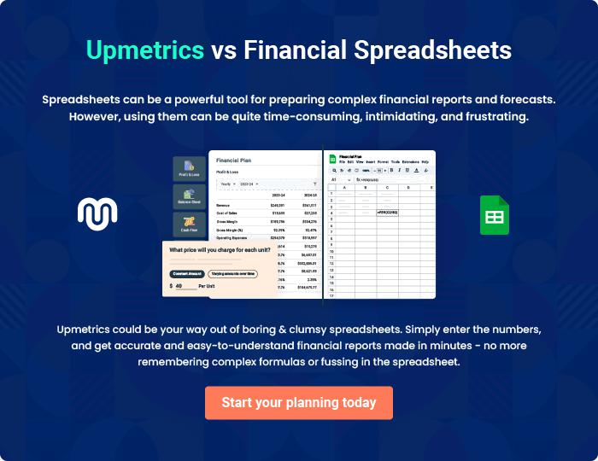
Appendix

When writing the appendix section, you should include any additional information that supports the main content of your plan. This may include financial statements, market research data, legal documents, and other
To unlock help try Upmetrics! 
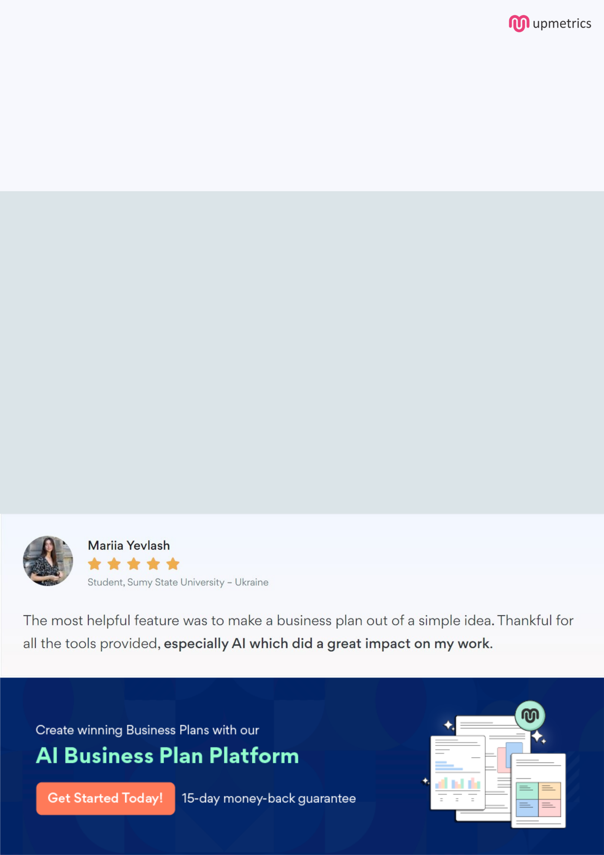
Create a winning business plan that gets you funded

Creating a stunning and investment-ready plan requires no writing, graphic designing, or financial planning expertise.

Upmetrics has all the features required to help you create a comprehensive business plan—from start to finish. Make no mistakes, it’s the modern way of planning to structure ideas, make plans, and create stunning pitch decks to awe investors.

Pitch decks that impress investors

Create pitch decks that provide a visual representation of your business, engage investors, and make them want to invest in your business idea.

Interactive plans in no time

Import business plan sections like—SWOT analysis, comparison tables, and others to create an interactive business plan. No designing skills are required.

Stunning cover page designs

With Upmetrics, you have the liberty to choose from multiple stunning cover page designs. Choose a creative design and make your plan stand out.

Online sharing made simple

Upmetrics makes online sharing quick and easier for users. Easily share your business plans with a link while tracking reader activity.

500+ sample business plans

Simply import a template from our library of sample plans into the editor and start customizing it to make it yours. It takes only a few clicks to get started.

Collaborate with team in real-time

Invite team members, initiate conversations, discuss ideas & strategies, share feedback, and work on a business plan in real-time.

