
Indoor Playground Business Plan

ADDRESS CONTACT

10200 Bolsa Ave, Westminster, CA, 92683 (650) 359-3153

http://www.example.com info@example.com


Business Plan

2023

Prepared By

John Doe


Play, Learn, Grow, Indoors

Information provided in this business plan is unique to this business and confidential; therefore, anyone reading this plan agrees not to disclose any of the information in this business plan without prior written permission of the company.

Table of Contents

Executive Summary | 6
Market opportunity | 6
Services Offered | 6
Management team | 7
John Doe | 7
Jane Doe | 7
Alice Brown | 7
Financial Highlights | 7
Units Sold v/s Revenue | 8

Company Overview | 9
Ownership | 9
Business Owners | 9
Mission statement | 10
Business history | 10
Future goals | 10

Market Analysis | 11
Target Market | 11
Market size and growth potential | 11
Market Size | 12
Competitive analysis | 12
KidZone AdventureLand | 12
Jump & Innovate PlayCenter | 13
Market trends | 13
Regulatory environment | 13

Products and Services | 15
Facilities | 15
Open Play Access | 15
Party Package | 16
Wall Experience | 16
Interactive Learning Zone | 16
Trampoline Time | 17
Snack Bar Combo | 17
Additional Services | 17

Sales And Marketing Strategies | 18
Unique Selling Proposition (USP) | 18
Pricing Strategy | 18
Marketing strategies | 19
Online | 19
Offline | 19
Sales strategies | 20
Customer retention | 20

Operations Plan | 21
Hiring Plan | 21
Operational Process | 21
Technologies | 22

Management Team | 23
Key managers | 23
John Doe | 23
Jane Doe | 24
Alice Brown | 24
Robert Brown | 24
Organizational structure | 24
Organization chart | 25
Compensation plan | 25
Board of advisors | 26
[ADVISOR NAME] | 26
[ADVISOR NAME] | 26
Financial Plan | 27
Profit & loss statement | 27
Cash flow statement | 30
Balance sheet | 32
Break-even Analysis | 34
Financing needs | 36
Appendix
Appendix | 38
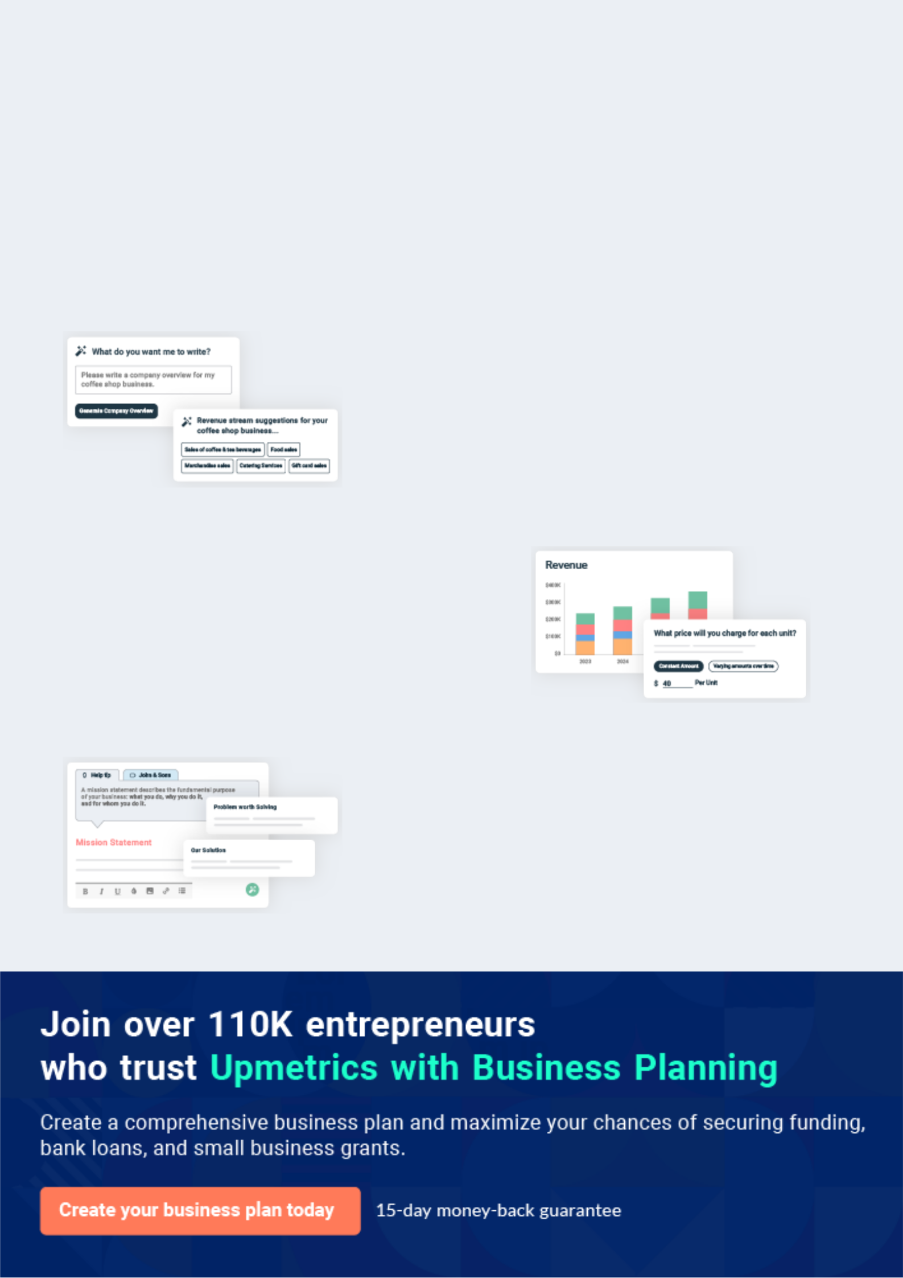
Business planning that’s simpler and faster than you think

Creating a business plan using Upmetrics to start and grow a business is literally the easiest thing in the World. Simply read the instructions and fill in the blanks. It’s as simple as that.

❛ | Upmetrics has everything you need to create a | ❜
❛ | comprehensive business plan. | ❜

AI-powered Upmetrics Assistant

AI-powered insights to streamline your plan

Not sure where to start? Upmetrics’ AI Assistant will automatically generate ideas for each section of your plan and offer improved versions of your writing, adjusting for tone, voice, and grammar or spelling errors.

Financial Forecasting Tool

All the financials are calculated for you

Forget the complex formulas and clumsy spreadsheets — with automatic financials and drag-and-drop forecasting, you can finish your plan faster and be confident that your numbers are accurate.

Business Plan Builder

Guides you like a business mentor

Upmetrics’ step-by-step instructions, prompts, and the library of 400+ sample business plans will guide you through each section of your plan as a business mentor.
Executive Summary


An executive summary is the first section of the business plan intended to provide an overview of the whole business plan.
To unlock help try Upmetrics! 

 Help tip  Indoor Playground Business Plan


Start your executive summary by introducing your idea behind starting an indoor playground business and explaining what it does.
To unlock help try Upmetrics! 

Start writing here..

Market opportunity

 Help tip  Indoor Playground Business Plan

Describe the target market in brief, and explain the demographics, geographic location, and psychographic attributes of your customer.
To unlock help try Upmetrics! 

Start writing here..

Services Offered

 Help tip  Indoor Playground Business Plan

Describe in detail the services that a client can expect at your indoor playground like – play area, snacks, beverages, or safety equipment.
To unlock help try Upmetrics! 

Start writing here..

Management team


JOHN DOE

CEO - john.doe@example.com

Bringing over a decade of experience in [relevant experience, e.g., "childcare and recreation management"], Johnleads the vision and strategy for [PlayScape Innovations].


JANE DOE

CTO - jane.doe@example.com

An expert in operations, Jane ensures the smooth day-to-day functioning of the playground, leveraging his extensive background in [relevant experience, e.g., "facility management"].


ALICE BROWN

CFO - alice.brown@example.com

Alice, with her [number, e.g., "15 years"] of financial expertise, oversees the fiscal health and sustainability of our venture.

Financial Highlights

 Help tip  Indoor Playground Business Plan

Provide a summary of your financial projections for the company’s initial years of operation.

Include any capital or investment requirements, startup costs, projected revenues, and profits.
To unlock help try Upmetrics! 

Start writing here..
Units Sold v/s Revenue
To unlock help try Upmetrics!

 |  | Units Sold | Revenue
15.00k
10.00k
5.00k
0
Year 1 | Year 2 | Year 3


Financial Year |  |  | Units Sold | Revenue
Year 1 | 1,550 |  |  | $10,000
Year 2 | 1,800 |  |  | $12,000
Year 3 | 2,050 |  |  | $14,000
 Help tip |  |  Indoor Playground Business Plan


After giving a brief about your business plan, end your summary with a call to action, for example; inviting potential investors or readers to the next meeting if they are interested in your business.



Write a call to action for your business plan.
Company Overview

Depending on what details of your business are essential, you’ll need different elements in your business overview.
To unlock help try Upmetrics! 

 Help tip  Indoor Playground Business Plan

Provide all the basic information about your business in this section like:

• The name of the indoor playground and the concept behind it like – children’s indoor
To unlock help try Upmetrics! 

Start writing here..

Ownership

 Help tip  Indoor Playground Business Plan

Describe the owners of your indoor playground and mention their roles in running it. Whose shares in the corporation are they, and how each owner helps in the business?
To unlock help try Upmetrics! 

Start writing here..

Business Owners



40% Jone Doe



30% Jane Doe



30% Alice Brown

Mission statement
To unlock help try Upmetrics!

 Help tip  Indoor Playground Business Plan

Add a mission statement that sums up the objectives and core principles of your business. This statement needs to be memorable, clear, and brief.
To unlock help try Upmetrics! 

❛ Our mission at [PlayScape Innovations] is to fuse fun, fitness, and education in a safe environment, cultivating creativity, curiosity,
and healthy habits in every child.
❜

Business history

 Help tip  Indoor Playground Business Plan


Include an outline playground’s history and how it came to be in its current position. If you can,
add some personality and intriguing details, especially if you got any achievements or
recognitions till now for your incredible services.
 |  |  |  |  | To unlock help try Upmetrics! 
Start writing here..
Future goals
 Help tip |  |  |  Indoor Playground Business Plan

It’s crucial to convey your aspirations and your vision. Include the vision of where you see your business in the near future and if you have any plans of opening a new franchise of your business in the same city in the future.



Start writing here..

Market Analysis
To unlock help try Upmetrics!
To unlock help try Upmetrics!


 |  | Market analysis provides a clear understanding of the market in which your
 |  | printing business will run along with the target market, competitors, and
 |  | growth opportunities.
 |  |  |  | To unlock help try Upmetrics! 
 Help tip |  |  Indoor Playground Business Plan

To write the introduction section of your market analysis, start by clearly identifying your primary target market.
To unlock help try Upmetrics! 

Start writing here..

Target Market

 Help tip  Indoor Playground Business Plan

Identify your target market and define your ideal customer. Know more about your customers and which services they prefer: only play area, or play area with educational amenities, fitness indoor playground, or something else.



Start writing here..

Market size and growth potential

 Help tip  Indoor Playground Business Plan

Provide an overview of the child services industry. It will include market size, trends, growth potential, and regulatory considerations. Highlight the competitive edge and how your business is different from the rest.



Start writing here..

Market Size


Available Market | 1M
All children aged 3-12 in the entire state. | 1M

Served Market
Children aged 3-12 in the city and 400k surrounding suburbs.

Target Market | 50k
Serviceable Obtainable Market | 50k

 Help tip  Indoor Playground Business Plan

Identify and analyze all other indoor playgrounds in the local market, including direct and indirect competitors.
To unlock help try Upmetrics! 

Competitive analysis

KidZone AdventureLand

KidZone AdventureLand, established in [Year, e.g., "2015"], is one of the most frequented indoor playgrounds in [City/Location]. With a footprint of [Specific size, e.g., "15,000 square feet"], it offers a blend of traditional play equipment and a cafe for parents.

Features

Traditional play areas with slides, ball pits, and climbing structures

Dedicated toddler zone

Parental relaxation area with Wi-Fi and a cafe

Themed birthday party packages

Strengths

Strong brand recognition in the local market

Diverse age-specific zones ensuring broader customer appeal

Loyalty programs for frequent visitors

Weaknesses

Limited innovation and integration of educational components

Overcrowding during peak hours leading to compromised experience

Aging equipment in need of refurbishment

Jump & Innovate PlayCenter

Jump & Innovate, launched in [Year, e.g., "2018"], merges trampoline zones with tech-infused play areas. Covering [Specific size, e.g., "20,000 square feet"], it targets both younger children and teenagers.

Features Strengths

Weaknesses

Expansive trampoline zones with foam pits

Augmented reality play corners

Interactive learning screens for educational fun

VR (Virtual Reality) zones for older children

Unique tech offerings setting them apart in the market

Appeals to a wider age group, including teenagers

Frequent updates to tech games ensuring repeat visitors

Higher pricing due to tech integrations, potentially alienating budget-conscious families

Technical glitches occasionally disrupt the experience

Limited traditional play areas, making it less appealing for parents seeking old-school fun

Market trends

 Help tip  Indoor Playground Business Plan

Analyze current and emerging trends in your industry, such as changes in customer preference
like: shift towards eco-friendly practices, or trendy layouts. Explain how your business will cope
with all the trends.
 |  |  |  | To unlock help try Upmetrics! 
Start writing here..
Regulatory environment
 Help tip |  |  Indoor Playground Business Plan

Describe any regulations or licensing requirements that affect the indoor playground business, such as safety codes, or requirements of a full-time trainer should be mentioned here.
To unlock help try Upmetrics! 

Start writing here..

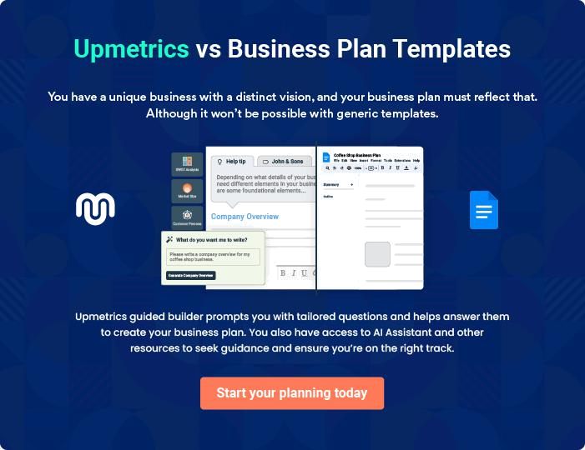
Products and Services

The product and services section of an indoor playground business plan should describe the specific services and products that will be offered to customers. To write this section should include the following:
To unlock help try Upmetrics! 

 Help tip  Indoor Playground Business Plan

To craft the introduction for your "Products and Services" chapter, begin by positioning your business within its industry, emphasizing its unique strengths or value proposition.
To unlock help try Upmetrics! 

Start writing here..

 Help tip


Explain the amenities and play structures you intend to include in your indoor playground, such as trampolines, climbing walls, ball pits, slides, and so on.
To unlock help try Upmetrics! 

Facilities

Open Play Access


Price: [$10] per child (up to 2 hours)

Access to the entire playground area where children can play freely, experiencing various play structures and equipment.

Specifications

- Age limit: 1-12 years

- Socks required

- Adult supervision mandatory for children below 5 years
Party Package

Price: [$250] (for up to 10 children, $20 for each additional child)

A 2-hour private party space rental, including decorations, food, and beverages.

Specifications

- Private party room

- Food and drinks included (pizza slices, juice boxes)

- Custom decorations based on theme selected

- Dedicated party coordinator

Wall Experience

Price: [$7] per child

Access to the climbing wall with safety gear and guidance from trained staff.

Specifications

- Age limit: 4-12 years

- Safety harness and helmet provided

- Climbing time: 30 minutes

Interactive Learning Zone

Price: [$8] per child

A tech-driven educational space with interactive screens and games for learning while playing.

Specifications

- Age limit: 3-10 years

- Duration: 1 hour

- Themes available: Ocean Life, Space Exploration, Ancient History
Trampoline Time
- To unlock help try Upmetrics!

Price: [$5] per 30 minutes

Unlimited jumping on professional trampolines with safety nets and padding.

Specifications

- Age limit: 4-12 years

- Safety rules enforced

- Waiver to be signed by parent/guardian

Snack Bar Combo

Price: [$6]

A combo meal including a sandwich, juice box, and a fruit cup or cookie.

Specifications

- Options available: Chicken, Veggie, or Turkey sandwich

- Fruit cup or chocolate chip cookie option

- Juice flavors: Apple, Orange, or Berry

Additional Services

 Help tip  Indoor Playground Business Plan

Think of providing extra services like food and drink, retail sales, or child care. By offering these added services, you can attract more customers and turn your indoor playground into a one-stop shop for families.



Start writing here..

Sales And Marketing Strategies

Writing the sales and marketing strategies section means a list of strategies you will use to attract and retain your clients.
To unlock help try Upmetrics! 

 Help Tip  Indoor Playground Business Plan


To create an effective introduction for your "Sales and Marketing Strategies" chapter, start by setting the stage within your specific industry or market.
To unlock help try Upmetrics! 

Start writing here..

Unique Selling Proposition (USP)

 Help tip  Indoor Playground Business Plan

Clearly define your playground’s unique selling proposition, such as your services, innovative designs, largest trampoline, or something else.
To unlock help try Upmetrics! 

Start writing here..

Pricing Strategy

 Help tip  Indoor Playground Business Plan

Develop a pricing strategy that is competitive and affordable, yet profitable. Consider offering promotions, discounts, or packages for your indoor playground to attract new customers.
To unlock help try Upmetrics! 

Start writing here..

 Help tip
To unlock help try Upmetrics!

Develop a marketing strategy that includes a mix of online and offline marketing tactics. Consider social media, email marketing, content marketing, brochures, print marketing, and events.



Marketing strategies

Online


Social Media

Our active presence on platforms such as Facebook, Instagram, and Twitter will feature regular posts, engaging content, and customer testimonials.

Content Marketing

Blogs, articles, and videos that resonate with parents, emphasizing the value of play in child development.

Offline

Brochures

Distribute colorful, informative brochures at strategic points such as pediatric clinics, schools, and local businesses.

Events

Email Marketing

Monthly newsletters to subscribers detailing upcoming events, new additions, and exclusive offers.

Print Marketing

Brochures and flyers distributed in strategic locations such as schools, pediatric clinics, and community centers.

Participation in and hosting of

community events, workshops, and

seminars.

 Help tip
To unlock help try Upmetrics!

Mention your sales strategy as in – partner with other businesses and schools to establish referral programs that can help you generate more business. Consider offering incentives for referrals or special discounts for partnerships.



Sales strategies

Partner with Businesses

We will establish alliances with local businesses, offering them group discounts and event collaboration opportunities.

School Programs

Tailored packages for schools, allowing them to use our facility for special events or regular physical education classes.

Referral Programs

Customers who refer others will

receive [benefits] as a token of our

appreciation.

 Help tip

Describe how your indoor playground will retain customers and build loyalty, such as through loyalty programs, special events, or personalized service.
To unlock help try Upmetrics! 

Customer retention

Loyalty Programs

Points-based systems where accumulated points can be redeemed for free access or other perks.

Special Events

Regular themed events or workshops that offer unique experiences.

Personalized Service

Training our staff to recognize and

remember our regular visitors,

ensuring a more personalized and

warm experience.

Operations Plan
To unlock help try Upmetrics!

 |  | When writing the operations plan section, it’s important to consider the
 |  | various aspects of your business operations.
 |  |  |  | To unlock help try Upmetrics! 
 Help tip |  |  Indoor Playground Business Plan


To create an effective introduction for your "Operational Plan" chapter, start by emphasizing the
pivotal role of efficient operations in the success of your business, underscoring how they
directly impact the quality of services delivered.
 |  |  |  | To unlock help try Upmetrics! 
Start writing here..
Hiring Plan
 Help tip |  |  Indoor Playground Business Plan

Tell the staffing requirements of your indoor playground, including the number of employees
needed, their qualifications, and the duties they will perform. Also mention the perks you will
provide to your employees.
 |  |  |  | To unlock help try Upmetrics! 
Start writing here..
Operational Process
 Help tip |  |  Indoor Playground Business Plan

Outline the processes and procedures that you will use to run your indoor playground. It includes scheduling events, the check-in and check-out process, and the management of equipment.



Start writing here..

Technologies

 Help tip  Indoor Playground Business Plan

Use technological tools like online reservation systems, point-of-sale systems, and customer relationship management to improve operations and customer service.
To unlock help try Upmetrics! 

Start writing here..
Management Team
To unlock help try Upmetrics!

The management team section provides an overview of the individuals responsible for running your business plan.
To unlock help try Upmetrics! 

 Help tip  Indoor Playground Business Plan

To craft an introduction for your "Management Team" chapter, begin by emphasizing the crucial role of leadership in the success of any business.
To unlock help try Upmetrics! 

Start writing here..

Key managers

 Help tip  Indoor Playground Business Plan

Describe the key members of your management team, their roles, and their responsibilities. It should include the owners, senior management, and any other trainer, safety officer, or other people.



Start writing here..

JOHN DOE

CEO - john.doe@example.com

John Doe is the visionary founder behind [PlayScape Innovations] Indoor Playground.

With an MBA from Harvard Business School and over 20 years of experience in the children's entertainment and recreational industry, John combines business acumen with a passion for creating safe and innovative play spaces.


His leadership and vision are instrumental in driving the company's growth and ensuring that PlayScape remains at the forefront of indoor playground innovations.
JANE DOE

Senior Manager of Operations - jane.doe@example.com

Jane Doe, equipped with a Master's in Operations Management from the University of California, Berkeley, boasts 15 years in managing recreational facilities.


Her meticulous attention to detail, combined with her unwavering commitment to excellence, ensures that [PlayScape Innovations] operates seamlessly.

Her forte lies in staff training and customer service, ensuring every visitor has a memorable experience.


ALICE BROWN

Safety Officer - alice.brown@example.com

Alice Brown, a certified safety professional with a degree in Child Safety and Protection from Stanford University, brings 10 years of dedicated experience in ensuring child safety in recreational environments.

Her expertise in risk assessment and her proactive approach to safety protocols make PlayScape one of the safest indoor playgrounds in the region.


ROBERT BROWN

Head Trainer - robert.brown@example.com

Robert, with a degree in Physical Education and Child Development from New York University, has been designing and leading child-centric physical programs for over 12 years.

At [PlayScape Innovations], he crafts programs that are not only fun but also developmental, ensuring that play and learning go hand-in-hand.

Organizational structure

 Help tip  Indoor Playground Business Plan

Describe the organizational structure of the management team, including reporting lines and how decisions will be made.
To unlock help try Upmetrics! 

Start writing here..

Organization chart


John Doe

CEO


Jane Doe

Robert Brown Senior Manager of Operations

Head Trainer


Michael Brown

Alice Brown Operations Manager

Safety Officer

Compensation plan

 Help tip  Indoor Playground Business Plan

Describe your compensation plan for the management team and staff, including salaries, bonuses, and other benefits.
To unlock help try Upmetrics! 

Start writing here..
 Help tip  Indoor Playground Business Plan

If you have a board of advisors for your business, then mention them along with their roles and experience.
To unlock help try Upmetrics! 

Board of advisors


[ADVISOR NAME]

Advisor 1

With a background in [relevant industry], [Name] advises us on [specific aspect, e.g., business strategy or growth].

[ADVISOR NAME]

Advisor 2

[Name]'s expertise in [relevant field, e.g., child safety] provides invaluable insights into maintaining a secure environment.
Financial Plan

When writing the financial plan section of a business plan, it’s important to provide a comprehensive overview of your financial projections for the first few years of your business, You may provide the following:
To unlock help try Upmetrics! 

 Help tip  Indoor Playground Business Plan


To create an effective introduction for your "Financial Plan" chapter, begin by stressing the critical role of a well-structured financial plan in the success of your venture.
To unlock help try Upmetrics! 

Start writing here..

 Help tip


Create a projected profit & loss statement that describes the expected revenue, cost of products sold, and operational costs. Your playground’s anticipated net profit or loss should be computed and included.
To unlock help try Upmetrics! 

Profit & loss statement

Revenue

Cost Of Sales

General Costs

Revenue Specific Costs

Personnel Costs (Direct

Labor)

Gross Margin

Gross Margin (%)

Operating Expense

Payroll Expense

(Indirect Labor)

General Expense

Bad Debt

Amortization of Current

Assets

2023-24 | 2024-25 | 2025-26 | 2026-27 | 2027-28
$0 | $0 | $0 | $0 | $0

$0 | $0 | $0 | $0 | $0
$0 | $0 | $0 | $0 | $0
$0 | $0 | $0 | $0 | $0
$0 | $0 | $0 | $0 | $0

$0 | $0 | $0 | $0 | $0
0% | 0% | 0% | 0% | 0%

$0 | $0 | $0 | $0 | $0
$0 | $0 | $0 | $0 | $0
$0 | $0 | $0 | $0 | $0
$0 | $0 | $0 | $0 | $0
$0 | $0 | $0 | $0 | $0

EBITDA

Additional Expense

Long Term

Depreciation

Gain or loss from Sale

of Assets

EBIT

Interest Expenses

EBT

Income Tax Expense

Total Expense

Net Income

Net Income (%)

2023-24 | 2024-25 | 2025-26 | 2026-27 | 2027-28
$0 | $0 | $0 | $0 | $0
$0 | $0 | $0 | $0 | $0
$0 | $0 | $0 | $0 | $0
$0 | $0 | $0 | $0 | $0
$0 | $0 | $0 | $0 | $0
$0 | $0 | $0 | $0 | $0
$0 | $0 | $0 | $0 | $0
$0 | $0 | $0 | $0 | $0
$0 | $0 | $0 | $0 | $0
$0 | $0 | $0 | $0 | $0
0% | 0% | 0% | 0% | 0%
 | 2023-24 | 2024-25 | 2025-26 | 2026-27 | 2027-28
Retained Earning | $0 | $0 | $0 | $0 | $0
Opening
Owner's Distribution | $0 | $0 | $0 | $0 | $0
Retained Earning | $0 | $0 | $0 | $0 | $0
Closing

 Help tip

Estimate your cash inflows and outflows for the first few years of operation. It should include cash receipts from clients, payments to vendors, loan payments, and any other cash inflows and outflows.
To unlock help try Upmetrics! 

Cash flow statement

 | 2023-24 | 2024-25 | 2025-26 | 2026-27 | 2027-28
Cash Received | $0 | $0 | $0 | $0 | $0
Cash Paid | $0 | $0 | $0 | $0 | $0
COS & General Expenses | $0 | $0 | $0 | $0 | $0
Salary & Wages | $0 | $0 | $0 | $0 | $0
Interest | $0 | $0 | $0 | $0 | $0

Sales Tax

Income Tax

Net Cash From

Operations

Assets Sell

Assets Purchase

Net Cash From

Investments

Amount Received

Loan Received

Common Stock

Preferred Stock

Owner's Contribution

Amount Paid

2023-24 | 2024-25 | 2025-26 | 2026-27 | 2027-28
$0 | $0 | $0 | $0 | $0
$0 | $0 | $0 | $0 | $0
$0 | $0 | $0 | $0 | $0

$0 | $0 | $0 | $0 | $0
$0 | $0 | $0 | $0 | $0
$0 | $0 | $0 | $0 | $0

$0 | $0 | $0 | $0 | $0
$0 | $0 | $0 | $0 | $0

$0 | $0 | $0 | $0 | $0
$0 | $0 | $0 | $0 | $0
$0 | $0 | $0 | $0 | $0

Loan Capital $0 $0 $0 $0 $0

 | 2023-24 | 2024-25 | 2025-26 | 2026-27 | 2027-28
Dividends & Distributions | $0 | $0 | $0 | $0 | $0
Net Cash From | $0 | $0 | $0 | $0 | $0
Financing

Summary
Starting Cash | $0 | $0 | $0 | $0 | $0
Cash In | $0 | $0 | $0 | $0 | $0
Cash Out | $0 | $0 | $0 | $0 | $0
Change in Cash | $0 | $0 | $0 | $0 | $0
Ending Cash | $0 | $0 | $0 | $0 | $0

 Help tip

Prepare a projected balance sheet, which shows the assets, liabilities, and equity of your business.

To unlock help try Upmetrics! 

Balance sheet

 | 2023-24 | 2024-25 | 2025-26 | 2026-27 | 2027-28
Assets | $0 | $0 | $0 | $0 | $0
Current Assets | $0 | $0 | $0 | $0 | $0
Cash | $0 | $0 | $0 | $0 | $0
Accounts Receivable | $0 | $0 | $0 | $0 | $0
Inventory | $0 | $0 | $0 | $0 | $0
Other Current Assets | $0 | $0 | $0 | $0 | $0
Long Term Assets | $0 | $0 | $0 | $0 | $0
Gross Long Term Assets | $0 | $0 | $0 | $0 | $0
Accumulated Depreciation | $0 | $0 | $0 | $0 | $0

Liabilities & Equity | $0 | $0 | $0 | $0 | $0
Liabilities | $0 | $0 | $0 | $0 | $0
Current Liabilities | $0 | $0 | $0 | $0 | $0
Accounts Payable | $0 | $0 | $0 | $0 | $0
Income Tax Payable | $0 | $0 | $0 | $0 | $0
Sales Tax Payable | $0 | $0 | $0 | $0 | $0
Short Term Debt | $0 | $0 | $0 | $0 | $0
 | 2023-24 | 2024-25 | 2025-26 | 2026-27 | 2027-28
Long Term Liabilities | $0 | $0 | $0 | $0 | $0
Long Term Debt | $0 | $0 | $0 | $0 | $0
Equity | $0 | $0 | $0 | $0 | $0
Paid-in Capital | $0 | $0 | $0 | $0 | $0
Common Stock | $0 | $0 | $0 | $0 | $0
Preferred Stock | $0 | $0 | $0 | $0 | $0
Owner's Contribution | $0 | $0 | $0 | $0 | $0
Retained Earnings | $0 | $0 | $0 | $0 | $0

Check | $0 |  |  | $0 | $0 | $0 | $0
 Help tip |  |  Indoor Playground Business Plan


Determine the point at which your indoor playground will break even, or generate enough revenue to cover its operating costs. This will help you understand how much revenue you need to generate to make a profit.
To unlock help try Upmetrics! 

Break-even Analysis

 | 2023-24 | 2024-25 | 2025-26 | 2026-27 | 2027-28
Starting Revenue | $0 | $0 | $0 | $0 | $0
Net Revenue | $0 | $0 | $0 | $0 | $0
Closing Revenue | $0 | $0 | $0 | $0 | $0

Starting Expense | $0 | $0 | $0 | $0 | $0
Net Expense | $0 | $0 | $0 | $0 | $0
Closing Expense | $0 | $0 | $0 | $0 | $0

Is Break Even? | 0 | 0 | 0 | 0 | 0
Break Even Month | 0 | 0 | 0 | 0 | 0
Days Required | 0 | 0 | 0 | 0 | 0
Break Even Revenue | $0 | $0 | $0 | $0 | $0
Break Even Units
Financing needs

 Help tip  Indoor Playground Business Plan

Estimate how much financing you will need to start and operate your indoor playground business. It should include both short-term and long-term financing needs, such as loans or investment capital.
To unlock help try Upmetrics! 

Start writing here..
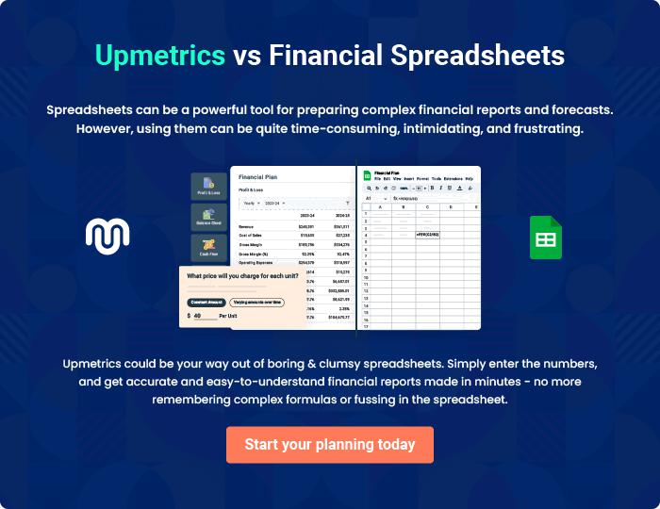
Appendix

When writing the appendix section, you should include any additional information that supports the main content of your plan. This may include financial statements, market research data, legal documents, and other
To unlock help try Upmetrics! 
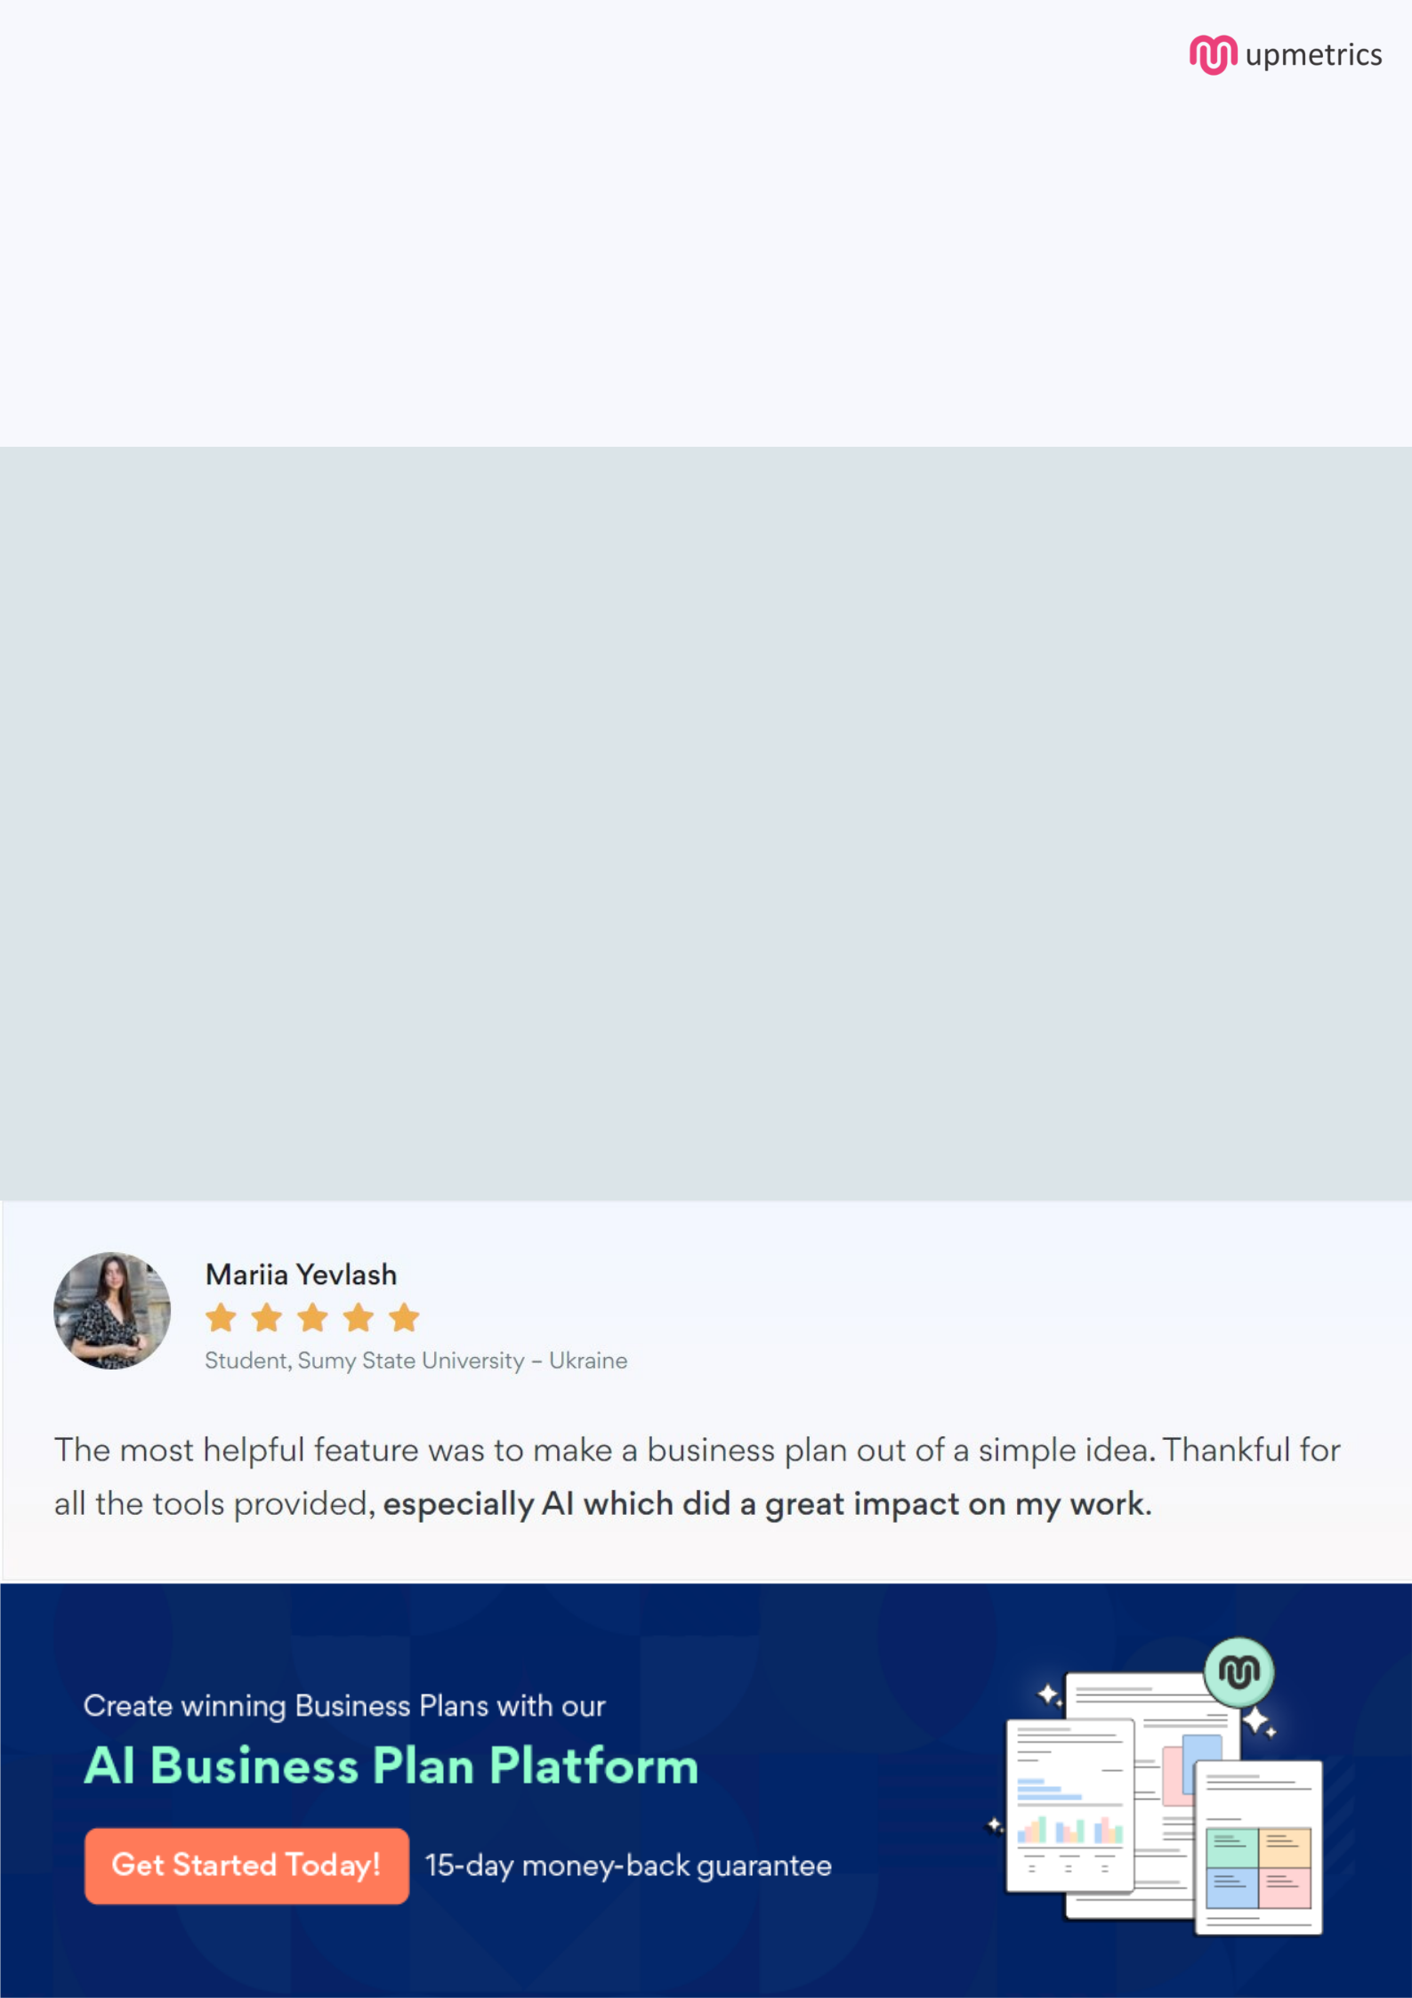
Create a winning business plan that gets you funded

Creating a stunning and investment-ready plan requires no writing, graphic designing, or financial planning expertise.

Upmetrics has all the features required to help you create a comprehensive business plan—from start to finish. Make no mistakes, it’s the modern way of planning to structure ideas, make plans, and create stunning pitch decks to awe investors.

Pitch decks that impress investors

Create pitch decks that provide a visual representation of your business, engage investors, and make them want to invest in your business idea.

Interactive plans in no time

Import business plan sections like—SWOT analysis, comparison tables, and others to create an interactive business plan. No designing skills are required.

Stunning cover page designs

With Upmetrics, you have the liberty to choose from multiple stunning cover page designs. Choose a creative design and make your plan stand out.

Online sharing made simple

Upmetrics makes online sharing quick and easier for users. Easily share your business plans with a link while tracking reader activity.

500+ sample business plans

Simply import a template from our library of sample plans into the editor and start customizing it to make it yours. It takes only a few clicks to get started.

Collaborate with team in real-time

Invite team members, initiate conversations, discuss ideas & strategies, share feedback, and work on a business plan in real-time.

