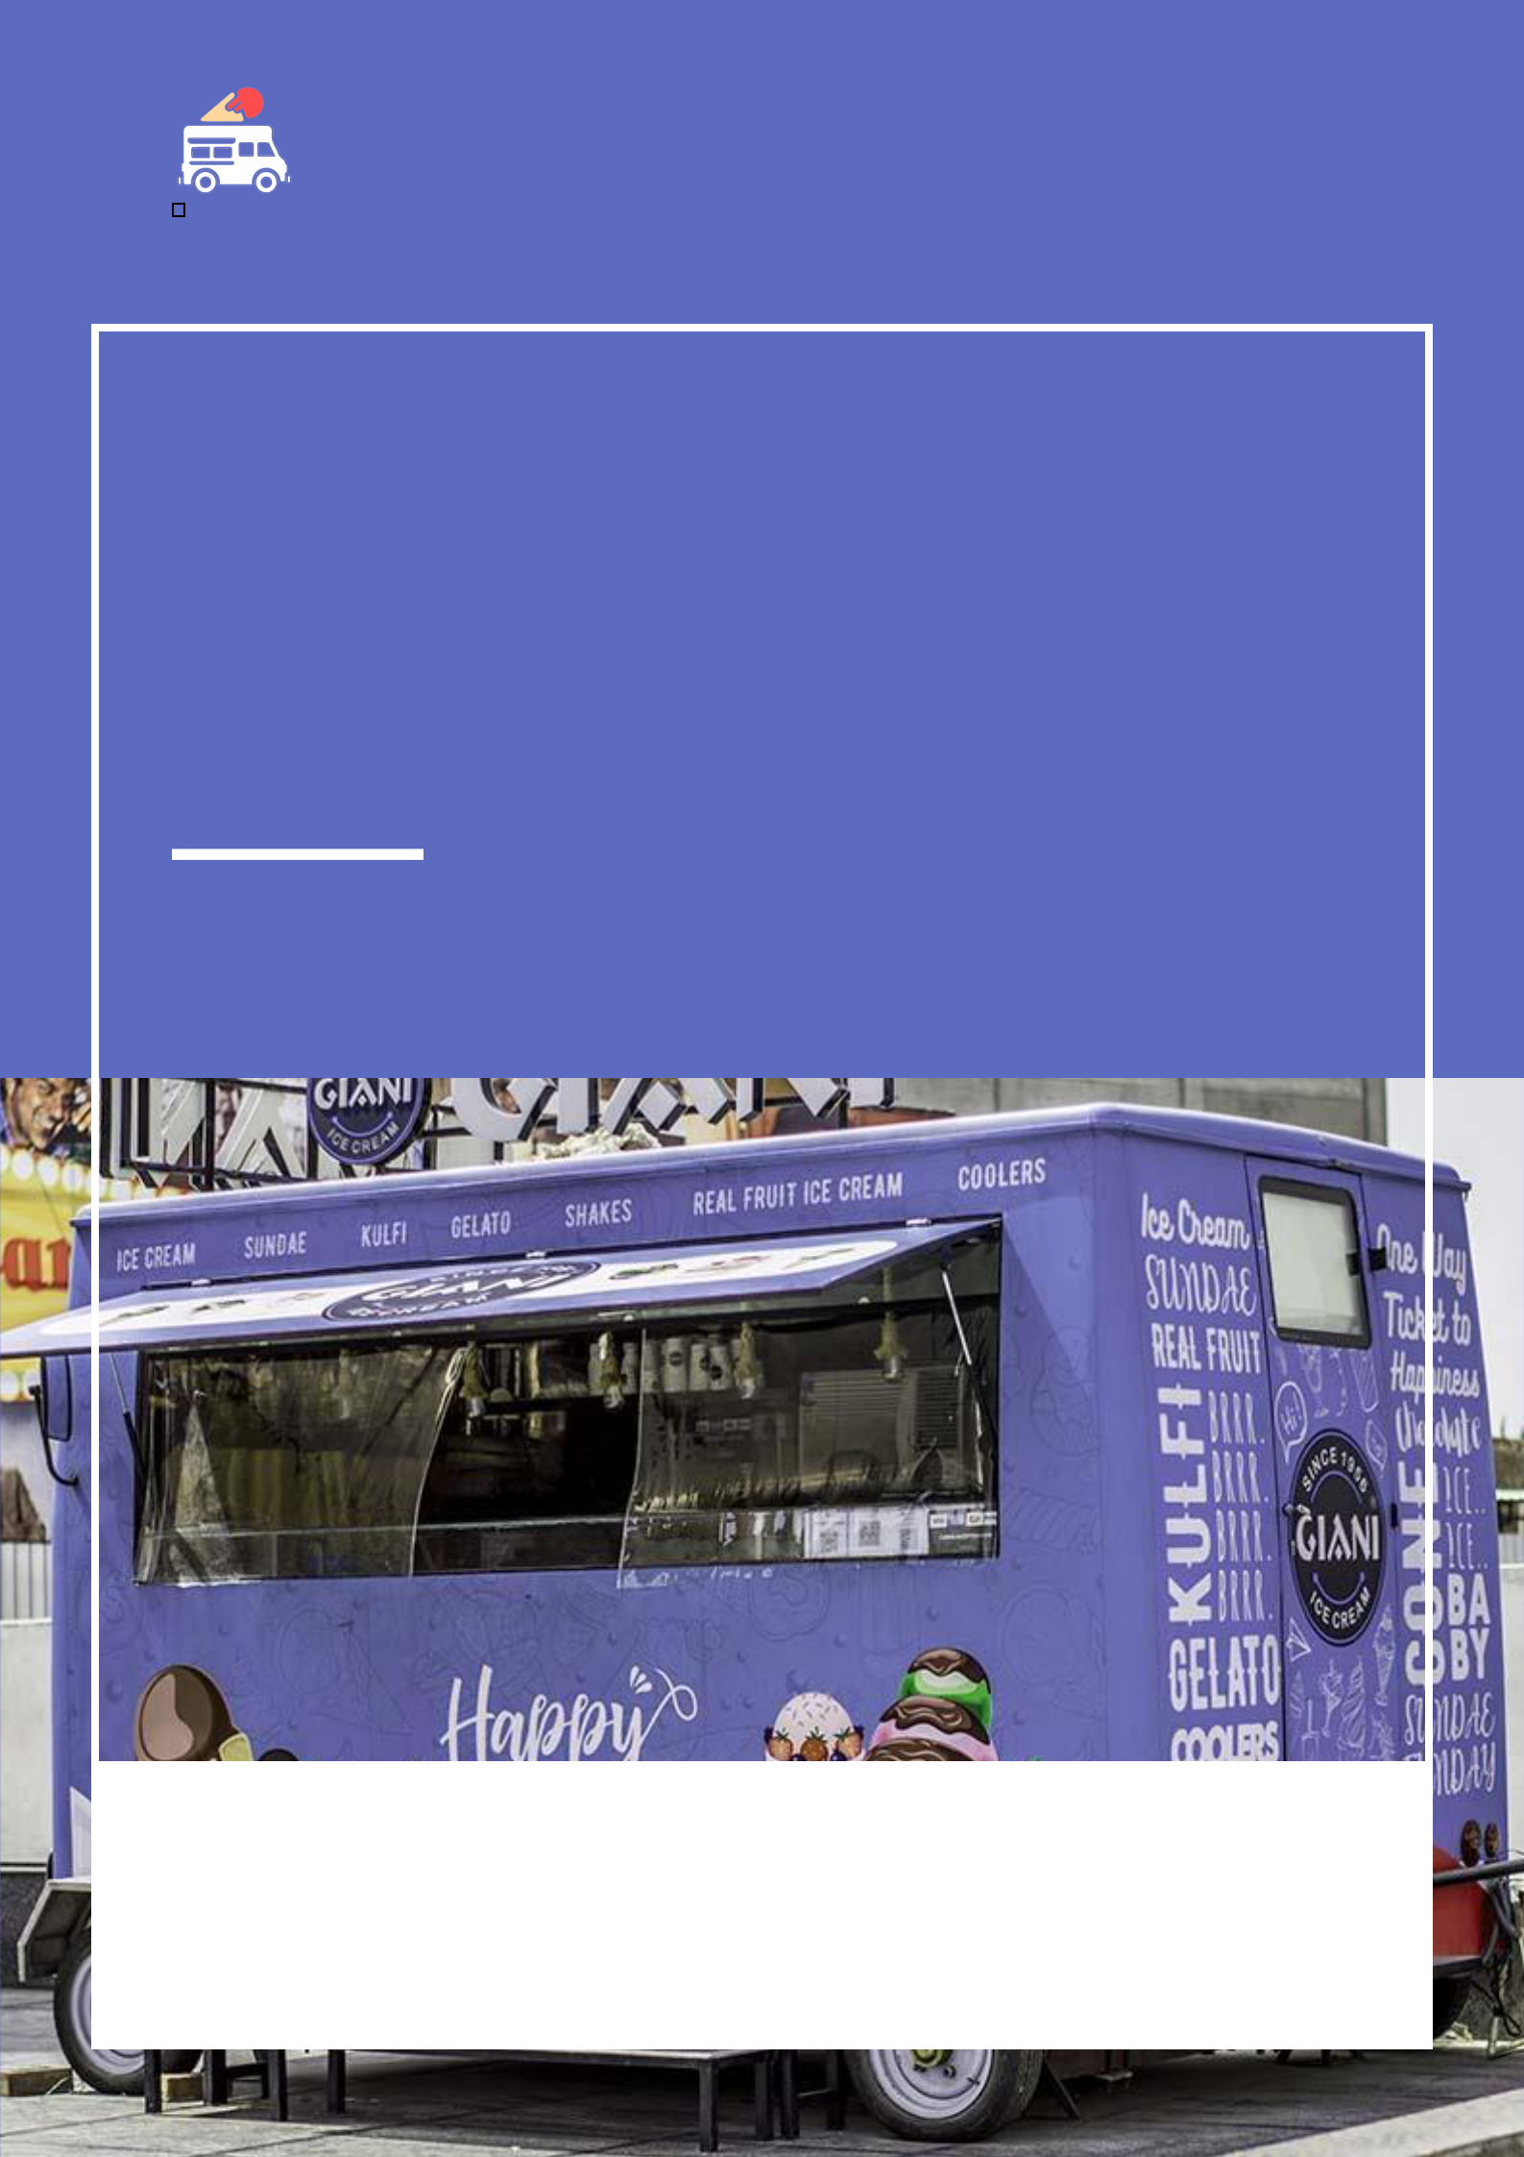
Ice Cream Truck Business Plan

BUSINESS PLAN

Joyful Ice Cream Journeys

Prepared By

John Doe

10200 Bolsa Ave, Westminster, CA, 92683

info@example.com

(650) 359-3153 http://www.example.com

Table of Contents

Executive Summary | 6
Market opportunity | 6
Services Offered | 6
Marketing and Sales Strategies | 7
Financial Highlights | 7
Units Sold v/s Revenue | 8

Company Overview | 9
Ownership | 9
Mission statement | 10
Business history | 10
Future goals | 10

Market Analysis | 11
Target Market | 11
Market size and growth potential | 11
Market Size | 12
Competitive analysis | 12
Sweet Treats on Wheels | 12
Frozen Delights Express | 13
Ice Cream Adventure | 13
Market trends | 13
Regulatory environment | 14

Products and Services | 15
Products | 15
Classic Ice Cream Cones | 16
Ice Cream Bars & Popsicles | 17
Soft Serve Ice Cream | 17
Gourmet Ice Cream | 18
Sundaes | 18
Product Sourcing | 19
Additional Services | 19

Sales And Marketing Strategies | 20
Unique Selling Proposition (USP) | 20
Pricing Strategy | 20
Marketing strategies | 21
Online | 21
Offline | 21
Sales strategies | 22
Customer retention | 23

Operations Plan | 24
Staffing & Training | 24
Operational Process | 24
Equipment & Machinery | 25

Management Team | 26
Key managers | 26
John Doe | 26
Jane Doe | 27
Alice Brown | 27
Robert Brown | 28
Organizational structure | 28
Organization chart | 29
Compensation plan | 29
Advisors/Consultants | 30
[ADVISOR NAME] | 30

Financial Plan | 31
Profit & loss statement | 31
Cash flow statement | 34
Balance sheet | 36
Break-even Analysis | 38
Financing needs | 40
Appendix
Appendix | 42
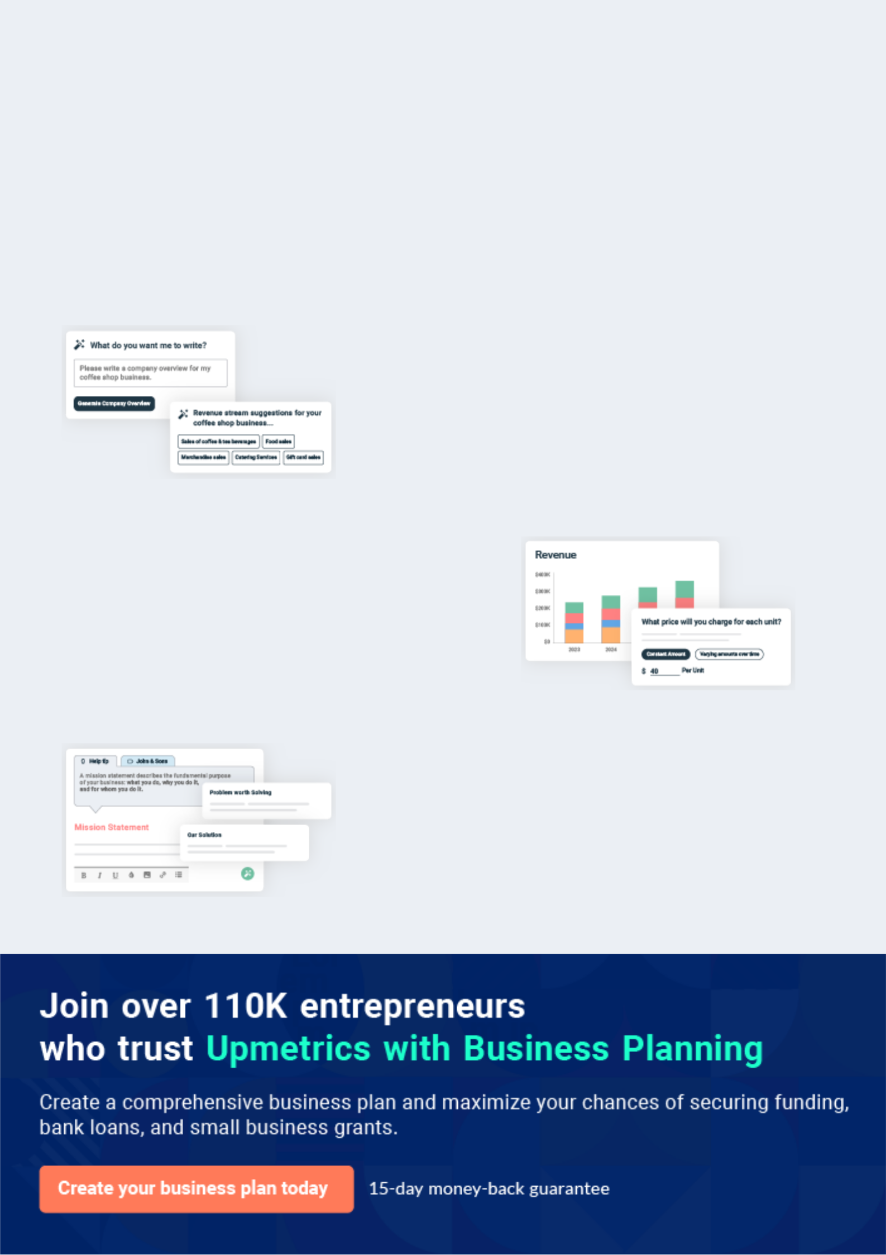
Business planning that’s simpler and faster than you think

Creating a business plan using Upmetrics to start and grow a business is literally the easiest thing in the World. Simply read the instructions and fill in the blanks. It’s as simple as that.

❛ | Upmetrics has everything you need to create a | ❜
❛ | comprehensive business plan. | ❜

AI-powered Upmetrics Assistant

AI-powered insights to streamline your plan

Not sure where to start? Upmetrics’ AI Assistant will automatically generate ideas for each section of your plan and offer improved versions of your writing, adjusting for tone, voice, and grammar or spelling errors.

Financial Forecasting Tool

All the financials are calculated for you

Forget the complex formulas and clumsy spreadsheets — with automatic financials and drag-and-drop forecasting, you can finish your plan faster and be confident that your numbers are accurate.

Business Plan Builder

Guides you like a business mentor

Upmetrics’ step-by-step instructions, prompts, and the library of 400+ sample business plans will guide you through each section of your plan as a business mentor.
Executive Summary


An executive summary is the first section of the business plan intended to provide an overview of the whole business plan.
To unlock help try Upmetrics! 

 Help tip  Ice Cream Truck Business Plan


Start your executive summary by briefly introducing your business to your readers.

This section may include the name of your ice cream truck business, its location, when it was
To unlock help try Upmetrics! 

Start writing here..

Market opportunity

 Help tip  Ice Cream Truck Business Plan

Summarize your market research, including market size, growth potential, and marketing trends. Highlight the opportunities in the market and how your business will fit in to fill the gap.
To unlock help try Upmetrics! 

Start writing here..

Services Offered

 Help tip  Ice Cream Truck Business Plan

Highlight the products you offer to your clients. The USPs and differentiators you offer are always a plus.
To unlock help try Upmetrics! 

Start writing here..

Marketing and Sales Strategies
To unlock help try Upmetrics!

 Help tip  Ice Cream Truck Business Plan

Outline your sales and marketing strategies—what marketing platforms you use, how you plan on acquiring customers, etc.
To unlock help try Upmetrics! 

Start writing here..

Financial Highlights

 Help tip  Ice Cream Truck Business Plan

Briefly summarize your financial projections for the initial years of business operations. Include any capital or investment requirements, associated startup costs, projected revenues, and profit forecasts.



Start writing here..
Units Sold v/s Revenue

 |  | Units Sold | Revenue
15.00k
10.00k
5.00k
0
Year 1 | Year 2 | Year 3
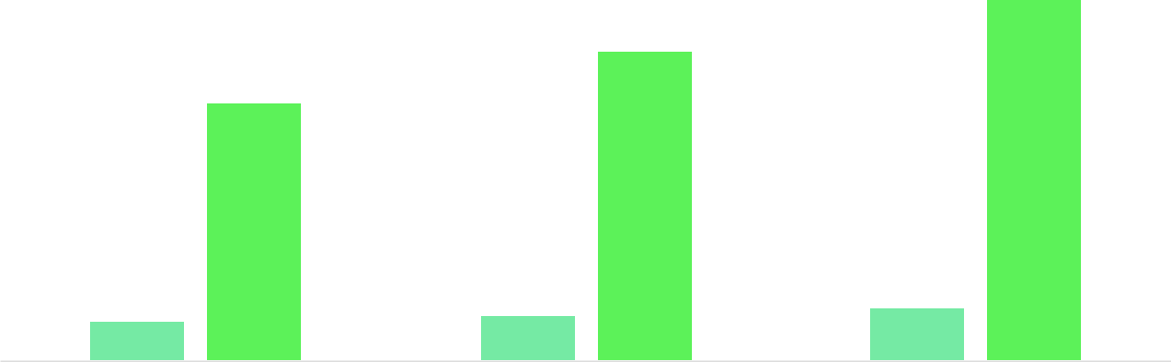

Financial Year |  |  | Units Sold | Revenue
Year 1 | 1,550 |  |  | $10,000
Year 2 | 1,800 |  |  | $12,000
Year 3 | 2,050 |  |  | $14,000
 Help tip |  |  Ice Cream Truck Business Plan


Summarize your executive summary section with a clear CTA, for example, inviting angel investors to discuss the potential business investment.
To unlock help try Upmetrics! 

Write a call to action for your business plan.
Company Overview

Depending on what details of your business are essential, you’ll need different elements in your business overview.
To unlock help try Upmetrics! 

 Help tip  Ice Cream Truck Business Plan

Describe your business in this section by providing all the basic information:

Describe what kind of ice cream truck you run and the name of it. You may specialize in one of
To unlock help try Upmetrics! 

Start writing here..

Ownership

 Help tip  Ice Cream Truck Business Plan

List the names of your ice cream truck company’s founders or owners. Describe what shares they own and their responsibilities for efficiently managing the business.
To unlock help try Upmetrics! 

Start writing here..
Mission statement

 Help tip  Ice Cream Truck Business Plan

Summarize your business’ objective, core principles, and values in your mission statement. This statement needs to be memorable, clear, and brief.
To unlock help try Upmetrics! 

❛ At [Chill on Wheels], we bring joy and sweetness to every corner
of [Location], serving up an array of high-quality, innovative frozen treats with a side of smiles and exceptional service.

We believe in creating memorable moments, fostering community connections, and ensuring that every customer leaves with a treat in hand and happiness in their heart.

❜

Business history

 Help tip  Ice Cream Truck Business Plan

If you’re an established ice cream truck service provider, briefly describe your business history, like—when it was founded, how it evolved over time, etc.
To unlock help try Upmetrics! 

Start writing here..

Future goals

 Help tip  Ice Cream Truck Business Plan

It’s crucial to convey your aspirations and vision. Mention your short-term and long-term goals; they can be specific targets for revenue, market share, or expanding your services.
To unlock help try Upmetrics! 

Start writing here..

Market Analysis
To unlock help try Upmetrics!


 |  | Market analysis provides a clear understanding of the market in which your
 |  | printing business will run along with the target market, competitors, and
 |  | growth opportunities.
 |  |  |  | To unlock help try Upmetrics! 
 Help tip |  |  Ice Cream Truck Business Plan

To write the introduction section of your market analysis, start by clearly identifying your primary target market.
To unlock help try Upmetrics! 

Start writing here..

Target Market

 Help tip  Ice Cream Truck Business Plan

Start this section by describing your target market. Define your ideal customer and explain what types of services they prefer. Creating a buyer persona will help you easily define your target market to your readers.



Start writing here..

Market size and growth potential

 Help tip  Ice Cream Truck Business Plan

Describe your market size and growth potential and whether you will target a niche or a much broader market.
To unlock help try Upmetrics! 

Start writing here..

Market Size

Available Market

Includes everyone in [Location] who 1M purchases ice cream.

Served Market
Residents and workers in our specific 300k service areas.

Target Market
Families, young adults, and corporate 50k employees in key locations.

 Help tip  Ice Cream Truck Business Plan

Identify and analyze your direct and indirect competitors. Identify their strengths and weaknesses, and describe what differentiates your ice cream truck business from them.
To unlock help try Upmetrics! 

Competitive analysis

Sweet Treats on Wheels

Sweet Treats on Wheels has been a popular choice in the [City/Area Name] for over a decade. They offer a wide variety of ice creams, including classic flavors and seasonal specialties. They operate in parks, community events, and are available for private parties.

Features | Strengths | Weaknesses
Extensive menu with over 50 | Well-established brand with a | Limited innovation in terms of
flavors | loyal customer base | flavors or serving methods
Seasonal and holiday specials | Strong presence in community | Older truck models, which might
Catering services for private | events | be less appealing to younger
Catering services for private |  | demographics
events | Extensive menu catering to all | demographics
 | age groups | Heavily reliant on seasonal
 |  | business

Frozen Delights Express

Frozen Delights Express is known for its quick service and prime location choices. They operate newer, more modern trucks and focus heavily on high-traffic areas.

Features | Strengths | Weaknesses
Fast service, even during peak | Efficient service, especially | Limited menu options
hours | appreciated during busy hours | Less focus on community
Modern, visually appealing | High visibility leads to | engagement, which might impact
trucks | increased impulse purchases | customer loyalty
Strategic location planning for | Modern trucks provide a fresh | Higher operating costs due to the
maximum visibility | and clean image | need for newer trucks and prime
 |  | locations

Ice Cream Adventure

Ice Cream Adventure focuses on providing a unique experience with their gourmet and artisanal ice cream flavors. They are popular among foodies and those looking for a premium ice cream experience.

Features | Strengths | Weaknesses
Gourmet and artisanal ice | Unique product offering in the | Less appeal to the mass market
cream flavors | market | or budget-conscious consumers
Premium pricing for a premium | Strong branding that appeals to | Limited product offerings might
product | a niche market | not appeal to children or
Strong branding focused on | Ability to charge premium | traditional ice cream lovers
quality and uniqueness | prices | Higher production costs due to
 |  | premium ingredients

Market trends

 Help tip  Ice Cream Truck Business Plan

Analyse emerging trends in the industry, such as changes in customer behavior or preferences, etc. Explain how your business will cope with all the trends.
To unlock help try Upmetrics! 

Start writing here..

Regulatory environment

 Help tip  Ice Cream Truck Business Plan

List regulations and licensing requirements that may affect your ice cream truck company, such as licensing & permits, health & safety regulations, insurance, etc.
To unlock help try Upmetrics! 

Start writing here..
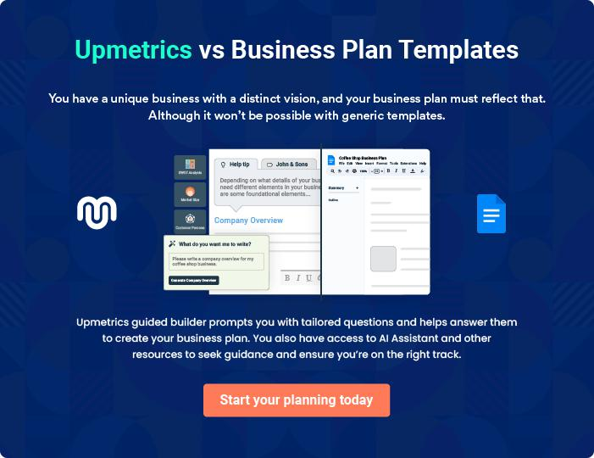
Products and Services

 |  | The product and services section of the ice cream truck business plan should
 |  | describe the specific services and products offered to customers. To write
 |  | this section should include the following:
 |  |  |  | To unlock help try Upmetrics! 
 Help tip |  |  Ice Cream Truck Business Plan

To craft the introduction for your "Products and Services" chapter, begin by positioning your business within its industry, emphasizing its unique strengths or value proposition.
To unlock help try Upmetrics! 

Start writing here..

 Help tip


Mention the ice cream truck products your business will offer. This list may include products like,
To unlock help try Upmetrics! 

Products
Classic Ice Cream Cones


Price: [$3.00 - $4.00]

A range of your favorite ice cream flavors served in a fresh, crispy cone. Perfect for a quick treat on a sunny day.

Specifications

- Flavors Available: Vanilla, Chocolate, Strawberry, Mint Chocolate Chip, Cookies & Cream

- Cone Types: Regular, Waffle (+$1.00)

- Serving Size: Single scoop (with the option to add additional scoops for [$1.00] each)

- Toppings: Sprinkles, Chocolate Chips, Nuts (Additional [$0.50] each)
Ice Cream Bars & Popsicles

Price: [$2.00 - $3.50]

A selection of pre-packaged ice cream bars and popsicles for an on-the-go, mess-free experience.

Specifications

- Options: Classic Ice Cream Bars, Fruit Popsicles, Gelato Bars

- Flavors: Various, including seasonal and limited-edition options

- Packaging: Individually wrapped for convenience and hygiene

Soft Serve Ice Cream

Price: [$3.00 - $4.50]

Creamy, smooth soft serve ice cream available in a variety of flavors and served in a cone or cup.

Specifications

- Flavors: Vanilla, Chocolate, Swirl

- Serving Options: Cone or Cup

- Sizes: Small, Medium, Large

- Toppings: Hot Fudge, Caramel, Sprinkles, Whipped Cream (Additional [$0.50] each)
Gourmet Ice Cream

Price: [$4.50 - $6.00]

Indulge in our premium range of gourmet ice cream flavors, made with high-quality ingredients and unique combinations.

Specifications

- Flavors: Lavender Honey, Bourbon Vanilla Bean, Salted Caramel Pretzel, and more

- Serving Size: Single scoop (with the option to add additional scoops for [$2.00] each)

- Toppings: Gourmet options available including hand-crafted sauces and luxury sprinkles (Additional [$1.00] each)

Sundaes

Price: [$5.00 - $7.00]

Our sundaes are a delightful treat, with layers of ice cream, toppings, and sauces, creating a dessert experience like no other

Specifications

- Flavors: Customer’s choice of any available ice cream flavors

- Sizes: Regular, Large

- Included Toppings: Whipped Cream, Nuts, Cherry on Top

- Extra Toppings: Choice of 3 additional toppings included; extra toppings available for [$0.50] each
Product Sourcing

 Help tip  Ice Cream Truck Business Plan

In all descriptions of services, emphasize the importance of safety and quality.

Explain how your printing house will ensure that all services are delivered with the highest
To unlock help try Upmetrics! 

Start writing here..

Additional Services

 Help tip  Ice Cream Truck Business Plan

Include information about the kinds of events you cater and the services you offer in this section if you provide catering or event services.
To unlock help try Upmetrics! 

Start writing here..
Sales And Marketing Strategies

Writing the sales and marketing strategies section means a list of strategies you will use to attract and retain your clients.
To unlock help try Upmetrics! 

 Help Tip  Ice Cream Truck Business Plan


To create an effective introduction for your "Sales and Marketing Strategies" chapter, start by setting the stage within your specific industry or market.
To unlock help try Upmetrics! 

Start writing here..

Unique Selling Proposition (USP)

 Help tip  Ice Cream Truck Business Plan

Define your business’s USPs depending on the market you serve, the equipment you use, and the unique services you provide. Identifying USPs will help you plan your marketing strategies.
To unlock help try Upmetrics! 

Start writing here..

Pricing Strategy

 Help tip  Ice Cream Truck Business Plan

Describe your pricing strategy—how you plan to price your products and stay competitive in the local market. You can mention any discounts you plan on offering to attract new customers.
To unlock help try Upmetrics! 

Start writing here..

 Help tip  Ice Cream Truck Business Plan
To unlock help try Upmetrics!

Discuss your marketing strategies to market your services. You may include some of these marketing strategies in your business plan—social media marketing, content marketing, and print marketing.



Marketing strategies

Online


Social Media

Utilizing platforms such as Instagram, Facebook, and Twitter to share updates, promotions, and engage with our community.

Content Marketing

Creating and sharing engaging content, including blogs, videos, and infographics, to educate our audience about our products and values.

Offline

Brochures

Detailed informational brochures available at our outlets and events.

Events

Email Marketing

Regular newsletters and updates to our subscriber base.

Print Marketing

Distributing flyers and brochures in strategic locations and during community events to increase visibility.

Local Partnerships

Participation in [specific events, e.g., "industry trade shows and local tech fairs"].

Collaborating with local businesses and organizations for cross-promotional opportunities.

 Help tip  Ice Cream Truck Business Plan

Outline the strategies you’ll implement to maximize your sales. Your sales strategies may include partnering with other businesses, offering referral programs, coupons, etc.
To unlock help try Upmetrics! 

Sales strategies

Strategic Location Planning

Utilizing data and local insights to position our ice cream truck in high-traffic and high-visibility areas.

Referral Programs

Implementing a referral program to encourage satisfied customers to refer new clients, rewarding them with discounts or free products.

Event Bookings

Actively seeking and securing bookings for private and corporate events to generate additional revenue streams.

 Help tip  Ice Cream Truck Business Plan

Describe your customer retention strategies and how you plan to execute them. For instance, introducing loyalty programs, discounts on bulk orders, personalized service, etc.
To unlock help try Upmetrics! 

Customer retention

Loyalty Programs

Offering a loyalty program that rewards frequent purchases, encouraging customers to choose [Chill on Wheels] time and time again

Personalized Service

Taking note of regular customers’ preferences to provide a personalized service experience.

Feedback and Improvement

Actively seeking customer feedback and using it to continually improve our products and services.

Operations Plan
To unlock help try Upmetrics!

 |  | When writing the operations plan section, it’s important to consider the
 |  | various aspects of your business operations.
 |  |  |  | To unlock help try Upmetrics! 
 Help tip |  |  Ice Cream Truck Business Plan


To create an effective introduction for your "Operational Plan" chapter, start by emphasizing the
pivotal role of efficient operations in the success of your business, underscoring how they
directly impact the quality of services delivered.
 |  |  |  | To unlock help try Upmetrics! 
Start writing here..
Staffing & Training
 Help tip |  |  Ice Cream Truck Business Plan

Mention your business’s staffing requirements, including the number of employees, cashiers, or
food preparation staff needed. Include their qualifications, the training required, and the duties
they will perform.
 |  |  |  | To unlock help try Upmetrics! 
Start writing here..
Operational Process
 Help tip |  |  Ice Cream Truck Business Plan

Outline the processes and procedures you will use to run your ice cream truck business. Your operational processes may include menu planning, driving to locations, preparing food, ordering materials, etc.



Start writing here..

Equipment & Machinery

 Help tip  Ice Cream Truck Business Plan

Include the list of equipment and machinery required for an ice cream truck business, such as ice cream trucks, refrigerators, utensils, etc.
To unlock help try Upmetrics! 

Start writing here..
Management Team

The management team section provides an overview of the individuals responsible for running your business plan.
To unlock help try Upmetrics! 

 Help tip  Ice Cream Truck Business Plan

To craft an introduction for your "Management Team" chapter, begin by emphasizing the crucial role of leadership in the success of any business.
To unlock help try Upmetrics! 

Start writing here..

Key managers

 Help tip  Ice Cream Truck Business Plan

Introduce your management and key members of your team, and explain their roles and responsibilities.
To unlock help try Upmetrics! 

Start writing here..


JOHN DOE

CEO - john.doe@example.com

The visionary behind [Chill on Wheels], our Founder and CEO plays a pivotal role in steering the company towards success.


JANE DOE

Inventory Manager - jane.doe@example.com

Jane brings over a decade of experience in inventory management and supply chain logistics to [Chill on Wheels].

Her expertise in negotiating with suppliers and managing inventory levels ensures that our ice cream truck is always stocked with the freshest and highest-quality products.


- Educational Background: Jane holds a Bachelor’s degree in Business Administration with a specialization in Supply Chain Management from [University Name].

- Professional Background: Before joining [Chill on Wheels], Jane worked as a Senior Inventory Analyst at [Previous Company Name], where she successfully managed inventory for a large retail chain, significantly reducing wastage and improving supply chain efficiency.


ALICE BROWN

Operations Manager - alice.brown@example.com

Alice is the driving force behind the seamless day-to-day operations of [Chill on Wheels].

Her strong leadership skills and extensive experience in operations management ensure that our staff is motivated, our customers are satisfied, and our business runs efficiently.

- Educational Background: Alice has a Master’s degree in Operations Management from [University Name].

- Professional Background: Alice has over eight years of experience in the food and beverage industry, having previously held the position of Assistant Operations Manager at [Previous Company Name], where she was instrumental in improving operational workflows and customer service standards.

ROBERT BROWN

Marketing Manager - robert.brown@example.com

Robert is our creative genius, responsible for developing innovative marketing strategies that put [Chill on Wheels] on the map.

His knack for identifying market trends and his expertise in digital marketing have been crucial in building our brand’s presence and driving sales.

- Educational Background: Robert earned his Bachelor’s degree in Marketing from [University Name], with a focus on digital marketing and brand management.

- Professional Background: With over six years of experience in marketing within the food industry, Robert has a proven track record of successful campaign management and brand development.

He previously worked as a Marketing Specialist at [Previous Company Name], where he led numerous successful promotional campaigns.

Organizational structure

 Help tip  Ice Cream Truck Business Plan

Explain the organizational structure of your management team. Include the reporting line and decision-making hierarchy.
To unlock help try Upmetrics! 

Start writing here..
Organization chart


John Doe

CEO


Alice Brown

Robert Brown

Jane Doe

Operations Manager


Marketing Manager


Inventory Manager

Maria Smith | James White
Maria Smith | Sales and Event
Inventory Manager | Sales and Event
Inventory Manager | Coordinator


Compensation plan

 Help tip  Ice Cream Truck Business Plan

Describe your compensation plan for the management and staff. Include their salaries, incentives, and other benefits.
To unlock help try Upmetrics! 

Start writing here..

 Help tip  Ice Cream Truck Business Plan

Mentioning advisors or consultants in your business plans adds credibility to your business idea.
To unlock help try Upmetrics! 

Advisors/Consultants


[ADVISOR NAME]

Advisor

- [Advisor’s Name], providing expertise in [Area of Expertise].

- [Brief description of their experience, credentials, and any relevant industry involvement.]
Financial Plan

When writing the financial plan section of a business plan, it’s important to provide a comprehensive overview of your financial projections for the first few years of your business, You may provide the following:
To unlock help try Upmetrics! 

 Help tip  Ice Cream Truck Business Plan


To create an effective introduction for your "Financial Plan" chapter, begin by stressing the critical role of a well-structured financial plan in the success of your venture.
To unlock help try Upmetrics! 

Start writing here..

 Help tip  Ice Cream Truck Business Plan

Describe details such as projected revenue, operational costs, and service costs in your projected profit and loss statement. Make sure to include your business’s expected net profit or loss.
To unlock help try Upmetrics! 

Profit & loss statement

Revenue

Cost Of Sales

General Costs

Revenue Specific Costs

Personnel Costs (Direct

Labor)

Gross Margin

Gross Margin (%)

Operating Expense

Payroll Expense

(Indirect Labor)

General Expense

Bad Debt

Amortization of Current

Assets

2023-24 | 2024-25 | 2025-26 | 2026-27 | 2027-28
$0 | $0 | $0 | $0 | $0

$0 | $0 | $0 | $0 | $0
$0 | $0 | $0 | $0 | $0
$0 | $0 | $0 | $0 | $0
$0 | $0 | $0 | $0 | $0

$0 | $0 | $0 | $0 | $0
0% | 0% | 0% | 0% | 0%

$0 | $0 | $0 | $0 | $0
$0 | $0 | $0 | $0 | $0
$0 | $0 | $0 | $0 | $0
$0 | $0 | $0 | $0 | $0
$0 | $0 | $0 | $0 | $0

EBITDA

Additional Expense

Long Term

Depreciation

Gain or loss from Sale

of Assets

EBIT

Interest Expenses

EBT

Income Tax Expense

Total Expense

Net Income

Net Income (%)

2023-24 | 2024-25 | 2025-26 | 2026-27 | 2027-28
$0 | $0 | $0 | $0 | $0
$0 | $0 | $0 | $0 | $0
$0 | $0 | $0 | $0 | $0
$0 | $0 | $0 | $0 | $0
$0 | $0 | $0 | $0 | $0
$0 | $0 | $0 | $0 | $0
$0 | $0 | $0 | $0 | $0
$0 | $0 | $0 | $0 | $0
$0 | $0 | $0 | $0 | $0
$0 | $0 | $0 | $0 | $0
0% | 0% | 0% | 0% | 0%

 |  |  | 2023-24 |  | 2024-25 | 2025-26
Retained Earning |  |  | $0 |  | $0 | $0
Opening |  |  |  |  | $0 | $0
Owner's Distribution |  |  | $0 |  | $0 | $0
Retained Earning |  |  | $0 |  | $0 | $0
Closing |  |  |  |  | $0 | $0
 Help tip |  |  |  Ice Cream Truck Business Plan


The cash flow for the first few years of your operation should be estimated and described in this section.

This may include billing invoices, payment receipts, loan payments, and any other cash flow statements.
2026-27 2027-28

$0 $0

$0 $0

$0 $0

To unlock help try Upmetrics! 

Cash flow statement

 | 2023-24 | 2024-25 | 2025-26 | 2026-27 | 2027-28
Cash Received | $0 | $0 | $0 | $0 | $0
Cash Paid | $0 | $0 | $0 | $0 | $0
COS & General Expenses | $0 | $0 | $0 | $0 | $0
Salary & Wages | $0 | $0 | $0 | $0 | $0
Interest | $0 | $0 | $0 | $0 | $0

Sales Tax

Income Tax

Net Cash From

Operations

Assets Sell

Assets Purchase

Net Cash From

Investments

Amount Received

Loan Received

Common Stock

Preferred Stock

Owner's Contribution

Amount Paid

2023-24 | 2024-25 | 2025-26 | 2026-27 | 2027-28
$0 | $0 | $0 | $0 | $0
$0 | $0 | $0 | $0 | $0
$0 | $0 | $0 | $0 | $0

$0 | $0 | $0 | $0 | $0
$0 | $0 | $0 | $0 | $0
$0 | $0 | $0 | $0 | $0

$0 | $0 | $0 | $0 | $0
$0 | $0 | $0 | $0 | $0

$0 | $0 | $0 | $0 | $0
$0 | $0 | $0 | $0 | $0
$0 | $0 | $0 | $0 | $0

Loan Capital $0 $0 $0 $0 $0

 |  |  | 2023-24 |  | 2024-25 | 2025-26 | 2026-27 | 2027-28
Dividends & Distributions |  |  | $0 |  | $0 | $0 | $0 | $0
Net Cash From |  |  | $0 |  | $0 | $0 | $0 | $0
Financing
Summary
Starting Cash |  |  | $0 |  | $0 | $0 | $0 | $0
Cash In |  |  | $0 |  | $0 | $0 | $0 | $0
Cash Out |  |  | $0 |  | $0 | $0 | $0 | $0
Change in Cash |  |  | $0 |  | $0 | $0 | $0 | $0
Ending Cash |  |  | $0 |  | $0 | $0 | $0 | $0
 Help tip |  |  Ice Cream Truck Business Plan

Create a projected balance sheet documenting your ice cream truck business’s assets, liabilities, and equity.

To unlock help try Upmetrics! 

Balance sheet

 | 2023-24 | 2024-25 | 2025-26 | 2026-27 | 2027-28
Assets | $0 | $0 | $0 | $0 | $0
Current Assets | $0 | $0 | $0 | $0 | $0
Cash | $0 | $0 | $0 | $0 | $0
Accounts Receivable | $0 | $0 | $0 | $0 | $0
Inventory | $0 | $0 | $0 | $0 | $0
Other Current Assets | $0 | $0 | $0 | $0 | $0
Long Term Assets | $0 | $0 | $0 | $0 | $0
Gross Long Term Assets | $0 | $0 | $0 | $0 | $0
Accumulated Depreciation | $0 | $0 | $0 | $0 | $0

Liabilities & Equity | $0 | $0 | $0 | $0 | $0
Liabilities | $0 | $0 | $0 | $0 | $0
Current Liabilities | $0 | $0 | $0 | $0 | $0
Accounts Payable | $0 | $0 | $0 | $0 | $0
Income Tax Payable | $0 | $0 | $0 | $0 | $0
Sales Tax Payable | $0 | $0 | $0 | $0 | $0
Short Term Debt | $0 | $0 | $0 | $0 | $0
 | 2023-24 | 2024-25 | 2025-26 | 2026-27 | 2027-28
Long Term Liabilities | $0 | $0 | $0 | $0 | $0
Long Term Debt | $0 | $0 | $0 | $0 | $0
Equity | $0 | $0 | $0 | $0 | $0
Paid-in Capital | $0 | $0 | $0 | $0 | $0
Common Stock | $0 | $0 | $0 | $0 | $0
Preferred Stock | $0 | $0 | $0 | $0 | $0
Owner's Contribution | $0 | $0 | $0 | $0 | $0
Retained Earnings | $0 | $0 | $0 | $0 | $0

Check | $0 |  |  | $0 | $0 | $0 | $0
 Help tip |  |  Ice Cream Truck Business Plan

Determine and mention your business’s break-even point—the point at which your business costs and revenue will be equal.

This exercise will help you understand how much revenue you need to generate to sustain or be profitable.
To unlock help try Upmetrics! 

Break-even Analysis

 | 2023-24 | 2024-25 | 2025-26 | 2026-27 | 2027-28
Starting Revenue | $0 | $0 | $0 | $0 | $0
Net Revenue | $0 | $0 | $0 | $0 | $0
Closing Revenue | $0 | $0 | $0 | $0 | $0

Starting Expense | $0 | $0 | $0 | $0 | $0
Net Expense | $0 | $0 | $0 | $0 | $0
Closing Expense | $0 | $0 | $0 | $0 | $0

Is Break Even? | 0 | 0 | 0 | 0 | 0
Break Even Month | 0 | 0 | 0 | 0 | 0
Days Required | 0 | 0 | 0 | 0 | 0
Break Even Revenue | $0 | $0 | $0 | $0 | $0
Break Even Units
Financing needs

 Help tip  Ice Cream Truck Business Plan

Calculate costs associated with starting an ice cream truck business, and estimate your financing needs and how much capital you need to raise to operate your business.
To unlock help try Upmetrics! 

Start writing here..
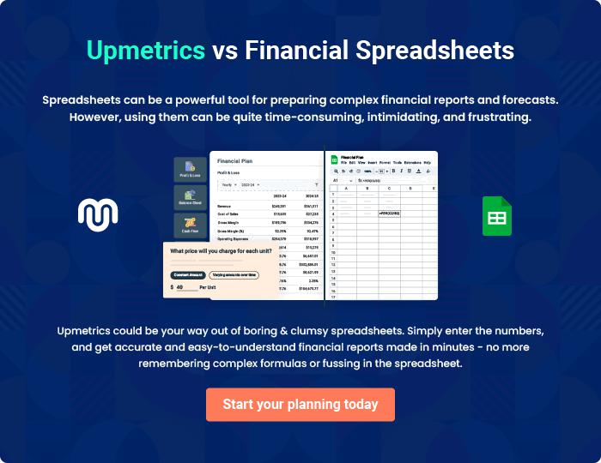
Appendix

When writing the appendix section, you should include any additional information that supports the main content of your plan. This may include financial statements, market research data, legal documents, and other
To unlock help try Upmetrics! 
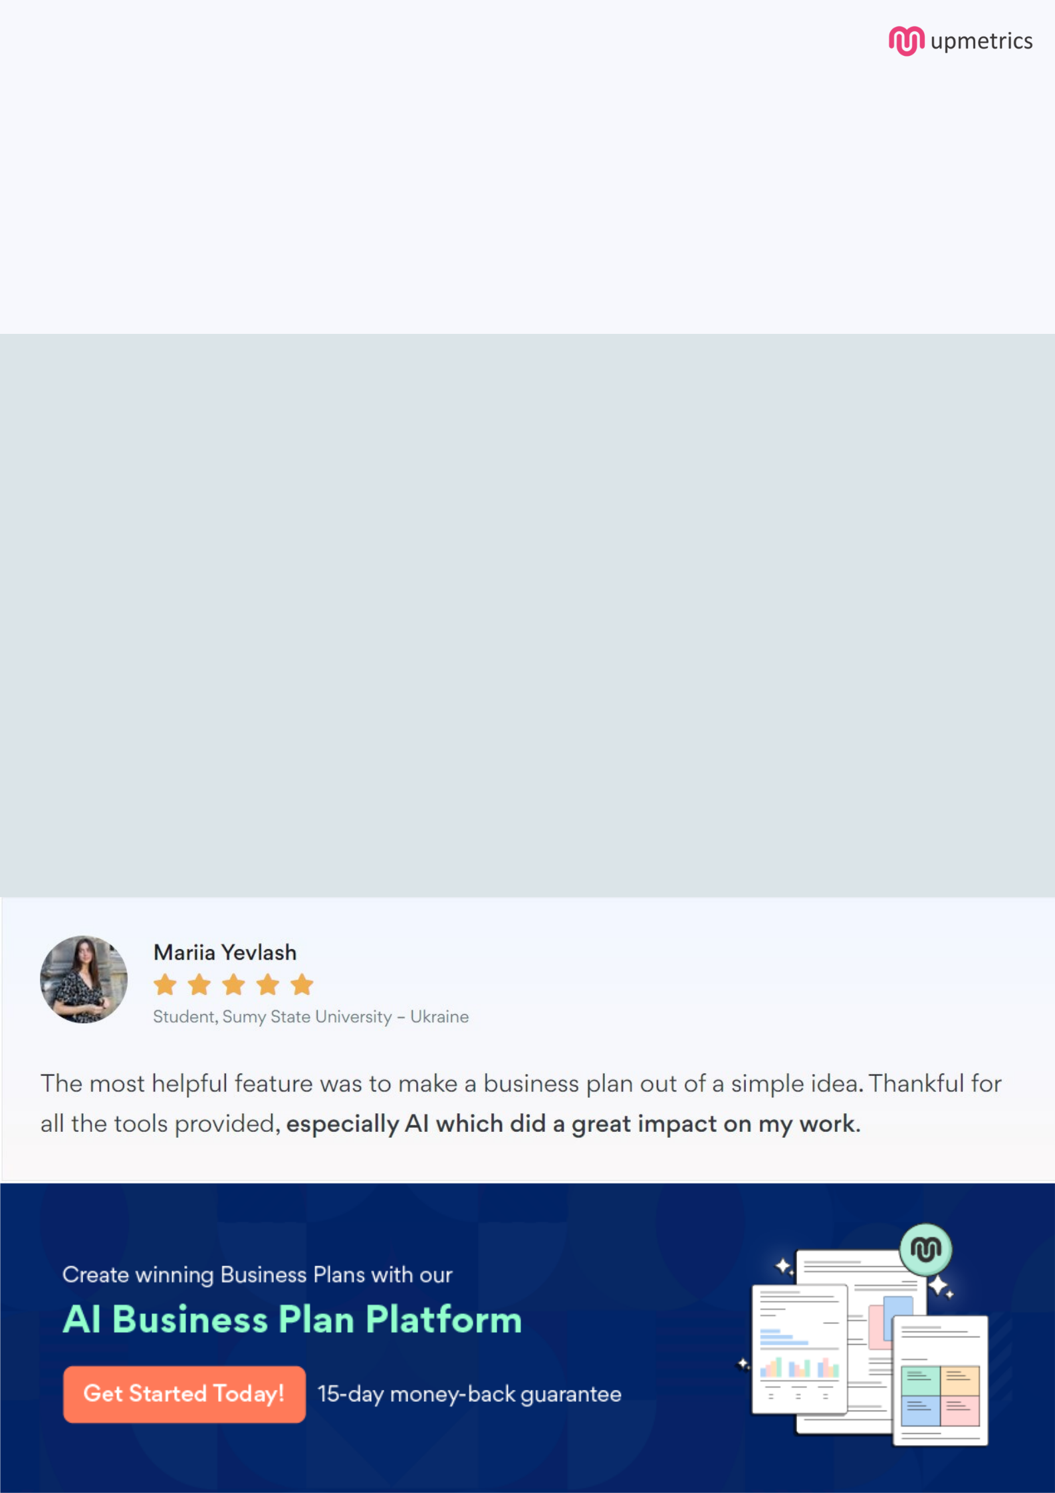
Create a winning business plan that gets you funded

Creating a stunning and investment-ready plan requires no writing, graphic designing, or financial planning expertise.

Upmetrics has all the features required to help you create a comprehensive business plan—from start to finish. Make no mistakes, it’s the modern way of planning to structure ideas, make plans, and create stunning pitch decks to awe investors.

Pitch decks that impress investors

Create pitch decks that provide a visual representation of your business, engage investors, and make them want to invest in your business idea.

Interactive plans in no time

Import business plan sections like—SWOT analysis, comparison tables, and others to create an interactive business plan. No designing skills are required.

Stunning cover page designs

With Upmetrics, you have the liberty to choose from multiple stunning cover page designs. Choose a creative design and make your plan stand out.

Online sharing made simple

Upmetrics makes online sharing quick and easier for users. Easily share your business plans with a link while tracking reader activity.

500+ sample business plans

Simply import a template from our library of sample plans into the editor and start customizing it to make it yours. It takes only a few clicks to get started.

Collaborate with team in real-time

Invite team members, initiate conversations, discuss ideas & strategies, share feedback, and work on a business plan in real-time.

