
Hot Dog Cart Business Plan

BUSINESS PLAN

Sizzling Taste on Wheels

Prepared By

John Doe

10200 Bolsa Ave, Westminster, CA, 92683

info@example.com

(650) 359-3153 http://www.example.com

Table of Contents

Executive Summary | 6
Market opportunity | 6
Hot Dog Menu | 6
Marketing & Sales Strategies | 7
Financial Highlights | 7
Units Sold v/s Revenue | 8

Company Overview | 9
Ownership | 9
Mission statement | 10
Business history | 10
Future goals | 10

Market Analysis | 11
Target Market | 11
Market size and growth potential | 11
Market Size | 12
Competitive analysis | 12
Hot Dog Haven | 12
City Sausage Stands | 13
Market trends | 13
Regulatory environment | 13

Products and Services | 15
Products | 15
Classic Downtown Dog | 15
Truffle Delight Dog | 16
Vegan Veggie Dog | 16
Crispy French Fries | 16
Artisanal Iced Tea Blend | 17
Classic Downtown Dog + Fries + Drink | 17
Side Items and Beverages | 17
Quality Measures | 18
Additional Offerings | 18

Sales And Marketing Strategies | 19
Unique Selling Proposition (USP) | 19
Pricing Strategy | 19
Marketing strategies | 20
Online | 20
Offline | 20
Sales strategies | 21
Customer retention | 21

Operations Plan | 22
Staffing & Training | 22
Operational Process | 22
Kitchen Equipment & Machinery | 23

Management Team | 24
Key managers | 24
John Doe | 24
Jane Doe | 25
Alice Brown | 25
Robert Brown | 25
Organizational structure | 25
Organization chart | 26
Compensation plan | 26
Advisors/Consultants | 27
[ADVISOR NAME] | 27
[CONSULTANT NAME] | 27
Financial Plan
Financial Plan | 28

Profit & loss statement 28

Cash flow statement | 31
Balance sheet | 33
Break-even Analysis | 35
Financing needs | 37
Appendix
Appendix | 39
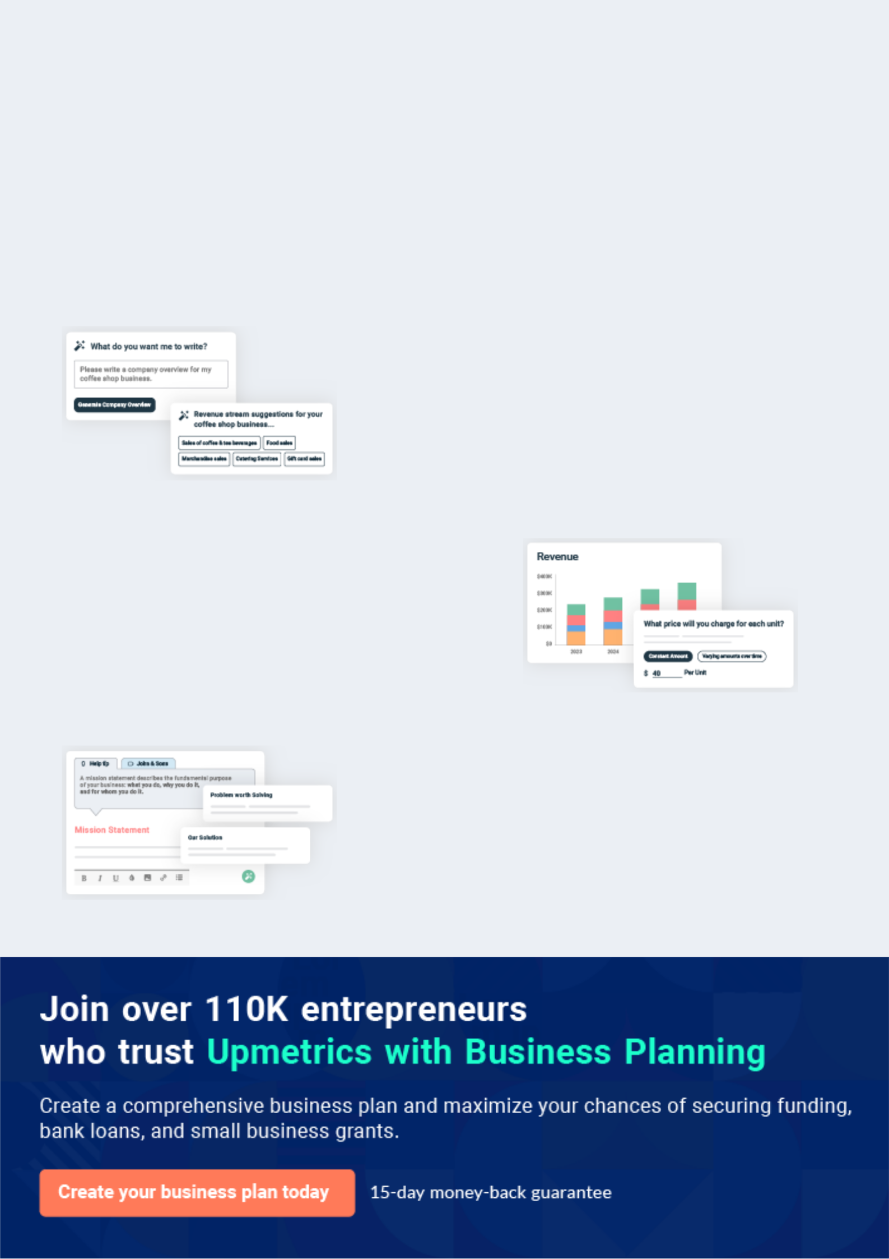
Business planning that’s simpler and faster than you think

Creating a business plan using Upmetrics to start and grow a business is literally the easiest thing in the World. Simply read the instructions and fill in the blanks. It’s as simple as that.

❛ | Upmetrics has everything you need to create a | ❜
❛ | comprehensive business plan. | ❜

AI-powered Upmetrics Assistant

AI-powered insights to streamline your plan

Not sure where to start? Upmetrics’ AI Assistant will automatically generate ideas for each section of your plan and offer improved versions of your writing, adjusting for tone, voice, and grammar or spelling errors.

Financial Forecasting Tool

All the financials are calculated for you

Forget the complex formulas and clumsy spreadsheets — with automatic financials and drag-and-drop forecasting, you can finish your plan faster and be confident that your numbers are accurate.

Business Plan Builder

Guides you like a business mentor

Upmetrics’ step-by-step instructions, prompts, and the library of 400+ sample business plans will guide you through each section of your plan as a business mentor.
Executive Summary


An executive summary is the first section of the business plan intended to provide an overview of the whole business plan.
To unlock help try Upmetrics! 

 Help tip  Hot Dog Cart Business Plan


Start your executive summary by briefly introducing your business to your readers.

This section may include the name of your hot dog cart business, its location, when it was
To unlock help try Upmetrics! 

Start writing here..

Market opportunity

 Help tip  Hot Dog Cart Business Plan

Summarize your market research, including market size, growth potential, and marketing trends. Highlight the opportunities in the market and how your business will fit in to fill the gap.
To unlock help try Upmetrics! 

Start writing here..

Hot Dog Menu

 Help tip  Hot Dog Cart Business Plan

Highlight the variety of hotdogs you offer to your customers. You may also mention any additional services you provide.
To unlock help try Upmetrics! 

Start writing here..

Marketing & Sales Strategies
To unlock help try Upmetrics!

 Help tip  Hot Dog Cart Business Plan

Outline your sales and marketing strategies—what marketing platforms you use, how you plan on acquiring customers, etc.
To unlock help try Upmetrics! 

Start writing here..

Financial Highlights

 Help tip  Hot Dog Cart Business Plan

Briefly summarize your financial projections for the initial years of business operations. Include any capital or investment requirements, associated startup costs, projected revenues, and profit forecasts.



Start writing here..
Units Sold v/s Revenue

 |  | Units Sold | Revenue
15.00k
10.00k
5.00k
0
Year 1 | Year 2 | Year 3


Financial Year |  |  | Units Sold | Revenue
Year 1 | 1,550 |  |  | $10,000
Year 2 | 1,800 |  |  | $12,000
Year 3 | 2,050 |  |  | $14,000
 Help tip |  |  Hot Dog Cart Business Plan


Summarize your executive summary section with a clear CTA, for example, inviting angel investors to discuss the potential business investment.
To unlock help try Upmetrics! 

Write a call to action for your business plan.
Company Overview

Depending on what details of your business are essential, you’ll need different elements in your business overview.
To unlock help try Upmetrics! 

 Help tip  Hot Dog Cart Business Plan

Describe your business in this section by providing all the basic information:

Describe what kind of hot dog cart you run and the name of it. You may specialize in one of the
To unlock help try Upmetrics! 

Start writing here..

Ownership

 Help tip  Hot Dog Cart Business Plan

List the names of your hot dog cart founders or owners. Describe what shares they own and their responsibilities for efficiently managing the business.
To unlock help try Upmetrics! 

Start writing here..
Mission statement

 Help tip  Hot Dog Cart Business Plan

Summarize your business’ objective, core principles, and values in your mission statement. This statement needs to be memorable, clear, and brief.
To unlock help try Upmetrics! 

❛ At [Downtown Dog Delights], we believe in more than just serving hot dogs. We're here to offer [Core Principle e.g., a taste adventure], embracing the essence of [Value e.g., global street food culture] with every bite.

Our mission is simple: deliver unparalleled flavor experiences, one hot dog at a time.

❜

Business history

 Help tip  Hot Dog Cart Business Plan

If you’re an established hot dog cart owner, briefly describe your business history, like—when it was founded, how it evolved over time, etc.
To unlock help try Upmetrics! 

Start writing here..

Future goals

 Help tip  Hot Dog Cart Business Plan

It’s crucial to convey your aspirations and vision. Mention your short-term and long-term goals; they can be specific targets for revenue, market share, or expanding your services.
To unlock help try Upmetrics! 

Start writing here..

Market Analysis
To unlock help try Upmetrics!


 |  | Market analysis provides a clear understanding of the market in which your
 |  | printing business will run along with the target market, competitors, and
 |  | growth opportunities.
 |  |  |  | To unlock help try Upmetrics! 
 Help tip |  |  Hot Dog Cart Business Plan

To write the introduction section of your market analysis, start by clearly identifying your primary target market.
To unlock help try Upmetrics! 

Start writing here..

Target Market

 Help tip  Hot Dog Cart Business Plan

Start this section by describing your target market. Define your ideal customer and explain what types of services they prefer. Creating a buyer persona will help you easily define your target market to your readers.



Start writing here..

Market size and growth potential

 Help tip  Hot Dog Cart Business Plan

Describe your market size and growth potential and whether you will target a niche or a much broader market.
To unlock help try Upmetrics! 

Start writing here..

Market Size

Available Market

All individuals in [City/Location] 500k consuming fast food monthly.

Served Market
Those specifically consuming hot dogs 250k or similar fast food items monthly.

Target Market
Lunchtime workers & students preferring 75k gourmet or specialty hot dogs.

 Help tip  Hot Dog Cart Business Plan

Identify and analyze your direct and indirect competitors. Identify their strengths and weaknesses, and describe what differentiates your hot dog cart from them.
To unlock help try Upmetrics! 

Competitive analysis

Hot Dog Haven

Established in [Year e.g., 2015], Hot Dog Haven has been a staple in [City/Location], catering to traditional hot dog enthusiasts. With its signature [Specific Dish e.g., "Chili Cheese Dog"], it has garnered a loyal customer base.

Features | Strengths | Weaknesses
Extensive menu boasting over | Established brand recognition | Limited to traditional hot dog
[X number e.g., 20] different hot | in [City/Location]. | flavors, with no international or
dog variations. | A significant online presence | gourmet options.
Loyalty program offering | with robust social media | Lacks vegan or dietary specific
discounts to repeat customers. | engagement. | offerings.
Online ordering system with a | Quick service due to their | The mobile app has [specific
dedicated mobile app. | streamlined ordering system. | issue e.g., frequent technical
 |  | glitches], affecting user
 |  | experience.

City Sausage Stands
To unlock help try Upmetrics!

City Sausage Stands, a chain of hot dog carts sprinkled throughout [City/Location], focuses on offering premium sausages as their unique selling proposition. Founded in [Year e.g., 2018], they've managed to expand to [X number e.g., 10] locations citywide.

Features

Specializes in gourmet sausages, from bratwurst to chorizo.

Collaborations with local breweries, offering drink and dog combos.

Pop-up stands at local events and festivals.

Strengths

Wide variety of unique sausages differentiates them in the market.

Strong local partnerships enhance brand visibility and offer lucrative deals to customers.

Regular participation in city events increases brand exposure.

Weaknesses

Higher price point due to gourmet offerings may alienate budget-conscious customers.

Limited vegetarian options.

Dependent on local events, potentially affecting sales during off-seasons.

Market trends

 Help tip  Hot Dog Cart Business Plan

Analyse emerging trends in the industry, such as technology disruptions, changes in customer behavior or preferences, etc. Explain how your business will cope with all the trends.
To unlock help try Upmetrics! 

Start writing here..

Regulatory environment

 Help tip  Hot Dog Cart Business Plan

List regulations and licensing requirements that may affect your hot dog cart company, such as business license, food handler’s permit, mobile food vendor license, zoning and location restrictions, business insurance, etc.



Start writing here..

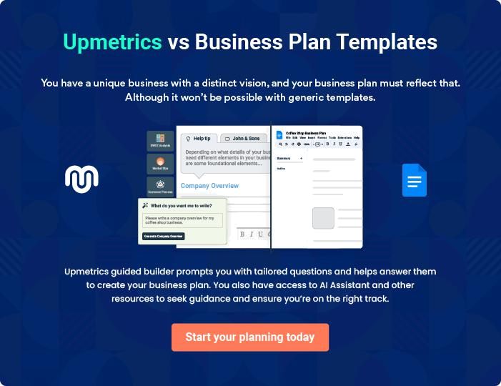
Products and Services
To unlock help try Upmetrics!
To unlock help try Upmetrics!

The product and services section of a hot dog cart business plan should describe the specific services and products that will be offered to customers. To write this section should include the following:



 Help tip  Hot Dog Cart Business Plan

To craft the introduction for your "Products and Services" chapter, begin by positioning your business within its industry, emphasizing its unique strengths or value proposition.
To unlock help try Upmetrics! 

Start writing here..

 Help tip


Start this section by describing the variety of hot dogs you will serve including types of sausages, buns, toppings, sauces, and other ingredients. Mention if your cart has any specialty or vegetarian alternatives.



Products

Classic Downtown Dog


Price: [$5.50]

A nod to timeless flavors, this hot dog is a staple for traditionalists who love a good, hearty meal.

Specifications

- Sausage: All-beef frank

- Bun: Sesame seed

- Toppings: Mustard, ketchup, relish

- Size: 6 inches
Truffle Delight Dog

Price: [$8.00]

A gourmet hot dog experience, infused with the luxurious flavors of truffle and complementing toppings.

Specifications

- Sausage: Premium beef with truffle infusion

- Bun: Artisanal brioche

- Toppings: Truffle mayo, caramelized onions, grated parmesan

- Size: 7 inches

Vegan Veggie Dog

Price: [$6.50]

Crafted for vegetarians and vegans, this plant-based hot dog ensures flavor without compromise.

Specifications

- Sausage: Vegan soy-based

- Bun: Whole wheat

- Toppings: Vegan cheese, lettuce, tomato, vegan mayo

- Size: 6 inches

Crispy French Fries

Price: [$3.00]

The perfect complement to any hot dog, these fries are golden, crispy, and seasoned to perfection.

Specifications

- Type: Potato, thinly sliced

- Serving Size: 150 grams

- Extras: Choice of dips - ketchup, mayo, or spicy aioli
Artisanal Iced Tea Blend

Price: [$2.50]

A refreshing blend of classic tea with a hint of [specific flavor e.g., "peach and mint"], served chilled.

Specifications

- Base: Black tea

- Flavor: [specific e.g., "Peach and mint"]

- Serving Size: 16 oz

- Add-ons: Option for added sweetener or lemon slice

Classic Downtown Dog + Fries + Drink

Price: [$9.50] (Save $1.50)

Our value combo for those wanting a full meal, combining our classic dog, crispy fries, and a beverage of choice.

Specifications

- Hot Dog: Classic Downtown Dog

- Side: Crispy French Fries

- Drink: Choice of any standard-sized beverage from our menu

Side Items and Beverages

 Help tip  Hot Dog Cart Business Plan

Mention if you offer any beverages and side items like french fries and coke, and describe how they complement your hot dog offerings.
To unlock help try Upmetrics! 

Start writing here..

Quality Measures

 Help tip  Hot Dog Cart Business Plan

This section should explain how you maintain quality standards and emphasize the quality of ingredients.
To unlock help try Upmetrics! 

Start writing here..

Additional Offerings

 Help tip  Additional Offerings:


Mention if your hot dog cart offers any additional offerings. These may include combo meals, delivery & online ordering, catering services, etc.
To unlock help try Upmetrics! 

Start writing here..
Sales And Marketing Strategies
To unlock help try Upmetrics!

Writing the sales and marketing strategies section means a list of strategies you will use to attract and retain your clients.
To unlock help try Upmetrics! 

 Help Tip  Hot Dog Cart Business Plan


To create an effective introduction for your "Sales and Marketing Strategies" chapter, start by setting the stage within your specific industry or market.
To unlock help try Upmetrics! 

Start writing here..

Unique Selling Proposition (USP)

 Help tip  Hot Dog Cart Business Plan

Define your business’s USPs depending on the market you serve, the equipment you use, and the unique services you provide. Identifying USPs will help you plan your marketing strategies.
To unlock help try Upmetrics! 

Start writing here..

Pricing Strategy

 Help tip  Hot Dog Cart Business Plan

Describe your pricing strategy—how you plan to price your food offerings and stay competitive in the local market. You can mention any discounts you plan on offering to attract new customers.



Start writing here..

 Help tip  Hot Dog Cart Business Plan
To unlock help try Upmetrics!

Discuss your marketing strategies to market your services. You may include some of these marketing strategies in your business plan—social media marketing, brochures, local business listings and directories, and print marketing.



Marketing strategies

Online


Social Media

Utilizing platforms like Instagram, Twitter, and Facebook, we'll post engaging content showcasing our hot dogs, special offers, and behind-the-scenes glimpses to create a loyal online following.

Offline

Brochures and Flyers

Distributed in high footfall areas and during local events, our brochures will visually highlight our offerings and USPs.

Local Business Listings and Directories

Ensuring our business is listed on local directories and platforms like Yelp or Google My Business will make it easier for potential customers to discover us.

 Help tip
To unlock help try Upmetrics!

Outline the strategies you’ll implement to maximize your sales. Your sales strategies may include partnering with other restaurants or food trucks, food sampling and tasting, introducing bundle deals and lunch combos, etc.



Sales strategies

Partner with Businesses

Collaborating with nearby restaurants or other food trucks for joint promotions or events can boost our visibility and sales.

Food Sampling and Tasting

Introducing potential customers to our flavors through sampling can entice them to purchase a full meal.

Bundle Deals and Combos

Offering value combos, such as a

hot dog with fries and a drink at a

discounted rate, can increase our

average ticket size.

 Help tip  Hot Dog Cart Business Plan

Describe your customer retention strategies and how you plan to execute them. For example, introducing loyalty programs, providing personalized service, etc.
To unlock help try Upmetrics! 

Customer retention

Loyalty Programs

Frequent customers can earn points for every purchase, which can be redeemed for discounts or free items.

Personalized Service

Recognizing our regular patrons and occasionally customizing offers for them can enhance their loyalty to our brand.

Operations Plan

 |  | When writing the operations plan section, it’s important to consider the
 |  | various aspects of your business operations.
 |  |  |  | To unlock help try Upmetrics! 
 Help tip |  |  Hot Dog Cart Business Plan


To create an effective introduction for your "Operational Plan" chapter, start by emphasizing the
pivotal role of efficient operations in the success of your business, underscoring how they
directly impact the quality of services delivered.
 |  |  |  | To unlock help try Upmetrics! 
Start writing here..
Staffing & Training
 Help tip |  |  Hot Dog Cart Business Plan

Mention your business’s staffing requirements, including the number of employees needed.

Include their qualifications, the training required, and the duties they will perform.
To unlock help try Upmetrics! 

Start writing here..

Operational Process

 Help tip  Hot Dog Cart Business Plan

Outline the processes and procedures you will use to run your hot dog cart business. Your operational processes may include preparing and stocking supplies, cart setup, food preparation and cooking, cleaning and sanitation, and inventory management.
To unlock help try Upmetrics! 

Start writing here..

Kitchen Equipment & Machinery

 Help tip  Hot Dog Cart Business Plan

Include the list of kitchen equipment and machinery required for hot dog carts, such as griddles, steamers, refrigerators, fire extinguishers, propane tanks, and other equipment.
To unlock help try Upmetrics! 

Start writing here..
Management Team

The management team section provides an overview of the individuals responsible for running your business plan.
To unlock help try Upmetrics! 

 Help tip  Hot Dog Cart Business Plan

To craft an introduction for your "Management Team" chapter, begin by emphasizing the crucial role of leadership in the success of any business.
To unlock help try Upmetrics! 

Start writing here..

Key managers

 Help tip  Hot Dog Cart Business Plan

Introduce your management and key members of your team, and explain their roles and responsibilities.
To unlock help try Upmetrics! 

Start writing here..


JOHN DOE

CEO - john.doe@example.com

John stands at the helm of [Downtown Dog Delights].

With a Bachelor’s Degree in Business Administration from Harvard University and an MBA from Stanford, John brings over 15 years of entrepreneurial experience in the food industry.


His leadership style blends strategic vision with hands-on operational expertise.

JANE DOE

Operations Manager - jane.doe@example.com

Jane is the heart of our daily operations. Holding a degree in Hotel & Restaurant Management from Cornell University, she spent 10 years managing operations at renowned food chains before joining [Downtown Dog Delights].


Her keen attention to detail ensures our operations are efficient and of the highest standard.


ALICE BROWN

Marketing Manager - alice.brown@example.com

With a passion for storytelling and brand-building, Alice spearheads our marketing campaigns and partnerships. Alice graduated in Marketing from the University of Pennsylvania's Wharton School.

Having worked at major ad agencies for over 8 years, she has an adept understanding of customer behavior and brand positioning.


ROBERT BROWN

Financial Manager - robert.brown@example.com

Guarding our finances and ensuring fiscal responsibility, Robert is a seasoned financial expert with a Bachelor’s in Finance from New York University and an ACCA certification.

He worked with top financial firms for 12 years, making him adept in budgeting, forecasting, and ensuring our financial health.

Organizational structure

 Help tip  Hot Dog Cart Business Plan

Explain the organizational structure of your management team. Include the reporting line and decision-making hierarchy.
To unlock help try Upmetrics! 

Start writing here..

Organization chart


John Doe

CEO


Alice Brown

Jane Doe

Robert Brown

Marketing Manager



Operations Manager

Financial Manager

Lucy Gray | Paul Smith
Social Media | Paul Smith
Social Media | Head Chef
Coordinator | Head Chef


Compensation plan

 Help tip  Hot Dog Cart Business Plan

Describe your compensation plan for the management and staff. Include their salaries, incentives, and other benefits.
To unlock help try Upmetrics! 

Start writing here..

 Help tip

Mentioning advisors or consultants in your business plans adds credibility to your business idea.
To unlock help try Upmetrics! 

Advisors/Consultants


[ADVISOR NAME]

Business Strategy Advisor

With [X years] in the industry, [Full Name] brings a wealth of experience, helping shape our strategic direction.


[CONSULTANT NAME]

Food and Safety Consultant

Ensuring we adhere to the highest safety standards, [Full Name]'s insights are invaluable.
Financial Plan

When writing the financial plan section of a business plan, it’s important to provide a comprehensive overview of your financial projections for the first few years of your business, You may provide the following:
To unlock help try Upmetrics! 

 Help tip  Hot Dog Cart Business Plan


To create an effective introduction for your "Financial Plan" chapter, begin by stressing the critical role of a well-structured financial plan in the success of your venture.
To unlock help try Upmetrics! 

Start writing here..

 Help tip


Describe details such as projected revenue, operational costs, and service costs in your projected profit and loss statement. Make sure to include your business’s expected net profit or loss.
To unlock help try Upmetrics! 

Profit & loss statement

Revenue

Cost Of Sales

General Costs

Revenue Specific Costs

Personnel Costs (Direct

Labor)

Gross Margin

Gross Margin (%)

Operating Expense

Payroll Expense

(Indirect Labor)

General Expense

Bad Debt

Amortization of Current

Assets

2023-24 | 2024-25 | 2025-26 | 2026-27 | 2027-28
$0 | $0 | $0 | $0 | $0

$0 | $0 | $0 | $0 | $0
$0 | $0 | $0 | $0 | $0
$0 | $0 | $0 | $0 | $0
$0 | $0 | $0 | $0 | $0

$0 | $0 | $0 | $0 | $0
0% | 0% | 0% | 0% | 0%

$0 | $0 | $0 | $0 | $0
$0 | $0 | $0 | $0 | $0
$0 | $0 | $0 | $0 | $0
$0 | $0 | $0 | $0 | $0
$0 | $0 | $0 | $0 | $0

EBITDA

Additional Expense

Long Term

Depreciation

Gain or loss from Sale

of Assets

EBIT

Interest Expenses

EBT

Income Tax Expense

Total Expense

Net Income

Net Income (%)

2023-24 | 2024-25 | 2025-26 | 2026-27 | 2027-28
$0 | $0 | $0 | $0 | $0
$0 | $0 | $0 | $0 | $0
$0 | $0 | $0 | $0 | $0
$0 | $0 | $0 | $0 | $0
$0 | $0 | $0 | $0 | $0
$0 | $0 | $0 | $0 | $0
$0 | $0 | $0 | $0 | $0
$0 | $0 | $0 | $0 | $0
$0 | $0 | $0 | $0 | $0
$0 | $0 | $0 | $0 | $0
0% | 0% | 0% | 0% | 0%
 | 2023-24 | 2024-25 | 2025-26 | 2026-27 | 2027-28
Retained Earning | $0 | $0 | $0 | $0 | $0
Opening
Owner's Distribution | $0 | $0 | $0 | $0 | $0
Retained Earning | $0 | $0 | $0 | $0 | $0
Closing

 Help tip

The cash flow for the first few years of your operation should be estimated and described in this section. This may include billing invoices, payment receipts, loan payments, and any other cash flow statements.
To unlock help try Upmetrics! 

Cash flow statement

 | 2023-24 | 2024-25 | 2025-26 | 2026-27 | 2027-28
Cash Received | $0 | $0 | $0 | $0 | $0
Cash Paid | $0 | $0 | $0 | $0 | $0
COS & General Expenses | $0 | $0 | $0 | $0 | $0
Salary & Wages | $0 | $0 | $0 | $0 | $0
Interest | $0 | $0 | $0 | $0 | $0

Sales Tax

Income Tax

Net Cash From

Operations

Assets Sell

Assets Purchase

Net Cash From

Investments

Amount Received

Loan Received

Common Stock

Preferred Stock

Owner's Contribution

Amount Paid

2023-24 | 2024-25 | 2025-26 | 2026-27 | 2027-28
$0 | $0 | $0 | $0 | $0
$0 | $0 | $0 | $0 | $0
$0 | $0 | $0 | $0 | $0

$0 | $0 | $0 | $0 | $0
$0 | $0 | $0 | $0 | $0
$0 | $0 | $0 | $0 | $0

$0 | $0 | $0 | $0 | $0
$0 | $0 | $0 | $0 | $0

$0 | $0 | $0 | $0 | $0
$0 | $0 | $0 | $0 | $0
$0 | $0 | $0 | $0 | $0

Loan Capital $0 $0 $0 $0 $0

 | 2023-24 | 2024-25 | 2025-26 | 2026-27 | 2027-28
Dividends & Distributions | $0 | $0 | $0 | $0 | $0
Net Cash From | $0 | $0 | $0 | $0 | $0
Financing

Summary
Starting Cash | $0 | $0 | $0 | $0 | $0
Cash In | $0 | $0 | $0 | $0 | $0
Cash Out | $0 | $0 | $0 | $0 | $0
Change in Cash | $0 | $0 | $0 | $0 | $0
Ending Cash | $0 | $0 | $0 | $0 | $0

 Help tip

Create a projected balance sheet documenting your hot dog cart business’s assets, liabilities, and equity.

To unlock help try Upmetrics! 

Balance sheet

 | 2023-24 | 2024-25 | 2025-26 | 2026-27 | 2027-28
Assets | $0 | $0 | $0 | $0 | $0
Current Assets | $0 | $0 | $0 | $0 | $0
Cash | $0 | $0 | $0 | $0 | $0
Accounts Receivable | $0 | $0 | $0 | $0 | $0
Inventory | $0 | $0 | $0 | $0 | $0
Other Current Assets | $0 | $0 | $0 | $0 | $0
Long Term Assets | $0 | $0 | $0 | $0 | $0
Gross Long Term Assets | $0 | $0 | $0 | $0 | $0
Accumulated Depreciation | $0 | $0 | $0 | $0 | $0

Liabilities & Equity | $0 | $0 | $0 | $0 | $0
Liabilities | $0 | $0 | $0 | $0 | $0
Current Liabilities | $0 | $0 | $0 | $0 | $0
Accounts Payable | $0 | $0 | $0 | $0 | $0
Income Tax Payable | $0 | $0 | $0 | $0 | $0
Sales Tax Payable | $0 | $0 | $0 | $0 | $0
Short Term Debt | $0 | $0 | $0 | $0 | $0
 | 2023-24 | 2024-25 | 2025-26 | 2026-27 | 2027-28
Long Term Liabilities | $0 | $0 | $0 | $0 | $0
Long Term Debt | $0 | $0 | $0 | $0 | $0
Equity | $0 | $0 | $0 | $0 | $0
Paid-in Capital | $0 | $0 | $0 | $0 | $0
Common Stock | $0 | $0 | $0 | $0 | $0
Preferred Stock | $0 | $0 | $0 | $0 | $0
Owner's Contribution | $0 | $0 | $0 | $0 | $0
Retained Earnings | $0 | $0 | $0 | $0 | $0

Check | $0 |  |  | $0 | $0 | $0 | $0
 Help tip |  |  Hot Dog Cart Business Plan


Determine and mention your business’s break-even point—the point at which your business costs and revenue will be equal.

This exercise will help you understand how much revenue you need to generate to sustain or be profitable.
To unlock help try Upmetrics! 

Break-even Analysis

 | 2023-24 | 2024-25 | 2025-26 | 2026-27 | 2027-28
Starting Revenue | $0 | $0 | $0 | $0 | $0
Net Revenue | $0 | $0 | $0 | $0 | $0
Closing Revenue | $0 | $0 | $0 | $0 | $0

Starting Expense | $0 | $0 | $0 | $0 | $0
Net Expense | $0 | $0 | $0 | $0 | $0
Closing Expense | $0 | $0 | $0 | $0 | $0

Is Break Even? | 0 | 0 | 0 | 0 | 0
Break Even Month | 0 | 0 | 0 | 0 | 0
Days Required | 0 | 0 | 0 | 0 | 0
Break Even Revenue | $0 | $0 | $0 | $0 | $0
Break Even Units
Financing needs

 Help tip  Hot Dog Cart Business Plan

Calculate costs associated with starting a hot dog cart business, and estimate your financing needs and how much capital you need to raise to operate your business.
To unlock help try Upmetrics! 

Start writing here..
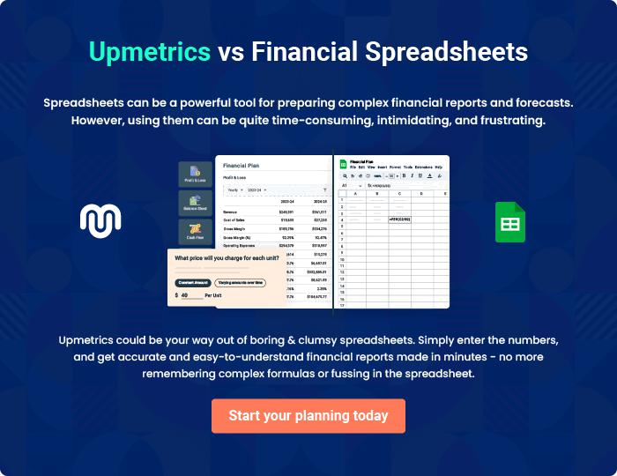
Appendix

When writing the appendix section, you should include any additional information that supports the main content of your plan. This may include financial statements, market research data, legal documents, and other
To unlock help try Upmetrics! 
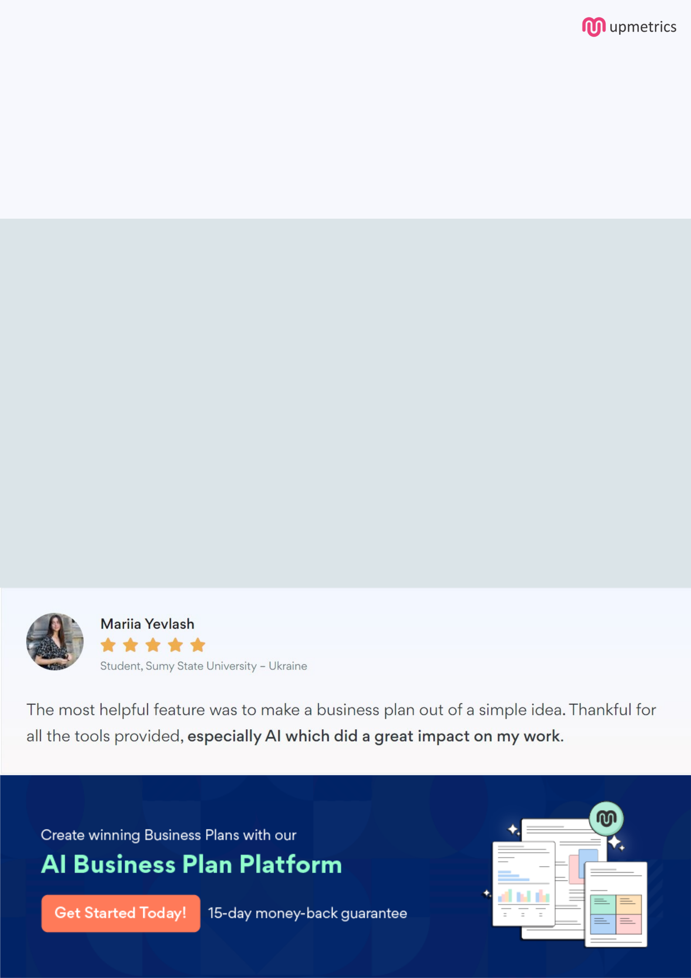
Create a winning business plan that gets you funded

Creating a stunning and investment-ready plan requires no writing, graphic designing, or financial planning expertise.

Upmetrics has all the features required to help you create a comprehensive business plan—from start to finish. Make no mistakes, it’s the modern way of planning to structure ideas, make plans, and create stunning pitch decks to awe investors.

Pitch decks that impress investors

Create pitch decks that provide a visual representation of your business, engage investors, and make them want to invest in your business idea.

Interactive plans in no time

Import business plan sections like—SWOT analysis, comparison tables, and others to create an interactive business plan. No designing skills are required.

Stunning cover page designs

With Upmetrics, you have the liberty to choose from multiple stunning cover page designs. Choose a creative design and make your plan stand out.

Online sharing made simple

Upmetrics makes online sharing quick and easier for users. Easily share your business plans with a link while tracking reader activity.

500+ sample business plans

Simply import a template from our library of sample plans into the editor and start customizing it to make it yours. It takes only a few clicks to get started.

Collaborate with team in real-time

Invite team members, initiate conversations, discuss ideas & strategies, share feedback, and work on a business plan in real-time.

