

Hospital Business Plan

Healing Lives, Empowering Health

Business

Plan

2023

John Doe

10200 Bolsa Ave, Westminster, CA, 92683

- 359-3153 info@example.com http://www.example.com

CONFIDENTIAL

Table of Contents

Executive Summary | 6
Market opportunity | 6
Services Offered | 6
Marketing & Sales Strategies | 7
Financial Highlights | 7
Units Sold v/s Revenue | 8

Company Overview | 9
Ownership | 9
Mission statement | 10
Business history | 10
Future goals | 10

Market Analysis | 11
Target Market | 11
Competitive analysis | 11
MediCare Central | 12
HealthBridge Clinics | 12
PureLife Maternity Homes | 13
Market trends | 13
Regulatory environment | 13

Products and Services | 15
Facilities | 15
Comprehensive Health Checkup | 15
Cardiology Consultation | 16
MRI Scan | 16
Neonatal Intensive Care Unit (NICU) Stay | 16
Knee Replacement | 17
Prenatal Package | 17

Medical Specialties 17

Quality Measures | 18
Additional Services | 18

Sales And Marketing Strategies | 19
Unique Selling Proposition (USP) | 19
Marketing strategies | 20
Online | 20
Offline | 20
Sales strategies | 21
Testimonials and Success Stories | 21

Operations Plan | 22
Staffing & Training | 22
Operational Process | 22
Equipment & Machinery | 23

Management Team | 24
Key managers | 24
John Doe | 24
Jane Doe | 25
Alice Brown | 25
Robert Brown | 25
Organizational structure | 26
Organization chart | 26
Compensation plan | 27
Advisors/Consultants | 27
[ADVISOR NAME] | 27
[CONSULTANT NAME] | 27

Financial Plan | 28
Profit & loss statement | 28
Cash flow statement | 31
Balance sheet | 33
Break-even Analysis | 35
Financing needs | 37
Appendix
Appendix | 39
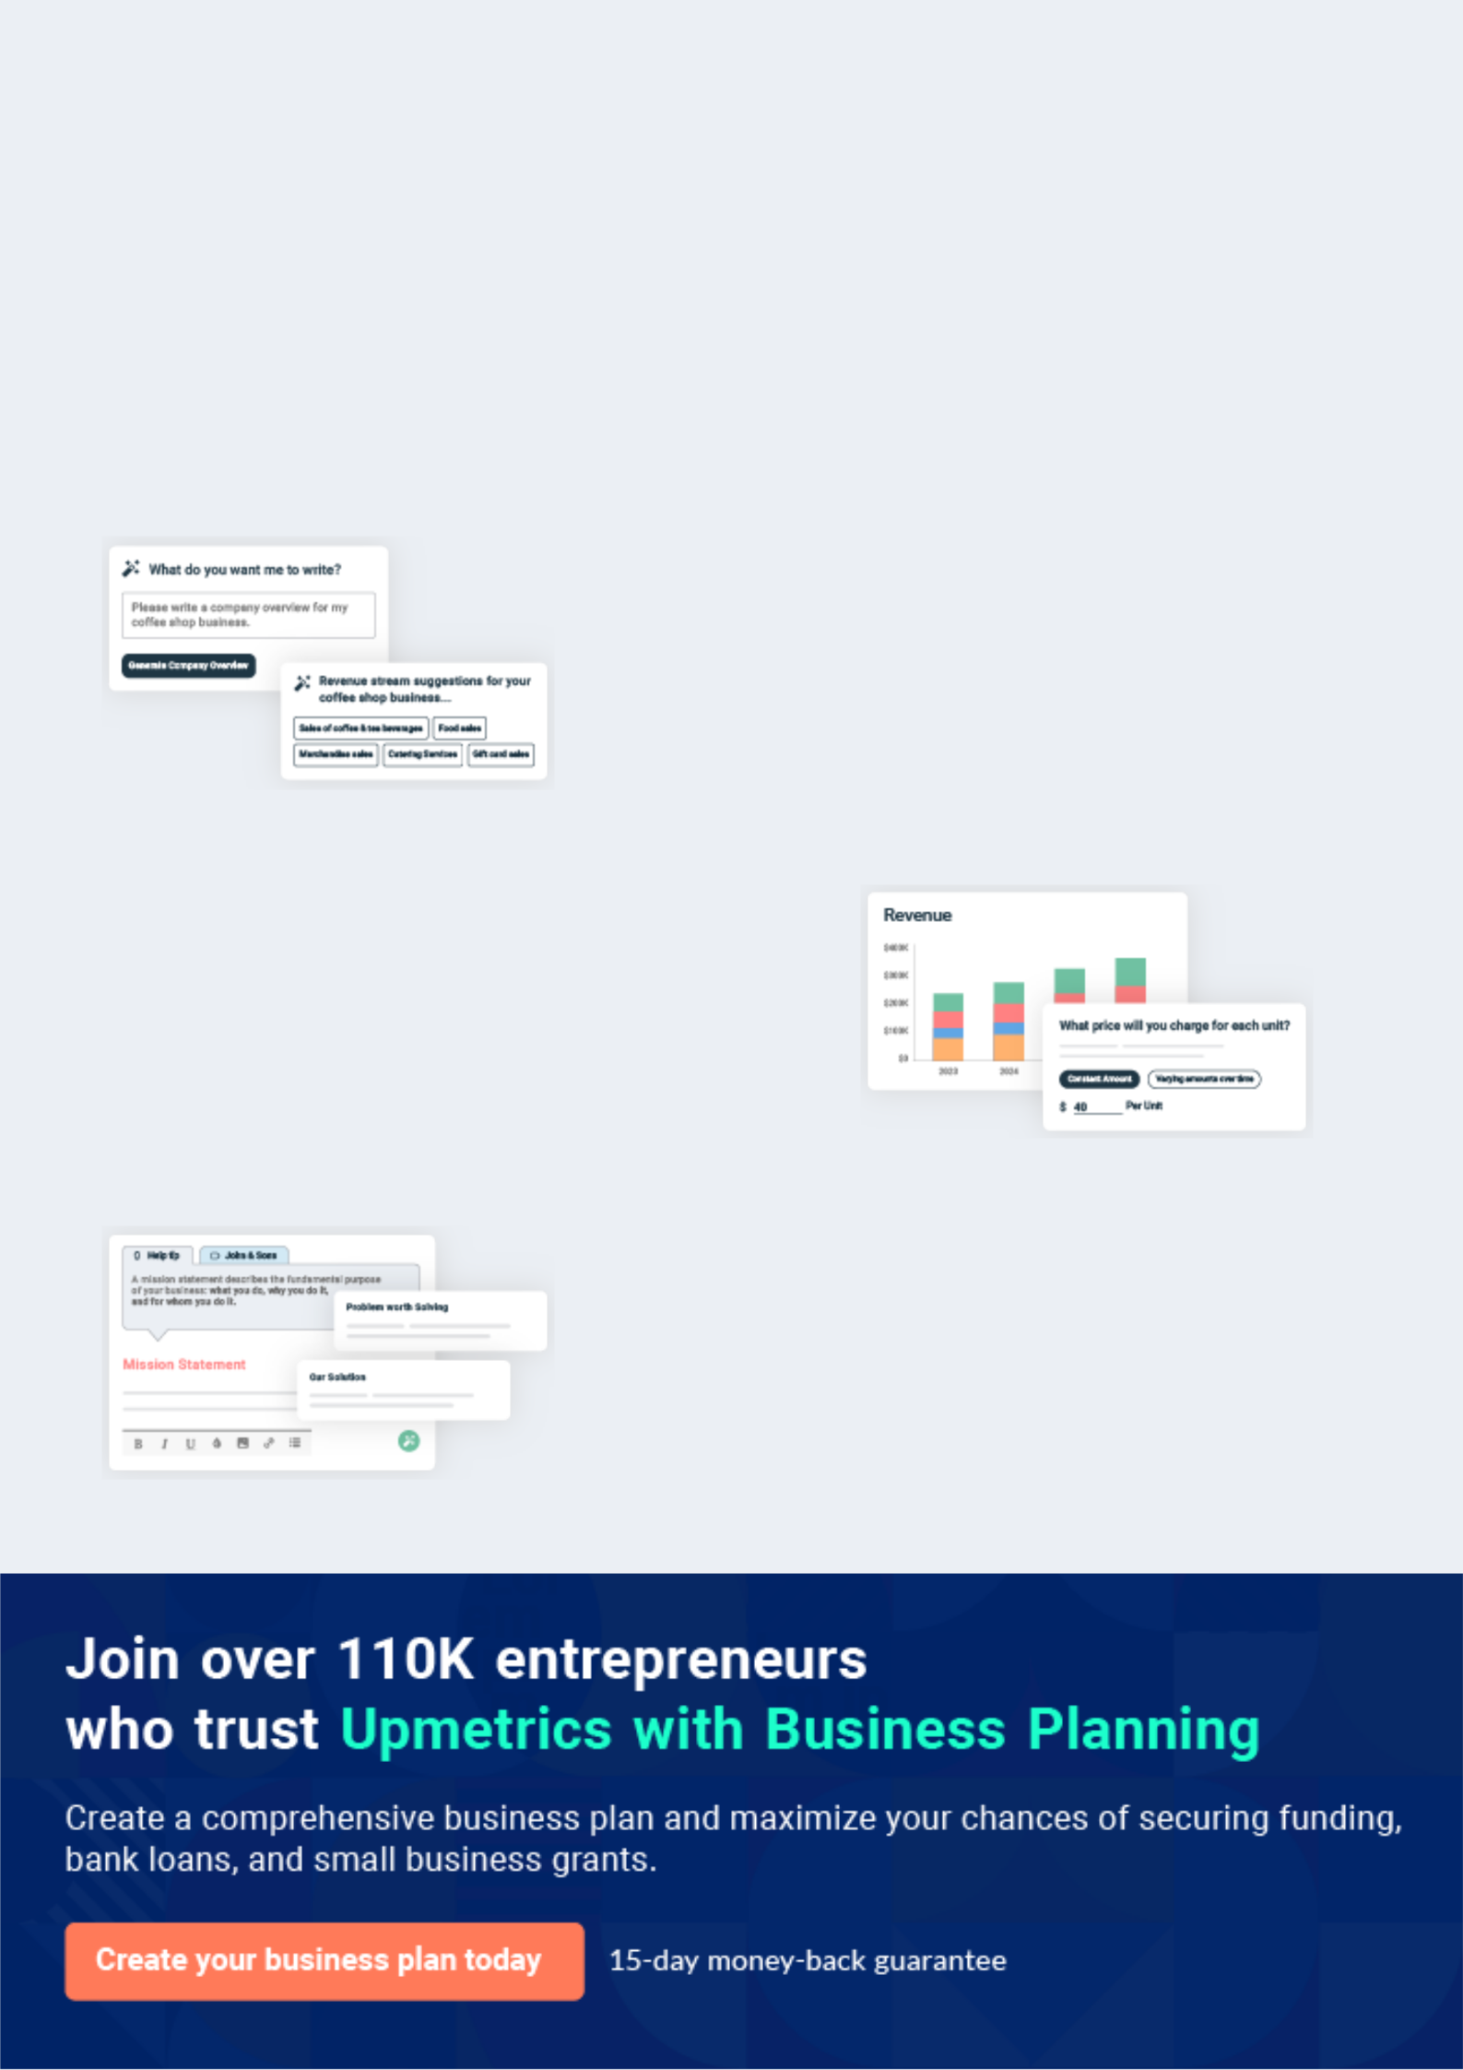
Business planning that’s simpler and faster than you think

Creating a business plan using Upmetrics to start and grow a business is literally the easiest thing in the World. Simply read the instructions and fill in the blanks. It’s as simple as that.

❛ | Upmetrics has everything you need to create a | ❜
❛ | comprehensive business plan. | ❜

AI-powered Upmetrics Assistant

AI-powered insights to streamline your plan

Not sure where to start? Upmetrics’ AI Assistant will automatically generate ideas for each section of your plan and offer improved versions of your writing, adjusting for tone, voice, and grammar or spelling errors.

Financial Forecasting Tool

All the financials are calculated for you

Forget the complex formulas and clumsy spreadsheets — with automatic financials and drag-and-drop forecasting, you can finish your plan faster and be confident that your numbers are accurate.

Business Plan Builder

Guides you like a business mentor

Upmetrics’ step-by-step instructions, prompts, and the library of 400+ sample business plans will guide you through each section of your plan as a business mentor.
Executive Summary


An executive summary is the first section of the business plan intended to provide an overview of the whole business plan.
To unlock help try Upmetrics! 

 Help tip  Hospital Business Plan


Start your executive summary by briefly introducing your business to your readers.

This section may include the name of your hospital business, its location, when it was founded,
To unlock help try Upmetrics! 

Start writing here..

Market opportunity

 Help tip  Hospital Business Plan

Summarize your market research, including market size, growth potential, and marketing trends. Highlight the opportunities in the market and how your business will fit in to fill the gap.
To unlock help try Upmetrics! 

Start writing here..

Services Offered

 Help tip  Hospital Business Plan

Highlight the hospital services you offer your clients. The USPs and differentiators you offer are always a plus.
To unlock help try Upmetrics! 

Start writing here..

Marketing & Sales Strategies
To unlock help try Upmetrics!

 Help tip  Hospital Business Plan

Outline your sales and marketing strategies—what marketing platforms you use, how you plan on acquiring patients, etc.
To unlock help try Upmetrics! 

Start writing here..

Financial Highlights

 Help tip  Hospital Business Plan

Briefly summarize your financial projections for the initial years of business operations. Include any capital or investment requirements, associated startup costs, projected revenues, and profit forecasts.



Start writing here..
Units Sold v/s Revenue

 |  | Units Sold | Revenue
15.00k
10.00k
5.00k
0
Year 1 | Year 2 | Year 3


Financial Year |  |  | Units Sold | Revenue
Year 1 | 1,550 |  |  | $10,000
Year 2 | 1,800 |  |  | $12,000
Year 3 | 2,050 |  |  | $14,000
 Help tip |  |  Hospital Business Plan


Summarize your executive summary section with a clear CTA, for example, inviting angel investors to discuss the potential business investment.
To unlock help try Upmetrics! 

Write a call to action for your business plan.
Company Overview

Depending on what details of your business are essential, you’ll need different elements in your business overview.
To unlock help try Upmetrics! 

 Help tip  Hospital Business Plan


Describe your business in this section by providing all the basic information. Describe what
kind of hospital you run and the name of it. You may specialize in one of the following hospital
businesses:
 |  |  |  | To unlock help try Upmetrics! 
Start writing here..
Ownership
 Help tip |  |  Hospital Business Plan

List the names of your hospital founders or owners. Describe what shares they own and their responsibilities for efficiently managing the business.
To unlock help try Upmetrics! 

Start writing here..
Mission statement

 Help tip  Hospital Business Plan

Summarize your business’ objective, core principles, and values in your mission statement. This statement needs to be memorable, clear, and brief.
To unlock help try Upmetrics! 

❛ At [HealthVitality Hospital], our mission is to deliver unparalleled healthcare services with compassion, excellence, and efficiency.

We believe in preserving the sanctity of human life and are committed to fostering an environment that promotes healing, education, and the well-being of our community.

❜

Business history

 Help tip  Hospital Business Plan

If you’re an established hospital, briefly describe your business history, like—when it was founded, how it evolved over time, etc.
To unlock help try Upmetrics! 

Start writing here..

Future goals

 Help tip  Hospital Business Plan

It’s crucial to convey your aspirations and vision. Mention your short-term and long-term goals; they can be specific targets for revenue, market share, or expanding your services.
To unlock help try Upmetrics! 

Start writing here..

Market Analysis


 |  | Market analysis provides a clear understanding of the market in which your
 |  | printing business will run along with the target market, competitors, and
 |  | growth opportunities.
 |  |  |  | To unlock help try Upmetrics! 
 Help tip |  |  Hospital Business Plan

To write the introduction section of your market analysis, start by clearly identifying your primary target market.
To unlock help try Upmetrics! 

Start writing here..

Target Market

 Help tip  Hospital Business Plan

Start this section by describing your target market. Define your target market and explain what
types of services they prefer. Creating a buyer persona will help you easily define your target
market to your readers.
 |  |  |  | To unlock help try Upmetrics! 
Start writing here..
 Help tip |  |  Hospital Business Plan

Identify and analyze your direct and indirect competitors. Identify their strengths and weaknesses, and describe what differentiates your hospital from them.
To unlock help try Upmetrics! 

Competitive analysis

MediCare Central

MediCare Central, established in [Year], is a renowned [Type, e.g., "General Hospital"] located in [City/ Area]. With a bed capacity of [Number, e.g., "500 beds"], it serves approximately [Number, e.g., "20,000"] patients annually.

Features | Strengths | Weaknesses
Comprehensive cardiac care | Reputation for advanced | Often reported long wait times
unit | cardiac treatments. | for outpatient services.
State-of-the-art radiology and | An extensive network of | Limited specialty departments
imaging services | affiliated physicians. | for rare conditions.
24/7 emergency department | Modern infrastructure with | Online presence and telehealth
Pediatric care center | cutting-edge medical | services are not yet fully
Pediatric care center | technology. | developed.
On-site pharmacy services

HealthBridge Clinics

Founded in [Year], HealthBridge Clinics is a chain of [Type, e.g., "Outpatient Clinics"] spread across [City/Area]. Catering mainly to day-care treatments and minor procedures, they have successfully treated over [Number, e.g., "50,000"] patients.

Features | Strengths | Weaknesses
Day-care surgical procedures | Conveniently located branches | Limited capability for handling
Orthopaedic consultation and | across the city. | major surgeries or critical cases.
minor surgeries | Swift appointment scheduling | Smaller facility size leads to
Obstetrics and gynecology | system. | quick overcrowding.
consultations | Partnerships with leading | Less focus on holistic and
Dermatology and cosmetic | health insurance providers. | integrated care.
procedures
Physiotherapy and
rehabilitation center

PureLife Maternity Homes

PureLife Maternity Homes, established in [Year], specialize in maternity care in [City/Area]. With a strong focus on mother and child health, they have a bed capacity of [Number, e.g., "100 beds"] and have assisted in the birth of over [Number, e.g., "5,000"] babies.

Features

Dedicated birthing suites

Pre-natal and post-natal care programs

Neonatal Intensive Care Unit (NICU)

Parenting workshops and classes

Lactation consultation

Strengths

Highly trained obstetricians and neonatologists.

Warm and comforting environment for expecting mothers.

High success rate for safe deliveries.

Weaknesses

Sole focus on maternity limits patient demographic.

Lack of broader medical departments or emergency services.

Limited outreach in terms of community health programs.

Market trends

 Help tip  Hospital Business Plan

Analyze emerging trends in the industry, such as changes in patient behavior or preferences, etc. Explain how your business will cope with all the trends.
To unlock help try Upmetrics! 

Start writing here..

Regulatory environment

 Help tip  Hospital Business Plan

List regulations and licensing requirements that may affect your hospital, such as business licensing & accreditation, health & safety regulations, patient privacy & data protection, etc.
To unlock help try Upmetrics! 

Start writing here..

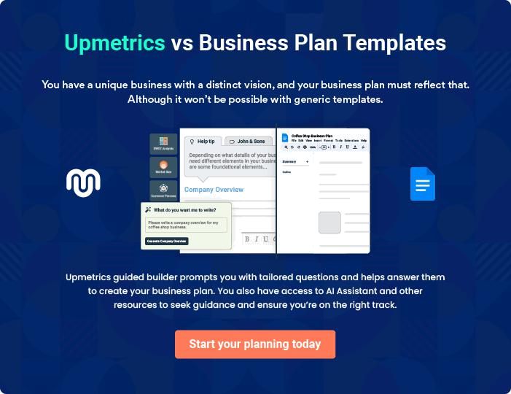
Products and Services

 |  | The product and services section of a hospital business plan should describe
 |  | the specific services and products that will be offered to customers. To write
 |  | this section should include the following:
 |  |  |  | To unlock help try Upmetrics! 
 Help tip |  |  Hospital Business Plan

To craft the introduction for your "Products and Services" chapter, begin by positioning your business within its industry, emphasizing its unique strengths or value proposition.
To unlock help try Upmetrics! 

Start writing here..

 Help tip


Mention the hospital facilities your business will offer. This list may include,

• Laboratory
To unlock help try Upmetrics! 

Facilities

Comprehensive Health Checkup


Price: [$250]

A thorough medical examination that covers all basic health parameters, ensuring early detection of potential health risks.

Specifications

- Blood tests including CBC, Lipid Profile, Liver Function Tests, etc.

- Vital stats monitoring: Blood pressure, heart rate, temperature.

- Doctor's consultation for evaluation of test results and recommendations.
Cardiology Consultation

Price: [$120] per session

A one-on-one session with our board-certified cardiologists to address any heart-related concerns.

Specifications

- ECG test if necessary.

- Evaluation of patient's medical history.

- Recommendations for further tests or treatments if required.

MRI Scan

Price: [$600]

Utilizing advanced imaging technology to create detailed images of organs and tissues within the body.

Specifications

- High-resolution 3T MRI machine.

- Suitable for brain, spine, joint, and muscle imaging.

- Images reviewed and interpreted by specialized radiologists.

Neonatal Intensive Care Unit (NICU) Stay

Price: [$1,500] per day

Specialized care for newborns facing health challenges, ensuring they receive the dedicated attention they need.

Specifications

- 24-hour monitoring by pediatric specialists.

- Advanced incubators and vital stats monitoring systems.

- Dedicated nursing staff for individual care.
Knee Replacement

Price: [$15,000] (includes pre-surgery consultation, surgery, and post-surgery care)

A surgical procedure to replace the weight-bearing surfaces of the knee joint to relieve pain and disability.

Specifications

•

- Use of high-quality biocompatible prosthetics.

- Performed by board-certified orthopedic surgeons with specialization in joint replacements.

- Rehabilitation support post-surgery for faster recovery.

Prenatal Package

Price: [$1,200]

A comprehensive package covering all essential prenatal services, ensuring the well-being of both the mother and the baby.

Specifications

- Monthly checkups leading up to the delivery.

- Includes all essential scans: Ultrasound, anomaly scan, etc.

- Nutritional counseling and prenatal classes.

Medical Specialties

 Help tip  Hospital Business Plan

The medical specializations and services your hospital will provide should be mentioned here.

Cardiology, orthopedics, oncology, neurology, obstetrics & gynecology, pediatrics, and other

To unlock help try Upmetrics! 

Start writing here..

Quality Measures

 Help tip  Hospital Business Plan

This section should explain how you maintain quality standards and consistently provide the highest quality facility.
To unlock help try Upmetrics! 

Start writing here..

Additional Services

 Help tip  Hospital Business Plan

Mention if your hospital offers any additional facilities or services. You may include services like surgical services, maternal services, etc.
To unlock help try Upmetrics! 

Start writing here..
Sales And Marketing Strategies

Writing the sales and marketing strategies section means a list of strategies you will use to attract and retain your clients.
To unlock help try Upmetrics! 

 Help Tip  Hospital Business Plan


To create an effective introduction for your "Sales and Marketing Strategies" chapter, start by setting the stage within your specific industry or market.
To unlock help try Upmetrics! 

Start writing here..

Unique Selling Proposition (USP)

 Help tip  Hospital Business Plan

Define your business’s USPs depending on the market you serve, the equipment you use, and the unique services you provide. Identifying USPs will help you plan your marketing strategies.
To unlock help try Upmetrics! 

Start writing here..
 Help tip  Hospital Business Plan
To unlock help try Upmetrics!

Discuss your marketing strategies to market your facilities. You may include some of these marketing strategies in your business plan—social media marketing, Google ads, brochures, content marketing, and print marketing.



Marketing strategies

Online


Social Media

Through platforms like Facebook, Instagram, and Twitter, we engage with our community by sharing health tips, hospital events, and patient success stories.

Content Marketing

Regular blog posts and articles on our website educate our community about health issues, treatments, and preventive measures

Offline

Brochures

Elegantly designed brochures available both in digital and print formats offer detailed insights into our services, specialists, and patient care protocols.

Google Ads

We employ targeted pay-per-click ads that appear when potential patients search for relevant healthcare services in our locality.

Print Marketing

Ad placements in local newspapers, magazines, and billboards amplify our presence in the local community.

 Help tip  Hospital Business Plan
To unlock help try Upmetrics!
To unlock help try Upmetrics!

Outline the strategies you’ll implement to maximize your sales. Your sales strategies may include direct sales calls, partnering with other insurance providers or other wellness businesses, offering referral programs, etc.



Sales strategies

Partner with Businesses

Collaborative efforts with insurance providers and wellness businesses ensure that our patients receive comprehensive care and benefits.

Direct Sales Calls

Our dedicated team reaches out to corporates, insurance providers, and residential communities to offer tailored health packages.

Referral Programs

Encouraging our existing patients

and partners to refer others with

attractive incentives strengthens

our community's trust.

 Help tip  Hospital Business Plan

Share patient success stories and testimonials on your website, social media accounts, and other platforms. These stories can increase confidence in other people about the services and facilities of the hospital.



Testimonials and Success Stories

Website Showcase

Our website features a dedicated section where patients share their journey, challenges, and the exceptional care they received at HealthVitality.

Social Media Highlights

Regularly highlighting success stories and testimonials on our social channels boosts engagement and trust within our online community

Operations Plan
To unlock help try Upmetrics!

 |  | When writing the operations plan section, it’s important to consider the
 |  | various aspects of your business operations.
 |  |  |  | To unlock help try Upmetrics! 
 Help tip |  |  Hospital Business Plan


To create an effective introduction for your "Operational Plan" chapter, start by emphasizing the
pivotal role of efficient operations in the success of your business, underscoring how they
directly impact the quality of services delivered.
 |  |  |  | To unlock help try Upmetrics! 
Start writing here..
Staffing & Training
 Help tip |  |  Hospital Business Plan

Mention your business’s staffing requirements, including the number of employees, nurses, or
doctors needed. Include their qualifications, the training required, and the duties they will
perform.
 |  |  |  | To unlock help try Upmetrics! 
Start writing here..
Operational Process
 Help tip |  |  Hospital Business Plan

Outline the processes and procedures you will use to run your hospital business. Your operational processes may include patient registration, appointment scheduling, medical documentation, etc.



Start writing here..

Equipment & Machinery

 Help tip  Hospital Business Plan

Include the list of equipment and machinery required for the hospital, such as operating rooms, tables, surgical lasers, surgical drills & saws, vital signs monitors, etc.
To unlock help try Upmetrics! 

Start writing here..
Management Team

The management team section provides an overview of the individuals responsible for running your business plan.
To unlock help try Upmetrics! 

 Help tip  Hospital Business Plan

To craft an introduction for your "Management Team" chapter, begin by emphasizing the crucial role of leadership in the success of any business.
To unlock help try Upmetrics! 

Start writing here..

Key managers

 Help tip  Hospital Business Plan

Introduce your management and key members of your team, and explain their roles and responsibilities.
To unlock help try Upmetrics! 

Start writing here..


JOHN DOE

CEO - john.doe@example.com

John, as the CEO of [HealthVitality Hospital], spearheads our hospital's vision and mission.

With a Master's in Healthcare Administration from [University Name] and an MBA from [University Name], he possesses both the medical and business acumen required to drive a hospital to success.


John's 20-year career has seen him hold pivotal roles in some of the country's most reputable healthcare institutions. His leadership style emphasizes transparency, innovation, and patient-centricity.

JANE DOE

Chief Operating Officer (COO) - jane.doe@example.com

Jane is the driving force behind [HealthVitality Hospital]'s operational efficiency.

Graduating with a degree in Hospital Management from [University Name] and a subsequent MBA, she brings over 15 years of experience in optimizing hospital operations.


Prior to joining HealthVitality, Jane served as the Operations Director at [Previous Hospital Name], where she played a key role in its transformative journey.


ALICE BROWN

CMO - alice.brown@example.com

Dr. Alice Brown, a board-certified physician with a specialty in [specific specialty e.g., cardiology], leads our medical team.

She graduated from [Medical University Name] and pursued further training at [Another University/Institute].

Dr. Brown has been practicing medicine for over 18 years, with 8 of those years in hospital leadership roles, ensuring that medical best practices are consistently upheld.


ROBERT BROWN

Operations Manger - robert.brown@example.com

Robert ensures the smooth functioning of all our patient services, from registration to discharge.

He holds a Master's in Hospital Operations from [University Name] and has previously overseen operations at [Another Hospital's Name] for over a decade.

Robert's passion lies in enhancing patient experiences through streamlined processes and staff empowerment.
Organizational structure

 Help tip  Hospital Business Plan

Explain the organizational structure of your management team. Include the reporting line and decision-making hierarchy.
To unlock help try Upmetrics! 

Start writing here..

Organization chart


John Doe

CEO


Alice Brown

Jane Doe

CMO


COO

Emily White

Head of Patient Services Robert Brown

Operations Manager




David Black

Laura Grey

HR Manager

Marketing Manager

Compensation plan

 Help tip  Hospital Business Plan

Describe your compensation plan for the management and staff. Include their salaries, incentives, and other benefits.
To unlock help try Upmetrics! 

Start writing here..

 Help tip  Hospital Business Plan

Mentioning advisors or consultants in your business plans adds credibility to your business idea.
To unlock help try Upmetrics! 

Advisors/Consultants


[ADVISOR NAME]

Advisor

A renowned [specific specialty e.g., cardiologist], [Advisor's Name] provides invaluable insights and expertise.


[CONSULTANT NAME]

Consultant

With experience in hospital administration and management, [Consultant's Name]'s guidance is essential in our strategic planning.
Financial Plan

When writing the financial plan section of a business plan, it’s important to provide a comprehensive overview of your financial projections for the first few years of your business, You may provide the following:
To unlock help try Upmetrics! 

 Help tip  Hospital Business Plan


To create an effective introduction for your "Financial Plan" chapter, begin by stressing the critical role of a well-structured financial plan in the success of your venture.
To unlock help try Upmetrics! 

Start writing here..

 Help tip


Describe details such as projected revenue, operational costs, and service costs in your projected profit and loss statement. Make sure to include your business’s expected net profit or loss.
To unlock help try Upmetrics! 

Profit & loss statement

Revenue

Cost Of Sales

General Costs

Revenue Specific Costs

Personnel Costs (Direct

Labor)

Gross Margin

Gross Margin (%)

Operating Expense

Payroll Expense

(Indirect Labor)

General Expense

Bad Debt

Amortization of Current

Assets

2023-24 | 2024-25 | 2025-26 | 2026-27 | 2027-28
$0 | $0 | $0 | $0 | $0

$0 | $0 | $0 | $0 | $0
$0 | $0 | $0 | $0 | $0
$0 | $0 | $0 | $0 | $0
$0 | $0 | $0 | $0 | $0

$0 | $0 | $0 | $0 | $0
0% | 0% | 0% | 0% | 0%

$0 | $0 | $0 | $0 | $0
$0 | $0 | $0 | $0 | $0
$0 | $0 | $0 | $0 | $0
$0 | $0 | $0 | $0 | $0
$0 | $0 | $0 | $0 | $0

EBITDA

Additional Expense

Long Term

Depreciation

Gain or loss from Sale

of Assets

EBIT

Interest Expenses

EBT

Income Tax Expense

Total Expense

Net Income

Net Income (%)

2023-24 | 2024-25 | 2025-26 | 2026-27 | 2027-28
$0 | $0 | $0 | $0 | $0
$0 | $0 | $0 | $0 | $0
$0 | $0 | $0 | $0 | $0
$0 | $0 | $0 | $0 | $0
$0 | $0 | $0 | $0 | $0
$0 | $0 | $0 | $0 | $0
$0 | $0 | $0 | $0 | $0
$0 | $0 | $0 | $0 | $0
$0 | $0 | $0 | $0 | $0
$0 | $0 | $0 | $0 | $0
0% | 0% | 0% | 0% | 0%
 | 2023-24 | 2024-25 | 2025-26 | 2026-27 | 2027-28
Retained Earning | $0 | $0 | $0 | $0 | $0
Opening
Owner's Distribution | $0 | $0 | $0 | $0 | $0
Retained Earning | $0 | $0 | $0 | $0 | $0
Closing

 Help tip

The cash flow for the first few years of your operation should be estimated and described in this section. This may include billing invoices, payment receipts, loan payments, and any other cash flow statements.
To unlock help try Upmetrics! 

Cash flow statement

 | 2023-24 | 2024-25 | 2025-26 | 2026-27 | 2027-28
Cash Received | $0 | $0 | $0 | $0 | $0
Cash Paid | $0 | $0 | $0 | $0 | $0
COS & General Expenses | $0 | $0 | $0 | $0 | $0
Salary & Wages | $0 | $0 | $0 | $0 | $0
Interest | $0 | $0 | $0 | $0 | $0

Sales Tax

Income Tax

Net Cash From

Operations

Assets Sell

Assets Purchase

Net Cash From

Investments

Amount Received

Loan Received

Common Stock

Preferred Stock

Owner's Contribution

Amount Paid

2023-24 | 2024-25 | 2025-26 | 2026-27 | 2027-28
$0 | $0 | $0 | $0 | $0
$0 | $0 | $0 | $0 | $0
$0 | $0 | $0 | $0 | $0

$0 | $0 | $0 | $0 | $0
$0 | $0 | $0 | $0 | $0
$0 | $0 | $0 | $0 | $0

$0 | $0 | $0 | $0 | $0
$0 | $0 | $0 | $0 | $0

$0 | $0 | $0 | $0 | $0
$0 | $0 | $0 | $0 | $0
$0 | $0 | $0 | $0 | $0

Loan Capital $0 $0 $0 $0 $0

 | 2023-24 | 2024-25 | 2025-26 | 2026-27 | 2027-28
Dividends & Distributions | $0 | $0 | $0 | $0 | $0
Net Cash From | $0 | $0 | $0 | $0 | $0
Financing

Summary
Starting Cash | $0 | $0 | $0 | $0 | $0
Cash In | $0 | $0 | $0 | $0 | $0
Cash Out | $0 | $0 | $0 | $0 | $0
Change in Cash | $0 | $0 | $0 | $0 | $0
Ending Cash | $0 | $0 | $0 | $0 | $0

 Help tip

Create a projected balance sheet documenting your hospital business’s assets, liabilities, and equity.

To unlock help try Upmetrics! 

Balance sheet

 | 2023-24 | 2024-25 | 2025-26 | 2026-27 | 2027-28
Assets | $0 | $0 | $0 | $0 | $0
Current Assets | $0 | $0 | $0 | $0 | $0
Cash | $0 | $0 | $0 | $0 | $0
Accounts Receivable | $0 | $0 | $0 | $0 | $0
Inventory | $0 | $0 | $0 | $0 | $0
Other Current Assets | $0 | $0 | $0 | $0 | $0
Long Term Assets | $0 | $0 | $0 | $0 | $0
Gross Long Term Assets | $0 | $0 | $0 | $0 | $0
Accumulated Depreciation | $0 | $0 | $0 | $0 | $0

Liabilities & Equity | $0 | $0 | $0 | $0 | $0
Liabilities | $0 | $0 | $0 | $0 | $0
Current Liabilities | $0 | $0 | $0 | $0 | $0
Accounts Payable | $0 | $0 | $0 | $0 | $0
Income Tax Payable | $0 | $0 | $0 | $0 | $0
Sales Tax Payable | $0 | $0 | $0 | $0 | $0
Short Term Debt | $0 | $0 | $0 | $0 | $0
 | 2023-24 | 2024-25 | 2025-26 | 2026-27 | 2027-28
Long Term Liabilities | $0 | $0 | $0 | $0 | $0
Long Term Debt | $0 | $0 | $0 | $0 | $0
Equity | $0 | $0 | $0 | $0 | $0
Paid-in Capital | $0 | $0 | $0 | $0 | $0
Common Stock | $0 | $0 | $0 | $0 | $0
Preferred Stock | $0 | $0 | $0 | $0 | $0
Owner's Contribution | $0 | $0 | $0 | $0 | $0
Retained Earnings | $0 | $0 | $0 | $0 | $0

Check | $0 |  |  | $0 | $0 | $0 | $0
 Help tip |  |  Hospital Business Plan


Determine and mention your business’s break-even point—the point at which your business costs and revenue will be equal.

This exercise will help you understand how much revenue you need to generate to sustain or be profitable.
To unlock help try Upmetrics! 

Break-even Analysis

 | 2023-24 | 2024-25 | 2025-26 | 2026-27 | 2027-28
Starting Revenue | $0 | $0 | $0 | $0 | $0
Net Revenue | $0 | $0 | $0 | $0 | $0
Closing Revenue | $0 | $0 | $0 | $0 | $0

Starting Expense | $0 | $0 | $0 | $0 | $0
Net Expense | $0 | $0 | $0 | $0 | $0
Closing Expense | $0 | $0 | $0 | $0 | $0

Is Break Even? | 0 | 0 | 0 | 0 | 0
Break Even Month | 0 | 0 | 0 | 0 | 0
Days Required | 0 | 0 | 0 | 0 | 0
Break Even Revenue | $0 | $0 | $0 | $0 | $0
Break Even Units
Financing needs

 Help tip  Hospital Business Plan

Calculate costs associated with starting a hospital, and estimate your financing needs and how much capital you need to raise to operate your business.
To unlock help try Upmetrics! 

Start writing here..
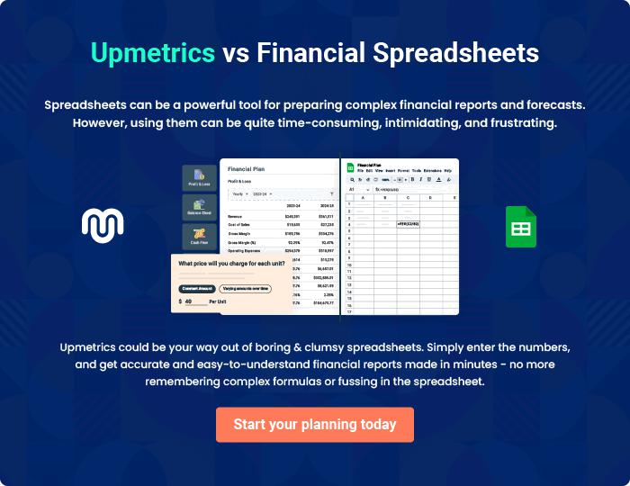
Appendix

When writing the appendix section, you should include any additional information that supports the main content of your plan. This may include financial statements, market research data, legal documents, and other
To unlock help try Upmetrics! 

Create a winning business plan that gets you funded

Creating a stunning and investment-ready plan requires no writing, graphic designing, or financial planning expertise.

Upmetrics has all the features required to help you create a comprehensive business plan—from start to finish. Make no mistakes, it’s the modern way of planning to structure ideas, make plans, and create stunning pitch decks to awe investors.

Pitch decks that impress investors

Create pitch decks that provide a visual representation of your business, engage investors, and make them want to invest in your business idea.

Interactive plans in no time

Import business plan sections like—SWOT analysis, comparison tables, and others to create an interactive business plan. No designing skills are required.

Stunning cover page designs

With Upmetrics, you have the liberty to choose from multiple stunning cover page designs. Choose a creative design and make your plan stand out.

Online sharing made simple

Upmetrics makes online sharing quick and easier for users. Easily share your business plans with a link while tracking reader activity.

500+ sample business plans

Simply import a template from our library of sample plans into the editor and start customizing it to make it yours. It takes only a few clicks to get started.

Collaborate with team in real-time

Invite team members, initiate conversations, discuss ideas & strategies, share feedback, and work on a business plan in real-time.

