
BUSINESS PLAN

2023

Home Improvement Business Plan

Renovate, Upgrade, Elevate

John Doe

10200 Bolsa Ave, Westminster, CA, 92683

- 359-3153 info@example.com http://www.example.com

Information provided in this business plan is unique to this business and confidential; therefore, anyone reading this plan agrees not to disclose any of the information in this business plan without prior written permission of the company.
Table of Contents

Executive Summary | 6
Market opportunity | 6
Services Offered | 6
Marketing & Sales Strategies | 7
Financial Highlights | 7
Units Sold v/s Revenue | 8

Company Overview | 9
Ownership | 9
Mission statement | 10
Business history | 10
Future goals | 11

Market Analysis | 12
Target Market | 12
Market size and growth potential | 12
Market Size | 13
Competitive analysis | 13
HomeRevive Solutions | 13
ModernSpaces Creations | 14
Traditions & Trends Co. | 14
Market trends | 14
Regulatory environment | 15

Products and Services | 16
Services | 16
Design Consultation | 16
Project Planning & Management | 17
Installation and Remodeling Services | 17
Painting Services | 18
Repair & Maintenance | 18
Home Improvement Products | 18
Quality Measures | 19
Additional Services | 19

Sales And Marketing Strategies | 20
Unique Selling Proposition (USP) | 20
Pricing Strategy | 20
Marketing strategies | 21
Online | 21
Offline | 21
Sales strategies | 22
Customer retention | 22

Operations Plan | 23
Staffing & Training | 23
Operational Process | 23
Equipment & Machinery | 24

Management Team | 25
Key managers | 25
John Doe | 25
Jane Doe | 26
Alice Brown | 26
Robert Brown | 26
Organizational structure | 27
Organization chart | 27
Compensation plan | 27
Advisors/Consultants | 28
[ADVISOR NAME] | 28
[CONSULTANT NAME] | 28
Financial Plan
Financial Plan | 29

Profit & loss statement 29

Cash flow statement | 32
Balance sheet | 34
Break-even Analysis | 36
Financing needs | 38
Appendix
Appendix | 40
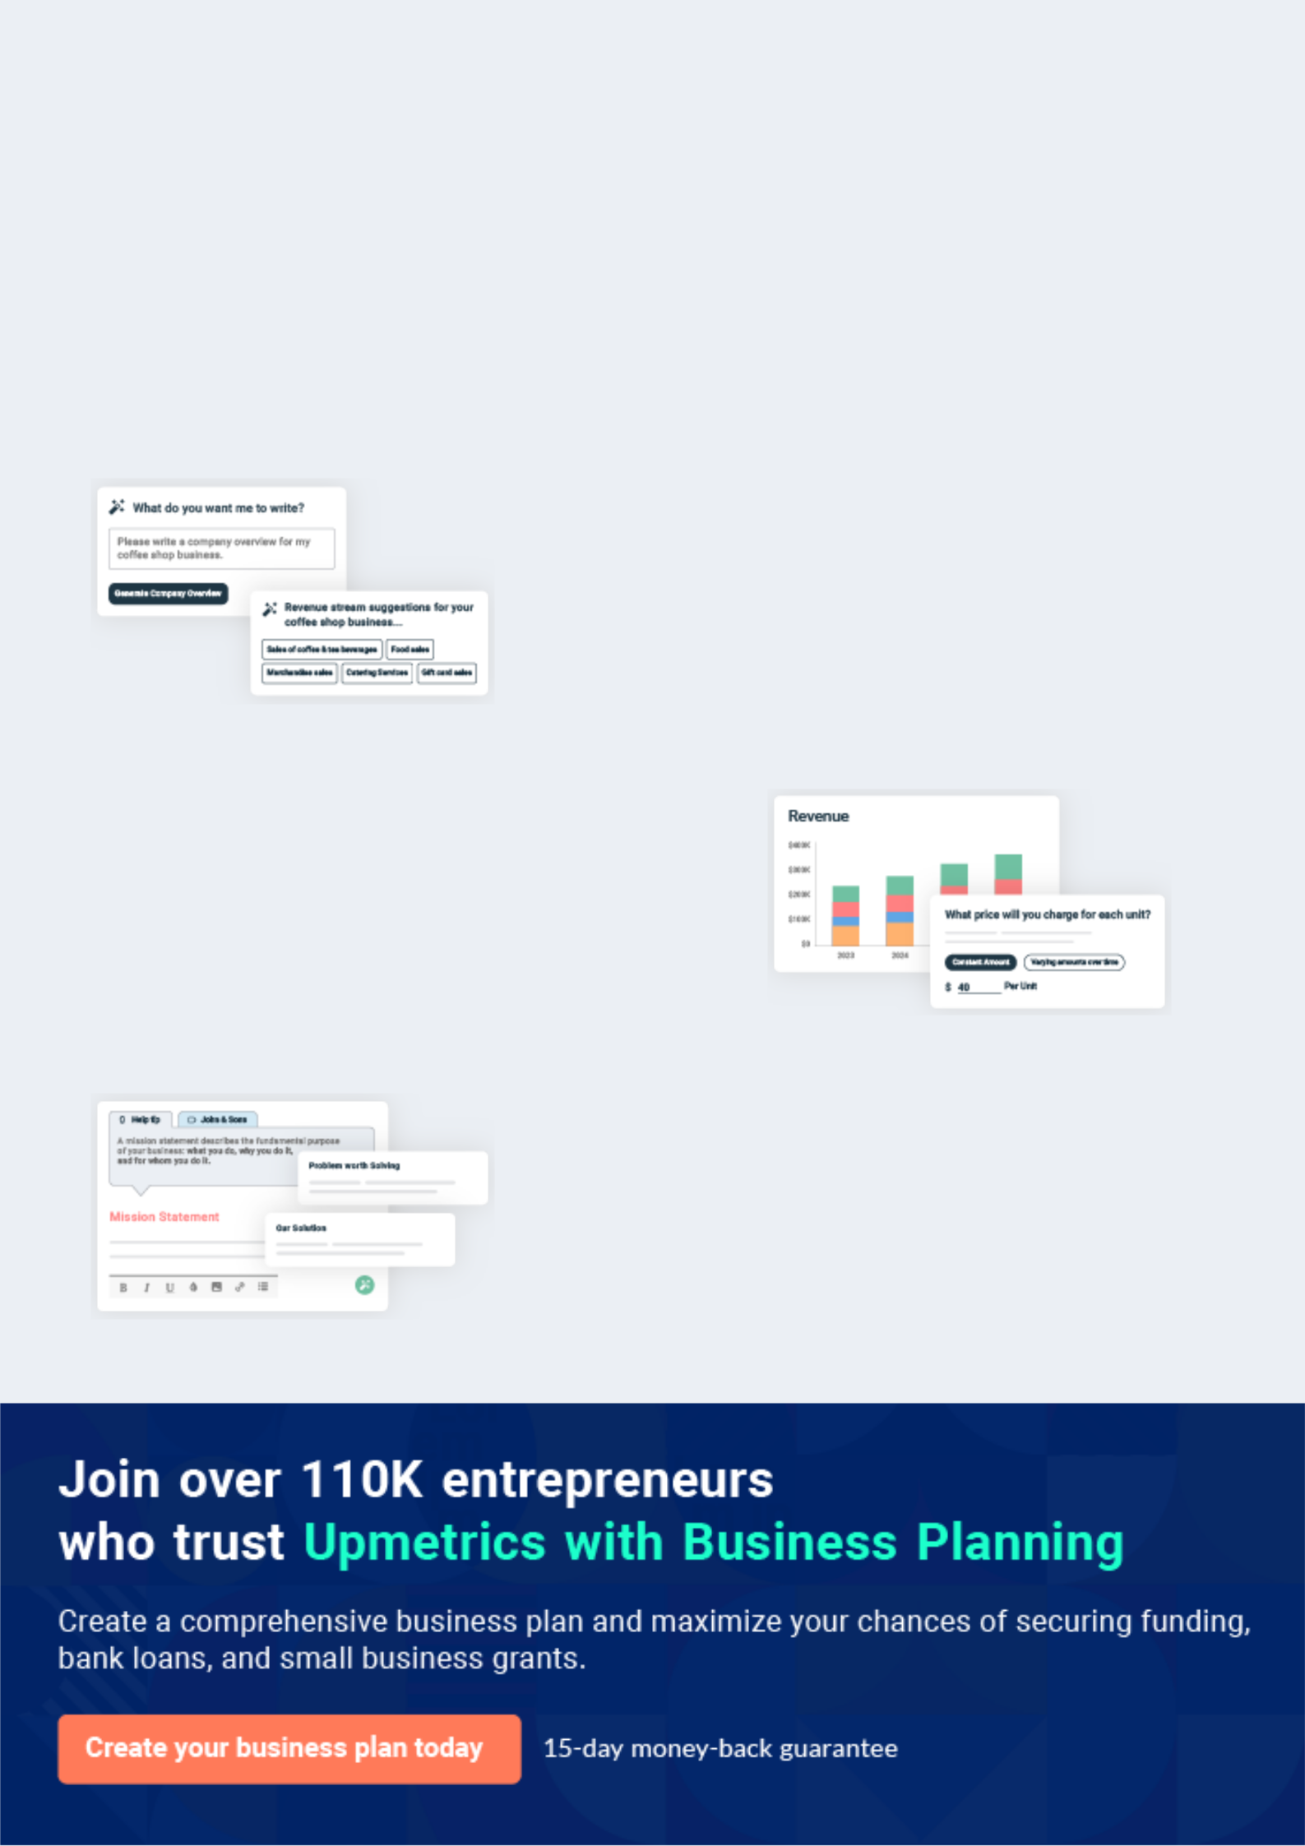
Business planning that’s simpler and faster than you think

Creating a business plan using Upmetrics to start and grow a business is literally the easiest thing in the World. Simply read the instructions and fill in the blanks. It’s as simple as that.

❛ | Upmetrics has everything you need to create a | ❜
❛ | comprehensive business plan. | ❜

AI-powered Upmetrics Assistant

AI-powered insights to streamline your plan

Not sure where to start? Upmetrics’ AI Assistant will automatically generate ideas for each section of your plan and offer improved versions of your writing, adjusting for tone, voice, and grammar or spelling errors.

Financial Forecasting Tool

All the financials are calculated for you

Forget the complex formulas and clumsy spreadsheets — with automatic financials and drag-and-drop forecasting, you can finish your plan faster and be confident that your numbers are accurate.

Business Plan Builder

Guides you like a business mentor

Upmetrics’ step-by-step instructions, prompts, and the library of 400+ sample business plans will guide you through each section of your plan as a business mentor.
Executive Summary


An executive summary is the first section of the business plan intended to provide an overview of the whole business plan.
To unlock help try Upmetrics! 

 Help tip  Home Improvement Business Plan


Start your executive summary by briefly introducing your business to your readers.

This section may include the name of your home improvement business, its location, when it
To unlock help try Upmetrics! 

Start writing here..

Market opportunity

 Help tip  Home Improvement Business Plan

Summarize your market research, including market size, growth potential, and marketing trends. Highlight the opportunities in the market and how your business will fit in to fill the gap.
To unlock help try Upmetrics! 

Start writing here..

Services Offered

 Help tip  Home Improvement Business Plan

Highlight the home improvement services you offer your clients. The USPs and differentiators you offer are always a plus.
To unlock help try Upmetrics! 

Start writing here..

Marketing & Sales Strategies
To unlock help try Upmetrics!

 Help tip  Home Improvement Business Plan

Outline your sales and marketing strategies—what marketing platforms you use, how you plan on acquiring customers, etc.
To unlock help try Upmetrics! 

Start writing here..

Financial Highlights

 Help tip  Home Improvement Business Plan

Briefly summarize your financial projections for the initial years of business operations. Include any capital or investment requirements, associated startup costs, projected revenues, and profit forecasts.



Start writing here..
Units Sold v/s Revenue

 |  | Units Sold | Revenue
15.00k
10.00k
5.00k
0
Year 1 | Year 2 | Year 3


Financial Year |  |  | Units Sold | Revenue
Year 1 | 1,550 |  |  | $10,000
Year 2 | 1,800 |  |  | $12,000
Year 3 | 2,050 |  |  | $14,000
 Help tip |  |  Home Improvement Business Plan


Summarize your executive summary section with a clear CTA, for example, inviting angel investors to discuss the potential business investment
To unlock help try Upmetrics! 

Write a call to action for your business plan.
Company Overview

Depending on what details of your business are essential, you’ll need different elements in your business overview.
To unlock help try Upmetrics! 

 Help tip  Home Improvement Business Plan

Describe your business in this section by providing all the basic information:

Describe what kind of home improvement company you run and the name of it. You may
To unlock help try Upmetrics! 

Start writing here..

Ownership

 Help tip  Home Improvement Business Plan

List the names of your home improvement company’s founders or owners. Describe what shares they own and their responsibilities for efficiently managing the business.
To unlock help try Upmetrics! 

Start writing here..
Mission statement

 Help tip  Home Improvement Business Plan

Summarize your business’ objective, core principles, and values in your mission statement. This statement needs to be memorable, clear, and brief.
To unlock help try Upmetrics! 

❛ At [EnhanceMyHome, Inc.], our mission is to [specific mission, e.g., "transform living spaces into timeless havens of comfort and elegance"].

Guided by core principles of [specific principles, e.g., "integrity, precision, and sustainability"], we pledge to uphold the trust our clients place in us, consistently delivering results that resonate with our promise of excellence.

❜

Business history

 Help tip  Home Improvement Business Plan

If you’re an established home improvement service provider, briefly describe your business history, like—when it was founded, how it evolved over time, etc.
To unlock help try Upmetrics! 

Start writing here..
Future goals

 Help tip  Home Improvement Business Plan

It’s crucial to convey your aspirations and vision. Mention your short-term and long-term goals; they can be specific targets for revenue, market share, or expanding your services.
To unlock help try Upmetrics! 

Start writing here..
Market Analysis
To unlock help try Upmetrics!


 |  | Market analysis provides a clear understanding of the market in which your
 |  | printing business will run along with the target market, competitors, and
 |  | growth opportunities.
 |  |  |  | To unlock help try Upmetrics! 
 Help tip |  |  Home Improvement Business Plan

To write the introduction section of your market analysis, start by clearly identifying your primary target market.
To unlock help try Upmetrics! 

Start writing here..

Target Market

 Help tip  Home Improvement Business Plan

Start this section by describing your target market. Define your ideal customer and explain what types of services they prefer. Creating a buyer persona will help you easily define your target market to your readers.



Start writing here..

Market size and growth potential

 Help tip  Home Improvement Business Plan

Describe your market size and growth potential and whether you will target a niche or a much broader market.
To unlock help try Upmetrics! 

Start writing here..

Market Size

Available Market

Total potential consumers interested 500M in home improvement services.

Served Market
Consumers already using home 300M improvement services.

Target Market
Homeowners aged 30-50 seeking 50M modern design solutions.

 Help tip  Home Improvement Business Plan

Identify and analyze your direct and indirect competitors. Identify their strengths and weaknesses, and describe what differentiates your home improvement business from them.
To unlock help try Upmetrics! 

Competitive analysis

HomeRevive Solutions

Established in [Year], HomeRevive Solutions has been a stalwart in the home improvement industry, serving over [XX,000] clients across [specific geographic region].

Features Strengths Weaknesses

Comprehensive home | Extensive experience in the
remodeling | industry
Customized design | Wide network of suppliers
consultations | ensuring competitive pricing
Eco-friendly material options | Strong customer loyalty backed
Kitchen and bathroom | by consistent service quality
specialist services
Smart home integrations

Limited digital presence, reducing reach to the younger demographic

Longer turnaround time for project completions

Relatively inflexible pricing structures

ModernSpaces Creations

ModernSpaces Creations, founded in [Year], has carved a niche for itself with its avant-garde designs and modern home improvement solutions.

Features

Modular kitchen and living space designs

Home automation and tech integrations

Energy-efficient home solutions

Virtual design mockups and consultations

Strengths

Strong focus on technology-driven solutions appealing to a tech-savvy audience

Agile project management ensuring swift project completions

Collaborations with leading tech brands for integrated home solutions

Weaknesses

Premium pricing may alienate budget-conscious customers

Limited options for traditional home designs

Dependence on third-party tech providers, sometimes leading to integration issues

Traditions & Trends Co.

Traditions & Trends Co., with roots tracing back to [Year], seamlessly blends traditional craftsmanship with contemporary trends.

Features

Bespoke carpentry and woodworking solutions

Heritage property restorations

Tailored design consultations

Outdoor and landscape design services

Strengths

Unique proposition of merging the old with the new, appealing to a broad audience

Skilled craftsmen ensuring authentic restorations and designs

Strong community presence and reputation

Weaknesses

Limited adoption of modern technologies and solutions

Slower adaptation to rapidly changing market trends

Less emphasis on eco-friendly practices

Market trends

 Help tip  Home Improvement Business Plan

Analyze emerging trends in the industry, such as technology disruptions, changes in customer behavior or preferences, etc. Explain how your business will cope with all the trends.
To unlock help try Upmetrics! 

Start writing here..

Regulatory environment
To unlock help try Upmetrics!

 Help tip  Home Improvement Business Plan

List regulations and licensing requirements that may affect your home improvements company, such as business registration, license, and permits, compliance with safety standards, insurance, environmental regulations, state and federal regulations, etc.

Start writing here..
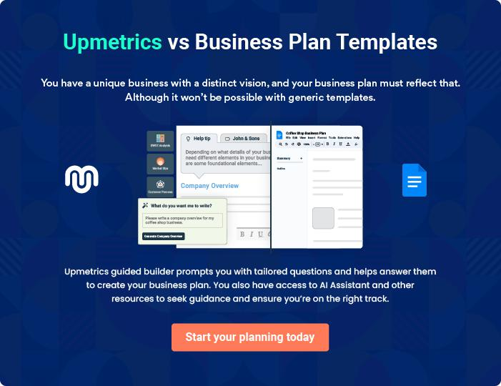


Products and Services

The product and services section of a home improvement business plan should describe the specific services and products that will be offered to customers. To write this section should include the following:
To unlock help try Upmetrics! 

 Help tip  Home Improvement Business Plan

To craft the introduction for your "Products and Services" chapter, begin by positioning your business within its industry, emphasizing its unique strengths or value proposition.
To unlock help try Upmetrics! 

Start writing here..

 Help tip


Mention the home improvement services your business will offer. This list may include services like,
To unlock help try Upmetrics! 

Services

Design Consultation


Price: $[150] per hour

A one-on-one session with our expert designers to understand client preferences, discuss potential design themes, and offer recommendations tailored to individual tastes and the property's layout.

Specifications

- Duration: Approximately [1-2] hours.

- Includes: Mood boards, initial sketches, and color palette discussions.

- Platform: In-person or virtual meetings available.
Project Planning & Management

Price: $[2,500] per project

Dedicated project managers oversee the project from inception to completion, ensuring all tasks are completed on time and within budget.

Specifications

- Duration: Based on project complexity.

- Includes: Timelines, budgeting, task allocation, and regular progress updates.

- Tools Used: Advanced project management software and tools.

Installation and Remodeling Services

Price: Starting at $[5,000] (varies based on room size and requirements)

Complete overhaul or specific installations, tailored to transform spaces as per the design consultation outcomes.

Specifications

- Offerings: Kitchen, bathroom, living room, etc.

- Materials: Choice of standard, premium, or luxury materials.

- Features: Custom cabinetry, countertops, fixtures, etc.
Painting Services

Price: $[3] per square foot

Breathe life into rooms with our vast palette of shades and professional painting services.

Specifications

- Type: Matte, gloss, semi-gloss, etc.

- Brand Options: [Brand A], [Brand B], etc.

- Additional: Wallpaper installation, textured painting.

Repair & Maintenance

Price: $[50] per hour

Periodic checks and repairs ensuring the home stays in pristine condition, with an emphasis on longevity and sustainability.

Specifications

- Services: Plumbing, electrical, carpentry, etc.

- Frequency: On-demand or scheduled.

- Warranty: [XX] months on all repair works.

Home Improvement Products

 Help tip  Home Improvement Business Plan

List down home improvement products offered by your business. This list may include,

• Building materials
To unlock help try Upmetrics! 

Start writing here..

Quality Measures

 Help tip  Home Improvement Business Plan

This section should explain how you maintain quality standards and consistently provide the highest quality service.
To unlock help try Upmetrics! 

Start writing here..

Additional Services

 Help tip  Home Improvement Business Plan

Mention if your home improvement business offers any additional services. You may include services like customization, tool rentals, DIY workshops, etc.
To unlock help try Upmetrics! 

Start writing here..
Sales And Marketing Strategies
To unlock help try Upmetrics!

Writing the sales and marketing strategies section means a list of strategies you will use to attract and retain your clients.
To unlock help try Upmetrics! 

 Help Tip  Home Improvement Business Plan


To create an effective introduction for your "Sales and Marketing Strategies" chapter, start by setting the stage within your specific industry or market.
To unlock help try Upmetrics! 

Start writing here..

Unique Selling Proposition (USP)

 Help tip  Home Improvement Business Plan

Define your business’s USPs depending on the market you serve, the equipment you use, and the unique services you provide. Identifying USPs will help you plan your marketing strategies.
To unlock help try Upmetrics! 

Start writing here..

Pricing Strategy

 Help tip  Home Improvement Business Plan

Describe your pricing strategy—how you plan to price your remodeling services and stay competitive in the local market. You can mention any entry discounts you plan on offering to attract new customers to your home improvement service.



Start writing here..

 Help tip  Home Improvement Business Plan
To unlock help try Upmetrics!

Discuss your marketing strategies to market your services. You may include some of these marketing strategies in your business plan—social media marketing, Google ads, brochures, email marketing, content marketing, and print marketing.



Marketing strategies

Online


Social Media

Targeted campaigns on platforms like Facebook, Instagram, and Pinterest, showcasing our latest projects and client testimonials.

Content Marketing

Engaging blog posts and videos providing value and showcasing our expertise.

Email Marketing

Periodic newsletters with tips, tricks, and special offers for our subscriber base.

Google Ads

Optimized ad campaigns to reach those actively searching for home improvement services.

Offline

Brochures

High-quality print material distributed in [specific localities/ regions].

Print Marketing

Local newspaper ads and magazine features to reach a traditional audience.

 Help tip  Home Improvement Business Plan
To unlock help try Upmetrics!

Outline the strategies you’ll implement to maximize your sales. Your sales strategies may include direct sales calls, partnering with local contractors, home builders, and the local community, offering referral programs, etc.



Sales strategies

Partner with Businesses

Collaborative efforts with local contractors, home builders, and community events to broaden our reach.

Direct Sales Calls

Engaging potential clients who've shown interest or been referred to us.

Referral Programs

Rewarding our satisfied customers

who refer our services to friends

and family, thereby amplifying our

sales.

 Help tip  Home Improvement Business Plan

Describe your customer retention strategies and how you plan to execute them. For instance, introducing loyalty programs, discounts on annual maintenance services, priority services, etc.
To unlock help try Upmetrics! 

Customer retention

Loyalty Programs

Rewarding customers with points for every service availed, which can be redeemed for discounts or complimentary services.

Annual Membership Discounts

Special rates for customers opting for yearly maintenance services.

Priority Services

Ensuring our loyal customer base

always gets priority slots and

faster service.

Operations Plan

 |  | When writing the operations plan section, it’s important to consider the
 |  | various aspects of your business operations.
 |  |  |  | To unlock help try Upmetrics! 
 Help tip |  |  Home Improvement Business Plan


To create an effective introduction for your "Operational Plan" chapter, start by emphasizing the
pivotal role of efficient operations in the success of your business, underscoring how they
directly impact the quality of services delivered.
 |  |  |  | To unlock help try Upmetrics! 
Start writing here..
Staffing & Training
 Help tip |  |  Home Improvement Business Plan

Mention your home improvement company’s staffing requirements, including the number of
sales associates, cashiers, and technicians, design consultants. Include their qualifications, the
training required, and the duties they will perform.
 |  |  |  | To unlock help try Upmetrics! 
Start writing here..
Operational Process
 Help tip |  |  Home Improvement Business Plan

Outline the processes and procedures you will use to run your home improvement business.

Your operational processes may include sourcing materials, offering quotes, drafting and
To unlock help try Upmetrics! 

Start writing here..

Equipment & Machinery

 Help tip  Home Improvement Business Plan

Include the list of equipment and machinery required for home improvements, such as hand and power tools, power generators, air compressors, ladders, safety equipment, etc.
To unlock help try Upmetrics! 

Start writing here..
Management Team

The management team section provides an overview of the individuals responsible for running your business plan.
To unlock help try Upmetrics! 

 Help tip  Home Improvement Business Plan

To craft an introduction for your "Management Team" chapter, begin by emphasizing the crucial role of leadership in the success of any business.
To unlock help try Upmetrics! 

Start writing here..

Key managers

 Help tip  Home Improvement Business Plan

Introduce your management and key members of your team, and explain their roles and responsibilities.
To unlock help try Upmetrics! 

Start writing here..


JOHN DOE

CEO - john.doe@example.com

As the co-founder and CEO of [EnhanceMyHome, Inc.], John is responsible for setting the strategic direction of the company, ensuring its financial stability, and overseeing its operations.


His insightful leadership has been instrumental in positioning the company as a leading name in the home improvement sector.

With a Bachelor’s Degree in Business Management from Stanford University and over 15 years of experience in the home improvement industry, John's vast knowledge and business acumen have been invaluable.

JANE DOE

Chief Operating Officer (COO) - jane.doe@example.com

Jane oversees the daily operational aspects of [EnhanceMyHome, Inc.], ensuring that all processes run seamlessly and efficiently. With an MBA from Harvard Business School and a background in operational logistics,


Jane has streamlined many of our core processes, helping the company save time and resources.

Her expertise lies in optimizing supply chain management, managing vendor relationships, and ensuring top-tier quality control.


ALICE BROWN

CMO - alice.brown@example.com

Leading our brand's presence across multiple channels, Alice is the strategic brain behind our marketing endeavors.

She graduated with a Master's in Marketing from the Wharton School and has spent over 10 years in various marketing roles, sharpening her expertise in both digital and traditional mediums.

At [EnhanceMyHome, Inc.], Alice has led numerous successful campaigns, elevating our brand recognition substantially.


ROBERT BROWN

Store Manager - robert.brown@example.com

Robert ensures our flagship store operates without a hitch, handling inventory, staff, and customer interactions with finesse.

A graduate in Retail Management from New York University, Robert has a keen eye for detail and an unparalleled ability to manage large teams.

With over 8 years of retail management experience, Robert’s leadership has been key to the thriving environment of our store.
Organizational structure

 Help tip  Home Improvement Business Plan

Explain the organizational structure of your management team. Include the reporting line and decision-making hierarchy.
To unlock help try Upmetrics! 

Start writing here..

Organization chart


John Doe

CEO
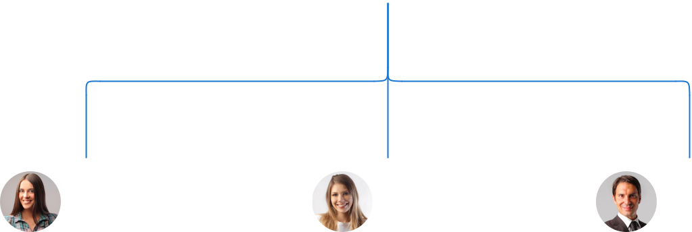

Alice Brown Jane Doe Robert Brown

CMO COO Store Manager




Emily Johnson Tim Lee

Sales Associate Operations Associate

Compensation plan

 Help tip  Home Improvement Business Plan

Describe your compensation plan for the management and staff. Include their salaries, incentives, and other benefits.
To unlock help try Upmetrics! 

Start writing here..

 Help tip  Home Improvement Business Plan

Mentioning advisors or consultants in your business plans adds credibility to your business idea.
To unlock help try Upmetrics! 

Advisors/Consultants


[ADVISOR NAME]

Advisor

With [X years] in the home improvement domain, [First Name]'s insights have been invaluable.


[CONSULTANT NAME]

Consultant

Specializing in [specific area e.g., green building practices], [First Name] aids us in staying updated with industry trends.
Financial Plan

When writing the financial plan section of a business plan, it’s important to provide a comprehensive overview of your financial projections for the first few years of your business, You may provide the following:
To unlock help try Upmetrics! 

 Help tip  Home Improvement Business Plan


To create an effective introduction for your "Financial Plan" chapter, begin by stressing the critical role of a well-structured financial plan in the success of your venture.
To unlock help try Upmetrics! 

Start writing here..

 Help tip


Describe details such as projected revenue, operational costs, and service costs in your projected profit and loss statement. Make sure to include your business’s expected net profit or loss.
To unlock help try Upmetrics! 

Profit & loss statement

Revenue

Cost Of Sales

General Costs

Revenue Specific Costs

Personnel Costs (Direct

Labor)

Gross Margin

Gross Margin (%)

Operating Expense

Payroll Expense

(Indirect Labor)

General Expense

Bad Debt

Amortization of Current

Assets

2023-24 | 2024-25 | 2025-26 | 2026-27 | 2027-28
$0 | $0 | $0 | $0 | $0

$0 | $0 | $0 | $0 | $0
$0 | $0 | $0 | $0 | $0
$0 | $0 | $0 | $0 | $0
$0 | $0 | $0 | $0 | $0

$0 | $0 | $0 | $0 | $0
0% | 0% | 0% | 0% | 0%

$0 | $0 | $0 | $0 | $0
$0 | $0 | $0 | $0 | $0
$0 | $0 | $0 | $0 | $0
$0 | $0 | $0 | $0 | $0
$0 | $0 | $0 | $0 | $0

EBITDA

Additional Expense

Long Term

Depreciation

Gain or loss from Sale

of Assets

EBIT

Interest Expenses

EBT

Income Tax Expense

Total Expense

Net Income

Net Income (%)

2023-24 | 2024-25 | 2025-26 | 2026-27 | 2027-28
$0 | $0 | $0 | $0 | $0
$0 | $0 | $0 | $0 | $0
$0 | $0 | $0 | $0 | $0
$0 | $0 | $0 | $0 | $0
$0 | $0 | $0 | $0 | $0
$0 | $0 | $0 | $0 | $0
$0 | $0 | $0 | $0 | $0
$0 | $0 | $0 | $0 | $0
$0 | $0 | $0 | $0 | $0
$0 | $0 | $0 | $0 | $0
0% | 0% | 0% | 0% | 0%
 | 2023-24 | 2024-25 | 2025-26 | 2026-27 | 2027-28
Retained Earning | $0 | $0 | $0 | $0 | $0
Opening
Owner's Distribution | $0 | $0 | $0 | $0 | $0
Retained Earning | $0 | $0 | $0 | $0 | $0
Closing

 Help tip

The cash flow for the first few years of your operation should be estimated and described in this section. This may include billing invoices, payment receipts, loan payments, and any other cash flow statements.
To unlock help try Upmetrics! 

Cash flow statement

 | 2023-24 | 2024-25 | 2025-26 | 2026-27 | 2027-28
Cash Received | $0 | $0 | $0 | $0 | $0
Cash Paid | $0 | $0 | $0 | $0 | $0
COS & General Expenses | $0 | $0 | $0 | $0 | $0
Salary & Wages | $0 | $0 | $0 | $0 | $0
Interest | $0 | $0 | $0 | $0 | $0

Sales Tax

Income Tax

Net Cash From

Operations

Assets Sell

Assets Purchase

Net Cash From

Investments

Amount Received

Loan Received

Common Stock

Preferred Stock

Owner's Contribution

Amount Paid

2023-24 | 2024-25 | 2025-26 | 2026-27 | 2027-28
$0 | $0 | $0 | $0 | $0
$0 | $0 | $0 | $0 | $0
$0 | $0 | $0 | $0 | $0

$0 | $0 | $0 | $0 | $0
$0 | $0 | $0 | $0 | $0
$0 | $0 | $0 | $0 | $0

$0 | $0 | $0 | $0 | $0
$0 | $0 | $0 | $0 | $0

$0 | $0 | $0 | $0 | $0
$0 | $0 | $0 | $0 | $0
$0 | $0 | $0 | $0 | $0

Loan Capital $0 $0 $0 $0 $0

 | 2023-24 | 2024-25 | 2025-26 | 2026-27 | 2027-28
Dividends & Distributions | $0 | $0 | $0 | $0 | $0
Net Cash From | $0 | $0 | $0 | $0 | $0
Financing

Summary
Starting Cash | $0 | $0 | $0 | $0 | $0
Cash In | $0 | $0 | $0 | $0 | $0
Cash Out | $0 | $0 | $0 | $0 | $0
Change in Cash | $0 | $0 | $0 | $0 | $0
Ending Cash | $0 | $0 | $0 | $0 | $0

 Help tip

Create a projected balance sheet documenting your home improvement business’s assets, liabilities, and equity.

To unlock help try Upmetrics! 

Balance sheet

 | 2023-24 | 2024-25 | 2025-26 | 2026-27 | 2027-28
Assets | $0 | $0 | $0 | $0 | $0
Current Assets | $0 | $0 | $0 | $0 | $0
Cash | $0 | $0 | $0 | $0 | $0
Accounts Receivable | $0 | $0 | $0 | $0 | $0
Inventory | $0 | $0 | $0 | $0 | $0
Other Current Assets | $0 | $0 | $0 | $0 | $0
Long Term Assets | $0 | $0 | $0 | $0 | $0
Gross Long Term Assets | $0 | $0 | $0 | $0 | $0
Accumulated Depreciation | $0 | $0 | $0 | $0 | $0

Liabilities & Equity | $0 | $0 | $0 | $0 | $0
Liabilities | $0 | $0 | $0 | $0 | $0
Current Liabilities | $0 | $0 | $0 | $0 | $0
Accounts Payable | $0 | $0 | $0 | $0 | $0
Income Tax Payable | $0 | $0 | $0 | $0 | $0
Sales Tax Payable | $0 | $0 | $0 | $0 | $0
Short Term Debt | $0 | $0 | $0 | $0 | $0
 | 2023-24 | 2024-25 | 2025-26 | 2026-27 | 2027-28
Long Term Liabilities | $0 | $0 | $0 | $0 | $0
Long Term Debt | $0 | $0 | $0 | $0 | $0
Equity | $0 | $0 | $0 | $0 | $0
Paid-in Capital | $0 | $0 | $0 | $0 | $0
Common Stock | $0 | $0 | $0 | $0 | $0
Preferred Stock | $0 | $0 | $0 | $0 | $0
Owner's Contribution | $0 | $0 | $0 | $0 | $0
Retained Earnings | $0 | $0 | $0 | $0 | $0

Check | $0 |  |  | $0 | $0 | $0 | $0
 Help tip |  |  Home Improvement Business Plan


Determine and mention your business’s break-even point—the point at which your business costs and revenue will be equal.

This exercise will help you understand how much revenue you need to generate to sustain or be profitable.
To unlock help try Upmetrics! 

Break-even Analysis

 | 2023-24 | 2024-25 | 2025-26 | 2026-27 | 2027-28
Starting Revenue | $0 | $0 | $0 | $0 | $0
Net Revenue | $0 | $0 | $0 | $0 | $0
Closing Revenue | $0 | $0 | $0 | $0 | $0

Starting Expense | $0 | $0 | $0 | $0 | $0
Net Expense | $0 | $0 | $0 | $0 | $0
Closing Expense | $0 | $0 | $0 | $0 | $0

Is Break Even? | 0 | 0 | 0 | 0 | 0
Break Even Month | 0 | 0 | 0 | 0 | 0
Days Required | 0 | 0 | 0 | 0 | 0
Break Even Revenue | $0 | $0 | $0 | $0 | $0
Break Even Units
Financing needs

 Help tip  Home Improvement Business Plan

Calculate costs associated with starting a home improvement business, and estimate your financing needs and how much capital you need to raise to operate your business.
To unlock help try Upmetrics! 

Start writing here..
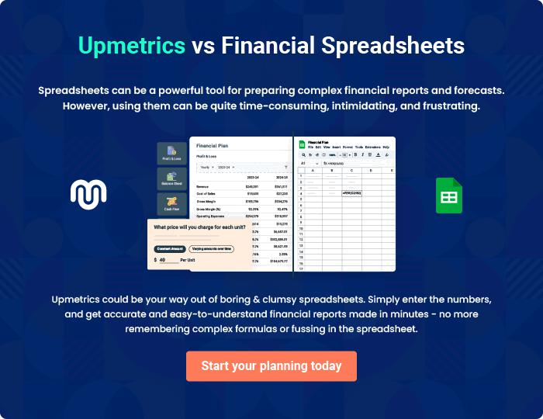
Appendix

When writing the appendix section, you should include any additional information that supports the main content of your plan. This may include financial statements, market research data, legal documents, and other
To unlock help try Upmetrics! 
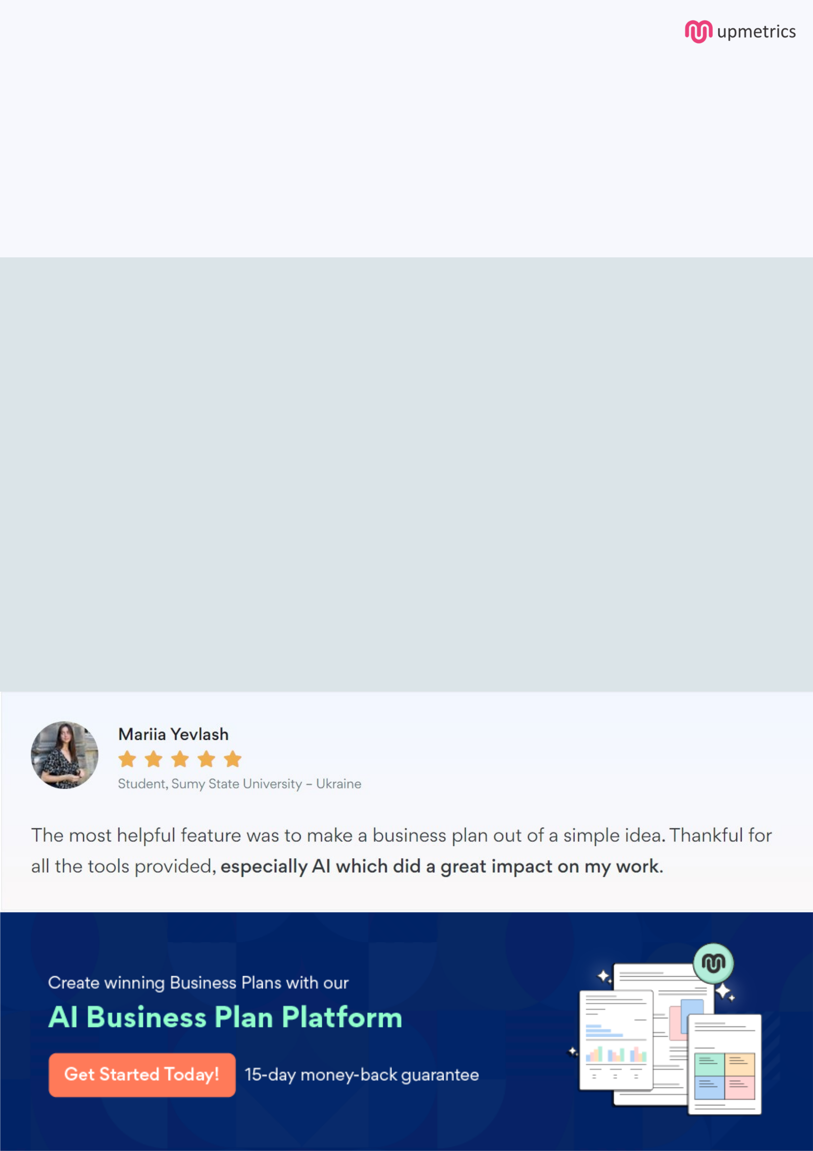
Create a winning business plan that gets you funded

Creating a stunning and investment-ready plan requires no writing, graphic designing, or financial planning expertise.

Upmetrics has all the features required to help you create a comprehensive business plan—from start to finish. Make no mistakes, it’s the modern way of planning to structure ideas, make plans, and create stunning pitch decks to awe investors.

Pitch decks that impress investors

Create pitch decks that provide a visual representation of your business, engage investors, and make them want to invest in your business idea.

Interactive plans in no time

Import business plan sections like—SWOT analysis, comparison tables, and others to create an interactive business plan. No designing skills are required.

Stunning cover page designs

With Upmetrics, you have the liberty to choose from multiple stunning cover page designs. Choose a creative design and make your plan stand out.

Online sharing made simple

Upmetrics makes online sharing quick and easier for users. Easily share your business plans with a link while tracking reader activity.

500+ sample business plans

Simply import a template from our library of sample plans into the editor and start customizing it to make it yours. It takes only a few clicks to get started.

Collaborate with team in real-time

Invite team members, initiate conversations, discuss ideas & strategies, share feedback, and work on a business plan in real-time.

