
Home Decor Business Plan


Business
Plan

2023
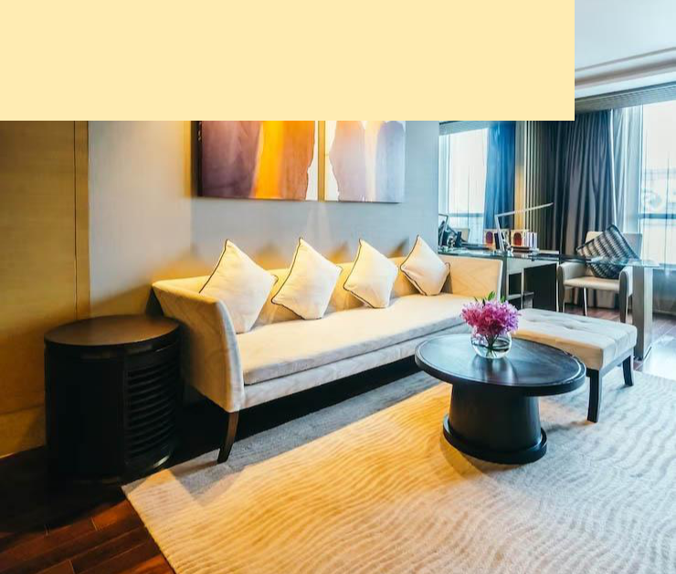

Decorate Dreams, Design Realities

Information provided in this business plan is unique to this business and confidential; therefore, anyone reading this plan agrees not to disclose any of the information in this business plan without prior written permission of the company.

 | Prepared By | 10200 Bolsa Ave, Westminster, CA, 92683
 | John Doe | info@example.com
 | (650) 359-3153 | http://www.example.com

Table of Contents

Executive Summary | 6
Market opportunity | 6
Services Offered | 6
Marketing & Sales Strategies | 7
Financial Highlights | 7
Units Sold v/s Revenue | 8

Company Overview | 9
Ownership | 9
Mission statement | 10
Business history | 10
Future goals | 11

Market Analysis | 12
Target Market | 12
Market size and growth potential | 12
Market Size | 13
Competitive analysis | 13
Decor Delight Inc. | 13
GreenNest Furnishings | 14
ModernSpaces Ltd. | 14
Market trends | 15
Regulatory environment | 15

Products and Services | 17
Products | 17
Luxury Oakwood Dining Table | 17
Custom Wall Mural Design | 19
Eco-friendly Bamboo Floor Lamp | 19
Space Optimization Consultation | 20
Velvet Accent Armchair | 20
Customization option | 21
Quality measures | 21
Additional Services | 21

Sales And Marketing Strategies | 22
Unique Selling Proposition (USP) | 22
Pricing Strategy | 22
Marketing strategies | 23
Online | 23
Offline | 23
Sales strategies | 24
Customer retention | 25

Operations Plan | 26
Staffing & Training | 26
Operational Process | 26
Equipment & Software | 27

Management Team | 28
Key managers | 28
John Doe | 28
Jane Doe | 29
Alice Brown | 29
Robert Brown | 30
Organizational structure | 30
Organization chart | 31
Compensation plan | 31
Advisors/Consultants | 32
[ADVISOR NAME] | 32
[CONSULTANT NAME] | 32
Financial Plan
Financial Plan | 33

Profit & loss statement 33

Cash flow statement | 36
Balance sheet | 38
Break-even Analysis | 40
Financing needs | 42
Appendix
Appendix | 44
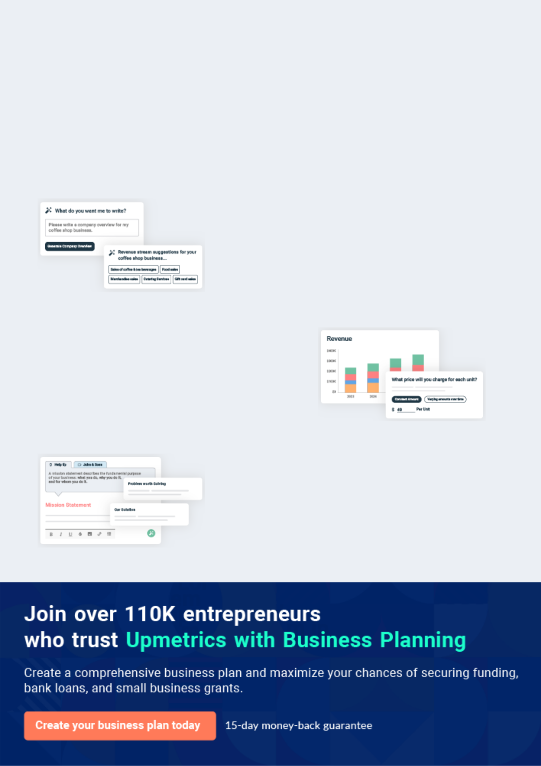
Business planning that’s simpler and faster than you think

Creating a business plan using Upmetrics to start and grow a business is literally the easiest thing in the World. Simply read the instructions and fill in the blanks. It’s as simple as that.

❛ | Upmetrics has everything you need to create a | ❜
❛ | comprehensive business plan. | ❜

AI-powered Upmetrics Assistant

AI-powered insights to streamline your plan

Not sure where to start? Upmetrics’ AI Assistant will automatically generate ideas for each section of your plan and offer improved versions of your writing, adjusting for tone, voice, and grammar or spelling errors.

Financial Forecasting Tool

All the financials are calculated for you

Forget the complex formulas and clumsy spreadsheets — with automatic financials and drag-and-drop forecasting, you can finish your plan faster and be confident that your numbers are accurate.

Business Plan Builder

Guides you like a business mentor

Upmetrics’ step-by-step instructions, prompts, and the library of 400+ sample business plans will guide you through each section of your plan as a business mentor.
Executive Summary


An executive summary is the first section of the business plan intended to provide an overview of the whole business plan.
To unlock help try Upmetrics! 

 Help tip  Home Decor Business Plan


Start your executive summary by briefly introducing your business to your readers.

This section may include the name of your home decor business, its location, when it was
To unlock help try Upmetrics! 

Start writing here..

Market opportunity

 Help tip  Home Decor Business Plan

Summarize your market research, including market size, growth potential, and marketing trends. Highlight the opportunities in the market and how your business will fit in to fill the gap.
To unlock help try Upmetrics! 

Start writing here..

Services Offered

 Help tip  Home Decor Business Plan

Highlight the home decor services you offer your clients. The USPs and differentiators you offer are always a plus.
To unlock help try Upmetrics! 

Start writing here..

Marketing & Sales Strategies
To unlock help try Upmetrics!

 Help tip  Home Decor Business Plan

Outline your sales and marketing strategies—what marketing platforms you use, how you plan on acquiring customers, etc.
To unlock help try Upmetrics! 

Start writing here..

Financial Highlights

 Help tip  Home Decor Business Plan

Briefly summarize your financial projections for the initial years of business operations. Include any capital or investment requirements, associated startup costs, projected revenues, and profit forecasts.



Start writing here..
Units Sold v/s Revenue

 |  | Units Sold | Revenue
15.00k
10.00k
5.00k
0
Year 1 | Year 2 | Year 3


Financial Year |  |  | Units Sold | Revenue
Year 1 | 1,550 |  |  | $10,000
Year 2 | 1,800 |  |  | $12,000
Year 3 | 2,050 |  |  | $14,000
 Help tip |  |  Home Decor Business Plan
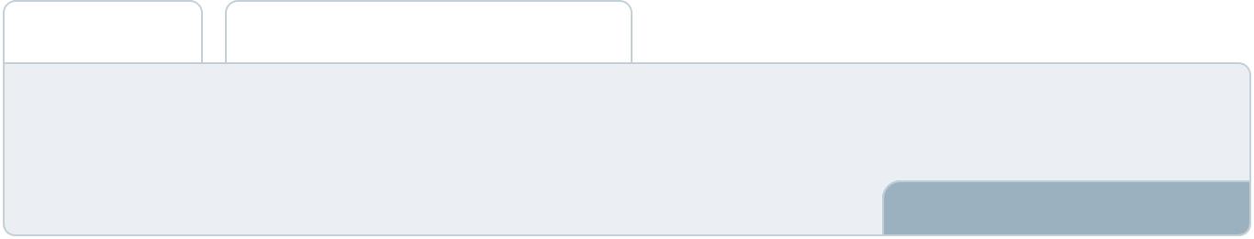

Summarize your executive summary section with a clear CTA, for example, inviting angel investors to discuss the potential business investment.
To unlock help try Upmetrics! 

Write a call to action for your business plan.
Company Overview

Depending on what details of your business are essential, you’ll need different elements in your business overview.
To unlock help try Upmetrics! 

 Help tip  Home Decor Business Plan

Describe your business in this section by providing all the basic information:

Describe what kind of home decor company you run and the name of it. You may specialize in
To unlock help try Upmetrics! 

Start writing here..

Ownership

 Help tip  Home Decor Business Plan

List the names of your home decor company’s founders or owners. Describe what shares they own and their responsibilities for efficiently managing the business.
To unlock help try Upmetrics! 

Start writing here..
Mission statement

 Help tip  Home Decor Business Plan

Summarize your business’ objective, core principles, and values in your mission statement. This statement needs to be memorable, clear, and brief.
To unlock help try Upmetrics! 

❛ At [Elegant Spaces Interiors], we are committed to redefining elegance. Our mission is to transform every space, big or small, into a visual masterpiece that echoes the personalities of its inhabitants.

Rooted in the principles of [Core Principle 1, e.g., "sustainability"], [Core Principle 2, e.g., "craftsmanship"], and [Core Principle 3, e.g., "customer-centric design"], we aim to set the gold standard in interior decor.

❜

Business history

 Help tip  Home Decor Business Plan

If you’re an established home decor firm, briefly describe your business history, like—when it was founded, how it evolved over time, etc.
To unlock help try Upmetrics! 

Start writing here..
Future goals

 Help tip  Home Decor Business Plan

It’s crucial to convey your aspirations and vision. Mention your short-term and long-term goals; they can be specific targets for revenue, market share, or expanding your services.
To unlock help try Upmetrics! 

Start writing here..
Market Analysis
To unlock help try Upmetrics!


 |  | Market analysis provides a clear understanding of the market in which your
 |  | printing business will run along with the target market, competitors, and
 |  | growth opportunities.
 |  |  |  | To unlock help try Upmetrics! 
 Help tip |  |  Home Decor Business Plan

To write the introduction section of your market analysis, start by clearly identifying your primary target market.
To unlock help try Upmetrics! 

Start writing here..

Target Market

 Help tip  Home Decor Business Plan

Start this section by describing your target market. Define your ideal customer and explain what types of services they prefer. Creating a buyer persona will help you easily define your target market to your readers.



Start writing here..

Market size and growth potential

 Help tip  Home Decor Business Plan

Describe your market size and growth potential and whether you will target a niche or a much broader market.
To unlock help try Upmetrics! 

Start writing here..

Market Size

Available Market

Total consumers seeking home decor 500M solutions globally.

Served Market
Consumers in regions where major 200M decor companies operate.

Target Market
Urban, eco-conscious consumers 50M seeking premium decor.

 Help tip  Home Decor Business Plan

Identify and analyze your direct and indirect competitors. Identify their strengths and weaknesses, and describe what differentiates your home decor business from them.
To unlock help try Upmetrics! 

Competitive analysis

Decor Delight Inc.

A behemoth in the industry, Decor Delight Inc. has been in the business for over two decades. With a significant online presence and a chain of brick-and-mortar stores across the country, they have a comprehensive catalogue ranging from classic designs to contemporary pieces.

Features | Strengths
E-commerce platform with | Vast distribution network
virtual room planning tools. | enabling nationwide reach.
Collaborative pieces with | Strong brand recall and
renowned designers. | customer loyalty.
Seasonal collections, catering | A wide variety of product
to festivals and holidays. | choices catering to diverse
Membership program offering | tastes.
exclusive designs and
discounts.

Weaknesses

Often criticized for not being environmentally conscious in their manufacturing processes.

Customer complaints regarding the durability of some products.

Limited customization options.

GreenNest Furnishings

A relatively new entrant, GreenNest Furnishings, focuses on eco-friendly and sustainable home decor. Their USP lies in merging aesthetics with environmental responsibility, catering to a growing segment of eco-conscious consumers.

Features | Strengths | Weaknesses
Furniture made from reclaimed | Strong emphasis on | Limited presence in physical
and recycled materials. | sustainability, appealing to a | stores, restricting touch-and-feel
A dedicated line of decor | growing demographic. | experiences.
catering to minimalistic design | transparent about their supply | Premium pricing might alienate
principles. | chain, enhancing consumer | budget-conscious consumers
A dedicated line of decor | trust. | Limited choices in comparison to
catering to minimalistic design | Collaborations with | more established players.
principles. Workshops and DIY | environmental activists and
kits for consumers to create | influencers.
their own decor pieces.
Carbon-neutral shipping.

ModernSpaces Ltd.

ModernSpaces Ltd. specializes in catering to urban apartments and compact homes. Their designs focus on multi-functionality, ensuring space optimization without compromising on aesthetics.

Features | Strengths | Weaknesses
Transformable furniture (e.g., | Addressing specific pain points | Limited appeal to homeowners
sofas that turn into beds). | of urban dwellers. | with larger spaces.
Wall-mounted units to | Innovative designs that | Dependence on technology might
maximize floor space. | combine utility and style. | deter traditional consumers.
VR-assisted design | Partnerships with real estate | Some designs might be
consultations. | developers for integrated | perceived as too avant-garde.
VR-assisted design | furnishing solutions.
consultations. Rental and lease
options for transient urban
populations.

Market trends
To unlock help try Upmetrics!

 Help tip  Home Decor Business Plan

Analyze emerging trends in the industry, such as technology disruptions, changes in customer behavior or preferences, etc. Explain how your business will cope with all the trends.
To unlock help try Upmetrics! 

Start writing here..

Regulatory environment

 Help tip  Home Decor Business Plan

List regulations and licensing requirements that may affect your home decor company, such as business registration, zoning, product safety & compliance, taxation, online sales & data privacy, etc.



Start writing here..
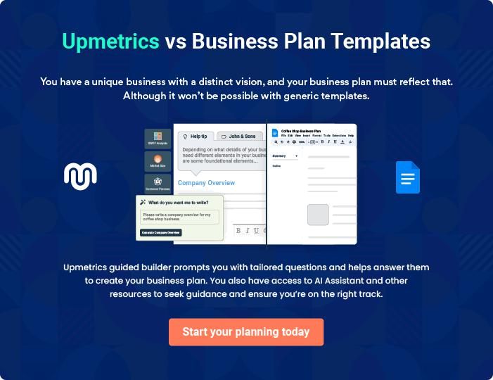
Products and Services
To unlock help try Upmetrics!

The product and services section of a home decor business plan should describe the specific services and products that will be offered to customers. To write this section should include the following:



 Help tip  Home Decor Business Plan

To craft the introduction for your "Products and Services" chapter, begin by positioning your business within its industry, emphasizing its unique strengths or value proposition.
To unlock help try Upmetrics! 

Start writing here..

 Help tip


Mention the home decor products & services your business will offer. This list may include:

• Furniture
To unlock help try Upmetrics! 

Products

Luxury Oakwood Dining Table


Price: [$2,500]

A handcrafted dining table made from premium Oakwood, designed to add a touch of luxury and elegance to your dining space.
Specifications

- Dimensions: 90" L x 42" W x 30" H

- Material: Solid Oakwood

- Finish: Matte Walnut

- Seating Capacity: 8 persons

- Features: Water-resistant, Scratch-proof top, and Carved leg details.
Custom Wall Mural Design

Price: Starting from [$750]

Transform your walls into a canvas with our custom mural designs. Collaborate with our in-house artists to create a bespoke wall art piece.

Specifications

- Style Options: Abstract, Landscape, Portraiture, Geometric.

- Size: Customizable as per wall dimensions.

- Materials Used: Eco-friendly paints, Wall-safe adhesives.

- Process: Consultation, Design Mockup, Finalization, Application.

Eco-friendly Bamboo Floor Lamp

Price: [$450]

Illuminate your living spaces with our sustainable Bamboo Floor Lamp, combining style with environmental consciousness.

Specifications

- Height: 72 inches

- Material: Bamboo and Linen (lampshade)

- Bulb Type: Compatible with LED and CFL

- Features: Adjustable brightness, Energy-efficient, Hand-woven shade.
Space Optimization Consultation

Price: [$100/hr]

Leverage our expertise to maximize space utility without compromising on aesthetics. Ideal for urban homes and compact spaces.

Specifications

- Duration: Typically 2-3 hours per room.

- Deliverables: Detailed room layout, Furniture arrangement plan, Storage solutions.

- Platforms: In-person or Virtual consultation available.

- Follow-ups: Two post-consultation follow-ups included.

Velvet Accent Armchair

Price: [$1,200]

Dive into comfort with our plush velvet armchair, the perfect blend of style, comfort, and luxury for your living room or study.

Specifications

- Dimensions: 34" W x 36" D x 38" H

- Material: Velvet upholstery, Solid wood frame.

- Color Options: Royal Blue, Emerald Green, Deep Maroon.

- Features: Deep cushioning, Stain-resistant fabric, Gold-tone metal accents.
Customization option

 Help tip  Home Decor Business Plan

Emphasize this feature if you provide customization. Describe how buyers can alter things to match their tastes, for as by selecting fabrics, colors, finishes, or adding unique touches.
To unlock help try Upmetrics! 

Start writing here..

Quality measures

 Help tip  Home Decor Business Plan

This section should explain how you maintain quality standards and consistently provide the highest quality service.
To unlock help try Upmetrics! 

Start writing here..

Additional Services

 Help tip  Home Decor Business Plan

Mention if your home decor company offers any additional services. You may include services like design consultation, space planning, 3D images, project management, etc.
To unlock help try Upmetrics! 

Start writing here..
Sales And Marketing Strategies

Writing the sales and marketing strategies section means a list of strategies you will use to attract and retain your clients.
To unlock help try Upmetrics! 

 Help Tip  Home Decor Business Plan


To create an effective introduction for your "Sales and Marketing Strategies" chapter, start by setting the stage within your specific industry or market.
To unlock help try Upmetrics! 

Start writing here..

Unique Selling Proposition (USP)

 Help tip  Home Decor Business Plan

Define your business’s USPs depending on the market you serve, the equipment you use, and the unique services you provide. Identifying USPs will help you plan your marketing strategies.
To unlock help try Upmetrics! 

Start writing here..

Pricing Strategy

 Help tip  Home Decor Business Plan

Describe your pricing strategy—how you plan to price your services and stay competitive in the local market. You can mention any discounts you plan on offering to attract new customers.
To unlock help try Upmetrics! 

Start writing here..

 Help tip  Home Decor Business Plan
To unlock help try Upmetrics!

Discuss your marketing strategies to market your services. You may include some of these marketing strategies in your business plan—social media marketing, brochures, email marketing, content marketing, and print marketing.



Marketing strategies

Online


Social Media

Leveraging platforms like Instagram, Pinterest, and Facebook, we will showcase our products, share behind-the-scenes content, and engage with our audience through interactive posts and ads.

Content Marketing

A blog on our website focusing on home decor trends, DIY tips, and showcasing client transformations will help in organic search visibility and customer engagement.

Offline

Brochures

Elegantly designed brochures detailing our product range, services, and USPs will be distributed in strategic locations like [Real Estate Agencies, Coffee Shops, etc.].

Email Marketing

Regular newsletters featuring our latest collections, design tips, and exclusive offers will be sent to our subscriber base.

Print Marketing

Collaborations with home & lifestyle magazines, and local newspapers for featured articles and ads.

 Help tip  Home Decor Business Plan
To unlock help try Upmetrics!

Outline the strategies you’ll implement to maximize your sales. Your sales strategies may include partnering with other businesses, offering referral programs, upselling & cross-selling, etc.



Sales strategies

Partner with Businesses

Engage in collaborations with real estate agencies, architects, and home service providers to offer packaged deals.

Referral Programs

Introduce an incentive-based program where existing clients can refer and earn benefits for each successful referral

Upselling & Cross-selling

Train our in-house consultants to identify opportunities where clients can be introduced to complementary products or services.

 Help tip  Home Decor Business Plan

Describe your customer retention strategies and how you plan to execute them. For instance, introducing loyalty programs, discounts or offers, personalized service, etc.
To unlock help try Upmetrics! 

Customer retention

Loyalty Programs

Reward repeat customers with points for every purchase, which can be redeemed against future buys.

Personalized Service

Offering design consultations, and feedback sessions, and ensuring that every interaction is tailored to individual customer needs.

Exclusive Offers

Periodic discounts or early access to new collections for our member base.

Operations Plan
To unlock help try Upmetrics!

 |  | When writing the operations plan section, it’s important to consider the
 |  | various aspects of your business operations.
 |  |  |  | To unlock help try Upmetrics! 
 Help tip |  |  Home Decor Business Plan
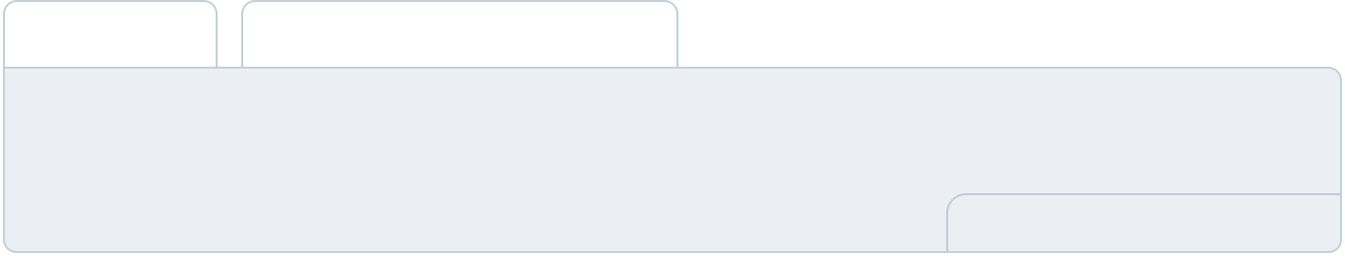

To create an effective introduction for your "Operational Plan" chapter, start by emphasizing the
pivotal role of efficient operations in the success of your business, underscoring how they
directly impact the quality of services delivered.
 |  |  |  | To unlock help try Upmetrics! 
Start writing here..
Staffing & Training
 Help tip |  |  Home Decor Business Plan

Mention your business’s staffing requirements, including the number of employees, designers,
or other qualified staff needed. Include their qualifications, the training required, and the duties
they will perform.
 |  |  |  | To unlock help try Upmetrics! 
Start writing here..
Operational Process
 Help tip |  |  Home Decor Business Plan

Outline the processes and procedures you will use to run your home decor business. Your operational processes may include procurement & inventory management, product display & visual merchandising, and order fulfillment & delivery.



Start writing here..

Equipment & Software

 Help tip  Home Decor Business Plan

Include the list of equipment and software required for home decor, such as design & planning software, manufacturing & production equipment, installment & assembly tools, etc.
To unlock help try Upmetrics! 

Start writing here..
Management Team

The management team section provides an overview of the individuals responsible for running your business plan.
To unlock help try Upmetrics! 

 Help tip  Home Decor Business Plan

To craft an introduction for your "Management Team" chapter, begin by emphasizing the crucial role of leadership in the success of any business.
To unlock help try Upmetrics! 

Start writing here..

Key managers

 Help tip  Home Decor Business Plan

Introduce your management and key members of your team, and explain their roles and responsibilities.
To unlock help try Upmetrics! 

Start writing here..


JOHN DOE

CEO - john.doe@example.com

Serving as the CEO and one of the primary founders, [John Doe] is the driving force behind [Elegant Spaces Interiors].

Oversees the overall strategic direction of the company, forms alliances with suppliers and strategic partners, and ensures consistent brand messaging across all platforms.


JANE DOE

Operations Manager - jane.doe@example.com

Jane brings a meticulous approach to overseeing operations at [Elegant Spaces Interiors].

Her attention to detail and knack for efficient operational methodologies ensures that the business runs smoothly, meeting both its short-term and long-term objectives.


- Education: Jane holds an MBA in Operations Management from the University of Prestige and a Bachelor's Degree in Business Administration from State University.

- Professional Background: With over a decade of experience in the home decor industry, Jane previously served as the Assistant Operations Manager for Elite Decor Group, where she led initiatives that increased operational efficiency by 25%.


ALICE BROWN

Customer Service Manager - alice.brown@example.com

Alice is the face behind the impeccable customer service standards at [Elegant Spaces Interiors].

He believes in the philosophy that every customer is a brand ambassador, and it's reflected in his dedication to ensuring every customer interaction is a positive one.

- Education: He graduated with a degree in Communication Studies from Sunbright University and later pursued a Master’s in Customer Relationship Management from Metro Business School.

- Professional Background: Alice has over 8 years of experience in customer-centric roles. Before joining Elegant Spaces, he was the Lead Customer Relations Officer at Decor Impressions, where he played a pivotal role in enhancing customer satisfaction scores by 40%.

ROBERT BROWN

Design Manager - robert.brown@example.com

Robert, with her innate artistic sensibilities and design prowess, spearheads the design team at [Elegant Spaces Interiors].

He is committed to turning visions into tangible designs and ensures that every project encapsulates both innovation and elegance.

- Education: Robert graduated with honors in Interior Design from the esteemed Design & Arts College and later acquired a Master’s in Modern Art & Design Theory from the Newhaven Institute of Arts.

- Professional Background: Boasting 12 years in the design arena, Robert was the Senior Interior Designer at Luxe Interiors prior to joining our team.

There, she was recognized for her design of the "Eco-friendly Modern Home", which won the National Design Excellence Award.

Organizational structure

 Help tip  Home Decor Business Plan

Explain the organizational structure of your management team. Include the reporting line and decision-making hierarchy.
To unlock help try Upmetrics! 

Start writing here..
Organization chart


John Doe

CEO
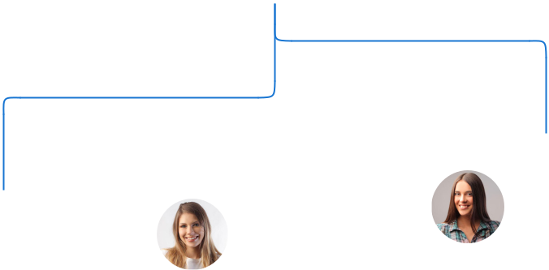

 |  |  | Alice Brown
Robert Brown | Jane Doe |  | Alice Brown
Robert Brown |  |  | Customer Service
Design | Operations |  | Manager
Manager | Manager

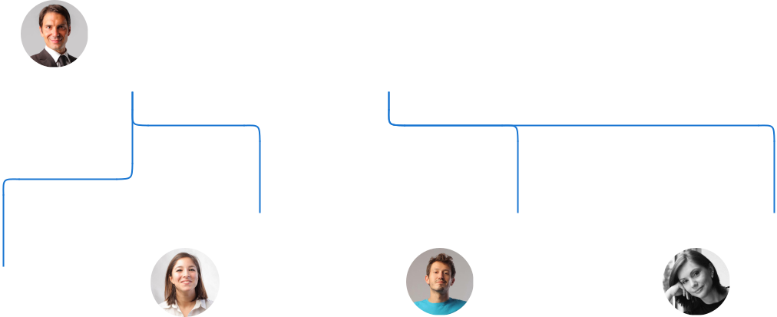

 | Emily White | Mike Smith | Laura Green
David | Lead Sales | Procurement | Procurement
Johnson | Representative | Specialist | Specialist
Lead Designer


Compensation plan

 Help tip  Home Decor Business Plan

Describe your compensation plan for the management and staff. Include their salaries, incentives, and other benefits.
To unlock help try Upmetrics! 

Start writing here..
 Help tip  Home Decor Business Plan

Mentioning advisors or consultants in your business plans adds credibility to your business idea.
To unlock help try Upmetrics! 

Advisors/Consultants


[ADVISOR NAME]

Advisor

An industry veteran with [X years] of experience, [Advisor 1] offers invaluable insights into market trends and competitive strategies.


[CONSULTANT NAME]

Consultant

Specializing in [specific aspect, e.g., sustainable design], [Consultant 1] assists our team in ensuring we remain at the forefront of industry innovations.
Financial Plan

When writing the financial plan section of a business plan, it’s important to provide a comprehensive overview of your financial projections for the first few years of your business, You may provide the following:
To unlock help try Upmetrics! 

 Help tip  Home Decor Business Plan


To create an effective introduction for your "Financial Plan" chapter, begin by stressing the critical role of a well-structured financial plan in the success of your venture.
To unlock help try Upmetrics! 

Start writing here..

 Help tip


Describe details such as projected revenue, operational costs, and service costs in your projected profit and loss statement. Make sure to include your business’s expected net profit or loss.
To unlock help try Upmetrics! 

Profit & loss statement

Revenue

Cost Of Sales

General Costs

Revenue Specific Costs

Personnel Costs (Direct

Labor)

Gross Margin

Gross Margin (%)

Operating Expense

Payroll Expense

(Indirect Labor)

General Expense

Bad Debt

Amortization of Current

Assets

2023-24 | 2024-25 | 2025-26 | 2026-27 | 2027-28
$0 | $0 | $0 | $0 | $0

$0 | $0 | $0 | $0 | $0
$0 | $0 | $0 | $0 | $0
$0 | $0 | $0 | $0 | $0
$0 | $0 | $0 | $0 | $0

$0 | $0 | $0 | $0 | $0
0% | 0% | 0% | 0% | 0%

$0 | $0 | $0 | $0 | $0
$0 | $0 | $0 | $0 | $0
$0 | $0 | $0 | $0 | $0
$0 | $0 | $0 | $0 | $0
$0 | $0 | $0 | $0 | $0

EBITDA

Additional Expense

Long Term

Depreciation

Gain or loss from Sale

of Assets

EBIT

Interest Expenses

EBT

Income Tax Expense

Total Expense

Net Income

Net Income (%)

2023-24 | 2024-25 | 2025-26 | 2026-27 | 2027-28
$0 | $0 | $0 | $0 | $0
$0 | $0 | $0 | $0 | $0
$0 | $0 | $0 | $0 | $0
$0 | $0 | $0 | $0 | $0
$0 | $0 | $0 | $0 | $0
$0 | $0 | $0 | $0 | $0
$0 | $0 | $0 | $0 | $0
$0 | $0 | $0 | $0 | $0
$0 | $0 | $0 | $0 | $0
$0 | $0 | $0 | $0 | $0
0% | 0% | 0% | 0% | 0%
 | 2023-24 | 2024-25 | 2025-26 | 2026-27 | 2027-28
Retained Earning | $0 | $0 | $0 | $0 | $0
Opening
Owner's Distribution | $0 | $0 | $0 | $0 | $0
Retained Earning | $0 | $0 | $0 | $0 | $0
Closing

 Help tip

The cash flow for the first few years of your operation should be estimated and described in this section. This may include billing invoices, payment receipts, loan payments, and any other cash flow statements.
To unlock help try Upmetrics! 

Cash flow statement

 | 2023-24 | 2024-25 | 2025-26 | 2026-27 | 2027-28
Cash Received | $0 | $0 | $0 | $0 | $0
Cash Paid | $0 | $0 | $0 | $0 | $0
COS & General Expenses | $0 | $0 | $0 | $0 | $0
Salary & Wages | $0 | $0 | $0 | $0 | $0
Interest | $0 | $0 | $0 | $0 | $0

Sales Tax

Income Tax

Net Cash From

Operations

Assets Sell

Assets Purchase

Net Cash From

Investments

Amount Received

Loan Received

Common Stock

Preferred Stock

Owner's Contribution

Amount Paid

2023-24 | 2024-25 | 2025-26 | 2026-27 | 2027-28
$0 | $0 | $0 | $0 | $0
$0 | $0 | $0 | $0 | $0
$0 | $0 | $0 | $0 | $0

$0 | $0 | $0 | $0 | $0
$0 | $0 | $0 | $0 | $0
$0 | $0 | $0 | $0 | $0

$0 | $0 | $0 | $0 | $0
$0 | $0 | $0 | $0 | $0

$0 | $0 | $0 | $0 | $0
$0 | $0 | $0 | $0 | $0
$0 | $0 | $0 | $0 | $0

Loan Capital $0 $0 $0 $0 $0

 | 2023-24 | 2024-25 | 2025-26 | 2026-27 | 2027-28
Dividends & Distributions | $0 | $0 | $0 | $0 | $0
Net Cash From | $0 | $0 | $0 | $0 | $0
Financing

Summary
Starting Cash | $0 | $0 | $0 | $0 | $0
Cash In | $0 | $0 | $0 | $0 | $0
Cash Out | $0 | $0 | $0 | $0 | $0
Change in Cash | $0 | $0 | $0 | $0 | $0
Ending Cash | $0 | $0 | $0 | $0 | $0

 Help tip

Create a projected balance sheet documenting your home decor business’s assets, liabilities, and equity.

To unlock help try Upmetrics! 

Balance sheet

 | 2023-24 | 2024-25 | 2025-26 | 2026-27 | 2027-28
Assets | $0 | $0 | $0 | $0 | $0
Current Assets | $0 | $0 | $0 | $0 | $0
Cash | $0 | $0 | $0 | $0 | $0
Accounts Receivable | $0 | $0 | $0 | $0 | $0
Inventory | $0 | $0 | $0 | $0 | $0
Other Current Assets | $0 | $0 | $0 | $0 | $0
Long Term Assets | $0 | $0 | $0 | $0 | $0
Gross Long Term Assets | $0 | $0 | $0 | $0 | $0
Accumulated Depreciation | $0 | $0 | $0 | $0 | $0

Liabilities & Equity | $0 | $0 | $0 | $0 | $0
Liabilities | $0 | $0 | $0 | $0 | $0
Current Liabilities | $0 | $0 | $0 | $0 | $0
Accounts Payable | $0 | $0 | $0 | $0 | $0
Income Tax Payable | $0 | $0 | $0 | $0 | $0
Sales Tax Payable | $0 | $0 | $0 | $0 | $0
Short Term Debt | $0 | $0 | $0 | $0 | $0
 | 2023-24 | 2024-25 | 2025-26 | 2026-27 | 2027-28
Long Term Liabilities | $0 | $0 | $0 | $0 | $0
Long Term Debt | $0 | $0 | $0 | $0 | $0
Equity | $0 | $0 | $0 | $0 | $0
Paid-in Capital | $0 | $0 | $0 | $0 | $0
Common Stock | $0 | $0 | $0 | $0 | $0
Preferred Stock | $0 | $0 | $0 | $0 | $0
Owner's Contribution | $0 | $0 | $0 | $0 | $0
Retained Earnings | $0 | $0 | $0 | $0 | $0

Check | $0 |  |  | $0 | $0 | $0 | $0
 Help tip |  |  Home Decor Business Plan
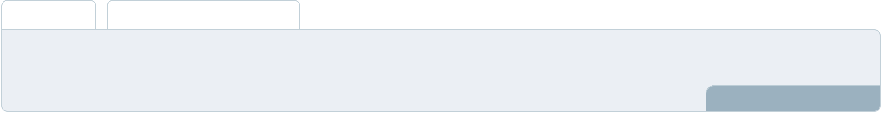

Determine and mention your business’s break-even point—the point at which your business costs and revenue will be equal.

This exercise will help you understand how much revenue you need to generate to sustain or be profitable.
To unlock help try Upmetrics! 

Break-even Analysis

 | 2023-24 | 2024-25 | 2025-26 | 2026-27 | 2027-28
Starting Revenue | $0 | $0 | $0 | $0 | $0
Net Revenue | $0 | $0 | $0 | $0 | $0
Closing Revenue | $0 | $0 | $0 | $0 | $0

Starting Expense | $0 | $0 | $0 | $0 | $0
Net Expense | $0 | $0 | $0 | $0 | $0
Closing Expense | $0 | $0 | $0 | $0 | $0

Is Break Even? | 0 | 0 | 0 | 0 | 0
Break Even Month | 0 | 0 | 0 | 0 | 0
Days Required | 0 | 0 | 0 | 0 | 0
Break Even Revenue | $0 | $0 | $0 | $0 | $0
Break Even Units
Financing needs

 Help tip  Home Decor Business Plan

Calculate costs associated with starting a home decor business, and estimate your financing needs and how much capital you need to raise to operate your business.
To unlock help try Upmetrics! 

Start writing here..
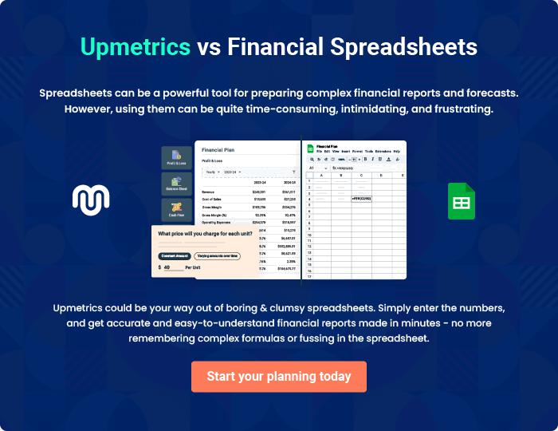
Appendix

When writing the appendix section, you should include any additional information that supports the main content of your plan. This may include financial statements, market research data, legal documents, and other
To unlock help try Upmetrics! 
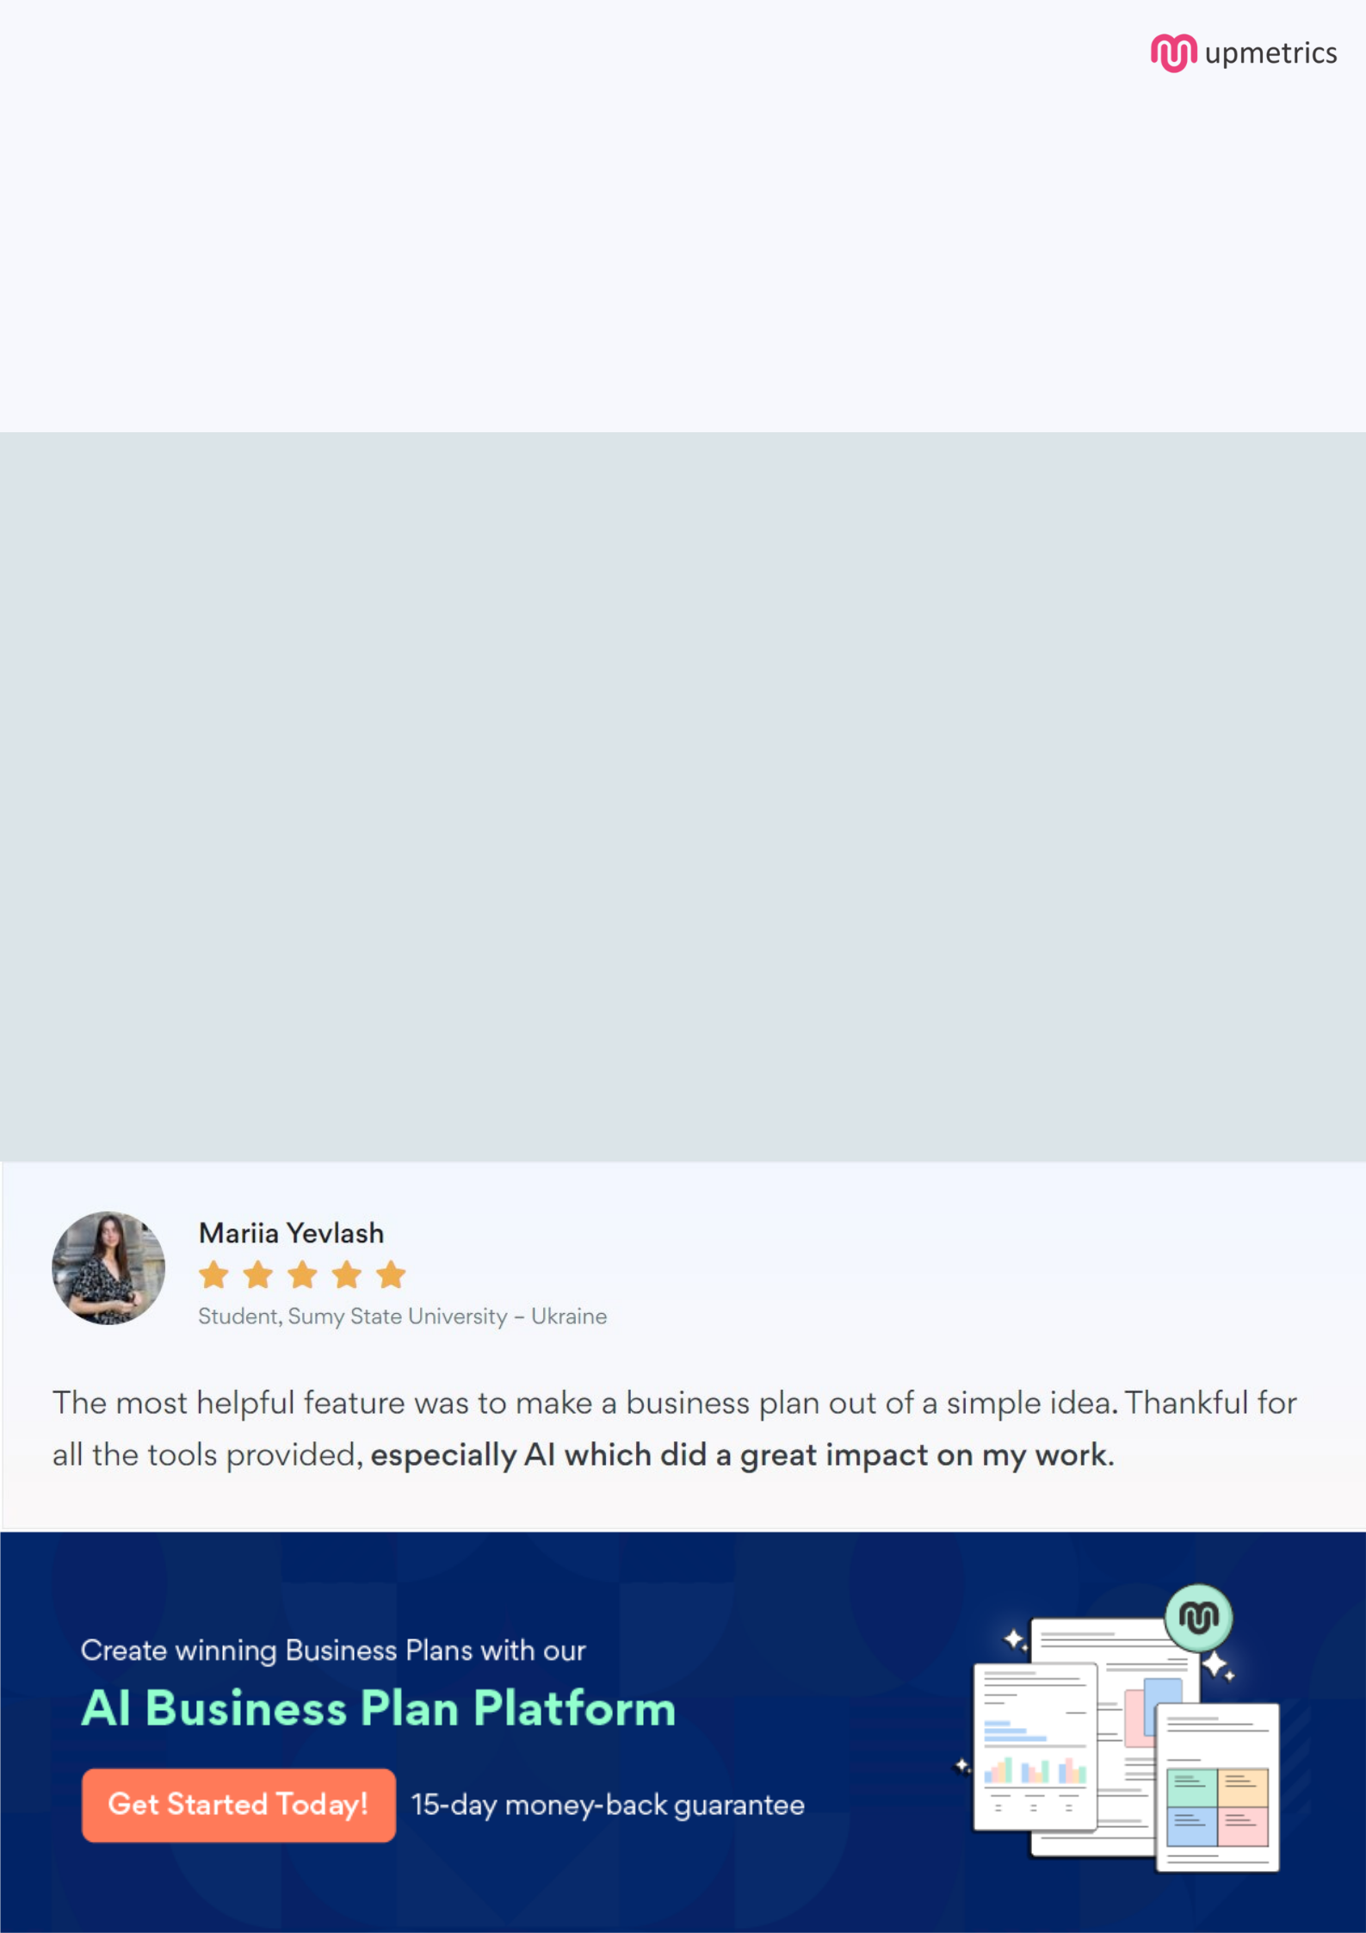
Create a winning business plan that gets you funded

Creating a stunning and investment-ready plan requires no writing, graphic designing, or financial planning expertise.

Upmetrics has all the features required to help you create a comprehensive business plan—from start to finish. Make no mistakes, it’s the modern way of planning to structure ideas, make plans, and create stunning pitch decks to awe investors.

Pitch decks that impress investors

Create pitch decks that provide a visual representation of your business, engage investors, and make them want to invest in your business idea.

Interactive plans in no time

Import business plan sections like—SWOT analysis, comparison tables, and others to create an interactive business plan. No designing skills are required.

Stunning cover page designs

With Upmetrics, you have the liberty to choose from multiple stunning cover page designs. Choose a creative design and make your plan stand out.

Online sharing made simple

Upmetrics makes online sharing quick and easier for users. Easily share your business plans with a link while tracking reader activity.

500+ sample business plans

Simply import a template from our library of sample plans into the editor and start customizing it to make it yours. It takes only a few clicks to get started.

Collaborate with team in real-time

Invite team members, initiate conversations, discuss ideas & strategies, share feedback, and work on a business plan in real-time.

