
BUSINESS PLAN

2023


Hedge Fund Business Plan

Navigating Markets, Amplifying Returns

John Doe

10200 Bolsa Ave, Westminster, CA, 92683

- 359-3153 info@example.com http://www.example.com

Information provided in this business plan is unique to this business and confidential; therefore, anyone reading this plan agrees not to disclose any of the information in this business plan without prior written permission of the company.
Table of Contents

Executive Summary | 6
Market opportunity | 6
Services Offered | 6
Marketing and Sales Strategies | 7
Financial Highlights | 7
Units Sold v/s Revenue | 8

Company Overview | 9
Ownership | 9
Mission statement | 10
Business history | 10
Future goals | 11

Market Analysis | 12
Target Market | 12
Market size and growth potential | 12
Market Size | 13
Competitive analysis | 13
AlphaStrat Capital | 13
BetaGrowth Funds | 14
GammaSecure Investments | 14
Market trends | 14
Regulatory environment | 15

Products and Services | 16
Services | 16
Equity Growth Portfolio | 16
Fixed Income Solutions | 17
Alternative Investments | 17
Sustainable Investing Portfolio | 18
Customized Investment Strategy | 18
Investment Philosophy | 19
Risk Management | 19

Sales And Marketing Strategies | 20
Unique Selling Proposition (USP) | 20
Pricing Strategy | 20
Marketing strategies | 21
Online | 21
Offline | 21
Sales strategies | 22
Customer retention | 23

Operations Plan | 24
Staffing & Training | 24
Operational Process | 24
Equipment & Software | 25

Management Team | 26
Key managers | 26
John Doe | 26
Jane Doe | 27
Alice Brown | 27
Robert Brown | 27
Emma Taylor | 28
Organizational structure | 28
Organization chart | 29
Compensation plan | 29
Advisors/Consultants | 30
Emily White | 30
Michael Johnson | 30
Sarah Parker | 30
Financial Plan | 31
Profit & loss statement | 31
Cash flow statement | 34
Balance sheet | 36
Break-even Analysis | 38
Financing needs | 40
Appendix
Appendix | 42
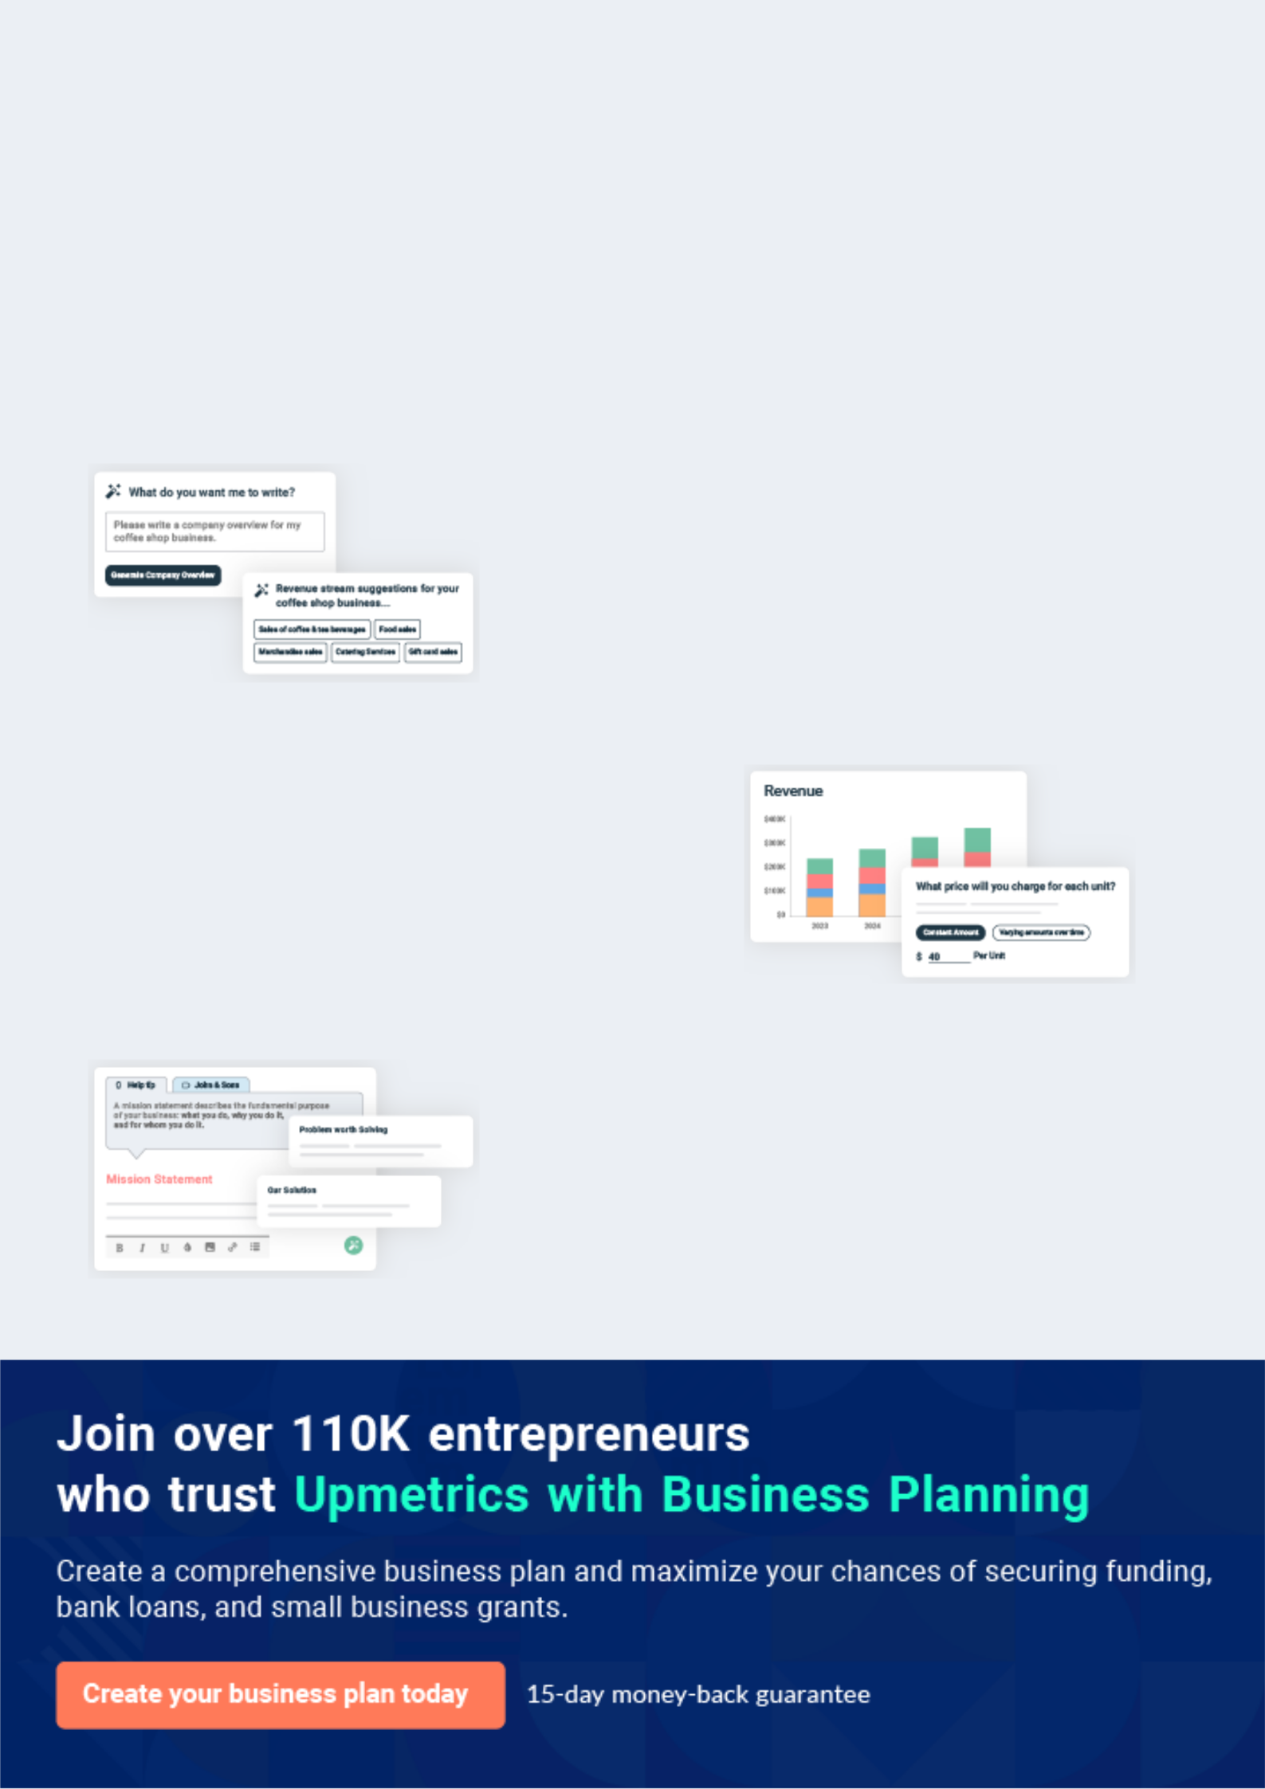
Business planning that’s simpler and faster than you think

Creating a business plan using Upmetrics to start and grow a business is literally the easiest thing in the World. Simply read the instructions and fill in the blanks. It’s as simple as that.

❛ | Upmetrics has everything you need to create a | ❜
❛ | comprehensive business plan. | ❜

AI-powered Upmetrics Assistant

AI-powered insights to streamline your plan

Not sure where to start? Upmetrics’ AI Assistant will automatically generate ideas for each section of your plan and offer improved versions of your writing, adjusting for tone, voice, and grammar or spelling errors.

Financial Forecasting Tool

All the financials are calculated for you

Forget the complex formulas and clumsy spreadsheets — with automatic financials and drag-and-drop forecasting, you can finish your plan faster and be confident that your numbers are accurate.

Business Plan Builder

Guides you like a business mentor

Upmetrics’ step-by-step instructions, prompts, and the library of 400+ sample business plans will guide you through each section of your plan as a business mentor.
Executive Summary


An executive summary is the first section of the business plan intended to provide an overview of the whole business plan.
To unlock help try Upmetrics! 

 Help tip  Hedge Fund Business Plan


Start your executive summary by briefly introducing your business to your readers.

This section may include the name of your hedge fund business, its location, when it was
To unlock help try Upmetrics! 

Start writing here..

Market opportunity

 Help tip  Hedge Fund Business Plan

Summarize your market research, including market size, growth potential, and marketing trends. Highlight the opportunities in the market and how your business will fit in to fill the gap.
To unlock help try Upmetrics! 

Start writing here..

Services Offered

 Help tip  Hedge Fund Business Plan

Highlight the hedge fund services you offer your clients. The USPs and differentiators you offer are always a plus.
To unlock help try Upmetrics! 

Start writing here..

Marketing and Sales Strategies
To unlock help try Upmetrics!

 Help tip  Hedge Fund Business Plan

Outline your sales and marketing strategies—what marketing platforms you use, how you plan on acquiring customers, etc.
To unlock help try Upmetrics! 

Start writing here..

Financial Highlights

 Help tip  Hedge Fund Business Plan

Briefly summarize your financial projections for the initial years of business operations. Include any capital or investment requirements, associated startup costs, projected revenues, and profit forecasts.



Start writing here..
Units Sold v/s Revenue

 |  | Units Sold | Revenue
15.00k
10.00k
5.00k
0
Year 1 | Year 2 | Year 3


Financial Year |  |  | Units Sold | Revenue
Year 1 | 1,550 |  |  | $10,000
Year 2 | 1,800 |  |  | $12,000
Year 3 | 2,050 |  |  | $14,000
 Help tip |  |  Hedge Fund Business Plan


Summarize your executive summary section with a clear CTA, for example, inviting angel investors to discuss the potential business investment.
To unlock help try Upmetrics! 

Write a call to action for your business plan.
Company Overview

Depending on what details of your business are essential, you’ll need different elements in your business overview.
To unlock help try Upmetrics! 

 Help tip  Hedge Fund Business Plan

Describe your business in this section by providing all the basic information:

Describe what kind of hedge fund company you run and the name of it. You may specialize in
To unlock help try Upmetrics! 

Start writing here..

Ownership

 Help tip  Hedge Fund Business Plan

List the names of your hedge fund company’s founders or owners. Describe what shares they own and their responsibilities for efficiently managing the business.
To unlock help try Upmetrics! 

Start writing here..
Mission statement

 Help tip  Hedge Fund Business Plan

Summarize your business’ objective, core principles, and values in your mission statement. This statement needs to be memorable, clear, and brief.
To unlock help try Upmetrics! 

❛ At [MeridianEdge Investments], our mission is to empower our clients to achieve their financial goals through innovative investment strategies and unparalleled service. We are committed to integrity, transparency, and excellence, ensuring that our clients’ interests always come first.

Our mission serves as a guiding light, driving us to constantly push the boundaries of what is possible in the world of hedge fund management.

❜

Business history

 Help tip  Hedge Fund Business Plan

If you’re an established hedge fund service provider, briefly describe your business history, like— when it was founded, how it evolved over time, etc.
To unlock help try Upmetrics! 

Start writing here..
Future goals

 Help tip  Hedge Fund Business Plan

It’s crucial to convey your aspirations and vision. Mention your short-term and long-term goals; they can be specific targets for revenue, market share, or expanding your services.
To unlock help try Upmetrics! 

Start writing here..
Market Analysis
To unlock help try Upmetrics!


 |  | Market analysis provides a clear understanding of the market in which your
 |  | printing business will run along with the target market, competitors, and
 |  | growth opportunities.
 |  |  |  | To unlock help try Upmetrics! 
 Help tip |  |  Hedge Fund Business Plan

To write the introduction section of your market analysis, start by clearly identifying your primary target market.
To unlock help try Upmetrics! 

Start writing here..

Target Market

 Help tip  Hedge Fund Business Plan

Start this section by describing your target market. Define your ideal customer and explain what types of services they prefer. Creating a buyer persona will help you easily define your target market to your readers.



Start writing here..

Market size and growth potential

 Help tip  Hedge Fund Business Plan

Describe your market size and growth potential and whether you will target a niche or a much broader market.
To unlock help try Upmetrics! 

Start writing here..

Market Size

Available Market | 3T
Total global assets potentially | 3T
manageable by hedge funds. | 3T
Served Market | 750B
Assets within our operational regions | 750B
and strategy expertise. | 750B
Target Market | 150B
Assets from high-net-worth individuals | 150B
and institutional investors interested in | 150B

our specific hedge

 Help tip  Hedge Fund Business Plan

Identify and analyze your direct and indirect competitors. Identify their strengths and weaknesses, and describe what differentiates your hedge fund services from them.
To unlock help try Upmetrics! 

Competitive analysis

AlphaStrat Capital

AlphaStrat Capital is a well-established player in the hedge fund industry, renowned for its long/short equity strategies and significant market presence. With over a decade of experience and assets under management (AUM) totalling $[AUM of AlphaStrat], it caters predominantly to institutional investors.

Features | Strengths | Weaknesses
Long/short equity strategies | Extensive experience in the | Limited innovation in investment
In-depth market analysis | market | strategies
Robust risk management | Strong reputation and brand | Heavy reliance on traditional
Robust risk management | recognition | investment models
protocols | recognition | investment models
 | Large and diverse client base | Potentially slower adaptation to
 |  | market changes

BetaGrowth Funds

BetaGrowth Funds is recognized for its innovative approach to macro-economic hedge fund strategies. With assets under management amounting to $[AUM of BetaGrowth], it has shown remarkable growth in the past five years, appealing primarily to high-net-worth individuals.

Features | Strengths | Weaknesses
Global macro-economic | Innovative and adaptive | Relatively new in the market, less
investment strategies | investment strategies | experience
Real-time data analysis and | Strong performance track | Smaller AUM compared to
reporting | record in recent years | industry giants
Personalized client service | Excellent customer service and | Limited brand recognition and
 | client relations | market presence

GammaSecure Investments

With a focus on risk aversion and capital preservation, GammaSecure Investments specializes in distressed securities and has been a stable player in the hedge fund industry for over 15 years. They manage assets totalling $[AUM of GammaSecure], primarily catering to conservative investors.

Features | Strengths | Weaknesses
Distressed securities | Proven track record of risk | Potentially lower returns in bull
investment | management | markets
Comprehensive risk | Stability and reliability in | Limited appeal to aggressive
assessment | market downturns | investors
Stable and consistent returns | Strong reputation among | Less adaptability to market
 | conservative investor circles | innovations

Market trends

 Help tip  Hedge Fund Business Plan

Analyse emerging trends in the industry, such as technology disruptions, changes in customer behavior or preferences, etc. Explain how your business will cope with all the trends.
To unlock help try Upmetrics! 

Start writing here..

Regulatory environment

 Help tip  Hedge Fund Business Plan

List regulations and licensing requirements that may affect your hedge fund company, such as business registration, insurance, environmental regulations, state and federal regulations, etc.
To unlock help try Upmetrics! 

Start writing here..
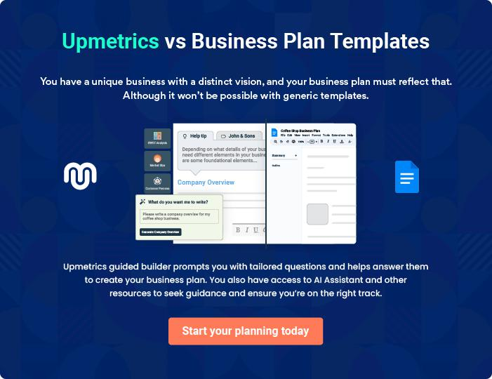
Products and Services

 |  | The product and services section of the hedge fund business plan should
 |  | describe the specific services and products offered to customers. To write
 |  | this section should include the following:
 |  |  |  | To unlock help try Upmetrics! 
 Help tip |  |  Hedge Fund Business Plan

To craft the introduction for your "Products and Services" chapter, begin by positioning your business within its industry, emphasizing its unique strengths or value proposition.
To unlock help try Upmetrics! 

Start writing here..

 Help tip


Give a brief description of the investment services the hedge fund provides to its clients. It may include:
To unlock help try Upmetrics! 

Services

Equity Growth Portfolio


Price: [1.5%] Annual Management Fee

A high-performance portfolio primarily focused on capital appreciation, investing in a diversified selection of growth-oriented stocks.

Specifications

- Investment Horizon: Long-term (5+ years)

- Risk Level: High

- Asset Allocation: [90%] Equities, [10%] Cash and Equivalents

- Minimum Investment: [$100,000]
Fixed Income Solutions

Price: [1.0%] Annual Management Fee

A portfolio designed to provide stable income through investments in government and corporate bonds.

Specifications

- Investment Horizon: Medium to Long-term (3-10 years)

- Risk Level: Low to Medium

- Asset Allocation: [100%] Fixed Income Securities

- Minimum Investment: [$50,000]

Alternative Investments

Price: [2.0%] Annual Management Fee + [20%] Performance Fee

A diverse portfolio investing in alternative assets, including real estate, private equity, and hedge funds.

Specifications

- Investment Horizon: Long-term (7+ years)

- Risk Level: High

- Asset Allocation: [100%] Alternative Investments

- Minimum Investment: [$250,000]
Sustainable Investing Portfolio

Price: [1.25%] Annual Management Fee

An ethically driven portfolio investing in companies with strong environmental, social, and governance (ESG) practices.

Specifications

- Investment Horizon: Long-term (5+ years)

- Risk Level: Medium

- Asset Allocation: [80%] Equities (ESG focused), [20%] Bonds

- Minimum Investment: [$100,000]

Customized Investment Strategy

Price: Varies based on complexity and assets under management

Tailored investment solutions crafted to meet the specific needs and objectives of individual clients or institutions.

Specifications

- Investment Horizon: Varies

- Risk Level: Customizable

- Asset Allocation: Customizable

- Minimum Investment: [$500,000]
Investment Philosophy
- To unlock help try Upmetrics!

 Help tip  Hedge Fund Business Plan


Describe the investment philosophies that influence the fund’s selection of investments. It
could cover topics including the fund’s strategy for managing risk, allocating assets, and
diversification.
 |  |  |  | To unlock help try Upmetrics! 
Start writing here..
Risk Management
 Help tip |  |  Hedge Fund Business Plan

Talk about the main risks of investing in the hedge fund, such as market, liquidity, and operational risks. To protect investor money, be open and honest about the risks involved and how the fund manages these risks.



Start writing here..
Sales And Marketing Strategies

Writing the sales and marketing strategies section means a list of strategies you will use to attract and retain your clients.
To unlock help try Upmetrics! 

 Help Tip  Hedge Fund Business Plan


To create an effective introduction for your "Sales and Marketing Strategies" chapter, start by setting the stage within your specific industry or market.
To unlock help try Upmetrics! 

Start writing here..

Unique Selling Proposition (USP)

 Help tip  Hedge Fund Business Plan

Define your business’s USPs depending on the market you serve, the equipment you use, and the unique services you provide. Identifying USPs will help you plan your marketing strategies.
To unlock help try Upmetrics! 

Start writing here..

Pricing Strategy

 Help tip  Hedge Fund Business Plan

Describe your pricing strategy—how you plan to price your services and stay competitive in the local market. You can mention any discounts you plan on offering to attract new customers.
To unlock help try Upmetrics! 

Start writing here..

 Help tip  Hedge Fund Business Plan
To unlock help try Upmetrics!

Discuss your marketing strategies to market your services. You may include some of these marketing strategies in your business plan—social media marketing, digital marketing, or events.



Marketing strategies

Online


Social Media

We maintain active profiles on [List of Social Media Platforms], sharing market insights, company news, and thought leadership content to engage with our audience.

Content Marketing

Our blog and newsletter provide valuable content, helping to establish our authority in the industry and keep our clients informed.

Offline

Events

We host and participate in industry events, creating opportunities for face-to-face engagement with potential clients and partners.

 Help tip  Hedge Fund Business Plan

Outline the strategies you’ll implement to maximize your sales. Your sales strategies may include direct sales calls, partnering with other businesses, offering referral programs, etc.
To unlock help try Upmetrics! 

Sales strategies

Partner with Businesses

We form partnerships with other financial institutions and service providers, broadening our reach and creating mutual business opportunities

Referral Programs

We have established a referral program, encouraging satisfied clients to introduce us to their network, rewarding them for successful conversions

Direct Sales Calls

Our team regularly reaches out to potential clients, introducing them to MeridianEdge and discussing how our services can meet their investment needs.

 Help tip  Hedge Fund Business Plan

Describe your customer retention strategies and how you plan to execute them. For instance, introducing loyalty programs, discounts on annual membership, personalized service, etc.
To unlock help try Upmetrics! 

Customer retention

Loyalty Programs

Clients who have been with us for

- years or more enjoy benefits such as [List of Benefits], showing our appreciation for their trust and loyalty.

Personalized Service

Each client is assigned a dedicated account manager, ensuring personalized attention and service.

Regular Check-ins

We schedule regular calls and meetings with our clients, ensuring we are continually aligned with their goals and addressing any concerns promptly.

Operations Plan

 |  | When writing the operations plan section, it’s important to consider the
 |  | various aspects of your business operations.
 |  |  |  | To unlock help try Upmetrics! 
 Help tip |  |  Hedge Fund Business Plan


To create an effective introduction for your "Operational Plan" chapter, start by emphasizing the
pivotal role of efficient operations in the success of your business, underscoring how they
directly impact the quality of services delivered.
 |  |  |  | To unlock help try Upmetrics! 
Start writing here..
Staffing & Training
 Help tip |  |  Hedge Fund Business Plan

Mention your business’s staffing requirements, including the number of employees, portfolio
managers, investment bankers, or analysts needed. Include their qualifications, the training
required, and the duties they will perform.
 |  |  |  | To unlock help try Upmetrics! 
Start writing here..
Operational Process
 Help tip |  |  Hedge Fund Business Plan

The hedge fund’s main operational procedures, such as portfolio management, trade execution, risk monitoring, and performance reporting, should be mentioned here.
To unlock help try Upmetrics! 

Start writing here..

Equipment & Software

 Help tip  Hedge Fund Business Plan

Include the list of equipment and machinery required for a hedge fund, such as trading platforms, cybersecurity platforms, data analytics software, etc.
To unlock help try Upmetrics! 

Start writing here..
Management Team

The management team section provides an overview of the individuals responsible for running your business plan.
To unlock help try Upmetrics! 

 Help tip  Hedge Fund Business Plan

To craft an introduction for your "Management Team" chapter, begin by emphasizing the crucial role of leadership in the success of any business.
To unlock help try Upmetrics! 

Start writing here..

Key managers

 Help tip  Hedge Fund Business Plan

Introduce your management and key members of your team, and explain their roles and responsibilities.
To unlock help try Upmetrics! 

Start writing here..


JOHN DOE

CEO & Co-founder - john.doe@example.com

John holds a Master’s degree in Finance from Harvard University and has over 20 years of experience in the hedge fund industry.

He has previously worked in senior positions at prestigious financial institutions such as Goldman Sachs and JP Morgan.


As the CEO, John is responsible for setting the overall strategic direction of [MeridianEdge Investments], leading the development of the company’s short-and long-term strategy, and managing the company’s overall resources and operations.

JANE DOE

Chief Operating Officer (COO) - jane.doe@example.com

Jane graduated with a Bachelor’s degree in Economics from Stanford University and has 15 years of experience in operational roles within the hedge fund sector.


She has a strong track record of optimizing operational processes to increase efficiency and reduce costs.

As COO, Jane oversees the day-to-day administrative and operational functions of [MeridianEdge Investments], ensuring that the business runs smoothly and efficiently.


ALICE BROWN

CMO - alice.brown@example.com

Alice holds an MBA with a specialization in Marketing from New York University. She has over 12 years of experience in marketing, with a particular focus on digital marketing within the financial services sector.

As CMO, Alice is responsible for overseeing the development and execution of [MeridianEdge Investments]’ marketing and advertising initiatives, increasing the company’s market presence and driving business growth.


ROBERT BROWN

Operations Manager - robert.brown@example.com

Robert graduated with a degree in Business Administration from the University of Chicago and has 10 years of experience in operations management within the financial sector.

Robert is responsible for ensuring the smooth operation of [MeridianEdge Investments], overseeing the implementation of business guidelines and strategies, working with other department heads, and interacting with clients on a regular basis.

EMMA TAYLOR

Customer Services Manager - emma.taylor@example.com

Emma has a Bachelor’s degree in Communication from Boston University and has 8 years of experience in customer service and relationship management, particularly in the financial services industry.

As the Customer Services Manager, Emma is responsible for maintaining strong client relations, addressing client inquiries, and ensuring high levels of customer satisfaction.

Organizational structure

 Help tip  Hedge Fund Business Plan

Explain the organizational structure of your management team. Include the reporting line and decision-making hierarchy.
To unlock help try Upmetrics! 

Start writing here..
Organization chart


John Doe

CEO


Alice Brown Jane Doe

CMO COO


Emma Taylor

Customer Service Manager Robert Brown

Operations Manager




Mike Johnson Sarah White

Portfolio Manager Investment Analyst

Compensation plan

 Help tip  Hedge Fund Business Plan

Describe your compensation plan for the management and staff. Include their salaries, incentives, and other benefits.
To unlock help try Upmetrics! 

Start writing here..

 Help tip  Hedge Fund Business Plan

Mentioning advisors or consultants in your business plans adds credibility to your business idea.
To unlock help try Upmetrics! 

Advisors/Consultants


EMILY WHITE

Legal Advisor

Providing legal guidance and ensuring compliance with industry regulations.


MICHAEL JOHNSON

Financial Analyst

• Offering insights on market trends and investment opportunities.


SARAH PARKER

Technology Consultant

Ensuring the integration of cutting-edge technology and robust cybersecurity measures.
Financial Plan

When writing the financial plan section of a business plan, it’s important to provide a comprehensive overview of your financial projections for the first few years of your business, You may provide the following:
To unlock help try Upmetrics! 

 Help tip  Hedge Fund Business Plan


To create an effective introduction for your "Financial Plan" chapter, begin by stressing the critical role of a well-structured financial plan in the success of your venture.
To unlock help try Upmetrics! 

Start writing here..

 Help tip  Hedge Fund Business Plan

Describe details such as projected revenue, operational costs, and service costs in your projected profit and loss statement. Make sure to include your business’s expected net profit or loss.
To unlock help try Upmetrics! 

Profit & loss statement

Revenue

Cost Of Sales

General Costs

Revenue Specific Costs

Personnel Costs (Direct

Labor)

Gross Margin

Gross Margin (%)

Operating Expense

Payroll Expense

(Indirect Labor)

General Expense

Bad Debt

Amortization of Current

Assets

2023-24 | 2024-25 | 2025-26 | 2026-27 | 2027-28
$0 | $0 | $0 | $0 | $0

$0 | $0 | $0 | $0 | $0
$0 | $0 | $0 | $0 | $0
$0 | $0 | $0 | $0 | $0
$0 | $0 | $0 | $0 | $0

$0 | $0 | $0 | $0 | $0
0% | 0% | 0% | 0% | 0%

$0 | $0 | $0 | $0 | $0
$0 | $0 | $0 | $0 | $0
$0 | $0 | $0 | $0 | $0
$0 | $0 | $0 | $0 | $0
$0 | $0 | $0 | $0 | $0

EBITDA

Additional Expense

Long Term

Depreciation

Gain or loss from Sale

of Assets

EBIT

Interest Expenses

EBT

Income Tax Expense

Total Expense

Net Income

Net Income (%)

2023-24 | 2024-25 | 2025-26 | 2026-27 | 2027-28
$0 | $0 | $0 | $0 | $0
$0 | $0 | $0 | $0 | $0
$0 | $0 | $0 | $0 | $0
$0 | $0 | $0 | $0 | $0
$0 | $0 | $0 | $0 | $0
$0 | $0 | $0 | $0 | $0
$0 | $0 | $0 | $0 | $0
$0 | $0 | $0 | $0 | $0
$0 | $0 | $0 | $0 | $0
$0 | $0 | $0 | $0 | $0
0% | 0% | 0% | 0% | 0%

 |  |  | 2023-24 |  | 2024-25 | 2025-26
Retained Earning |  |  | $0 |  | $0 | $0
Opening |  |  |  |  | $0 | $0
Owner's Distribution |  |  | $0 |  | $0 | $0
Retained Earning |  |  | $0 |  | $0 | $0
Closing |  |  |  |  | $0 | $0
 Help tip |  |  |  Hedge Fund Business Plan


The cash flow for the first few years of your operation should be estimated and described in this section.

This may include billing invoices, payment receipts, loan payments, and any other cash flow statements.
2026-27 2027-28

$0 $0

$0 $0

$0 $0

To unlock help try Upmetrics! 

Cash flow statement

 | 2023-24 | 2024-25 | 2025-26 | 2026-27 | 2027-28
Cash Received | $0 | $0 | $0 | $0 | $0
Cash Paid | $0 | $0 | $0 | $0 | $0
COS & General Expenses | $0 | $0 | $0 | $0 | $0
Salary & Wages | $0 | $0 | $0 | $0 | $0
Interest | $0 | $0 | $0 | $0 | $0

Sales Tax

Income Tax

Net Cash From

Operations

Assets Sell

Assets Purchase

Net Cash From

Investments

Amount Received

Loan Received

Common Stock

Preferred Stock

Owner's Contribution

Amount Paid

2023-24 | 2024-25 | 2025-26 | 2026-27 | 2027-28
$0 | $0 | $0 | $0 | $0
$0 | $0 | $0 | $0 | $0
$0 | $0 | $0 | $0 | $0

$0 | $0 | $0 | $0 | $0
$0 | $0 | $0 | $0 | $0
$0 | $0 | $0 | $0 | $0

$0 | $0 | $0 | $0 | $0
$0 | $0 | $0 | $0 | $0

$0 | $0 | $0 | $0 | $0
$0 | $0 | $0 | $0 | $0
$0 | $0 | $0 | $0 | $0

Loan Capital $0 $0 $0 $0 $0

 |  |  | 2023-24 | 2024-25 | 2025-26 | 2026-27 | 2027-28
Dividends & Distributions |  |  | $0 | $0 | $0 | $0 | $0
Net Cash From |  |  | $0 | $0 | $0 | $0 | $0
Financing
Summary
Starting Cash |  |  | $0 | $0 | $0 | $0 | $0
Cash In |  |  | $0 | $0 | $0 | $0 | $0
Cash Out |  |  | $0 | $0 | $0 | $0 | $0
Change in Cash |  |  | $0 | $0 | $0 | $0 | $0
Ending Cash |  |  | $0 | $0 | $0 | $0 | $0
 Help tip |  |  Hedge Fund Business Plan

Create a projected balance sheet documenting your hedge fund business’s assets, liabilities, and equity.

To unlock help try Upmetrics! 

Balance sheet

 | 2023-24 | 2024-25 | 2025-26 | 2026-27 | 2027-28
Assets | $0 | $0 | $0 | $0 | $0
Current Assets | $0 | $0 | $0 | $0 | $0
Cash | $0 | $0 | $0 | $0 | $0
Accounts Receivable | $0 | $0 | $0 | $0 | $0
Inventory | $0 | $0 | $0 | $0 | $0
Other Current Assets | $0 | $0 | $0 | $0 | $0
Long Term Assets | $0 | $0 | $0 | $0 | $0
Gross Long Term Assets | $0 | $0 | $0 | $0 | $0
Accumulated Depreciation | $0 | $0 | $0 | $0 | $0

Liabilities & Equity | $0 | $0 | $0 | $0 | $0
Liabilities | $0 | $0 | $0 | $0 | $0
Current Liabilities | $0 | $0 | $0 | $0 | $0
Accounts Payable | $0 | $0 | $0 | $0 | $0
Income Tax Payable | $0 | $0 | $0 | $0 | $0
Sales Tax Payable | $0 | $0 | $0 | $0 | $0
Short Term Debt | $0 | $0 | $0 | $0 | $0
 | 2023-24 | 2024-25 | 2025-26 | 2026-27 | 2027-28
Long Term Liabilities | $0 | $0 | $0 | $0 | $0
Long Term Debt | $0 | $0 | $0 | $0 | $0
Equity | $0 | $0 | $0 | $0 | $0
Paid-in Capital | $0 | $0 | $0 | $0 | $0
Common Stock | $0 | $0 | $0 | $0 | $0
Preferred Stock | $0 | $0 | $0 | $0 | $0
Owner's Contribution | $0 | $0 | $0 | $0 | $0
Retained Earnings | $0 | $0 | $0 | $0 | $0

Check | $0 |  |  | $0 | $0 | $0 | $0
 Help tip |  |  Hedge Fund Business Plan

Determine and mention your business’s break-even point—the point at which your business costs and revenue will be equal.

This exercise will help you understand how much revenue you need to generate to sustain or be profitable.
To unlock help try Upmetrics! 

Break-even Analysis

 | 2023-24 | 2024-25 | 2025-26 | 2026-27 | 2027-28
Starting Revenue | $0 | $0 | $0 | $0 | $0
Net Revenue | $0 | $0 | $0 | $0 | $0
Closing Revenue | $0 | $0 | $0 | $0 | $0

Starting Expense | $0 | $0 | $0 | $0 | $0
Net Expense | $0 | $0 | $0 | $0 | $0
Closing Expense | $0 | $0 | $0 | $0 | $0

Is Break Even? | 0 | 0 | 0 | 0 | 0
Break Even Month | 0 | 0 | 0 | 0 | 0
Days Required | 0 | 0 | 0 | 0 | 0
Break Even Revenue | $0 | $0 | $0 | $0 | $0
Break Even Units
Financing needs

 Help tip  Hedge Fund Business Plan

Calculate costs associated with starting a hedge fund business, and estimate your financing needs and how much capital you need to raise to operate your business.
To unlock help try Upmetrics! 

Start writing here..
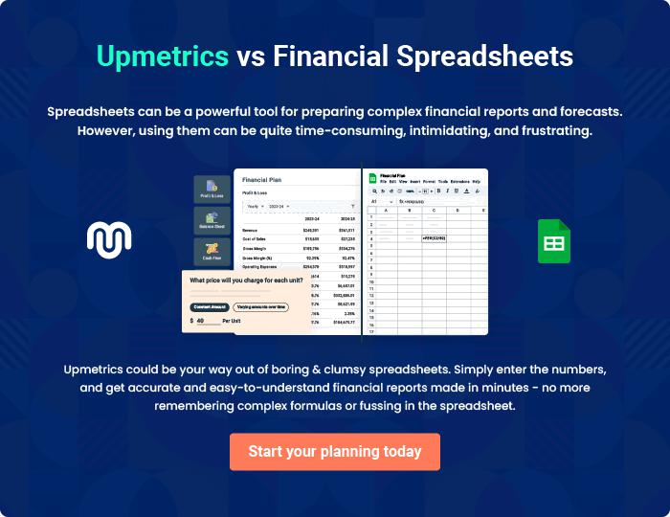
Appendix

When writing the appendix section, you should include any additional information that supports the main content of your plan. This may include financial statements, market research data, legal documents, and other
To unlock help try Upmetrics! 

Create a winning business plan that gets you funded

Creating a stunning and investment-ready plan requires no writing, graphic designing, or financial planning expertise.

Upmetrics has all the features required to help you create a comprehensive business plan—from start to finish. Make no mistakes, it’s the modern way of planning to structure ideas, make plans, and create stunning pitch decks to awe investors.

Pitch decks that impress investors

Create pitch decks that provide a visual representation of your business, engage investors, and make them want to invest in your business idea.

Interactive plans in no time

Import business plan sections like—SWOT analysis, comparison tables, and others to create an interactive business plan. No designing skills are required.

Stunning cover page designs

With Upmetrics, you have the liberty to choose from multiple stunning cover page designs. Choose a creative design and make your plan stand out.

Online sharing made simple

Upmetrics makes online sharing quick and easier for users. Easily share your business plans with a link while tracking reader activity.

500+ sample business plans

Simply import a template from our library of sample plans into the editor and start customizing it to make it yours. It takes only a few clicks to get started.

Collaborate with team in real-time

Invite team members, initiate conversations, discuss ideas & strategies, share feedback, and work on a business plan in real-time.

