
Hardware Shop Business Plan

BUSINESS PLAN

Build, Repair, Innovate

Prepared By

John Doe

10200 Bolsa Ave, Westminster, CA, 92683

info@example.com

(650) 359-3153 http://www.example.com

Table of Contents

Executive Summary | 6
Market opportunity | 6
Products & Services | 6
Marketing & Sales Strategies | 7
Financial Highlights | 7
Units Sold v/s Revenue | 8

Company Overview | 9
Ownership | 9
Mission statement | 10
Business history | 10
Future goals | 10

Market Analysis | 11
Target Market | 11
Market size and growth potential | 11
Market Size | 12
Competitive analysis | 12
BuildRight Supplies | 12
UrbanTool Shed | 13
ToolHouse Central | 13
Market trends | 13
Regulatory environment | 14

Products and Services | 15
Products & Services List | 15
Power Drill Set | 15
Lumber (Pine Wood) | 16
Pipe Cutting & Threading Service | 16
LED Light Bulbs | 16
Safety Helmet | 17
Custom Wood Engraving Service | 17
Quality Measures | 17
Additional Services | 18

Sales And Marketing Strategies | 19
Unique Selling Proposition (USP) | 19
Pricing Strategy | 19
Marketing strategies | 20
Online | 20
Offline | 20
Sales strategies | 21
Customer retention | 21

Operations Plan | 22
Staffing & Training | 22
Operational Process | 22
Equipment & Machinery | 23

Management Team | 24
Key managers | 24
John Doe | 24
Jane Doe | 25
Alice Brown | 25
Robert Brown | 25
Organizational structure | 26
Organization chart | 26
Compensation plan | 27
Advisors/Consultants | 27
[ADVISOR NAME] | 27
[CONSULTANT NAME] | 27
Financial Plan
Financial Plan | 28

Profit & loss statement 28

Cash flow statement | 31
Balance sheet | 33
Break-even Analysis | 35
Financing needs | 37
Appendix
Appendix | 39
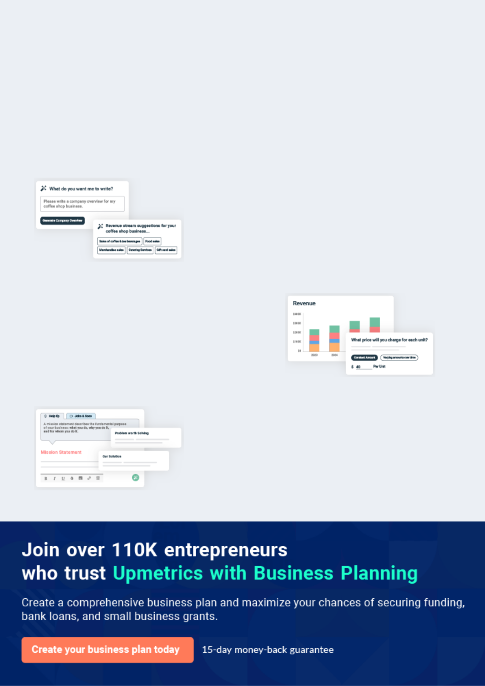
Business planning that’s simpler and faster than you think

Creating a business plan using Upmetrics to start and grow a business is literally the easiest thing in the World. Simply read the instructions and fill in the blanks. It’s as simple as that.

❛ | Upmetrics has everything you need to create a | ❜
❛ | comprehensive business plan. | ❜

AI-powered Upmetrics Assistant

AI-powered insights to streamline your plan

Not sure where to start? Upmetrics’ AI Assistant will automatically generate ideas for each section of your plan and offer improved versions of your writing, adjusting for tone, voice, and grammar or spelling errors.

Financial Forecasting Tool

All the financials are calculated for you

Forget the complex formulas and clumsy spreadsheets — with automatic financials and drag-and-drop forecasting, you can finish your plan faster and be confident that your numbers are accurate.

Business Plan Builder

Guides you like a business mentor

Upmetrics’ step-by-step instructions, prompts, and the library of 400+ sample business plans will guide you through each section of your plan as a business mentor.
Executive Summary


An executive summary is the first section of the business plan intended to provide an overview of the whole business plan.
To unlock help try Upmetrics! 

 Help tip  Hardware Shop Business Plan


Start your executive summary by briefly introducing your business to your readers.

This section may include the name of your hardware shop, its location, when it was founded,
To unlock help try Upmetrics! 

Start writing here..

Market opportunity

 Help tip  Hardware Shop Business Plan

Summarize your market research, including market size, growth potential, and marketing trends. Highlight the opportunities in the market and how your business will fit in to fill the gap.
To unlock help try Upmetrics! 

Start writing here..

Products & Services

 Help tip  Hardware Shop Business Plan

Highlight the products you offer your clients. The USPs and differentiators you offer are always a plus.
To unlock help try Upmetrics! 

Start writing here..

Marketing & Sales Strategies
To unlock help try Upmetrics!

 Help tip  Hardware Shop Business Plan

Outline your sales and marketing strategies—what marketing platforms you use, how you plan on acquiring customers, etc.
To unlock help try Upmetrics! 

Start writing here..

Financial Highlights

 Help tip  Hardware Shop Business Plan

Briefly summarize your financial projections for the initial years of business operations. Include any capital or investment requirements, associated startup costs, projected revenues, and profit forecasts.



Start writing here..
Units Sold v/s Revenue

 |  | Units Sold | Revenue
15.00k
10.00k
5.00k
0
Year 1 | Year 2 | Year 3


Financial Year |  |  | Units Sold | Revenue
Year 1 | 1,550 |  |  | $10,000
Year 2 | 1,800 |  |  | $12,000
Year 3 | 2,050 |  |  | $14,000
 Help tip |  |  Hardware Shop Business Plan
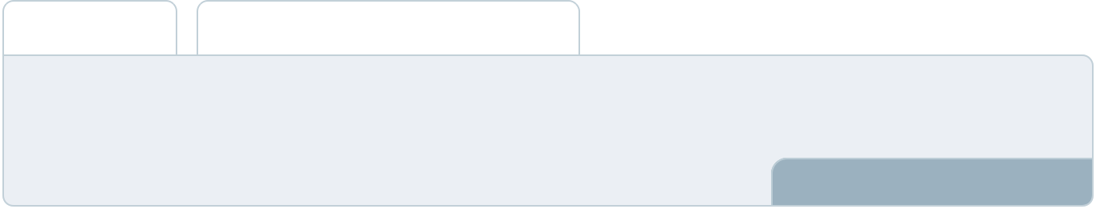

Summarize your executive summary section with a clear CTA, for example, inviting angel investors to discuss the potential business investment.
To unlock help try Upmetrics! 

Write a call to action for your business plan.
Company Overview

Depending on what details of your business are essential, you’ll need different elements in your business overview.
To unlock help try Upmetrics! 

 Help tip  Hardware Shop Business Plan

Describe your business in this section by providing all the basic information:

Describe what kind of language school business you run and the name of it. You may specialize
To unlock help try Upmetrics! 

Start writing here..

Ownership

 Help tip  Hardware Shop Business Plan

List the names of your hardware store’s founders or owners. Describe what shares they own and their responsibilities for efficiently managing the business.
To unlock help try Upmetrics! 

Start writing here..
Mission statement

 Help tip  Hardware Shop Business Plan

Summarize your business’ objective, core principles, and values in your mission statement. This statement needs to be memorable, clear, and brief.
To unlock help try Upmetrics! 

❛ At [Handy Haven Hardware], our commitment is to empower every project with quality, reliability, and precision. We believe in fostering trust through unparalleled product offerings and impeccable service, ensuring every customer finds exactly what

they need.
❜

Business history

 Help tip  Hardware Shop Business Plan

If you’re an established hardware store, briefly describe your business history, like—when it was founded, how it evolved over time, etc.
To unlock help try Upmetrics! 

Start writing here..

Future goals

 Help tip  Hardware Shop Business Plan

It’s crucial to convey your aspirations and vision. Mention your short-term and long-term goals; they can be specific targets for revenue, market share, or expanding your services.
To unlock help try Upmetrics! 

Start writing here..

Market Analysis
To unlock help try Upmetrics!


 |  | Market analysis provides a clear understanding of the market in which your
 |  | printing business will run along with the target market, competitors, and
 |  | growth opportunities.
 |  |  |  | To unlock help try Upmetrics! 
 Help tip |  |  Hardware Shop Business Plan

To write the introduction section of your market analysis, start by clearly identifying your primary target market.
To unlock help try Upmetrics! 

Start writing here..

Target Market

 Help tip  Hardware Shop Business Plan

Start this section by describing your target market. Define your ideal customer and explain what types of services they prefer. Creating a buyer persona will help you easily define your target market to your readers.



Start writing here..

Market size and growth potential

 Help tip  Hardware Shop Business Plan

Describe your market size and growth potential and whether you will target a niche or a much broader market.
To unlock help try Upmetrics! 

Start writing here..

Market Size

Available Market | 1M
All potential hardware shoppers in [City/ | 1M
Location]. | 1M
Served Market | 600k
Shoppers purchasing from organized | 600k
retail hardware stores in [City/Location]. | 600k
Target Market | 150k
Homeowners and contractors seeking | 150k
specialized hardware tools in [City/ | 150k

Location].

 Help tip  Hardware Shop Business Plan

Identify and analyze your direct and indirect competitors. Identify their strengths and weaknesses, and describe what differentiates your hardware store from them.
To unlock help try Upmetrics! 

Competitive analysis

BuildRight Supplies

Established in 2000, BuildRight Supplies is a renowned name in the [City/Location] hardware industry. With over two decades in business, they have a broad network of suppliers and a vast clientele base, ranging from homeowners to big contractors

Features | Strengths | Weaknesses
Extensive product range | Brand reputation built over | Limited specialization in niche
covering general hardware | years | hardware areas
needs | Wide reach due to online and | Occasional stockouts reported
In-store workshops for DIY | offline presence | by customers
enthusiasts | Regular workshops and training | Some online reviews point
Loyalty programs for regular | sessions enhance customer | towards dated in-store
customers | engagement | infrastructure
Online store with home delivery
options

UrbanTool Shed

UrbanTool Shed, launched in 2015, brings a modern approach to hardware retail. They focus on eco-friendly products and offer digital solutions to make DIY projects simpler for their customers.

Features

Specialized eco-friendly product range

Augmented Reality (AR) app for virtual product testing

Consultation services for DIY projects

Collaborative events with local craftsmen and businesses

Strengths

Strong emphasis on sustainability attracts eco-conscious customers

Technological innovations offer unique customer experience

Partnerships with local craftsmen foster community relations

Weaknesses

Premium pricing might alienate budget-conscious customers

Limited traditional product range

Relatively newer in the market, lacking the depth of relationship that longer-standing competitors have

ToolHouse Central

ToolHouse Central is a family-owned business serving the community since 1985. They rely heavily on personal relationships and word-of-mouth marketing, ensuring every customer feels like a part of their extended family.

Features | Strengths | Weaknesses
Handpicked product range | Deep-rooted community trust | No online presence, limiting
emphasizing quality | and loyalty | reach
Custom order services for | Ability to procure rare items on | In-store inventory can be limited
hard-to-find items | demand | compared to bigger chains
After-sales services including | Personalized customer service | Lack of modern technology or
tool repair and maintenance | experience | digital solutions for customers

Market trends

 Help tip  Hardware Shop Business Plan

Analyze emerging trends in the industry, such as technology disruptions, changes in customer behavior or preferences, etc. Explain how your business will cope with all the trends.
To unlock help try Upmetrics! 

Start writing here..

Regulatory environment
To unlock help try Upmetrics!

 Help tip  Hardware Shop Business Plan

List regulations and licensing requirements that may affect your hardware, such as business registration, license and permits, CPSA compliance, insurance, environmental regulations, state and federal regulations, etc.



Start writing here..
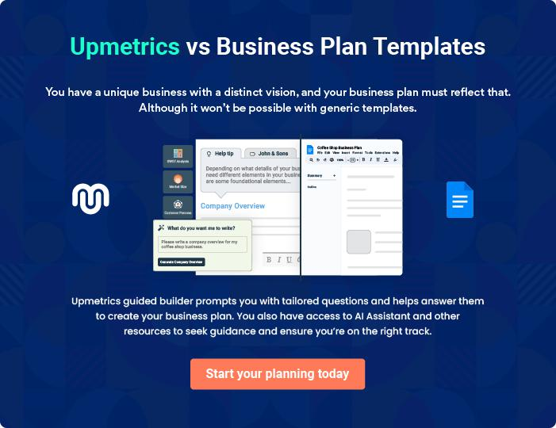
Products and Services
To unlock help try Upmetrics!

The product and services section of a hardware shop business plan should describe the specific services and products that will be offered to customers. To write this section should include the following:



 Help tip  Hardware Shop Business Plan

To craft the introduction for your "Products and Services" chapter, begin by positioning your business within its industry, emphasizing its unique strengths or value proposition.
To unlock help try Upmetrics! 

Start writing here..

 Help tip


Mention the products your business will offer. This list may include product categories like,

• Tools
To unlock help try Upmetrics! 

Products & Services List

Power Drill Set


Price: [$89.99]

A comprehensive power drill set ideal for both beginners and professionals.

Specifications

- Brand: [TopBrand Drills]

- Power: 20V Lithium-ion battery

- Speed: 0-1500 RPM

- Set includes: Drill, two batteries, charger, and 10 drill bits
Lumber (Pine Wood)

Price: [$5.99] per foot

High-quality pine wood, perfect for crafting furniture or construction.

Specifications

- Type: Softwood

- Dimensions: 2x4

- Finish: Smooth

- Origin: [Forest/Country of origin]

Pipe Cutting & Threading Service

Price: [$9.99] per cut/thread

Expert service to ensure precise cuts and accurate threading for your plumbing projects.

Specifications

- Materials: Copper, PVC, steel

- Max Length: Up to 10 feet

- Accuracy: ±0.5mm

LED Light Bulbs

Price: [$3.99] each

Energy-efficient LED light bulbs that last longer and save on electricity bills

Specifications

- Wattage: 10W

- Luminosity: 800 lumens

- Color Temperature: 4000K (Neutral White)

- Lifetime: 25,000 hours
Safety Helmet

Price: [$25.99]

A durable safety helmet designed to protect against impact and ensure safety during construction or renovation tasks.

Specifications

- Material: High-density polyethylene

- Color: Yellow

- Strap: Adjustable, with a chin strap

- Standards: Meets [Specific Safety Standard]

Custom Wood Engraving Service

Price: Starting at [$15] per engraving

Personalize your wood pieces with our custom engraving service, great for gifts or unique furniture pieces.

Specifications

- Materials: All types of wood

- Design: Customer-provided or choose from our catalog

- Max Size: 12x12 inches

Quality Measures

 Help tip  Hardware Shop Business Plan

This section should explain how you maintain quality standards and consistently provide the highest quality service.
To unlock help try Upmetrics! 

Start writing here..

Additional Services

 Help tip  Hardware Shop Business Plan

Mention if your hardware store offers any additional services. You may include services like fittings, maintenance, customization, etc.
To unlock help try Upmetrics! 

Start writing here..
Sales And Marketing Strategies
To unlock help try Upmetrics!

Writing the sales and marketing strategies section means a list of strategies you will use to attract and retain your clients.
To unlock help try Upmetrics! 

 Help Tip  Hardware Shop Business Plan


To create an effective introduction for your "Sales and Marketing Strategies" chapter, start by setting the stage within your specific industry or market.
To unlock help try Upmetrics! 

Start writing here..

Unique Selling Proposition (USP)

 Help tip  Hardware Shop Business Plan

Define your business’s USPs depending on the market you serve, the equipment you use, and the unique services you provide. Identifying USPs will help you plan your marketing strategies.
To unlock help try Upmetrics! 

Start writing here..

Pricing Strategy

 Help tip  Hardware Shop Business Plan

Describe your pricing strategy—how you plan to price your products in hardware stores and stay competitive in the local market. You can mention any introductory offers you plan on offering to attract new customers to your hardware store.



Start writing here..

 Help tip  Hardware Shop Business Plan
To unlock help try Upmetrics!

Discuss your marketing strategies to market your services. You may include some of these marketing strategies in your business plan—social media marketing, Google ads, brochures, email marketing, content marketing, and print marketing.



Marketing strategies

Online


Social Media

Regular updates, promotions, and engagement activities on platforms like Facebook, Instagram, and Twitter.

Content Marketing

Sharing insightful articles and DIY tips on our official blog.

Email Marketing

Regular newsletters and promotional offers to our subscribed customer base.

Google Ads

Leveraging the power of online search through targeted advertisements.

Offline

Brochures

Distributing informative brochures in strategic locations to ensure potential customers understand our offerings.

Print Marketing

Local newspaper advertisements, banners, and hoardings to ensure local visibility.

 Help tip  Hardware Shop Business Plan
To unlock help try Upmetrics!
To unlock help try Upmetrics!

Outline the strategies you’ll implement to maximize your sales. Your sales strategies may include direct sales calls, partnering with local plumbers, contractors, and trade professionals, offering referral programs, etc.



Sales strategies

Partner with Businesses Direct Sales Calls

Teaming up with local plumbers, Proactive outreach to potential

contractors, and trade bulk buyers and partnerships.

professionals to drive consistent referrals.

Referral Programs

Encouraging our satisfied

customers to refer friends and

family with lucrative incentives.

 Help tip  Hardware Shop Business Plan

Describe your customer retention strategies and how you plan to execute them. For instance, introducing loyalty programs, service offers, discounts on annual membership, personalized service, etc.



Customer retention

Loyalty Programs

Rewarding regular customers with points that can be redeemed on future purchases.

Service Offers

Exclusive offers and discounts for our regular patrons.

Personalized Service

Ensuring that every customer feels valued through personalized recommendations and assistance.

Discounts on Annual Membership

Providing added benefits and discounts to those who opt for our annual membership.

Operations Plan
To unlock help try Upmetrics!
To unlock help try Upmetrics!

 |  | When writing the operations plan section, it’s important to consider the
 |  | various aspects of your business operations.
 |  |  |  | To unlock help try Upmetrics! 
 Help tip |  |  Hardware Shop Business Plan
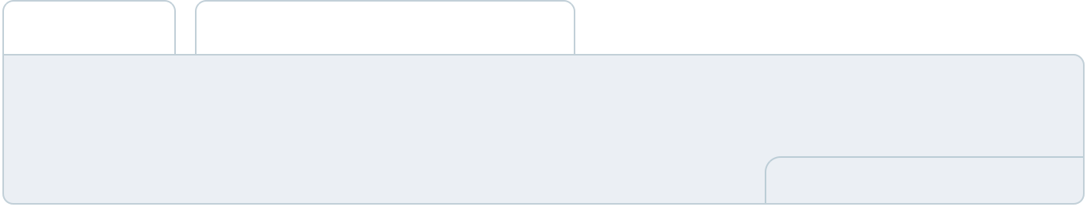

To create an effective introduction for your "Operational Plan" chapter, start by emphasizing the
pivotal role of efficient operations in the success of your business, underscoring how they
directly impact the quality of services delivered.
 |  |  |  | To unlock help try Upmetrics! 
Start writing here..
Staffing & Training
 Help tip |  |  Hardware Shop Business Plan

Outline the processes and procedures you will use to run your hardware shop. Your operational processes may include inviting walk-ins, assisting customers, making sales, collection and payment, scheduling fittings, store maintenance, and order restocking.

Start writing here..

Operational Process

 Help tip  Hardware Shop Business Plan

Outline the processes and procedures you will use to run your hardware shop. Your operational processes may include inviting walk-ins, assisting customers, making sales, collection and payment, scheduling fittings, store maintenance, and order restocking.





Start writing here..

Equipment & Machinery
To unlock help try Upmetrics!

 Help tip  Hardware Shop Business Plan

Include the list of equipment and machinery required for hardware, such as pipe cutters, pipe threaders, showroom displays, and fixtures, pressure testing equipment, cutting and measuring tools, office equipment, etc.



Start writing here..
Management Team

The management team section provides an overview of the individuals responsible for running your business plan.
To unlock help try Upmetrics! 

 Help tip  Hardware Shop Business Plan

To craft an introduction for your "Management Team" chapter, begin by emphasizing the crucial role of leadership in the success of any business.
To unlock help try Upmetrics! 

Start writing here..

Key managers

 Help tip  Hardware Shop Business Plan

Introduce your management and key members of your team, and explain their roles and responsibilities.
To unlock help try Upmetrics! 

Start writing here..


JOHN DOE

CEO - john.doe@example.com

John is the visionary behind [Handy Haven Hardware].

With an MBA from Stanford University and over 20 years of experience in the hardware retail industry, John founded [Handy Haven] with the goal of revolutionizing the local hardware scene by blending traditional service values with modern retail innovations.


- Educational Background: MBA, Stanford University

- Professional Background: 15 years at XYZ Hardware Chain, ascending from Floor Manager to Regional Director

JANE DOE

Chief Operating Officer (COO) - jane.doe@example.com

Jane has been instrumental in streamlining [Handy Haven]'s operations since its inception.

Holding a degree in Operations Management from Harvard Business School and a rich stint as Operations Director at ABC Retailers, Jane’s expertise ensures that [Handy Haven] operates seamlessly.


- Educational Background: MSc in Operations Management, Harvard Business School

- Professional Background: Operations Director, ABC Retailers for 10 years


ALICE BROWN

CMO - alice.brown@example.com

With a keen eye for market trends and a flair for crafting compelling campaigns, Alice has been at the forefront of [Handy Haven]'s marketing efforts.

An alumna of the University of Chicago with a specialization in Retail Marketing, Alice’s prior role as Senior Marketing Manager at DEF Tools has equipped her with the acumen to make [Handy Haven] a household name.

- Educational Background: MA in Retail Marketing, University of Chicago

- Professional Background: Senior Marketing Manager, DEF Tools for 8 years


ROBERT BROWN

Store Manager - robert.brown@example.com

Robert, with his impeccable managerial skills and dedication to customer service, ensures that every visit to [Handy Haven] is a pleasant experience for our customers.

A graduate in Business Management from UCLA and a former Assistant Store Manager at GHI Supplies, Robert's leadership ensures the store’s day-to-day functions are executed flawlessly.

- Educational Background: BSc in Business Management, UCLA

- Professional Background: Assistant Store Manager, GHI Supplies for 6 years
Organizational structure

 Help tip  Hardware Shop Business Plan

Explain the organizational structure of your management team. Include the reporting line and decision-making hierarchy.
To unlock help try Upmetrics! 

Start writing here..

Organization chart


John Doe

CEO


Richard Gray


Alice Brown

Jane Doe

CFO

CMO



COO


Samuel Green

Marketing Specialist Robert Brown

Store Manager



Emily White

Inventory Manager

Compensation plan

 Help tip  Hardware Shop Business Plan

Describe your compensation plan for the management and staff. Include their salaries, incentives, and other benefits.
To unlock help try Upmetrics! 

Start writing here..

 Help tip  Hardware Shop Business Plan

Mentioning advisors or consultants in your business plans adds credibility to your business idea.
To unlock help try Upmetrics! 

Advisors/Consultants


[ADVISOR NAME]

Advisor

An industry veteran with [X years] in the hardware business, [Advisor's Name] offers strategic guidance.


[CONSULTANT NAME]

Consultant

Specializing in [specific area, e.g., retail strategy], [Consultant's Name]'s consultancy has been instrumental in shaping certain aspects of our business.
Financial Plan

When writing the financial plan section of a business plan, it’s important to provide a comprehensive overview of your financial projections for the first few years of your business, You may provide the following:
To unlock help try Upmetrics! 

 Help tip  Hardware Shop Business Plan


To create an effective introduction for your "Financial Plan" chapter, begin by stressing the critical role of a well-structured financial plan in the success of your venture.
To unlock help try Upmetrics! 

Start writing here..

 Help tip


Describe details such as projected revenue, operational costs, and service costs in your projected profit and loss statement. Make sure to include your business’s expected net profit or loss.
To unlock help try Upmetrics! 

Profit & loss statement

Revenue

Cost Of Sales

General Costs

Revenue Specific Costs

Personnel Costs (Direct

Labor)

Gross Margin

Gross Margin (%)

Operating Expense

Payroll Expense

(Indirect Labor)

General Expense

Bad Debt

Amortization of Current

Assets

2023-24 | 2024-25 | 2025-26 | 2026-27 | 2027-28
$0 | $0 | $0 | $0 | $0

$0 | $0 | $0 | $0 | $0
$0 | $0 | $0 | $0 | $0
$0 | $0 | $0 | $0 | $0
$0 | $0 | $0 | $0 | $0

$0 | $0 | $0 | $0 | $0
0% | 0% | 0% | 0% | 0%

$0 | $0 | $0 | $0 | $0
$0 | $0 | $0 | $0 | $0
$0 | $0 | $0 | $0 | $0
$0 | $0 | $0 | $0 | $0
$0 | $0 | $0 | $0 | $0

EBITDA

Additional Expense

Long Term

Depreciation

Gain or loss from Sale

of Assets

EBIT

Interest Expenses

EBT

Income Tax Expense

Total Expense

Net Income

Net Income (%)

2023-24 | 2024-25 | 2025-26 | 2026-27 | 2027-28
$0 | $0 | $0 | $0 | $0
$0 | $0 | $0 | $0 | $0
$0 | $0 | $0 | $0 | $0
$0 | $0 | $0 | $0 | $0
$0 | $0 | $0 | $0 | $0
$0 | $0 | $0 | $0 | $0
$0 | $0 | $0 | $0 | $0
$0 | $0 | $0 | $0 | $0
$0 | $0 | $0 | $0 | $0
$0 | $0 | $0 | $0 | $0
0% | 0% | 0% | 0% | 0%
 | 2023-24 | 2024-25 | 2025-26 | 2026-27 | 2027-28
Retained Earning | $0 | $0 | $0 | $0 | $0
Opening
Owner's Distribution | $0 | $0 | $0 | $0 | $0
Retained Earning | $0 | $0 | $0 | $0 | $0
Closing

 Help tip

The cash flow for the first few years of your operation should be estimated and described in this section. This may include billing invoices, payment receipts, loan payments, and any other cash flow statements.
To unlock help try Upmetrics! 

Cash flow statement

 | 2023-24 | 2024-25 | 2025-26 | 2026-27 | 2027-28
Cash Received | $0 | $0 | $0 | $0 | $0
Cash Paid | $0 | $0 | $0 | $0 | $0
COS & General Expenses | $0 | $0 | $0 | $0 | $0
Salary & Wages | $0 | $0 | $0 | $0 | $0
Interest | $0 | $0 | $0 | $0 | $0

Sales Tax

Income Tax

Net Cash From

Operations

Assets Sell

Assets Purchase

Net Cash From

Investments

Amount Received

Loan Received

Common Stock

Preferred Stock

Owner's Contribution

Amount Paid

2023-24 | 2024-25 | 2025-26 | 2026-27 | 2027-28
$0 | $0 | $0 | $0 | $0
$0 | $0 | $0 | $0 | $0
$0 | $0 | $0 | $0 | $0

$0 | $0 | $0 | $0 | $0
$0 | $0 | $0 | $0 | $0
$0 | $0 | $0 | $0 | $0

$0 | $0 | $0 | $0 | $0
$0 | $0 | $0 | $0 | $0

$0 | $0 | $0 | $0 | $0
$0 | $0 | $0 | $0 | $0
$0 | $0 | $0 | $0 | $0

Loan Capital $0 $0 $0 $0 $0

 | 2023-24 | 2024-25 | 2025-26 | 2026-27 | 2027-28
Dividends & Distributions | $0 | $0 | $0 | $0 | $0
Net Cash From | $0 | $0 | $0 | $0 | $0
Financing

Summary
Starting Cash | $0 | $0 | $0 | $0 | $0
Cash In | $0 | $0 | $0 | $0 | $0
Cash Out | $0 | $0 | $0 | $0 | $0
Change in Cash | $0 | $0 | $0 | $0 | $0
Ending Cash | $0 | $0 | $0 | $0 | $0

 Help tip

Create a projected balance sheet documenting your hardware shop’s assets, liabilities, and equity.

To unlock help try Upmetrics! 

Balance sheet

 | 2023-24 | 2024-25 | 2025-26 | 2026-27 | 2027-28
Assets | $0 | $0 | $0 | $0 | $0
Current Assets | $0 | $0 | $0 | $0 | $0
Cash | $0 | $0 | $0 | $0 | $0
Accounts Receivable | $0 | $0 | $0 | $0 | $0
Inventory | $0 | $0 | $0 | $0 | $0
Other Current Assets | $0 | $0 | $0 | $0 | $0
Long Term Assets | $0 | $0 | $0 | $0 | $0
Gross Long Term Assets | $0 | $0 | $0 | $0 | $0
Accumulated Depreciation | $0 | $0 | $0 | $0 | $0

Liabilities & Equity | $0 | $0 | $0 | $0 | $0
Liabilities | $0 | $0 | $0 | $0 | $0
Current Liabilities | $0 | $0 | $0 | $0 | $0
Accounts Payable | $0 | $0 | $0 | $0 | $0
Income Tax Payable | $0 | $0 | $0 | $0 | $0
Sales Tax Payable | $0 | $0 | $0 | $0 | $0
Short Term Debt | $0 | $0 | $0 | $0 | $0
 | 2023-24 | 2024-25 | 2025-26 | 2026-27 | 2027-28
Long Term Liabilities | $0 | $0 | $0 | $0 | $0
Long Term Debt | $0 | $0 | $0 | $0 | $0
Equity | $0 | $0 | $0 | $0 | $0
Paid-in Capital | $0 | $0 | $0 | $0 | $0
Common Stock | $0 | $0 | $0 | $0 | $0
Preferred Stock | $0 | $0 | $0 | $0 | $0
Owner's Contribution | $0 | $0 | $0 | $0 | $0
Retained Earnings | $0 | $0 | $0 | $0 | $0

Check | $0 |  |  | $0 | $0 | $0 | $0
 Help tip |  |  Hardware Shop Business Plan
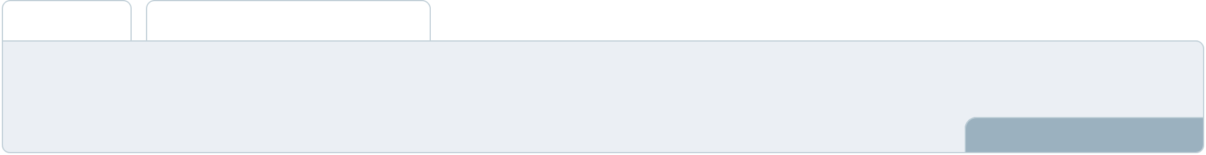

Determine and mention your business’s break-even point—the point at which your business costs and revenue will be equal.

This exercise will help you understand how much revenue you need to generate to sustain or be profitable.
To unlock help try Upmetrics! 

Break-even Analysis

 | 2023-24 | 2024-25 | 2025-26 | 2026-27 | 2027-28
Starting Revenue | $0 | $0 | $0 | $0 | $0
Net Revenue | $0 | $0 | $0 | $0 | $0
Closing Revenue | $0 | $0 | $0 | $0 | $0

Starting Expense | $0 | $0 | $0 | $0 | $0
Net Expense | $0 | $0 | $0 | $0 | $0
Closing Expense | $0 | $0 | $0 | $0 | $0

Is Break Even? | 0 | 0 | 0 | 0 | 0
Break Even Month | 0 | 0 | 0 | 0 | 0
Days Required | 0 | 0 | 0 | 0 | 0
Break Even Revenue | $0 | $0 | $0 | $0 | $0
Break Even Units
Financing needs

 Help tip  Hardware Shop Business Plan

Calculate costs associated with starting a hardware shop, and estimate your financing needs and how much capital you need to raise to operate your business.
To unlock help try Upmetrics! 

Start writing here..
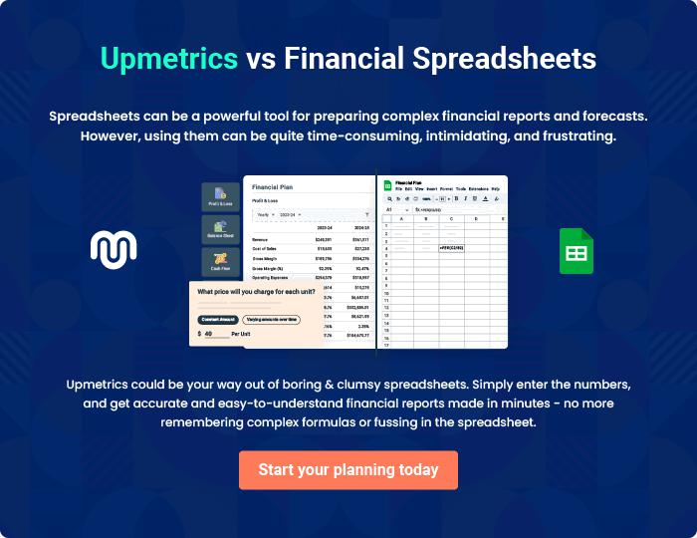
Appendix

When writing the appendix section, you should include any additional information that supports the main content of your plan. This may include financial statements, market research data, legal documents, and other
To unlock help try Upmetrics! 
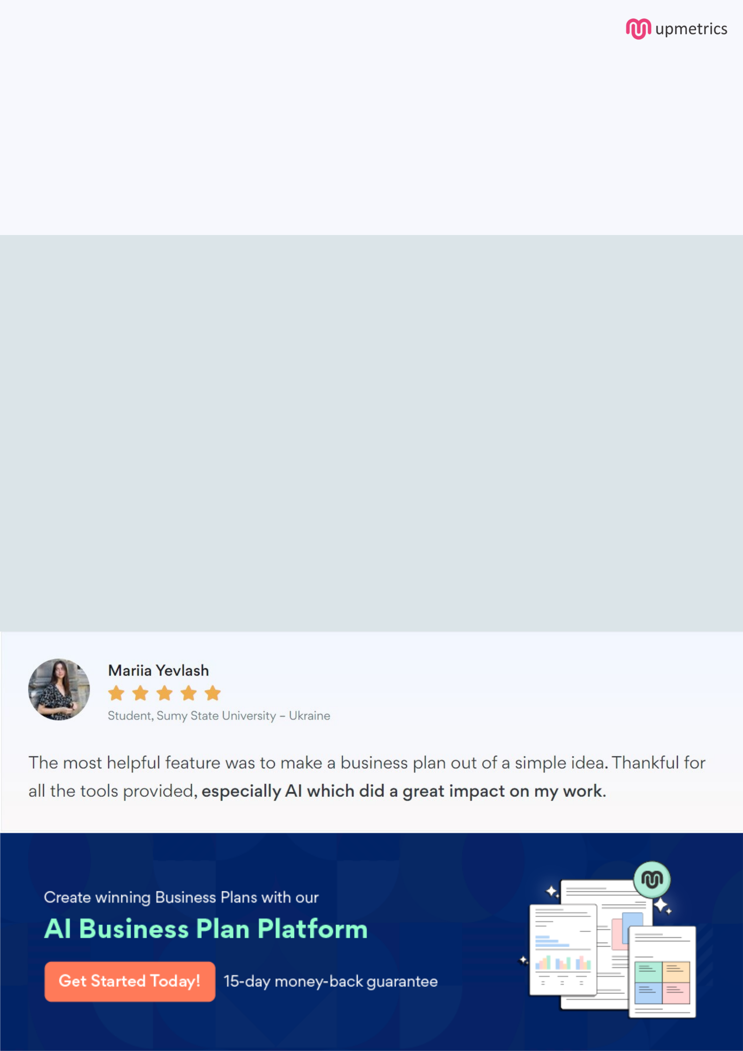
Create a winning business plan that gets you funded

Creating a stunning and investment-ready plan requires no writing, graphic designing, or financial planning expertise.

Upmetrics has all the features required to help you create a comprehensive business plan—from start to finish. Make no mistakes, it’s the modern way of planning to structure ideas, make plans, and create stunning pitch decks to awe investors.

Pitch decks that impress investors

Create pitch decks that provide a visual representation of your business, engage investors, and make them want to invest in your business idea.

Interactive plans in no time

Import business plan sections like—SWOT analysis, comparison tables, and others to create an interactive business plan. No designing skills are required.

Stunning cover page designs

With Upmetrics, you have the liberty to choose from multiple stunning cover page designs. Choose a creative design and make your plan stand out.

Online sharing made simple

Upmetrics makes online sharing quick and easier for users. Easily share your business plans with a link while tracking reader activity.

500+ sample business plans

Simply import a template from our library of sample plans into the editor and start customizing it to make it yours. It takes only a few clicks to get started.

Collaborate with team in real-time

Invite team members, initiate conversations, discuss ideas & strategies, share feedback, and work on a business plan in real-time.

