
BUSINESS PLAN

2023


Hair Extension

Business Plan

Long Hair, Endless Possibilities

John Doe

10200 Bolsa Ave, Westminster, CA, 92683

- 359-3153 info@example.com http://www.example.com

Information provided in this business plan is unique to this business and confidential; therefore, anyone reading this plan agrees not to disclose any of the information in this business plan without prior written permission of the company.
Table of Contents

Executive Summary | 6
Market opportunity | 6
Services Offered | 6
Marketing & Sales Strategies | 7
Financial Highlights | 7
Units Sold v/s Revenue | 8

Company Overview | 9
Ownership | 9
Business Owners | 9
Mission statement | 10
Business history | 10
Future goals | 10

Market Analysis | 11
Target Market | 11
Market size and growth potential | 11
Market Size | 12
Competitive analysis | 12
LuxeLocks Inc. | 12
NaturalStrandz | 13
ExtensionsPlus Boutique | 13
Market trends | 13
Regulatory environment | 14

Products and Services | 15
Products & Services List | 15
Classic Hair Extensions | 15
Synthetic Hair Extensions | 16
Extension Accessories Kit | 16
Hair Extension Installation | 17
Customization & Color Matching Session | 17
Hair Extension Consultation | 17
Quality Measures | 18
Additional Services | 18

Sales And Marketing Strategies | 19
Unique Selling Proposition (USP) | 19
Pricing Strategy | 19
Marketing strategies | 20
Online | 20
Offline | 20
Sales strategies | 21
Customer retention | 21

Operations Plan | 22
Staffing & Training | 22
Operational Process | 22
Equipment & Machinery | 23

Management Team | 24
Key managers | 24
John Doe | 25
Jane Doe | 25
Alice Brown | 26
Robert Brown | 26
Organizational structure | 26
Organization chart | 27
Compensation plan | 27
Board of advisors | 28
[ADVISOR NAME] | 28
Financial Plan
Financial Plan | 29

Profit & loss statement 29

Cash flow statement | 32
Balance sheet | 34
Break-even Analysis | 36
Financing needs | 38
Appendix
Appendix | 40

Business planning that’s simpler and faster than you think

Creating a business plan using Upmetrics to start and grow a business is literally the easiest thing in the World. Simply read the instructions and fill in the blanks. It’s as simple as that.

❛ | Upmetrics has everything you need to create a | ❜
❛ | comprehensive business plan. | ❜

AI-powered Upmetrics Assistant

AI-powered insights to streamline your plan

Not sure where to start? Upmetrics’ AI Assistant will automatically generate ideas for each section of your plan and offer improved versions of your writing, adjusting for tone, voice, and grammar or spelling errors.

Financial Forecasting Tool

All the financials are calculated for you

Forget the complex formulas and clumsy spreadsheets — with automatic financials and drag-and-drop forecasting, you can finish your plan faster and be confident that your numbers are accurate.

Business Plan Builder

Guides you like a business mentor

Upmetrics’ step-by-step instructions, prompts, and the library of 400+ sample business plans will guide you through each section of your plan as a business mentor.
Executive Summary


An executive summary is the first section of the business plan intended to provide an overview of the whole business plan.
To unlock help try Upmetrics! 

 Help tip  Hair Extension Business Plan


Start your executive summary by briefly introducing your business to your readers.

This section may include the name of your hair extension business, its location, when it was
To unlock help try Upmetrics! 

Start writing here..

Market opportunity

 Help tip  Hair Extension Business Plan

Summarize your market research, including market size, growth potential, and marketing trends. Highlight the opportunities in the market and how your business will fit in to fill the gap.
To unlock help try Upmetrics! 

Start writing here..

Services Offered

 Help tip  Hair Extension Business Plan

Highlight the hair extension products & services you offer your clients. The USPs and differentiators you offer are always a plus.
To unlock help try Upmetrics! 

Start writing here..

Marketing & Sales Strategies
To unlock help try Upmetrics!

 Help tip  Hair Extension Business Plan

Outline your sales and marketing strategies—what marketing platforms you use, how you plan on acquiring customers, etc.
To unlock help try Upmetrics! 

Start writing here..

Financial Highlights

 Help tip  Hair Extension Business Plan

Briefly summarize your financial projections for the initial years of business operations. Include any capital or investment requirements, associated startup costs, projected revenues, and profit forecasts.



Start writing here..
Units Sold v/s Revenue

 |  | Units Sold | Revenue
15.00k
10.00k
5.00k
0
Year 1 | Year 2 | Year 3


Financial Year |  |  | Units Sold | Revenue
Year 1 | 1,550 |  |  | $10,000
Year 2 | 1,800 |  |  | $12,000
Year 3 | 2,050 |  |  | $14,000
 Help tip |  |  Hair Extension Business Plan


Summarize your executive summary section with a clear CTA, for example, inviting angel investors to discuss the potential business investment.
To unlock help try Upmetrics! 

Write a call to action for your business plan.
Company Overview

Depending on what details of your business are essential, you’ll need different elements in your business overview.
To unlock help try Upmetrics! 

 Help tip  Hair Extension Business Plan

Describe your business in this section by providing all the basic information:

Describe what kind of hair extension company you run and the name of it. You may specialize
To unlock help try Upmetrics! 

Start writing here..

Ownership

 Help tip  Hair Extension Business Plan

List the names of your hair extension company’s founders or owners. Describe what shares they own and their responsibilities for efficiently managing the business.
To unlock help try Upmetrics! 

Start writing here..

Business Owners



60% John Doe



40% Jane Doe
Mission statement

 Help tip  Hair Extension Business Plan

Summarize your business’ objective, core principles, and values in your mission statement. This statement needs to be memorable, clear, and brief.
To unlock help try Upmetrics! 

- At [Hair Extensions Elegances], our mission is to empower individuals to express themselves confidently.

We believe in the transformative power of beauty, and through our high-quality hair extensions, we aim to enhance natural beauty, ensuring everyone can wear their hair with pride and elegance.

Business history

 Help tip  Hair Extension Business Plan

❜

If you’re an established hair extension service provider, briefly describe your business history, like—when it was founded, how it evolved over time, etc.
To unlock help try Upmetrics! 

Start writing here..

Future goals

 Help tip  Hair Extension Business Plan

It’s crucial to convey your aspirations and vision. Mention your short-term and long-term goals; they can be specific targets for revenue, market share, or expanding your services.
To unlock help try Upmetrics! 

Start writing here..

Market Analysis
To unlock help try Upmetrics!


 |  | Market analysis provides a clear understanding of the market in which your
 |  | printing business will run along with the target market, competitors, and
 |  | growth opportunities.
 |  |  |  | To unlock help try Upmetrics! 
 Help tip |  |  Hair Extension Business Plan

To write the introduction section of your market analysis, start by clearly identifying your primary target market.
To unlock help try Upmetrics! 

Start writing here..

Target Market

 Help tip  Hair Extension Business Plan

Start this section by describing your target market. Define your ideal customer and explain what types of services they prefer. Creating a buyer persona will help you easily define your target market to your readers.



Start writing here..

Market size and growth potential

 Help tip  Hair Extension Business Plan

Describe your market size and growth potential and whether you will target a niche or a much broader market.
To unlock help try Upmetrics! 

Start writing here..

Market Size

Available Market

Total individuals interested in hair 5M extensions across the country.

Served Market
Consumers currently buying extensions, 3M irrespective of the brand.

Target Market
Fashion-forward 20-35 year-olds seeking 500k premium extensions.

 Help tip  Hair Extension Business Plan

Identify and analyze your direct and indirect competitors. Identify their strengths and weaknesses, and describe what differentiates your hair extension services from them.
To unlock help try Upmetrics! 

Competitive analysis

LuxeLocks Inc.

Established in 2015, LuxeLocks Inc. has become a recognized name in the luxury hair extension segment. They have a strong online presence and partnerships with leading beauty salons.

Features | Strengths | Weaknesses
Ethically sourced hair | Strong brand recognition | Premium pricing can alienate
extensions | Extensive online marketing | some market segments
Wide variety of color options | campaigns | Limited physical store presence
Customizable lengths and | Collaborations with celebrity | Occasional stock shortages
textures | stylists and influencers | reported by customers
Virtual try-on with augmented
reality integration

NaturalStrandz

NaturalStrandz is renowned for offering hair extensions that seamlessly mimic natural hair. Their USP is their focus on a diverse range of textures catering to all hair types.

Features | Strengths | Weaknesses
Extensions specifically tailored | Niche focus gives them a | Limited color customization
for various hair types (curly, | unique market position | options
wavy, straight) | High customer retention due to | Branding and marketing efforts
Heat-resistant options | subscription model | are not as aggressive as other
Subscription model for regular | Regular product innovations | competitors
customers |  | Longer delivery times compared
 |  | to industry average

ExtensionsPlus Boutique

A brick-and-mortar favorite, ExtensionsPlus Boutique has multiple outlets across the state and is often the first choice for those looking to touch and feel extensions before purchasing.

Features Strengths Weaknesses

In-store professional fitting sessions

Loyalty programs for repeat customers

Collaboration with local stylists for on-site styling

Direct customer interaction allows for immediate feedback and personalization

Strategic store locations in high footfall areas

Strong community engagement through local events

Lacks a comprehensive online shopping platform

Inventory management issues have been highlighted in certain stores

Slow adaptation to emerging industry trends

Market trends

 Help tip  Hair Extension Business Plan

Analyze emerging trends in the industry, such as technology disruptions, changes in customer behavior or preferences, etc. Explain how your business will cope with all the trends.
To unlock help try Upmetrics! 

Start writing here..

Regulatory environment
To unlock help try Upmetrics!

 Help tip  Hair Extension Business Plan

List regulations and licensing requirements that may affect your hair extension company, such as product safety & compliance, labeling & packaging, business licensing & registration, health & sanitation, etc.



Start writing here..
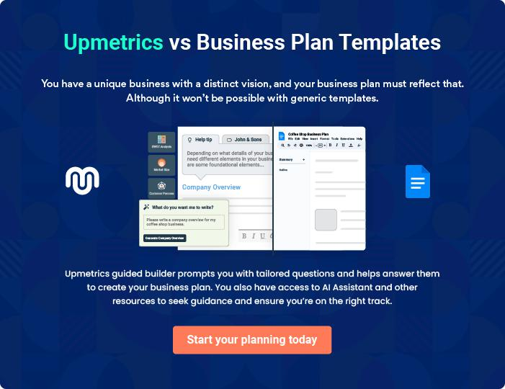
Products and Services
To unlock help try Upmetrics!

The product and services section of a hair extension business plan should describe the specific services and products that will be offered to customers. To write this section should include the following:



 Help tip  Hair Extension Business Plan

To craft the introduction for your "Products and Services" chapter, begin by positioning your business within its industry, emphasizing its unique strengths or value proposition.
To unlock help try Upmetrics! 

Start writing here..

 Help tip


Mention the hair extension products & services your business will offer. This list may include

• THair extension
To unlock help try Upmetrics! 

Products & Services List

Classic Hair Extensions


Price: [$150] per set

Premium quality human hair extensions designed to seamlessly blend with natural hair, adding volume and length.

Specifications

- Type: Human Hair

- Lengths Available: 14", 18", 24"

- Colors Available: Jet Black, Chestnut Brown, Sun-Kissed Blonde, etc.

- Texture: Straight, Wavy, Curly
Synthetic Hair Extensions

Price: [$50] per set

High-quality synthetic hair extensions, perfect for those seeking a budget-friendly solution without compromising on style.

Specifications

- Type: Synthetic Fibers

- Lengths Available: 12", 16", 20"

- Colors Available: Vibrant Blue, Ruby Red, Electric Pink, etc.

- Texture: Straight, Curly

Extension Accessories Kit

Price: [$30] per kit

A curated set of essential accessories ensuring secure and optimal extension application and maintenance.

Specifications

- Items Included: Extension Clips, Tapes, Beads, Hair Extension Brush

- Material: Stainless Steel (Clips, Beads), High-Quality Adhesive (Tapes)
Hair Extension Installation

Price: [$100] per session

Professional installation service provided by trained stylists to ensure perfect application, placement, and blend with natural hair.

Specifications

- Duration: 2-3 hours (depending on hair length & volume)

- Tools Used: Professional-grade heat tools, clips, and tapes

Customization & Color Matching Session

Price: [$50] per session

Bespoke service ensuring that extensions match the client's natural hair color, providing an indistinguishable and flawless blend.

Specifications

- Duration: 1 hour

- Techniques Used: Advanced color matching technology, manual dyeing for unique shades

Hair Extension Consultation

Price: [$25] per session (deducted from final purchase)

A comprehensive discussion with experts to understand client needs and preferences, ensuring they make an informed choice.

Specifications

- Duration: 30-45 minutes

- Key Points Covered: Hair health, desired look, maintenance tips, product recommendations
Quality Measures
- To unlock help try Upmetrics!

 Help tip  Hair Extension Business Plan

This section should explain how you maintain quality standards and consistently provide the highest quality service.
To unlock help try Upmetrics! 

Start writing here..

Additional Services

 Help tip  Hair Extension Business Plan

Mention if your hair extension company offers any additional services. You may include services like consultations, styling services, maintenance & upkeep, removal & reinstallment, etc.



Start writing here..
Sales And Marketing Strategies

Writing the sales and marketing strategies section means a list of strategies you will use to attract and retain your clients.
To unlock help try Upmetrics! 

 Help Tip  Hair Extension Business Plan


To create an effective introduction for your "Sales and Marketing Strategies" chapter, start by setting the stage within your specific industry or market.
To unlock help try Upmetrics! 

Start writing here..

Unique Selling Proposition (USP)

 Help tip  Hair Extension Business Plan

Define your business’s USPs depending on the market you serve, the equipment you use, and the unique services you provide. Identifying USPs will help you plan your marketing strategies.
To unlock help try Upmetrics! 

Start writing here..

Pricing Strategy

 Help tip  Hair Extension Business Plan

Describe your pricing strategy—how you plan to price your services and stay competitive in the local market. You can mention any discounts you plan on offering to attract new customers.
To unlock help try Upmetrics! 

Start writing here..

 Help tip  Hair Extension Business Plan
To unlock help try Upmetrics!

Discuss your marketing strategies to market your services. You may include some of these marketing strategies in your business plan—social media marketing, brochures, email marketing, content marketing, and print marketing



Marketing strategies

Online


Social Media

Leveraging platforms like Instagram, Facebook, and Pinterest, we showcase our work, share client testimonials, and engage with our community.

Content Marketing

Regular blog posts and video content highlight our expertise and offer valuable insights into hair care and fashion.

Offline

Brochures

Elegantly designed brochures provide an in-depth look into our offerings, available at our store and strategic partner locations.

Email Marketing

Periodic newsletters and offers are sent to our subscribers, keeping them updated on the latest trends and services.

Print Marketing

Advertisements in local magazines and newspapers enhance our visibility in the local community.

 Help tip  Hair Extension Business Plan

Outline the strategies you’ll implement to maximize your sales. Your sales strategies may include partnering with other businesses, influencer marketing, offering referral programs, etc.
To unlock help try Upmetrics! 

Sales strategies

Partner with Businesses

Collaborating with local salons, beauty bloggers, and stylists to cross-promote services.

Influencer Marketing

Partnering with beauty influencers to reach a wider audience and gain credibility in the industry.

Referral Programs

Encouraging satisfied clients to

refer friends and family, with

attractive incentives for both the

referrer and the referred.

 Help tip  Hair Extension Business Plan

Describe your customer retention strategies and how you plan to execute them. For instance, introducing loyalty programs, discounts & offers, personalized service, etc.
To unlock help try Upmetrics! 

Customer retention

Loyalty Programs Exclusive Offers

Rewarding frequent customers Periodic offers tailored exclusively

with points that can be redeemed for our regular clientele.

for services or products.

Personalized Service

Understanding individual

preferences and maintaining a

client profile ensures they receive a

tailored experience on every visit.

Operations Plan
To unlock help try Upmetrics!

 |  | When writing the operations plan section, it’s important to consider the
 |  | various aspects of your business operations.
 |  |  |  | To unlock help try Upmetrics! 
 Help tip |  |  Hair Extension Business Plan


To create an effective introduction for your "Operational Plan" chapter, start by emphasizing the
pivotal role of efficient operations in the success of your business, underscoring how they
directly impact the quality of services delivered.
 |  |  |  | To unlock help try Upmetrics! 
Start writing here..
Staffing & Training
 Help tip |  |  Hair Extension Business Plan

Mention your business’s staffing requirements, including the number of employees or
hairstylists needed. Include their qualifications, the training required, and the duties they will
perform.
 |  |  |  | To unlock help try Upmetrics! 
Start writing here..
Operational Process
 Help tip |  |  Hair Extension Business Plan

Outline the processes and procedures you will use to run your hair extension business. Your operational processes may include product sourcing & inventory management, order processing, application & installation, etc.



Start writing here..

Equipment & Machinery

 Help tip  Hair Extension Business Plan

Include the list of equipment and machinery required for hair extension, such as styling tools, application tools, cutting & shaping tools, etc.
To unlock help try Upmetrics! 

Start writing here..
Management Team

The management team section provides an overview of the individuals responsible for running your business plan.
To unlock help try Upmetrics! 

 Help tip  Hair Extension Business Plan

To craft an introduction for your "Management Team" chapter, begin by emphasizing the crucial role of leadership in the success of any business.
To unlock help try Upmetrics! 

Start writing here..

Key managers

 Help tip  Hair Extension Business Plan

Introduce your management and key members of your team, and explain their roles and responsibilities.
To unlock help try Upmetrics! 

Start writing here..

JOHN DOE

CEO - john.doe@example.com

John Doe, the visionary founder and CEO of "[Hair Extensions Elegance]," has been pivotal in setting the business's strategic direction.

With over 15 years of experience in the beauty and hair extension industry, John understands market nuances, ensuring that the company remains at the forefront of industry trends and innovations.


- Educational Background: John holds an MBA from Harvard Business School, where he specializes in Luxury Brand Management. Prior to that, he earned his Bachelor's in Fashion and Beauty Management from the University of California.

- Professional Background: John has worked with renowned beauty brands such as L'Oréal and Sephora before embarking on his entrepreneurial journey.

His depth of experience gives him an unparalleled edge in understanding customer needs and industry shifts.


JANE DOE

Chief Operating Officer (COO) - jane.doe@example.com

Jane, with her meticulous attention to detail and operational expertise, ensures the smooth functioning of "[Hair Extensions Elegance]".

She is pivotal in streamlining processes, optimizing efficiency, and managing our operations teams.

- Educational Background: Jane graduated Magna Cum Laude with a degree in Business Operations from Stanford University.

- Professional Background: Before joining the team, Jane served as an Operations Director for a global beauty brand, handling multiple product lines and ensuring optimal stock levels and operational efficiency.

ALICE BROWN

Customer Service Manager - alice.brown@example.com

Alice, with her personable nature and commitment to excellence, heads our customer service division.

Her team ensures that every client has a memorable experience with our brand, addressing any concerns and refining service standards.

- Educational Background: Alice has a Bachelor's in Communications from New York University, where she honed her skills in understanding and connecting with diverse clientele.

- Professional Background: Alice's experience spans over a decade in customer relationship management with top-tier beauty conglomerates, making her a natural fit for leading our customer-centric vision.


ROBERT BROWN

Operations Lead - robert.brown@example.com

Robert is the linchpin behind our product sourcing and inventory management.

His adeptness in managing supply chain complexities ensures our products are always of top quality and available when our clients need them.

- Educational Background: Robert holds a Master's in Supply Chain Management from the Massachusetts Institute of Technology (MIT).

- Professional Background: With prior roles at beauty giants like Estée Lauder, Robert brings in-depth knowledge about sourcing the best products and ensuring their timely availability.

Organizational structure

 Help tip  Hair Extension Business Plan

Explain the organizational structure of your management team. Include the reporting line and decision-making hierarchy.
To unlock help try Upmetrics! 

Start writing here..

Organization chart


John Doe

CEO


Alice Brown


Customer Service Manager Jane Doe

COO


Emily White

Customer Service Lead Robert Brown

Operation Lead




Samuel Green Laura Black

Inventory Specialist Customer Service Representatives

Compensation plan

 Help tip  Hair Extension Business Plan

Describe your compensation plan for the management and staff. Include their salaries, incentives, and other benefits.
To unlock help try Upmetrics! 

Start writing here..

 Help tip

Mentioning advisors or consultants in your business plans adds credibility to your business idea.
To unlock help try Upmetrics! 

Board of advisors


[ADVISOR NAME]

Advisor

As an industry veteran with [X years] in the hair and beauty sector, [Advisor's Name] provides invaluable insights and guidance, ensuring we remain abreast of industry trends and best practices.
Financial Plan

When writing the financial plan section of a business plan, it’s important to provide a comprehensive overview of your financial projections for the first few years of your business, You may provide the following:
To unlock help try Upmetrics! 

 Help tip  Hair Extension Business Plan


To create an effective introduction for your "Financial Plan" chapter, begin by stressing the critical role of a well-structured financial plan in the success of your venture.
To unlock help try Upmetrics! 

Start writing here..

 Help tip


Describe details such as projected revenue, operational costs, and service costs in your projected profit and loss statement. Make sure to include your business’s expected net profit or loss.
To unlock help try Upmetrics! 

Profit & loss statement

Revenue

Cost Of Sales

General Costs

Revenue Specific Costs

Personnel Costs (Direct

Labor)

Gross Margin

Gross Margin (%)

Operating Expense

Payroll Expense

(Indirect Labor)

General Expense

Bad Debt

Amortization of Current

Assets

2023-24 | 2024-25 | 2025-26 | 2026-27 | 2027-28
$0 | $0 | $0 | $0 | $0

$0 | $0 | $0 | $0 | $0
$0 | $0 | $0 | $0 | $0
$0 | $0 | $0 | $0 | $0
$0 | $0 | $0 | $0 | $0

$0 | $0 | $0 | $0 | $0
0% | 0% | 0% | 0% | 0%

$0 | $0 | $0 | $0 | $0
$0 | $0 | $0 | $0 | $0
$0 | $0 | $0 | $0 | $0
$0 | $0 | $0 | $0 | $0
$0 | $0 | $0 | $0 | $0

EBITDA

Additional Expense

Long Term

Depreciation

Gain or loss from Sale

of Assets

EBIT

Interest Expenses

EBT

Income Tax Expense

Total Expense

Net Income

Net Income (%)

2023-24 | 2024-25 | 2025-26 | 2026-27 | 2027-28
$0 | $0 | $0 | $0 | $0
$0 | $0 | $0 | $0 | $0
$0 | $0 | $0 | $0 | $0
$0 | $0 | $0 | $0 | $0
$0 | $0 | $0 | $0 | $0
$0 | $0 | $0 | $0 | $0
$0 | $0 | $0 | $0 | $0
$0 | $0 | $0 | $0 | $0
$0 | $0 | $0 | $0 | $0
$0 | $0 | $0 | $0 | $0
0% | 0% | 0% | 0% | 0%
 | 2023-24 | 2024-25 | 2025-26 | 2026-27 | 2027-28
Retained Earning | $0 | $0 | $0 | $0 | $0
Opening
Owner's Distribution | $0 | $0 | $0 | $0 | $0
Retained Earning | $0 | $0 | $0 | $0 | $0
Closing

 Help tip

The cash flow for the first few years of your operation should be estimated and described in this section. This may include billing invoices, payment receipts, loan payments, and any other cash flow statements.
To unlock help try Upmetrics! 

Cash flow statement

 | 2023-24 | 2024-25 | 2025-26 | 2026-27 | 2027-28
Cash Received | $0 | $0 | $0 | $0 | $0
Cash Paid | $0 | $0 | $0 | $0 | $0
COS & General Expenses | $0 | $0 | $0 | $0 | $0
Salary & Wages | $0 | $0 | $0 | $0 | $0
Interest | $0 | $0 | $0 | $0 | $0

Sales Tax

Income Tax

Net Cash From

Operations

Assets Sell

Assets Purchase

Net Cash From

Investments

Amount Received

Loan Received

Common Stock

Preferred Stock

Owner's Contribution

Amount Paid

2023-24 | 2024-25 | 2025-26 | 2026-27 | 2027-28
$0 | $0 | $0 | $0 | $0
$0 | $0 | $0 | $0 | $0
$0 | $0 | $0 | $0 | $0

$0 | $0 | $0 | $0 | $0
$0 | $0 | $0 | $0 | $0
$0 | $0 | $0 | $0 | $0

$0 | $0 | $0 | $0 | $0
$0 | $0 | $0 | $0 | $0

$0 | $0 | $0 | $0 | $0
$0 | $0 | $0 | $0 | $0
$0 | $0 | $0 | $0 | $0

Loan Capital $0 $0 $0 $0 $0

 | 2023-24 | 2024-25 | 2025-26 | 2026-27 | 2027-28
Dividends & Distributions | $0 | $0 | $0 | $0 | $0
Net Cash From | $0 | $0 | $0 | $0 | $0
Financing

Summary
Starting Cash | $0 | $0 | $0 | $0 | $0
Cash In | $0 | $0 | $0 | $0 | $0
Cash Out | $0 | $0 | $0 | $0 | $0
Change in Cash | $0 | $0 | $0 | $0 | $0
Ending Cash | $0 | $0 | $0 | $0 | $0

 Help tip

Create a projected balance sheet documenting your bicycle shop’s assets, liabilities, and equity.

To unlock help try Upmetrics! 

Balance sheet

 | 2023-24 | 2024-25 | 2025-26 | 2026-27 | 2027-28
Assets | $0 | $0 | $0 | $0 | $0
Current Assets | $0 | $0 | $0 | $0 | $0
Cash | $0 | $0 | $0 | $0 | $0
Accounts Receivable | $0 | $0 | $0 | $0 | $0
Inventory | $0 | $0 | $0 | $0 | $0
Other Current Assets | $0 | $0 | $0 | $0 | $0
Long Term Assets | $0 | $0 | $0 | $0 | $0
Gross Long Term Assets | $0 | $0 | $0 | $0 | $0
Accumulated Depreciation | $0 | $0 | $0 | $0 | $0

Liabilities & Equity | $0 | $0 | $0 | $0 | $0
Liabilities | $0 | $0 | $0 | $0 | $0
Current Liabilities | $0 | $0 | $0 | $0 | $0
Accounts Payable | $0 | $0 | $0 | $0 | $0
Income Tax Payable | $0 | $0 | $0 | $0 | $0
Sales Tax Payable | $0 | $0 | $0 | $0 | $0
Short Term Debt | $0 | $0 | $0 | $0 | $0
 | 2023-24 | 2024-25 | 2025-26 | 2026-27 | 2027-28
Long Term Liabilities | $0 | $0 | $0 | $0 | $0
Long Term Debt | $0 | $0 | $0 | $0 | $0
Equity | $0 | $0 | $0 | $0 | $0
Paid-in Capital | $0 | $0 | $0 | $0 | $0
Common Stock | $0 | $0 | $0 | $0 | $0
Preferred Stock | $0 | $0 | $0 | $0 | $0
Owner's Contribution | $0 | $0 | $0 | $0 | $0
Retained Earnings | $0 | $0 | $0 | $0 | $0

Check | $0 |  |  | $0 | $0 | $0 | $0
 Help tip |  |  Hair Extension Business Plan


Determine and mention your business’s break-even point—the point at which your business costs and revenue will be equal.

This exercise will help you understand how much revenue you need to generate to sustain or be profitable.
To unlock help try Upmetrics! 

Break-even Analysis

 | 2023-24 | 2024-25 | 2025-26 | 2026-27 | 2027-28
Starting Revenue | $0 | $0 | $0 | $0 | $0
Net Revenue | $0 | $0 | $0 | $0 | $0
Closing Revenue | $0 | $0 | $0 | $0 | $0

Starting Expense | $0 | $0 | $0 | $0 | $0
Net Expense | $0 | $0 | $0 | $0 | $0
Closing Expense | $0 | $0 | $0 | $0 | $0

Is Break Even? | 0 | 0 | 0 | 0 | 0
Break Even Month | 0 | 0 | 0 | 0 | 0
Days Required | 0 | 0 | 0 | 0 | 0
Break Even Revenue | $0 | $0 | $0 | $0 | $0
Break Even Units
Financing needs

 Help tip  Hair Extension Business Plan

Calculate costs associated with starting a hair extension business, and estimate your financing needs and how much capital you need to raise to operate your business.
To unlock help try Upmetrics! 

Start writing here..
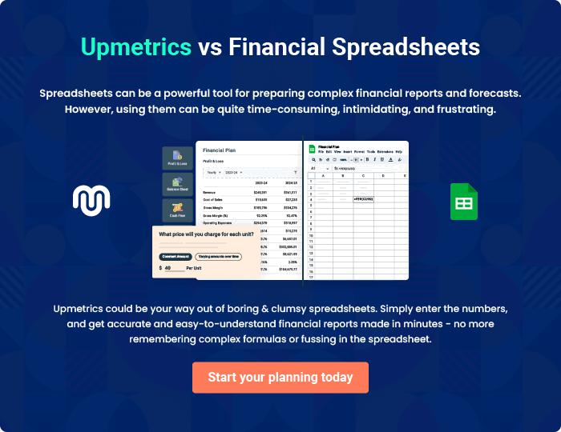
Appendix

When writing the appendix section, you should include any additional information that supports the main content of your plan. This may include financial statements, market research data, legal documents, and other
To unlock help try Upmetrics! 
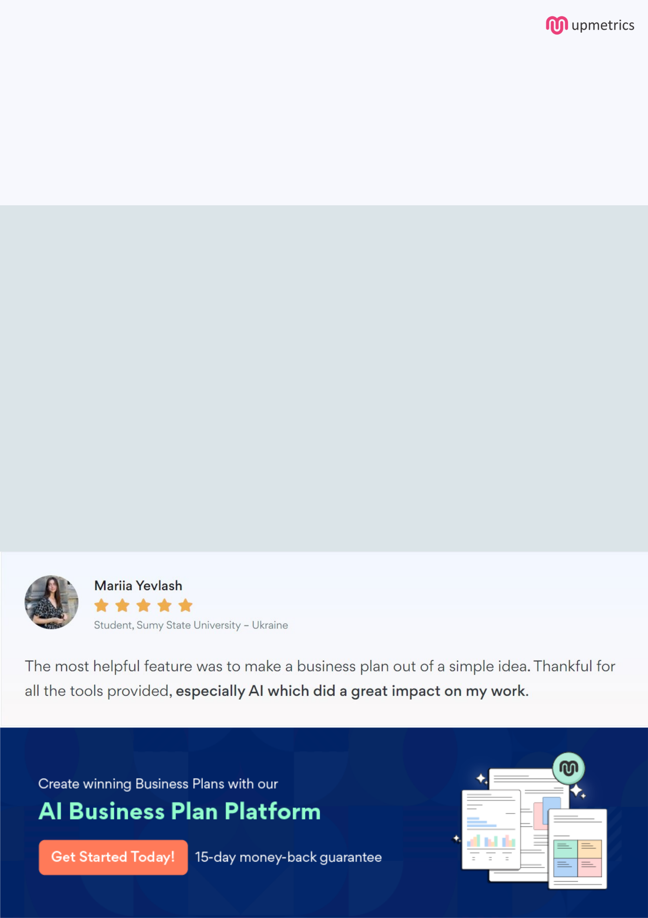
Create a winning business plan that gets you funded

Creating a stunning and investment-ready plan requires no writing, graphic designing, or financial planning expertise.

Upmetrics has all the features required to help you create a comprehensive business plan—from start to finish. Make no mistakes, it’s the modern way of planning to structure ideas, make plans, and create stunning pitch decks to awe investors.

Pitch decks that impress investors

Create pitch decks that provide a visual representation of your business, engage investors, and make them want to invest in your business idea.

Interactive plans in no time

Import business plan sections like—SWOT analysis, comparison tables, and others to create an interactive business plan. No designing skills are required.

Stunning cover page designs

With Upmetrics, you have the liberty to choose from multiple stunning cover page designs. Choose a creative design and make your plan stand out.

Online sharing made simple

Upmetrics makes online sharing quick and easier for users. Easily share your business plans with a link while tracking reader activity.

500+ sample business plans

Simply import a template from our library of sample plans into the editor and start customizing it to make it yours. It takes only a few clicks to get started.

Collaborate with team in real-time

Invite team members, initiate conversations, discuss ideas & strategies, share feedback, and work on a business plan in real-time.

