

Group Home Business Plan

Home and Hope for All


Business
Plan

2023

Prepared By

John Doe

10200 Bolsa Ave, Westminster, CA, 92683

info@example.com

(650) 359-3153 http://www.example.com

Table of Contents

Executive Summary | 6
Market opportunity | 6
Services Offered | 6
Marketing & Sales Strategies | 7
Financial Highlights | 7
Units Sold v/s Revenue | 8

Company Overview | 9
Ownership | 9
Mission statement | 10
Business history | 10
Future goals | 11

Market Analysis | 12
Target Market | 12
Market size and growth potential | 12
Market Size | 13
Competitive analysis | 13
Tranquil Respite Group Home | 13
Hopeful Horizons Group Home | 14
Market trends | 14
Regulatory environment | 14

Products and Services | 16
Services | 16
Housing and Accommodation | 16
Mental Health Support | 18
Substance Abuse Treatment | 18
Peer Support | 19
Vocational Training | 19

Supportive Service and Resources 19

Quality Assurance | 20
Additional Criteria | 20

Sales And Marketing Strategies | 21
Unique Selling Proposition (USP) | 21
Pricing Strategy | 21
Marketing strategies | 22
Online | 22
Offline | 22
Sales strategies | 23
Customer retention | 23

Operations Plan | 24
Staffing & Training | 24
Operational Process | 24
Facilities & Equipment | 25

Management Team | 26
Key managers | 26
John Doe | 26
Jane Doe | 27
Alice Brown | 27
Robert Brown | 27
Organizational structure | 28
Organization chart | 28
Compensation plan | 29
Advisors/Consultants | 29
[ADVISOR NAME] | 29
[CONSULTANT NAME] | 29

Financial Plan | 30
Profit & loss statement | 30
Cash flow statement | 33
Balance sheet | 35
Break-even Analysis | 37
Financing needs | 39
Appendix
Appendix | 41
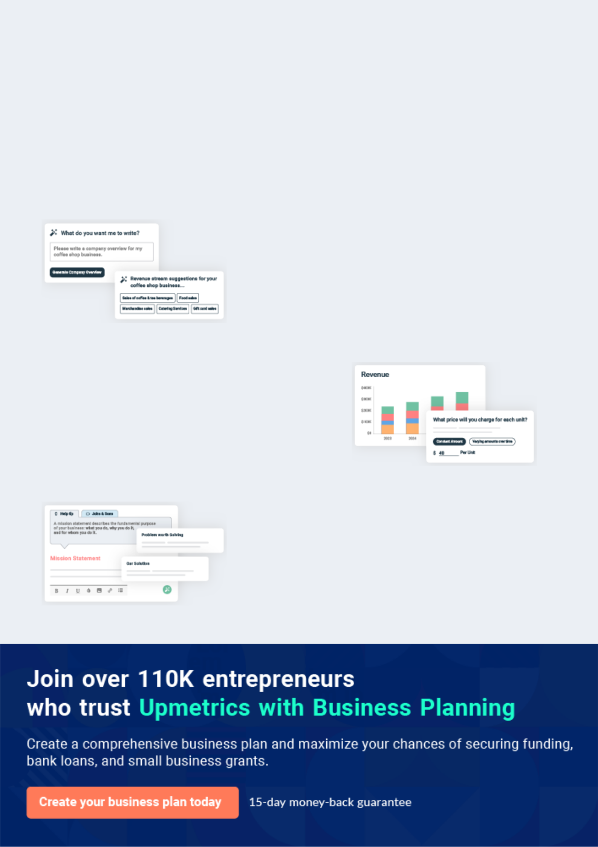
Business planning that’s simpler and faster than you think

Creating a business plan using Upmetrics to start and grow a business is literally the easiest thing in the World. Simply read the instructions and fill in the blanks. It’s as simple as that.

❛ | Upmetrics has everything you need to create a | ❜
❛ | comprehensive business plan. | ❜

AI-powered Upmetrics Assistant

AI-powered insights to streamline your plan

Not sure where to start? Upmetrics’ AI Assistant will automatically generate ideas for each section of your plan and offer improved versions of your writing, adjusting for tone, voice, and grammar or spelling errors.

Financial Forecasting Tool

All the financials are calculated for you

Forget the complex formulas and clumsy spreadsheets — with automatic financials and drag-and-drop forecasting, you can finish your plan faster and be confident that your numbers are accurate.

Business Plan Builder

Guides you like a business mentor

Upmetrics’ step-by-step instructions, prompts, and the library of 400+ sample business plans will guide you through each section of your plan as a business mentor.
Executive Summary


An executive summary is the first section of the business plan intended to provide an overview of the whole business plan.
To unlock help try Upmetrics! 

 Help tip  Group Home Business Plan


Start your executive summary by briefly introducing your business to your readers.

This section may include the name of your group home business, its location, when it was
To unlock help try Upmetrics! 

Start writing here..

Market opportunity

 Help tip  Group Home Business Plan

Summarize your market research, including market size, growth potential, and marketing trends. Highlight the opportunities in the market and how your business will fit in to fill the gap.
To unlock help try Upmetrics! 

Start writing here..

Services Offered

 Help tip  Group Home Business Plan

Highlight the services you offer your clients. The USPs and differentiators you offer are always a plus.
To unlock help try Upmetrics! 

Start writing here..

Marketing & Sales Strategies
To unlock help try Upmetrics!

 Help tip  Group Home Business Plan

Outline your sales and marketing strategies—what marketing platforms you use, how you plan on acquiring customers, etc.
To unlock help try Upmetrics! 

Start writing here..

Financial Highlights

 Help tip  Group Home Business Plan

Briefly summarize your financial projections for the initial years of business operations. Include any capital or investment requirements, associated startup costs, projected revenues, and profit forecasts.



Start writing here..
Units Sold v/s Revenue

 |  | Units Sold | Revenue
15.00k
10.00k
5.00k
0
Year 1 | Year 2 | Year 3
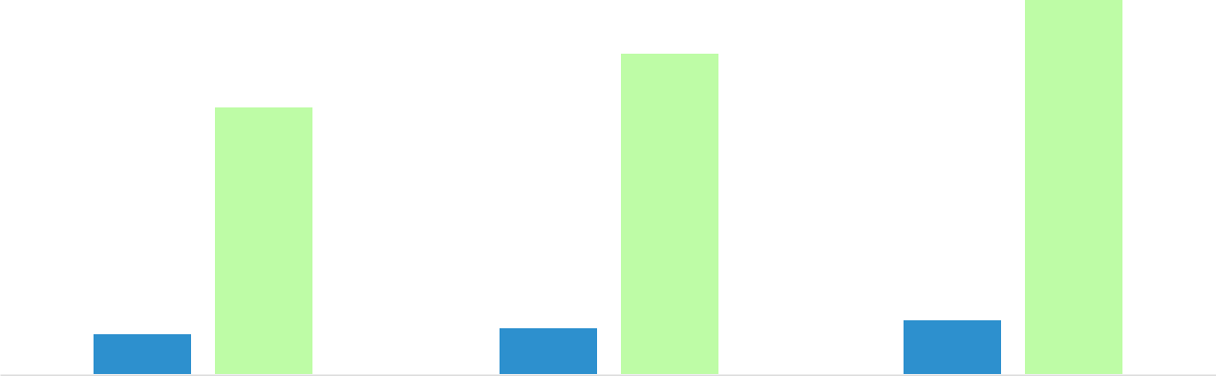

Financial Year |  |  | Units Sold | Revenue
Year 1 | 1,550 |  |  | $10,000
Year 2 | 1,800 |  |  | $12,000
Year 3 | 2,050 |  |  | $14,000
 Help tip |  |  Group Home Business Plan


Summarize your executive summary section with a clear CTA, for example, inviting angel investors to discuss the potential business investment.
To unlock help try Upmetrics! 

Write a call to action for your business plan.
Company Overview

Depending on what details of your business are essential, you’ll need different elements in your business overview.
To unlock help try Upmetrics! 

 Help tip  Group Home Business Plan

Describe your business in this section by providing all the basic information:

Describe what kind of group home you run and the name of it. You may specialize in one of the
To unlock help try Upmetrics! 

Start writing here..

Ownership

 Help tip  Group Home Business Plan

List the names of your group home business founders or owners. Describe what shares they own and their responsibilities for efficiently managing the business.
To unlock help try Upmetrics! 

Start writing here..
Mission statement

 Help tip  Group Home Business Plan

Summarize your business’ objective, core principles, and values in your mission statement. This statement needs to be memorable, clear, and brief.
To unlock help try Upmetrics! 

❛ At [Serenity Haven Group Home], our mission is to offer unparalleled care and support, creating an environment where residents feel at home, valued, and empowered.

Grounded in our core principles of [specific principles, e.g., "compassion, respect, and excellence"], we are unwavering in our commitment to enhancing the quality of life for all those we serve.

❜

Business history

 Help tip  Group Home Business Plan

If you’re an established service provider, briefly describe your business history, like—when it was founded, how it evolved over time, etc.
To unlock help try Upmetrics! 

Start writing here..
Future goals

 Help tip  Group Home Business Plan

It’s crucial to convey your aspirations and vision. Mention your short-term and long-term goals; they can be specific targets for revenue, market share, or expanding your services.
To unlock help try Upmetrics! 

Start writing here..
Market Analysis
To unlock help try Upmetrics!


 |  | Market analysis provides a clear understanding of the market in which your
 |  | printing business will run along with the target market, competitors, and
 |  | growth opportunities.
 |  |  |  | To unlock help try Upmetrics! 
 Help tip |  |  Group Home Business Plan

To write the introduction section of your market analysis, start by clearly identifying your primary target market.
To unlock help try Upmetrics! 

Start writing here..

Target Market

 Help tip  Group Home Business Plan

Start this section by describing your target market. Define your ideal customer and explain what types of services they prefer. Creating a buyer persona will help you easily define your target market to your readers.



Start writing here..

Market size and growth potential

 Help tip  Group Home Business Plan

Describe your market size and growth potential and whether you will target a niche or a much broader market.
To unlock help try Upmetrics! 

Start writing here..

Market Size

Available Market

Total individuals requiring group home 10M services in the U.S.

Served Market
Those currently accommodated in 5M existing group homes in the U.S.

Target Market
Youth with complex medical needs in 500k the Northeast U.S.

 Help tip  Group Home Business Plan

Identify and analyze your direct and indirect competitors. Identify their strengths and weaknesses, and describe what differentiates your group home services from them.
To unlock help try Upmetrics! 

Competitive analysis

Tranquil Respite Group Home

Founded in [Year, e.g., "2010"], Tranquil Respite has rapidly grown in reputation, primarily serving [specific target group, e.g., "adolescents requiring therapeutic interventions"]. With their main facility located in [Location, e.g., "Downtown Springfield"], they've managed to establish a strong community presence.

Features

Comprehensive therapeutic programs encompassing art, music, and physical therapies.

On-site medical facilities catering to non-emergency needs.

Recreational spaces fostering group activities and community building.

Strengths

A wide range of therapeutic interventions offered.

Prime location, enhancing community integration.

Strong partnerships with local health institutions ensuring timely medical interventions.

Weaknesses

Limited capacity for residents with acute medical needs.

Relatively higher pricing, making it less accessible for some families.

Hopeful Horizons Group Home

A seasoned player, Hopeful Horizons, established in [Year, e.g., "2005"], specializes in [specific target group, e.g., "children with special educational needs"]. Their sprawling facility in [Location, e.g., "North Springfield"] is a testament to their expansive approach.

Features

Specialized educational programs tailored to each resident's needs

Collaborations with local schools for inclusive educational opportunities.

A robust mentorship program aiding in personal and professional development.

Strengths | Weaknesses
Pioneers in providing | Lacks an in-depth medical
educational solutions within | support infrastructure.
the group home setting. | Limited therapeutic modalities
A strong network of | outside the educational realm.
educational specialists
ensuring tailored interventions.
Extensive outdoor spaces
promoting physical activity.

Market trends

 Help tip  Group Home Business Plan

Analyse emerging trends in the industry, such as technology disruptions, changes in customer behavior or preferences, etc. Explain how your business will cope with all the trends.
To unlock help try Upmetrics! 

Start writing here..

Regulatory environment

 Help tip  Group Home Business Plan

List regulations and licensing requirements that may affect your group home, such as zoning regulations, health and safety standards, building codes, licensing requirements, etc.
To unlock help try Upmetrics! 

Start writing here..

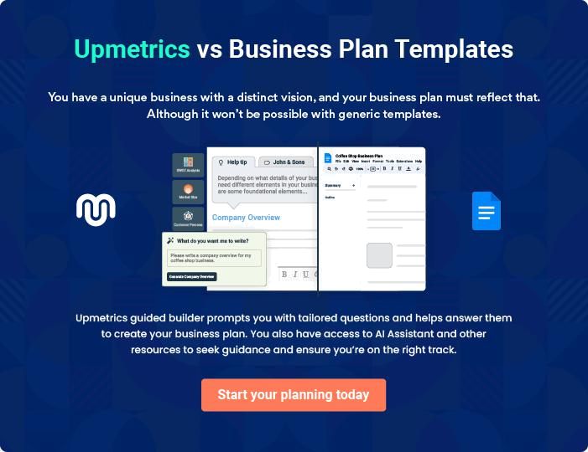
Products and Services
To unlock help try Upmetrics!

The product and services section of a group home business plan should describe the specific services and products that will be offered to customers. To write this section should include the following:



 Help tip  Group Home Business Plan

To craft the introduction for your "Products and Services" chapter, begin by positioning your business within its industry, emphasizing its unique strengths or value proposition.
To unlock help try Upmetrics! 

Start writing here..

 Help tip


Mention your organization’s services to its residents. This list may include services like,

• Housing and accommodation
To unlock help try Upmetrics! 

Services

Housing and Accommodation


Price: [$1,200/month]

Comfortable living spaces designed to offer residents a safe and nurturing environment.
Specifications

•

- Single or shared room options.

- Each room equipped with an attached bathroom, study space, and storage.

- 24/7 security monitoring.

- Regular room maintenance and cleaning service.
Mental Health Support

Price: [$80/session]

Comprehensive mental health services provided by a team of licensed therapists and counselors.

Specifications

- Personalized therapy sessions.

- Group therapy options available.

- Crisis intervention and management.

- Sessions tailored to individual needs and recovery goals.

Substance Abuse Treatment

Price: [$2,000] for a 3-month program

Holistic substance abuse treatment program focused on detoxification, counseling, and long-term recovery.

Specifications

- Medical detoxification under professional supervision.

- Weekly group therapy sessions.

- One-on-one counseling.

- Customized recovery and relapse prevention planning.
Peer Support

Price: Included with accommodation

Weekly peer support groups fostering community spirit and shared experiences.

Specifications

- Moderated by trained facilitators.

- Encourages open dialogue and personal growth.

- Empowers residents through shared experiences and mutual support.

Vocational Training

Price: [$500/course]

Skill-based training programs designed to empower residents and enhance employment opportunities.

Specifications

- Partnership with [Local Organization, e.g., "Springfield Vocational Center"].

- Course options include [specific skills, e.g., "carpentry, digital marketing, culinary arts"].

- Certification upon course completion.

- Job placement assistance for successful candidates.

Supportive Service and Resources

 Help tip  Group Home Business Plan

List the supportive services and resources available for group home residents.

For instance, these resources may include support in transitioning to independent living, family
To unlock help try Upmetrics! 

Start writing here..

Quality Assurance

 Help tip  Group Home Business Plan

List section should explain how you maintain quality standards and consistently provide the highest quality service.
To unlock help try Upmetrics! 

Start writing here..

Additional Criteria

 Help tip  Group Home Business Plan

Describe the admission criteria for residents. Your admission criteria may include age limit, income requirements, and other specific requirements.
To unlock help try Upmetrics! 

Start writing here..
Sales And Marketing Strategies
To unlock help try Upmetrics!

Writing the sales and marketing strategies section means a list of strategies you will use to attract and retain your clients.
To unlock help try Upmetrics! 

 Help Tip  Group Home Business Plan


To create an effective introduction for your "Sales and Marketing Strategies" chapter, start by setting the stage within your specific industry or market.
To unlock help try Upmetrics! 

Start writing here..

Unique Selling Proposition (USP)

 Help tip  Group Home Business Plan

Define your business’s USPs depending on the market you serve, the equipment you use, and your unique services. Identifying USPs will help you plan your marketing strategies.
To unlock help try Upmetrics! 

Start writing here..

Pricing Strategy

 Help tip  Group Home Business Plan

Describe your pricing strategy—how you plan to price your group home services and stay competitive in the local market. You can mention any discounts you plan on offering to attract new customers to your facility.



Start writing here..

 Help tip  Group Home Business Plan
To unlock help try Upmetrics!

Discuss your marketing strategies to market your services. You may include some of these marketing strategies in your business plan—social media marketing, Google ads, brochures, email marketing, content marketing, and print marketing.



Marketing strategies

Online


Social Media

Regular updates, success stories, and informational content on platforms like Facebook, Instagram, and LinkedIn.

Content Marketing

Blog posts and articles providing valuable insights into group home living and care.

Email Marketing

Monthly newsletters keeping our community informed about events, news, and updates.

Google Ads

Targeted campaigns to reach those searching for group home facilities in our region.

Offline

Brochures Print Marketing

Beautifully designed brochures Advertisements in local

available at health centers, newspapers, magazines, and

community centers, and upon community bulletins.

request.

 Help tip  Group Home Business Plan
To unlock help try Upmetrics!

Outline the strategies you’ll implement to maximize your sales. Your sales strategies may include developing referral programs, attending community meetings, hosting events, etc.
To unlock help try Upmetrics! 

Sales strategies

Partner with Businesses

Collaborations with [specific businesses, e.g., "design studios and architectural firms"] to offer them specialized services.

Engage with Community

Regular participation in community meetings and events to keep [Serenity Haven] top-of-mind.

Hosting Events

From open houses to seminars on

care, we host various events to

introduce our facilities and

services to potential residents and

their families.

 Help tip  Group Home Business Plan

Describe your resident retention strategies and how you plan to execute them. For instance, quality care and services, a personalized approach, and regular communication can be some of your customer retention strategies.



Customer retention

Quality Care & Services

Our team is consistently trained to provide the best care, ensuring resident satisfaction.

Regular Communication

Keeping families informed about their loved ones, fostering trust, and building stronger relationships.

Personalized Service

Regular feedback sessions and

care plan evaluations to cater to

evolving resident needs.

Operations Plan
To unlock help try Upmetrics!

 |  | When writing the operations plan section, it’s important to consider the
 |  | various aspects of your business operations.
 |  |  |  | To unlock help try Upmetrics! 
 Help tip |  |  Group Home Business Plan


To create an effective introduction for your "Operational Plan" chapter, start by emphasizing the
pivotal role of efficient operations in the success of your business, underscoring how they
directly impact the quality of services delivered.
 |  |  |  | To unlock help try Upmetrics! 
Start writing here..
Staffing & Training
 Help tip |  |  Group Home Business Plan

Mention your cleaning business’s staffing requirements, including the number of employees or
administrative staff needed. Include their qualifications, the training required, and the duties
they will perform.
 |  |  |  | To unlock help try Upmetrics! 
Start writing here..
Operational Process
 Help tip |  |  Group Home Business Plan

Outline the processes and procedures you will use to run your group home business. Your operational processes may include resident care, staff management, care planning and documentation, medication management, and health monitoring.



Start writing here..

Facilities & Equipment
To unlock help try Upmetrics!

 Help tip  Group Home Business Plan

Include the list of facilities and equipment required for a group home, such as residential facility, safety & security measures, furniture, kitchen equipment, safety & mobility equipment, etc.



Start writing here..
Management Team

The management team section provides an overview of the individuals responsible for running your business plan.
To unlock help try Upmetrics! 

 Help tip  Group Home Business Plan

To craft an introduction for your "Management Team" chapter, begin by emphasizing the crucial role of leadership in the success of any business.
To unlock help try Upmetrics! 

Start writing here..

Key managers

 Help tip  Group Home Business Plan

Introduce your management and key members of your team, and explain their roles and responsibilities.
To unlock help try Upmetrics! 

Start writing here..


JOHN DOE

CEO - john.doe@example.com

John is the visionary behind [Serenity Haven Group Home].

With an MBA in Healthcare Management from Harvard University and over 20 years of experience in the assisted living sector, John understands the intricate nuances of running a successful group home.


His leadership, combined with his passion for providing exemplary care, has been pivotal in establishing the reputation of [Serenity Haven] in the community.

JANE DOE

Program Director - jane.doe@example.com

Jane holds a Master's degree in Social Work from Columbia University.

With over 15 years of experience in developing and supervising group home programs, she is instrumental in ensuring that our residents receive the best care and activities tailored to their individual needs.


Her innovative and resident-centric programs have been lauded by industry experts.


ALICE BROWN

Nursing Director - alice.brown@example.com

Alice comes with a stellar background, having completed her BSN from Johns Hopkins University and her MSN from the University of Pennsylvania.

Her 18 years of hands-on experience in geriatric care ensures that all medical procedures and protocols are up to industry standards.

Her compassionate approach coupled with her stringent adherence to best practices ensures that residents are always in safe hands.


ROBERT BROWN

Chief Technology Officer (CTO) - robert.brown@example.com

Robert holds an MBA in Operations Management from Stanford University. His 12 years of experience in overseeing the operations of several successful group homes is invaluable to [Serenity Haven].

Robert ensures the smooth daily functioning of the home, from resident care to staff management and everything in between.

His efficiency-driven approach guarantees that our processes are streamlined and effective.
Organizational structure

 Help tip  Group Home Business Plan

Explain the organizational structure of your management team. Include the reporting line and decision-making hierarchy.
To unlock help try Upmetrics! 

Start writing here..

Organization chart


John Doe

CEO
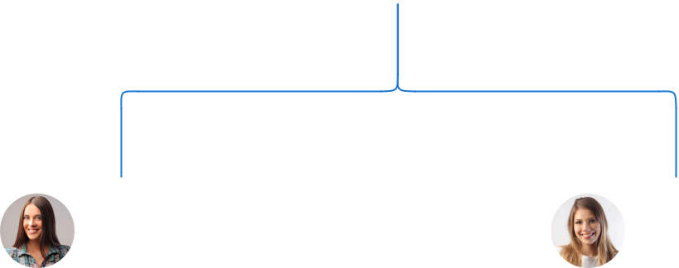

Alice Brown

Jane Doe

Nursing Director


Program Director

Emily White

HR Manager Robert Brown

Operations Manager




Mike Smith

Linda Green

Facility Supervisor

Head of Outreach

Compensation plan

 Help tip  Group Home Business Plan

Describe your compensation plan for the management and staff. Include their salaries, incentives, and other benefits.
To unlock help try Upmetrics! 

Start writing here..

 Help tip  Group Home Business Plan

Mentioning advisors or consultants in your business plans adds credibility to your business idea.
To unlock help try Upmetrics! 

Advisors/Consultants


[ADVISOR NAME]

Advisor

A known figure in the group home industry, [Advisor Name] brings [X years] of experience and offers strategic advice.


[CONSULTANT NAME]

Consultant

Specializing in [specific area e.g., healthcare regulations], [Consultant Name] ensures we remain compliant and updated on industry best practices.
Financial Plan

When writing the financial plan section of a business plan, it’s important to provide a comprehensive overview of your financial projections for the first few years of your business, You may provide the following:
To unlock help try Upmetrics! 

 Help tip  Group Home Business Plan


To create an effective introduction for your "Financial Plan" chapter, begin by stressing the critical role of a well-structured financial plan in the success of your venture.
To unlock help try Upmetrics! 

Start writing here..

 Help tip


Describe details such as projected revenue, operational costs, and service costs in your projected profit and loss statement. Make sure to include your business’s expected net profit or loss.
To unlock help try Upmetrics! 

Profit & loss statement

Revenue

Cost Of Sales

General Costs

Revenue Specific Costs

Personnel Costs (Direct

Labor)

Gross Margin

Gross Margin (%)

Operating Expense

Payroll Expense

(Indirect Labor)

General Expense

Bad Debt

Amortization of Current

Assets

2023-24 | 2024-25 | 2025-26 | 2026-27 | 2027-28
$0 | $0 | $0 | $0 | $0

$0 | $0 | $0 | $0 | $0
$0 | $0 | $0 | $0 | $0
$0 | $0 | $0 | $0 | $0
$0 | $0 | $0 | $0 | $0

$0 | $0 | $0 | $0 | $0
0% | 0% | 0% | 0% | 0%

$0 | $0 | $0 | $0 | $0
$0 | $0 | $0 | $0 | $0
$0 | $0 | $0 | $0 | $0
$0 | $0 | $0 | $0 | $0
$0 | $0 | $0 | $0 | $0

EBITDA

Additional Expense

Long Term

Depreciation

Gain or loss from Sale

of Assets

EBIT

Interest Expenses

EBT

Income Tax Expense

Total Expense

Net Income

Net Income (%)

2023-24 | 2024-25 | 2025-26 | 2026-27 | 2027-28
$0 | $0 | $0 | $0 | $0
$0 | $0 | $0 | $0 | $0
$0 | $0 | $0 | $0 | $0
$0 | $0 | $0 | $0 | $0
$0 | $0 | $0 | $0 | $0
$0 | $0 | $0 | $0 | $0
$0 | $0 | $0 | $0 | $0
$0 | $0 | $0 | $0 | $0
$0 | $0 | $0 | $0 | $0
$0 | $0 | $0 | $0 | $0
0% | 0% | 0% | 0% | 0%
 | 2023-24 | 2024-25 | 2025-26 | 2026-27 | 2027-28
Retained Earning | $0 | $0 | $0 | $0 | $0
Opening
Owner's Distribution | $0 | $0 | $0 | $0 | $0
Retained Earning | $0 | $0 | $0 | $0 | $0
Closing

 Help tip

The section should estimate and describe the cash flow for the first few years of your operation. This may include billing invoices, payment receipts, loan payments, and any other cash flow statements.
To unlock help try Upmetrics! 

Cash flow statement

 | 2023-24 | 2024-25 | 2025-26 | 2026-27 | 2027-28
Cash Received | $0 | $0 | $0 | $0 | $0
Cash Paid | $0 | $0 | $0 | $0 | $0
COS & General Expenses | $0 | $0 | $0 | $0 | $0
Salary & Wages | $0 | $0 | $0 | $0 | $0
Interest | $0 | $0 | $0 | $0 | $0

Sales Tax

Income Tax

Net Cash From

Operations

Assets Sell

Assets Purchase

Net Cash From

Investments

Amount Received

Loan Received

Common Stock

Preferred Stock

Owner's Contribution

Amount Paid

2023-24 | 2024-25 | 2025-26 | 2026-27 | 2027-28
$0 | $0 | $0 | $0 | $0
$0 | $0 | $0 | $0 | $0
$0 | $0 | $0 | $0 | $0

$0 | $0 | $0 | $0 | $0
$0 | $0 | $0 | $0 | $0
$0 | $0 | $0 | $0 | $0

$0 | $0 | $0 | $0 | $0
$0 | $0 | $0 | $0 | $0

$0 | $0 | $0 | $0 | $0
$0 | $0 | $0 | $0 | $0
$0 | $0 | $0 | $0 | $0

Loan Capital $0 $0 $0 $0 $0

 | 2023-24 | 2024-25 | 2025-26 | 2026-27 | 2027-28
Dividends & Distributions | $0 | $0 | $0 | $0 | $0
Net Cash From | $0 | $0 | $0 | $0 | $0
Financing

Summary
Starting Cash | $0 | $0 | $0 | $0 | $0
Cash In | $0 | $0 | $0 | $0 | $0
Cash Out | $0 | $0 | $0 | $0 | $0
Change in Cash | $0 | $0 | $0 | $0 | $0
Ending Cash | $0 | $0 | $0 | $0 | $0

 Help tip

Create a projected balance sheet documenting your group home’s assets, liabilities, and equity.

To unlock help try Upmetrics! 

Balance sheet

 | 2023-24 | 2024-25 | 2025-26 | 2026-27 | 2027-28
Assets | $0 | $0 | $0 | $0 | $0
Current Assets | $0 | $0 | $0 | $0 | $0
Cash | $0 | $0 | $0 | $0 | $0
Accounts Receivable | $0 | $0 | $0 | $0 | $0
Inventory | $0 | $0 | $0 | $0 | $0
Other Current Assets | $0 | $0 | $0 | $0 | $0
Long Term Assets | $0 | $0 | $0 | $0 | $0
Gross Long Term Assets | $0 | $0 | $0 | $0 | $0
Accumulated Depreciation | $0 | $0 | $0 | $0 | $0

Liabilities & Equity | $0 | $0 | $0 | $0 | $0
Liabilities | $0 | $0 | $0 | $0 | $0
Current Liabilities | $0 | $0 | $0 | $0 | $0
Accounts Payable | $0 | $0 | $0 | $0 | $0
Income Tax Payable | $0 | $0 | $0 | $0 | $0
Sales Tax Payable | $0 | $0 | $0 | $0 | $0
Short Term Debt | $0 | $0 | $0 | $0 | $0
 | 2023-24 | 2024-25 | 2025-26 | 2026-27 | 2027-28
Long Term Liabilities | $0 | $0 | $0 | $0 | $0
Long Term Debt | $0 | $0 | $0 | $0 | $0
Equity | $0 | $0 | $0 | $0 | $0
Paid-in Capital | $0 | $0 | $0 | $0 | $0
Common Stock | $0 | $0 | $0 | $0 | $0
Preferred Stock | $0 | $0 | $0 | $0 | $0
Owner's Contribution | $0 | $0 | $0 | $0 | $0
Retained Earnings | $0 | $0 | $0 | $0 | $0

Check | $0 |  |  | $0 | $0 | $0 | $0
 Help tip |  |  Group Home Business Plan


Determine and mention your business’s break-even point—the point at which your business costs and revenue will be equal.

This exercise will help you understand how much revenue you need to generate to sustain or be profitable.
To unlock help try Upmetrics! 

Break-even Analysis

 | 2023-24 | 2024-25 | 2025-26 | 2026-27 | 2027-28
Starting Revenue | $0 | $0 | $0 | $0 | $0
Net Revenue | $0 | $0 | $0 | $0 | $0
Closing Revenue | $0 | $0 | $0 | $0 | $0

Starting Expense | $0 | $0 | $0 | $0 | $0
Net Expense | $0 | $0 | $0 | $0 | $0
Closing Expense | $0 | $0 | $0 | $0 | $0

Is Break Even? | 0 | 0 | 0 | 0 | 0
Break Even Month | 0 | 0 | 0 | 0 | 0
Days Required | 0 | 0 | 0 | 0 | 0
Break Even Revenue | $0 | $0 | $0 | $0 | $0
Break Even Units
Financing needs

 Help tip  Group Home Business Plan

Calculate costs associated with starting a group home, and estimate your financing needs and how much capital you need to raise to operate your business.
To unlock help try Upmetrics! 

Start writing here..
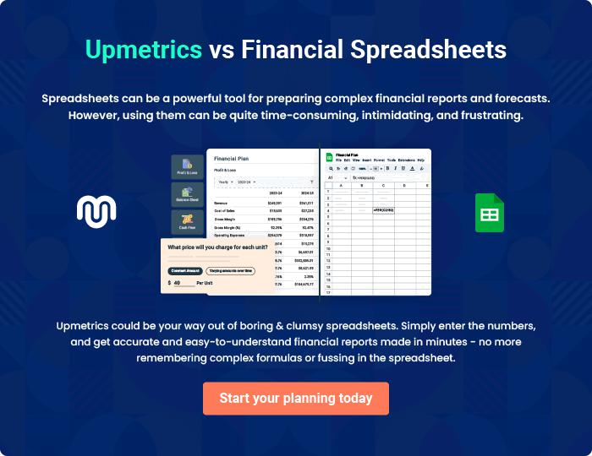
Appendix

When writing the appendix section, you should include any additional information that supports the main content of your plan. This may include financial statements, market research data, legal documents, and other
To unlock help try Upmetrics! 
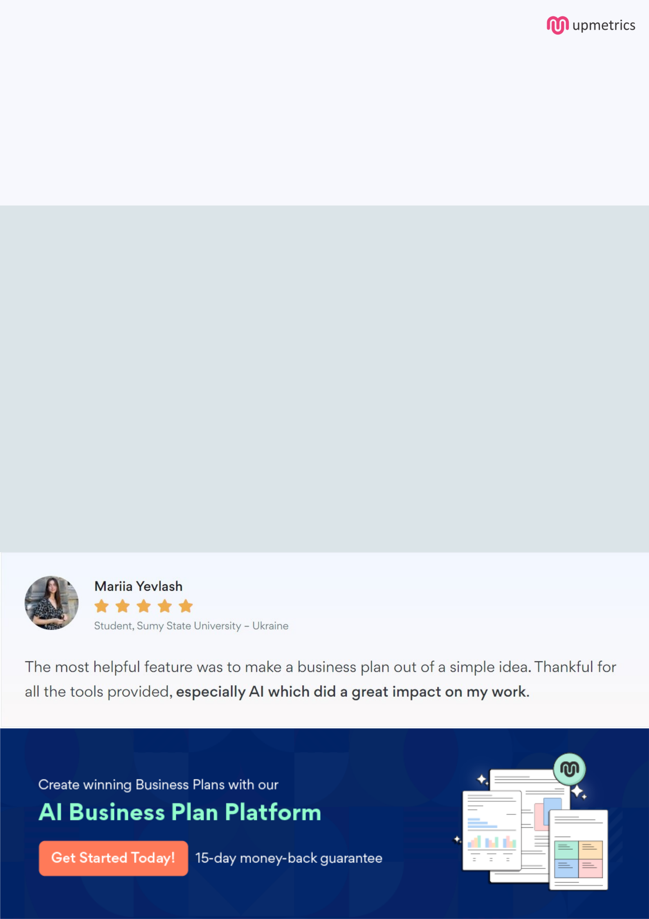
Create a winning business plan that gets you funded

Creating a stunning and investment-ready plan requires no writing, graphic designing, or financial planning expertise.

Upmetrics has all the features required to help you create a comprehensive business plan—from start to finish. Make no mistakes, it’s the modern way of planning to structure ideas, make plans, and create stunning pitch decks to awe investors.

Pitch decks that impress investors

Create pitch decks that provide a visual representation of your business, engage investors, and make them want to invest in your business idea.

Interactive plans in no time

Import business plan sections like—SWOT analysis, comparison tables, and others to create an interactive business plan. No designing skills are required.

Stunning cover page designs

With Upmetrics, you have the liberty to choose from multiple stunning cover page designs. Choose a creative design and make your plan stand out.

Online sharing made simple

Upmetrics makes online sharing quick and easier for users. Easily share your business plans with a link while tracking reader activity.

500+ sample business plans

Simply import a template from our library of sample plans into the editor and start customizing it to make it yours. It takes only a few clicks to get started.

Collaborate with team in real-time

Invite team members, initiate conversations, discuss ideas & strategies, share feedback, and work on a business plan in real-time.

