
BUSINESS PLAN

2023


Grocery Store Business Plan

Fresh Finds, Everyday Essentials

John Doe

10200 Bolsa Ave, Westminster, CA, 92683

- 359-3153 info@example.com http://www.example.com

Information provided in this business plan is unique to this business and confidential; therefore, anyone reading this plan agrees not to disclose any of the information in this business plan without prior written permission of the company.
Table of Contents

Executive Summary | 6
Market opportunity | 6
Services Offered | 6
Management team | 7
John Doe | 7
Jane Doe | 7
Alice Brown | 7
Financial Highlights | 7
Units Sold v/s Revenue | 8

Company Overview | 9
Ownership | 9
Business Owners | 9
Mission statement | 10
Business history | 10
Future goals | 10

Market Analysis | 11
Target Market | 11
Market size and growth potential | 11
Market Size | 12
Competitive analysis | 12
LocalMart | 12
FreshFoods Superstore | 13
Downtown Grocers | 13
Market trends | 13
Regulatory environment | 14

Products and Services | 15
Products | 15

Fresh Produce 15

Meat and Poultry Products | 16
Dairy Products | 16
Turkey | 16
Cookies & Chocolates | 17
Emphasize safety and quality | 17

Sales And Marketing Strategies | 18
Unique Selling Proposition (USP) | 18
Pricing Strategy | 18
Marketing strategies | 19
Online | 19
Offline | 19
Sales strategies | 20
Customer retention | 20

Operations Plan | 21
Hiring Plan | 21
Operational Process | 21
Technology and Equipment | 22

Management Team | 23
Key managers | 23
John Doe | 23
Jane Doe | 24
Alice Brown | 24
Robert Brown | 24
Organizational structure | 25
Organization chart | 25
Compensation plan | 25
Board of advisors | 26
[ADVISOR NAME] | 26
[ADVISOR NAME] | 26
Financial Plan | 27
Profit & loss statement | 27
Cash flow statement | 30
Balance sheet | 32
Break-even Analysis | 34
Financing needs | 36
Appendix
Appendix | 38
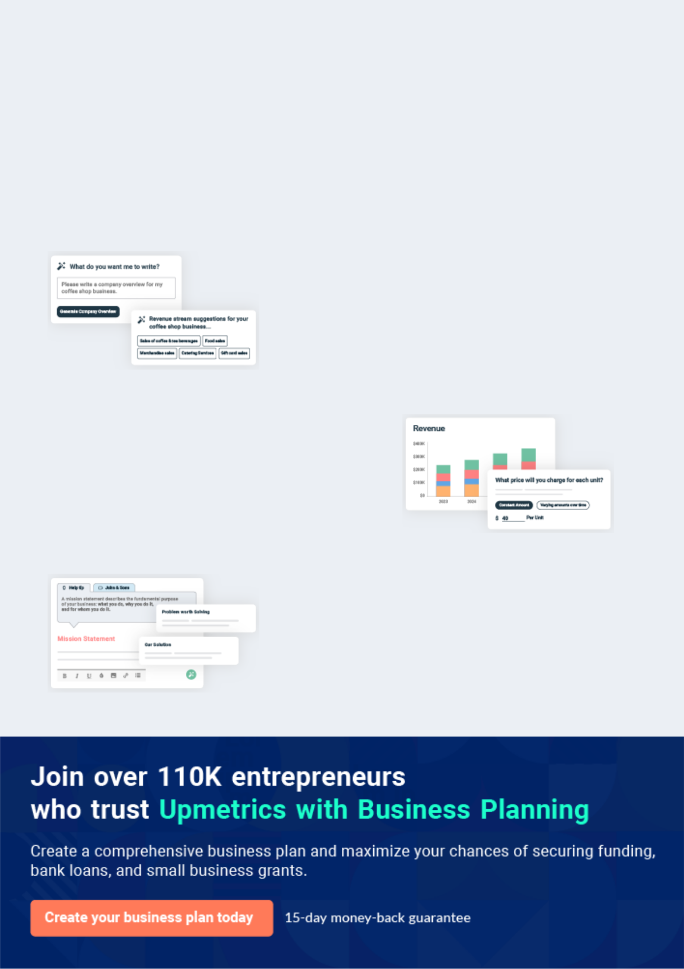
Business planning that’s simpler and faster than you think

Creating a business plan using Upmetrics to start and grow a business is literally the easiest thing in the World. Simply read the instructions and fill in the blanks. It’s as simple as that.

❛ | Upmetrics has everything you need to create a | ❜
❛ | comprehensive business plan. | ❜

AI-powered Upmetrics Assistant

AI-powered insights to streamline your plan

Not sure where to start? Upmetrics’ AI Assistant will automatically generate ideas for each section of your plan and offer improved versions of your writing, adjusting for tone, voice, and grammar or spelling errors.

Financial Forecasting Tool

All the financials are calculated for you

Forget the complex formulas and clumsy spreadsheets — with automatic financials and drag-and-drop forecasting, you can finish your plan faster and be confident that your numbers are accurate.

Business Plan Builder

Guides you like a business mentor

Upmetrics’ step-by-step instructions, prompts, and the library of 400+ sample business plans will guide you through each section of your plan as a business mentor.
Executive Summary
To unlock help try Upmetrics!


An executive summary is the first section of the business plan intended to provide an overview of the whole business plan.
To unlock help try Upmetrics! 

 Help tip  Grocery Store Business Plan


Start your executive summary by introducing your idea behind starting a grocery shop business and explaining what it does.
To unlock help try Upmetrics! 

Start writing here..

Market opportunity

 Help tip  Grocery Store Business Plan

Describe the target market in brief, and explain the demographics, geographic location, and psychographic attributes of your customer.
To unlock help try Upmetrics! 

Start writing here..

Services Offered

 Help tip  Grocery Store Business Plan

Describe in detail the products and services a client can expect at your store like dairy products, beverages, frozen items, candies, cookies, grains, meat, canned products, and things like if you provide delivery or not.



Start writing here..

Management team


JOHN DOE

CEO - john.doe@example.com

CEO, bringing [qualifications, e.g., "a decade of retail leadership and an MBA from Stanford"].


JANE DOE

COO - jane.doe@example.com

COO, tasked with [responsibilities, e.g., "streamlining operations and vendor partnerships"], and holding [qualifications, e.g., "a strong background in supply chain management"].


ALICE BROWN

CMO - alice.brown@example.com

CMO, with [qualifications, e.g., "expertise in digital marketing and a proven track record in the FMCG sector"].

Financial Highlights

 Help tip  Grocery Store Business Plan

Provide a summary of your financial projections for the company’s initial years of operation.

Include any capital or investment requirements, startup costs, projected revenues, and profits.
To unlock help try Upmetrics! 

Start writing here..
Units Sold v/s Revenue
To unlock help try Upmetrics!

 |  | Units Sold | Revenue
15.00k
10.00k
5.00k
0
Year 1 | Year 2 | Year 3


Financial Year |  |  | Units Sold | Revenue
Year 1 | 1,550 |  |  | $10,000
Year 2 | 1,800 |  |  | $12,000
Year 3 | 2,050 |  |  | $14,000
 Help tip |  |  Grocery Store Business Plan


After giving a brief about your business plan, end your summary with a call to action, for example; inviting potential investors or readers to the next meeting if they are interested in your business.



Write a call to action for your business plan.
Company Overview

Depending on what details of your business are essential, you’ll need different elements in your business overview.
To unlock help try Upmetrics! 

 Help tip  Grocery Store Business Plan

Provide all the basic information about your business in this section like:

• The name of the grocery store and the concept behind it: like are you opening a
To unlock help try Upmetrics! 

Start writing here..

Ownership

 Help tip  Grocery Store Business Plan

Describe the owners of your store and mention their roles in running it. Whose shares in the corporation are they, and how each owner helps in the business?
To unlock help try Upmetrics! 

Start writing here..

Business Owners



60% John Doe



40% Jane Doe
Mission statement
To unlock help try Upmetrics!

 Help tip  Grocery Store Business Plan

Add a mission statement that sums up the objectives and core principles of your mini grocery store. This statement needs to be memorable, clear, and brief.
To unlock help try Upmetrics! 

❛ "At [GreenGrocer Essentials], we are dedicated to enriching lives with quality, sustainability, and a touch of home in every product. We strive to be the community's trusted partner for fresh, ethical,

and delightful grocery experiences."
❜

Business history

 Help tip  Grocery Store Business Plan


Include an outline of the grocery store’s history and how it came to be in its current position. If
you can, add some personality and intriguing details, especially if you got any achievements or
recognitions till now for your incredible services.
 |  |  |  |  | To unlock help try Upmetrics! 
Start writing here..
Future goals
 Help tip |  |  |  Grocery Store Business Plan

It’s crucial to convey your aspirations and your vision. Include the vision of where you see your business in the near future and if you have any plans of opening a new franchise store of your grocery store in the same city in the future.



Start writing here..

Market Analysis
To unlock help try Upmetrics!


 |  | Market analysis provides a clear understanding of the market in which your
 |  | printing business will run along with the target market, competitors, and
 |  | growth opportunities.
 |  |  |  | To unlock help try Upmetrics! 
 Help tip |  |  Grocery Store Business Plan

To write the introduction section of your market analysis, start by clearly identifying your primary target market.
To unlock help try Upmetrics! 

Start writing here..

Target Market

 Help tip  Grocery Store Business Plan

Identify your target market and define your ideal customer. This can include age, economic level, family size, purchasing interests, and nutritional preferences.
To unlock help try Upmetrics! 

Start writing here..

Market size and growth potential

 Help tip  Grocery Store Business Plan

Provide an overview of the grocery industry. It will include market size, trends, growth potential, and regulatory considerations. Highlight the competitive edge and how your store is different from the rest of the grocery stores.



Start writing here..

Market Size

Available Market

Total individuals purchasing groceries in 1M the region.

Served Market
Individuals buying from organized 600k grocery stores.

Target Market
Health-conscious consumers seeking 200k quality, organic products.

 Help tip  Grocery Store Business Plan

Identify and analyze all other small grocery stores in the local market, including direct and indirect competitors.
To unlock help try Upmetrics! 

Competitive analysis

LocalMart

LocalMart is a well-established grocery chain with several outlets across the region, renowned for its extensive product range and competitive pricing.

Features | Strengths | Weaknesses
Wide product selection, | Strong brand presence and | Limited focus on organic and
including international brands | market penetration | locally-sourced produce
Membership and loyalty | Economies of scale due to | Customer service can be
programs | large volume sales | inconsistent due to high foot
Regular promotions and | Extensive supply chain network | traffic
discounts |  | Less emphasis on sustainable
 |  | practices and packaging

FreshFoods Superstore

FreshFoods Superstore caters to the upper-middle-class demographic, emphasizing quality, freshness, and a premium shopping experience.

Features | Strengths | Weaknesses
Fresh produce section with an | Strong reputation for quality | Higher price points may deter
in-house butcher and bakery | and freshness | budget-conscious shoppers
Gourmet and specialty | Clean, well-organized store | Limited number of store
products | layout | locations
Home delivery and online | High level of customer service | Less competitive in terms of
shopping options |  | promotions and discounts

Downtown Grocers

Downtown Grocers is a smaller, community-focused store known for its local produce and friendly service.

Features | Strengths | Weaknesses
Locally-sourced fruits, | Strong community ties and | Limited product range compared
vegetables, and artisanal | local brand loyalty | to larger competitors
products | Focus on organic and | Higher operational costs due to
Community events and | sustainable products | sourcing from small-scale
partnerships | Unique, curated product | producers
Personalized customer service | offerings | Less technological integration in
 |  | shopping experience

Market trends

 Help tip  Grocery Store Business Plan

Analyze current and emerging trends in your industry, such as the shift towards local and organic food. Explain how your business will cope with all the trends.
To unlock help try Upmetrics! 

Start writing here..

Regulatory environment

 Help tip  Grocery Store Business Plan

Describe any regulations or licensing requirements that affect the store, such as safety codes, or quality and inventory control.
To unlock help try Upmetrics! 

Start writing here..
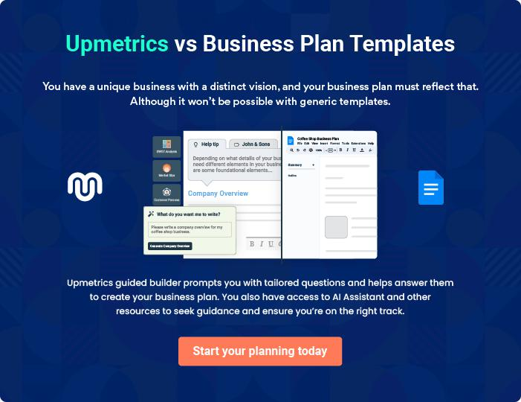
Products and Services
To unlock help try Upmetrics!
To unlock help try Upmetrics!

The product and services section of a grocery store business plan should describe the specific services and products that will be offered to customers. To write this section should include the following:



 Help tip  Grocery Store Business Plan

To craft the introduction for your "Products and Services" chapter, begin by positioning your business within its industry, emphasizing its unique strengths or value proposition.
To unlock help try Upmetrics! 

Start writing here..

 Help tip


Create a list of the services that your grocery store will offer: fresh produce, meat, poultry products, dairy products, turkey, cookies, chocolates, bread, grain, beverages, frozen food, and others.



Products

Fresh Produce


Price: Ranges from [$0.99/lb] (e.g., for carrots) to [$2.49/lb] (e.g., for avocados)

Farm-fresh vegetables and fruits sourced directly from trusted local farmers.

Specifications

- Organic and non-organic options available.

- Seasonal varieties introduced regularly.

- Strict quality checks to ensure freshness.
Meat and Poultry Products

Price: Chicken Breast at [$5.99/lb]; Sirloin Steak at [$12.99/lb]

A diverse range of premium cuts and a selection of organic options.

Specifications

- Grass-fed and grain-fed beef options.

- Free-range chicken available.

- Halal and kosher meat selections.

Dairy Products

Price: Fresh Milk at [$3.49/gallon]; Artisanal Cheese at [$14.99/lb]

A spectrum of dairy essentials, from fresh milk to artisanal cheeses.

Specifications

- Locally sourced and imported options.

- Lactose-free and alternative milk products available.

- Stringent quality checks for shelf life.

Turkey

Price: Fresh Turkey at [$2.49/lb]; Frozen Turkey at [$1.99/lb]

Fresh and frozen options available, perfect for festivities or everyday meals.

Specifications

- Antibiotic-free options.

- Available whole or in parts (e.g., turkey breast, legs).

- Clear labeling of expiration dates.
Cookies & Chocolates
- To unlock help try Upmetrics!

Price: Classic Cookies at [$3.99/pack]; Gourmet Chocolates at [$14.99/box]

A delightful mix of classic favorites and gourmet offerings.

Specifications

- Gluten-free and vegan options.

- Imported and artisanal varieties.

- Ingredient and allergen information clearly labeled.

Emphasize safety and quality

 Help tip  Grocery Store Business Plan

In all descriptions of services and products, emphasize the importance of safety and quality. Explain how your store will ensure that all services and products are delivered with the highest standards of safety and fresh products.



Start writing here..
Sales And Marketing Strategies

Writing the sales and marketing strategies section means a list of strategies you will use to attract and retain your clients.
To unlock help try Upmetrics! 

 Help Tip  Grocery Store Business Plan


To create an effective introduction for your "Sales and Marketing Strategies" chapter, start by setting the stage within your specific industry or market.
To unlock help try Upmetrics! 

Start writing here..

Unique Selling Proposition (USP)

 Help tip  Grocery Store Business Plan

Clearly define your grocery store’s unique selling proposition, such as a focus on local organic produce, and a wide selection of international products.
To unlock help try Upmetrics! 

Start writing here..

Pricing Strategy

 Help tip  Grocery Store Business Plan

Develop a pricing strategy that is competitive and affordable, yet profitable. Consider offering promotions, discounts, or packages for your products to attract new customers.
To unlock help try Upmetrics! 

Start writing here..

 Help tip  Grocery Store Business Plan
To unlock help try Upmetrics!

Develop a marketing strategy that includes a mix of online and offline marketing tactics. Consider social media, email marketing, content marketing, brochures, print marketing, and events.



Marketing strategies

Online


Social Media

Robust profiles on platforms like Instagram, Facebook, and Twitter. Regular posts, including product highlights, customer testimonials, and behind-the-scenes looks.

Content Marketing

A blog on our website covering topics ranging from healthy recipes to sustainability in the food industry.

Offline

Brochures & Print Marketing

Eye-catching brochures, banners, and print marketing for distribution in strategic locations around [City/ Region].

Email Marketing

Weekly newsletters highlighting promotions, new product arrivals, and store events.

Events

Hosting workshops, tasting sessions, or community events to engage with our clientele.

 Help tip
To unlock help try Upmetrics!

Develop a marketing strategy that includes a mix of online and offline marketing tactics. Consider social media, email marketing, content marketing, brochures, print marketing, and events.



Sales strategies

In-Store Events

Organizing weekly or monthly events like 'Taste of [Country]' days or 'Fresh Produce Fridays.'

Cross-Selling Initiatives

Collaborating with local businesses such as cafes, bakeries, or fitness centers to offer special deals to mutual customers.

 Help tip  Grocery Store Business Plan

Describe how your grocery store will retain customers and build loyalty, such as through loyalty programs, special events, or personalized service.
To unlock help try Upmetrics! 

Customer retention

Loyalty Programs

Points-based system where customers can accumulate points with each purchase and redeem them for discounts or free products.

Personalized Service

Implementing feedback systems, ensuring a responsive grievance-redressal mechanism, and personalizing shopping experiences.

Special Events

Exclusive previews of new products or sale events for loyal customers.

Operations Plan

 |  | When writing the operations plan section, it’s important to consider the
 |  | various aspects of your business operations.
 |  |  |  | To unlock help try Upmetrics! 
 Help tip |  |  Grocery Store Business Plan


To create an effective introduction for your "Operational Plan" chapter, start by emphasizing the
pivotal role of efficient operations in the success of your business, underscoring how they
directly impact the quality of services delivered.
 |  |  |  | To unlock help try Upmetrics! 
Start writing here..
Hiring Plan
 Help tip |  |  Grocery Store Business Plan

Tell the staffing requirements of your grocery store, including the number of employees needed,
their qualifications, and the duties they will perform. Also mention the perks you will provide to
your employees.
 |  |  |  |  | To unlock help try Upmetrics! 
Start writing here..
Operational Process
 Help tip |  |  |  Grocery Store Business Plan

Outline the processes and procedures that you will use to run your grocery store. It includes the ordering of the products and delivering on time.
To unlock help try Upmetrics! 

Start writing here..

Technology and Equipment

 Help tip  Grocery Store Business Plan

Locate and purchase tools like point-of-sale systems, inventory management software, and refrigeration units that can increase productivity and efficiency.
To unlock help try Upmetrics! 

Start writing here..
Management Team

The management team section provides an overview of the individuals responsible for running your business plan.
To unlock help try Upmetrics! 

 Help tip  Grocery Store Business Plan

To craft an introduction for your "Management Team" chapter, begin by emphasizing the crucial role of leadership in the success of any business.
To unlock help try Upmetrics! 

Start writing here..

Key managers

 Help tip  Grocery Store Business Plan

Describe the key members of your management team, their roles, and their responsibilities. It should include the owners, senior management, and customer service manager.
To unlock help try Upmetrics! 

Start writing here..

JOHN DOE

CEO & Co-founder - john.doe@example.com

John, with a Bachelor's degree in Business Management from the University of Exampleton and an MBA from Prestige Business School, has over 20 years of experience in the grocery retail sector.


He has previously served in senior management roles in leading grocery chains and has a proven track record of driving sales growth, implementing innovative retail strategies, and leading large teams.
JANE DOE

Chief Operations Manager - jane.doe@example.com

Jane graduated from Example State University with a degree in Retail Management.

She brings over 15 years of hands-on experience in grocery store operations, having previously managed several flagship stores for a renowned grocery chain.


Her expertise lies in optimizing operational processes, staff management, and ensuring customer satisfaction.


ALICE BROWN

Customer Service Manager - alice.brown@example.com

Alice holds a Bachelor's degree in Communication from Exampleville College and a certification in Customer Relationship Management.

She has 10 years of experience in leading customer service teams in retail environments.

Known for her problem-solving abilities and dedication to customer satisfaction, Alice ensures that every customer interaction with [GreenGrocer Essentials] is a positive one.


ROBERT BROWN

Supply Chain Head - robert.brown@example.com

Robert, an alumnus of Logistics University, holds a Master's degree in Supply Chain Management.

With over 12 years in the field, he has efficiently managed supply chains for major retail players.

Robert's strategic vision ensures that [GreenGrocer Essentials] always has the right product, at the right place, and at the right time.
Organizational structure

 Help tip  Grocery Store Business Plan

Describe the organizational structure of the management team, including reporting lines and how decisions will be made.
To unlock help try Upmetrics! 

Start writing here..

Organization chart


John Doe

CEO


 | Alice Brown | Robert Brown
 | Customer Service | Robert Brown
Jane Doe | Customer Service | Supply Chain Head
COO | Manager





Sam White Lily Green

Finance Manager Marketing Head

Compensation plan

 Help tip  Grocery Store Business Plan

Describe your compensation plan for the management team and staff, including salaries, bonuses, and other benefits.
To unlock help try Upmetrics! 

Start writing here..

 Help tip

If you have a board of advisors for your business, then mention them along with their roles and experience.
To unlock help try Upmetrics! 

Board of advisors


[ADVISOR NAME]

Advisor 1

With over [XX] years in the grocery retail sector, [Advisor Name 1] brings invaluable expertise in [specific domain, e.g., supply chain management].

[ADVISOR NAME]

Advisor 2

A known name in [specific industry], [Advisor Name 2]'s guidance in [e.g., marketing strategies] has been pivotal for our brand's outreach.
Financial Plan

When writing the financial plan section of a business plan, it’s important to provide a comprehensive overview of your financial projections for the first few years of your business, You may provide the following:
To unlock help try Upmetrics! 

 Help tip  Grocery Store Business Plan


To create an effective introduction for your "Financial Plan" chapter, begin by stressing the critical role of a well-structured financial plan in the success of your venture.
To unlock help try Upmetrics! 

Start writing here..

 Help tip


Create a projected profit & loss statement that describes the expected revenue, cost of products sold, and operational costs. Your store’s anticipated net profit or loss should be computed and included.
To unlock help try Upmetrics! 

Profit & loss statement

Revenue

Cost Of Sales

General Costs

Revenue Specific Costs

Personnel Costs (Direct

Labor)

Gross Margin

Gross Margin (%)

Operating Expense

Payroll Expense

(Indirect Labor)

General Expense

Bad Debt

Amortization of Current

Assets

2023-24 | 2024-25 | 2025-26 | 2026-27 | 2027-28
$0 | $0 | $0 | $0 | $0

$0 | $0 | $0 | $0 | $0
$0 | $0 | $0 | $0 | $0
$0 | $0 | $0 | $0 | $0
$0 | $0 | $0 | $0 | $0

$0 | $0 | $0 | $0 | $0
0% | 0% | 0% | 0% | 0%

$0 | $0 | $0 | $0 | $0
$0 | $0 | $0 | $0 | $0
$0 | $0 | $0 | $0 | $0
$0 | $0 | $0 | $0 | $0
$0 | $0 | $0 | $0 | $0

EBITDA

Additional Expense

Long Term

Depreciation

Gain or loss from Sale

of Assets

EBIT

Interest Expenses

EBT

Income Tax Expense

Total Expense

Net Income

Net Income (%)

2023-24 | 2024-25 | 2025-26 | 2026-27 | 2027-28
$0 | $0 | $0 | $0 | $0
$0 | $0 | $0 | $0 | $0
$0 | $0 | $0 | $0 | $0
$0 | $0 | $0 | $0 | $0
$0 | $0 | $0 | $0 | $0
$0 | $0 | $0 | $0 | $0
$0 | $0 | $0 | $0 | $0
$0 | $0 | $0 | $0 | $0
$0 | $0 | $0 | $0 | $0
$0 | $0 | $0 | $0 | $0
0% | 0% | 0% | 0% | 0%
 | 2023-24 | 2024-25 | 2025-26 | 2026-27 | 2027-28
Retained Earning | $0 | $0 | $0 | $0 | $0
Opening
Owner's Distribution | $0 | $0 | $0 | $0 | $0
Retained Earning | $0 | $0 | $0 | $0 | $0
Closing

 Help tip

Estimate your cash inflows and outflows for the first few years of operation. It should include cash receipts from clients, payments to vendors, loan payments, and any other cash inflows and outflows.
To unlock help try Upmetrics! 

Cash flow statement

 | 2023-24 | 2024-25 | 2025-26 | 2026-27 | 2027-28
Cash Received | $0 | $0 | $0 | $0 | $0
Cash Paid | $0 | $0 | $0 | $0 | $0
COS & General Expenses | $0 | $0 | $0 | $0 | $0
Salary & Wages | $0 | $0 | $0 | $0 | $0
Interest | $0 | $0 | $0 | $0 | $0

Sales Tax

Income Tax

Net Cash From

Operations

Assets Sell

Assets Purchase

Net Cash From

Investments

Amount Received

Loan Received

Common Stock

Preferred Stock

Owner's Contribution

Amount Paid

2023-24 | 2024-25 | 2025-26 | 2026-27 | 2027-28
$0 | $0 | $0 | $0 | $0
$0 | $0 | $0 | $0 | $0
$0 | $0 | $0 | $0 | $0

$0 | $0 | $0 | $0 | $0
$0 | $0 | $0 | $0 | $0
$0 | $0 | $0 | $0 | $0

$0 | $0 | $0 | $0 | $0
$0 | $0 | $0 | $0 | $0

$0 | $0 | $0 | $0 | $0
$0 | $0 | $0 | $0 | $0
$0 | $0 | $0 | $0 | $0

Loan Capital $0 $0 $0 $0 $0

 | 2023-24 | 2024-25 | 2025-26 | 2026-27 | 2027-28
Dividends & Distributions | $0 | $0 | $0 | $0 | $0
Net Cash From | $0 | $0 | $0 | $0 | $0
Financing

Summary
Starting Cash | $0 | $0 | $0 | $0 | $0
Cash In | $0 | $0 | $0 | $0 | $0
Cash Out | $0 | $0 | $0 | $0 | $0
Change in Cash | $0 | $0 | $0 | $0 | $0
Ending Cash | $0 | $0 | $0 | $0 | $0

 Help tip

Prepare a projected balance sheet, which shows the store’s assets, liabilities, and equity.

To unlock help try Upmetrics! 

Balance sheet

 | 2023-24 | 2024-25 | 2025-26 | 2026-27 | 2027-28
Assets | $0 | $0 | $0 | $0 | $0
Current Assets | $0 | $0 | $0 | $0 | $0
Cash | $0 | $0 | $0 | $0 | $0
Accounts Receivable | $0 | $0 | $0 | $0 | $0
Inventory | $0 | $0 | $0 | $0 | $0
Other Current Assets | $0 | $0 | $0 | $0 | $0
Long Term Assets | $0 | $0 | $0 | $0 | $0
Gross Long Term Assets | $0 | $0 | $0 | $0 | $0
Accumulated Depreciation | $0 | $0 | $0 | $0 | $0

Liabilities & Equity | $0 | $0 | $0 | $0 | $0
Liabilities | $0 | $0 | $0 | $0 | $0
Current Liabilities | $0 | $0 | $0 | $0 | $0
Accounts Payable | $0 | $0 | $0 | $0 | $0
Income Tax Payable | $0 | $0 | $0 | $0 | $0
Sales Tax Payable | $0 | $0 | $0 | $0 | $0
Short Term Debt | $0 | $0 | $0 | $0 | $0
 | 2023-24 | 2024-25 | 2025-26 | 2026-27 | 2027-28
Long Term Liabilities | $0 | $0 | $0 | $0 | $0
Long Term Debt | $0 | $0 | $0 | $0 | $0
Equity | $0 | $0 | $0 | $0 | $0
Paid-in Capital | $0 | $0 | $0 | $0 | $0
Common Stock | $0 | $0 | $0 | $0 | $0
Preferred Stock | $0 | $0 | $0 | $0 | $0
Owner's Contribution | $0 | $0 | $0 | $0 | $0
Retained Earnings | $0 | $0 | $0 | $0 | $0

Check | $0 |  |  | $0 | $0 | $0 | $0
 Help tip |  |  Grocery Store Business Plan


Determine the point at which your grocery store will break even, or generate enough revenue to cover its operating costs. This will help you understand how much revenue you need to generate to make a profit.
To unlock help try Upmetrics! 

Break-even Analysis

 | 2023-24 | 2024-25 | 2025-26 | 2026-27 | 2027-28
Starting Revenue | $0 | $0 | $0 | $0 | $0
Net Revenue | $0 | $0 | $0 | $0 | $0
Closing Revenue | $0 | $0 | $0 | $0 | $0

Starting Expense | $0 | $0 | $0 | $0 | $0
Net Expense | $0 | $0 | $0 | $0 | $0
Closing Expense | $0 | $0 | $0 | $0 | $0

Is Break Even? | 0 | 0 | 0 | 0 | 0
Break Even Month | 0 | 0 | 0 | 0 | 0
Days Required | 0 | 0 | 0 | 0 | 0
Break Even Revenue | $0 | $0 | $0 | $0 | $0
Break Even Units
Financing needs

 Help tip  Grocery Store Business Plan

Estimate how much financing you will need to start and operate your grocery store. It should include both short-term and long-term financing needs, such as loans or investment capital.
To unlock help try Upmetrics! 

Start writing here..
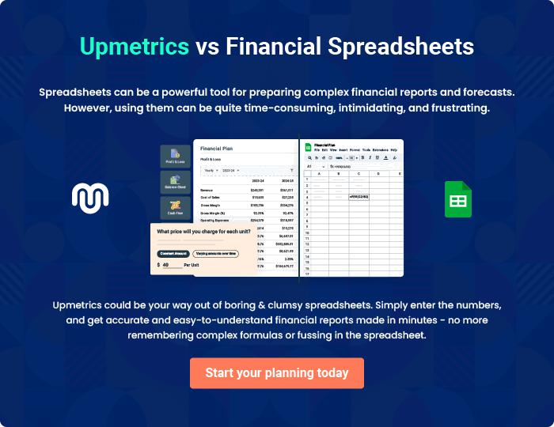
Appendix

When writing the appendix section, you should include any additional information that supports the main content of your plan. This may include financial statements, market research data, legal documents, and other
To unlock help try Upmetrics! 
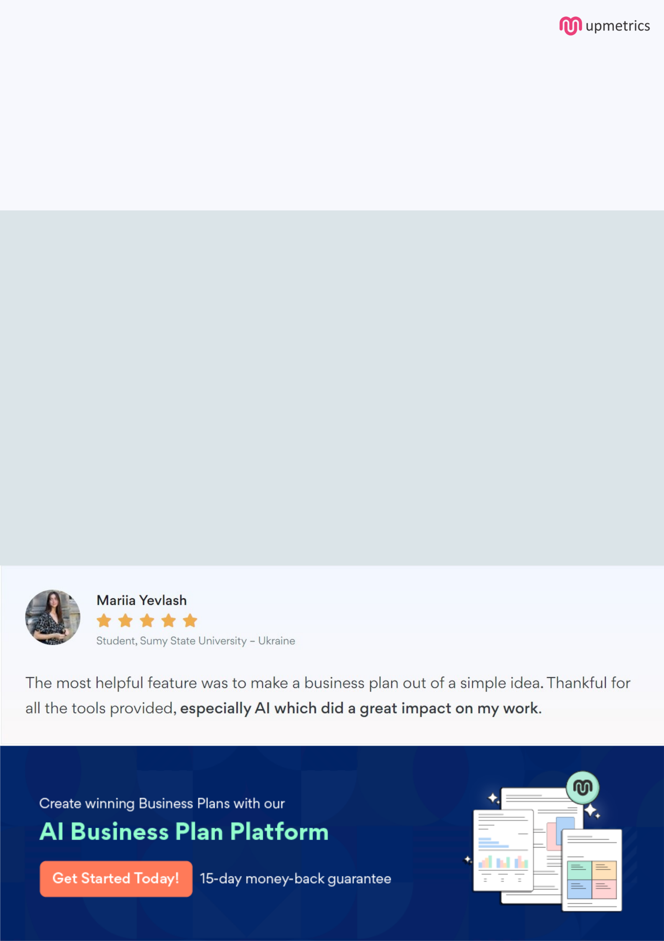
Create a winning business plan that gets you funded

Creating a stunning and investment-ready plan requires no writing, graphic designing, or financial planning expertise.

Upmetrics has all the features required to help you create a comprehensive business plan—from start to finish. Make no mistakes, it’s the modern way of planning to structure ideas, make plans, and create stunning pitch decks to awe investors.

Pitch decks that impress investors

Create pitch decks that provide a visual representation of your business, engage investors, and make them want to invest in your business idea.

Interactive plans in no time

Import business plan sections like—SWOT analysis, comparison tables, and others to create an interactive business plan. No designing skills are required.

Stunning cover page designs

With Upmetrics, you have the liberty to choose from multiple stunning cover page designs. Choose a creative design and make your plan stand out.

Online sharing made simple

Upmetrics makes online sharing quick and easier for users. Easily share your business plans with a link while tracking reader activity.

500+ sample business plans

Simply import a template from our library of sample plans into the editor and start customizing it to make it yours. It takes only a few clicks to get started.

Collaborate with team in real-time

Invite team members, initiate conversations, discuss ideas & strategies, share feedback, and work on a business plan in real-time.

