
Golf Simulator Business Plan


Business
Plan

2023


Play Anytime, Anywhere, Par Excellence

Information provided in this business plan is unique to this business and confidential; therefore, anyone reading this plan agrees not to disclose any of the information in this business plan without prior written permission of the company.

 | Prepared By | 10200 Bolsa Ave, Westminster, CA, 92683
 | John Doe | info@example.com
 | (650) 359-3153 | http://www.example.com

Table of Contents

Executive Summary | 6
Market opportunity | 6
Services Offered | 6
Marketing & Sales Strategies | 7
Financial Highlights | 7
Units Sold v/s Revenue | 8

Company Overview | 9
Ownership | 9
Business Owners | 9
Mission statement | 10
Business history | 10
Future goals | 11

Market Analysis | 12
Target Market | 12
Market size and growth potential | 12
Market Size | 13
Competitive analysis | 13
Fairway Virtual Golf | 14
SwingSpace Simulators | 14
Market trends | 15
Regulatory environment | 15

Products and Services | 17
Services | 17
Premium Golf Simulator Experience | 17
Golf Simulator Rental | 18
Personalized Golf Lessons | 18
Corporate Golf League & Events | 19
Golf Merchandise & Apparel | 19
Virtual Experience | 19
Customer Support & Maintenance | 20
Additional Services | 20

Sales And Marketing Strategies | 21
Unique Selling Proposition (USP) | 21
Pricing Strategy | 21
Marketing strategies | 22
Online | 22
Offline | 22
Sales strategies | 23
Customer retention | 23

Operations Plan | 24
Staffing & Training | 24
Operational Process | 24
Equipment & Machinery | 25

Management Team | 26
Key managers | 26
John Doe | 27
Jane Doe | 28
Alice Brown | 28
Robert Brown | 28
Organizational structure | 29
Organization chart | 29
Compensation plan | 30
Advisors/consultants | 30
Ms. Lucy White | 30
Dr. William Green | 30
Financial Plan
Financial Plan | 31

Profit & loss statement 31

Cash flow statement | 34
Balance sheet | 36
Break-even Analysis | 38
Financing needs | 40
Appendix
Appendix | 42
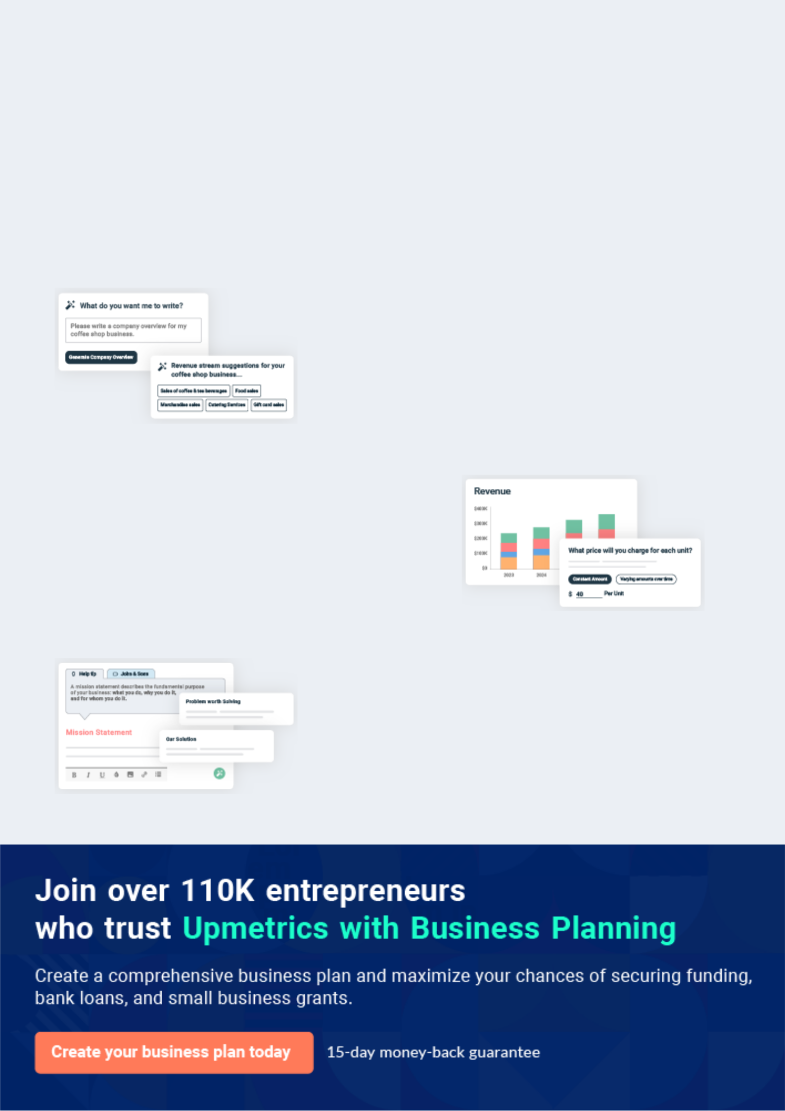
Business planning that’s simpler and faster than you think

Creating a business plan using Upmetrics to start and grow a business is literally the easiest thing in the World. Simply read the instructions and fill in the blanks. It’s as simple as that.

❛ | Upmetrics has everything you need to create a | ❜
❛ | comprehensive business plan. | ❜

AI-powered Upmetrics Assistant

AI-powered insights to streamline your plan

Not sure where to start? Upmetrics’ AI Assistant will automatically generate ideas for each section of your plan and offer improved versions of your writing, adjusting for tone, voice, and grammar or spelling errors.

Financial Forecasting Tool

All the financials are calculated for you

Forget the complex formulas and clumsy spreadsheets — with automatic financials and drag-and-drop forecasting, you can finish your plan faster and be confident that your numbers are accurate.

Business Plan Builder

Guides you like a business mentor

Upmetrics’ step-by-step instructions, prompts, and the library of 400+ sample business plans will guide you through each section of your plan as a business mentor.
Executive Summary


An executive summary is the first section of the business plan intended to provide an overview of the whole business plan.
To unlock help try Upmetrics! 

 Help tip  Golf Simulator Business Plan


Start your executive summary section by briefly introducing your golfing business to your readers.
To unlock help try Upmetrics! 

Start writing here..

Market opportunity

 Help tip  Golf Simulator Business Plan

Summarize your market research, including market size, growth potential, and marketing trends. Highlight the opportunities in the market and how your business will fit in to fill the gap.
To unlock help try Upmetrics! 

Start writing here..

Services Offered

 Help tip  Golf Simulator Business Plan

Provide a description of the golf simulation services you provide to your clients. Include any additional or value-added services you offer that may differentiate you from the competition.
To unlock help try Upmetrics! 

Start writing here..

Marketing & Sales Strategies
To unlock help try Upmetrics!

 Help tip  Golf Simulator Business Plan

Outline your sales and marketing strategies—what marketing platforms you use, how you plan on acquiring customers, etc.
To unlock help try Upmetrics! 

Start writing here..

Financial Highlights

 Help tip  Golf Simulator Business Plan

Briefly summarize your financial projections for the initial years of business operations. Include any capital or investment requirements, associated startup costs, projected revenues, and profit forecasts.



Start writing here..
Units Sold v/s Revenue

 |  | Units Sold | Revenue
15.00k
10.00k
5.00k
0
Year 1 | Year 2 | Year 3
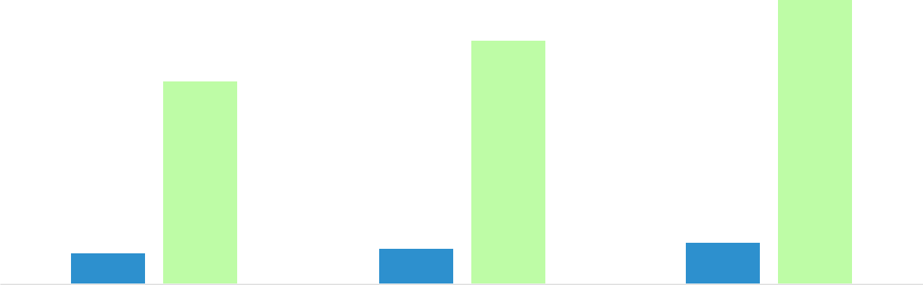

Financial Year |  |  | Units Sold | Revenue
Year 1 | 1,550 |  |  | $10,000
Year 2 | 1,800 |  |  | $12,000
Year 3 | 2,050 |  |  | $14,000
 Help tip |  |  Golf Simulator Business Plan


Summarize your executive summary section with a clear CTA, for example, inviting angel investors to discuss the potential business investment.
To unlock help try Upmetrics! 

Write a call to action for your business plan.
Company Overview

Depending on what details of your business are essential, you’ll need different elements in your business overview.
To unlock help try Upmetrics! 

 Help tip  Golf Simulator Business Plan

Describe what kind of golf simulation business you operate and the name of it.

Here are a few common types of golf simulation businesses:

Start writing here..

Ownership

 Help tip  Golf Simulator Business Plan

To unlock help try Upmetrics! 

List the names of the founders or owners of your golfing business. Describe what shares they own and their responsibilities for efficiently managing the business.
To unlock help try Upmetrics! 

Start writing here..

Business Owners



60% John Doe



40% Jane Doe

Mission statement

 Help tip  Golf Simulator Business Plan

Summarize your business’ objective, core principles, and values in your mission statement. This statement needs to be memorable, clear, and brief.
To unlock help try Upmetrics! 

❛ At [Golf Sim Innovations], we aim to revolutionize the golfing experience. Merging advanced technology with the timeless allure of golf, we are dedicated to providing unforgettable, immersive golfing sessions.

Our core principles revolve around quality, innovation, and customer-centricity, ensuring every swing taken in our facility feels authentic.

❜

Business history

 Help tip  Golf Simulator Business Plan

If you’re an established golfing simulation service provider, briefly describe your business history, like—when it was founded, how it evolved over time, etc.
To unlock help try Upmetrics! 

Start writing here..
Future goals

 Help tip  Golf Simulator Business Plan

It’s crucial to convey your aspirations and vision. Mention your short-term and long-term goals; they can be specific targets for revenue, market share, or expanding your services.
To unlock help try Upmetrics! 

Start writing here..
Market Analysis
To unlock help try Upmetrics!


 |  | Market analysis provides a clear understanding of the market in which your
 |  | printing business will run along with the target market, competitors, and
 |  | growth opportunities.
 |  |  |  | To unlock help try Upmetrics! 
 Help tip |  |  Golf Simulator Business Plan

To write the introduction section of your market analysis, start by clearly identifying your primary target market.
To unlock help try Upmetrics! 

Start writing here..

Target Market

 Help tip  Golf Simulator Business Plan

Start this section by describing your target market. Define your ideal customer and explain what types of services they prefer. Creating a buyer persona will help you easily define your target market to your readers.



Start writing here..

Market size and growth potential

 Help tip  Golf Simulator Business Plan

Describe your market size and growth potential and whether you will target a niche or a much broader market.
To unlock help try Upmetrics! 

Start writing here..

Market Size

Available Market

All golf enthusiasts & corporate entities 10M interested in golf simulation.

Served Market
Golfers in regions with golf simulation 3M facilities & event organizers.

Target Market
Golfers in [City/Area] & corporate clients 500k seeking event tie-ins.

 Help tip  Golf Simulator Business Plan

Identify and analyze your direct and indirect competitors. Identify their strengths and weaknesses, and describe what differentiates your golf simulating services from them.
To unlock help try Upmetrics! 

Competitive analysis
Fairway Virtual Golf

Founded in [2015], Fairway Virtual Golf has established itself as a market leader in the golf simulator space. With a flagship facility in [Downtown Metropolis], they have expanded to over [10] locations nationwide.

Features

Wide Range of Courses: Over

- virtual courses from around the world.

Instructional Modules: Integrated coaching for players at various skill levels.

Corporate Packages: Tailored packages for corporate events and team-building exercises.

Membership Plans: Tiered plans for frequent users, offering discounts and exclusive benefits.

SwingSpace Simulators

Strengths

Brand Recognition: Being in the industry for several years has given them a strong reputation and loyal customer base.

Diverse Offerings: A wide range of courses and tailored packages appeals to both individual and corporate clients.

Weaknesses

Pricing: Their services come at a premium, potentially alienating budget-conscious customers

Wait Times: Due to high demand, customers often face long wait times, especially during weekends.

SwingSpace Simulators started in [2018] as a mobile golf simulator service catering to events and parties. They've since branched out with a permanent location in [Suburban City].

Features

Mobile Simulation: Offering golf simulation experiences at various events and venues.

Customizable Experiences: Personalized settings and experiences based on event type or audience.

Advanced Analytics: Detailed game analytics and feedback for players to improve their technique.

Junior Programs: Specialized programs and packages for younger golf enthusiasts.

Strengths

Flexibility: The mobile service offers a unique proposition, allowing them to cater to a different segment of the market

Youth Engagement: Their junior programs make them popular among families and younger audiences.

Weaknesses

Limited Fixed Location: Having only one permanent facility may limit their reach to a wider audience.

Brand Fragmentation: Balancing between mobile services and their fixed location might dilute their brand message and focus.

Market trends
To unlock help try Upmetrics!

 Help tip  Golf Simulator Business Plan

Analyse emerging trends in the industry, such as technology disruptions, changes in customer behavior or preferences, etc.
To unlock help try Upmetrics! 

Start writing here..

Regulatory environment

 Help tip  Golf Simulator Business Plan

List regulations and licensing requirements that may affect your golf simulator company, such as business licensing, health, and safety regulations, intellectual property rights, data privacy, security, etc.



Start writing here..
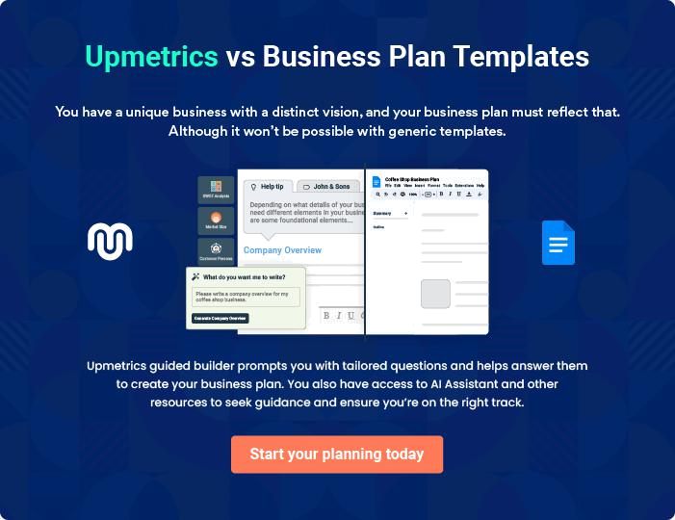
Products and Services
To unlock help try Upmetrics!

The product and services section of a golf simulator business plan should describe the specific services and products that will be offered to customers. To write this section should include the following:



 Help tip  Golf Simulator Business Plan

To craft the introduction for your "Products and Services" chapter, begin by positioning your business within its industry, emphasizing its unique strengths or value proposition.
To unlock help try Upmetrics! 

Start writing here..

 Help tip


Mention details about the golf simulator you offer, including the brand, technology, and special features, such as realistic ball tracking, AR(Augmented Reality), and VR(Virtual Reality).
To unlock help try Upmetrics! 

Services

Premium Golf Simulator Experience


Price: [$50/hour]

Experience golf like never before with our state-of-the-art simulators that transport you to world-renowned golf courses, right from the comfort of our facility.

Specifications

- Brand: [Brand Name]

- Technology: [Specific Technology, e.g., "Infrared Sensor Technology"]

- Features: Realistic ball tracking, AR & VR capabilities, live weather simulation.
Golf Simulator Rental

Price: [$500/day]

Bring the golfing experience to your event or personal occasion. Our simulator rentals come with all necessary equipment and an optional technician for setup and troubleshooting.

Specifications

- Dimensions: [Dimensions in feet or meters]

- Weight: [Weight in pounds or kilograms]

- Power Requirement: [Specific power requirement, e.g., "220V AC"]

Personalized Golf Lessons

Price: [$100/session] (1 hour)

Get personalized coaching from our in-house golf professionals. Suitable for players at all levels – from beginners to advanced.

Specifications

- Session Length: 60 minutes

- Included: Swing analysis, putt calibration, customized drills.
Corporate Golf League & Events

Price: Starting at [$1,000] (Varies based on requirements)

Organize team-building events or tournaments at our facility. Custom packages are available based on client needs, including catering and awards.

Specifications

- Max Participants: [Number, e.g., "50 participants"]

- Duration: [e.g., "3-5 hours"]

- Extras: Leaderboard setup, live scoring, optional photography services.

Golf Merchandise & Apparel

Price: Varies (Starting at [$20] for golf balls, [$50] for apparel)

Explore a curated range of high-quality golf merchandise and apparel, ensuring you're equipped for both virtual and real-world courses.

Specifications

- Brands: [List of brands, e.g., "Nike, Callaway, TaylorMade"]

- Products: Golf balls, clubs, apparel, gloves, and accessories.

Virtual Experience

 Help tip  Golf Simulator Business Plan

Describe the virtual golf experiences you offer through your simulators, such as practice modes, driving ranges, and golf courses.
To unlock help try Upmetrics! 

Start writing here..

Customer Support & Maintenance

 Help tip  Golf Simulator Business Plan

Describe your customer support and maintenance system and how you will ensure that the simulators are well-maintained and customers have the best experience.
To unlock help try Upmetrics! 

Start writing here..

Additional Services

 Help tip  Golf Simulator Business Plan

Mention if your golf simulator company offers any additional services. You may include services like simulator rental, hosting leagues and corporate events, golf lessons and instructions, retail sales (E.g., golf-related merchandise, apparel, golf balls.), etc.
To unlock help try Upmetrics! 

Start writing here..
Sales And Marketing Strategies
To unlock help try Upmetrics!

Writing the sales and marketing strategies section means a list of strategies you will use to attract and retain your clients.
To unlock help try Upmetrics! 

 Help Tip  Golf Simulator Business Plan


To create an effective introduction for your "Sales and Marketing Strategies" chapter, start by setting the stage within your specific industry or market.
To unlock help try Upmetrics! 

Start writing here..

Unique Selling Proposition (USP)

 Help tip  Golf Simulator Business Plan


Define your business’s USPs depending on the market you serve, the equipment you use, and
the unique services you provide. Identifying USPs will help you to plan your marketing
strategies.
 |  |  |  | To unlock help try Upmetrics! 
Start writing here..
Pricing Strategy
 Help tip |  |  Golf Simulator Business Plan

Describe your pricing strategy—how you plan to price your services and stay competitive in the local market. You can mention any discounts you plan on offering to attract new customers to your golf simulation service.



Start writing here..

 Help tip  Golf Simulator Business Plan
To unlock help try Upmetrics!

Discuss your marketing strategies to market your services. You may include some of these marketing strategies in your business plan—social media marketing, Google ads, brochures, email marketing, content marketing, and print marketing.



Marketing strategies

Online


Social Media

Leveraging platforms like Facebook, Instagram, and Twitter to showcase our facilities, promote special events, and engage with our community.

Content Marketing

Engaging blog posts and articles highlighting the latest in golf simulation technology, tips, and more.

Email Marketing

Regular updates, exclusive deals, and newsletters sent to our subscribers.

Google Ads

Targeted ads to capture potential customers searching for golf simulation experiences in [City/ Region].

Offline

Brochures & Print Marketing

Distributed at strategic locations including golf clubs, sports centers, and local businesses.

 Help tip  Golf Simulator Business Plan

Outline your strategies to maximize your sales. Your sales strategies may include introducing referral programs, promotional and seasonal campaigns, partnerships and affiliations, etc.
To unlock help try Upmetrics! 

Sales strategies

Partner with Businesses

Collaborations with local businesses, golf clubs, and events to offer exclusive deals.

Referral Programs

Rewards for customers who refer friends and family to experience our simulations.

Promotional and Seasonal Campaigns

Special rates during off-peak hours, holiday specials, and more

 Help tip  Golf Simulator Business Plan

Describe your customer retention strategies and how you plan to execute them. For instance, introducing loyalty programs, exclusive offers and discounts, taking regular feedback, etc.
To unlock help try Upmetrics! 

Customer retention

Loyalty Programs Exclusive Offers and Discounts

Earn points for every booking, which can be redeemed for discounts or free sessions.

Periodic deals available only to our regular members.

Feedback Mechanisms

Regular surveys and feedback

forms to understand our

customers' experiences and areas

of improvement.

Operations Plan
To unlock help try Upmetrics!

 |  | When writing the operations plan section, it’s important to consider the
 |  | various aspects of your business operations.
 |  |  |  | To unlock help try Upmetrics! 
 Help tip |  |  Golf Simulator Business Plan


To create an effective introduction for your "Operational Plan" chapter, start by emphasizing the
pivotal role of efficient operations in the success of your business, underscoring how they
directly impact the quality of services delivered.
 |  |  |  | To unlock help try Upmetrics! 
Start writing here..
Staffing & Training
 Help tip |  |  Golf Simulator Business Plan

Mention your business’s staffing requirements, including the number of employees or golf
instructors needed. Include their qualifications, the training required, and the duties they will
perform.
 |  |  |  | To unlock help try Upmetrics! 
Start writing here..
Operational Process
 Help tip |  |  Golf Simulator Business Plan

Outline the processes and procedures you will use to run your golf simulator business. Your operational processes may include facility management, booking and reservation management, inventory management, administration, and customer service.



Start writing here..

Equipment & Machinery

 Help tip  Golf Simulator Business Plan

Include the list of equipment and accessories required for golf simulation, such as golf clubs, balls, tees, and other golf-related accessories.
To unlock help try Upmetrics! 

Start writing here..
Management Team
To unlock help try Upmetrics!

The management team section provides an overview of the individuals responsible for running your business plan.
To unlock help try Upmetrics! 

 Help tip  Golf Simulator Business Plan

To craft an introduction for your "Management Team" chapter, begin by emphasizing the crucial role of leadership in the success of any business.
To unlock help try Upmetrics! 

Start writing here..

Key managers

 Help tip  Golf Simulator Business Plan

Introduce your management and key members of your team, and explain their roles and responsibilities. You will need to provide this information depending on the size of your company and the number of employees you have.



Start writing here..

JOHN DOE

CEO - john.doe@example.com

John is the driving force behind [Golf Sim Innovations], setting the vision, mission, and strategic direction for the company.

With a penchant for golf and a keen business acumen, John ensures the business remains at the forefront of technological advancements in the golf simulation industry.


- Educational Background: John holds an MBA from [Harvard Business School] and a Bachelor's in [Computer Science] from [Stanford University].

- Professional Background: With over 15 years in the tech industry, John has a track record of scaling startups to successful enterprises. Prior to founding [Golf Sim Innovations], he was a senior executive at [XYZ Tech Company], a leading technology firm.

JANE DOE

Chief Operating Officer (COO) - jane.doe@example.com

Jane is responsible for the day-to-day operations of [Golf Sim Innovations]. She ensures all departments work in sync, driving efficiency, and optimizing processes to ensure customer satisfaction and business growth.

- Educational Background: Jane graduated with a degree in [Operations Management] from [MIT Sloan School of Management] and has a certification in [Six Sigma Green Belt].

- Professional Background: With over a decade in operations management, Jane previously worked as an Operations Director at [ABC Tech Solutions], where she played a pivotal role in streamlining their processes.


ALICE BROWN

CMO - alice.brown@example.com

Alice oversees the marketing strategy of [Golf Sim Innovations], ensuring our brand's voice is consistent and resonates with our target audience.

She spearheads campaigns, partnerships, and digital marketing initiatives to bolster our brand's market presence.

- Educational Background: Alice earned her Master’s in Marketing from [Wharton School, University of Pennsylvania] and a Bachelor’s in [Communications] from [UCLA].

- Professional Background: Alice has 12 years of experience in brand development and digital marketing. Before joining us, she was the VP of Marketing at [DEF Digital Corp], a global digital marketing agency.


ROBERT BROWN

Golf Coaching Manager - robert.brown@example.com

Robert is the linchpin of our golf coaching program, ensuring that our trainers are equipped with the latest techniques and that our customers receive unparalleled instruction.

- Educational Background: Robert pursued his Bachelor’s in [Physical Education] from [Ohio State University] and holds a certification from [PGA - Professional Golfers' Association].

- Professional Background: With a decade-long journey in the world of golf, Robert previously worked as a Senior Golf Trainer at [GHI Golf Academy], one of the nation's top golf schools.
Organizational structure

 Help tip  Golf Simulator Business Plan

Explain the organizational structure of your management team. Include the reporting line and decision-making hierarchy.
To unlock help try Upmetrics! 

Start writing here..

Organization chart


John Doe

CEO


 | Robert Brown
Alice Brown | Golf Coaching | Jane Doe
Alice Brown | Manager | Jane Doe
CMO | Manager | COO



Emily Wong |  | James White | Sarah Lee
Marketing |  | James White | Finance
Marketing | Tim Smith | Lead Instructor | Finance
Specialist | Tim Smith | Lead Instructor | Manager
Specialist | Sales Manager |  | Manager



Compensation plan

 Help tip  Golf Simulator Business Plan

Describe your compensation plan for the management and staff. Include their salaries, incentives, and other benefits.
To unlock help try Upmetrics! 

Start writing here..

Advisors/consultants

 Help tip  Golf Simulator Business Plan

Mentioning advisors or consultants in your business plans adds credibility to your business idea.
To unlock help try Upmetrics! 

Start writing here..

MS. LUCY WHITE

Consultant

A consultant with expertise in business strategy.


DR. WILLIAM GREEN

Advisor

A renowned figure in the golf simulation industry.
Financial Plan

When writing the financial plan section of a business plan, it’s important to provide a comprehensive overview of your financial projections for the first few years of your business, You may provide the following:
To unlock help try Upmetrics! 

 Help tip  Golf Simulator Business Plan


To create an effective introduction for your "Financial Plan" chapter, begin by stressing the critical role of a well-structured financial plan in the success of your venture.
To unlock help try Upmetrics! 

Start writing here..

 Help tip


Describe details such as projected revenue, operational costs, and service costs in your projected profit and loss statement. Make sure to include your business’s expected net profit or loss.
To unlock help try Upmetrics! 

Profit & loss statement

Revenue

Cost Of Sales

General Costs

Revenue Specific Costs

Personnel Costs (Direct

Labor)

Gross Margin

Gross Margin (%)

Operating Expense

Payroll Expense

(Indirect Labor)

General Expense

Bad Debt

Amortization of Current

Assets

2023-24 | 2024-25 | 2025-26 | 2026-27 | 2027-28
$0 | $0 | $0 | $0 | $0

$0 | $0 | $0 | $0 | $0
$0 | $0 | $0 | $0 | $0
$0 | $0 | $0 | $0 | $0
$0 | $0 | $0 | $0 | $0

$0 | $0 | $0 | $0 | $0
0% | 0% | 0% | 0% | 0%

$0 | $0 | $0 | $0 | $0
$0 | $0 | $0 | $0 | $0
$0 | $0 | $0 | $0 | $0
$0 | $0 | $0 | $0 | $0
$0 | $0 | $0 | $0 | $0

EBITDA

Additional Expense

Long Term

Depreciation

Gain or loss from Sale

of Assets

EBIT

Interest Expenses

EBT

Income Tax Expense

Total Expense

Net Income

Net Income (%)

2023-24 | 2024-25 | 2025-26 | 2026-27 | 2027-28
$0 | $0 | $0 | $0 | $0
$0 | $0 | $0 | $0 | $0
$0 | $0 | $0 | $0 | $0
$0 | $0 | $0 | $0 | $0
$0 | $0 | $0 | $0 | $0
$0 | $0 | $0 | $0 | $0
$0 | $0 | $0 | $0 | $0
$0 | $0 | $0 | $0 | $0
$0 | $0 | $0 | $0 | $0
$0 | $0 | $0 | $0 | $0
0% | 0% | 0% | 0% | 0%
 | 2023-24 | 2024-25 | 2025-26 | 2026-27 | 2027-28
Retained Earning | $0 | $0 | $0 | $0 | $0
Opening
Owner's Distribution | $0 | $0 | $0 | $0 | $0
Retained Earning | $0 | $0 | $0 | $0 | $0
Closing

 Help tip

The section should estimate and describe the cash flow for the first few years of your operation. This may include billing invoices, payment receipts, loan payments, and any other cash flow statements.
To unlock help try Upmetrics! 

Cash flow statement

 | 2023-24 | 2024-25 | 2025-26 | 2026-27 | 2027-28
Cash Received | $0 | $0 | $0 | $0 | $0
Cash Paid | $0 | $0 | $0 | $0 | $0
COS & General Expenses | $0 | $0 | $0 | $0 | $0
Salary & Wages | $0 | $0 | $0 | $0 | $0
Interest | $0 | $0 | $0 | $0 | $0

Sales Tax

Income Tax

Net Cash From

Operations

Assets Sell

Assets Purchase

Net Cash From

Investments

Amount Received

Loan Received

Common Stock

Preferred Stock

Owner's Contribution

Amount Paid

2023-24 | 2024-25 | 2025-26 | 2026-27 | 2027-28
$0 | $0 | $0 | $0 | $0
$0 | $0 | $0 | $0 | $0
$0 | $0 | $0 | $0 | $0

$0 | $0 | $0 | $0 | $0
$0 | $0 | $0 | $0 | $0
$0 | $0 | $0 | $0 | $0

$0 | $0 | $0 | $0 | $0
$0 | $0 | $0 | $0 | $0

$0 | $0 | $0 | $0 | $0
$0 | $0 | $0 | $0 | $0
$0 | $0 | $0 | $0 | $0

Loan Capital $0 $0 $0 $0 $0

 | 2023-24 | 2024-25 | 2025-26 | 2026-27 | 2027-28
Dividends & Distributions | $0 | $0 | $0 | $0 | $0
Net Cash From | $0 | $0 | $0 | $0 | $0
Financing

Summary
Starting Cash | $0 | $0 | $0 | $0 | $0
Cash In | $0 | $0 | $0 | $0 | $0
Cash Out | $0 | $0 | $0 | $0 | $0
Change in Cash | $0 | $0 | $0 | $0 | $0
Ending Cash | $0 | $0 | $0 | $0 | $0

 Help tip

Create a projected balance sheet documenting your golf simulator business’s assets, liabilities, and equity.

To unlock help try Upmetrics! 

Balance sheet

 | 2023-24 | 2024-25 | 2025-26 | 2026-27 | 2027-28
Assets | $0 | $0 | $0 | $0 | $0
Current Assets | $0 | $0 | $0 | $0 | $0
Cash | $0 | $0 | $0 | $0 | $0
Accounts Receivable | $0 | $0 | $0 | $0 | $0
Inventory | $0 | $0 | $0 | $0 | $0
Other Current Assets | $0 | $0 | $0 | $0 | $0
Long Term Assets | $0 | $0 | $0 | $0 | $0
Gross Long Term Assets | $0 | $0 | $0 | $0 | $0
Accumulated Depreciation | $0 | $0 | $0 | $0 | $0

Liabilities & Equity | $0 | $0 | $0 | $0 | $0
Liabilities | $0 | $0 | $0 | $0 | $0
Current Liabilities | $0 | $0 | $0 | $0 | $0
Accounts Payable | $0 | $0 | $0 | $0 | $0
Income Tax Payable | $0 | $0 | $0 | $0 | $0
Sales Tax Payable | $0 | $0 | $0 | $0 | $0
Short Term Debt | $0 | $0 | $0 | $0 | $0
 | 2023-24 | 2024-25 | 2025-26 | 2026-27 | 2027-28
Long Term Liabilities | $0 | $0 | $0 | $0 | $0
Long Term Debt | $0 | $0 | $0 | $0 | $0
Equity | $0 | $0 | $0 | $0 | $0
Paid-in Capital | $0 | $0 | $0 | $0 | $0
Common Stock | $0 | $0 | $0 | $0 | $0
Preferred Stock | $0 | $0 | $0 | $0 | $0
Owner's Contribution | $0 | $0 | $0 | $0 | $0
Retained Earnings | $0 | $0 | $0 | $0 | $0

Check | $0 |  |  | $0 | $0 | $0 | $0
 Help tip |  |  Golf Simulator Business Plan


Determine and mention your business’s break-even point—the point at which your business costs and revenue will be equal.

This exercise will help you understand how much revenue you need to generate to sustain or be profitable.
To unlock help try Upmetrics! 

Break-even Analysis

 | 2023-24 | 2024-25 | 2025-26 | 2026-27 | 2027-28
Starting Revenue | $0 | $0 | $0 | $0 | $0
Net Revenue | $0 | $0 | $0 | $0 | $0
Closing Revenue | $0 | $0 | $0 | $0 | $0

Starting Expense | $0 | $0 | $0 | $0 | $0
Net Expense | $0 | $0 | $0 | $0 | $0
Closing Expense | $0 | $0 | $0 | $0 | $0

Is Break Even? | 0 | 0 | 0 | 0 | 0
Break Even Month | 0 | 0 | 0 | 0 | 0
Days Required | 0 | 0 | 0 | 0 | 0
Break Even Revenue | $0 | $0 | $0 | $0 | $0
Break Even Units
Financing needs

 Help tip  Golf Simulator Business Plan

Calculate costs associated with starting a golf simulator business, and estimate your financing needs and how much capital you need to raise to operate your business.
To unlock help try Upmetrics! 

Start writing here..
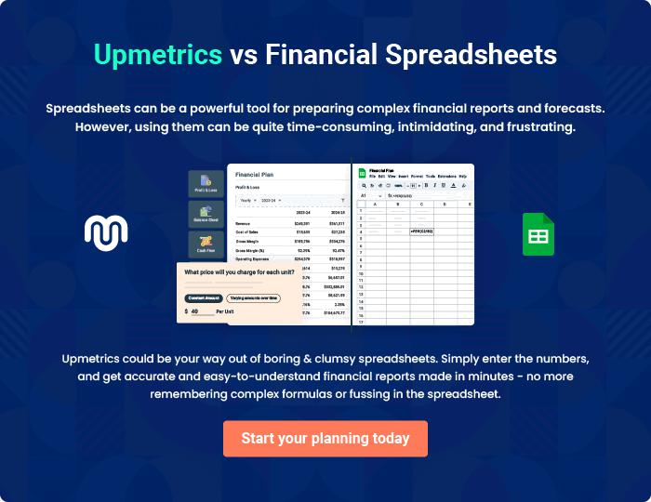
Appendix

When writing the appendix section, you should include any additional information that supports the main content of your plan. This may include financial statements, market research data, legal documents, and other
To unlock help try Upmetrics! 

Create a winning business plan that gets you funded

Creating a stunning and investment-ready plan requires no writing, graphic designing, or financial planning expertise.

Upmetrics has all the features required to help you create a comprehensive business plan—from start to finish. Make no mistakes, it’s the modern way of planning to structure ideas, make plans, and create stunning pitch decks to awe investors.

Pitch decks that impress investors

Create pitch decks that provide a visual representation of your business, engage investors, and make them want to invest in your business idea.

Interactive plans in no time

Import business plan sections like—SWOT analysis, comparison tables, and others to create an interactive business plan. No designing skills are required.

Stunning cover page designs

With Upmetrics, you have the liberty to choose from multiple stunning cover page designs. Choose a creative design and make your plan stand out.

Online sharing made simple

Upmetrics makes online sharing quick and easier for users. Easily share your business plans with a link while tracking reader activity.

500+ sample business plans

Simply import a template from our library of sample plans into the editor and start customizing it to make it yours. It takes only a few clicks to get started.

Collaborate with team in real-time

Invite team members, initiate conversations, discuss ideas & strategies, share feedback, and work on a business plan in real-time.

