Golf Driving Range Business Plan



Business Plan

2023


Drive, Golf, Relax

Information provided in this business plan is unique to this business and confidential; therefore, anyone reading this plan agrees not to disclose any of the information in this business plan without prior written permission of the company.

Prepared By

John Doe

10200 Bolsa Ave, Westminster, CA, 92683

info@example.com

(650) 359-3153 http://www.example.com

Table of Contents

Executive Summary | 6
Market opportunity | 6
Food-Packaging Services | 6
Marketing & Sales Strategies | 7
Financial Highlights | 7
Units Sold v/s Revenue | 8

Company Overview | 9
Ownership | 9
Business Owners | 9
Mission statement | 10
Business history | 10
Future goals | 10

Market Analysis | 11
Target Market | 11
Market size and growth potential | 11
Market Size | 12
Competitive analysis | 12
Topgolf | 12
Drive Shack | 13
Bayside Golf Club | 13
Market trends | 13
Regulatory environment | 14

Products and Services | 15
Services | 15
Golf Club Rentals | 15
Golf Ball Rentals | 16
Golf Lessons | 16
Snacks and Refreshment Services | 16
Rental Hitting Bays | 17
Products | 17
Golf Clubs | 17
Golf Balls | 18
Golf Tees | 18
Training Aids | 18
Golf Gloves | 19
Quality Measures | 19
Additional Services | 19

Sales And Marketing Strategies | 20
Unique Selling Proposition (USP) | 20
Pricing Strategy | 20
Marketing strategies | 21
Online | 21
Offline | 21
Sales strategies | 22
Customer retention | 23

Operations Plan | 24
Staffing & Training | 24
Operational Process | 24
Equipment & Machinery | 25

Management Team | 26
Key managers | 26
John Doe | 26
Jane Doe | 27
Alice Brown | 27
Robert Brown | 27
Organizational structure | 27
Organization chart | 28

Compensation plan 28

Advisors/Consultants | 29
Michael Taylor | 29
Emily Johnson | 29

Financial Plan | 30
Profit & loss statement | 30
Cash flow statement | 33
Balance sheet | 35
Break-even Analysis | 37
Financing needs | 39
Appendix
Appendix | 41
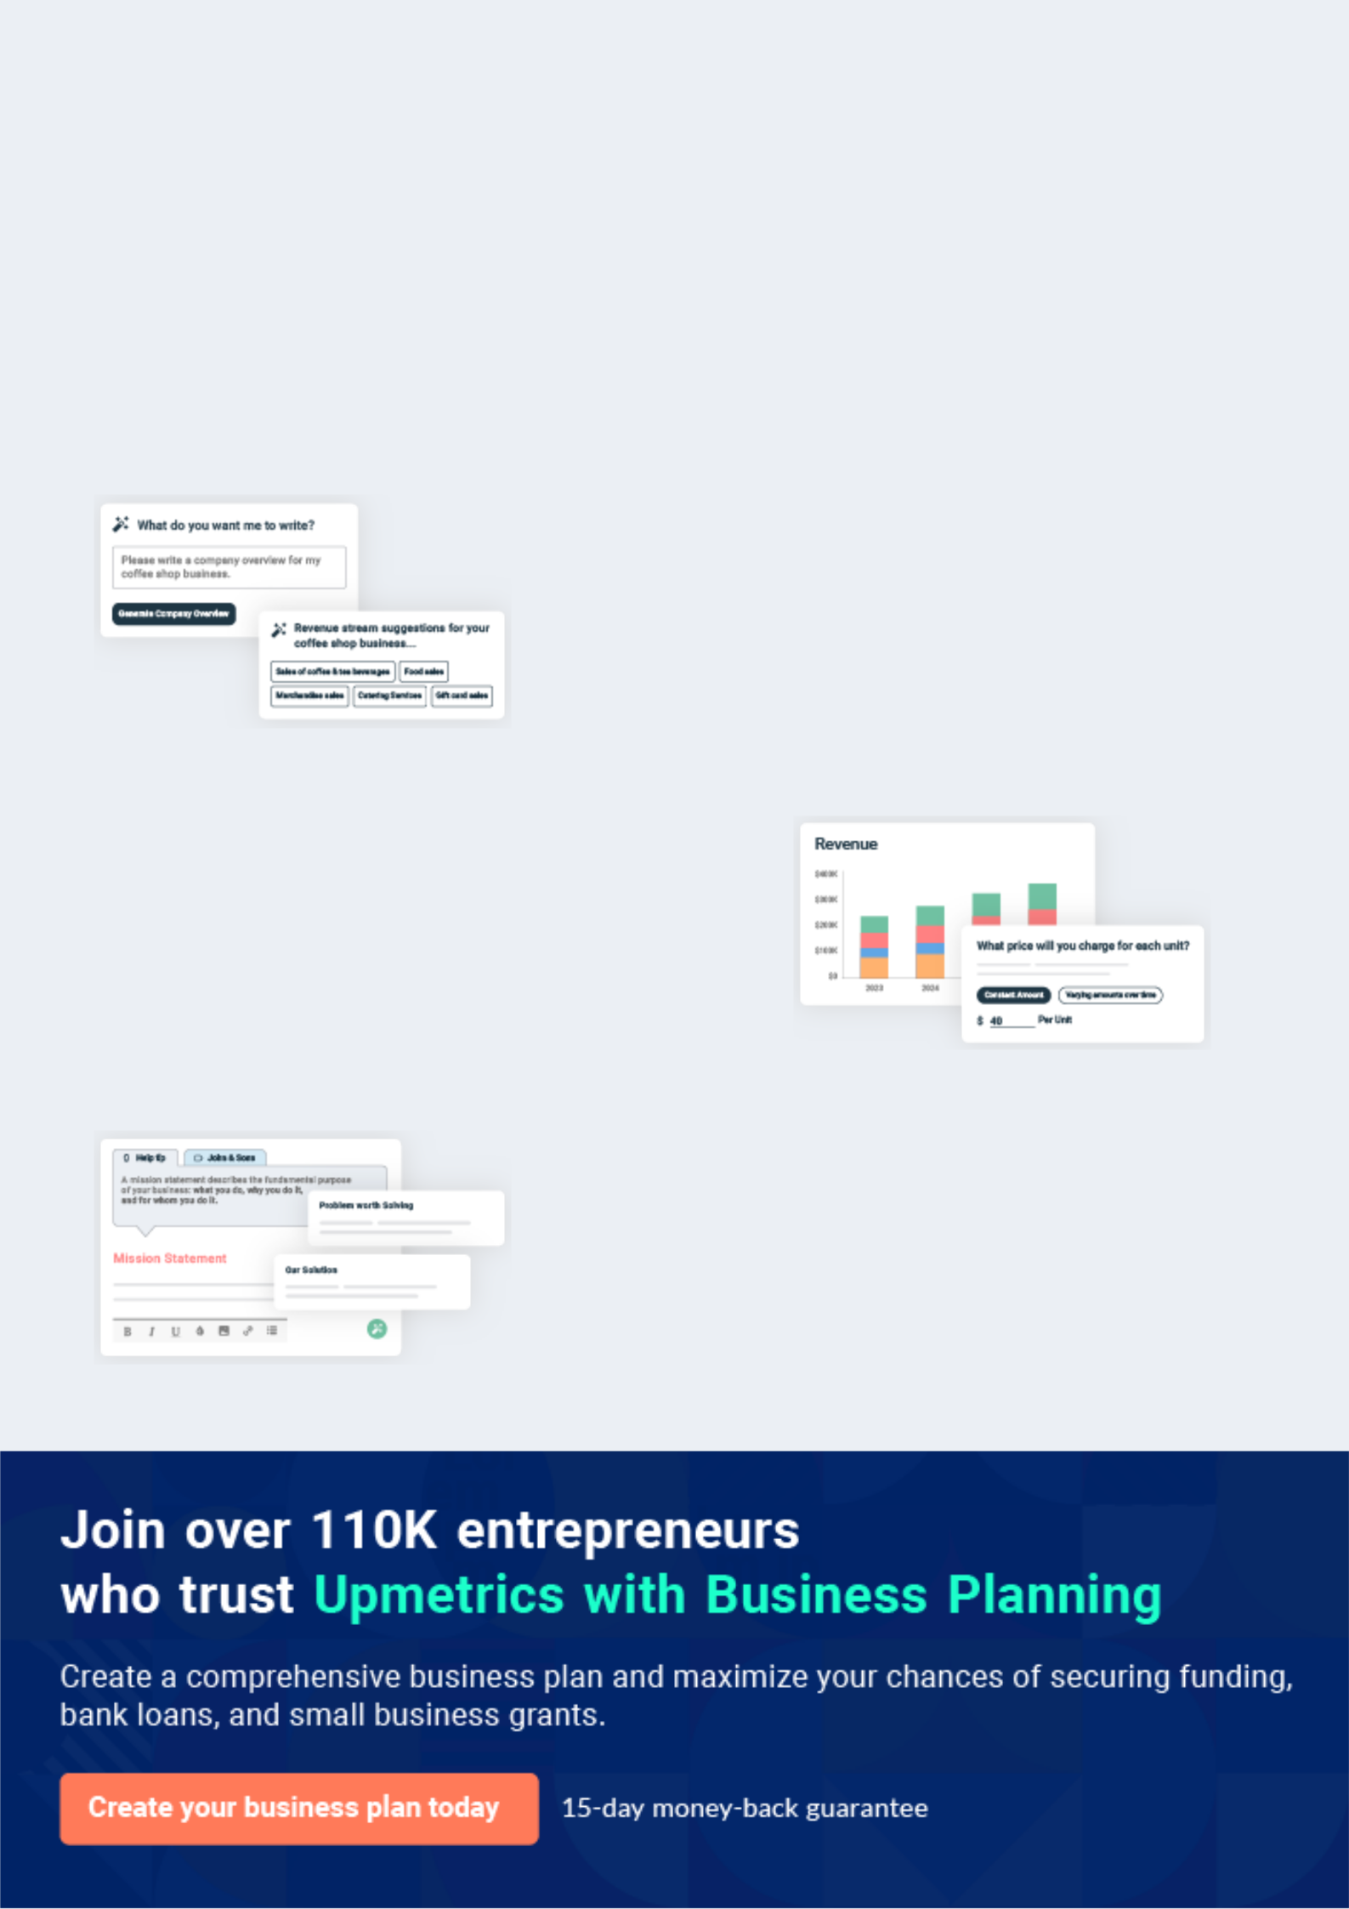
Business planning that’s simpler and faster than you think

Creating a business plan using Upmetrics to start and grow a business is literally the easiest thing in the World. Simply read the instructions and fill in the blanks. It’s as simple as that.

❛ | Upmetrics has everything you need to create a | ❜
❛ | comprehensive business plan. | ❜

AI-powered Upmetrics Assistant

AI-powered insights to streamline your plan

Not sure where to start? Upmetrics’ AI Assistant will automatically generate ideas for each section of your plan and offer improved versions of your writing, adjusting for tone, voice, and grammar or spelling errors.

Financial Forecasting Tool

All the financials are calculated for you

Forget the complex formulas and clumsy spreadsheets — with automatic financials and drag-and-drop forecasting, you can finish your plan faster and be confident that your numbers are accurate.

Business Plan Builder

Guides you like a business mentor

Upmetrics’ step-by-step instructions, prompts, and the library of 400+ sample business plans will guide you through each section of your plan as a business mentor.
Executive Summary


An executive summary is the first section of the business plan intended to provide an overview of the whole business plan.
To unlock help try Upmetrics! 

 Help tip  Golf Driving Range Business Plan


Start your executive summary by briefly introducing your business to your readers.

This section may include the name of your golf driving range, its location, when it was founded,
To unlock help try Upmetrics! 

Start writing here..

Market opportunity

 Help tip  Golf Driving Range Business Plan

Summarize your market research, including market size, growth potential, and marketing trends. Highlight the opportunities in the market and how your business will fit in to fill the gap.
To unlock help try Upmetrics! 

Start writing here..

Food-Packaging Services

 Help tip  Golf Driving Range Business Plan

Highlight the golf driving range services you offer your clients. The USPs and differentiators you offer are always a plus.
To unlock help try Upmetrics! 

Start writing here..

Marketing & Sales Strategies
To unlock help try Upmetrics!

 Help tip  Golf Driving Range Business Plan

Outline your sales and marketing strategies—what marketing platforms you use, how you plan on acquiring customers, etc.
To unlock help try Upmetrics! 

Start writing here..

Financial Highlights

 Help tip  Golf Driving Range Business Plan

Briefly summarize your financial projections for the initial years of business operations. Include any capital or investment requirements, associated startup costs, projected revenues, and profit forecasts.



Start writing here..
Units Sold v/s Revenue

 |  | Units Sold | Revenue
15.00k
10.00k
5.00k
0
Year 1 | Year 2 | Year 3


Financial Year |  |  | Units Sold | Revenue
Year 1 | 1,550 |  |  | $10,000
Year 2 | 1,800 |  |  | $12,000
Year 3 | 2,050 |  |  | $14,000
 Help tip |  |  Golf Driving Range Business Plan


Summarize your executive summary section with a clear CTA, for example, inviting angel investors to discuss the potential business investment.
To unlock help try Upmetrics! 

Write a call to action for your business plan.
Company Overview

Depending on what details of your business are essential, you’ll need different elements in your business overview.
To unlock help try Upmetrics! 

 Help tip  Golf Driving Range Business Plan

Describe your business in this section by providing all the basic information:

Describe what kind of golf driving range you run and the name of it. You may specialize in one
To unlock help try Upmetrics! 

Start writing here..

Ownership

 Help tip  Golf Driving Range Business Plan

List the names of founders or owners at your golf driving range. Describe what shares they own and their responsibilities for efficiently managing the business.
To unlock help try Upmetrics! 

Start writing here..

Business Owners



60% John Doe



40% Jane Doe
Mission statement

 Help tip  Golf Driving Range Business Plan

Summarize your business’ objective, core principles, and values in your mission statement. This statement needs to be memorable, clear, and brief.
To unlock help try Upmetrics! 

❛ At [TopGolf Range], we are committed to delivering an unparalleled golfing experience. Our mission is to foster a love for the game, provide top-notch facilities, and ensure every golfer, from novice to pro, feels valued.

Through innovation, dedication, and a passion for excellence, we strive to be the premier golf destination in [City/Region].

❜

Business history

 Help tip  Golf Driving Range Business Plan

If you’re an established golf driving range service provider, briefly describe your business history, like—when it was founded, how it evolved over time, etc.
To unlock help try Upmetrics! 

Start writing here..

Future goals

 Help tip  Golf Driving Range Business Plan

It’s crucial to convey your aspirations and vision. Mention your short-term and long-term goals; they can be specific targets for revenue, market share, or expanding your services.
To unlock help try Upmetrics! 

Start writing here..

Market Analysis
To unlock help try Upmetrics!


 |  | Market analysis provides a clear understanding of the market in which your
 |  | printing business will run along with the target market, competitors, and
 |  | growth opportunities.
 |  |  |  | To unlock help try Upmetrics! 
 Help tip |  |  Golf Driving Range Business Plan

To write the introduction section of your market analysis, start by clearly identifying your primary target market.
To unlock help try Upmetrics! 

Start writing here..

Target Market

 Help tip  Golf Driving Range Business Plan

Start this section by describing your target market. Define your ideal customer and explain what types of services they prefer. Creating a buyer persona will help you easily define your target market to your readers.



Start writing here..

Market size and growth potential

 Help tip  Golf Driving Range Business Plan

Describe your market size and growth potential and whether you will target a niche or a much broader market.
To unlock help try Upmetrics! 

Start writing here..

Market Size


Available Market | 50M
Total golf enthusiasts in the country | 50M

Served Market | 20M
Golf enthusiasts who visit ranges | 20M

Target Market | 5M
Families and groups seeking golf fun | 5M

 Help tip  Golf Driving Range Business Plan

Identify and analyze your direct and indirect competitors. Identify their strengths and weaknesses, and describe what differentiates your golf driving range services from them.
To unlock help try Upmetrics! 

Competitive analysis

Topgolf

Topgolf is one of the pioneers in revolutionizing the golf driving range experience. Beyond the conventional range, they provide a multi-tiered, high-tech entertainment venue with a mix of golf, food, and drinks.

Features Strengths

Weaknesses

Advanced ball-tracing technology

Multi-level hitting bays

An extensive menu with a full-service bar

Event hosting, including corporate events and parties

Golf lessons and leagues

Strong brand recognition

Advanced technology providing interactive feedback

A wide array of food and beverage options, enhancing customer experience

Premium pricing might exclude some potential customers

Being a large chain, it can sometimes lack the personalized touch local ranges offer

Drive Shack

Drive Shack offers a similar entertainment venue experience but tends to be more flexible in pricing and membership options.

Features Strengths Weaknesses

Multi-level driving ranges with | A balanced mix of golf and
technology feedback | entertainment
Arcade games and other | Membership options offering
recreational activities | flexibility for frequent visitors
A diverse food menu and bar | Hosting capabilities for diverse
Golf academies and lessons | events, from birthdays to
Golf academies and lessons | corporate get-togethers

Limited locations compared to larger competitors

Technology offerings, while advanced, don't match the breadth of some leading competitors

Bayside Golf Club

Bayside Golf Club offers a more traditional golf driving range experience, focusing on pure golf skills without the added entertainment components.

Features

Spacious golf range

Pro shop with equipment and gear

PGA certified instructors for lessons

Quiet, serene environment ideal for serious practice

Strengths

Appeals to purist golfers looking for a traditional experience

Expert instructors providing quality lessons

Typically lower pricing due to a focus on core golfing without entertainment frills

Weaknesses

Lacks the entertainment aspects which can appeal to a broader audience

Limited tech integration might not appeal to younger, tech-savvy golfers

Market trends

 Help tip  Golf Driving Range Business Plan

nalyze emerging trends in the industry, such as technology disruptions, changes in customer profiles or preferences, etc. Explain how your business will cope with all the trends.
To unlock help try Upmetrics! 

Start writing here..

Regulatory environment
To unlock help try Upmetrics!

 Help tip  Golf Driving Range Business Plan

List regulations and licensing requirements that may affect your golf driving range, such as business registration, business permits and licenses, ADA compliance, liquor and food service permits, state and federal regulations, etc.



Start writing here..
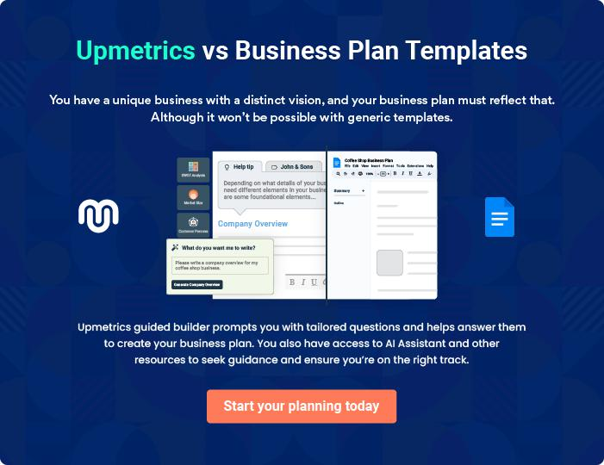
Products and Services
To unlock help try Upmetrics!

The product and services section of a golf driving range business plan should describe the specific services and products that will be offered to customers. To write this section should include the following:



 Help tip  Golf Driving Range Business Plan

To craft the introduction for your "Products and Services" chapter, begin by positioning your business within its industry, emphasizing its unique strengths or value proposition.
To unlock help try Upmetrics! 

Start writing here..

 Help tip


Mention the golf driving range services your business will offer. This list may include services like,
To unlock help try Upmetrics! 

Services

Golf Club Rentals


Price: [$20] per hour

High-quality golf clubs available for rent, suitable for players of all skill levels.

Specifications

Brands include Titleist, Callaway, and TaylorMade. Sets include drivers, irons, wedges, and putters.
Golf Ball Rentals

Price: [$5] for a bucket of 30 balls

Premium quality golf balls available for rent, ensuring an optimal golfing experience.

Specifications

Brands include Titleist Pro V1, Callaway Chrome Soft, and Srixon Z-Star.

Golf Lessons

Price: [$50] per 30-minute session

Personalized golf lessons from PGA-certified instructors, catering to golfers of all skill levels.

Specifications

Lessons cover all aspects of the game, including driving, chipping, putting, and course management.

Snacks and Refreshment Services

Price: Varies by item

A range of snacks and refreshments available to keep golfers energized during their game.

Specifications

Offerings include sandwiches, hot dogs, chips, candy, sodas, and water.
Rental Hitting Bays

Price: [$30] per hour

High-tech rental hitting bays equipped with the latest technology to provide instant feedback on your performance.

Specifications

Bays are equipped with launch monitors, video analysis, and other tech tools.

 Help Tip


Mention the products you sell at your golf driving range. This list may include golf merchandise like,
To unlock help try Upmetrics! 

Products

Golf Clubs

Price: Varies by brand and model

A range of golf clubs from top brands, catering to golfers of all skill levels.

Specifications

Offerings include drivers, fairway woods, hybrids, irons, wedges, and putters.
Golf Balls

Price: Varies by brand and model

A variety of golf balls from top brands, ensuring that golfers have access to the best quality balls for their game.

Specifications

Offerings include Titleist Pro V1, Callaway Chrome Soft, and Srixon Z-Star.

Golf Tees

Price: [$3] for a pack of 50

A selection of golf tees available for purchase.

Specifications

Offerings include wooden and plastic tees in various lengths.

Training Aids

Price: Varies by product

A range of training aids designed to help golfers improve their skills and take their game to the next level.

Specifications

Offerings include swing trainers, putting mats, and alignment aids.
Golf Gloves
To unlock help try Upmetrics!

Price: Varies by brand and model

A selection of high-quality golf gloves that provide a great grip.

Specifications

Offerings include gloves made from leather, synthetic materials, or a combination of both.

Quality Measures

 Help tip  Golf Driving Range Business Plan

This section should explain how you maintain quality standards and consistently provide the highest quality service.
To unlock help try Upmetrics! 

Start writing here..

Additional Services

 Help tip  Golf Driving Range Business Plan

Mention if your golf driving range company offers any additional services. You may include services like, hosting tournaments, organizing professional classes, entertainment sessions, etc.



Start writing here..
Sales And Marketing Strategies
To unlock help try Upmetrics!

Writing the sales and marketing strategies section means a list of strategies you will use to attract and retain your clients.
To unlock help try Upmetrics! 

 Help Tip  Golf Driving Range Business Plan


To create an effective introduction for your "Sales and Marketing Strategies" chapter, start by setting the stage within your specific industry or market.
To unlock help try Upmetrics! 

Start writing here..

Unique Selling Proposition (USP)

 Help tip  Golf Driving Range Business Plan

Define your business’s USPs depending on the market you serve, the equipment you use, and the unique services you provide. Identifying USPs will help you plan your marketing strategies.
To unlock help try Upmetrics! 

Start writing here..

Pricing Strategy

 Help tip  Golf Driving Range Business Plan

Describe your pricing strategy—how you plan to price your golf services and stay competitive in the local market. You can mention any introductory offers you plan on offering to attract new customers to your driving range.



Start writing here..

 Help tip  Golf Driving Range Business Plan

Discuss your marketing strategies to market your services. You may include some of these marketing strategies in your business plan—social media marketing, Google ads, brochures, email marketing, content marketing, event sponsorship, and print marketing.
To unlock help try Upmetrics! 

Marketing strategies

Online


Social Media

With platforms like Facebook, Instagram, and Twitter, we aim to engage our audience with regular updates, promotions, and golfing tips.

Content Marketing

Blog posts, articles, and videos that provide value to golf enthusiasts will be published, positioning [TopGolf Range] as a thought leader in the industry.

Email Marketing

Regular newsletters and updates will be sent to our subscribed members, keeping them informed about upcoming events and promotions.

Google Ads

Targeted ads will ensure we appear in relevant search results, capturing potential customers looking for golfing experiences.

Offline

Brochures

Distributed at strategic locations, our brochures will provide comprehensive information about our offerings.

Event Sponsorship

By sponsoring local golf tournaments or events, we'll gain visibility and build our brand's reputation.

Print Marketing

Local magazines, newspapers, and banners will feature our ads, targeting a local demographic.

 Help tip  Golf Driving Range Business Plan
To unlock help try Upmetrics!

Outline the strategies you’ll implement to maximize your sales. Your sales strategies may include partnerships and affiliations, individual and group packages, events, targeted marketing, etc.



Sales strategies

Partnerships and Affiliations

Collaborations with local businesses and golf brands can provide mutual benefits and widen our customer base.

Targeted Marketing

Specific marketing campaigns will be launched for different segments of our audience, ensuring we address their unique needs.

Group Packages

Special offers for corporate events, birthdays, or large gatherings will attract group bookings.

 Help tip  Golf Driving Range Business Plan
To unlock help try Upmetrics!

Describe your customer retention strategies and how you plan to execute them. For instance, introducing annual memberships, organizing exciting events and competitions, personalized service, etc.



Customer retention

Annual Memberships

Attractive membership packages will be available, offering discounts and exclusive benefits.

Personalized Service

Recognizing the preferences of our regular customers and tailoring our service accordingly will make them feel valued and appreciated.

Events and Competitions

Regular tournaments, championships, and social events will keep our customers engaged and connected to the [TopGolf Range] community.

Operations Plan
To unlock help try Upmetrics!

 |  | When writing the operations plan section, it’s important to consider the
 |  | various aspects of your business operations.
 |  |  |  | To unlock help try Upmetrics! 
 Help tip |  |  Golf Driving Range Business Plan


To create an effective introduction for your "Operational Plan" chapter, start by emphasizing the
pivotal role of efficient operations in the success of your business, underscoring how they
directly impact the quality of services delivered.
 |  |  |  | To unlock help try Upmetrics! 
Start writing here..
Staffing & Training
 Help tip |  |  Golf Driving Range Business Plan

Mention your golf business’s staffing requirements, including the number of employees,
coaches, and hospitality staff needed. Include their qualifications, the training required, and the
duties they will perform.
 |  |  |  | To unlock help try Upmetrics! 
Start writing here..
Operational Process
 Help tip |  |  Golf Driving Range Business Plan

Outline the processes and procedures you will use to run your golf driving range. Your operational processes may include facility maintenance, customer check-in, service offering, and implementing quality check measures.



Start writing here..

Equipment & Machinery

 Help tip  Golf Driving Range Business Plan

Include the list of equipment and machinery required for the golf driving range, such as golf carts, retrieval vehicles, range dividers, ball dispensers, maintenance equipment, etc.
To unlock help try Upmetrics! 

Start writing here..
Management Team

The management team section provides an overview of the individuals responsible for running your business plan.
To unlock help try Upmetrics! 

 Help tip  Golf Driving Range Business Plan

To craft an introduction for your "Management Team" chapter, begin by emphasizing the crucial role of leadership in the success of any business.
To unlock help try Upmetrics! 

Start writing here..

Key managers

 Help tip  Golf Driving Range Business Plan

Introduce your management and key members of your team, and explain their roles and responsibilities.
To unlock help try Upmetrics! 

Start writing here..


JOHN DOE

Founder & CEO - john.doe@example.com

With over 15 years of experience in the golf industry and a Bachelor's degree in Business Administration, John has a profound understanding of the golf business and its intricacies.


His strategic planning, financial management, and leadership skills are instrumental in steering [TopGolf Range] toward success.

JANE DOE

Chief Operating Officer (COO) - jane.doe@example.com

Jane has a Master's degree in Operations Management and over 10 years of experience in the field.

Her meticulous attention to detail and organizational skills ensure that the day-to-day operations at [TopGolf Range] run smoothly and efficiently.



ALICE BROWN

Chief Marketing Officer (CMO) - alice.brown@example.com

Alice holds a Bachelor's degree in Marketing and has a proven track record of successful brand development and marketing strategy implementation.

Her innovative ideas and strategies are pivotal in establishing [TopGolf Range] as a premier golf driving range destination.


ROBERT BROWN

Head Coach - robert.brown@example.com

With a Bachelor's degree in Sports Science and numerous golf coaching certifications, Robert brings a wealth of knowledge and expertise to [TopGolf Range].

His passion for teaching and commitment to delivering top-quality instruction make him a valuable asset to our team.

Organizational structure

 Help tip  Golf Driving Range Business Plan

Explain the organizational structure of your management team. Include the reporting line and decision-making hierarchy.
To unlock help try Upmetrics! 

Start writing here..

Organization chart


John Doe

CEO


Jane Doe

Alice Brown

Robert Brown

COO

CMO



Head Coach

Emily White | Michael Stone
Emily White | Customer Service
Operations Manager | Customer Service
Operations Manager | Manager


Compensation plan

 Help tip  Golf Driving Range Business Plan

Describe your compensation plan for the management and staff. Include their salaries, incentives, and other benefits.
To unlock help try Upmetrics! 

Start writing here..

 Help tip

Mentioning advisors or consultants in your business plans adds credibility to your business idea.
To unlock help try Upmetrics! 

Advisors/Consultants


MICHAEL TAYLOR

Advisor - michael.taylor@example.com

With over 20 years of experience in the golf industry, Michael is an invaluable source of knowledge and insights.

His guidance and advice have been instrumental in shaping the strategic direction of [TopGolf Range].


EMILY JOHNSON

Consultant - emily.johnson@example.com

Emily is a seasoned business consultant with a specialization in the golf industry.

Her expertise in strategic planning and financial management has provided [TopGolf Range] with the tools and knowledge needed to navigate the competitive golf business landscape.
Financial Plan

When writing the financial plan section of a business plan, it’s important to provide a comprehensive overview of your financial projections for the first few years of your business, You may provide the following:
To unlock help try Upmetrics! 

 Help tip  Golf Driving Range Business Plan


To create an effective introduction for your "Financial Plan" chapter, begin by stressing the critical role of a well-structured financial plan in the success of your venture.
To unlock help try Upmetrics! 

Start writing here..

 Help tip  Golf Driving Range Business Plan

Describe details such as projected revenue, operational costs, and service costs in your projected profit and loss statement. Make sure to include your business’s expected net profit or loss.
To unlock help try Upmetrics! 

Profit & loss statement

Revenue

Cost Of Sales

General Costs

Revenue Specific Costs

Personnel Costs (Direct

Labor)

Gross Margin

Gross Margin (%)

Operating Expense

Payroll Expense

(Indirect Labor)

General Expense

Bad Debt

Amortization of Current

Assets

2023-24 | 2024-25 | 2025-26 | 2026-27 | 2027-28
$0 | $0 | $0 | $0 | $0

$0 | $0 | $0 | $0 | $0
$0 | $0 | $0 | $0 | $0
$0 | $0 | $0 | $0 | $0
$0 | $0 | $0 | $0 | $0

$0 | $0 | $0 | $0 | $0
0% | 0% | 0% | 0% | 0%

$0 | $0 | $0 | $0 | $0
$0 | $0 | $0 | $0 | $0
$0 | $0 | $0 | $0 | $0
$0 | $0 | $0 | $0 | $0
$0 | $0 | $0 | $0 | $0

EBITDA

Additional Expense

Long Term

Depreciation

Gain or loss from Sale

of Assets

EBIT

Interest Expenses

EBT

Income Tax Expense

Total Expense

Net Income

Net Income (%)

2023-24 | 2024-25 | 2025-26 | 2026-27 | 2027-28
$0 | $0 | $0 | $0 | $0
$0 | $0 | $0 | $0 | $0
$0 | $0 | $0 | $0 | $0
$0 | $0 | $0 | $0 | $0
$0 | $0 | $0 | $0 | $0
$0 | $0 | $0 | $0 | $0
$0 | $0 | $0 | $0 | $0
$0 | $0 | $0 | $0 | $0
$0 | $0 | $0 | $0 | $0
$0 | $0 | $0 | $0 | $0
0% | 0% | 0% | 0% | 0%

 |  |  | 2023-24 |  | 2024-25 | 2025-26
Retained Earning |  |  | $0 |  | $0 | $0
Opening |  |  |  |  | $0 | $0
Owner's Distribution |  |  | $0 |  | $0 | $0
Retained Earning |  |  | $0 |  | $0 | $0
Closing |  |  |  |  | $0 | $0
 Help tip |  |  |  Golf Driving Range Business Plan


The cash flow for the first few years of your operation should be estimated and described in this section.

This may include billing invoices, payment receipts, loan payments, and any other cash flow statements.
2026-27 2027-28

$0 $0

$0 $0

$0 $0

To unlock help try Upmetrics! 

Cash flow statement

 | 2023-24 | 2024-25 | 2025-26 | 2026-27 | 2027-28
Cash Received | $0 | $0 | $0 | $0 | $0
Cash Paid | $0 | $0 | $0 | $0 | $0
COS & General Expenses | $0 | $0 | $0 | $0 | $0
Salary & Wages | $0 | $0 | $0 | $0 | $0
Interest | $0 | $0 | $0 | $0 | $0

Sales Tax

Income Tax

Net Cash From

Operations

Assets Sell

Assets Purchase

Net Cash From

Investments

Amount Received

Loan Received

Common Stock

Preferred Stock

Owner's Contribution

Amount Paid

2023-24 | 2024-25 | 2025-26 | 2026-27 | 2027-28
$0 | $0 | $0 | $0 | $0
$0 | $0 | $0 | $0 | $0
$0 | $0 | $0 | $0 | $0

$0 | $0 | $0 | $0 | $0
$0 | $0 | $0 | $0 | $0
$0 | $0 | $0 | $0 | $0

$0 | $0 | $0 | $0 | $0
$0 | $0 | $0 | $0 | $0

$0 | $0 | $0 | $0 | $0
$0 | $0 | $0 | $0 | $0
$0 | $0 | $0 | $0 | $0

Loan Capital $0 $0 $0 $0 $0

 |  |  | 2023-24 |  | 2024-25 | 2025-26 | 2026-27 | 2027-28
Dividends & Distributions |  |  | $0 |  | $0 | $0 | $0 | $0
Net Cash From |  |  | $0 |  | $0 | $0 | $0 | $0
Financing
Summary
Starting Cash |  |  | $0 |  | $0 | $0 | $0 | $0
Cash In |  |  | $0 |  | $0 | $0 | $0 | $0
Cash Out |  |  | $0 |  | $0 | $0 | $0 | $0
Change in Cash |  |  | $0 |  | $0 | $0 | $0 | $0
Ending Cash |  |  | $0 |  | $0 | $0 | $0 | $0
 Help tip |  |  Golf Driving Range Business Plan

Create a projected balance sheet documenting your golf driving range assets, liabilities, and equity.

To unlock help try Upmetrics! 

Balance sheet

 | 2023-24 | 2024-25 | 2025-26 | 2026-27 | 2027-28
Assets | $0 | $0 | $0 | $0 | $0
Current Assets | $0 | $0 | $0 | $0 | $0
Cash | $0 | $0 | $0 | $0 | $0
Accounts Receivable | $0 | $0 | $0 | $0 | $0
Inventory | $0 | $0 | $0 | $0 | $0
Other Current Assets | $0 | $0 | $0 | $0 | $0
Long Term Assets | $0 | $0 | $0 | $0 | $0
Gross Long Term Assets | $0 | $0 | $0 | $0 | $0
Accumulated Depreciation | $0 | $0 | $0 | $0 | $0

Liabilities & Equity | $0 | $0 | $0 | $0 | $0
Liabilities | $0 | $0 | $0 | $0 | $0
Current Liabilities | $0 | $0 | $0 | $0 | $0
Accounts Payable | $0 | $0 | $0 | $0 | $0
Income Tax Payable | $0 | $0 | $0 | $0 | $0
Sales Tax Payable | $0 | $0 | $0 | $0 | $0
Short Term Debt | $0 | $0 | $0 | $0 | $0
 | 2023-24 | 2024-25 | 2025-26 | 2026-27 | 2027-28
Long Term Liabilities | $0 | $0 | $0 | $0 | $0
Long Term Debt | $0 | $0 | $0 | $0 | $0
Equity | $0 | $0 | $0 | $0 | $0
Paid-in Capital | $0 | $0 | $0 | $0 | $0
Common Stock | $0 | $0 | $0 | $0 | $0
Preferred Stock | $0 | $0 | $0 | $0 | $0
Owner's Contribution | $0 | $0 | $0 | $0 | $0
Retained Earnings | $0 | $0 | $0 | $0 | $0

Check | $0 |  |  | $0 | $0 | $0 | $0
 Help tip |  |  Golf Driving Range Business Plan

Determine and mention your business’s break-even point—the point at which your business costs and revenue will be equal.

This exercise will help you understand how much revenue you need to generate to sustain or be profitable.
To unlock help try Upmetrics! 

Break-even Analysis

 | 2023-24 | 2024-25 | 2025-26 | 2026-27 | 2027-28
Starting Revenue | $0 | $0 | $0 | $0 | $0
Net Revenue | $0 | $0 | $0 | $0 | $0
Closing Revenue | $0 | $0 | $0 | $0 | $0

Starting Expense | $0 | $0 | $0 | $0 | $0
Net Expense | $0 | $0 | $0 | $0 | $0
Closing Expense | $0 | $0 | $0 | $0 | $0

Is Break Even? | 0 | 0 | 0 | 0 | 0
Break Even Month | 0 | 0 | 0 | 0 | 0
Days Required | 0 | 0 | 0 | 0 | 0
Break Even Revenue | $0 | $0 | $0 | $0 | $0
Break Even Units
Financing needs

 Help tip  Golf Driving Range Business Plan

Calculate costs associated with starting a golf driving range, and estimate your financing needs and how much capital you need to raise to operate your business.
To unlock help try Upmetrics! 

Start writing here..
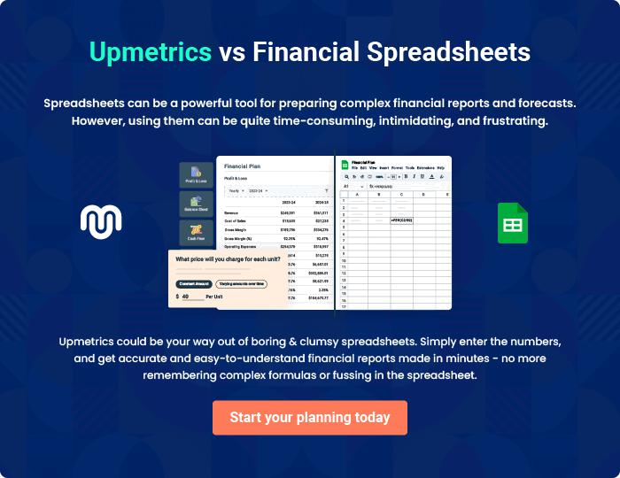
Appendix

When writing the appendix section, you should include any additional information that supports the main content of your plan. This may include financial statements, market research data, legal documents, and other
To unlock help try Upmetrics! 

Create a winning business plan that gets you funded

Creating a stunning and investment-ready plan requires no writing, graphic designing, or financial planning expertise.

Upmetrics has all the features required to help you create a comprehensive business plan—from start to finish. Make no mistakes, it’s the modern way of planning to structure ideas, make plans, and create stunning pitch decks to awe investors.

Pitch decks that impress investors

Create pitch decks that provide a visual representation of your business, engage investors, and make them want to invest in your business idea.

Interactive plans in no time

Import business plan sections like—SWOT analysis, comparison tables, and others to create an interactive business plan. No designing skills are required.

Stunning cover page designs

With Upmetrics, you have the liberty to choose from multiple stunning cover page designs. Choose a creative design and make your plan stand out.

Online sharing made simple

Upmetrics makes online sharing quick and easier for users. Easily share your business plans with a link while tracking reader activity.

500+ sample business plans

Simply import a template from our library of sample plans into the editor and start customizing it to make it yours. It takes only a few clicks to get started.

Collaborate with team in real-time

Invite team members, initiate conversations, discuss ideas & strategies, share feedback, and work on a business plan in real-time.

