
 Golf Course Business Plan

ADDRESS CONTACT

10200 Bolsa Ave, Westminster, CA, 92683 (650) 359-3153

http://www.example.com info@example.com


Business Plan

2023

Prepared By

John Doe


Tee Up for Unparalleled Experiences

Information provided in this business plan is unique to this business and confidential; therefore, anyone reading this plan agrees not to disclose any of the information in this business plan without prior written permission of the company.

Table of Contents

Executive Summary | 6
Market opportunity | 6
Products or Services Offered | 6
Marketing & Sales Strategies | 7
Financial Highlights | 7
Units Sold v/s Revenue | 8

Company Overview | 9
Ownership | 9
Mission statement | 10
Business history | 10
Future goals | 11

Market Analysis | 12
Target Market | 12
Market size and growth potential | 12
Market Size | 13
Competitive analysis | 13
Green Meadows Golf Club | 13
Silver Creek Golf Retreat | 14
Pine Ridge Elite Golf Club | 14
Market trends | 14
Regulatory environment | 15

Products and Services | 16
Products | 16
Premium Golf Course Access | 16
Golf Equipment Rental | 17
Electric Golf Cart Rental | 17
Individual Golf Lessons | 17
Corporate Event Hosting | 18
Pro Shop Retail Sales | 18
Customer Support & Maintenance | 18
Additional Services | 19

Sales And Marketing Strategies | 20
Unique Selling Proposition (USP) | 20
Pricing Strategy | 20
Marketing strategies | 21
Online | 21
Offline | 21
Sales strategies | 22
Customer retention | 22

Operations Plan | 23
Staffing & Training | 23
Operational Process | 23
Equipment & Accessories | 24

Management Team | 25
Key managers | 25
John Doe | 25
Jane Doe | 26
Alice Brown | 26
Robert Brown | 26
Organizational structure | 27
Organization chart | 27
Compensation plan | 27
Board of advisors | 28
[ADVISOR NAME] | 28
[ADVISOR NAME] | 28
Financial Plan
Financial Plan | 29

Profit & loss statement 29

Cash flow statement | 32
Balance sheet | 34
Break-even Point | 36
Financing needs | 37
Appendix
Appendix | 39
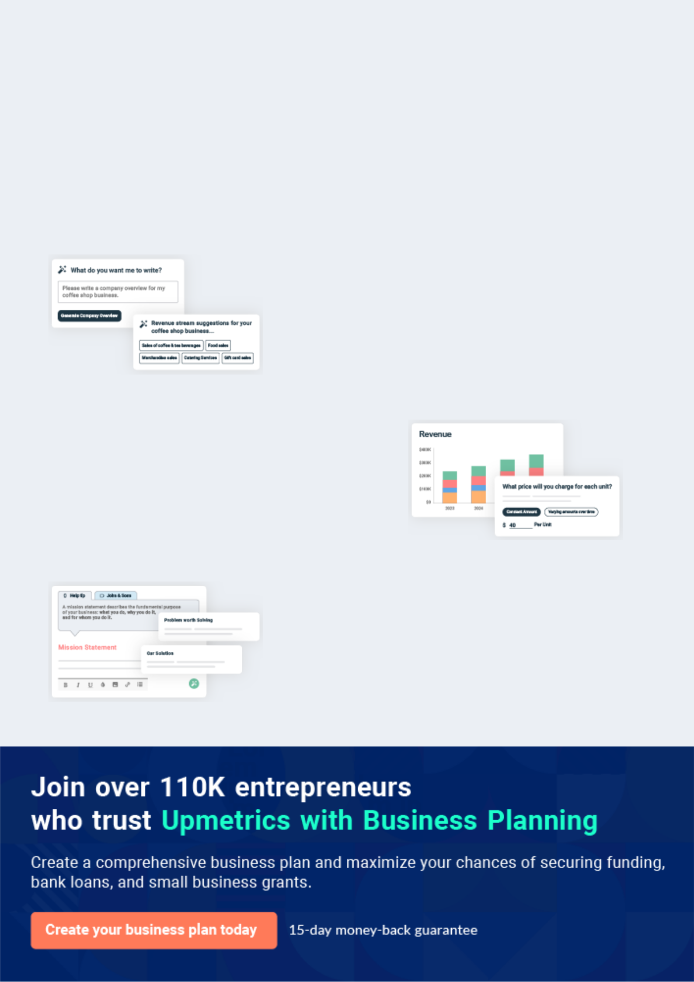
Business planning that’s simpler and faster than you think

Creating a business plan using Upmetrics to start and grow a business is literally the easiest thing in the World. Simply read the instructions and fill in the blanks. It’s as simple as that.

❛ | Upmetrics has everything you need to create a | ❜
❛ | comprehensive business plan. | ❜

AI-powered Upmetrics Assistant

AI-powered insights to streamline your plan

Not sure where to start? Upmetrics’ AI Assistant will automatically generate ideas for each section of your plan and offer improved versions of your writing, adjusting for tone, voice, and grammar or spelling errors.

Financial Forecasting Tool

All the financials are calculated for you

Forget the complex formulas and clumsy spreadsheets — with automatic financials and drag-and-drop forecasting, you can finish your plan faster and be confident that your numbers are accurate.

Business Plan Builder

Guides you like a business mentor

Upmetrics’ step-by-step instructions, prompts, and the library of 400+ sample business plans will guide you through each section of your plan as a business mentor.
Executive Summary


An executive summary is the first section of the business plan intended to provide an overview of the whole business plan.
To unlock help try Upmetrics! 

 Help tip  Golf Course Business Plan


Start your executive summary by briefly introducing your business to your readers.

This section may include the name of your golf course business, its location, when it was
To unlock help try Upmetrics! 

Start writing here..

Market opportunity

 Help tip  Golf Course Business Plan

Summarize your market research, including market size, growth potential, and marketing trends. Highlight the opportunities in the market and how your business will fit in to fill the gap.
To unlock help try Upmetrics! 

Start writing here..

Products or Services Offered

 Help tip  Golf Course Business Plan

Highlight the products and services you offer your clients. The USPs and differentiators you offer are always a plus.
To unlock help try Upmetrics! 

Start writing here..

Marketing & Sales Strategies
To unlock help try Upmetrics!

 Help tip  Golf Course Business Plan

Outline your sales and marketing strategies—what marketing platforms you use, how you plan on acquiring customers, etc.
To unlock help try Upmetrics! 

Start writing here..

Financial Highlights

 Help tip  Golf Course Business Plan

Briefly summarize your financial projections for the initial years of business operations. Include any capital or investment requirements, associated startup costs, projected revenues, and profit forecasts.



Start writing here..
Units Sold v/s Revenue

 |  | Units Sold | Revenue
15.00k
10.00k
5.00k
0
Year 1 | Year 2 | Year 3


Financial Year |  |  | Units Sold | Revenue
Year 1 | 1,550 |  |  | $10,000
Year 2 | 1,800 |  |  | $12,000
Year 3 | 2,050 |  |  | $14,000
 Help tip |  |  Golf Course Business Plan


Summarize your executive summary section with a clear CTA, for example, inviting angel investors to discuss the potential business investment.
To unlock help try Upmetrics! 

Write a call to action for your business plan.
Company Overview

Depending on what details of your business are essential, you’ll need different elements in your business overview.
To unlock help try Upmetrics! 

 Help tip  Golf Course Business Plan

Describe your business in this section by providing all the basic information:

Describe what kind of golf course you run and the name of it. For instance, here are some of the
To unlock help try Upmetrics! 

Start writing here..

Ownership

 Help tip  Golf Course Business Plan

List the names of your business’s founders or owners. Describe what shares they own and their responsibilities for efficiently managing the business.
To unlock help try Upmetrics! 

Start writing here..
Mission statement

 Help tip  Golf Course Business Plan

Summarize your business’ objective, core principles, and values in your mission statement. This statement needs to be memorable, clear, and brief.
To unlock help try Upmetrics! 

❛ At [Whispering Pines Golf Resort], our mission is to redefine golfing excellence. We commit to offering an unparalleled golfing journey, underscored by our core principles of innovation, integrity, and inclusivity.

Every swing, every putt, every moment at [Whispering Pines] is a testament to our unwavering dedication to the sport and our patrons.

❜

Business history

 Help tip  Golf Course Business Plan

If you’re an established business, briefly describe your business history, like—when it was founded, how it evolved over time, etc.
To unlock help try Upmetrics! 

Start writing here..
Future goals

 Help tip  Golf Course Business Plan

It’s crucial to convey your aspirations and vision. Mention your short-term and long-term goals; they can be specific targets for revenue, market share, or expanding your services.
To unlock help try Upmetrics! 

Start writing here..
Market Analysis
To unlock help try Upmetrics!


 |  | Market analysis provides a clear understanding of the market in which your
 |  | printing business will run along with the target market, competitors, and
 |  | growth opportunities.
 |  |  |  | To unlock help try Upmetrics! 
 Help tip |  |  Golf Course Business Plan

To write the introduction section of your market analysis, start by clearly identifying your primary target market.
To unlock help try Upmetrics! 

Start writing here..

Target Market

 Help tip  Golf Course Business Plan

Start this section by describing your target market. Define your ideal customer and explain what types of services they prefer. Creating a buyer persona will help you easily define your target market to your readers.



Start writing here..

Market size and growth potential

 Help tip  Golf Course Business Plan

Describe your market size and growth potential and whether you will target a niche or a much broader market.
To unlock help try Upmetrics! 

Start writing here..

Market Size

Available Market

Total golf enthusiasts in the region, | 10M
including casual and professional | 10M
players.
Served Market | 2M
Those within reach of existing golf | 2M
courses and willing to pay for premium | 2M
services.
Target Market | 500k
Middle-high income professionals, aged | 500k
25-50, seeking upscale golf experiences.

 Help tip  Golf Course Business Plan

Identify and analyze your direct and indirect competitors. Identify their strengths and weaknesses, and describe what differentiates your golf course from them.
To unlock help try Upmetrics! 

Competitive analysis

Green Meadows Golf Club

Green Meadows Golf Club, established in 1995, is a staple name within [City/Region]. With a sprawling 18-hole course and a reputation for hosting major local tournaments, it has carved a distinct place for itself in the golfing community.

Features | Strengths | Weaknesses
18-hole championship golf | Long-standing reputation in the | Aging infrastructure showing
course | community | signs of wear
On-site golf equipment store | Hosts renowned local golf | Limited technological integration,
Golf academy with certified | tournaments | such as booking systems or
Golf academy with certified |  | digital swing analysis
trainers | Comprehensive golf training | digital swing analysis
Clubhouse with dining facilities | programs | Predominantly targets the older
Clubhouse with dining facilities |  | demographic, missing out on
and bar |  | demographic, missing out on
and bar |  | younger golf enthusiasts

Silver Creek Golf Retreat

A relatively new entrant, Silver Creek Golf Retreat is known for its modern approach to golf. Located at the heart of [City/Region], it's quickly gaining traction among younger golfers.

Features | Strengths | Weaknesses
9-hole executive golf course, | Emphasis on modern | Lacks the tradition and prestige
suitable for quick rounds | technology attracts younger | associated with long-standing
State-of-the-art golf simulator | patrons | golf clubs
Membership packages with | Partnership deals provide | Limited physical golfing space,
Membership packages with | additional value to members | restricting major tournaments
allied fitness centers | additional value to members | restricting major tournaments
Eco-friendly, sustainable | Strong commitment to | Relatively lesser known among
Eco-friendly, sustainable | environmental sustainability | seasoned golfers
golfing solutions | environmental sustainability | seasoned golfers

Pine Ridge Elite Golf Club

Pine Ridge is the epitome of luxury golfing in [City/Region]. Established in 1980, it caters exclusively to a premium clientele, ensuring privacy and top-notch services.

Features | Strengths
Exclusive 18-hole golf course | Exclusivity ensures a premium
with limited membership | and private golfing experience
Personalized golf training with | World-class amenities and
international coaches | services
Helicopter landing facility | Strong network with
Gourmet dining and luxury | international golfing
Gourmet dining and luxury | communities
accommodation suites | communities

Weaknesses

Prohibitive membership costs alienate a broader market segment

Due to its exclusiveness, it misses out on the larger local golfing events

Dependency on a specific high-end clientele makes it vulnerable to economic downturns

Market trends

 Help tip  Golf Course Business Plan

Analyze emerging trends in the industry, such as technology disruptions, changes in customer behavior or preferences, etc. Explain how your business will cope with all the trends.
To unlock help try Upmetrics! 

Start writing here..

Regulatory environment
To unlock help try Upmetrics!

 Help tip  Golf Course Business Plan

List regulations and licensing requirements that may affect your golf course, such as business registration, insurance, alcohol licensing, employment, and labor laws, health and safety regulations, and tax obligations.



Start writing here..
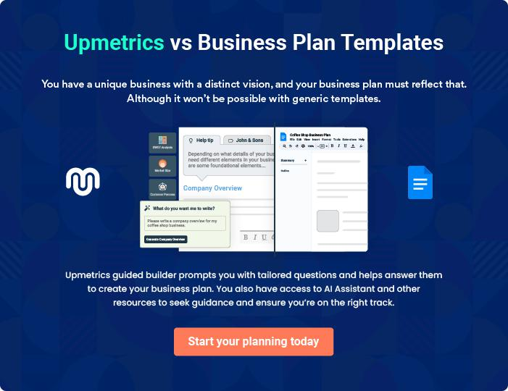
Products and Services
To unlock help try Upmetrics!

The product and services section of a golf course business plan should describe the specific services and products that will be offered to customers. To write this section should include the following:



 Help tip  Golf Course Business Plan

To craft the introduction for your "Products and Services" chapter, begin by positioning your business within its industry, emphasizing its unique strengths or value proposition.
To unlock help try Upmetrics! 

Start writing here..

 Help tip


Describe the Golf Course:

Mention details about your golf course, including details about par ratings, number of holes,
To unlock help try Upmetrics! 

Products

Premium Golf Course Access


Price: $[120] per round

Access to our meticulously designed 18-hole golf course, ensuring a challenging yet rewarding experience set amidst breathtaking landscapes.

Specifications

- Par-[72] course

- Total yardage: [7,200] yards

- Features: Lush green landscapes, water bodies, strategically placed bunkers
Golf Equipment Rental

Price: $[30] per set

Rent top-tier golf clubs from renowned brands, suitable for all skill levels. Each set includes a driver, fairway woods, irons, a wedge, and a putter.

Specifications

- Brands: [Titleist, Callaway, TaylorMade]

- Left and right-handed options

- Suitable for all player heights

Electric Golf Cart Rental

Price: $[25] for 18 holes

Eco-friendly, electric-powered carts that provide convenience and comfort as you traverse our expansive course.

Specifications

- Battery Life: Up to [36 holes]

- Seating Capacity: [2 passengers]

- On-board GPS for course navigation

Individual Golf Lessons

Price: $[80] per hour

Tailored lessons from certified trainers to refine your skills or start your golfing journey.

Specifications

- Duration: [1 hour]

- Equipment provided

- Customized as per skill level: Beginner, Intermediate, Advanced
Corporate Event Hosting

Price: Starting at $[5,000]

An exclusive package for corporate tournaments and events, ensuring a seamless experience from booking to execution.

Specifications

- Maximum participants: [100]

- Full course access

- Event management and catering options

Pro Shop Retail Sales

Price: Varies by item

A curated selection of golf-related merchandise, from apparel to custom golf balls.

Specifications

- Brands: [Nike, Under Armour, Puma]

- Sizes: [S, M, L, XL, XXL]

- Material: [100% Cotton, Moisture-wicking fabric]

Customer Support & Maintenance

 Help tip  Golf Course Business Plan

Describe your customer support and maintenance system and how you will ensure that the course is well-maintained and customers have the best experience.
To unlock help try Upmetrics! 

Start writing here..

Additional Services
To unlock help try Upmetrics!

 Help tip  Golf Course Business Plan

Mention if your golf course offers any additional services. You may include services like equipment rental, hosting leagues and corporate events, golf lessons and instructions, retail sales (E.g., golf-related merchandise, apparel, golf balls.), etc.



Start writing here..
Sales And Marketing Strategies

Writing the sales and marketing strategies section means a list of strategies you will use to attract and retain your clients.
To unlock help try Upmetrics! 

 Help Tip  Golf Course Business Plan


To create an effective introduction for your "Sales and Marketing Strategies" chapter, start by setting the stage within your specific industry or market.
To unlock help try Upmetrics! 

Start writing here..

Unique Selling Proposition (USP)

 Help tip  Golf Course Business Plan

Define your business’s USPs depending on the market you serve, the equipment you use, and the unique services you provide. Identifying USPs will help you plan your marketing strategies.
To unlock help try Upmetrics! 

Start writing here..

Pricing Strategy

 Help tip  Golf Course Business Plan

Describe your pricing strategy—how you plan to price your services and stay competitive in the local market. You can mention any discounts you plan on offering to attract new members.
To unlock help try Upmetrics! 

Start writing here..

 Help tip  Golf Course Business Plan
To unlock help try Upmetrics!

Discuss your marketing strategies to market your services. You may include some of these marketing strategies in your business plan—social media marketing, Google ads, brochures, email marketing, content marketing, and print marketing.



Marketing strategies

Online


Social Media Marketing Email Marketing

Regular updates, events, and Monthly newsletters highlighting

promotions on platforms such as events, offers, and news.

Facebook, Instagram, and LinkedIn.

Content Marketing

Blog posts and articles on golfing tips, course features, and more.

Google Ads

Targeted campaigns to reach potential customers actively looking for golfing experiences.

Offline

Brochures

Elegantly designed brochures available both digitally and at prime locations to provide information.

Print Marketing

Collaboration with magazines and newspapers to feature articles and advertisements.

 Help tip
To unlock help try Upmetrics!

Outline the strategies you’ll implement to maximize your sales. Your sales strategies may include introducing referral programs, promotional and seasonal campaigns, partnerships and affiliations, etc.



Sales strategies

Partner with Businesses Promotional Campaigns

Collaborating with local Seasonal campaigns like summer

businesses, hotels, and travel specials or festive offers.

agencies to offer bundled packages.

Referral Programs

Encouraging existing members to

refer friends in exchange for

benefits.

 Help tip

Describe your customer retention strategies and how you plan to execute them. For instance, introducing loyalty programs, exclusive offers and discounts, taking regular feedback, etc.
To unlock help try Upmetrics! 

Customer retention

Loyalty Programs Exclusive Offers

Rewarding frequent visitors with Special discounts for longstanding

points that can be redeemed. members.

Feedback Mechanisms

Regular surveys and suggestion

boxes to understand and

implement customer suggestions.

Operations Plan
To unlock help try Upmetrics!

 |  | When writing the operations plan section, it’s important to consider the
 |  | various aspects of your business operations.
 |  |  |  | To unlock help try Upmetrics! 
 Help tip |  |  Golf Course Business Plan


To create an effective introduction for your "Operational Plan" chapter, start by emphasizing the
pivotal role of efficient operations in the success of your business, underscoring how they
directly impact the quality of services delivered.
 |  |  |  | To unlock help try Upmetrics! 
Start writing here..
Staffing & Training
 Help tip |  |  Golf Course Business Plan

Mention your business’s staffing requirements, including the number of employees or golf
instructors needed. Include their qualifications, the training required, and the duties they will
perform.
 |  |  |  | To unlock help try Upmetrics! 
Start writing here..
Operational Process
 Help tip |  |  Golf Course Business Plan

Outline the processes and procedures you will use to run your golf course business. Your operational processes may include course maintenance, tee time reservations, golf instructions and coaching, event management, and staff management.



Start writing here..

Equipment & Accessories

 Help tip  Golf Course Business Plan

Include the list of equipment and accessories required for your day-to-day business operations, such as golf clubs, balls, tees, and other golf-related accessories.
To unlock help try Upmetrics! 

Start writing here..
Management Team

The management team section provides an overview of the individuals responsible for running your business plan.
To unlock help try Upmetrics! 

 Help tip  Golf Course Business Plan

To craft an introduction for your "Management Team" chapter, begin by emphasizing the crucial role of leadership in the success of any business.
To unlock help try Upmetrics! 

Start writing here..

Key managers

 Help tip  Golf Course Business Plan

Introduce your management and key members of your team, and explain their roles and responsibilities.
To unlock help try Upmetrics! 

Start writing here..


JOHN DOE

CEO & Owner - john.doe@example.com

As the founder and driving force behind [Whispering Pines Golf Resort], John has dedicated over two decades to refining the golfing experience.

His visionary approach to club management has positioned our resort at the forefront of the industry.


- Educational Background: John holds an MBA from Harvard Business School and a B.S. in Business Management from Stanford University.

- Professional Background: John began his career as a golf instructor, before ascending through the ranks of club management, giving him a holistic understanding of the industry.

JANE DOE

COO - jane.doe@example.com

Jane oversees the daily operations, ensuring the resort's service standards are met consistently. Her keen eye for detail and organizational prowess are pivotal to our operations.


- Educational Background: Jane earned her Master in Resort and Hospitality Management from Cornell University and a B.A. in Management from the University of Florida.

- Professional Background: With over 15 years in luxury resort management, Jane has a proven track record of operational success.


ALICE BROWN

Director of Golf Operations - alice.brown@example.com

Alice is responsible for overseeing all golf-related activities, from course maintenance to organizing tournaments.

She ensures that golfers have a premium experience every time.

- Educational Background: Alice holds a degree in Sports Management from Duke University.

- Professional Background: A former professional golfer, Alice transitioned into golf management and brings a player's perspective to our resort's operations.


ROBERT BROWN

Head of Marketing & Sales - robert.brown@example.com

Robert spearheads our marketing initiatives and sales strategies. His innovative campaigns have significantly increased our brand's visibility and membership rates.

- Educational Background: Robert earned his Master in Marketing from the Wharton School and a B.A. in Communication from UCLA.

- Professional Background: With over a decade in luxury brand marketing, Robert's expertise has been instrumental in shaping our brand's image.
Organizational structure

 Help tip  Golf Course Business Plan

Explain the organizational structure of your management team. Include the reporting line and decision-making hierarchy.
To unlock help try Upmetrics! 

Start writing here..

Organization chart


John Doe

CEO


Alice Brown | Robert Brown
Director of golf | Head of Marketing & | Jane Smith
operation | sales | CFO


Emily White | Daniel Green | Mark Grey
Digital Marketing | Daniel Green | Mark Grey
Digital Marketing | Operations Assistant | Finance Analyst
Specialist | Operations Assistant | Finance Analyst



Compensation plan

 Help tip  Golf Course Business Plan

Describe your compensation plan for the management and staff. Include their salaries, incentives, and other benefits.
To unlock help try Upmetrics! 

Start writing here..

 Help tip

Mentioning advisors or consultants in your business plans adds credibility to your business idea.
To unlock help try Upmetrics! 

Board of advisors


[ADVISOR NAME]

Advisor

Notable advisors include [Dr. ABC, a renowned figure in the golf industry]


[ADVISOR NAME]

Consultant

[Mr. XYZ, an expert in simulator technology]
Financial Plan

When writing the financial plan section of a business plan, it’s important to provide a comprehensive overview of your financial projections for the first few years of your business, You may provide the following:
To unlock help try Upmetrics! 

 Help tip  Golf Course Business Plan


To create an effective introduction for your "Financial Plan" chapter, begin by stressing the critical role of a well-structured financial plan in the success of your venture.
To unlock help try Upmetrics! 

Start writing here..

 Help tip


Describe details such as projected revenue, operational costs, and service costs in your projected profit and loss statement. Make sure to include your business’s expected net profit or loss.
To unlock help try Upmetrics! 

Profit & loss statement

Revenue

Cost Of Sales

General Costs

Revenue Specific Costs

Personnel Costs (Direct

Labor)

Gross Margin

Gross Margin (%)

Operating Expense

Payroll Expense

(Indirect Labor)

General Expense

Bad Debt

Amortization of Current

Assets

2023-24 | 2024-25 | 2025-26 | 2026-27 | 2027-28
$0 | $0 | $0 | $0 | $0

$0 | $0 | $0 | $0 | $0
$0 | $0 | $0 | $0 | $0
$0 | $0 | $0 | $0 | $0
$0 | $0 | $0 | $0 | $0

$0 | $0 | $0 | $0 | $0
0% | 0% | 0% | 0% | 0%

$0 | $0 | $0 | $0 | $0
$0 | $0 | $0 | $0 | $0
$0 | $0 | $0 | $0 | $0
$0 | $0 | $0 | $0 | $0
$0 | $0 | $0 | $0 | $0

EBITDA

Additional Expense

Long Term

Depreciation

Gain or loss from Sale

of Assets

EBIT

Interest Expenses

EBT

Income Tax Expense

Total Expense

Net Income

Net Income (%)

2023-24 | 2024-25 | 2025-26 | 2026-27 | 2027-28
$0 | $0 | $0 | $0 | $0
$0 | $0 | $0 | $0 | $0
$0 | $0 | $0 | $0 | $0
$0 | $0 | $0 | $0 | $0
$0 | $0 | $0 | $0 | $0
$0 | $0 | $0 | $0 | $0
$0 | $0 | $0 | $0 | $0
$0 | $0 | $0 | $0 | $0
$0 | $0 | $0 | $0 | $0
$0 | $0 | $0 | $0 | $0
0% | 0% | 0% | 0% | 0%
 | 2023-24 | 2024-25 | 2025-26 | 2026-27 | 2027-28
Retained Earning | $0 | $0 | $0 | $0 | $0
Opening
Owner's Distribution | $0 | $0 | $0 | $0 | $0
Retained Earning | $0 | $0 | $0 | $0 | $0
Closing

 Help tip

The cash flow for the first few years of your operation should be estimated and described in this section. This may include billing invoices, payment receipts, loan payments, and any other cash flow statements.
To unlock help try Upmetrics! 

Cash flow statement

 | 2023-24 | 2024-25 | 2025-26 | 2026-27 | 2027-28
Cash Received | $0 | $0 | $0 | $0 | $0
Cash Paid | $0 | $0 | $0 | $0 | $0
COS & General Expenses | $0 | $0 | $0 | $0 | $0
Salary & Wages | $0 | $0 | $0 | $0 | $0
Interest | $0 | $0 | $0 | $0 | $0

Sales Tax

Income Tax

Net Cash From

Operations

Assets Sell

Assets Purchase

Net Cash From

Investments

Amount Received

Loan Received

Common Stock

Preferred Stock

Owner's Contribution

Amount Paid

2023-24 | 2024-25 | 2025-26 | 2026-27 | 2027-28
$0 | $0 | $0 | $0 | $0
$0 | $0 | $0 | $0 | $0
$0 | $0 | $0 | $0 | $0

$0 | $0 | $0 | $0 | $0
$0 | $0 | $0 | $0 | $0
$0 | $0 | $0 | $0 | $0

$0 | $0 | $0 | $0 | $0
$0 | $0 | $0 | $0 | $0

$0 | $0 | $0 | $0 | $0
$0 | $0 | $0 | $0 | $0
$0 | $0 | $0 | $0 | $0

Loan Capital $0 $0 $0 $0 $0

 | 2023-24 | 2024-25 | 2025-26 | 2026-27 | 2027-28
Dividends & Distributions | $0 | $0 | $0 | $0 | $0
Net Cash From | $0 | $0 | $0 | $0 | $0
Financing

Summary
Starting Cash | $0 | $0 | $0 | $0 | $0
Cash In | $0 | $0 | $0 | $0 | $0
Cash Out | $0 | $0 | $0 | $0 | $0
Change in Cash | $0 | $0 | $0 | $0 | $0
Ending Cash | $0 | $0 | $0 | $0 | $0

 Help tip

Create a projected balance sheet documenting your golf course business’s assets, liabilities, and equity.

To unlock help try Upmetrics! 

Balance sheet

 | 2023-24 | 2024-25 | 2025-26 | 2026-27 | 2027-28
Assets | $0 | $0 | $0 | $0 | $0
Current Assets | $0 | $0 | $0 | $0 | $0
Cash | $0 | $0 | $0 | $0 | $0
Accounts Receivable | $0 | $0 | $0 | $0 | $0
Inventory | $0 | $0 | $0 | $0 | $0
Other Current Assets | $0 | $0 | $0 | $0 | $0
Long Term Assets | $0 | $0 | $0 | $0 | $0
Gross Long Term Assets | $0 | $0 | $0 | $0 | $0
Accumulated Depreciation | $0 | $0 | $0 | $0 | $0

Liabilities & Equity | $0 | $0 | $0 | $0 | $0
Liabilities | $0 | $0 | $0 | $0 | $0
Current Liabilities | $0 | $0 | $0 | $0 | $0
Accounts Payable | $0 | $0 | $0 | $0 | $0
Income Tax Payable | $0 | $0 | $0 | $0 | $0
Sales Tax Payable | $0 | $0 | $0 | $0 | $0
Short Term Debt | $0 | $0 | $0 | $0 | $0
 | 2023-24 | 2024-25 | 2025-26 | 2026-27 | 2027-28
Long Term Liabilities | $0 | $0 | $0 | $0 | $0
Long Term Debt | $0 | $0 | $0 | $0 | $0
Equity | $0 | $0 | $0 | $0 | $0
Paid-in Capital | $0 | $0 | $0 | $0 | $0
Common Stock | $0 | $0 | $0 | $0 | $0
Preferred Stock | $0 | $0 | $0 | $0 | $0
Owner's Contribution | $0 | $0 | $0 | $0 | $0
Retained Earnings | $0 | $0 | $0 | $0 | $0

Check | $0 | $0 | $0 | $0 | $0

Break-even Point

 Help tip  Golf Course Business Plan

Determine and mention your business’s break-even point—the point at which your business costs and revenue will be equal.

This exercise will help you understand how much revenue you need to generate to sustain or be profitable.

To unlock help try Upmetrics! 

Start writing here..

Financing needs

 Help tip  Golf Course Business Plan

Calculate costs associated with starting a golf course business, and estimate your financing needs and how much capital you need to raise to operate your business.
To unlock help try Upmetrics! 

Start writing here..
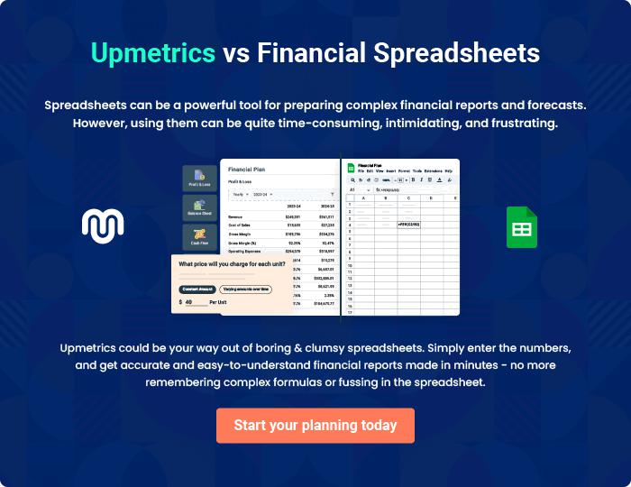
Appendix

When writing the appendix section, you should include any additional information that supports the main content of your plan. This may include financial statements, market research data, legal documents, and other
To unlock help try Upmetrics! 

Create a winning business plan that gets you funded

Creating a stunning and investment-ready plan requires no writing, graphic designing, or financial planning expertise.

Upmetrics has all the features required to help you create a comprehensive business plan—from start to finish. Make no mistakes, it’s the modern way of planning to structure ideas, make plans, and create stunning pitch decks to awe investors.

Pitch decks that impress investors

Create pitch decks that provide a visual representation of your business, engage investors, and make them want to invest in your business idea.

Interactive plans in no time

Import business plan sections like—SWOT analysis, comparison tables, and others to create an interactive business plan. No designing skills are required.

Stunning cover page designs

With Upmetrics, you have the liberty to choose from multiple stunning cover page designs. Choose a creative design and make your plan stand out.

Online sharing made simple

Upmetrics makes online sharing quick and easier for users. Easily share your business plans with a link while tracking reader activity.

500+ sample business plans

Simply import a template from our library of sample plans into the editor and start customizing it to make it yours. It takes only a few clicks to get started.

Collaborate with team in real-time

Invite team members, initiate conversations, discuss ideas & strategies, share feedback, and work on a business plan in real-time.

