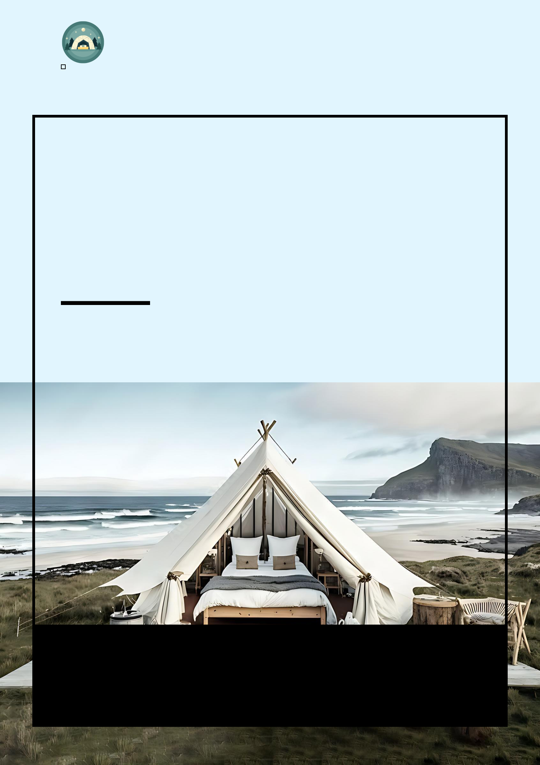
Glamping Business Plan

BUSINESS PLAN

Glamorous Camping, Unforgettable Experiences

Prepared By

John Doe

10200 Bolsa Ave, Westminster, CA, 92683

info@example.com

(650) 359-3153 http://www.example.com

Table of Contents

Executive Summary | 6
Market opportunity | 6
Services Offered | 6
Marketing & Sales Strategies | 7
Financial Highlights | 7
Units Sold v/s Revenue | 8

Company Overview | 9
Ownership | 9
Mission statement | 9
Business history | 10
Future goals | 10

Market Analysis | 11
Target Market | 11
Market size and growth potential | 11
Market Size | 12
Competitive analysis | 12
Green Canopy Glamping | 12
LuxTree Resorts | 13
Nomadic Trails Co. | 13
Market trends | 13
Regulatory environment | 14

Products and Services | 15
Services | 15
Luxurious Lakeside Tents | 15
Treetop Canopy Treehouses | 16
Rustic Woodland Cabins | 16
Gourmet Campfire Dinner | 17
Guided Forest Hike | 17
Outline the Amenities | 17
Quality Measures | 18

Sales And Marketing Strategies | 19
Unique Selling Proposition (USP) | 19
Pricing Strategy | 19
Marketing strategies | 20
Online | 20
Offline | 20
Sales strategies | 21
Customer retention | 21

Operations Plan | 22
Staffing and Training | 22
Operational Process | 22
Equipment and Machinery | 23

Management Team | 24
Key managers | 24
John Doe | 25
Jane Doe | 26
Alice Brown | 26
Robert Brown | 26
Organizational structure | 27
Organization chart | 27
Compensation plan | 28
Board of advisors | 28
[ADVISOR NAME] | 28

Financial Plan | 29
Profit & loss statement | 29
Cash flow statement | 32
Balance sheet | 34
Break-even Point | 36
Financing needs | 37
Appendix
Appendix | 39
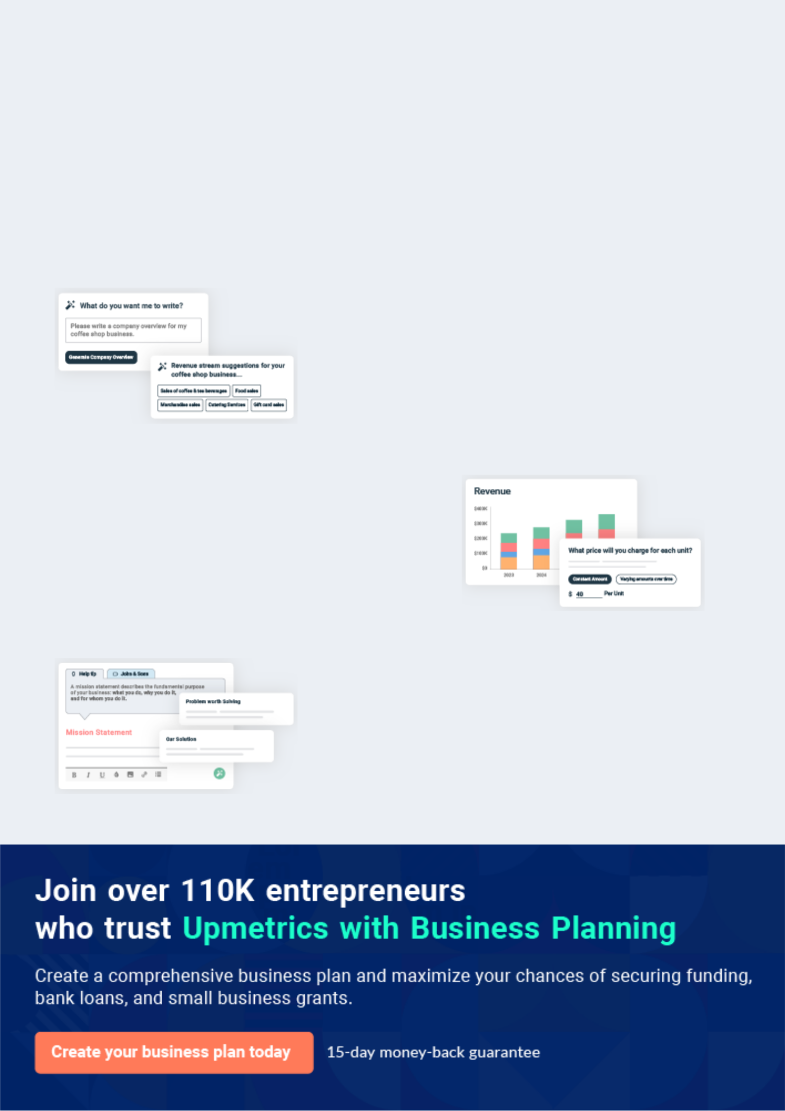
Business planning that’s simpler and faster than you think

Creating a business plan using Upmetrics to start and grow a business is literally the easiest thing in the World. Simply read the instructions and fill in the blanks. It’s as simple as that.

❛ | Upmetrics has everything you need to create a | ❜
❛ | comprehensive business plan. | ❜

AI-powered Upmetrics Assistant

AI-powered insights to streamline your plan

Not sure where to start? Upmetrics’ AI Assistant will automatically generate ideas for each section of your plan and offer improved versions of your writing, adjusting for tone, voice, and grammar or spelling errors.

Financial Forecasting Tool

All the financials are calculated for you

Forget the complex formulas and clumsy spreadsheets — with automatic financials and drag-and-drop forecasting, you can finish your plan faster and be confident that your numbers are accurate.

Business Plan Builder

Guides you like a business mentor

Upmetrics’ step-by-step instructions, prompts, and the library of 400+ sample business plans will guide you through each section of your plan as a business mentor.
Executive Summary


An executive summary is the first section of the business plan intended to provide an overview of the whole business plan.
To unlock help try Upmetrics! 

 Help tip  Glamping Business Plan


Start your executive summary section by briefly introducing your business to your readers.

This section may include the name of your glamping business, its location when it was
To unlock help try Upmetrics! 

Start writing here..

Market opportunity

 Help tip  Glamping Business Plan

Summarize your market research, including market size, growth potential, and marketing trends. Highlight the opportunities in the market and how your business will fit in to fill the gap.
To unlock help try Upmetrics! 

Start writing here..

Services Offered

 Help tip  Glamping Business Plan

Highlight the glamping services you offer your clients. The USPs and differentiators you offer are always a plus.
To unlock help try Upmetrics! 

Start writing here..

Marketing & Sales Strategies
To unlock help try Upmetrics!

 Help tip  Glamping Business Plan

Outline your sales and marketing strategies—what marketing platforms you use, how you plan on acquiring customers, etc.
To unlock help try Upmetrics! 

Start writing here..

Financial Highlights

 Help tip  Glamping Business Plan

Briefly summarize your financial projections for the initial years of business operations. Include any capital or investment requirements, associated startup costs, projected revenues, and profit forecasts.



Start writing here..
Units Sold v/s Revenue

 |  | Units Sold | Revenue
15.00k
10.00k
5.00k
0
Year 1 | Year 2 | Year 3


Financial Year |  |  | Units Sold | Revenue
Year 1 | 1,550 |  |  | $10,000
Year 2 | 1,800 |  |  | $12,000
Year 3 | 2,050 |  |  | $14,000
 Help tip |  |  Glamping Business Plan


Summarize your executive summary section with a clear CTA, for example, inviting angel investors to discuss the potential business investment.
To unlock help try Upmetrics! 

Write a call to action for your business plan.
Company Overview

Depending on what details of your business are essential, you’ll need different elements in your business overview.
To unlock help try Upmetrics! 

 Help tip  Glamping Business Plan

Describe your business in this section by providing all the essential information:

Describe what kind of glamping company you run and the name of it. You may specialize in one
To unlock help try Upmetrics! 

Start writing here..

Ownership

 Help tip  Glamping Business Plan

List the names of your glamping business’s founders or owners. Describe what shares they own and their responsibilities for efficiently managing the business.
To unlock help try Upmetrics! 

Start writing here..

Mission statement

 Help tip  Glamping Business Plan

Summarize your business’ objective, core principles, and values in your mission statement. This statement needs to be memorable, clear, and brief.
To unlock help try Upmetrics! 
❛ At [Starlight Glamping Retreats], we meld luxury with nature, crafting unparalleled experiences that rejuvenate the soul and body. Rooted in sustainability, authenticity, and unparalleled

guest service, we promise memories that last a lifetime.
❜

Business history

 Help tip  Glamping Business Plan

If you’re an established glamping business, briefly describe your business history, like—when it was founded, how it evolved over time, etc.
To unlock help try Upmetrics! 

Start writing here..

Future goals

 Help tip  Glamping Business Plan

It’s crucial to convey your aspirations and vision. Mention your short-term and long-term goals; they can be specific targets for revenue, market share, or expanding your services.
To unlock help try Upmetrics! 

Start writing here..
Market Analysis
To unlock help try Upmetrics!


 |  | Market analysis provides a clear understanding of the market in which your
 |  | printing business will run along with the target market, competitors, and
 |  | growth opportunities.
 |  |  |  | To unlock help try Upmetrics! 
 Help tip |  |  Glamping Business Plan

To write the introduction section of your market analysis, start by clearly identifying your primary target market.
To unlock help try Upmetrics! 

Start writing here..

Target Market

 Help tip  Glamping Business Plan

Start this section by describing your target market. Define your ideal customer and explain what types of services they prefer. Creating a buyer persona will help you easily define your target market to your readers.



Start writing here..

Market size and growth potential

 Help tip  Glamping Business Plan

Describe your market size and growth potential and whether you will target a niche or a much broader market.
To unlock help try Upmetrics! 

Start writing here..

Market Size

Available Market

All individuals who vacation outdoors 50M annually in the U.S.

Served Market
Those opting for luxurious outdoor 10M accommodations in the U.S.

Target Market
U.S. youth and travelers seeking unique 2M glamping experiences.

 Help tip  Glamping Business Plan

Identify and analyze your direct and indirect competitors. Identify their strengths and weaknesses, and describe what differentiates your glamping business from theirs.
To unlock help try Upmetrics! 

Competitive analysis

Green Canopy Glamping

Established in 2016, Green Canopy Glamping is a prominent player, mainly recognized for its sustainable practices. With a network spanning three states, they primarily focus on tent-based glamping experiences.

Features Strengths Weaknesses

Eco-friendly tent accommodations with solar-powered amenities.

Organic, farm-to-table dining experiences.

Workshops on sustainable living and nature conservation.

Strong brand recognition in the sustainable travel niche.

High repeat customer rate due to their unique workshops.

Collaborations with local environmental NGOs, enhancing their credibility.

Limited variety in accommodation types.

Some customer feedback indicates their locations lack certain basic amenities, such as reliable Wi-Fi.

LuxTree Resorts

LuxTree Resorts has carved its niche in luxury treehouse accommodations. Founded in 2018, their resorts are known for blending modern luxury with the charm of elevated living.

Features

Premium treehouse suites with panoramic views.

On-demand concierge services.

Spa and wellness centers focused on holistic treatments

Nomadic Trails Co.

Strengths | Weaknesses
Unique selling proposition with | Premium pricing might alienate
luxurious treehouse | budget travellers.
experiences. | Being heavily dependent on
Partnerships with renowned | technology, occasional technical
wellness brands, providing top- | glitches impact customer
notch spa services. | experiences.
A dedicated mobile app for
reservations, in-stay services,
and feedback.

Nomadic Trails Co. offers a blend of trekking and glamping. In operation since 2017, they cater to adventure seekers, blending wilderness treks with comfortable stays.

Features | Strengths | Weaknesses
Guided trekking expeditions | Adventure packages like rock | Seasonal business model, as
followed by glamping nights. | climbing, river rafting, and | certain trek routes are
Emphasis on local experiences, | more. | inaccessible during off-seasons.
including regional cuisines and | Strong relationships with local | Safety concerns have been
cultural nights. | communities, enriching their | raised in a few customer reviews.
Adventure packages like rock | cultural offerings.
climbing, river rafting, and | Variety in packages, catering to
more. | different adventure levels.

Market trends

 Help tip  Glamping Business Plan

Analyze emerging trends in the industry, such as technology disruptions, changes in customer behavior or preferences, etc. Explain how your business will cope with all the trends.
To unlock help try Upmetrics! 

Start writing here..

Regulatory environment
To unlock help try Upmetrics!

 Help tip  Glamping Business Plan

List regulations and licensing requirements that may affect your glamping business, such as business registration, health, and safety regulation, environmental regulations, business licenses, taxes, etc.



Start writing here..
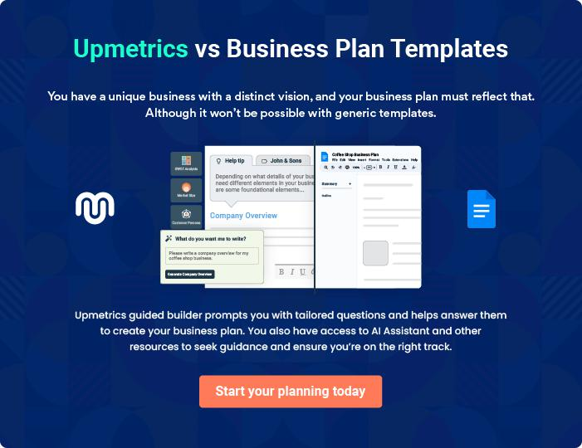
Products and Services
To unlock help try Upmetrics!

The product and services section of a glamping business plan should describe the specific services and products that will be offered to customers. To write this section should include the following:



 Help tip  Glamping Business Plan

To craft the introduction for your "Products and Services" chapter, begin by positioning your business within its industry, emphasizing its unique strengths or value proposition.
To unlock help try Upmetrics! 

Start writing here..

 Help tip


Mention the services your glamping business will offer. This list may include services like,

• Accommodations (what all accommodations you will provide like tents, treehouse, etc.)
To unlock help try Upmetrics! 

Services

Luxurious Lakeside Tents


Price: $[250] per night

Experience the magic of the lakeside under the canopy of the stars. Our tents offer an elegant retreat with panoramic views of serene landscapes.

Specifications

- Size: 320 sq. ft.

- Amenities: Queen-size bed, bedside table, lamp, Wi-Fi, private deck area.

- Capacity: Sleeps 2 adults comfortably.

- Special Feature: Zip-open windows for stargazing.
Treetop Canopy Treehouses

Price: $[400] per night

Elevate your glamping experience, quite literally, by opting for our treehouses, designed to blend seamlessly into nature while offering unmatched comfort.

Specifications

- Size: 450 sq. ft.

- Amenities: King-size bed, lounge area, mini-bar, modern bathroom, Wi-Fi, balcony with seating.

- Capacity: Sleeps 2 adults and 1 child.

- Special Feature: Glass floor section for a bird's-eye view of the forest floor.

Rustic Woodland Cabins

Price: $[350] per night

Immerse yourself in a woodland retreat with our rustic cabins, combining the charm of woodwork with modern amenities.

Specifications

- Size: 500 sq. ft.

- Amenities: Double bed, sofa, kitchenette, fireplace, modern bathroom, Wi-Fi, outdoor patio.

- Capacity: Sleeps 4 adults.

- Special Feature: Private outdoor hot tub.
Gourmet Campfire Dinner
- To unlock help try Upmetrics!

Price: $[50] per person

Revel in a culinary journey as you dine by the campfire. Our gourmet menu showcases local ingredients, turning your meal into an unforgettable experience.

Specifications

- Menu: Three-course meal with options for appetizers, mains, and desserts.

- Specials: Vegan, vegetarian, and gluten-free options available.

- Add-ons: Wine pairing at an additional $20

Guided Forest Hike

Price: $[30] per person

Discover the secrets of the forest with our expert guides. From rare flora to playful fauna, uncover nature's wonders during this 2-hour excursion.

Specifications

- Duration: 2 hours.

- Equipment: Binoculars provided.

- Group Size: Maximum of 10 people per group.

- Special Feature: Option for sunrise or sunset hikes.

Outline the Amenities

 Help tip  Glamping Business Plan

What more services would you provide your visitors in addition to your accommodations? Will there be a gathering place with furniture, a kitchen, or a fire pit? Will you provide guided hikes or bike rentals?



Start writing here..

Quality Measures

 Help tip  Glamping Business Plan

This section should explain how you maintain quality standards and consistently provide the highest quality service.
To unlock help try Upmetrics! 

Start writing here..
Sales And Marketing Strategies
To unlock help try Upmetrics!

Writing the sales and marketing strategies section means a list of strategies you will use to attract and retain your clients.
To unlock help try Upmetrics! 

 Help Tip  Glamping Business Plan


To create an effective introduction for your "Sales and Marketing Strategies" chapter, start by setting the stage within your specific industry or market.
To unlock help try Upmetrics! 

Start writing here..

Unique Selling Proposition (USP)

 Help tip  Glamping Business Plan


Define your business’s USPs depending on the market you serve, the equipment you use, and
the unique services you provide. Identifying USPs will help you to plan your marketing
strategies.
 |  |  |  | To unlock help try Upmetrics! 
Start writing here..
Pricing Strategy
 Help tip |  |  Glamping Business Plan

Describe your pricing strategy—how you plan to price your services and stay competitive in the local market. You can mention any discounts you plan on offering to attract new customers to your service.



Start writing here..

 Help tip  Glamping Business Plan

Discuss your marketing strategies to market your services.

You may include some of these marketing strategies in your business plan—social media
To unlock help try Upmetrics! 

Marketing strategies

Online


Social Media Marketing

Through platforms like Instagram, Facebook, and Pinterest, we aim to showcase visual stories of our retreats. [Special campaigns], interactive posts, and influencer partnerships are in the pipeline.

Google Ads

Targeted ads will be employed to capture those seeking glamping experiences, directing potential clients to our website.

Email Marketing

Newsletters, updates, and special offers will be sent to our subscription list, maintaining engagement and awareness among our audience.

Online Booking Platforms

Listing on popular platforms such as [website] and [website] will increase our visibility to potential customers globally.

Offline

Brochures and Print Media

Elegant brochures capturing our retreat's essence will be distributed at travel agencies, cafes, and other strategic locations.

 Help tip

Outline the strategies you’ll implement to maximize your sales. Your sales strategies may include direct sales calls, partnering with other businesses, offering referral programs, etc.
To unlock help try Upmetrics! 

Sales strategies

Partner with Businesses

Forming alliances with travel agencies and local businesses will ensure mutual referrals and sustained customer flow.

Direct Sales Calls

Proactively reaching out to corporate entities and event planners for potential collaborations and bookings.

Referral Programs

Introducing programs where

existing customers can refer

friends and families for added

benefits during their next stay.

 Help tip

Describe your customer retention strategies and how you plan to execute them. For instance, introducing loyalty programs, discounts on annual membership, personalized service, etc.
To unlock help try Upmetrics! 

Customer retention

Loyalty Programs

Rewarding frequent visitors with loyalty points that can be redeemed for services or stays.

Annual Membership Discounts

Offering exclusive rates and perks for members ensuring repeated bookings

Personalized Service

Recognizing return guests and

offering them tailor-made

experiences, making every visit

unique.

Operations Plan
To unlock help try Upmetrics!

 |  | When writing the operations plan section, it’s important to consider the
 |  | various aspects of your business operations.
 |  |  |  | To unlock help try Upmetrics! 
 Help tip |  |  Glamping Business Plan


To create an effective introduction for your "Operational Plan" chapter, start by emphasizing the
pivotal role of efficient operations in the success of your business, underscoring how they
directly impact the quality of services delivered.
 |  |  |  | To unlock help try Upmetrics! 
Start writing here..
Staffing and Training
 Help tip |  |  Glamping Business Plan

Consider the number of employees you’ll need for your glamping operation, as well as their
duties. It must contain details about hiring, educating, and supervising employees, trainers,
chefs, etc.
 |  |  |  | To unlock help try Upmetrics! 
Start writing here..
Operational Process
 Help tip |  |  Glamping Business Plan

Outline the processes and procedures you will use to run your glamping business. Your operational processes may include sending quotations, scheduling appointments, training employees, etc.



Start writing here..

Equipment and Machinery

 Help tip  Glamping Business Plan

Include the list of equipment and machinery required for glamping, such as cleaning and cooking equipment, laundry machinery, recreational equipment, etc.
To unlock help try Upmetrics! 

Start writing here..
Management Team

The management team section provides an overview of the individuals responsible for running your business plan.
To unlock help try Upmetrics! 

 Help tip  Glamping Business Plan

To craft an introduction for your "Management Team" chapter, begin by emphasizing the crucial role of leadership in the success of any business.
To unlock help try Upmetrics! 

Start writing here..

Key managers

 Help tip  Glamping Business Plan

Introduce your management and key members of your team, and explain their roles and responsibilities.
To unlock help try Upmetrics! 

Start writing here..

JOHN DOE

CEO & Co-founder - john.doe@example.com

John Doe, the visionary founder and CEO of [Starlight Glamping Retreats], has been pivotal in shaping the retreat's luxurious offerings.

With over 15 years in the hospitality and tourism industry, John combines his passion for nature with a keen business sense to create unique, memorable experiences for every guest.


- Educational Background: MBA in Hospitality Management from the University of Prestige, Bachelor's in Business Administration from Elite University.

- Professional Background: Prior to founding Starlight, John served as the Director of Operations for Luxury Resorts International for 7 years, overseeing their expansion into new global markets.

JANE DOE

Chief Operating Officer (COO) - jane.doe@example.com

Jane Doe ensures the seamless day-to-day running of [Starlight Glamping Retreats.] Her meticulous attention to detail and commitment to guest satisfaction have set new standards in the glamping industry.

- Educational Background: Master’s in Operational Management from Metro University, Bachelor's in Hospitality from Greenfield College.

- Professional Background: Jane has managed several high-profile luxury resorts in the past, most notably as the Operations Manager for Serene Getaways for 5 years.


ALICE BROWN

CMO - alice.brown@example.com

Alice crafts the brand's voice and image, drawing guests from all corners of the globe. Her innovative campaigns and digital strategies have significantly boosted Starlight's online presence and bookings.

- Educational Background: Master’s in Marketing from Business Elite University, Bachelor's in Communications from Sunridge University.

- Professional Background: Alice served as the Head of Marketing for Tranquil Stays Resorts, where she led a team that doubled online bookings in just two years.


ROBERT BROWN

CFO - robert.brown@example.com

Robert oversees Starlight’s financial health, ensuring sustainability and profitability. His fiscal strategies have allowed the retreat to offer competitive prices without compromising on luxury.

- Educational Background: Master’s in Finance from Financial Leaders University, Bachelor's in Economics from MarketMasters College.

- Professional Background: With a decade as the Financial Head of Paradise Resorts Group, Robert brings a wealth of knowledge about financial management in the hospitality sector.
Organizational structure

 Help tip  Glamping Business Plan

Explain the organizational structure of your management team. Include the reporting line and decision-making hierarchy.
To unlock help try Upmetrics! 

Start writing here..

Organization chart


John Doe

CEO


Jane Doe

Robert Brown

Alice Brown

COO

CFO



CTO

Tom White | Emma Stone
Tom White | Customer Service
HR Manager | Customer Service
HR Manager | Manager


Compensation plan

 Help tip  Glamping Business Plan

Describe your compensation plan for the management and staff. Include their salaries, incentives, and other benefits.
To unlock help try Upmetrics! 

Start writing here..

 Help tip

Mentioning advisors or consultants in your business plans adds credibility to your business idea.
To unlock help try Upmetrics! 

Board of advisors


[ADVISOR NAME]

Advisor

Starlight Glamping Retreats is proud to have [Advisor/Consultant Name(s)] on board.

With expertise in [specific domain, e.g., 'sustainable tourism' or 'luxury hospitality'], they have been pivotal in refining our offerings and strategies, adding a layer of credibility and insight to our operations.
Financial Plan

When writing the financial plan section of a business plan, it’s important to provide a comprehensive overview of your financial projections for the first few years of your business, You may provide the following:
To unlock help try Upmetrics! 

 Help tip  Glamping Business Plan


To create an effective introduction for your "Financial Plan" chapter, begin by stressing the critical role of a well-structured financial plan in the success of your venture.
To unlock help try Upmetrics! 

Start writing here..

 Help tip


Describe details such as projected revenue, operational costs, and service costs in your projected profit and loss statement. Make sure to include your business’s expected net profit or loss.
To unlock help try Upmetrics! 

Profit & loss statement

Revenue

Cost Of Sales

General Costs

Revenue Specific Costs

Personnel Costs (Direct

Labor)

Gross Margin

Gross Margin (%)

Operating Expense

Payroll Expense

(Indirect Labor)

General Expense

Bad Debt

Amortization of Current

Assets

2023-24 | 2024-25 | 2025-26 | 2026-27 | 2027-28
$0 | $0 | $0 | $0 | $0

$0 | $0 | $0 | $0 | $0
$0 | $0 | $0 | $0 | $0
$0 | $0 | $0 | $0 | $0
$0 | $0 | $0 | $0 | $0

$0 | $0 | $0 | $0 | $0
0% | 0% | 0% | 0% | 0%

$0 | $0 | $0 | $0 | $0
$0 | $0 | $0 | $0 | $0
$0 | $0 | $0 | $0 | $0
$0 | $0 | $0 | $0 | $0
$0 | $0 | $0 | $0 | $0

EBITDA

Additional Expense

Long Term

Depreciation

Gain or loss from Sale

of Assets

EBIT

Interest Expenses

EBT

Income Tax Expense

Total Expense

Net Income

Net Income (%)

2023-24 | 2024-25 | 2025-26 | 2026-27 | 2027-28
$0 | $0 | $0 | $0 | $0
$0 | $0 | $0 | $0 | $0
$0 | $0 | $0 | $0 | $0
$0 | $0 | $0 | $0 | $0
$0 | $0 | $0 | $0 | $0
$0 | $0 | $0 | $0 | $0
$0 | $0 | $0 | $0 | $0
$0 | $0 | $0 | $0 | $0
$0 | $0 | $0 | $0 | $0
$0 | $0 | $0 | $0 | $0
0% | 0% | 0% | 0% | 0%
 | 2023-24 | 2024-25 | 2025-26 | 2026-27 | 2027-28
Retained Earning | $0 | $0 | $0 | $0 | $0
Opening
Owner's Distribution | $0 | $0 | $0 | $0 | $0
Retained Earning | $0 | $0 | $0 | $0 | $0
Closing

 Help tip

The cash flow for the first few years of your operation should be estimated and described in this section. This may include billing invoices, payment receipts, loan payments, and any other cash flow statements.
To unlock help try Upmetrics! 

Cash flow statement

 | 2023-24 | 2024-25 | 2025-26 | 2026-27 | 2027-28
Cash Received | $0 | $0 | $0 | $0 | $0
Cash Paid | $0 | $0 | $0 | $0 | $0
COS & General Expenses | $0 | $0 | $0 | $0 | $0
Salary & Wages | $0 | $0 | $0 | $0 | $0
Interest | $0 | $0 | $0 | $0 | $0

Sales Tax

Income Tax

Net Cash From

Operations

Assets Sell

Assets Purchase

Net Cash From

Investments

Amount Received

Loan Received

Common Stock

Preferred Stock

Owner's Contribution

Amount Paid

2023-24 | 2024-25 | 2025-26 | 2026-27 | 2027-28
$0 | $0 | $0 | $0 | $0
$0 | $0 | $0 | $0 | $0
$0 | $0 | $0 | $0 | $0

$0 | $0 | $0 | $0 | $0
$0 | $0 | $0 | $0 | $0
$0 | $0 | $0 | $0 | $0

$0 | $0 | $0 | $0 | $0
$0 | $0 | $0 | $0 | $0

$0 | $0 | $0 | $0 | $0
$0 | $0 | $0 | $0 | $0
$0 | $0 | $0 | $0 | $0

Loan Capital $0 $0 $0 $0 $0

 | 2023-24 | 2024-25 | 2025-26 | 2026-27 | 2027-28
Dividends & Distributions | $0 | $0 | $0 | $0 | $0
Net Cash From | $0 | $0 | $0 | $0 | $0
Financing

Summary
Starting Cash | $0 | $0 | $0 | $0 | $0
Cash In | $0 | $0 | $0 | $0 | $0
Cash Out | $0 | $0 | $0 | $0 | $0
Change in Cash | $0 | $0 | $0 | $0 | $0
Ending Cash | $0 | $0 | $0 | $0 | $0

 Help tip

Create a projected balance sheet documenting your business’s assets, liabilities, and equity.

To unlock help try Upmetrics! 

Balance sheet

 | 2023-24 | 2024-25 | 2025-26 | 2026-27 | 2027-28
Assets | $0 | $0 | $0 | $0 | $0
Current Assets | $0 | $0 | $0 | $0 | $0
Cash | $0 | $0 | $0 | $0 | $0
Accounts Receivable | $0 | $0 | $0 | $0 | $0
Inventory | $0 | $0 | $0 | $0 | $0
Other Current Assets | $0 | $0 | $0 | $0 | $0
Long Term Assets | $0 | $0 | $0 | $0 | $0
Gross Long Term Assets | $0 | $0 | $0 | $0 | $0
Accumulated Depreciation | $0 | $0 | $0 | $0 | $0

Liabilities & Equity | $0 | $0 | $0 | $0 | $0
Liabilities | $0 | $0 | $0 | $0 | $0
Current Liabilities | $0 | $0 | $0 | $0 | $0
Accounts Payable | $0 | $0 | $0 | $0 | $0
Income Tax Payable | $0 | $0 | $0 | $0 | $0
Sales Tax Payable | $0 | $0 | $0 | $0 | $0
Short Term Debt | $0 | $0 | $0 | $0 | $0
 | 2023-24 | 2024-25 | 2025-26 | 2026-27 | 2027-28
Long Term Liabilities | $0 | $0 | $0 | $0 | $0
Long Term Debt | $0 | $0 | $0 | $0 | $0
Equity | $0 | $0 | $0 | $0 | $0
Paid-in Capital | $0 | $0 | $0 | $0 | $0
Common Stock | $0 | $0 | $0 | $0 | $0
Preferred Stock | $0 | $0 | $0 | $0 | $0
Owner's Contribution | $0 | $0 | $0 | $0 | $0
Retained Earnings | $0 | $0 | $0 | $0 | $0

Check | $0 | $0 | $0 | $0 | $0

Break-even Point

 Help tip  Glamping Business Plan

Determine and mention your business’s break-even point—the point at which your business costs and revenue will be equal.

This exercise will help you understand how much revenue you need to generate to sustain or be profitable.

To unlock help try Upmetrics! 

Start writing here..

Financing needs

 Help tip  Glamping Business Plan

Calculate costs associated with starting a glamping business, and estimate your financing needs and how much capital you need to raise to operate your business. Be specific about your short-term and long-term financing requirements, such as investment capital or loans.
To unlock help try Upmetrics! 

Start writing here..
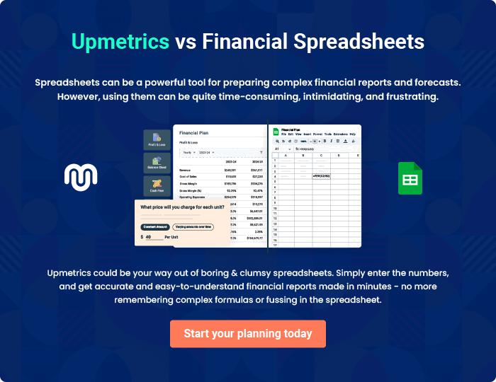
Appendix

When writing the appendix section, you should include any additional information that supports the main content of your plan. This may include financial statements, market research data, legal documents, and other
To unlock help try Upmetrics! 
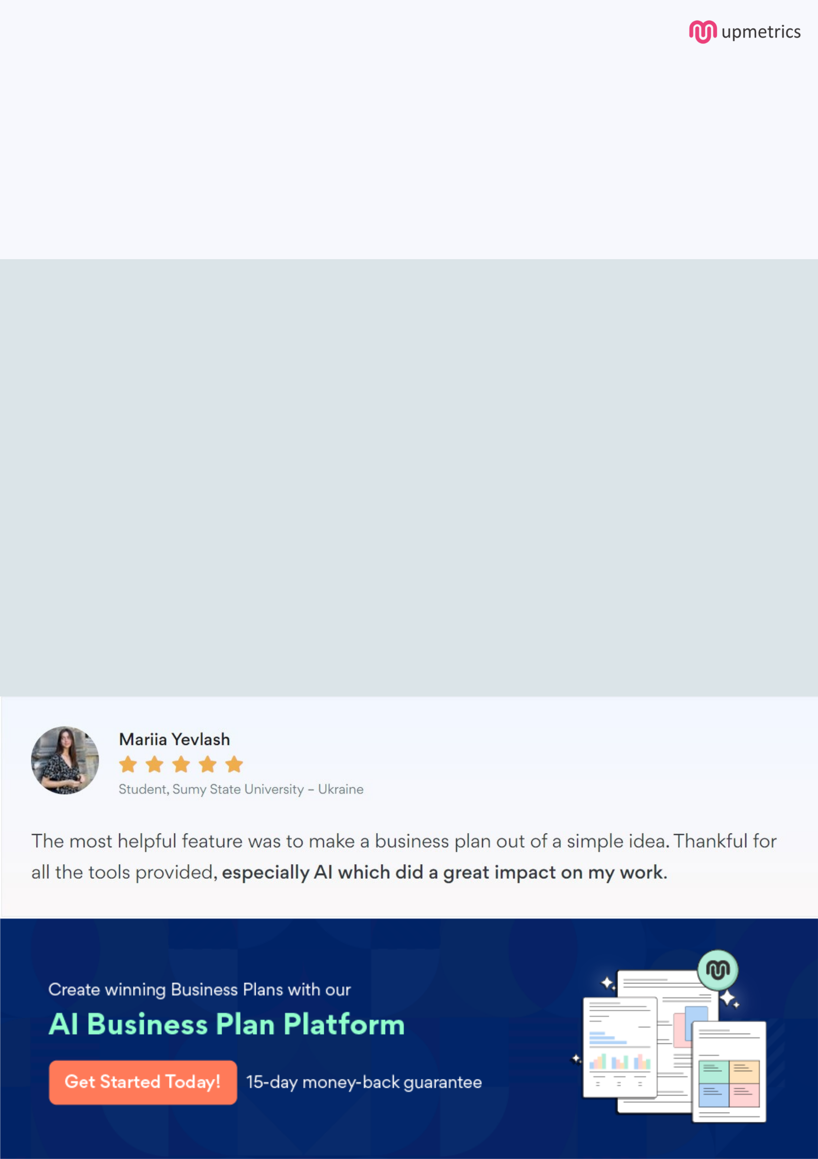
Create a winning business plan that gets you funded

Creating a stunning and investment-ready plan requires no writing, graphic designing, or financial planning expertise.

Upmetrics has all the features required to help you create a comprehensive business plan—from start to finish. Make no mistakes, it’s the modern way of planning to structure ideas, make plans, and create stunning pitch decks to awe investors.

Pitch decks that impress investors

Create pitch decks that provide a visual representation of your business, engage investors, and make them want to invest in your business idea.

Interactive plans in no time

Import business plan sections like—SWOT analysis, comparison tables, and others to create an interactive business plan. No designing skills are required.

Stunning cover page designs

With Upmetrics, you have the liberty to choose from multiple stunning cover page designs. Choose a creative design and make your plan stand out.

Online sharing made simple

Upmetrics makes online sharing quick and easier for users. Easily share your business plans with a link while tracking reader activity.

500+ sample business plans

Simply import a template from our library of sample plans into the editor and start customizing it to make it yours. It takes only a few clicks to get started.

Collaborate with team in real-time

Invite team members, initiate conversations, discuss ideas & strategies, share feedback, and work on a business plan in real-time.

