

General Contractor

Business Plan

From Blueprint to Reality

Business Plan

2023

John Doe

10200 Bolsa Ave, Westminster, CA, 92683

- 359-3153 info@example.com http://www.example.com

Information provided in this business plan is unique to this business and confidential; therefore, anyone reading this plan agrees not to disclose any of the information in this business plan without prior written permission of the company.
Table of Contents

Executive Summary | 6
Market opportunity | 6
Services Offered | 6
Marketing & Sales Strategies | 7
Financial Highlights | 7
Units Sold v/s Revenue | 8

Company Overview | 9
Ownership | 9
Business Owners | 9
Mission statement | 10
Business history | 10
Future goals | 10

Market Analysis | 11
Target Market | 11
Market size and growth potential | 11
Market Size | 12
Competitive analysis | 12
XYZ Constructions | 12
BuildTech Enterprises | 13
FastBuild Inc. | 13
Market trends | 14
Regulatory environment | 14

Products and Services | 16
Services | 16
Construction Project Managemen | 16
Renovation Services | 18
Budgeting or Cost Estimation Services | 18
Project Coordination | 19
Maintenance and Repair | 19
Service Process | 20
Case Studies | 20
Additional Services | 20

Sales And Marketing Strategies | 21
Unique Selling Proposition (USP) | 21
Pricing Strategy | 21
Marketing strategies | 22
Online | 22
Offline | 22
Sales strategies | 23
Customer retention | 24

Operations Plan | 25
Staffing & Training | 25
Operational Policies and Procedures | 25
Equipment & Technologies | 26
Contingency Plans | 26

Management Team | 27
Key managers | 27
John Doe | 28
Jane Doe | 29
Alice Brown | 29
Robert Brown | 29
Organizational structure | 30
Organization chart | 30
Compensation plan | 30
Advisors/Consultants | 31
Dr. Alan Turner | 31
Ms. Emily Harris | 31
Financial Plan | 32
Profit & loss statement | 32
Cash flow statement | 35
Balance sheet | 37
Break-even Point | 39
Financing needs | 40
Appendix
Appendix | 42
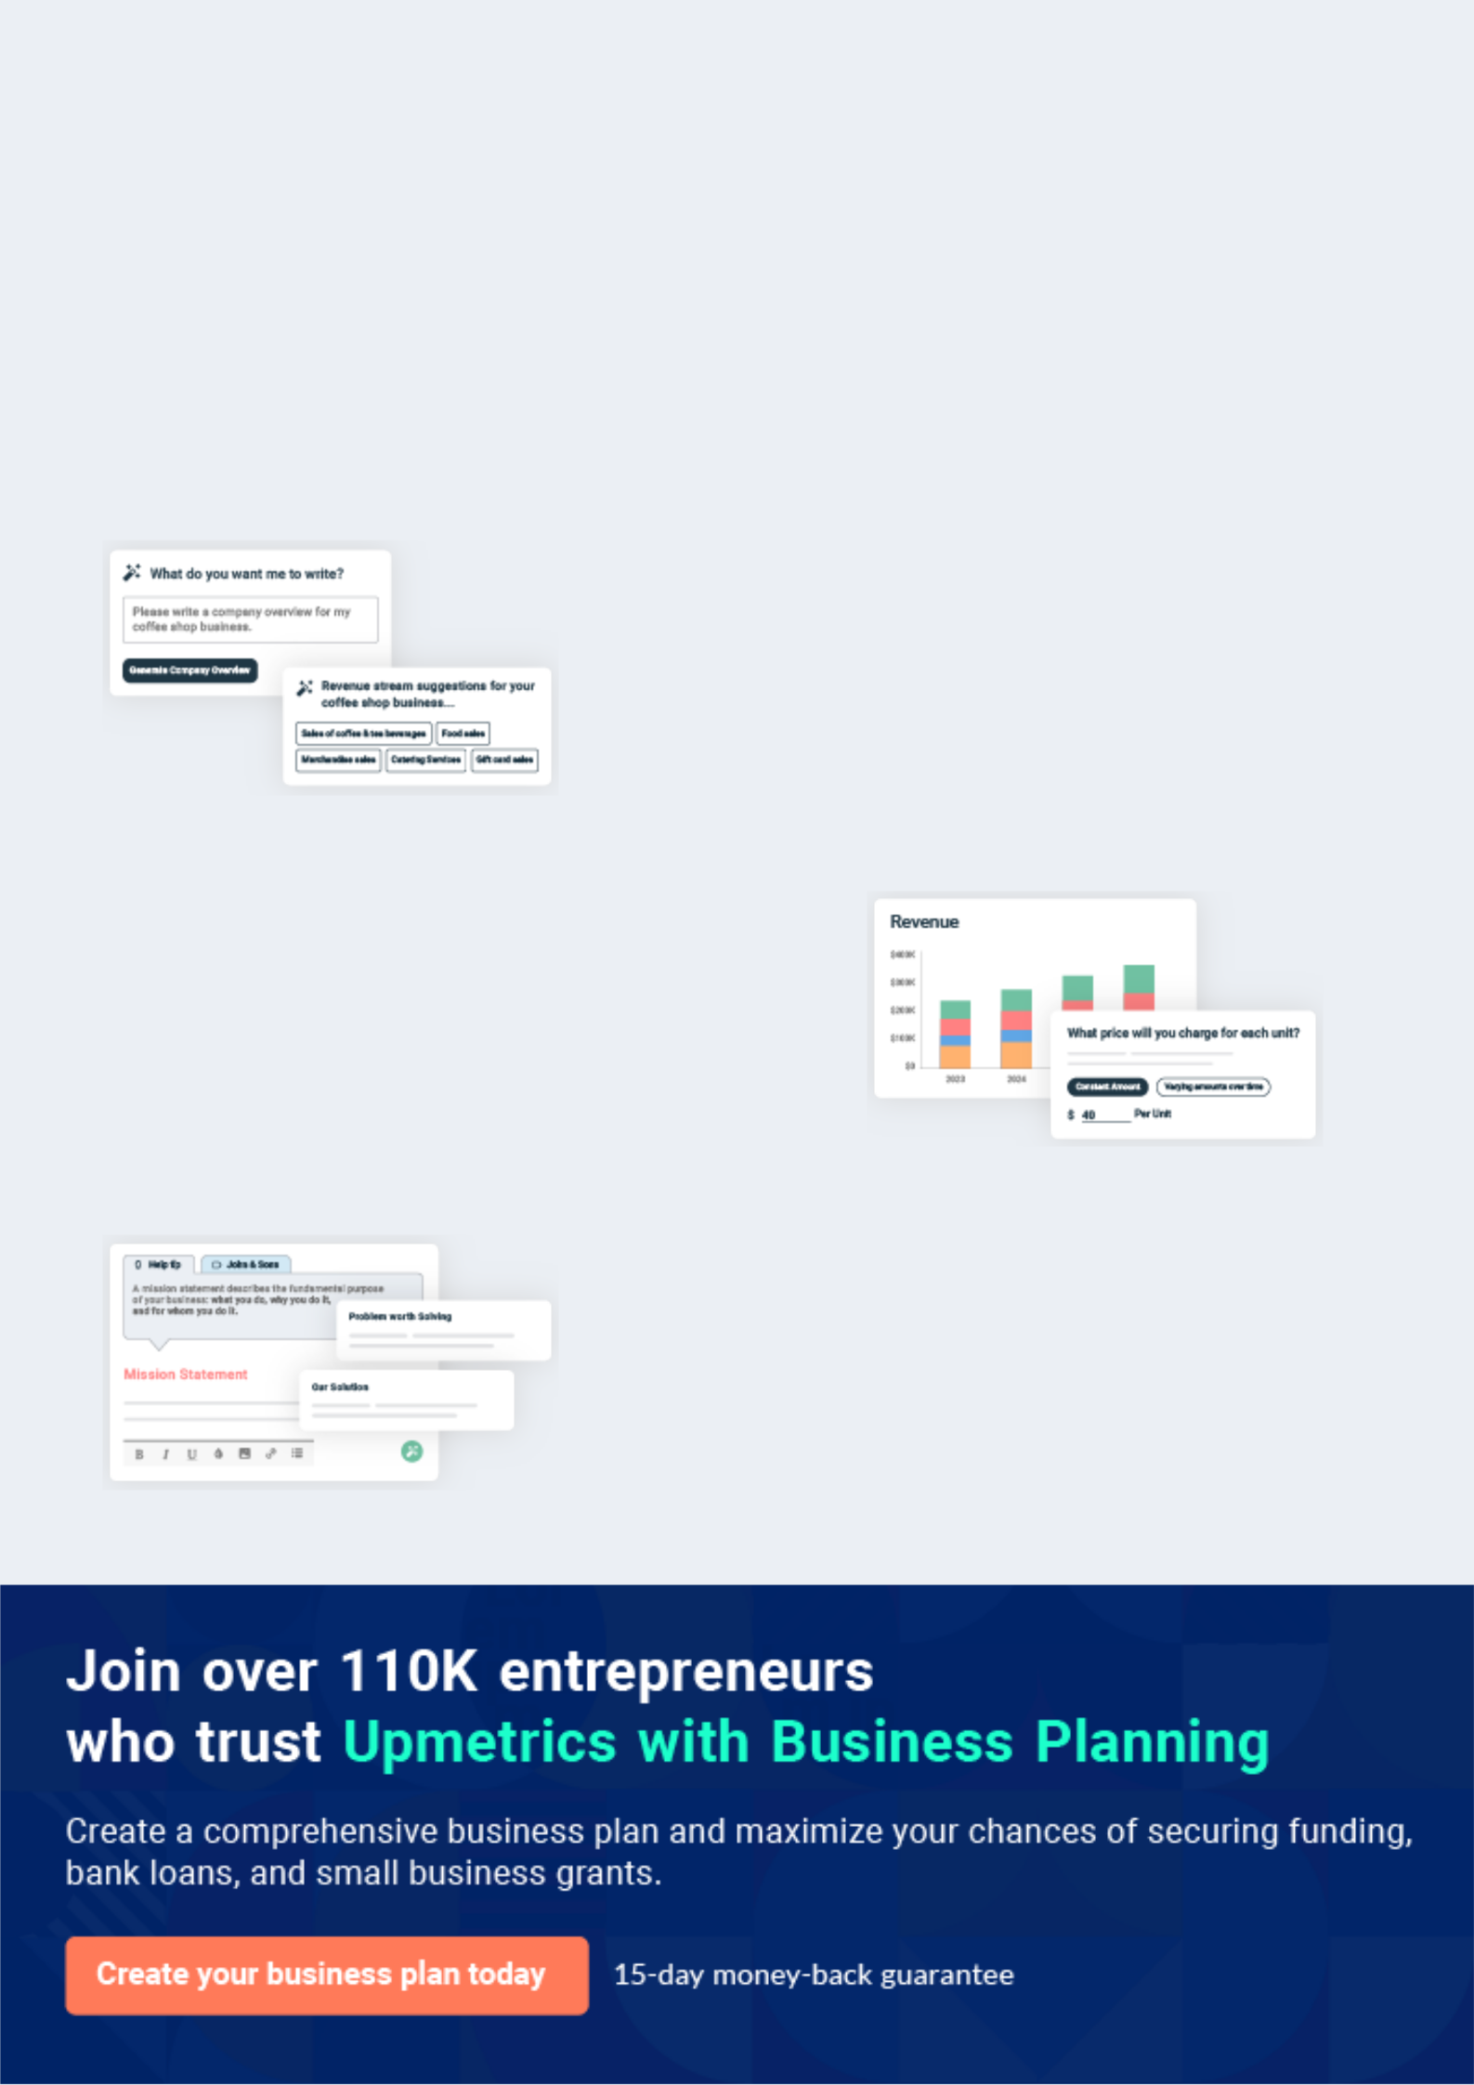
Business planning that’s simpler and faster than you think

Creating a business plan using Upmetrics to start and grow a business is literally the easiest thing in the World. Simply read the instructions and fill in the blanks. It’s as simple as that.

❛ | Upmetrics has everything you need to create a | ❜
❛ | comprehensive business plan. | ❜

AI-powered Upmetrics Assistant

AI-powered insights to streamline your plan

Not sure where to start? Upmetrics’ AI Assistant will automatically generate ideas for each section of your plan and offer improved versions of your writing, adjusting for tone, voice, and grammar or spelling errors.

Financial Forecasting Tool

All the financials are calculated for you

Forget the complex formulas and clumsy spreadsheets — with automatic financials and drag-and-drop forecasting, you can finish your plan faster and be confident that your numbers are accurate.

Business Plan Builder

Guides you like a business mentor

Upmetrics’ step-by-step instructions, prompts, and the library of 400+ sample business plans will guide you through each section of your plan as a business mentor.
Executive Summary


An executive summary is the first section of the business plan intended to provide an overview of the whole business plan.
To unlock help try Upmetrics! 

 Help tip  General Contractor Business Plan


Start your executive summary section by briefly introducing your business to your readers.

To unlock help try Upmetrics! 

Start writing here..

Market opportunity

 Help tip  General Contractor Business Plan

Summarize your market research, including market size, growth potential, and marketing trends. Highlight the opportunities in the market and how your business will fit in to fill the gap.
To unlock help try Upmetrics! 

Start writing here..

Services Offered

 Help tip  General Contractor Business Plan

Highlight the general contracting services you offer your clients. The USPs and differentiators you offer are always a plus.
To unlock help try Upmetrics! 

Start writing here..

Marketing & Sales Strategies
To unlock help try Upmetrics!

 Help tip  General Contractor Business Plan

Outline your sales and marketing strategies—what marketing platforms you use, how you plan on acquiring customers, etc.
To unlock help try Upmetrics! 

Start writing here..

Financial Highlights

 Help tip  General Contractor Business Plan

Briefly summarize your financial projections for the initial years of business operations. Include any capital or investment requirements, associated startup costs, projected revenues, and profit forecasts.



Start writing here..
Units Sold v/s Revenue

 |  | Units Sold | Revenue
15.00k
10.00k
5.00k
0
Year 1 | Year 2 | Year 3
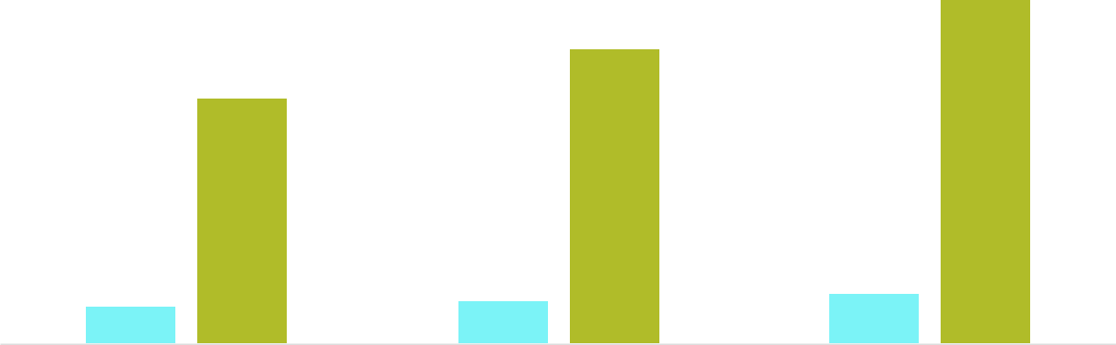

Financial Year |  |  | Units Sold | Revenue
Year 1 | 1,550 |  |  | $10,000
Year 2 | 1,800 |  |  | $12,000
Year 3 | 2,050 |  |  | $14,000
 Help tip |  |  General Contractor Business Plan


Summarize your executive summary section with a clear CTA, for example, inviting investors to discuss the potential business investment.
To unlock help try Upmetrics! 

Write a call to action for your business plan.
Company Overview

Depending on what details of your business are essential, you’ll need different elements in your business overview.
To unlock help try Upmetrics! 

 Help tip  General Contractor Business Plan

Describe what kind of general contracting company you operate and the name of it. You may specialize in one of the following types of construction projects:
To unlock help try Upmetrics! 

Start writing here..

Ownership

 Help tip  General Contractor Business Plan

List the names of your general contracting company’s founders or owners. Describe what shares they own and their responsibilities for efficiently managing the business.
To unlock help try Upmetrics! 

Start writing here..

Business Owners



60% John Doe



40% Jane Doe
Mission statement

 Help tip  General Contractor Business Plan

Summarize your business’ objective, core principles, and values in your mission statement. This statement needs to be memorable, clear, and brief.
To unlock help try Upmetrics! 

❛ "At [ABC General Contractors], our mission is to bring dreams to life. Rooted in integrity, innovation, and an unwavering commitment to quality, we strive to exceed client expectations, champion sustainable practices, and foster community growth

with every project we undertake."
❜

Business history

 Help tip  General Contractor Business Plan

If you’re an established general contracting service provider, briefly describe your business history, like—when it was founded, how it evolved over time, etc.
To unlock help try Upmetrics! 

Start writing here..

Future goals

 Help tip  General Contractor Business Plan

It’s crucial to convey your aspirations and vision. Mention your short-term and long-term goals; they can be specific targets for revenue, market share, or expanding your services.
To unlock help try Upmetrics! 

Start writing here..

Market Analysis
To unlock help try Upmetrics!


 |  | Market analysis provides a clear understanding of the market in which your
 |  | printing business will run along with the target market, competitors, and
 |  | growth opportunities.
 |  |  |  | To unlock help try Upmetrics! 
 Help tip |  |  General Contractor Business Plan

To write the introduction section of your market analysis, start by clearly identifying your primary target market.
To unlock help try Upmetrics! 

Start writing here..

Target Market

 Help tip  General Contractor Business Plan

Start this section by describing your target market. Define your ideal customer and explain what types of services they prefer. Creating a buyer persona will help you easily define your target market to your readers.



Start writing here..

Market size and growth potential

 Help Tip  General Contractor Business Plan


Describe your market size and growth potential and whether you will target a niche or a much broader market.
To unlock help try Upmetrics! 

Start writing here..

Market Size

Available Market

Customers in [Region/City] who can | 1M
afford and are interested in premium | 1M
construction services.
Served Market | 600k
Homeowners & developers in [Region/ | 600k
City] seeking sustainable construction | 600k
solutions.
Target Market | 200k
Homeowners & developers in [Region/ | 200k
City] seeking sustainable construction | 200k

solutions.

 Help tip  General Contractor Business Plan

Identify and analyze your direct and indirect competitors. Identify their strengths and weaknesses, and describe what differentiates your general contracting services from them.
To unlock help try Upmetrics! 

Competitive analysis

XYZ Constructions

Founded in [2005], XYZ Constructions has been a prominent player in the [Region/City] construction scene, with over [300] successful projects under its belt. The firm primarily specializes in commercial and residential projects.

Features

High-rise commercial building construction

Custom residential projects

Pre-construction consulting services

Interior design and finishing services

Strengths

With nearly two decades in the industry, XYZ has a wealth of experience.

Numerous industry awards and positive client testimonials.

Their in-house interior design team offers clients an end-to-end solution.

Weaknesses

XYZ's premium pricing can be a barrier for some clients.

Limited capacity to manage multiple large projects concurrently.

Past projects have sometimes faced delays in completion.

BuildTech Enterprises

Established in [2010], BuildTech Enterprises focuses on green building and sustainable construction practices, having completed over [150] projects that meet internationally recognized green building standards.

Features | Strengths
Eco-friendly residential | Leading the charge in green
constructions | building practices in the region.
Sustainable commercial | Accredited by international
projects | green building councils.
Retrofitting services for energy | A pioneer in introducing new
efficiency | sustainable materials and
Green consultation and audit | construction techniques.
services

Weaknesses

Primarily serves a specific market segment, limiting broader appeal.

Green construction can be expensive, making it less attractive to budget-conscious clients.

Relies heavily on specific suppliers for unique materials, potentially causing supply chain disruptions

FastBuild Inc.

A relatively new entrant, founded in [2018], FastBuild Inc. focuses on rapid construction techniques, aiming to cut traditional construction times in half.

Features | Strengths | Weaknesses
Quick residential project | Their rapid construction | Speedy constructions have led to
completion | methods promise faster project | questions about the longevity
Speedy commercial | completion. | and durability of their projects.
constructions | Offers flexibility and scalability | Being newer to the market, they
Modular building solutions | in design. | have fewer completed projects to
Modular building solutions |  | showcase.
 | Adoption of new-age | showcase.
Pre-fabricated components | Adoption of new-age
Pre-fabricated components | construction technologies. | Their methods often require
 |  | more manpower, leading to
 |  | higher labour costs.

Market trends
To unlock help try Upmetrics!

 Help tip  General Contractor Business Plan

Analyze emerging trends in the industry, such as technology disruptions, changes in customer behavior or preferences, etc. Explain how your business will cope with all the trends.
To unlock help try Upmetrics! 

Start writing here..

Regulatory environment

 Help tip  General Contractor Business Plan

List regulations and licensing requirements that may affect your general contracting company, such as business registration, insurance, environmental regulations, state and federal regulations, etc.



Start writing here..
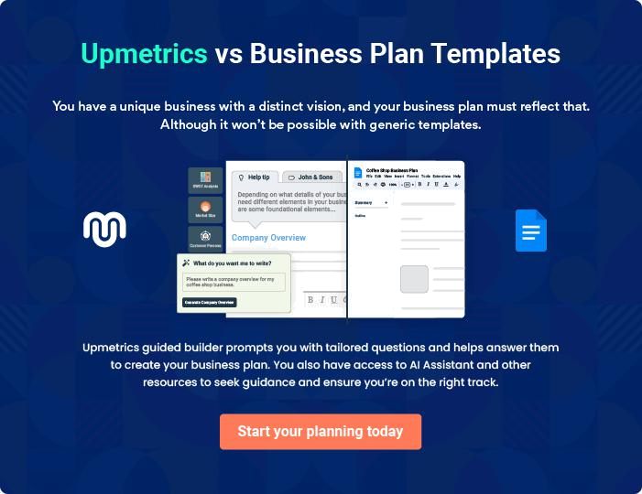
Products and Services

The product and services section of a general contractor business plan should describe the specific services and products that will be offered to customers. To write this section should include the following:
To unlock help try Upmetrics! 

 Help tip  General Contractor Business Plan

To craft the introduction for your "Products and Services" chapter, begin by positioning your business within its industry, emphasizing its unique strengths or value proposition.
To unlock help try Upmetrics! 

Start writing here..

 Help tip


Mention the services your contracting business will offer. This list may include services like,

• Construction project management
To unlock help try Upmetrics! 

Services

Construction Project Managemen


Price: $[XX,XXX] per project (Variable based on project size and complexity)

Comprehensive management of the entire construction project, ensuring timely completion, budget adherence, and superior quality.
Specifications

- Initial project assessment and consultation

- Stakeholder communication and coordination

- Regular project monitoring and reporting

- Quality assurance at each construction phase

- Final project review and handover
Renovation Services

Price: $[X,XXX] per room (Variable based on room size and requirements)

Tailored solutions to revamp and rejuvenate spaces, enhancing their aesthetic and functional appeal.

Specifications

- Space evaluation and consultation

- Customized design proposals

- Material and labor coordination

- Quality checks post-completion

- Clean-up and final walkthrough

Budgeting or Cost Estimation Services

Price: $[XXX] per consultation

Detailed financial planning and project estimation to provide clarity and efficient budget utilization.

Specifications

- Initial financial consultation

- Detailed cost breakdown structure

- Regular budget monitoring

- Financial reporting at each project milestone

- Final budget reconciliation
Project Coordination

Price: $[X,XXX] per month

Seamless coordination of project operations, from liaising with stakeholders to on-ground execution.

Specifications

- Dedicated project coordinator assignment

- Regular project updates and meetings

- On-ground team management

- Conflict resolution (if any)

- Project timeline adherence

Maintenance and Repair

Price: Starting at $[XXX] (Variable based on the extent of maintenance/repair required)

Ensuring the longevity and durability of constructed spaces through routine maintenance and efficient repair solutions.

Specifications

- Periodic site inspections

- Customized maintenance plans

- Immediate repair interventions for urgent issues

- Quality assurance post-repair

- Maintenance and repair reports
Service Process

 Help tip  General Contractor Business Plan


Provide a detailed description of your service process, from initial consultation and planning to
project completion. Include any unique or proprietary processes you follow to ensure quality
and efficiency.
 |  |  |  |  | To unlock help try Upmetrics! 
Start writing here..
Case Studies
 Help tip |  |  |  General Contractor Business Plan

Provide case studies and testimonials from your satisfied customers. Showcasing successful projects and client testimonials will bring credibility to your business plan.
To unlock help try Upmetrics! 

Start writing here..

Additional Services

 Help tip  General Contractor Business Plan

Mention if your general contracting company offers any additional services. You may include services like regulatory compliance, permit acquisition, design-build services, etc.
To unlock help try Upmetrics! 

Start writing here..
Sales And Marketing Strategies
To unlock help try Upmetrics!

Writing the sales and marketing strategies section means a list of strategies you will use to attract and retain your clients.
To unlock help try Upmetrics! 

 Help Tip  General Contractor Business Plan

To create an effective introduction for your "Sales and Marketing Strategies" chapter, start by setting the stage within your specific industry or market.
To unlock help try Upmetrics! 

Start writing here..

Unique Selling Proposition (USP)

 Help tip  General Contractor Business Plan

Define your business’s USPs depending on the market you serve and the unique services you provide. Identifying USPs will help you to plan your marketing strategies.
To unlock help try Upmetrics! 

Start writing here..

Pricing Strategy

 Help tip  General Contractor Business Plan

Describe your pricing strategy—how you plan to price your services and stay competitive in the local market. You can mention any discounts you plan to attract new customers to your contracting service.



Start writing here..

 Help tip  General Contractor Business Plan
To unlock help try Upmetrics!

Discuss your marketing strategies to market your services. You may include some of these marketing strategies in your business plan—social media marketing, Google ads, brochures, email marketing, content marketing, and print marketing.



Marketing strategies

Online


Social Media

Harnessing platforms like Facebook, Instagram, and LinkedIn, we curate engaging content, fostering community-building and brand recognition.

Content Marketing

Through insightful blogs and articles on our website, we position ourselves as thought leaders in the construction domain.

Email Marketing

Regular newsletters and project updates are disseminated to our client base, nurturing leads and ensuring top-of-mind recall.

Google Ads

By targeting specific keywords and demographics, we ensure that [ABC General Contractors] remains prominent in relevant search queries.

Offline

Brochures

High-quality, informative brochures are distributed at industry events, real estate offices, and to potential clients, providing a tangible overview of our offerings.

Print Marketing

Leveraging traditional media, we run periodic ads in renowned construction magazines and local newspapers.

 Help tip
To unlock help try Upmetrics!

Outline the strategies you’ll implement to maximize your sales. Your sales strategies may include direct sales calls, partnering with real estate developers, proposal planning, negotiation tactics, etc.



Sales strategies

Real Estate Developer Partnerships

By forming alliances with prominent real estate developers, we ensure a steady influx of projects and mutual growth.

Proposal Planning

Each proposal is meticulously crafted, aligning with client requirements and showcasing our expertise.

Direct Sales Calls

Our dedicated sales team undertakes regular outreach, connecting with potential clients to discuss their needs and offer tailored solutions.

Negotiation Tactics

Our team is trained in effective negotiation, ensuring mutually beneficial terms and long-lasting partnerships

 Help tip

Describe your customer retention strategies and how you plan to execute them. For instance, introducing loyalty programs, offering excellent customer service, etc.
To unlock help try Upmetrics! 

Customer retention

Loyalty Programs

Repeat clients can avail of special discounts and exclusive offers, rewarding their continued patronage.

Personalized Service

Offering tailored solutions and dedicated account managers for personalized assistance.

Excellent Customer Service

Our post-project support, prompt grievance redressal, and consistent communication ensure clients remain loyal to the ABC brand.

Operations Plan
To unlock help try Upmetrics!
To unlock help try Upmetrics!

 |  | When writing the operations plan section, it’s important to consider the
 |  | various aspects of your business operations.
 |  |  |  | To unlock help try Upmetrics! 
 Help tip |  |  General Contractor Business Plan


To create an effective introduction for your "Operational Plan" chapter, start by emphasizing the
pivotal role of efficient operations in the success of your business, underscoring how they
directly impact the quality of services delivered.
 |  |  |  | To unlock help try Upmetrics! 
Start writing here..
Staffing & Training
 Help tip |  |  General Contractor Business Plan

Mention your business’s staffing requirements, including the number of employees, construction workers or subcontractors (e.g. electrical contractor, roofing contractor, painting contractor, etc.)needed.



Start writing here..

Operational Policies and Procedures

 Help tip  General Contractor Business Plan

Outline the operational policies and procedures you will follow to run your general contractor business. These procedures may include standard operating procedures(SOPs), quality control measures, safety protocols, etc.



Start writing here..

Equipment & Technologies

 Help tip  General Contractor Business Plan

Include the list of equipment and technology required in a general contractor business, such as
construction tools, project management software, safety equipment, green building technology,
survey equipment, etc.
 |  |  |  | To unlock help try Upmetrics! 
Start writing here..
Contingency Plans
 Help tip |  |  General Contractor Business Plan

Provide emergency plans for potential emergencies or disasters, such as natural disasters, accidents, equipment failures, and other unanticipated events.
To unlock help try Upmetrics! 

Start writing here..
Management Team
To unlock help try Upmetrics!

The management team section provides an overview of the individuals responsible for running your business plan.
To unlock help try Upmetrics! 

 Help tip  General Contractor Business Plan

To craft an introduction for your "Management Team" chapter, begin by emphasizing the crucial role of leadership in the success of any business.
To unlock help try Upmetrics! 

Start writing here..

Key managers

 Help tip  General Contractor Business Plan

Introduce your management and key members of your team, and explain their roles and responsibilities. You will need to provide this information depending on the size of your company and the number of employees you have.



Start writing here..

JOHN DOE

CEO - john.doe@example.com

As the driving force behind ABC General Contractors, John is tasked with setting the company's strategic direction, managing client relationships, and overseeing its financial health.


His visionary leadership has consistently enabled the company to scale new heights and outperform in a highly competitive market.

- Educational Background: John holds an MBA from Harvard Business School and a Bachelor’s in Civil Engineering from Stanford University.

- Professional Background: Prior to founding ABC General Contractors, John held significant roles at leading construction conglomerates, contributing to mega projects worth billions.

JANE DOE

Chief Operating Officer (COO) - jane.doe@example.com

Jane manages the company's day-to-day operations, ensuring that projects adhere to their timelines and the company's standards of excellence.

She also plays a pivotal role in managing ground staff and optimising operational procedures.

- Educational Background: Jane has a Master's in Project Management from MIT and a Bachelor's in Architecture from Cornell University.

- Professional Background: With over 15 years in the construction industry, Jane has managed operations for various large-scale projects nationwide.


ALICE BROWN

General Cont. - alice.brown@example.com

Alice liaises with clients and manages subcontractors to ensure each project's seamless execution. She plays a critical role in maintaining the company's reputation for quality and efficiency.

- Educational Background: Alice possesses a Bachelor’s in Building Construction Management from the University of Florida.

- Professional Background: With a decade of hands-on experience, Alice has been at the forefront of many iconic projects, driving them to successful completion.


ROBERT BROWN

Safety Manager - robert.brown@example.com

Robert ensures the utmost safety at all of [ABC General Contractors'] sites. He enforces safety protocols, conducts regular safety drills, and ensures compliance with industry standards.

- Educational Background: Robert is certified in Occupational Safety from the National Safety Council and has a Bachelor's in Environmental Health from Yale University.

- Professional Background: Before joining ABC, Robert was the head of safety at a major construction firm, where he implemented innovative safety measures that reduced incidents by 40%.
Organizational structure

 Help tip  General Contractor Business Plan

Explain the organizational structure of your management team. Include the reporting line and decision-making hierarchy.
To unlock help try Upmetrics! 

Start writing here..

Organization chart


John Doe

CEO
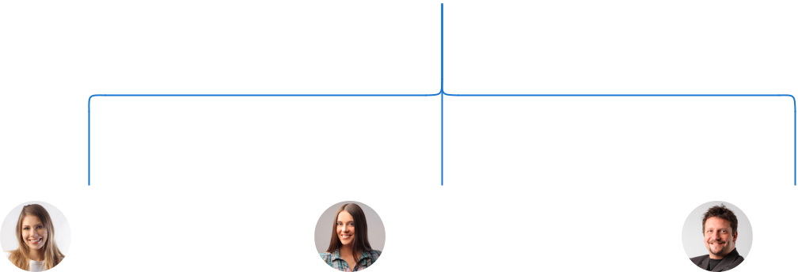

Jane Doe Alice Brown Robert Brown

COO General Contractor Safety Manager
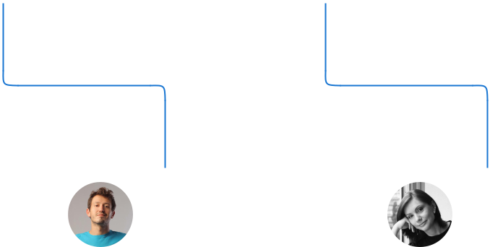

Peter Green Lucy Black

Lead Engineer Sales Manager

Compensation plan

 Help tip  General Contractor Business Plan

Describe your compensation plan for the management and staff. Include their salaries, incentives, and other benefits.
To unlock help try Upmetrics! 

Start writing here..

 Help tip

Mentioning advisors or consultants in your business plans adds credibility to your business idea.
To unlock help try Upmetrics! 

Advisors/Consultants


DR. ALAN TURNER

Advisor

A luminary in [e.g., sustainable construction], Dr Turner's consultancy ensures our projects align with green building best practices.


MS. EMILY HARRIS

Consultant

Specializing in [e.g., construction legalities], Ms. Harris ensures our operations remain compliant with industry norms.
Financial Plan

When writing the financial plan section of a business plan, it’s important to provide a comprehensive overview of your financial projections for the first few years of your business, You may provide the following:
To unlock help try Upmetrics! 

 Help tip  General Contractor Business Plan


To create an effective introduction for your "Financial Plan" chapter, begin by stressing the critical role of a well-structured financial plan in the success of your venture.
To unlock help try Upmetrics! 

Start writing here..

 Help tip


Describe details such as projected revenue, operational costs, and service costs in your projected profit and loss statement. Make sure to include your business’s expected net profit or loss.
To unlock help try Upmetrics! 

Profit & loss statement

Revenue

Cost Of Sales

General Costs

Revenue Specific Costs

Personnel Costs (Direct

Labor)

Gross Margin

Gross Margin (%)

Operating Expense

Payroll Expense

(Indirect Labor)

General Expense

Bad Debt

Amortization of Current

Assets

2023-24 | 2024-25 | 2025-26 | 2026-27 | 2027-28
$0 | $0 | $0 | $0 | $0

$0 | $0 | $0 | $0 | $0
$0 | $0 | $0 | $0 | $0
$0 | $0 | $0 | $0 | $0
$0 | $0 | $0 | $0 | $0

$0 | $0 | $0 | $0 | $0
0% | 0% | 0% | 0% | 0%

$0 | $0 | $0 | $0 | $0
$0 | $0 | $0 | $0 | $0
$0 | $0 | $0 | $0 | $0
$0 | $0 | $0 | $0 | $0
$0 | $0 | $0 | $0 | $0

EBITDA

Additional Expense

Long Term

Depreciation

Gain or loss from Sale

of Assets

EBIT

Interest Expenses

EBT

Income Tax Expense

Total Expense

Net Income

Net Income (%)

2023-24 | 2024-25 | 2025-26 | 2026-27 | 2027-28
$0 | $0 | $0 | $0 | $0
$0 | $0 | $0 | $0 | $0
$0 | $0 | $0 | $0 | $0
$0 | $0 | $0 | $0 | $0
$0 | $0 | $0 | $0 | $0
$0 | $0 | $0 | $0 | $0
$0 | $0 | $0 | $0 | $0
$0 | $0 | $0 | $0 | $0
$0 | $0 | $0 | $0 | $0
$0 | $0 | $0 | $0 | $0
0% | 0% | 0% | 0% | 0%
 | 2023-24 | 2024-25 | 2025-26 | 2026-27 | 2027-28
Retained Earning | $0 | $0 | $0 | $0 | $0
Opening
Owner's Distribution | $0 | $0 | $0 | $0 | $0
Retained Earning | $0 | $0 | $0 | $0 | $0
Closing

 Help tip

This section should estimate and describe the cash flow for the first few years of your operation. This may include billing invoices, payment receipts, loan payments, and any other cash flow statements.
To unlock help try Upmetrics! 

Cash flow statement

 | 2023-24 | 2024-25 | 2025-26 | 2026-27 | 2027-28
Cash Received | $0 | $0 | $0 | $0 | $0
Cash Paid | $0 | $0 | $0 | $0 | $0
COS & General Expenses | $0 | $0 | $0 | $0 | $0
Salary & Wages | $0 | $0 | $0 | $0 | $0
Interest | $0 | $0 | $0 | $0 | $0

Sales Tax

Income Tax

Net Cash From

Operations

Assets Sell

Assets Purchase

Net Cash From

Investments

Amount Received

Loan Received

Common Stock

Preferred Stock

Owner's Contribution

Amount Paid

2023-24 | 2024-25 | 2025-26 | 2026-27 | 2027-28
$0 | $0 | $0 | $0 | $0
$0 | $0 | $0 | $0 | $0
$0 | $0 | $0 | $0 | $0

$0 | $0 | $0 | $0 | $0
$0 | $0 | $0 | $0 | $0
$0 | $0 | $0 | $0 | $0

$0 | $0 | $0 | $0 | $0
$0 | $0 | $0 | $0 | $0

$0 | $0 | $0 | $0 | $0
$0 | $0 | $0 | $0 | $0
$0 | $0 | $0 | $0 | $0

Loan Capital $0 $0 $0 $0 $0

 | 2023-24 | 2024-25 | 2025-26 | 2026-27 | 2027-28
Dividends & Distributions | $0 | $0 | $0 | $0 | $0
Net Cash From | $0 | $0 | $0 | $0 | $0
Financing

Summary
Starting Cash | $0 | $0 | $0 | $0 | $0
Cash In | $0 | $0 | $0 | $0 | $0
Cash Out | $0 | $0 | $0 | $0 | $0
Change in Cash | $0 | $0 | $0 | $0 | $0
Ending Cash | $0 | $0 | $0 | $0 | $0

 Help tip

Create a projected balance sheet documenting your general contractor business’s assets, liabilities, and equity.

To unlock help try Upmetrics! 

Balance sheet

 | 2023-24 | 2024-25 | 2025-26 | 2026-27 | 2027-28
Assets | $0 | $0 | $0 | $0 | $0
Current Assets | $0 | $0 | $0 | $0 | $0
Cash | $0 | $0 | $0 | $0 | $0
Accounts Receivable | $0 | $0 | $0 | $0 | $0
Inventory | $0 | $0 | $0 | $0 | $0
Other Current Assets | $0 | $0 | $0 | $0 | $0
Long Term Assets | $0 | $0 | $0 | $0 | $0
Gross Long Term Assets | $0 | $0 | $0 | $0 | $0
Accumulated Depreciation | $0 | $0 | $0 | $0 | $0

Liabilities & Equity | $0 | $0 | $0 | $0 | $0
Liabilities | $0 | $0 | $0 | $0 | $0
Current Liabilities | $0 | $0 | $0 | $0 | $0
Accounts Payable | $0 | $0 | $0 | $0 | $0
Income Tax Payable | $0 | $0 | $0 | $0 | $0
Sales Tax Payable | $0 | $0 | $0 | $0 | $0
Short Term Debt | $0 | $0 | $0 | $0 | $0
 | 2023-24 | 2024-25 | 2025-26 | 2026-27 | 2027-28
Long Term Liabilities | $0 | $0 | $0 | $0 | $0
Long Term Debt | $0 | $0 | $0 | $0 | $0
Equity | $0 | $0 | $0 | $0 | $0
Paid-in Capital | $0 | $0 | $0 | $0 | $0
Common Stock | $0 | $0 | $0 | $0 | $0
Preferred Stock | $0 | $0 | $0 | $0 | $0
Owner's Contribution | $0 | $0 | $0 | $0 | $0
Retained Earnings | $0 | $0 | $0 | $0 | $0

Check | $0 | $0 | $0 | $0 | $0

Break-even Point

 Help tip  General Contractor Business Plan

Determine and mention your business’s break-even point—the point at which your business costs and revenue will be equal.

This exercise will help you understand how much revenue you need to generate to sustain or be profitable.

To unlock help try Upmetrics! 

Start writing here..

Financing needs

 Help tip  General Contractor Business Plan

Calculate costs associated with starting a general contractor business, and estimate your financing needs and how much capital you need to raise to operate your business.
To unlock help try Upmetrics! 

Start writing here..
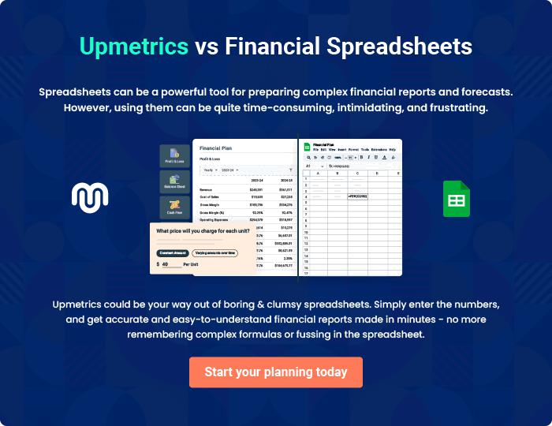
Appendix

When writing the appendix section, you should include any additional information that supports the main content of your plan. This may include financial statements, market research data, legal documents, and other
To unlock help try Upmetrics! 
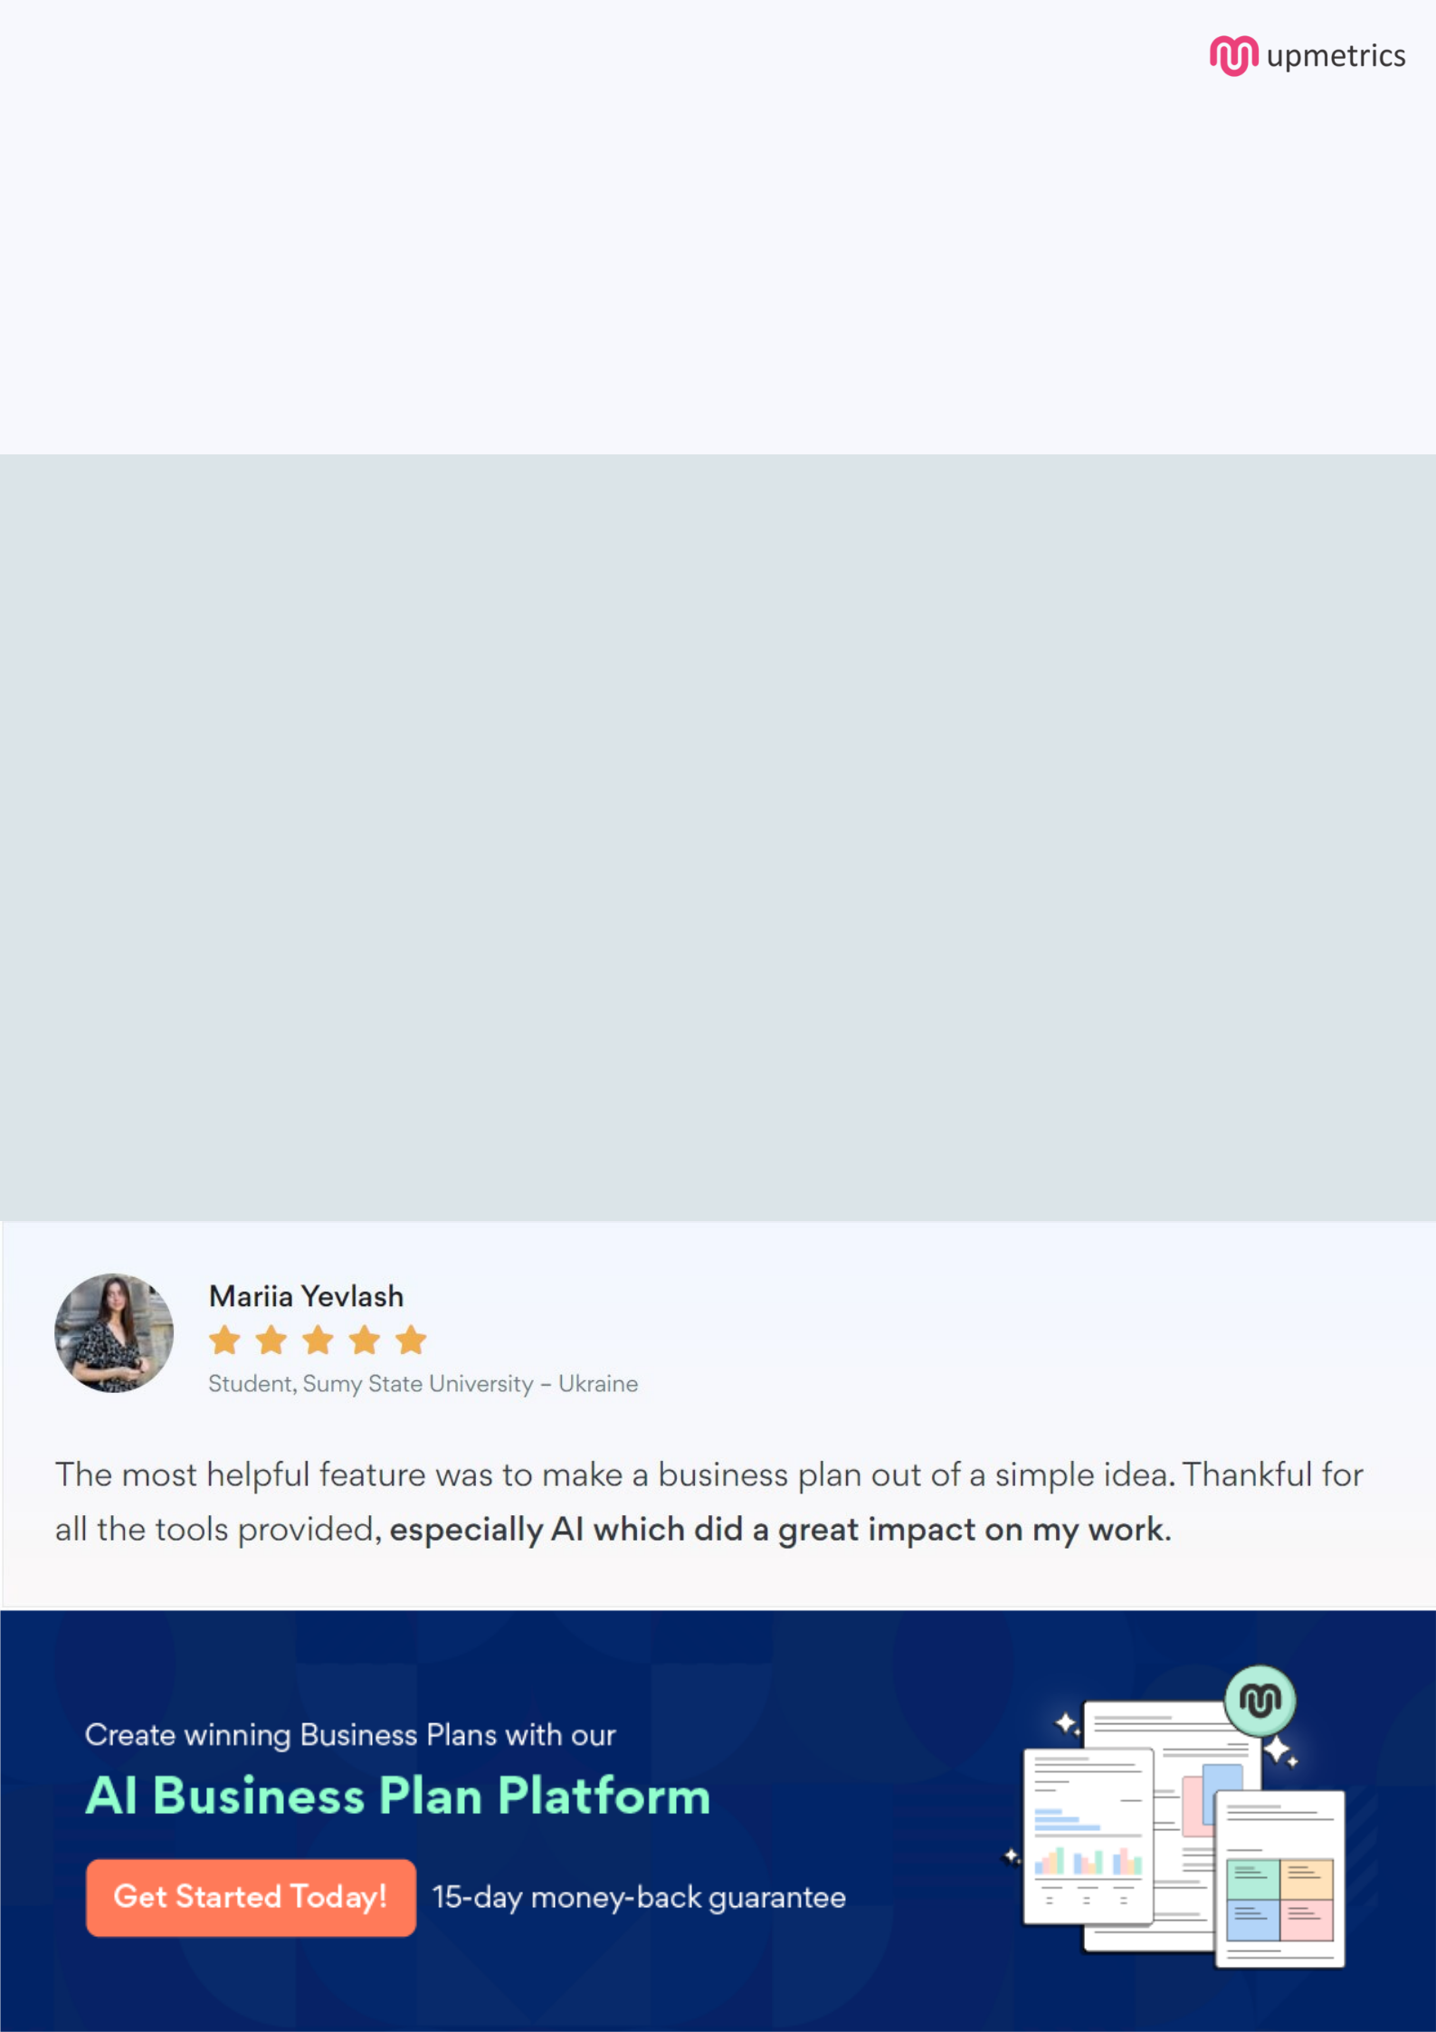
Create a winning business plan that gets you funded

Creating a stunning and investment-ready plan requires no writing, graphic designing, or financial planning expertise.

Upmetrics has all the features required to help you create a comprehensive business plan—from start to finish. Make no mistakes, it’s the modern way of planning to structure ideas, make plans, and create stunning pitch decks to awe investors.

Pitch decks that impress investors

Create pitch decks that provide a visual representation of your business, engage investors, and make them want to invest in your business idea.

Interactive plans in no time

Import business plan sections like—SWOT analysis, comparison tables, and others to create an interactive business plan. No designing skills are required.

Stunning cover page designs

With Upmetrics, you have the liberty to choose from multiple stunning cover page designs. Choose a creative design and make your plan stand out.

Online sharing made simple

Upmetrics makes online sharing quick and easier for users. Easily share your business plans with a link while tracking reader activity.

500+ sample business plans

Simply import a template from our library of sample plans into the editor and start customizing it to make it yours. It takes only a few clicks to get started.

Collaborate with team in real-time

Invite team members, initiate conversations, discuss ideas & strategies, share feedback, and work on a business plan in real-time.

