

Franchise Business Plan

BUSINESS PLAN

2023

John Doe

10200 Bolsa Ave, Westminster, CA, 92683

- 359-3153 info@example.com http://www.example.com

Information provided in this business plan is unique to this business and confidential; therefore, anyone reading this plan agrees not to disclose any of the information in this business plan without prior written permission of the company.
Table of Contents

Executive Summary | 6
Market opportunity | 6
Product or services | 6
Management team | 7
John Doe | 7
Jane Doe | 7
Alice Brown | 7
Financial Highlights | 8
Units Sold v/s Revenue | 8

Company Overview | 9
Ownership | 9
Mission statement | 10
Business history | 10
Future goals | 10

Market Analysis | 11
Target Market | 11
Market size and growth potential | 11
Market Size | 12
Competitive analysis | 12
Java Junction | 12
Brewed Awakening | 13
Market trends | 13
Regulatory environment | 13

Products and Services | 15
Products & Services List | 15
Classic Espresso | 15
Creamy Cappuccino | 16
French Vanilla Latte | 16
Almond Croissant | 17
Wi-Fi & Charging Workstation | 17
Emphasize safety and quality | 18

Sales And Marketing Strategies | 19
Unique Selling Proposition (USP) | 19
Marketing strategies | 20
Online | 20
Offline | 20
Sales strategies | 21
Customer retention | 21

Operations Plan | 22
Hiring Plan | 22
Operational Process | 22
Equipment & Technology | 23

Management Team | 24
Key managers | 24
John Doe | 25
Jane Doe | 26
Alice Brown | 26
Robert Brown | 27
Organizational structure | 27
Organization chart | 27
Compensation plan | 28
Board of advisors | 28
[ADVISOR NAME] | 28
[ADVISOR NAME] | 28

Financial Plan | 29
Profit & loss statement | 29
Cash flow statement | 32
Balance sheet | 34
Break-even Point | 36
Financing needs | 37
Appendix
Appendix | 39
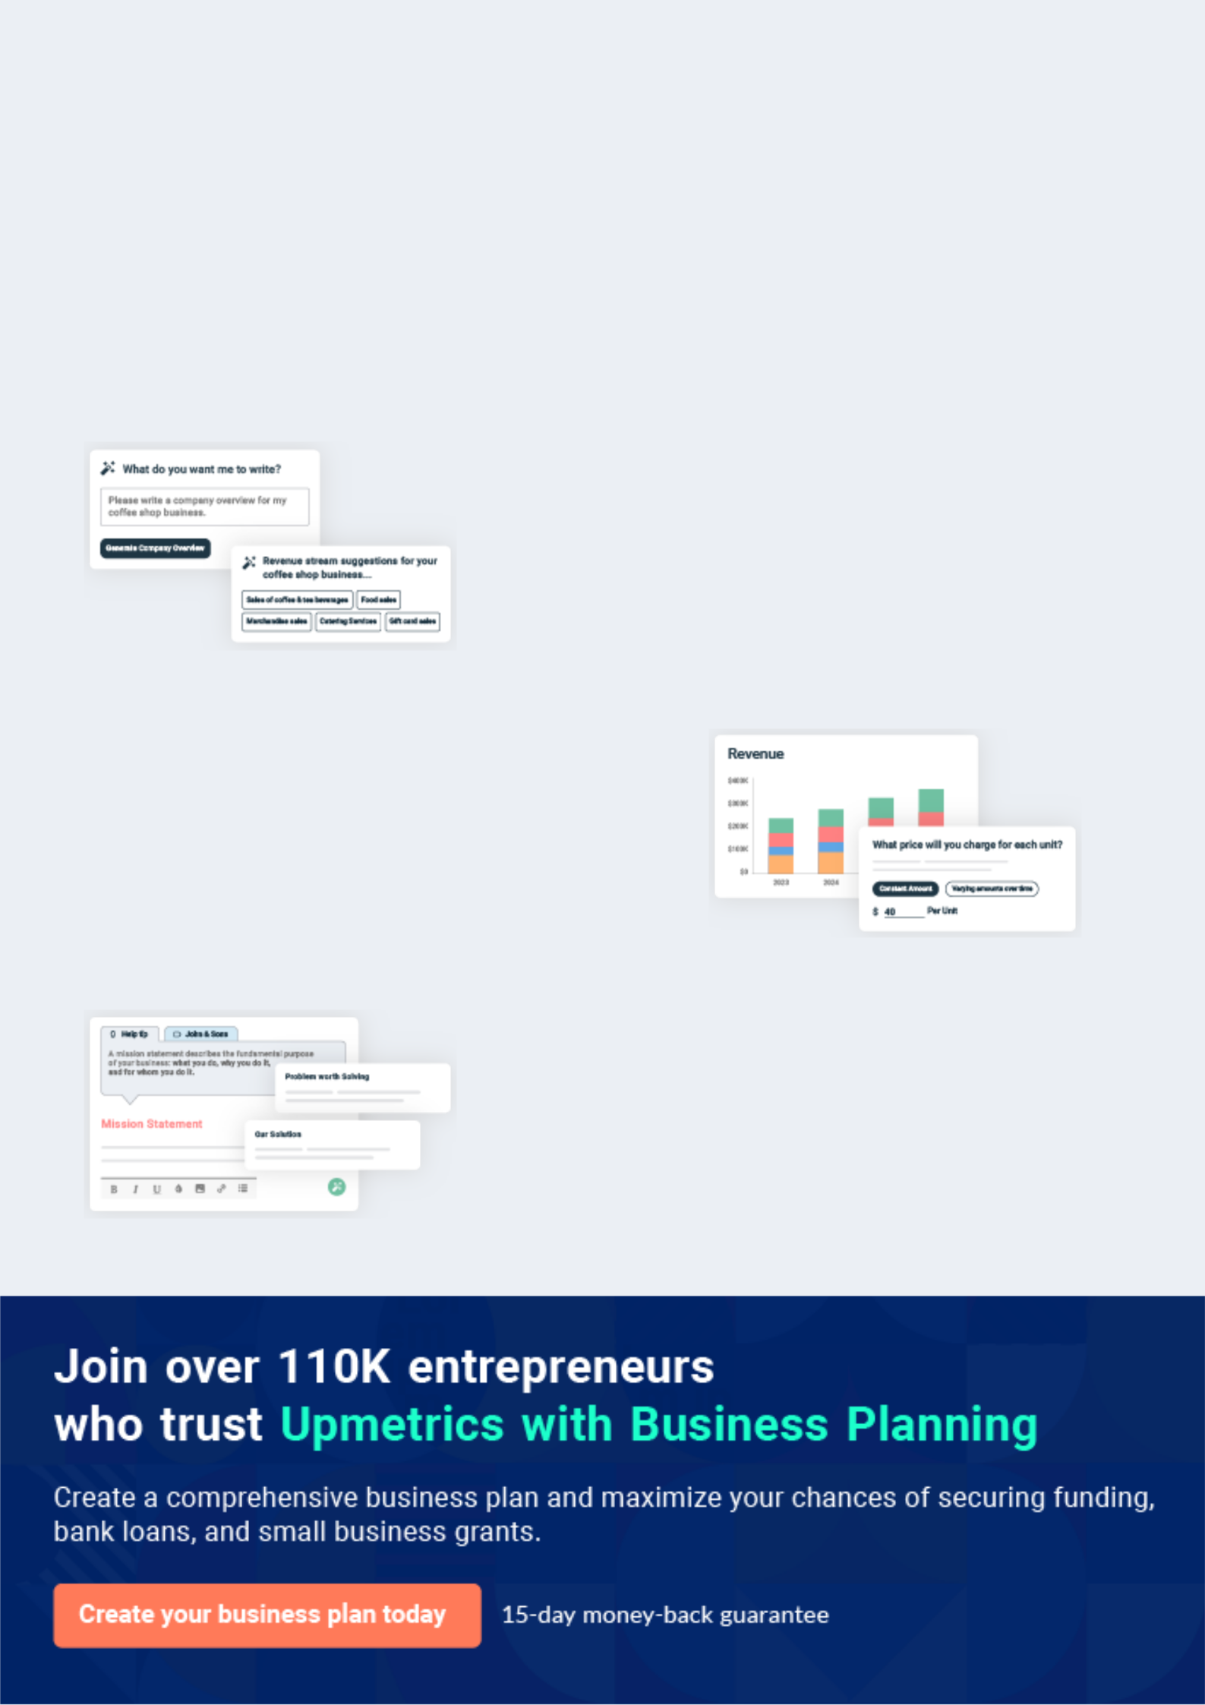
Business planning that’s simpler and faster than you think

Creating a business plan using Upmetrics to start and grow a business is literally the easiest thing in the World. Simply read the instructions and fill in the blanks. It’s as simple as that.

❛ | Upmetrics has everything you need to create a | ❜
❛ | comprehensive business plan. | ❜

AI-powered Upmetrics Assistant

AI-powered insights to streamline your plan

Not sure where to start? Upmetrics’ AI Assistant will automatically generate ideas for each section of your plan and offer improved versions of your writing, adjusting for tone, voice, and grammar or spelling errors.

Financial Forecasting Tool

All the financials are calculated for you

Forget the complex formulas and clumsy spreadsheets — with automatic financials and drag-and-drop forecasting, you can finish your plan faster and be confident that your numbers are accurate.

Business Plan Builder

Guides you like a business mentor

Upmetrics’ step-by-step instructions, prompts, and the library of 400+ sample business plans will guide you through each section of your plan as a business mentor.
Executive Summary


An executive summary is the first section of the business plan intended to provide an overview of the whole business plan.
To unlock help try Upmetrics! 

 Help tip  Franchise Business Plan


Your executive summary should explain why you want to start a franchise business. It should also explain which franchise brand you’re pursuing and what it does.
To unlock help try Upmetrics! 

Start writing here..

Market opportunity

 Help tip  Franchise Business Plan


Describe the target market in brief, and explain the demographics, geographic location, and
psychographic attributes of your customer. Explain how your franchise business meets its
needs.
 |  |  |  | To unlock help try Upmetrics! 
Start writing here..
Product or services
 Help tip |  |  Franchise Business Plan


Briefly describe what products or services a customer can expect from your business, depending on your industry and franchise type.
To unlock help try Upmetrics! 

Start writing here..

 Help tip


Name all the key members of your management team with their duties, responsibilities, and qualifications.
To unlock help try Upmetrics! 

Management team


JOHN DOE

CEO - john.doe@example.com

With over [x years] in the coffee industry and a deep understanding of the local market, [John Doe] will oversee business strategy and daily operations.


JANE DOE

COO - jane.doe@example.com

Boasting [x years] of franchise management, [Partner/Manager Name] will focus on operations, ensuring efficiency and adherence to [Franchise Brand Name]'s standards.


ALICE BROWN

Marketing Director - alice.brown@example.com

With a proven track record in [specific achievement or company e.g., "boosting sales by 20% at XYZ Coffee Co."], [Team Member Name] will spearhead our marketing and branding efforts.
Financial Highlights

 Help tip  Franchise Business Plan

Provide a summary of your financial projections for the business’s initial years of operation.

Include any capital or investment requirements, startup costs, projected revenues, and profits.
To unlock help try Upmetrics! 

Start writing here..

Units Sold v/s Revenue

 |  | Units Sold | Revenue
15.00k
10.00k
5.00k
0
Year 1 | Year 2 | Year 3


Financial Year |  |  | Units Sold | Revenue
Year 1 | 1,550 |  |  | $10,000
Year 2 | 1,800 |  |  | $12,000
Year 3 | 2,050 |  |  | $14,000
 Help tip |  |  Franchise Business Plan

After giving a brief about your business plan, end your summary with a call to action, inviting potential investors or readers to the next meeting if they are interested in your business.
To unlock help try Upmetrics! 

Write a call to action for your business plan.

Company Overview

Depending on what details of your business are essential, you’ll need different elements in your business overview.
To unlock help try Upmetrics! 

 Help tip  Franchise Business Plan

Provide all the basic information about your business in this section like:

The name and type of your franchise business: mention details about your franchise brand,
To unlock help try Upmetrics! 

Start writing here..

Ownership

 Help tip  Franchise Business Plan

Describe the owners of your franchisee and mention their roles in running it. Who owns what shares in the business, and how each owner helps in the business?
To unlock help try Upmetrics! 

Start writing here..
Mission statement

 Help tip  Franchise Business Plan

Include a mission statement that aligns with the franchisor’s statement while highlighting your values and goals.
To unlock help try Upmetrics! 

❛ "While staying true to the core values and standards of [Franchise Brand Name], at [Coffee Haven], we are committed to [specific mission e.g., "offering an authentic coffee experience, fostering community ties, and championing sustainable practices."]. Our

goal is to create moments, one cup at a time."
❜

Business history

 Help tip  Franchise Business Plan

Include an outline of your franchise business’s history and how it came to be in its current
position. If you can, add some personality and intriguing details, especially if you got any
achievements or recognitions till now for your incredible services.
 |  |  |  |  | To unlock help try Upmetrics! 
Start writing here..
Future goals
 Help tip |  |  |  Franchise Business Plan

It’s crucial to convey your aspirations and your vision. Include the vision of where you see your franchisee in the near future.
To unlock help try Upmetrics! 

Start writing here..

Market Analysis
To unlock help try Upmetrics!


 |  | Market analysis provides a clear understanding of the market in which your
 |  | printing business will run along with the target market, competitors, and
 |  | growth opportunities.
 |  |  |  | To unlock help try Upmetrics! 
 Help tip |  |  Franchise Business Plan

To write the introduction section of your market analysis, start by clearly identifying your primary target market.
To unlock help try Upmetrics! 

Start writing here..

Target Market

 Help tip  Franchise Business Plan

Identify your target market and define your ideal customer. Know more about your ideal customer and the products or services they prefer.
To unlock help try Upmetrics! 

Start writing here..

Market size and growth potential

 Help Tip  Franchise Business Plan


Provide an overview of the industry. It will include market size, trends, growth potential, and regulatory considerations. Highlight the competitive edge and how your business is different from the rest.



Start writing here..

Market Size


Available Market | 10M
Total coffee drinkers in [Region/City]. | 10M

Served Market
Those who prefer coffeehouses over 5M home brews.

Target Market
Professionals & students seeking 2M premium blends & workspaces.

 Help tip  Franchise Business Plan

Identify and analyze the local market, including direct and indirect competitors. Evaluate their strengths and weaknesses, and explain how your business can offer qualitative services.
To unlock help try Upmetrics! 

Competitive analysis

Java Junction

Established in 2010, Java Junction has expanded rapidly, boasting over 50 outlets in the [Region/City]. Known for their contemporary design and tech-driven service, they've garnered a significant millennial following.

Features

Mobile App Ordering System

Subscription-based Coffee Delivery

“Brew Your Blend” Stations

Strengths

Tech Integration: Their mobile app makes ordering and payment seamless, enhancing the customer experience.

Wide Network: With outlets in almost every major part of the city, they have a broad reach.

Innovative Offerings: The “Brew Your Blend” station, where customers can customize their coffee, has been a hit.

Weaknesses

While their design is modern, it lacks the warmth and personal touch that local coffee aficionados cherish

Their offerings are on the higher end, potentially alienating a segment of price-sensitive consumers.

Brewed Awakening

A local favorite since 1998, Brewed Awakening resonates with those who crave a traditional coffee experience. With handcrafted brews and rustic interiors, it's a haven for the old souls.

Features

Artisan Coffee Workshops

Book Clubs and Poetry

Evenings

Locally-sourced Organic Coffee

Strengths

Their events like book clubs foster a sense of community.

Handcrafted brews and barista interactions add a personal touch.

Their commitment to local sourcing resonates with eco-conscious consumers.

Weaknesses

The lack of an online ordering system or app can deter tech-savvy consumers.

The emphasis on handcrafted brews sometimes results in longer wait times

Market trends

 Help tip  Franchise Business Plan

Analyze current and emerging trends in your industry, such as technological changes or customer preferences. Explain how your business will cope with all the trends.
To unlock help try Upmetrics! 

Start writing here..

Regulatory environment

 Help tip  Franchise Business Plan

Describe any regulations or licensing requirements that affect your business depending on your industry.
To unlock help try Upmetrics! 

Start writing here..

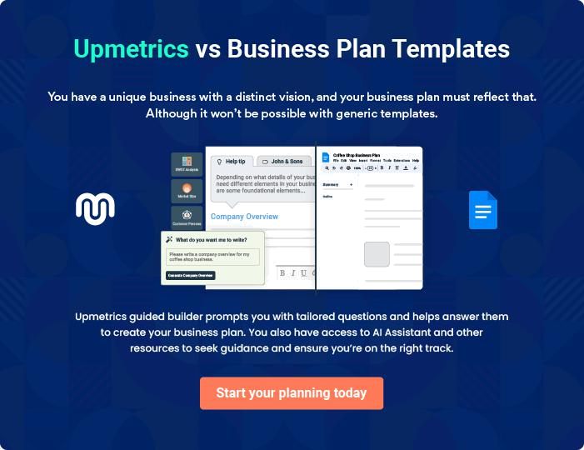
Products and Services
To unlock help try Upmetrics!
To unlock help try Upmetrics!

The product and services section of a franchise business plan should describe the specific services and products that will be offered to customers. To write this section should include the following:



 Help tip  Franchise Business Plan

To craft the introduction for your "Products and Services" chapter, begin by positioning your business within its industry, emphasizing its unique strengths or value proposition.
To unlock help try Upmetrics! 

Start writing here..

 Help tip

Create a list of the products or services your franchisee will offer. For example, if you own a fast-food franchise, you may include a menu description, pricing strategy, and specific services like takeaway, home delivery, drive-through facility, etc.



Products & Services List

Classic Espresso


Price: [$3.50]

Our Classic Espresso is the heart of our coffee offerings. It's a concentrated coffee brewed by expressing or forcing a small amount of nearly boiling water through finely-ground coffee beans.

Specifications

- Size: 30 ml (single shot)

- Origin: Colombia

- Brewing Method: Espresso Machine

- Caffeine Content: Approximately 63 mg
Creamy Cappuccino

Price: [$4.50]

A favourite among many, our Creamy Cappuccino blends rich, velvety foam with the intense flavour of an espresso shot, topped with a sprinkle of cocoa powder.

Specifications

- Size: 240 ml

- Ingredients: Espresso, Steamed Milk, Foamed Milk, Cocoa Powder

- Serving Temperature: Approximately 150°F (65°C)

French Vanilla Latte

Price: [$5.00]

Our French Vanilla Latte combines the subtle sweetness of vanilla syrup with our signature espresso, perfectly complemented by steamed milk.

Specifications

- Size: 240 ml

- Ingredients: Espresso, Steamed Milk, French Vanilla Syrup

- Flavor Profile: Sweet with hints of creamy vanilla

- Serving Temperature: Approximately 150°F (65°C)
Almond Croissant

Price: [$2.50]

Freshly baked and brimming with almond paste and sliced almonds, our Almond Croissant is a delightful pastry option for those seeking a nutty treat.

Specifications

- Size: 100 grams

- Ingredients: Flour, Butter, Almonds, Sugar, Almond Paste

- Shelf Life: Best consumed within 24 hours

- Serving Recommendation: Best served warm

Wi-Fi & Charging Workstation

Price: [$5.00] per hour

Designed for remote workers and students, our workstations are equipped with high-speed Wi-Fi and charging ports, offering a quiet and comfortable working environment.

Specifications

- Seating: Ergonomic chairs and spacious tables

- Internet: High-speed Wi-Fi with speeds up to [X Mbps]

- Electrical Outlets: Available at every workstation

- Noise Level: Quiet zones with soundproofing
Emphasize safety and quality
- To unlock help try Upmetrics!

 Help tip  Franchise Business Plan

In all descriptions of services and products, emphasize the importance of safety and quality. Explain how your franchisee will ensure consumer safety and quality depending on your business.



Start writing here..
Sales And Marketing Strategies

Writing the sales and marketing strategies section means a list of strategies you will use to attract and retain your clients.
To unlock help try Upmetrics! 

 Help Tip  Franchise Business Plan

To create an effective introduction for your "Sales and Marketing Strategies" chapter, start by setting the stage within your specific industry or market.
To unlock help try Upmetrics! 

Start writing here..

Unique Selling Proposition (USP)

 Help tip  Franchise Business Plan

Clearly define your unique selling propositions; which can be competitive pricing, extraordinary ambiance, brand recognition, etc.
To unlock help try Upmetrics! 

Start writing here..
 Help tip  Franchise Business Plan
To unlock help try Upmetrics!

Develop a marketing strategy that includes a mix of online and offline marketing tactics. Consider social media, email marketing, content marketing, brochures, print marketing, and local events.



Marketing strategies

Online


Social Media

Regular posts, contests, and promotions on platforms like Instagram, Facebook, and Twitter.

Email Marketing

Monthly newsletters featuring new products, special offers, and events

Content Marketing

Blog posts and articles about coffee, brewing techniques, and the story behind [Coffee Haven].

Offline

Brochures

Distributed in strategic locations in [City/Location] to capture local foot traffic.

Local Events

Participate in or sponsor local events and fairs to establish a community presence and brand recognition.

 Help tip

Mention your sales strategy as in – offering discounts, utilizing online delivery, planning royalty programs, partnering with local businesses, etc.
To unlock help try Upmetrics! 

Sales strategies

Online Delivery

Partnering with popular delivery platforms to ensure our products reach a wider audience

Seasonal Discounts

Offering promotions during festive seasons or local events to attract a higher footfall

Loyalty Programs

Rewarding frequent patrons with discounts, freebies, or exclusive offers.

Local Business Partnership

Collaborative promotions or offers with neighboring businesses to tap into their customer base.

 Help tip

Describe how your business will retain customers and build loyalty, such as through loyalty programs, special events, or personalized service.
To unlock help try Upmetrics! 

Customer retention

Loyalty Cards

After a certain number of purchases, customers earn a free coffee or pastry.

Personalized Service

Recognizing regulars and occasionally surprising them with on-the-house offerings or discounts.

Special Events

Monthly or quarterly events, like coffee tasting sessions or live music nights, to engage our community.

Feedback Channels

Encouraging customers to provide feedback and acting upon it to continually refine our offerings and service.

Operations Plan

 |  | When writing the operations plan section, it’s important to consider the
 |  | various aspects of your business operations.
 |  |  |  | To unlock help try Upmetrics! 
 Help tip |  |  Franchise Business Plan


To create an effective introduction for your "Operational Plan" chapter, start by emphasizing the
pivotal role of efficient operations in the success of your business, underscoring how they
directly impact the quality of services delivered.
 |  |  |  | To unlock help try Upmetrics! 
Start writing here..
Hiring Plan
 Help tip |  |  Franchise Business Plan

Tell the staffing requirements of your business, including the number of employees needed, their qualifications, and the duties they will perform.
To unlock help try Upmetrics! 

Start writing here..

Operational Process

 Help tip  Franchise Business Plan

As you are owning a franchisee, you should follow the standard operation procedure (SOP) set by your franchisor.
To unlock help try Upmetrics! 

Start writing here..

Equipment & Technology

 Help tip  Franchise Business Plan

Describe the types of equipment that will be used in your daily operations, for example. If you own a fast-food franchisee you may require cold storage, a microwave, a refrigerator, etc.
To unlock help try Upmetrics! 

Start writing here..
Management Team

The management team section provides an overview of the individuals responsible for running your business plan.
To unlock help try Upmetrics! 

 Help tip  Franchise Business Plan

To craft an introduction for your "Management Team" chapter, begin by emphasizing the crucial role of leadership in the success of any business.
To unlock help try Upmetrics! 

Start writing here..

Key managers

 Help tip  Franchise Business Plan

Describe your management team’s key members, roles, and responsibilities.

It should include the owners, senior management, and people involved in the business
To unlock help try Upmetrics! 

Start writing here..
JOHN DOE

CEO & Co-founder - john.doe@example.com

As the CEO and Co-founder, John steers the strategic vision of [Coffee Haven], ensuring alignment with our mission and values.

With his extensive experience in the coffee industry, he's instrumental in fostering relationships with partners, suppliers, and the franchisor.


- Educational Background: John has an MBA from Harvard Business School specialising in Entrepreneurship.

- Professional Background: John boasts over a decade in the coffee industry. He began his journey as a barista at 'Global Coffee Chain', quickly climbing the ranks due to his passion and expertise.

Before founding [Coffee Haven], he was a regional manager at 'Premium Beans Coffeehouse', overseeing 30 outlets in the North-Eastern region.
JANE DOE

Chief Operating Officer (COO) - jane.doe@example.com

Jane oversees the operational backbone of [Coffee Haven], ensuring the smooth functioning of daily tasks, staff training, and inventory management.

Her meticulous attention to detail and adeptness at streamlining processes make her indispensable.

- Educational Background: Jane holds a Bachelor's in Business Management from Stanford University.

- Professional Background: With 8 years in retail management, Jane has a sharp understanding of customer experience.

She spent 5 years at 'Cuppa Delight' as an outlet manager before taking on broader roles in the supply chain at 'Brewed Bliss Coffee'.


ALICE BROWN

CFO - alice.brown@example.com

Alice is the financial compass of [Coffee Haven]. From budgeting and forecasting to insightful financial analysis, she ensures that our financial decisions bolster growth and profitability.

- Educational Background: Alice completed her Master's in Finance from the Wharton School and is also a Certified Public Accountant.

- Professional Background: Alice started her career in finance with 'Big Financial Firm', where she honed her skills in fiscal analysis and planning.

Later, she joined 'BeanCounter Coffees as a senior financial analyst, where she played a pivotal role in their expansion strategy.

ROBERT BROWN

Director of Marketing - robert.brown@example.com

Robert is the voice behind [Coffee Haven's] brand.

He spearheads our marketing campaigns, digital outreach, and community engagement initiatives, ensuring that [Coffee Haven] remains top-of-mind for all coffee aficionados.

- Educational Background: Robert graduated with a degree in Marketing and Communications from the University of California, Berkeley.

- Professional Background: Robert’s marketing acumen was shaped at 'Buzzing Beans Marketing Agency', where he worked with numerous F&B clients.

He later took on a role as the lead marketing strategist at 'Java Jolt Cafes', building and executing their digital marketing campaigns.

Organizational structure

 Help tip  Franchise Business Plan

Describe the organizational structure of the management team, including reporting lines and how decisions will be made.
To unlock help try Upmetrics! 

Start writing here..

Organization chart


John Doe

CEO
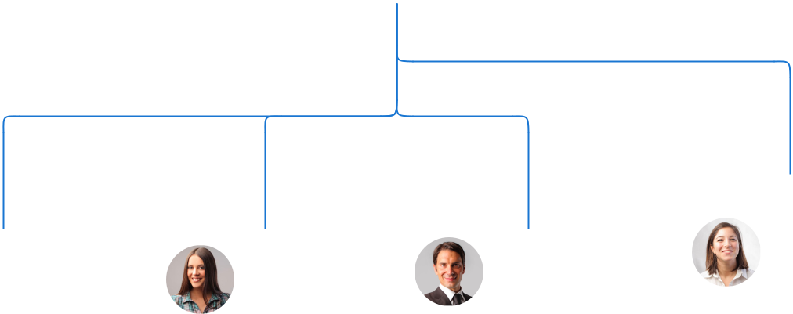

Jane Doe |  | Robert Brown | Emily White
Jane Doe | Alice Brown | Robert Brown | HR Manager
Operation | Alice Brown | Marketing | HR Manager
Operation | CFO | Marketing
Manager | CFO | Director

Compensation plan

 Help tip  Franchise Business Plan

Describe your compensation plan for the management team and staff, including salaries, bonuses, and other benefits.
To unlock help try Upmetrics! 

Start writing here..

 Help tip

If you have a board of advisors for your business, then mention them along with their roles and experience.
To unlock help try Upmetrics! 

Board of advisors


[ADVISOR NAME]

Advisor

Former CEO of [Major Coffee Chain], advises on expansion strategies.

[ADVISOR NAME]

Advisor

Renowned coffee bean grower provides expertise on sourcing and quality.
Financial Plan

When writing the financial plan section of a business plan, it’s important to provide a comprehensive overview of your financial projections for the first few years of your business, You may provide the following:
To unlock help try Upmetrics! 

 Help tip  Franchise Business Plan


To create an effective introduction for your "Financial Plan" chapter, begin by stressing the critical role of a well-structured financial plan in the success of your venture.
To unlock help try Upmetrics! 

Start writing here..

 Help tip


Create a projected profit & loss statement that describes the expected revenue, cost of products sold, and operational costs. Your business’s anticipated net profit or loss should be computed and included.
To unlock help try Upmetrics! 

Profit & loss statement

Revenue

Cost Of Sales

General Costs

Revenue Specific Costs

Personnel Costs (Direct

Labor)

Gross Margin

Gross Margin (%)

Operating Expense

Payroll Expense

(Indirect Labor)

General Expense

Bad Debt

Amortization of Current

Assets

2023-24 | 2024-25 | 2025-26 | 2026-27 | 2027-28
$0 | $0 | $0 | $0 | $0

$0 | $0 | $0 | $0 | $0
$0 | $0 | $0 | $0 | $0
$0 | $0 | $0 | $0 | $0
$0 | $0 | $0 | $0 | $0

$0 | $0 | $0 | $0 | $0
0% | 0% | 0% | 0% | 0%

$0 | $0 | $0 | $0 | $0
$0 | $0 | $0 | $0 | $0
$0 | $0 | $0 | $0 | $0
$0 | $0 | $0 | $0 | $0
$0 | $0 | $0 | $0 | $0

EBITDA

Additional Expense

Long Term

Depreciation

Gain or loss from Sale

of Assets

EBIT

Interest Expenses

EBT

Income Tax Expense

Total Expense

Net Income

Net Income (%)

2023-24 | 2024-25 | 2025-26 | 2026-27 | 2027-28
$0 | $0 | $0 | $0 | $0
$0 | $0 | $0 | $0 | $0
$0 | $0 | $0 | $0 | $0
$0 | $0 | $0 | $0 | $0
$0 | $0 | $0 | $0 | $0
$0 | $0 | $0 | $0 | $0
$0 | $0 | $0 | $0 | $0
$0 | $0 | $0 | $0 | $0
$0 | $0 | $0 | $0 | $0
$0 | $0 | $0 | $0 | $0
0% | 0% | 0% | 0% | 0%
 | 2023-24 | 2024-25 | 2025-26 | 2026-27 | 2027-28
Retained Earning | $0 | $0 | $0 | $0 | $0
Opening
Owner's Distribution | $0 | $0 | $0 | $0 | $0
Retained Earning | $0 | $0 | $0 | $0 | $0
Closing

 Help tip

Estimate your cash inflows and outflows for the first few years of operation. It should include cash receipts from clients, vendor payments, loan payments, and any other cash inflows and outflows.
To unlock help try Upmetrics! 

Cash flow statement

 | 2023-24 | 2024-25 | 2025-26 | 2026-27 | 2027-28
Cash Received | $0 | $0 | $0 | $0 | $0
Cash Paid | $0 | $0 | $0 | $0 | $0
COS & General Expenses | $0 | $0 | $0 | $0 | $0
Salary & Wages | $0 | $0 | $0 | $0 | $0
Interest | $0 | $0 | $0 | $0 | $0

Sales Tax

Income Tax

Net Cash From

Operations

Assets Sell

Assets Purchase

Net Cash From

Investments

Amount Received

Loan Received

Common Stock

Preferred Stock

Owner's Contribution

Amount Paid

2023-24 | 2024-25 | 2025-26 | 2026-27 | 2027-28
$0 | $0 | $0 | $0 | $0
$0 | $0 | $0 | $0 | $0
$0 | $0 | $0 | $0 | $0

$0 | $0 | $0 | $0 | $0
$0 | $0 | $0 | $0 | $0
$0 | $0 | $0 | $0 | $0

$0 | $0 | $0 | $0 | $0
$0 | $0 | $0 | $0 | $0

$0 | $0 | $0 | $0 | $0
$0 | $0 | $0 | $0 | $0
$0 | $0 | $0 | $0 | $0

Loan Capital $0 $0 $0 $0 $0

 | 2023-24 | 2024-25 | 2025-26 | 2026-27 | 2027-28
Dividends & Distributions | $0 | $0 | $0 | $0 | $0
Net Cash From | $0 | $0 | $0 | $0 | $0
Financing

Summary
Starting Cash | $0 | $0 | $0 | $0 | $0
Cash In | $0 | $0 | $0 | $0 | $0
Cash Out | $0 | $0 | $0 | $0 | $0
Change in Cash | $0 | $0 | $0 | $0 | $0
Ending Cash | $0 | $0 | $0 | $0 | $0

 Help tip

Prepare a projected balance sheet, which shows the business’s assets, liabilities, and equity.

To unlock help try Upmetrics! 

Balance sheet

 | 2023-24 | 2024-25 | 2025-26 | 2026-27 | 2027-28
Assets | $0 | $0 | $0 | $0 | $0
Current Assets | $0 | $0 | $0 | $0 | $0
Cash | $0 | $0 | $0 | $0 | $0
Accounts Receivable | $0 | $0 | $0 | $0 | $0
Inventory | $0 | $0 | $0 | $0 | $0
Other Current Assets | $0 | $0 | $0 | $0 | $0
Long Term Assets | $0 | $0 | $0 | $0 | $0
Gross Long Term Assets | $0 | $0 | $0 | $0 | $0
Accumulated Depreciation | $0 | $0 | $0 | $0 | $0

Liabilities & Equity | $0 | $0 | $0 | $0 | $0
Liabilities | $0 | $0 | $0 | $0 | $0
Current Liabilities | $0 | $0 | $0 | $0 | $0
Accounts Payable | $0 | $0 | $0 | $0 | $0
Income Tax Payable | $0 | $0 | $0 | $0 | $0
Sales Tax Payable | $0 | $0 | $0 | $0 | $0
Short Term Debt | $0 | $0 | $0 | $0 | $0
 | 2023-24 | 2024-25 | 2025-26 | 2026-27 | 2027-28
Long Term Liabilities | $0 | $0 | $0 | $0 | $0
Long Term Debt | $0 | $0 | $0 | $0 | $0
Equity | $0 | $0 | $0 | $0 | $0
Paid-in Capital | $0 | $0 | $0 | $0 | $0
Common Stock | $0 | $0 | $0 | $0 | $0
Preferred Stock | $0 | $0 | $0 | $0 | $0
Owner's Contribution | $0 | $0 | $0 | $0 | $0
Retained Earnings | $0 | $0 | $0 | $0 | $0

Check | $0 | $0 | $0 | $0 | $0

Break-even Point

 Help tip  Franchise Business Plan

Determine the point at which your franchise business will break even or generate enough revenue to cover its operating costs. This will help you understand how much revenue you need to generate to make a profit.
To unlock help try Upmetrics! 
Start writing here..

Financing needs

 Help tip  Franchise Business Plan

Estimate how much financing you will need to start and operate your business. It should include short-term and long-term financing needs, such as business loans.
To unlock help try Upmetrics! 

Start writing here..
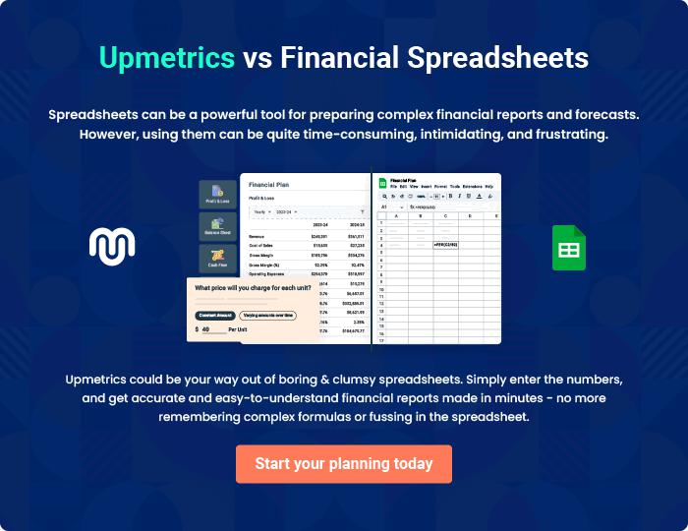
Appendix

When writing the appendix section, you should include any additional information that supports the main content of your plan. This may include financial statements, market research data, legal documents, and other
To unlock help try Upmetrics! 
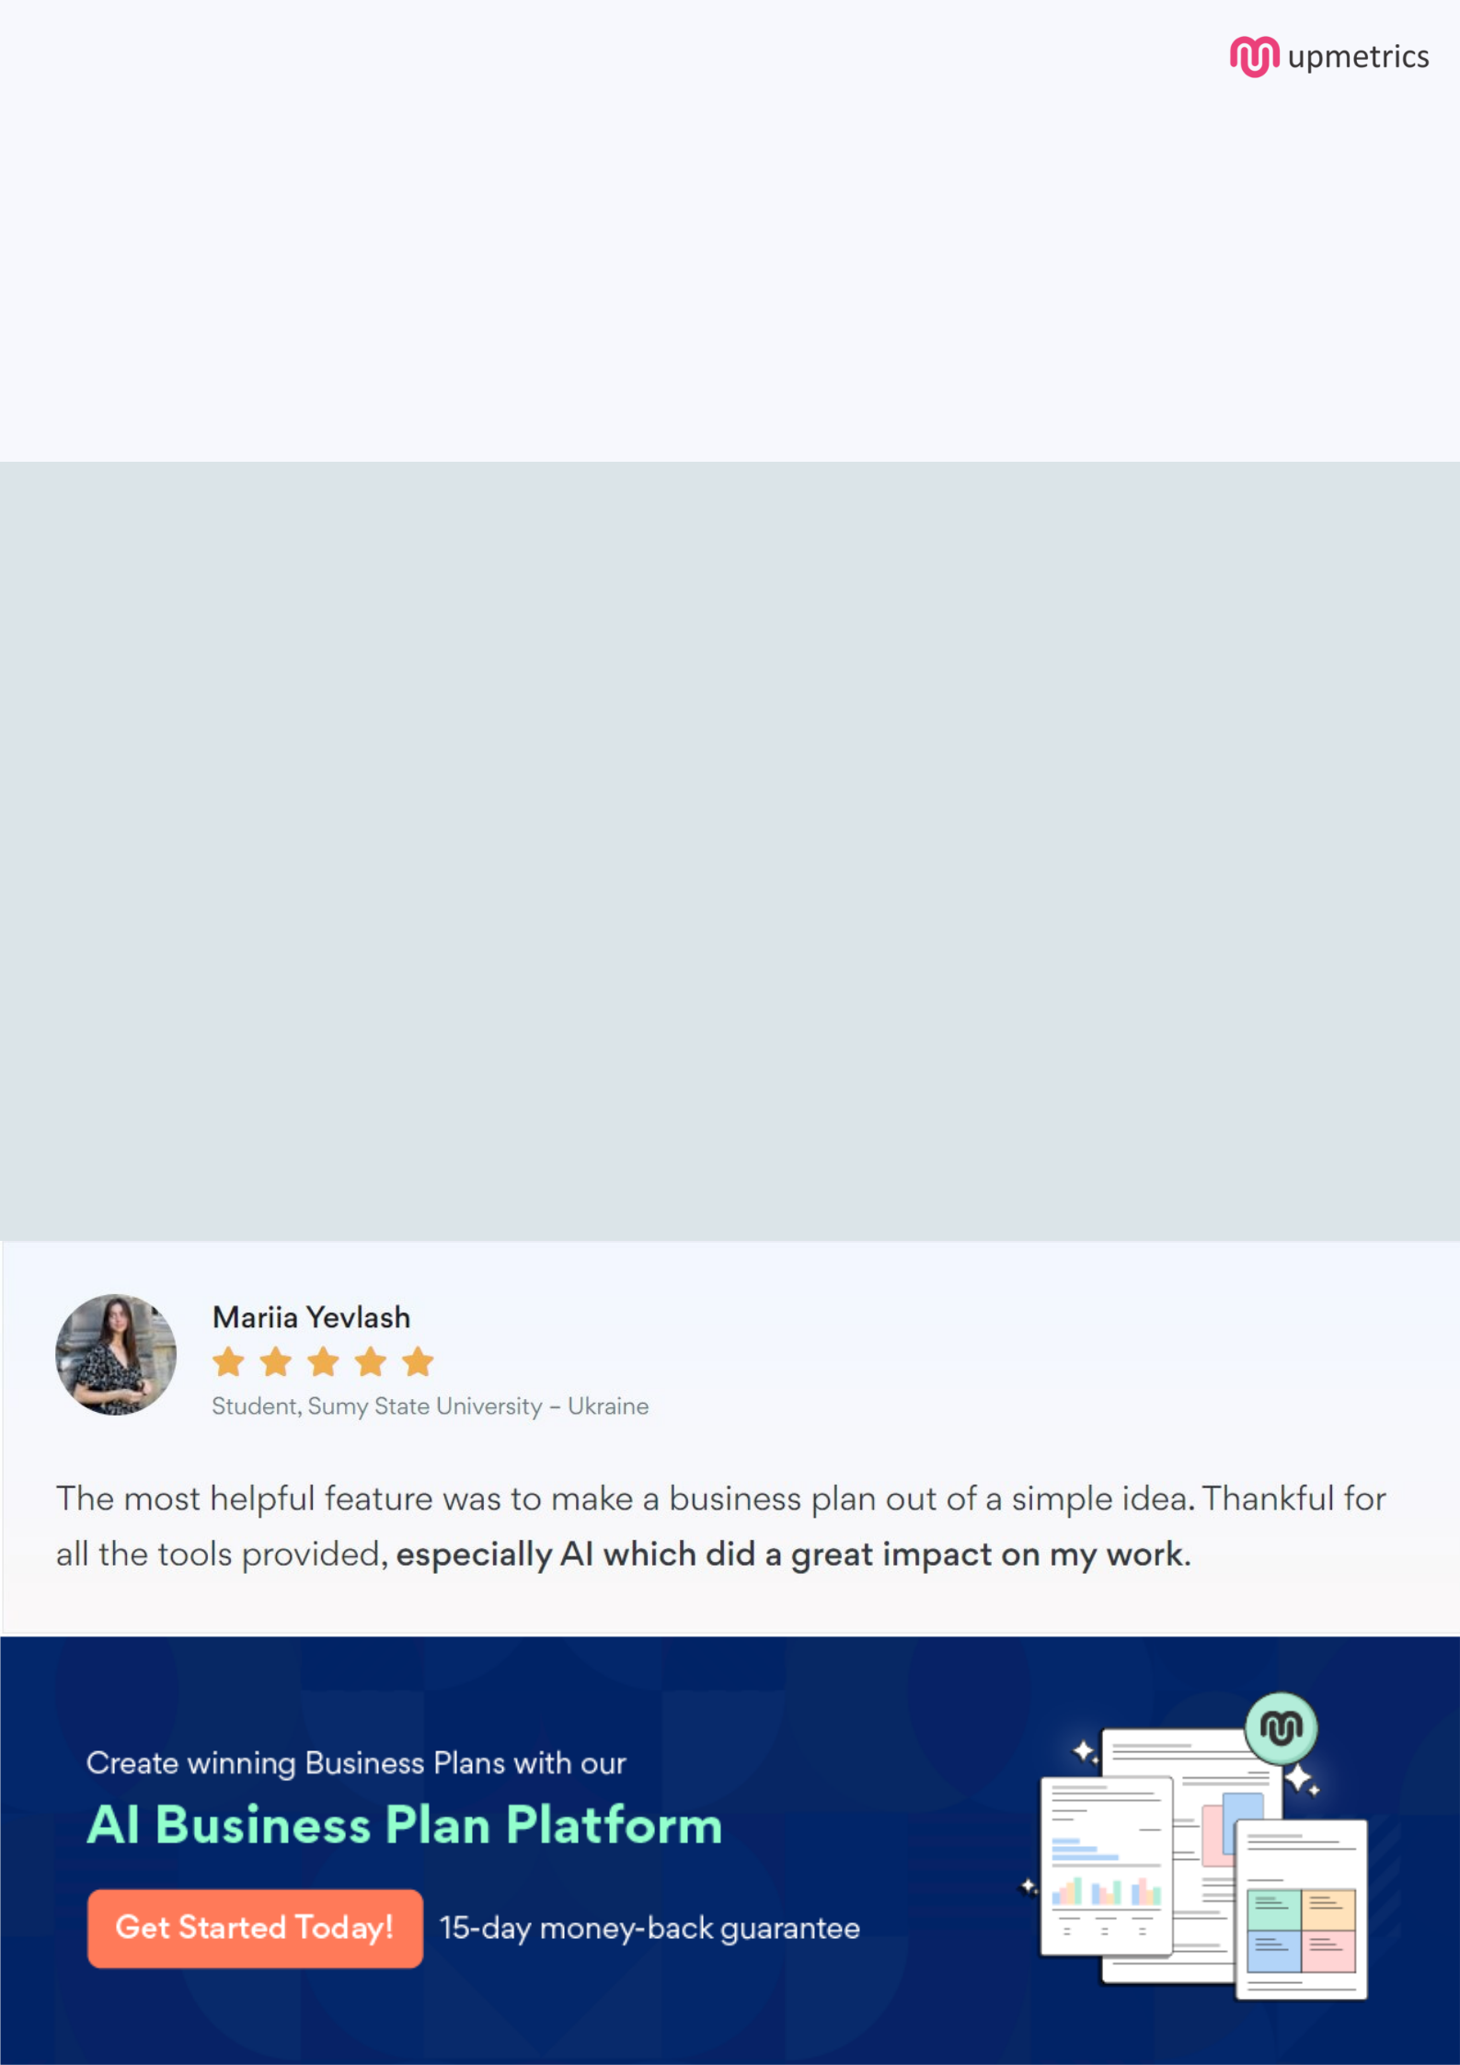
Create a winning business plan that gets you funded

Creating a stunning and investment-ready plan requires no writing, graphic designing, or financial planning expertise.

Upmetrics has all the features required to help you create a comprehensive business plan—from start to finish. Make no mistakes, it’s the modern way of planning to structure ideas, make plans, and create stunning pitch decks to awe investors.

Pitch decks that impress investors

Create pitch decks that provide a visual representation of your business, engage investors, and make them want to invest in your business idea.

Interactive plans in no time

Import business plan sections like—SWOT analysis, comparison tables, and others to create an interactive business plan. No designing skills are required.

Stunning cover page designs

With Upmetrics, you have the liberty to choose from multiple stunning cover page designs. Choose a creative design and make your plan stand out.

Online sharing made simple

Upmetrics makes online sharing quick and easier for users. Easily share your business plans with a link while tracking reader activity.

500+ sample business plans

Simply import a template from our library of sample plans into the editor and start customizing it to make it yours. It takes only a few clicks to get started.

Collaborate with team in real-time

Invite team members, initiate conversations, discuss ideas & strategies, share feedback, and work on a business plan in real-time.

