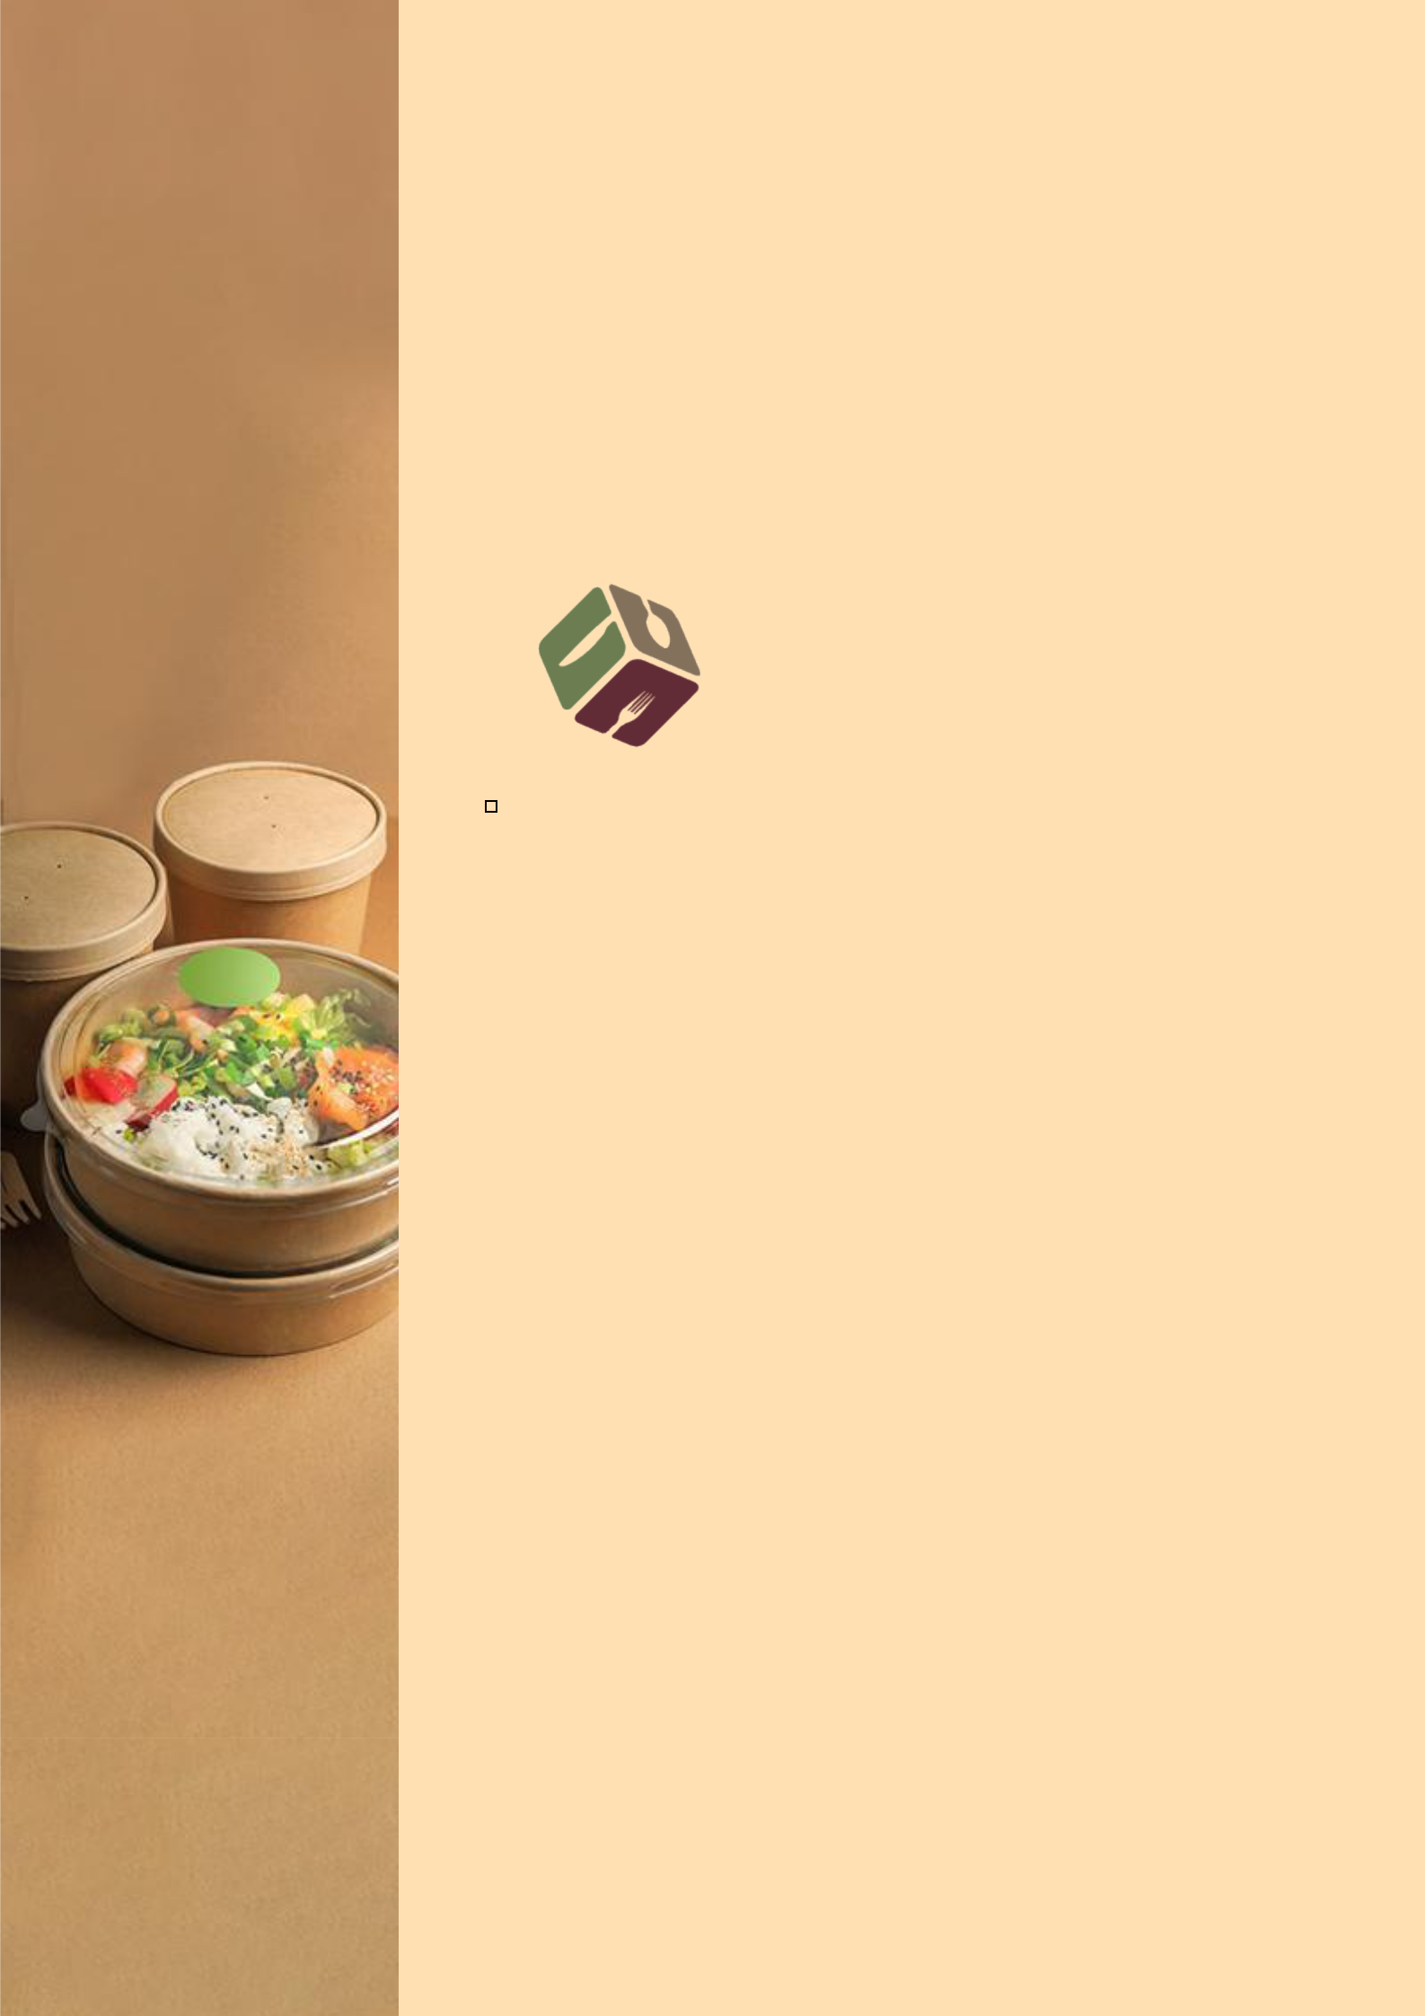
BUSINESS PLAN

2023

Food Packaging Business Plan

Food Packaging, Trusted Solutions

John Doe

10200 Bolsa Ave, Westminster, CA, 92683

- 359-3153 upm.templates+4@gmail.com https://www.example.com/

Information provided in this business plan is unique to this business and confidential; therefore, anyone reading this plan agrees not to disclose any of the information in this business plan without prior written permission of the company.
Table of Contents

Executive Summary | 6
Market opportunity | 6
Services Offered | 6
Marketing & Sales Strategies | 7
Financial Highlights | 7
Units Sold v/s Revenue | 8

Company Overview | 9
Ownership | 9
Mission statement | 10
Business history | 10
Future Goals | 11

Market Analysis | 12
Target Market | 12
Market size and growth potential | 12
Market Size | 13
Competitive analysis | 13
PackPro Solutions | 13
EcoWrap Innovations | 14
QuickPacks | 14
Market trends | 15
Regulatory environment | 15

Products and Services | 17
Services | 17
Custom Design Consultation | 17
Premium Material Sourcing | 18
Customized Packaging Solutions | 18
Prototype Development and Testing | 19
Labeling and Graphic Design | 19
Quality Assurance and Certification | 20
Quality Measures | 20
Additional Services | 20

Sales And Marketing Strategies | 21
Unique Selling Proposition (USP) | 21
Pricing Strategy | 21
Marketing strategies | 22
Online | 22
Sales strategies | 23
Customer retention | 24

Operations Plan | 25
Staffing & Training | 25
Operational Process | 25
Equipment & Machinery | 26

Management Team | 27
Key managers | 27
John Doe | 27
Jane Doe | 28
Alice Brown | 28
Robert Brown | 28
Organizational structure | 29
Organization chart | 29
Compensation plan | 30
Advisors/Consultants | 30
Dr. William Green | 30
Ms. Emily Clark | 30

Financial Plan | 31
Profit & loss statement | 31
Cash flow statement | 34
Balance sheet | 36
Break-even Analysis | 38
Financing needs | 40
Appendix
Appendix | 42
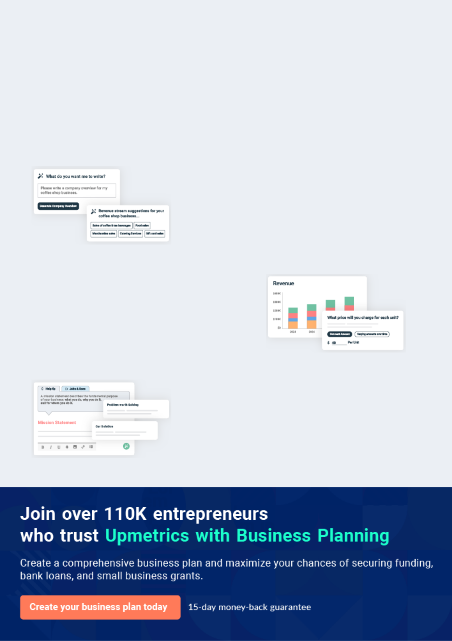
Business planning that’s simpler and faster than you think

Creating a business plan using Upmetrics to start and grow a business is literally the easiest thing in the World. Simply read the instructions and fill in the blanks. It’s as simple as that.

❛ | Upmetrics has everything you need to create a | ❜
❛ | comprehensive business plan. | ❜

AI-powered Upmetrics Assistant

AI-powered insights to streamline your plan

Not sure where to start? Upmetrics’ AI Assistant will automatically generate ideas for each section of your plan and offer improved versions of your writing, adjusting for tone, voice, and grammar or spelling errors.

Financial Forecasting Tool

All the financials are calculated for you

Forget the complex formulas and clumsy spreadsheets — with automatic financials and drag-and-drop forecasting, you can finish your plan faster and be confident that your numbers are accurate.

Business Plan Builder

Guides you like a business mentor

Upmetrics’ step-by-step instructions, prompts, and the library of 400+ sample business plans will guide you through each section of your plan as a business mentor.
Executive Summary


An executive summary is the first section of the business plan intended to provide an overview of the whole business plan.
To unlock help try Upmetrics! 

 Help tip  Food Packaging Business Plan


Start your executive summary by briefly introducing your business to your readers.

This section may include the name of your food packaging business, its location, when it was
To unlock help try Upmetrics! 

Start writing here..

Market opportunity

 Help tip  Food Packaging Business Plan

Summarize your market research, including market size, growth potential, and marketing trends. Highlight the opportunities in the market and how your business will fit in to fill the gap.
To unlock help try Upmetrics! 

Start writing here..

Services Offered

 Help tip  Food Packaging Business Plan

Highlight the food packaging services you offer your clients. The USPs and differentiators you offer are always a plus.
To unlock help try Upmetrics! 

Start writing here..

Marketing & Sales Strategies
To unlock help try Upmetrics!

 Help tip  Food Packaging Business Plan

Outline your sales and marketing strategies—what marketing platforms you use, how you plan on acquiring customers, etc.
To unlock help try Upmetrics! 

Start writing here..

Financial Highlights

 Help tip  Food Packaging Business Plan

Briefly summarize your financial projections for the initial years of business operations. Include any capital or investment requirements, associated startup costs, projected revenues, and profit forecasts.



Start writing here..
Units Sold v/s Revenue

 |  | Units Sold | Revenue
15.00k
10.00k
5.00k
0
Year 1 | Year 2 | Year 3
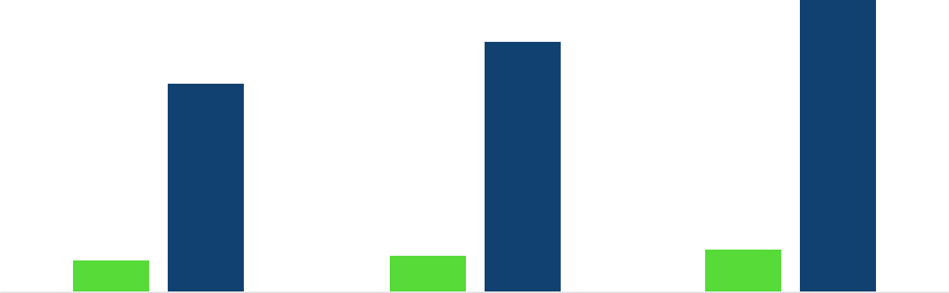

Financial Year |  |  | Units Sold | Revenue
Year 1 | 1,550 |  |  | $10,000
Year 2 | 1,800 |  |  | $12,000
Year 3 | 2,050 |  |  | $14,000
 Help tip |  |  Food Packaging Business Plan


Summarize your executive summary section with a clear CTA, for example, inviting angel investors to discuss the potential business investment.
To unlock help try Upmetrics! 

Write a call to action for your business plan.
Company Overview

Depending on what details of your business are essential, you’ll need different elements in your business overview.
To unlock help try Upmetrics! 

 Help tip  Food Packaging Business Plan

Describe your business in this section by providing all the basic information:

Describe what kind of food packaging company you run and the name of it. You may specialize
To unlock help try Upmetrics! 

Start writing here..

Ownership

 Help tip  Food Packaging Business Plan

List the names of your food packaging company’s founders or owners. Describe what shares they own and their responsibilities for efficiently managing the business.
To unlock help try Upmetrics! 

Start writing here..
Mission statement

 Help tip  Food Packaging Business Plan

Summarize your business’ objective, core principles, and values in your mission statement. This statement needs to be memorable, clear, and brief.
To unlock help try Upmetrics! 

❛ At [GourmetGuard Packaging], our mission is to empower gourmet food producers by providing them with packaging solutions that are as exceptional as their products.

We are committed to innovation, sustainability, and excellence in every aspect of our operations, ensuring that every package we create not only protects but also elevates the culinary delights within.

❜

Business history

 Help tip  Food Packaging Business Plan

If you’re an established food packaging service provider, briefly describe your business history, like—when it was founded, how it evolved over time, etc.
To unlock help try Upmetrics! 

Start writing here..
Future Goals

 Help Tip  Food Packaging Business Plan


It’s crucial to convey your aspirations and vision. Mention your short-term and long-term goals; they can be specific targets for revenue, market share, or expanding your services.
To unlock help try Upmetrics! 

Start writing here..
Market Analysis
To unlock help try Upmetrics!


 |  | Market analysis provides a clear understanding of the market in which your
 |  | printing business will run along with the target market, competitors, and
 |  | growth opportunities.
 |  |  |  | To unlock help try Upmetrics! 
 Help tip |  |  Food Packaging Business Plan

To write the introduction section of your market analysis, start by clearly identifying your primary target market.
To unlock help try Upmetrics! 

Start writing here..

Target Market

 Help tip  Food Packaging Business Plan

Start this section by describing your target market. Define your ideal customer and explain what types of services they prefer. Creating a buyer persona will help you easily define your target market to your readers.



Start writing here..

Market size and growth potential

 Help tip  Food Packaging Business Plan

Describe your market size and growth potential and whether you will target a niche or a much broader market.
To unlock help try Upmetrics! 

Start writing here..

Market Size


Available Market | 650B
Entire food packaging industry | 650B

Served Market | 250B
Premium food packaging sector | 250B

Target Market | 50B
Gourmet food packaging niche | 50B

 Help tip  Food Packaging Business Plan

Identify and analyze your direct and indirect competitors. Identify their strengths and weaknesses, and describe what differentiates your food packaging services from them.
To unlock help try Upmetrics! 

Competitive analysis

PackPro Solutions

PackPro Solutions is an established player in the food packaging industry, with over 15 years of experience. They have a broad customer base ranging from local bakeries to national food producers. PackPro is known for its extensive range of packaging materials and turnkey solutions.

Features

Wide selection of packaging materials including plastic, paper, and biodegradable options.

Custom design and printing services.

Turnkey packaging solutions from design to delivery.

On-site consultation and support.

Strengths

Strong brand recognition and established customer trust.

Extensive experience and expertise in the industry.

Broad range of services and materials catering to various customer needs.

Strong distribution network ensuring timely delivery.

Weaknesses

Higher pricing compared to newer entrants in the market.

Less focus on sustainable and eco-friendly packaging solutions.

Limited customization in terms of innovative and unique packaging designs

EcoWrap Innovations

EcoWrap Innovations is a newer entrant in the market, focused primarily on providing sustainable and eco-friendly packaging solutions. They have quickly gained popularity among businesses looking for greener options.

Features Strengths

100% biodegradable and Strong market positioning in

compostable packaging the eco-friendly and

materials. sustainable packaging niche.

Innovative and sustainable Agile and innovative approach

design solutions. to packaging design.

Rapid prototyping and small High level of customer

batch production capabilities. engagement and education.

Strong focus on customer Competitive pricing and flexible

education regarding order quantities.

sustainable practices.

Weaknesses

Limited range of materials compared to more established competitors.

Smaller scale of operations may lead to challenges in meeting large orders.

Brand is less recognized in the broader food packaging market.

QuickPacks

QuickPacks is a mid-sized company known for its fast turnaround times and efficiency in handling short-notice orders. They have a solid reputation among businesses requiring quick and reliable packaging solutions.

Features | Strengths | Weaknesses
Expedited order processing | Industry-leading turnaround | Limited customization and
and delivery. | times for order fulfillment. | design consultation services.
Wide range of standard | User-friendly online ordering | Strong focus on customer
packaging options. | and design platform. | service and responsiveness.
Online ordering and design | Strong focus on customer | Competitive pricing for standard
tools. | service and responsiveness. | packaging solutions.
Responsive customer service | Competitive pricing for | User-friendly online ordering and
and support. | standard packaging solutions. | design platform.

Market trends
To unlock help try Upmetrics!

 Help tip  Food Packaging Business Plan

Analyze emerging trends in the industry, such as technology disruptions, changes in customer behavior or preferences, etc. Explain how your business will cope with all the trends.
To unlock help try Upmetrics! 

Start writing here..

Regulatory environment

 Help tip  Food Packaging Business Plan

List regulations and licensing requirements that may affect your food packaging company, such as the food safety modernization act, toxic substances control act, licensing & regulations, etc.



Start writing here..
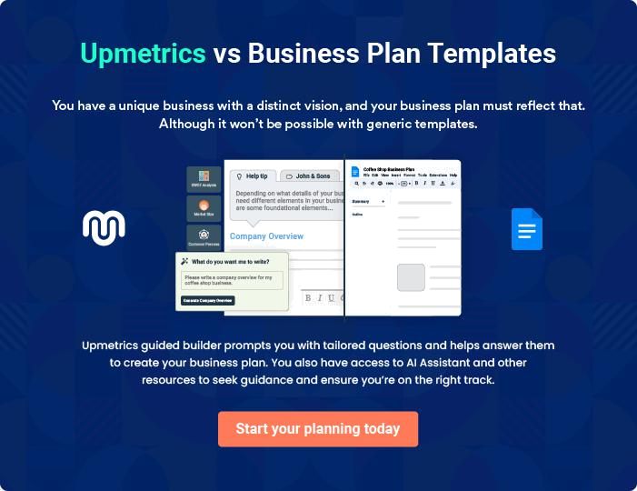
Products and Services

The product and services section of the food packaging business plan should describe the specific services and products that will be offered to customers. To write this section should include the following:
To unlock help try Upmetrics! 

 Help tip  Food Packaging Business Plan

To craft the introduction for your "Products and Services" chapter, begin by positioning your business within its industry, emphasizing its unique strengths or value proposition.
To unlock help try Upmetrics! 

Start writing here..

 Help tip


Mention the food packaging services your business will offer. This list may include services like,
To unlock help try Upmetrics! 

Services

Custom Design Consultation
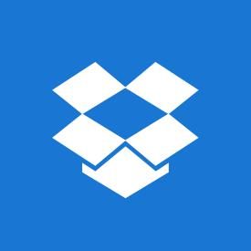

Price: [$150/hour]

Tailored packaging design services to create unique and innovative solutions that align with your brand and meet your product's specific needs.

Specifications

- Duration: 1-2 hours per session

- Includes: Initial consultation, design brainstorming, concept development
Premium Material Sourcing

Price: Varies based on materials sourced (average cost $500 - $5,000)

Access to a wide range of high-quality, sustainable packaging materials to ensure your product is protected and presented in the best possible way.

Specifications

- Materials: Glass, recyclable plastics, biodegradable options, premium papers

- Services: Material testing, supplier verification, price negotiation

Customized Packaging Solutions

Price: Starting at [$1,000] (varies based on complexity and quantity)

Bespoke packaging solutions, designed and produced to meet the specific requirements of your gourmet product.

Specifications

- Minimum Order: 500 units

- Production Time: 4-6 weeks

- Features: Custom shapes, sizes, and printing options
Prototype Development and Testing

Price: [$500] per prototype

Creation of a tangible sample of your packaging to test and refine before full-scale production.

Specifications

- Includes: One prototype, testing report, one round of revisions

- Turnaround Time: 2-3 weeks

- Additional Costs: Changes post-first revision billed at $150/hour

Labeling and Graphic Design

Price: [$200/hour]

Professional design services to create visually stunning labels and packaging artwork that enhances your product’s shelf appeal.

Specifications

- Includes: Concept development, design execution, two rounds of revisions

- Additional Costs: Additional revisions billed at $200/ hour

- Final Deliverables: High-resolution files ready for print
Quality Assurance and Certification
- To unlock help try Upmetrics!

Price: Starting at [$500] (varies based on scope)

Comprehensive quality assurance services to ensure that all packaging meets industry standards and certifications.

Specifications

- Includes: Material testing, product safety checks, certification assistance

- Turnaround Time: 3-5 weeks

- Additional Services: Ongoing quality assurance packages available

Quality Measures

 Help tip  Food Packaging Business Plan

This section should explain how you maintain quality standards and consistently provide the highest quality service.
To unlock help try Upmetrics! 

Start writing here..

Additional Services

 Help tip  Food Packaging Business Plan

Mention if your food packaging company offers any additional services. You may include services like packaging automation solutions, supply chain support, technical support & training, etc.



Start writing here..

Sales And Marketing Strategies

Writing the sales and marketing strategies section means a list of strategies you will use to attract and retain your clients.
To unlock help try Upmetrics! 

 Help Tip  Food Packaging Business Plan

To create an effective introduction for your "Sales and Marketing Strategies" chapter, start by setting the stage within your specific industry or market.
To unlock help try Upmetrics! 

Start writing here..

Unique Selling Proposition (USP)

 Help tip  Food Packaging Business Plan

Define your business’s USPs depending on the market you serve, the equipment you use, and the unique services you provide. Identifying USPs will help you plan your marketing strategies.
To unlock help try Upmetrics! 

Start writing here..

Pricing Strategy

 Help tip  Food Packaging Business Plan

Describe your pricing strategy—how you plan to price your services and stay competitive in the local market. You can mention any discounts you plan on offering to attract new customers.
To unlock help try Upmetrics! 

Start writing here..

 Help tip
To unlock help try Upmetrics!

Discuss your marketing strategies to market your services. You may include some of these marketing strategies in your business plan—social media marketing, Google ads, email marketing, content marketing, etc.



Marketing strategies

Online


Social Media

Our social media presence, spanning across [platforms], enables us to engage with our audience in real-time, showcasing our expertise and services.

Content Marketing

Content marketing, through [platforms], will help establish our thought leadership, providing valuable insights and information to the industry.

Email Marketing

Our email marketing initiatives aim to nurture leads and maintain communication with existing clients.

Google Ads

Google Ads will play a crucial role in driving targeted traffic.

 Help tip

Outline the strategies you’ll implement to maximize your sales. Your sales strategies may include direct sales calls, partnering with other businesses, offering referral programs, etc.
To unlock help try Upmetrics! 

Sales strategies

Partner with Businesses

Forming strategic business partnerships will open avenues for mutual growth.

Referral Programs

Our referral programs are designed to incentivize existing clients to recommend our services, amplifying our sales efforts.

Direct Sales Calls

Direct sales calls will enable us to connect personally with potential clients, understanding their needs and presenting tailored solutions.

 Help tip

Describe your customer retention strategies and how you plan to execute them. For instance, introducing loyalty programs, discounts on bulk orders, personalized service, etc.
To unlock help try Upmetrics! 

Customer retention

Loyalty Programs Bulk Order Discounts

Our loyalty programs reward clients for their continued trust in our services.

Bulk order discounts provide tangible incentives for larger engagements.

Personalized Service

Personalized services ensure that

each client feels valued and

understood, fostering a positive

connection and encouraging

repeat business.

Operations Plan
To unlock help try Upmetrics!

 |  | When writing the operations plan section, it’s important to consider the
 |  | various aspects of your business operations.
 |  |  |  | To unlock help try Upmetrics! 
 Help tip |  |  Food Packaging Business Plan
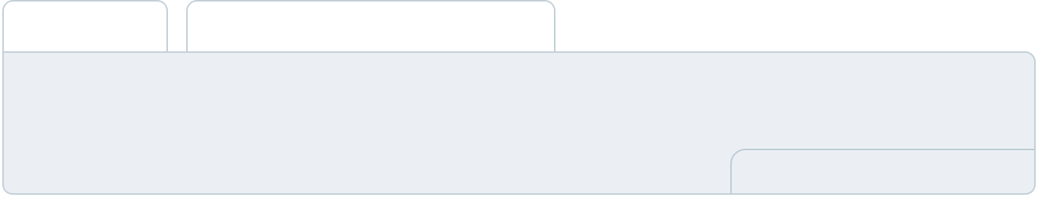

To create an effective introduction for your "Operational Plan" chapter, start by emphasizing the
pivotal role of efficient operations in the success of your business, underscoring how they
directly impact the quality of services delivered.
 |  |  |  | To unlock help try Upmetrics! 
Start writing here..
Staffing & Training
 Help tip |  |  Food Packaging Business Plan

Mention your business’s staffing requirements, including the number of employees or
packaging specialists needed. Include their qualifications, the training required, and the duties
they will perform.
 |  |  |  | To unlock help try Upmetrics! 
Start writing here..
Operational Process
 Help tip |  |  Food Packaging Business Plan

Outline the processes and procedures you will use to run your food packaging business. Your operational processes may include inventory management, packaging design & development, quality assurance, production & packaging, etc.



Start writing here..

Equipment & Machinery

 Help tip  Food Packaging Business Plan

Include the list of equipment and machinery required for food packaging, such as filling machines, sealing machines, labeling machines, inspection systems, etc.
To unlock help try Upmetrics! 

Start writing here..
Management Team

The management team section provides an overview of the individuals responsible for running your business plan.
To unlock help try Upmetrics! 

 Help tip  Food Packaging Business Plan

To craft an introduction for your "Management Team" chapter, begin by emphasizing the crucial role of leadership in the success of any business.
To unlock help try Upmetrics! 

Start writing here..

Key managers

 Help tip  Food Packaging Business Plan

Introduce your management and key members of your team, and explain their roles and responsibilities.
To unlock help try Upmetrics! 

Start writing here..


JOHN DOE

CEO & Co-founder - john.doe@example.com

John holds the vision for [GourmetGuard Packaging] Business, bringing over 20 years of experience in the food packaging industry.

He is responsible for strategic decision-making, overseeing company operations, and establishing key partnerships.


- Educational Background: MBA in Business Administration from Harvard Business School.

- Professional Background: Prior to founding [GourmetGuard Packaging], John served as the Director of Operations at PackItRight, a leading packaging solutions provider.

JANE DOE

Chief Operating Officer (COO) - jane.doe@example.com

As the COO, Jane oversees the day-to-day administrative and operational functions of [GourmetGuard Packaging].

She ensures that business operations are efficient and effective, and that the proper management of resources, distribution of goods, and services to customers are conducted in an efficient manner.


- Educational Background: Bachelor’s in Industrial Engineering from MIT.

- Professional Background: Jane brings a wealth of experience from her time as an Operations Manager at SecurePack, where she implemented innovative packaging solutions to streamline operations.


ALICE BROWN

Director of Sales and Marketing - alice.brown@example.com

Alice is responsible for developing and executing the sales and marketing strategy of [GourmetGuard Packaging], focusing on customer acquisition and brand development.

- Educational Background: Bachelor’s in Marketing from the University of Chicago.

- Professional Background: Alice has an extensive background in sales and marketing within the packaging industry, having previously worked as a Senior Sales Manager at EcoPack Solutions.


ROBERT BROWN

Head of Product Development - robert.brown@example.com

Robert leads the product development team, focusing on innovation and quality in [GourmetGuard Packaging] solutions.

- Educational Background: Master’s in Material Science from Stanford University.

- Professional Background: With a background as a Product Engineer at InnovatePack, Robert brings a deep understanding of materials science and design innovation to the team.
Organizational structure

 Help tip  Food Packaging Business Plan

Explain the organizational structure of your management team. Include the reporting line and decision-making hierarchy.
To unlock help try Upmetrics! 

Start writing here..

Organization chart


John Doe

CEO


Alice Brown | Robert Brown
Director of Sales and | Head of Product | Jane Doe
Marketing | Development | COO

William White |  | Emily Johnson
 |  |  |  | Michael Grey
Financial Analyst |  | Sales Manager
 |  |  |  | Operations Manager



Compensation plan

 Help tip  Food Packaging Business Plan

Describe your compensation plan for the management and staff. Include their salaries, incentives, and other benefits.
To unlock help try Upmetrics! 

Start writing here..

 Help tip  Food Packaging Business Plan

Mentioning advisors or consultants in your business plans adds credibility to your business idea.
To unlock help try Upmetrics! 

Advisors/Consultants


DR. WILLIAM GREEN

Advisor on Sustainability

A prominent name in sustainable packaging solutions, [Dr. Green] has been instrumental in guiding us towards eco-friendly and sustainable packaging options.


MS. EMILY CLARK

Consultant in Packaging Innovations

With a vast experience spanning over two decades, [Emily] has been pivotal in introducing us to the latest trends and innovations in the packaging industry
Financial Plan

When writing the financial plan section of a business plan, it’s important to provide a comprehensive overview of your financial projections for the first few years of your business, You may provide the following:
To unlock help try Upmetrics! 

 Help tip  Food Packaging Business Plan


To create an effective introduction for your "Financial Plan" chapter, begin by stressing the critical role of a well-structured financial plan in the success of your venture.
To unlock help try Upmetrics! 

Start writing here..

 Help tip  Food Packaging Business Plan

Describe details such as projected revenue, operational costs, and service costs in your projected profit and loss statement. Make sure to include your business’s expected net profit or loss.
To unlock help try Upmetrics! 

Profit & loss statement

Revenue

Cost Of Sales

General Costs

Revenue Specific Costs

Personnel Costs (Direct

Labor)

Gross Margin

Gross Margin (%)

Operating Expense

Payroll Expense

(Indirect Labor)

General Expense

Bad Debt

Amortization of Current

Assets

2023-24 | 2024-25 | 2025-26 | 2026-27 | 2027-28
$0 | $0 | $0 | $0 | $0

$0 | $0 | $0 | $0 | $0
$0 | $0 | $0 | $0 | $0
$0 | $0 | $0 | $0 | $0
$0 | $0 | $0 | $0 | $0

$0 | $0 | $0 | $0 | $0
0% | 0% | 0% | 0% | 0%

$0 | $0 | $0 | $0 | $0
$0 | $0 | $0 | $0 | $0
$0 | $0 | $0 | $0 | $0
$0 | $0 | $0 | $0 | $0
$0 | $0 | $0 | $0 | $0

EBITDA

Additional Expense

Long Term

Depreciation

Gain or loss from Sale

of Assets

EBIT

Interest Expenses

EBT

Income Tax Expense

Total Expense

Net Income

Net Income (%)

2023-24 | 2024-25 | 2025-26 | 2026-27 | 2027-28
$0 | $0 | $0 | $0 | $0
$0 | $0 | $0 | $0 | $0
$0 | $0 | $0 | $0 | $0
$0 | $0 | $0 | $0 | $0
$0 | $0 | $0 | $0 | $0
$0 | $0 | $0 | $0 | $0
$0 | $0 | $0 | $0 | $0
$0 | $0 | $0 | $0 | $0
$0 | $0 | $0 | $0 | $0
$0 | $0 | $0 | $0 | $0
0% | 0% | 0% | 0% | 0%

 |  |  | 2023-24 |  | 2024-25 | 2025-26
Retained Earning |  |  | $0 |  | $0 | $0
Opening |  |  |  |  | $0 | $0
Owner's Distribution |  |  | $0 |  | $0 | $0
Retained Earning |  |  | $0 |  | $0 | $0
Closing |  |  |  |  | $0 | $0
 Help tip |  |  |  Food Packaging Business Plan


The cash flow for the first few years of your operation should be estimated and described in this section.

This may include billing invoices, payment receipts, loan payments, and any other cash flow statements.
2026-27 2027-28

$0 $0

$0 $0

$0 $0

To unlock help try Upmetrics! 

Cash flow statement

 | 2023-24 | 2024-25 | 2025-26 | 2026-27 | 2027-28
Cash Received | $0 | $0 | $0 | $0 | $0
Cash Paid | $0 | $0 | $0 | $0 | $0
COS & General Expenses | $0 | $0 | $0 | $0 | $0
Salary & Wages | $0 | $0 | $0 | $0 | $0
Interest | $0 | $0 | $0 | $0 | $0

Sales Tax

Income Tax

Net Cash From

Operations

Assets Sell

Assets Purchase

Net Cash From

Investments

Amount Received

Loan Received

Common Stock

Preferred Stock

Owner's Contribution

Amount Paid

2023-24 | 2024-25 | 2025-26 | 2026-27 | 2027-28
$0 | $0 | $0 | $0 | $0
$0 | $0 | $0 | $0 | $0
$0 | $0 | $0 | $0 | $0

$0 | $0 | $0 | $0 | $0
$0 | $0 | $0 | $0 | $0
$0 | $0 | $0 | $0 | $0

$0 | $0 | $0 | $0 | $0
$0 | $0 | $0 | $0 | $0

$0 | $0 | $0 | $0 | $0
$0 | $0 | $0 | $0 | $0
$0 | $0 | $0 | $0 | $0

Loan Capital $0 $0 $0 $0 $0

 |  |  | 2023-24 |  | 2024-25 | 2025-26 | 2026-27 | 2027-28
Dividends & Distributions |  |  | $0 |  | $0 | $0 | $0 | $0
Net Cash From |  |  | $0 |  | $0 | $0 | $0 | $0
Financing
Summary
Starting Cash |  |  | $0 |  | $0 | $0 | $0 | $0
Cash In |  |  | $0 |  | $0 | $0 | $0 | $0
Cash Out |  |  | $0 |  | $0 | $0 | $0 | $0
Change in Cash |  |  | $0 |  | $0 | $0 | $0 | $0
Ending Cash |  |  | $0 |  | $0 | $0 | $0 | $0
 Help tip |  |  Food Packaging Business Plan

Create a projected balance sheet documenting your food packaging business’s assets, liabilities, and equity.

To unlock help try Upmetrics! 

Balance sheet

 | 2023-24 | 2024-25 | 2025-26 | 2026-27 | 2027-28
Assets | $0 | $0 | $0 | $0 | $0
Current Assets | $0 | $0 | $0 | $0 | $0
Cash | $0 | $0 | $0 | $0 | $0
Accounts Receivable | $0 | $0 | $0 | $0 | $0
Inventory | $0 | $0 | $0 | $0 | $0
Other Current Assets | $0 | $0 | $0 | $0 | $0
Long Term Assets | $0 | $0 | $0 | $0 | $0
Gross Long Term Assets | $0 | $0 | $0 | $0 | $0
Accumulated Depreciation | $0 | $0 | $0 | $0 | $0

Liabilities & Equity | $0 | $0 | $0 | $0 | $0
Liabilities | $0 | $0 | $0 | $0 | $0
Current Liabilities | $0 | $0 | $0 | $0 | $0
Accounts Payable | $0 | $0 | $0 | $0 | $0
Income Tax Payable | $0 | $0 | $0 | $0 | $0
Sales Tax Payable | $0 | $0 | $0 | $0 | $0
Short Term Debt | $0 | $0 | $0 | $0 | $0
 | 2023-24 | 2024-25 | 2025-26 | 2026-27 | 2027-28
Long Term Liabilities | $0 | $0 | $0 | $0 | $0
Long Term Debt | $0 | $0 | $0 | $0 | $0
Equity | $0 | $0 | $0 | $0 | $0
Paid-in Capital | $0 | $0 | $0 | $0 | $0
Common Stock | $0 | $0 | $0 | $0 | $0
Preferred Stock | $0 | $0 | $0 | $0 | $0
Owner's Contribution | $0 | $0 | $0 | $0 | $0
Retained Earnings | $0 | $0 | $0 | $0 | $0

Check | $0 |  |  | $0 | $0 | $0 | $0
 Help tip |  |  Food Packaging Business Plan

Determine and mention your business’s break-even point—the point at which your business costs and revenue will be equal.

This exercise will help you understand how much revenue you need to generate to sustain or be profitable.
To unlock help try Upmetrics! 

Break-even Analysis

 | 2023-24 | 2024-25 | 2025-26 | 2026-27 | 2027-28
Starting Revenue | $0 | $0 | $0 | $0 | $0
Net Revenue | $0 | $0 | $0 | $0 | $0
Closing Revenue | $0 | $0 | $0 | $0 | $0

Starting Expense | $0 | $0 | $0 | $0 | $0
Net Expense | $0 | $0 | $0 | $0 | $0
Closing Expense | $0 | $0 | $0 | $0 | $0

Is Break Even? | 0 | 0 | 0 | 0 | 0
Break Even Month | 0 | 0 | 0 | 0 | 0
Days Required | 0 | 0 | 0 | 0 | 0
Break Even Revenue | $0 | $0 | $0 | $0 | $0
Break Even Units
Financing needs

 Help tip  Food Packaging Business Plan

Calculate costs associated with starting a food packaging business, and estimate your financing needs and how much capital you need to raise to operate your business.
To unlock help try Upmetrics! 

Start writing here..
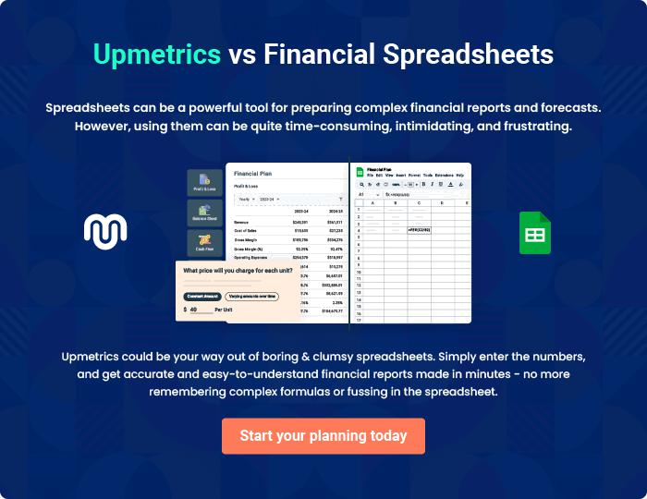
Appendix

When writing the appendix section, you should include any additional information that supports the main content of your plan. This may include financial statements, market research data, legal documents, and other
To unlock help try Upmetrics! 
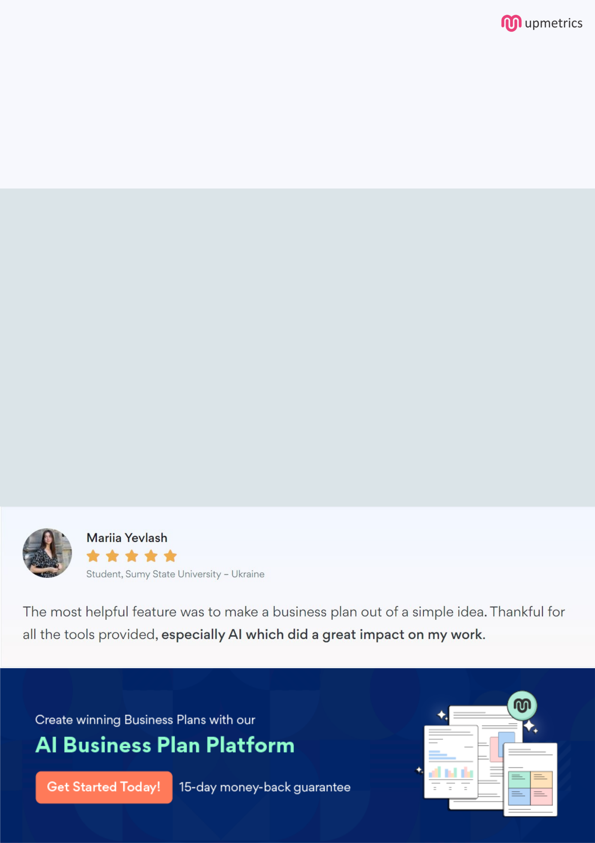
Create a winning business plan that gets you funded

Creating a stunning and investment-ready plan requires no writing, graphic designing, or financial planning expertise.

Upmetrics has all the features required to help you create a comprehensive business plan—from start to finish. Make no mistakes, it’s the modern way of planning to structure ideas, make plans, and create stunning pitch decks to awe investors.

Pitch decks that impress investors

Create pitch decks that provide a visual representation of your business, engage investors, and make them want to invest in your business idea.

Interactive plans in no time

Import business plan sections like—SWOT analysis, comparison tables, and others to create an interactive business plan. No designing skills are required.

Stunning cover page designs

With Upmetrics, you have the liberty to choose from multiple stunning cover page designs. Choose a creative design and make your plan stand out.

Online sharing made simple

Upmetrics makes online sharing quick and easier for users. Easily share your business plans with a link while tracking reader activity.

500+ sample business plans

Simply import a template from our library of sample plans into the editor and start customizing it to make it yours. It takes only a few clicks to get started.

Collaborate with team in real-time

Invite team members, initiate conversations, discuss ideas & strategies, share feedback, and work on a business plan in real-time.

