
BUSINESS PLAN

2023


Firewood Business Plan

Warmth Delivered, Nature's Comfort

John Doe

10200 Bolsa Ave, Westminster, CA, 92683

- 359-3153 info@example.com http://www.example.com

Information provided in this business plan is unique to this business and confidential; therefore, anyone reading this plan agrees not to disclose any of the information in this business plan without prior written permission of the company.
Table of Contents

Executive Summary | 6
Market opportunity | 6
Services Offered | 6
Marketing & Sales Strategies | 7
Financial Highlights | 7
Units Sold v/s Revenue | 8

Company Overview | 9
Ownership | 9
Mission statement | 9
Business history | 10
Future goals | 10

Market Analysis | 11
Target Market | 11
Market size and growth potential | 11
Market Size | 12
Competitive analysis | 12
FireFlame Logs Ltd. | 12
WoodWarmth Enterprises | 13
Market trends | 13
Regulatory environment | 13

Products and Services | 15
Services | 15
Seasoned Firewood | 15
Firewood Delivery | 16
Bundled Firewood | 16
Wholesale Firewood Supplies | 16
Stove Installation & Repair | 17

Product Range and Customization 17

Quality Measures | 17
Additional Services | 18

Sales And Marketing Strategies | 19
Unique Selling Proposition (USP) | 19
Pricing Strategy | 19
Marketing strategies | 20
Online | 20
Sales strategies | 21
Customer retention | 21

Operations Plan | 22
Staffing & Training | 22
Operational Process | 22
Equipment & Machinery | 23

Management Team | 24
Key managers | 24
John Doe | 24
Jane Doe | 25
Alice Brown | 25
Robert Brown | 25
Organizational structure | 25
Organization chart | 26
Compensation plan | 26
Advisors/consultants | 27
Lucy Gray | 27
Adrian Green | 27

Financial Plan | 28
Profit & loss statement | 28
Cash flow statement | 30
Balance sheet | 31
Break-even Point | 33
Financing needs | 33
Appendix
Appendix | 35
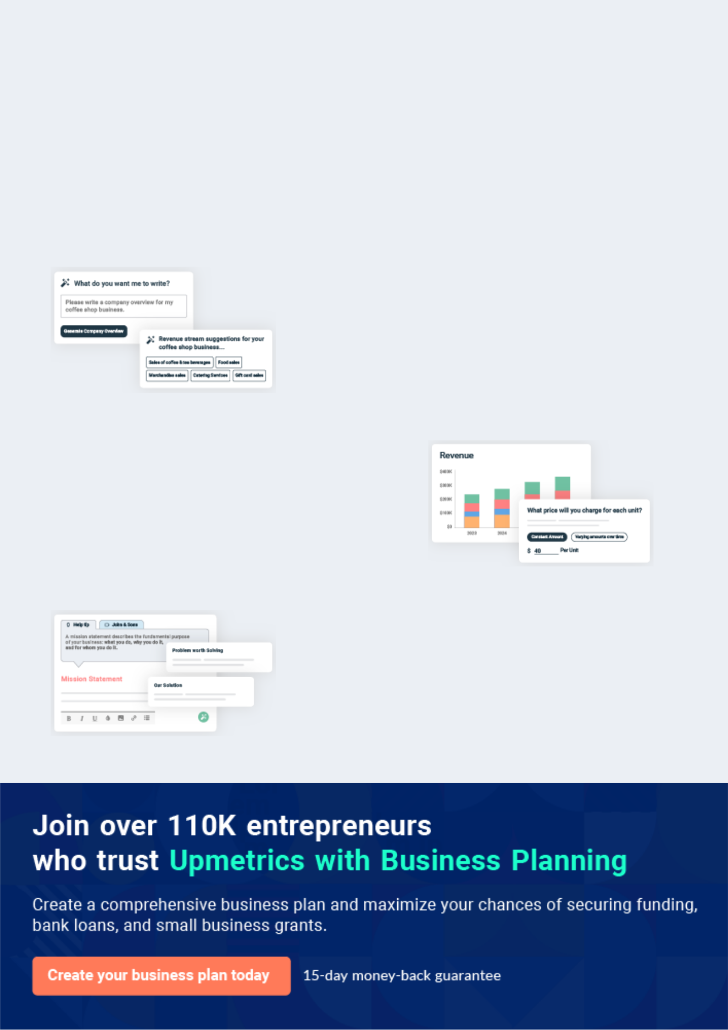
Business planning that’s simpler and faster than you think

Creating a business plan using Upmetrics to start and grow a business is literally the easiest thing in the World. Simply read the instructions and fill in the blanks. It’s as simple as that.

❛ | Upmetrics has everything you need to create a | ❜
❛ | comprehensive business plan. | ❜

AI-powered Upmetrics Assistant

AI-powered insights to streamline your plan

Not sure where to start? Upmetrics’ AI Assistant will automatically generate ideas for each section of your plan and offer improved versions of your writing, adjusting for tone, voice, and grammar or spelling errors.

Financial Forecasting Tool

All the financials are calculated for you

Forget the complex formulas and clumsy spreadsheets — with automatic financials and drag-and-drop forecasting, you can finish your plan faster and be confident that your numbers are accurate.

Business Plan Builder

Guides you like a business mentor

Upmetrics’ step-by-step instructions, prompts, and the library of 400+ sample business plans will guide you through each section of your plan as a business mentor.
Executive Summary


An executive summary is the first section of the business plan intended to provide an overview of the whole business plan.
To unlock help try Upmetrics! 

 Help tip  Firewood Business Plan


Start your executive summary by briefly introducing your business to your readers.

This section may include the name of your firewood business, its location, when it was
To unlock help try Upmetrics! 

Start writing here..

Market opportunity

 Help tip  Firewood Business Plan

Summarize your market research, including market size, growth potential, and marketing trends. Highlight the opportunities in the market and how your business will fit in to fill the gap.
To unlock help try Upmetrics! 

Start writing here..

Services Offered

 Help tip  Firewood Business Plan

Highlight the firewood services you offer your clients. The USPs and differentiators you offer are always a plus.
To unlock help try Upmetrics! 

Start writing here..

Marketing & Sales Strategies
To unlock help try Upmetrics!

 Help tip  Firewood Business Plan

Outline your sales and marketing strategies—what marketing platforms you use, how you plan on acquiring customers, etc.
To unlock help try Upmetrics! 

Start writing here..

Financial Highlights

 Help tip  Firewood Business Plan

Briefly summarize your financial projections for the initial years of business operations. Include any capital or investment requirements, associated startup costs, projected revenues, and profit forecasts.



Start writing here..
Units Sold v/s Revenue

 |  | Units Sold | Revenue
15.00k
10.00k
5.00k
0
Year 1 | Year 2 | Year 3


Financial Year |  |  | Units Sold | Revenue
Year 1 | 1,550 |  |  | $10,000
Year 2 | 1,800 |  |  | $12,000
Year 3 | 2,050 |  |  | $14,000
 Help tip |  |  Firewood Business Plan


Summarize your executive summary section with a clear CTA, for example, inviting angel investors to discuss the potential business investment.
To unlock help try Upmetrics! 

Write a call to action for your business plan.
Company Overview

Depending on what details of your business are essential, you’ll need different elements in your business overview.
To unlock help try Upmetrics! 

 Help tip  Firewood Business Plan

Describe your business in this section by providing all the basic information:

Describe what kind of firewood company you run and the name of it. You may specialize in one
To unlock help try Upmetrics! 

Start writing here..

Ownership

 Help tip  Firewood Business Plan

List the names of your firewood company’s founders or owners. Describe what shares they own and their responsibilities for efficiently managing the business.
To unlock help try Upmetrics! 

Start writing here..

Mission statement

 Help tip  Firewood Business Plan

Summarize your business’ objective, core principles, and values in your mission statement. This statement needs to be memorable, clear, and brief.
To unlock help try Upmetrics! 
❛ At [TimberTorch Firewood Co.], we ignite warmth and sustainability, providing our clients with top-tier firewood solutions, underpinned by our unwavering commitment to environmental responsibility and unparalleled quality.

❜

Business history

 Help tip  Firewood Business Plan

If you’re an established firewood business, briefly describe your business history, like—when it was founded, how it evolved over time, etc.
To unlock help try Upmetrics! 

Start writing here..

Future goals

 Help tip  Firewood Business Plan

It’s crucial to convey your aspirations and vision. Mention your short-term and long-term goals; they can be specific targets for revenue, market share, or expanding your services.
To unlock help try Upmetrics! 

Start writing here..
Market Analysis
To unlock help try Upmetrics!


 |  | Market analysis provides a clear understanding of the market in which your
 |  | printing business will run along with the target market, competitors, and
 |  | growth opportunities.
 |  |  |  | To unlock help try Upmetrics! 
 Help tip |  |  Firewood Business Plan

To write the introduction section of your market analysis, start by clearly identifying your primary target market.
To unlock help try Upmetrics! 

Start writing here..

Target Market

 Help tip  Firewood Business Plan

Start this section by describing your target market. Define your ideal customer and explain what types of services they prefer. Creating a buyer persona will help you easily define your target market to your readers.



Start writing here..

Market size and growth potential

 Help Tip  Firewood Business Plan


Describe your market size and growth potential and whether you will target a niche or a much broader market.
To unlock help try Upmetrics! 

Start writing here..

Market Size
To unlock help try Upmetrics!

Available Market | 10M
All households using firewood in the | 10M
U.S.
Served Market | 2M
Households in the Northeast U.S. using | 2M
firewood. | 2M
Target Market | 500k
Northeast U.S. homes preferring | 500k
sustainable firewood. | 500k


 Help tip  Firewood Business Plan

Identify and analyze your direct and indirect competitors. Identify their strengths and weaknesses, and describe what differentiates your firewood business from them. Point out how you have a competitive edge in the market.



Competitive analysis

FireFlame Logs Ltd.

Established in [Year], FireFlame Logs Ltd. has been a prominent name in the [specific region or nationwide] firewood market. Based out of [City, State], they have been primarily focusing on [firewood retail and delivery services].

Features

Seasoned firewood bundles

Express delivery within 24 hours

Customizable firewood packages for events

Strengths Weaknesses

Extensive distribution network Limited focus on sustainability

covering [X regions/states]. and eco-friendly sourcing.

Strong brand recognition due to Inconsistent wood quality in

years of market presence. some batches.

Diverse product range catering Higher price point compared to

to various customer needs. the industry average.

WoodWarmth Enterprises

WoodWarmth Enterprises, founded in [Year], has carved a niche for itself in the [specific region or nationwide] market by offering specialized [eco-friendly firewood solutions]. With its headquarters in [City, State], it boasts an impressive clientele spanning both residential and commercial sectors.

Features

Eco-friendly firewood sourced from renewable forests.

Firewood bundles are tailored for culinary use.

Subscription-based delivery model.

Strengths

Strong commitment to environmental responsibility, attracting eco-conscious clientele.

Unique offerings like culinary-grade firewood.

Regular and timely deliveries are ensured through a subscription model.

Weaknesses

Limited service area, not covering [specific regions/ states].

Dependency on a single sourcing point, leads to potential supply chain vulnerabilities.

Relatively new in the market, thus lacking in extensive brand recognition.

Market trends

 Help tip  Firewood Business Plan

Analyse emerging trends in the industry, such as changes in customer behavior or preferences, etc. Explain how your business will cope with all the trends.
To unlock help try Upmetrics! 

Start writing here..

Regulatory environment

 Help tip  Firewood Business Plan

List regulations and licensing requirements that may affect your firewood business, such as business registration, environmental regulations, firewood treatment & quarantine regulations.
To unlock help try Upmetrics! 

Start writing here..

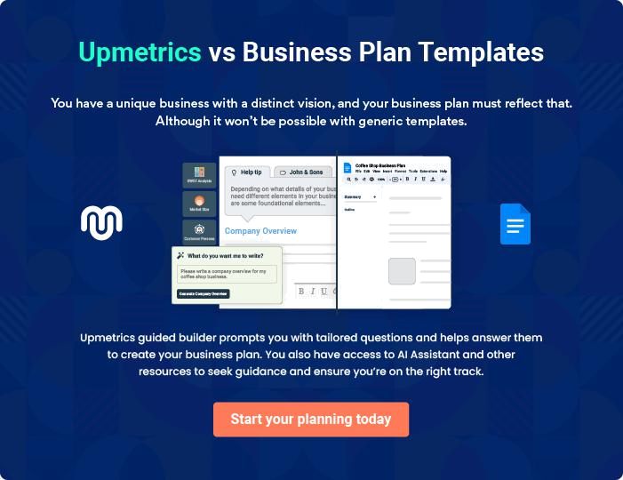
Products and Services
To unlock help try Upmetrics!

The product and services section of a firewood business plan should describe the specific services and products that will be offered to customers. To write this section should include the following:



 Help tip  Firewood Business Plan

To craft the introduction for your "Products and Services" chapter, begin by positioning your business within its industry, emphasizing its unique strengths or value proposition.
To unlock help try Upmetrics! 

Start writing here..

 Help tip


Mention the firewood services your business will offer. This list may include services like,

• Seasoned firewood
To unlock help try Upmetrics! 

Services

Seasoned Firewood


Price: $[X] per cord

Premium quality firewood, aged to perfection to provide optimal burning efficiency. Ideal for heating, cooking, and recreational use.

Specifications

- Wood Type: [Oak, Maple, etc.]

- Moisture Content: Less than 20%

- Size: [X inches] in length, [Y inches] diameter

- Weight: Approximately [Z lbs] per bundle
Firewood Delivery

Price: $[A] for up to [B miles], additional $[C] per extra mile

Hassle-free, prompt delivery service bringing your chosen firewood directly to your doorstep.

Specifications

- Delivery Window: [X hours] from order placement

- Coverage Area: Up to [Y miles] from [specific location]

- Vehicle: Environment-friendly [specific truck/van model]

Bundled Firewood

Price: $[D] per bundle

Conveniently packaged firewood tailored for individual needs, perfect for single-use events or cozy evenings.

Specifications

- Bundle Weight: Approximately [P lbs]

- Number of Logs: Approximately [Q logs] per bundle

- Packaging: Eco-friendly, weather-resistant wrap

Wholesale Firewood Supplies

Price: $[E] per pallet

Catering to businesses and bulk buyers, ensuring consistent quality at competitive rates.

Specifications

- Minimum Order: [R pallets]

- Wood Type: Customizable (e.g., Oak, Pine, Maple)

- Volume Discount: Available for orders above [S pallets]
Stove Installation & Repair
- To unlock help try Upmetrics!

Price: Installation at $[F], Repair services starting at $[G]

Professional stove setups to enhance your firewood experience, complemented by expert maintenance and repair services.

Specifications

- Service Time: Typically [T hours] for installation, repairs vary based on complexity

- Equipment: Use of high-grade tools and original parts

- Warranty: [U months] warranty on installation and repairs

Product Range and Customization

 Help tip  Firewood Business Plan


Describe the assortment of firewood goods that are offered to customers. You can mention
various firewood lengths, diameters, or sizes as well as particular packaging choices (bundles,
cords, or bulk).
 |  |  |  | To unlock help try Upmetrics! 
Start writing here..
Quality Measures
 Help tip |  |  Firewood Business Plan

Emphasize giving high-quality firewood. Describe the steps you take to make sure the firewood is properly stored, well-seasoned, and pest & contaminant-free. Talk about any accreditations, professional requirements, or quality assurance procedures you follow.



Start writing here..

Additional Services
To unlock help try Upmetrics!

 Help tip  Firewood Business Plan

Mention if your firewood company offers any additional services. You may include services like stove installation & repair, specific packaging options, equipment rentals like firewood racks, etc.



Start writing here..
Sales And Marketing Strategies

Writing the sales and marketing strategies section means a list of strategies you will use to attract and retain your clients.
To unlock help try Upmetrics! 

 Help Tip  Firewood Business Plan

To create an effective introduction for your "Sales and Marketing Strategies" chapter, start by setting the stage within your specific industry or market.
To unlock help try Upmetrics! 

Start writing here..

Unique Selling Proposition (USP)

 Help tip  Firewood Business Plan

Define your business’s USPs depending on the market you serve, the equipment you use, and the unique services you provide. Identifying USPs will help you plan your marketing strategies.
To unlock help try Upmetrics! 

Start writing here..

Pricing Strategy

 Help tip  Firewood Business Plan

Describe your pricing strategy—how you plan to price your products and stay competitive in the local market. You can mention any discounts you plan on offering to attract new customers.
To unlock help try Upmetrics! 

Start writing here..

 Help tip  Firewood Business Plan
To unlock help try Upmetrics!

Discuss your marketing strategies to market your services. You may include some of these marketing strategies in your business plan—targeted online marketing, local SEO & listings, direct mail & local flyers, etc.



Marketing strategies

Online


Social Media

Running ads on platforms like [Facebook, Google Ads], targeting specific demographics and regions.

Local SEO and Listing

Ensuring our business ranks high on local search queries and is listed on prominent directories.

Direct Mail & Local Flyers

Engaging with the local community, we distribute flyers and send direct mails, offering special promotions and educating them about our offerings.

 Help tip

Outline the strategies you’ll implement to maximize your sales. Your sales strategies may include targeted customer outreach, upselling & cross-selling, promotions & packages, etc.
To unlock help try Upmetrics! 

Sales strategies

Targeted Customer Outreach

Identifying potential bulk buyers or businesses and reaching out with tailored proposals.

Upselling & Cross-Selling

Offering complementary products or services, like stove maintenance, when customers purchase firewood.

Promotions & Packages

Introducing seasonal packages or

promotional bundles, enticing

customers to purchase more.

 Help tip

Describe your customer retention strategies and how you plan to execute them. For instance, introducing loyalty programs, discounts on bulk orders, personalized service, etc.
To unlock help try Upmetrics! 

Customer retention

Loyalty Programs Bulk Order Discounts

Rewarding frequent buyers with points that can be redeemed on future purchases.

Offering special pricing for customers ordering in large quantities.

Personalized Service

Taking note of individual customer

preferences and ensuring they

have a consistent, tailored

experience with each order.

Operations Plan
To unlock help try Upmetrics!

 |  | When writing the operations plan section, it’s important to consider the
 |  | various aspects of your business operations.
 |  |  |  | To unlock help try Upmetrics! 
 Help tip |  |  Firewood Business Plan


To create an effective introduction for your "Operational Plan" chapter, start by emphasizing the
pivotal role of efficient operations in the success of your business, underscoring how they
directly impact the quality of services delivered.
 |  |  |  | To unlock help try Upmetrics! 
Start writing here..
Staffing & Training
 Help tip |  |  Firewood Business Plan

Mention your business’s staffing requirements, including the number of employees, production
staff, or delivery personnel needed. Include their qualifications, the training required, and the
duties they will perform.
 |  |  |  | To unlock help try Upmetrics! 
Start writing here..
Operational Process
 Help tip |  |  Firewood Business Plan

Outline the processes and procedures you will use to run your firewood business. Your operational processes may include wood procurement, wood processing, seasoning & drying, and quality control.



Start writing here..

Equipment & Machinery

 Help tip  Firewood Business Plan

Include the list of equipment and machinery required for the firewood business, such as a chainsaw, log splitter, firewood processor, conveyors, etc.
To unlock help try Upmetrics! 

Start writing here..
Management Team

The management team section provides an overview of the individuals responsible for running your business plan.
To unlock help try Upmetrics! 

 Help tip  Firewood Business Plan

To craft an introduction for your "Management Team" chapter, begin by emphasizing the crucial role of leadership in the success of any business.
To unlock help try Upmetrics! 

Start writing here..

Key managers

 Help tip  Firewood Business Plan

Introduce your management and key members of your team, and explain their roles and responsibilities.
To unlock help try Upmetrics! 

Start writing here..


JOHN DOE

CEO & Co-founder - john.doe@example.com

As the visionary behind [TimberTorch Firewood Co.], John has been instrumental in charting the company's growth trajectory since its inception.

With a degree in Business Management from [University Name] and over 15 years of experience in the firewood industry, John’s leadership combines hands-on knowledge with strategic foresight.


JANE DOE

Chief Operating Officer (COO) - jane.doe@example.com

Jane holds an MBA from [Top University Name] and has been pivotal in refining the operational processes at TimberTorch.

With 10 years of industry-specific expertise, she plays a key role in ensuring every logistical and operational aspect runs seamlessly, furthering the company's commitment to quality and efficiency.



ALICE BROWN

CMO - alice.brown@example.com

A marketing dynamo, Alice graduated with a degree in Marketing from [Renowned University Name].

Her 12 years in strategic marketing, paired with her keen understanding of the firewood market dynamics, have been instrumental in elevating TimberTorch's brand presence and customer engagement.


ROBERT BROWN

Operations Manager - robert.brown@example.com

Robert, an alumnus of [Notable University Name] with a degree in Supply Chain Management, has been steering the operations department with precision.

His 8 years of hands-on experience in firewood processing, paired with his managerial acumen, ensure that the company's operational standards are unparalleled.

Organizational structure

 Help tip  Firewood Business Plan

Explain the organizational structure of your management team. Include the reporting line and decision-making hierarchy.
To unlock help try Upmetrics! 

Start writing here..

Organization chart


John Doe

CEO


Alice Brown

Jane Doe

CTO


COO

Emily Clark

Customer Service Manager Robert Brown

Operations Manager

Compensation plan

 Help tip  Firewood Business Plan

Describe your compensation plan for the management and staff. Include their salaries, incentives, and other benefits.
To unlock help try Upmetrics! 

Start writing here..

 Help tip

Mentioning advisors or consultants in your business plans adds credibility to your business idea.
To unlock help try Upmetrics! 

Advisors/consultants


LUCY GRAY

Sustainability Advisor

Lucy aids our commitment to eco-friendly practices, ensuring our operations align with sustainability standards.


ADRIAN GREEN

Industry Consultant

With over [M years] in the firewood industry, Adrian provides insights into industry trends and best practices
Financial Plan
To unlock help try Upmetrics!

When writing the financial plan section of a business plan, it’s important to provide a comprehensive overview of your financial projections for the first few years of your business, You may provide the following:
To unlock help try Upmetrics! 

 Help tip  Firewood Business Plan

To create an effective introduction for your "Financial Plan" chapter, begin by stressing the critical role of a well-structured financial plan in the success of your venture.
To unlock help try Upmetrics! 

Start writing here..

 Help tip

Describe details such as projected revenue, operational costs, and service costs in your projected profit and loss statement. Make sure to include your business’s expected net profit or loss.



Profit & loss statement

 | 2023-24 | 2024-25 | 2025-26 | 2026-27 | 2027-28
Revenue | $0 | $0 | $0 | $0 | $0

Cost Of Sales | $0 | $0 | $0 | $0 | $0
General Costs | $0 | $0 | $0 | $0 | $0
Revenue Specific Costs | $0 | $0 | $0 | $0 | $0
Personnel Costs (Direct | $0 | $0 | $0 | $0 | $0
Labor)

Gross Margin $0 $0 $0 $0 $0

Gross Margin (%)

Operating Expense

Payroll Expense

(Indirect Labor)

General Expense

Bad Debt

Amortization of Current Assets

EBITDA

Additional Expense

Long Term

Depreciation

Gain or loss from Sale of Assets

EBIT

Interest Expenses

EBT

Income Tax Expense

Total Expense

Net Income

Net Income (%)

2023-24 | 2024-25 | 2025-26 | 2026-27 | 2027-28
0% | 0% | 0% | 0% | 0%
$0 | $0 | $0 | $0 | $0
$0 | $0 | $0 | $0 | $0
$0 | $0 | $0 | $0 | $0
$0 | $0 | $0 | $0 | $0
$0 | $0 | $0 | $0 | $0
$0 | $0 | $0 | $0 | $0
$0 | $0 | $0 | $0 | $0
$0 | $0 | $0 | $0 | $0
$0 | $0 | $0 | $0 | $0
$0 | $0 | $0 | $0 | $0
$0 | $0 | $0 | $0 | $0
$0 | $0 | $0 | $0 | $0
$0 | $0 | $0 | $0 | $0
$0 | $0 | $0 | $0 | $0
$0 | $0 | $0 | $0 | $0
0% | 0% | 0% | 0% | 0%
To unlock help try Upmetrics!
 | 2023-24 | 2024-25 | 2025-26 | 2026-27 | 2027-28
Retained Earning | $0 | $0 | $0 | $0 | $0
Opening
Owner's Distribution | $0 | $0 | $0 | $0 | $0
Retained Earning | $0 | $0 | $0 | $0 | $0
Closing

 Help tip

The cash flow for the first few years of your operation should be estimated and described in this section. This may include billing invoices, payment receipts, loan payments, and any other cash flow statements.



Cash flow statement

Cash Received

Cash Paid

COS & General Expenses

Salary & Wages

Interest

Sales Tax

Income Tax

Net Cash From

Operations

Assets Sell

Assets Purchase

Net Cash From

Investments

2023-24 | 2024-25 | 2025-26 | 2026-27 | 2027-28
$0 | $0 | $0 | $0 | $0
$0 | $0 | $0 | $0 | $0
$0 | $0 | $0 | $0 | $0
$0 | $0 | $0 | $0 | $0
$0 | $0 | $0 | $0 | $0
$0 | $0 | $0 | $0 | $0
$0 | $0 | $0 | $0 | $0
$0 | $0 | $0 | $0 | $0

$0 | $0 | $0 | $0 | $0
$0 | $0 | $0 | $0 | $0
$0 | $0 | $0 | $0 | $0

 | 2023-24 | 2024-25 | 2025-26 | 2026-27 | 2027-28
Amount Received | $0 | $0 | $0 | $0 | $0
Loan Received | $0 | $0 | $0 | $0 | $0
Common Stock
Preferred Stock | $0 | $0 | $0 | $0 | $0
Owner's Contribution | $0 | $0 | $0 | $0 | $0
Amount Paid | $0 | $0 | $0 | $0 | $0
Loan Capital | $0 | $0 | $0 | $0 | $0
Dividends & Distributions | $0 | $0 | $0 | $0 | $0
Net Cash From | $0 | $0 | $0 | $0 | $0
Financing

Summary
Starting Cash | $0 | $0 | $0 | $0 | $0
Cash In | $0 | $0 | $0 | $0 | $0
Cash Out | $0 | $0 | $0 | $0 | $0
Change in Cash | $0 | $0 | $0 | $0 | $0
Ending Cash | $0 | $0 | $0 | $0 | $0

 Help tip

Create a projected balance sheet documenting your firewood business’s assets, liabilities, and equity.
To unlock help try Upmetrics! 

Balance sheet

 | 2023-24 | 2024-25 | 2025-26 | 2026-27 | 2027-28
Assets | $0 | $0 | $0 | $0 | $0
 | 2023-24 | 2024-25 | 2025-26 | 2026-27 | 2027-28
Current Assets | $0 | $0 | $0 | $0 | $0
Cash | $0 | $0 | $0 | $0 | $0
Accounts Receivable | $0 | $0 | $0 | $0 | $0
Inventory | $0 | $0 | $0 | $0 | $0
Other Current Assets | $0 | $0 | $0 | $0 | $0
Long Term Assets | $0 | $0 | $0 | $0 | $0
Gross Long Term Assets | $0 | $0 | $0 | $0 | $0
Accumulated Depreciation | $0 | $0 | $0 | $0 | $0

Liabilities & Equity | $0 | $0 | $0 | $0 | $0
Liabilities | $0 | $0 | $0 | $0 | $0
Current Liabilities | $0 | $0 | $0 | $0 | $0
Accounts Payable | $0 | $0 | $0 | $0 | $0
Income Tax Payable | $0 | $0 | $0 | $0 | $0
Sales Tax Payable | $0 | $0 | $0 | $0 | $0
Short Term Debt | $0 | $0 | $0 | $0 | $0
Long Term Liabilities | $0 | $0 | $0 | $0 | $0
Long Term Debt | $0 | $0 | $0 | $0 | $0
Equity | $0 | $0 | $0 | $0 | $0
Paid-in Capital | $0 | $0 | $0 | $0 | $0
Common Stock | $0 | $0 | $0 | $0 | $0
Preferred Stock | $0 | $0 | $0 | $0 | $0
Owner's Contribution | $0 | $0 | $0 | $0 | $0
Retained Earnings | $0 | $0 | $0 | $0 | $0
 | 2023-24 | 2024-25 | 2025-26 | 2026-27 | 2027-28
Check | $0 | $0 | $0 | $0 | $0

Break-even Point

 Help tip  Firewood Business Plan

Determine and mention your business’s break-even point—the point at which your business costs and revenue will be equal.
To unlock help try Upmetrics! 

Start writing here..

Financing needs

 Help tip  Firewood Business Plan

Calculate costs associated with starting a firewood business, and estimate your financing needs and how much capital you need to raise to operate your business.
To unlock help try Upmetrics! 

Start writing here..
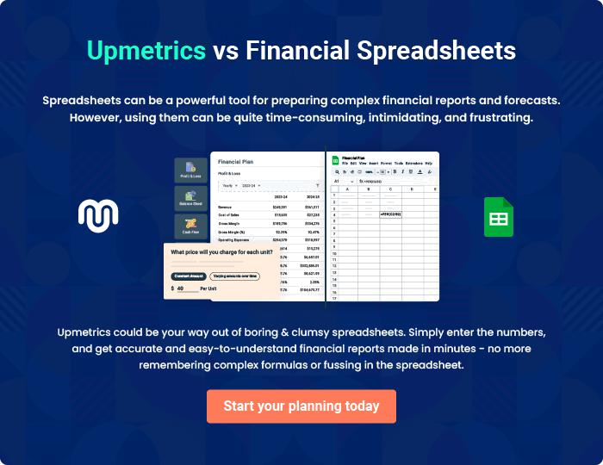
Appendix

When writing the appendix section, you should include any additional information that supports the main content of your plan. This may include financial statements, market research data, legal documents, and other
To unlock help try Upmetrics! 

Create a winning business plan that gets you funded

Creating a stunning and investment-ready plan requires no writing, graphic designing, or financial planning expertise.

Upmetrics has all the features required to help you create a comprehensive business plan—from start to finish. Make no mistakes, it’s the modern way of planning to structure ideas, make plans, and create stunning pitch decks to awe investors.

Pitch decks that impress investors

Create pitch decks that provide a visual representation of your business, engage investors, and make them want to invest in your business idea.

Interactive plans in no time

Import business plan sections like—SWOT analysis, comparison tables, and others to create an interactive business plan. No designing skills are required.

Stunning cover page designs

With Upmetrics, you have the liberty to choose from multiple stunning cover page designs. Choose a creative design and make your plan stand out.

Online sharing made simple

Upmetrics makes online sharing quick and easier for users. Easily share your business plans with a link while tracking reader activity.

500+ sample business plans

Simply import a template from our library of sample plans into the editor and start customizing it to make it yours. It takes only a few clicks to get started.

Collaborate with team in real-time

Invite team members, initiate conversations, discuss ideas & strategies, share feedback, and work on a business plan in real-time.

