
Fast Food Restaurant Business Plan

ADDRESS CONTACT

10200 Bolsa Ave, Westminster, CA, 92683 (650) 359-3153

http://www.example.com info@example.com
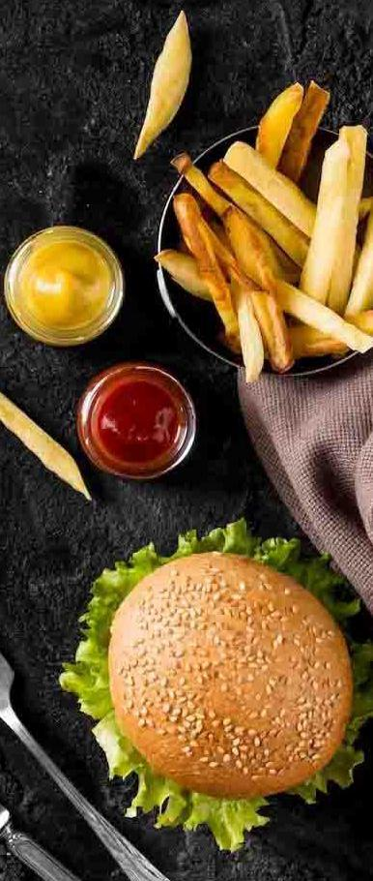

Business Plan

2023

Prepared By

John Doe


Quick Bites, Big Delights

Information provided in this business plan is unique to this business and confidential; therefore, anyone reading this plan agrees not to disclose any of the information in this business plan without prior written permission of the company.

Table of Contents

Executive Summary | 6
Market opportunity | 6
Products & Services Offered | 6
Marketing & Sales Strategies | 7
Financial Highlights | 7
Units Sold v/s Revenue | 8

Company Overview | 9
Ownership | 9
Business Owners | 9
Mission statement | 10
Business history | 10
Future goals | 10

Market Analysis | 11
Target Market | 11
Market size and growth potential | 11
Market Size | 12
Competitive analysis | 12
MexiQuick | 12
RapidBurrito | 13
Market trends | 13
Regulatory environment | 13

Products and Services | 15
Products | 15
Spicy Al Pastor Taco | 15
Chipotle Chicken Bowl | 16
Churros with Chocolate Dip | 16
Classic Margarita | 17
Online Ordering via the Tasty Bites App | 17
Beverages and Desserts | 17
Food Preparation and Safety Measures | 18
Special Services | 18

Sales And Marketing Strategies | 19
Unique Selling Proposition (USP) | 19
Pricing Strategy | 19
Marketing strategies | 20
Online | 20
Offline | 20
Sales strategies | 21
Customer retention | 21

Operations Plan | 22
Staffing & Training | 22
Operational Process | 22
Equipment & Machinery | 23

Management Team | 24
Key managers | 24
John Doe | 24
Jane Doe | 25
Alice Brown | 25
Robert Brown | 25
Organizational structure | 25
Organization chart | 26
Compensation plan | 26
Advisors/Consultants | 27
Mr. David Collins | 27
Dr. Rachel Johnson | 27
Financial Plan
Financial Plan | 28

Profit & loss statement 28

Cash flow statement | 30
Balance sheet | 31
Break-even Point | 33
Financing needs | 33
Appendix
Appendix | 35
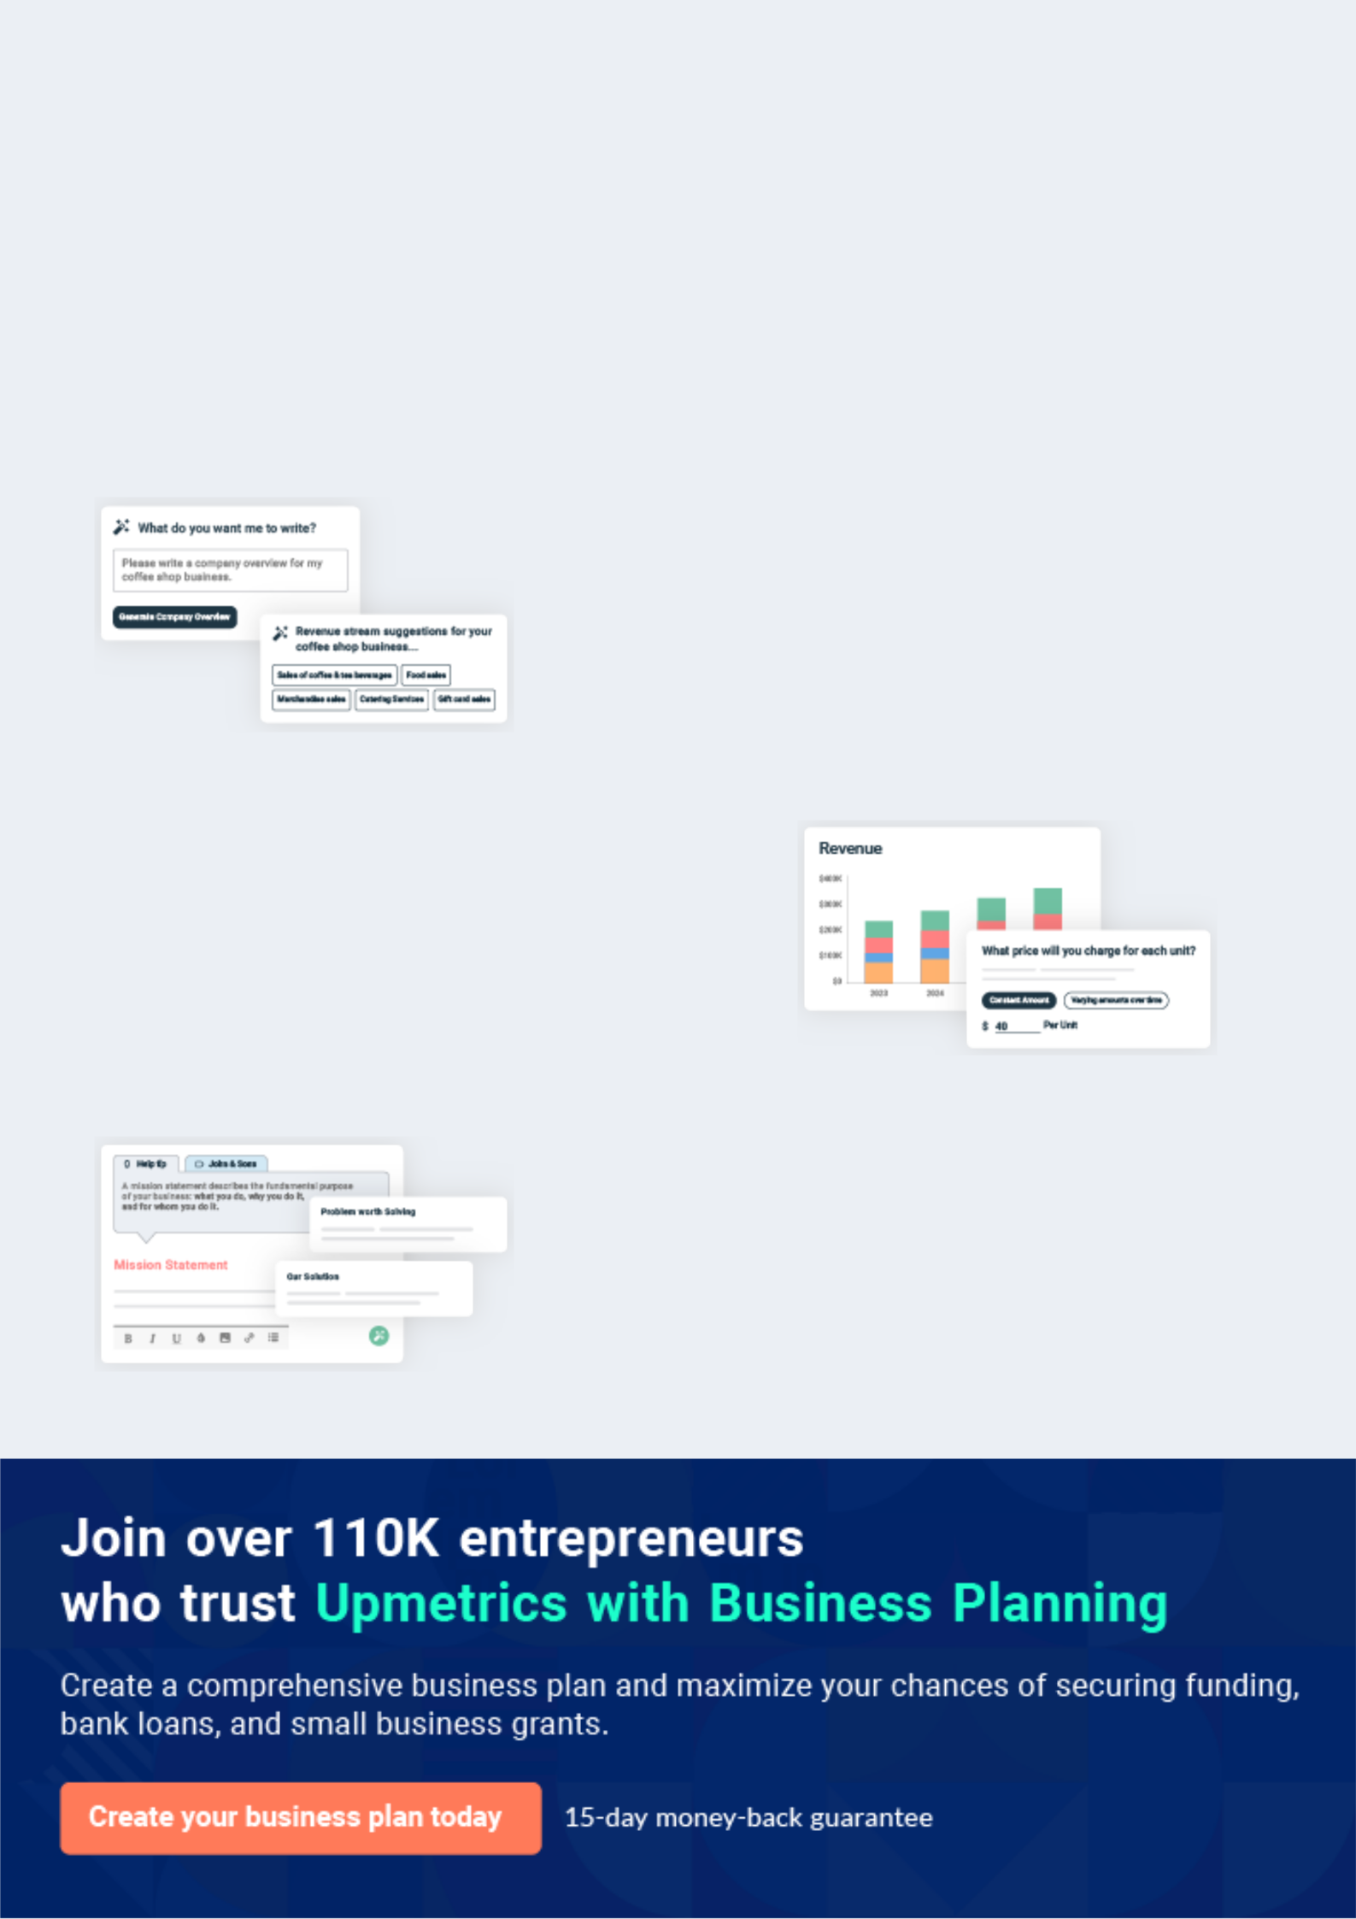
Business planning that’s simpler and faster than you think

Creating a business plan using Upmetrics to start and grow a business is literally the easiest thing in the World. Simply read the instructions and fill in the blanks. It’s as simple as that.

❛ | Upmetrics has everything you need to create a | ❜
❛ | comprehensive business plan. | ❜

AI-powered Upmetrics Assistant

AI-powered insights to streamline your plan

Not sure where to start? Upmetrics’ AI Assistant will automatically generate ideas for each section of your plan and offer improved versions of your writing, adjusting for tone, voice, and grammar or spelling errors.

Financial Forecasting Tool

All the financials are calculated for you

Forget the complex formulas and clumsy spreadsheets — with automatic financials and drag-and-drop forecasting, you can finish your plan faster and be confident that your numbers are accurate.

Business Plan Builder

Guides you like a business mentor

Upmetrics’ step-by-step instructions, prompts, and the library of 400+ sample business plans will guide you through each section of your plan as a business mentor.
Executive Summary


An executive summary is the first section of the business plan intended to provide an overview of the whole business plan.
To unlock help try Upmetrics! 

 Help tip  Fast Food Restaurant Business Plan


Start your executive summary by briefly introducing your business to your readers.

This section may include the name of your fast food restaurant, its location, when it was
To unlock help try Upmetrics! 

Start writing here..

Market opportunity

 Help tip  Fast Food Restaurant Business Plan

Summarize your market research, including market size, growth potential, and marketing trends. Highlight the opportunities in the market and how your business will fit in to fill the gap.
To unlock help try Upmetrics! 

Start writing here..

Products & Services Offered

 Help tip  Fast Food Restaurant Business Plan

Highlight your food menu and the services you will offer to your customers. Describe any special dishes you serve.
To unlock help try Upmetrics! 

Start writing here..

Marketing & Sales Strategies
To unlock help try Upmetrics!

 Help tip  Fast Food Restaurant Business Plan

Outline your sales and marketing strategies—what marketing platforms you use, how you plan on acquiring customers, etc.
To unlock help try Upmetrics! 

Start writing here..

Financial Highlights

 Help tip  Fast Food Restaurant Business Plan

Briefly summarize your financial projections for the initial years of business operations. Include any capital or investment requirements, associated startup costs, projected revenues, and profit forecasts.



Start writing here..
Units Sold v/s Revenue

 |  | Units Sold | Revenue
15.00k
10.00k
5.00k
0
Year 1 | Year 2 | Year 3


Financial Year |  |  | Units Sold | Revenue
Year 1 | 1,550 |  |  | $10,000
Year 2 | 1,800 |  |  | $12,000
Year 3 | 2,050 |  |  | $14,000
 Help tip |  |  Fast Food Restaurant Business Plan


Summarize your executive summary section with a clear CTA, for example, inviting angel investors to discuss the potential business investment.
To unlock help try Upmetrics! 

Write a call to action for your business plan.
Company Overview

Depending on what details of your business are essential, you’ll need different elements in your business overview.
To unlock help try Upmetrics! 

 Help tip  Fast Food Restaurant Business Plan

Describe your business in this section by providing all the basic information:

Describe what kind of fast food restaurant you run and the name of it. Here are some of the
To unlock help try Upmetrics! 

Start writing here..

Ownership

 Help tip  Fast Food Restaurant Business Plan

List the founders or owners of your fast food restaurant. Describe what shares they own and their responsibilities for efficiently managing the business.
To unlock help try Upmetrics! 

Start writing here..

Business Owners



60% John Doe



40% Jane Doe
Mission statement

 Help tip  Fast Food Restaurant Business Plan

Summarize your business’ objective, core principles, and values in your mission statement. This statement needs to be memorable, clear, and brief.
To unlock help try Upmetrics! 

❛ "At [Tasty Bites Fast Food], we are committed to satiating culinary curiosities by delivering authentic Mexican flavours wrapped in quick-service excellence. Our core principles revolve around authenticity, quality, and customer delight, ensuring every bite

evokes a memorable experience."
❜

Business history

 Help tip  Fast Food Restaurant Business Plan

If you’re an established fast food restaurant business, briefly describe your business history, like—when it was founded, how it evolved over time, etc.
To unlock help try Upmetrics! 

Start writing here..

Future goals

 Help tip  Fast Food Restaurant Business Plan

It’s crucial to convey your aspirations and vision. Mention your short-term and long-term goals; they can be specific targets for revenue, market share, or expanding your services.
To unlock help try Upmetrics! 

Start writing here..

Market Analysis
To unlock help try Upmetrics!


 |  | Market analysis provides a clear understanding of the market in which your
 |  | printing business will run along with the target market, competitors, and
 |  | growth opportunities.
 |  |  |  | To unlock help try Upmetrics! 
 Help tip |  |  Fast Food Restaurant Business Plan

To write the introduction section of your market analysis, start by clearly identifying your primary target market.
To unlock help try Upmetrics! 

Start writing here..

Target Market

 Help tip  Fast Food Restaurant Business Plan

Start this section by describing your target market. Define your ideal customer and explain what types of services they prefer. Creating a buyer persona will help you easily define your target market to your readers.



Start writing here..

Market size and growth potential

 Help Tip  Fast Food Restaurant Business Plan


Describe your market size and growth potential and whether you will target a niche or a much broader market.
To unlock help try Upmetrics! 

Start writing here..

Market Size

Available Market

Total individuals eating out in Cityville 2M monthly.

Served Market
Those preferring Mexican fast food in 500k Cityville.

Target Market
Cityville's busy professionals and 250k millennials seeking Mexican fast food.

 Help tip  Fast Food Restaurant Business Plan

Identify and analyze your direct and indirect competitors. Identify their strengths and weaknesses, and describe what differentiates your fast food restaurant from them.
To unlock help try Upmetrics! 

Competitive analysis

MexiQuick

MexiQuick, a chain with over [20] outlets across [Cityville], has been a mainstay in the Mexican fast-food arena for over [10] years. They're known for their [quick service] and [value meals].

Features

Comprehensive menu with a variety of tacos, burritos, and quesadillas

Loyalty program for frequent customers

Online ordering with a user-friendly app

Combo meal options for families

Several vegetarian choices

Strengths

Established brand name with a loyal customer base

Efficient online order system and delivery network

Frequent promotional offers and discounts

Well-trained staff with customer-friendly service

Weaknesses

The menu lacks innovation and has remained largely unchanged

Quality inconsistency reported across different outlets

Slow adaptation to emerging market trends, such as health-conscious food options

Limited marketing presence in newer digital platforms

RapidBurrito

RapidBurrito, a relatively new entrant, focuses exclusively on a wide range of burritos. With their [5] locations in strategic parts of [Cityville], they have rapidly gained a following among burrito enthusiasts.

Features

Extensive burrito menu with unique fillings like [barbecue pulled pork] and [spicy tofu]

Customizable burritos where customers can choose ingredients

Monthly limited-time specials introducing new flavors

An app that not only allows ordering but also tracks nutritional information

Strengths

Novel concept focusing on a niche, attracting dedicated burrito lovers

High adaptability and introduction of new flavors regularly

Strong online and social media marketing campaigns

Weaknesses

Limited offerings beyond burritos, which may deter customers looking for variety

Fewer outlets compared to more established chains, limiting accessibility

Initial reviews indicate some inconsistencies in food quality and preparation

No loyalty programs or incentives for repeat customers

Market trends

 Help tip  Fast Food Restaurant Business Plan

Analyze emerging trends in the industry, such as technology disruptions, changes in customer behavior or preferences, etc. Explain how your business will cope with all the trends.
To unlock help try Upmetrics! 

Start writing here..

Regulatory environment

 Help tip  Fast Food Restaurant Business Plan

List regulations and licensing requirements affecting fast food restaurants, such as business registration, insurance, food service license, employment, and environmental regulations.
To unlock help try Upmetrics! 

Start writing here..

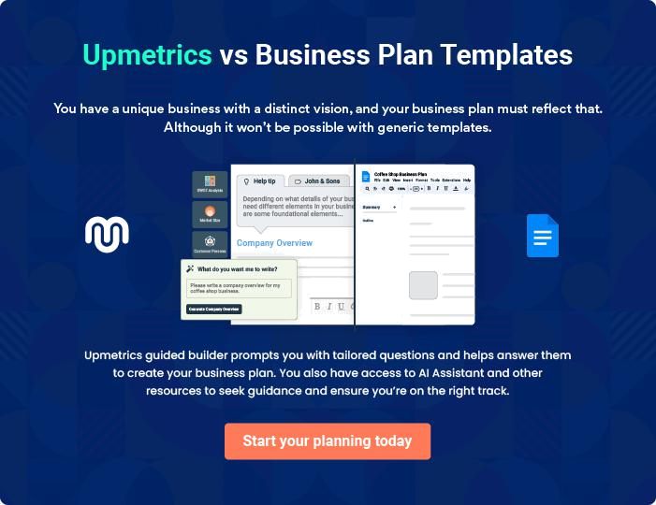
Products and Services

The product and services section of a fast food restaurant business plan should describe the specific services and products that will be offered to customers. To write this section should include the following:
To unlock help try Upmetrics! 

 Help tip  Fast Food Restaurant Business Plan

To craft the introduction for your "Products and Services" chapter, begin by positioning your business within its industry, emphasizing its unique strengths or value proposition.
To unlock help try Upmetrics! 

Start writing here..

 Help tip


Start this section by offering an overview of your fast food menu. Include the details about the types of cuisine, dietary options you provide, and any signature dishes.
To unlock help try Upmetrics! 

Products

Spicy Al Pastor Taco


Price: $[3.50]

A fusion of spicy and tangy, this taco is loaded with marinated pork, finely chopped onions, and cilantro, and topped with a dash of fresh pineapple.

Specifications

- Size: Regular taco size with a 6-inch diameter.

- Ingredients: Corn tortilla, marinated pork, onions, cilantro, pineapple, and salsa.

- Dietary: Gluten-free.
Chipotle Chicken Bowl

Price: $[7.00]

A hearty bowl brimming with seasoned rice, juicy chipotle-flavoured chicken, black beans, corn, and fresh pico de gallo.

Specifications

- Size: 16 oz bowl.

- Ingredients: Rice, chipotle chicken, black beans, corn, pico de gallo, shredded cheese, and guacamole.

- Dietary: Gluten-free. Vegetarian option available.

Churros with Chocolate Dip

Price: $[5.00]

Crispy, golden churros sprinkled with sugar and cinnamon, served with a side of rich chocolate dipping sauce.

Specifications

- Size: Order includes 4 churros, each 6 inches long.

- Ingredients: Wheat flour, sugar, cinnamon, and chocolate.

- Dietary: Vegetarian.
Classic Margarita

Price: $[4.50]

A refreshing drink with the perfect blend of tartness and sweetness, served with a salt-rimmed glass.

Specifications

- Size: 12 oz serving.

- Ingredients: Lime juice, tequila, triple sec, sugar syrup, and salt.

- Dietary: Gluten-free. The non-alcoholic version is available

Online Ordering via the Tasty Bites App

Price: Free to download, with special app-exclusive discounts.

A user-friendly app allowing customers to browse our menu, place orders, and track delivery in real-time.

Specifications

- Platform: Available on iOS and Android.

- Features: Menu browsing, online payment, real-time tracking, and order history.

- Dietary: Filter options to sort by dietary preferences.

Beverages and Desserts

 Help tip  Fast Food Restaurant Business Plan

Besides the fast food items, mention if your restaurant serves any other beverages such as tea, coffee, soft drinks, juices, and desserts or treats.
To unlock help try Upmetrics! 

Start writing here..

Food Preparation and Safety Measures

 Help tip  Fast Food Restaurant Business Plan

This section should explain your food preparation process, cooking methods, and how your business aligns with food safety regulations.
To unlock help try Upmetrics! 

Start writing here..

Special Services

 Help tip  Fast Food Restaurant Business Plan

Mention if your fast food restaurant offers any additional services. You may include services like online ordering, drive-thru, and valet parking.
To unlock help try Upmetrics! 

Start writing here..
Sales And Marketing Strategies
To unlock help try Upmetrics!

Writing the sales and marketing strategies section means a list of strategies you will use to attract and retain your clients.
To unlock help try Upmetrics! 

 Help Tip  Fast Food Restaurant Business Plan

To create an effective introduction for your "Sales and Marketing Strategies" chapter, start by setting the stage within your specific industry or market.
To unlock help try Upmetrics! 

Start writing here..

Unique Selling Proposition (USP)

 Help tip  Fast Food Restaurant Business Plan

Define your business’s USPs depending on the market you serve, the equipment you use, and the unique services you provide. Identifying USPs will help you plan your marketing strategies.
To unlock help try Upmetrics! 

Start writing here..

Pricing Strategy

 Help tip  Fast Food Restaurant Business Plan

Describe your pricing strategy—how you plan to price your products and services and stay competitive in the local market. You can mention any discounts you plan on offering to attract new customers.



Start writing here..

 Help tip  Fast Food Restaurant Business Plan
To unlock help try Upmetrics!

Discuss your marketing strategies to market your services. You may include some of these marketing strategies in your business plan—social media marketing, Google ads, brochures, email marketing, content marketing, and print marketing.



Marketing strategies

Online


Social Media Marketing

Platforms like [Instagram and Facebook] will showcase our dishes, behind-the-scenes content, and customer testimonials.

Content Marketing

Blog posts and articles about Mexican cuisine, food trends, and sustainability

Email Marketing

Regular newsletters with updates, promotions, and special offers for our subscribers.

Google Ads

Targeted ads to capture those searching for fast food options in [Cityville].

Offline

Brochures Print Marketing

Distributed in strategic locations, Collaborations with local

highlighting our menu and USPs newspapers and magazines for

feature pieces and ads.

 Help tip
To unlock help try Upmetrics!

Outline the strategies you’ll implement to maximize your sales. Your sales strategies may include offering loyalty programs, online food delivery services, and creating corporate accounts.



Sales strategies

Loyalty Programs

Points for every purchase, leading to discounts and special treats.

Online Food Delivery

Partnering with platforms like [UberEats and Grubhub] and offering direct delivery through our app.

Corporate Accounts

Special accounts for businesses,

offering catered meals for events

and meetings.

 Help tip

Describe your customer retention strategies and how you plan to execute them. For instance, introducing loyalty programs, focusing on personalized service, offering promotions, etc
To unlock help try Upmetrics! 

Customer retention

Loyalty Programs

Beyond points, offering exclusive sneak peeks at new dishes and events.

Promotions

Special deals for milestones like anniversaries of joining our loyalty program or birthdays.

Personalized Service

Recognizing regular customers,

understanding their preferences,

and sometimes surprising them

with complimentary dishes.

Operations Plan

 |  | When writing the operations plan section, it’s important to consider the
 |  | various aspects of your business operations.
 |  |  |  | To unlock help try Upmetrics! 
 Help tip |  |  Fast Food Restaurant Business Plan


To create an effective introduction for your "Operational Plan" chapter, start by emphasizing the
pivotal role of efficient operations in the success of your business, underscoring how they
directly impact the quality of services delivered.
 |  |  |  | To unlock help try Upmetrics! 
Start writing here..
Staffing & Training
 Help tip |  |  Fast Food Restaurant Business Plan

Mention your restaurant’s staffing requirements, including the number of employees or kitchen staff needed. Include their qualifications, the training required, and the duties they will perform.
To unlock help try Upmetrics! 

Start writing here..

Operational Process

 Help tip  Fast Food Restaurant Business Plan

Outline the processes and procedures you will use to run your fast food restaurant. Your operational processes may include restaurant opening, staff assignments, food preparation and cooking, order fulfillment, cleanliness and sanitization, and closing procedures.
To unlock help try Upmetrics! 

Start writing here..

Equipment & Machinery
To unlock help try Upmetrics!

 Help tip  Fast Food Restaurant Business Plan

Include the list of equipment and machinery required for fast food restaurants, such as refrigerators, coffee machines, ice machines, POS systems, Utensils and kitchen tools, and food preparation equipment.



Start writing here..
Management Team

The management team section provides an overview of the individuals responsible for running your business plan.
To unlock help try Upmetrics! 

 Help tip  Fast Food Restaurant Business Plan

To craft an introduction for your "Management Team" chapter, begin by emphasizing the crucial role of leadership in the success of any business.
To unlock help try Upmetrics! 

Start writing here..

Key managers

 Help tip  Fast Food Restaurant Business Plan

Introduce your management and key members of your team, and explain their roles and responsibilities.
To unlock help try Upmetrics! 

Start writing here..


JOHN DOE

CEO & Co-founder - john.doe@example.com

John, with his [MBA from Prestigious Business School] and over [12 years of experience in the restaurant industry], serves as the driving force behind [Tasty Bites Fast Food].


He has successfully led [3 prior restaurant ventures] before co-founding Tasty Bites. As the CEO, he sets the vision and ensures the operational and financial health of the restaurant.

JANE DOE

Chief Financial Officer - jane.doe@example.com

Jane, a graduate of [Elite Finance University] with a degree in Finance, has [10 years of experience in financial management for restaurants].

As CFO, Jane's expertise in budgeting, financial forecasting, and analysis ensures that [Tasty Bites Fast Food] remains financially stable and poised for growth.



ALICE BROWN

Executive Chef - alice.brown@example.com

Alice graduated top of her class from [World-renowned Culinary School] and has since accrued over [8 years of experience in renowned restaurants].

With her innovative culinary techniques and passion for Mexican cuisine, Alice curates and oversees the execution of Tasty Bites' tantalizing menu.


ROBERT BROWN

Operations Manager - robert.brown@example.com

Robert, with his [MBA from Top-tier University] and a specialization in Operations, brings in [7 years of experience managing restaurant chains].

He's the linchpin coordinating between various departments, ensuring efficiency from supply chain management to customer service.

Organizational structure

 Help tip  Fast Food Restaurant Business Plan

Explain the organizational structure of your management team. Include the reporting line and decision-making hierarchy.
To unlock help try Upmetrics! 

Start writing here..

Organization chart


John Doe

CEO




Jane Doe

Robert Brown

Chief Financial Officer



Operations manager


Alice Brown

Linda Green

Executive Chef

Marketing Manager

Compensation plan

 Help tip  Fast Food Restaurant Business Plan

Describe your compensation plan for the management and staff. Include their salaries, incentives, and other benefits.
To unlock help try Upmetrics! 

Start writing here..

 Help tip

Mentioning advisors or consultants in your business plans adds credibility to your business idea.
To unlock help try Upmetrics! 

Advisors/Consultants


MR. DAVID COLLINS

Business Strategy Advisor

A seasoned restaurateur, David provides guidance on growth and expansion strategies.


DR. RACHEL JOHNSON

Food Safety Consultant

Ensuring we adhere to and exceed safety standards.
Financial Plan
To unlock help try Upmetrics!

When writing the financial plan section of a business plan, it’s important to provide a comprehensive overview of your financial projections for the first few years of your business, You may provide the following:
To unlock help try Upmetrics! 

 Help tip  Fast Food Restaurant Business Plan

To create an effective introduction for your "Financial Plan" chapter, begin by stressing the critical role of a well-structured financial plan in the success of your venture.
To unlock help try Upmetrics! 

Start writing here..

 Help tip

Describe details such as projected revenue, operational costs, and service costs in your projected profit and loss statement. Make sure to include your business’s expected net profit or loss.



Profit & loss statement

 | 2023-24 | 2024-25 | 2025-26 | 2026-27 | 2027-28
Revenue | $0 | $0 | $0 | $0 | $0

Cost Of Sales | $0 | $0 | $0 | $0 | $0
General Costs | $0 | $0 | $0 | $0 | $0
Revenue Specific Costs | $0 | $0 | $0 | $0 | $0
Personnel Costs (Direct | $0 | $0 | $0 | $0 | $0
Labor)

Gross Margin $0 $0 $0 $0 $0

Gross Margin (%)

Operating Expense

Payroll Expense

(Indirect Labor)

General Expense

Bad Debt

Amortization of Current Assets

EBITDA

Additional Expense

Long Term

Depreciation

Gain or loss from Sale of Assets

EBIT

Interest Expenses

EBT

Income Tax Expense

Total Expense

Net Income

Net Income (%)

2023-24 | 2024-25 | 2025-26 | 2026-27 | 2027-28
0% | 0% | 0% | 0% | 0%
$0 | $0 | $0 | $0 | $0
$0 | $0 | $0 | $0 | $0
$0 | $0 | $0 | $0 | $0
$0 | $0 | $0 | $0 | $0
$0 | $0 | $0 | $0 | $0
$0 | $0 | $0 | $0 | $0
$0 | $0 | $0 | $0 | $0
$0 | $0 | $0 | $0 | $0
$0 | $0 | $0 | $0 | $0
$0 | $0 | $0 | $0 | $0
$0 | $0 | $0 | $0 | $0
$0 | $0 | $0 | $0 | $0
$0 | $0 | $0 | $0 | $0
$0 | $0 | $0 | $0 | $0
$0 | $0 | $0 | $0 | $0
0% | 0% | 0% | 0% | 0%
To unlock help try Upmetrics!
 | 2023-24 | 2024-25 | 2025-26 | 2026-27 | 2027-28
Retained Earning | $0 | $0 | $0 | $0 | $0
Opening
Owner's Distribution | $0 | $0 | $0 | $0 | $0
Retained Earning | $0 | $0 | $0 | $0 | $0
Closing

 Help tip

The cash flow for the first few years of your operation should be estimated and described in this section. This may include billing invoices, payment receipts, loan payments, and any other cash flow statements.



Cash flow statement

Cash Received

Cash Paid

COS & General Expenses

Salary & Wages

Interest

Sales Tax

Income Tax

Net Cash From

Operations

Assets Sell

Assets Purchase

Net Cash From

Investments

2023-24 | 2024-25 | 2025-26 | 2026-27 | 2027-28
$0 | $0 | $0 | $0 | $0
$0 | $0 | $0 | $0 | $0
$0 | $0 | $0 | $0 | $0
$0 | $0 | $0 | $0 | $0
$0 | $0 | $0 | $0 | $0
$0 | $0 | $0 | $0 | $0
$0 | $0 | $0 | $0 | $0
$0 | $0 | $0 | $0 | $0

$0 | $0 | $0 | $0 | $0
$0 | $0 | $0 | $0 | $0
$0 | $0 | $0 | $0 | $0

 | 2023-24 | 2024-25 | 2025-26 | 2026-27 | 2027-28
Amount Received | $0 | $0 | $0 | $0 | $0
Loan Received | $0 | $0 | $0 | $0 | $0
Common Stock
Preferred Stock | $0 | $0 | $0 | $0 | $0
Owner's Contribution | $0 | $0 | $0 | $0 | $0
Amount Paid | $0 | $0 | $0 | $0 | $0
Loan Capital | $0 | $0 | $0 | $0 | $0
Dividends & Distributions | $0 | $0 | $0 | $0 | $0
Net Cash From | $0 | $0 | $0 | $0 | $0
Financing

Summary
Starting Cash | $0 | $0 | $0 | $0 | $0
Cash In | $0 | $0 | $0 | $0 | $0
Cash Out | $0 | $0 | $0 | $0 | $0
Change in Cash | $0 | $0 | $0 | $0 | $0
Ending Cash | $0 | $0 | $0 | $0 | $0

 Help tip

Create a projected balance sheet documenting your business’s assets, liabilities, and equity.

To unlock help try Upmetrics! 

Balance sheet

 | 2023-24 | 2024-25 | 2025-26 | 2026-27 | 2027-28
Assets | $0 | $0 | $0 | $0 | $0
 | 2023-24 | 2024-25 | 2025-26 | 2026-27 | 2027-28
Current Assets | $0 | $0 | $0 | $0 | $0
Cash | $0 | $0 | $0 | $0 | $0
Accounts Receivable | $0 | $0 | $0 | $0 | $0
Inventory | $0 | $0 | $0 | $0 | $0
Other Current Assets | $0 | $0 | $0 | $0 | $0
Long Term Assets | $0 | $0 | $0 | $0 | $0
Gross Long Term Assets | $0 | $0 | $0 | $0 | $0
Accumulated Depreciation | $0 | $0 | $0 | $0 | $0

Liabilities & Equity | $0 | $0 | $0 | $0 | $0
Liabilities | $0 | $0 | $0 | $0 | $0
Current Liabilities | $0 | $0 | $0 | $0 | $0
Accounts Payable | $0 | $0 | $0 | $0 | $0
Income Tax Payable | $0 | $0 | $0 | $0 | $0
Sales Tax Payable | $0 | $0 | $0 | $0 | $0
Short Term Debt | $0 | $0 | $0 | $0 | $0
Long Term Liabilities | $0 | $0 | $0 | $0 | $0
Long Term Debt | $0 | $0 | $0 | $0 | $0
Equity | $0 | $0 | $0 | $0 | $0
Paid-in Capital | $0 | $0 | $0 | $0 | $0
Common Stock | $0 | $0 | $0 | $0 | $0
Preferred Stock | $0 | $0 | $0 | $0 | $0
Owner's Contribution | $0 | $0 | $0 | $0 | $0
Retained Earnings | $0 | $0 | $0 | $0 | $0
 | 2023-24 | 2024-25 | 2025-26 | 2026-27 | 2027-28
Check | $0 | $0 | $0 | $0 | $0

Break-even Point

 Help tip  Fast Food Restaurant Business Plan

Determine and mention your business’s break-even point—the point at which your business costs and revenue will be equal.
To unlock help try Upmetrics! 

Start writing here..

Financing needs

 Help tip  Fast Food Restaurant Business Plan

Calculate costs associated with starting a fast food restaurant, and estimate your financing needs and how much capital you need to raise to operate your business.
To unlock help try Upmetrics! 

Start writing here..
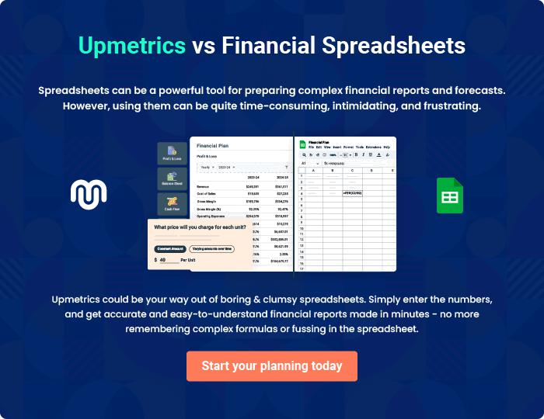
Appendix

When writing the appendix section, you should include any additional information that supports the main content of your plan. This may include financial statements, market research data, legal documents, and other
To unlock help try Upmetrics! 
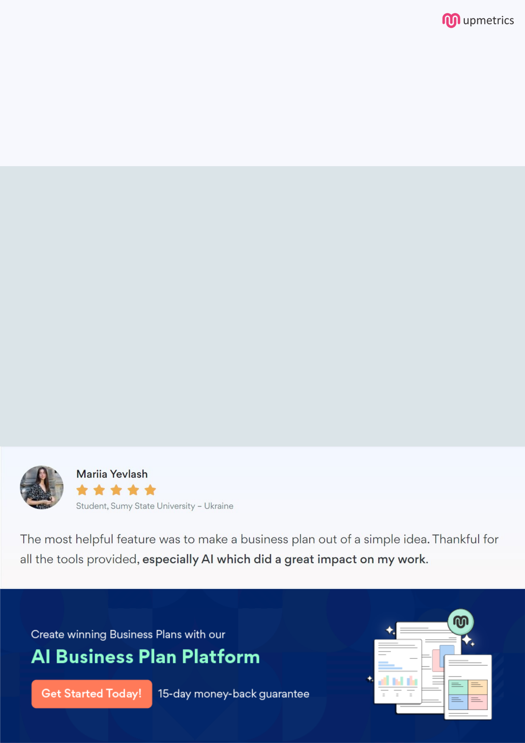
Create a winning business plan that gets you funded

Creating a stunning and investment-ready plan requires no writing, graphic designing, or financial planning expertise.

Upmetrics has all the features required to help you create a comprehensive business plan—from start to finish. Make no mistakes, it’s the modern way of planning to structure ideas, make plans, and create stunning pitch decks to awe investors.

Pitch decks that impress investors

Create pitch decks that provide a visual representation of your business, engage investors, and make them want to invest in your business idea.

Interactive plans in no time

Import business plan sections like—SWOT analysis, comparison tables, and others to create an interactive business plan. No designing skills are required.

Stunning cover page designs

With Upmetrics, you have the liberty to choose from multiple stunning cover page designs. Choose a creative design and make your plan stand out.

Online sharing made simple

Upmetrics makes online sharing quick and easier for users. Easily share your business plans with a link while tracking reader activity.

500+ sample business plans

Simply import a template from our library of sample plans into the editor and start customizing it to make it yours. It takes only a few clicks to get started.

Collaborate with team in real-time

Invite team members, initiate conversations, discuss ideas & strategies, share feedback, and work on a business plan in real-time.

