
BUSINESS PLAN

2023


Farming Business Plan

Harvesting Dreams, Sowing Sustainability

John Doe

10200 Bolsa Ave, Westminster, CA, 92683

- 359-3153 info@example.com http://www.example.com

Information provided in this business plan is unique to this business and confidential; therefore, anyone reading this plan agrees not to disclose any of the information in this business plan without prior written permission of the company.
Table of Contents

Executive Summary | 6
Market opportunity | 6
Services Offered | 6
Management team | 7
John Doe | 7
Jane Smith | 7
Alice Brown | 7
Financial Highlights | 7
Units Sold v/s Revenue | 8

Company Overview | 9
Ownership | 9
Business Owners | 9
Mission statement | 10
Business history | 10
Future goals | 10

Market Analysis | 11
Target Market | 11
Market size and growth potential | 11
Market Size | 12
Competitive analysis | 12
Farm Fresh Organics | 12
Golden Grain Farms | 13
Dairy Delight Farms | 13
Market trends | 13
Regulatory environment | 14

Products and Services | 15
Products | 15

Grains 15

Vegetables | 17
Fruits | 17
Flowers | 18
Livestock - Dairy | 18
Jams & Preserves | 19
Emphasize safety and quality | 19

Sales And Marketing Strategies | 20
Unique Selling Proposition (USP) | 20
Pricing Strategy | 20
Marketing strategies | 21
Online | 21
Offline | 21
Sales strategies | 22
Customer retention | 23

Operations Plan | 24
Operational Process | 24
Technology | 24
Management Team
Management Team | 25
Key managers | 25
John Doe | 25
Jane Smith | 26
Alice Brown | 26
Robert Brown | 26
Organizational structure | 26
Organization chart | 27
Compensation plan | 27
Board of advisors | 28
[Advisor 1 Name] | 28
[Advisor 2 Name] | 28
Financial Plan | 29
Profit & loss statement | 29
Cash flow statement | 31
Balance sheet | 32
Break-even Point | 34
Financing needs | 35
Appendix
Appendix | 36
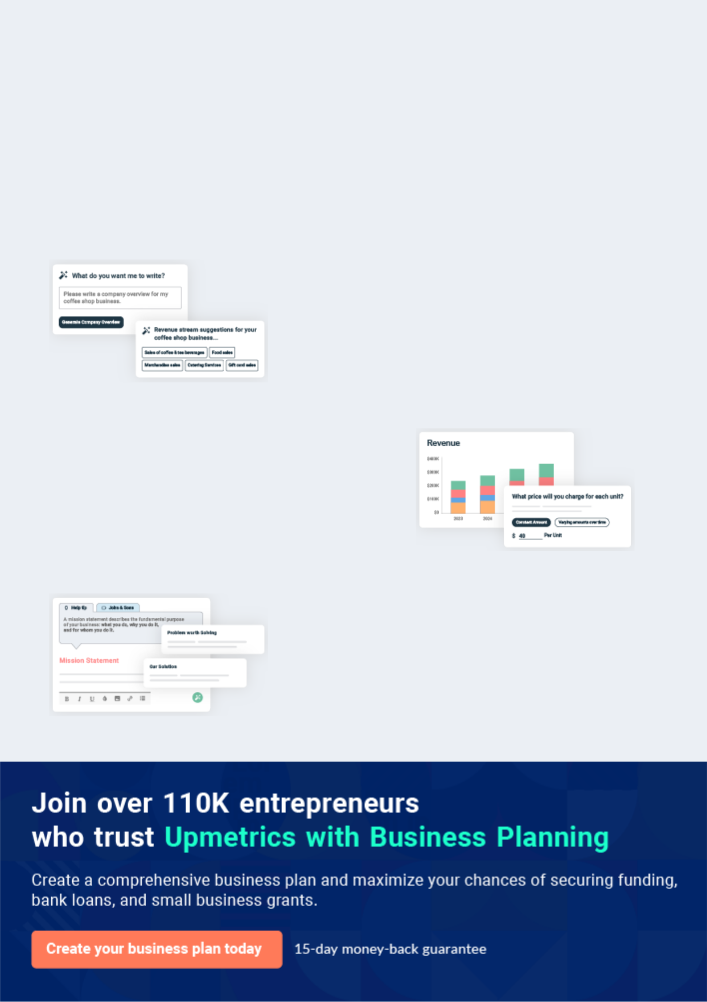
Business planning that’s simpler and faster than you think

Creating a business plan using Upmetrics to start and grow a business is literally the easiest thing in the World. Simply read the instructions and fill in the blanks. It’s as simple as that.

❛ | Upmetrics has everything you need to create a | ❜
❛ | comprehensive business plan. | ❜

AI-powered Upmetrics Assistant

AI-powered insights to streamline your plan

Not sure where to start? Upmetrics’ AI Assistant will automatically generate ideas for each section of your plan and offer improved versions of your writing, adjusting for tone, voice, and grammar or spelling errors.

Financial Forecasting Tool

All the financials are calculated for you

Forget the complex formulas and clumsy spreadsheets — with automatic financials and drag-and-drop forecasting, you can finish your plan faster and be confident that your numbers are accurate.

Business Plan Builder

Guides you like a business mentor

Upmetrics’ step-by-step instructions, prompts, and the library of 400+ sample business plans will guide you through each section of your plan as a business mentor.
Executive Summary


An executive summary is the first section of the business plan intended to provide an overview of the whole business plan.
To unlock help try Upmetrics! 

 Help tip  Farming Business Plan


Start your executive summary by introducing your idea behind starting a farming business and explaining what it does.
To unlock help try Upmetrics! 

Start writing here..

Market opportunity

 Help tip  Farming Business Plan

Describe the target market in brief, and explain the demographics, geographic location, and psychographic attributes of your customer.
To unlock help try Upmetrics! 

Start writing here..

Services Offered

 Help tip  Farming Business Plan

Describe in detail the products and crops your agriculture farm produces. Also, incorporate all the details about the tools and equipment you will use keeping quality in mind.
To unlock help try Upmetrics! 

Start writing here..

 Help tip


Name all the key members of your management team with their duties, responsibilities, and qualifications.
To unlock help try Upmetrics! 

Management team


JOHN DOE

Founder/CEO - john.doe@example.com

A seasoned agronomist with over [X years] in sustainable farming.


JANE SMITH

COO - jane.smith@example.com

Holds a Ph.D. in agricultural economics and has managed large-scale farming operations for over [X years].


ALICE BROWN

Chief Marketing Manager - alice.brown@example.com

An expert in agri-marketing, with a keen sense of the evolving consumer palate.

Financial Highlights

 Help tip  Farming Business Plan

Provide a summary of your financial projections for the company’s initial years of operation.

Include any capital or investment requirements, startup costs, projected revenues, and profits.
To unlock help try Upmetrics! 
Start writing here..
To unlock help try Upmetrics!

Units Sold v/s Revenue

 |  | Units Sold | Revenue
15.00k
10.00k
5.00k
0
Year 1 | Year 2 | Year 3
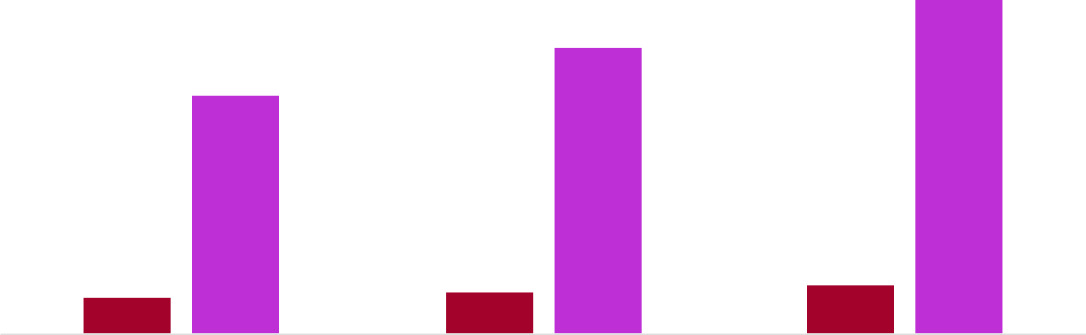

Financial Year |  |  | Units Sold | Revenue
Year 1 | 1,550 |  |  | $10,000
Year 2 | 1,800 |  |  | $12,000
Year 3 | 2,050 |  |  | $14,000
 Help tip |  |  Farming Business Plan


After giving a brief about your business plan, end your summary with a call to action, for example; inviting potential investors or readers to the next meeting if they are interested in your business.



Write a call to action for your business plan.
Company Overview

Depending on what details of your business are essential, you’ll need different elements in your business overview.
To unlock help try Upmetrics! 

 Help tip  Farming Business Plan

Provide all the basic information about your business in this section like:

• The name of your farming business and the type of business you are running or will run:
To unlock help try Upmetrics! 

Start writing here..

Ownership

 Help tip  Farming Business Plan

Describe the owners of your farm and mention their roles in running it. Whose shares in the business are they, and how each owner helps in the business?
To unlock help try Upmetrics! 

Start writing here..

Business Owners



60% John Doe



40% Jane Smith
Mission statement

 Help tip  Farming Business Plan

Add a mission statement that sums up your farming business’s objectives and core principles.

This statement needs to be memorable, clear, and brief.
To unlock help try Upmetrics! 

❛ At [GreenField Acres], we commit to nourishing communities with nature's purest produce. Our farming principles revolve around sustainability, responsibility, and innovation, ensuring that every harvest not only meets but exceeds, the expectations of the

modern consumer.
❜

Business history

 Help tip  Farming Business Plan

Include an outline of the farming business history and how it came to be in its current position.

If you can, add some personality and intriguing details, especially if you got any achievements
To unlock help try Upmetrics! 

Start writing here..

Future goals

 Help tip  Farming Business Plan

It’s crucial to convey your aspirations and your vision. Include the vision of where you see your agriculture in the near future.
To unlock help try Upmetrics! 

Start writing here..

Market Analysis


 |  | Market analysis provides a clear understanding of the market in which your
 |  | printing business will run along with the target market, competitors, and
 |  | growth opportunities.
 |  |  |  | To unlock help try Upmetrics! 
 Help tip |  |  Farming Business Plan

To write the introduction section of your market analysis, start by clearly identifying your primary target market.
To unlock help try Upmetrics! 

Start writing here..

Target Market

 Help tip  Farming Business Plan

Identify your target market and define your ideal customer. Know more about your customers and which products they prefer: meat, crops, vegetables, or some other products.
To unlock help try Upmetrics! 

Start writing here..

Market size and growth potential

 Help tip  Farming Business Plan

Provide an overview of the agriculture industry. It will include market size, trends, growth potential, and regulatory considerations.
To unlock help try Upmetrics! 

Start writing here..

Market Size

Available Market

All individuals purchasing fresh produce | 10M
in the [specific region, e.g., North-Eastern | 10M
US].

Served Market | 6M
Those preferring organic and sustainably- | 6M
farmed produce. | 6M
Target Market | 2M
Health-conscious adults, 25-50, in urban/ | 2M
suburban locales. | 2M

Competitive analysis

 Help tip  Farming Business Plan

Identify and analyze all other agricultural farms nearby, including direct and indirect competitors.
To unlock help try Upmetrics! 

Start writing here..

Farm Fresh Organics

Established in [2010], [Farm Fresh Organics] has carved a niche for itself in the organic fruits and vegetable market, servicing both B2B and B2C sectors in the [specific region, e.g., North-Eastern US].

Features | Strengths | Weaknesses
Wide variety of organic | Strong brand presence due to a | Limited to only fruit and
vegetables and fruits. | decade in the industry. | vegetable production.
Farm-to-table subscription | Established distribution | Higher pricing compared to
model for households. | channels. | newer entrants.
Partnerships with leading | Loyal customer base for their | Relatively slower adaptation to
organic retail chains. | subscription model. | technological advancements in
 |  | farming.

Golden Grain Farms

[Golden Grain Farms] is renowned for its vast expanse of grain farms and has been a leading supplier of organic grains since [2005].

Features

Extensive range of organic grains including wheat, barley, and millet.

Export capabilities to neighboring countries.

In-house milling facilities for flour production.

Strengths Weaknesses

Dominant player in the organic Over-reliance on grain products,

grain market. lack of diversification.

Diversification into grain-based Vulnerability to grain market

products. price fluctuations.

Strong export relationships. Limited local market penetration

due to a focus on exports.

Dairy Delight Farms

A newer entrant, [Dairy Delight Farms], founded in [2018], focuses on organic dairy production and has seen rapid growth.

Features

Organic milk, cheese, and yoghurt offerings.

Sustainable and cruelty-free dairy farming practices.

Home delivery services.

Strengths

Niche focus on the dairy segment has created a unique brand identity.

Rapid adaptation to consumer feedback, introducing new products.

Strong emphasis on ethical and sustainable practices.

Weaknesses

Still in the early growth phase with potential operational inefficiencies.

Limited product range compared to more established dairy producers

Challenges in scaling up production due to the emphasis on sustainability.

Market trends

 Help tip  Farming Business Plan

Analyze current and emerging trends in your industry, such as changes in technology, fertilizers, or customer preference. Explain how your farming business will cope with all the trends.
To unlock help try Upmetrics! 

Start writing here..

Regulatory environment

 Help tip  Farming Business Plan

Describe any regulations or licensing requirements that affect the agricultural farm, such as safety codes, or hiring any agricultural engineer or food safety employee.
To unlock help try Upmetrics! 

Start writing here..
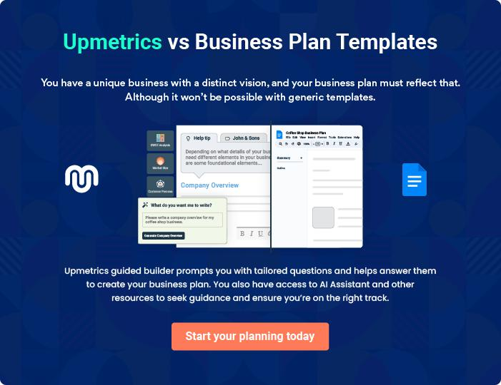
Products and Services

 |  | The product and services section of a farming business plan should describe
 |  | the specific services and products that will be offered to customers. To write
 |  | this section should include the following:
 |  |  |  | To unlock help try Upmetrics! 
 Help tip |  |  Farming Business Plan

To craft the introduction for your "Products and Services" chapter, begin by positioning your business within its industry, emphasizing its unique strengths or value proposition.
To unlock help try Upmetrics! 

Start writing here..

 Help tip

List the products you will produce or sell, such as crops, fruits, flowers, livestock, or value-added products like cheese or jams.
To unlock help try Upmetrics! 

Products

Grains


Price: [$4 - $6] per lb

Our grains, encompassing varieties like [wheat, barley, and millet], are cultivated using organic, non-GMO seeds. They are grown with minimal intervention, ensuring a rich, natural flavour and high nutritional value.
Product Specifications

- Packaged in eco-friendly, biodegradable bags with clear labelling showcasing the grain variety, harvest date, and nutritional information.

- Promoted as "Nature's True Grains," emphasizing their organic cultivation and rich, untouched flavour. Collaborations with health bloggers and nutritionists will further bolster their appeal to health-conscious consumers.
Vegetables

Price: $1.50 - $3 per lb (varies based on vegetable type)

Our range of vegetables, including [tomatoes, bell peppers, and zucchinis], are grown in mineral-rich soil, resulting in vibrant colors, juicy textures, and robust flavors.

Product / Service Specifications

- Vegetables are placed in reusable mesh bags, minimizing plastic usage. A QR code on the tag provides information on the cultivation and benefits of each vegetable.

•

- Vegetables are placed in reusable mesh bags, minimizing plastic usage. A QR code on the tag provides information on the cultivation and benefits of each vegetable.

Fruits

Price: $2 - $5 per lb (varies based on fruit type)

Our fruits, with varieties like [apples, berries, and cherries], are sun-ripened, ensuring natural sweetness. They're free from artificial ripening agents, ensuring purity and taste.

Product Specifications

- Housed in recyclable carton boxes with a small booklet sharing recipes and the story of the fruit's journey from our farm to the consumer's table.

- Pushed under the campaign "Naturally Sweetened by the Sun," with an emphasis on the absence of chemicals. Seasonal promotions will be run during harvest months for maximum reach.
Flowers

Price: $10 - $20 per bouquet (varies based on flower type)

Our flowers, varieties like [roses, lilies, and tulips], are grown without synthetic fertilizers. They stand out for their vibrant hues, longevity, and natural fragrance.

Product Specifications

- Wrapped in recyclable paper with an attached care guide, ensuring longevity post-purchase

- Promoted as "Nature's Unfiltered Beauty," collaborations with local florists and online influencers will be key in reaching a broader audience.

Livestock - Dairy

Price: $3 - $5 per liter

Our dairy products are sourced from livestock that are grass-fed and raised in open pastures. This results in milk that's creamier, richer, and free from antibiotics or growth hormones.

Product / Service Specifications

- Housed in glass bottles, promoting reusability. Each bottle comes with information about the livestock and the benefits of consuming organic dairy.

- The campaign "Pure, Creamy Goodness" will emphasize the organic nature of the dairy. Partnerships with local cafes and eateries will be pursued to increase product reach.
Jams & Preserves

Price: $5 - $8 per jar

Crafted from our farm's fruits, our jams and preserves like [strawberry jam, apple preserves, and cherry compote] stand out for their natural sweetness, chunky fruit pieces, and absence of artificial preservatives.

Product / Service Specifications

- Contained in glass jars with rustic labelling that exudes a homemade feel. Each label has a short story about the fruit used, adding a personal touch.

- Marketed under "A Jar of Farm Freshness," with emphasis on the use of farm-grown fruits. Workshops on making desserts using our jams can be conducted to engage directly with consumers.

Emphasize safety and quality

 Help tip  Farming Business Plan

In all descriptions of services and products, emphasize the importance of safety and quality.

Explain how your farming business will ensure that all services and products are delivered with
To unlock help try Upmetrics! 

Start writing here..
Sales And Marketing Strategies

Writing the sales and marketing strategies section means a list of strategies you will use to attract and retain your clients.
To unlock help try Upmetrics! 

 Help tip  Farming Business Plan

To create an effective introduction for your "Sales and Marketing Strategies" chapter, start by setting the stage within your specific industry or market.
To unlock help try Upmetrics! 

Unique Selling Proposition (USP)

 Help tip  Farming Business Plan

Explain in detail how your farming business differs from competitors and why clients should pick your business services over rivals.
To unlock help try Upmetrics! 

Start writing here..

Pricing Strategy

 Help tip  Farming Business Plan

Develop a pricing strategy that is competitive and affordable, yet profitable.

Consider offering promotions, discounts, or packages for your farming services to attract new
To unlock help try Upmetrics! 

Start writing here..

Marketing strategies

 Help tip

Develop a marketing strategy that includes a mix of online and offline marketing tactics.

Consider social media, email marketing, content marketing, brochures, farming marketing, and
To unlock help try Upmetrics! 

Start writing here..

Online


Social Media

Active engagement on platforms like [specific platforms e.g., "Instagram, Facebook, and Twitter"], showcasing our farming processes, produce, and customer testimonials.

Email Marketing

Monthly newsletters detailing farm updates, seasonal offerings, and special promotions.

Content Marketing

Blog posts and articles focusing on the importance of organic farming, health benefits, and recipes.

Offline

Brochures

Visually appealing brochures available at local stores, farmer markets, and delivered with every purchase, detailing our offerings

Farm Marketing

Hosting farm tours, allowing consumers to experience the agricultural process firsthand

Events

Participating in local farmer

markets, agricultural fairs, and

hosting farm-to-table dinners.

Sales strategies

 Help tip  Farming Business Plan

Mention your sales strategy as in – partner with other agriculture businesses and farms to establish referral programs that can help you generate more business.
To unlock help try Upmetrics! 

Partnerships with [specific businesses

We aim to establish partnerships with [specific businesses e.g., "local restaurants, cafes, and health stores"], offering them special rates for bulk purchases.

Exclusive partnerships

Exclusive partnerships, where our farm becomes the sole supplier for specific produce, is also a strategy we're keen on pursuing.

Referral programs

Referral programs with other agricultural businesses will be set up, providing incentives [specific incentives e.g., "discounts or complimentary products"] for every successful referral.

Customer retention

 Help tip  Farming Business Plan

Describe how your agricultural business will retain customers and build loyalty, such as through loyalty programs, special events, or personalized service.
To unlock help try Upmetrics! 

Start writing here..

Loyalty Programs

Points-based systems where accumulated points can be redeemed for products.

Personalized Service

Offering customization, such as curated vegetable baskets based on customer preferences.

Special Events

Exclusive events for loyal customers, like harvest festivals or farm dinners.

Operations Plan

 |  | When writing the operations plan section, it’s important to consider the
 |  | various aspects of your business operations.
 |  |  |  | To unlock help try Upmetrics! 
 Help tip |  |  Faming Business Plan


To create an effective introduction for your "Operational Plan" chapter, start by emphasizing the
pivotal role of efficient operations in the success of your business, underscoring how they
directly impact the quality of services delivered.
 |  |  |  | To unlock help try Upmetrics! 
Start writing here..
Operational Process
 Help tip |  |  Faming Business Plan


Explain the steps taken to produce your crops or raise your livestock. This can involve planting, fertilizing, watering, harvesting, looking after animals, and other activities.
To unlock help try Upmetrics! 

Start writing here..

Technology

 Help tip  Faming Business Plan


Make a list of the tools and equipment you’ll need to run your farm, including tractors, harvesters, greenhouses, barns, and processing machinery.
To unlock help try Upmetrics! 

Start writing here..

Management Team

The management team section provides an overview of the individuals responsible for running your business plan.
To unlock help try Upmetrics! 

 Help tip  Farming Business Plan

To craft an introduction for your "Management Team" chapter, begin by emphasizing the crucial role of leadership in the success of any business.
To unlock help try Upmetrics! 

Start writing here..

 Help tip

Describe the key members of your management team, their roles, and their responsibilities.

It should include the owners, senior management, and any other farm manager, soil and plant
To unlock help try Upmetrics! 

Key managers

Start writing here..

JOHN DOE

CEO - john.doe@example.com

John has been an influential figure in the agricultural sector for over 20 years.

With a degree in [Agricultural Business Management] from [University of Agriculture Example], he has successfully combined traditional farming techniques with modern business strategies to optimize yield and profit.


Prior to founding [GreenField Acres], John held managerial positions in [ABC Farming Corp.], where he played a pivotal role in their growth trajectory.
JANE SMITH

Chief Operating Officer (COO) - jane.smith@example.com

Jane possesses a deep-seated passion for farming, bolstered by her degree in [Agricultural Operations] from [State Agricultural University Example].

Her 15-year tenure in the industry, including a crucial role at [XYZ Agriculture Innovations], has endowed her with the expertise to streamline farm operations, ensuring efficiency and sustainability at [GreenField Acres].



ALICE BROWN

Soil and Plant Scientist - alice.brown@example.com

Alice is the cornerstone of our crop health initiatives. Graduating with a PhD in [Plant and Soil Sciences] from [Prestigious University Example], she has worked in premier research institutions like [DEF Research Labs].


At [GreenField Acres], Alice leads efforts in soil health, plant nutrition, and sustainable farming practices, ensuring optimal crop yields.


ROBERT BROWN

Agricultural Sales Director - robert.brown@example.com

Robert, an alumnus of [Top Business School Example], majored in [Sales and Marketing]. His professional journey spans over a decade, including a strategic sales role at [GHI Agri Sales Inc.].

He possesses a unique blend of sales acumen and a deep understanding of the agricultural industry, making him the ideal spearhead for our sales and marketing endeavours.

Organizational structure

 Help tip  Farming Business Plan

Describe the organizational structure of the management team, including reporting lines and how decisions will be made.
To unlock help try Upmetrics! 

Start writing here..

Organization chart


John Doe

CEO


Alice Lee


Jane Smith

Head of Agronomy

Robert Brown

COO


Sales Director

Eva Green
Finance Manager Liam Brown

Marketing Manager

Compensation plan

 Help tip  Farming Business Plan

Describe your compensation plan for the management team and staff, including salaries, bonuses, and other benefits.
To unlock help try Upmetrics! 

Start writing here..

 Help tip

If you have a board of advisors for your business, then mention them along with their roles and experience.
To unlock help try Upmetrics! 

Board of advisors


[ADVISOR 1 NAME]

Agricultural Technology Expert

With over [X years] of experience in [specific field e.g., "agri-tech innovations"], [Advisor Name] provides valuable insights into leveraging technology for farming.

[ADVISOR 2 NAME]

Sustainable Farming Specialist

[Advisor Name]'s expertise in sustainable and eco-friendly practices helps [GreenField Acres] stay aligned with global sustainability goals.
Financial Plan
To unlock help try Upmetrics!

When writing the financial plan section of a business plan, it’s important to provide a comprehensive overview of your financial projections for the first few years of your business, You may provide the following:
To unlock help try Upmetrics! 

 Help tip  Farming Business Plan

To create an effective introduction for your "Financial Plan" chapter, begin by stressing the critical role of a well-structured financial plan in the success of your venture.
To unlock help try Upmetrics! 

Start writing here..

 Help tip

Create a projected profit & loss statement that describes the expected revenue, cost of products sold, and operational costs. Your farm’s anticipated net profit or loss should be computed and included.



Profit & loss statement

 | 2023-24 | 2024-25 | 2025-26 | 2026-27 | 2027-28
Revenue | $0 | $0 | $0 | $0 | $0

Cost Of Sales | $0 | $0 | $0 | $0 | $0
General Costs | $0 | $0 | $0 | $0 | $0
Revenue Specific Costs | $0 | $0 | $0 | $0 | $0
Personnel Costs (Direct | $0 | $0 | $0 | $0 | $0
Labor)

Gross Margin $0 $0 $0 $0 $0

Gross Margin (%)

Operating Expense

Payroll Expense

(Indirect Labor)

General Expense

Bad Debt

Amortization of Current Assets

EBITDA

Additional Expense

Long Term

Depreciation

Gain or loss from Sale of Assets

EBIT

Interest Expenses

EBT

Income Tax Expense

Total Expense

Net Income

Net Income (%)

2023-24 | 2024-25 | 2025-26 | 2026-27 | 2027-28
0% | 0% | 0% | 0% | 0%
$0 | $0 | $0 | $0 | $0
$0 | $0 | $0 | $0 | $0
$0 | $0 | $0 | $0 | $0
$0 | $0 | $0 | $0 | $0
$0 | $0 | $0 | $0 | $0
$0 | $0 | $0 | $0 | $0
$0 | $0 | $0 | $0 | $0
$0 | $0 | $0 | $0 | $0
$0 | $0 | $0 | $0 | $0
$0 | $0 | $0 | $0 | $0
$0 | $0 | $0 | $0 | $0
$0 | $0 | $0 | $0 | $0
$0 | $0 | $0 | $0 | $0
$0 | $0 | $0 | $0 | $0
$0 | $0 | $0 | $0 | $0
0% | 0% | 0% | 0% | 0%
To unlock help try Upmetrics!
 | 2023-24 | 2024-25 | 2025-26 | 2026-27 | 2027-28
Retained Earning | $0 | $0 | $0 | $0 | $0
Opening
Owner's Distribution | $0 | $0 | $0 | $0 | $0
Retained Earning | $0 | $0 | $0 | $0 | $0
Closing

 Help tip

Estimate your cash inflows and outflows for the first few years of operation. It should include cash receipts from clients, payments to vendors, loan payments, and any other cash inflows and outflows.



Cash flow statement

Cash Received

Cash Paid

COS & General Expenses

Salary & Wages

Interest

Sales Tax

Income Tax

Net Cash From

Operations

Assets Sell

Assets Purchase

Net Cash From

Investments

2023-24 | 2024-25 | 2025-26 | 2026-27 | 2027-28
$0 | $0 | $0 | $0 | $0
$0 | $0 | $0 | $0 | $0
$0 | $0 | $0 | $0 | $0
$0 | $0 | $0 | $0 | $0
$0 | $0 | $0 | $0 | $0
$0 | $0 | $0 | $0 | $0
$0 | $0 | $0 | $0 | $0
$0 | $0 | $0 | $0 | $0

$0 | $0 | $0 | $0 | $0
$0 | $0 | $0 | $0 | $0
$0 | $0 | $0 | $0 | $0

 | 2023-24 | 2024-25 | 2025-26 | 2026-27 | 2027-28
Amount Received | $0 | $0 | $0 | $0 | $0
Loan Received | $0 | $0 | $0 | $0 | $0
Common Stock
Preferred Stock | $0 | $0 | $0 | $0 | $0
Owner's Contribution | $0 | $0 | $0 | $0 | $0
Amount Paid | $0 | $0 | $0 | $0 | $0
Loan Capital | $0 | $0 | $0 | $0 | $0
Dividends & Distributions | $0 | $0 | $0 | $0 | $0
Net Cash From | $0 | $0 | $0 | $0 | $0
Financing

Summary
Starting Cash | $0 | $0 | $0 | $0 | $0
Cash In | $0 | $0 | $0 | $0 | $0
Cash Out | $0 | $0 | $0 | $0 | $0
Change in Cash | $0 | $0 | $0 | $0 | $0
Ending Cash | $0 | $0 | $0 | $0 | $0

 Help tip

Prepare a projected balance sheet, which shows the business’s assets, liabilities, and equity.

To unlock help try Upmetrics! 

Balance sheet

 | 2023-24 | 2024-25 | 2025-26 | 2026-27 | 2027-28
Assets | $0 | $0 | $0 | $0 | $0
 | 2023-24 | 2024-25 | 2025-26 | 2026-27 | 2027-28
Current Assets | $0 | $0 | $0 | $0 | $0
Cash | $0 | $0 | $0 | $0 | $0
Accounts Receivable | $0 | $0 | $0 | $0 | $0
Inventory | $0 | $0 | $0 | $0 | $0
Other Current Assets | $0 | $0 | $0 | $0 | $0
Long Term Assets | $0 | $0 | $0 | $0 | $0
Gross Long Term Assets | $0 | $0 | $0 | $0 | $0
Accumulated Depreciation | $0 | $0 | $0 | $0 | $0

Liabilities & Equity | $0 | $0 | $0 | $0 | $0
Liabilities | $0 | $0 | $0 | $0 | $0
Current Liabilities | $0 | $0 | $0 | $0 | $0
Accounts Payable | $0 | $0 | $0 | $0 | $0
Income Tax Payable | $0 | $0 | $0 | $0 | $0
Sales Tax Payable | $0 | $0 | $0 | $0 | $0
Short Term Debt | $0 | $0 | $0 | $0 | $0
Long Term Liabilities | $0 | $0 | $0 | $0 | $0
Long Term Debt | $0 | $0 | $0 | $0 | $0
Equity | $0 | $0 | $0 | $0 | $0
Paid-in Capital | $0 | $0 | $0 | $0 | $0
Common Stock | $0 | $0 | $0 | $0 | $0
Preferred Stock | $0 | $0 | $0 | $0 | $0
Owner's Contribution | $0 | $0 | $0 | $0 | $0
Retained Earnings | $0 | $0 | $0 | $0 | $0
To unlock help try Upmetrics!
 | 2023-24 | 2024-25 | 2025-26 | 2026-27 | 2027-28
Check | $0 | $0 | $0 | $0 | $0

 Help tip

Determine the point at which your farming business will break even, or generate enough revenue to cover its operating costs. This will help you understand how much revenue you need to generate to make a profit.



Break-even Point

 | 2023-24 | 2024-25 | 2025-26 | 2026-27 | 2027-28
Starting Revenue | $0 | $0 | $0 | $0 | $0
Net Revenue | $0 | $0 | $0 | $0 | $0
Closing Revenue | $0 | $0 | $0 | $0 | $0

Starting Expense | $0 | $0 | $0 | $0 | $0
Net Expense | $0 | $0 | $0 | $0 | $0
Closing Expense | $0 | $0 | $0 | $0 | $0

Is Break Even? | 0 | 0 | 0 | 0 | 0
Break Even Month | 0 | 0 | 0 | 0 | 0
Days Required | 0 | 0 | 0 | 0 | 0
Break Even Revenue | $0 | $0 | $0 | $0 | $0
Break Even Units
Financing needs
To unlock help try Upmetrics!

 Help tip  Farming Business Plan

Estimate how much financing you will need to start and operate your farming business. It should include both short-term and long-term financing needs, such as loans or investment capital.



Start writing here..
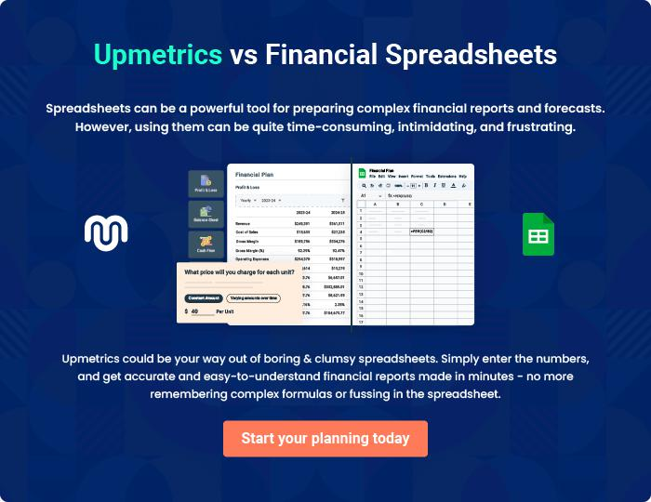
Appendix

When writing the appendix section, you should include any additional information that supports the main content of your plan. This may include financial statements, market research data, legal documents, and other
To unlock help try Upmetrics! 

Create a winning business plan that gets you funded

Creating a stunning and investment-ready plan requires no writing, graphic designing, or financial planning expertise.

Upmetrics has all the features required to help you create a comprehensive business plan—from start to finish. Make no mistakes, it’s the modern way of planning to structure ideas, make plans, and create stunning pitch decks to awe investors.

Pitch decks that impress investors

Create pitch decks that provide a visual representation of your business, engage investors, and make them want to invest in your business idea.

Interactive plans in no time

Import business plan sections like—SWOT analysis, comparison tables, and others to create an interactive business plan. No designing skills are required.

Stunning cover page designs

With Upmetrics, you have the liberty to choose from multiple stunning cover page designs. Choose a creative design and make your plan stand out.

Online sharing made simple

Upmetrics makes online sharing quick and easier for users. Easily share your business plans with a link while tracking reader activity.

500+ sample business plans

Simply import a template from our library of sample plans into the editor and start customizing it to make it yours. It takes only a few clicks to get started.

Collaborate with team in real-time

Invite team members, initiate conversations, discuss ideas & strategies, share feedback, and work on a business plan in real-time.

