Facility Management Business Plan



Business Plan

2023


Efficiency, Comfort, Management

Information provided in this business plan is unique to this business and confidential; therefore, anyone reading this plan agrees not to disclose any of the information in this business plan without prior written permission of the company.

Prepared By

John Doe

10200 Bolsa Ave, Westminster, CA, 92683

info@example.com

(650) 359-3153 http://www.example.com

Table of Contents

Executive Summary | 6
Market opportunity | 6
Services Offered | 6
Marketing & Sales Strategies | 7
Financial Highlights | 7
Units Sold v/s Revenue | 8

Company Overview | 9
Ownership | 9
Mission statement | 9
Business history | 10
Future goals | 10

Market Analysis | 11
Target Market | 11
Market size and growth potential | 11
Market Size | 12
Competitive analysis | 12
Competitor A | 12
Competitor B | 13
Competitor C | 13
Market trends | 13
Regulatory environment | 14

Products and Services | 15
Services | 15
HVAC Maintenance Service | 15
Plumbing Repair Service | 16
Electrical Maintenance Service | 16
General Cleaning Service | 17
Security Surveillance Installation | 17
Energy Management Consultation | 18
Cleaning and Janitorial Services | 18
Security Services | 18
Quality Measures | 19
Additional Services | 19

Sales And Marketing Strategies | 20
Unique Selling Proposition (USP) | 20
Pricing Strategy | 20
Marketing strategies | 21
Online | 21
Offline | 21
Sales strategies | 22
Customer retention | 23

Operations Plan | 24
Staffing & Training | 24
Operational Process | 24
Equipment & Machinery | 25

Management Team | 26
Key managers | 26
John Doe | 26
Jane Doe | 27
Alice Brown | 27
Robert Brown | 27
Organizational structure | 28
Organization chart | 28
Compensation plan | 28
Advisors/Consultants | 29
David Taylor | 29
Samantha Green | 29
Financial Plan | 30
Profit & loss statement | 30
Cash flow statement | 33
Balance sheet | 35
Break-even Analysis | 37
Financing needs | 39
Appendix
Appendix | 41
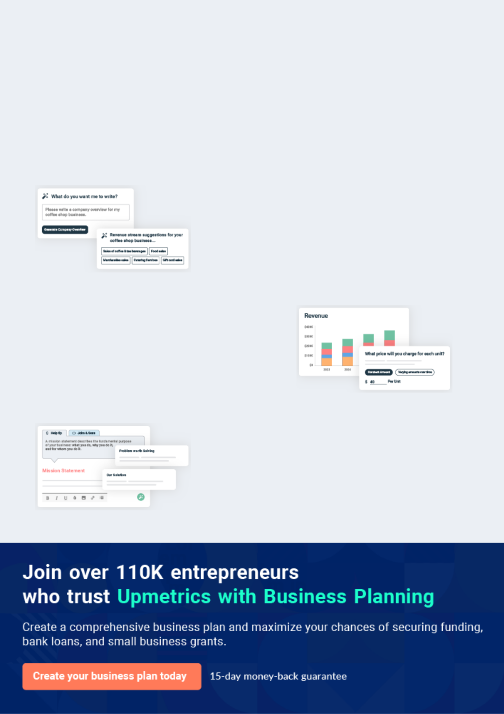
Business planning that’s simpler and faster than you think

Creating a business plan using Upmetrics to start and grow a business is literally the easiest thing in the World. Simply read the instructions and fill in the blanks. It’s as simple as that.

❛ | Upmetrics has everything you need to create a | ❜
❛ | comprehensive business plan. | ❜

AI-powered Upmetrics Assistant

AI-powered insights to streamline your plan

Not sure where to start? Upmetrics’ AI Assistant will automatically generate ideas for each section of your plan and offer improved versions of your writing, adjusting for tone, voice, and grammar or spelling errors.

Financial Forecasting Tool

All the financials are calculated for you

Forget the complex formulas and clumsy spreadsheets — with automatic financials and drag-and-drop forecasting, you can finish your plan faster and be confident that your numbers are accurate.

Business Plan Builder

Guides you like a business mentor

Upmetrics’ step-by-step instructions, prompts, and the library of 400+ sample business plans will guide you through each section of your plan as a business mentor.
Executive Summary


An executive summary is the first section of the business plan intended to provide an overview of the whole business plan.
To unlock help try Upmetrics! 

 Help tip  Facility Management Business Plan


Start your executive summary by briefly introducing your business to your readers.

This section may include the name of your facility management business, its location, when it
To unlock help try Upmetrics! 

Start writing here..

Market opportunity

 Help tip  Facility Management Business Plan

Summarize your market research, including market size, growth potential, and marketing trends. Highlight the opportunities in the market and how your business will fit in to fill the gap.
To unlock help try Upmetrics! 

Start writing here..

Services Offered

 Help tip  Facility Management Business Plan

Highlight the facility management services you offer your clients. The USPs and differentiators you offer are always a plus.
To unlock help try Upmetrics! 

Start writing here..

Marketing & Sales Strategies
To unlock help try Upmetrics!

 Help tip  Facility Management Business Plan

Outline your sales and marketing strategies—what marketing platforms you use, how you plan on acquiring customers, etc.
To unlock help try Upmetrics! 

Start writing here..

Financial Highlights

 Help tip  Facility Management Business Plan

Briefly summarize your financial projections for the initial years of business operations. Include any capital or investment requirements, associated startup costs, projected revenues, and profit forecasts.



Start writing here..
Units Sold v/s Revenue

 |  | Units Sold | Revenue
15.00k
10.00k
5.00k
0
Year 1 | Year 2 | Year 3


Financial Year |  |  | Units Sold | Revenue
Year 1 | 1,550 |  |  | $10,000
Year 2 | 1,800 |  |  | $12,000
Year 3 | 2,050 |  |  | $14,000
 Help tip |  |  Facility Management Business Plan


Summarize your executive summary section with a clear CTA, for example, inviting angel investors to discuss the potential business investment.
To unlock help try Upmetrics! 

Write a call to action for your business plan.
Company Overview

Depending on what details of your business are essential, you’ll need different elements in your business overview.
To unlock help try Upmetrics! 

 Help tip  Facility Management Business Plan

Describe your business in this section by providing all the basic information:

Describe what kind of facility management company you run and the name of it. You may
To unlock help try Upmetrics! 

Start writing here..

Ownership

 Help tip  Facility Management Business Plan

List the names of your facility management company’s founders or owners. Describe what shares they own and their responsibilities for efficiently managing the business.
To unlock help try Upmetrics! 

Start writing here..

Mission statement

 Help tip  Facility Management Business Plan

Summarize your business’ objective, core principles, and values in your mission statement. This statement needs to be memorable, clear, and brief.
To unlock help try Upmetrics! 
❛ At [FacilityFlare Management], we are committed to excellence, integrity, and innovation in facility management. Our mission is to enhance property value, ensuring a safe, efficient, and

comfortable environment for our clients and their occupants.
❜

Business history

 Help tip  Facility Management Business Plan

If you’re an established facility management service provider, briefly describe your business history, like—when it was founded, how it evolved over time, etc.
To unlock help try Upmetrics! 

Start writing here..

Future goals

 Help tip  Facility Management Business Plan

It’s crucial to convey your aspirations and vision. Mention your short-term and long-term goals; they can be specific targets for revenue, market share, or expanding your services.
To unlock help try Upmetrics! 

Start writing here..
Market Analysis
To unlock help try Upmetrics!


 |  | Market analysis provides a clear understanding of the market in which your
 |  | printing business will run along with the target market, competitors, and
 |  | growth opportunities.
 |  |  |  | To unlock help try Upmetrics! 
 Help tip |  |  Facility Management Business Plan

To write the introduction section of your market analysis, start by clearly identifying your primary target market.
To unlock help try Upmetrics! 

Start writing here..

Target Market

 Help tip  Facility Management Business Plan

Start this section by describing your target market. Define your ideal customer and explain what types of services they prefer. Creating a buyer persona will help you easily define your target market to your readers.



Start writing here..

Market size and growth potential

 Help tip  Facility Management Business Plan

Describe your market size and growth potential and whether you will target a niche or a much broader market.
To unlock help try Upmetrics! 

Start writing here..

Market Size

Available Market

All potential facility management | 5M
contracts across various sectors in the | 5M
region.
Served Market | 2M
Contracts within the commercial and | 2M
industrial sectors that [FacilityFlare | 2M
Management] can serve.
Target Market | 500k
Commercial office spaces and industrial | 500k
facilities requiring sustainable facility | 500k

management solutio

 Help tip  Facility Management Business Plan

Identify and analyze your direct and indirect competitors. Identify their strengths and weaknesses, and describe what differentiates your facility management services from them.
To unlock help try Upmetrics! 

Competitive analysis

Competitor A

Competitor A is a well-established player in the facility management industry, offering a wide range of services to commercial and industrial clients. They have a strong market presence in the [Region] region and have been operating for over [Number] years.

Features

Comprehensive maintenance and repair services

Safety and security

management

Energy management and sustainability solutions

Space planning and allocation

Strengths

Extensive industry experience

Strong brand recognition in the market

Wide service coverage and large client base

Weaknesses

Services can be generic and not tailored to specific client needs

Limited focus on sustainable practices and innovations

Customer service challenges due to large client base

Competitor B

Competitor B specializes in residential and healthcare facility management, providing targeted solutions for these sectors. They have established a reputation for quality and reliability, operating for [Number] years in the [Region] region.

Features Strengths Weaknesses

Customized facility | Niche focus, resulting in
management for residential | specialized expertise
complexes | High customer satisfaction due
Specialized services for | to tailored services
healthcare facilities | Strong operational efficiency in
Emergency response and risk | targeted sectors
management

Limited service offerings outside of residential and healthcare sectors

Smaller market presence compared to larger competitors

Potential scalability challenges due to niche focus

Competitor C

Competitor C is a newer entrant in the market, focusing on integrating technology and innovation into facility management. They serve a broad spectrum of clients, with a particular emphasis on tech-savvy solutions.

Features | Strengths | Weaknesses
IoT-based facility management | Strong emphasis on | Limited market experience and
solutions | technology and innovation | brand recognition
Real-time monitoring and | Modern and sustainable | Potential reliability issues with
reporting | service offerings | new tech-based solutions
Energy-efficient and | Agile and adaptive to market | Smaller client base compared to
sustainable practices | changes | established competitors
Innovative space optimization
solutions

Market trends

 Help tip  Facility Management Business Plan

Analyze emerging trends in the industry, such as technology disruptions, changes in customer behavior or preferences, etc. Explain how your business will cope with all the trends.
To unlock help try Upmetrics! 

Start writing here..

Regulatory environment

 Help tip  Facility Management Business Plan

List regulations and licensing requirements that may affect your facility management company, such as business registration, contracting and subcontracting compliances, occupational health and safety protocols, insurance, environmental regulations, state and federal regulations,
To unlock help try Upmetrics! 

Start writing here..
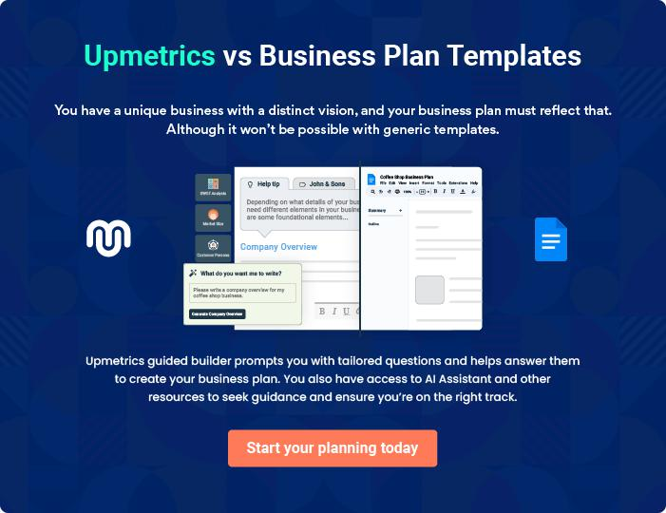
Products and Services

The product and services section of a facility management business plan should describe the specific services and products that will be offered to customers. To write this section should include the following:
To unlock help try Upmetrics! 

 Help tip  Facility Management Business Plan

To craft the introduction for your "Products and Services" chapter, begin by positioning your business within its industry, emphasizing its unique strengths or value proposition.
To unlock help try Upmetrics! 

Start writing here..

 Help tip


Outline the facility maintenance services your business will offer. This would include maintenance services such as,
To unlock help try Upmetrics! 

Services

HVAC Maintenance Service


Price: [$200 - $500] per service (depending on the complexity and size of the system)

Comprehensive maintenance of heating, ventilation, and air conditioning systems to ensure they are running efficiently and reliably.

Specifications

- Includes inspection, cleaning, and repair of all HVAC components.

- Service duration: 2-4 hours

- Availability: On-call and scheduled maintenance
Plumbing Repair Service

Price: [$100 - $300] per service (varying by the nature and extent of the repair)

Timely and effective repair services for all plumbing issues, ensuring smooth and leak-free operations.

Specifications

- Services include fixing leaks, unclogging drains, and repairing or replacing damaged pipes.

- Response time: Within 24 hours

- Emergency services available at an additional cost

Electrical Maintenance Service

Price: [$150 - $400] per service (depending on the complexity of the job)

Comprehensive electrical maintenance to ensure all wiring, outlets, and fixtures are in excellent condition.

Specifications

- Includes inspection, repair, and replacement of faulty electrical components.

- Service duration: 2-3 hours

- Certified electricians on staff
General Cleaning Service

Price: [$0.10 - $0.20] per square foot (based on the type of cleaning required)

Regular cleaning services to maintain a clean and hygienic environment in your facility.

Specifications

- Includes dusting, vacuuming, trash removal, and bathroom cleaning.

- Service duration: Based on facility size

- Green cleaning options available

Security Surveillance Installation

Price: Starting at [$1,000] (varies based on system complexity and facility size)

Installation of state-of-the-art security surveillance systems to monitor and protect your property.

Specifications

- Includes cameras, motion sensors, and recording equipment.

- Customizable based on client needs

- 24/7 monitoring options available
Energy Management Consultation
- To unlock help try Upmetrics!

Price: [$500 - $1,500] per consultation (dependent on facility size and complexity)

Expert consultancy services to help optimize energy consumption and reduce operational costs.

Specifications

- Includes energy audit, report, and tailored recommendations.

- Duration: 1-3 days

- Follow-up support available

Cleaning and Janitorial Services

 Help tip  Facility Management Business Plan

Outline the cleaning services you offer to maintain cleanliness in clients’ facilities. Mention specialized cleaning services like carpet cleaning, window cleaning, etc.
To unlock help try Upmetrics! 

Start writing here..

Security Services

 Help tip  Facility Management Business Plan

Describe the measures you will take to offer security services at clients’ facilities. This will include managing security personnel, installing security systems, i.e. surveillance camera and alarm systems, etc.



Start writing here..

Quality Measures
To unlock help try Upmetrics!

 Help tip  Facility Management Business Plan

This section should explain how you maintain quality standards and consistently provide the highest quality service.
To unlock help try Upmetrics! 

Start writing here..

Additional Services

 Help tip  Facility Management Business Plan

Mention if your facility management company offers any additional services. You may include services like energy management, space and design planning, asset management, consulting and advisory, etc.



Start writing here..
Sales And Marketing Strategies
To unlock help try Upmetrics!

Writing the sales and marketing strategies section means a list of strategies you will use to attract and retain your clients.
To unlock help try Upmetrics! 

 Help Tip  Facility Management Business Plan


To create an effective introduction for your "Sales and Marketing Strategies" chapter, start by setting the stage within your specific industry or market.
To unlock help try Upmetrics! 

Start writing here..

Unique Selling Proposition (USP)

 Help tip  Facility Management Business Plan

Define your business’s USPs depending on the market you serve, the equipment you use, and the unique services you provide. Identifying USPs will help you plan your marketing strategies.
To unlock help try Upmetrics! 

Start writing here..

Pricing Strategy

 Help tip  Facility Management Business Plan

Describe your pricing strategy—how you plan to price your maintenance services and stay competitive in the local market. You can mention any discounts you plan on offering to attract new customers to your maintenance service.



Start writing here..

 Help tip  Facility Management Business Plan
To unlock help try Upmetrics!

Discuss your marketing strategies to market your services. You may include some of these marketing strategies in your business plan—social media marketing, Google ads, brochures, email marketing, content marketing, and print marketing.



Marketing strategies

Online


Social Media

Utilizing platforms like LinkedIn, Facebook, and Instagram to connect with potential clients, showcase our services, and establish our brand as an industry leader.

Content Marketing

Crafting informative and engaging content to highlight our expertise, share insights, and foster trust with our audience.

Email Marketing

Developing personalized communication strategies to keep our clients informed about our services, promotions, and industry news.

Google Ads

Implementing targeted advertising campaigns to capture the attention of businesses actively seeking facility management solutions.

Offline

Print Marketing

Utilizing brochures, flyers, and other printed materials for local advertising and direct mail campaigns.

 Help tip  Facility Management Business Plan
To unlock help try Upmetrics!

Outline the strategies you’ll implement to maximize your sales. Your sales strategies may include direct sales calls, partnering with real estate developers and agents, offering referral programs, etc.



Sales strategies

Partner with Businesses

Collaborating with real estate developers and agents to tap into a wider network and gain referrals

Referral Programs

Implementing referral incentives to encourage existing clients to recommend our services, fostering organic growth.

Direct Sales Calls

Engaging with potential clients through outbound calls to introduce our services and schedule consultations.

Client Meetings

Conducting face-to-face meetings to understand client needs, showcase our capabilities, and build rapport.

 Help tip  Facility Management Business Plan

Describe your customer retention strategies and how you plan to execute them. For instance, introducing loyalty programs, discounts on annual membership, personalized service, etc.
To unlock help try Upmetrics! 

Customer retention

Loyalty Programs

Offering rewards and benefits to long-term clients, ensuring they feel valued and appreciated.

Personalized Service

Tailoring our offerings to meet the specific needs of each client, ensuring they receive the optimal solution for their facility.

Annual Membership Discounts

Providing discounted rates for clients who commit to annual service contracts, fostering stability and loyalty.

Operations Plan
To unlock help try Upmetrics!

 |  | When writing the operations plan section, it’s important to consider the
 |  | various aspects of your business operations.
 |  |  |  | To unlock help try Upmetrics! 
 Help tip |  |  Facility Management Business Plan


To create an effective introduction for your "Operational Plan" chapter, start by emphasizing the
pivotal role of efficient operations in the success of your business, underscoring how they
directly impact the quality of services delivered.
 |  |  |  | To unlock help try Upmetrics! 
Start writing here..
Staffing & Training
 Help tip |  |  Facility Management Business Plan

Mention your facility management business’s staffing requirements, including the number of
employees or maintenance and management staff needed. Include their qualifications, the
training required, and the duties they will perform.
 |  |  |  | To unlock help try Upmetrics! 
Start writing here..
Operational Process
 Help tip |  |  Facility Management Business Plan

Outline the processes and procedures you will use to run your facility management business. Your operational processes may include onboarding clients, creating a strategy plan, offering services, billing accounts, and training employees.



Start writing here..

Equipment & Machinery

 Help tip  Facility Management Business Plan

Include the list of equipment and machinery required for facility management, such as cleaning and maintenance equipment, protective gear, mechanical equipment, fire safety tools, etc.
To unlock help try Upmetrics! 

Start writing here..
Management Team

The management team section provides an overview of the individuals responsible for running your business plan.
To unlock help try Upmetrics! 

 Help tip  Facility Management Business Plan

To craft an introduction for your "Management Team" chapter, begin by emphasizing the crucial role of leadership in the success of any business.
To unlock help try Upmetrics! 

Start writing here..

Key managers

 Help tip  Facility Management Business Plan

Introduce your management and key members of your team, and explain their roles and responsibilities.
To unlock help try Upmetrics! 

Start writing here..


JOHN DOE

CEO & Co-founder - john.doe@example.com

Serving as our CEO, [Founder’s Name] has been the driving force behind [FacilityFlare Management] since its inception in [Year].

With a background in [Field] and over [Number] years of experience in facility management, [He/She] has a deep understanding of what it takes to run a successful operation.


[His/Her] roles and responsibilities include strategic planning, business development, and overseeing the entire organization to ensure smooth operations and client satisfaction.

JANE DOE

Chief Operating Officer (COO) - jane.doe@example.com

As the Chief Operating Officer of FacilityFlare, Jane Doe brings over 15 years of experience in operational management and facility maintenance.

She holds a Master’s degree in Business Administration from the University of Example and a Bachelor’s degree in Environmental Engineering.


Jane has previously worked with major facility management firms, where she successfully led teams to enhance operational efficiency and client satisfaction.

At FacilityFlare, her responsibilities include overseeing daily operations, implementing process improvements, and ensuring all services meet our rigorous standards.


ALICE BROWN

CMO - alice.brown@example.com

Alice Brown serves as our Chief Marketing Officer, responsible for developing and executing our marketing and sales strategies.

She earned her MBA with a focus on Marketing from Example State University and has a rich background in digital marketing and client relations.

With over 12 years of experience in the industry, Alice has a proven ability to drive business growth through innovative marketing campaigns and strategic client engagement. At FacilityFlare, she leads the marketing team to increase brand awareness and generate leads.


ROBERT BROWN

Facility Manager - robert.brown@example.com

Robert Brown, our Facility Manager, is a seasoned professional with over 10 years of experience in facility management and maintenance.

He holds a Bachelor’s degree in Facility Management from Example Technical Institute and various certifications in building systems and safety protocols.

Robert has a strong track record of maintaining facilities to the highest standards and implementing preventative maintenance programs.

His responsibilities at [FacilityFlare Management] include overseeing all facility operations, managing maintenance staff, and ensuring client satisfaction.
Organizational structure

 Help tip  Facility Management Business Plan

Explain the organizational structure of your management team. Include the reporting line and decision-making hierarchy.
To unlock help try Upmetrics! 

Start writing here..

Organization chart


John Doe

CEO
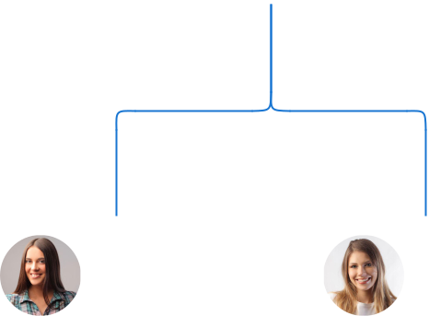

Alice Brown Jane Doe

CMO COO



Emily Johnson | David White |  |  |  | John Smith
Emily Johnson |  |  | Robert Brown |  | John Smith
Project | Human |  |  |  | Operations
Manager | Resouces |  | Facility |  | Manager
 |  |  | Manager





Compensation plan

 Help tip  Facility Management Business Plan

Describe your compensation plan for the management and staff. Include their salaries, incentives, and other benefits.
To unlock help try Upmetrics! 

Start writing here..

 Help tip  Facility Management Business Plan

Mentioning advisors or consultants in your business plans adds credibility to your business idea.
To unlock help try Upmetrics! 

Advisors/Consultants


DAVID TAYLOR

Senior Consultant - Facility Management and Operations - david.taylor@example.com

With over [25 years] of experience in facility management, [David] provides strategic advice on operational efficiency, best practices in maintenance, and the integration of innovative technologies to enhance service delivery.



SAMANTHA GREEN

Real Estate and Sustainability Expert - samantha.green@example.com

[Samantha] advises us on sustainable practices, helping us incorporate eco-friendly solutions into our facility management services.

Her knowledge of green certifications and energy efficiency is crucial as we strive to meet the growing demand for sustainable facility management.
Financial Plan

When writing the financial plan section of a business plan, it’s important to provide a comprehensive overview of your financial projections for the first few years of your business, You may provide the following:
To unlock help try Upmetrics! 

 Help tip  Facility Management Business Plan


To create an effective introduction for your "Financial Plan" chapter, begin by stressing the critical role of a well-structured financial plan in the success of your venture.
To unlock help try Upmetrics! 

Start writing here..

 Help tip  Facility Management Business Plan

Describe details such as projected revenue, operational costs, and service costs in your projected profit and loss statement. Make sure to include your business’s expected net profit or loss
To unlock help try Upmetrics! 

Profit & loss statement

Revenue

Cost Of Sales

General Costs

Revenue Specific Costs

Personnel Costs (Direct

Labor)

Gross Margin

Gross Margin (%)

Operating Expense

Payroll Expense

(Indirect Labor)

General Expense

Bad Debt

Amortization of Current

Assets

2023-24 | 2024-25 | 2025-26 | 2026-27 | 2027-28
$0 | $0 | $0 | $0 | $0

$0 | $0 | $0 | $0 | $0
$0 | $0 | $0 | $0 | $0
$0 | $0 | $0 | $0 | $0
$0 | $0 | $0 | $0 | $0

$0 | $0 | $0 | $0 | $0
0% | 0% | 0% | 0% | 0%

$0 | $0 | $0 | $0 | $0
$0 | $0 | $0 | $0 | $0
$0 | $0 | $0 | $0 | $0
$0 | $0 | $0 | $0 | $0
$0 | $0 | $0 | $0 | $0

EBITDA

Additional Expense

Long Term

Depreciation

Gain or loss from Sale

of Assets

EBIT

Interest Expenses

EBT

Income Tax Expense

Total Expense

Net Income

Net Income (%)

2023-24 | 2024-25 | 2025-26 | 2026-27 | 2027-28
$0 | $0 | $0 | $0 | $0
$0 | $0 | $0 | $0 | $0
$0 | $0 | $0 | $0 | $0
$0 | $0 | $0 | $0 | $0
$0 | $0 | $0 | $0 | $0
$0 | $0 | $0 | $0 | $0
$0 | $0 | $0 | $0 | $0
$0 | $0 | $0 | $0 | $0
$0 | $0 | $0 | $0 | $0
$0 | $0 | $0 | $0 | $0
0% | 0% | 0% | 0% | 0%

 |  |  | 2023-24 |  | 2024-25 | 2025-26
Retained Earning |  |  | $0 |  | $0 | $0
Opening |  |  |  |  | $0 | $0
Owner's Distribution |  |  | $0 |  | $0 | $0
Retained Earning |  |  | $0 |  | $0 | $0
Closing |  |  |  |  | $0 | $0
 Help tip |  |  |  Facility Management Business Plan


The cash flow for the first few years of your operation should be estimated and described in this section.

This may include billing invoices, payment receipts, loan payments, and any other cash flow statements.
2026-27 2027-28

$0 $0

$0 $0

$0 $0

To unlock help try Upmetrics! 

Cash flow statement

 | 2023-24 | 2024-25 | 2025-26 | 2026-27 | 2027-28
Cash Received | $0 | $0 | $0 | $0 | $0
Cash Paid | $0 | $0 | $0 | $0 | $0
COS & General Expenses | $0 | $0 | $0 | $0 | $0
Salary & Wages | $0 | $0 | $0 | $0 | $0
Interest | $0 | $0 | $0 | $0 | $0

Sales Tax

Income Tax

Net Cash From

Operations

Assets Sell

Assets Purchase

Net Cash From

Investments

Amount Received

Loan Received

Common Stock

Preferred Stock

Owner's Contribution

Amount Paid

2023-24 | 2024-25 | 2025-26 | 2026-27 | 2027-28
$0 | $0 | $0 | $0 | $0
$0 | $0 | $0 | $0 | $0
$0 | $0 | $0 | $0 | $0

$0 | $0 | $0 | $0 | $0
$0 | $0 | $0 | $0 | $0
$0 | $0 | $0 | $0 | $0

$0 | $0 | $0 | $0 | $0
$0 | $0 | $0 | $0 | $0

$0 | $0 | $0 | $0 | $0
$0 | $0 | $0 | $0 | $0
$0 | $0 | $0 | $0 | $0

Loan Capital $0 $0 $0 $0 $0

 |  |  | 2023-24 |  | 2024-25 | 2025-26 | 2026-27 | 2027-28
Dividends & Distributions |  |  | $0 |  | $0 | $0 | $0 | $0
Net Cash From |  |  | $0 |  | $0 | $0 | $0 | $0
Financing
Summary
Starting Cash |  |  | $0 |  | $0 | $0 | $0 | $0
Cash In |  |  | $0 |  | $0 | $0 | $0 | $0
Cash Out |  |  | $0 |  | $0 | $0 | $0 | $0
Change in Cash |  |  | $0 |  | $0 | $0 | $0 | $0
Ending Cash |  |  | $0 |  | $0 | $0 | $0 | $0
 Help tip |  |  Facility Management Business Plan

Create a projected balance sheet documenting your facility management business’s assets, liabilities, and equity.

To unlock help try Upmetrics! 

Balance sheet

 | 2023-24 | 2024-25 | 2025-26 | 2026-27 | 2027-28
Assets | $0 | $0 | $0 | $0 | $0
Current Assets | $0 | $0 | $0 | $0 | $0
Cash | $0 | $0 | $0 | $0 | $0
Accounts Receivable | $0 | $0 | $0 | $0 | $0
Inventory | $0 | $0 | $0 | $0 | $0
Other Current Assets | $0 | $0 | $0 | $0 | $0
Long Term Assets | $0 | $0 | $0 | $0 | $0
Gross Long Term Assets | $0 | $0 | $0 | $0 | $0
Accumulated Depreciation | $0 | $0 | $0 | $0 | $0

Liabilities & Equity | $0 | $0 | $0 | $0 | $0
Liabilities | $0 | $0 | $0 | $0 | $0
Current Liabilities | $0 | $0 | $0 | $0 | $0
Accounts Payable | $0 | $0 | $0 | $0 | $0
Income Tax Payable | $0 | $0 | $0 | $0 | $0
Sales Tax Payable | $0 | $0 | $0 | $0 | $0
Short Term Debt | $0 | $0 | $0 | $0 | $0
 | 2023-24 | 2024-25 | 2025-26 | 2026-27 | 2027-28
Long Term Liabilities | $0 | $0 | $0 | $0 | $0
Long Term Debt | $0 | $0 | $0 | $0 | $0
Equity | $0 | $0 | $0 | $0 | $0
Paid-in Capital | $0 | $0 | $0 | $0 | $0
Common Stock | $0 | $0 | $0 | $0 | $0
Preferred Stock | $0 | $0 | $0 | $0 | $0
Owner's Contribution | $0 | $0 | $0 | $0 | $0
Retained Earnings | $0 | $0 | $0 | $0 | $0

Check | $0 |  |  | $0 | $0 | $0 | $0
 Help tip |  |  Facility Management Business Plan

Determine and mention your business’s break-even point—the point at which your business costs and revenue will be equal.

This exercise will help you understand how much revenue you need to generate to sustain or be profitable.
To unlock help try Upmetrics! 

Break-even Analysis

 | 2023-24 | 2024-25 | 2025-26 | 2026-27 | 2027-28
Starting Revenue | $0 | $0 | $0 | $0 | $0
Net Revenue | $0 | $0 | $0 | $0 | $0
Closing Revenue | $0 | $0 | $0 | $0 | $0

Starting Expense | $0 | $0 | $0 | $0 | $0
Net Expense | $0 | $0 | $0 | $0 | $0
Closing Expense | $0 | $0 | $0 | $0 | $0

Is Break Even? | 0 | 0 | 0 | 0 | 0
Break Even Month | 0 | 0 | 0 | 0 | 0
Days Required | 0 | 0 | 0 | 0 | 0
Break Even Revenue | $0 | $0 | $0 | $0 | $0
Break Even Units
Financing needs

 Help tip  Facility Management Business Plan

Calculate costs associated with starting a facility management business, and estimate your financing needs and how much capital you need to raise to operate your business.
To unlock help try Upmetrics! 

Start writing here..
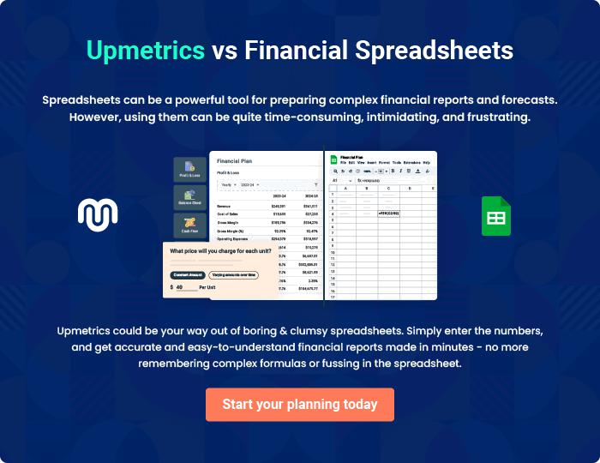
Appendix

When writing the appendix section, you should include any additional information that supports the main content of your plan. This may include financial statements, market research data, legal documents, and other
To unlock help try Upmetrics! 
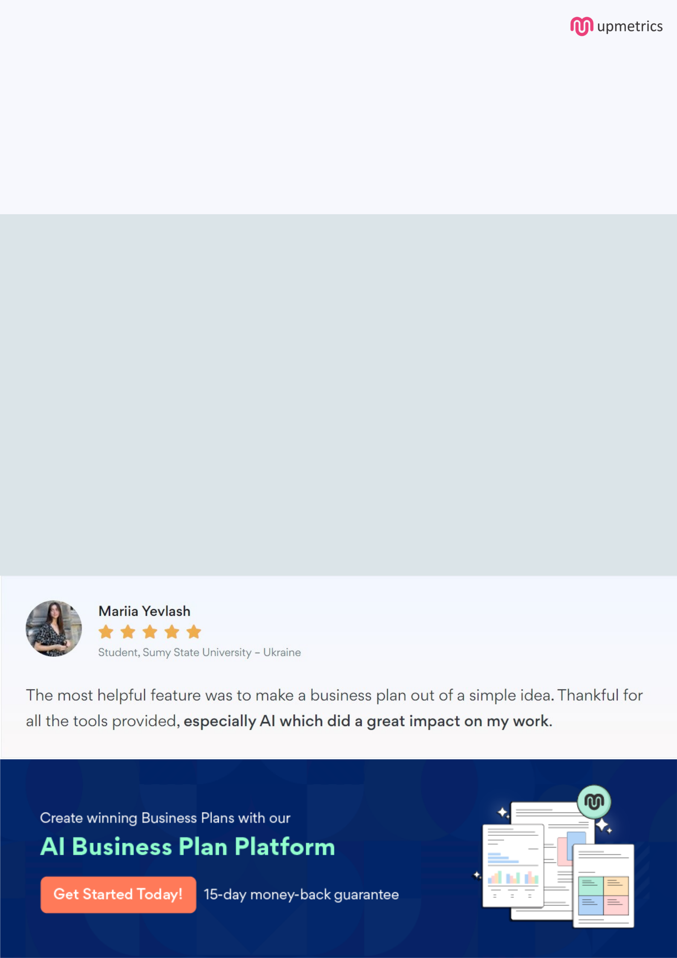
Create a winning business plan that gets you funded

Creating a stunning and investment-ready plan requires no writing, graphic designing, or financial planning expertise.

Upmetrics has all the features required to help you create a comprehensive business plan—from start to finish. Make no mistakes, it’s the modern way of planning to structure ideas, make plans, and create stunning pitch decks to awe investors.

Pitch decks that impress investors

Create pitch decks that provide a visual representation of your business, engage investors, and make them want to invest in your business idea.

Interactive plans in no time

Import business plan sections like—SWOT analysis, comparison tables, and others to create an interactive business plan. No designing skills are required.

Stunning cover page designs

With Upmetrics, you have the liberty to choose from multiple stunning cover page designs. Choose a creative design and make your plan stand out.

Online sharing made simple

Upmetrics makes online sharing quick and easier for users. Easily share your business plans with a link while tracking reader activity.

500+ sample business plans

Simply import a template from our library of sample plans into the editor and start customizing it to make it yours. It takes only a few clicks to get started.

Collaborate with team in real-time

Invite team members, initiate conversations, discuss ideas & strategies, share feedback, and work on a business plan in real-time.

