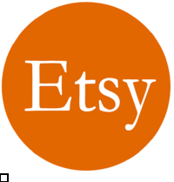

Etsy Business Plan

Where Artistry Finds its Place


Business
Plan

2023

Prepared By

John Doe

10200 Bolsa Ave, Westminster, CA, 92683

info@example.com

(650) 359-3153 http://www.example.com

Table of Contents

Executive Summary | 6
Market opportunity | 6
Products | 6
Marketing & Sales Strategies | 7
Financial Highlights | 7
Units Sold v/s Revenue | 8

Company Overview | 9
Ownership | 9
Mission statement | 10
Business history | 10
Future goals | 11

Market Analysis | 12
Target Market | 12
Market size and growth potential | 12
Market Size | 13
Competitive analysis | 13
Artisan Gems | 13
EcoTreasures | 14
Charm Collective | 14
Market trends | 15
Regulatory environment | 15

Products and Services | 17
Products | 17
Handmade Emerald Necklace | 17
Boho Crochet Scarf | 18
Leather-Engraved Keychain | 18
Custom Portrait Painting | 19
Handmade jewellery | 19
Crotchet | 19
Cute little keychains | 20
Customized Products | 20
Quality Measures | 20

Sales And Marketing Strategies | 21
Unique Selling Proposition (USP) | 21
Pricing Strategy | 21
Marketing strategies | 22
Online | 22
Sales strategies | 23
Customer retention | 23

Operations Plan | 24
Staffing & Training | 24
Operational Process | 24
Equipment & Machinery | 25

Management Team | 26
Key managers | 26
John Doe | 26
Jane Smith | 27
Alice Brown | 27
Robert Brown | 27
Organizational structure | 27
Organization chart | 28
Compensation plan | 28
Advisors & Consultants | 29
Dr. Robert White | 29
[ADVISOR NAME] | 29
Financial Plan
Financial Plan | 30

Profit & loss statement 30

Cash flow statement | 32
Balance sheet | 33
Break-even Point | 35
Financing needs | 35
Appendix
Appendix | 37
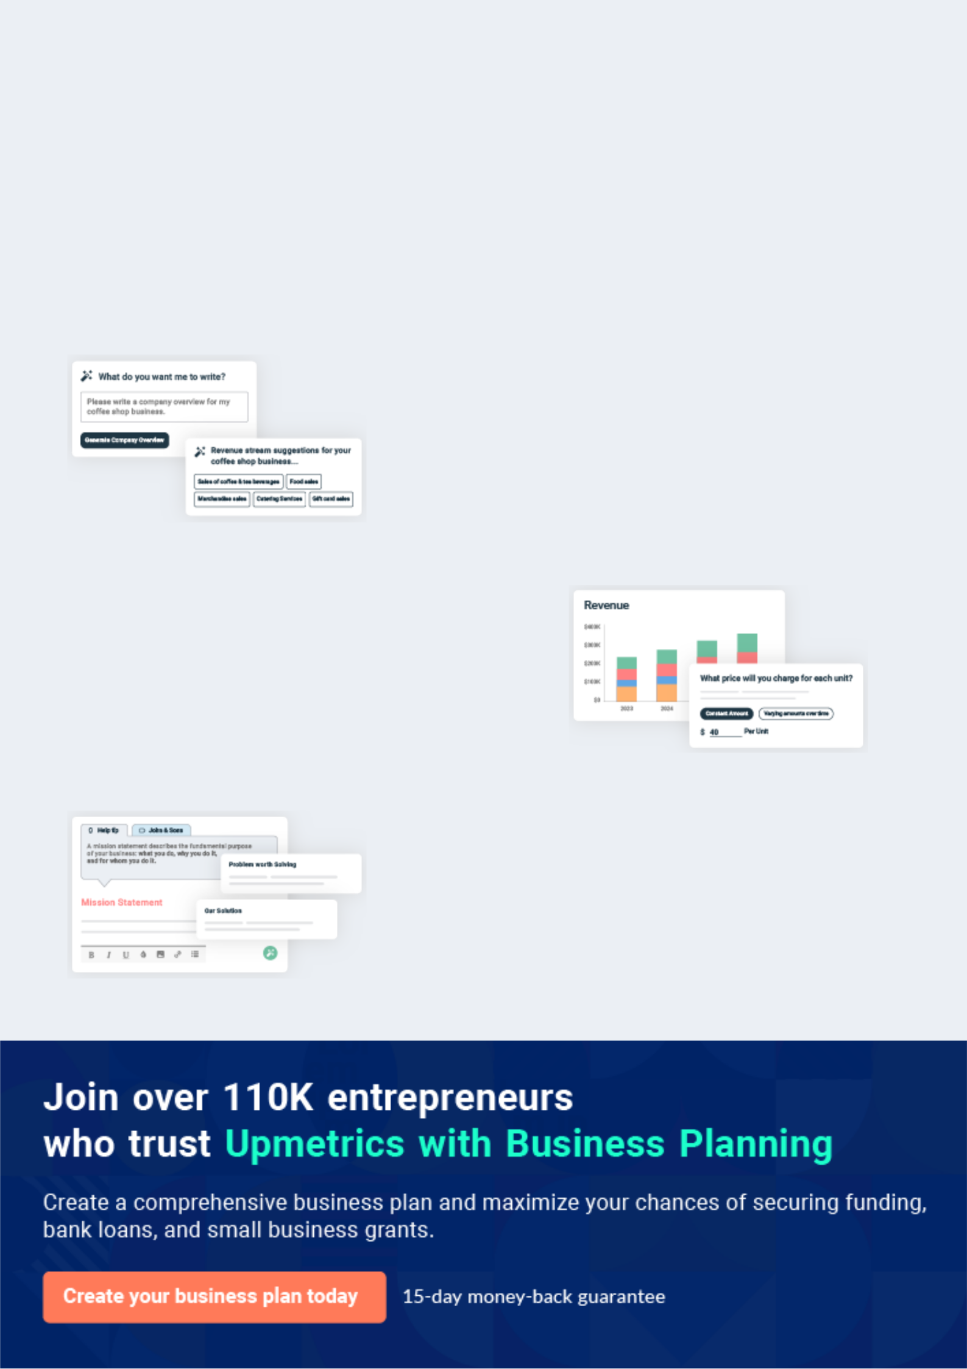
Business planning that’s simpler and faster than you think

Creating a business plan using Upmetrics to start and grow a business is literally the easiest thing in the World. Simply read the instructions and fill in the blanks. It’s as simple as that.

❛ | Upmetrics has everything you need to create a | ❜
❛ | comprehensive business plan. | ❜

AI-powered Upmetrics Assistant

AI-powered insights to streamline your plan

Not sure where to start? Upmetrics’ AI Assistant will automatically generate ideas for each section of your plan and offer improved versions of your writing, adjusting for tone, voice, and grammar or spelling errors.

Financial Forecasting Tool

All the financials are calculated for you

Forget the complex formulas and clumsy spreadsheets — with automatic financials and drag-and-drop forecasting, you can finish your plan faster and be confident that your numbers are accurate.

Business Plan Builder

Guides you like a business mentor

Upmetrics’ step-by-step instructions, prompts, and the library of 400+ sample business plans will guide you through each section of your plan as a business mentor.
Executive Summary


An executive summary is the first section of the business plan intended to provide an overview of the whole business plan.
To unlock help try Upmetrics! 

 Help tip  Etsy Business Plan


Start your executive summary by briefly introducing your business to your readers. This section may include the name of your Etsy business, when it was founded, etc.
To unlock help try Upmetrics! 

Start writing here..

Market opportunity

 Help tip  Etsy Business Plan

Summarize your market research, including market size, growth potential, and marketing trends. Highlight the opportunities in the market and how your business will fit in to fill the gap.
To unlock help try Upmetrics! 

Start writing here..

Products

 Help tip  Etsy Business Plan

Highlight the products you offer your clients. The USPs and differentiators you offer are always a plus. For instance, you might make homemade jewelry, art pieces, etc.
To unlock help try Upmetrics! 

Start writing here..

Marketing & Sales Strategies
To unlock help try Upmetrics!

 Help tip  Etsy Business Plan

Outline your sales and marketing strategies—what marketing platforms you use, how you plan on acquiring customers, etc.
To unlock help try Upmetrics! 

Start writing here..

Financial Highlights

 Help tip  Etsy Business Plan

Briefly summarize your financial projections for the initial years of business operations. Include any capital or investment requirements, associated startup costs, projected revenues, and profit forecasts.



Start writing here..
Units Sold v/s Revenue

 |  | Units Sold | Revenue
15.00k
10.00k
5.00k
0
Year 1 | Year 2 | Year 3


Financial Year |  |  | Units Sold | Revenue
Year 1 | 1,550 |  |  | $10,000
Year 2 | 1,800 |  |  | $12,000
Year 3 | 2,050 |  |  | $14,000
 Help tip |  |  Etsy Business Plan
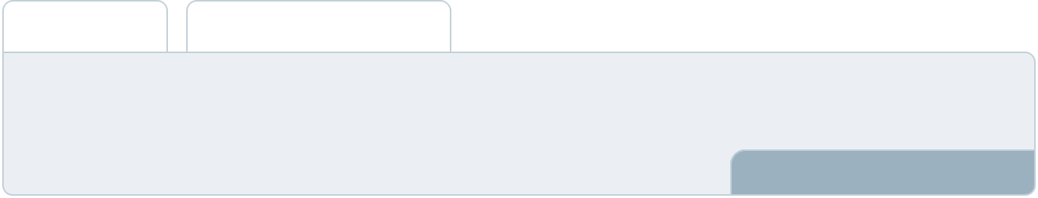

Summarize your executive summary section with a clear CTA, for example, inviting angel investors to discuss the potential business investment.
To unlock help try Upmetrics! 

Write a call to action for your business plan.
Company Overview

Depending on what details of your business are essential, you’ll need different elements in your business overview.
To unlock help try Upmetrics! 

 Help tip  Etsy Business Plan

Describe your business in this section by providing all the basic information:

Describe what kind of Etsy business you run and the name of it. You may specialize in one of
To unlock help try Upmetrics! 

Start writing here..

Ownership

 Help tip  Etsy Business Plan

List the names of your company’s founders or owners. Describe what shares they own and their responsibilities for efficiently managing the business.
To unlock help try Upmetrics! 

Start writing here..
Mission statement

 Help tip  Etsy Business Plan

Summarize your business’ objective, core principles, and values in your mission statement. This statement needs to be memorable, clear, and brief.
To unlock help try Upmetrics! 

❛ “At XYZ Creations, we aspire to [specific business objective, e.g., "infuse artistry into everyday life"]. Rooted in our core principles of [principle A, e.g., "sustainability"], [principle B, e.g., "craftsmanship"], and [principle C, e.g., "customer satisfaction"], our mission is to [memorable statement, e.g., "transform ordinary moments into extraordinary memories through our handcrafted

products."]
❜

Business history

 Help tip  Etsy Business Plan

If you’re an established business, briefly describe your business history, like—when it was founded, how it evolved over time, etc.
To unlock help try Upmetrics! 

Start writing here..
Future goals

 Help tip  Etsy Business Plan

It’s crucial to convey your aspirations and vision. Mention your short-term and long-term goals; they can be specific targets for revenue, market share, or expanding your services.
To unlock help try Upmetrics! 

Start writing here..
Market Analysis
To unlock help try Upmetrics!
To unlock help try Upmetrics!

Market analysis provides a clear understanding of the market in which your printing business will run along with the target market, competitors, and growth opportunities.



 Help tip  Etsy Business Plan

To write the introduction section of your market analysis, start by clearly identifying your primary target market.
To unlock help try Upmetrics! 

Start writing here..

Target Market

 Help tip  Etsy Business Plan

Start this section by describing your target market. Define your ideal customer and explain what types of products they prefer. Creating a buyer persona will help you easily define your target market to your readers.



Start writing here..

Market size and growth potential

 Help Tip  Etsy Business Plan


Describe your market size and growth potential and whether you will target a niche or a much broader market.
To unlock help try Upmetrics! 

Start writing here..

Market Size

Available Market

Total potential consumers seeking 5M handcrafted jewellery globally.

Served Market
Consumers on Etsy actively buying 1M handcrafted jewellery pieces.

Target Market
Eco-conscious millennials on Etsy 500k seeking sustainable jewellery

 Help tip  Etsy Business Plan

Identify and analyze your direct and indirect competitors. Identify their strengths and weaknesses, and describe what differentiates your products from them.
To unlock help try Upmetrics! 

Competitive analysis

Artisan Gems

Artisan Gems, founded in [Year], specializes in [specific product type, e.g., "boho-inspired gemstone jewellery"]. With a significant following on social media platforms, they've successfully established a loyal customer base, particularly among millennials.

Features | Strengths | Weaknesses
A wide range of gemstone | Strong brand presence on | Limited options for
jewellery, including rings, | platforms like Instagram and | personalization and
necklaces, and bracelets. | Pinterest. | customization of jewellery.
Monthly subscription boxes | Collaborations with popular | Pricier compared to market
offering curated jewellery | influencers in the jewellery | averages, potentially alienating
pieces. | niche. | cost-conscious customers.
Virtual jewellery customization | Swift shipping and responsive | Some user feedback indicates
workshops. | customer service. | quality inconsistencies in
 |  | products.

EcoTreasures

Launched in [Year], EcoTreasures champions eco-friendly jewellery, emphasizing sustainable and ethical sourcing. Their brand ethos strongly resonates with eco-conscious consumers.

Features

jewellery made from recycled materials and ethically-sourced stones.

A dedicated "Eco Blog" on their website, discussing sustainability in the jewellery industry.

Partnerships with environmental organizations, donating a percentage of sales to related causes.

Strengths

Unique selling proposition of sustainability appeals to a growing eco-friendly market segment.

Regular engagement initiatives, such as webinars on sustainable fashion.

Positive brand reputation for social responsibility.

Weaknesses

Limited product variety due to strict sustainability criteria.

Longer delivery times because of handmade production processes.

A premium pricing strategy, which could deter potential customers seeking more affordable options.

Charm Collective

Established in [Year], Charm Collective focuses on charm bracelets and accessories, offering a wide array of charms for every occasion and memory.

Features

Extensive collection of charms, from birthdays to travel themes.

"Build Your Bracelet" feature on their website, allowing full customization.

Seasonal limited-edition charm releases.

Strengths

Niche focuses on charm bracelets, attracting a specific target audience.

Regular product launches keep the brand fresh and top-of-mind.

Strong referral program encouraging word-of-mouth marketing.

Weaknesses

Dependence on a singular product line could be risky if market trends shift.

Some customer feedback cites challenges with the website's user experience.

Comparatively lower engagement on social media platforms.

Market trends

 Help tip  Etsy Business Plan

Analyse emerging trends in the industry, such as technology disruptions, changes in customer behavior or preferences, etc. Explain how your business will cope with all the trends.
To unlock help try Upmetrics! 

Start writing here..

Regulatory environment

 Help tip  Etsy Business Plan

List regulations and licensing requirements that may affect your Etsy business, such as business registration, sales tax, international regulations, intellectual property, etc.
To unlock help try Upmetrics! 

Start writing here..
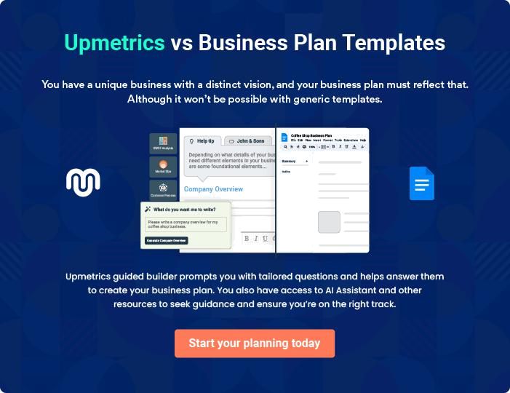
Products and Services
To unlock help try Upmetrics!

The product and services section of an etsy business plan should describe the specific services and products that will be offered to customers. To write this section should include the following:



 Help tip  Etsy Business Plan

To craft the introduction for your "Products and Services" chapter, begin by positioning your business within its industry, emphasizing its unique strengths or value proposition.
To unlock help try Upmetrics! 

Start writing here..

 Help tip


Mention the products your business will offer. This list may include products like,

• Handmade Jewelry
To unlock help try Upmetrics! 

Products

Handmade Emerald Necklace


Price: $150.00

An elegantly crafted necklace featuring a radiant emerald stone set in sterling silver. Designed to enhance both casual and formal outfits.

Specifications

- Material: 925 Sterling Silver

- Gemstone: Natural Emerald, oval cut, 0.75 carats

- Chain Length: 18 inches, with adjustable clasp

- Closure: Lobster clasp
Boho Crochet Scarf

Price: $45.00

A beautifully crocheted scarf in a bohemian pattern, perfect for cool evenings or as a fashion statement.

Specifications

- Material: 100% Organic Cotton Yarn

- Dimensions: 70 inches long, 10 inches wide

- Color: Multi-color pattern

- Care Instructions: Hand wash recommended

Leather-Engraved Keychain

Price: $20.00

A durable keychain crafted from premium leather, featuring intricate engravings. Personalized engraving is available upon request.

Specifications

- Material: Genuine Leather

- Dimensions: 3 inches by 1 inch

- Color: Chestnut Brown

- Engraving: Customizable up to 15 characters
Custom Portrait Painting

Price: Starts at $100.00 (Price varies based on size and complexity)

Commission a hand-painted portrait, rendered meticulously to capture every detail. Ideal for special occasions or as a personalized gift.

Specifications

- Medium: Acrylic on Canvas

- Standard Sizes: 8x10, 12x16, 18x24 inches (Custom sizes available)

- Duration: 7-14 days, depending on size and details

- Reference: Clear photograph required for accuracy

Handmade jewellery

Price: Approximately [XX hours/days] from conceptualization to final product.

Each jewellery item is meticulously designed, incorporating [specific materials, e.g., "ethically sourced gemstones"] and metals. Using [specific techniques, e.g., "lost-wax casting"], our artisans bring designs to life.

Crotchet

Price: Typically ranges from [XX hours for smaller items] to [XX days for larger items].

Using premium [type of yarn, e.g., "organic cotton yarn"], our experts employ traditional crocheting techniques, creating [specific products, e.g., "scarves, beanies, and throws"].
Cute little keychains
To unlock help try Upmetrics!

Price: Approximately [XX hours/days] per batch.

Crafted from [specific material, e.g., "resin or leather"], these keychains are both durable and delightful. Incorporating designs ranging from [e.g., "floral motifs to abstract art"], there's something for everyone.

Customized Products

Price: Varies based on complexity, averaging around [XX hours/days].

After a consultation with the client to understand preferences and requirements, designs are drafted. Once approved, our team sets forth in crafting the unique piece, ensuring it aligns with the client's vision.

Quality Measures

 Help tip  Etsy Business Plan

This section should explain how you maintain quality standards and consistently provide the highest quality products by using top-notch materials, or by providing excellent packaging services, etc.



Start writing here..

Sales And Marketing Strategies

Writing the sales and marketing strategies section means a list of strategies you will use to attract and retain your clients.
To unlock help try Upmetrics! 

 Help tip  Etsy Business Plan

To create an effective introduction for your "Sales and Marketing Strategies" chapter, start by setting the stage within your specific industry or market.
To unlock help try Upmetrics! 

Unique Selling Proposition (USP)

 Help tip  Etsy Business Plan

Define your business’s USPs depending on the market you serve, the equipment you use, and the unique services you provide. Identifying USPs will help you plan your marketing strategies.
To unlock help try Upmetrics! 

Start writing here..

Pricing Strategy

 Help tip  Etsy Business Plan

Describe your pricing strategy—how you plan to price your products and stay competitive in the local market. You can mention any discounts you plan on offering to attract new customers.
To unlock help try Upmetrics! 

Start writing here..

 Help tip  Etsy Business Plan
To unlock help try Upmetrics!

Discuss your marketing strategies to market your services. You may include some of these marketing strategies in your business plan—social media marketing, Google ads, email marketing, content marketing, etc.



Marketing strategies

Online


Social Media Marketing

Leveraging platforms such as [specific platforms, e.g., "Instagram and Pinterest"], we'll showcase our products, share behind-the-scenes glimpses, and engage with our audience.

Content Marketing

Through [specific channels, e.g., "our blog and guest postings"], we'll share insights about our craft, DIY tips, and industry trends

Email Marketing

Curated newsletters and updates, offering exclusives, discounts, and insights to our subscribers.

Google Ads

Targeted advertisements will ensure we reach potential customers actively seeking products in our niche.

 Help tip

Outline the strategies you’ll implement to maximize your sales. Your sales strategies may include offering promotions & discounts, offering excellent customer service, etc.
To unlock help try Upmetrics! 

Sales strategies

Promotions and Discounts

Seasonal sales and bundle offers to incentivize purchases.

Stellar Customer Service

Quick response times, easy return policies, and attentive after-sales services to ensure customer satisfaction.

Interactive Product Showcases

Live sessions on [platforms e.g.,

"Instagram or Facebook Live"],

walking customers through new

arrivals and offering real-time

purchase options.

 Help tip

Describe your customer retention strategies and how you plan to execute them. For instance, introducing loyalty programs, discounts on bulk purchases, personalized service, etc.
To unlock help try Upmetrics! 

Customer retention

Loyalty Programs

Rewarding repeat customers with points that can be redeemed against future purchases.

Bulk Purchase Discounts

Special rates for customers buying in larger quantities.

Personalized Service

Offering bespoke customization

and design consultations to cater

to individual preferences.

Operations Plan
To unlock help try Upmetrics!


 |  | When writing the operations plan section, it’s important to consider the
 |  | various aspects of your business operations.
 |  |  |  | To unlock help try Upmetrics! 
 Help tip |  |  Etsy Business Plan
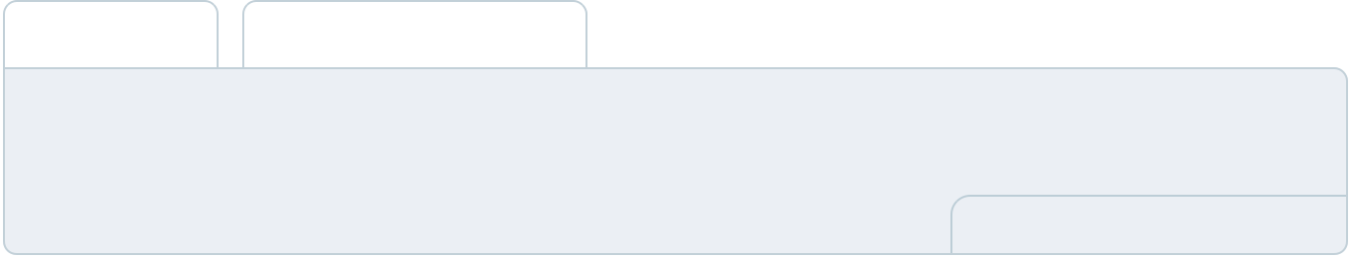

To create an effective introduction for your "Operational Plan" chapter, start by emphasizing the
pivotal role of efficient operations in the success of your business, underscoring how they
directly impact the quality of services delivered.
 |  |  |  | To unlock help try Upmetrics! 
Start writing here..
Staffing & Training
 Help tip |  |  Etsy Business Plan

Mention your Etsy business’s staffing requirements, including the number of employees.

Include their qualifications, the training required, and the duties they will perform.
To unlock help try Upmetrics! 

Start writing here..

Operational Process

 Help tip  Etsy Business Plan

Describe your production procedure and how you’ll carry out orders submitted through your Etsy shop. It should contain information about your plan for obtaining supplies, creating your goods, packaging them, and delivering them to clients.



Start writing here..

Equipment & Machinery
To unlock help try Upmetrics!

 Help tip  Etsy Business Plan

Describe your plan for managing your inventory levels, including the tools or software you’ll use to keep checks on stock levels and place new orders for supplies. It should also cover your strategy for handling inventory.



Start writing here..
Management Team

The management team section provides an overview of the individuals responsible for running your business plan.
To unlock help try Upmetrics! 

 Help tip  Etsy Business Plan

To craft an introduction for your "Management Team" chapter, begin by emphasizing the crucial role of leadership in the success of any business.
To unlock help try Upmetrics! 

Start writing here..

Key managers

 Help tip  Etsy Business Plan

Introduce your management and key members of your team, and explain their roles and responsibilities.
To unlock help try Upmetrics! 

Start writing here..


JOHN DOE

Founder and CEO - john.doe@example.com

- Education: MBA from Harvard Business School

- Professional Background: With over 15 years in the handcrafted jewellery sector, John has led multiple initiatives, transforming budding ideas into

successful enterprises.

His acumen for strategic planning and passion for artisanal craftsmanship have been the cornerstone of XYZ Creations.

JANE SMITH

Chief Operating Officer (COO) - jane.smith@example.com

- Education: Masters in Business Operations from Stanford University

- Professional Background: Jane brings a wealth of experience, having overseen operations in leading e-commerce platforms for over a decade.


Her expertise in optimizing processes and driving efficiency has been instrumental in the growth of XYZ Creations.


ALICE BROWN

Chief Marketing Officer (CMO) - alice.brown@example.com

- Education: Masters in Digital Marketing from the University of California, Berkeley

- Professional Background: Alice has spent over 12 years crafting

compelling narratives for brands in the digital space.

Her knack for understanding market nuances and designing impactful campaigns has led to significant brand milestones for XYZ Creations.


ROBERT BROWN

Chief Financial Officer (CFO) - robert.brown@example.com

- Education: CPA and Masters in Finance from MIT Sloan School of Management

- Professional Background: Robert, with his 20 years in corporate finance,

specializes in fiscal strategy and financial stewardship.

His analytical approach and experience in overseeing budgets, mergers, and acquisitions make him a vital asset to XYZ Creations.

Organizational structure

 Help tip  Etsy Business Plan

Explain the organizational structure of your management team. Include the reporting line and decision-making hierarchy.
To unlock help try Upmetrics! 

Start writing here..

Organization chart


John Doe

CEO
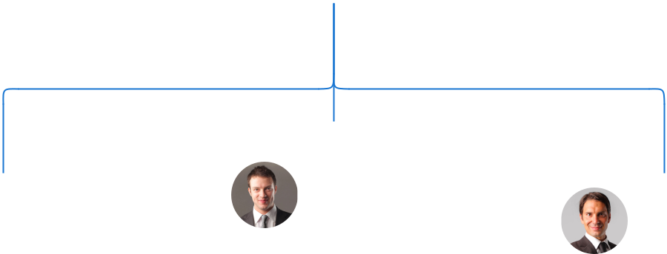

Robert Brown


Jane Smith

CFO

William White

COO
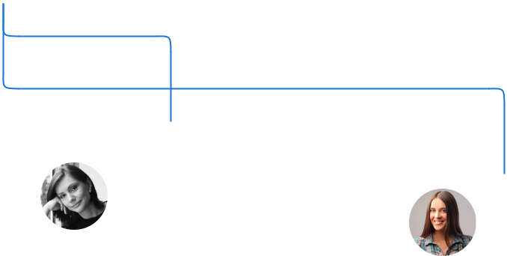

CTO

Emily Smith
Director of Marketing Alice Brown

CMO

Compensation plan

 Help tip  Etsy Business Plan

Describe your compensation plan for the management and staff. Include their salaries, incentives, and other benefits.
To unlock help try Upmetrics! 

Start writing here..

 Help tip

Mentioning advisors or consultants in your business plans adds credibility to your business idea.
To unlock help try Upmetrics! 

Advisors & Consultants


DR. ROBERT WHITE

Advisor

A renowned figure in the [specific industry, e.g., "handcrafted goods industry"], Dr. White offers insights into market trends and product innovation.


[ADVISOR NAME]

Consultant

A consulting firm specializing in e-commerce strategies, assisting XYZ Creations in optimizing its online presence and sales funnel.
Financial Plan
To unlock help try Upmetrics!

When writing the financial plan section of a business plan, it’s important to provide a comprehensive overview of your financial projections for the first few years of your business, You may provide the following:
To unlock help try Upmetrics! 

 Help tip  Etsy Business Plan

To create an effective introduction for your "Financial Plan" chapter, begin by stressing the critical role of a well-structured financial plan in the success of your venture.
To unlock help try Upmetrics! 

Start writing here..

 Help tip

Describe details such as projected revenue, operational costs, and service costs in your projected profit and loss statement. Make sure to include your business’s expected net profit or loss.



Profit & loss statement

 | 2023-24 | 2024-25 | 2025-26 | 2026-27 | 2027-28
Revenue | $0 | $0 | $0 | $0 | $0

Cost Of Sales | $0 | $0 | $0 | $0 | $0
General Costs | $0 | $0 | $0 | $0 | $0
Revenue Specific Costs | $0 | $0 | $0 | $0 | $0
Personnel Costs (Direct | $0 | $0 | $0 | $0 | $0
Labor)

Gross Margin $0 $0 $0 $0 $0

Gross Margin (%)

Operating Expense

Payroll Expense

(Indirect Labor)

General Expense

Bad Debt

Amortization of Current Assets

EBITDA

Additional Expense

Long Term

Depreciation

Gain or loss from Sale of Assets

EBIT

Interest Expenses

EBT

Income Tax Expense

Total Expense

Net Income

Net Income (%)

2023-24 | 2024-25 | 2025-26 | 2026-27 | 2027-28
0% | 0% | 0% | 0% | 0%
$0 | $0 | $0 | $0 | $0
$0 | $0 | $0 | $0 | $0
$0 | $0 | $0 | $0 | $0
$0 | $0 | $0 | $0 | $0
$0 | $0 | $0 | $0 | $0
$0 | $0 | $0 | $0 | $0
$0 | $0 | $0 | $0 | $0
$0 | $0 | $0 | $0 | $0
$0 | $0 | $0 | $0 | $0
$0 | $0 | $0 | $0 | $0
$0 | $0 | $0 | $0 | $0
$0 | $0 | $0 | $0 | $0
$0 | $0 | $0 | $0 | $0
$0 | $0 | $0 | $0 | $0
$0 | $0 | $0 | $0 | $0
0% | 0% | 0% | 0% | 0%
To unlock help try Upmetrics!
 | 2023-24 | 2024-25 | 2025-26 | 2026-27 | 2027-28
Retained Earning | $0 | $0 | $0 | $0 | $0
Opening
Owner's Distribution | $0 | $0 | $0 | $0 | $0
Retained Earning | $0 | $0 | $0 | $0 | $0
Closing

 Help tip

The cash flow for the first few years of your operation should be estimated and described in this section. This may include billing invoices, payment receipts, loan payments, and any other cash flow statements.



Cash flow statement

Cash Received

Cash Paid

COS & General Expenses

Salary & Wages

Interest

Sales Tax

Income Tax

Net Cash From

Operations

Assets Sell

Assets Purchase

Net Cash From

Investments

2023-24 | 2024-25 | 2025-26 | 2026-27 | 2027-28
$0 | $0 | $0 | $0 | $0
$0 | $0 | $0 | $0 | $0
$0 | $0 | $0 | $0 | $0
$0 | $0 | $0 | $0 | $0
$0 | $0 | $0 | $0 | $0
$0 | $0 | $0 | $0 | $0
$0 | $0 | $0 | $0 | $0
$0 | $0 | $0 | $0 | $0

$0 | $0 | $0 | $0 | $0
$0 | $0 | $0 | $0 | $0
$0 | $0 | $0 | $0 | $0

 | 2023-24 | 2024-25 | 2025-26 | 2026-27 | 2027-28
Amount Received | $0 | $0 | $0 | $0 | $0
Loan Received | $0 | $0 | $0 | $0 | $0
Common Stock
Preferred Stock | $0 | $0 | $0 | $0 | $0
Owner's Contribution | $0 | $0 | $0 | $0 | $0
Amount Paid | $0 | $0 | $0 | $0 | $0
Loan Capital | $0 | $0 | $0 | $0 | $0
Dividends & Distributions | $0 | $0 | $0 | $0 | $0
Net Cash From | $0 | $0 | $0 | $0 | $0
Financing

Summary
Starting Cash | $0 | $0 | $0 | $0 | $0
Cash In | $0 | $0 | $0 | $0 | $0
Cash Out | $0 | $0 | $0 | $0 | $0
Change in Cash | $0 | $0 | $0 | $0 | $0
Ending Cash | $0 | $0 | $0 | $0 | $0

 Help tip

Create a projected balance sheet documenting your Etsy business’s assets, liabilities, and equity.
To unlock help try Upmetrics! 

Balance sheet

 | 2023-24 | 2024-25 | 2025-26 | 2026-27 | 2027-28
Assets | $0 | $0 | $0 | $0 | $0
 | 2023-24 | 2024-25 | 2025-26 | 2026-27 | 2027-28
Current Assets | $0 | $0 | $0 | $0 | $0
Cash | $0 | $0 | $0 | $0 | $0
Accounts Receivable | $0 | $0 | $0 | $0 | $0
Inventory | $0 | $0 | $0 | $0 | $0
Other Current Assets | $0 | $0 | $0 | $0 | $0
Long Term Assets | $0 | $0 | $0 | $0 | $0
Gross Long Term Assets | $0 | $0 | $0 | $0 | $0
Accumulated Depreciation | $0 | $0 | $0 | $0 | $0

Liabilities & Equity | $0 | $0 | $0 | $0 | $0
Liabilities | $0 | $0 | $0 | $0 | $0
Current Liabilities | $0 | $0 | $0 | $0 | $0
Accounts Payable | $0 | $0 | $0 | $0 | $0
Income Tax Payable | $0 | $0 | $0 | $0 | $0
Sales Tax Payable | $0 | $0 | $0 | $0 | $0
Short Term Debt | $0 | $0 | $0 | $0 | $0
Long Term Liabilities | $0 | $0 | $0 | $0 | $0
Long Term Debt | $0 | $0 | $0 | $0 | $0
Equity | $0 | $0 | $0 | $0 | $0
Paid-in Capital | $0 | $0 | $0 | $0 | $0
Common Stock | $0 | $0 | $0 | $0 | $0
Preferred Stock | $0 | $0 | $0 | $0 | $0
Owner's Contribution | $0 | $0 | $0 | $0 | $0
Retained Earnings | $0 | $0 | $0 | $0 | $0
 | 2023-24 | 2024-25 | 2025-26 | 2026-27 | 2027-28
Check | $0 | $0 | $0 | $0 | $0

Break-even Point

 Help tip  Etsy Business Plan

Determine and mention your business’s break-even point—the point at which your business costs and revenue will be equal.
To unlock help try Upmetrics! 

Start writing here..

Financing needs

 Help tip  Etsy Business Plan

Calculate costs associated with starting an Etsy business, and estimate your financing needs and how much capital you need to raise to operate your business.
To unlock help try Upmetrics! 

Start writing here..
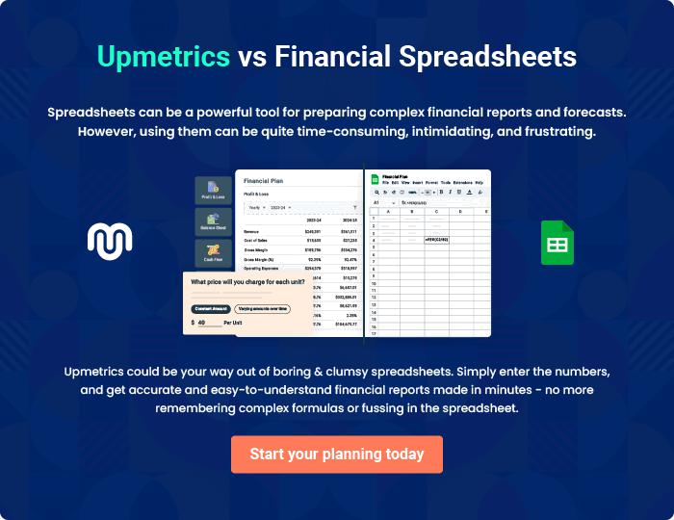
Appendix

When writing the appendix section, you should include any additional information that supports the main content of your plan. This may include financial statements, market research data, legal documents, and other
To unlock help try Upmetrics! 
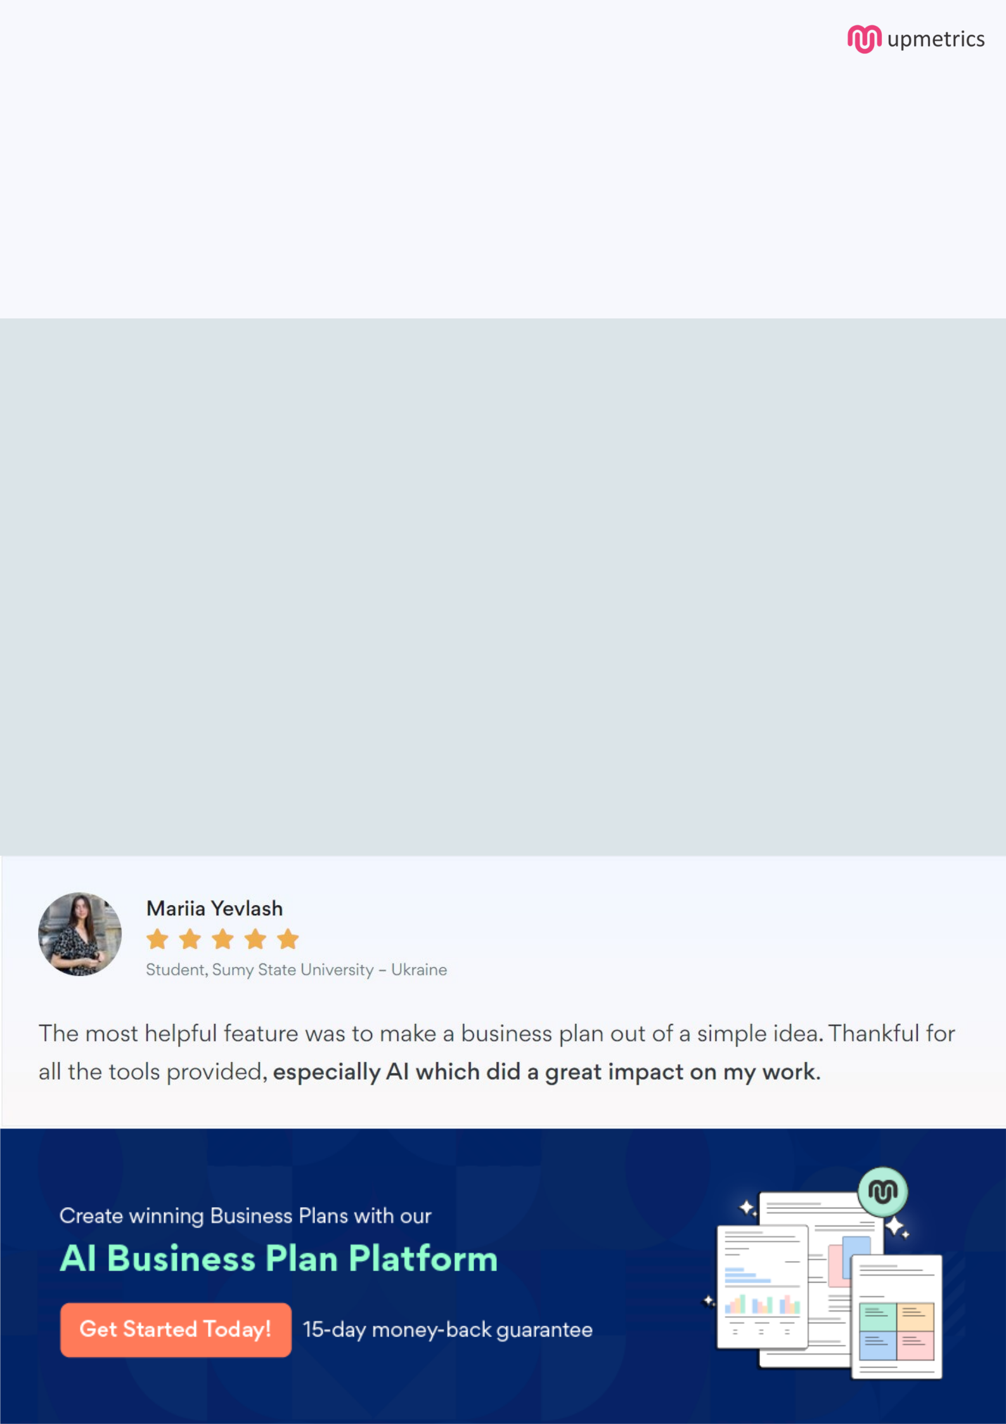
Create a winning business plan that gets you funded

Creating a stunning and investment-ready plan requires no writing, graphic designing, or financial planning expertise.

Upmetrics has all the features required to help you create a comprehensive business plan—from start to finish. Make no mistakes, it’s the modern way of planning to structure ideas, make plans, and create stunning pitch decks to awe investors.

Pitch decks that impress investors

Create pitch decks that provide a visual representation of your business, engage investors, and make them want to invest in your business idea.

Interactive plans in no time

Import business plan sections like—SWOT analysis, comparison tables, and others to create an interactive business plan. No designing skills are required.

Stunning cover page designs

With Upmetrics, you have the liberty to choose from multiple stunning cover page designs. Choose a creative design and make your plan stand out.

Online sharing made simple

Upmetrics makes online sharing quick and easier for users. Easily share your business plans with a link while tracking reader activity.

500+ sample business plans

Simply import a template from our library of sample plans into the editor and start customizing it to make it yours. It takes only a few clicks to get started.

Collaborate with team in real-time

Invite team members, initiate conversations, discuss ideas & strategies, share feedback, and work on a business plan in real-time.

