

Esthetician Business Plan

Radiance Unveiled, Skin Transformed

Business Plan

2023

John Doe

10200 Bolsa Ave, Westminster, CA, 92683

- 359-3153 info@example.com http://www.example.com

Information provided in this business plan is unique to this business and confidential; therefore, anyone reading this plan agrees not to disclose any of the information in this business plan without prior written permission of the company.
Table of Contents

Executive Summary | 6
Market opportunity | 6
Services Offered | 6
Management team | 7
John Doe | 7
Alice Brown | 7
Jane Doe | 7
Financial Highlights | 7
Units Sold v/s Revenue | 8

Company Overview | 9
Ownership | 9
Business Owners | 9
Mission statement | 10
Business history | 10
Future goals | 10

Market Analysis | 11
Target Market | 11
Market size and growth potential | 11
Market Size | 12
Competitive analysis | 12
Radiant Glow Esthetics | 12
Serenity Skincare Spa | 13
Natural Touch Wellness | 13
Market trends | 13
Regulatory environment | 14

Products and Services | 15
Products and Services | 15

Chemical Peels 15

Microdermabrasion | 16
Full Body Waxing | 16
Luxe Radiance Facial | 17
Anti-Aging Serum (For Sale) | 17
Emphasize safety and quality | 18

Sales And Marketing Strategies | 19
Unique Selling Proposition (USP) | 19
Pricing Strategy | 19
Marketing strategies | 20
Online | 20
Offline | 20
Sales strategies | 21
Customer retention | 21

Operations Plan | 22
Hiring Plan | 22
Operational Process | 22
Technologies | 23

Management Team | 24
Key managers | 24
John Doe | 24
Alice Brown | 25
Robert Brown | 25
Organizational structure | 25
Organization chart | 26
Compensation plan | 26
Board of advisors | 27
Dr. Alan Brown | 27
Ms. Lucy White | 27
Financial Plan
Financial Plan | 28

Profit & loss statement 28

Cash Flow statement | 30
Balance sheet | 31
Break-even Point | 33
Financing needs | 33
Appendix
Appendix | 35
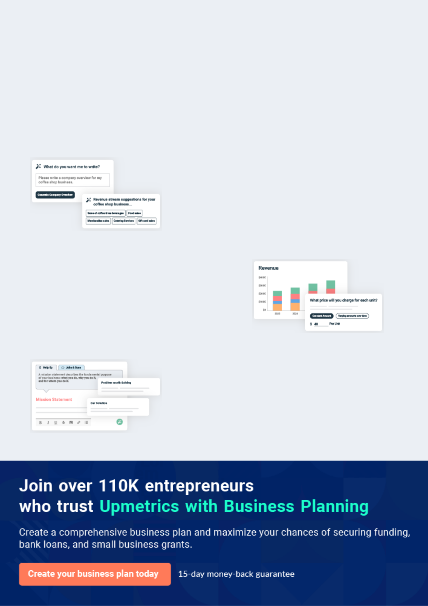
Business planning that’s simpler and faster than you think

Creating a business plan using Upmetrics to start and grow a business is literally the easiest thing in the World. Simply read the instructions and fill in the blanks. It’s as simple as that.

❛ | Upmetrics has everything you need to create a | ❜
❛ | comprehensive business plan. | ❜

AI-powered Upmetrics Assistant

AI-powered insights to streamline your plan

Not sure where to start? Upmetrics’ AI Assistant will automatically generate ideas for each section of your plan and offer improved versions of your writing, adjusting for tone, voice, and grammar or spelling errors.

Financial Forecasting Tool

All the financials are calculated for you

Forget the complex formulas and clumsy spreadsheets — with automatic financials and drag-and-drop forecasting, you can finish your plan faster and be confident that your numbers are accurate.

Business Plan Builder

Guides you like a business mentor

Upmetrics’ step-by-step instructions, prompts, and the library of 400+ sample business plans will guide you through each section of your plan as a business mentor.
Executive Summary
To unlock help try Upmetrics!


An executive summary is the first section of the business plan intended to provide an overview of the whole business plan.
To unlock help try Upmetrics! 

 Help tip  Esthetician Business Plan


Start your executive summary by introducing your idea behind starting an esthetician business and explaining what it does.
To unlock help try Upmetrics! 

Start writing here..

Market opportunity

 Help tip  Esthetician Business Plan

Describe the target market in brief, and explain the demographics, geographic location, and psychographic attributes of your customer.
To unlock help try Upmetrics! 

Start writing here..

Services Offered

 Help tip  Esthetician Business Plan

Describe in detail the aesthetic treatments and conventional skincare services that a client can expect at your salon. Also, incorporate all the details about the tools and equipment you will use keeping customers’ safety in your mind.



Start writing here..

Management team


JOHN DOE

Founder/CEO - john.doe@example.com

With over [X years] of industry experience and a passion for skincare, [John] brings expertise and vision to [LuxeSkin].


ALICE BROWN

Operations Manager - alice.brown@example.com

An expert in [specific skill or qualification], [Alice] ensures the smooth day-to-day functioning of the salon.


JANE DOE

Lead Esthetician - jane.doe@example.com

With credentials from [specific institution or training], Emily is the backbone of our treatment offerings, ensuring each client receives top-tier care.

Financial Highlights

 Help tip  Esthetician Business Plan

Provide a summary of your financial projections for the company’s initial years of operation.

Include any capital or investment requirements, startup costs, projected revenues, and profits.
To unlock help try Upmetrics! 

Start writing here..
Units Sold v/s Revenue
To unlock help try Upmetrics!

 |  | Units Sold | Revenue
15.00k
10.00k
5.00k
0
Year 1 | Year 2 | Year 3


Financial Year |  |  | Units Sold | Revenue
Year 1 | 1,550 |  |  | $10,000
Year 2 | 1,800 |  |  | $12,000
Year 3 | 2,050 |  |  | $14,000
 Help tip |  |  Esthetician Business Plan


After giving a brief about your business plan, end your summary with a call to action, for example; inviting potential investors or readers to the next meeting if they are interested in your business.



Write a call to action for your business plan.
Company Overview

Depending on what details of your business are essential, you’ll need different elements in your business overview.
To unlock help try Upmetrics! 

 Help tip  Esthetician Business Plan

Provide all the basic information about your business in this section like:

• The name of the esthetician salon and the concept behind it: a salon with a facial
To unlock help try Upmetrics! 

Start writing here..

Ownership

 Help tip  Esthetician Business Plan

Describe the owners of your salon and mention their roles in running it. Whose shares in the corporation are they, and how each owner helps in the business?
To unlock help try Upmetrics! 

Start writing here..

Business Owners



60% John Doe



40% Jane Smith
Mission statement
To unlock help try Upmetrics!

 Help tip  Esthetician Business Plan

Add a mission statement that sums up the objectives and core principles of your esthetician business. This statement needs to be memorable, clear, and brief.
To unlock help try Upmetrics! 

❛ At [LuxeSkin], we believe in the harmonious blend of luxury and genuine skincare. Our mission is to offer transformative experiences that go beyond the surface, empowering individuals

to embrace their authentic beauty.
❜

Business history

 Help tip  Esthetician Business Plan


Include an outline of the salon’s history and how it came to be in its current position. If you can,
add some personality and intriguing details, especially if you got any achievements or
recognitions till now for your incredible services.
 |  |  |  |  | To unlock help try Upmetrics! 
Start writing here..
Future goals
 Help tip |  |  |  Esthetician Business Plan

It’s crucial to convey your aspirations and your vision. Include the vision of where you see your business in the near future and if you have any plans of opening a new franchise of your business in the same city in the future.



Start writing here..

Market Analysis
To unlock help try Upmetrics!


 |  | Market analysis provides a clear understanding of the market in which your
 |  | printing business will run along with the target market, competitors, and
 |  | growth opportunities.
 |  |  |  | To unlock help try Upmetrics! 
 Help tip |  |  Esthetician Business Plan

To write the introduction section of your market analysis, start by clearly identifying your primary target market.
To unlock help try Upmetrics! 

Start writing here..

Target Market

 Help tip  Esthetician Business Plan

Identify your target market and define your ideal customer. Know more about your customers and which services they prefer: chemical peels, facials, waxing, body wraps, waxing, and other such services.



Start writing here..

Market size and growth potential

 Help tip  Esthetician Business Plan

The esthetician industry, currently valued at [specific market size, e.g., "$5 billion"], has witnessed a steady growth rate of [specific percentage, e.g., "7% annually"].
To unlock help try Upmetrics! 

Start writing here..

Market Size
To unlock help try Upmetrics!

Available Market

All individuals seeking skincare services 10M in the country.

Served Market
Individuals in urban areas who regularly 5M visit esthetician salons.

Target Market
Urban individuals aged 25-45 prioritizing 2M holistic luxury skincare.

 Help tip  Esthetician Business Plan

Identify and analyze all other estheticians in the local market, including direct and indirect competitors. Evaluate their strengths and weaknesses, and explain how your salon can offer qualitative services.



Competitive analysis

Radiant Glow Esthetics

Established in 2018, Radiant Glow Esthetics is a mid-tier salon offering a mix of traditional and modern skincare treatments. Located in the bustling downtown area, it attracts a diverse clientele ranging from young professionals to retirees.

Features

Facials (Organic, Anti-Aging, Hydrating)

Chemical Peels Microdermabrasion Waxing (Full Body)

Strengths Weaknesses

Centralized location making it Limited advanced treatment

easily accessible. options.

A diverse range of facials Overbooked appointments

catering to various skin types. leading to rushed services.

Regular promotional deals Lack of certified medical

attract budget-conscious estheticians for specialized

clients. procedures.

Serenity Skincare Spa

Serenity Skincare Spa is a high-end salon known for its luxurious ambience and premium services.

Established in 2015, it is often frequented by celebrities and socialites of the city.

Features

Exclusive Spa Retreat Packages

Gold Facial Treatments Customized Skin Health Plans Laser Hair Removal

Strengths

Exquisite ambience offering a serene escape.

Personalized treatments with skincare consultants.

Use of state-of-the-art equipment and high-end products.

Weaknesses

Premium pricing, which may alienate a wider customer base.

By appointment-only policy, making spontaneous visits impossible.

Sometimes perceived as too elitist, deterring potential middle-tier clientele.

Natural Touch Wellness

Natural Touch Wellness, operating since 2020, emphasizes organic and holistic skincare. Located near health hubs and yoga studios, it appeals to individuals leaning towards natural wellness.

Features

Vegan Facials

Herbal Body Wraps

Crystal-infused Skincare Treatments

Aromatherapy Massages

Strengths | Weaknesses
Strong emphasis on organic | Limited traditional esthetician
and vegan products. | services.
Collaborations with local | Slower adoption of technological
wellness brands for holistic | advancements in skincare.
packages. | Restricted target market due to a
Regular workshops on skincare | specific brand ethos.
awareness and self-care
rituals.

Market trends

 Help tip  Esthetician Business Plan

Analyze current and emerging trends in your industry, such as changes in customer preference.

Explain how your business will cope with all the trends.
To unlock help try Upmetrics! 

Start writing here..

Regulatory environment
To unlock help try Upmetrics!

 Help tip  Esthetician Business Plan

Describe any regulations or licensing requirements that affect the esthetician business, such as safety codes, or requirements of a full-time doctor or physician depending on your services should be mentioned here.



Start writing here..
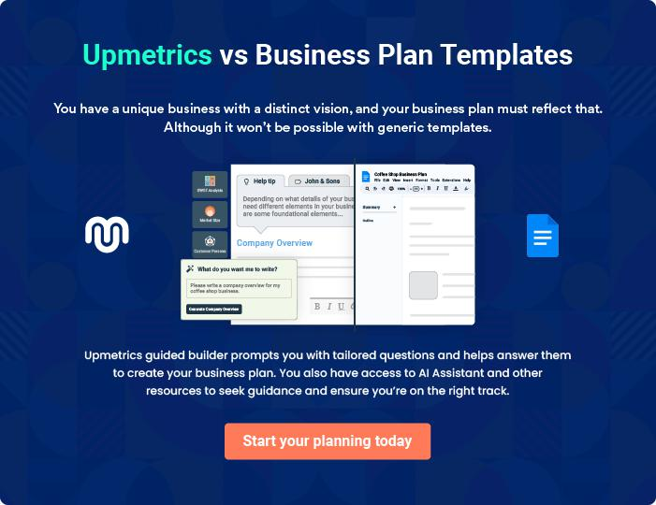
Products and Services
To unlock help try Upmetrics!
To unlock help try Upmetrics!

The product and services section of an esthetician business plan should describe the specific services and products that will be offered to customers. To write this section should include the following:



 Help tip  Esthetician Business Plan

To craft the introduction for your "Products and Services" chapter, begin by positioning your business within its industry, emphasizing its unique strengths or value proposition.
To unlock help try Upmetrics! 

Start writing here..

 Help tip


Define the services you will provide as an esthetician. These can involve chemical peels, microdermabrasion, the application of cosmetics, waxing, facials, and more. Be precise about the details of each service, including the cost.



Products and Services

Chemical Peels
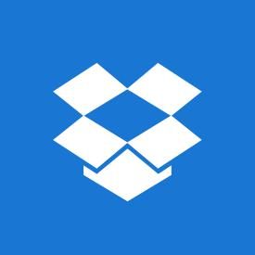

Price: $[150] per session

A transformative skincare treatment designed to rejuvenate the skin, targeting issues such as acne scars, fine lines, and uneven pigmentation.

Specifications

- Active Ingredient: Glycolic Acid (40%)

- Session Duration: 45 minutes

- Post-treatment care: Sunscreen application mandatory, avoid direct sun exposure for 48 hours

- Frequency: Recommended every 4-6 weeks
Microdermabrasion

Price: $[120] per session

A gentle yet effective exfoliating procedure that revitalizes dull skin, reduces enlarged pores, and mitigates age spots.

Specifications

- Equipment: Diamond-tip handpiece

- Session Duration: 60 minutes

- Suitable for: All skin types except active acne

- Post-treatment care: Moisturizing and sun protection

Full Body Waxing

Price: Starting from $[80]

Using premium organic honey-based wax, this service offers clients smooth, hair-free skin for weeks.

Specifications

- Wax Type: Organic Honey-Based

- Suitable for: All skin types, patch test recommended for sensitive skin

- Post-treatment care: Avoid hot showers for 24 hours, exfoliate after 48 hours to prevent ingrown hairs
Luxe Radiance Facial

Price: $[90] per session

A holistic facial tailored to individual skin needs, incorporating organic and vegan products, ensuring deep hydration, detoxification, and rejuvenation.

Specifications

- Product Line: [Brand Name, e.g., "EcoBeauty Organics"]

- Session Duration: 75 minutes

- Suitable for: All skin types, customization available for sensitive skin

- Included: Steam, extraction, massage, mask, and serum application

Anti-Aging Serum (For Sale)

Price: $[50] per bottle (30ml)

An elixir crafted with potent ingredients that combat signs of ageing, boost collagen production and impart a youthful glow.

Specifications

- Key Ingredients: Hyaluronic Acid, Vitamin C, Retinol

- Usage: Nightly, post-cleansing and before moisturizing

- Suitable for: Skin types showing signs of aging or as a preventive measure

- Shelf Life: 12 months from opening
Emphasize safety and quality
- To unlock help try Upmetrics!

 Help tip  Esthetician Business Plan

In all descriptions of services and products, emphasize the importance of safety and quality. Explain how your business will ensure that all services and products are delivered with the highest standards of safety and efficacy.



Start writing here..
Sales And Marketing Strategies

Writing the sales and marketing strategies section means a list of strategies you will use to attract and retain your clients.
To unlock help try Upmetrics! 

 Help tip  Esthetician Business Plan

To create an effective introduction for your "Sales and Marketing Strategies" chapter, start by setting the stage within your specific industry or market.
To unlock help try Upmetrics! 

Unique Selling Proposition (USP)

 Help tip  Esthetician Business Plan

Clearly define your salon’s unique selling proposition, such as your services, treatments, or
products. Determine what sets your salon apart from the competition and what benefits you
offer your target market.
 |  |  |  | To unlock help try Upmetrics! 
Start writing here..
Pricing Strategy
 Help tip |  |  Esthetician Business Plan

Develop a pricing strategy that is competitive and affordable, yet profitable. Consider offering promotions, discounts, or packages for your services to attract new customers.
To unlock help try Upmetrics! 

Start writing here..

 Help tip  Esthetician Business Plan
To unlock help try Upmetrics!

Develop a marketing strategy that includes a mix of online and offline marketing tactics. Consider social media, email marketing, content marketing, brochures, print marketing, and events.



Marketing strategies

Online


Social Media

Regular updates, live sessions, and skin care tips on platforms like [specific platforms, e.g., "Instagram and Facebook"].

Content Marketing

Blog posts on our website covering skincare trends, treatment benefits, and client testimonials

Offline

Brochures

Detailed brochures are available at our salon, covering our services, products, and esthetician profiles.

Email Marketing

Monthly newsletters with skincare insights, promotions, and appointment reminders

Print Marketing

Advertisements in [specific publications, e.g., "local lifestyle magazines and newspapers"].

Events

Participation in or hosting [specific

events, e.g., "beauty expos,

wellness retreats, and community

fairs"].

Sales strategies

 Help tip  Esthetician Business Plan

Mention your sales strategy as in – partner with other businesses and healthcare providers to establish referral programs that can help you generate more business.
To unlock help try Upmetrics! 

Start writing here..

Customer retention

 Help tip  Esthetician Business Plan

Describe how your salon will retain customers and build loyalty, such as through loyalty programs, special events, or personalized service.
To unlock help try Upmetrics! 

Start writing here..
Operations Plan
To unlock help try Upmetrics!

 |  | When writing the operations plan section, it’s important to consider the
 |  | various aspects of your business operations.
 |  |  |  | To unlock help try Upmetrics! 
 Help tip |  |  Esthetician Business Plan


To create an effective introduction for your "Operational Plan" chapter, start by emphasizing the
pivotal role of efficient operations in the success of your business, underscoring how they
directly impact the quality of services delivered.
 |  |  |  | To unlock help try Upmetrics! 
Start writing here..
Hiring Plan
 Help tip |  |  Esthetician Business Plan

Tell the staffing requirements of your esthetician business, including the number of employees
needed, their qualifications, and the duties they will perform. Also mention the perks you will
provide to your employees.
 |  |  |  | To unlock help try Upmetrics! 
Start writing here..
Operational Process
 Help tip |  |  Esthetician Business Plan

Outline the processes and procedures that you will use to run your esthetician business. It includes the scheduling of appointments, the check-in and check-out process, and the management of medical records.



Start writing here..

Technologies

 Help tip  Esthetician Business Plan

Describe the systems and technologies that will be used in your salon, types of needles, massage machines, laser machines, and everything else.
To unlock help try Upmetrics! 

Start writing here..
Management Team

The management team section provides an overview of the individuals responsible for running your business plan.
To unlock help try Upmetrics! 

 Help tip  Esthetician Business Plan

To craft an introduction for your "Management Team" chapter, begin by emphasizing the crucial role of leadership in the success of any business.
To unlock help try Upmetrics! 

Start writing here..

Key managers

 Help tip  Esthetician Business Plan

Describe the key members of your management team, their roles, and their responsibilities.

It should include the owners, senior management, and any other physician, doctors, and people
To unlock help try Upmetrics! 

Start writing here..

JOHN DOE

Owner - john.doe@example.com

With over 15 years of experience in the skincare and beauty industry, John Doe holds a Bachelor's degree in Aesthetic Science from the renowned Beauty Institute of New York.


His expertise in skincare treatments, coupled with his innovative techniques, form the cornerstone of [LuxeSkin].

Under his leadership, [LuxeSkin] has adopted a blend of traditional and modern aesthetics, catering to a diverse clientele.

ALICE BROWN

Operations Manager - alice.brown@example.com

Alice Brown graduated with an MBA from Stanford University and has since accumulated over 10 years of experience managing operations in top-tier salons across the country.


Her knack for optimizing workflow, coupled with her passion for skincare, makes her an invaluable asset to [LuxeSkin].

Alice's proficiency ensures that the salon runs seamlessly, ensuring both staff and clients have an exceptional experience.


ROBERT BROWN

Resident Dermatologist - robert.brown@example.com

Dr. Robert Brown, a seasoned dermatologist with over 20 years in practice, holds a medical degree from Harvard Medical School.

He has written numerous articles on skincare health and innovations.

At [LuxeSkin], Dr Brown consults on specialized treatments and works closely with the team to ensure holistic skin health approaches are employed, merging medical expertise with aesthetic treatments.

Organizational structure

 Help tip  Esthetician Business Plan

Describe the organizational structure of the management team, including reporting lines and how decisions will be made.
To unlock help try Upmetrics! 

Start writing here..
Organization chart


John Doe

CEO


 | Robert Brown
Alice Brown | Resident
Operations Manager | Dermatologist



 | Michael Green | Lucy Gray
Jane Doe | Marketing and outreach | Front Desk and
Lead Esthetician | Coordinator | customer Relations


Compensation plan

 Help tip  Esthetician Business Plan

Describe your compensation plan for the management team and staff, including salaries, bonuses, and other benefits.
To unlock help try Upmetrics! 

Start writing here..
 Help tip

If you have a board of advisors for your business, then mention them along with their roles and experience.
To unlock help try Upmetrics! 

Board of advisors


DR. ALAN BROWN

Dermatology Expert

With [X years, e.g., "20 years"] in dermatological research and practice, Dr.

Brown advises on treatment innovations and skin health protocols.

MS. LUCY WHITE

Spa & Wellness Consultant

An industry veteran with a background in luxury spa operations, Lucy lends expertise to service enhancements and customer experience.
Financial Plan
To unlock help try Upmetrics!

When writing the financial plan section of a business plan, it’s important to provide a comprehensive overview of your financial projections for the first few years of your business, You may provide the following:
To unlock help try Upmetrics! 

 Help tip  Esthetician Business Plan

To create an effective introduction for your "Financial Plan" chapter, begin by stressing the critical role of a well-structured financial plan in the success of your venture.
To unlock help try Upmetrics! 

Start writing here..

 Help tip

Create a projected profit & loss statement that describes the expected revenue, cost of products sold, and operational costs. Your business’s anticipated net profit or loss should be computed and included.



Profit & loss statement

 | 2023-24 | 2024-25 | 2025-26 | 2026-27 | 2027-28
Revenue | $0 | $0 | $0 | $0 | $0

Cost Of Sales | $0 | $0 | $0 | $0 | $0
General Costs | $0 | $0 | $0 | $0 | $0
Revenue Specific Costs | $0 | $0 | $0 | $0 | $0
Personnel Costs (Direct | $0 | $0 | $0 | $0 | $0
Labor)

Gross Margin $0 $0 $0 $0 $0

Gross Margin (%)

Operating Expense

Payroll Expense

(Indirect Labor)

General Expense

Bad Debt

Amortization of Current Assets

EBITDA

Additional Expense

Long Term

Depreciation

Gain or loss from Sale of Assets

EBIT

Interest Expenses

EBT

Income Tax Expense

Total Expense

Net Income

Net Income (%)

2023-24 | 2024-25 | 2025-26 | 2026-27 | 2027-28
0% | 0% | 0% | 0% | 0%
$0 | $0 | $0 | $0 | $0
$0 | $0 | $0 | $0 | $0
$0 | $0 | $0 | $0 | $0
$0 | $0 | $0 | $0 | $0
$0 | $0 | $0 | $0 | $0
$0 | $0 | $0 | $0 | $0
$0 | $0 | $0 | $0 | $0
$0 | $0 | $0 | $0 | $0
$0 | $0 | $0 | $0 | $0
$0 | $0 | $0 | $0 | $0
$0 | $0 | $0 | $0 | $0
$0 | $0 | $0 | $0 | $0
$0 | $0 | $0 | $0 | $0
$0 | $0 | $0 | $0 | $0
$0 | $0 | $0 | $0 | $0
0% | 0% | 0% | 0% | 0%
To unlock help try Upmetrics!
 | 2023-24 | 2024-25 | 2025-26 | 2026-27 | 2027-28
Retained Earning | $0 | $0 | $0 | $0 | $0
Opening
Owner's Distribution | $0 | $0 | $0 | $0 | $0
Retained Earning | $0 | $0 | $0 | $0 | $0
Closing

 Help tip

Estimate your cash inflows and outflows for the first few years of operation. It should include cash receipts from clients, payments to vendors, loan payments, and any other cash inflows and outflows.



Cash Flow statement

Cash Received

Cash Paid

COS & General Expenses

Salary & Wages

Interest

Sales Tax

Income Tax

Net Cash From

Operations

Assets Sell

Assets Purchase

Net Cash From

Investments

2023-24 | 2024-25 | 2025-26 | 2026-27 | 2027-28
$0 | $0 | $0 | $0 | $0
$0 | $0 | $0 | $0 | $0
$0 | $0 | $0 | $0 | $0
$0 | $0 | $0 | $0 | $0
$0 | $0 | $0 | $0 | $0
$0 | $0 | $0 | $0 | $0
$0 | $0 | $0 | $0 | $0
$0 | $0 | $0 | $0 | $0

$0 | $0 | $0 | $0 | $0
$0 | $0 | $0 | $0 | $0
$0 | $0 | $0 | $0 | $0

 | 2023-24 | 2024-25 | 2025-26 | 2026-27 | 2027-28
Amount Received | $0 | $0 | $0 | $0 | $0
Loan Received | $0 | $0 | $0 | $0 | $0
Common Stock
Preferred Stock | $0 | $0 | $0 | $0 | $0
Owner's Contribution | $0 | $0 | $0 | $0 | $0
Amount Paid | $0 | $0 | $0 | $0 | $0
Loan Capital | $0 | $0 | $0 | $0 | $0
Dividends & Distributions | $0 | $0 | $0 | $0 | $0
Net Cash From | $0 | $0 | $0 | $0 | $0
Financing

Summary
Starting Cash | $0 | $0 | $0 | $0 | $0
Cash In | $0 | $0 | $0 | $0 | $0
Cash Out | $0 | $0 | $0 | $0 | $0
Change in Cash | $0 | $0 | $0 | $0 | $0
Ending Cash | $0 | $0 | $0 | $0 | $0

 Help tip

Prepare a projected balance sheet, which shows the assets, liabilities, and equity of the business.
To unlock help try Upmetrics! 

Balance sheet

 | 2023-24 | 2024-25 | 2025-26 | 2026-27 | 2027-28
Assets | $0 | $0 | $0 | $0 | $0
 | 2023-24 | 2024-25 | 2025-26 | 2026-27 | 2027-28
Current Assets | $0 | $0 | $0 | $0 | $0
Cash | $0 | $0 | $0 | $0 | $0
Accounts Receivable | $0 | $0 | $0 | $0 | $0
Inventory | $0 | $0 | $0 | $0 | $0
Other Current Assets | $0 | $0 | $0 | $0 | $0
Long Term Assets | $0 | $0 | $0 | $0 | $0
Gross Long Term Assets | $0 | $0 | $0 | $0 | $0
Accumulated Depreciation | $0 | $0 | $0 | $0 | $0

Liabilities & Equity | $0 | $0 | $0 | $0 | $0
Liabilities | $0 | $0 | $0 | $0 | $0
Current Liabilities | $0 | $0 | $0 | $0 | $0
Accounts Payable | $0 | $0 | $0 | $0 | $0
Income Tax Payable | $0 | $0 | $0 | $0 | $0
Sales Tax Payable | $0 | $0 | $0 | $0 | $0
Short Term Debt | $0 | $0 | $0 | $0 | $0
Long Term Liabilities | $0 | $0 | $0 | $0 | $0
Long Term Debt | $0 | $0 | $0 | $0 | $0
Equity | $0 | $0 | $0 | $0 | $0
Paid-in Capital | $0 | $0 | $0 | $0 | $0
Common Stock | $0 | $0 | $0 | $0 | $0
Preferred Stock | $0 | $0 | $0 | $0 | $0
Owner's Contribution | $0 | $0 | $0 | $0 | $0
Retained Earnings | $0 | $0 | $0 | $0 | $0
To unlock help try Upmetrics!
 | 2023-24 | 2024-25 | 2025-26 | 2026-27 | 2027-28
Check | $0 | $0 | $0 | $0 | $0

Break-even Point

 Help tip  Esthetician Business Plan

Determine the point at which your esthetician business will break even, or generate enough
revenue to cover its operating costs. This will help you understand how much revenue you need
to generate to make a profit.
 |  |  |  | To unlock help try Upmetrics! 
Start writing here..
Financing needs
 Help tip |  |  Esthetician Business Plan

Estimate how much financing you will need to start and operate your esthetician business. It should include both short-term and long-term financing needs, such as loans or investment capital.



Start writing here..
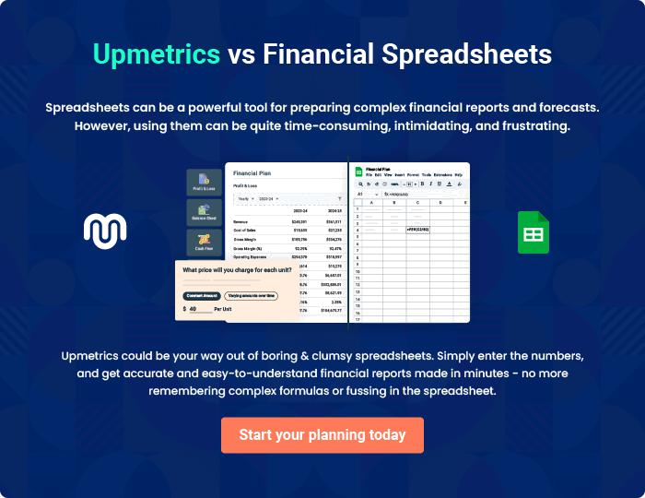
Appendix

When writing the appendix section, you should include any additional information that supports the main content of your plan. This may include financial statements, market research data, legal documents, and other
To unlock help try Upmetrics! 
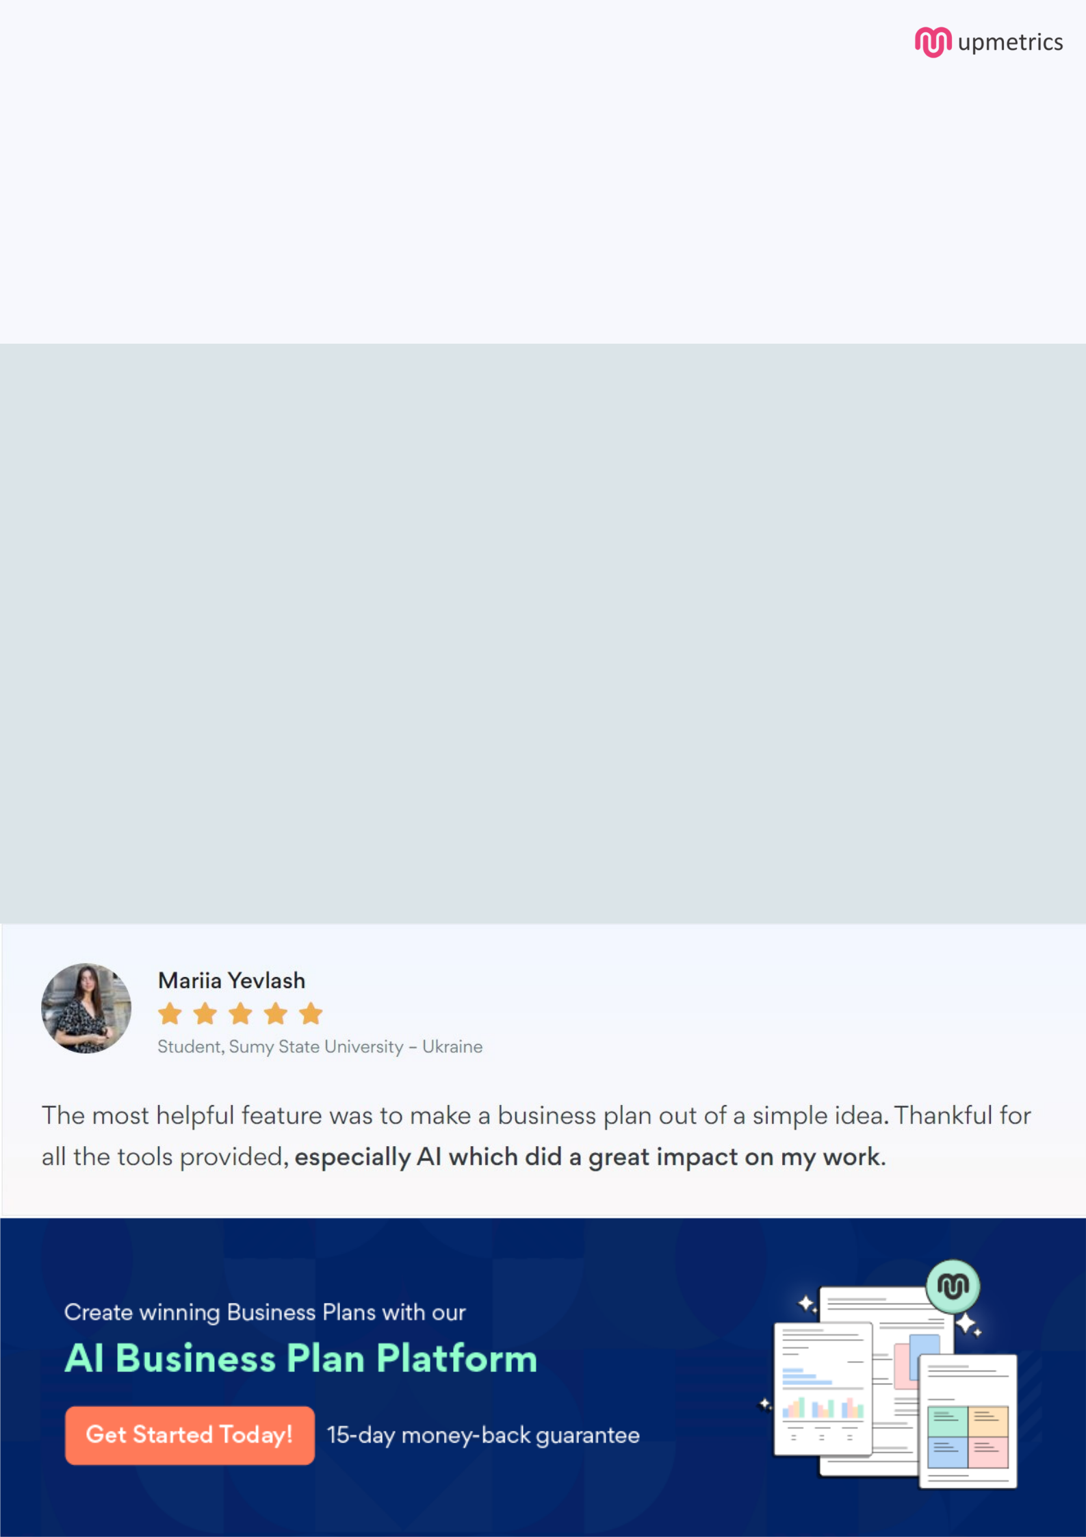
Create a winning business plan that gets you funded

Creating a stunning and investment-ready plan requires no writing, graphic designing, or financial planning expertise.

Upmetrics has all the features required to help you create a comprehensive business plan—from start to finish. Make no mistakes, it’s the modern way of planning to structure ideas, make plans, and create stunning pitch decks to awe investors.

Pitch decks that impress investors

Create pitch decks that provide a visual representation of your business, engage investors, and make them want to invest in your business idea.

Interactive plans in no time

Import business plan sections like—SWOT analysis, comparison tables, and others to create an interactive business plan. No designing skills are required.

Stunning cover page designs

With Upmetrics, you have the liberty to choose from multiple stunning cover page designs. Choose a creative design and make your plan stand out.

Online sharing made simple

Upmetrics makes online sharing quick and easier for users. Easily share your business plans with a link while tracking reader activity.

500+ sample business plans

Simply import a template from our library of sample plans into the editor and start customizing it to make it yours. It takes only a few clicks to get started.

Collaborate with team in real-time

Invite team members, initiate conversations, discuss ideas & strategies, share feedback, and work on a business plan in real-time.

