
BUSINESS PLAN

2023


Escape Room Business Plan

Puzzles, Thrills, Escapes

John Doe

10200 Bolsa Ave, Westminster, CA, 92683

- 359-3153 info@example.com http://www.example.com

Information provided in this business plan is unique to this business and confidential; therefore, anyone reading this plan agrees not to disclose any of the information in this business plan without prior written permission of the company.
Table of Contents

Executive Summary | 6
Market opportunity | 6
Services Offered | 6
Marketing & Sales Strategies | 7
Financial Highlights | 7
Units Sold v/s Revenue | 8

Company Overview | 9
Ownership | 9
Mission statement | 10
Business history | 10
Future goals | 10

Market Analysis | 11
Target Market | 11
Market size and growth potential | 11
Market Size | 12
Competitive analysis | 12
Competitor A | 12
Competitor B | 13
Competitor C | 13
Market trends | 13
Regulatory environment | 14

Products and Services | 15
Services | 15
The Time Traveler’s Quest | 16
The Galactic Escape | 16
The Haunted Manor | 17
Virtual Reality Escape Challenge | 17

Special Features 18

Safety and Security | 18
Additional Services | 18

Sales And Marketing Strategies | 19
Unique Selling Proposition (USP) | 19
Pricing Strategy | 19
Marketing strategies | 20
Online | 20
Offline | 20
Sales strategies | 21
Customer retention | 22

Operations Plan | 23
Staffing & Training | 23
Operational Process | 23
Equipment & Machinery | 24

Management Team | 25
Key managers | 25
John Doe | 25
Jane Doe | 26
Alice Brown | 26
Robert Brown | 27
Organizational structure | 27
Organization chart | 28
Compensation plan | 28
Advisors/Consultants | 29
[ADVISOR NAME] | 29
[CONSULTANT NAME] | 29

Financial Plan | 30
Profit & loss statement | 30
Cash flow statement | 33
Balance sheet | 35
Break-even Analysis | 37
Financing needs | 39
Appendix
Appendix | 41
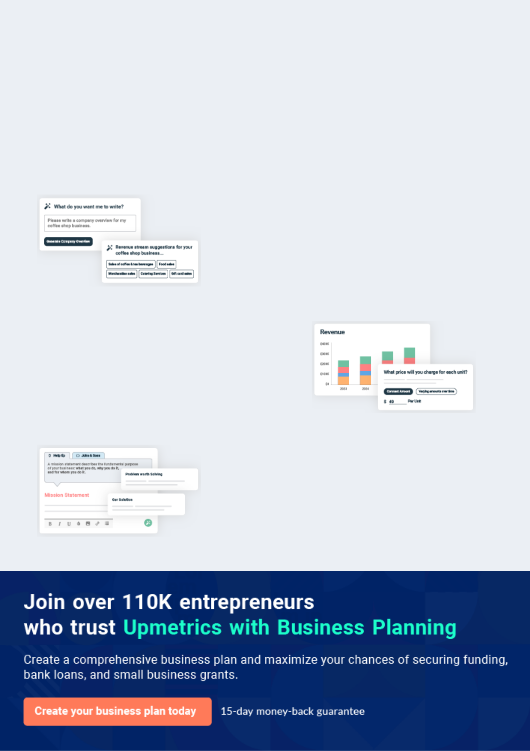
Business planning that’s simpler and faster than you think

Creating a business plan using Upmetrics to start and grow a business is literally the easiest thing in the World. Simply read the instructions and fill in the blanks. It’s as simple as that.

❛ | Upmetrics has everything you need to create a | ❜
❛ | comprehensive business plan. | ❜

AI-powered Upmetrics Assistant

AI-powered insights to streamline your plan

Not sure where to start? Upmetrics’ AI Assistant will automatically generate ideas for each section of your plan and offer improved versions of your writing, adjusting for tone, voice, and grammar or spelling errors.

Financial Forecasting Tool

All the financials are calculated for you

Forget the complex formulas and clumsy spreadsheets — with automatic financials and drag-and-drop forecasting, you can finish your plan faster and be confident that your numbers are accurate.

Business Plan Builder

Guides you like a business mentor

Upmetrics’ step-by-step instructions, prompts, and the library of 400+ sample business plans will guide you through each section of your plan as a business mentor.
Executive Summary


An executive summary is the first section of the business plan intended to provide an overview of the whole business plan.
To unlock help try Upmetrics! 

 Help tip  Escape Room Business Plan


Start your executive summary by briefly introducing your business to your readers.

This section may include the name of your escape room business, its location, when it was
To unlock help try Upmetrics! 

Start writing here..

Market opportunity

 Help tip  Escape Room Business Plan

Summarize your market research, including market size, growth potential, and marketing trends. Highlight the opportunities in the market and how your business will fit in to fill the gap.
To unlock help try Upmetrics! 

Start writing here..

Services Offered

 Help tip  Escape Room Business Plan

Highlight the escape room services you offer your clients. The USPs and differentiators you offer are always a plus.
To unlock help try Upmetrics! 

Start writing here..

Marketing & Sales Strategies
To unlock help try Upmetrics!

 Help tip  Escape Room Business Plan

Outline your sales and marketing strategies—what marketing platforms you use, how you plan on acquiring customers, etc.
To unlock help try Upmetrics! 

Start writing here..

Financial Highlights

 Help tip  Escape Room Business Plan

Briefly summarize your financial projections for the initial years of business operations. Include any capital or investment requirements, associated startup costs, projected revenues, and profit forecasts.



Start writing here..
Units Sold v/s Revenue

 |  | Units Sold | Revenue
15.00k
10.00k
5.00k
0
Year 1 | Year 2 | Year 3


Financial Year |  |  | Units Sold | Revenue
Year 1 | 1,550 |  |  | $10,000
Year 2 | 1,800 |  |  | $12,000
Year 3 | 2,050 |  |  | $14,000
 Help tip |  |  Escape Room Business Plan


Summarize your executive summary section with a clear CTA, for example, inviting angel investors to discuss the potential business investment.
To unlock help try Upmetrics! 

Write a call to action for your business plan.
Company Overview

Depending on what details of your business are essential, you’ll need different elements in your business overview.
To unlock help try Upmetrics! 

 Help tip  Escape Room Business Plan

Describe your business in this section by providing all the basic information:

Describe what kind of escape room business you run and the name of it. You may specialize in
To unlock help try Upmetrics! 

Start writing here..

Ownership

 Help tip  Escape Room Business Plan

List the founders or owners of your escape room business. Describe what shares they own and their responsibilities for efficiently managing the business.
To unlock help try Upmetrics! 

Start writing here..
Mission statement

 Help tip  Escape Room Business Plan

Summarize your business’ objective, core principles, and values in your mission statement. This statement needs to be memorable, clear, and brief.
To unlock help try Upmetrics! 

❛ At [Puzzle Quest Adventures], our mission is to provide captivating and challenging escape room experiences that foster creativity, teamwork, and fun.

We are committed to delivering exceptional customer service and continually innovating our offerings to ensure memorable adventures for every participant.

❜

Business history

 Help tip  Escape Room Business Plan

If you’re an established business owner, briefly describe your business history, like—when it was founded, how it evolved over time, etc.
To unlock help try Upmetrics! 

Start writing here..

Future goals

 Help tip  Escape Room Business Plan

It’s crucial to convey your aspirations and vision. Mention your short-term and long-term goals; they can be specific targets for revenue, market share, or expanding your services.
To unlock help try Upmetrics! 

Start writing here..

Market Analysis
To unlock help try Upmetrics!


 |  | Market analysis provides a clear understanding of the market in which your
 |  | printing business will run along with the target market, competitors, and
 |  | growth opportunities.
 |  |  |  | To unlock help try Upmetrics! 
 Help tip |  |  Escape Room Business Plan

To write the introduction section of your market analysis, start by clearly identifying your primary target market.
To unlock help try Upmetrics! 

Start writing here..

Target Market

 Help tip  Escape Room Business Plan

Start this section by describing your target market. Define your ideal customer and explain what types of services they prefer. Creating a buyer persona will help you easily define your target market to your readers.



Start writing here..

Market size and growth potential

 Help tip  Escape Room Business Plan

Describe your market size and growth potential and whether you will target a niche or a much broader market.
To unlock help try Upmetrics! 

Start writing here..

Market Size

Available Market

Total potential market for escape rooms 20M in the country.

Served Market | 5M
Potential market in our region. | 5M

Target Market | 2M
Millennials & families in our region. | 2M

 Help tip  Escape Room Business Plan

Identify and analyze your direct and indirect competitors. Identify their strengths and weaknesses, and describe what differentiates your escape room services from them.
To unlock help try Upmetrics! 

Competitive analysis

Competitor A

Competitor A has been a formidable player in the escape room market for over a decade, boasting a nationwide presence with multiple locations in major cities.

Features

A vast array of room themes ranging from historical mysteries to futuristic adventures.

Innovative use of technology, incorporating VR and AR elements into certain escape room experiences.

Loyalty programs for repeat customers, encouraging repeat business.

Strengths Weaknesses

Extensive market presence Higher pricing compared to

with a well-known brand. newer market entrants.

High customer retention due to Some customers report a lack of

loyalty programs. variety in new room themes.

Strong social media presence Limited personalization of

and online marketing escape room experiences.

strategies.

Competitor B

Competitor B is a regional escape room business known for its unique and challenging room designs, with a strong focus on customer experience.

Features | Strengths | Weaknesses
Custom-designed escape | Strong community engagement | Limited locations, primarily
rooms with intricate storylines. | and positive customer reviews. | situated in urban areas.
Special event nights, including | Innovative room designs that | Smaller advertising budget
Halloween and holiday-themed | stand out in the market. | compared to larger competitors.
rooms. | Competitive pricing attracting a | Some rooms may be too
Discounts and promotions for | broader customer base. | challenging for beginners,
students and large groups. |  | potentially deterring new
 |  | customers.

Competitor C

Competitor C targets the corporate market, positioning themselves as a solution for team-building and corporate events.

Features | Strengths | Weaknesses
Customizable escape room | Strong niche focus on the | Limited appeal to casual escape
experiences tailored for team- | corporate market. | room enthusiasts.
building. | All-inclusive packages | Dependent on the corporate
Comprehensive corporate | providing convenience for | market, which can be seasonal.
packages, including catering | corporate clients. | Less diversity in escape room
and meeting spaces. |  | Less diversity in escape room
and meeting spaces. | High-quality, professional | themes due to corporate focus.
Mobile escape room services | customer service.
for off-site corporate events.

Market trends

 Help tip  Escape Room Business Plan

Analyse emerging trends in the industry, such as technology disruptions, changes in customer behavior or preferences, etc. Explain how your business will cope with all the trends.
To unlock help try Upmetrics! 

Start writing here..

Regulatory environment
To unlock help try Upmetrics!

 Help tip  Escape Room Business Plan

List regulations and licensing requirements that may affect your escape room business, such as fire and building codes, zoning regulations, ADA compliance, business licensing, insurance, etc.



Start writing here..
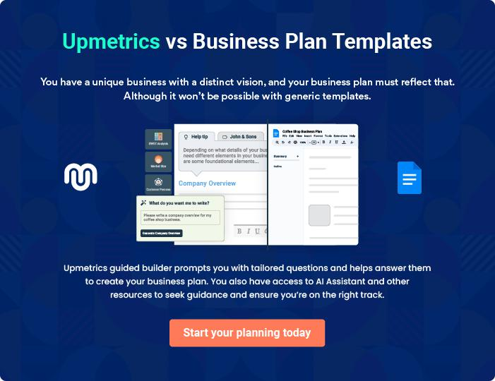
Products and Services

 |  | The product and services section of the escape room business plan should
 |  | describe the specific services and products offered to customers. To write
 |  | this section should include the following:
 |  |  |  | To unlock help try Upmetrics! 
 Help tip |  |  Escape Room Business Plan

To craft the introduction for your "Products and Services" chapter, begin by positioning your business within its industry, emphasizing its unique strengths or value proposition.
To unlock help try Upmetrics! 

Start writing here..

 Help tip


Mention your business’s escape room services. You may include details like the types, themes, and designs of escape rooms.
To unlock help try Upmetrics! 

Services
The Time Traveler’s Quest


Price: [$30] per person

Embark on a thrilling adventure through time in "The Time Traveler’s Quest." Solve intricate puzzles and unravel the mysteries of the past to secure your way back to the present. Perfect for history buffs and adventure seekers!

Specifications

- Duration: 60 minutes

- Room Capacity: 2-6 players

- Difficulty Level: Moderate

- Recommended Age: 12+

- Themes: Historical, Adventure

- Special Features: Authentic period props, interactive puzzle mechanisms

The Galactic Escape

Price: [$35] per person

Journey to the stars in "The Galactic Escape"! Solve cosmic puzzles and navigate through space anomalies to save your spaceship and return safely to Earth. A must-try for sci-fi enthusiasts and space explorers!

Specifications

- Duration: 75 minutes

- Room Capacity: 3-8 players

- Difficulty Level: Hard

- Recommended Age: 15+

- Themes: Sci-Fi, Space Adventure

- Special Features: Immersive sound effects, LED lighting, holographic displays
The Haunted Manor

Price: [$28] per person

Experience chills and thrills in "The Haunted Manor". Navigate through dark, eerie rooms, solving spooky puzzles to lift the curse and escape before time runs out. Ideal for fans of horror and supernatural mysteries!

Specifications

- Duration: 45 minutes

- Room Capacity: 2-5 players

- Difficulty Level: Easy

- Recommended Age: 18+ (due to frightening themes)

- Themes: Horror, Supernatural

- Special Features: Special effects makeup for live actors, fog machines, sound effects

Virtual Reality Escape Challenge

Price: [$25] per person

Dive into a digital world of puzzles with our Virtual Reality Escape Challenge! Choose from a variety of virtual escape room experiences and solve puzzles in a fully immersive 3D environment, all from the comfort of your home.

Specifications

- Duration: 30 minutes

- Participants: Single player or multiplayer options available

- Difficulty Level: Varies by experience

- Recommended Age: 12+

- Themes: Various themes available

- Special Features: Fully immersive VR experience, online leaderboards
Special Features

 Help tip  Escape Room Business Plan

Mention if you provide any special features with escape rooms. These features may include virtual reality, augmented reality, interactive props, or any other special features.
To unlock help try Upmetrics! 

Start writing here..

Safety and Security

 Help tip  Escape Room Business Plan

This section should explain the safety and security measures you plan to implement to ensure customer and employee safety.
To unlock help try Upmetrics! 

Start writing here..

Additional Services

 Help tip  Escape Room Business Plan

Mention if your escape room business offers any additional services. You may include services like catering, team-building activities, mobile escape rooms, and private events.
To unlock help try Upmetrics! 

Start writing here..
Sales And Marketing Strategies
To unlock help try Upmetrics!

Writing the sales and marketing strategies section means a list of strategies you will use to attract and retain your clients.
To unlock help try Upmetrics! 

 Help Tip  Escape Room Business Plan


To create an effective introduction for your "Sales and Marketing Strategies" chapter, start by setting the stage within your specific industry or market.
To unlock help try Upmetrics! 

Start writing here..

Unique Selling Proposition (USP)

 Help tip  Escape Room Business Plan

Define your business’s USPs depending on the market you serve, the equipment you use, and the unique services you provide. Identifying USPs will help you plan your marketing strategies.
To unlock help try Upmetrics! 

Start writing here..

Pricing Strategy

 Help tip  Escape Room Business Plan

Describe your pricing strategy—how you plan to price your services and stay competitive in the local market. You can mention any discounts you plan on offering to attract new customers to your facility.



Start writing here..

 Help tip  Escape Room Business Plan

Discuss your marketing strategies to market your services. You may include some of these marketing strategies in your business plan—social media marketing, guerrilla marketing, Google ads, brochures, email marketing, content marketing, and print marketing_{To unlock help try Upmetrics!} 

Marketing strategies

Online


Social Media

Utilizing platforms like Instagram, Facebook, and Twitter to showcase our escape rooms, share customer experiences, and run promotions.

Content Marketing

Maintaining an engaging blog with articles on team-building, puzzle-solving tips, and escape room news.

Email Marketing

Sending regular newsletters with updates, promotions, and exclusive offers to our mailing list.

Google Ads

Investing in targeted online advertising to reach potential customers actively searching for escape room experiences.

Offline

Brochures 7 Print Marketing

Distributing well-designed brochures in local businesses, hotels, and tourist centers.

Guerrilla Marketing

Creating buzz through unconventional marketing tactics in public spaces.

 Help tip  Escape Room Business Plan
To unlock help try Upmetrics!

Outline the strategies you’ll implement to maximize your sales. Your sales strategies may include special promotions, collaboration with other entertainment businesses, offering seasonal discounts, and offering referral discounts.



Sales strategies

Partner with Businesses

Special Promotions

Partnering with local businesses for cross-promotions

Running introductory offers for new rooms or limited-time discounts.

Referral Programs

Seasonal Discounts

Implementing a referral program to encourage word-of-mouth advertising.

Offering special rates during holidays or off-peak seasons.

 Help tip  Escape Room Business Plan

Describe your customer retention strategies and how you plan to execute them. For instance, introducing loyalty programs, discounts on group bookings, personalized service, etc.
To unlock help try Upmetrics! 

Customer retention

Loyalty Programs Group Booking Discounts

Offering points for every booking, Providing incentives for larger

redeemable against future visits. groups, encouraging repeat

business.

Personalized Service

Ensuring every visitor feels valued and appreciated, enhancing their overall experience.

Follow-Up Communication

Sending thank-you emails and satisfaction surveys post-visit to gather feedback and maintain a connection.

Operations Plan
To unlock help try Upmetrics!

 |  | When writing the operations plan section, it’s important to consider the
 |  | various aspects of your business operations.
 |  |  |  | To unlock help try Upmetrics! 
 Help tip |  |  Escape Room Business Plan
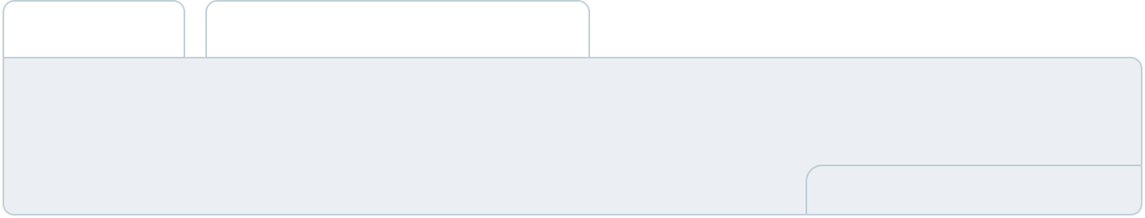

To create an effective introduction for your "Operational Plan" chapter, start by emphasizing the
pivotal role of efficient operations in the success of your business, underscoring how they
directly impact the quality of services delivered.
 |  |  |  | To unlock help try Upmetrics! 
Start writing here..
Staffing & Training
 Help tip |  |  Escape Room Business Plan

Mention your escape room business’s staffing requirements, including the number of employees, game masters, or IT personnel needed.
To unlock help try Upmetrics! 

Start writing here..

Operational Process

 Help tip  Escape Room Business Plan

Outline the processes and procedures you will use to run your escape room business. Your operational processes may include ticketing, room preparation, maintenance and repair, marketing and promotions, staff management, etc.



Start writing here..

Equipment & Machinery
To unlock help try Upmetrics!

 Help tip  Escape Room Business Plan

Include the list of equipment and machinery required for the escape room, such as safety equipment, cleaning and maintenance equipment, puzzle and game components, escape room props, etc.



Start writing here..
Management Team

The management team section provides an overview of the individuals responsible for running your business plan.
To unlock help try Upmetrics! 

 Help tip  Escape Room Business Plan

To craft an introduction for your "Management Team" chapter, begin by emphasizing the crucial role of leadership in the success of any business.
To unlock help try Upmetrics! 

Start writing here..

Key managers

 Help tip  Escape Room Business Plan

Introduce your management and key members of your team, and explain their roles and responsibilities.
To unlock help try Upmetrics! 

Start writing here..


JOHN DOE

CEO - john.doe@example.com

As the visionary behind [Puzzle Quest Adventures], [John Doe] serves as the CEO, actively involved in strategic planning, business development, and overall operation management.


[He/She/They] brings a wealth of experience, having worked in the entertainment and puzzle-solving industry for over [X] years.

Background: [A brief description of the Founder’s educational background, previous roles, and achievements that add value to this venture.]

JANE DOE

Escape Room Manager - jane.doe@example.com

Jane oversees the design, setup, and overall experience of our escape rooms. She has a Bachelor’s Degree in Game Design from [University Name] and has worked in the gaming and puzzle industry for over eight years.


Jane has a knack for creating compelling narratives and challenging puzzles, ensuring a memorable experience for our customers.

- Educational Background: B.A. in Game Design from [University Name]

- Professional Background: Previous roles include Puzzle Designer at [Previous Company] and Game Master at [Another Company].


ALICE BROWN

Operations Manager - alice.brown@example.com

Alice is responsible for the day-to-day operations of [Puzzle Quest Adventures], ensuring everything runs smoothly.

She holds a Master’s Degree in Business Administration from [University Name] and has over six years of experience in operations management within the entertainment sector. Alice is adept at staff management, inventory control, and customer service.

- Educational Background: MBA from [University Name]

- Professional Background: Prior roles include Assistant Manager at [Previous Company] and Operations Coordinator at [Another Company].

ROBERT BROWN

Marketing Manager - robert.brown@example.com

Robert spearheads our marketing efforts, developing strategies to boost brand awareness and attract new customers.

He has a Bachelor’s Degree in Marketing from [University Name] and brings over seven years of marketing experience in the entertainment and adventure industries to the team.

His expertise lies in digital marketing, event promotions, and brand development.

- Educational Background: B.A. in Marketing from [University Name]

- Professional Background: Previous experience includes Digital Marketing Specialist at [Previous Company] and Brand Manager at [Another Company].

Organizational structure

 Help tip  Escape Room Business Plan

Explain the organizational structure of your management team. Include the reporting line and decision-making hierarchy.
To unlock help try Upmetrics! 

Start writing here..
Organization chart


John Doe

CEO
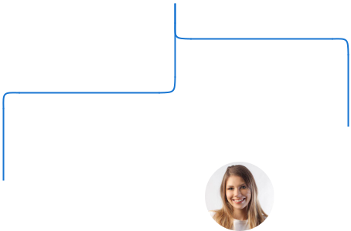

 | Jane Doe
Alice Brown | Escape Room
Operations Manager | Manager

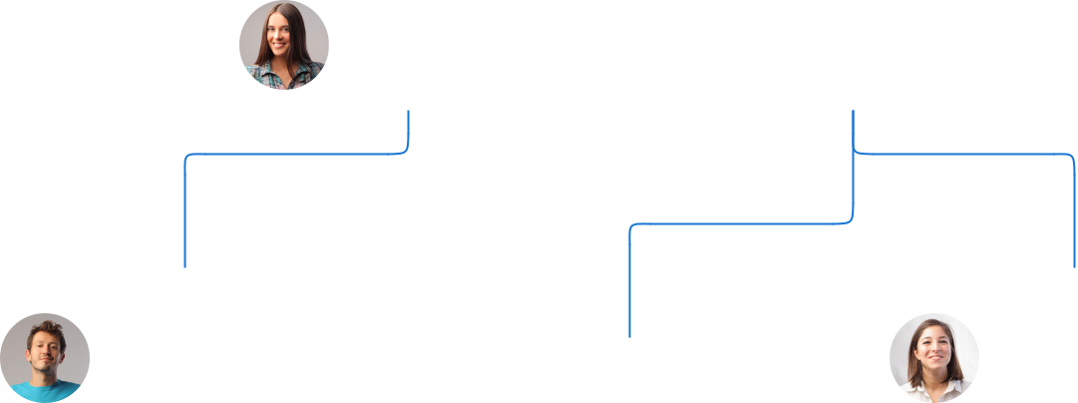

Mike Johnson |  | Emily White
Maintenance | Robert Brown | Customer Service
Supervisor | Marketing Manager | Manager



Compensation plan

 Help tip  Escape Room Business Plan

Describe your compensation plan for the management and staff. Include their salaries, incentives, and other benefits.
To unlock help try Upmetrics! 

Start writing here..
 Help tip

Mentioning advisors or consultants in your business plans adds credibility to your business idea.
To unlock help try Upmetrics! 

Advisors/Consultants


[ADVISOR NAME]

Advisor

Provides strategic advice and industry-specific knowledge.


[CONSULTANT NAME]

Consultant

Assists in optimizing operational efficiency and customer experience.
Financial Plan

When writing the financial plan section of a business plan, it’s important to provide a comprehensive overview of your financial projections for the first few years of your business, You may provide the following:
To unlock help try Upmetrics! 

 Help tip  Escape Room Business Plan


To create an effective introduction for your "Financial Plan" chapter, begin by stressing the critical role of a well-structured financial plan in the success of your venture.
To unlock help try Upmetrics! 

Start writing here..

 Help tip  Escape Room Business Plan

Describe details such as projected revenue, operational costs, and service costs in your projected profit and loss statement. Make sure to include your business’s expected net profit or loss
To unlock help try Upmetrics! 

Profit & loss statement

Revenue

Cost Of Sales

General Costs

Revenue Specific Costs

Personnel Costs (Direct

Labor)

Gross Margin

Gross Margin (%)

Operating Expense

Payroll Expense

(Indirect Labor)

General Expense

Bad Debt

Amortization of Current

Assets

2023-24 | 2024-25 | 2025-26 | 2026-27 | 2027-28
$0 | $0 | $0 | $0 | $0

$0 | $0 | $0 | $0 | $0
$0 | $0 | $0 | $0 | $0
$0 | $0 | $0 | $0 | $0
$0 | $0 | $0 | $0 | $0

$0 | $0 | $0 | $0 | $0
0% | 0% | 0% | 0% | 0%

$0 | $0 | $0 | $0 | $0
$0 | $0 | $0 | $0 | $0
$0 | $0 | $0 | $0 | $0
$0 | $0 | $0 | $0 | $0
$0 | $0 | $0 | $0 | $0

EBITDA

Additional Expense

Long Term

Depreciation

Gain or loss from Sale

of Assets

EBIT

Interest Expenses

EBT

Income Tax Expense

Total Expense

Net Income

Net Income (%)

2023-24 | 2024-25 | 2025-26 | 2026-27 | 2027-28
$0 | $0 | $0 | $0 | $0
$0 | $0 | $0 | $0 | $0
$0 | $0 | $0 | $0 | $0
$0 | $0 | $0 | $0 | $0
$0 | $0 | $0 | $0 | $0
$0 | $0 | $0 | $0 | $0
$0 | $0 | $0 | $0 | $0
$0 | $0 | $0 | $0 | $0
$0 | $0 | $0 | $0 | $0
$0 | $0 | $0 | $0 | $0
0% | 0% | 0% | 0% | 0%

 |  |  | 2023-24 |  | 2024-25 | 2025-26
Retained Earning |  |  | $0 |  | $0 | $0
Opening |  |  |  |  | $0 | $0
Owner's Distribution |  |  | $0 |  | $0 | $0
Retained Earning |  |  | $0 |  | $0 | $0
Closing |  |  |  |  | $0 | $0
 Help tip |  |  |  Escape Room Business Plan


The cash flow for the first few years of your operation should be estimated and described in this section.

This may include billing invoices, payment receipts, loan payments, and any other cash flow statements.
2026-27 2027-28

$0 $0

$0 $0

$0 $0

To unlock help try Upmetrics! 

Cash flow statement

 | 2023-24 | 2024-25 | 2025-26 | 2026-27 | 2027-28
Cash Received | $0 | $0 | $0 | $0 | $0
Cash Paid | $0 | $0 | $0 | $0 | $0
COS & General Expenses | $0 | $0 | $0 | $0 | $0
Salary & Wages | $0 | $0 | $0 | $0 | $0
Interest | $0 | $0 | $0 | $0 | $0

Sales Tax

Income Tax

Net Cash From

Operations

Assets Sell

Assets Purchase

Net Cash From

Investments

Amount Received

Loan Received

Common Stock

Preferred Stock

Owner's Contribution

Amount Paid

2023-24 | 2024-25 | 2025-26 | 2026-27 | 2027-28
$0 | $0 | $0 | $0 | $0
$0 | $0 | $0 | $0 | $0
$0 | $0 | $0 | $0 | $0

$0 | $0 | $0 | $0 | $0
$0 | $0 | $0 | $0 | $0
$0 | $0 | $0 | $0 | $0

$0 | $0 | $0 | $0 | $0
$0 | $0 | $0 | $0 | $0

$0 | $0 | $0 | $0 | $0
$0 | $0 | $0 | $0 | $0
$0 | $0 | $0 | $0 | $0

Loan Capital $0 $0 $0 $0 $0

 |  |  | 2023-24 | 2024-25 | 2025-26 | 2026-27 | 2027-28
Dividends & Distributions |  |  | $0 | $0 | $0 | $0 | $0
Net Cash From |  |  | $0 | $0 | $0 | $0 | $0
Financing
Summary
Starting Cash |  |  | $0 | $0 | $0 | $0 | $0
Cash In |  |  | $0 | $0 | $0 | $0 | $0
Cash Out |  |  | $0 | $0 | $0 | $0 | $0
Change in Cash |  |  | $0 | $0 | $0 | $0 | $0
Ending Cash |  |  | $0 | $0 | $0 | $0 | $0
 Help tip |  |  Escape Room Business Plan

Create a projected balance sheet documenting your business’s assets, liabilities, and equity.

To unlock help try Upmetrics! 

Balance sheet

 | 2023-24 | 2024-25 | 2025-26 | 2026-27 | 2027-28
Assets | $0 | $0 | $0 | $0 | $0
Current Assets | $0 | $0 | $0 | $0 | $0
Cash | $0 | $0 | $0 | $0 | $0
Accounts Receivable | $0 | $0 | $0 | $0 | $0
Inventory | $0 | $0 | $0 | $0 | $0
Other Current Assets | $0 | $0 | $0 | $0 | $0
Long Term Assets | $0 | $0 | $0 | $0 | $0
Gross Long Term Assets | $0 | $0 | $0 | $0 | $0
Accumulated Depreciation | $0 | $0 | $0 | $0 | $0

Liabilities & Equity | $0 | $0 | $0 | $0 | $0
Liabilities | $0 | $0 | $0 | $0 | $0
Current Liabilities | $0 | $0 | $0 | $0 | $0
Accounts Payable | $0 | $0 | $0 | $0 | $0
Income Tax Payable | $0 | $0 | $0 | $0 | $0
Sales Tax Payable | $0 | $0 | $0 | $0 | $0
Short Term Debt | $0 | $0 | $0 | $0 | $0
 | 2023-24 | 2024-25 | 2025-26 | 2026-27 | 2027-28
Long Term Liabilities | $0 | $0 | $0 | $0 | $0
Long Term Debt | $0 | $0 | $0 | $0 | $0
Equity | $0 | $0 | $0 | $0 | $0
Paid-in Capital | $0 | $0 | $0 | $0 | $0
Common Stock | $0 | $0 | $0 | $0 | $0
Preferred Stock | $0 | $0 | $0 | $0 | $0
Owner's Contribution | $0 | $0 | $0 | $0 | $0
Retained Earnings | $0 | $0 | $0 | $0 | $0

Check | $0 |  |  | $0 | $0 | $0 | $0
 Help tip |  |  Escape Room Business Plan

Determine and mention your business’s break-even point—the point at which your business costs and revenue will be equal.

This exercise will help you understand how much revenue you need to generate to sustain or be profitable.
To unlock help try Upmetrics! 

Break-even Analysis

 | 2023-24 | 2024-25 | 2025-26 | 2026-27 | 2027-28
Starting Revenue | $0 | $0 | $0 | $0 | $0
Net Revenue | $0 | $0 | $0 | $0 | $0
Closing Revenue | $0 | $0 | $0 | $0 | $0

Starting Expense | $0 | $0 | $0 | $0 | $0
Net Expense | $0 | $0 | $0 | $0 | $0
Closing Expense | $0 | $0 | $0 | $0 | $0

Is Break Even? | 0 | 0 | 0 | 0 | 0
Break Even Month | 0 | 0 | 0 | 0 | 0
Days Required | 0 | 0 | 0 | 0 | 0
Break Even Revenue | $0 | $0 | $0 | $0 | $0
Break Even Units
Financing needs

 Help tip  Escape Room Business Plan

Calculate costs associated with starting an escape room business, and estimate your financing needs and how much capital you need to raise to operate your business.
To unlock help try Upmetrics! 

Start writing here..
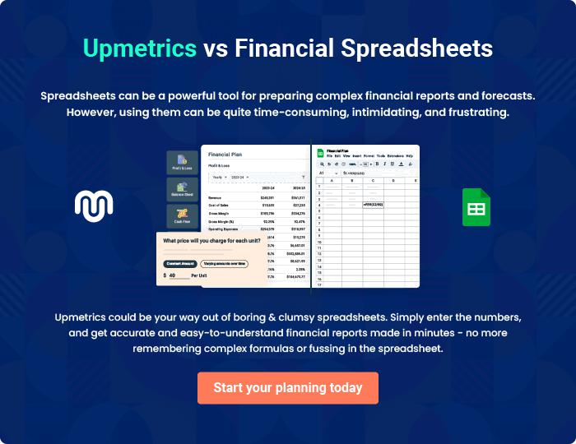
Appendix

When writing the appendix section, you should include any additional information that supports the main content of your plan. This may include financial statements, market research data, legal documents, and other
To unlock help try Upmetrics! 
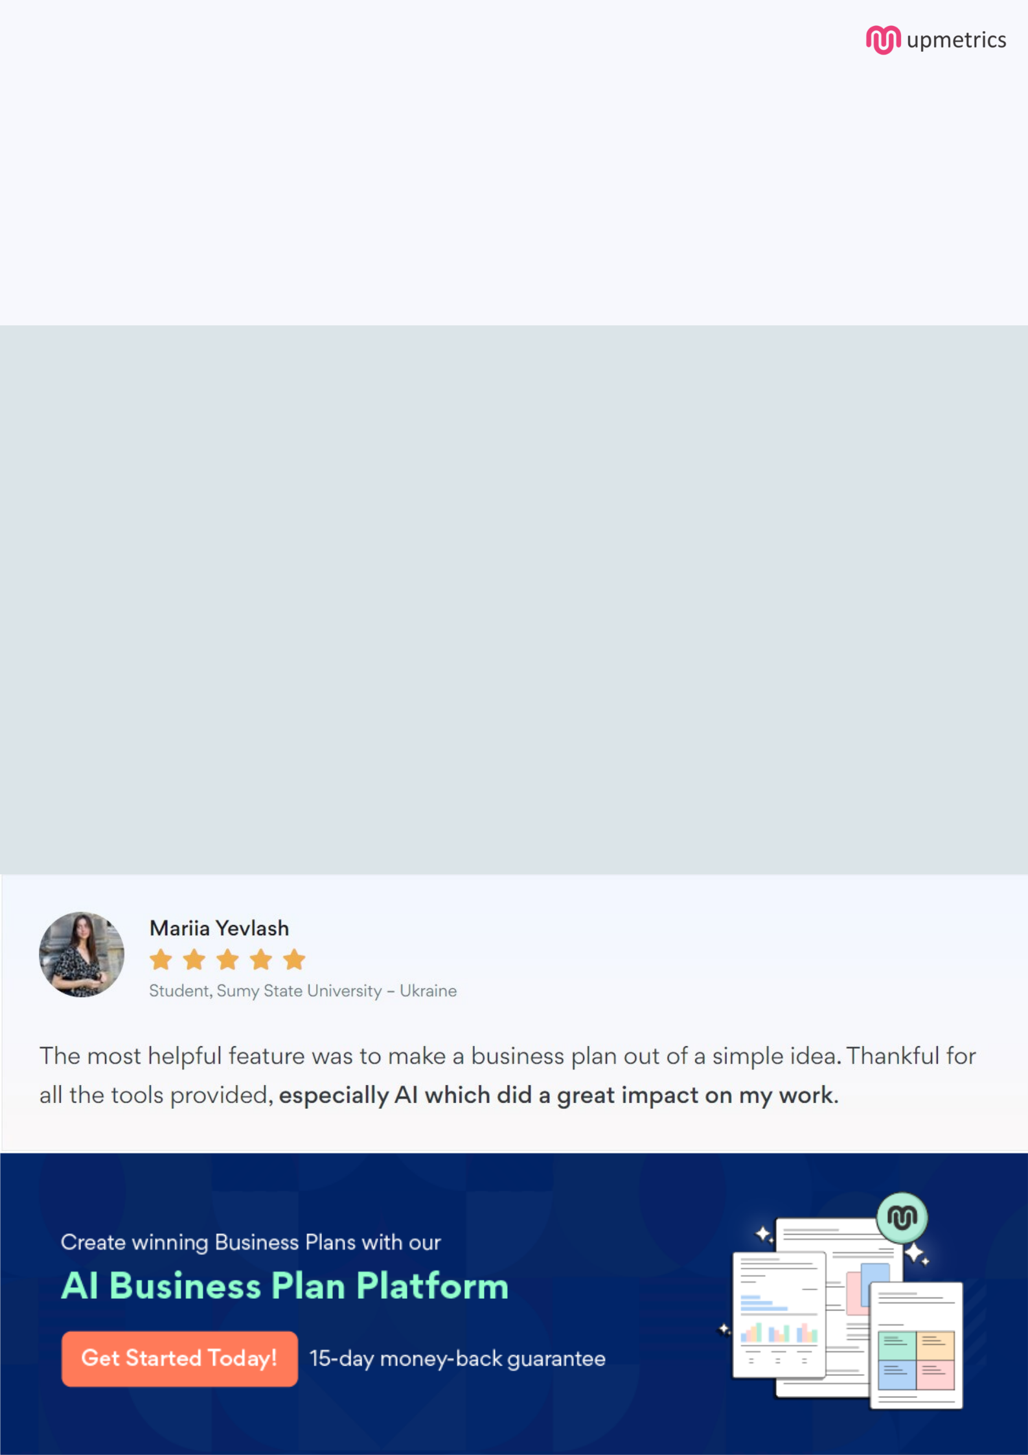
Create a winning business plan that gets you funded

Creating a stunning and investment-ready plan requires no writing, graphic designing, or financial planning expertise.

Upmetrics has all the features required to help you create a comprehensive business plan—from start to finish. Make no mistakes, it’s the modern way of planning to structure ideas, make plans, and create stunning pitch decks to awe investors.

Pitch decks that impress investors

Create pitch decks that provide a visual representation of your business, engage investors, and make them want to invest in your business idea.

Interactive plans in no time

Import business plan sections like—SWOT analysis, comparison tables, and others to create an interactive business plan. No designing skills are required.

Stunning cover page designs

With Upmetrics, you have the liberty to choose from multiple stunning cover page designs. Choose a creative design and make your plan stand out.

Online sharing made simple

Upmetrics makes online sharing quick and easier for users. Easily share your business plans with a link while tracking reader activity.

500+ sample business plans

Simply import a template from our library of sample plans into the editor and start customizing it to make it yours. It takes only a few clicks to get started.

Collaborate with team in real-time

Invite team members, initiate conversations, discuss ideas & strategies, share feedback, and work on a business plan in real-time.

