
Engineering Consulting Business Plan

BUSINESS PLAN

Engineering Solutions, Expertise

Prepared By

John Doe

10200 Bolsa Ave, Westminster, CA, 92683

info@example.com

(650) 359-3153 http://www.example.com

Table of Contents

Executive Summary | 6
Market opportunity | 6
Services Offered | 6
Marketing & Sales Strategies | 7
Financial Highlights | 7
Units Sold v/s Revenue | 8

Company Overview | 9
Ownership | 9
Business Owners | 9
Mission statement | 10
Business history | 10
Future goals | 11

Market Analysis | 12
Target Market | 12
Market size and growth potential | 12
Market Size | 13
Competitive analysis | 13
Alpha Engineering Innovators | 13
Beta Engineering Solutions | 14
Market trends | 14
Regulatory environment | 14

Products and Services | 16
Services | 16
Engineering Design & Analysis | 16
Project Management & Planning | 18
Sustainable Engineering Solutions | 18
Technology Consulting & Innovation | 19
Education & Training | 19
Maintenance & Asset Management | 20
Risk Assessment & Management | 20
Additional Services | 21

Sales And Marketing Strategies | 22
Unique Selling Proposition (USP) | 22
Pricing Strategy | 22
Marketing strategies | 23
Online | 23
Sales strategies | 24
Customer retention | 24

Operations Plan | 25
Staffing & Training | 25
Operational Process | 25
Equipment & Software | 26

Management Team | 27
Key managers | 27
John Doe | 27
Jane Doe | 28
Alice Brown | 28
Robert Brown | 28
Organizational structure | 29
Organization chart | 29
Compensation plan | 30
Board of advisors | 30
[ADVISOR NAME] | 30
[CONSULTANT NAME] | 30

Financial Plan | 31
Profit & loss statement | 31
Cash flow statement | 33
Balance sheet | 34
Break-even Point | 36
Financing needs | 36
Appendix
Appendix | 38
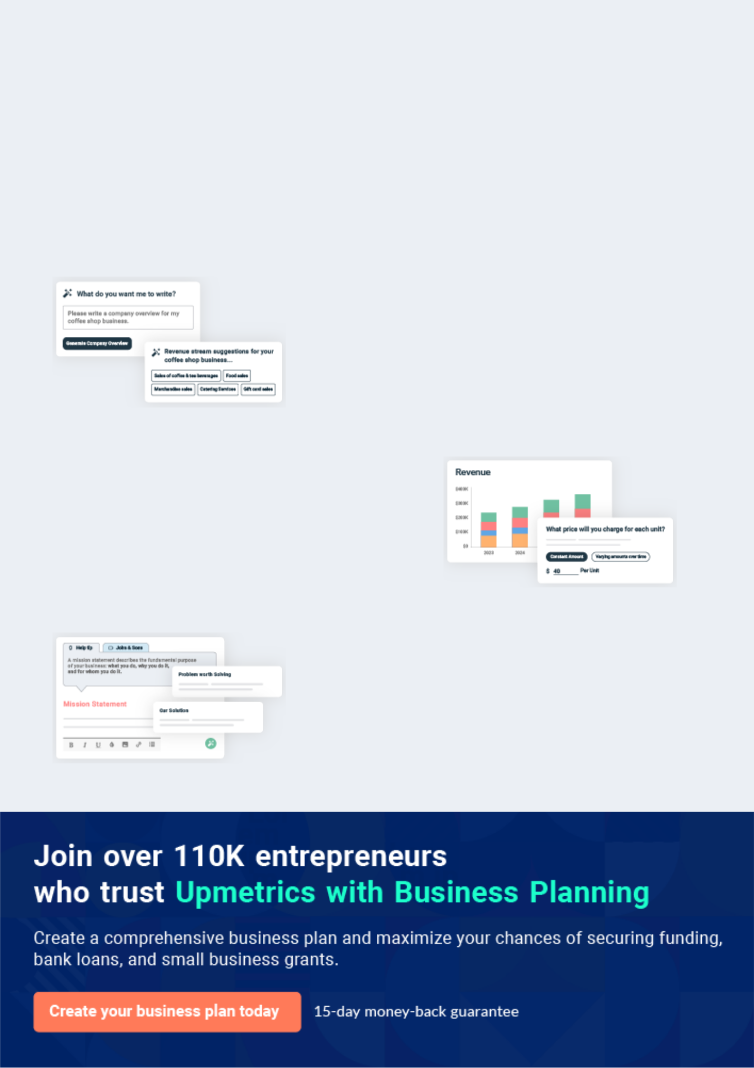
Business planning that’s simpler and faster than you think

Creating a business plan using Upmetrics to start and grow a business is literally the easiest thing in the World. Simply read the instructions and fill in the blanks. It’s as simple as that.

❛ | Upmetrics has everything you need to create a | ❜
❛ | comprehensive business plan. | ❜

AI-powered Upmetrics Assistant

AI-powered insights to streamline your plan

Not sure where to start? Upmetrics’ AI Assistant will automatically generate ideas for each section of your plan and offer improved versions of your writing, adjusting for tone, voice, and grammar or spelling errors.

Financial Forecasting Tool

All the financials are calculated for you

Forget the complex formulas and clumsy spreadsheets — with automatic financials and drag-and-drop forecasting, you can finish your plan faster and be confident that your numbers are accurate.

Business Plan Builder

Guides you like a business mentor

Upmetrics’ step-by-step instructions, prompts, and the library of 400+ sample business plans will guide you through each section of your plan as a business mentor.
Executive Summary


An executive summary is the first section of the business plan intended to provide an overview of the whole business plan.
To unlock help try Upmetrics! 

 Help tip  Engineering Consulting Business Plan


Start your executive summary by briefly introducing your business to your readers.

This section may include the name of your engineering consulting business, its location, when
To unlock help try Upmetrics! 

Start writing here..

Market opportunity

 Help tip  Engineering Consulting Business Plan

Summarize your market research, including market size, growth potential, and marketing trends. Highlight the opportunities in the market and how your business will fit in to fill the gap.
To unlock help try Upmetrics! 

Start writing here..

Services Offered

 Help tip  Engineering Consulting Business Plan

Highlight the engineering consulting services you offer your clients. The USPs and differentiators you offer are always a plus.
To unlock help try Upmetrics! 

Start writing here..

Marketing & Sales Strategies
To unlock help try Upmetrics!

 Help tip  Engineering Consulting Business Plan

Outline your sales and marketing strategies—what marketing platforms you use, how you plan on acquiring customers, etc.
To unlock help try Upmetrics! 

Start writing here..

Financial Highlights

 Help tip  Engineering Consulting Business Plan

Briefly summarize your financial projections for the initial years of business operations. Include capital or investment requirements, associated startup costs, projected revenues, and profit forecasts.



Start writing here..
Units Sold v/s Revenue

 |  | Units Sold | Revenue
15.00k
10.00k
5.00k
0
Year 1 | Year 2 | Year 3


Financial Year |  | Units Sold |  | Revenue
Year 1 | 1,550 |  |  | $10,000
Year 2 | 1,800 |  |  | $12,000
Year 3 | 2,050 |  |  | $14,000
 Help tip |  |  Engineering Consulting Business Plan


Summarize your executive summary section with a clear CTA, for example, inviting angel investors to discuss the potential business investment.
To unlock help try Upmetrics! 

Write a call to action for your business plan.
Company Overview

Depending on what details of your business are essential, you’ll need different elements in your business overview.
To unlock help try Upmetrics! 

 Help tip  Engineering Consulting Business Plan

Describe your business in this section by providing all the basic information:

Describe what kind of engineering consulting company you run and the name of it. You may
To unlock help try Upmetrics! 

Start writing here..

Ownership

 Help tip  Engineering Consulting Business Plan

List the names of your engineering consulting company’s founders or owners. Describe what shares they own and their responsibilities for efficiently managing the business.
To unlock help try Upmetrics! 

Start writing here..

Business Owners



60% John Doe



40% Jane Doe
Mission statement

 Help tip  Engineering Consulting Business Plan

Summarize your business’ objective, core principles, and values in your mission statement. This statement needs to be memorable, clear, and brief.
To unlock help try Upmetrics! 

❛ At [XYZ Engineering Consultants], our mission is to harness cutting-edge engineering solutions to shape tomorrow's [specific area, e.g., urban landscapes].

Rooted in integrity, innovation, and excellence, we strive to redefine standards, ensuring every project we undertake resonates with our commitment to quality and sustainable growth.

❜

Business history

 Help tip  Engineering Consulting Business Plan

If you’re an established engineering consulting service provider, briefly describe your business history, like—when it was founded, how it evolved over time, etc.
To unlock help try Upmetrics! 

Start writing here..
Future goals

 Help tip  Engineering Consulting Business Plan

It’s crucial to convey your aspirations and vision. Mention your short-term and long-term goals; they can be specific targets for revenue, market share, or expanding your services.
To unlock help try Upmetrics! 

Start writing here..
Market Analysis
To unlock help try Upmetrics!


 |  | Market analysis provides a clear understanding of the market in which your
 |  | printing business will run along with the target market, competitors, and
 |  | growth opportunities.
 |  |  |  | To unlock help try Upmetrics! 
 Help tip |  |  Engineering Consulting Business Plan

To write the introduction section of your market analysis, start by clearly identifying your primary target market.
To unlock help try Upmetrics! 

Start writing here..

Target Market

 Help tip  Engineering Consulting Business Plan

Start this section by describing your target market. Define your ideal customer and explain what types of services they prefer. Creating a buyer persona will help you easily define your target market to your readers.



Start writing here..

Market size and growth potential

 Help tip  Engineering Consulting Business Plan

Describe your market size and growth potential and whether you will target a niche or a much broader market.
To unlock help try Upmetrics! 

Start writing here..

Market Size

Available Market

Total potential customers needing 1B engineering consultancy globally.

Served Market
Customers already using engineering 900M consultancy services.

Target Market
Mid-large scale industries needing 300M specialized engineering consultation.

 Help tip  Engineering Consulting Business Plan

Identify and analyze your direct and indirect competitors. Identify their strengths and weaknesses, and describe what differentiates your engineering consulting services from them.
To unlock help try Upmetrics! 

Competitive analysis

Alpha Engineering Innovators

Founded in [Year], Alpha Engineering Innovators has established its presence predominantly in the [specific region, e.g., North-East] sector, focusing on [specific service, e.g., industrial engineering solutions].

With a workforce of over [X number] employees, they've successfully executed over [Y number] projects.

Features | Strengths
Specialized [specific service, | Strong regional presence and
e.g., automation design]. | recognition.
On-site training and workshops | Comprehensive post-project
for clients. | support leading to higher client
Extensive post-consultation | retention.
support. | Partnerships with leading
 | [industry-specific partners, e.g.,
 | manufacturing entities].

Weaknesses

Limited focus and expertise outside the [specific service, e.g., industrial engineering] domain.

Relatively slower adaptation to technological advancements.

Lesser emphasis on sustainability and eco-friendly solutions.

Beta Engineering Solutions
To unlock help try Upmetrics!

Beta Engineering Solutions, operational since [Year], boasts a diverse portfolio that spans across [specific domain, e.g., civil and mechanical engineering].

With their headquarters in [City], they have a global outreach, catering to both local and international clientele.

Features | Strengths
Multi-domain engineering | Broad service spectrum
consultancy. | attracting a diverse clientele.
Advanced [specific tool, e.g., | Cutting-edge technological
3D simulation techniques]. | solutions that resonate with
Collaboration with research | modern demands.
institutions for continuous | Strong academic and research
innovation. | affiliations.

Weaknesses

Diffused focus leading to occasional lapses in specialized solutions.

Higher pricing models making it inaccessible to smaller enterprises.

Limited regional presence in certain key areas like [specific region, e.g., the South-West].

Market trends

 Help tip  Engineering Consulting Business Plan

Analyze emerging trends in the industry, such as technology disruptions, changes in customer behavior or preferences, etc. Explain how your business will cope with all the trends.
To unlock help try Upmetrics! 

Start writing here..

Regulatory environment

 Help tip  Engineering Consulting Business Plan

List regulations and licensing requirements that may affect your engineering consulting company, such as professional licensing & registration, industry-specific regulations, intellectual property protection, ethical & professional standards, etc.



Start writing here..

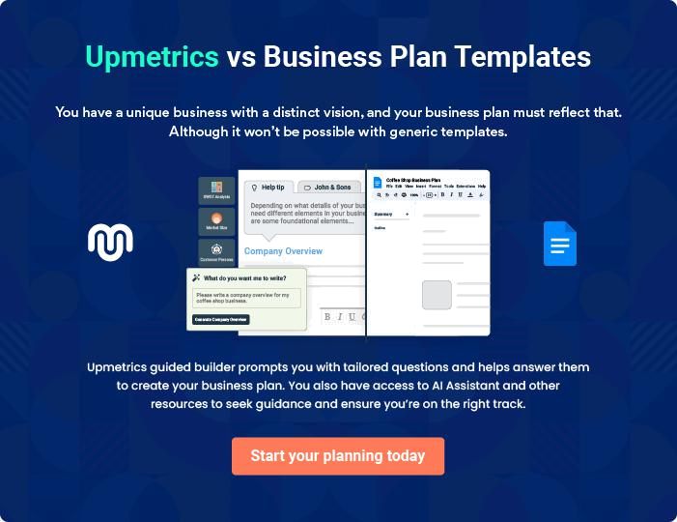
Products and Services

The product and services section of an engineering consulting business plan should describe the specific services and products that will be offered to customers. To write this section should include the following:
To unlock help try Upmetrics! 

 Help tip  Engineering Consulting Business Plan

To craft the introduction for your "Products and Services" chapter, begin by positioning your business within its industry, emphasizing its unique strengths or value proposition.
To unlock help try Upmetrics! 

Start writing here..

 Help tip


Mention the engineering consulting services your business will offer. This list may include services like,
To unlock help try Upmetrics! 

Services

Engineering Design & Analysis


Price: $[10,000] per project scope

A comprehensive service that encompasses the creation, testing, and refinement of infrastructural and technical designs tailored to the client's specific requirements.
Specifications

- Use of [specific software, e.g., AutoCAD, SolidWorks] for design.

- Advanced simulation tests to predict real-world performance.

- Iterative feedback loops for design optimization.

- Dedicated project lead for client interactions and feedback incorporation.
Project Management & Planning

Price: $[5,000] per month

Ensuring projects stay on schedule, within budget, and meet quality standards from inception to completion.

Specifications

- Resource allocation and optimization.

- Regular milestone checks and progress reporting.

- Risk assessment and contingency planning.

- Coordination with all stakeholders to ensure smooth execution.

Sustainable Engineering Solutions

Price: $[12,000] per solution implementation

Delivering eco-friendly, energy-efficient designs and systems for modern infrastructural needs.

Specifications

- Solutions compliant with [specific standards, e.g., LEED, Green Building].

- Use of sustainable materials and energy-efficient methods.

- Lifecycle analysis to predict and optimize long-term sustainability.

- Collaboration with environmental experts for solution validation.
Technology Consulting & Innovation

Price: $[7,000] per consultation session

Empowering businesses with the latest technological strategies to innovate and stay competitive.

Specifications

- Assessment of current technological landscape of the client.

- Recommendations based on latest tech trends, including [specific technologies, e.g., IoT, AI, cloud computing].

- Implementation roadmap for tech solutions.

- Post-implementation support and tech stack updates.

Education & Training

Price: $[3,500] per workshop

Workshops, seminars, and training sessions to equip clients with tools and knowledge to make the most of our solutions.

Specifications

- Tailored content based on client needs.

- Hands-on sessions with real-world scenarios.

- Provision of training materials and post-session resources.

- Feedback collection for continuous training improvement.
Maintenance & Asset Management

Price: $[2,500] per quarterly review

Periodic reviews, updates, and maintenance services to ensure the longevity and peak performance of implemented systems and designs.

Specifications

- Systematic asset auditing.

- Predictive maintenance using [specific tools, e.g., AI-driven analytics].

- On-site and remote maintenance support.

- Asset optimization recommendations.

Risk Assessment & Management

Price: $[4,000] per assessment

Evaluating potential risks in projects and crafting strategies to mitigate them, ensuring project security and viability.

Specifications

- Detailed risk profiling using [specific methodologies, e.g., SWOT, PESTLE].

- Quantitative and qualitative risk assessment.

- Development of risk mitigation and contingency plans.

- Periodic risk reviews during project lifespan.
Additional Services
- To unlock help try Upmetrics!

 Help tip  Engineering Consulting Business Plan

Mention if your engineering consulting company offers any additional services. You may include services like education & training, maintenance & asset management, risk assessment & management, etc.



Start writing here..
Sales And Marketing Strategies

Writing the sales and marketing strategies section means a list of strategies you will use to attract and retain your clients.
To unlock help try Upmetrics! 

 Help tip  Engineering Consulting Business Plan

To create an effective introduction for your "Sales and Marketing Strategies" chapter, start by setting the stage within your specific industry or market.
To unlock help try Upmetrics! 

Unique Selling Proposition (USP)

 Help tip  Engineering Consulting Business Plan

Define your business’s USPs depending on the market you serve, the equipment you use, and the unique services you provide. Identifying USPs will help you plan your marketing strategies.
To unlock help try Upmetrics! 

Start writing here..

Pricing Strategy

 Help tip  Engineering Consulting Business Plan

Describe your pricing strategy—how you plan to price your services and stay competitive in the local market. You can mention any discounts you plan on offering to attract new customers.
To unlock help try Upmetrics! 

Start writing here..

 Help tip  Engineering Consulting Business Plan
To unlock help try Upmetrics!

Discuss your marketing strategies to market your services. You may include some of these marketing strategies in your business plan—social media marketing, Google ads, email marketing, content marketing, and targeted advertising.



Marketing strategies

Online


Social Media Marketing

Harnessing platforms like [specific platforms, e.g., LinkedIn, Twitter] to showcase our projects, share insights, and engage with potential clients.

Content Marketing

Regular blogs and articles, positioning [XYZ] as a thought leader in the engineering consultancy domain.

Targeted Advertising

Collaborating with industry journals and platforms to ensure our presence is felt where it matters most.

Google Ads

Implementing targeted ad campaigns to attract clients actively seeking engineering consultancy services.

Email Marketing

Periodic newsletters and insights, keeping our audience informed about industry trends and our offerings.

 Help tip

Outline the strategies you’ll implement to maximize your sales. Your sales strategies may include partnering & collaborating with other businesses, offering referral programs, etc.
To unlock help try Upmetrics! 

Sales strategies

Partnering & Collaborating

Forming alliances with [specific businesses, e.g., construction firms, architectural agencies] to ensure a steady flow of projects.

Referral Programs

Incentivizing our existing clientele to refer our services, thus amplifying our reach through trusted networks.

 Help tip

Describe your customer retention strategies and how you plan to execute them. For instance, introducing loyalty programs, discounts & offers, personalized service, etc.
To unlock help try Upmetrics! 

Customer retention

Loyalty Programs

Offering discounts and additional services to repeat clients, recognizing their trust in our services

Personalized Service

Assigning dedicated consultants for clients, ensuring they always have a familiar point of contact.

Periodic Feedback

Regularly gauging client satisfaction and making iterative improvements, emphasizing our commitment to excellence.

Operations Plan
To unlock help try Upmetrics!

 |  | When writing the operations plan section, it’s important to consider the
 |  | various aspects of your business operations.
 |  |  |  | To unlock help try Upmetrics! 
 Help tip |  |  Engineering Consulting Business Plan


To create an effective introduction for your "Operational Plan" chapter, start by emphasizing the
pivotal role of efficient operations in the success of your business, underscoring how they
directly impact the quality of services delivered.
 |  |  |  | To unlock help try Upmetrics! 
Start writing here..
Staffing & Training
 Help tip |  |  Engineering Consulting Business Plan

Mention your business’s staffing requirements, including the number of employees, engineers,
or technicians needed. Include their qualifications, the training required, and the duties they will
perform.
 |  |  |  | To unlock help try Upmetrics! 
Start writing here..
Operational Process
 Help tip |  |  Engineering Consulting Business Plan

Outline the processes and procedures you will use to run your engineering consulting business. Your operational processes may include client acquisition & proposal development, project initiation & planning, research & data collection, etc.



Start writing here..

Equipment & Software
To unlock help try Upmetrics!

 Help tip  Engineering Consulting Business Plan

Include the list of equipment and software required for engineering consulting business, such as communication tools, project management software, field equipment, financial & accounting software, etc.



Start writing here..
Management Team

The management team section provides an overview of the individuals responsible for running your business plan.
To unlock help try Upmetrics! 

 Help tip  Engineering Consulting Business Plan

To craft an introduction for your "Management Team" chapter, begin by emphasizing the crucial role of leadership in the success of any business.
To unlock help try Upmetrics! 

Start writing here..

Key managers

 Help tip  Engineering Consulting Business Plan

Introduce your management and key members of your team, and explain their roles and responsibilities.
To unlock help try Upmetrics! 

Start writing here..


JOHN DOE

Founder/CEO - john.doe@example.com

As CEO, [Founder/CEO Name] oversees the company's overarching strategy, builds key industry relationships, and ensures the alignment of all business operations with our core mission and values.


JANE DOE

Chief Operating Officer (COO) - jane.doe@example.com

Jane holds a Master's Degree in Industrial Engineering from [Prestigious University Name].

With over 15 years of experience in the engineering consultancy industry, she has honed her skills in optimizing operations and ensuring project delivery excellence.


Before joining XYZ, Jane served as a Senior Operations Manager at [Renowned Engineering Firm], where she spearheaded multiple high-profile projects.


ALICE BROWN

Chief Marketing Officer (CMO) - alice.brown@example.com

Graduating with an MBA in Marketing from [Top-tier Business School], Alice has been pivotal in shaping and amplifying the brand presence of [XYZ Engineering Consultants] in the market.

Her 12-year tenure in marketing, with a focus on B2B engagements in the engineering sector, provides her with the expertise to craft strategies that resonate.

Previously, Alice was the Director of Marketing at [Prominent Engineering Solutions Company], where she led several successful campaigns.


ROBERT BROWN

Operations Manager - robert.brown@example.com

Robert graduated with a Bachelor's in Civil Engineering from [Esteemed University Name] and further pursued a Master's in Project Management.

With over 10 years under his belt in managing intricate engineering projects, Robert's meticulous nature and problem-solving skills have been instrumental in the timely and efficient execution of assignments at XYZ.

Before joining our team, he played a key role as a Project Coordinator at [Leading Infrastructure Company].
Organizational structure

 Help tip  Engineering Consulting Business Plan

Explain the organizational structure of your management team. Include the reporting line and decision-making hierarchy.
To unlock help try Upmetrics! 

Start writing here..

Organization chart


John Smith

CEO


Alice Brown

Jane Doe

CMO


COO

Michael Johnson | Robert Brown
Digital Marketing Head | Technical Lead




Sarah Green

Emily White

Content Strategist

Project Manager

Compensation plan

 Help tip  Engineering Consulting Business Plan

Describe your compensation plan for the management and staff. Include their salaries, incentives, and other benefits.
To unlock help try Upmetrics! 

Start writing here..

 Help tip

Mentioning advisors or consultants in your business plans adds credibility to your business idea.
To unlock help try Upmetrics! 

Board of advisors


[ADVISOR NAME]

[DOMAIN]

A stalwart in [specific domain, e.g., civil engineering], [Advisor Name]'s insights have been pivotal in shaping our [specific strategy, e.g., infrastructure projects].


[CONSULTANT NAME]

[DOMAIN]

With a rich history in [specific domain, e.g., sustainable engineering], [Consultant Name] has been instrumental in refining our green solutions.
Financial Plan
To unlock help try Upmetrics!

When writing the financial plan section of a business plan, it’s important to provide a comprehensive overview of your financial projections for the first few years of your business, You may provide the following:
To unlock help try Upmetrics! 

 Help tip  Engineering Consulting Business Plan

To create an effective introduction for your "Financial Plan" chapter, begin by stressing the critical role of a well-structured financial plan in the success of your venture.
To unlock help try Upmetrics! 

Start writing here..

 Help tip

Describe details such as projected revenue, operational costs, and service costs in your projected profit and loss statement. Make sure to include your business’s expected net profit or loss.



Profit & loss statement

 | 2023-24 | 2024-25 | 2025-26 | 2026-27 | 2027-28
Revenue | $0 | $0 | $0 | $0 | $0

Cost Of Sales | $0 | $0 | $0 | $0 | $0
General Costs | $0 | $0 | $0 | $0 | $0
Revenue Specific Costs | $0 | $0 | $0 | $0 | $0
Personnel Costs (Direct | $0 | $0 | $0 | $0 | $0
Labor)

Gross Margin $0 $0 $0 $0 $0

Gross Margin (%)

Operating Expense

Payroll Expense

(Indirect Labor)

General Expense

Bad Debt

Amortization of Current Assets

EBITDA

Additional Expense

Long Term

Depreciation

Gain or loss from Sale of Assets

EBIT

Interest Expenses

EBT

Income Tax Expense

Total Expense

Net Income

Net Income (%)

2023-24 | 2024-25 | 2025-26 | 2026-27 | 2027-28
0% | 0% | 0% | 0% | 0%
$0 | $0 | $0 | $0 | $0
$0 | $0 | $0 | $0 | $0
$0 | $0 | $0 | $0 | $0
$0 | $0 | $0 | $0 | $0
$0 | $0 | $0 | $0 | $0
$0 | $0 | $0 | $0 | $0
$0 | $0 | $0 | $0 | $0
$0 | $0 | $0 | $0 | $0
$0 | $0 | $0 | $0 | $0
$0 | $0 | $0 | $0 | $0
$0 | $0 | $0 | $0 | $0
$0 | $0 | $0 | $0 | $0
$0 | $0 | $0 | $0 | $0
$0 | $0 | $0 | $0 | $0
$0 | $0 | $0 | $0 | $0
0% | 0% | 0% | 0% | 0%
To unlock help try Upmetrics!
 | 2023-24 | 2024-25 | 2025-26 | 2026-27 | 2027-28
Retained Earning | $0 | $0 | $0 | $0 | $0
Opening
Owner's Distribution | $0 | $0 | $0 | $0 | $0
Retained Earning | $0 | $0 | $0 | $0 | $0
Closing

 Help tip

The cash flow for the first few years of your operation should be estimated and described in this section. This may include billing invoices, payment receipts, loan payments, and any other cash flow statements.



Cash flow statement

Cash Received

Cash Paid

COS & General Expenses

Salary & Wages

Interest

Sales Tax

Income Tax

Net Cash From

Operations

Assets Sell

Assets Purchase

Net Cash From

Investments

2023-24 | 2024-25 | 2025-26 | 2026-27 | 2027-28
$0 | $0 | $0 | $0 | $0
$0 | $0 | $0 | $0 | $0
$0 | $0 | $0 | $0 | $0
$0 | $0 | $0 | $0 | $0
$0 | $0 | $0 | $0 | $0
$0 | $0 | $0 | $0 | $0
$0 | $0 | $0 | $0 | $0
$0 | $0 | $0 | $0 | $0

$0 | $0 | $0 | $0 | $0
$0 | $0 | $0 | $0 | $0
$0 | $0 | $0 | $0 | $0

 | 2023-24 | 2024-25 | 2025-26 | 2026-27 | 2027-28
Amount Received | $0 | $0 | $0 | $0 | $0
Loan Received | $0 | $0 | $0 | $0 | $0
Common Stock
Preferred Stock | $0 | $0 | $0 | $0 | $0
Owner's Contribution | $0 | $0 | $0 | $0 | $0
Amount Paid | $0 | $0 | $0 | $0 | $0
Loan Capital | $0 | $0 | $0 | $0 | $0
Dividends & Distributions | $0 | $0 | $0 | $0 | $0
Net Cash From | $0 | $0 | $0 | $0 | $0
Financing

Summary
Starting Cash | $0 | $0 | $0 | $0 | $0
Cash In | $0 | $0 | $0 | $0 | $0
Cash Out | $0 | $0 | $0 | $0 | $0
Change in Cash | $0 | $0 | $0 | $0 | $0
Ending Cash | $0 | $0 | $0 | $0 | $0

 Help tip

Create a projected balance sheet documenting your engineering consulting business’s assets, liabilities, and equity.
To unlock help try Upmetrics! 

Balance sheet

 | 2023-24 | 2024-25 | 2025-26 | 2026-27 | 2027-28
Assets | $0 | $0 | $0 | $0 | $0
 | 2023-24 | 2024-25 | 2025-26 | 2026-27 | 2027-28
Current Assets | $0 | $0 | $0 | $0 | $0
Cash | $0 | $0 | $0 | $0 | $0
Accounts Receivable | $0 | $0 | $0 | $0 | $0
Inventory | $0 | $0 | $0 | $0 | $0
Other Current Assets | $0 | $0 | $0 | $0 | $0
Long Term Assets | $0 | $0 | $0 | $0 | $0
Gross Long Term Assets | $0 | $0 | $0 | $0 | $0
Accumulated Depreciation | $0 | $0 | $0 | $0 | $0

Liabilities & Equity | $0 | $0 | $0 | $0 | $0
Liabilities | $0 | $0 | $0 | $0 | $0
Current Liabilities | $0 | $0 | $0 | $0 | $0
Accounts Payable | $0 | $0 | $0 | $0 | $0
Income Tax Payable | $0 | $0 | $0 | $0 | $0
Sales Tax Payable | $0 | $0 | $0 | $0 | $0
Short Term Debt | $0 | $0 | $0 | $0 | $0
Long Term Liabilities | $0 | $0 | $0 | $0 | $0
Long Term Debt | $0 | $0 | $0 | $0 | $0
Equity | $0 | $0 | $0 | $0 | $0
Paid-in Capital | $0 | $0 | $0 | $0 | $0
Common Stock | $0 | $0 | $0 | $0 | $0
Preferred Stock | $0 | $0 | $0 | $0 | $0
Owner's Contribution | $0 | $0 | $0 | $0 | $0
Retained Earnings | $0 | $0 | $0 | $0 | $0
 | 2023-24 | 2024-25 | 2025-26 | 2026-27 | 2027-28
Check | $0 | $0 | $0 | $0 | $0

Break-even Point

 Help tip  Engineering Consulting Business Plan

Determine and mention your business’s break-even point—the point at which your business costs and revenue will be equal.
To unlock help try Upmetrics! 

Start writing here..

Financing needs

 Help tip  Engineering Consulting Business Plan

Calculate costs associated with starting an engineering consulting business, and estimate your financing needs and how much capital you need to raise to operate your business.
To unlock help try Upmetrics! 

Start writing here..
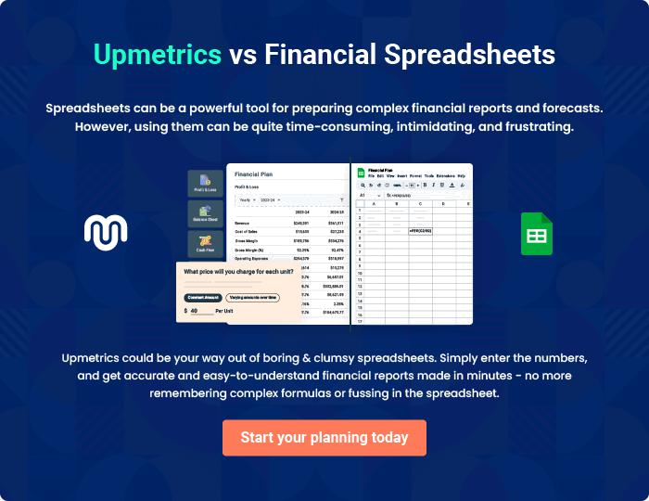
Appendix

When writing the appendix section, you should include any additional information that supports the main content of your plan. This may include financial statements, market research data, legal documents, and other
To unlock help try Upmetrics! 
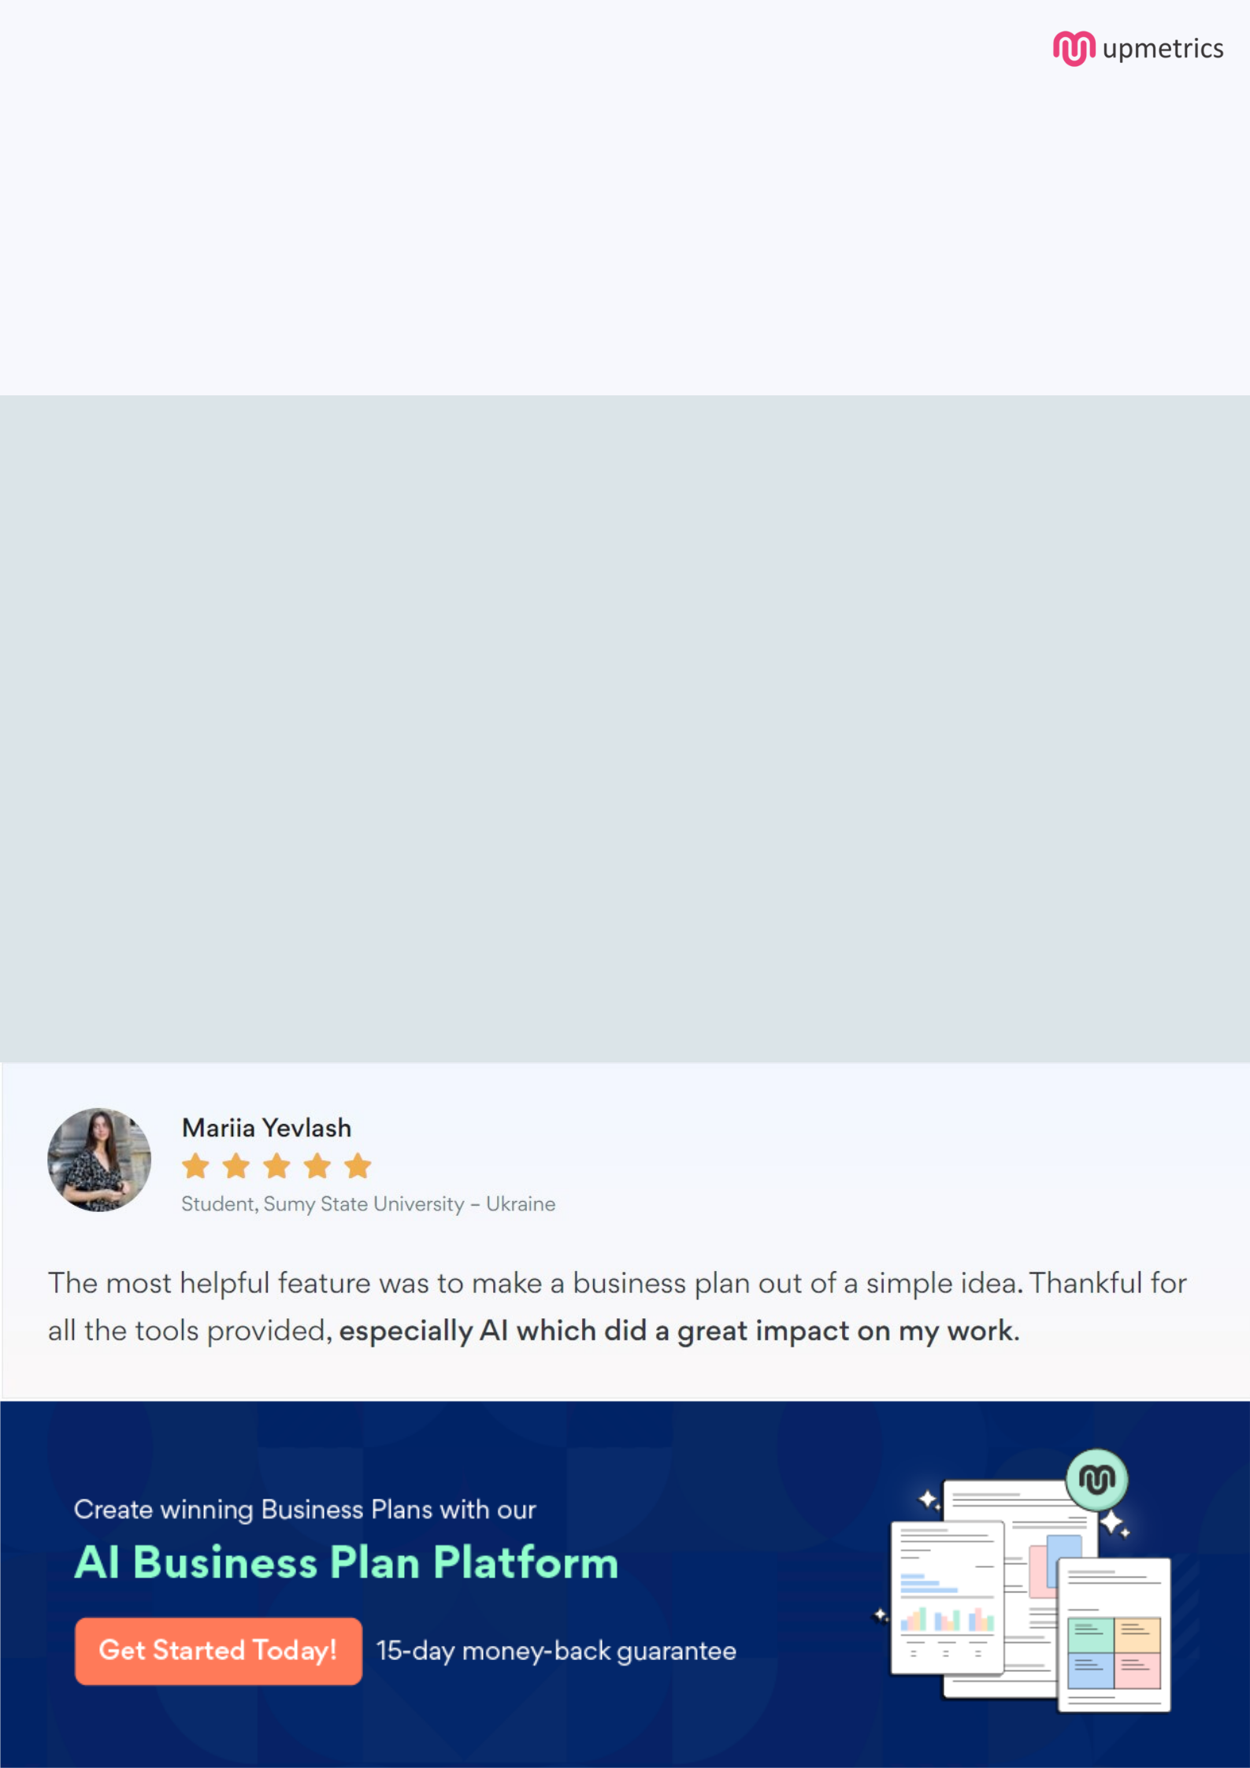
Create a winning business plan that gets you funded

Creating a stunning and investment-ready plan requires no writing, graphic designing, or financial planning expertise.

Upmetrics has all the features required to help you create a comprehensive business plan—from start to finish. Make no mistakes, it’s the modern way of planning to structure ideas, make plans, and create stunning pitch decks to awe investors.

Pitch decks that impress investors

Create pitch decks that provide a visual representation of your business, engage investors, and make them want to invest in your business idea.

Interactive plans in no time

Import business plan sections like—SWOT analysis, comparison tables, and others to create an interactive business plan. No designing skills are required.

Stunning cover page designs

With Upmetrics, you have the liberty to choose from multiple stunning cover page designs. Choose a creative design and make your plan stand out.

Online sharing made simple

Upmetrics makes online sharing quick and easier for users. Easily share your business plans with a link while tracking reader activity.

500+ sample business plans

Simply import a template from our library of sample plans into the editor and start customizing it to make it yours. It takes only a few clicks to get started.

Collaborate with team in real-time

Invite team members, initiate conversations, discuss ideas & strategies, share feedback, and work on a business plan in real-time.

