
 Embroidery Business Plan

ADDRESS CONTACT

10200 Bolsa Ave, Westminster, CA, 92683 (650) 359-3153

http://www.example.com info@example.com
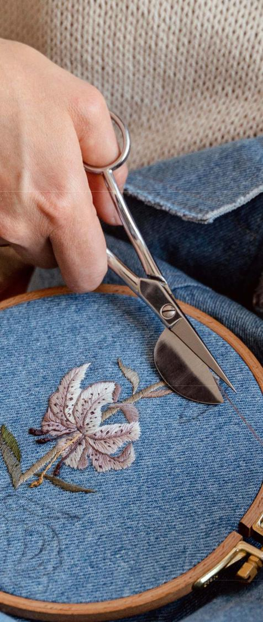

Business Plan

2023

Prepared By

John Doe


Designs, Needlework, Expression

Information provided in this business plan is unique to this business and confidential; therefore, anyone reading this plan agrees not to disclose any of the information in this business plan without prior written permission of the company.

Table of Contents

Executive Summary | 6
Market opportunity | 6
Services Offered | 6
Marketing & Sales Strategies | 7
Financial Highlights | 7
Units Sold v/s Revenue | 8

Company Overview | 9
Ownership | 9
Mission statement | 10
Business history | 10
Future goals | 10

Market Analysis | 11
Target Market | 11
Market size and growth potential | 11
Market Size | 12
Competitive analysis | 12
StitchMaster Inc. | 12
ThreadTales Co. | 13
EmbellishHub | 13
Market trends | 13
Regulatory environment | 14

Products and Services | 15
Services | 15
Custom Embroidery | 15
Patch Embroidery | 16
Specialty Embroidery | 16
Design Assistance | 16
Monogramming | 17
Appliqué Services | 17
Product Range | 17
Quality Measures | 18
Additional Services | 18

Sales And Marketing Strategies | 19
Unique Selling Proposition (USP) | 19
Pricing Strategy | 19
Marketing strategies | 20
Online | 20
Offline | 20
Sales strategies | 21
Customer retention | 22

Operations Plan | 23
Staffing & Training | 23
Operational Process | 23
Equipment & Machinery | 24

Management Team | 25
Key managers | 25
John Doe | 25
Jane Doe | 26
Ms. Alice Brown | 26
Robert Brown | 26
Organizational structure | 27
Organization chart | 27
Compensation plan | 27
Board of advisors | 28
[ADVISOR 1] | 28
[ADVISOR 2] | 28
Financial Plan | 29
Profit & loss statement | 29
Cash flow statement | 31
Balance sheet | 32
Break-even Point | 34
Financing needs | 34
Appendix
Appendix | 36
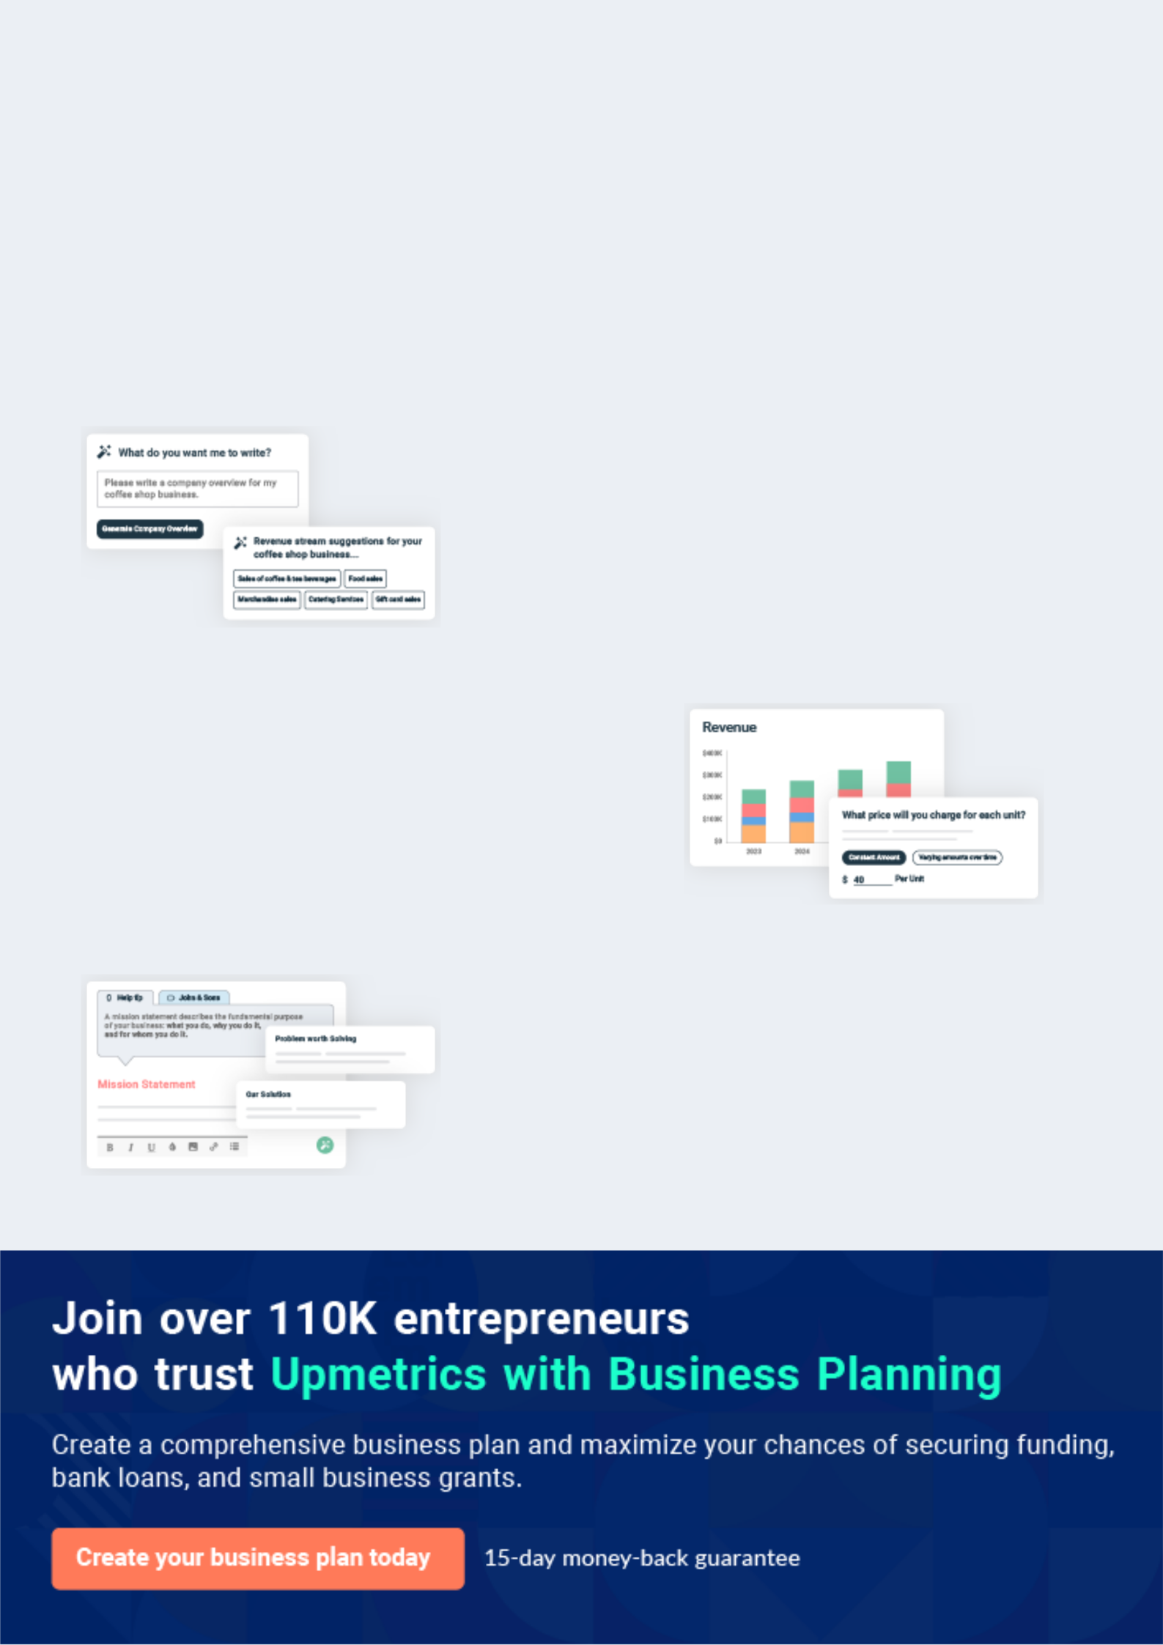
Business planning that’s simpler and faster than you think

Creating a business plan using Upmetrics to start and grow a business is literally the easiest thing in the World. Simply read the instructions and fill in the blanks. It’s as simple as that.

❛ | Upmetrics has everything you need to create a | ❜
❛ | comprehensive business plan. | ❜

AI-powered Upmetrics Assistant

AI-powered insights to streamline your plan

Not sure where to start? Upmetrics’ AI Assistant will automatically generate ideas for each section of your plan and offer improved versions of your writing, adjusting for tone, voice, and grammar or spelling errors.

Financial Forecasting Tool

All the financials are calculated for you

Forget the complex formulas and clumsy spreadsheets — with automatic financials and drag-and-drop forecasting, you can finish your plan faster and be confident that your numbers are accurate.

Business Plan Builder

Guides you like a business mentor

Upmetrics’ step-by-step instructions, prompts, and the library of 400+ sample business plans will guide you through each section of your plan as a business mentor.
Executive Summary


An executive summary is the first section of the business plan intended to provide an overview of the whole business plan.
To unlock help try Upmetrics! 

 Help tip  Embroidery Business Plan


Start your executive summary by briefly introducing your business to your readers.

This section may include the name of your embroidery business, its location when it was
To unlock help try Upmetrics! 

Start writing here..

Market opportunity

 Help tip  Embroidery Business Plan

Summarize your market research, including market size, growth potential, and marketing trends. Highlight the opportunities in the market and how your business will fit in to fill the gap.
To unlock help try Upmetrics! 

Start writing here..

Services Offered

 Help tip  Embroidery Business Plan

Highlight the products and services your embroidery business will provide to its clients. The USPs and differentiators you offer are always a plus.
To unlock help try Upmetrics! 

Start writing here..

Marketing & Sales Strategies
To unlock help try Upmetrics!

 Help tip  Embroidery Business Plan

Outline your sales and marketing strategies—what marketing platforms you use, how you plan on acquiring customers, etc.
To unlock help try Upmetrics! 

Start writing here..

Financial Highlights

 Help tip  Embroidery Business Plan

Briefly summarize your financial projections for the initial years of business operations. Include any capital or investment requirements, associated startup costs, projected revenues, and profit forecasts.



Start writing here..
Units Sold v/s Revenue

 |  | Units Sold | Revenue
15.00k
10.00k
5.00k
0
Year 1 | Year 2 | Year 3


Financial Year |  |  | Units Sold | Revenue
Year 1 | 1,550 |  |  | $10,000
Year 2 | 1,800 |  |  | $12,000
Year 3 | 2,050 |  |  | $14,000
 Help tip |  |  Embroidery Business Plan


Summarize your executive summary section with a clear CTA, for example, inviting angel investors to discuss the potential business investment.
To unlock help try Upmetrics! 

Write a call to action for your business plan.
Company Overview

Depending on what details of your business are essential, you’ll need different elements in your business overview.
To unlock help try Upmetrics! 

 Help tip  Embroidery Business Plan

Describe your business in this section by providing all the basic information:

Describe what kind of embroidery company you run and the name of it. You may specialize in
To unlock help try Upmetrics! 

Start writing here..

Ownership

 Help tip  Embroidery Business Plan

List the names of your embroidery company’s founders or owners. Describe what shares they own and their responsibilities for efficiently managing the business.
To unlock help try Upmetrics! 

Start writing here..
Mission statement

 Help tip  Embroidery Business Plan

Summarize your business’ objective, core principles, and values in your mission statement. This statement needs to be memorable, clear, and brief.
To unlock help try Upmetrics! 

❛ At Embroidery Dreams Inc., we weave dreams into threads, embodying excellence and individuality. Our commitment lies in delivering unparalleled craftsmanship, ensuring every stitch narrates a unique story, resonating with our core values of

integrity, creativity, and dedication.
❜

Business history

 Help tip  Embroidery Business Plan

If you’re an established embroidery service provider, briefly describe your business history, like —when it was founded, how it evolved over time, etc.
To unlock help try Upmetrics! 

Start writing here..

Future goals

 Help tip  Embroidery Business Plan

It’s crucial to convey your aspirations and vision. Mention your short-term and long-term goals; they can be specific targets for revenue, market share, or expanding your services.
To unlock help try Upmetrics! 

Start writing here..

Market Analysis
To unlock help try Upmetrics!


 |  | Market analysis provides a clear understanding of the market in which your
 |  | printing business will run along with the target market, competitors, and
 |  | growth opportunities.
 |  |  |  | To unlock help try Upmetrics! 
 Help tip |  |  Embroidery Business Plan

To write the introduction section of your market analysis, start by clearly identifying your primary target market.
To unlock help try Upmetrics! 

Start writing here..

Target Market

 Help tip  Embroidery Business Plan

Start this section by describing your target market. Define your ideal customer and explain what types of services they prefer. Creating a buyer persona will help you easily define your target market to your readers.



Start writing here..

Market size and growth potential

 Help tip  Embroidery Business Plan

Describe your market size and growth potential and whether you will target a niche or a much broader market.
To unlock help try Upmetrics! 

Start writing here..

Market Size

Available Market

Total potential consumers interested in 10M embroidery services/products.

Served Market
Consumers currently accessing 5M embroidery services/products.

Target Market
Startups/small businesses seeking 2M custom-branded apparel

 Help tip  Embroidery Business Plan

Identify and analyze your direct and indirect competitors. Identify their strengths and weaknesses, and describe what differentiates your embroidery services from them.
To unlock help try Upmetrics! 

Competitive analysis

StitchMaster Inc.

StitchMaster Inc., headquartered in [City, State], has been a staple in the embroidery landscape for over [X years]. With a rich legacy and a vast clientele spanning both corporate and individual segments, they've established themselves as market frontrunners.

Features

Comprehensive online and offline design catalogue

Custom design consultations

Rapid turnaround on bulk orders

Embroidery software integration for real-time design visualization

Strengths | Weaknesses
Established brand equity and a | Limited adaptability to trending
wide customer base | designs and personalization
High-quality craftsmanship | demands
maintained consistently over | Premium pricing alienating
the years | smaller businesses and startups
Strong supplier relationships | Occasional lag in delivery
ensuring uninterrupted raw | timelines
material supply

ThreadTales Co.

ThreadTales Co., based in [City, State], is a newer entrant but has swiftly made its mark, especially among younger demographics. Their unique selling proposition revolves around sustainable embroidery solutions.

Features

Eco-friendly threads and materials

Digital-only design submissions and consultations

Collaboration with local artists for exclusive design collections

Strengths

Strong appeal to environmentally-conscious customers

Agile business model with quick adaptability to market trends

Competitive pricing, especially for bulk orders

Weaknesses

Relatively limited brand recognition compared to long-standing competitors

Dependence on digital platforms may alienate non-tech-savvy clientele

Limited physical presence restricts face-to-face consultations

EmbellishHub

Operating from [City, State], EmbellishHub has carved a niche in providing embroidery classes and workshops alongside its standard services, fostering a community of embroidery enthusiasts.

Features

Regular embroidery workshops for beginners and experts

Subscription-based design catalogs

Collaboration with international designers for limited edition collections

Strengths

Strong community engagement through workshops and classes

Diverse revenue streams: service, education, and subscription-based

Regularly updated design catalogue, keeping pace with global trends

Weaknesses

Divided focus between service provision and educational endeavors

Limited customization options outside their design catalogues

Seasonal fluctuations in business, with peak periods around their workshop schedules

Market trends

 Help tip  Embroidery Business Plan

Analyze emerging trends in the industry, such as technology disruptions, changes in customer behavior or preferences, etc. Explain how your business will cope with all the trends.
To unlock help try Upmetrics! 

Start writing here..

Regulatory environment
To unlock help try Upmetrics!

 Help tip  Embroidery Business Plan

List regulations and licensing requirements that may affect your embroidery company, such as business registration, insurance, health and safety regulations, tax obligations, employment regulations, and intellectual property regulations.



Start writing here..
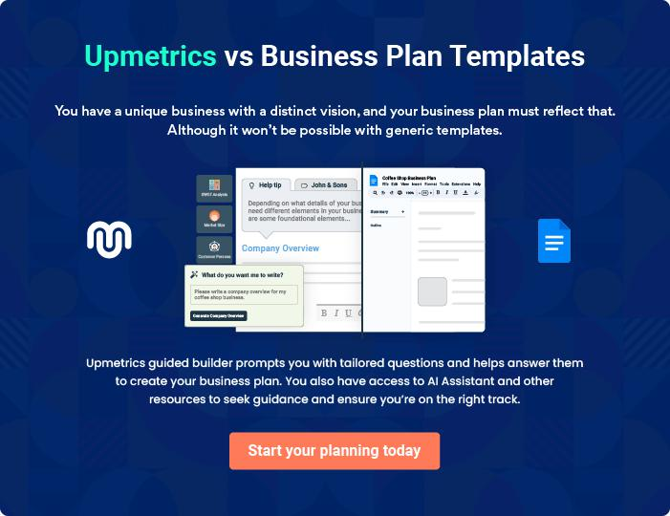
Products and Services
To unlock help try Upmetrics!

The product and services section of a embroidery business plan should describe the specific services and products that will be offered to customers. To write this section should include the following:



 Help tip  Embroidery Business Plan

To craft the introduction for your "Products and Services" chapter, begin by positioning your business within its industry, emphasizing its unique strengths or value proposition.
To unlock help try Upmetrics! 

Start writing here..

 Help tip


Mention the embroidery services your business will offer. This list may include services like

• Custom embroidery
To unlock help try Upmetrics! 

Services

Custom Embroidery


Price: $[20] per item

Tailored embroidery service, designed to bring any vision or design concept to life on a fabric of choice.

Specifications

- Maximum design size: 12"x12"

- Choice of up to [5] colors (additional colors at extra cost)

- Available for both individual and bulk orders
Patch Embroidery

Price: $[8] per patch

Durable and detachable embroidered patches, perfect for jeans, jackets, bags, and other apparel.

Specifications

- Available sizes: 2"x2", 4"x4", and 6"x6"

- Adhesive back or sew-on varieties are available

- Bulk order discounts are applicable

Specialty Embroidery

Price: Starting at $[30] per item

Advanced embroidery techniques for designs that demand intricate detailing or unique materials.

Specifications

- Utilizes materials like metallic threads, beads, or sequins

- Ideal for special occasions or luxury apparel

- Requires longer lead time due to complexity

Design Assistance

Price: $[50] per hour

Expert consultation to help clients refine and optimize their designs for embroidery.

Specifications

- Includes two design revision sessions

- Provides digital mockups of the final design

- Assistance in color and material selection
Monogramming

Price: $[15] per item

Elegant personalization option, ideal for gifts or individual items.

Specifications

- Up to three initials

- Choice of fonts: Serif, Sans Serif, Cursive

- Available in gold, silver, or standard thread colors

Appliqué Services

Price: $[25] per item

Multi-layered embroidery technique, combining fabrics for a textured, raised design.

Specifications

- Fabric choices include cotton, silk, or synthetic blends

- Ideal for large designs on sweatshirts, jackets, etc.

- Durable stitching ensures longevity

Product Range

 Help tip  Embroidery Business Plan

Mention details about your embroidery business’s product range. This list may include different types of garments, accessories, and other products.
To unlock help try Upmetrics! 

Start writing here..

Quality Measures

 Help tip  Embroidery Business Plan

This section should explain how you maintain quality standards and consistently provide the highest quality embroidery service.
To unlock help try Upmetrics! 

Start writing here..

Additional Services

 Help tip  Embroidery Business Plan

Mention if your embroidery business offers any additional services. You may include services like garment finishing, sewing, specialty embroidery techniques, and digitizing.
To unlock help try Upmetrics! 

Start writing here..
Sales And Marketing Strategies
To unlock help try Upmetrics!

Writing the sales and marketing strategies section means a list of strategies you will use to attract and retain your clients.
To unlock help try Upmetrics! 

 Help tip  Embroidery Business Plan

To create an effective introduction for your "Sales and Marketing Strategies" chapter, start by setting the stage within your specific industry or market.
To unlock help try Upmetrics! 

Unique Selling Proposition (USP)

 Help tip  Embroidery Business Plan

Define your business’s USPs depending on the market you serve, the equipment you use, and the unique services you provide. Identifying USPs will help you plan your marketing strategies.
To unlock help try Upmetrics! 

Start writing here..

Pricing Strategy

 Help tip  Embroidery Business Plan

Describe your pricing strategy—how you plan to price your services and stay competitive in the local market. You can mention any discounts you plan on offering to attract new customers to your service.



Start writing here..

 Help tip  Embroidery Business Plan
To unlock help try Upmetrics!

Discuss your marketing strategies to market your services. You may include some of these marketing strategies in your business plan—social media marketing, Google ads, brochures, email marketing, content marketing, and print marketing.



Marketing strategies

Online


Social Media Marketing

Platforms like [Instagram, Facebook, Pinterest] will showcase our portfolio, client testimonials, and behind-the-scenes glimpses.

Email Marketing

Regular newsletters to update our subscribers on new collections, offers, and embroidery trends.

Google Ads

Targeted campaigns to ensure we appear at the forefront for relevant search queries..

Content Marketing

Engaging blog posts and articles to establish our authority in the embroidery domain.

Offline

Brochures

Elegantly designed brochures, available both digitally and in print, to detail our services and products.

Print Marketing

Ad placements in local newspapers, magazines, and community bulletins to ensure local visibility.

 Help tip
To unlock help try Upmetrics!

Outline the strategies you’ll implement to maximize your sales. Your sales strategies may include offering samples and demonstrations, collaborating with influencers, partnering with other businesses, etc.



Sales strategies

Samples and Demonstrations

Potential clients can experience our craftsmanship firsthand, instilling confidence in our offerings.

Business Collaborations

Aligning with complementary businesses, such as apparel stores or event planners, to introduce our services to a broader audience.

Influencer Collaborations

Partnerships with fashion influencers to showcase our work, enhancing brand visibility.

 Help tip

Describe your customer retention strategies and how you plan to execute them.

For instance, your customer retention strategies may include introducing loyalty programs,
To unlock help try Upmetrics! 

Customer retention

Loyalty Programs

Rewarding repeat customers with discounts or exclusive previews.

After-Sales Support

We offer care guidelines, minor repair services, and consultations to ensure our products stand the test of time.

Feedback Mechanisms

Regularly seeking feedback and implementing suggestions, ensuring our services consistently meet client expectations.

Operations Plan
To unlock help try Upmetrics!

 |  | When writing the operations plan section, it’s important to consider the
 |  | various aspects of your business operations.
 |  |  |  | To unlock help try Upmetrics! 
 Help tip |  |  Embroidery Business Plan


To create an effective introduction for your "Operational Plan" chapter, start by emphasizing the
pivotal role of efficient operations in the success of your business, underscoring how they
directly impact the quality of services delivered.
 |  |  |  | To unlock help try Upmetrics! 
Start writing here..
Staffing & Training
 Help tip |  |  Embroidery Business Plan

Mention your embroidery business’s staffing requirements, including the number of employees
or production staff needed. Include their qualifications, the training required, and the duties they
will perform.
 |  |  |  | To unlock help try Upmetrics! 
Start writing here..
Operational Process
 Help tip |  |  Embroidery Business Plan

Outline the processes and procedures you will use to run your embroidery business. Your operational processes may include production management, design and customization, order management, and administrative tasks.



Start writing here..

Equipment & Machinery
To unlock help try Upmetrics!

 Help tip  Embroidery Business Plan

Include the list of equipment and machinery required for embroidery, such as embroidery machines, hoops and frames, digitizing software, stabilizers, scissors and cutting tools, and other optional equipment.



Start writing here..
Management Team

The management team section provides an overview of the individuals responsible for running your business plan.
To unlock help try Upmetrics! 

 Help tip  Embroidery Business Plan

To craft an introduction for your "Management Team" chapter, begin by emphasizing the crucial role of leadership in the success of any business.
To unlock help try Upmetrics! 

Start writing here..

Key managers

 Help tip  Embroidery Business Plan

Introduce your management and key members of your team, and explain their roles and responsibilities.
To unlock help try Upmetrics! 

Start writing here..


JOHN DOE

CEO - john.doe@example.com

At the helm of [Embroidery Dreams Inc] is our CEO and founder, [John Doe].

Entrusted with the responsibility of strategic decision-making, [John Doe] brings a wealth of experience from [relevant background/industry, e.g., "a decade in textile design and entrepreneurship"].

His role encompasses business strategy formulation, overseeing key operations, and spearheading expansion endeavors.

JANE DOE

Chief Operating Officer (COO) & Co-Founder - jane.doe@example.com

Jane oversees the company's day-to-day operations, ensuring efficiency and consistency in service delivery. Her knack for process optimization and her attention to detail are invaluable to our growth.


- Educational Background: Jane graduated with a Master’s in Operations Management from the Massachusetts Institute of Technology.

- Professional Background: Jane's rich experience includes a tenure as the Operations Manager at CraftThreads Inc., where she achieved a 30% efficiency boost in production.


MS. ALICE BROWN

Chief Marketing Officer (CMO) - alice.brown@example.com

Alice leads our marketing initiatives, crafting strategies that amplify our brand's voice and expand our market reach. Her creative prowess and market insights are central to our brand's recognition.


- Educational Background: Alice earned her MBA with a specialization in Marketing from Stanford University.

- Professional Background: Before joining Embroidery Dreams Inc., Alice was the Marketing Director at Stitch & Style, where she successfully launched three nationwide campaigns.


ROBERT BROWN

Production Manager - robert.brown@example.com

Robert ensures that our production line consistently meets the highest standards of quality. His expertise in embroidery techniques and machinery optimization ensures our products are always top-tier.

- Educational Background: Robert possesses a Bachelor's degree in Textile Engineering from Cornell University.

- Professional Background: Robert's journey includes an impactful role as the Lead Embroidery Specialist at FabricMasters Co., where he introduced cutting-edge embroidery techniques.
Organizational structure

 Help tip  Embroidery Business Plan

Explain the organizational structure of your management team. Include the reporting line and decision-making hierarchy.
To unlock help try Upmetrics! 

Start writing here..

Organization chart


John Doe

CEO


Jane Doe |  |  | Alice Brown
Jane Doe | Robert Brown |  | Alice Brown
COO & Co-Founder |  |  | CMO
 | Production Manager

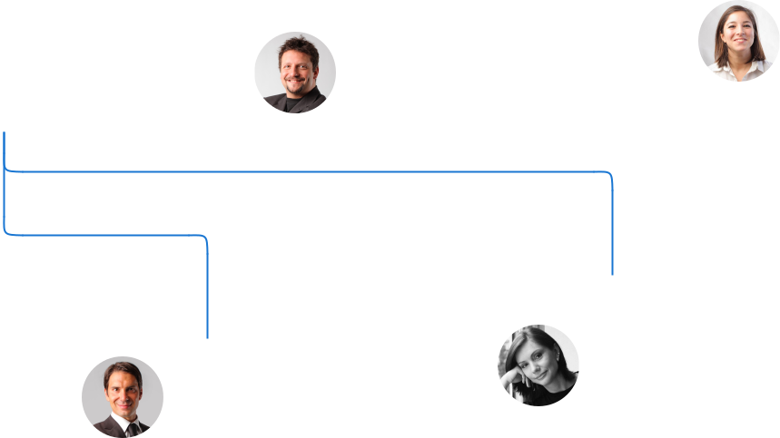

Emily White

David Smith Design Lead

Sales Manager

Compensation plan

 Help tip  Embroidery Business Plan

Describe your compensation plan for the management and staff. Include their salaries, incentives, and other benefits.
To unlock help try Upmetrics! 

Start writing here..

 Help tip

Mentioning advisors or consultants in your business plans adds credibility to your business idea.
To unlock help try Upmetrics! 

Board of advisors


[ADVISOR 1]

Business Strategy Advisor

[Full Name], with over [X years] in the embroidery industry, offers invaluable guidance on expansion and diversification.


[ADVISOR 2]

Technical Consultant

[Full Name], an expert in embroidery machinery and technology, advises us on equipment upgrades and process optimizations.
Financial Plan
To unlock help try Upmetrics!

When writing the financial plan section of a business plan, it’s important to provide a comprehensive overview of your financial projections for the first few years of your business, You may provide the following:
To unlock help try Upmetrics! 

 Help tip  Embroidery Business Plan

To create an effective introduction for your "Financial Plan" chapter, begin by stressing the critical role of a well-structured financial plan in the success of your venture.
To unlock help try Upmetrics! 

Start writing here..

 Help tip

Describe details such as projected revenue, operational costs, and service costs in your projected profit and loss statement. Make sure to include your business’s expected net profit or loss.



Profit & loss statement

 | 2023-24 | 2024-25 | 2025-26 | 2026-27 | 2027-28
Revenue | $0 | $0 | $0 | $0 | $0

Cost Of Sales | $0 | $0 | $0 | $0 | $0
General Costs | $0 | $0 | $0 | $0 | $0
Revenue Specific Costs | $0 | $0 | $0 | $0 | $0
Personnel Costs (Direct | $0 | $0 | $0 | $0 | $0
Labor)

Gross Margin $0 $0 $0 $0 $0

Gross Margin (%)

Operating Expense

Payroll Expense

(Indirect Labor)

General Expense

Bad Debt

Amortization of Current Assets

EBITDA

Additional Expense

Long Term

Depreciation

Gain or loss from Sale of Assets

EBIT

Interest Expenses

EBT

Income Tax Expense

Total Expense

Net Income

Net Income (%)

2023-24 | 2024-25 | 2025-26 | 2026-27 | 2027-28
0% | 0% | 0% | 0% | 0%
$0 | $0 | $0 | $0 | $0
$0 | $0 | $0 | $0 | $0
$0 | $0 | $0 | $0 | $0
$0 | $0 | $0 | $0 | $0
$0 | $0 | $0 | $0 | $0
$0 | $0 | $0 | $0 | $0
$0 | $0 | $0 | $0 | $0
$0 | $0 | $0 | $0 | $0
$0 | $0 | $0 | $0 | $0
$0 | $0 | $0 | $0 | $0
$0 | $0 | $0 | $0 | $0
$0 | $0 | $0 | $0 | $0
$0 | $0 | $0 | $0 | $0
$0 | $0 | $0 | $0 | $0
$0 | $0 | $0 | $0 | $0
0% | 0% | 0% | 0% | 0%
To unlock help try Upmetrics!
 | 2023-24 | 2024-25 | 2025-26 | 2026-27 | 2027-28
Retained Earning | $0 | $0 | $0 | $0 | $0
Opening
Owner's Distribution | $0 | $0 | $0 | $0 | $0
Retained Earning | $0 | $0 | $0 | $0 | $0
Closing

 Help tip

The cash flow for the first few years of your operation should be estimated and described in this section. This may include billing invoices, payment receipts, loan payments, and any other cash flow statements.



Cash flow statement

Cash Received

Cash Paid

COS & General Expenses

Salary & Wages

Interest

Sales Tax

Income Tax

Net Cash From

Operations

Assets Sell

Assets Purchase

Net Cash From

Investments

2023-24 | 2024-25 | 2025-26 | 2026-27 | 2027-28
$0 | $0 | $0 | $0 | $0
$0 | $0 | $0 | $0 | $0
$0 | $0 | $0 | $0 | $0
$0 | $0 | $0 | $0 | $0
$0 | $0 | $0 | $0 | $0
$0 | $0 | $0 | $0 | $0
$0 | $0 | $0 | $0 | $0
$0 | $0 | $0 | $0 | $0

$0 | $0 | $0 | $0 | $0
$0 | $0 | $0 | $0 | $0
$0 | $0 | $0 | $0 | $0

 | 2023-24 | 2024-25 | 2025-26 | 2026-27 | 2027-28
Amount Received | $0 | $0 | $0 | $0 | $0
Loan Received | $0 | $0 | $0 | $0 | $0
Common Stock
Preferred Stock | $0 | $0 | $0 | $0 | $0
Owner's Contribution | $0 | $0 | $0 | $0 | $0
Amount Paid | $0 | $0 | $0 | $0 | $0
Loan Capital | $0 | $0 | $0 | $0 | $0
Dividends & Distributions | $0 | $0 | $0 | $0 | $0
Net Cash From | $0 | $0 | $0 | $0 | $0
Financing

Summary
Starting Cash | $0 | $0 | $0 | $0 | $0
Cash In | $0 | $0 | $0 | $0 | $0
Cash Out | $0 | $0 | $0 | $0 | $0
Change in Cash | $0 | $0 | $0 | $0 | $0
Ending Cash | $0 | $0 | $0 | $0 | $0

 Help tip

Create a projected balance sheet documenting your embroidery business’s assets, liabilities, and equity.
To unlock help try Upmetrics! 

Balance sheet

 | 2023-24 | 2024-25 | 2025-26 | 2026-27 | 2027-28
Assets | $0 | $0 | $0 | $0 | $0
 | 2023-24 | 2024-25 | 2025-26 | 2026-27 | 2027-28
Current Assets | $0 | $0 | $0 | $0 | $0
Cash | $0 | $0 | $0 | $0 | $0
Accounts Receivable | $0 | $0 | $0 | $0 | $0
Inventory | $0 | $0 | $0 | $0 | $0
Other Current Assets | $0 | $0 | $0 | $0 | $0
Long Term Assets | $0 | $0 | $0 | $0 | $0
Gross Long Term Assets | $0 | $0 | $0 | $0 | $0
Accumulated Depreciation | $0 | $0 | $0 | $0 | $0

Liabilities & Equity | $0 | $0 | $0 | $0 | $0
Liabilities | $0 | $0 | $0 | $0 | $0
Current Liabilities | $0 | $0 | $0 | $0 | $0
Accounts Payable | $0 | $0 | $0 | $0 | $0
Income Tax Payable | $0 | $0 | $0 | $0 | $0
Sales Tax Payable | $0 | $0 | $0 | $0 | $0
Short Term Debt | $0 | $0 | $0 | $0 | $0
Long Term Liabilities | $0 | $0 | $0 | $0 | $0
Long Term Debt | $0 | $0 | $0 | $0 | $0
Equity | $0 | $0 | $0 | $0 | $0
Paid-in Capital | $0 | $0 | $0 | $0 | $0
Common Stock | $0 | $0 | $0 | $0 | $0
Preferred Stock | $0 | $0 | $0 | $0 | $0
Owner's Contribution | $0 | $0 | $0 | $0 | $0
Retained Earnings | $0 | $0 | $0 | $0 | $0
 | 2023-24 | 2024-25 | 2025-26 | 2026-27 | 2027-28
Check | $0 | $0 | $0 | $0 | $0

Break-even Point

 Help tip  Embroidery Business Plan

Determine and mention your business’s break-even point—the point at which your business costs and revenue will be equal.
To unlock help try Upmetrics! 

Start writing here..

Financing needs

 Help tip  Embroidery Business Plan

Calculate costs associated with starting an embroidery business, and estimate your financing needs and how much capital you need to raise to operate your business.
To unlock help try Upmetrics! 

Start writing here..
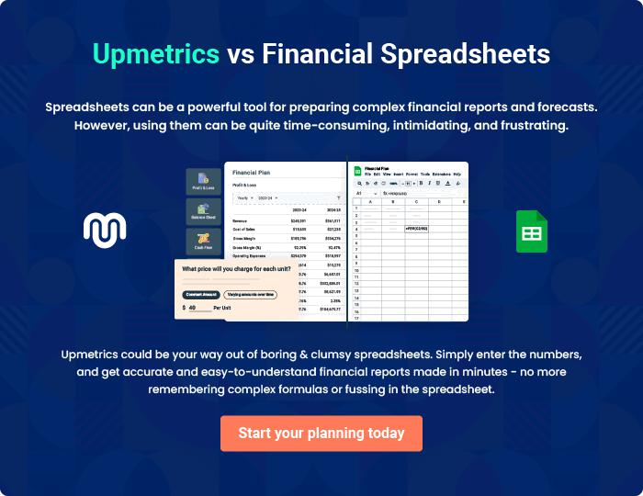
Appendix

When writing the appendix section, you should include any additional information that supports the main content of your plan. This may include financial statements, market research data, legal documents, and other
To unlock help try Upmetrics! 

Create a winning business plan that gets you funded

Creating a stunning and investment-ready plan requires no writing, graphic designing, or financial planning expertise.

Upmetrics has all the features required to help you create a comprehensive business plan—from start to finish. Make no mistakes, it’s the modern way of planning to structure ideas, make plans, and create stunning pitch decks to awe investors.

Pitch decks that impress investors

Create pitch decks that provide a visual representation of your business, engage investors, and make them want to invest in your business idea.

Interactive plans in no time

Import business plan sections like—SWOT analysis, comparison tables, and others to create an interactive business plan. No designing skills are required.

Stunning cover page designs

With Upmetrics, you have the liberty to choose from multiple stunning cover page designs. Choose a creative design and make your plan stand out.

Online sharing made simple

Upmetrics makes online sharing quick and easier for users. Easily share your business plans with a link while tracking reader activity.

500+ sample business plans

Simply import a template from our library of sample plans into the editor and start customizing it to make it yours. It takes only a few clicks to get started.

Collaborate with team in real-time

Invite team members, initiate conversations, discuss ideas & strategies, share feedback, and work on a business plan in real-time.

