
Electrical Contracting Business Plan

ADDRESS CONTACT

10200 Bolsa Ave, Westminster, CA, 92683 (650) 359-3153

http://www.example.com info@example.com


Business Plan

2023

Prepared By

John Doe


Empowering Your Electrical Needs

Information provided in this business plan is unique to this business and confidential; therefore, anyone reading this plan agrees not to disclose any of the information in this business plan without prior written permission of the company.

Table of Contents

Executive Summary | 6
Market opportunity | 6
Services Offered | 6
Marketing & Sales Strategies | 7
Financial Highlights | 7
Units Sold v/s Revenue | 8

Company Overview | 9
Ownership | 9
Mission statement | 9
Business history | 10
Future goals | 10

Market Analysis | 11
Target Market | 11
Market size and growth potential | 11
Market Size | 12
Competitive analysis | 12
ElectricPros, Inc. | 12
BrightSpark Electrical Services | 13
VoltMasters, LLC | 13
Market trends | 13
Regulatory environment | 14

Products and Services | 15
Services | 15
Electrical Installations | 15
Electrical Repairs | 16
Electrical Design Services | 16
Maintenance and Upgrades | 17
Fire Alarm Systems | 17
Security Systems | 18
Data Cabling – Telecommunication | 18
Home Automation Systems | 19
Quality Measures | 19
Additional Services | 19

Sales And Marketing Strategies | 20
Unique Selling Proposition (USP) | 20
Pricing Strategy | 20
Marketing strategies | 21
Online | 21
Offline | 21
Sales strategies | 22
Customer retention | 22

Operations Plan | 24
Staffing & Training | 24
Operational Process | 24
Equipment & Machinery | 25

Management Team | 26
Key managers | 26
John Doe | 26
Jane Doe | 27
Alice Brown | 27
Robert Brown | 27
Organizational structure | 28
Organization chart | 28
Compensation plan | 29
Board of advisors | 29
Mr. Edward Green | 29
Dr Jane Smith | 29
Financial Plan | 30
Profit & loss statement | 30
Cash flow statement | 33
Balance sheet | 35
Break-even Analysis | 37
Financing needs | 39
Appendix
Appendix | 41
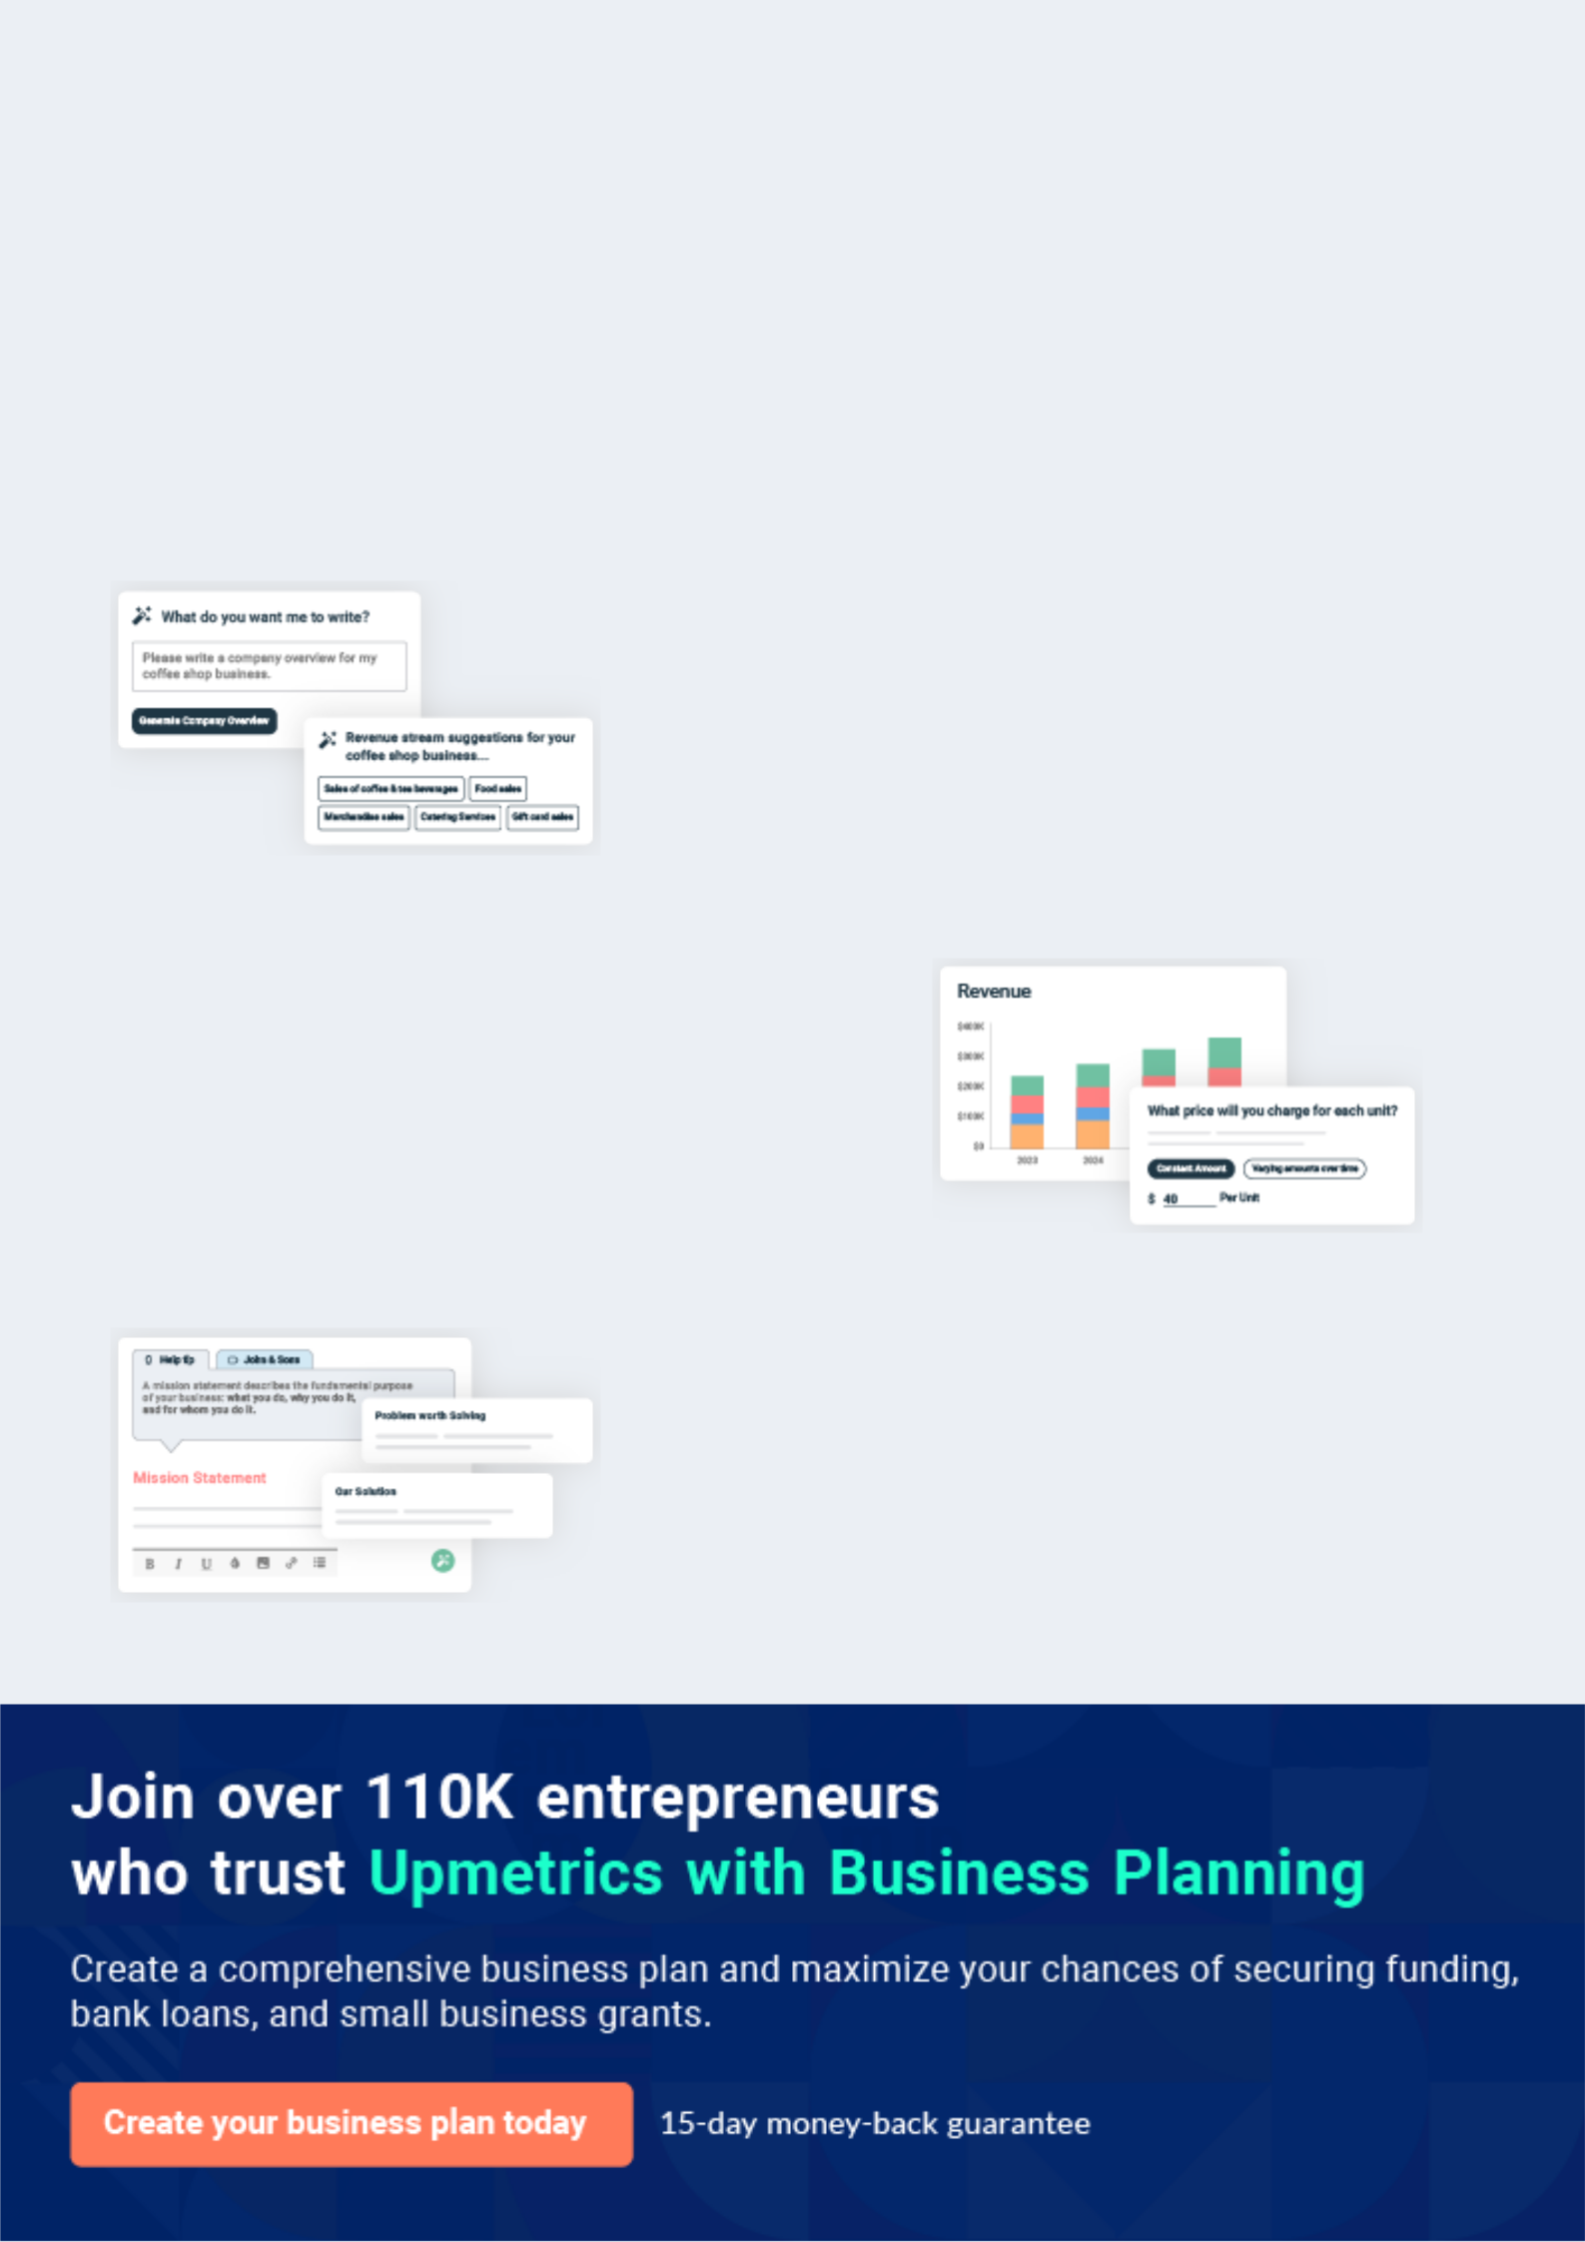
Business planning that’s simpler and faster than you think

Creating a business plan using Upmetrics to start and grow a business is literally the easiest thing in the World. Simply read the instructions and fill in the blanks. It’s as simple as that.

❛ | Upmetrics has everything you need to create a | ❜
❛ | comprehensive business plan. | ❜

AI-powered Upmetrics Assistant

AI-powered insights to streamline your plan

Not sure where to start? Upmetrics’ AI Assistant will automatically generate ideas for each section of your plan and offer improved versions of your writing, adjusting for tone, voice, and grammar or spelling errors.

Financial Forecasting Tool

All the financials are calculated for you

Forget the complex formulas and clumsy spreadsheets — with automatic financials and drag-and-drop forecasting, you can finish your plan faster and be confident that your numbers are accurate.

Business Plan Builder

Guides you like a business mentor

Upmetrics’ step-by-step instructions, prompts, and the library of 400+ sample business plans will guide you through each section of your plan as a business mentor.
Executive Summary


An executive summary is the first section of the business plan intended to provide an overview of the whole business plan.
To unlock help try Upmetrics! 

 Help tip  Electrical Contracting Business Plan


Start your executive summary by briefly introducing your business to your readers.

This section may include the name of your electrical contracting business, its location, when it
To unlock help try Upmetrics! 

Start writing here..

Market opportunity

 Help tip  Electrical Contracting Business Plan

Summarize your market research, including market size, growth potential, and marketing trends. Highlight the opportunities in the market and how your business will fit in to fill the gap.
To unlock help try Upmetrics! 

Start writing here..

Services Offered

 Help tip  Electrical Contracting Business Plan

Highlight the electrical contracting services you offer your clients. The USPs and differentiators you offer are always a plus.
To unlock help try Upmetrics! 

Start writing here..

Marketing & Sales Strategies
To unlock help try Upmetrics!

 Help tip  Electrical Contracting Business Plan

Outline your sales and marketing strategies—what marketing platforms you use, how you plan on acquiring customers, etc.
To unlock help try Upmetrics! 

Start writing here..

Financial Highlights

 Help tip  Electrical Contracting Business Plan

Briefly summarize your financial projections for the initial years of business operations. Include any capital or investment requirements, associated startup costs, projected revenues, and profit forecasts.



Start writing here..
Units Sold v/s Revenue

 |  | Units Sold | Revenue
15.00k
10.00k
5.00k
0
Year 1 | Year 2 | Year 3


Financial Year |  |  | Units Sold | Revenue
Year 1 | 1,550 |  |  | $10,000
Year 2 | 1,800 |  |  | $12,000
Year 3 | 2,050 |  |  | $14,000
 Help tip |  |  Electrical Contracting Business Plan


Summarize your executive summary section with a clear CTA, for example, inviting angel investors to discuss the potential business investment.
To unlock help try Upmetrics! 

Write a call to action for your business plan.
Company Overview

Depending on what details of your business are essential, you’ll need different elements in your business overview.
To unlock help try Upmetrics! 

 Help tip  Electrical Contracting Business Plan

Describe your business in this section by providing all the basic information:

Describe what kind of electrical contracting company you run and the name of it. You may
To unlock help try Upmetrics! 

Start writing here..

Ownership

 Help tip  Electrical Contracting Business Plan

List the names of your electrical contracting company’s founders or owners. Describe what shares they own and their responsibilities for efficiently managing the business.
To unlock help try Upmetrics! 

Start writing here..

Mission statement

 Help tip  Electrical Contracting Business Plan

Summarize your business’ objective, core principles, and values in your mission statement. This statement needs to be memorable, clear, and brief.
To unlock help try Upmetrics! 
❛ At [John Doe Electrical Contracting, Inc.], we are dedicated to illuminating lives through impeccable electrical solutions. Rooted in innovation, safety, and sustainability, our mission is to

empower communities, one circuit at a time.
❜

Business history

 Help tip  Electrical Contracting Business Plan

If you’re an established electrical contracting service provider, briefly describe your business history, like—when it was founded, how it evolved over time, etc.
To unlock help try Upmetrics! 

Start writing here..

Future goals

 Help tip  Electrical Contracting Business Plan

It’s crucial to convey your aspirations and vision. Mention your short-term and long-term goals; they can be specific targets for revenue, market share, or expanding your services.
To unlock help try Upmetrics! 

Start writing here..
Market Analysis
To unlock help try Upmetrics!


 |  | Market analysis provides a clear understanding of the market in which your
 |  | printing business will run along with the target market, competitors, and
 |  | growth opportunities.
 |  |  |  | To unlock help try Upmetrics! 
 Help tip |  |  Electrical Contracting Business Plan

To write the introduction section of your market analysis, start by clearly identifying your primary target market.
To unlock help try Upmetrics! 

Start writing here..

Target Market

 Help tip  Example title..


Start this section by describing your target market. Define your ideal customer and explain what types of services they prefer. Creating a buyer persona will help you easily define your target market to your readers.



Start writing here..

Market size and growth potential

 Help tip  Electrical Contracting Business Plan

Describe your market size and growth potential and whether you will target a niche or a much broader market.
To unlock help try Upmetrics! 

Start writing here..

Market Size

Available Market

Total potential consumers needing | 50M
electrical contracting services in the | 50M
region.
Served Market | 25M
Consumers within our operational reach | 25M
and service scope in the region.

Target Market | 5M
Homeowners aged 30-50 prioritizing | 5M
safety & energy efficiency. | 5M

 Help tip  Electrical Contracting Business Plan

Identify and analyze your direct and indirect competitors. Identify their strengths and weaknesses, and describe what differentiates your electrical contracting services from them.
To unlock help try Upmetrics! 

Competitive analysis

ElectricPros, Inc.

Founded in [Year], [ElectricPros, Inc.] has quickly risen through the ranks to become a recognized name in [specific market, e.g., "residential electrical contracting"]. With a network spanning over [X cities/states], they have successfully completed over [X number] of projects.

Features

Comprehensive electrical audits

Green energy solutions, including solar panel installations

Custom lighting designs 24/7 emergency response

Strengths

Strong brand recognition in the [specific market]

Vast network and accessibility

Dedicated customer support with quick response times

Weaknesses

Limited expertise in [specific domain, e.g., "smart home integrations"]

Higher price point compared to market average

[Specific reported issue, e.g., "some customer complaints regarding post-service follow-ups"]

BrightSpark Electrical Services

Operating since [Year], [BrightSpark Electrical Services] is a family-owned business that specializes in [specific specialization, e.g., "commercial electrical installations"]. Their personal touch and commitment to quality have garnered them a loyal customer base.

Features Strengths

Specialized commercial Deep-rooted community

electrical setups connections and trust

Maintenance contracts tailored Tailored solutions for

for businesses businesses of all sizes

Electrical retrofitting for older A strong emphasis on safety

commercial spaces and quality

Weaknesses

Limited geographic reach

Slower adoption of newer technologies

Dependence on a primarily local clientele, limiting expansion

VoltMasters, LLC

Established in [Year], [VoltMasters, LLC] prides itself on being at the forefront of technology. With a team of young innovators, they have captured a significant market share in [specific domain, e.g., "smart home installations"].

Features | Strengths | Weaknesses
Advanced smart home | Early adopters of new electrical | Limited experience in traditional
electrical integrations | technologies | electrical setups
Training sessions for clients on | A young, dynamic, and tech- | Premium pricing due to
smart system usage | savvy team | specialized services
Energy-efficient electrical | Strong partnerships with | Potential scalability issues with a
solutions | leading tech manufacturers | highly specialized focus

Market trends

 Help tip  Electrical Contracting Business Plan

Analyze emerging trends in the industry, such as technology disruptions, changes in customer behavior or preferences, etc. Explain how your business will cope with all the trends.
To unlock help try Upmetrics! 

Start writing here..

Regulatory environment
To unlock help try Upmetrics!

 Help tip  Electrical Contracting Business Plan

List regulations and licensing requirements that may affect your electrical contracting company, such as business registration, contractor license, permits, insurance, environmental regulations, state and federal regulations, etc.



Start writing here..
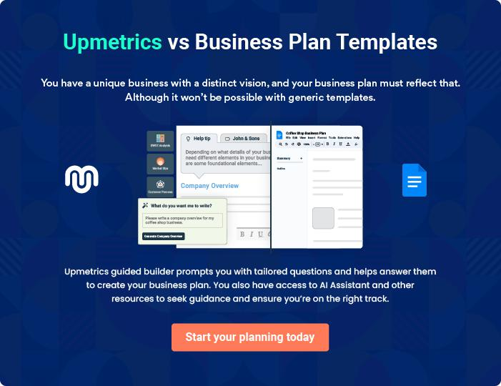
Products and Services

The product and services section of an electrical contracting business plan should describe the specific services and products that will be offered to customers. To write this section should include the following:
To unlock help try Upmetrics! 

 Help tip  Electrical Contracting Business Plan

To craft the introduction for your "Products and Services" chapter, begin by positioning your business within its industry, emphasizing its unique strengths or value proposition.
To unlock help try Upmetrics! 

Start writing here..

 Help tip


Mention the electrical contracting services your business will offer. This list may include services like,
To unlock help try Upmetrics! 

Services

Electrical Installations


Price: $[XXX] per hour / $[XXXX] per project

Comprehensive installation services tailored for new builds, renovations, and expansions.

Specifications

- Wiring of new rooms or entire buildings

- Circuit breaker installations

- Outlet and switch fittings

- Compliance with all local and national electrical codes
Electrical Repairs

Price: $[XXX] per hour

Prompt and reliable repair services to address electrical issues and restore functionality

Specifications

- Fault diagnosis and troubleshooting

- Replacement of damaged components

- System tests post-repair

- Emergency repair services available 24/7

Electrical Design Services

Price: Starting at $[XXXX] per project

End-to-end electrical design services to conceptualize and implement efficient systems tailored to clients' needs.

Specifications

- Blueprint and schematic creation

- Load calculation and distribution planning

- Integration with existing structures and systems

- Coordination with architects and builders
Maintenance and Upgrades

Price: $[XXX] per visit / Maintenance contracts starting at $[XXXX] per year

Periodic maintenance checks and upgrade services to keep electrical systems optimized and up-to-date.

Specifications

- System health checks

- Component replacements if needed

- Software and hardware upgrades for modern systems

- Compliance checks against updated regulations

Fire Alarm Systems

Price: Starting at $[XXXX] for installation / $[XXX] for maintenance visits

Comprehensive fire alarm system solutions, ensuring early detection and safety compliance.

Specifications

- Smoke and heat detector installations

- Alarm panel setups

- Regular testing and calibration

- Compliance with fire safety regulations
Security Systems

Price: Packages starting at $[XXXX]

State-of-the-art security systems ensuring comprehensive property and occupant safety.

Specifications

- CCTV camera installations

- Motion sensor setups

- Alarm and monitoring systems

- Integration with mobile apps for remote access

Data Cabling – Telecommunication

Price: $[XXX] per point / Packages starting at $[XXXX]

Efficient data cabling solutions, enabling seamless connectivity for businesses and homes.

Specifications

- CAT5e, CAT6, and fiber-optic installations

- Data rack and patch panel setups

- Testing and certification

- Compliance with telecommunication standards
Home Automation Systems

Price: Packages starting at $[XXXX]

Transforming homes into smart environments, ensuring comfort, efficiency, and convenience.

Specifications

- Voice-controlled lighting systems

- Smart thermostat installations

- Integration with popular home automation platforms

- Training sessions for users

Quality Measures

 Help tip  Electrical Contracting Business Plan

This section should explain how you maintain quality standards and consistently provide the highest quality service.
To unlock help try Upmetrics! 

Start writing here..

Additional Services

 Help tip  Electrical Contracting Business Plan

Mention if your electrical contracting company offers any additional services. You may include services like smart home integrations, renewable energy installations, etc.
To unlock help try Upmetrics! 

Start writing here..

Sales And Marketing Strategies
To unlock help try Upmetrics!

Writing the sales and marketing strategies section means a list of strategies you will use to attract and retain your clients.
To unlock help try Upmetrics! 

 Help tip  Electrical Contracting Business Plan

To create an effective introduction for your "Sales and Marketing Strategies" chapter, start by setting the stage within your specific industry or market.
To unlock help try Upmetrics! 

Unique Selling Proposition (USP)

 Help tip  Electrical Contracting Business Plan

Define your business’s USPs depending on the market you serve, the equipment you use, and the unique services you provide. Identifying USPs will help you plan your marketing strategies.
To unlock help try Upmetrics! 

Start writing here..

Pricing Strategy

 Help tip  Electrical Contracting Business Plan

Describe your pricing strategy—how you plan to price your contracting services and stay competitive in the local market. You can mention any entry offers you plan on offering to attract new customers to your contracting service.



Start writing here..

 Help tip  Electrical Contracting Business Plan

Discuss your marketing strategies to market your services. You may include some of these marketing strategies in your business plan—social media marketing, Google ads, brochures, email marketing, content marketing, local marketing, and print marketing.
To unlock help try Upmetrics! 

Marketing strategies

Online


Social Media

Harnessing platforms like Facebook, Instagram, and LinkedIn, we aim to create engaging content, tutorials, and client testimonials to engage with our target audience.

Content Marketing

Establishing ourselves as industry thought leaders through blogs, articles, and tutorials on emerging electrical trends.

Email Marketing

Regular newsletters and service updates will be sent to our existing client base and potential leads.

Google Ads

By leveraging paid search campaigns, we aim to feature prominently for key search queries related to our services.

Offline

Brochures

Informative brochures detailing our services will be distributed in strategic locations to target potential clients.

Local Marketing

Print Marketing

Strategic placements in local magazines, newspapers, and industry journals to reach a broader audience.

Participating in community events,

trade fairs, and hosting workshops

to gain local visibility and trust.

 Help tip
To unlock help try Upmetrics!
To unlock help try Upmetrics!

Outline the strategies you’ll implement to maximize your sales. Your sales strategies may include direct sales calls, partnering with related businesses like real estate companies, offering referral programs, etc.



Sales strategies

Partner with Businesses

Collaborating with related businesses, such as real estate companies and builders, to offer integrated solutions to clients.

Direct Sales Calls

Proactive outreach to potential clients, showcasing our expertise and understanding their requirements.

Referral Programs

Encouraging word-of-mouth

marketing by providing incentives

to clients who refer our services to

others.

 Help tip

Describe your customer retention strategies and how you plan to execute them. For instance, introducing loyalty programs, discounts on annual membership, proactive service and maintenance, personalized service, etc.



Customer retention

Loyalty Programs

Offering loyalty points for every service availed, which can be redeemed in future transactions.

Annual Membership Discounts

Proposing discounts to clients who opt for our annual maintenance contracts.


Personalized Service

Understanding the individual needs of clients and tailoring our services accordingly.

Proactive Service and Maintenance

Regular check-ins and maintenance visits to ensure the longevity of installed systems.
Operations Plan
To unlock help try Upmetrics!
To unlock help try Upmetrics!

 |  | When writing the operations plan section, it’s important to consider the
 |  | various aspects of your business operations.
 |  |  |  | To unlock help try Upmetrics! 
 Help tip |  |  Electrical Contracting Business Plan


To create an effective introduction for your "Operational Plan" chapter, start by emphasizing the
pivotal role of efficient operations in the success of your business, underscoring how they
directly impact the quality of services delivered.
 |  |  |  | To unlock help try Upmetrics! 
Start writing here..
Staffing & Training
 Help tip |  |  Electrical Contracting Business Plan

Mention your contracting business’s staffing requirements, including the number of employees, i.e. electrical engineers, electricians, and office administrative staff needed. Include their qualifications, the training required, and the duties they will perform.



Start writing here..

Operational Process

 Help tip  Electrical Contracting Business Plan

Outline the processes and procedures you will use to run your electrical contracting business. Your operational processes may include project planning, making installations, logistics, procuring materials, acquiring new clients, and billing and collection.



Start writing here..

Equipment & Machinery

 Help tip  Electrical Contracting Business Plan

Include the list of equipment and machinery required for electrical contracting, such as testing and measuring tools, hand and power tools, heavy machinery, safety equipment, etc.
To unlock help try Upmetrics! 

Start writing here..
Management Team

The management team section provides an overview of the individuals responsible for running your business plan.
To unlock help try Upmetrics! 

 Help tip  Electrical Contracting Business Plan

To craft an introduction for your "Management Team" chapter, begin by emphasizing the crucial role of leadership in the success of any business.
To unlock help try Upmetrics! 

Start writing here..

Key managers

 Help tip  Electrical Contracting Business Plan

Introduce your management and key members of your team, and explain their roles and responsibilities.
To unlock help try Upmetrics! 

Start writing here..


JOHN DOE

CEO & Co-founder - john.doe@example.com

[John Doe] is the visionary founder and Chief Executive Officer of our Electrical Contracting Business.

He holds a Bachelor's Degree in Electrical Engineering from [University Name] and an MBA from [Business School Name].


With over [20] years in the electrical contracting industry, John has cultivated a wealth of experience spanning project management, business strategy, and customer relationship management.

Under his leadership, the company has seen consistent growth and has forged valuable partnerships within the industry.

JANE DOE

Chief Operating Officer (COO) - jane.doe@example.com

[Jane Doe], as the Chief Operating Officer, is the driving force behind our company's daily operations.

She earned her Bachelor's in Business Administration from [University Name] and later pursued a Master's in Operations Management.


With a [15-year] track record in the electrical contracting space, Jane has excelled in ensuring operational efficiency, managing resources, and aligning the company's operations with its strategic goals.


ALICE BROWN

CMO - alice.brown@example.com

[Alice Brown] leads our marketing division as the Chief Marketing Officer. She holds a Bachelor's Degree in Marketing from [University Name] and a Master's Degree in Digital Marketing from [Business School Name].

With over [12] years in the field, Alice has a deep understanding of branding, customer acquisition, and digital outreach strategies.

Her innovative campaigns and strategies have played a pivotal role in enhancing our brand's visibility in the market.


ROBERT BROWN

Project Manager - robert.brown@example.com

As our Project Manager, [Robert Brown] is the linchpin ensuring that all our electrical projects are executed seamlessly.

He completed his Bachelor's in Project Management from [University Name] and boasts [10] years of experience in the electrical sector.

Robert's attention to detail, coupled with his expertise in resource allocation and time management, ensures that our projects are always completed on time and within budget.
Organizational structure

 Help tip  Electrical Contracting Business Plan

Explain the organizational structure of your management team. Include the reporting line and decision-making hierarchy.
To unlock help try Upmetrics! 

Start writing here..

Organization chart


John Doe

CEO


Alice Brown

Jane Doe

CMO


COO

Sam Smith

Finance Manager Robert Brown

Project Manager




David White

Emily Black

Lead Electrician

HR Manager

Compensation plan

 Help tip  Electrical Contracting Business Plan

Describe your compensation plan for the management and staff. Include their salaries, incentives, and other benefits.
To unlock help try Upmetrics! 

Start writing here..

 Help tip

Mentioning advisors or consultants in your business plans adds credibility to your business idea.
To unlock help try Upmetrics! 

Board of advisors


MR. EDWARD GREEN

Business Strategy Advisor

With [X] years in business strategy formulation, [Mr. Green] offers invaluable insights to steer our business in the right direction.


DR JANE SMITH

Electrical Industry Consultant

[Dr. Smith] brings [X] years of expertise, guiding us on industry best practices, technological advancements, and market dynamics.
Financial Plan

When writing the financial plan section of a business plan, it’s important to provide a comprehensive overview of your financial projections for the first few years of your business, You may provide the following:
To unlock help try Upmetrics! 

 Help tip  Electrical Contracting Business Plan


To create an effective introduction for your "Financial Plan" chapter, begin by stressing the critical role of a well-structured financial plan in the success of your venture.
To unlock help try Upmetrics! 

Start writing here..

 Help tip


Describe details such as projected revenue, operational costs, and service costs in your projected profit and loss statement. Make sure to include your business’s expected net profit or loss.
To unlock help try Upmetrics! 

Profit & loss statement

Revenue

Cost Of Sales

General Costs

Revenue Specific Costs

Personnel Costs (Direct

Labor)

Gross Margin

Gross Margin (%)

Operating Expense

Payroll Expense

(Indirect Labor)

General Expense

Bad Debt

Amortization of Current

Assets

2023-24 | 2024-25 | 2025-26 | 2026-27 | 2027-28
$0 | $0 | $0 | $0 | $0

$0 | $0 | $0 | $0 | $0
$0 | $0 | $0 | $0 | $0
$0 | $0 | $0 | $0 | $0
$0 | $0 | $0 | $0 | $0

$0 | $0 | $0 | $0 | $0
0% | 0% | 0% | 0% | 0%

$0 | $0 | $0 | $0 | $0
$0 | $0 | $0 | $0 | $0
$0 | $0 | $0 | $0 | $0
$0 | $0 | $0 | $0 | $0
$0 | $0 | $0 | $0 | $0

EBITDA

Additional Expense

Long Term

Depreciation

Gain or loss from Sale

of Assets

EBIT

Interest Expenses

EBT

Income Tax Expense

Total Expense

Net Income

Net Income (%)

2023-24 | 2024-25 | 2025-26 | 2026-27 | 2027-28
$0 | $0 | $0 | $0 | $0
$0 | $0 | $0 | $0 | $0
$0 | $0 | $0 | $0 | $0
$0 | $0 | $0 | $0 | $0
$0 | $0 | $0 | $0 | $0
$0 | $0 | $0 | $0 | $0
$0 | $0 | $0 | $0 | $0
$0 | $0 | $0 | $0 | $0
$0 | $0 | $0 | $0 | $0
$0 | $0 | $0 | $0 | $0
0% | 0% | 0% | 0% | 0%
 | 2023-24 | 2024-25 | 2025-26 | 2026-27 | 2027-28
Retained Earning | $0 | $0 | $0 | $0 | $0
Opening
Owner's Distribution | $0 | $0 | $0 | $0 | $0
Retained Earning | $0 | $0 | $0 | $0 | $0
Closing

 Help tip

The cash flow for the first few years of your operation should be estimated and described in this section. This may include billing invoices, payment receipts, loan payments, and any other cash flow statements.
To unlock help try Upmetrics! 

Cash flow statement

 | 2023-24 | 2024-25 | 2025-26 | 2026-27 | 2027-28
Cash Received | $0 | $0 | $0 | $0 | $0
Cash Paid | $0 | $0 | $0 | $0 | $0
COS & General Expenses | $0 | $0 | $0 | $0 | $0
Salary & Wages | $0 | $0 | $0 | $0 | $0
Interest | $0 | $0 | $0 | $0 | $0

Sales Tax

Income Tax

Net Cash From

Operations

Assets Sell

Assets Purchase

Net Cash From

Investments

Amount Received

Loan Received

Common Stock

Preferred Stock

Owner's Contribution

Amount Paid

2023-24 | 2024-25 | 2025-26 | 2026-27 | 2027-28
$0 | $0 | $0 | $0 | $0
$0 | $0 | $0 | $0 | $0
$0 | $0 | $0 | $0 | $0

$0 | $0 | $0 | $0 | $0
$0 | $0 | $0 | $0 | $0
$0 | $0 | $0 | $0 | $0

$0 | $0 | $0 | $0 | $0
$0 | $0 | $0 | $0 | $0

$0 | $0 | $0 | $0 | $0
$0 | $0 | $0 | $0 | $0
$0 | $0 | $0 | $0 | $0

Loan Capital $0 $0 $0 $0 $0

 | 2023-24 | 2024-25 | 2025-26 | 2026-27 | 2027-28
Dividends & Distributions | $0 | $0 | $0 | $0 | $0
Net Cash From | $0 | $0 | $0 | $0 | $0
Financing

Summary
Starting Cash | $0 | $0 | $0 | $0 | $0
Cash In | $0 | $0 | $0 | $0 | $0
Cash Out | $0 | $0 | $0 | $0 | $0
Change in Cash | $0 | $0 | $0 | $0 | $0
Ending Cash | $0 | $0 | $0 | $0 | $0

 Help tip

Create a projected balance sheet documenting your electrical contracting business’s assets, liabilities, and equity.

To unlock help try Upmetrics! 

Balance sheet

 | 2023-24 | 2024-25 | 2025-26 | 2026-27 | 2027-28
Assets | $0 | $0 | $0 | $0 | $0
Current Assets | $0 | $0 | $0 | $0 | $0
Cash | $0 | $0 | $0 | $0 | $0
Accounts Receivable | $0 | $0 | $0 | $0 | $0
Inventory | $0 | $0 | $0 | $0 | $0
Other Current Assets | $0 | $0 | $0 | $0 | $0
Long Term Assets | $0 | $0 | $0 | $0 | $0
Gross Long Term Assets | $0 | $0 | $0 | $0 | $0
Accumulated Depreciation | $0 | $0 | $0 | $0 | $0

Liabilities & Equity | $0 | $0 | $0 | $0 | $0
Liabilities | $0 | $0 | $0 | $0 | $0
Current Liabilities | $0 | $0 | $0 | $0 | $0
Accounts Payable | $0 | $0 | $0 | $0 | $0
Income Tax Payable | $0 | $0 | $0 | $0 | $0
Sales Tax Payable | $0 | $0 | $0 | $0 | $0
Short Term Debt | $0 | $0 | $0 | $0 | $0
 | 2023-24 | 2024-25 | 2025-26 | 2026-27 | 2027-28
Long Term Liabilities | $0 | $0 | $0 | $0 | $0
Long Term Debt | $0 | $0 | $0 | $0 | $0
Equity | $0 | $0 | $0 | $0 | $0
Paid-in Capital | $0 | $0 | $0 | $0 | $0
Common Stock | $0 | $0 | $0 | $0 | $0
Preferred Stock | $0 | $0 | $0 | $0 | $0
Owner's Contribution | $0 | $0 | $0 | $0 | $0
Retained Earnings | $0 | $0 | $0 | $0 | $0

Check | $0 |  |  | $0 | $0 | $0 | $0
 Help Tip |  |  Electrical Contracting Business Plan


Determine and mention your business’s break-even point—the point at which your business costs and revenue will be equal.

This exercise will help you understand how much revenue you need to generate to sustain or be profitable.
To unlock help try Upmetrics! 

Break-even Analysis

 | 2023-24 | 2024-25 | 2025-26 | 2026-27 | 2027-28
Starting Revenue | $0 | $0 | $0 | $0 | $0
Net Revenue | $0 | $0 | $0 | $0 | $0
Closing Revenue | $0 | $0 | $0 | $0 | $0

Starting Expense | $0 | $0 | $0 | $0 | $0
Net Expense | $0 | $0 | $0 | $0 | $0
Closing Expense | $0 | $0 | $0 | $0 | $0

Is Break Even? | 0 | 0 | 0 | 0 | 0
Break Even Month | 0 | 0 | 0 | 0 | 0
Days Required | 0 | 0 | 0 | 0 | 0
Break Even Revenue | $0 | $0 | $0 | $0 | $0
Break Even Units
Financing needs

 Help tip  Electrical Contracting Business Plan

Calculate costs associated with starting an electrical contracting business, and estimate your financing needs and how much capital you need to raise to operate your business.
To unlock help try Upmetrics! 

Start writing here..
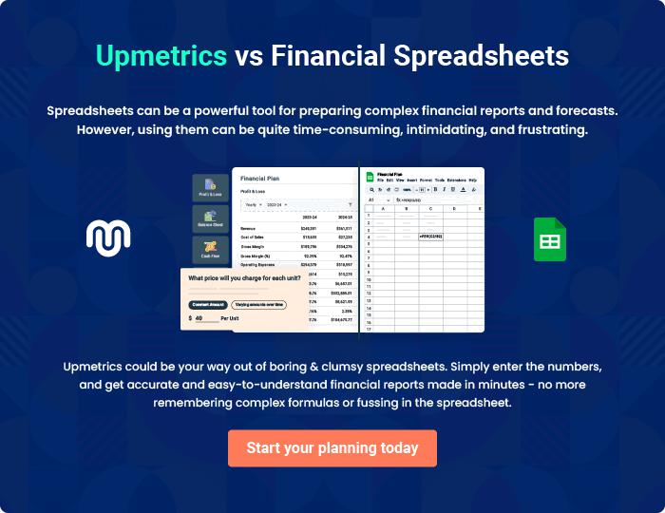
Appendix

When writing the appendix section, you should include any additional information that supports the main content of your plan. This may include financial statements, market research data, legal documents, and other
To unlock help try Upmetrics! 

Create a winning business plan that gets you funded

Creating a stunning and investment-ready plan requires no writing, graphic designing, or financial planning expertise.

Upmetrics has all the features required to help you create a comprehensive business plan—from start to finish. Make no mistakes, it’s the modern way of planning to structure ideas, make plans, and create stunning pitch decks to awe investors.

Pitch decks that impress investors

Create pitch decks that provide a visual representation of your business, engage investors, and make them want to invest in your business idea.

Interactive plans in no time

Import business plan sections like—SWOT analysis, comparison tables, and others to create an interactive business plan. No designing skills are required.

Stunning cover page designs

With Upmetrics, you have the liberty to choose from multiple stunning cover page designs. Choose a creative design and make your plan stand out.

Online sharing made simple

Upmetrics makes online sharing quick and easier for users. Easily share your business plans with a link while tracking reader activity.

500+ sample business plans

Simply import a template from our library of sample plans into the editor and start customizing it to make it yours. It takes only a few clicks to get started.

Collaborate with team in real-time

Invite team members, initiate conversations, discuss ideas & strategies, share feedback, and work on a business plan in real-time.

