
 Electric Vehicle Business Plan

ADDRESS CONTACT

10200 Bolsa Ave, Westminster, CA, 92683 (650) 359-3153

https://www.example.com/ upm.templates+4@gmail.com
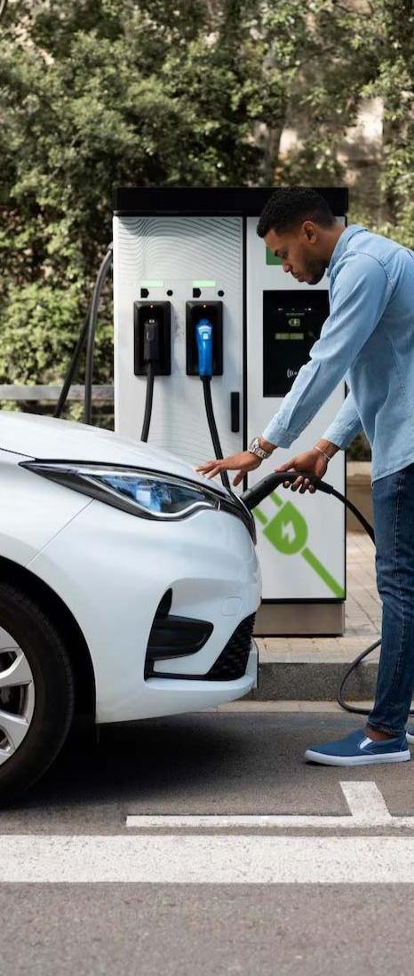

Business Plan

2023

Prepared By

Upmetrics Admin


Electric, Sustainable, Power

Information provided in this business plan is unique to this business and confidential; therefore, anyone reading this plan agrees not to disclose any of the information in this business plan without prior written permission of the company.

Table of Contents

Executive Summary | 6
Market opportunity | 6
Services Offered | 6
Marketing & Sales Strategies | 7
Financial Highlights | 7
Units Sold v/s Revenue | 8

Company Overview | 9
Ownership | 9
Mission statement | 10
Business history | 10
Future goals | 10

Market Analysis | 11
Target Market | 11
Market size and growth potential | 11
Market Size | 12
Competitive analysis | 12
GreenSpeed Motors | 12
EcoDrive Innovations | 13
VoltMotion Autos | 13
Market trends | 14
Regulatory environment | 14

Products and Services | 16
Products & Services | 16
EcoSprint Electric Scooter | 17
EV Maintenance Package | 17
Home Charging Station | 18
EV Fleet Consultation | 18

Quality Measures 19

Additional Services | 19

Sales And Marketing Strategies | 20
Unique Selling Proposition (USP) | 20
Pricing Strategy | 20
Marketing strategies | 21
Online | 21
Sales strategies | 22
Customer retention | 23

Operations Plan | 24
Staffing & Training | 24
Operational Process | 24
Equipment & Machinery | 25

Management Team | 26
Key managers | 26
John Doe | 26
Jane Doe | 27
Alice Brown | 27
Robert Brown | 27
Organizational structure | 27
Organization chart | 28
Compensation plan | 28
Advisors/Consultants | 29
Dr. William Stone | 29
Ms. Lily Grey | 29

Financial Plan | 30
Profit & loss statement | 30
Cash flow statement | 33
Balance sheet | 35
Break-even Analysis | 37
Financing needs | 39
Appendix
Appendix | 41
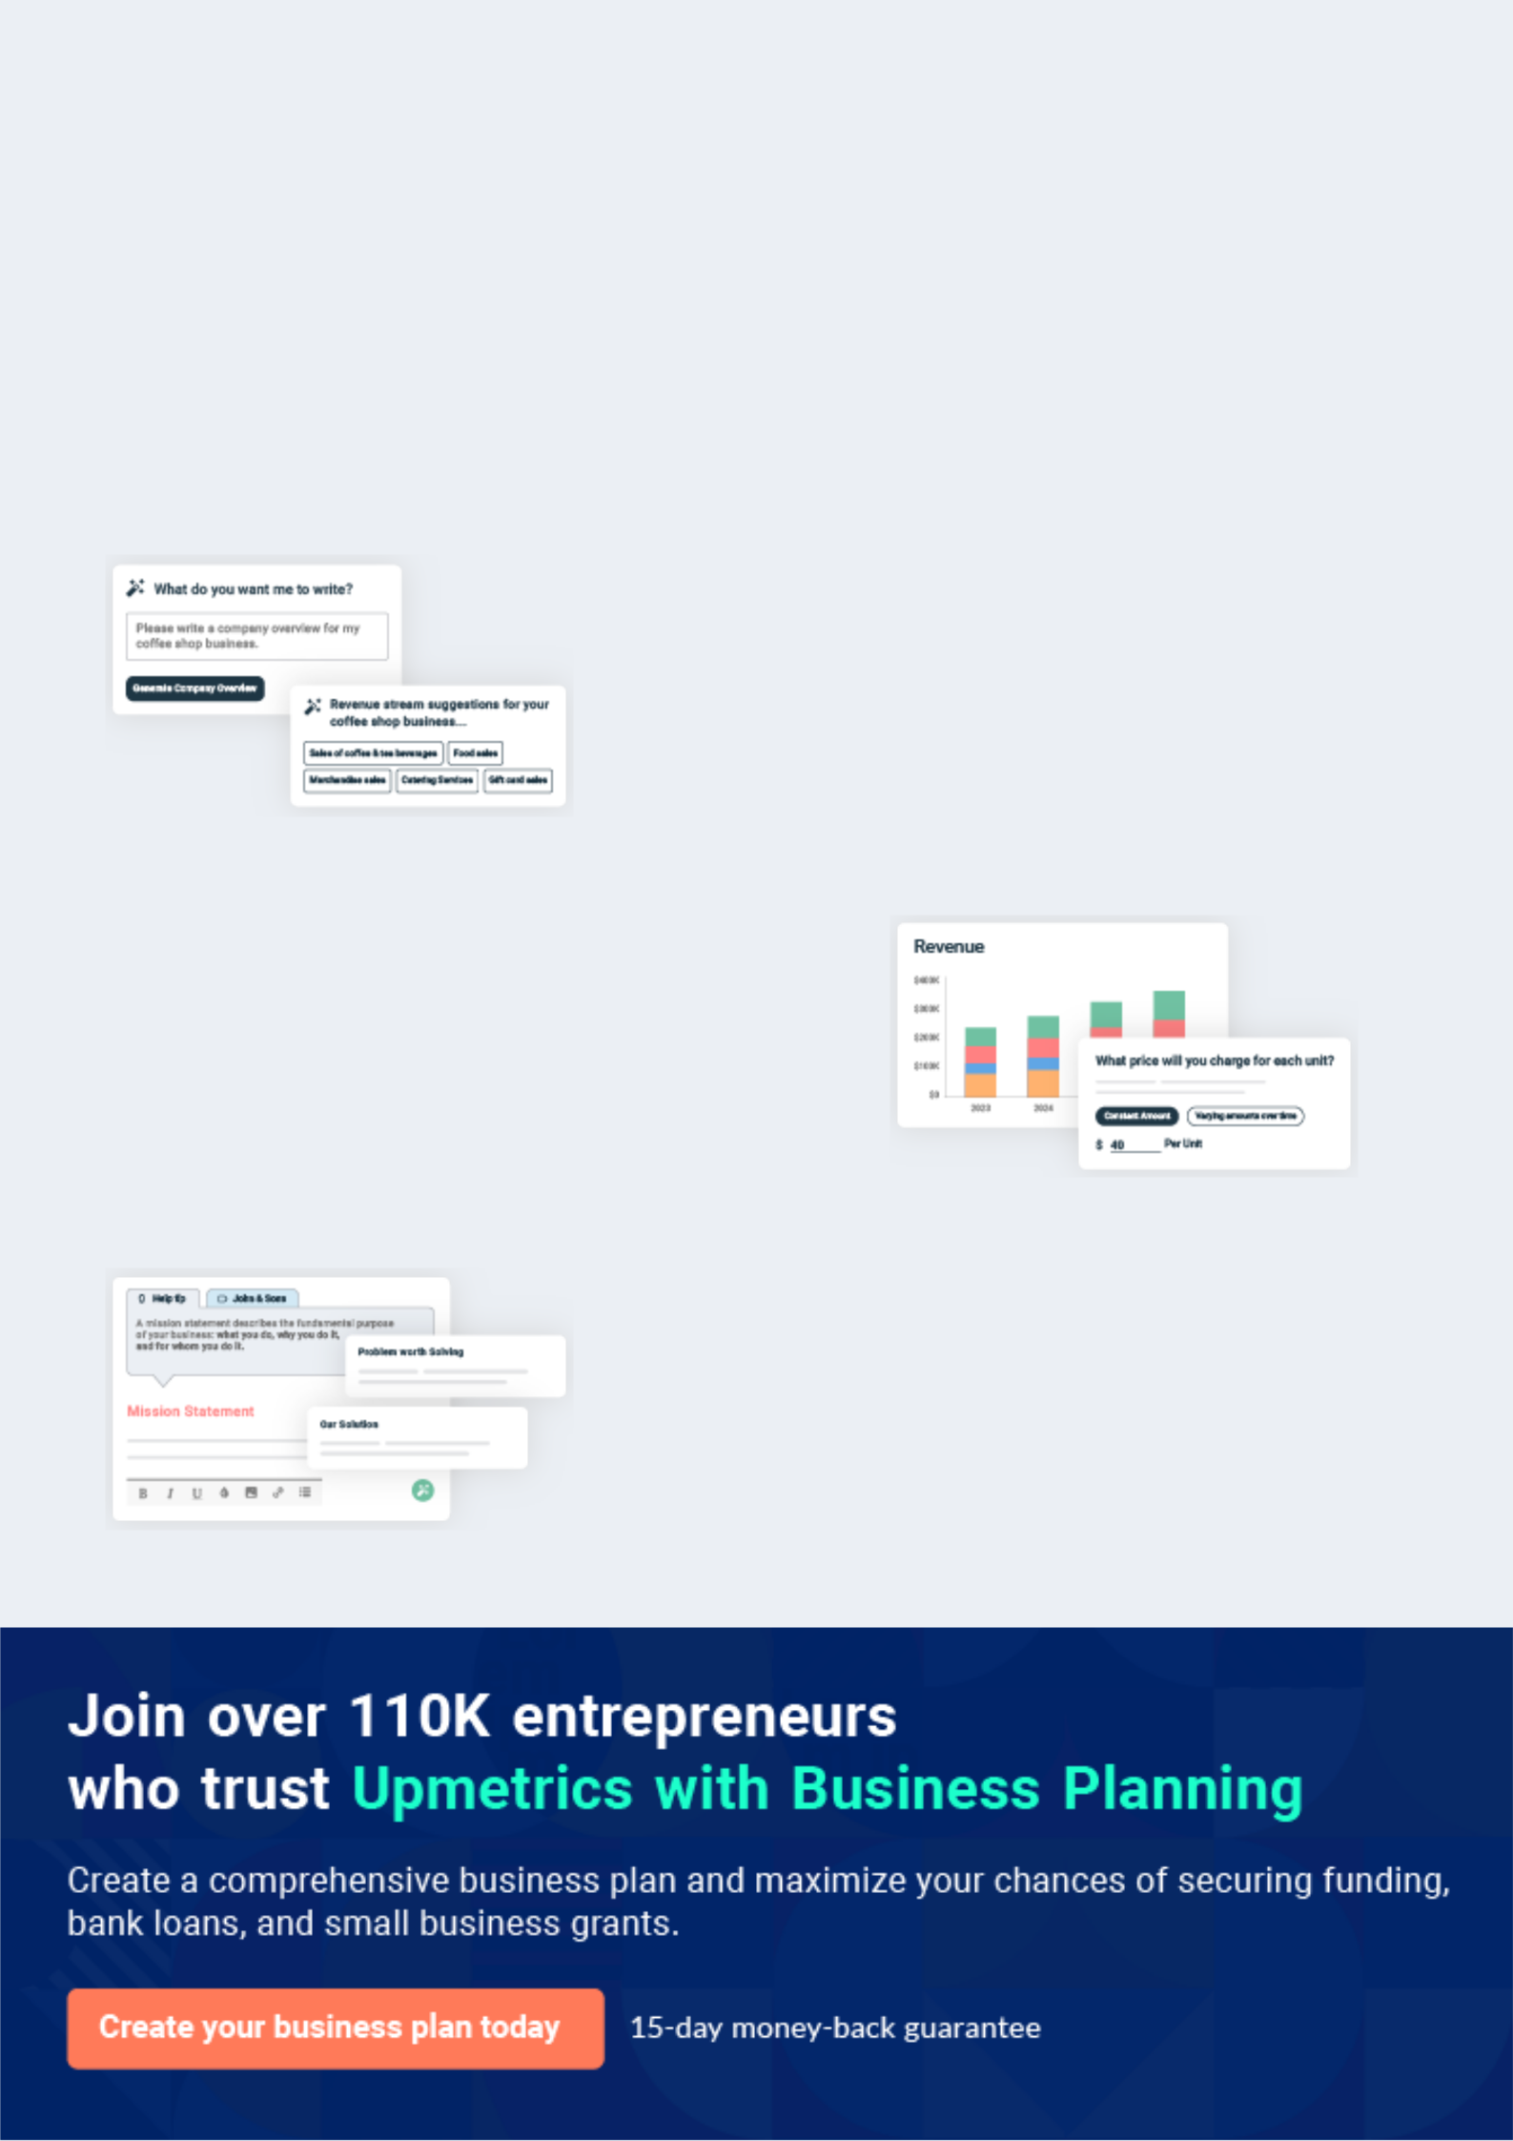
Business planning that’s simpler and faster than you think

Creating a business plan using Upmetrics to start and grow a business is literally the easiest thing in the World. Simply read the instructions and fill in the blanks. It’s as simple as that.

❛ | Upmetrics has everything you need to create a | ❜
❛ | comprehensive business plan. | ❜

AI-powered Upmetrics Assistant

AI-powered insights to streamline your plan

Not sure where to start? Upmetrics’ AI Assistant will automatically generate ideas for each section of your plan and offer improved versions of your writing, adjusting for tone, voice, and grammar or spelling errors.

Financial Forecasting Tool

All the financials are calculated for you

Forget the complex formulas and clumsy spreadsheets — with automatic financials and drag-and-drop forecasting, you can finish your plan faster and be confident that your numbers are accurate.

Business Plan Builder

Guides you like a business mentor

Upmetrics’ step-by-step instructions, prompts, and the library of 400+ sample business plans will guide you through each section of your plan as a business mentor.
Executive Summary


An executive summary is the first section of the business plan intended to provide an overview of the whole business plan.
To unlock help try Upmetrics! 

 Help tip  Electric Vehicle Business Plan


Start your executive summary by briefly introducing your business to your readers.

This section may include the name of your electric vehicle business, its location, when it was
To unlock help try Upmetrics! 

Start writing here..

Market opportunity

 Help tip  Electric Vehicle Business Plan

Summarize your market research, including market size, growth potential, and marketing trends. Highlight the opportunities in the market and how your business will fit in to fill the gap.
To unlock help try Upmetrics! 

Start writing here..

Services Offered

 Help tip  Electric Vehicle Business Plan

Highlight the electric vehicle services you offer your clients. The USPs and differentiators you offer are always a plus.
To unlock help try Upmetrics! 

Start writing here..

Marketing & Sales Strategies
To unlock help try Upmetrics!

 Help tip  Electric Vehicle Business Plan

Outline your sales and marketing strategies—what marketing platforms you use, how you plan on acquiring customers, etc.
To unlock help try Upmetrics! 

Start writing here..

Financial Highlights

 Help tip  Electric Vehicle Business Plan

Briefly summarize your financial projections for the initial years of business operations. Include any capital or investment requirements, associated startup costs, projected revenues, and profit forecasts.



Start writing here..
Units Sold v/s Revenue

 |  | Units Sold | Revenue
15.00k
10.00k
5.00k
0
Year 1 | Year 2 | Year 3


Financial Year |  |  | Units Sold | Revenue
Year 1 | 1,550 |  |  | $10,000
Year 2 | 1,800 |  |  | $12,000
Year 3 | 2,050 |  |  | $14,000
 Help tip |  |  Electric Vehicle Business Plan


Summarize your executive summary section with a clear CTA, for example, inviting angel investors to discuss the potential business investment.
To unlock help try Upmetrics! 

Write a call to action for your business plan.
Company Overview

Depending on what details of your business are essential, you’ll need different elements in your business overview.
To unlock help try Upmetrics! 

 Help tip  Electric Vehicle Business Plan

Describe your business in this section by providing all the basic information:

Describe what kind of electric vehicle company you run and the name of it. You may specialize
To unlock help try Upmetrics! 

Start writing here..

Ownership

 Help tip  Electric Vehicle Business Plan

List the names of your electric vehicle company’s founders or owners. Describe what shares they own and their responsibilities for efficiently managing the business.
To unlock help try Upmetrics! 

Start writing here..
Mission statement

 Help tip  Electric Vehicle Business Plan

Summarize your business’ objective, core principles, and values in your mission statement. This statement needs to be memorable, clear, and brief.
To unlock help try Upmetrics! 

- At [EcoMobil Ventures], our mission is to revolutionize the transportation sector, fostering sustainability and innovation in every stride. We are committed to delivering exceptional electric vehicles and services, contributing to a cleaner, greener planet.

We uphold integrity, excellence, and innovation as our core values, driving us to be leaders in sustainable mobility.

Business history

 Help tip  Electric Vehicle Business Plan

❜

If you’re an established electric vehicle service provider, briefly describe your business history, like—when it was founded, how it evolved over time, etc.
To unlock help try Upmetrics! 

Start writing here..

Future goals

 Help tip  Electric Vehicle Business Plan

It’s crucial to convey your aspirations and vision. Mention your short-term and long-term goals; they can be specific targets for revenue, market share, or expanding your services.
To unlock help try Upmetrics! 

Start writing here..

Market Analysis
To unlock help try Upmetrics!


 |  | Market analysis provides a clear understanding of the market in which your
 |  | printing business will run along with the target market, competitors, and
 |  | growth opportunities.
 |  |  |  | To unlock help try Upmetrics! 
 Help tip |  |  Electric Vehicle Business Plan

To write the introduction section of your market analysis, start by clearly identifying your primary target market.
To unlock help try Upmetrics! 

Start writing here..

Target Market

 Help tip  Electric Vehicle Business Plan

Start this section by describing your target market. Define your ideal customer and explain what types of services they prefer. Creating a buyer persona will help you easily define your target market to your readers.



Start writing here..

Market size and growth potential

 Help tip  Electric Vehicle Business Plan

Describe your market size and growth potential and whether you will target a niche or a much broader market.
To unlock help try Upmetrics! 

Start writing here..

Market Size

Available Market

All EV units potential customers could 100M buy globally

Served Market
Total EV units in our operational 25M regions

Target Market
EV units from urban areas and tech- 5M savvy consumers

 Help tip  Electric Vehicle Business Plan

Identify and analyze your direct and indirect competitors. Identify their strengths and weaknesses, and describe what differentiates your electric vehicle services from them.
To unlock help try Upmetrics! 

Competitive analysis

GreenSpeed Motors

GreenSpeed Motors is a well-established player in the EV market, known for their wide range of electric cars and robust charging infrastructure. They have been in the market for over a decade, with a significant share in the mid-range EV segment.

Features

Extensive line-up of electric cars ranging from compact to SUVs.

Wide network of fast-charging stations.

In-house developed battery technology with extended range.

Mobile app for vehicle monitoring and charging station locator.

Strengths Weaknesses

Strong brand recognition and Higher price point compared to

market presence. newer entrants.

Comprehensive charging Some reports of inconsistent

infrastructure battery performance.

Diverse product range catering Limited innovation in design in

to various customer needs. recent years.

Robust after-sales service and

support.

EcoDrive Innovations

EcoDrive Innovations is a rising star in the EV industry, gaining popularity for their affordable and innovative electric vehicles. They have a keen focus on integrating cutting-edge technology and sustainable practices in their operations.

Features

Affordable range of electric vehicles.

Innovative use of sustainable materials in vehicle production.

Partnership with third-party charging networks.

Active involvement in community-based sustainability initiatives.

Strengths

Competitive pricing strategy.

Strong emphasis on sustainability and innovation.

Engaged and positive brand image.

Agile and responsive to market trends.

Weaknesses

Limited range of vehicles available.

Smaller charging network compared to established players.

Less brand recognition and market trust.

VoltMotion Autos

VoltMotion Autos is a luxury electric vehicle manufacturer, renowned for their high-performance EVs and cutting-edge technology integration. They target the premium segment of the market, with a reputation for excellence and innovation.

Features Strengths Weaknesses

High-performance electric vehicles with impressive acceleration and top speed.

State-of-the-art autonomous driving capabilities.

Premium interior and advanced in-car technology.

Exclusive network of charging stations and customer service centers.

Strong position in the luxury EV segment.

Advanced technology and performance capabilities.

Exclusive and premium customer experience.

Robust research and development, leading to regular innovation.

Limited accessibility due to high pricing.

Niche market focus, with less appeal to the mass market.

Dependence on the premium segment may limit growth during economic downturns.

Market trends

 Help tip  Electric Vehicle Business Plan

Analyze emerging trends in the industry, such as technology disruptions, changes in customer behavior or preferences, etc. Explain how your business will cope with all the trends.
To unlock help try Upmetrics! 

Start writing here..

Regulatory environment

 Help tip  Electric Vehicle Business Plan

List regulations and licensing requirements that may affect your electric vehicle company, such as business registration, vehicle compliance and certification, intellectual property and patent rights, insurance, environmental regulations, state and federal regulations, etc.
To unlock help try Upmetrics! 

Start writing here..
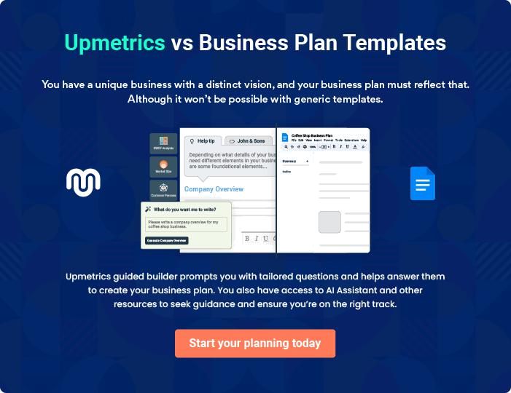
Products and Services
To unlock help try Upmetrics!

The product and services section of an electric vehicle business plan should describe the specific services and products that will be offered to customers. To write this section should include the following:



 Help tip  Electric Vehicle Business Plan

To craft the introduction for your "Products and Services" chapter, begin by positioning your business within its industry, emphasizing its unique strengths or value proposition.
To unlock help try Upmetrics! 

Start writing here..

 Help tip


Mention any physical or digital products that your electric vehicle company produces or sells. This list may include,
To unlock help try Upmetrics! 

Products & Services
EcoSprint Electric Scooter


Price: [$1,499]

The EcoSprint Electric Scooter is our flagship urban mobility solution, designed for the environmentally conscious city dweller. It offers a perfect blend of performance, convenience, and sustainability.

Specifications

- Top Speed: 20 mph

- Range: 40 miles per charge

- Charging Time: 4 hours

- Weight: 27 lbs

- Max Load: 220 lbs

- Battery: Lithium-ion, 36V 10.4Ah

- Motor: 350W brushless

EV Maintenance Package

Price: Starting at [$199]

Our EV Maintenance Package ensures your electric vehicle is always in top condition. It includes a comprehensive inspection, software updates, and essential part replacements.

Specifications

- Comprehensive vehicle inspection

- Software updates and optimization

- Battery health check

- Tire rotation and pressure check

- Brake inspection and service

- 12-month/12,000-mile warranty on all services
Home Charging Station

Price: [$699] (installation not included)

The EcoMobil Home Charging Station allows you to charge your electric vehicle quickly and conveniently at home. With its compact design and user-friendly interface, it's the perfect solution for EV owners.

Specifications

- Power: 7.4 kW

- Charging Speed: Up to 25 miles of range per hour

- Compatibility: All SAE J1772 compliant vehicles

- Installation: Professional installation recommended

- Warranty: 3 years

EV Fleet Consultation

Price: Customized based on client needs

Our EV Fleet Consultation service is designed for businesses looking to transition to an electric vehicle fleet. We provide expert advice, cost-benefit analysis, and implementation strategies.

Specifications

- Comprehensive fleet analysis

- Total Cost of Ownership (TCO) calculation

- Charging infrastructure advice

- Incentive and rebate navigation

- Transition and implementation planning
Quality Measures

 Help tip  Electric Vehicle Business Plan

This section should explain how you maintain quality standards and consistently provide the highest quality service.
To unlock help try Upmetrics! 

Start writing here..

Additional Services

 Help tip  Electric Vehicle Business Plan

Mention if your electric vehicle company offers any additional services. You may include services like insurance coverage, customization, software solutions, etc.
To unlock help try Upmetrics! 

Start writing here..
Sales And Marketing Strategies
To unlock help try Upmetrics!

Writing the sales and marketing strategies section means a list of strategies you will use to attract and retain your clients.
To unlock help try Upmetrics! 

 Help Tip  Electric Vehicle Business Plan


To create an effective introduction for your "Sales and Marketing Strategies" chapter, start by setting the stage within your specific industry or market.
To unlock help try Upmetrics! 

Start writing here..

Unique Selling Proposition (USP)

 Help tip  Electric Vehicle Business Plan

Define your business’s USPs depending on the market you serve, the equipment you use, and the unique services you provide. Identifying USPs will help you plan your marketing strategies.
To unlock help try Upmetrics! 

Start writing here..

Pricing Strategy

 Help tip  Electric Vehicle Business Plan

Describe your pricing strategy—how you plan to price your EV products and services and stay competitive in the local market. You can mention any subsidiary or discounts you plan on offering to attract customers in your EV segment.



Start writing here..

 Help tip  Electric Vehicle Business Plan

Discuss your marketing strategies to market your services. You may include some of these marketing strategies in your business plan—social media marketing, Google ads, brochures, email marketing, content marketing, influencer marketing, and print marketing.
To unlock help try Upmetrics! 

Marketing strategies

Online


Social Media

Leveraging platforms like Facebook, Instagram, and LinkedIn to connect with our audience and promote our products.

Content Marketing

Creating educational and engaging content to establish authority and drive organic traffic.

Email Marketing

Utilizing newsletters and promotional emails to nurture leads and keep our audience engaged.

Google Ads

Implementing targeted PPC campaigns to capture high-intent traffic.

 Help tip  Electric Vehicle Business Plan
To unlock help try Upmetrics!

Outline the strategies you’ll implement to maximize your sales. Your sales strategies may include test drives and demonstrations, partnerships with commercial businesses, government and large industries, targeted sales, etc.



Sales strategies

Partner with Businesses

Targeted Sales Initiatives

Forming strategic alliances with commercial businesses, government entities, and industries to expand our reach.

Implementing promotions and incentives for specific customer segments.

Test Drives and

Demonstrations

Offering hands-on experiences to

showcase our vehicles'

performance and features.

 Help tip  Electric Vehicle Business Plan
To unlock help try Upmetrics!

Describe your customer retention strategies and how you plan to execute them. For instance, introducing loyalty programs, exclusive events and experiences, proactive support, offers on maintenance and repair, etc.



Customer retention

Loyalty Programs

Proactive Support

Introducing rewards programs to incentivize repeat purchases.

Offering exceptional after-sales service and support.

Personalized Service

Maintenance and Repair Offers

Offering tailored solutions and dedicated account managers for personalized assistance.

Providing special rates and packages for vehicle servicing.

Operations Plan
To unlock help try Upmetrics!

 |  | When writing the operations plan section, it’s important to consider the
 |  | various aspects of your business operations.
 |  |  |  | To unlock help try Upmetrics! 
 Help tip |  |  Electric Vehicle Business Plan


To create an effective introduction for your "Operational Plan" chapter, start by emphasizing the
pivotal role of efficient operations in the success of your business, underscoring how they
directly impact the quality of services delivered.
 |  |  |  | To unlock help try Upmetrics! 
Start writing here..
Staffing & Training
 Help tip |  |  Electric Vehicle Business Plan

Mention your EV business’s staffing requirements, including the number of employees needed
in production, service, marketing, and supply chain. Include their qualifications, the training
required, and the duties they will perform.
 |  |  |  | To unlock help try Upmetrics! 
Start writing here..
Operational Process
 Help tip |  |  Electric Vehicle Business Plan

Outline the processes and procedures you will use to run your electric vehicle business. Your operational processes may include research and development, manufacturing, marketing, logistics, training, and regulatory checks.



Start writing here..

Equipment & Machinery

 Help tip  Electric Vehicle Business Plan

Include the list of equipment and machinery required for electric vehicles, such as manufacturing equipment, maintenance and repair equipment, service and repair tools, etc.
To unlock help try Upmetrics! 

Start writing here..
Management Team

The management team section provides an overview of the individuals responsible for running your business plan.
To unlock help try Upmetrics! 

 Help tip  Electric Vehicle Business Plan

To craft an introduction for your "Management Team" chapter, begin by emphasizing the crucial role of leadership in the success of any business.
To unlock help try Upmetrics! 

Start writing here..

Key managers

 Help tip  Electric Vehicle Business Plan

Introduce your management and key members of your team, and explain their roles and responsibilities.
To unlock help try Upmetrics! 

Start writing here..


JOHN DOE

CEO & Co-founder - john.doe@example.com

Serving as the CEO, John is a visionary entrepreneur with over [Number] years of experience in the electric vehicle industry.

He oversees the overall strategic direction of the company, ensuring alignment with our mission and values.


JANE DOE

CTO - jane.doe@example.com

Jane is a tech-savvy innovator with over 18 years of experience in product development and technology management, specifically in the electric vehicle industry.


She has a Ph.D. in Electrical Engineering from Stanford University and a Bachelor's in Computer Science from MIT.


ALICE BROWN

COO - alice.brown@example.com

Alice is a strategic thinker with over 15 years of experience in operations and project management within the electric vehicle industry.

She holds a Master’s Degree in Business Administration from Harvard University and a Bachelor's Degree in Mechanical Engineering from MIT.


ROBERT BROWN

CMO - robert.brown@example.com

With a passion for branding and a keen understanding of market dynamics, Robert has been at the forefront of marketing within the electric vehicle sector for over 12 years.

He has a Master’s in Marketing from the University of California and a Bachelor's in Communications from Stanford University.

Organizational structure

 Help tip  Electric Vehicle Business Plan

Explain the organizational structure of your management team. Include the reporting line and decision-making hierarchy.
To unlock help try Upmetrics! 

Start writing here..

Organization chart


John Doe

CEO


Alice Brown Robert Brown

COO CMO


William Smith

Jane Doe Marketing Specialist

CTO




Lily White Eva Green

Content Strategist Procurement Specialist

Compensation plan

 Help tip  Electric Vehicle Business Plan

Describe your compensation plan for the management and staff. Include their salaries, incentives, and other benefits.
To unlock help try Upmetrics! 

Start writing here..

 Help tip  Electric Vehicle Business Plan

Mentioning advisors or consultants in your business plans adds credibility to your business idea.
To unlock help try Upmetrics! 

Advisors/Consultants


DR. WILLIAM STONE

Advisor

A renowned figure in the EV industry, [Dr. Stone] provides valuable insights into market trends and technological advancements.


MS. LILY GREY

Consultant

With over [15] years as an automotive consultant, [Lily] aids in strategic positioning and market penetration strategies.

Engaging with these advisors not only lends credibility to our venture but also ensures we remain aligned with industry best practices and innovations.
Financial Plan

When writing the financial plan section of a business plan, it’s important to provide a comprehensive overview of your financial projections for the first few years of your business, You may provide the following:
To unlock help try Upmetrics! 

 Help tip  Electric Vehicle Business Plan


To create an effective introduction for your "Financial Plan" chapter, begin by stressing the critical role of a well-structured financial plan in the success of your venture.
To unlock help try Upmetrics! 

Start writing here..

 Help tip  Electric Vehicle Business Plan

Describe details such as projected revenue, operational costs, and service costs in your projected profit and loss statement. Make sure to include your business’s expected net profit or loss.
To unlock help try Upmetrics! 

Profit & loss statement

Revenue

Cost Of Sales

General Costs

Revenue Specific Costs

Personnel Costs (Direct

Labor)

Gross Margin

Gross Margin (%)

Operating Expense

Payroll Expense

(Indirect Labor)

General Expense

Bad Debt

Amortization of Current

Assets

2023-24 | 2024-25 | 2025-26 | 2026-27 | 2027-28
$0 | $0 | $0 | $0 | $0

$0 | $0 | $0 | $0 | $0
$0 | $0 | $0 | $0 | $0
$0 | $0 | $0 | $0 | $0
$0 | $0 | $0 | $0 | $0

$0 | $0 | $0 | $0 | $0
0% | 0% | 0% | 0% | 0%

$0 | $0 | $0 | $0 | $0
$0 | $0 | $0 | $0 | $0
$0 | $0 | $0 | $0 | $0
$0 | $0 | $0 | $0 | $0
$0 | $0 | $0 | $0 | $0

EBITDA

Additional Expense

Long Term

Depreciation

Gain or loss from Sale

of Assets

EBIT

Interest Expenses

EBT

Income Tax Expense

Total Expense

Net Income

Net Income (%)

2023-24 | 2024-25 | 2025-26 | 2026-27 | 2027-28
$0 | $0 | $0 | $0 | $0
$0 | $0 | $0 | $0 | $0
$0 | $0 | $0 | $0 | $0
$0 | $0 | $0 | $0 | $0
$0 | $0 | $0 | $0 | $0
$0 | $0 | $0 | $0 | $0
$0 | $0 | $0 | $0 | $0
$0 | $0 | $0 | $0 | $0
$0 | $0 | $0 | $0 | $0
$0 | $0 | $0 | $0 | $0
0% | 0% | 0% | 0% | 0%

 |  |  | 2023-24 |  | 2024-25 | 2025-26
Retained Earning |  |  | $0 |  | $0 | $0
Opening |  |  |  |  | $0 | $0
Owner's Distribution |  |  | $0 |  | $0 | $0
Retained Earning |  |  | $0 |  | $0 | $0
Closing |  |  |  |  | $0 | $0
 Help tip |  |  |  Electric Vehicle Business Plan


The cash flow for the first few years of your operation should be estimated and described in this section.

This may include billing invoices, payment receipts, loan payments, and any other cash flow statements.
2026-27 2027-28

$0 $0

$0 $0

$0 $0

To unlock help try Upmetrics! 

Cash flow statement

 | 2023-24 | 2024-25 | 2025-26 | 2026-27 | 2027-28
Cash Received | $0 | $0 | $0 | $0 | $0
Cash Paid | $0 | $0 | $0 | $0 | $0
COS & General Expenses | $0 | $0 | $0 | $0 | $0
Salary & Wages | $0 | $0 | $0 | $0 | $0
Interest | $0 | $0 | $0 | $0 | $0

Sales Tax

Income Tax

Net Cash From

Operations

Assets Sell

Assets Purchase

Net Cash From

Investments

Amount Received

Loan Received

Common Stock

Preferred Stock

Owner's Contribution

Amount Paid

2023-24 | 2024-25 | 2025-26 | 2026-27 | 2027-28
$0 | $0 | $0 | $0 | $0
$0 | $0 | $0 | $0 | $0
$0 | $0 | $0 | $0 | $0

$0 | $0 | $0 | $0 | $0
$0 | $0 | $0 | $0 | $0
$0 | $0 | $0 | $0 | $0

$0 | $0 | $0 | $0 | $0
$0 | $0 | $0 | $0 | $0

$0 | $0 | $0 | $0 | $0
$0 | $0 | $0 | $0 | $0
$0 | $0 | $0 | $0 | $0

Loan Capital $0 $0 $0 $0 $0

 |  |  | 2023-24 |  | 2024-25 | 2025-26 | 2026-27 | 2027-28
Dividends & Distributions |  |  | $0 |  | $0 | $0 | $0 | $0
Net Cash From |  |  | $0 |  | $0 | $0 | $0 | $0
Financing
Summary
Starting Cash |  |  | $0 |  | $0 | $0 | $0 | $0
Cash In |  |  | $0 |  | $0 | $0 | $0 | $0
Cash Out |  |  | $0 |  | $0 | $0 | $0 | $0
Change in Cash |  |  | $0 |  | $0 | $0 | $0 | $0
Ending Cash |  |  | $0 |  | $0 | $0 | $0 | $0
 Help tip |  |  Electric Vehicle Business Plan

Create a projected balance sheet documenting your electric vehicle business’s assets, liabilities, and equity.

To unlock help try Upmetrics! 

Balance sheet

 | 2023-24 | 2024-25 | 2025-26 | 2026-27 | 2027-28
Assets | $0 | $0 | $0 | $0 | $0
Current Assets | $0 | $0 | $0 | $0 | $0
Cash | $0 | $0 | $0 | $0 | $0
Accounts Receivable | $0 | $0 | $0 | $0 | $0
Inventory | $0 | $0 | $0 | $0 | $0
Other Current Assets | $0 | $0 | $0 | $0 | $0
Long Term Assets | $0 | $0 | $0 | $0 | $0
Gross Long Term Assets | $0 | $0 | $0 | $0 | $0
Accumulated Depreciation | $0 | $0 | $0 | $0 | $0

Liabilities & Equity | $0 | $0 | $0 | $0 | $0
Liabilities | $0 | $0 | $0 | $0 | $0
Current Liabilities | $0 | $0 | $0 | $0 | $0
Accounts Payable | $0 | $0 | $0 | $0 | $0
Income Tax Payable | $0 | $0 | $0 | $0 | $0
Sales Tax Payable | $0 | $0 | $0 | $0 | $0
Short Term Debt | $0 | $0 | $0 | $0 | $0
 | 2023-24 | 2024-25 | 2025-26 | 2026-27 | 2027-28
Long Term Liabilities | $0 | $0 | $0 | $0 | $0
Long Term Debt | $0 | $0 | $0 | $0 | $0
Equity | $0 | $0 | $0 | $0 | $0
Paid-in Capital | $0 | $0 | $0 | $0 | $0
Common Stock | $0 | $0 | $0 | $0 | $0
Preferred Stock | $0 | $0 | $0 | $0 | $0
Owner's Contribution | $0 | $0 | $0 | $0 | $0
Retained Earnings | $0 | $0 | $0 | $0 | $0

Check | $0 |  |  | $0 | $0 | $0 | $0
 Help tip |  |  Electric Vehicle Business Plan

Determine and mention your business’s break-even point—the point at which your business costs and revenue will be equal.

This exercise will help you understand how much revenue you need to generate to sustain or be profitable.
To unlock help try Upmetrics! 

Break-even Analysis

 | 2023-24 | 2024-25 | 2025-26 | 2026-27 | 2027-28
Starting Revenue | $0 | $0 | $0 | $0 | $0
Net Revenue | $0 | $0 | $0 | $0 | $0
Closing Revenue | $0 | $0 | $0 | $0 | $0

Starting Expense | $0 | $0 | $0 | $0 | $0
Net Expense | $0 | $0 | $0 | $0 | $0
Closing Expense | $0 | $0 | $0 | $0 | $0

Is Break Even? | 0 | 0 | 0 | 0 | 0
Break Even Month | 0 | 0 | 0 | 0 | 0
Days Required | 0 | 0 | 0 | 0 | 0
Break Even Revenue | $0 | $0 | $0 | $0 | $0
Break Even Units
Financing needs

 Help tip  Electric Vehicle Business Plan

Calculate costs associated with starting an electric vehicle business, and estimate your financing needs and how much capital you need to raise to operate your business.
To unlock help try Upmetrics! 

Start writing here..
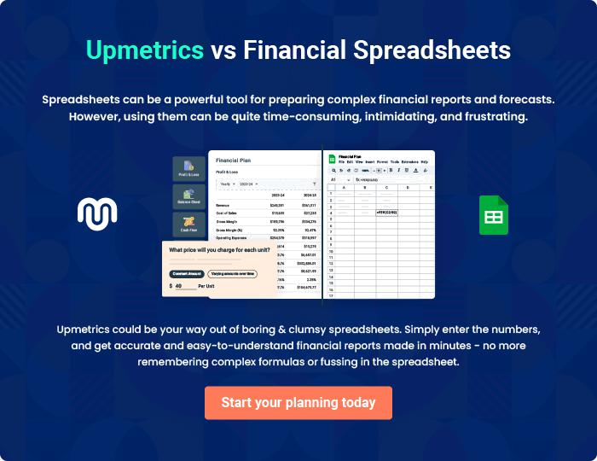
Appendix

When writing the appendix section, you should include any additional information that supports the main content of your plan. This may include financial statements, market research data, legal documents, and other
To unlock help try Upmetrics! 

Create a winning business plan that gets you funded

Creating a stunning and investment-ready plan requires no writing, graphic designing, or financial planning expertise.

Upmetrics has all the features required to help you create a comprehensive business plan—from start to finish. Make no mistakes, it’s the modern way of planning to structure ideas, make plans, and create stunning pitch decks to awe investors.

Pitch decks that impress investors

Create pitch decks that provide a visual representation of your business, engage investors, and make them want to invest in your business idea.

Interactive plans in no time

Import business plan sections like—SWOT analysis, comparison tables, and others to create an interactive business plan. No designing skills are required.

Stunning cover page designs

With Upmetrics, you have the liberty to choose from multiple stunning cover page designs. Choose a creative design and make your plan stand out.

Online sharing made simple

Upmetrics makes online sharing quick and easier for users. Easily share your business plans with a link while tracking reader activity.

500+ sample business plans

Simply import a template from our library of sample plans into the editor and start customizing it to make it yours. It takes only a few clicks to get started.

Collaborate with team in real-time

Invite team members, initiate conversations, discuss ideas & strategies, share feedback, and work on a business plan in real-time.

