
BUSINESS PLAN

2023
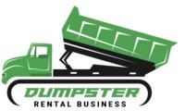

Dumpster Rental Business Plan

Streamlined Cleanup, Hassle-Free

John Doe

10200 Bolsa Ave, Westminster, CA, 92683

- 359-3153 info@example.com http://www.example.com

Information provided in this business plan is unique to this business and confidential; therefore, anyone reading this plan agrees not to disclose any of the information in this business plan without prior written permission of the company.
Table of Contents

Executive Summary | 6
Market opportunity | 6
Services Offered | 6
Marketing & Sales Strategies | 7
Financial Highlights | 7
Units Sold v/s Revenue | 8

Company Overview | 9
Ownership | 9
Business Owners | 9
Mission statement | 10
Business history | 10
Future goals | 10

Market Analysis | 11
Target Market | 11
Market size and growth potential | 11
Market Size | 12
Competitive analysis | 12
[WasteMaster Solutions | 12
EcoDump Services | 13
BuildClean Dumpsters | 13
Market trends | 13
Regulatory environment | 14

Products and Services | 15
Services | 15
Residential Dumpster Rental | 15
Commercial Dumpster Rental | 17
Construction Dumpster Rental | 17
Green Waste Dumpster Rental | 17
Waste Management Consultation | 18
Extended Rental Periods | 18
Quality Measures | 18
Additional Services | 19

Sales And Marketing Strategies | 20
Unique Selling Proposition (USP) | 20
Pricing Strategy | 20
Marketing strategies | 21
Online | 21
Offline | 21
Sales strategies | 22
Customer retention | 23

Operations Plan | 24
Staffing & Training | 24
Operational Process | 24
Equipment & Machinery | 25

Management Team | 26
Key managers | 26
John Doe | 26
Jane Smith | 27
Alex Brown | 27
Emily Clarke | 27
Robert Taylor | 27
Organizational structure | 28
Organization chart | 28
Compensation plan | 29
Advisors/Consultants | 29

Dr Linda Green 29

Financial Plan | 30
Profit & loss statement | 30
Cash flow statement | 33
Balance sheet | 35
Break-even Analysis | 37
Financing needs | 39
Appendix
Appendix | 41
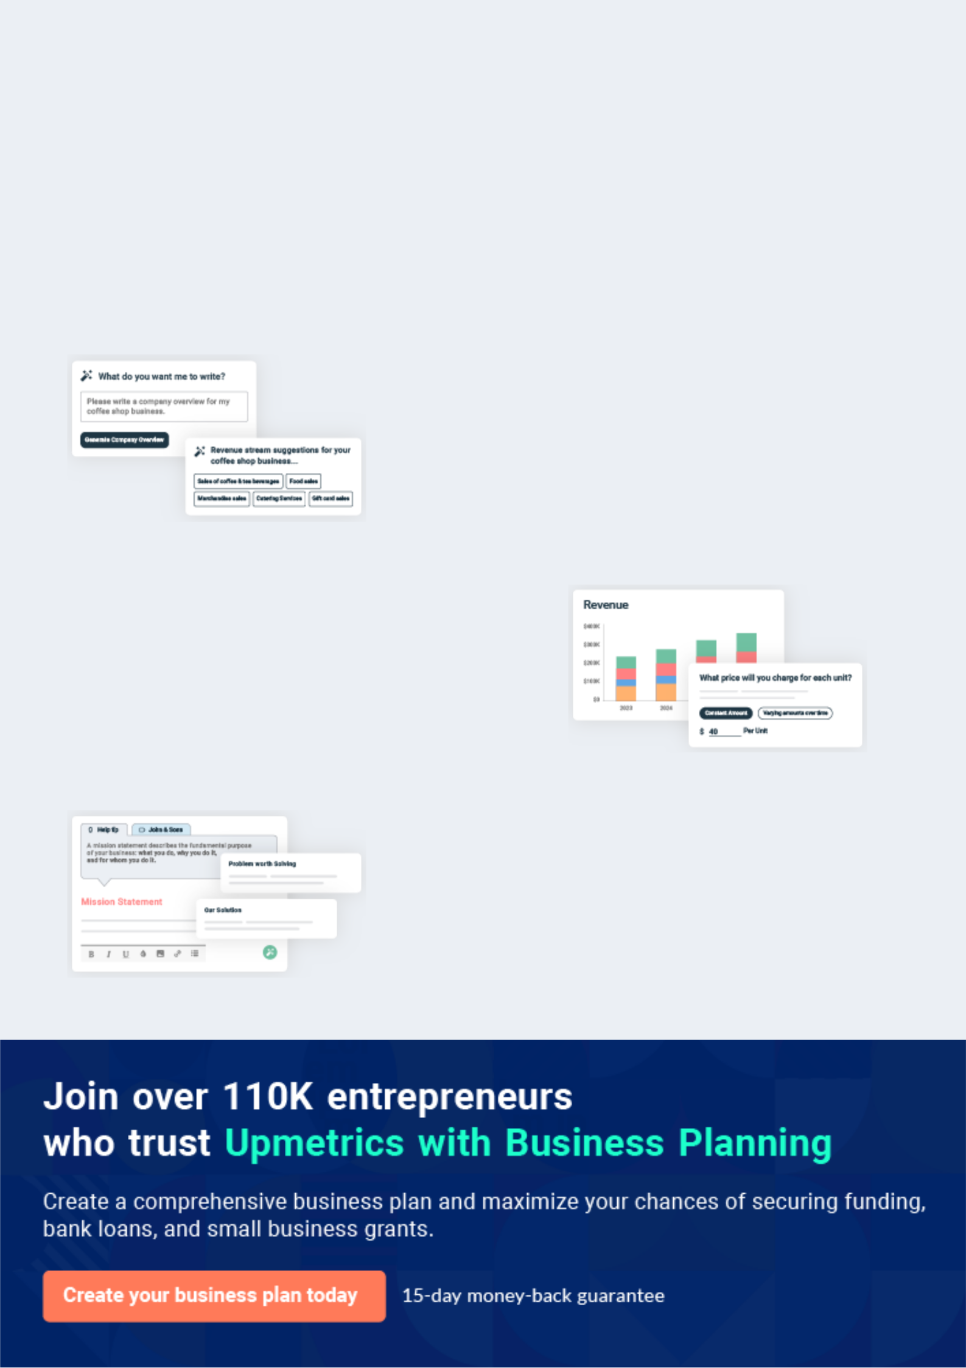
Business planning that’s simpler and faster than you think

Creating a business plan using Upmetrics to start and grow a business is literally the easiest thing in the World. Simply read the instructions and fill in the blanks. It’s as simple as that.

❛ | Upmetrics has everything you need to create a | ❜
❛ | comprehensive business plan. | ❜

AI-powered Upmetrics Assistant

AI-powered insights to streamline your plan

Not sure where to start? Upmetrics’ AI Assistant will automatically generate ideas for each section of your plan and offer improved versions of your writing, adjusting for tone, voice, and grammar or spelling errors.

Financial Forecasting Tool

All the financials are calculated for you

Forget the complex formulas and clumsy spreadsheets — with automatic financials and drag-and-drop forecasting, you can finish your plan faster and be confident that your numbers are accurate.

Business Plan Builder

Guides you like a business mentor

Upmetrics’ step-by-step instructions, prompts, and the library of 400+ sample business plans will guide you through each section of your plan as a business mentor.
Executive Summary


An executive summary is the first section of the business plan intended to provide an overview of the whole business plan.
To unlock help try Upmetrics! 

 Help tip  Dumpster Rental Business Plan


Start your executive summary by briefly introducing your business to your readers.

This section may include the name of your dumpster rental business, its location, when it was
To unlock help try Upmetrics! 

Start writing here..

Market opportunity

 Help tip  Dumpster Rental Business Plan

Summarize your market research, including market size, growth potential, and marketing trends. Highlight the opportunities in the market and how your business will fit in to fill the gap.
To unlock help try Upmetrics! 

Start writing here..

Services Offered

 Help tip  Dumpster Rental Business Plan

Highlight the dumpster rental services you offer your clients. The USPs and differentiators you offer are always a plus.
To unlock help try Upmetrics! 

Start writing here..

Marketing & Sales Strategies
To unlock help try Upmetrics!

 Help tip  Dumpster Rental Business Plan

Outline your sales and marketing strategies—what marketing platforms you use, how you plan on acquiring customers, etc.
To unlock help try Upmetrics! 

Start writing here..

Financial Highlights

 Help tip  Dumpster Rental Business Plan

Briefly summarize your financial projections for the initial years of business operations. Include any capital or investment requirements, associated startup costs, projected revenues, and profit forecasts.



Start writing here..
Units Sold v/s Revenue

 |  | Units Sold | Revenue
15.00k
10.00k
5.00k
0
Year 1 | Year 2 | Year 3


Financial Year |  |  | Units Sold | Revenue
Year 1 | 1,550 |  |  | $10,000
Year 2 | 1,800 |  |  | $12,000
Year 3 | 2,050 |  |  | $14,000
 Help tip |  |  Dumpster Rental Business Plan


Summarize your executive summary section with a clear CTA, for example, inviting angel investors to discuss the potential business investment.
To unlock help try Upmetrics! 

Write a call to action for your business plan.
Company Overview

Depending on what details of your business are essential, you’ll need different elements in your business overview.
To unlock help try Upmetrics! 

 Help tip  Dumpster Rental Business Plan

Describe your business in this section by providing all the basic information:

Describe what kind of dumpster rental company you run and the name of it. You may specialize
To unlock help try Upmetrics! 

Start writing here..

Ownership

 Help tip  Dumpster Rental Business Plan

List the names of your dumpster rental business’s founders or owners. Describe what shares they own and their responsibilities for efficiently managing the business.
To unlock help try Upmetrics! 

Start writing here..

Business Owners



60% John Doe



40% Jane Smith
Mission statement

 Help tip  Dumpster Rental Business Plan

Summarize your business’ objective, core principles, and values in your mission statement. This statement needs to be memorable, clear, and brief.
To unlock help try Upmetrics! 

❛ At [GreenEdge Dumpster Solutions], our mission is to provide unparalleled waste management solutions that blend efficiency, sustainability, and customer-centricity. We're committed to a greener future, working diligently to ensure our practices minimize environmental impact, serving every client with the

same level of dedication and respect.
❜

Business history

 Help tip  Dumpster Rental Business Plan

If you’re an established dumpster rental service provider, briefly describe your business history, like—when it was founded, how it evolved over time, etc.
To unlock help try Upmetrics! 

Start writing here..

Future goals

 Help tip  Dumpster Rental Business Plan

It’s crucial to convey your aspirations and vision. Mention your short-term and long-term goals; they can be specific targets for revenue, market share, or expanding your services.
To unlock help try Upmetrics! 

Start writing here..

Market Analysis
To unlock help try Upmetrics!


 |  | Market analysis provides a clear understanding of the market in which your
 |  | printing business will run along with the target market, competitors, and
 |  | growth opportunities.
 |  |  |  | To unlock help try Upmetrics! 
 Help tip |  |  Dumpster Rental Business Plan

To write the introduction section of your market analysis, start by clearly identifying your primary target market.
To unlock help try Upmetrics! 

Start writing here..

Target Market

 Help tip  Dumpster Rental Business Plan

Start this section by describing your target market. Define your ideal customer and explain what types of services they prefer. Creating a buyer persona will help you easily define your target market to your readers.



Start writing here..

Market size and growth potential

 Help tip  Dumpster Rental Business Plan

Describe your market size and growth potential and whether you will target a niche or a much broader market.
To unlock help try Upmetrics! 

Start writing here..

Market Size

Available Market

The total number of waste-producing | 2M
units (homes, businesses, events) in the | 2M
[City/Region].
Served Market | 1M
Units currently using dumpster rental | 1M
services in the [City/Region]. | 1M
Target Market | 750k
Eco-conscious units preferring | 750k
sustainable waste management in the | 750k

[City/Region].

 Help tip  Dumpster Rental Business Plan

Identify and analyze your direct and indirect competitors. Identify their strengths and weaknesses, and describe what differentiates your dumpster rental services from them.
To unlock help try Upmetrics! 

Competitive analysis

[WasteMaster Solutions

Established in 20[XX], [WasteMaster Solutions] has been a leading player in the [City/Region]'s waste management scene. With a fleet of over [XXX] dumpsters, they cater primarily to commercial and residential customers.

Features | Strengths | Weaknesses
Broad range of dumpster sizes | Extensive market presence and | Limited focus on sustainable or
from [XX] to [XX] yards. | brand recognition. | green disposal methods.
24/7 customer service support. | A vast fleet allowing wide | Reports of delayed pickups and
Online booking and payment | coverage. | deliveries.
system. | Strong digital infrastructure for | Higher pricing compared to
 | easy bookings. | market average

EcoDump Services

[EcoDump Services], founded in 20[YY], is a modern player emphasizing eco-friendly waste disposal.

They cater mainly to green waste and event-based dumpster rentals.

Features | Strengths
Specialized dumpsters for | Strong branding around
green waste and biodegradable | sustainable and eco-friendly
materials. | services.
Partnership with recycling | Collaborations with
centers. | environmental organizations
Eco-conscious waste | and events.
segregation and disposal | Tailored solutions for specific
services. | waste types.

Weaknesses

Limited fleet size.

Narrow focus, leaving out significant market segments.

Narrow focus, leaving out significant market segments. Occasional lack of availability during peak seasons.

BuildClean Dumpsters

Having started operations in 20[ZZ], [BuildClean Dumpsters] specializes in serving contractors, construction sites, and home improvement professionals.

Features | Strengths
Heavy-duty dumpsters | Tailored solutions for the
designed for construction | construction sector
debris. | Quick turnaround times.
On-site waste segregation | Competitive pricing for long-
services. | Competitive pricing for long-
services. | term rentals.
Flexible long-term rental
options.

Weaknesses

Exclusive focus on construction waste, missing out on other market opportunities.

Less emphasis on digital marketing and online presence.

Limited customer service support.

Market trends

 Help tip  Dumpster Rental Business Plan

Analyze emerging trends in the industry, such as technology disruptions, changes in customer behavior or preferences, etc. Explain how your business will cope with all the trends.
To unlock help try Upmetrics! 

Start writing here..

Regulatory environment
To unlock help try Upmetrics!

 Help tip  Dumpster Rental Business Plan

List regulations and licensing requirements that may affect your dumpster rental company, such as permits & licenses, health & safety standards, zoning & land use regulations, waste disposal regulations, etc.



Start writing here..
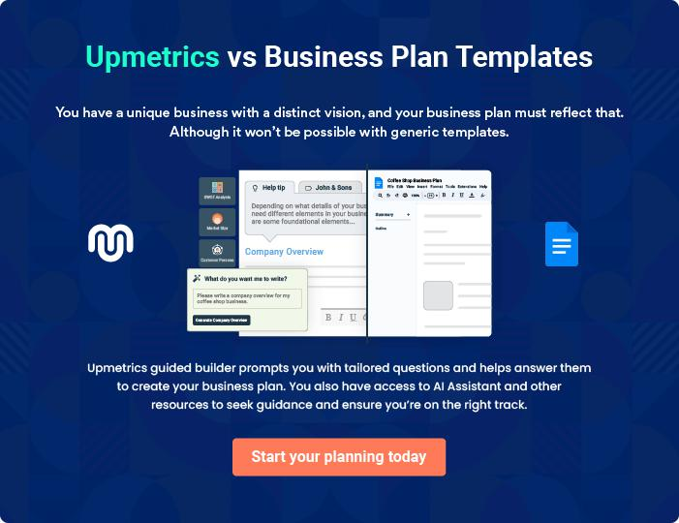
Products and Services
To unlock help try Upmetrics!

The product and services section of a dumpster rental business plan should describe the specific services and products that will be offered to customers. To write this section should include the following:



 Help tip  Dumpster Rental Business Plan

To craft the introduction for your "Products and Services" chapter, begin by positioning your business within its industry, emphasizing its unique strengths or value proposition.
To unlock help try Upmetrics! 

Start writing here..

 Help tip


Mention the dumpster rental services your business will offer. This list may include services like,
To unlock help try Upmetrics! 

Services

Residential Dumpster Rental


Price: 10-yard dumpster: $[150] per week 20-yard dumpster: $[250] per week 30-yard dumpster: $[325] per week

Ideal for home cleanouts, small renovation projects, or seasonal cleaning, our residential dumpsters make waste disposal a breeze.
Specifications

•

- Material: Heavy-duty steel

- Weight Limit: Varies by size (10-yard: [2,000 lbs.], 20-

yard: [4,000 lbs.], 30-yard: [6,000 lbs.])

- Features: Walk-in doors, easy-load design, driveway-friendly wheels
Commercial Dumpster Rental

Price: Monthly flat rate: $[350]

Perfect for businesses, offices, or commercial spaces, these dumpsters cater to regular waste disposal needs.

Specifications

- Material: Reinforced steel

- Capacity: [8] cubic yards

- Features: Sliding lids, odor control, scheduled pickups

Construction Dumpster Rental

Price: 20-yard dumpster: $[275] per week 40-yard

dumpster: $[450] per week

Designed for construction sites, handling heavy debris like concrete, bricks, and tiles.

Specifications

- Material: Rugged steel

- Weight Limit: 20-yard: [10,000 lbs.], 40-yard: [20,000 lbs.]

- Features: Large walk-in doors, reinforced base, and sides

Green Waste Dumpster Rental

Price: 15-yard dumpster: $[200] per week

Specially crafted for garden, yard, or organic waste, ensuring compostable materials are correctly handled.

Specifications

- Material: Eco-friendly materials

- Weight Limit: [3,500 lbs.]

- Features: Ventilation for odour control, compostable bag lining
Waste Management Consultation

Price: $[50] per hour

Our experts evaluate your waste disposal needs and provide tailored recommendations.

Specifications

- Service Mode: On-site or virtual

- Duration: Typically [1-2] hours

- Includes: Waste audit, tailored disposal strategy, recycling recommendations

Extended Rental Periods

Price: Additional $[50] per day beyond the standard week

For projects that require more time, we offer easy and affordable rental extensions.

Specifications

- Duration: Daily increments

- Availability: Based on dumpster availability

- Notification: Clients must notify [24] hours before rental expiration

Quality Measures

 Help tip  Dumpster Rental Business Plan

This section should explain how you maintain quality standards and consistently provide the highest quality service.
To unlock help try Upmetrics! 

Start writing here..

Additional Services

 Help tip  Dumpster Rental Business Plan

Mention any other services your company provides to improve client satisfaction or offer all-encompassing waste management solutions.
To unlock help try Upmetrics! 

Start writing here..
Sales And Marketing Strategies

Writing the sales and marketing strategies section means a list of strategies you will use to attract and retain your clients.
To unlock help try Upmetrics! 

 Help tip  Dumpster Rental Business Plan

To create an effective introduction for your "Sales and Marketing Strategies" chapter, start by setting the stage within your specific industry or market.
To unlock help try Upmetrics! 

Unique Selling Proposition (USP)

 Help tip  Dumpster Rental Business Plan

Define your business’s USPs depending on the market you serve, the equipment you use, and the unique services you provide. Identifying USPs will help you plan your marketing strategies.
To unlock help try Upmetrics! 

Start writing here..

Pricing Strategy

 Help tip  Dumpster Rental Business Plan

Describe your pricing strategy—how you plan to price your services and stay competitive in the local market. You can mention any discounts you plan on offering to attract new customers.
To unlock help try Upmetrics! 

Start writing here..

 Help tip  Dumpster Rental Business Plan
To unlock help try Upmetrics!

Discuss your marketing strategies to market your services. You may include some of these marketing strategies in your business plan—social media marketing, local advertising, content marketing, and print marketing.



Marketing strategies

Online


Social Media

Leveraging platforms like Facebook, Instagram, and LinkedIn to engage with potential clients, share client testimonials, and showcase our sustainable initiatives.

Content Marketing

Regular blog posts and articles related to waste management, recycling tips, and best practices, establish us as thought leaders in the industry.

Offline

Local Advertising

Targeted ads in local newspapers, magazines, and community bulletins to reach our primary audience.

Email Marketing

Regular newsletters and updates to our subscriber base.

Print Marketing

Brochures, flyers, and banners for local events and trade shows, ensuring offline brand visibility.

 Help tip
To unlock help try Upmetrics!

Outline the strategies you’ll implement to maximize your sales. Your sales strategies may include upselling & cross-selling, partnering with other businesses, offering referral programs, etc.



Sales strategies

Partner with Businesses

Collaborating with local businesses, especially in construction and events, to offer bundled services or referrals.

Referral Programs

Providing incentives to current clients who bring in new customers, creates a win-win situation.

Upselling & Cross-selling

Offering complementary services or larger packages when appropriate, maximizing value for our clients and increasing sales potential.

 Help tip

Describe your customer retention strategies and how you plan to execute them. For instance, introducing loyalty programs, discounts on annual membership, personalized service, etc.
To unlock help try Upmetrics! 

Customer retention

Loyalty Programs

Offering discounts and benefits to frequent clients, reinforcing our commitment to their continued business.

Personalized Service

Ensuring every client feels valued by catering to their specific needs, understanding their concerns, and providing tailored solutions.

Annual Membership Plans

Offering premium services, quicker response times, and priority bookings for members.

Operations Plan
To unlock help try Upmetrics!

 |  | When writing the operations plan section, it’s important to consider the
 |  | various aspects of your business operations.
 |  |  |  | To unlock help try Upmetrics! 
 Help tip |  |  Dumpster Rental Business Plan


To create an effective introduction for your "Operational Plan" chapter, start by emphasizing the
pivotal role of efficient operations in the success of your business, underscoring how they
directly impact the quality of services delivered.
 |  |  |  | To unlock help try Upmetrics! 
Start writing here..
Staffing & Training
 Help tip |  |  Dumpster Rental Business Plan

Mention your business’s staffing requirements, including the number of employees or cleaning staff needed. Include their qualifications, the training required, and the duties they will perform.
To unlock help try Upmetrics! 

Start writing here..

Operational Process

 Help tip  Dumpster Rental Business Plan

Outline the processes and procedures you will use to run your dumpster rental business. Your operational processes may include customer inquiry & booking, waste removal & pickup, record keeping & documentation, etc.



Start writing here..

Equipment & Machinery

 Help tip  Dumpster Rental Business Plan

Include the list of equipment and machinery required for dumpster rental, such as delivery trucks, lift mechanisms, safety equipment, etc.
To unlock help try Upmetrics! 

Start writing here..
Management Team

The management team section provides an overview of the individuals responsible for running your business plan.
To unlock help try Upmetrics! 

 Help tip  Dumpster Rental Business Plan

To craft an introduction for your "Management Team" chapter, begin by emphasizing the crucial role of leadership in the success of any business.
To unlock help try Upmetrics! 

Start writing here..

Key managers

 Help tip  Dumpster Rental Business Plan

Introduce your management and key members of your team, and explain their roles and responsibilities.
To unlock help try Upmetrics! 

Start writing here..


JOHN DOE

CEO & Co-founder - john.doe@example.com

John is the visionary leader behind [GreenEdge Dumpster Solutions]. Holding an MBA from Stanford University, he has accumulated over [15] years of experience in the waste management sector.


He began his journey as an operations manager at [Previous Company Name], where he scaled operations in three states.

John's keen sense of market dynamics and sustainability principles led him to co-found [GreenEdge], aiming to revolutionize the dumpster rental industry with innovative solutions.

JANE SMITH

Chief Operating Officer (COO) - jane.smith@example.com

With a stellar academic record, Jane graduated summa cum laude from MIT with a degree in Operational Research.

She has been instrumental in shaping [GreenEdge]'s operational excellence with her decade-long experience in waste management.


Prior to joining [GreenEdge], she was the director of operations at [Previous Company Name], a nationwide waste disposal company.


ALEX BROWN

Chief Technology Officer (CTO) - alex.brown@example.com

Alex, an alumnus of the Wharton School of Business, brings a blend of creative strategy and analytical acumen to [GreenEdge].

His [12] years in marketing for environmental services have helped [GreenEdge] establish a robust brand presence in a short span.

Previously, Alex led successful campaigns as the Marketing Head for [Previous Company Name], a global recycling firm.


EMILY CLARKE

Operations Manager - emily.clarke@example.com

Emily, a graduate in Logistics and Supply Chain Management from the University of Michigan, has been pivotal in streamlining [GreenEdge]'s operations.

With [8] years in logistics management for environmental solutions, Emily's expertise ensures timely service delivery and operational efficiency.


ROBERT TAYLOR

Customer Service Manager - robert.taylor@example.com

Holding a degree in Communication Studies from UCLA, Robert has spent the last [10] years perfecting customer relations in the waste management industry.

At [GreenEdge], he leads a dedicated team ensuring that client interactions are always positive, addressing grievances and feedback with professionalism.

Organizational structure

 Help tip  Dumpster Rental Business Plan

Explain the organizational structure of your management team. Include the reporting line and decision-making hierarchy.
To unlock help try Upmetrics! 

Start writing here..

Organization chart


John Doe

CEO


Alex Brown

Jane Smith

CMO


COO


Robert Taylor

Emily Clarke

Customer Service Manager


Operations Manager


Samantha White

Michael Ross

HR Manager

Field Supervisor

Compensation plan

 Help tip  Dumpster Rental Business Plan

Describe your compensation plan for the management and staff. Include their salaries, incentives, and other benefits.
To unlock help try Upmetrics! 

Start writing here..

 Help tip

Mentioning advisors or consultants in your business plans adds credibility to your business idea.
To unlock help try Upmetrics! 

Advisors/Consultants


DR LINDA GREEN

Waste Management Consultant

With [X years] of experience in sustainable waste management practices, Dr. Linda brings valuable insights to our waste disposal methodologies and helps us stay environmentally responsible
Financial Plan

When writing the financial plan section of a business plan, it’s important to provide a comprehensive overview of your financial projections for the first few years of your business, You may provide the following:
To unlock help try Upmetrics! 

 Help tip  Dumpster Rental Business Plan


To create an effective introduction for your "Financial Plan" chapter, begin by stressing the critical role of a well-structured financial plan in the success of your venture.
To unlock help try Upmetrics! 

Start writing here..

 Help tip


Describe details such as projected revenue, operational costs, and service costs in your projected profit and loss statement. Make sure to include your business’s expected net profit or loss.
To unlock help try Upmetrics! 

Profit & loss statement

Revenue

Cost Of Sales

General Costs

Revenue Specific Costs

Personnel Costs (Direct

Labor)

Gross Margin

Gross Margin (%)

Operating Expense

Payroll Expense

(Indirect Labor)

General Expense

Bad Debt

Amortization of Current

Assets

2023-24 | 2024-25 | 2025-26 | 2026-27 | 2027-28
$0 | $0 | $0 | $0 | $0

$0 | $0 | $0 | $0 | $0
$0 | $0 | $0 | $0 | $0
$0 | $0 | $0 | $0 | $0
$0 | $0 | $0 | $0 | $0

$0 | $0 | $0 | $0 | $0
0% | 0% | 0% | 0% | 0%

$0 | $0 | $0 | $0 | $0
$0 | $0 | $0 | $0 | $0
$0 | $0 | $0 | $0 | $0
$0 | $0 | $0 | $0 | $0
$0 | $0 | $0 | $0 | $0

EBITDA

Additional Expense

Long Term

Depreciation

Gain or loss from Sale

of Assets

EBIT

Interest Expenses

EBT

Income Tax Expense

Total Expense

Net Income

Net Income (%)

2023-24 | 2024-25 | 2025-26 | 2026-27 | 2027-28
$0 | $0 | $0 | $0 | $0
$0 | $0 | $0 | $0 | $0
$0 | $0 | $0 | $0 | $0
$0 | $0 | $0 | $0 | $0
$0 | $0 | $0 | $0 | $0
$0 | $0 | $0 | $0 | $0
$0 | $0 | $0 | $0 | $0
$0 | $0 | $0 | $0 | $0
$0 | $0 | $0 | $0 | $0
$0 | $0 | $0 | $0 | $0
0% | 0% | 0% | 0% | 0%
 | 2023-24 | 2024-25 | 2025-26 | 2026-27 | 2027-28
Retained Earning | $0 | $0 | $0 | $0 | $0
Opening
Owner's Distribution | $0 | $0 | $0 | $0 | $0
Retained Earning | $0 | $0 | $0 | $0 | $0
Closing

 Help tip

The cash flow for the first few years of your operation should be estimated and described in this section. This may include billing invoices, payment receipts, loan payments, and any other cash flow statements.
To unlock help try Upmetrics! 

Cash flow statement

 | 2023-24 | 2024-25 | 2025-26 | 2026-27 | 2027-28
Cash Received | $0 | $0 | $0 | $0 | $0
Cash Paid | $0 | $0 | $0 | $0 | $0
COS & General Expenses | $0 | $0 | $0 | $0 | $0
Salary & Wages | $0 | $0 | $0 | $0 | $0
Interest | $0 | $0 | $0 | $0 | $0

Sales Tax

Income Tax

Net Cash From

Operations

Assets Sell

Assets Purchase

Net Cash From

Investments

Amount Received

Loan Received

Common Stock

Preferred Stock

Owner's Contribution

Amount Paid

2023-24 | 2024-25 | 2025-26 | 2026-27 | 2027-28
$0 | $0 | $0 | $0 | $0
$0 | $0 | $0 | $0 | $0
$0 | $0 | $0 | $0 | $0

$0 | $0 | $0 | $0 | $0
$0 | $0 | $0 | $0 | $0
$0 | $0 | $0 | $0 | $0

$0 | $0 | $0 | $0 | $0
$0 | $0 | $0 | $0 | $0

$0 | $0 | $0 | $0 | $0
$0 | $0 | $0 | $0 | $0
$0 | $0 | $0 | $0 | $0

Loan Capital $0 $0 $0 $0 $0

 | 2023-24 | 2024-25 | 2025-26 | 2026-27 | 2027-28
Dividends & Distributions | $0 | $0 | $0 | $0 | $0
Net Cash From | $0 | $0 | $0 | $0 | $0
Financing

Summary
Starting Cash | $0 | $0 | $0 | $0 | $0
Cash In | $0 | $0 | $0 | $0 | $0
Cash Out | $0 | $0 | $0 | $0 | $0
Change in Cash | $0 | $0 | $0 | $0 | $0
Ending Cash | $0 | $0 | $0 | $0 | $0

 Help tip

Create a projected balance sheet documenting your dumpster rental business’s assets, liabilities, and equity.

To unlock help try Upmetrics! 

Balance sheet

 | 2023-24 | 2024-25 | 2025-26 | 2026-27 | 2027-28
Assets | $0 | $0 | $0 | $0 | $0
Current Assets | $0 | $0 | $0 | $0 | $0
Cash | $0 | $0 | $0 | $0 | $0
Accounts Receivable | $0 | $0 | $0 | $0 | $0
Inventory | $0 | $0 | $0 | $0 | $0
Other Current Assets | $0 | $0 | $0 | $0 | $0
Long Term Assets | $0 | $0 | $0 | $0 | $0
Gross Long Term Assets | $0 | $0 | $0 | $0 | $0
Accumulated Depreciation | $0 | $0 | $0 | $0 | $0

Liabilities & Equity | $0 | $0 | $0 | $0 | $0
Liabilities | $0 | $0 | $0 | $0 | $0
Current Liabilities | $0 | $0 | $0 | $0 | $0
Accounts Payable | $0 | $0 | $0 | $0 | $0
Income Tax Payable | $0 | $0 | $0 | $0 | $0
Sales Tax Payable | $0 | $0 | $0 | $0 | $0
Short Term Debt | $0 | $0 | $0 | $0 | $0
 | 2023-24 | 2024-25 | 2025-26 | 2026-27 | 2027-28
Long Term Liabilities | $0 | $0 | $0 | $0 | $0
Long Term Debt | $0 | $0 | $0 | $0 | $0
Equity | $0 | $0 | $0 | $0 | $0
Paid-in Capital | $0 | $0 | $0 | $0 | $0
Common Stock | $0 | $0 | $0 | $0 | $0
Preferred Stock | $0 | $0 | $0 | $0 | $0
Owner's Contribution | $0 | $0 | $0 | $0 | $0
Retained Earnings | $0 | $0 | $0 | $0 | $0

Check | $0 |  |  | $0 | $0 | $0 | $0
 Help Tip |  |  Dumpster Rental Business Plan


Determine and mention your business’s break-even point—the point at which your business costs and revenue will be equal.

This exercise will help you understand how much revenue you need to generate to sustain or be profitable.
To unlock help try Upmetrics! 

Break-even Analysis

 | 2023-24 | 2024-25 | 2025-26 | 2026-27 | 2027-28
Starting Revenue | $0 | $0 | $0 | $0 | $0
Net Revenue | $0 | $0 | $0 | $0 | $0
Closing Revenue | $0 | $0 | $0 | $0 | $0

Starting Expense | $0 | $0 | $0 | $0 | $0
Net Expense | $0 | $0 | $0 | $0 | $0
Closing Expense | $0 | $0 | $0 | $0 | $0

Is Break Even? | 0 | 0 | 0 | 0 | 0
Break Even Month | 0 | 0 | 0 | 0 | 0
Days Required | 0 | 0 | 0 | 0 | 0
Break Even Revenue | $0 | $0 | $0 | $0 | $0
Break Even Units
Financing needs

 Help tip  Dumpster Rental Business Plan

Calculate costs associated with starting a dumpster rental business, and estimate your financing needs and how much capital you need to raise to operate your business.
To unlock help try Upmetrics! 

Start writing here..
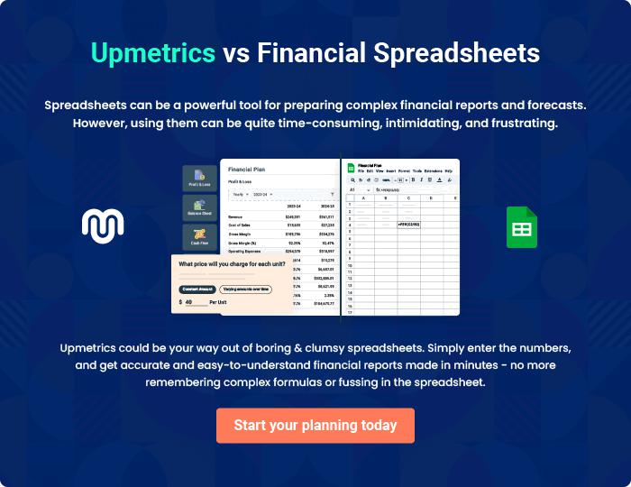
Appendix

When writing the appendix section, you should include any additional information that supports the main content of your plan. This may include financial statements, market research data, legal documents, and other
To unlock help try Upmetrics! 
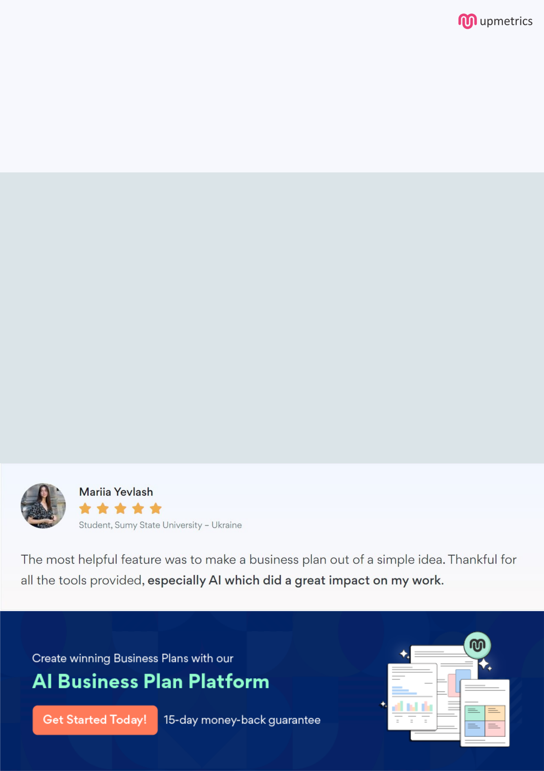
Create a winning business plan that gets you funded

Creating a stunning and investment-ready plan requires no writing, graphic designing, or financial planning expertise.

Upmetrics has all the features required to help you create a comprehensive business plan—from start to finish. Make no mistakes, it’s the modern way of planning to structure ideas, make plans, and create stunning pitch decks to awe investors.

Pitch decks that impress investors

Create pitch decks that provide a visual representation of your business, engage investors, and make them want to invest in your business idea.

Interactive plans in no time

Import business plan sections like—SWOT analysis, comparison tables, and others to create an interactive business plan. No designing skills are required.

Stunning cover page designs

With Upmetrics, you have the liberty to choose from multiple stunning cover page designs. Choose a creative design and make your plan stand out.

Online sharing made simple

Upmetrics makes online sharing quick and easier for users. Easily share your business plans with a link while tracking reader activity.

500+ sample business plans

Simply import a template from our library of sample plans into the editor and start customizing it to make it yours. It takes only a few clicks to get started.

Collaborate with team in real-time

Invite team members, initiate conversations, discuss ideas & strategies, share feedback, and work on a business plan in real-time.

