
 Dry Cleaning Business Plan

ADDRESS CONTACT

10200 Bolsa Ave, Westminster, CA, 92683 (650) 359-3153

http://www.example.com info@example.com


Business Plan

2023

Prepared By

John Doe


Fresh, Clean, Care

Information provided in this business plan is unique to this business and confidential; therefore, anyone reading this plan agrees not to disclose any of the information in this business plan without prior written permission of the company.

Table of Contents

Executive Summary | 6
Market opportunity | 6
Services Offered | 6
Marketing & Sales Strategies | 7
Financial Highlights | 7
Units Sold v/s Revenue | 8

Company Overview | 9
Ownership | 9
Mission statement | 10
Business history | 10
Future goals | 10

Market Analysis | 11
Target Market | 11
Market size and growth potential | 11
Market Size | 12
Competitive analysis | 12
Prestige Laundry | 12
UrbanDrapes | 13
Clean & Shine | 13
Market trends | 13
Regulatory environment | 14

Products and Services | 15
Services | 15
Dry Cleaning | 15
Laundering & Pressing | 16
Alterations & Repairs | 16
Wedding Gown Preservation | 17
Leather & Suede Cleaning | 17
Shoe & Bag Cleaning | 18
Quality Measures | 18
Additional Services | 18

Sales And Marketing Strategies | 19
Unique Selling Proposition (USP) | 19
Pricing Strategy | 19
Marketing strategies | 20
Online | 20
Offline | 20
Sales strategies | 21
Customer retention | 21

Operations Plan | 22
Staffing & Training | 22
Operational Process | 22
Equipment & Machinery | 23

Management Team | 24
Key managers | 24
John Doe | 24
Jane Doe | 25
Alice Brown | 25
Robert Brown | 25
Organizational structure | 26
Organization chart | 26
Compensation plan | 27
Advisors/Consultants | 27
Dr Michael Johnson | 27

Financial Plan | 28
Profit & loss statement | 28
Cash flow statement | 31
Balance sheet | 33
Break-even Analysis | 35
Financing needs | 37
Appendix
Appendix | 39
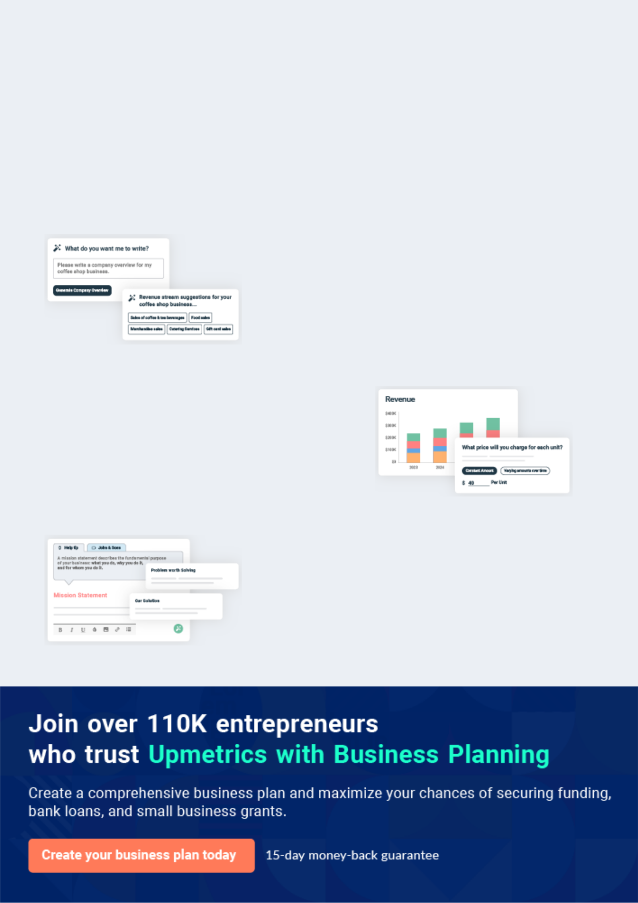
Business planning that’s simpler and faster than you think

Creating a business plan using Upmetrics to start and grow a business is literally the easiest thing in the World. Simply read the instructions and fill in the blanks. It’s as simple as that.

❛ | Upmetrics has everything you need to create a | ❜
❛ | comprehensive business plan. | ❜

AI-powered Upmetrics Assistant

AI-powered insights to streamline your plan

Not sure where to start? Upmetrics’ AI Assistant will automatically generate ideas for each section of your plan and offer improved versions of your writing, adjusting for tone, voice, and grammar or spelling errors.

Financial Forecasting Tool

All the financials are calculated for you

Forget the complex formulas and clumsy spreadsheets — with automatic financials and drag-and-drop forecasting, you can finish your plan faster and be confident that your numbers are accurate.

Business Plan Builder

Guides you like a business mentor

Upmetrics’ step-by-step instructions, prompts, and the library of 400+ sample business plans will guide you through each section of your plan as a business mentor.
Executive Summary


An executive summary is the first section of the business plan intended to provide an overview of the whole business plan.
To unlock help try Upmetrics! 

 Help tip  Dry Cleaning Business Plan


Start your executive summary by briefly introducing your business to your readers.

This section may include the name of your dry cleaning business, its location when it was
To unlock help try Upmetrics! 

Start writing here..

Market opportunity

 Help tip  Dry Cleaning Business Plan

Summarize your market research, including market size, growth potential, and marketing trends. Highlight the opportunities in the market and how your business will fit in to fill the gap.
To unlock help try Upmetrics! 

Start writing here..

Services Offered

 Help tip  Dry Cleaning Business Plan

Highlight the dry cleaning services you offer your clients. The USPs and differentiators you offer are always a plus.
To unlock help try Upmetrics! 

Start writing here..

Marketing & Sales Strategies
To unlock help try Upmetrics!

 Help tip  Dry Cleaning Business Plan

Outline your sales and marketing strategies—what marketing platforms you use, how you plan on acquiring customers, etc.
To unlock help try Upmetrics! 

Start writing here..

Financial Highlights

 Help tip  Dry Cleaning Business Plan

Briefly summarize your financial projections for the initial years of business operations. Include any capital or investment requirements, associated startup costs, projected revenues, and profit forecasts.



Start writing here..
Units Sold v/s Revenue

 |  | Units Sold | Revenue
15.00k
10.00k
5.00k
0
Year 1 | Year 2 | Year 3


Financial Year |  |  | Units Sold | Revenue
Year 1 | 1,550 |  |  | $10,000
Year 2 | 1,800 |  |  | $12,000
Year 3 | 2,050 |  |  | $14,000
 Help tip |  |  Dry Cleaning Business Plan


Summarize your executive summary section with a clear CTA, for example, inviting angel investors to discuss the potential business investment.
To unlock help try Upmetrics! 

Write a call to action for your business plan.
Company Overview

Depending on what details of your business are essential, you’ll need different elements in your business overview.
To unlock help try Upmetrics! 

 Help tip  Dry Cleaning Business Plan

Describe your business in this section by providing all the basic information:

Describe what kind of dry cleaning company you run and the name of it. You may specialize in
To unlock help try Upmetrics! 

Start writing here..

Ownership

 Help tip  Dry Cleaning Business Plan

List the names of your dry cleaning company’s founders or owners. Describe what shares they own and their responsibilities for efficiently managing the business.
To unlock help try Upmetrics! 

Start writing here..
Mission statement

 Help tip  Dry Cleaning Business Plan

Summarize your business’ objective, core principles, and values in your mission statement. This statement needs to be memorable, clear, and brief.
To unlock help try Upmetrics! 

❛ At [Dry Luxe Cleaners], our mission is to provide unparalleled dry cleaning services that resonate with quality, convenience, and care. Rooted in core principles of integrity, sustainability, and excellence, we strive to redefine the essence of garment care for

our community.
❜

Business history

 Help tip  Dry Cleaning Business Plan

If you’re an established dry cleaning service provider, briefly describe your business history, like —when it was founded, how it evolved over time, etc.
To unlock help try Upmetrics! 

Start writing here..

Future goals

 Help tip  Dry Cleaning Business Plan

It’s crucial to convey your aspirations and vision. Mention your short-term and long-term goals; they can be specific targets for revenue, market share, or expanding your services.
To unlock help try Upmetrics! 

Start writing here..

Market Analysis
To unlock help try Upmetrics!


 |  | Market analysis provides a clear understanding of the market in which your
 |  | printing business will run along with the target market, competitors, and
 |  | growth opportunities.
 |  |  |  | To unlock help try Upmetrics! 
 Help tip |  |  Dry Cleaning Business Plan

To write the introduction section of your market analysis, start by clearly identifying your primary target market.
To unlock help try Upmetrics! 

Start writing here..

Target Market

 Help tip  Dry Cleaning Business Plan

Start this section by describing your target market. Define your ideal customer and explain what types of services they prefer. Creating a buyer persona will help you easily define your target market to your readers.



Start writing here..

Market size and growth potential

 Help tip  Dry Cleaning Business Plan

Describe your market size and growth potential and whether you will target a niche or a much broader market.
To unlock help try Upmetrics! 

Start writing here..

Market Size

Available Market

Total potential consumers needing dry 10M cleaning services in the region.

Served Market
Consumers reachable via current 6M distribution channels & marketing efforts.

Target Market
Professionals & businesses prioritizing 1M premium & eco-friendly cleaning.

 Help tip  Dry Cleaning Business Plan

Identify and analyze your direct and indirect competitors. Identify their strengths and weaknesses, and describe what differentiates your dry cleaning services from them.
To unlock help try Upmetrics! 

Competitive analysis

Prestige Laundry

Established in [Year], [Prestige Laundry] has quickly ascended the ranks as a premier dry cleaning service in [Specific Region or City]. With multiple outlets across the area and a loyal customer base, they've built a reputation for [Specific Attribute e.g., "fast and reliable service"].

Features | Strengths
Home pickup and delivery | Wide network of branches
service | Strong online presence through
24-hour express cleaning | their user-friendly app
Membership and loyalty | Efficient customer service with
programs | quick response time
Specialized garment care for
delicate fabrics

Weaknesses

Limited eco-friendly cleaning solutions

Higher price range compared to market average

Occasionally reported inconsistencies in garment care across different branches

UrbanDrapes

A newer entrant, [UrbanDrapes] began operations in [Year]. Touting themselves as the eco-friendly cleaning solution, they've captured a niche of environmentally-conscious consumers in [Specific Region or City].

Features | Strengths
100% eco-friendly cleaning | Strong branding around
agents | sustainability and green
Subscription-based services | practices
for regular clients | Tailored solutions for high-end
Tailored cleaning for luxury | garments
garments | Competitive pricing for
Online booking through their | subscription members
website

Weaknesses

Limited physical outlets

Slower turnaround time for certain services

Relatively lesser-known in the commercial and corporate segment

Clean & Shine

A veteran in the industry, [Clean & Shine] has been serving customers since [Year]. With a vast operational history, they've catered to diverse clientele, from individual customers to large corporate contracts.

Features | Strengths | Weaknesses
In-store and mobile cleaning | Extensive industry experience | Outdated branding and online
units | and customer trust | presence
Bulk cleaning solutions for | Broad service range, from | Less emphasis on sustainability
corporates | cleaning to alterations | and eco-friendly practices
Seasonal promotions and | Strong partnerships with | Inconsistencies in quality among
discounts | corporate clients | mobile units
Garment repair and alteration
services

Market trends

 Help tip  Dry Cleaning Business Plan

Analyze emerging trends in the industry, such as changes in customer behavior or preferences, etc. Explain how your business will cope with all the trends.
To unlock help try Upmetrics! 

Start writing here..

Regulatory environment

 Help tip  Dry Cleaning Business Plan

List regulations and licensing requirements that may affect your dry cleaning company, such as environmental regulations, occupational health & safety, business licenses & permits, etc.
To unlock help try Upmetrics! 

Start writing here..
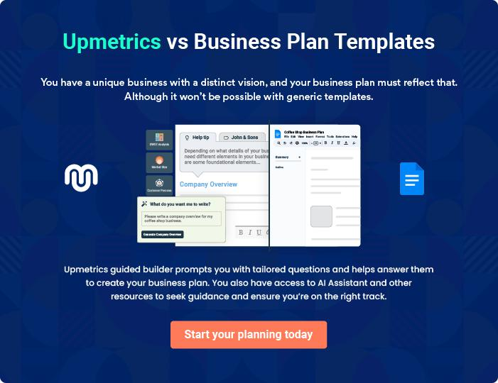
Products and Services
To unlock help try Upmetrics!

The product and services section of a dry cleaning business plan should describe the specific services and products that will be offered to customers. To write this section should include the following:



 Help tip  Dry Cleaning Business Plan

To craft the introduction for your "Products and Services" chapter, begin by positioning your business within its industry, emphasizing its unique strengths or value proposition.
To unlock help try Upmetrics! 

Start writing here..

 Help tip


Mention the dry cleaning services your business will offer. This list may include services like,

• Dry cleaning
To unlock help try Upmetrics! 

Services

Dry Cleaning


Price: [$12.00] per item

Comprehensive cleaning service using eco-friendly solvents to effectively remove stains while preserving the garment’s quality, texture, and colour.

Specifications

- Suitable for: Silk, wool, cotton, synthetic blends.

- Turnaround: [48] hours.

- Process: Garments undergo pre-spotting, machine cleaning, post-spotting, and finishing.

- Add-ons: Express 24-hour service available at a [$5.00] premium.
Laundering & Pressing

Price: [$5.00] per shirt

Essential cleaning and pressing service for maintaining the crispness of business attire.

Specifications

- Suitable for: Cotton, linen, and synthetic shirts/ blouses.

- Turnaround: [24] hours.

- Process: Garments are washed, dried, and professionally pressed.

- Add-ons: Starch options are available at [$0.50] extra.

Alterations & Repairs

Price: Starts at [$10.00] (varies based on requirement)

Tailored solutions for garment adjustments and repairs.

Specifications

- Services: Hemming, button attachment, zipper repairs, size adjustments.

- Turnaround: Varies, usually [72] hours.

- Materials: Matching threads, buttons, and zippers used.
Wedding Gown Preservation

Price: [$120.00] per gown

Specialized cleaning and preservation service for bridal gowns to retain their elegance for years.

Specifications

- Turnaround: [One week].

- Process: Detailed cleaning, followed by preservation sealing in a specialized box.

- Storage: Gowns are sealed in acid-free tissue paper for longevity.

Leather & Suede Cleaning

Price: Starts at [$50.00] (varies based on item size)

Expert cleaning method ensuring leather and suede items remain soft, supple, and spotless.

Specifications

- Suitable for: Jackets, pants, bags, and accessories.

- Turnaround: [One week].

- Process: Specialized agents and methods used for different leather/suede types.

- Add-ons: Reconditioning and water repellency treatments available
Shoe & Bag Cleaning
- To unlock help try Upmetrics!

Price: [$25.00] per pair/item

Comprehensive cleaning service to refurbish and rejuvenate shoes and bags, restoring them to near-new conditions.

Specifications

- Suitable for: Leather, suede, canvas, and synthetic materials.

- Turnaround: [72] hours.

- Process: Cleaning, stain removal, polishing, and finishing.

- Add-ons: Waterproofing treatment available at a [$10.00] premium.

Quality Measures

 Help tip  Drya Cleaning Business Plan


This section should explain how you maintain quality standards and consistently provide the highest quality service.
To unlock help try Upmetrics! 

Start writing here..

Additional Services

 Help tip  Drya Cleaning Business Plan

Mention if your dry cleaning company offers any additional services. You may include services like leather & suede cleaning, fur cleaning & storage, shoe repair & cleaning, rug & carpet cleaning, household item cleaning, etc.



Start writing here..

Sales And Marketing Strategies
To unlock help try Upmetrics!

Writing the sales and marketing strategies section means a list of strategies you will use to attract and retain your clients.
To unlock help try Upmetrics! 

 Help tip  Dry Cleaning Business Plan

To create an effective introduction for your "Sales and Marketing Strategies" chapter, start by setting the stage within your specific industry or market.
To unlock help try Upmetrics! 

Unique Selling Proposition (USP)

 Help tip  Dry Cleaning Business Plan

Define your business’s USPs depending on the market you serve, the equipment you use, and the unique services you provide. Identifying USPs will help you plan your marketing strategies.
To unlock help try Upmetrics! 

Start writing here..

Pricing Strategy

 Help tip  Dry Cleaning Business Plan

Describe your pricing strategy—how you plan to price your cleaning services and stay competitive in the local market. You can mention any discounts you plan on offering to attract new customers to your cleaning service.



Start writing here..

 Help tip  Dry Cleaning Business Plan
To unlock help try Upmetrics!

Discuss your marketing strategies to market your services. You may include some of these marketing strategies in your business plan—social media marketing, Google ads, brochures, email marketing, content marketing, and print marketing.



Marketing strategies

Online


Social Media

Leveraging platforms like Facebook and Instagram to showcase our work, share customer testimonials, and announce promotions.

Content Marketing

Sharing blog posts and articles related to garment care, stain removal tips, and the benefits of professional cleaning.

Email Marketing

Engaging our existing clientele with monthly newsletters, updates, and exclusive offers.

Google Ads

Implementing targeted ad campaigns to reach potential customers actively searching for dry cleaning services in our region.

Offline

Brochures

Distributing informational materials in strategic locations to provide insight into our services and promotions.

 Help tip
To unlock help try Upmetrics!

Outline the strategies you’ll implement to maximize your sales. Your sales strategies may include direct sales calls, partnering with other cleaning or housekeeping businesses, offering referral programs, etc.



Sales strategies

Partner with Businesses

Collaborating with other cleaning or housekeeping services to provide bundled offers.

Direct Sales Calls

Engaging with local businesses and offices, presenting our corporate packages and benefits.

Referral Programs

Introducing a program where

current clients can refer friends

and earn discounts for each

successful referral.

 Help tip

Describe your customer retention strategies and how you plan to execute them. For instance, introducing loyalty programs, discounts on annual membership, personalized service, etc.
To unlock help try Upmetrics! 

Customer retention

Loyalty Programs

Customers who frequent our services can earn points that can be redeemed for discounts or free services.

Personalized Service

Taking note of individual client preferences, ensuring their garments are cared for exactly as they like.

Annual Membership Discounts

Offering reduced rates for clients who opt for our yearly membership plan.

Operations Plan
To unlock help try Upmetrics!

 |  | When writing the operations plan section, it’s important to consider the
 |  | various aspects of your business operations.
 |  |  |  | To unlock help try Upmetrics! 
 Help tip |  |  Dry Cleaning Business Plan


To create an effective introduction for your "Operational Plan" chapter, start by emphasizing the
pivotal role of efficient operations in the success of your business, underscoring how they
directly impact the quality of services delivered.
 |  |  |  | To unlock help try Upmetrics! 
Start writing here..
Staffing & Training
 Help tip |  |  Dry Cleaning Business Plan

Mention your cleaning business’s staffing requirements, including the number of employees or
cleaning staff needed. Include their qualifications, the training required, and the duties they will
perform.
 |  |  |  | To unlock help try Upmetrics! 
Start writing here..
Operational Process
 Help tip |  |  Dry Cleaning Business Plan

Outline the processes and procedures you will use to run your dry cleaning business. Your operational processes may include sending quotations, scheduling appointments, site visits, training employees, and dry cleaning.



Start writing here..

Equipment & Machinery
To unlock help try Upmetrics!

 Help tip  Dry Cleaning Business Plan

Include the list of equipment and machinery required for dry cleaning, such as dry cleaning machines, pressing equipment, spotting stations, garment finishing equipment, sewing machines, etc.



Start writing here..
Management Team

The management team section provides an overview of the individuals responsible for running your business plan.
To unlock help try Upmetrics! 

 Help tip  Dry Cleaning Business Plan

To craft an introduction for your "Management Team" chapter, begin by emphasizing the crucial role of leadership in the success of any business.
To unlock help try Upmetrics! 

Start writing here..

Key managers

 Help tip  Dry Cleaning Business Plan

Introduce your management and key members of your team, and explain their roles and responsibilities.
To unlock help try Upmetrics! 

Start writing here..


JOHN DOE

CEO & Co-founder - john.doe@example.com

[John Doe], the visionary behind [Dry Luxe Cleaners], has been pivotal in setting the company's strategic direction and ensuring its growth.

Holding a Bachelor's degree in Business Administration from [University Name] and an MBA from [University Name], John has a solid academic foundation that complements his [15 years] of hands-on experience in the dry cleaning industry.


His leadership is rooted in his commitment to customer satisfaction and ensuring top-notch service quality.

JANE DOE

Chief Operating Officer (COO) - jane.doe@example.com

Jane steers the operational helm of [Dry Luxe Cleaners]. A graduate of [Operational Management] from [University Name], she went on to pursue her Master's in Business Administration.


Jane's [10 years] in the industry, combined with her academic knowledge, equips her with the skills to manage the day-to-day operations of the company efficiently.

Her role is crucial in optimizing our processes and ensuring seamless service delivery.


ALICE BROWN

CMO - alice.brown@example.com

Alice Brown champions our marketing initiatives, bringing [Dry Luxe Cleaners] to the forefront of our target market's mind.

She graduated with a degree in Marketing from [University Name] and further honed her skills with a post-graduate diploma in Digital Marketing.

With over [8 years] of experience in service-based industries, Alice crafts marketing strategies that resonate with our clientele and drive brand engagement.


ROBERT BROWN

Operations Manager - robert.brown@example.com

Robert ensures the heart of [Dry Luxe Cleaners], our dry cleaning processes, beats efficiently and effectively.

With a background in [Textile Engineering] from [University Name] and [7 years] in the industry, Robert's expertise is vital in guaranteeing the quality and efficiency of our operations.

His sharp eye and dedication ensure that every garment we handle meets the highest standards.
Organizational structure

 Help tip  Dry Cleaning Business Plan

Explain the organizational structure of your management team. Include the reporting line and decision-making hierarchy.
To unlock help try Upmetrics! 

Start writing here..

Organization chart


John Doe

CEO


Alice Brown Jane Doe

CMO COO


Employee 2 Robert Brown Employee 1

Marketing Staff Operation Managers Operations Staff


Employee 3

Cleaning Staff

Compensation plan

 Help tip  Dry Cleaning Business Plan

Describe your compensation plan for the management and staff. Include their salaries, incentives, and other benefits.
To unlock help try Upmetrics! 

Start writing here..

 Help tip

Mentioning advisors or consultants in your business plans adds credibility to your business idea.
To unlock help try Upmetrics! 

Advisors/Consultants


DR MICHAEL JOHNSON

Industry Consultant

With over [20 years] in the dry cleaning and textile industry, Dr. Johnson offers invaluable insights and advice to [Dry Luxe Cleaners], ensuring we adhere to the best industry standards.
Financial Plan

When writing the financial plan section of a business plan, it’s important to provide a comprehensive overview of your financial projections for the first few years of your business, You may provide the following:
To unlock help try Upmetrics! 

 Help tip  Dry Cleaning Business Plan


To create an effective introduction for your "Financial Plan" chapter, begin by stressing the critical role of a well-structured financial plan in the success of your venture.
To unlock help try Upmetrics! 

Start writing here..

 Help tip


Describe details such as projected revenue, operational costs, and service costs in your projected profit and loss statement. Make sure to include your business’s expected net profit or loss.
To unlock help try Upmetrics! 

Profit & loss statement

Revenue

Cost Of Sales

General Costs

Revenue Specific Costs

Personnel Costs (Direct

Labor)

Gross Margin

Gross Margin (%)

Operating Expense

Payroll Expense

(Indirect Labor)

General Expense

Bad Debt

Amortization of Current

Assets

2023-24 | 2024-25 | 2025-26 | 2026-27 | 2027-28
$0 | $0 | $0 | $0 | $0

$0 | $0 | $0 | $0 | $0
$0 | $0 | $0 | $0 | $0
$0 | $0 | $0 | $0 | $0
$0 | $0 | $0 | $0 | $0

$0 | $0 | $0 | $0 | $0
0% | 0% | 0% | 0% | 0%

$0 | $0 | $0 | $0 | $0
$0 | $0 | $0 | $0 | $0
$0 | $0 | $0 | $0 | $0
$0 | $0 | $0 | $0 | $0
$0 | $0 | $0 | $0 | $0

EBITDA

Additional Expense

Long Term

Depreciation

Gain or loss from Sale

of Assets

EBIT

Interest Expenses

EBT

Income Tax Expense

Total Expense

Net Income

Net Income (%)

2023-24 | 2024-25 | 2025-26 | 2026-27 | 2027-28
$0 | $0 | $0 | $0 | $0
$0 | $0 | $0 | $0 | $0
$0 | $0 | $0 | $0 | $0
$0 | $0 | $0 | $0 | $0
$0 | $0 | $0 | $0 | $0
$0 | $0 | $0 | $0 | $0
$0 | $0 | $0 | $0 | $0
$0 | $0 | $0 | $0 | $0
$0 | $0 | $0 | $0 | $0
$0 | $0 | $0 | $0 | $0
0% | 0% | 0% | 0% | 0%
 | 2023-24 | 2024-25 | 2025-26 | 2026-27 | 2027-28
Retained Earning | $0 | $0 | $0 | $0 | $0
Opening
Owner's Distribution | $0 | $0 | $0 | $0 | $0
Retained Earning | $0 | $0 | $0 | $0 | $0
Closing

 Help tip

The cash flow for the first few years of your operation should be estimated and described in this section. This may include billing invoices, payment receipts, loan payments, and any other cash flow statements.
To unlock help try Upmetrics! 

Cash flow statement

 | 2023-24 | 2024-25 | 2025-26 | 2026-27 | 2027-28
Cash Received | $0 | $0 | $0 | $0 | $0
Cash Paid | $0 | $0 | $0 | $0 | $0
COS & General Expenses | $0 | $0 | $0 | $0 | $0
Salary & Wages | $0 | $0 | $0 | $0 | $0
Interest | $0 | $0 | $0 | $0 | $0

Sales Tax

Income Tax

Net Cash From

Operations

Assets Sell

Assets Purchase

Net Cash From

Investments

Amount Received

Loan Received

Common Stock

Preferred Stock

Owner's Contribution

Amount Paid

2023-24 | 2024-25 | 2025-26 | 2026-27 | 2027-28
$0 | $0 | $0 | $0 | $0
$0 | $0 | $0 | $0 | $0
$0 | $0 | $0 | $0 | $0

$0 | $0 | $0 | $0 | $0
$0 | $0 | $0 | $0 | $0
$0 | $0 | $0 | $0 | $0

$0 | $0 | $0 | $0 | $0
$0 | $0 | $0 | $0 | $0

$0 | $0 | $0 | $0 | $0
$0 | $0 | $0 | $0 | $0
$0 | $0 | $0 | $0 | $0

Loan Capital $0 $0 $0 $0 $0

 | 2023-24 | 2024-25 | 2025-26 | 2026-27 | 2027-28
Dividends & Distributions | $0 | $0 | $0 | $0 | $0
Net Cash From | $0 | $0 | $0 | $0 | $0
Financing

Summary
Starting Cash | $0 | $0 | $0 | $0 | $0
Cash In | $0 | $0 | $0 | $0 | $0
Cash Out | $0 | $0 | $0 | $0 | $0
Change in Cash | $0 | $0 | $0 | $0 | $0
Ending Cash | $0 | $0 | $0 | $0 | $0

 Help tip

Create a projected balance sheet documenting your dry cleaning business’s assets, liabilities, and equity.

To unlock help try Upmetrics! 

Balance sheet

 | 2023-24 | 2024-25 | 2025-26 | 2026-27 | 2027-28
Assets | $0 | $0 | $0 | $0 | $0
Current Assets | $0 | $0 | $0 | $0 | $0
Cash | $0 | $0 | $0 | $0 | $0
Accounts Receivable | $0 | $0 | $0 | $0 | $0
Inventory | $0 | $0 | $0 | $0 | $0
Other Current Assets | $0 | $0 | $0 | $0 | $0
Long Term Assets | $0 | $0 | $0 | $0 | $0
Gross Long Term Assets | $0 | $0 | $0 | $0 | $0
Accumulated Depreciation | $0 | $0 | $0 | $0 | $0

Liabilities & Equity | $0 | $0 | $0 | $0 | $0
Liabilities | $0 | $0 | $0 | $0 | $0
Current Liabilities | $0 | $0 | $0 | $0 | $0
Accounts Payable | $0 | $0 | $0 | $0 | $0
Income Tax Payable | $0 | $0 | $0 | $0 | $0
Sales Tax Payable | $0 | $0 | $0 | $0 | $0
Short Term Debt | $0 | $0 | $0 | $0 | $0
 | 2023-24 | 2024-25 | 2025-26 | 2026-27 | 2027-28
Long Term Liabilities | $0 | $0 | $0 | $0 | $0
Long Term Debt | $0 | $0 | $0 | $0 | $0
Equity | $0 | $0 | $0 | $0 | $0
Paid-in Capital | $0 | $0 | $0 | $0 | $0
Common Stock | $0 | $0 | $0 | $0 | $0
Preferred Stock | $0 | $0 | $0 | $0 | $0
Owner's Contribution | $0 | $0 | $0 | $0 | $0
Retained Earnings | $0 | $0 | $0 | $0 | $0

Check | $0 |  |  | $0 | $0 | $0 | $0
 Help Tip |  |  Dry Cleaning Business Plan


Determine and mention your business’s break-even point—the point at which your business costs and revenue will be equal.

This exercise will help you understand how much revenue you need to generate to sustain or be profitable.
To unlock help try Upmetrics! 

Break-even Analysis

 | 2023-24 | 2024-25 | 2025-26 | 2026-27 | 2027-28
Starting Revenue | $0 | $0 | $0 | $0 | $0
Net Revenue | $0 | $0 | $0 | $0 | $0
Closing Revenue | $0 | $0 | $0 | $0 | $0

Starting Expense | $0 | $0 | $0 | $0 | $0
Net Expense | $0 | $0 | $0 | $0 | $0
Closing Expense | $0 | $0 | $0 | $0 | $0

Is Break Even? | 0 | 0 | 0 | 0 | 0
Break Even Month | 0 | 0 | 0 | 0 | 0
Days Required | 0 | 0 | 0 | 0 | 0
Break Even Revenue | $0 | $0 | $0 | $0 | $0
Break Even Units
Financing needs

 Help tip  Dry Cleaning Business Plan

Calculate costs associated with starting a dry cleaning business, and estimate your financing needs and how much capital you need to raise to operate your business.
To unlock help try Upmetrics! 

Start writing here..
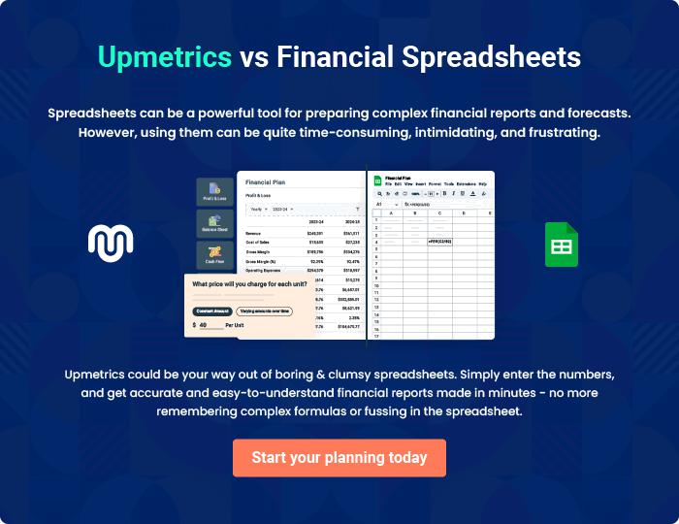
Appendix

When writing the appendix section, you should include any additional information that supports the main content of your plan. This may include financial statements, market research data, legal documents, and other
To unlock help try Upmetrics! 

Create a winning business plan that gets you funded

Creating a stunning and investment-ready plan requires no writing, graphic designing, or financial planning expertise.

Upmetrics has all the features required to help you create a comprehensive business plan—from start to finish. Make no mistakes, it’s the modern way of planning to structure ideas, make plans, and create stunning pitch decks to awe investors.

Pitch decks that impress investors

Create pitch decks that provide a visual representation of your business, engage investors, and make them want to invest in your business idea.

Interactive plans in no time

Import business plan sections like—SWOT analysis, comparison tables, and others to create an interactive business plan. No designing skills are required.

Stunning cover page designs

With Upmetrics, you have the liberty to choose from multiple stunning cover page designs. Choose a creative design and make your plan stand out.

Online sharing made simple

Upmetrics makes online sharing quick and easier for users. Easily share your business plans with a link while tracking reader activity.

500+ sample business plans

Simply import a template from our library of sample plans into the editor and start customizing it to make it yours. It takes only a few clicks to get started.

Collaborate with team in real-time

Invite team members, initiate conversations, discuss ideas & strategies, share feedback, and work on a business plan in real-time.

