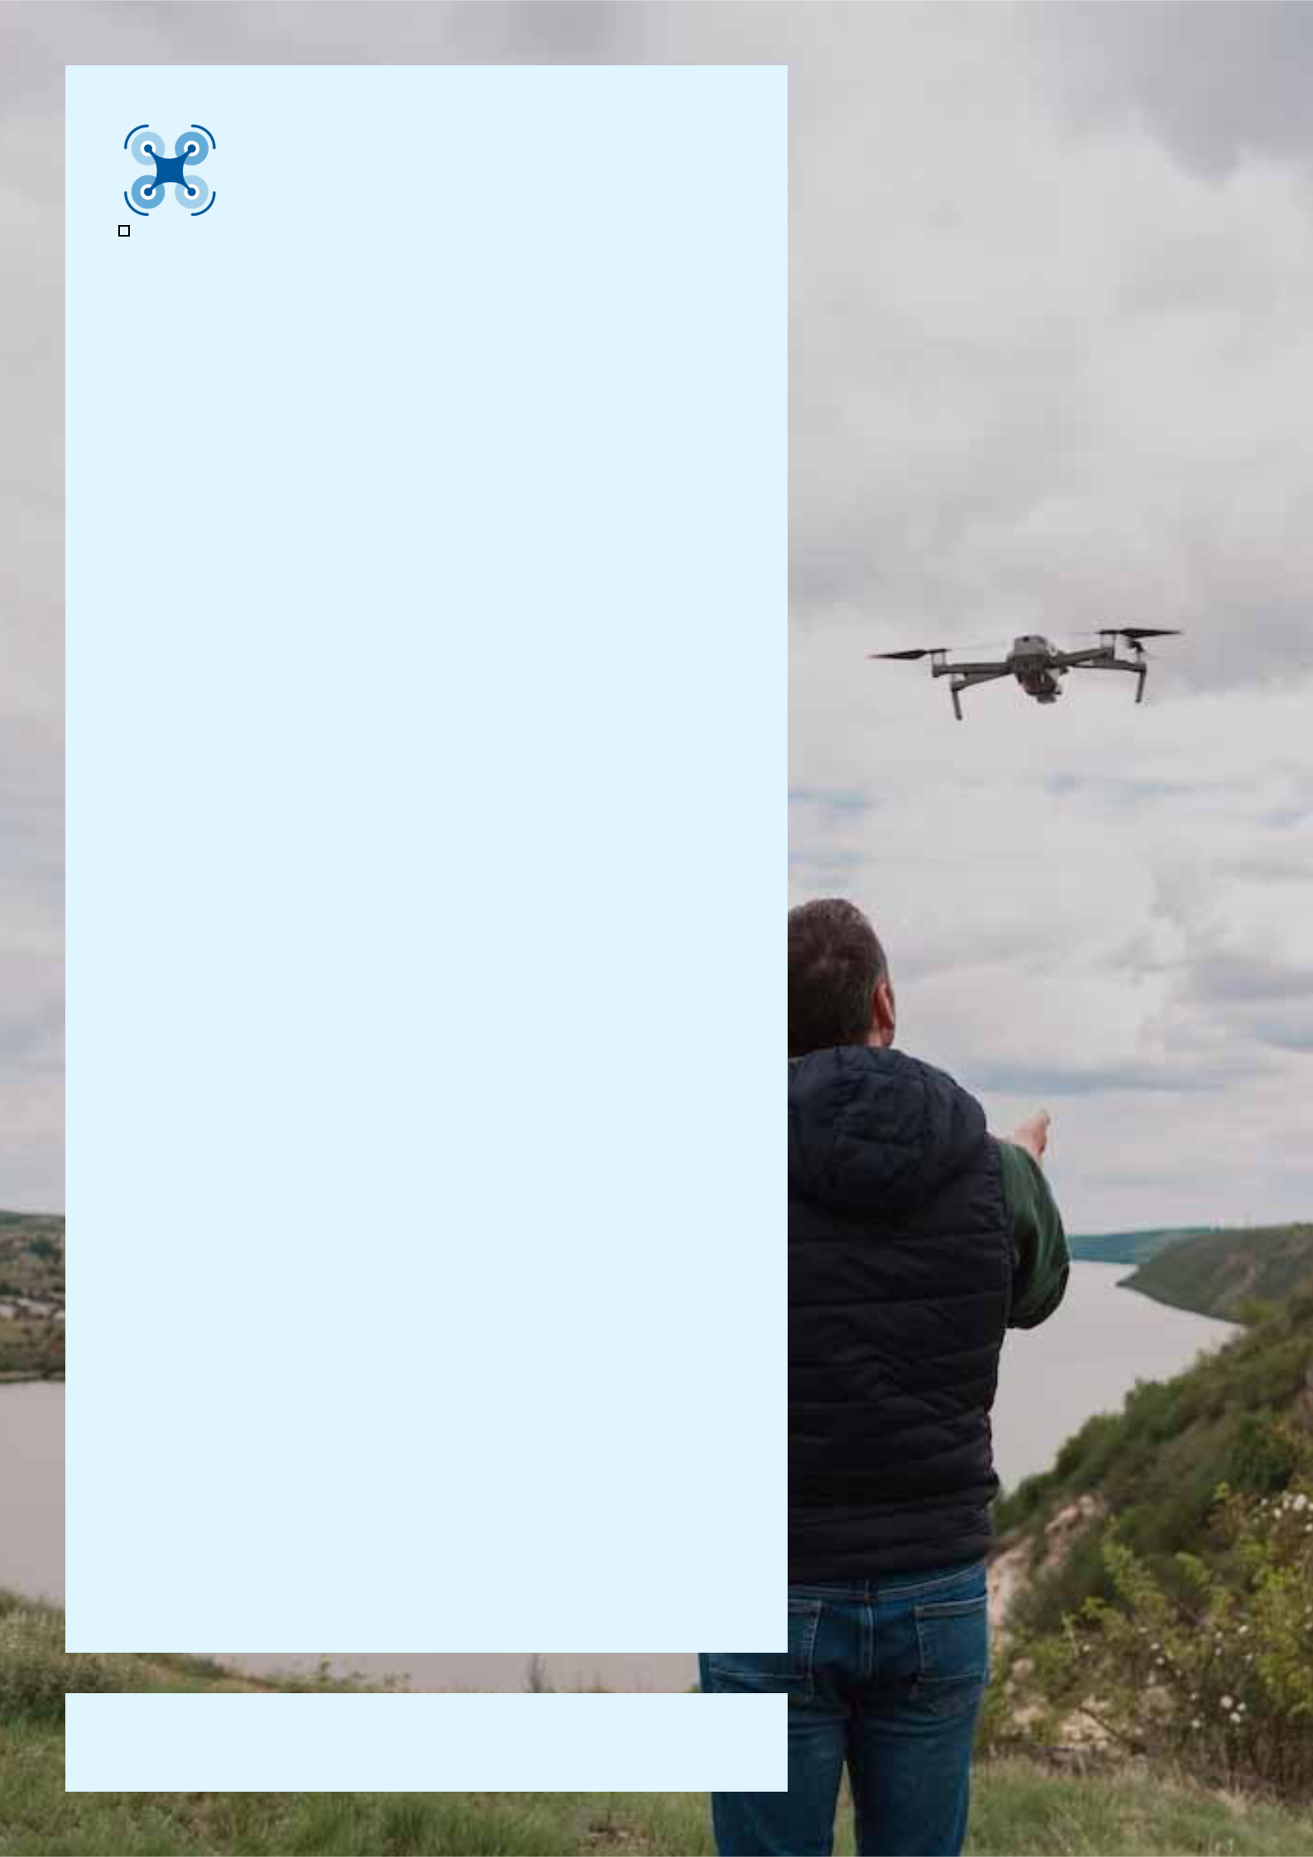

Drone

Business Plan

Elevating Perspectives, Innovating Skies

Business

Plan

2023

John Doe

10200 Bolsa Ave, Westminster, CA, 92683

- 359-3153 info@example.com http://www.example.com

CONFIDENTIAL

Table of Contents

Executive Summary | 6
Market opportunity | 6
Services Offered | 6
Marketing & Sales Strategies | 7
Financial Highlights | 7
Units Sold v/s Revenue | 8

Company Overview | 9
Ownership | 9
Mission statement | 10
Business history | 10
Future goals | 10

Market Analysis | 11
Target Market | 11
Market size and growth potential | 11
Market Size | 12
Competitive analysis | 12
SkyView Drones | 12
AeroFly Innovations | 13
UrbanWings Solutions | 13
Market trends | 13
Regulatory environment | 14

Products and Services | 15
Product/Service List | 15
PhantomFlyer Drone | 15
SkySight Drone Camera Accessory | 17
DroneGuard Protection Kit | 17
SkyMapper Software Suite | 18
Aerial Photography Service | 18
Drone Repair and Maintenance Service | 18
Quality Measures | 19
Additional Services | 19

Sales And Marketing Strategies | 20
Unique Selling Proposition (USP) | 20
Pricing Strategy | 20
Marketing strategies | 21
Online | 21
Offline | 21
Sales strategies | 22
Customer retention | 23

Operations Plan | 24
Staffing & Training | 24
Operational Process | 24
Equipment & Software | 25

Management Team | 26
Key managers | 26
John Doe | 27
Jane Smith | 27
Mark White | 28
Organizational structure | 28
Organization chart | 29
Compensation plan | 29
Advisors/Consultants | 30
Dr. Allen Grey | 30
Ms. Clara Blue | 30

Financial Plan | 31
Profit & loss statement | 31
Cash flow statement | 34
Balance sheet | 36
Break-even Analysis | 38
Financing needs | 40
Appendix
Appendix | 42
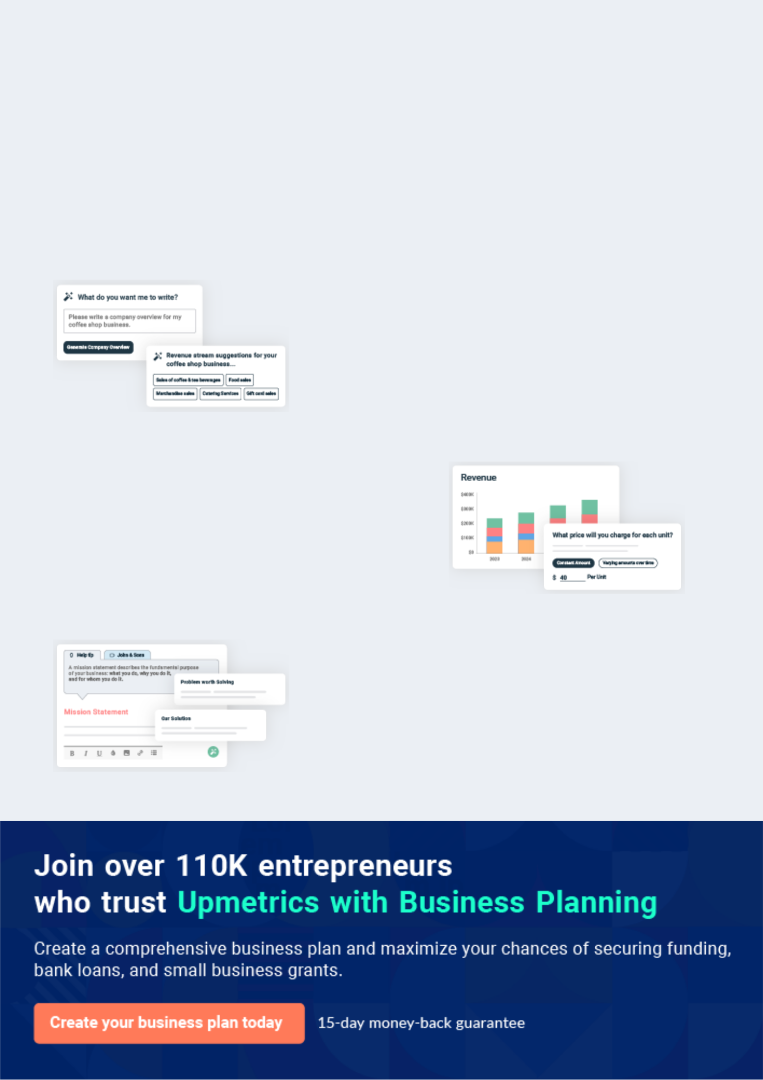
Business planning that’s simpler and faster than you think

Creating a business plan using Upmetrics to start and grow a business is literally the easiest thing in the World. Simply read the instructions and fill in the blanks. It’s as simple as that.

❛ | Upmetrics has everything you need to create a | ❜
❛ | comprehensive business plan. | ❜

AI-powered Upmetrics Assistant

AI-powered insights to streamline your plan

Not sure where to start? Upmetrics’ AI Assistant will automatically generate ideas for each section of your plan and offer improved versions of your writing, adjusting for tone, voice, and grammar or spelling errors.

Financial Forecasting Tool

All the financials are calculated for you

Forget the complex formulas and clumsy spreadsheets — with automatic financials and drag-and-drop forecasting, you can finish your plan faster and be confident that your numbers are accurate.

Business Plan Builder

Guides you like a business mentor

Upmetrics’ step-by-step instructions, prompts, and the library of 400+ sample business plans will guide you through each section of your plan as a business mentor.
Executive Summary


An executive summary is the first section of the business plan intended to provide an overview of the whole business plan.
To unlock help try Upmetrics! 

 Help tip  Drone Business Plan


Start your executive summary by briefly introducing your business to your readers.

This section may include the name of your drone business, its location, when it was founded,
To unlock help try Upmetrics! 

Start writing here..

Market opportunity

 Help tip  Drone Business Plan

Summarize your market research, including market size, growth potential, and marketing trends. Highlight the opportunities in the market and how your business will fit in to fill the gap.
To unlock help try Upmetrics! 

Start writing here..

Services Offered

 Help tip  Drone Business Plan

Highlight the drone services you offer your clients. The USPs and differentiators you offer are always a plus.
To unlock help try Upmetrics! 

Start writing here..

Marketing & Sales Strategies
To unlock help try Upmetrics!

 Help tip  Drone Business Plan

Outline your sales and marketing strategies—what marketing platforms you use, how you plan on acquiring customers, etc.
To unlock help try Upmetrics! 

Start writing here..

Financial Highlights

 Help tip  Drone Business Plan

Briefly summarize your financial projections for the initial years of business operations. Include any capital or investment requirements, associated startup costs, projected revenues, and profit forecasts.



Start writing here..
Units Sold v/s Revenue

 |  | Units Sold | Revenue
15.00k
10.00k
5.00k
0
Year 1 | Year 2 | Year 3


Financial Year |  |  | Units Sold | Revenue
Year 1 | 1,550 |  |  | $10,000
Year 2 | 1,800 |  |  | $12,000
Year 3 | 2,050 |  |  | $14,000
 Help tip |  |  Drone Business Plan


Summarize your executive summary section with a clear CTA, for example, inviting angel investors to discuss the potential business investment.
To unlock help try Upmetrics! 

Write a call to action for your business plan.
Company Overview

Depending on what details of your business are essential, you’ll need different elements in your business overview.
To unlock help try Upmetrics! 

 Help tip  Drone Business Plan

Describe your business in this section by providing all the basic information:

Describe what kind of drone company you run and the name of it. You may specialize in one of
To unlock help try Upmetrics! 

Start writing here..

Ownership

 Help tip  Drone Business Plan

List the names of your drone business’s founders or owners. Describe what shares they own and their responsibilities for efficiently managing the business.
To unlock help try Upmetrics! 

Start writing here..
Mission statement

 Help tip  Drone Business Plan

Summarize your business’ objective, core principles, and values in your mission statement. This statement needs to be memorable, clear, and brief.
To unlock help try Upmetrics! 

❛ At [DroneTech Ventures], we aim to [specific objective, e.g., revolutionize aerial photography], upholding our core principles of innovation, excellence, and client satisfaction. We strive to lead, inspire, and set benchmarks in the drone industry, consistently

pushing the boundaries of what's possible.
❜

Business history

 Help tip  Drone Business Plan

If you’re an established drone business, briefly describe your business history, like—when it was founded, how it evolved over time, etc.
To unlock help try Upmetrics! 

Start writing here..

Future goals

 Help tip  Drone Business Plan

It’s crucial to convey your aspirations and vision. Mention your short-term and long-term goals; they can be specific targets for revenue, market share, or expanding your services.
To unlock help try Upmetrics! 

Start writing here..

Market Analysis
To unlock help try Upmetrics!
To unlock help try Upmetrics!

Market analysis provides a clear understanding of the market in which your printing business will run along with the target market, competitors, and growth opportunities.



 Help tip  Drone Business Plan

To write the introduction section of your market analysis, start by clearly identifying your primary target market.
To unlock help try Upmetrics! 

Start writing here..

Target Market

 Help tip  Drone Business Plan

Start this section by describing your target market. Define your ideal customer and explain what types of services they prefer. Creating a buyer persona will help you easily define your target market to your readers.



Start writing here..

Market size and growth potential

 Help tip  Drone Business Plan

Describe your market size and growth potential and whether you will target a niche or a much broader market.
To unlock help try Upmetrics! 

Start writing here..

Market Size

Available Market

Total global spend on drone services 1B & products annually.

Served Market
Spend in North America on drone 300M services & products annually.

Target Market
Spend by real estate & media sectors 60M in North America on drones annually.

 Help tip  Drone Business Plan

Identify and analyze your direct and indirect competitors. Identify their strengths and weaknesses, and describe what differentiates your drone services from them.
To unlock help try Upmetrics! 

Competitive analysis

SkyView Drones

[SkyView Drones], headquartered in [City, State], has been in the drone business for over [X years]. They've made a significant mark in the real estate and media production sectors, with an extensive clientele spanning both national and international markets.

Features | Strengths
High-resolution camera drones | Robust R&D department,
suitable for cinematic filming. | consistently innovating.
Customizable flight plans | Wide range of drones catering
through their proprietary | to different budgets.
software. | Strong brand recognition and
Advanced drone training | reputation in the media sector.
programs for beginners and
professionals.

Weaknesses

Limited after-sales support.

Software platform is not user-friendly for beginners.

Lack of solutions tailored to the agriculture sector.

AeroFly Innovations

A relatively new entrant, [AeroFly Innovations], based in [City, State], specializes in drone solutions for agriculture and farming. Their data-driven approach has resonated well with farmers and agribusinesses.

Features | Strengths | Weaknesses
Drones are equipped with | Deep focus on agriculture, | Limited experience and market
multispectral sensors for crop | offering tailored solutions. | presence compared to older
health monitoring. | Partnerships with major | players.
Software integration for soil | agribusinesses, bolstering their | Restricted to the agriculture
analysis and irrigation | credibility. | niche; limited diversification.
optimization. | Quick customer support | Dependence on third-party
Comprehensive data analytics | turnaround time. | components, affecting the drone
dashboard. |  | supply chain.

UrbanWings Solutions

[UrbanWings Solutions], located in [City, State], is a pioneer in drone delivery services. With an emphasis on urban logistics, they've transformed how businesses approach last-mile delivery.

Features | Strengths | Weaknesses
Efficient and fast drone delivery | First-mover advantage in the | Regulatory challenges in several
system. | drone delivery sector. | cities, limiting expansion.
Integration with e-commerce | Advanced safety protocols, | High operational costs, reflecting
platforms for streamlined | leading to fewer accidents. | in premium pricing.
operations. | Strong partnerships with | Drones are not optimized for
Safety mechanisms, ensuring | leading e-commerce brands. | varying weather conditions.
secure and accident-free
deliveries.

Market trends

 Help tip  Drone Business Plan

Analyze emerging trends in the industry, such as technology disruptions, changes in customer behavior or preferences, etc. Explain how your business will cope with all the trends.
To unlock help try Upmetrics! 

Start writing here..

Regulatory environment
To unlock help try Upmetrics!

 Help tip  Drone Business Plan

List regulations and licensing requirements that may affect your drone company, such as business registration, no-fly zones or restricted area regulations, privacy & data protection, flight restrictions, etc.



Start writing here..
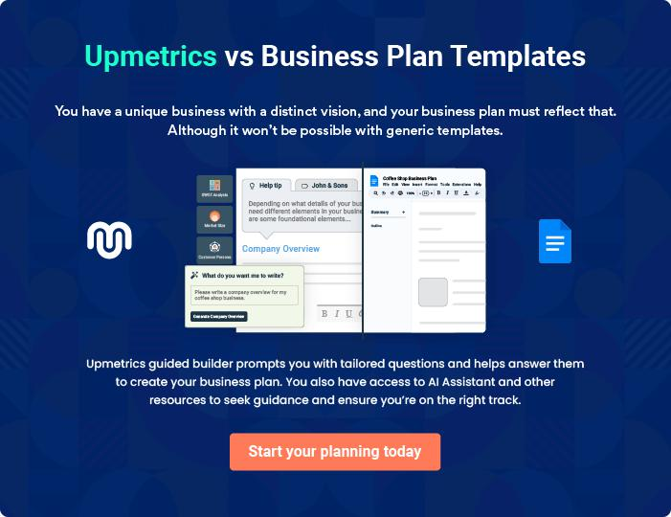
Products and Services
To unlock help try Upmetrics!

The product and services section of a drone business plan should describe the specific services and products that will be offered to customers. To write this section should include the following:



 Help tip  Drone Business Plan

To craft the introduction for your "Products and Services" chapter, begin by positioning your business within its industry, emphasizing its unique strengths or value proposition.
To unlock help try Upmetrics! 

Start writing here..

 Help tip  Example title..


Mention the drone products your business will offer. This list may include products like,

• Drones
To unlock help try Upmetrics! 

Product/Service List

PhantomFlyer Drone


Price: [$1,500]

A versatile quadcopter designed primarily for aerial photography and videography, suitable for both amateurs and professionals.
Specifications

- Flight Time: 30 minutes

- Camera: 20 MP, 4K UHD video

- Range: 5 km

- Weight: 1.3 kg

- Features: Obstacle avoidance, auto return-to-home, intelligent flight modes
SkySight Drone Camera Accessory

Price: [$450]

An attachable camera module tailored for detailed surveying and mapping.

Specifications

- Resolution: 24 MP

- Video: 6K UHD

- Zoom: 5x optical, 8x digital

- Features: Low light performance, panoramic shooting mode

DroneGuard Protection Kit

Price: [$120]

A comprehensive accessory kit to enhance the protection and durability of drones during challenging flights.

Specifications

- Material: Reinforced carbon fiber

- Weight: 250g

- Components: Propeller guards, landing gear extensions, protective cage

- Compatibility: Fits most mid-sized drones
SkyMapper Software Suite

Price: [$200] (annual subscription)

Drone flight planning and data analysis software tailored for detailed mapping and surveying tasks.

Specifications

- Platform: Windows, macOS

- Features: Real-time data processing, customizable flight paths, terrain analysis, cloud storage integration

Aerial Photography Service

Price: Aerial Photography Service

Professional aerial photography and videography service suitable for real estate showcases, events, or promotional content.

Specifications

- Duration: Minimum 1 hour

- Deliverables: High-resolution photos and 4K videos

- Equipment Used: PhantomFlyer Drone with SkySight Camera Accessory

- Editing: Post-processing included, with up to 2 revisions

Drone Repair and Maintenance Service

Price: Free, Repairs starting at [$50]

Comprehensive check-up and repair solutions to ensure drones remain in optimal flying condition.

Specifications

- Turnaround: 48 hours for common repairs

- Parts: Original manufacturer components

- Warranty: 30 days on all repair jobs
Quality Measures

 Help tip  Drone Business Plan

This section should explain how you maintain quality standards and consistently provide the highest quality service.
To unlock help try Upmetrics! 

Start writing here..

Additional Services

 Help tip  Drone Business Plan

Mention if your drone company offers any additional services. You may include services like 3D mapping & modeling, event coverage, live streaming, etc.
To unlock help try Upmetrics! 

Start writing here..
Sales And Marketing Strategies
To unlock help try Upmetrics!

Writing the sales and marketing strategies section means a list of strategies you will use to attract and retain your clients.
To unlock help try Upmetrics! 

 Help tip  Drone Business Plan

To create an effective introduction for your "Sales and Marketing Strategies" chapter, start by setting the stage within your specific industry or market.
To unlock help try Upmetrics! 

Unique Selling Proposition (USP)

 Help tip  Drone Business Plan

Define your business’s USPs depending on the market you serve, the equipment you use, and the unique services you provide. Identifying USPs will help you plan your marketing strategies.
To unlock help try Upmetrics! 

Start writing here..

Pricing Strategy

 Help tip  Drone Business Plan

Describe your pricing strategy—how you plan to price your products or services and stay competitive in the local market. You can mention any discounts you plan on offering to attract new customers.



Start writing here..

 Help tip  Drone Business Plan
To unlock help try Upmetrics!

Discuss your marketing strategies to market your services. You may include some of these marketing strategies in your business plan—social media marketing, Google ads, brochures, content marketing, and local marketing.



Marketing strategies

Online


Social Media

Leveraging platforms such as [Facebook, Instagram, and LinkedIn] to showcase our products, share testimonials, and engage with our audience.

Content Marketing

Sharing knowledgeable content on our [Blog], positioning ourselves as industry experts.

Offline

Brochures

High-quality brochures distributed at [local trade shows, conventions, and within our store] to provide a tangible reminder of our offerings.

Google Ads

Targeted advertising to reach potential customers actively searching for drone products and services.

Local Marketing

Engaging in [community events, workshops, and partnerships] to establish a strong local presence.

 Help tip


Outline the strategies you’ll implement to maximize your sales. Your sales strategies may include direct sales calls, partnering with other businesses, offering referral programs, etc.
To unlock help try Upmetrics! 

Sales strategies

Partner with Businesses

Collaborating with complementary businesses, such as [photography studios or event planners], to provide bundled offerings.

Referral Programs

Encouraging our satisfied customers to refer our services and products to others, rewarding them with [discounts or complimentary services].

Direct Sales Calls

Reaching out to potential B2B clients, such as [real estate agencies and agricultural businesses], offering customized solutions.

 Help tip

Describe your customer retention strategies and how you plan to execute them. For instance, introducing loyalty programs, discounts on bulk purchases, personalized service, etc.
To unlock help try Upmetrics! 

Customer retention

Loyalty Programs

Rewarding repeat customers with [points or discounts] for every purchase, redeemable on future transactions.

Personalized Service

Understanding individual customer needs and preferences, offering tailored recommendations and solutions.

Bulk Order Discounts

Offering attractive discounts to customers purchasing in volume, ensuring they choose us for major requirements.

Operations Plan


 |  | When writing the operations plan section, it’s important to consider the
 |  | various aspects of your business operations.
 |  |  |  | To unlock help try Upmetrics! 
 Help tip |  |  Drone Business Plan


To create an effective introduction for your "Operational Plan" chapter, start by emphasizing the
pivotal role of efficient operations in the success of your business, underscoring how they
directly impact the quality of services delivered.
 |  |  |  | To unlock help try Upmetrics! 
Start writing here..
Staffing & Training
 Help tip |  |  Drone Business Plan

Mention your business’s staffing requirements, including the number of employees or drone pilots needed. Include their qualifications, the training required, and the duties they will perform.
To unlock help try Upmetrics! 

Start writing here..

Operational Process

 Help tip  Drone Business Plan

Outline the processes and procedures you will use to run your drone business. Your operational processes may include client consultation, project planning, drone operations, etc.
To unlock help try Upmetrics! 

Start writing here..

Equipment & Software

 Help tip  Drone Business Plan

Include the list of equipment and software required for the drone, such as cameras, sensors, batteries, project management software, etc.
To unlock help try Upmetrics! 

Start writing here..
Management Team

The management team section provides an overview of the individuals responsible for running your business plan.
To unlock help try Upmetrics! 

 Help tip  Drone Business Plan

To craft an introduction for your "Management Team" chapter, begin by emphasizing the crucial role of leadership in the success of any business.
To unlock help try Upmetrics! 

Start writing here..

Key managers

 Help tip  Drone Business Plan

Introduce your management and key members of your team, and explain their roles and responsibilities.
To unlock help try Upmetrics! 

Start writing here..

JOHN DOE

CEO - john.doe@example.com

[John Doe] is responsible for setting the company's strategic direction and spearheading growth initiatives. He has been the driving force behind the company’s rapid ascent in the drone industry.


With a keen sense of market dynamics and an unwavering commitment to innovation, John exemplifies leadership par excellence.

- Educational Background: John holds a Bachelor's degree in [Aerospace Engineering from the esteemed XYZ University and further honed his skills with an MBA from ABC Business School.]

- Professional Background: Prior to founding [DroneTech Ventures], John served as a [Senior Project Manager at TechGiant Corp, where he managed key drone development projects. He also worked as a Strategy Consultant for AeroSolutions for 3 years.]


JANE SMITH

Chief Operating Officer (COO) - jane.smith@example.com

As the Chief Operations Officer, [Jane Smith] oversees the company's day-to-day functions ensuring maximum efficiency and productivity.

She plays a crucial role in process optimization and workforce management, making sure the team always delivers its best.

- Educational Background: Jane pursued her undergraduate degree in [Business Management from DEF University and later completed her Master's in Operations Management from PQR University.]

- Professional Background: With [8] years of experience under her belt, Jane was the Lead Operations Strategist at Drone Innovators Inc. before joining [DroneTech Ventures]. She also spent a couple of years at [SkyHigh Drones as an Operations Supervisor].

MARK WHITE

CMO - robert.brown@example.com

Entrusted with the brand's voice and visibility, [Mark White], as the Chief Marketing Officer, formulates and oversees marketing strategies that elevate DroneTech's brand presence and drive customer acquisition.

- Educational Background: Mark graduated with honours in Marketing from [GHI University and later went on to attain a Master's degree in Digital Marketing from UVW Institute].

- Professional Background: Mark's professional journey boasts a tenure as a Marketing Director at [FutureTech Corp and as a Brand Strategist at Skyline Drones].

Organizational structure

 Help tip  Drone Business Plan

Explain the organizational structure of your management team. Include the reporting line and decision-making hierarchy.
To unlock help try Upmetrics! 

Start writing here..
Organization chart


John Doe

CEO


Mark White Jane Smith

CMO COO


Lucas Green

Alice Brown Marketing Manager

Operations Manager



Bob Gray Sara Lee

Operations Assistant Marketing Assistant

Compensation plan

 Help tip  Drone Business Plan

Describe your compensation plan for the management and staff. Include their salaries, incentives, and other benefits.
To unlock help try Upmetrics! 

Start writing here..

 Help tip  Example title..

Mentioning advisors or consultants in your business plans adds credibility to your business idea.
To unlock help try Upmetrics! 

Advisors/Consultants


DR. ALLEN GREY

Consultant

Serving as a technical consultant with over [20 years] of experience in drone technology and has been a faculty member at [ABC University].


MS. CLARA BLUE

Advisor

Our business strategy advisor, Clara, brings [15 years] of experience in scaling tech businesses and holds an MBA from [XYZ Business School].
Financial Plan

When writing the financial plan section of a business plan, it’s important to provide a comprehensive overview of your financial projections for the first few years of your business, You may provide the following:
To unlock help try Upmetrics! 

 Help tip  Drone Business Plan


To create an effective introduction for your "Financial Plan" chapter, begin by stressing the critical role of a well-structured financial plan in the success of your venture.
To unlock help try Upmetrics! 

Start writing here..

 Help tip


Describe details such as projected revenue, operational costs, and service costs in your projected profit and loss statement. Make sure to include your business’s expected net profit or loss.
To unlock help try Upmetrics! 

Profit & loss statement

Revenue

Cost Of Sales

General Costs

Revenue Specific Costs

Personnel Costs (Direct

Labor)

Gross Margin

Gross Margin (%)

Operating Expense

Payroll Expense

(Indirect Labor)

General Expense

Bad Debt

Amortization of Current

Assets

2023-24 | 2024-25 | 2025-26 | 2026-27 | 2027-28
$0 | $0 | $0 | $0 | $0

$0 | $0 | $0 | $0 | $0
$0 | $0 | $0 | $0 | $0
$0 | $0 | $0 | $0 | $0
$0 | $0 | $0 | $0 | $0

$0 | $0 | $0 | $0 | $0
0% | 0% | 0% | 0% | 0%

$0 | $0 | $0 | $0 | $0
$0 | $0 | $0 | $0 | $0
$0 | $0 | $0 | $0 | $0
$0 | $0 | $0 | $0 | $0
$0 | $0 | $0 | $0 | $0

EBITDA

Additional Expense

Long Term

Depreciation

Gain or loss from Sale

of Assets

EBIT

Interest Expenses

EBT

Income Tax Expense

Total Expense

Net Income

Net Income (%)

2023-24 | 2024-25 | 2025-26 | 2026-27 | 2027-28
$0 | $0 | $0 | $0 | $0
$0 | $0 | $0 | $0 | $0
$0 | $0 | $0 | $0 | $0
$0 | $0 | $0 | $0 | $0
$0 | $0 | $0 | $0 | $0
$0 | $0 | $0 | $0 | $0
$0 | $0 | $0 | $0 | $0
$0 | $0 | $0 | $0 | $0
$0 | $0 | $0 | $0 | $0
$0 | $0 | $0 | $0 | $0
0% | 0% | 0% | 0% | 0%
 | 2023-24 | 2024-25 | 2025-26 | 2026-27 | 2027-28
Retained Earning | $0 | $0 | $0 | $0 | $0
Opening
Owner's Distribution | $0 | $0 | $0 | $0 | $0
Retained Earning | $0 | $0 | $0 | $0 | $0
Closing

 Help tip

The cash flow for the first few years of your operation should be estimated and described in this section. This may include billing invoices, payment receipts, loan payments, and any other cash flow statements.
To unlock help try Upmetrics! 

Cash flow statement

 | 2023-24 | 2024-25 | 2025-26 | 2026-27 | 2027-28
Cash Received | $0 | $0 | $0 | $0 | $0
Cash Paid | $0 | $0 | $0 | $0 | $0
COS & General Expenses | $0 | $0 | $0 | $0 | $0
Salary & Wages | $0 | $0 | $0 | $0 | $0
Interest | $0 | $0 | $0 | $0 | $0

Sales Tax

Income Tax

Net Cash From

Operations

Assets Sell

Assets Purchase

Net Cash From

Investments

Amount Received

Loan Received

Common Stock

Preferred Stock

Owner's Contribution

Amount Paid

2023-24 | 2024-25 | 2025-26 | 2026-27 | 2027-28
$0 | $0 | $0 | $0 | $0
$0 | $0 | $0 | $0 | $0
$0 | $0 | $0 | $0 | $0

$0 | $0 | $0 | $0 | $0
$0 | $0 | $0 | $0 | $0
$0 | $0 | $0 | $0 | $0

$0 | $0 | $0 | $0 | $0
$0 | $0 | $0 | $0 | $0

$0 | $0 | $0 | $0 | $0
$0 | $0 | $0 | $0 | $0
$0 | $0 | $0 | $0 | $0

Loan Capital $0 $0 $0 $0 $0

 | 2023-24 | 2024-25 | 2025-26 | 2026-27 | 2027-28
Dividends & Distributions | $0 | $0 | $0 | $0 | $0
Net Cash From | $0 | $0 | $0 | $0 | $0
Financing

Summary
Starting Cash | $0 | $0 | $0 | $0 | $0
Cash In | $0 | $0 | $0 | $0 | $0
Cash Out | $0 | $0 | $0 | $0 | $0
Change in Cash | $0 | $0 | $0 | $0 | $0
Ending Cash | $0 | $0 | $0 | $0 | $0

 Help tip

Create a projected balance sheet documenting your drone business’s assets, liabilities, and equity.

To unlock help try Upmetrics! 

Balance sheet

 | 2023-24 | 2024-25 | 2025-26 | 2026-27 | 2027-28
Assets | $0 | $0 | $0 | $0 | $0
Current Assets | $0 | $0 | $0 | $0 | $0
Cash | $0 | $0 | $0 | $0 | $0
Accounts Receivable | $0 | $0 | $0 | $0 | $0
Inventory | $0 | $0 | $0 | $0 | $0
Other Current Assets | $0 | $0 | $0 | $0 | $0
Long Term Assets | $0 | $0 | $0 | $0 | $0
Gross Long Term Assets | $0 | $0 | $0 | $0 | $0
Accumulated Depreciation | $0 | $0 | $0 | $0 | $0

Liabilities & Equity | $0 | $0 | $0 | $0 | $0
Liabilities | $0 | $0 | $0 | $0 | $0
Current Liabilities | $0 | $0 | $0 | $0 | $0
Accounts Payable | $0 | $0 | $0 | $0 | $0
Income Tax Payable | $0 | $0 | $0 | $0 | $0
Sales Tax Payable | $0 | $0 | $0 | $0 | $0
Short Term Debt | $0 | $0 | $0 | $0 | $0
 | 2023-24 | 2024-25 | 2025-26 | 2026-27 | 2027-28
Long Term Liabilities | $0 | $0 | $0 | $0 | $0
Long Term Debt | $0 | $0 | $0 | $0 | $0
Equity | $0 | $0 | $0 | $0 | $0
Paid-in Capital | $0 | $0 | $0 | $0 | $0
Common Stock | $0 | $0 | $0 | $0 | $0
Preferred Stock | $0 | $0 | $0 | $0 | $0
Owner's Contribution | $0 | $0 | $0 | $0 | $0
Retained Earnings | $0 | $0 | $0 | $0 | $0

Check | $0 |  |  | $0 | $0 | $0 | $0
 Help Tip |  |  Drone Business Plan


Determine and mention your business’s break-even point—the point at which your business costs and revenue will be equal.

This exercise will help you understand how much revenue you need to generate to sustain or be profitable.
To unlock help try Upmetrics! 

Break-even Analysis

 | 2023-24 | 2024-25 | 2025-26 | 2026-27 | 2027-28
Starting Revenue | $0 | $0 | $0 | $0 | $0
Net Revenue | $0 | $0 | $0 | $0 | $0
Closing Revenue | $0 | $0 | $0 | $0 | $0

Starting Expense | $0 | $0 | $0 | $0 | $0
Net Expense | $0 | $0 | $0 | $0 | $0
Closing Expense | $0 | $0 | $0 | $0 | $0

Is Break Even? | 0 | 0 | 0 | 0 | 0
Break Even Month | 0 | 0 | 0 | 0 | 0
Days Required | 0 | 0 | 0 | 0 | 0
Break Even Revenue | $0 | $0 | $0 | $0 | $0
Break Even Units
Financing needs

 Help tip  Drone Business Plan

Calculate costs associated with starting a drone business, and estimate your financing needs and how much capital you need to raise to operate your business.
To unlock help try Upmetrics! 

Start writing here..
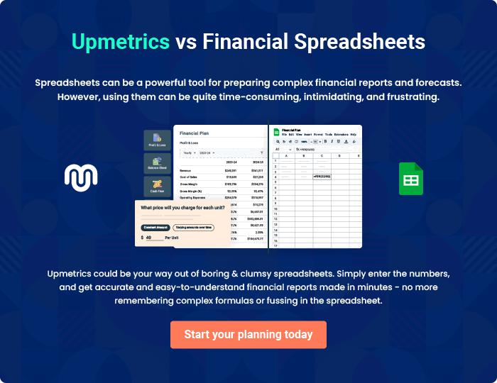
Appendix

When writing the appendix section, you should include any additional information that supports the main content of your plan. This may include financial statements, market research data, legal documents, and other
To unlock help try Upmetrics! 

Create a winning business plan that gets you funded

Creating a stunning and investment-ready plan requires no writing, graphic designing, or financial planning expertise.

Upmetrics has all the features required to help you create a comprehensive business plan—from start to finish. Make no mistakes, it’s the modern way of planning to structure ideas, make plans, and create stunning pitch decks to awe investors.

Pitch decks that impress investors

Create pitch decks that provide a visual representation of your business, engage investors, and make them want to invest in your business idea.

Interactive plans in no time

Import business plan sections like—SWOT analysis, comparison tables, and others to create an interactive business plan. No designing skills are required.

Stunning cover page designs

With Upmetrics, you have the liberty to choose from multiple stunning cover page designs. Choose a creative design and make your plan stand out.

Online sharing made simple

Upmetrics makes online sharing quick and easier for users. Easily share your business plans with a link while tracking reader activity.

500+ sample business plans

Simply import a template from our library of sample plans into the editor and start customizing it to make it yours. It takes only a few clicks to get started.

Collaborate with team in real-time

Invite team members, initiate conversations, discuss ideas & strategies, share feedback, and work on a business plan in real-time.

