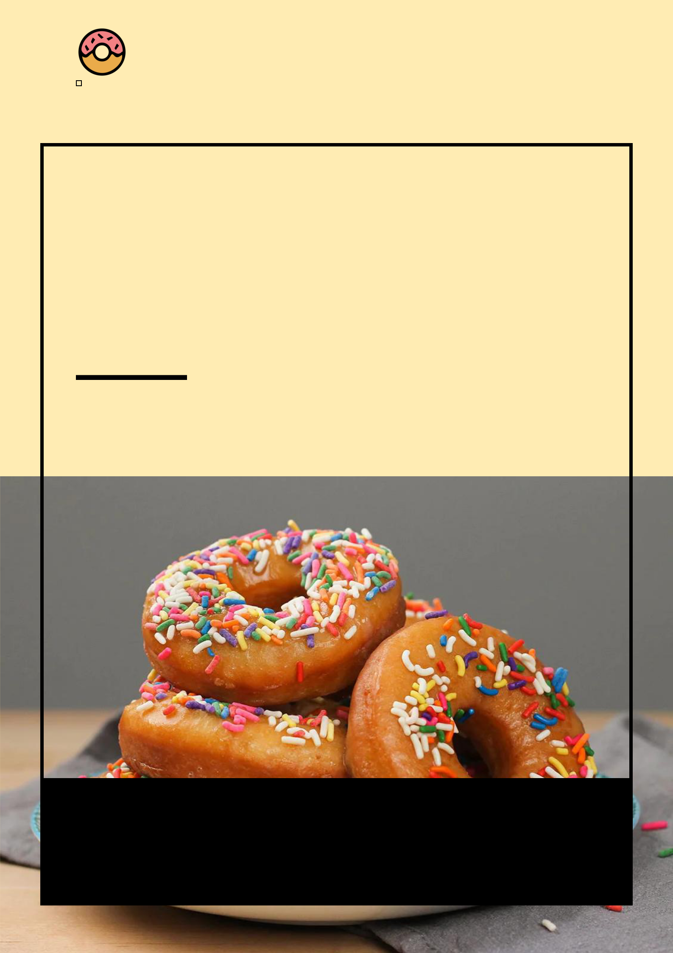
Donut Shop Business Plan

BUSINESS PLAN

Doughnuts Delight, Moments to Savor

Prepared By

John Doe

10200 Bolsa Ave, Westminster, CA, 92683

info@example.com

(650) 359-3153 http://www.example.com/

Table of Contents

Executive Summary | 6
Market opportunity | 6
Services Offered | 6
Marketing and Sales Strategies | 7
Financial Highlights | 7
Units Sold v/s Revenue | 8

Company Overview | 9
Ownership | 9
Mission statement | 10
Business history | 10
Future goals | 10

Market Analysis | 11
Target Market | 11
Market size and growth potential | 11
Market Size | 12
Competitive analysis | 12
Sugar Ring Donuts | 12
Artisan Delight Bakery | 13
Market trends | 13
Regulatory environment | 13

Products and Services | 15
Products | 15
Classic Glazed Donut | 15
Vegan Blueberry Bliss | 16
Gluten-Free Chocolate Decadence | 16
Fancy Strawberry Cream Cheese Donut | 16
Handcrafted Espresso Coffee | 17
Custom Donut Orders | 17
Quality Assurance | 17
Additional Offerings | 18

Sales And Marketing Strategies | 19
Unique Selling Proposition (USP) | 19
Pricing Strategy | 19
Marketing strategies | 20
Online | 20
Offline | 20
Sales strategies | 21
Customer retention | 22

Operations Plan | 23
Staffing and Training | 23
Operational Process | 23
Equipment & Machinery | 24

Management Team | 25
Key managers | 25
John Doe | 25
Jane Smith | 26
Alice Williams | 26
Organizational structure | 26
Organization chart | 27
Compensation plan | 27
Advisors/Consultants | 28
Dr. Robert Martin | 28

Financial Plan | 29
Profit & loss statement | 29
Cash flow statement | 32
Balance sheet | 34
Break-even Analysis | 36
Financing needs | 38
Appendix
Appendix | 40
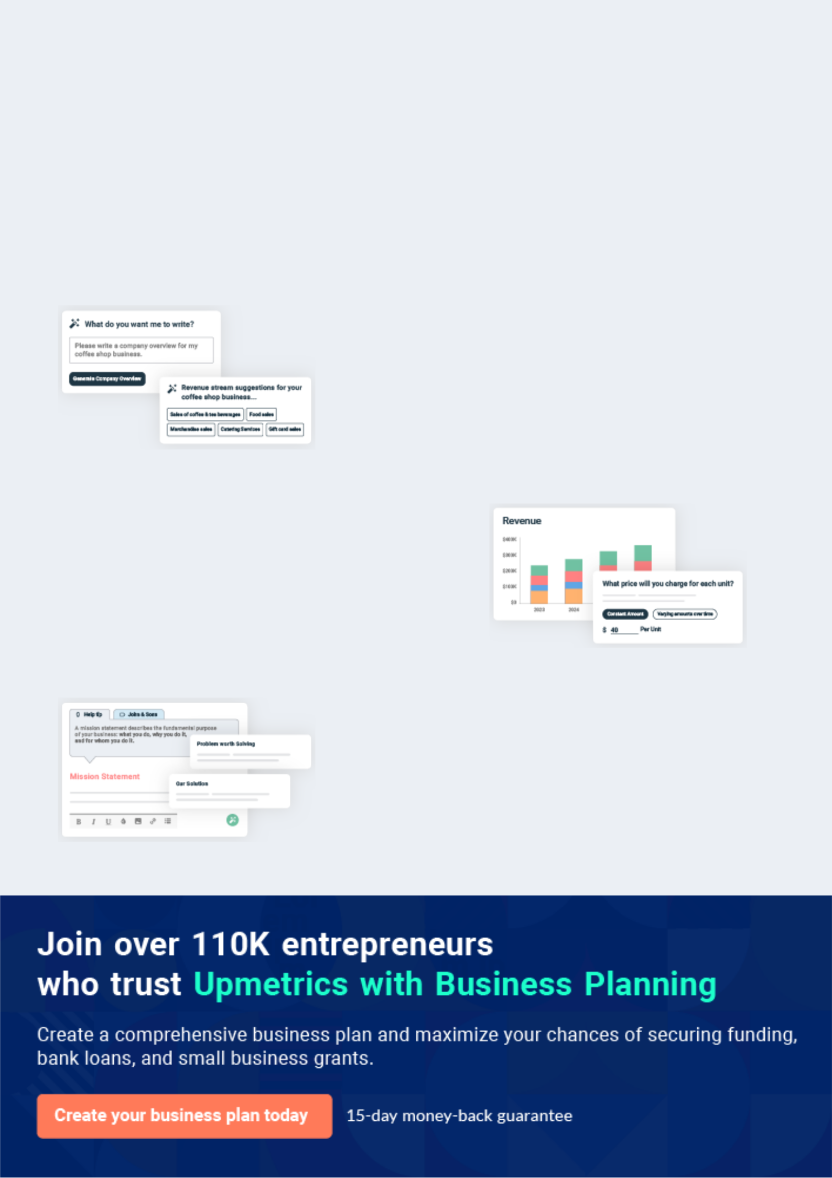
Business planning that’s simpler and faster than you think

Creating a business plan using Upmetrics to start and grow a business is literally the easiest thing in the World. Simply read the instructions and fill in the blanks. It’s as simple as that.

❛ | Upmetrics has everything you need to create a | ❜
❛ | comprehensive business plan. | ❜

AI-powered Upmetrics Assistant

AI-powered insights to streamline your plan

Not sure where to start? Upmetrics’ AI Assistant will automatically generate ideas for each section of your plan and offer improved versions of your writing, adjusting for tone, voice, and grammar or spelling errors.

Financial Forecasting Tool

All the financials are calculated for you

Forget the complex formulas and clumsy spreadsheets — with automatic financials and drag-and-drop forecasting, you can finish your plan faster and be confident that your numbers are accurate.

Business Plan Builder

Guides you like a business mentor

Upmetrics’ step-by-step instructions, prompts, and the library of 400+ sample business plans will guide you through each section of your plan as a business mentor.
Executive Summary


An executive summary is the first section of the business plan intended to provide an overview of the whole business plan.
To unlock help try Upmetrics! 

 Help tip  Donut Shop Business Plan


Start your business overview section by briefly introducing your business to your readers.

This section may include the name of your donut shop, its location when it was founded, and
To unlock help try Upmetrics! 

Start writing here..

Market opportunity

 Help tip  Donut Shop Business Plan

Outline the market you serve, discuss user demographics and preferences, and highlight the problems you intend to solve with your services.
To unlock help try Upmetrics! 

Start writing here..

Services Offered

 Help tip  Donut Shop Business Plan

Highlight the variety of donuts you offer your customers. Mention any additional products or services also if you are providing them.
To unlock help try Upmetrics! 

Start writing here..

Marketing and Sales Strategies
To unlock help try Upmetrics!

 Help tip  Donut Shop Business Plan

Outline your sales and marketing strategies—what marketing platforms you use, how you plan on acquiring customers, etc.
To unlock help try Upmetrics! 

Start writing here..

Financial Highlights

 Help tip  Donut Shop Business Plan

Briefly summarize your financial projections for the initial years of business operations. Include any capital or investment requirements, associated startup costs, projected revenues, and profit forecasts.



Start writing here..
Units Sold v/s Revenue

 |  | Units Sold | Revenue
15.00k
10.00k
5.00k
0
Year 1 | Year 2 | Year 3


Financial Year |  |  | Units Sold | Revenue
Year 1 | 1,550 |  |  | $10,000
Year 2 | 1,800 |  |  | $12,000
Year 3 | 2,050 |  |  | $14,000
 Help tip |  |  Donut Shop Business Plan


Summarize your executive summary section with a clear CTA, for example, inviting angel investors to discuss the potential business investment.
To unlock help try Upmetrics! 

Write a call to action for your business plan.
Company Overview

Depending on what details of your business are essential, you’ll need different elements in your business overview.
To unlock help try Upmetrics! 

 Help tip  Donut Shop Business Plan

Describe what kind of donut shop you run and the name of it. You may specialize in one of the following donut shops:
To unlock help try Upmetrics! 

Start writing here..

Ownership

 Help tip  Donut Shop Business Plan

List the names of your donut shop’s founders or owners. Describe what shares they own and their responsibilities for efficiently managing the business.
To unlock help try Upmetrics! 

Start writing here..
Mission statement

 Help tip  Donut Shop Business Plan

Summarize your business’ objective, core principles, and values in your mission statement. This statement needs to be memorable, clear, and brief.
To unlock help try Upmetrics! 

❛ At [Golden Glaze Donuts], our mission is to craft moments of joy, one doughnut at a time. We are dedicated to combining traditional techniques with modern twists, always prioritizing quality, community, and sustainability. Our passion goes beyond baking; it's about creating memories, fostering connections, and

adding a touch of sweetness to every day.
❜

Business history

 Help tip  Donut Shop Business Plan

If you’re an established donut shop, briefly describe your business history, like—when it was founded, how it evolved over time, etc.
To unlock help try Upmetrics! 

Start writing here..

Future goals

 Help tip  Donut Shop Business Plan

It’s crucial to convey your aspirations and vision. Mention your short-term and long-term goals; they can be specific targets for revenue, market share, or expanding your services.
To unlock help try Upmetrics! 

Start writing here..

Market Analysis
To unlock help try Upmetrics!


 |  | Market analysis provides a clear understanding of the market in which your
 |  | printing business will run along with the target market, competitors, and
 |  | growth opportunities.
 |  |  |  | To unlock help try Upmetrics! 
 Help tip |  |  Donut Shop Business Plan

To write the introduction section of your market analysis, start by clearly identifying your primary target market.
To unlock help try Upmetrics! 

Start writing here..

Target Market

 Help tip  Donut Shop Business Plan

Start this section by describing your target market. Define your ideal customer and explain what types of services they prefer. Creating a buyer persona will help you easily define your target market to your readers.



Start writing here..

Market size and growth potential

 Help tip  Donut Shop Business Plan

Offer an overview of the donut shop. Include necessary information like market size and growth potential for new stores.
To unlock help try Upmetrics! 

Start writing here..

Market Size

Available Market

Total individuals in [city/region] who 5M consume baked goods annually.

Served Market
Individuals in [city/region] who frequent donut 3M shops specifically.

Target Market
Professionals, students, and locals within a 5- 1M mile radius of our location.

 Help tip  Donut Shop Business Plan

Identify and analyze your direct and indirect competitors. Identify their strengths and weaknesses, and describe what differentiates your donut shop from them.
To unlock help try Upmetrics! 

Competitive analysis

Sugar Ring Donuts

[Sugar Ring Donuts], established in [year], is a popular chain donut shop with over [number] locations throughout [city/region]. Renowned for their classic flavors and quick service, they've become a staple for many locals

Features

Extensive range of traditional donuts.

Loyalty program offering discounts and promotions

Mobile app for quick ordering and pick-up.

Strengths

Brand recognition due to multiple locations and years in business.

Efficient service and consistent product quality.

Strong digital presence with a user-friendly mobile app.

Weaknesses

Limited innovation in flavors or specialty offerings.

The chain nature can sometimes result in impersonal customer service.

Less focus on health-conscious or dietary-specific options.

Artisan Delight Bakery

[Artisan Delight Bakery], founded in [year], positions itself as a premium, hand-crafted donut boutique.

Their focus is on unique, artisanal flavors and a personalized customer experience.

Features | Strengths
Seasonal, rotating menu with | Distinctive and innovative
gourmet donut flavors. | flavors, often drawing media
Eco-friendly packaging and | attention.
sustainable ingredient | Strong emphasis on
sourcing. | sustainability and community
Limited-time collaborations | engagement.
with local businesses and | Personalized and intimate
influencers. | customer service experience.

Weaknesses

Premium pricing can deter budget-conscious customers.

Limited reach with only one brick-and-mortar location.

Longer waiting times due to the emphasis on hand-crafted processes.

Market trends

 Help tip  Donut Shop Business Plan

Analyze emerging trends in the industry, such as technology disruptions, changes in customer behavior or preferences, etc. Explain how your business will cope with all the trends.
To unlock help try Upmetrics! 

Start writing here..

Regulatory environment

 Help tip  Donut Shop Business Plan

List regulations and licensing requirements that may affect your donut stores, such as business licenses, health and safety regulations, labor laws, etc.
To unlock help try Upmetrics! 

Start writing here..

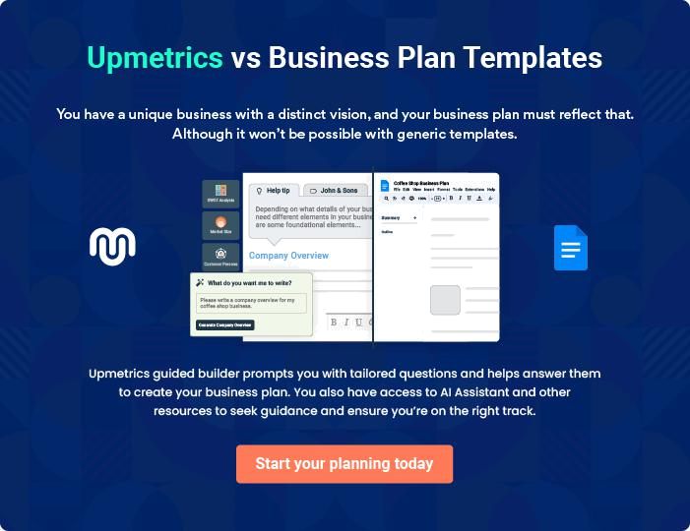
Products and Services
To unlock help try Upmetrics!

The product and services section of a donut shop business plan should describe the specific services and products that will be offered to customers. To write this section should include the following:



 Help tip  Donut Shop Business Plan

To craft the introduction for your "Products and Services" chapter, begin by positioning your business within its industry, emphasizing its unique strengths or value proposition.
To unlock help try Upmetrics! 

Start writing here..

 Help tip


Mention the donuts your business will offer. This list may include services like,

• Gluten-free
To unlock help try Upmetrics! 

Products

Classic Glazed Donut


Price: [$1.50] each

Our signature donut, lightly glazed, offering a sweet and fluffy experience with every bite.

Specifications

- Diameter: 3.5 inches

- Weight: 60 grams

- Ingredients: Organic flour, sugar, yeast, milk, eggs, salt, and natural vanilla flavoring.
Vegan Blueberry Bliss

Price: [$2.00] each

A vegan-friendly treat bursting with blueberries and topped with a light lemon glaze.

Specifications

- Diameter: 3.5 inches

- Weight: 65 grams

- Ingredients: Organic flour, almond milk, fresh blueberries, lemon zest, and vegan glazing agents.

Gluten-Free Chocolate Decadence

Price: [$2.50] each

A gluten-free indulgence, rich in cocoa, topped with velvety chocolate ganache.

Specifications

- Diameter: 3.5 inches

- Weight: 70 grams

- Ingredients: Gluten-free flour blend, cocoa powder, eggs, milk, sugar, and dark chocolate.

Fancy Strawberry Cream Cheese Donut

Price: [$3.00 each]

A gourmet donut filled with creamy strawberry cheese, finished with white chocolate drizzle and gold flakes.

Specifications

- Diameter: 4 inches

- Weight: 80 grams

- Ingredients: Organic flour, cream cheese, fresh strawberries, sugar, white chocolate, and edible gold flakes.
Handcrafted Espresso Coffee

Price: [$2.75 (12 oz.)]

A rich, aromatic coffee, brewed from the finest beans sourced from the highlands of Colombia.

Specifications

- Serving Size: 12 oz.

- Caffeine Content: 120 mg per serving

- Ingredients: Water and freshly ground Colombian coffee beans.

Custom Donut Orders

Price: Starts at [$4.00] each (varies based on design and complexity)

Tailored to your preferences, our custom donuts cater to specific themes, colors, and designs for special occasions.

Specifications

- Base Choices: Classic, Vegan, Gluten-free

- Toppings: Varied (sprinkles, chocolates, fruits, etc.)

- Design: As per customer request.

Quality Assurance

 Help tip  Donut Shop Business Plan

This section should explain how you maintain quality standards and consistently provide the highest quality service.
To unlock help try Upmetrics! 

Start writing here..

Additional Offerings
To unlock help try Upmetrics!

 Help tip  Donut Shop Business Plan

If your donut shop provides additional services, such as custom orders for special occasions, catering for events, or online ordering for pickup or delivery, include information about these services and how they will be offered.



Start writing here..
Sales And Marketing Strategies
To unlock help try Upmetrics!

Writing the sales and marketing strategies section means a list of strategies you will use to attract and retain your clients.
To unlock help try Upmetrics! 

 Help tip  Donut Shop Business Plan

To create an effective introduction for your "Sales and Marketing Strategies" chapter, start by setting the stage within your specific industry or market.
To unlock help try Upmetrics! 

Unique Selling Proposition (USP)

 Help tip  Donut Shop Business Plan


Define your business’s USPs depending on the market you serve, the equipment you use, and
the unique services you provide. Identifying USPs will help you to plan your marketing
strategies.
 |  |  |  | To unlock help try Upmetrics! 
Start writing here..
Pricing Strategy
 Help tip |  |  Donut Shop Business Plan

Describe your pricing strategy—how you plan to price your products and stay competitive in the local market. You can mention any discounts you plan on offering to attract new customers to your donut shop.



Start writing here..

 Help tip  Donut Shop Business Plan
To unlock help try Upmetrics!

Discuss your marketing strategies to market your services. You may include some of these marketing strategies in your business plan—social media marketing, Google ads, brochures, content marketing, and print marketing.



Marketing strategies

Online


Social Media

Regular updates, promotions, and engaging content will be posted on platforms like Facebook, Instagram, and Twitter. This not only keeps our audience informed but also helps in building a loyal customer base.

Google Ads

Targeted advertising campaigns will be launched to attract online searches related to donut shops in [city/region].

Offline

Brochures

Vibrant brochures showcasing our product range will be distributed in high footfall areas, such as shopping malls and office complexes.

Content Marketing

Blog posts and articles highlighting the uniqueness of our products, donut recipes, and the art of donut-making will be featured on our website.

Print Marketing

Ads will be placed in local newspapers and magazines, especially during promotional periods.

 Help tip

Outline the strategies you’ll implement to maximize your sales. Your sales strategies may include in-store sales, partnering with businesses, catering or hosting parties, etc.
To unlock help try Upmetrics! 

Sales strategies

Partner with Businesses

Collaborations with nearby offices and educational institutions for bulk orders and special events.

Catering and Parties

Offering specialized services for events, including birthdays, corporate events, and other occasions, allowing us to tap into a larger audience.

In-Store Sales

Our prime location at [address] will be optimized with attractive displays, promotional offers, and efficient staff training to maximize walk-in sales.

 Help tip
Regular Customer Discounts
Our frequent customers will benefit from a [XX]% discount on every [nth] purchase.
To unlock help try Upmetrics!

Describe your customer retention strategies and how you plan to execute them. For instance, introducing loyalty programs, discounts for loyal customers or bulk orders, personalized service, etc.



Customer retention

Loyalty Programs

Customers can accumulate points with every purchase, which can be redeemed for free products or discounts.

Personalized Service

Recognizing regular customers,

understanding their preferences,

and occasionally surprising them

with free samples or upgrades
Operations Plan
To unlock help try Upmetrics!

 |  | When writing the operations plan section, it’s important to consider the
 |  | various aspects of your business operations.
 |  |  |  | To unlock help try Upmetrics! 
 Help tip |  |  Donut Shop Business Plan


To create an effective introduction for your "Operational Plan" chapter, start by emphasizing the
pivotal role of efficient operations in the success of your business, underscoring how they
directly impact the quality of services delivered.
 |  |  |  | To unlock help try Upmetrics! 
Start writing here..
Staffing and Training
 Help tip |  |  Donut Shop Business Plan

Mention your donut shop’s staffing requirements, including the head baker, assistant kitchen
staff, or workers needed. Include their qualifications, the training required, and the duties they
will perform
 |  |  |  | To unlock help try Upmetrics! 
Start writing here..
Operational Process
 Help tip |  |  Donut Shop Business Plan

Outline the processes and procedures you will use to run your donut shop. Your operational processes may include dough preparation, cleaning and maintenance, customer service process, etc.



Start writing here..

Equipment & Machinery

 Help tip  Donut Shop Business Plan

Include the list of equipment and machinery required for the donut shop, utensils, display cabinets, mixers, fryers, and ovens.
To unlock help try Upmetrics! 

Start writing here..
Management Team

The management team section provides an overview of the individuals responsible for running your business plan.
To unlock help try Upmetrics! 

 Help tip  Donut Shop Business Plan

To craft an introduction for your "Management Team" chapter, begin by emphasizing the crucial role of leadership in the success of any business.
To unlock help try Upmetrics! 

Start writing here..

Key managers

 Help tip  Donut Shop Business Plan

Introduce your management and key members of your team, and explain their roles and responsibilities.
To unlock help try Upmetrics! 

Start writing here..


JOHN DOE

CEO & Co-founder - john.doe@example.com

[John Doe] is the visionary behind [Golden Glaze Donuts]. His passion for crafting the perfect doughnut, combined with his astute business acumen, brought the dream of [Golden Glaze] to life.


- Education: [MBA from Harvard Business School].

- Professional Background: John has over [15] years of experience in the food industry, having held managerial positions at renowned eateries like [Sample Restaurant] and [Sample Bakery Chain].

JANE SMITH

Operations Manager - jane.smith@example.com

Jane is the linchpin ensuring the smooth daily operations at [Golden Glaze Donuts]. Her meticulous attention to detail and deep understanding of the bakery operations ensure every doughnut is a masterpiece.


- Education: [Bachelor's in Business Management from Stanford University.]

- Professional Background: With over [12] years in the food industry, Jane has managed operations at leading establishments such as [Sample Café] and [Sample Patisserie].


ALICE WILLIAMS

Customer Relations Manager - robert.brown@example.com

Alice is the bridge between [Golden Glaze Donuts] and its cherished customers. Her innate ability to understand customer needs and feedback helps tailor the [Golden Glaze] experience uniquely for each patron.

- Education: [Degree in Communications from UCLA].

- Professional Background: Alice has dedicated over [8] years to mastering customer service roles, including stints at renowned establishments like [Sample Bistro] and [Sample Coffee House].

Organizational structure

 Help tip  Donut Shop Business Plan

Explain the organizational structure of your management team. Include the reporting line and decision-making hierarchy.
To unlock help try Upmetrics! 

Start writing here..
Organization chart


John Doe

CEO


Alice Williams
Alice Williams | Jane Smith |  | Michael Ray
CRM |  |  | Michael Ray
 | Operations Manager |  | Marketing Head



Tom Brown


Sales Lead Emma Watson

Bakery Lead

Compensation plan

 Help tip  Donut Shop Business Plan

Describe your compensation plan for the management and staff. Include their salaries, incentives, and other benefits.
To unlock help try Upmetrics! 

Start writing here..
 Help tip

Mentioning advisors or consultants in your business plans adds credibility to your business idea.
To unlock help try Upmetrics! 

Advisors/Consultants


DR. ROBERT MARTIN

Consultant

A seasoned consultant with over [X] years in the food and beverage industry.

Provides guidance on quality control, sourcing of ingredients, and innovation in the baking process.
Financial Plan

When writing the financial plan section of a business plan, it’s important to provide a comprehensive overview of your financial projections for the first few years of your business, You may provide the following:
To unlock help try Upmetrics! 

 Help tip  Donut Shop Business Plan


To create an effective introduction for your "Financial Plan" chapter, begin by stressing the critical role of a well-structured financial plan in the success of your venture.
To unlock help try Upmetrics! 

Start writing here..

 Help tip


Describe details such as projected revenue, operational costs, and service costs in your projected profit and loss statement. Make sure to include your business’s expected net profit or loss.
To unlock help try Upmetrics! 

Profit & loss statement

Revenue

Cost Of Sales

General Costs

Revenue Specific Costs

Personnel Costs (Direct

Labor)

Gross Margin

Gross Margin (%)

Operating Expense

Payroll Expense

(Indirect Labor)

General Expense

Bad Debt

Amortization of Current

Assets

2023-24 | 2024-25 | 2025-26 | 2026-27 | 2027-28
$0 | $0 | $0 | $0 | $0

$0 | $0 | $0 | $0 | $0
$0 | $0 | $0 | $0 | $0
$0 | $0 | $0 | $0 | $0
$0 | $0 | $0 | $0 | $0

$0 | $0 | $0 | $0 | $0
0% | 0% | 0% | 0% | 0%

$0 | $0 | $0 | $0 | $0
$0 | $0 | $0 | $0 | $0
$0 | $0 | $0 | $0 | $0
$0 | $0 | $0 | $0 | $0
$0 | $0 | $0 | $0 | $0

EBITDA

Additional Expense

Long Term

Depreciation

Gain or loss from Sale

of Assets

EBIT

Interest Expenses

EBT

Income Tax Expense

Total Expense

Net Income

Net Income (%)

2023-24 | 2024-25 | 2025-26 | 2026-27 | 2027-28
$0 | $0 | $0 | $0 | $0
$0 | $0 | $0 | $0 | $0
$0 | $0 | $0 | $0 | $0
$0 | $0 | $0 | $0 | $0
$0 | $0 | $0 | $0 | $0
$0 | $0 | $0 | $0 | $0
$0 | $0 | $0 | $0 | $0
$0 | $0 | $0 | $0 | $0
$0 | $0 | $0 | $0 | $0
$0 | $0 | $0 | $0 | $0
0% | 0% | 0% | 0% | 0%
 | 2023-24 | 2024-25 | 2025-26 | 2026-27 | 2027-28
Retained Earning | $0 | $0 | $0 | $0 | $0
Opening
Owner's Distribution | $0 | $0 | $0 | $0 | $0
Retained Earning | $0 | $0 | $0 | $0 | $0
Closing

 Help tip

The cash flow for the first few years of your operation should be estimated and described in this section. This may include billing invoices, payment receipts, loan payments, and any other cash flow statements.
To unlock help try Upmetrics! 

Cash flow statement

 | 2023-24 | 2024-25 | 2025-26 | 2026-27 | 2027-28
Cash Received | $0 | $0 | $0 | $0 | $0
Cash Paid | $0 | $0 | $0 | $0 | $0
COS & General Expenses | $0 | $0 | $0 | $0 | $0
Salary & Wages | $0 | $0 | $0 | $0 | $0
Interest | $0 | $0 | $0 | $0 | $0

Sales Tax

Income Tax

Net Cash From

Operations

Assets Sell

Assets Purchase

Net Cash From

Investments

Amount Received

Loan Received

Common Stock

Preferred Stock

Owner's Contribution

Amount Paid

2023-24 | 2024-25 | 2025-26 | 2026-27 | 2027-28
$0 | $0 | $0 | $0 | $0
$0 | $0 | $0 | $0 | $0
$0 | $0 | $0 | $0 | $0

$0 | $0 | $0 | $0 | $0
$0 | $0 | $0 | $0 | $0
$0 | $0 | $0 | $0 | $0

$0 | $0 | $0 | $0 | $0
$0 | $0 | $0 | $0 | $0

$0 | $0 | $0 | $0 | $0
$0 | $0 | $0 | $0 | $0
$0 | $0 | $0 | $0 | $0

Loan Capital $0 $0 $0 $0 $0

 | 2023-24 | 2024-25 | 2025-26 | 2026-27 | 2027-28
Dividends & Distributions | $0 | $0 | $0 | $0 | $0
Net Cash From | $0 | $0 | $0 | $0 | $0
Financing

Summary
Starting Cash | $0 | $0 | $0 | $0 | $0
Cash In | $0 | $0 | $0 | $0 | $0
Cash Out | $0 | $0 | $0 | $0 | $0
Change in Cash | $0 | $0 | $0 | $0 | $0
Ending Cash | $0 | $0 | $0 | $0 | $0

 Help tip

Create a projected balance sheet documenting your donut shop’s assets, liabilities, and equity.

To unlock help try Upmetrics! 

Balance sheet

 | 2023-24 | 2024-25 | 2025-26 | 2026-27 | 2027-28
Assets | $0 | $0 | $0 | $0 | $0
Current Assets | $0 | $0 | $0 | $0 | $0
Cash | $0 | $0 | $0 | $0 | $0
Accounts Receivable | $0 | $0 | $0 | $0 | $0
Inventory | $0 | $0 | $0 | $0 | $0
Other Current Assets | $0 | $0 | $0 | $0 | $0
Long Term Assets | $0 | $0 | $0 | $0 | $0
Gross Long Term Assets | $0 | $0 | $0 | $0 | $0
Accumulated Depreciation | $0 | $0 | $0 | $0 | $0

Liabilities & Equity | $0 | $0 | $0 | $0 | $0
Liabilities | $0 | $0 | $0 | $0 | $0
Current Liabilities | $0 | $0 | $0 | $0 | $0
Accounts Payable | $0 | $0 | $0 | $0 | $0
Income Tax Payable | $0 | $0 | $0 | $0 | $0
Sales Tax Payable | $0 | $0 | $0 | $0 | $0
Short Term Debt | $0 | $0 | $0 | $0 | $0
 | 2023-24 | 2024-25 | 2025-26 | 2026-27 | 2027-28
Long Term Liabilities | $0 | $0 | $0 | $0 | $0
Long Term Debt | $0 | $0 | $0 | $0 | $0
Equity | $0 | $0 | $0 | $0 | $0
Paid-in Capital | $0 | $0 | $0 | $0 | $0
Common Stock | $0 | $0 | $0 | $0 | $0
Preferred Stock | $0 | $0 | $0 | $0 | $0
Owner's Contribution | $0 | $0 | $0 | $0 | $0
Retained Earnings | $0 | $0 | $0 | $0 | $0

Check | $0 |  |  | $0 | $0 | $0 | $0
 Help Tip |  |  Donut Shop Business Plan


Determine and mention your business’s break-even point—the point at which your business costs and revenue will be equal.

This exercise will help you understand how much revenue you need to generate to sustain or be profitable.
To unlock help try Upmetrics! 

Break-even Analysis

 | 2023-24 | 2024-25 | 2025-26 | 2026-27 | 2027-28
Starting Revenue | $0 | $0 | $0 | $0 | $0
Net Revenue | $0 | $0 | $0 | $0 | $0
Closing Revenue | $0 | $0 | $0 | $0 | $0

Starting Expense | $0 | $0 | $0 | $0 | $0
Net Expense | $0 | $0 | $0 | $0 | $0
Closing Expense | $0 | $0 | $0 | $0 | $0

Is Break Even? | 0 | 0 | 0 | 0 | 0
Break Even Month | 0 | 0 | 0 | 0 | 0
Days Required | 0 | 0 | 0 | 0 | 0
Break Even Revenue | $0 | $0 | $0 | $0 | $0
Break Even Units
Financing needs

 Help tip  Donut Shop Business Plan

Calculate costs associated with starting a donut shop, and estimate your financing needs and how much capital you need to raise to operate your business.
To unlock help try Upmetrics! 

Start writing here..
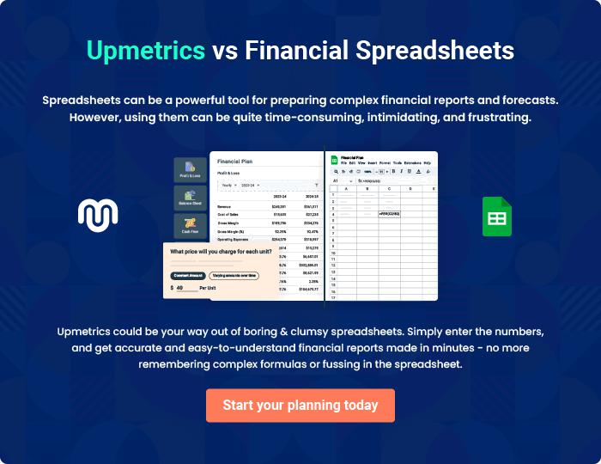
Appendix

When writing the appendix section, you should include any additional information that supports the main content of your plan. This may include financial statements, market research data, legal documents, and other
To unlock help try Upmetrics! 
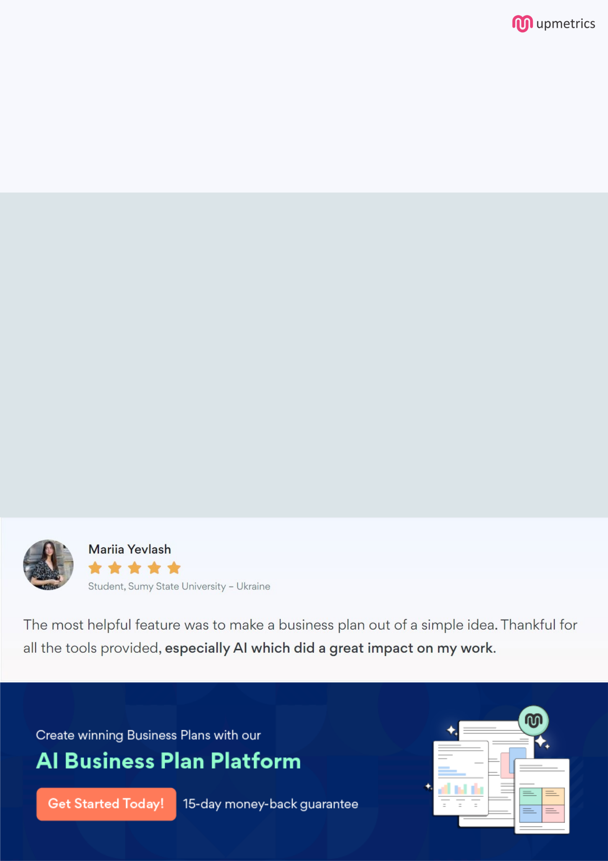
Create a winning business plan that gets you funded

Creating a stunning and investment-ready plan requires no writing, graphic designing, or financial planning expertise.

Upmetrics has all the features required to help you create a comprehensive business plan—from start to finish. Make no mistakes, it’s the modern way of planning to structure ideas, make plans, and create stunning pitch decks to awe investors.

Pitch decks that impress investors

Create pitch decks that provide a visual representation of your business, engage investors, and make them want to invest in your business idea.

Interactive plans in no time

Import business plan sections like—SWOT analysis, comparison tables, and others to create an interactive business plan. No designing skills are required.

Stunning cover page designs

With Upmetrics, you have the liberty to choose from multiple stunning cover page designs. Choose a creative design and make your plan stand out.

Online sharing made simple

Upmetrics makes online sharing quick and easier for users. Easily share your business plans with a link while tracking reader activity.

500+ sample business plans

Simply import a template from our library of sample plans into the editor and start customizing it to make it yours. It takes only a few clicks to get started.

Collaborate with team in real-time

Invite team members, initiate conversations, discuss ideas & strategies, share feedback, and work on a business plan in real-time.

