
BUSINESS PLAN

2023

Dog Walking Business Plan

Happy Tails, Walks to Remember

John Doe

10200 Bolsa Ave, Westminster, CA, 92683

- 359-3153 info@example.com http://www.example.com

Information provided in this business plan is unique to this business and confidential; therefore, anyone reading this plan agrees not to disclose any of the information in this business plan without prior written permission of the company.
Table of Contents

Executive Summary | 6
Market opportunity | 6
Services Offered | 6
Marketing & Sales Strategies | 7
Financial Highlights | 7
Units Sold v/s Revenue | 8

Company Overview | 9
Ownership | 9
Business Owners | 9
Mission statement | 10
Business history | 10
Future goals | 10

Market Analysis | 11
Target Market | 11
Market size and growth potential | 11
Market Size | 12
Competitive analysis | 12
Paws & Strides | 12
Canine Companions | 13
Market trends | 13
Regulatory environment | 13

Products and Services | 15
Services | 15
Dog Walking | 15
Group Dog Walks | 16
Puppy Visits and Potty Breaks | 16
Pet Sitting and Feeding | 17
Pet Transportation | 17
Pet Waste Cleanup | 17
Pet Grooming (Additional Service) | 18
Service Area and Availability | 18
Security and Safety Measures | 18
Additional Services | 19

Sales And Marketing Strategies | 20
Unique Selling Proposition (USP) | 20
Pricing Strategy | 20
Marketing strategies | 21
Online | 21
Offline | 21
Sales strategies | 22
Customer retention | 22

Operations Plan | 23
Staffing & Training | 23
Operational Process | 23
Equipment & Technology | 24

Management Team | 25
Key managers | 25
John Doe | 25
Jane Doe | 26
Alice Brown | 26
Robert Brown | 26
Organizational structure | 27
Organization chart | 27
Compensation plan | 28
Board of advisors | 28
Dr. Mary Smith | 28
Steve Rogers | 28
Financial Plan | 29
Profit & loss statement | 29
Cash flow statement | 32
Balance sheet | 34
Break-even Analysis | 36
Financing needs | 38
Appendix
Appendix | 40
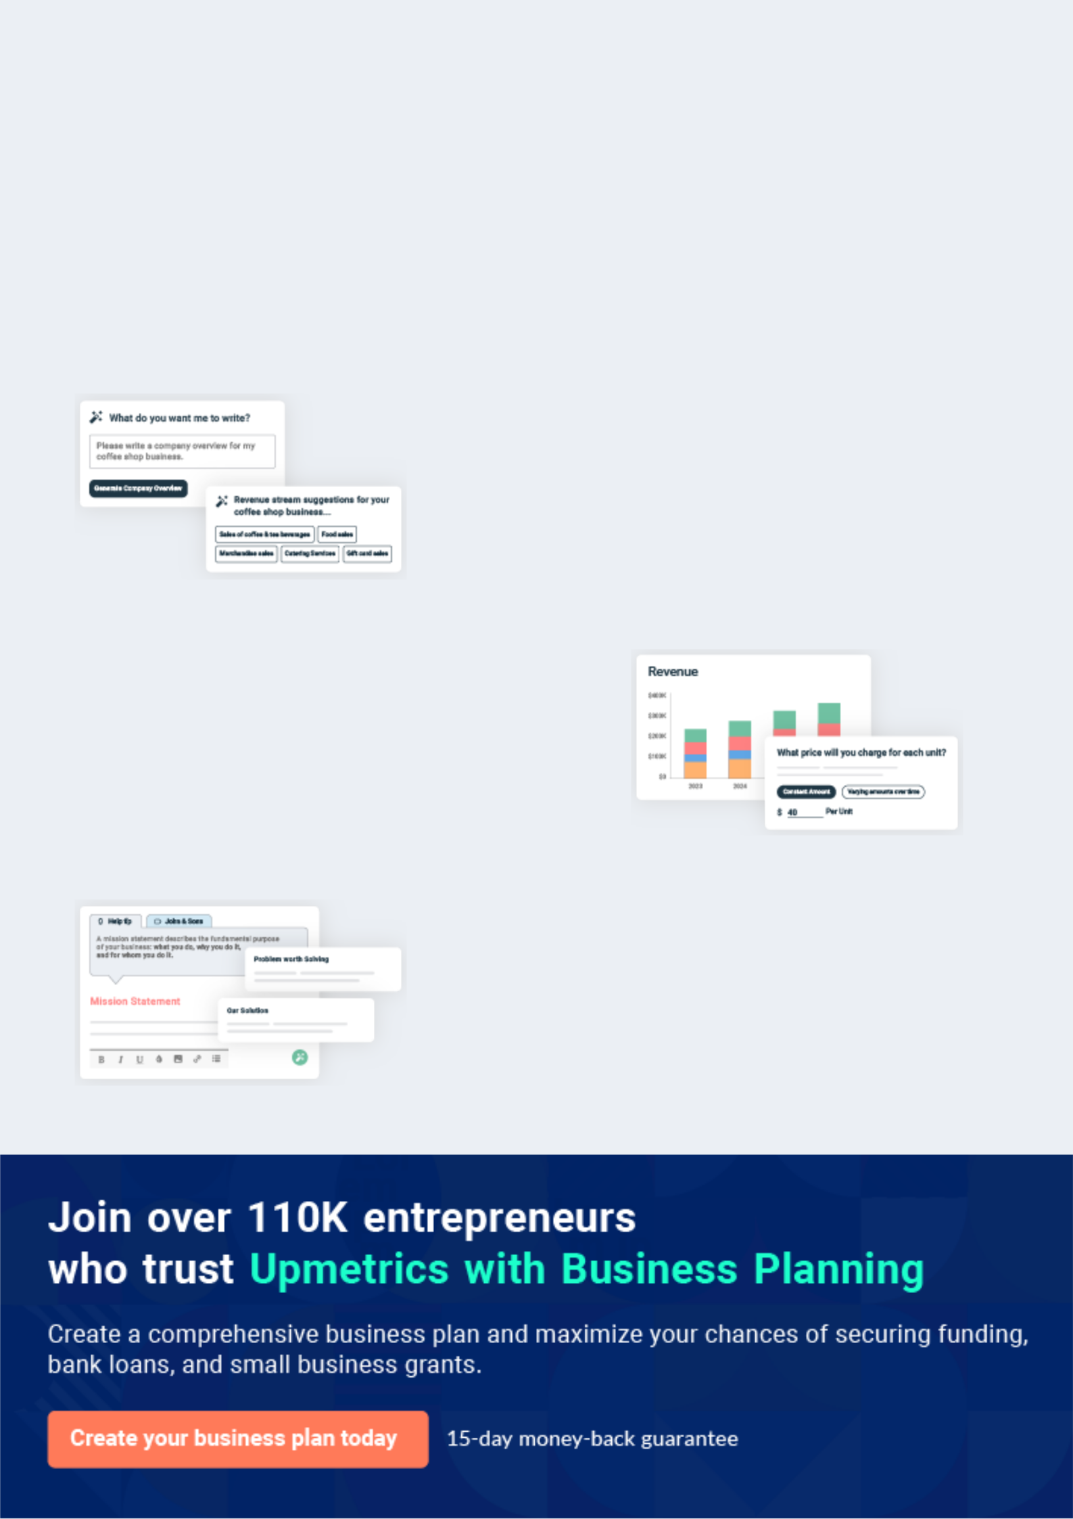
Business planning that’s simpler and faster than you think

Creating a business plan using Upmetrics to start and grow a business is literally the easiest thing in the World. Simply read the instructions and fill in the blanks. It’s as simple as that.

❛ | Upmetrics has everything you need to create a | ❜
❛ | comprehensive business plan. | ❜

AI-powered Upmetrics Assistant

AI-powered insights to streamline your plan

Not sure where to start? Upmetrics’ AI Assistant will automatically generate ideas for each section of your plan and offer improved versions of your writing, adjusting for tone, voice, and grammar or spelling errors.

Financial Forecasting Tool

All the financials are calculated for you

Forget the complex formulas and clumsy spreadsheets — with automatic financials and drag-and-drop forecasting, you can finish your plan faster and be confident that your numbers are accurate.

Business Plan Builder

Guides you like a business mentor

Upmetrics’ step-by-step instructions, prompts, and the library of 400+ sample business plans will guide you through each section of your plan as a business mentor.
Executive Summary


An executive summary is the first section of the business plan intended to provide an overview of the whole business plan.
To unlock help try Upmetrics! 

 Help tip  Dog Walking Business Plan


Start your executive summary by briefly introducing your business to your readers. This section may include your dog walking business’s name, location, when it was founded, etc.
To unlock help try Upmetrics! 

Start writing here..

Market opportunity

 Help tip  Dog Walking Business Plan

Summarize your market research, including market size, growth potential, and marketing trends. Highlight the opportunities in the market and how your business will fit in to fill the gap.
To unlock help try Upmetrics! 

Start writing here..

Services Offered

 Help tip  Dog Walking Business Plan

Highlight the dog walking services you offer your clients. You may also include any additional service you provide, like pet grooming or something else.
To unlock help try Upmetrics! 

Start writing here..

Marketing & Sales Strategies
To unlock help try Upmetrics!

 Help tip  Dog Walking Business Plan

Outline your sales and marketing strategies—what marketing platforms you use, how you plan on acquiring customers, etc.
To unlock help try Upmetrics! 

Start writing here..

Financial Highlights

 Help tip  Dog Walking Business Plan

Briefly summarize your financial projections for the initial years of business operations. Include any capital or investment requirements, associated startup costs, projected revenues, and profit forecasts.



Start writing here..
Units Sold v/s Revenue

 |  | Units Sold | Revenue
15.00k
10.00k
5.00k
0
Year 1 | Year 2 | Year 3


Financial Year |  |  | Units Sold | Revenue
Year 1 | 1,550 |  |  | $10,000
Year 2 | 1,800 |  |  | $12,000
Year 3 | 2,050 |  |  | $14,000
 Help tip |  |  Dog Walking Business Plan


Summarize your executive summary section with a clear CTA, for example, inviting angel investors to discuss the potential business investment.
To unlock help try Upmetrics! 

Write a call to action for your business plan.
Company Overview

Depending on what details of your business are essential, you’ll need different elements in your business overview.
To unlock help try Upmetrics! 

 Help tip  Dog Walking Business Plan

Describe your business in this section by providing all the basic information:

Describe what kind of dog walking business you run and the name of it. You may specialize in
To unlock help try Upmetrics! 

Start writing here..

Ownership

 Help tip  Dog Walking Business Plan

List the names of your dog walking company’s founders or owners. Describe what shares they own and their responsibilities for efficiently managing the business.
To unlock help try Upmetrics! 

Start writing here..

Business Owners



60% John Doe



40% Jane Doe
Mission statement

 Help tip  Dog Walking Business Plan

Summarize your business’ objective, core principles, and values in your mission statement. This statement needs to be memorable, clear, and brief.
To unlock help try Upmetrics! 

❛ At [Dogtopia Walks], we believe every dog deserves happiness, health, and adventure. Our mission is to provide unparalleled care and tailored experiences, ensuring every tail-wagging moment

counts.
❜

Business history

 Help tip  Dog Walking Business Plan

If you’re an established dog walking service provider, briefly describe your business history, like —when it was founded, how it evolved over time, etc.
To unlock help try Upmetrics! 

Start writing here..

Future goals

 Help tip  Dog Walking Business Plan

It’s crucial to convey your aspirations and vision. Mention your short-term and long-term goals; they can be specific targets for revenue, market share, or expanding your services.
To unlock help try Upmetrics! 

Start writing here..

Market Analysis
To unlock help try Upmetrics!


 |  | Market analysis provides a clear understanding of the market in which your
 |  | printing business will run along with the target market, competitors, and
 |  | growth opportunities.
 |  |  |  | To unlock help try Upmetrics! 
 Help tip |  |  Dog Walking Business Plan

To write the introduction section of your market analysis, start by clearly identifying your primary target market.
To unlock help try Upmetrics! 

Start writing here..

Target Market

 Help tip  Dog Walking Business Plan

Start this section by describing your target market. Define your ideal customer and explain what types of services they prefer. Creating a buyer persona will help you easily define your target market to your readers.



Start writing here..

Market size and growth potential

 Help tip  Dog Walking Business Plan

Describe your market size and growth potential and whether you will target a niche or a much broader market.
To unlock help try Upmetrics! 

Start writing here..

Market Size

Available Market | 5M
Total number of dog owners in | 5M
California. | 5M
Served Market | 500k
Dog owners in [Westminster, CA] | 500k
actively seeking dog walking services. | 500k
Target Market | 100k
Busy professionals in [Westminster] | 100k
needing specialized dog walking | 100k

services.

 Help tip  Dog Walking Business Plan

Identify and analyze your direct and indirect competitors. Identify their strengths and weaknesses, and describe what differentiates your dog walking services from them.
To unlock help try Upmetrics! 

Competitive analysis

Paws & Strides

[Paws & Strides] has been in the dog walking industry for over [five] years and has a strong digital presence with its proprietary app-based booking system. Catering mostly to the tech-savvy, urban clientele, they've established a strong foothold in the younger demographic.

Features

App-based scheduling and payment system.

GPS tracking of dog walks.

Automated feedback and rating system.

Monthly subscription packages.

Strengths

Technology Integration: Their advanced app provides real-time tracking and seamless booking.

Young Clientele: Strong rapport with younger dog owners who prefer digital solutions.

Consistent Service: Monthly subscription model ensures regular clientele and consistent revenue.

Weaknesses

Lack of Personalization: The app-based approach, while efficient, often lacks the personal touch that many pet owners desire.

Limited Service Diversity: Primarily focused on standard dog walks, missing out on niche services like senior dog care or adventure walks.

Canine Companions
To unlock help try Upmetrics!

[Canine Companions] is a stalwart in the dog walking industry, boasting over a decade of service. With a vast customer base, they're known for their traditional approach, focusing on long-term relationships and community engagement.

Features

Loyalty programs with discounts for long-term clients.

Community events and dog meet-ups.

Vet partnerships offering health check-ups during walks.

Referral incentives.

Strengths

Loyal Customer Base: Years of service have cemented a strong and loyal clientele.

Community Engagement: Regular events foster a sense of community among pet owners.

Holistic Care: Collaborations with vets ensure pets get comprehensive care.

Weaknesses

Slow Technological Adoption: Lack a digital booking system, relying primarily on phone bookings.

Limited Marketing: With a traditional approach, they're yet to tap into the vast online marketing potential.

Market trends

 Help tip  Dog Walking Business Plan

Analyze emerging trends in the industry, such as technology disruptions, changes in customer behavior or preferences, etc. Explain how your business will cope with all the trends.
To unlock help try Upmetrics! 

Start writing here..

Regulatory environment

 Help tip  Dog Walking Business Plan

List regulations and licensing requirements that may affect your dog-walking company, such as business registration, insurance, dog licensing, leash laws, and permits for operating in public spaces.



Start writing here..

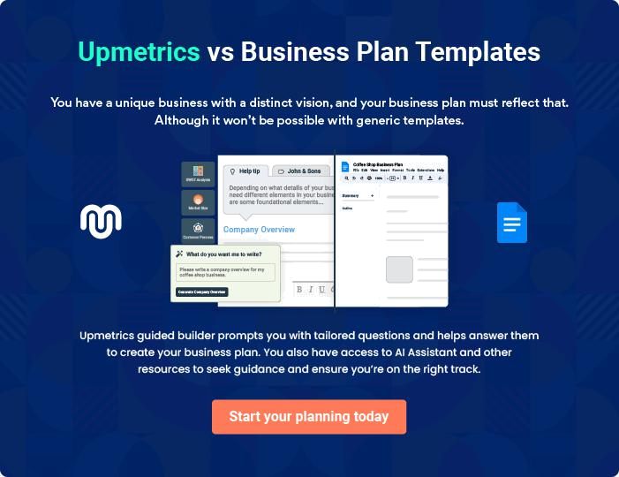
Products and Services
To unlock help try Upmetrics!

The product and services section of a dog walking business plan should describe the specific services and products that will be offered to customers. To write this section should include the following:



 Help tip  Dog Walking Business Plan

To craft the introduction for your "Products and Services" chapter, begin by positioning your business within its industry, emphasizing its unique strengths or value proposition.
To unlock help try Upmetrics! 

Start writing here..

 Help tip


Mention the dog walking services your business will offer. This list may include services like

• Dog walking
To unlock help try Upmetrics! 

Services

Dog Walking


Price: [$20 per 30-minute walk]

Individualized walks tailored to the dog's pace, ensuring they get their required exercise and mental stimulation.

Specifications

- One-on-one attention

- Flexible routes based on dog's preference

- Availability for daily or occasional scheduling

- Instant updates and photos upon request
Group Dog Walks

Price: [$15 per dog for a 45-minute session]

Socializing sessions where dogs can interact in a controlled environment, fostering better social behavior.

Specifications

- Groups of [3-5] dogs

- Controlled and supervised environment

- Locations vary – parks, trails, beaches

- Suitable for sociable dogs

Puppy Visits and Potty Breaks

Price: [$15 per 20-minute] visit

Catering to the youngest members, ensuring they are well taken care of in their formative months.

Specifications

- Gentle handling suitable for puppies

- Basic training and command reinforcement

- Waste cleanup

- Feedback on puppy behavior
Pet Sitting and Feeding

Price: [$50 per day]

For owners who are away, we ensure their pets are well-fed and comfortable in their home environment.

Specifications

- Up to three visits per day

- Feeding according to owner's instructions

- Playtime and companionship

- Medication administration if needed

Pet Transportation

Price: Starting at [$30] (based on distance and duration)

Safe and secure transport for pets to vet appointments, grooming sessions, or other locations.

Specifications

- Comfortable, climate-controlled vehicles

- Secure harnessing and crate options

- Pick-up and drop-off service

- Suitable for all pet sizes

Pet Waste Cleanup

Price: [$10] per session

Ensuring clean and hygienic environments post-walk.

Specifications

- Use of eco-friendly waste bags

- Suitable for backyards, gardens, or patios

- Disposal in a responsible manner

Pet Grooming (Additional Service)
- To unlock help try Upmetrics!

Price: Starting at [$40] (based on breed and grooming requirements)

Keeping your pet looking their best with grooming sessions tailored to their breed and preference.

Specifications

- Includes bathing, brushing, nail trimming, and ear cleaning

- Breed-specific grooming styles

- Use of hypoallergenic and eco-friendly grooming products

Service Area and Availability

 Help tip  Dog Walking Business Plan

Provide details about your geographic service area and the availability of your business. This may include specific neighborhoods of the city where your business will operate and the working hours of your business operations.



Start writing here..

Security and Safety Measures

 Help tip  Dog Walking Business Plan

This section should explain the security and safety measures you plan to implement to provide the highest quality service consistently.
To unlock help try Upmetrics! 

Start writing here..

Additional Services

 Help tip  Dog Walking Business Plan

Mention if your dog walking company offers any additional services. You may include services like pet sitting, grooming, and transportation.
To unlock help try Upmetrics! 

Start writing here..
Sales And Marketing Strategies
To unlock help try Upmetrics!

Writing the sales and marketing strategies section means a list of strategies you will use to attract and retain your clients.
To unlock help try Upmetrics! 

 Help tip  Dog Walking Business Plan

To create an effective introduction for your "Sales and Marketing Strategies" chapter, start by setting the stage within your specific industry or market.
To unlock help try Upmetrics! 

Unique Selling Proposition (USP)

 Help tip  Dog Walking Business Plan

Define your business’s USPs depending on the market you serve, the equipment you use, and the unique services you provide. Identifying USPs will help you plan your marketing strategies.
To unlock help try Upmetrics! 

Start writing here..

Pricing Strategy

 Help tip  Dog Walking Business Plan

Describe your pricing strategy—how you plan to price your dog walking services and stay competitive in the local market. You can mention any discounts you plan on offering to attract new customers.



Start writing here..

 Help tip  Dog Walking Business Plan
To unlock help try Upmetrics!

Discuss your marketing strategies to market your services. You may include some of these marketing strategies in your business plan—social media marketing, online advertising, brochures, email marketing, content marketing, and print marketing.



Marketing strategies

Online


Social Media

Leveraging platforms such as Instagram and Facebook to showcase client testimonials, dog care tips, and behind-the-scenes glimpses of our operations.

Content Marketing

A blog offering dog care advice, behavioral tips, and updates on local pet-related events.

Email Marketing

Regular newsletters with updates, promotions, and pet care advice to engage our subscriber base.

Google Ads

Targeted pay-per-click (PPC) campaigns on search engines to reach potential customers actively looking for dog walking services.

Offline

Brochures

Distributed in local pet stores, vet clinics, and community centers, providing detailed information on our services.

Print Marketing

Local newspaper ads and flyers promoting seasonal discounts and events.

 Help tip
To unlock help try Upmetrics!
To unlock help try Upmetrics!

Outline the strategies you’ll implement to maximize your sales. Your sales strategies may include community involvement, offering special promotions, and partnering with other pet care businesses.



Sales strategies

Partner with Businesses

Collaborating with local pet care businesses, including groomers and vet clinics, for mutual referrals.

Community Involvement

Hosting and sponsoring local pet-related events, from dog park clean-up days to pet adoption drives.

Special Promotions

Seasonal offers to attract new

clients during peak times such as

holidays.

 Help tip

Describe your customer retention strategies and how you plan to execute them. For instance, introducing loyalty programs, discounts on annual membership, flexible scheduling, personalized service, etc.



Customer retention

Loyalty Programs

Points-based system where accumulated points can be redeemed for discounts or complimentary services.

Personalized Service

Regular check-ins with clients to gather feedback and ensure our services continue to meet their needs.

Annual Membership Discounts

Special rates for clients who commit to our services on an annual basis.

Flexible Scheduling

Adapting to the diverse schedules of our clients, ensuring they can always find a slot that works for them.

Operations Plan

 |  | When writing the operations plan section, it’s important to consider the
 |  | various aspects of your business operations.
 |  |  |  | To unlock help try Upmetrics! 
 Help tip |  |  Dog Walking Business Plan


To create an effective introduction for your "Operational Plan" chapter, start by emphasizing the
pivotal role of efficient operations in the success of your business, underscoring how they
directly impact the quality of services delivered.
 |  |  |  | To unlock help try Upmetrics! 
Start writing here..
Staffing & Training
 Help tip |  |  Dog Walking Business Plan

Mention your dog walking business’s staffing requirements, including the number of employees
or dog walkers needed. Include their qualifications, the training required, and the duties they will
perform.
 |  |  |  | To unlock help try Upmetrics! 
Start writing here..
Operational Process
 Help tip |  |  Dog Walking Business Plan

Outline the processes and procedures you will use to run your dog walking business. Your operational processes may include appointment scheduling, dog pick-ups and drop-offs, dog handling & control, basic care and feeding, equipment maintenance, etc._{To unlock help try Upmetrics!} 

Start writing here..

Equipment & Technology
To unlock help try Upmetrics!

 Help tip  Dog Walking Business Plan

Include the list of equipment and technology required for dog walking, such as collars or harnesses, waste bags and dispensers, dog ID tags, GPS and navigation devices, and safety equipment.



Start writing here..
Management Team

The management team section provides an overview of the individuals responsible for running your business plan.
To unlock help try Upmetrics! 

 Help tip  Dog Walking Business Plan

To craft an introduction for your "Management Team" chapter, begin by emphasizing the crucial role of leadership in the success of any business.
To unlock help try Upmetrics! 

Start writing here..

Key managers

 Help tip  Dog Walking Business Plan

Introduce your management and key members of your team, and explain their roles and responsibilities.
To unlock help try Upmetrics! 

Start writing here..


JOHN DOE

CEO - john.doe@example.com

[John] is the visionary behind [Dogtopia Walks]. A graduate of [Harvard Business School] with an MBA in Business Administration, he possesses over [10 years] of experience in the pet care industry.


Starting as a dog handler, John's love for animals combined with his business acumen led him to establish [Dogtopia Walks].

His leadership ensures that the company remains committed to excellence in service and stays ahead of industry trends.

He has been a keynote speaker at several pet care conventions and is known for his innovative approach to pet care and business strategy.

JANE DOE

Operations Manager - jane.doe@example.com

[Jane] holds a Bachelor's Degree in Business Management from [Stanford University].

With her robust [8 years] of experience in operational management and an additional [5 years] in the pet care domain, she's the linchpin that ensures the smooth functioning of [Dogtopia Walks].


Jane's leadership in operations ensures efficiency, timely service delivery, and overall client satisfaction.

Her strategic insights have significantly reduced operational costs while maximizing service quality.


ALICE BROWN

Marketing Director - alice.brown@example.com

[Alice] graduated with honours from [MIT Sloan School of Management] majoring in Marketing. Over her illustrious [7-year] career, she has spearheaded marketing campaigns for notable brands, bringing them to market prominence.

At [Dogtopia Walks], Alice crafts and oversees strategic marketing initiatives, ensuring our services resonate with our target audience and forging a strong brand identity.

She frequently attends marketing seminars and continuously integrates cutting-edge marketing tactics to amplify [Dogtopia Walks]' reach.


ROBERT BROWN

HR Manager - robert.brown@example.com

Robert, a graduate of [Yale School of Management], specializes in Human Resource Management.

His [6-year] journey in HR spans various industries, but his passion for animals brought him to [Dogtopia Walks]. Robert's expertise lies in talent acquisition, staff development, and fostering a collaborative work environment.

He has successfully orchestrated training programs and emphasizes the professional development of each team member.

His strategies have notably improved employee retention and overall workplace morale at [Dogtopia Walks].
Organizational structure

 Help tip  Dog Walking Business Plan

Explain the organizational structure of your management team. Include the reporting line and decision-making hierarchy.
To unlock help try Upmetrics! 

Start writing here..

Organization chart


John Doe

CEO


Alice Brown | Robert Brown | Jane Doe
Marketing | Robert Brown | Operations
Marketing | HR Manager | Operations
Director | HR Manager | Manager



 | Emily Black | Mike Smith | Lisa White
James Green | Training | Lead Dog | Customer
Digital | Coordinator | Walker | Service
Marketing

Compensation plan

 Help tip  Dog Walking Business Plan

Describe your compensation plan for the management and staff. Include their salaries, incentives, and other benefits.
To unlock help try Upmetrics! 

Start writing here..

 Help tip

Mentioning advisors or consultants in your business plans adds credibility to your business idea.
To unlock help try Upmetrics! 

Board of advisors


DR. MARY SMITH

Pet Behavior Consultant

With over [15 years] in animal behaviour studies, [Dr. Smith] provides insights into dog handling and behaviour management.


STEVE ROGERS

Business Strategy Advisor

A seasoned entrepreneur with [20 years] of experience, [Steve] offers strategic guidance, helping [Dogtopia Walks] navigate growth and market challenges.
Financial Plan

When writing the financial plan section of a business plan, it’s important to provide a comprehensive overview of your financial projections for the first few years of your business, You may provide the following:
To unlock help try Upmetrics! 

 Help tip  Dog Walking Business Plan


To create an effective introduction for your "Financial Plan" chapter, begin by stressing the critical role of a well-structured financial plan in the success of your venture.
To unlock help try Upmetrics! 

Start writing here..

 Help tip


Describe details such as projected revenue, operational costs, and service costs in your projected profit and loss statement. Make sure to include your business’s expected net profit or loss.
To unlock help try Upmetrics! 

Profit & loss statement

Revenue

Cost Of Sales

General Costs

Revenue Specific Costs

Personnel Costs (Direct

Labor)

Gross Margin

Gross Margin (%)

Operating Expense

Payroll Expense

(Indirect Labor)

General Expense

Bad Debt

Amortization of Current

Assets

2023-24 | 2024-25 | 2025-26 | 2026-27 | 2027-28
$0 | $0 | $0 | $0 | $0

$0 | $0 | $0 | $0 | $0
$0 | $0 | $0 | $0 | $0
$0 | $0 | $0 | $0 | $0
$0 | $0 | $0 | $0 | $0

$0 | $0 | $0 | $0 | $0
0% | 0% | 0% | 0% | 0%

$0 | $0 | $0 | $0 | $0
$0 | $0 | $0 | $0 | $0
$0 | $0 | $0 | $0 | $0
$0 | $0 | $0 | $0 | $0
$0 | $0 | $0 | $0 | $0

EBITDA

Additional Expense

Long Term

Depreciation

Gain or loss from Sale

of Assets

EBIT

Interest Expenses

EBT

Income Tax Expense

Total Expense

Net Income

Net Income (%)

2023-24 | 2024-25 | 2025-26 | 2026-27 | 2027-28
$0 | $0 | $0 | $0 | $0
$0 | $0 | $0 | $0 | $0
$0 | $0 | $0 | $0 | $0
$0 | $0 | $0 | $0 | $0
$0 | $0 | $0 | $0 | $0
$0 | $0 | $0 | $0 | $0
$0 | $0 | $0 | $0 | $0
$0 | $0 | $0 | $0 | $0
$0 | $0 | $0 | $0 | $0
$0 | $0 | $0 | $0 | $0
0% | 0% | 0% | 0% | 0%
 | 2023-24 | 2024-25 | 2025-26 | 2026-27 | 2027-28
Retained Earning | $0 | $0 | $0 | $0 | $0
Opening
Owner's Distribution | $0 | $0 | $0 | $0 | $0
Retained Earning | $0 | $0 | $0 | $0 | $0
Closing

 Help tip

The cash flow for the first few years of your operation should be estimated and described in this section. This may include billing invoices, payment receipts, loan payments, and any other cash flow statements.
To unlock help try Upmetrics! 

Cash flow statement

 | 2023-24 | 2024-25 | 2025-26 | 2026-27 | 2027-28
Cash Received | $0 | $0 | $0 | $0 | $0
Cash Paid | $0 | $0 | $0 | $0 | $0
COS & General Expenses | $0 | $0 | $0 | $0 | $0
Salary & Wages | $0 | $0 | $0 | $0 | $0
Interest | $0 | $0 | $0 | $0 | $0

Sales Tax

Income Tax

Net Cash From

Operations

Assets Sell

Assets Purchase

Net Cash From

Investments

Amount Received

Loan Received

Common Stock

Preferred Stock

Owner's Contribution

Amount Paid

2023-24 | 2024-25 | 2025-26 | 2026-27 | 2027-28
$0 | $0 | $0 | $0 | $0
$0 | $0 | $0 | $0 | $0
$0 | $0 | $0 | $0 | $0

$0 | $0 | $0 | $0 | $0
$0 | $0 | $0 | $0 | $0
$0 | $0 | $0 | $0 | $0

$0 | $0 | $0 | $0 | $0
$0 | $0 | $0 | $0 | $0

$0 | $0 | $0 | $0 | $0
$0 | $0 | $0 | $0 | $0
$0 | $0 | $0 | $0 | $0

Loan Capital $0 $0 $0 $0 $0

 | 2023-24 | 2024-25 | 2025-26 | 2026-27 | 2027-28
Dividends & Distributions | $0 | $0 | $0 | $0 | $0
Net Cash From | $0 | $0 | $0 | $0 | $0
Financing

Summary
Starting Cash | $0 | $0 | $0 | $0 | $0
Cash In | $0 | $0 | $0 | $0 | $0
Cash Out | $0 | $0 | $0 | $0 | $0
Change in Cash | $0 | $0 | $0 | $0 | $0
Ending Cash | $0 | $0 | $0 | $0 | $0

 Help tip

Create a projected balance sheet documenting your business’s assets, liabilities, and equity.

To unlock help try Upmetrics! 

Balance sheet

 | 2023-24 | 2024-25 | 2025-26 | 2026-27 | 2027-28
Assets | $0 | $0 | $0 | $0 | $0
Current Assets | $0 | $0 | $0 | $0 | $0
Cash | $0 | $0 | $0 | $0 | $0
Accounts Receivable | $0 | $0 | $0 | $0 | $0
Inventory | $0 | $0 | $0 | $0 | $0
Other Current Assets | $0 | $0 | $0 | $0 | $0
Long Term Assets | $0 | $0 | $0 | $0 | $0
Gross Long Term Assets | $0 | $0 | $0 | $0 | $0
Accumulated Depreciation | $0 | $0 | $0 | $0 | $0

Liabilities & Equity | $0 | $0 | $0 | $0 | $0
Liabilities | $0 | $0 | $0 | $0 | $0
Current Liabilities | $0 | $0 | $0 | $0 | $0
Accounts Payable | $0 | $0 | $0 | $0 | $0
Income Tax Payable | $0 | $0 | $0 | $0 | $0
Sales Tax Payable | $0 | $0 | $0 | $0 | $0
Short Term Debt | $0 | $0 | $0 | $0 | $0
 | 2023-24 | 2024-25 | 2025-26 | 2026-27 | 2027-28
Long Term Liabilities | $0 | $0 | $0 | $0 | $0
Long Term Debt | $0 | $0 | $0 | $0 | $0
Equity | $0 | $0 | $0 | $0 | $0
Paid-in Capital | $0 | $0 | $0 | $0 | $0
Common Stock | $0 | $0 | $0 | $0 | $0
Preferred Stock | $0 | $0 | $0 | $0 | $0
Owner's Contribution | $0 | $0 | $0 | $0 | $0
Retained Earnings | $0 | $0 | $0 | $0 | $0

Check | $0 |  |  | $0 | $0 | $0 | $0
 Help tip |  |  Dog Walking Business Plan


Determine and mention your business’s break-even point—the point at which your business costs and revenue will be equal.

This exercise will help you understand how much revenue you need to generate to sustain or be profitable.
To unlock help try Upmetrics! 

Break-even Analysis

 | 2023-24 | 2024-25 | 2025-26 | 2026-27 | 2027-28
Starting Revenue | $0 | $0 | $0 | $0 | $0
Net Revenue | $0 | $0 | $0 | $0 | $0
Closing Revenue | $0 | $0 | $0 | $0 | $0

Starting Expense | $0 | $0 | $0 | $0 | $0
Net Expense | $0 | $0 | $0 | $0 | $0
Closing Expense | $0 | $0 | $0 | $0 | $0

Is Break Even? | 0 | 0 | 0 | 0 | 0
Break Even Month | 0 | 0 | 0 | 0 | 0
Days Required | 0 | 0 | 0 | 0 | 0
Break Even Revenue | $0 | $0 | $0 | $0 | $0
Break Even Units
Financing needs

 Help tip  Dog Walking Business Plan

Calculate costs associated with starting a dog walking business, and estimate your financing needs and how much capital you need to raise to operate your business.
To unlock help try Upmetrics! 

Start writing here..
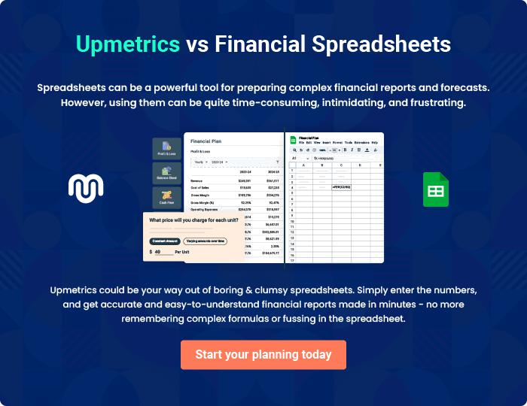
Appendix

When writing the appendix section, you should include any additional information that supports the main content of your plan. This may include financial statements, market research data, legal documents, and other
To unlock help try Upmetrics! 
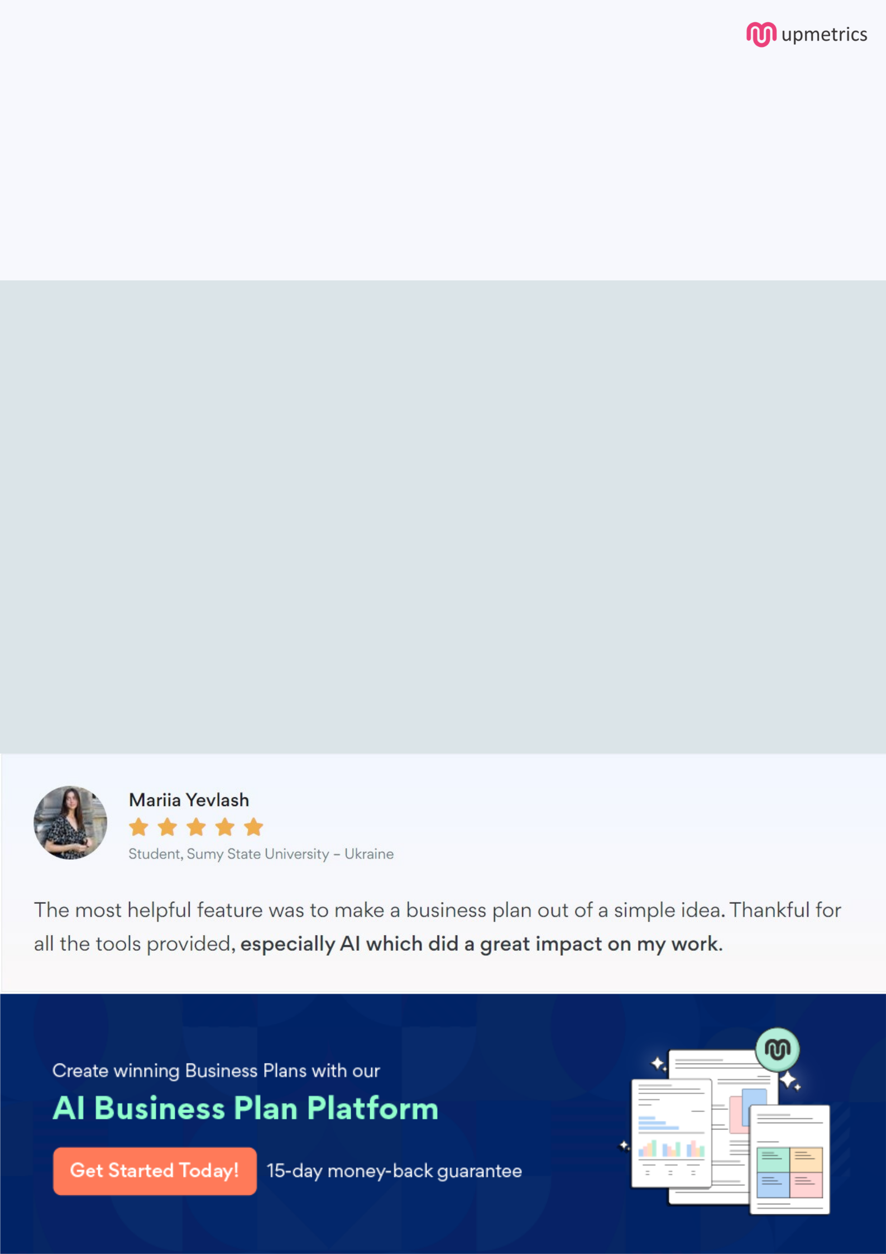
Create a winning business plan that gets you funded

Creating a stunning and investment-ready plan requires no writing, graphic designing, or financial planning expertise.

Upmetrics has all the features required to help you create a comprehensive business plan—from start to finish. Make no mistakes, it’s the modern way of planning to structure ideas, make plans, and create stunning pitch decks to awe investors.

Pitch decks that impress investors

Create pitch decks that provide a visual representation of your business, engage investors, and make them want to invest in your business idea.

Interactive plans in no time

Import business plan sections like—SWOT analysis, comparison tables, and others to create an interactive business plan. No designing skills are required.

Stunning cover page designs

With Upmetrics, you have the liberty to choose from multiple stunning cover page designs. Choose a creative design and make your plan stand out.

Online sharing made simple

Upmetrics makes online sharing quick and easier for users. Easily share your business plans with a link while tracking reader activity.

500+ sample business plans

Simply import a template from our library of sample plans into the editor and start customizing it to make it yours. It takes only a few clicks to get started.

Collaborate with team in real-time

Invite team members, initiate conversations, discuss ideas & strategies, share feedback, and work on a business plan in real-time.

