
BUSINESS PLAN

2023


Dog Breeding Business Plan

Nurturing Paws, Sharing Joy

John Doe

10200 Bolsa Ave, Westminster, CA, 92683

- 359-3153 info@example.com http://www.example.com

Information provided in this business plan is unique to this business and confidential; therefore, anyone reading this plan agrees not to disclose any of the information in this business plan without prior written permission of the company.
Table of Contents

Executive Summary | 6
Market opportunity | 6
Services Offered | 6
Marketing and Sales Strategies | 7
Financial Highlights | 7
Units Sold v/s Revenue | 8

Company Overview | 9
Ownership | 9
Mission statement | 10
Business history | 10
Future goals | 10

Market Analysis | 11
Target Market | 11
Market size and growth potential | 11
Market Size | 12
Competitive analysis | 12
Canine Companions Ltd. | 12
Best Friend Breeds | 13
Paws & Pedigree | 13
Market trends | 13
Regulatory environment | 14

Products and Services | 15
Dog Breeds and services: | 15
Golden Retriever Puppies | 15
Labrador Retriever Puppies | 16
Dog Grooming Services | 16
Basic Obedience Training | 17
Dog Boarding Services | 17
Breeding Program | 17
Health & Genetic Guarantees | 18
Additional Services | 18

Sales And Marketing Strategies | 19
Unique Selling Proposition (USP) | 19
Pricing Strategy | 19
Marketing strategies | 20
Online | 20
Offline | 20
Sales strategies | 21
Customer retention | 21

Operations Plan | 22
Staffing & Training | 22
Operational Process | 22
Breeding Practices | 23

Management Team | 24
Key managers | 24
John Doe | 24
Jane Doe | 25
Alice Brown | 25
Robert Brown | 25
Organizational structure | 26
Organization chart | 26
Compensation plan | 26
Board of advisors | 27
[ADVISOR NAME] | 27
[ADVISOR NAME] | 27
Financial Plan
Financial Plan | 28

Profit & loss statement 28

Cash flow statement | 31
Balance sheet | 33
Break-even Analysis | 35
Financing needs | 37
Appendix
Appendix | 39
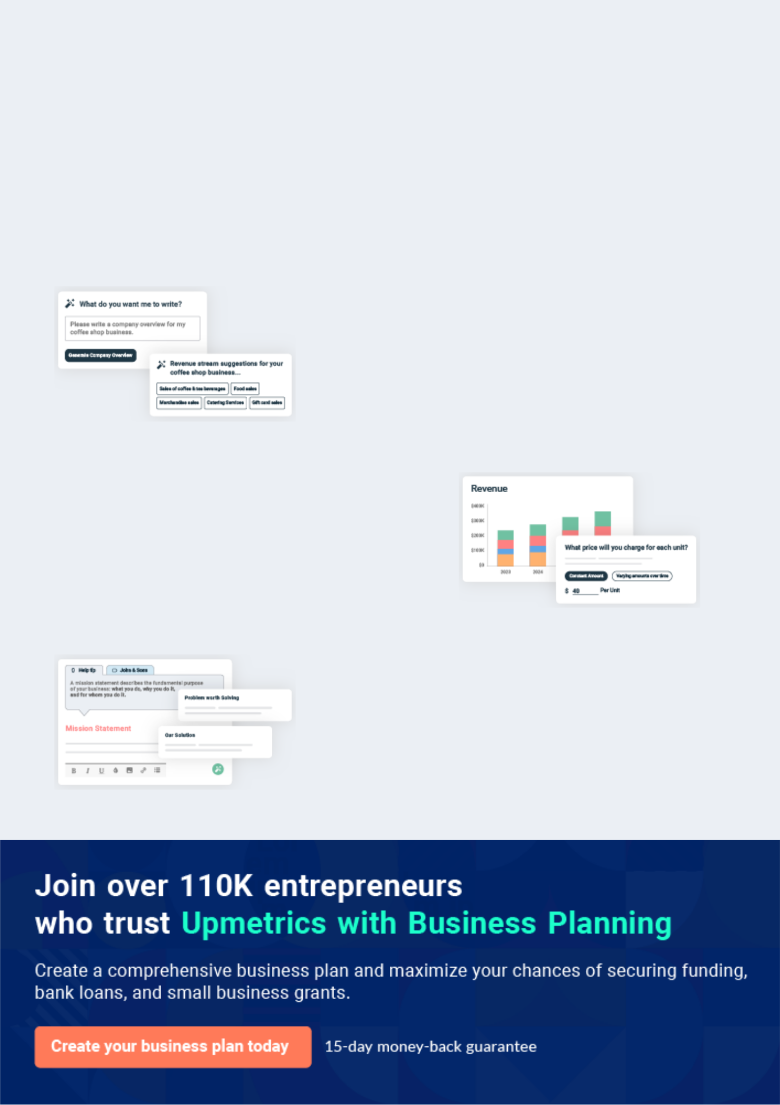
Business planning that’s simpler and faster than you think

Creating a business plan using Upmetrics to start and grow a business is literally the easiest thing in the World. Simply read the instructions and fill in the blanks. It’s as simple as that.

❛ | Upmetrics has everything you need to create a | ❜
❛ | comprehensive business plan. | ❜

AI-powered Upmetrics Assistant

AI-powered insights to streamline your plan

Not sure where to start? Upmetrics’ AI Assistant will automatically generate ideas for each section of your plan and offer improved versions of your writing, adjusting for tone, voice, and grammar or spelling errors.

Financial Forecasting Tool

All the financials are calculated for you

Forget the complex formulas and clumsy spreadsheets — with automatic financials and drag-and-drop forecasting, you can finish your plan faster and be confident that your numbers are accurate.

Business Plan Builder

Guides you like a business mentor

Upmetrics’ step-by-step instructions, prompts, and the library of 400+ sample business plans will guide you through each section of your plan as a business mentor.
Executive Summary


An executive summary is the first section of the business plan intended to provide an overview of the whole business plan.
To unlock help try Upmetrics! 

 Help tip  Dog Breeding Business Plan


Start your executive summary section by briefly introducing your business to your readers.

This section may include the name of your dog breeding business, its location, when it was
To unlock help try Upmetrics! 

Start writing here..

Market opportunity

 Help tip  Dog Breeding Business Plan

Summarize your market research, including market size, growth potential, and marketing trends. Highlight the opportunities in the market and how your business will fit in to fill the gap.
To unlock help try Upmetrics! 

Start writing here..

Services Offered

 Help tip  Dog Breeding Business Plan

Highlight the breeding services you offer your clients, including the specific dog breeds you breed, puppy care, and any additional services.
To unlock help try Upmetrics! 

Start writing here..

Marketing and Sales Strategies
To unlock help try Upmetrics!

 Help tip  Dog Breeding Business Plan

Outline your sales and marketing strategies—what marketing platforms you use and how you plan on acquiring new customers.
To unlock help try Upmetrics! 

Start writing here..

Financial Highlights

 Help tip  Dog Breeding Business Plan

Briefly summarize your financial projections for the initial years of business operations. Include any capital or investment requirements, associated startup costs, projected revenues, and profit forecasts.



Start writing here..
Units Sold v/s Revenue
To unlock help try Upmetrics!

 |  | Units Sold | Revenue
15.00k
10.00k
5.00k
0
Year 1 | Year 2 | Year 3


Financial Year |  |  | Units Sold | Revenue
Year 1 | 1,550 |  |  | $10,000
Year 2 | 1,800 |  |  | $12,000
Year 3 | 2,050 |  |  | $14,000
 Help tip |  |  Dog Breeding Business Plan


After giving a brief about your business plan, end your summary with a call to action, for example; inviting potential investors or readers to the next meeting if they are interested in your business.



Write a call to action for your business plan.
Company Overview

Depending on what details of your business are essential, you’ll need different elements in your business overview.
To unlock help try Upmetrics! 

 Help tip  Dog Breeding Business Plan

Describe your business in this section by providing all the basic information:

Business name type: Describe what kind of dog breeding business you operate and the name of
To unlock help try Upmetrics! 

Start writing here..

Ownership

 Help tip  Dog Breeding Business Plan

List the names of your dog breeding business’s founders or owners. Describe what shares they own and their responsibilities for efficiently managing the business.
To unlock help try Upmetrics! 

Start writing here..
Mission statement

 Help tip  Dog Breeding Business Plan

Summarize your business’ objective, core principles, and values in your mission statement. This statement needs to be memorable, clear, and brief.
To unlock help try Upmetrics! 

❛ At '[Paw Perfect Breeders],' our mission is to breed healthy, well-socialized dogs that become cherished members of families and communities. We are dedicated to responsible breeding, prioritizing animal welfare, and championing the bond between

humans and their canine companions.
❜

Business history

 Help tip  Dog Breeding Business Plan

If you’re an established dog breeding service provider, briefly describe your business history, like—when it was founded, how it evolved over time, etc.
To unlock help try Upmetrics! 

Start writing here..

Future goals

 Help tip  Dog Breeding Business Plan

It’s crucial to convey your aspirations and vision. Mention your short-term and long-term goals; they can be specific targets for revenue, market share, or expanding your breeding program.
To unlock help try Upmetrics! 

Start writing here..

Market Analysis
To unlock help try Upmetrics!


 |  | Market analysis provides a clear understanding of the market in which your
 |  | printing business will run along with the target market, competitors, and
 |  | growth opportunities.
 |  |  |  | To unlock help try Upmetrics! 
 Help tip |  |  Dog Breeding Business Plan

To write the introduction section of your market analysis, start by clearly identifying your primary target market.
To unlock help try Upmetrics! 

Start writing here..

Target Market

 Help tip  Dog Breeding Business Plan

Start this section by describing your target market. Include user demographics and preferences related to dog ownership, and define your ideal customer. Creating a buyer persona will help you easily define your target market to your readers.



Start writing here..

Market size and growth potential

 Help tip  Dog Breeding Business Plan

Describe your market size and growth potential and whether you will target a niche or a much broader market.
To unlock help try Upmetrics! 

Start writing here..

Market Size


Available Market | 15M
Total number of dog owners in the region. | 15M

Served Market
Dog owners specifically seeking bred 5M dogs (vs. adopting).

Target Market
Owners desiring specific breeds, training, 2M and after-sales support.

 Help tip  Dog Breeding Business Plan

Identify and analyze your direct and indirect competitors. Identify their strengths and weaknesses, and describe what differentiates your dog breeding services from them.
To unlock help try Upmetrics! 

Competitive analysis

Canine Companions Ltd.

Established in [2005], [Canine Companions Ltd.] has swiftly emerged as a leader in the dog breeding world, known for their expansive breed variety and customer education initiatives.

Features

Extensive breed range, spanning over 40 breeds.

Health Guarantee for all puppies.

Online portal for customers to view puppy lineage and health records.

Puppy training programs for the first six months.

Strengths

Vast breed selection caters to a wide range of customer preferences.

Strong emphasis on customer education ensures informed purchases.

Online portal integration allows transparent access to dog information.

Weaknesses

Limited physical locations may hinder access for some potential clients.

Higher pricing due to brand positioning might alienate cost-conscious customers.

Best Friend Breeds

With a legacy spanning two decades, [Best Friend Breeds] prides itself on ethical breeding practices and post-purchase support for customers.

Features

Emphasis on purebred and designer breeds.

Lifetime support guarantee, with veterinary consultations and behavioral training.

Regular workshops and seminars for dog owners.

Certified health screenings for all breeding dogs.

Strengths

Robust post-purchase support ensures long-term customer satisfaction.

Regular events foster a sense of community among buyers.

Staunch commitment to ethical breeding is a significant market differentiator.

Weaknesses

Limited breed variety might turn away customers looking for more exotic breeds.

Over-reliance on physical events might not resonate with younger, digital-first clientele.

Paws & Pedigree

A newer entrant, [Paws & Pedigree] focuses on leveraging technology to enhance the dog buying experience, especially for younger customers.

Features

Virtual tours of breeding facilities through their app.

Digital health tracking for puppies, accessible to buyers.

AI-powered matchmaking, pairing customers with suitable breeds based on lifestyle and preferences.

Strengths

Tech-forward approach caters to a growing digital-native demographic.

Transparent operations through virtual tours inspire trust.

Personalized matchmaking enhances customer experience.

Weaknesses

Being relatively new, they lack the legacy or long-standing reputation of more established breeders.

Tech-heavy approach might alienate traditionalists or non-tech-savvy customers.

Market trends

 Help tip  Dog Breeding Business Plan

Analyze emerging trends in the industry, such as technology disruptions, changes in customer behavior or preferences, etc. Explain how your business will cope with all the trends.
To unlock help try Upmetrics! 

Start writing here..

Regulatory environment
To unlock help try Upmetrics!

 Help tip  Dog Breeding Business Plan

List regulations and licensing requirements that may affect your dog breeding business, such as business license, insurance, breeding and animal welfare regulations, generic testing and health screening requirements, etc.



Start writing here..
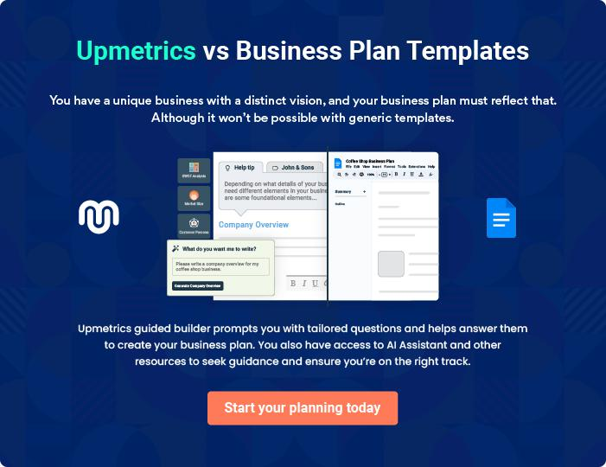
Products and Services
To unlock help try Upmetrics!

The product and services section of a dog breeding business plan should describe the specific services and products that will be offered to customers. To write this section should include the following:



 Help tip  Dog Breeding Business Plan

To craft the introduction for your "Products and Services" chapter, begin by positioning your business within its industry, emphasizing its unique strengths or value proposition.
To unlock help try Upmetrics! 

Start writing here..

 Help tip


Start this section by describing the breed(s) you plan to breed. Include all the necessary details about these breeds, including breed standard, coat, temperament, color/texture, etc.
To unlock help try Upmetrics! 

Dog Breeds and services:

Golden Retriever Puppies


Price: [$1,500] each

Purebred Golden Retriever puppies with a friendly disposition and a lustrous golden coat, ideal for families.

Specifications

- Age: 8-12 weeks

- Vaccination: Up-to-date

- Microchipped: Yes

- AKC Registered: Yes

- Health Guarantee: 24 months
Labrador Retriever Puppies

Price: [$1,400] each

Labrador Retrievers are known for their gentle nature and adaptability, making them one of America's favorite breeds.

Specifications

- Age: 8-12 weeks

- Vaccination: Up-to-date

- Microchipped: Yes

- AKC Registered: Yes

- Health Guarantee: 24 months

Dog Grooming Services

Price: Starting from [$50] (Varies by breed and size)

Comprehensive grooming services to keep your pet looking and feeling their best.

Specifications

- Bath and shampoo

- Ear cleaning

- Nail trimming

- Coat brushing and trimming
Basic Obedience Training

Price: [$300] for an 8-week course

An 8-week program focused on teaching dogs basic commands and good manners.

Specifications

- Duration: 8 weeks, 1 session/week

- Commands taught: Sit, Stay, Come, Heel, etc.

- Group sessions with a max of 10 dogs

Dog Boarding Services

Price: [$40/night]

Safe and comfortable boarding facilities for dogs, ensuring they are well-taken care of in the absence of their owners.

Specifications

- Climate-controlled kennels

- 24/7 on-site staff

- Daily playtime and walks

- Feeding as per owner's instructions

Breeding Program

 Help tip  Dog Breeding Business Plan

Provide a detailed description of your breeding program. Describe any ethical breeding practices you will follow, such as health testing protocols, genetic screening, proper care and socialization of dogs, and any standards or certifications you plan to adhere to.
To unlock help try Upmetrics! 

Start writing here..

Health & Genetic Guarantees

 Help tip  Dog Breeding Business Plan


Mention any health and genetic guarantees you offer to your clients for puppies they purchase.
Generally, these guarantees include health testing and screening on breeding dogs, refunds, or
replacements in case of genetic or health problems with puppies.
 |  |  |  | To unlock help try Upmetrics! 
Start writing here..
Additional Services
 Help tip |  |  Dog Breeding Business Plan

Mention if you offer any additional services. You may include services like dog grooming, training, boarding, etc. Include a detailed description of these services.
To unlock help try Upmetrics! 

Start writing here..
Sales And Marketing Strategies
To unlock help try Upmetrics!

Writing the sales and marketing strategies section means a list of strategies you will use to attract and retain your clients.
To unlock help try Upmetrics! 

 Help tip  Dog Breeding Business Plan

To create an effective introduction for your "Sales and Marketing Strategies" chapter, start by setting the stage within your specific industry or market.
To unlock help try Upmetrics! 

Unique Selling Proposition (USP)

 Help tip  Dog Breeding Business Plan

Describe what makes your breeding services different from other breeders in the market.
Describe why people should choose your breeding business over others in the market and why
you have a competitive edge.
 |  |  |  | To unlock help try Upmetrics! 
Start writing here..
Pricing Strategy
 Help tip |  |  Dog Breeding Business Plan

Describe your pricing strategy—how you plan to price your breeding services and stay competitive in the local market. You can mention any discounts you plan on offering to attract new customers to your breeding service.



Start writing here..

 Help tip  Dog Breeding Business Plan
To unlock help try Upmetrics!

Discuss your marketing strategies to market your services. You may include some of these marketing strategies in your business plan—social media marketing, Google ads, brochures, email marketing, content marketing, and print marketing.



Marketing strategies

Online


Social Media

Engaging content showcasing our puppies, breeding facilities, and client testimonials will be shared across platforms like Facebook, Instagram, and Twitter.

Content Marketing

Our website will host a blog section providing valuable insights into dog care, breeding news, and more.

Email Marketing

A monthly newsletter with updates, available litters, and care tips will be sent to our subscriber base.

Google Ads

We will implement pay-per-click campaigns targeting specific keywords related to dog breeding and [specific breed(s)].

Offline

Brochures

High-quality brochures detailing our services will be distributed at dog shows, vet clinics, and pet stores.

Print Marketing

Ads will be placed in local newspapers and dog-related magazines, reaching a broader audience.

Sales strategies

 Help tip  Dog Breeding Business Plan

Describe how you plan to provide your breeding services or sell puppies. For example, you can do business independently, partner or collaborate with other breeders, or work with pet stores.
To unlock help try Upmetrics! 

Start writing here..

Customer retention

 Help tip  Dog Breeding Business Plan

Describe your customer acquisition and retention strategies and how you plan to execute them.

For instance, introducing incentives for referrals, providing personalized service, etc.
To unlock help try Upmetrics! 

Start writing here..
Operations Plan

 |  | When writing the operations plan section, it’s important to consider the
 |  | various aspects of your business operations.
 |  |  |  | To unlock help try Upmetrics! 
 Help tip |  |  Dog Breeding Business Plan


To create an effective introduction for your "Operational Plan" chapter, start by emphasizing the
pivotal role of efficient operations in the success of your business, underscoring how they
directly impact the quality of services delivered.
 |  |  |  | To unlock help try Upmetrics! 
Start writing here..
Staffing & Training
 Help tip |  |  Dog Breeding Business Plan

Mention the staffing requirements of your dog breeding business, including the number of
employees needed. Include their qualifications, any specific training or certification required,
and the duties they will perform.
 |  |  |  | To unlock help try Upmetrics! 
Start writing here..
Operational Process
 Help tip |  |  Dog Breeding Business Plan

Outline the processes and procedures you will use to run your dog breeding business. Your operational processes may include caring and breeding dogs, breeding management, puppy care, record-keeping and documentation, sales and customer management, etc.
To unlock help try Upmetrics! 

Start writing here..

Breeding Practices
To unlock help try Upmetrics!

 Help tip  Dog Breeding Business Plan

Describe your breeding practices, including specific breeds you breed, breeding frequency, methods, and goals. Ensure ethical breeding practices by including health testing, genetic screening, and record-keeping.



Start writing here..
Management Team
To unlock help try Upmetrics!

The management team section provides an overview of the individuals responsible for running your business plan.
To unlock help try Upmetrics! 

 Help tip  Dog Breeding Business Plan

To craft an introduction for your "Management Team" chapter, begin by emphasizing the crucial role of leadership in the success of any business.
To unlock help try Upmetrics! 

Start writing here..

Key managers

 Help tip  Dog Breeding Business Plan

Introduce your management and key members of your team, and explain their roles and responsibilities. The information you provide will be based on how big your business is and how many employees you have.



Start writing here..


JOHN DOE

CEO & Co-founder - john.doe@example.com

- Educational Background: John graduated with a Bachelor's degree in Animal Science from Stanford University. He further honed his business acumen by pursuing an MBA from [Harvard Business School].


• Professional Background: With over [15 years] of experience in the dog breeding industry, John has established a reputation for his ethical breeding practices and passion for canine welfare.

Before founding "[Paw Perfect Breeders]", he worked with several renowned breeders and animal welfare organizations, gaining hands-on experience in both breeding and business management.

JANE DOE

Chief Operating Officer (COO) - jane.doe@example.com

- Educational Background: Jane holds a Master's degree in Veterinary Medicine from UC Davis and a certification in [Canine Genetics and Epidemiology].

- Professional Background: With a deep understanding of canine health and over [10 years] in operational roles within the breeding industry, Jane ensures the smooth daily operations of "[Paw Perfect Breeders]", from the welfare of the animals to the efficiency of breeding processes.



ALICE BROWN

CMO - alice.brown@example.com

- Educational Background: Alice earned her Bachelor's degree in Marketing from [New York University] and later pursued a Master's in [Digital Marketing from UCLA].

- Professional Background: With a career spanning over [12 years] in the dog industry, Alice specializes in branding, digital advertising, and customer engagement. Her strategies have driven growth and built strong brand identities for multiple canine-focused businesses.


ROBERT BROWN

Operations Manager - robert.brown@example.com

- Educational Background: Robert graduated with a degree in Animal Husbandry from [the University of Minnesota].

- Professional Background: Bringing [8 years] of hands-on experience in the breeding industry, Robert's keen attention to detail and operational skills ensure the streamlined execution of all breeding activities at "[Paw Perfect Breeders]".
Organizational structure

 Help tip  Dog Breeding Business Plan

Describe the organizational structure of the management team, including reporting lines and how decisions will be made.
To unlock help try Upmetrics! 

Start writing here..

Organization chart


John Doe

CEO


Alice Brown Robert Brown Jane Doe

CMO Operations Manager COO


Emily White | Laura Black | Michael Stone
Emily White | Laura Black | Customer Service
Head of Marketing | Supply Chain Manager | Customer Service
Head of Marketing | Supply Chain Manager | Manager



Compensation plan

 Help tip  Dog Breeding Business Plan

Describe your compensation plan for the management and staff. Include their salaries, incentives, and other benefits.
To unlock help try Upmetrics! 

Start writing here..

 Help tip

Mentioning advisors or consultants in your business plans adds credibility to your business idea.
To unlock help try Upmetrics! 

Board of advisors


[ADVISOR NAME]

Veterinary Consultant

With over [X years] in veterinary science, Dr. [Last Name] advises us on health protocols, ensuring that our dogs are always in peak condition.


[ADVISOR NAME]

Business Consultant

A seasoned entrepreneur with [X years] in the industry, [Full Name] guides us in business expansion and strategy formulation.
Financial Plan

When writing the financial plan section of a business plan, it’s important to provide a comprehensive overview of your financial projections for the first few years of your business, You may provide the following:
To unlock help try Upmetrics! 

 Help tip  Dog Breeding Business Plan


To create an effective introduction for your "Financial Plan" chapter, begin by stressing the critical role of a well-structured financial plan in the success of your venture.
To unlock help try Upmetrics! 

Start writing here..

 Help tip


Describe details such as projected revenue, operational costs, and service costs in your projected profit and loss statement. Make sure to include your business’s expected net profit or loss.
To unlock help try Upmetrics! 

Profit & loss statement

Revenue

Cost Of Sales

General Costs

Revenue Specific Costs

Personnel Costs (Direct

Labor)

Gross Margin

Gross Margin (%)

Operating Expense

Payroll Expense

(Indirect Labor)

General Expense

Bad Debt

Amortization of Current

Assets

2023-24 | 2024-25 | 2025-26 | 2026-27 | 2027-28
$0 | $0 | $0 | $0 | $0

$0 | $0 | $0 | $0 | $0
$0 | $0 | $0 | $0 | $0
$0 | $0 | $0 | $0 | $0
$0 | $0 | $0 | $0 | $0

$0 | $0 | $0 | $0 | $0
0% | 0% | 0% | 0% | 0%

$0 | $0 | $0 | $0 | $0
$0 | $0 | $0 | $0 | $0
$0 | $0 | $0 | $0 | $0
$0 | $0 | $0 | $0 | $0
$0 | $0 | $0 | $0 | $0

EBITDA

Additional Expense

Long Term

Depreciation

Gain or loss from Sale

of Assets

EBIT

Interest Expenses

EBT

Income Tax Expense

Total Expense

Net Income

Net Income (%)

2023-24 | 2024-25 | 2025-26 | 2026-27 | 2027-28
$0 | $0 | $0 | $0 | $0
$0 | $0 | $0 | $0 | $0
$0 | $0 | $0 | $0 | $0
$0 | $0 | $0 | $0 | $0
$0 | $0 | $0 | $0 | $0
$0 | $0 | $0 | $0 | $0
$0 | $0 | $0 | $0 | $0
$0 | $0 | $0 | $0 | $0
$0 | $0 | $0 | $0 | $0
$0 | $0 | $0 | $0 | $0
0% | 0% | 0% | 0% | 0%
 | 2023-24 | 2024-25 | 2025-26 | 2026-27 | 2027-28
Retained Earning | $0 | $0 | $0 | $0 | $0
Opening
Owner's Distribution | $0 | $0 | $0 | $0 | $0
Retained Earning | $0 | $0 | $0 | $0 | $0
Closing

 Help tip

This section should estimate and describe the cash flow for the first few years of your operation. This may include billing invoices, payment receipts, loan payments, and any other cash flow statements.
To unlock help try Upmetrics! 

Cash flow statement

 | 2023-24 | 2024-25 | 2025-26 | 2026-27 | 2027-28
Cash Received | $0 | $0 | $0 | $0 | $0
Cash Paid | $0 | $0 | $0 | $0 | $0
COS & General Expenses | $0 | $0 | $0 | $0 | $0
Salary & Wages | $0 | $0 | $0 | $0 | $0
Interest | $0 | $0 | $0 | $0 | $0

Sales Tax

Income Tax

Net Cash From

Operations

Assets Sell

Assets Purchase

Net Cash From

Investments

Amount Received

Loan Received

Common Stock

Preferred Stock

Owner's Contribution

Amount Paid

2023-24 | 2024-25 | 2025-26 | 2026-27 | 2027-28
$0 | $0 | $0 | $0 | $0
$0 | $0 | $0 | $0 | $0
$0 | $0 | $0 | $0 | $0

$0 | $0 | $0 | $0 | $0
$0 | $0 | $0 | $0 | $0
$0 | $0 | $0 | $0 | $0

$0 | $0 | $0 | $0 | $0
$0 | $0 | $0 | $0 | $0

$0 | $0 | $0 | $0 | $0
$0 | $0 | $0 | $0 | $0
$0 | $0 | $0 | $0 | $0

Loan Capital $0 $0 $0 $0 $0

 | 2023-24 | 2024-25 | 2025-26 | 2026-27 | 2027-28
Dividends & Distributions | $0 | $0 | $0 | $0 | $0
Net Cash From | $0 | $0 | $0 | $0 | $0
Financing

Summary
Starting Cash | $0 | $0 | $0 | $0 | $0
Cash In | $0 | $0 | $0 | $0 | $0
Cash Out | $0 | $0 | $0 | $0 | $0
Change in Cash | $0 | $0 | $0 | $0 | $0
Ending Cash | $0 | $0 | $0 | $0 | $0

 Help tip

Create a projected balance sheet documenting your dog breeding business’s assets, liabilities, and equity.

To unlock help try Upmetrics! 

Balance sheet

 | 2023-24 | 2024-25 | 2025-26 | 2026-27 | 2027-28
Assets | $0 | $0 | $0 | $0 | $0
Current Assets | $0 | $0 | $0 | $0 | $0
Cash | $0 | $0 | $0 | $0 | $0
Accounts Receivable | $0 | $0 | $0 | $0 | $0
Inventory | $0 | $0 | $0 | $0 | $0
Other Current Assets | $0 | $0 | $0 | $0 | $0
Long Term Assets | $0 | $0 | $0 | $0 | $0
Gross Long Term Assets | $0 | $0 | $0 | $0 | $0
Accumulated Depreciation | $0 | $0 | $0 | $0 | $0

Liabilities & Equity | $0 | $0 | $0 | $0 | $0
Liabilities | $0 | $0 | $0 | $0 | $0
Current Liabilities | $0 | $0 | $0 | $0 | $0
Accounts Payable | $0 | $0 | $0 | $0 | $0
Income Tax Payable | $0 | $0 | $0 | $0 | $0
Sales Tax Payable | $0 | $0 | $0 | $0 | $0
Short Term Debt | $0 | $0 | $0 | $0 | $0
 | 2023-24 | 2024-25 | 2025-26 | 2026-27 | 2027-28
Long Term Liabilities | $0 | $0 | $0 | $0 | $0
Long Term Debt | $0 | $0 | $0 | $0 | $0
Equity | $0 | $0 | $0 | $0 | $0
Paid-in Capital | $0 | $0 | $0 | $0 | $0
Common Stock | $0 | $0 | $0 | $0 | $0
Preferred Stock | $0 | $0 | $0 | $0 | $0
Owner's Contribution | $0 | $0 | $0 | $0 | $0
Retained Earnings | $0 | $0 | $0 | $0 | $0

Check | $0 |  |  | $0 | $0 | $0 | $0
 Help tip |  |  Dog Breeding Business Plan


Determine and mention your business’s break-even point—the point at which your business costs and revenue will be equal.

This exercise will help you understand how much revenue you need to generate to sustain or be profitable.
To unlock help try Upmetrics! 

Break-even Analysis

 | 2023-24 | 2024-25 | 2025-26 | 2026-27 | 2027-28
Starting Revenue | $0 | $0 | $0 | $0 | $0
Net Revenue | $0 | $0 | $0 | $0 | $0
Closing Revenue | $0 | $0 | $0 | $0 | $0

Starting Expense | $0 | $0 | $0 | $0 | $0
Net Expense | $0 | $0 | $0 | $0 | $0
Closing Expense | $0 | $0 | $0 | $0 | $0

Is Break Even? | 0 | 0 | 0 | 0 | 0
Break Even Month | 0 | 0 | 0 | 0 | 0
Days Required | 0 | 0 | 0 | 0 | 0
Break Even Revenue | $0 | $0 | $0 | $0 | $0
Break Even Units
Financing needs

 Help tip  Dog Breeding Business Plan

Calculate costs associated with starting a dog breeding business, and estimate your financing needs and how much capital you need to raise to operate your business.
To unlock help try Upmetrics! 

Start writing here..
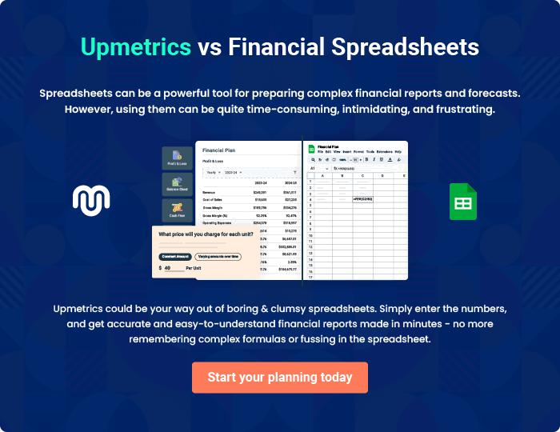
Appendix

When writing the appendix section, you should include any additional information that supports the main content of your plan. This may include financial statements, market research data, legal documents, and other
To unlock help try Upmetrics! 

Create a winning business plan that gets you funded

Creating a stunning and investment-ready plan requires no writing, graphic designing, or financial planning expertise.

Upmetrics has all the features required to help you create a comprehensive business plan—from start to finish. Make no mistakes, it’s the modern way of planning to structure ideas, make plans, and create stunning pitch decks to awe investors.

Pitch decks that impress investors

Create pitch decks that provide a visual representation of your business, engage investors, and make them want to invest in your business idea.

Interactive plans in no time

Import business plan sections like—SWOT analysis, comparison tables, and others to create an interactive business plan. No designing skills are required.

Stunning cover page designs

With Upmetrics, you have the liberty to choose from multiple stunning cover page designs. Choose a creative design and make your plan stand out.

Online sharing made simple

Upmetrics makes online sharing quick and easier for users. Easily share your business plans with a link while tracking reader activity.

500+ sample business plans

Simply import a template from our library of sample plans into the editor and start customizing it to make it yours. It takes only a few clicks to get started.

Collaborate with team in real-time

Invite team members, initiate conversations, discuss ideas & strategies, share feedback, and work on a business plan in real-time.

