
DJ Business Plan

Dance, Groove, Party

BUSINESS PLAN

2023

John Doe | 10200 Bolsa Ave, Westminster, CA, 92683 | (650) 359-3153 | info@example.com
http://www.example.com

Information provided in this business plan is unique to this business and confidential; therefore, anyone reading this plan agrees not to disclose any of the information in this business plan without prior written permission of the company.
Table of Contents

Executive Summary | 6
Market opportunity | 6
Services Offered | 6
Marketing & Sales Strategies | 7
Financial Highlights | 7
Units Sold v/s Revenue | 8

Company Overview | 9
Ownership | 9
Business Owners | 9
Mission statement | 10
Business history | 10
Future goals | 10

Market Analysis | 11
Target Market | 11
Market size and growth potential | 11
Market Size | 12
Competitive analysis | 12
SonicWave DJ Services | 12
Pulse Rhythms Inc. | 13
RetroVibes Entertainment | 13
Market trends | 13
Regulatory environment | 14

Products and Services | 15
Services | 15
Music Selection & Mixing | 15
Equipment Setup & Operation | 16
Event Planning & Consultation | 16
Lighting & Visual Effects | 16
Customized Playlists & Requests | 17
Audio Recording & Production | 17
Event Coordination & Timeline Management | 17
Music genres | 18
Additional Services | 18

Sales And Marketing Strategies | 19
Unique Selling Proposition (USP) | 19
Pricing Strategy | 19
Marketing strategies | 20
Online | 20
Offline | 20
Sales strategies | 21
Customer retention | 21

Operations Plan | 22
Staffing & Training | 22
Operational Process | 22
Equipment & Machinery | 23

Management Team | 24
Key managers | 24
John Doe | 24
Jane Smith | 25
Alex Johnson | 25
Rachel Adams | 25
Samuel Clark | 25
Organizational structure | 26
Organization chart | 26
Compensation plan | 27
Board of advisors | 27
[ADVISOR NAME] | 27
[ADVISOR NAME] | 27
Financial Plan | 28
Profit & loss statement | 28
Cash flow statement | 31
Balance sheet | 33
Break-even Analysis | 35
Financing needs | 37
Appendix
Appendix | 39
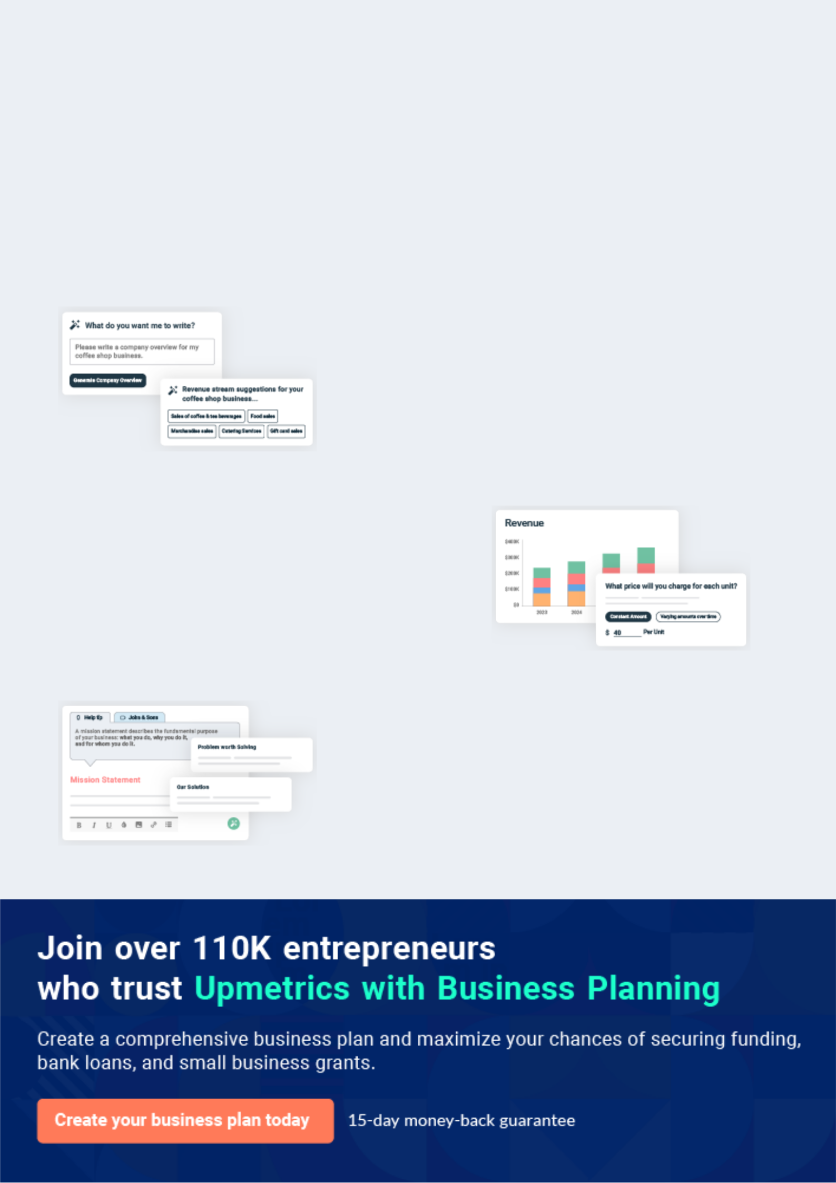
Business planning that’s simpler and faster than you think

Creating a business plan using Upmetrics to start and grow a business is literally the easiest thing in the World. Simply read the instructions and fill in the blanks. It’s as simple as that.

❛ | Upmetrics has everything you need to create a | ❜
❛ | comprehensive business plan. | ❜

AI-powered Upmetrics Assistant

AI-powered insights to streamline your plan

Not sure where to start? Upmetrics’ AI Assistant will automatically generate ideas for each section of your plan and offer improved versions of your writing, adjusting for tone, voice, and grammar or spelling errors.

Financial Forecasting Tool

All the financials are calculated for you

Forget the complex formulas and clumsy spreadsheets — with automatic financials and drag-and-drop forecasting, you can finish your plan faster and be confident that your numbers are accurate.

Business Plan Builder

Guides you like a business mentor

Upmetrics’ step-by-step instructions, prompts, and the library of 400+ sample business plans will guide you through each section of your plan as a business mentor.
Executive Summary


An executive summary is the first section of the business plan intended to provide an overview of the whole business plan.
To unlock help try Upmetrics! 

 Help tip  DJ Business Plan


Start your executive summary by briefly introducing your business to your readers.

This section may include the name of your DJ business, its location, when it was founded, the
To unlock help try Upmetrics! 

Start writing here..

Market opportunity

 Help tip  DJ Business Plan

Summarize your market research, including market size, growth potential, and marketing trends. Highlight the opportunities in the market and how your business will fit in to fill the gap.
To unlock help try Upmetrics! 

Start writing here..

Services Offered

 Help tip  DJ Business Plan

Highlight the DJ services you offer your clients. The USPs and differentiators you offer are always a plus.
To unlock help try Upmetrics! 

Start writing here..

Marketing & Sales Strategies
To unlock help try Upmetrics!

 Help tip  DJ Business Plan

Outline your sales and marketing strategies—what marketing platforms you use, how you plan on acquiring customers, etc.
To unlock help try Upmetrics! 

Start writing here..

Financial Highlights

 Help tip  DJ Business Plan

Briefly summarize your financial projections for the initial years of business operations. Include any capital or investment requirements, associated startup costs, projected revenues, and profit forecasts.



Start writing here..
Units Sold v/s Revenue

 |  | Units Sold | Revenue
15.00k
10.00k
5.00k
0
Year 1 | Year 2 | Year 3


Financial Year |  |  | Units Sold | Revenue
Year 1 | 1,550 |  |  | $10,000
Year 2 | 1,800 |  |  | $12,000
Year 3 | 2,050 |  |  | $14,000
 Help tip |  |  DJ Business Plan


Summarize your executive summary section with a clear CTA, for example, inviting angel investors to discuss the potential business investment.
To unlock help try Upmetrics! 

Write a call to action for your business plan.
Company Overview

Depending on what details of your business are essential, you’ll need different elements in your business overview.
To unlock help try Upmetrics! 

 Help tip  DJ Business Plan

Describe your business in this section by providing all the basic information:

Describe what kind of DJ company you run and the name of it. You may specialize in one of the
To unlock help try Upmetrics! 

Start writing here..

Ownership

 Help tip  DJ Business Plan

List the names of your DJ company’s founders or owners. Describe what shares they own and their responsibilities for efficiently managing the business.
To unlock help try Upmetrics! 

Start writing here..

Business Owners



70% John Doe



15% Jane Smith



15% Alex Johnson

Mission statement

 Help tip  DJ Business Plan

Summarize your business’ objective, core principles, and values in your mission statement. This statement needs to be memorable, clear, and brief.
To unlock help try Upmetrics! 

❛ At [Dynamix Sounds], we are dedicated to creating unparalleled auditory experiences. Rooted in innovation, professionalism, and a passion for music, our mission is to enhance every event's ambience, ensuring memories that resonate long after the last

note.
❜

Business history

 Help tip  DJ Business Plan

If you’re an established DJ service provider, briefly describe your business history, like—when it was founded, how it evolved over time, etc.
To unlock help try Upmetrics! 

Start writing here..

Future goals

 Help tip  DJ Business Plan

It’s crucial to convey your aspirations and vision. Mention your short-term and long-term goals; they can be specific targets for revenue, market share, or expanding your services.
To unlock help try Upmetrics! 

Start writing here..

Market Analysis
To unlock help try Upmetrics!
To unlock help try Upmetrics!

Market analysis provides a clear understanding of the market in which your printing business will run along with the target market, competitors, and growth opportunities.



 Help tip  DJ Business Plan

To write the introduction section of your market analysis, start by clearly identifying your primary target market.
To unlock help try Upmetrics! 

Start writing here..

Target Market

 Help tip  DJ Business Plan

Start this section by describing your target market. Define your ideal customer and explain what types of services they prefer. Creating a buyer persona will help you easily define your target market to your readers.



Start writing here..

Market size and growth potential

 Help tip  DJ Business Plan

Describe your market size and growth potential and whether you will target a niche or a much broader market.
To unlock help try Upmetrics! 

Start writing here..

Market Size

Available Market | 10M
Total individuals attending any form of | 10M
event requiring DJ services annually. | 10M
Served Market | 7M
Individuals attending weddings, clubs, or | 7M
private events, our primary event | 7M

categories.

Target Market | 1M
Engaged couples in [Region] planning | 1M
weddings in the next year. | 1M

 Help tip  DJ Business Plan

Identify and analyze your direct and indirect competitors. Identify their strengths and weaknesses, and describe what differentiates your DJ services from them.
To unlock help try Upmetrics! 

Competitive analysis

SonicWave DJ Services

[SonicWave DJ Services], established in [2015], has quickly risen to be a recognized name, especially within the wedding circuit. Based out of [Location], they have managed to cater to over [X] events in the past year alone.

Features

Extensive music library spanning multiple genres and decades.

Customizable playlists with client collaboration.

LED Light shows synchronized with the music.

MC services for events.

Strengths

Strong reputation for reliability and punctuality.

Partnerships with several renowned event organizers, ensuring a consistent flow of clientele.

In-house training program for DJs, ensuring consistent quality.

Weaknesses

Limited adaptability to newer music trends, often sticking to tried-and-tested playlists.

Higher price point compared to industry average.

Pulse Rhythms Inc.

[Pulse Rhythms Inc.] specializes in club and electronic music, establishing strongholds in major nightclubs across [City]. Founded in [2018], their rise has been meteoric, attributed mainly to their fusion mixes.

Features

Specialized in electronic, trance, and house music.

High-tech DJ equipment suitable for large venues.

Collaborations with upcoming artists for exclusive tracks.

Strengths

Well-regarded in the nightlife scene with exclusive contracts with top-tier clubs.

Strong social media presence, especially on platforms like Instagram and TikTok.

Regular releases of mixtapes, keep their audience engaged.

Weaknesses

Limited versatility outside of electronic genres.

Relatively inexperienced in handling diverse crowds, especially at private events.

RetroVibes Entertainment

With a niche focus, [RetroVibes Entertainment] provides DJ services for those looking for classic rock, jazz, and older pop music. Founded in [2010], they've catered to a specific, yet loyal customer base.

Features

Curated playlists from the '50s to the '90s.

Vintage-themed setups for events.

Collaborative event planning for thematic consistency.

Strengths

Unparalleled in the niche of classic tunes, with a library that's hard to rival.

High client retention due to specialized services.

Strong reviews and testimonials from a dedicated customer base.

Weaknesses

Limited appeal to a younger demographic.

Slow to adapt to technological advancements in the DJ industry.

Market trends

 Help tip  DJ Business Plan

Analyze emerging trends in the industry, such as technology disruptions, changes in customer behavior or preferences, etc. Explain how your business will cope with all the trends.
To unlock help try Upmetrics! 

Start writing here..

Regulatory environment
To unlock help try Upmetrics!

 Help tip  DJ Business Plan

List regulations and licensing requirements that may affect your DJ company, such as business registration & licensing, music licensing, noise regulations, insurance coverage, tax obligations, health & safety regulations, etc.



Start writing here..
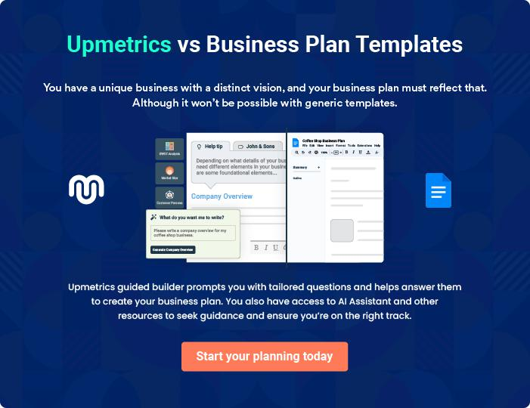
Products and Services
To unlock help try Upmetrics!

The product and services section of a DJ business plan should describe the specific services and products that will be offered to customers. To write this section should include the following:



 Help tip  DJ Business Plan

To craft the introduction for your "Products and Services" chapter, begin by positioning your business within its industry, emphasizing its unique strengths or value proposition.
To unlock help try Upmetrics! 

Start writing here..

 Help tip


Mention the DJ services your business will offer. This list may include services like,

• Music selection & mixing
To unlock help try Upmetrics! 

Services

Music Selection & Mixing


Price: [$500] per event

Expertly curated music sets tailored to the mood and theme of your event, seamlessly blended to keep the energy high.

Specifications

- Duration: Up to [5 hours] (Additional hours priced at $100/hour)

- Genre Customization: Up to 5 genres

- On-the-spot request handling
Equipment Setup & Operation

Price: [$300]

State-of-the-art equipment setup to ensure the highest quality sound experience, managed by our team from start to finish.

Specifications

- Speaker System: [Brand] 1000W PA System

- Mixer: [Brand] 12-Channel Mixer

- Microphones: Up to 3 wireless mics

Event Planning & Consultation

Price: [$200] per consultation session

Work alongside our event specialists to conceptualize and plan your event, ensuring every detail aligns with your vision.

Specifications

- Session Duration: [2 hours]

- Theme Discussion & Integration

- Event Timeline Planning

Lighting & Visual Effects

Price: [$400]

Elevate the ambiance with synchronized light shows that seamlessly match the music's rhythm.

Specifications

- LED Par Lights: 10 Units

- Moving Heads: 2 Units

- Smoke Machine: 1 Unit
Customized Playlists & Requests

Price: [$150]

Collaborate with our DJs to curate a specific playlist tailored to your event or let us handle on-the-spot song requests from guests.

Specifications

- Playlist Duration: Up to [4 hours]

- Song Limit: 60 songs (Additional songs can be added for a fee)

- Guest Request Handling: Up to 15 requests

Audio Recording & Production

Price: [$250]

Capture the essence of your event with high-quality audio recording, with post-event production for a polished final product.

Specifications

- Recording Duration: Up to [5 hours]

- File Format: MP3 & WAV

- Post-Production: Basic editing & mastering

Event Coordination & Timeline Management

Price: [$350]

Seamless coordination with event organizers and other vendors, ensuring punctuality and smooth transitions throughout your event.

Specifications

- Pre-Event Coordination Meetings: [2 sessions] (1 hour each)

- On-the-day Event Management: Up to 6 hours
Music genres

 Help tip  DJ Business Plan

Name the musical genres that your DJ business supports. Mention how you can accommodate a wide range of musical tastes, from mainstream hits to specialized genres.
To unlock help try Upmetrics! 

Start writing here..

Additional Services

 Help tip  DJ Business Plan

Mention if your DJ company offers any additional services. You may include services like event planning, sound system rentals, lighting design, etc.
To unlock help try Upmetrics! 

Start writing here..
Sales And Marketing Strategies

Writing the sales and marketing strategies section means a list of strategies you will use to attract and retain your clients.
To unlock help try Upmetrics! 

 Help tip  DJ Business Plan

To create an effective introduction for your "Sales and Marketing Strategies" chapter, start by setting the stage within your specific industry or market.
To unlock help try Upmetrics! 

Unique Selling Proposition (USP)

 Help tip  DJ Business Plan

Define your business’s USPs depending on the market you serve, the equipment you use, and the unique services you provide. Identifying USPs will help you plan your marketing strategies.
To unlock help try Upmetrics! 

Start writing here..

Pricing Strategy

 Help tip  DJ Business Plan

Describe your pricing strategy—how you plan to price your services and stay competitive in the local market. You can mention any discounts you plan on offering to attract new customers.
To unlock help try Upmetrics! 

Start writing here..

 Help tip  DJ Business Plan
To unlock help try Upmetrics!

Discuss your marketing strategies to market your services. You may include some of these marketing strategies in your business plan—social media marketing, email marketing, content marketing, and print marketing.



Marketing strategies

Online


Social Media

Leveraging platforms like Instagram, Facebook, and TikTok, we showcase our events, testimonials, and music sets, engaging with our audience in real-time.

Email Marketing

Regular newsletters featuring updates, offers, and music trends are sent to our subscriber base.

Content Marketing

Our blog focuses on event planning

insights, music trends, and DJing

tips, positioning us as thought

leaders in the industry.

Offline

Print Marketing

Collaborations with event magazines and local newspapers ensure we have a strong offline presence.

 Help tip

Outline the strategies you’ll implement to maximize your sales. Your sales strategies may include partnering with other businesses, offering referral programs, etc.
To unlock help try Upmetrics! 

Sales strategies

Partner with Businesses

Aligning with event planners, venues, and catering services, we offer package deals, ensuring clients have a one-stop solution for their events.

Referral Programs

Loyal clients referring our services are rewarded with discounts on future bookings, incentivizing word-of-mouth promotions.

 Help tip

Describe your customer retention strategies and how you plan to execute them. For instance, introducing loyalty programs, discounts, personalized service, etc.
To unlock help try Upmetrics! 

Customer retention

Loyalty Programs

Repeat clients receive exclusive discounts and priority booking slots.

Exclusive Offers

Periodic promotions exclusive to our existing client base, celebrating milestones and festivals.

Personalized Service

Tailoring our offerings based on

client feedback and preferences,

ensuring they always receive a

fresh experience.

Operations Plan
To unlock help try Upmetrics!


 |  | When writing the operations plan section, it’s important to consider the
 |  | various aspects of your business operations.
 |  |  |  | To unlock help try Upmetrics! 
 Help tip |  |  DJ Business Plan


To create an effective introduction for your "Operational Plan" chapter, start by emphasizing the
pivotal role of efficient operations in the success of your business, underscoring how they
directly impact the quality of services delivered.
 |  |  |  | To unlock help try Upmetrics! 
Start writing here..
Staffing & Training
 Help tip |  |  DJ Business Plan

Mention your business’s staffing requirements, including the number of DJs or support staff needed. Include their qualifications, the training required, and the duties they will perform.
To unlock help try Upmetrics! 

Start writing here..

Operational Process

 Help tip  DJ Business Plan

Outline the processes and procedures you will use to run your DJ business. Your operational processes may include pre-event preparation, client inquiry & booking, equipment preparation, event execution, etc.



Start writing here..

Equipment & Machinery

 Help tip  DJ Business Plan

Include the list of equipment and machinery required for DJ, such as DJ mixer or controller, laptop or computer, DJ software, DJ headphones, microphones, lighting equipment, etc.
To unlock help try Upmetrics! 

Start writing here..
Management Team

The management team section provides an overview of the individuals responsible for running your business plan.
To unlock help try Upmetrics! 

 Help tip  DJ Business Plan

To craft an introduction for your "Management Team" chapter, begin by emphasizing the crucial role of leadership in the success of any business.
To unlock help try Upmetrics! 

Start writing here..

Key managers

 Help tip  DJ Business Plan

Introduce your management and key members of your team, and explain their roles and responsibilities.
To unlock help try Upmetrics! 

Start writing here..


JOHN DOE

CEO & Co-founder - john.doe@example.com

John Doe, a graduate of [Harvard Business School] with a degree in [Music Production and Business Management], transformed his passion for music into the successful venture that [Dynamix Sounds DJ Services] is today.


With over [15 years] of experience in both the music and event management industries, John has a unique blend of artistic finesse and business acumen that serves as the driving force behind the company.

JANE SMITH

Chief Operating Officer (COO) - jane.smith@example.com

Jane Smith, an alumna of [Stanford University] with a master's degree in [Event Management], is the linchpin ensuring the flawless execution of every event.

With over [12 years] of hands-on experience in event planning and operations, her knack for detail and organizational skills have made her an indispensable asset to [Dynamix Sounds DJ Services].



ALEX JOHNSON

CMO - alex.johnson@example.com

Alex Johnson graduated from [Yale School of Management] specializing in [Digital Marketing].

With a career spanning over [10 years] in brand promotion and digital marketing strategies for entertainment companies, Alex has brought a modern, dynamic touch to our marketing campaigns, ensuring our brand remains resonant and relevant in today's digital age


RACHEL ADAMS

Operations Manager - rachel.adams@example.com

Holding a bachelor's degree in [Operational Management] from [MIT Sloan School of Management], Rachel Adams came onboard with [Dynamix Sounds DJ Services] [8 years] ago.

Since then, her methodical approach and commitment have streamlined our operations, ensuring efficiency in every project.


SAMUEL CLARK

Customer Services Manager - samuel.clark@example.com

Samuel Clark, a [Cornell University] graduate in [Customer Relationship Management], is the heart and soul of our customer-centric approach.

With over [7 years] of experience in customer service roles for top-tier entertainment agencies, Samuel’s expertise lies in understanding, anticipating, and meeting client needs, ensuring their utmost satisfaction.
Organizational structure

 Help tip  DJ Business Plan

Explain the organizational structure of your management team. Include the reporting line and decision-making hierarchy.
To unlock help try Upmetrics! 

Start writing here..

Organization chart


John Doe

CEO


 |  |  | Rachel Adams
Jane Smith | Alex Johnson |  | Rachel Adams
Jane Smith |  |  | Operations Manager
COO | CMO




Samuel Clark

Customer Services

Manager


Emily Davis

Event Coordinator
Compensation plan

 Help tip  DJ Business Plan

Describe your compensation plan for the management and staff. Include their salaries, incentives, and other benefits.
To unlock help try Upmetrics! 

Start writing here..

 Help tip

Mentioning advisors or consultants in your business plans adds credibility to your business idea.
To unlock help try Upmetrics! 

Board of advisors

[ADVISOR NAME]

Advisor 1

A renowned name in the DJ world, [Advisor 1’s name] serves as our chief consultant, bringing in [X years] of industry insights.


[ADVISOR NAME]

Advisor 2

Specializing in business strategy, [Advisor 2’s name] has been instrumental in our expansion efforts.
Financial Plan

When writing the financial plan section of a business plan, it’s important to provide a comprehensive overview of your financial projections for the first few years of your business, You may provide the following:
To unlock help try Upmetrics! 

 Help tip  DJ Business Plan


To create an effective introduction for your "Financial Plan" chapter, begin by stressing the critical role of a well-structured financial plan in the success of your venture.
To unlock help try Upmetrics! 

Start writing here..

 Help tip


Describe details such as projected revenue, operational costs, and service costs in your projected profit and loss statement. Make sure to include your business’s expected net profit or loss.
To unlock help try Upmetrics! 

Profit & loss statement

Revenue

Cost Of Sales

General Costs

Revenue Specific Costs

Personnel Costs (Direct

Labor)

Gross Margin

Gross Margin (%)

Operating Expense

Payroll Expense

(Indirect Labor)

General Expense

Bad Debt

Amortization of Current

Assets

2023-24 | 2024-25 | 2025-26 | 2026-27 | 2027-28
$0 | $0 | $0 | $0 | $0

$0 | $0 | $0 | $0 | $0
$0 | $0 | $0 | $0 | $0
$0 | $0 | $0 | $0 | $0
$0 | $0 | $0 | $0 | $0

$0 | $0 | $0 | $0 | $0
0% | 0% | 0% | 0% | 0%

$0 | $0 | $0 | $0 | $0
$0 | $0 | $0 | $0 | $0
$0 | $0 | $0 | $0 | $0
$0 | $0 | $0 | $0 | $0
$0 | $0 | $0 | $0 | $0

EBITDA

Additional Expense

Long Term

Depreciation

Gain or loss from Sale

of Assets

EBIT

Interest Expenses

EBT

Income Tax Expense

Total Expense

Net Income

Net Income (%)

2023-24 | 2024-25 | 2025-26 | 2026-27 | 2027-28
$0 | $0 | $0 | $0 | $0
$0 | $0 | $0 | $0 | $0
$0 | $0 | $0 | $0 | $0
$0 | $0 | $0 | $0 | $0
$0 | $0 | $0 | $0 | $0
$0 | $0 | $0 | $0 | $0
$0 | $0 | $0 | $0 | $0
$0 | $0 | $0 | $0 | $0
$0 | $0 | $0 | $0 | $0
$0 | $0 | $0 | $0 | $0
0% | 0% | 0% | 0% | 0%
 | 2023-24 | 2024-25 | 2025-26 | 2026-27 | 2027-28
Retained Earning | $0 | $0 | $0 | $0 | $0
Opening
Owner's Distribution | $0 | $0 | $0 | $0 | $0
Retained Earning | $0 | $0 | $0 | $0 | $0
Closing

 Help tip

The cash flow for the first few years of your operation should be estimated and described in this section. This may include billing invoices, payment receipts, loan payments, and any other cash flow statements.
To unlock help try Upmetrics! 

Cash flow statement

 | 2023-24 | 2024-25 | 2025-26 | 2026-27 | 2027-28
Cash Received | $0 | $0 | $0 | $0 | $0
Cash Paid | $0 | $0 | $0 | $0 | $0
COS & General Expenses | $0 | $0 | $0 | $0 | $0
Salary & Wages | $0 | $0 | $0 | $0 | $0
Interest | $0 | $0 | $0 | $0 | $0

Sales Tax

Income Tax

Net Cash From

Operations

Assets Sell

Assets Purchase

Net Cash From

Investments

Amount Received

Loan Received

Common Stock

Preferred Stock

Owner's Contribution

Amount Paid

2023-24 | 2024-25 | 2025-26 | 2026-27 | 2027-28
$0 | $0 | $0 | $0 | $0
$0 | $0 | $0 | $0 | $0
$0 | $0 | $0 | $0 | $0

$0 | $0 | $0 | $0 | $0
$0 | $0 | $0 | $0 | $0
$0 | $0 | $0 | $0 | $0

$0 | $0 | $0 | $0 | $0
$0 | $0 | $0 | $0 | $0

$0 | $0 | $0 | $0 | $0
$0 | $0 | $0 | $0 | $0
$0 | $0 | $0 | $0 | $0

Loan Capital $0 $0 $0 $0 $0

 | 2023-24 | 2024-25 | 2025-26 | 2026-27 | 2027-28
Dividends & Distributions | $0 | $0 | $0 | $0 | $0
Net Cash From | $0 | $0 | $0 | $0 | $0
Financing

Summary
Starting Cash | $0 | $0 | $0 | $0 | $0
Cash In | $0 | $0 | $0 | $0 | $0
Cash Out | $0 | $0 | $0 | $0 | $0
Change in Cash | $0 | $0 | $0 | $0 | $0
Ending Cash | $0 | $0 | $0 | $0 | $0

 Help tip

Create a projected balance sheet documenting your DJ business’s assets, liabilities, and equity.

To unlock help try Upmetrics! 

Balance sheet

 | 2023-24 | 2024-25 | 2025-26 | 2026-27 | 2027-28
Assets | $0 | $0 | $0 | $0 | $0
Current Assets | $0 | $0 | $0 | $0 | $0
Cash | $0 | $0 | $0 | $0 | $0
Accounts Receivable | $0 | $0 | $0 | $0 | $0
Inventory | $0 | $0 | $0 | $0 | $0
Other Current Assets | $0 | $0 | $0 | $0 | $0
Long Term Assets | $0 | $0 | $0 | $0 | $0
Gross Long Term Assets | $0 | $0 | $0 | $0 | $0
Accumulated Depreciation | $0 | $0 | $0 | $0 | $0

Liabilities & Equity | $0 | $0 | $0 | $0 | $0
Liabilities | $0 | $0 | $0 | $0 | $0
Current Liabilities | $0 | $0 | $0 | $0 | $0
Accounts Payable | $0 | $0 | $0 | $0 | $0
Income Tax Payable | $0 | $0 | $0 | $0 | $0
Sales Tax Payable | $0 | $0 | $0 | $0 | $0
Short Term Debt | $0 | $0 | $0 | $0 | $0
 | 2023-24 | 2024-25 | 2025-26 | 2026-27 | 2027-28
Long Term Liabilities | $0 | $0 | $0 | $0 | $0
Long Term Debt | $0 | $0 | $0 | $0 | $0
Equity | $0 | $0 | $0 | $0 | $0
Paid-in Capital | $0 | $0 | $0 | $0 | $0
Common Stock | $0 | $0 | $0 | $0 | $0
Preferred Stock | $0 | $0 | $0 | $0 | $0
Owner's Contribution | $0 | $0 | $0 | $0 | $0
Retained Earnings | $0 | $0 | $0 | $0 | $0

Check | $0 |  |  | $0 | $0 | $0 | $0
 Help tip |  |  DJ Business Plan


Determine and mention your business’s break-even point—the point at which your business costs and revenue will be equal.

This exercise will help you understand how much revenue you need to generate to sustain or be profitable.
To unlock help try Upmetrics! 

Break-even Analysis

 | 2023-24 | 2024-25 | 2025-26 | 2026-27 | 2027-28
Starting Revenue | $0 | $0 | $0 | $0 | $0
Net Revenue | $0 | $0 | $0 | $0 | $0
Closing Revenue | $0 | $0 | $0 | $0 | $0

Starting Expense | $0 | $0 | $0 | $0 | $0
Net Expense | $0 | $0 | $0 | $0 | $0
Closing Expense | $0 | $0 | $0 | $0 | $0

Is Break Even? | 0 | 0 | 0 | 0 | 0
Break Even Month | 0 | 0 | 0 | 0 | 0
Days Required | 0 | 0 | 0 | 0 | 0
Break Even Revenue | $0 | $0 | $0 | $0 | $0
Break Even Units
Financing needs

 Help tip  DJ Business Plan

Calculate costs associated with starting a DJ business, and estimate your financing needs and how much capital you need to raise to operate your business.
To unlock help try Upmetrics! 

Start writing here..
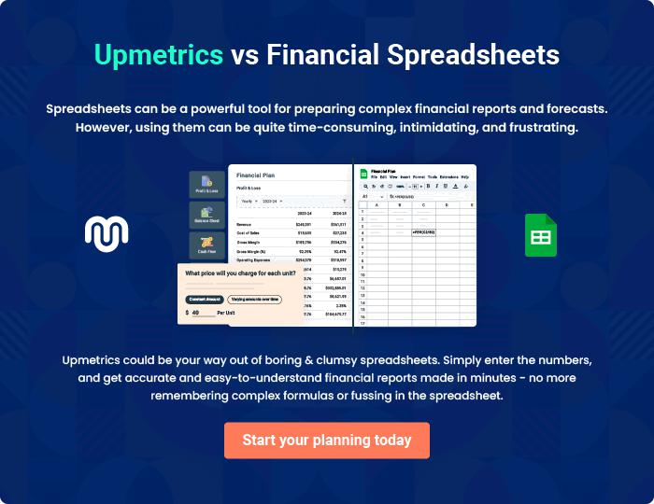
Appendix

When writing the appendix section, you should include any additional information that supports the main content of your plan. This may include financial statements, market research data, legal documents, and other
To unlock help try Upmetrics! 
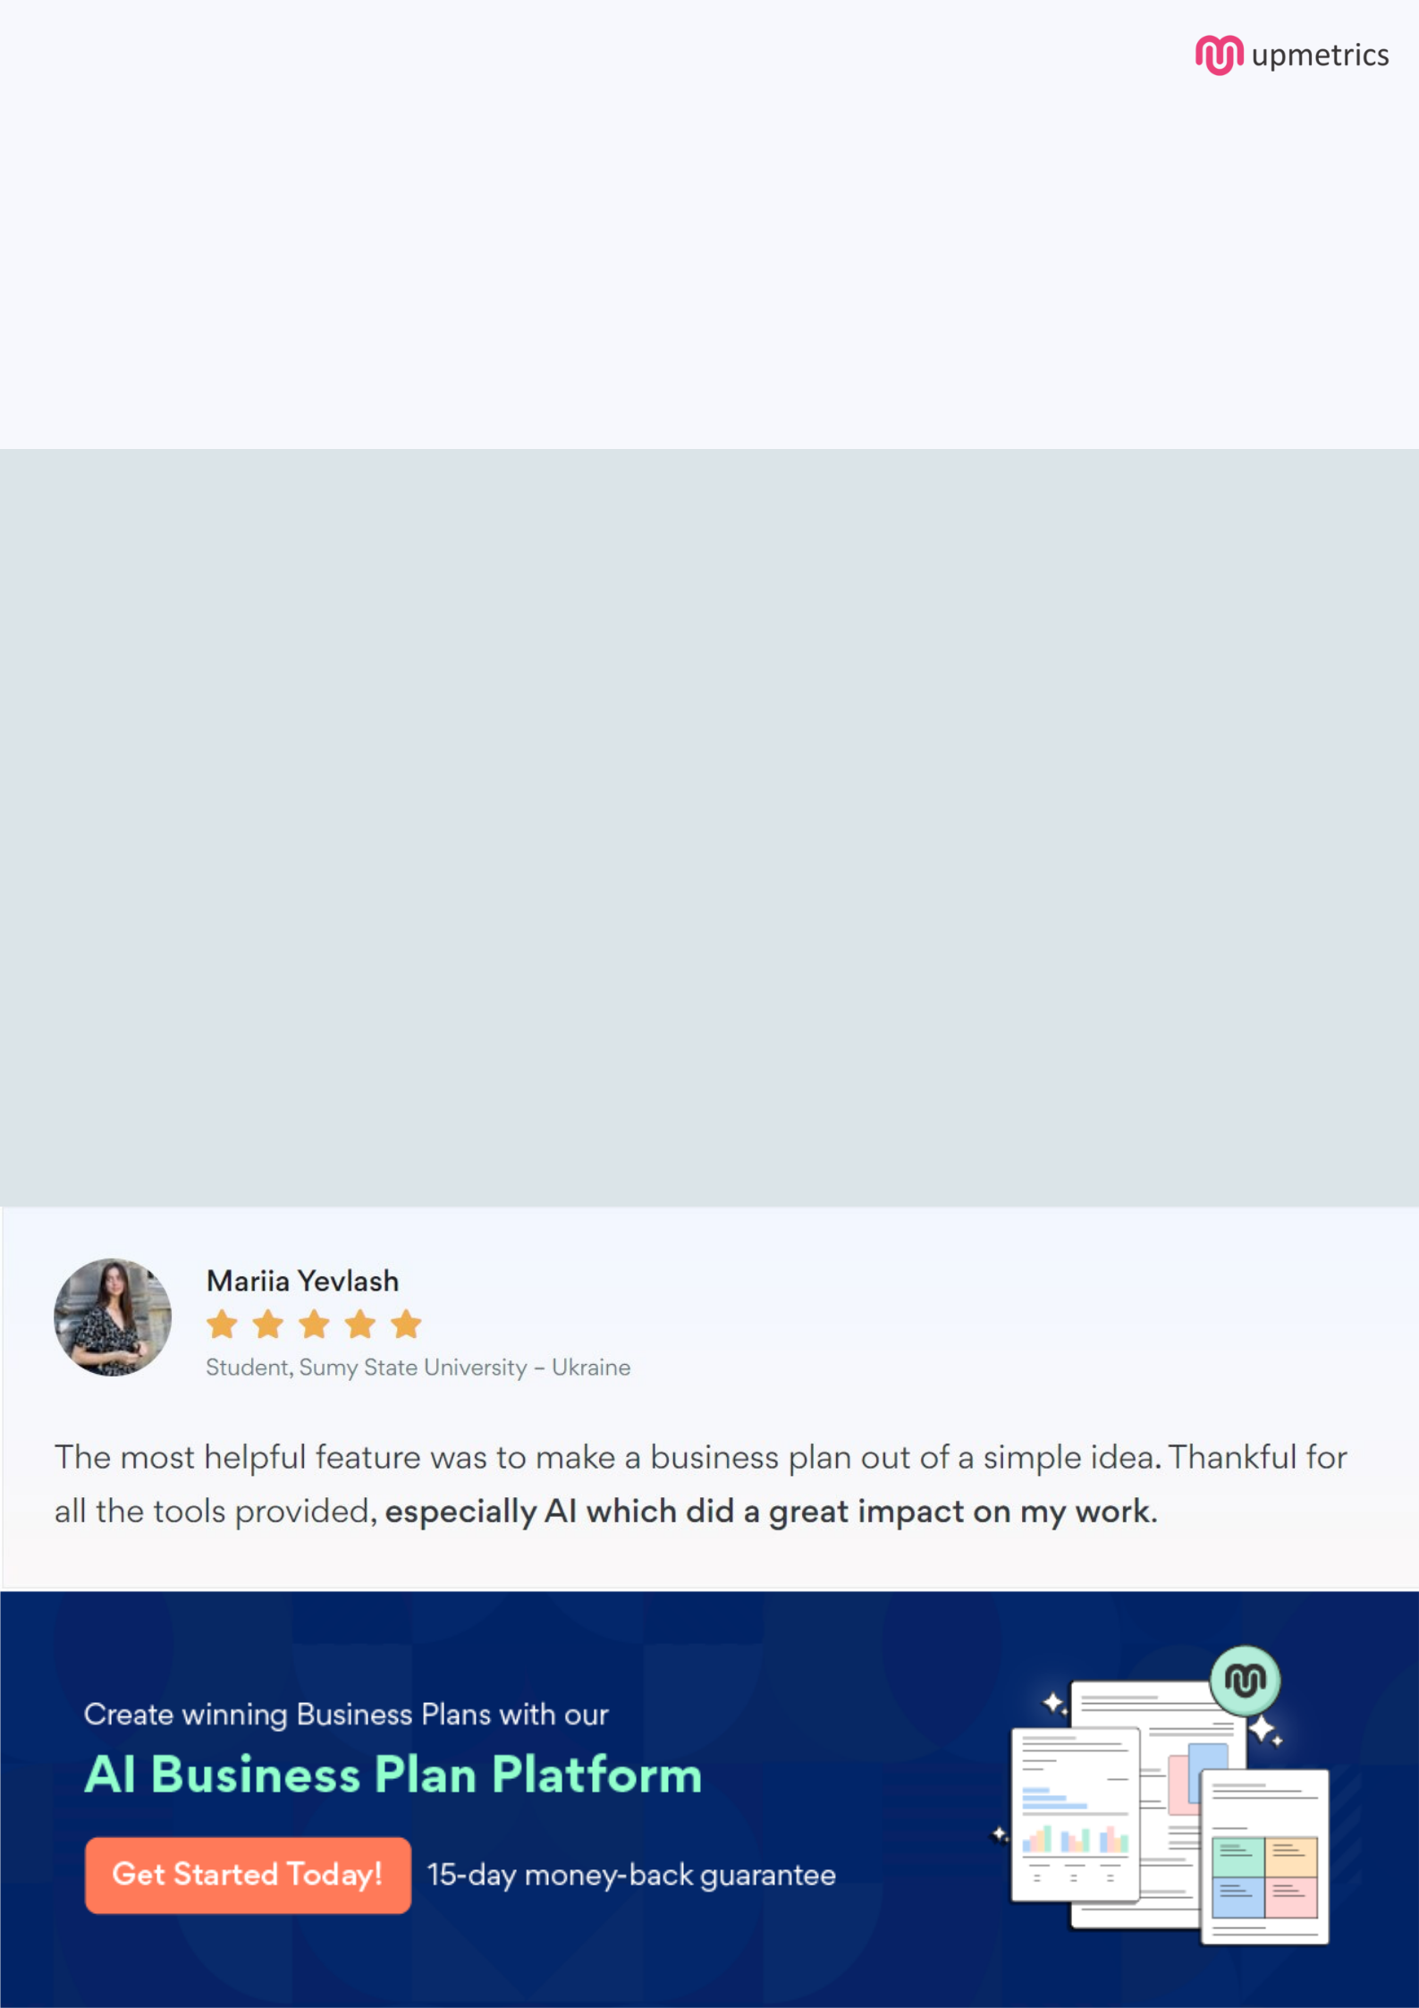
Create a winning business plan that gets you funded

Creating a stunning and investment-ready plan requires no writing, graphic designing, or financial planning expertise.

Upmetrics has all the features required to help you create a comprehensive business plan—from start to finish. Make no mistakes, it’s the modern way of planning to structure ideas, make plans, and create stunning pitch decks to awe investors.

Pitch decks that impress investors

Create pitch decks that provide a visual representation of your business, engage investors, and make them want to invest in your business idea.

Interactive plans in no time

Import business plan sections like—SWOT analysis, comparison tables, and others to create an interactive business plan. No designing skills are required.

Stunning cover page designs

With Upmetrics, you have the liberty to choose from multiple stunning cover page designs. Choose a creative design and make your plan stand out.

Online sharing made simple

Upmetrics makes online sharing quick and easier for users. Easily share your business plans with a link while tracking reader activity.

500+ sample business plans

Simply import a template from our library of sample plans into the editor and start customizing it to make it yours. It takes only a few clicks to get started.

Collaborate with team in real-time

Invite team members, initiate conversations, discuss ideas & strategies, share feedback, and work on a business plan in real-time.

