

Dental Business Plan

BUSINESS PLAN

2023

John Doe

10200 Bolsa Ave, Westminster, CA, 92683

- 359-3153 info@example.com http://www.example.com/

Information provided in this business plan is unique to this business and confidential; therefore, anyone reading this plan agrees not to disclose any of the information in this business plan without prior written permission of the company.
Table of Contents

Executive Summary | 6
Market opportunity | 6
Services Offered | 6
Marketing & Sales Strategies | 7
Financial Highlights | 7
Units Sold v/s Revenue | 8

Company Overview | 9
Ownership | 9
Mission statement | 10
Business history | 10
Future goals | 10

Market Analysis | 11
Target Market | 11
Market size and growth potential | 11
Market Size | 12
Competitive analysis | 12
BrightSmile Clinic | 12
ToothTech Dental Spa | 13
Pearly Whites Family Dentistry | 13
Market trends | 13
Regulatory environment | 14

Products and Services | 15
Services | 15
Teeth Whitening | 15
Tooth Extraction | 16
Cosmetic Fillings | 16
Dentures | 17
Root Canal Therapy | 17
Oral Surgery | 18
Insurance & Payment Options | 18
Additional Services | 18

Sales And Marketing Strategies | 19
Unique Selling Proposition (USP) | 19
Pricing Strategy | 19
Marketing strategies | 20
Online | 20
Offline | 20
Sales strategies | 21
Customer retention | 21

Operations Plan | 22
Staffing & Training | 22
Operational Process | 22
Safety & Infection Control | 23
Equipment & Technologies | 23

Management Team | 24
Key managers | 24
John Doe | 24
Jane Doe | 25
Alice Brown | 25
Robert Brown | 25
Organizational structure | 26
Organization chart | 26
Compensation plan | 27
Board of advisors | 27
[ADVISOR NAME] | 27
[ADVISOR NAME] | 27
Financial Plan | 28
Profit & loss statement | 28
Cash flow statement | 31
Balance sheet | 33
Break-even Analysis | 35
Financing needs | 37
Appendix
Appendix | 39
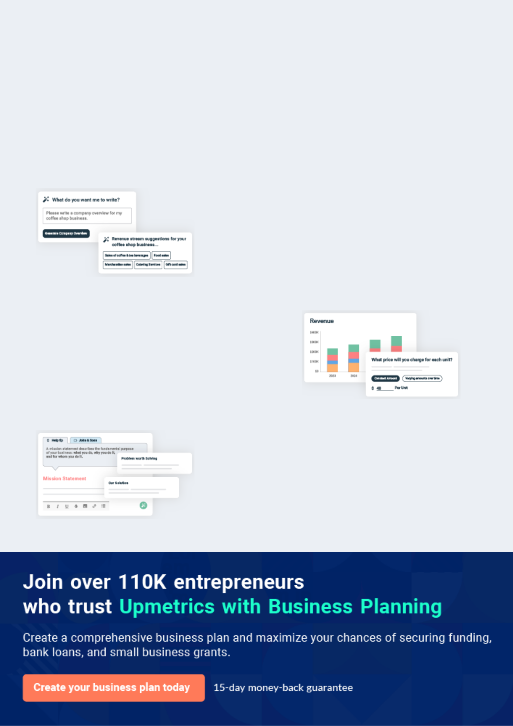
Business planning that’s simpler and faster than you think

Creating a business plan using Upmetrics to start and grow a business is literally the easiest thing in the World. Simply read the instructions and fill in the blanks. It’s as simple as that.

❛ | Upmetrics has everything you need to create a | ❜
❛ | comprehensive business plan. | ❜

AI-powered Upmetrics Assistant

AI-powered insights to streamline your plan

Not sure where to start? Upmetrics’ AI Assistant will automatically generate ideas for each section of your plan and offer improved versions of your writing, adjusting for tone, voice, and grammar or spelling errors.

Financial Forecasting Tool

All the financials are calculated for you

Forget the complex formulas and clumsy spreadsheets — with automatic financials and drag-and-drop forecasting, you can finish your plan faster and be confident that your numbers are accurate.

Business Plan Builder

Guides you like a business mentor

Upmetrics’ step-by-step instructions, prompts, and the library of 400+ sample business plans will guide you through each section of your plan as a business mentor.
Executive Summary


An executive summary is the first section of the business plan intended to provide an overview of the whole business plan.
To unlock help try Upmetrics! 

 Help tip  Dental Business Plan


Start your executive summary section by briefly introducing your business to your readers.

This section may include the name of your dental business, its location, when it was founded,
To unlock help try Upmetrics! 

Start writing here..

Market opportunity

 Help tip  Dental Business Plan

Summarize your market research, including market size, growth potential, and marketing trends. Highlight the opportunities in the market and how your business will fit in to fill the gap.
To unlock help try Upmetrics! 

Start writing here..

Services Offered

 Help tip  Dental Business Plan

Highlight the dental services you offer to your patients. Mention any dental specialties you have.
To unlock help try Upmetrics! 

Start writing here..

Marketing & Sales Strategies
To unlock help try Upmetrics!

 Help tip  Dental Business Plan

Outline your sales and marketing strategies—what marketing platforms you use and how you intend to attract new patients and retain existing ones.
To unlock help try Upmetrics! 

Start writing here..

Financial Highlights

 Help tip  Dental Business Plan

Briefly summarize your financial projections for the initial years of business operations. Include any capital or investment requirements, associated startup costs, projected revenues, and profit forecasts.



Start writing here..
Units Sold v/s Revenue

 |  | Units Sold | Revenue
15.00k
10.00k
5.00k
0
Year 1 | Year 2 | Year 3


Financial Year |  |  | Units Sold | Revenue
Year 1 | 1,550 |  |  | $10,000
Year 2 | 1,800 |  |  | $12,000
Year 3 | 2,050 |  |  | $14,000
 Help tip |  |  Dental Business Plan


Summarize your executive summary section with a clear CTA, for example, inviting angel investors to discuss the potential business investment.
To unlock help try Upmetrics! 

Write a call to action for your business plan.
Company Overview

Depending on what details of your business are essential, you’ll need different elements in your business overview.
To unlock help try Upmetrics! 

 Help tip  Dental Business Plan

Describe what type of dental clinic you run and the name of it. You may specialize in one of the following dental practices:
To unlock help try Upmetrics! 

Start writing here..

Ownership

 Help tip  Dental Business Plan

List the names of the founders of your clinic. Describe what shares they own and their responsibilities for efficiently managing the business.
To unlock help try Upmetrics! 

Start writing here..
Mission statement

 Help tip  Dental Business Plan

Summarize your business’ objective, core principles, and values in your mission statement. This statement needs to be memorable, clear, and brief.
To unlock help try Upmetrics! 

❛ At [Dental Delight], our mission is to illuminate smiles and elevate overall oral health. We are committed to patient-centric care, underpinned by innovation, expertise, and compassion. Every smile we nurture reflects our core values of integrity, excellence,

and community service.
❜

Business history

 Help tip  Dental Business Plan

If you’re an established dental business, briefly describe your business history, like—when it was founded, how it evolved over time, etc.
To unlock help try Upmetrics! 

Start writing here..

Future goals

 Help tip  Dental Business Plan

It’s crucial to convey your aspirations and vision. Mention your short-term and long-term goals; they can be specific targets for revenue, market share, or about expanding your services.
To unlock help try Upmetrics! 

Start writing here..

Market Analysis
To unlock help try Upmetrics!


 |  | Market analysis provides a clear understanding of the market in which your
 |  | printing business will run along with the target market, competitors, and
 |  | growth opportunities.
 |  |  |  | To unlock help try Upmetrics! 
 Help tip |  |  Dental Business Plan

To write the introduction section of your market analysis, start by clearly identifying your primary target market.
To unlock help try Upmetrics! 

Start writing here..

Target Market

 Help tip  Dental Business Plan

Start this section by describing your target market. Define your ideal customer and explain what types of services they prefer. Creating a buyer persona will help you easily define your target market to your readers.



Start writing here..

Market size and growth potential

 Help tip  Dental Business Plan

Describe your market size and growth potential and whether you will target a niche or a much broader market.
To unlock help try Upmetrics! 

Start writing here..

Market Size

Available Market

Total number of individuals in the region 500k seeking dental care.

Served Market
Those currently accessing dental 300k services in the region.

Target Market
Families and individuals aged 25-45 100k prioritizing preventive care.

 Help tip  Dental Business Plan

Identify and analyze your direct and indirect competitors. Identify their strengths and weaknesses, and describe what differentiates your dentistry services from them.
To unlock help try Upmetrics! 

Competitive analysis

BrightSmile Clinic

Established in 1995, BrightSmile Clinic has been a staple in the Westminster community, serving over 10,000 patients in its tenure. They offer general dentistry services alongside cosmetic procedures.

Features Strengths Weaknesses

Comprehensive general dentistry (check-ups, cleanings, fillings)

Orthodontic treatments (braces, retainers)

Cosmetic dentistry (veneers, teeth whitening)

Brand recognition due to long- Limited adoption of newer

standing presence technologies

Experienced staff with a Longer wait times for

number of specialists on-site appointments

Loyalty programs and family Limited marketing or online

packages presence

ToothTech Dental Spa

A modern entrant, ToothTech Dental Spa has rapidly gained popularity since its inauguration in 2019. Their focus on technology-driven solutions and spa-like experience sets them apart

Features | Strengths | Weaknesses
Digital impressions and 3D | Strong emphasis on patient | Premium pricing which may
dental imaging | comfort | alienate certain customer
Aesthetic treatments (teeth | Quick adoption of the latest | segments
whitening, invisalign) | dental technologies | Relatively newer, hence less
Relaxing environment with | Active online engagement | historical credibility
amenities like massage chairs, | through social media and | Limited range of traditional
music, and aromatherapy | online booking | dental services

Pearly Whites Family Dentistry

Catering mainly to families, Pearly Whites Family Dentistry, operational since 2005, emphasizes pediatric care and offers family packages.

Features | Strengths | Weaknesses
Pediatric dentistry (sealants, | Tailored approach to children's | Less focus on cosmetic and
fluoride treatments) | dentistry | advanced dental treatments
Family dental plans | Cost-effective family plans | Outdated facility in need of
Oral hygiene education | Community outreach programs | renovations
programs | in schools | Outdated facility in need of
 |  | renovations Infrequent updates
 |  | on services and limited digital
 |  | engagement

Market trends

 Help tip  Dental Business Plan

Analyze emerging trends in the industry, such as technology disruptions, changes in customer behavior or preferences, etc. Explain how your business will cope with all the trends.
To unlock help try Upmetrics! 

Start writing here..

Regulatory environment
To unlock help try Upmetrics!

 Help tip  Dental Business Plan

List regulations and licensing requirements that may affect your dental business, such as dental license, business insurance, facility requirements(fire safety, infection control standards), HIPPA compliance, etc.



Start writing here..
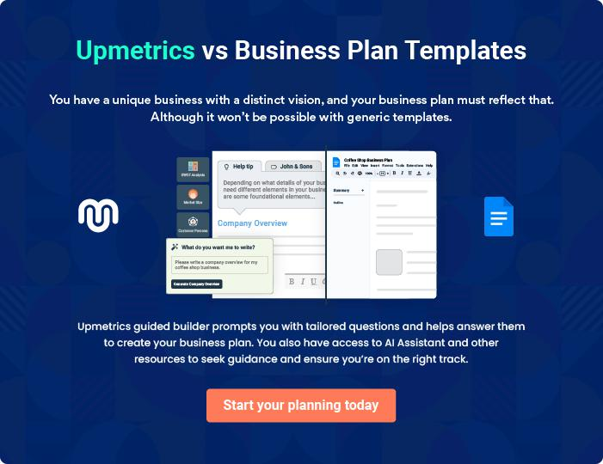
Products and Services

 |  | The product and services section of a dental business plan should describe
 |  | the specific services and products that will be offered to customers. To write
 |  | this section should include the following:
 |  |  |  | To unlock help try Upmetrics! 
 Help tip |  |  Dental Business Plan

To craft the introduction for your "Products and Services" chapter, begin by positioning your business within its industry, emphasizing its unique strengths or value proposition.
To unlock help try Upmetrics! 

Start writing here..

 Help tip


Mention the dentistry services your clinic will offer. This list may include services like,

• Teeth whitening
To unlock help try Upmetrics! 

Services

Teeth Whitening


Price: [$250] per session

A cosmetic procedure designed to brighten and enhance the natural appearance of your smile.

Specifications

- Uses advanced hydrogen peroxide gel

- Session duration: 45 minutes

- Results last up to 6 months with proper care

- Safe for enamel and gums
Tooth Extraction

Price: [$150] (simple extraction), $350 (surgical extraction)

Removal of damaged or decayed teeth to prevent further complications.

Specifications

- Pre-procedure X-ray assessment

- Local anesthesia applied

- Sterilized equipment

- Post-extraction care instructions provided

Cosmetic Fillings

Price: [$100-$300] (depending on tooth size and material)

Treatment for cavities using tooth-colored fillings that blend seamlessly with natural teeth.

Specifications

- Uses composite resin material

- UV-cured for durability

- Mercury-free

- Matches tooth shade
Dentures

Price: [$800] (partial), $1500 (full set)

Custom-made replacements for missing teeth to restore function and aesthetics.

Specifications

- Made using high-quality acrylic resin

- Option for metal or non-metal clasps

- Fitted over multiple sessions

- Durable and natural-looking

Root Canal Therapy

Price: [$600-$1200] (depending on tooth complexity)

Treatment to save an infected tooth by removing its damaged pulp and sealing it.

Specifications

- Advanced rotary endodontic tools used

- Biocompatible filling material

- Multiple sittings, if required

- Post-treatment crown placement recommended
Oral Surgery

Price: [$2,500] (per implant)

Surgical procedure to replace missing teeth with permanent, screw-like implants that act as artificial tooth roots.

Specifications

- Titanium implant post

- Custom-made crowns

- 3D scanning for precise placement

- Post-surgery care guide provided

Insurance & Payment Options

 Help tip  Dental Business Plan


his section should include details about accepted payment methods and insurance plans.
These options may include credit cards, cash, dental health insurance, third-party insurance,
etc.
 |  |  |  | To unlock help try Upmetrics! 
Start writing here..
Additional Services
 Help tip |  |  Dental Business Plan

Mention if your dental office offers any additional services. You may include services like mobile dental services, sedation dentistry, etc.
To unlock help try Upmetrics! 

Start writing here..

Sales And Marketing Strategies

Writing the sales and marketing strategies section means a list of strategies you will use to attract and retain your clients.
To unlock help try Upmetrics! 

 Help tip  Dental Business Plan

To create an effective introduction for your "Sales and Marketing Strategies" chapter, start by setting the stage within your specific industry or market.
To unlock help try Upmetrics! 

Unique Selling Proposition (USP)

 Help tip  Dental Business Plan

Define your business’s USPs depending on the market you serve, the equipment you use, and the unique services you provide.
To unlock help try Upmetrics! 

Start writing here..

Pricing Strategy

 Help tip  Dental Business Plan

Describe your pricing strategy—how you plan to price your dental services and stay competitive in the local market. You can mention any discounts you plan on offering to attract new patients.
To unlock help try Upmetrics! 

Start writing here..

 Help tip  Dental Business Plan
To unlock help try Upmetrics!

Discuss your marketing strategies to market your dentistry services. You may include some of these marketing strategies in your business plan—social media marketing, Google ads, brochures, email marketing, content marketing, and print marketing.



Marketing strategies

Online


Social Media

Regular updates on platforms like [specific platforms e.g., "Facebook, Instagram, LinkedIn"] showcasing patient testimonials, dental tips, and clinic updates.

Content Marketing

Blog posts and articles on dental health and hygiene, establishing [Dental Delight] as a knowledge hub.

Email Marketing

Monthly newsletters and reminders for check-ups, ensuring our patients are always informed

Google Ads

Targeted pay-per-click campaigns aimed at local residents searching for dental services

Offline

Brochures

Distributed in strategic locations such as [local businesses, community centers], providing comprehensive details of our services.

Print Marketing

Regular advertisements in [local newspapers, magazines] for widespread local reach.

 Help tip
To unlock help try Upmetrics!
To unlock help try Upmetrics!

Outline the strategies you’ll implement to maximize your sales. Your sales strategies may include partnering with other healthcare service providers(e.g., Orthodontists, oral surgeons.), offering referral programs, etc.



Sales strategies

Healthcare Partnerships

Collaborations with local healthcare service providers like orthodontists and oral surgeons to offer a holistic healthcare package.

Referral Programs

Incentivizing our existing patients to refer friends and family, offering [specific benefits e.g., "discounts on subsequent visits"].

 Help tip

Describe your patient retention strategies and how you plan to execute them. For instance, introducing patient loyalty programs, offering membership discounts, encouraging routine dental check-ups, etc.



Customer retention

Loyalty Programs Membership Discounts

Rewards for regular visits, Offering annual membership plans

encouraging consistent dental that provide discounts on

care. treatments.

Personalized Service

Personalized reminders to patients

for their bi-annual check-ups,

emphasizing the importance of

regular dental care.

Operations Plan

 |  | When writing the operations plan section, it’s important to consider the
 |  | various aspects of your business operations.
 |  |  |  | To unlock help try Upmetrics! 
 Help tip |  |  Dental Business Plan


To create an effective introduction for your "Operational Plan" chapter, start by emphasizing the
pivotal role of efficient operations in the success of your business, underscoring how they
directly impact the quality of services delivered.
 |  |  |  | To unlock help try Upmetrics! 
Start writing here..
Staffing & Training
 Help tip |  |  Dental Business Plan

Describe your staffing requirements, including the number of dentists, dental assistants,
nurses, and any other support staff you will need. Include their qualifications, years of
experience, and the duties they will perform.
 |  |  |  | To unlock help try Upmetrics! 
Start writing here..
Operational Process
 Help tip |  |  Dental Business Plan

Outline the processes and procedures you will use to run your dental business. Your operational processes may include managing patient flow, scheduling appointments, patient registration, patient treatment, record-keeping, billing, and after-treatment check-ups._{To unlock help try Upmetrics!} 

Start writing here..

Safety & Infection Control

 Help tip  Dental Business Plan

Describe the safety and infection control practices and protocols you plan to implement, keeping patients, staff, and visitors’ safety in mind.
To unlock help try Upmetrics! 

Start writing here..

Equipment & Technologies

 Help tip  Dental Business Plan

Include the list of equipment and technology that will be used in the dental practice, such as digital X-rays, intraoral cameras, laser dentistry, etc
To unlock help try Upmetrics! 

Start writing here..
Management Team

The management team section provides an overview of the individuals responsible for running your business plan.
To unlock help try Upmetrics! 

 Help tip  Dental Business Plan

To craft an introduction for your "Management Team" chapter, begin by emphasizing the crucial role of leadership in the success of any business.
To unlock help try Upmetrics! 

Start writing here..

Key managers

 Help tip  Dental Business Plan

Introduce your management and key team members, and explain their roles and responsibilities. Business plans for solo practitioners typically don’t include key managers.
To unlock help try Upmetrics! 

Start writing here..


JOHN DOE

CEO & Co-founder - john.doe@example.com

As the chief visionary behind Dental Delight, John Doe established the clinic with the intent of redefining quality dental care.

John graduated with a DDS from the University of California and has since garnered over 20 years of experience in various dental practices.


His commitment to integrating modern technology with personal patient care has set Dental Delight apart from the competition.

Operating out of 10200 Bolsa Ave, Westminster, CA, 92683, John oversees the clinic’s overall strategy and ensures the team aligns with the clinic's core values and objectives.

JANE DOE

Dental Director - jane.doe@example.com

With a DMD from the University of Southern California and 15 years of experience, Jane Doe supervises the quality of dental procedures, oversees the clinic’s operational flow, and ensures continuous professional development for the team.


Jane's innovative practices and patient-first approach have been crucial in shaping the clinic’s reputation.


ALICE BROWN

Head of Pediatric Dentistry - alice.brown@example.com

Alice Brown, with her degree from Stanford University School of Dentistry and a specialization in pediatric dentistry, ensures that even the youngest of patients receive the highest quality care at Dental Delight.

With over 12 years in pediatric dentistry, Alice's gentle approach and focus on preventive dental health have made her a favourite among parents and children alike.


ROBERT BROWN

Head of Orthodontics - robert.brown@example.com

Robert Brown spearheads the orthodontic department, boasting a degree from the Harvard School of Dental Medicine.

With 18 years of hands-on experience, Robert is known for his precision and attention to detail, ensuring that patients achieve perfect smiles.

His innovative techniques and modern approach have significantly reduced treatment times and enhanced patient comfort.
Organizational structure

 Help tip  Dental Business Plan

Explain the organizational structure of your management team. Include the reporting line and decision-making hierarchy.
To unlock help try Upmetrics! 

Start writing here..

Organization chart


John Doe

CEO


Alice Brown


Head of Pediatric Dentistry Jane Doe

Dental Director



Emma White

Robert Smith

Patient Relations Manager


Chief of Surgery


Lucas Green

Head of Marketing

Compensation plan

 Help tip  Dental Business Plan

Describe your compensation plan for the management and staff. Include their salaries, incentives, and other benefits.
To unlock help try Upmetrics! 

Start writing here..

 Help tip

Mentioning advisors or consultants in your business plans adds credibility to your business idea.
To unlock help try Upmetrics! 

Board of advisors


[ADVISOR NAME]

[DESIGNATION]

With over [X years] of experience in [specific field, e.g., "dental equipment technology"], [he/she] advises on the acquisition and maintenance of state-of-the-art dental equipment.


[ADVISOR NAME]

[DESIGNATION]

A seasoned expert in [specific field, e.g., "dental practice management"], [he/ she] provides insights into optimizing clinic operations and patient management strategies.
Financial Plan

When writing the financial plan section of a business plan, it’s important to provide a comprehensive overview of your financial projections for the first few years of your business, You may provide the following:
To unlock help try Upmetrics! 

 Help tip  Dental Business Plan


To create an effective introduction for your "Financial Plan" chapter, begin by stressing the critical role of a well-structured financial plan in the success of your venture.
To unlock help try Upmetrics! 

Start writing here..

 Help tip


Describe details such as projected revenue, operational costs, and service costs in your projected profit and loss statement. Make sure to include your business’s expected net profit or loss.
To unlock help try Upmetrics! 

Profit & loss statement

Revenue

Cost Of Sales

General Costs

Revenue Specific Costs

Personnel Costs (Direct

Labor)

Gross Margin

Gross Margin (%)

Operating Expense

Payroll Expense

(Indirect Labor)

General Expense

Bad Debt

Amortization of Current

Assets

2023-24 | 2024-25 | 2025-26 | 2026-27 | 2027-28
$0 | $0 | $0 | $0 | $0

$0 | $0 | $0 | $0 | $0
$0 | $0 | $0 | $0 | $0
$0 | $0 | $0 | $0 | $0
$0 | $0 | $0 | $0 | $0

$0 | $0 | $0 | $0 | $0
0% | 0% | 0% | 0% | 0%

$0 | $0 | $0 | $0 | $0
$0 | $0 | $0 | $0 | $0
$0 | $0 | $0 | $0 | $0
$0 | $0 | $0 | $0 | $0
$0 | $0 | $0 | $0 | $0

EBITDA

Additional Expense

Long Term

Depreciation

Gain or loss from Sale

of Assets

EBIT

Interest Expenses

EBT

Income Tax Expense

Total Expense

Net Income

Net Income (%)

2023-24 | 2024-25 | 2025-26 | 2026-27 | 2027-28
$0 | $0 | $0 | $0 | $0
$0 | $0 | $0 | $0 | $0
$0 | $0 | $0 | $0 | $0
$0 | $0 | $0 | $0 | $0
$0 | $0 | $0 | $0 | $0
$0 | $0 | $0 | $0 | $0
$0 | $0 | $0 | $0 | $0
$0 | $0 | $0 | $0 | $0
$0 | $0 | $0 | $0 | $0
$0 | $0 | $0 | $0 | $0
0% | 0% | 0% | 0% | 0%
 | 2023-24 | 2024-25 | 2025-26 | 2026-27 | 2027-28
Retained Earning | $0 | $0 | $0 | $0 | $0
Opening
Owner's Distribution | $0 | $0 | $0 | $0 | $0
Retained Earning | $0 | $0 | $0 | $0 | $0
Closing

 Help tip

This section should estimate and describe the cash flow for the first few years of your operation. This may include billing invoices, payment receipts, loan payments, and any other cash flow statements.
To unlock help try Upmetrics! 

Cash flow statement

 | 2023-24 | 2024-25 | 2025-26 | 2026-27 | 2027-28
Cash Received | $0 | $0 | $0 | $0 | $0
Cash Paid | $0 | $0 | $0 | $0 | $0
COS & General Expenses | $0 | $0 | $0 | $0 | $0
Salary & Wages | $0 | $0 | $0 | $0 | $0
Interest | $0 | $0 | $0 | $0 | $0

Sales Tax

Income Tax

Net Cash From

Operations

Assets Sell

Assets Purchase

Net Cash From

Investments

Amount Received

Loan Received

Common Stock

Preferred Stock

Owner's Contribution

Amount Paid

2023-24 | 2024-25 | 2025-26 | 2026-27 | 2027-28
$0 | $0 | $0 | $0 | $0
$0 | $0 | $0 | $0 | $0
$0 | $0 | $0 | $0 | $0

$0 | $0 | $0 | $0 | $0
$0 | $0 | $0 | $0 | $0
$0 | $0 | $0 | $0 | $0

$0 | $0 | $0 | $0 | $0
$0 | $0 | $0 | $0 | $0

$0 | $0 | $0 | $0 | $0
$0 | $0 | $0 | $0 | $0
$0 | $0 | $0 | $0 | $0

Loan Capital $0 $0 $0 $0 $0

 | 2023-24 | 2024-25 | 2025-26 | 2026-27 | 2027-28
Dividends & Distributions | $0 | $0 | $0 | $0 | $0
Net Cash From | $0 | $0 | $0 | $0 | $0
Financing

Summary
Starting Cash | $0 | $0 | $0 | $0 | $0
Cash In | $0 | $0 | $0 | $0 | $0
Cash Out | $0 | $0 | $0 | $0 | $0
Change in Cash | $0 | $0 | $0 | $0 | $0
Ending Cash | $0 | $0 | $0 | $0 | $0

 Help tip

Create a projected balance sheet documenting your dental business’s assets, liabilities, and equity.

To unlock help try Upmetrics! 

Balance sheet

 | 2023-24 | 2024-25 | 2025-26 | 2026-27 | 2027-28
Assets | $0 | $0 | $0 | $0 | $0
Current Assets | $0 | $0 | $0 | $0 | $0
Cash | $0 | $0 | $0 | $0 | $0
Accounts Receivable | $0 | $0 | $0 | $0 | $0
Inventory | $0 | $0 | $0 | $0 | $0
Other Current Assets | $0 | $0 | $0 | $0 | $0
Long Term Assets | $0 | $0 | $0 | $0 | $0
Gross Long Term Assets | $0 | $0 | $0 | $0 | $0
Accumulated Depreciation | $0 | $0 | $0 | $0 | $0

Liabilities & Equity | $0 | $0 | $0 | $0 | $0
Liabilities | $0 | $0 | $0 | $0 | $0
Current Liabilities | $0 | $0 | $0 | $0 | $0
Accounts Payable | $0 | $0 | $0 | $0 | $0
Income Tax Payable | $0 | $0 | $0 | $0 | $0
Sales Tax Payable | $0 | $0 | $0 | $0 | $0
Short Term Debt | $0 | $0 | $0 | $0 | $0
 | 2023-24 | 2024-25 | 2025-26 | 2026-27 | 2027-28
Long Term Liabilities | $0 | $0 | $0 | $0 | $0
Long Term Debt | $0 | $0 | $0 | $0 | $0
Equity | $0 | $0 | $0 | $0 | $0
Paid-in Capital | $0 | $0 | $0 | $0 | $0
Common Stock | $0 | $0 | $0 | $0 | $0
Preferred Stock | $0 | $0 | $0 | $0 | $0
Owner's Contribution | $0 | $0 | $0 | $0 | $0
Retained Earnings | $0 | $0 | $0 | $0 | $0

Check | $0 |  |  | $0 | $0 | $0 | $0
 Help tip |  |  Dental Business Plan


Determine and mention your business’s break-even point—the point at which your business costs and revenue will be equal.

This exercise will help you understand how much revenue you need to generate to sustain or be profitable.
To unlock help try Upmetrics! 

Break-even Analysis

 | 2023-24 | 2024-25 | 2025-26 | 2026-27 | 2027-28
Starting Revenue | $0 | $0 | $0 | $0 | $0
Net Revenue | $0 | $0 | $0 | $0 | $0
Closing Revenue | $0 | $0 | $0 | $0 | $0

Starting Expense | $0 | $0 | $0 | $0 | $0
Net Expense | $0 | $0 | $0 | $0 | $0
Closing Expense | $0 | $0 | $0 | $0 | $0

Is Break Even? | 0 | 0 | 0 | 0 | 0
Break Even Month | 0 | 0 | 0 | 0 | 0
Days Required | 0 | 0 | 0 | 0 | 0
Break Even Revenue | $0 | $0 | $0 | $0 | $0
Break Even Units
Financing needs

 Help tip  Dental Business Plan

Estimate your financing needs and how much capital you need to raise to operate your business.

Be specific about your short-term and long-term financing requirements, such as investment capital or loans.
To unlock help try Upmetrics! 

Start writing here..
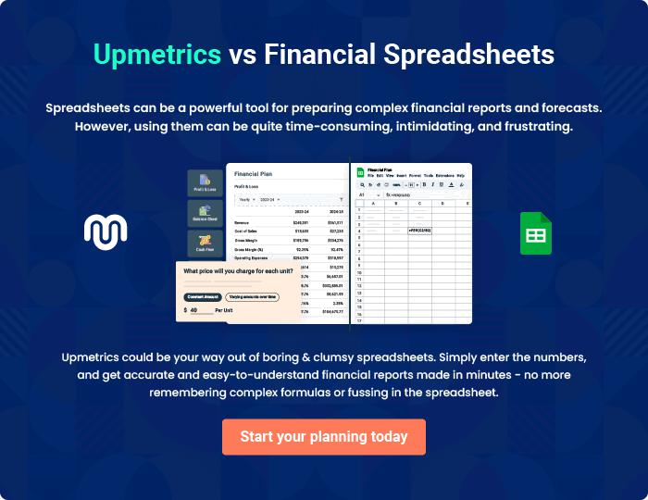
Appendix

When writing the appendix section, you should include any additional information that supports the main content of your plan. This may include financial statements, market research data, legal documents, and other
To unlock help try Upmetrics! 

Create a winning business plan that gets you funded

Creating a stunning and investment-ready plan requires no writing, graphic designing, or financial planning expertise.

Upmetrics has all the features required to help you create a comprehensive business plan—from start to finish. Make no mistakes, it’s the modern way of planning to structure ideas, make plans, and create stunning pitch decks to awe investors.

Pitch decks that impress investors

Create pitch decks that provide a visual representation of your business, engage investors, and make them want to invest in your business idea.

Interactive plans in no time

Import business plan sections like—SWOT analysis, comparison tables, and others to create an interactive business plan. No designing skills are required.

Stunning cover page designs

With Upmetrics, you have the liberty to choose from multiple stunning cover page designs. Choose a creative design and make your plan stand out.

Online sharing made simple

Upmetrics makes online sharing quick and easier for users. Easily share your business plans with a link while tracking reader activity.

500+ sample business plans

Simply import a template from our library of sample plans into the editor and start customizing it to make it yours. It takes only a few clicks to get started.

Collaborate with team in real-time

Invite team members, initiate conversations, discuss ideas & strategies, share feedback, and work on a business plan in real-time.

