
BUSINESS PLAN

2023


Delivery Service Business Plan

Timely Deliveries, Every Demand

John Doe

10200 Bolsa Ave, Westminster, CA, 92683

- 359-3153 info@example.com http://www.example.com

Information provided in this business plan is unique to this business and confidential; therefore, anyone reading this plan agrees not to disclose any of the information in this business plan without prior written permission of the company.
Table of Contents

Executive Summary | 6
Market opportunity | 6
Services Offered | 6
Marketing and Sales Strategies | 7
Financial Highlights | 7
Units Sold v/s Revenue | 8

Company Overview | 9
Ownership | 9
Mission statement | 10
Business history | 10
Future goals | 10

Market Analysis | 11
Target Market | 11
Market size and growth potential | 11
Market Size | 12
Competitive analysis | 12
FastTrack Couriers | 12
GreenParcel | 13
GlobalShip | 13
Market trends | 13
Regulatory environment | 14

Products and Services | 15
Services | 15
International Delivery Services | 15
Food Delivery Services | 16
Grocery Delivery Services | 16
Medical Delivery Services | 17
Packing and Storing Delivery Services | 17
Delivery Logistics | 18
Additional Services | 18

Sales And Marketing Strategies | 19
Unique Selling Proposition (USP) | 19
Pricing Strategy | 19
Marketing strategies | 20
Online | 20
Offline | 20
Sales strategies | 21
Customer retention | 22

Operations Plan | 23
Staffing & Training | 23
Operational process | 23
Equipment & Technology | 24

Management Team | 25
Key managers | 25
John Doe | 25
Jane Doe | 26
Alice Brown | 26
Robert Brown | 26
Organizational structure | 27
Organization chart | 27
Compensation plan | 28
Advisors/Consultants | 28
[Advisor Name] | 28
[Consultant Name] | 28

Financial Plan | 29
Profit & loss statement | 29
Cash flow statement | 32
Balance sheet | 34
Break-even Analysis | 36
Financing needs | 38
Appendix
Appendix | 40
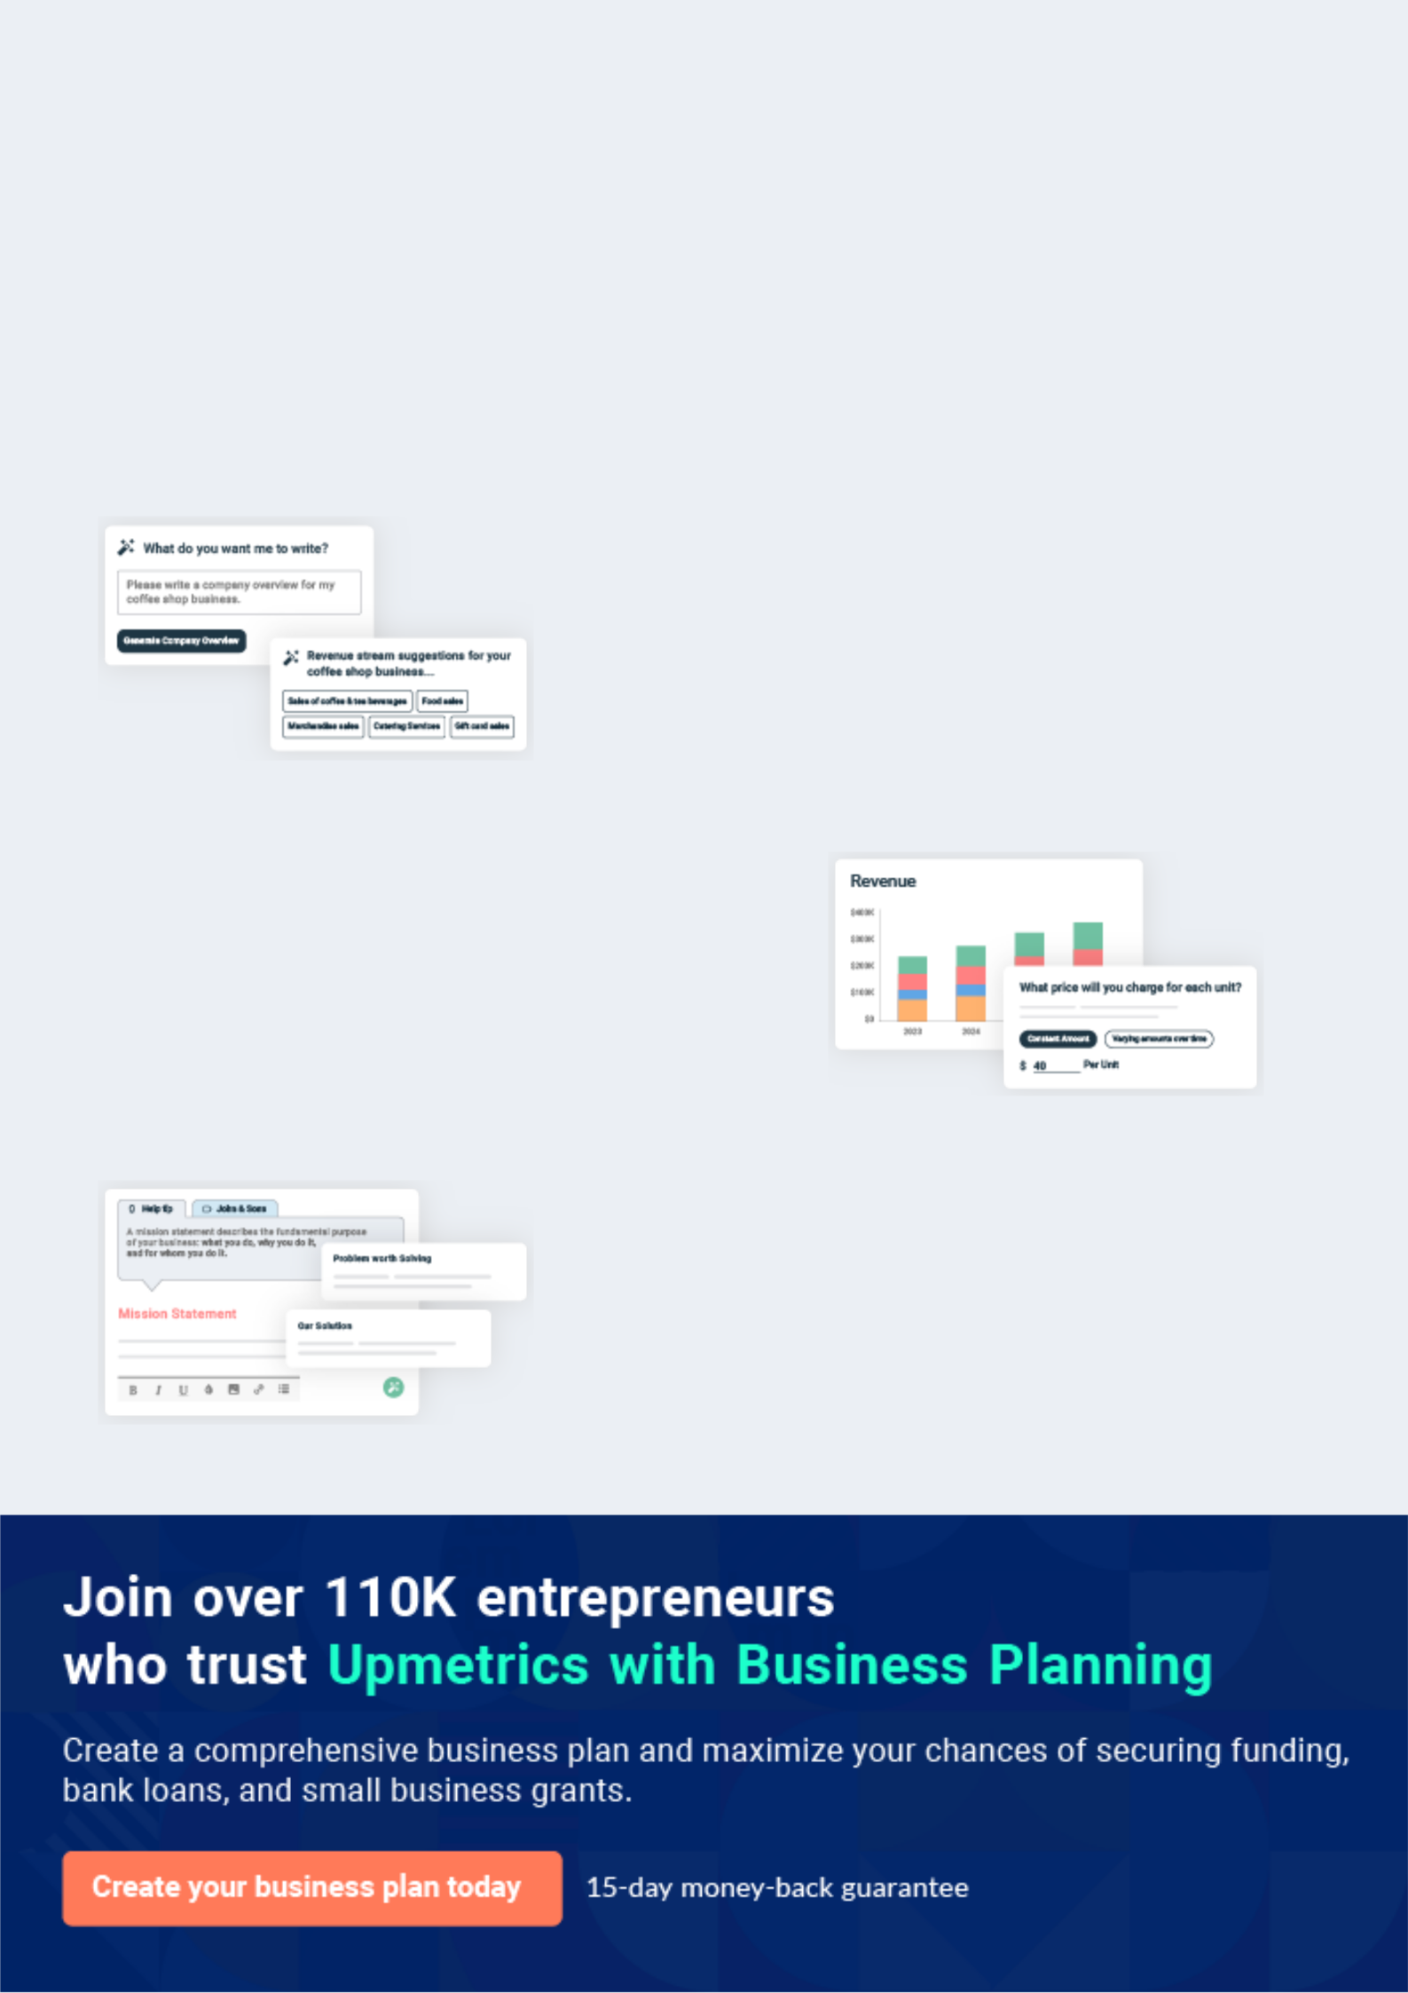
Business planning that’s simpler and faster than you think

Creating a business plan using Upmetrics to start and grow a business is literally the easiest thing in the World. Simply read the instructions and fill in the blanks. It’s as simple as that.

❛ | Upmetrics has everything you need to create a | ❜
❛ | comprehensive business plan. | ❜

AI-powered Upmetrics Assistant

AI-powered insights to streamline your plan

Not sure where to start? Upmetrics’ AI Assistant will automatically generate ideas for each section of your plan and offer improved versions of your writing, adjusting for tone, voice, and grammar or spelling errors.

Financial Forecasting Tool

All the financials are calculated for you

Forget the complex formulas and clumsy spreadsheets — with automatic financials and drag-and-drop forecasting, you can finish your plan faster and be confident that your numbers are accurate.

Business Plan Builder

Guides you like a business mentor

Upmetrics’ step-by-step instructions, prompts, and the library of 400+ sample business plans will guide you through each section of your plan as a business mentor.
Executive Summary


An executive summary is the first section of the business plan intended to provide an overview of the whole business plan.
To unlock help try Upmetrics! 

 Help tip  Delivery Service Business Plan


Start your business overview section by briefly introducing your business to your readers.

This section may include the name of your delivery service business, its location, and when it
To unlock help try Upmetrics! 

Start writing here..

Market opportunity

 Help tip  Delivery Service Business Plan

Outline the market you serve, discuss user demographics and preferences, and highlight the problems you intend to solve with your services.
To unlock help try Upmetrics! 

Start writing here..

Services Offered

 Help tip  Delivery Service Business Plan

Highlight the delivery services you offer your clients. The USPs and differentiators you offer are always a plus.
To unlock help try Upmetrics! 

Start writing here..

Marketing and Sales Strategies
To unlock help try Upmetrics!

 Help tip  Delivery Service Business Plan

Outline your sales and marketing strategies—what marketing platforms you use, how you plan on acquiring customers, etc.
To unlock help try Upmetrics! 

Start writing here..

Financial Highlights

 Help tip  Delivery Service Business Plan

Briefly summarize your financial projections for the initial years of business operations. Include any capital or investment requirements, associated startup costs, projected revenues, and profit forecasts.



Start writing here..
Units Sold v/s Revenue

 |  | Units Sold | Revenue
15.00k
10.00k
5.00k
0
Year 1 | Year 2 | Year 3


Financial Year |  |  | Units Sold | Revenue
Year 1 | 1,550 |  |  | $10,000
Year 2 | 1,800 |  |  | $12,000
Year 3 | 2,050 |  |  | $14,000
 Help tip |  |  Delivery Service Business Plan


Summarize your executive summary section with a clear CTA, for example, inviting angel investors to discuss the potential business investment.
To unlock help try Upmetrics! 

Write a call to action for your business plan.
Company Overview

Depending on what details of your business are essential, you’ll need different elements in your business overview.
To unlock help try Upmetrics! 

 Help tip  Delivery Service Business Plan

Describe what kind of delivery service business you run and the name of it. You may specialize in one of the following types:

• Food delivery services

Start writing here..

Ownership
To unlock help try Upmetrics! 

 Help tip  Delivery Service Business Plan

List the names of your delivery services business’s founders or owners. Describe what shares they own and their responsibilities for efficiently managing the business.
To unlock help try Upmetrics! 

Start writing here..

Mission statement

 Help tip  Delivery Service Business Plan

Summarize your business’ objective, core principles, and values in your mission statement. This statement needs to be memorable, clear, and brief.
To unlock help try Upmetrics! 

❛ At [ABC Delivery Services], we commit to providing unparalleled delivery solutions, prioritizing efficiency, reliability, and customer satisfaction. Our mission is to bridge distances, ensuring that

every package, regardless of size, arrives on time.
❜

Business history

 Help tip  Delivery Service Business Plan

If you’re an established delivery service provider, briefly describe your business history, like— when it was founded, how it evolved, etc.
To unlock help try Upmetrics! 

Start writing here..

Future goals

 Help tip  Delivery Service Business Plan

It’s crucial to convey your aspirations and vision. Mention your short-term and long-term goals; they can be specific targets for revenue, market share, or expanding your services.
To unlock help try Upmetrics! 

Start writing here..

Market Analysis
To unlock help try Upmetrics!


 |  | Market analysis provides a clear understanding of the market in which your
 |  | printing business will run along with the target market, competitors, and
 |  | growth opportunities.
 |  |  |  | To unlock help try Upmetrics! 
 Help tip |  |  Delivery Service Business Plan

To write the introduction section of your market analysis, start by clearly identifying your primary target market.
To unlock help try Upmetrics! 

Start writing here..

Target Market

 Help tip  Delivery Service Business Plan

Start this section by describing your target market. Define your ideal customer and explain what types of services they prefer. Creating a buyer persona will help you easily define your target market to your readers.



Start writing here..

Market size and growth potential

 Help tip  Delivery Service Business Plan

Offer an overview of the delivery service industry. Include necessary information like market size and growth potential for new entrepreneurs.
To unlock help try Upmetrics! 

Start writing here..

Market Size

Available Market

Total individuals using delivery 100M services in the U.S.

Served Market
Individuals in urban areas using 60M delivery services frequently.

Target Market
Urban professionals aged 25-45 20M prioritizing express deliveries.

 Help tip  Delivery Service Business Plan

Identify and analyze your direct and indirect competitors. Identify their strengths and weaknesses, and describe what differentiates your delivery services from them.
To unlock help try Upmetrics! 

Competitive analysis

FastTrack Couriers

FastTrack Couriers, established in [Year], has quickly risen to prominence in the metropolitan areas, known for their express delivery solutions catering primarily to corporate clients.

Features | Strengths | Weaknesses
Express Same-day Delivery | Strong brand recognition in | Limited presence in suburban
Overnight Corporate Packages | urban areas. | and rural areas.
Secure Document Delivery | Significant corporate | Higher pricing compared to
Secure Document Delivery | partnerships leading to regular | industry standards.
Customized Corporate | bulk orders. | Customer feedback suggests
Packages |  | Customer feedback suggests
Packages | Advanced technological | occasional delays during peak
 | integration, including real-time | business times.
 | tracking.

GreenParcel

Established in [Year], GreenParcel is known for its environmentally-friendly delivery solutions, emphasizing sustainability in all its operations.

Features

Eco-friendly Packaging Options Carbon-neutral Delivery Fleet Recyclable Package Pickup

Membership-based Discount System

Strengths

Appeals to the growing eco-conscious consumer base.

Strong partnerships with green businesses and products.

Unique membership model encouraging customer loyalty.

Weaknesses

Limited service options compared to larger competitors.

Premium pricing for specialized eco-friendly services.

Premium pricing for specialized eco-friendly services. Slower delivery times due to sustainable delivery practices.

GlobalShip

A giant in the delivery industry, GlobalShip has been operating since [Year], offering a vast range of services, from local to international deliveries.

Features

Worldwide Shipping

Express International Delivery

Custom and Duty Paid Parcels

Freight and Large Package Solutions

Strengths | Weaknesses
Extensive global network | Complex pricing structure, often
ensuring wide coverage. | confusing for first-time users.
Solid reputation for reliable | Customer service issues,
international shipments. | particularly during holiday
Bulk and freight options | seasons.
catering to diverse client | Less flexibility in service
needs. | customization compared to
 | smaller competitors.

Market trends

 Help tip  Delivery Service Business Plan

Analyze emerging trends in the industry, such as technology disruptions, changes in customer behavior or preferences, etc. Explain how your business will cope with all the trends.
To unlock help try Upmetrics! 

Start writing here..

Regulatory environment

 Help tip  Delivery Service Business Plan

List regulations and licensing requirements that may affect your company, such as business registration, insurance, state and federal regulations, etc.
To unlock help try Upmetrics! 

Start writing here..
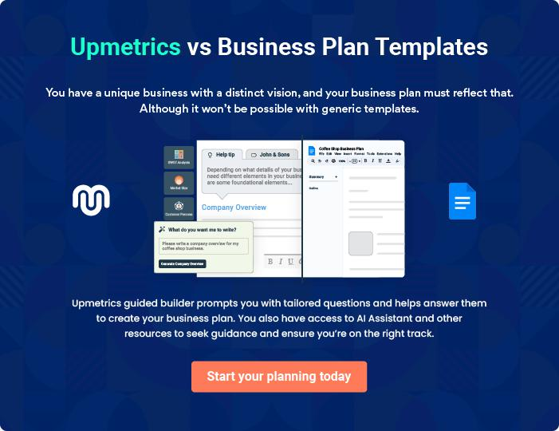
Products and Services
To unlock help try Upmetrics!

The product and services section of a delivery service business plan should describe the specific services and products that will be offered to customers. To write this section should include the following:



 Help tip  Delivery Service Business Plan

To craft the introduction for your "Products and Services" chapter, begin by positioning your business within its industry, emphasizing its unique strengths or value proposition.
To unlock help try Upmetrics! 

Start writing here..

 Help tip


Mention the delivery services your business will offer. This list may include services like,

• International delivery services
To unlock help try Upmetrics! 

Services

International Delivery Services


Price: $[15] per package (up to 1kg); additional $[5] for every subsequent kg.

A service tailored for clients who require overseas shipping. Efficient, reliable, and hassle-free, our international deliveries ensure your package reaches its destination anywhere in the world.

Specifications

- Delivery to over [200] countries worldwide.

- Maximum weight: [30kg] per package.

- Delivery time: [3-7] business days.

- Insurance option available at an additional cost.
Food Delivery Services

Price: Flat rate of $[5] for orders below $[50]; Free for orders above $[50].

Ensuring meals from our partnered restaurants and chains are delivered piping hot and fresh to your doorstep.

Specifications

- Insulated delivery containers for temperature maintenance.

- Partnered with over [100] restaurants.

- Average delivery time: [30-45] minutes.

- Option to schedule delivery.

Grocery Delivery Services

Price: $[8] for standard delivery; Express (same-day) delivery at $[12].

Fresh groceries sourced from local stores and delivered with utmost care directly to you.

Specifications

- Special packaging for perishable items.

- No minimum order.

- Express delivery within [2-4] hours of order.

- Returns accepted within [24] hours for damaged items.
Medical Delivery Services

Price: $[10] per delivery (up to 5kg); additional $[3] for every subsequent kg.

Specialized service ensuring the timely and safe delivery of medical supplies and medicines.

Specifications

- Temperature-controlled options for sensitive medications.

- Partnerships with major pharmacies and clinics.

- Delivery within [1-3] hours.

- Secure and discreet packaging.

Packing and Storing Delivery Services

Price: $[20] per cubic meter for storage (monthly); Delivery charges based on package size and distance.

Ideal for clients needing a temporary storage solution before delivery. Store your items securely with us and have them delivered when needed.

Specifications

- [X square feet] of climate-controlled storage facility.

- 24/7 security and surveillance.

- Items cataloged and easily retrievable.

- Delivery upon request with [24] hours notice.
Delivery Logistics

 Help tip  Delivery Service Business Plan

Provide details on how the delivery process will work, including information on the delivery vehicles, delivery routes, and delivery personnel.
To unlock help try Upmetrics! 

Start writing here..

Additional Services

 Help tip  Delivery Service Business Plan

Throw light on additional services you provide in this section, such as package tracking or real-time delivery information, customer services, etc.
To unlock help try Upmetrics! 

Start writing here..
Sales And Marketing Strategies
To unlock help try Upmetrics!

Writing the sales and marketing strategies section means a list of strategies you will use to attract and retain your clients.
To unlock help try Upmetrics! 

 Help tip  Delivery Service Business Plan

To create an effective introduction for your "Sales and Marketing Strategies" chapter, start by setting the stage within your specific industry or market.
To unlock help try Upmetrics! 

Unique Selling Proposition (USP)

 Help tip  Delivery Service Business Plan


Define your business’s USPs depending on the market you serve, the equipment you use, and
the unique services you provide. Identifying USPs will help you to plan your marketing
strategies.
 |  |  |  | To unlock help try Upmetrics! 
Start writing here..
Pricing Strategy
 Help tip |  |  Delivery Service Business Plan

Describe your pricing strategy—how you plan to price your services and stay competitive in the local market. You can mention any discounts you plan on offering to attract new customers to your service.



Start writing here..

 Help tip  Delivery Service Business Plan
To unlock help try Upmetrics!

Discuss your marketing strategies to market your services. You may include some of these marketing strategies in your business plan—social media marketing, Google ads, brochures, email marketing, content marketing, and print marketing.



Marketing strategies

Online


Social Media

Engage with our audience through platforms like Facebook, Instagram, and LinkedIn, sharing testimonials, behind-the-scenes glimpses, and promotions.

Content Marketing

Blog posts, articles, and infographics that provide value, position us as industry leaders, and drive organic traffic to our website.

Email Marketing

Regular newsletters and updates to our subscribers about new features, offers, and company news.

Google Ads

Targeted advertising campaigns to boost our visibility to potential clients searching for delivery services.

Offline

Print Marketing

Brochures, flyers, and posters for local dissemination, especially in high-footfall areas.

 Help tip
To unlock help try Upmetrics!

Outline the sales strategy as in – partnering with other businesses and healthcare providers to establish referral programs that can help you generate more business. Consider offering incentives for referrals or special discounts for partnerships.



Sales strategies

Partner with Businesses

Collaborate with local businesses, restaurants, and retailers for exclusive delivery partnerships.

Referral Programs

Incentivize existing clients to refer our services to others by offering them discounts or rewards for successful referrals.

Healthcare Partnerships

Working closely with healthcare providers to ensure safe and prompt delivery of medical supplies.

 Help tip

Describe your customer retention strategies and how you plan to execute them. For instance, introducing discounts on annual membership, personalized service, etc.
To unlock help try Upmetrics! 

Customer retention

Loyalty Programs

Offering points-based rewards for frequent users which can be redeemed for discounts or free deliveries.

Personalized Service

Recognizing customer preferences, delivering personalized experiences, and occasional surprise offers.

Annual Membership Discounts

Special rates for customers who opt for our annual membership program.

Operations Plan
To unlock help try Upmetrics!

 |  | When writing the operations plan section, it’s important to consider the
 |  | various aspects of your business operations.
 |  |  |  | To unlock help try Upmetrics! 
 Help tip |  |  Delivery Service Business Plan


To create an effective introduction for your "Operational Plan" chapter, start by emphasizing the
pivotal role of efficient operations in the success of your business, underscoring how they
directly impact the quality of services delivered.
 |  |  |  | To unlock help try Upmetrics! 
Start writing here..
Staffing & Training
 Help tip |  |  Delivery Service Business Plan

Mention your business’s staffing requirements, including the number of employees needed.

Include their qualifications, the training required, and the duties they will perform.
To unlock help try Upmetrics! 

Start writing here..

Operational process

 Help tip  Delivery Service Business Plan

Outline the processes and procedures you will use to run your delivery service business. Your operational processes may include handling clients, customer services, timely delivery, training employees, etc.



Start writing here..

Equipment & Technology

 Help tip  Delivery Service Business Plan

Describe the tools you’ll need to run your delivery services, such as the equipment, technology, and trucks.
To unlock help try Upmetrics! 

Start writing here..
Management Team

The management team section provides an overview of the individuals responsible for running your business plan.
To unlock help try Upmetrics! 

 Help tip  Delivery Service Business Plan

To craft an introduction for your "Management Team" chapter, begin by emphasizing the crucial role of leadership in the success of any business.
To unlock help try Upmetrics! 

Start writing here..

Key managers

 Help tip  Delivery Service Business Plan

Introduce your management and key members of your team, and explain their roles and responsibilities.
To unlock help try Upmetrics! 

Start writing here..


JOHN DOE

CEO & Co-founder - john.doe@example.com

- Educational Background: John holds an MBA from Stanford University and a Bachelor's degree in Supply Chain Management from the University of Michigan.


• Professional Background: With over 15 years of experience in the logistics and delivery industry, John has worked with leading firms such as DHL and FedEx, overseeing regional operations and spearheading innovative projects.

John's vision drives ABC Delivery Services. He is responsible for strategic planning, overseeing company operations, and establishing valuable partnerships.

JANE DOE

Operations Manager - jane.doe@example.com

- Educational Background: Jane has a Master's degree in Operations Management from MIT and a Bachelor's in Business Administration from UCLA.

- Professional Background: Jane served as the Regional Operations Head for UPS for 8 years, managing complex delivery systems and streamlining operational processes.


Jane oversees day-to-day operations, ensuring efficient route optimization, timely deliveries, and seamless coordination between teams.


ALICE BROWN

Customer Services Manager - alice.brown@example.com

- Educational Background: Alice holds a degree in Communications from New York University.

- Professional Background: With over 10 years of experience in customer relations, Alice has managed customer service teams at Amazon and eBay, ensuring top-tier customer satisfaction levels.

Alice is in charge of the customer service team, addressing feedback, handling escalations, and ensuring service quality.


ROBERT BROWN

Marketing Manager - robert.brown@example.com

- Educational Background: Robert pursued his Master's in Marketing from Wharton School and holds a Bachelor's degree in Digital Media from Boston University.

- Professional Background: Robert was previously the Digital Marketing Lead at DoorDash, where he initiated several successful campaigns that significantly boosted user acquisition.

Robert oversees the marketing team, sets campaign strategies, and collaborates with sales teams to drive revenue growth.
Organizational structure

 Help tip  Delivery Service Business Plan

Explain the organizational structure of your management team. Include the reporting line and decision-making hierarchy.
To unlock help try Upmetrics! 

Start writing here..

Organization chart


John Doe

CEO


Robert Brown

Alice White

Marketing Mgr.

Operations Mgr.


Jane Doe

Michael Lee Delivery Coordinator

Marketing Associate



Tom Wilson

Eva Green

Social Media Specialist

Driver Lead

Compensation plan

 Help tip  Delivery Service Business Plan

Describe your compensation plan for the management and staff. Include their salaries, incentives, and other benefits.
To unlock help try Upmetrics! 

Start writing here..

 Help tip

Mentioning advisors or consultants in your business plans adds credibility to your business idea.
To unlock help try Upmetrics! 

Advisors/Consultants


[ADVISOR NAME]

Advisor

A veteran in [specific industry or expertise], [Advisor Name] provides valuable counsel on [specific area, e.g., "expanding to international markets"].


[CONSULTANT NAME]

Consultant

As a seasoned [specific role, e.g., "logistics consultant"], [Consultant Name] offers strategies for optimizing our delivery processes.
Financial Plan

When writing the financial plan section of a business plan, it’s important to provide a comprehensive overview of your financial projections for the first few years of your business, You may provide the following:
To unlock help try Upmetrics! 

 Help tip  Delivery Service Business Plan


To create an effective introduction for your "Financial Plan" chapter, begin by stressing the critical role of a well-structured financial plan in the success of your venture.
To unlock help try Upmetrics! 

Start writing here..

 Help tip


Describe details such as projected revenue, operational costs, and service costs in your projected profit and loss statement. Make sure to include your business’s expected net profit or loss.
To unlock help try Upmetrics! 

Profit & loss statement

Revenue

Cost Of Sales

General Costs

Revenue Specific Costs

Personnel Costs (Direct

Labor)

Gross Margin

Gross Margin (%)

Operating Expense

Payroll Expense

(Indirect Labor)

General Expense

Bad Debt

Amortization of Current

Assets

2023-24 | 2024-25 | 2025-26 | 2026-27 | 2027-28
$0 | $0 | $0 | $0 | $0

$0 | $0 | $0 | $0 | $0
$0 | $0 | $0 | $0 | $0
$0 | $0 | $0 | $0 | $0
$0 | $0 | $0 | $0 | $0

$0 | $0 | $0 | $0 | $0
0% | 0% | 0% | 0% | 0%

$0 | $0 | $0 | $0 | $0
$0 | $0 | $0 | $0 | $0
$0 | $0 | $0 | $0 | $0
$0 | $0 | $0 | $0 | $0
$0 | $0 | $0 | $0 | $0

EBITDA

Additional Expense

Long Term

Depreciation

Gain or loss from Sale

of Assets

EBIT

Interest Expenses

EBT

Income Tax Expense

Total Expense

Net Income

Net Income (%)

2023-24 | 2024-25 | 2025-26 | 2026-27 | 2027-28
$0 | $0 | $0 | $0 | $0
$0 | $0 | $0 | $0 | $0
$0 | $0 | $0 | $0 | $0
$0 | $0 | $0 | $0 | $0
$0 | $0 | $0 | $0 | $0
$0 | $0 | $0 | $0 | $0
$0 | $0 | $0 | $0 | $0
$0 | $0 | $0 | $0 | $0
$0 | $0 | $0 | $0 | $0
$0 | $0 | $0 | $0 | $0
0% | 0% | 0% | 0% | 0%
 | 2023-24 | 2024-25 | 2025-26 | 2026-27 | 2027-28
Retained Earning | $0 | $0 | $0 | $0 | $0
Opening
Owner's Distribution | $0 | $0 | $0 | $0 | $0
Retained Earning | $0 | $0 | $0 | $0 | $0
Closing

 Help tip

The cash flow for the first few years of your operation should be estimated and described in this section. This may include billing invoices, payment receipts, loan payments, and any other cash flow statements.
To unlock help try Upmetrics! 

Cash flow statement

 | 2023-24 | 2024-25 | 2025-26 | 2026-27 | 2027-28
Cash Received | $0 | $0 | $0 | $0 | $0
Cash Paid | $0 | $0 | $0 | $0 | $0
COS & General Expenses | $0 | $0 | $0 | $0 | $0
Salary & Wages | $0 | $0 | $0 | $0 | $0
Interest | $0 | $0 | $0 | $0 | $0

Sales Tax

Income Tax

Net Cash From

Operations

Assets Sell

Assets Purchase

Net Cash From

Investments

Amount Received

Loan Received

Common Stock

Preferred Stock

Owner's Contribution

Amount Paid

2023-24 | 2024-25 | 2025-26 | 2026-27 | 2027-28
$0 | $0 | $0 | $0 | $0
$0 | $0 | $0 | $0 | $0
$0 | $0 | $0 | $0 | $0

$0 | $0 | $0 | $0 | $0
$0 | $0 | $0 | $0 | $0
$0 | $0 | $0 | $0 | $0

$0 | $0 | $0 | $0 | $0
$0 | $0 | $0 | $0 | $0

$0 | $0 | $0 | $0 | $0
$0 | $0 | $0 | $0 | $0
$0 | $0 | $0 | $0 | $0

Loan Capital $0 $0 $0 $0 $0

 | 2023-24 | 2024-25 | 2025-26 | 2026-27 | 2027-28
Dividends & Distributions | $0 | $0 | $0 | $0 | $0
Net Cash From | $0 | $0 | $0 | $0 | $0
Financing

Summary
Starting Cash | $0 | $0 | $0 | $0 | $0
Cash In | $0 | $0 | $0 | $0 | $0
Cash Out | $0 | $0 | $0 | $0 | $0
Change in Cash | $0 | $0 | $0 | $0 | $0
Ending Cash | $0 | $0 | $0 | $0 | $0

 Help tip

Create a projected balance sheet documenting your delivery service business’s assets, liabilities, and equity.

To unlock help try Upmetrics! 

Balance sheet

 | 2023-24 | 2024-25 | 2025-26 | 2026-27 | 2027-28
Assets | $0 | $0 | $0 | $0 | $0
Current Assets | $0 | $0 | $0 | $0 | $0
Cash | $0 | $0 | $0 | $0 | $0
Accounts Receivable | $0 | $0 | $0 | $0 | $0
Inventory | $0 | $0 | $0 | $0 | $0
Other Current Assets | $0 | $0 | $0 | $0 | $0
Long Term Assets | $0 | $0 | $0 | $0 | $0
Gross Long Term Assets | $0 | $0 | $0 | $0 | $0
Accumulated Depreciation | $0 | $0 | $0 | $0 | $0

Liabilities & Equity | $0 | $0 | $0 | $0 | $0
Liabilities | $0 | $0 | $0 | $0 | $0
Current Liabilities | $0 | $0 | $0 | $0 | $0
Accounts Payable | $0 | $0 | $0 | $0 | $0
Income Tax Payable | $0 | $0 | $0 | $0 | $0
Sales Tax Payable | $0 | $0 | $0 | $0 | $0
Short Term Debt | $0 | $0 | $0 | $0 | $0
 | 2023-24 | 2024-25 | 2025-26 | 2026-27 | 2027-28
Long Term Liabilities | $0 | $0 | $0 | $0 | $0
Long Term Debt | $0 | $0 | $0 | $0 | $0
Equity | $0 | $0 | $0 | $0 | $0
Paid-in Capital | $0 | $0 | $0 | $0 | $0
Common Stock | $0 | $0 | $0 | $0 | $0
Preferred Stock | $0 | $0 | $0 | $0 | $0
Owner's Contribution | $0 | $0 | $0 | $0 | $0
Retained Earnings | $0 | $0 | $0 | $0 | $0

Check | $0 |  |  | $0 | $0 | $0 | $0
 Help tip |  |  Delivery Service Business Plan


Determine and mention your business’s break-even point—the point at which your business costs and revenue will be equal.

This exercise will help you understand how much revenue you need to generate to sustain or be profitable.
To unlock help try Upmetrics! 

Break-even Analysis

 | 2023-24 | 2024-25 | 2025-26 | 2026-27 | 2027-28
Starting Revenue | $0 | $0 | $0 | $0 | $0
Net Revenue | $0 | $0 | $0 | $0 | $0
Closing Revenue | $0 | $0 | $0 | $0 | $0

Starting Expense | $0 | $0 | $0 | $0 | $0
Net Expense | $0 | $0 | $0 | $0 | $0
Closing Expense | $0 | $0 | $0 | $0 | $0

Is Break Even? | 0 | 0 | 0 | 0 | 0
Break Even Month | 0 | 0 | 0 | 0 | 0
Days Required | 0 | 0 | 0 | 0 | 0
Break Even Revenue | $0 | $0 | $0 | $0 | $0
Break Even Units
Financing needs

 Help tip  Delivery Service Business Plan

Calculate costs associated with starting a delivery service business, and estimate your financing needs and how much capital you need to raise to operate your business.
To unlock help try Upmetrics! 

Start writing here..
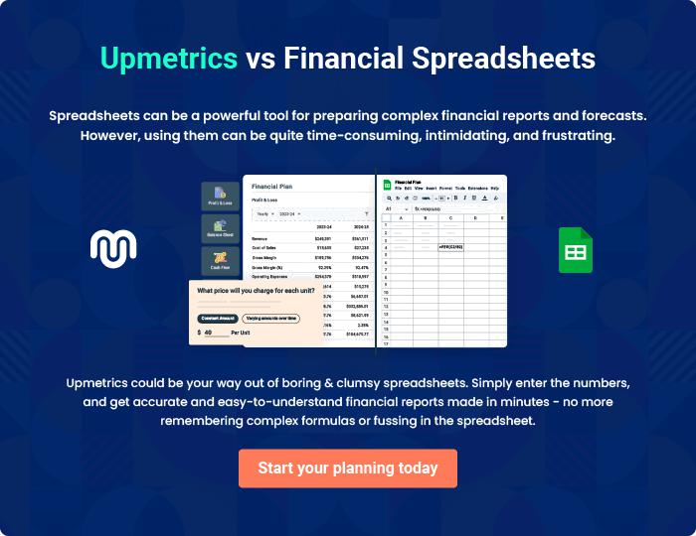
Appendix

When writing the appendix section, you should include any additional information that supports the main content of your plan. This may include financial statements, market research data, legal documents, and other
To unlock help try Upmetrics! 
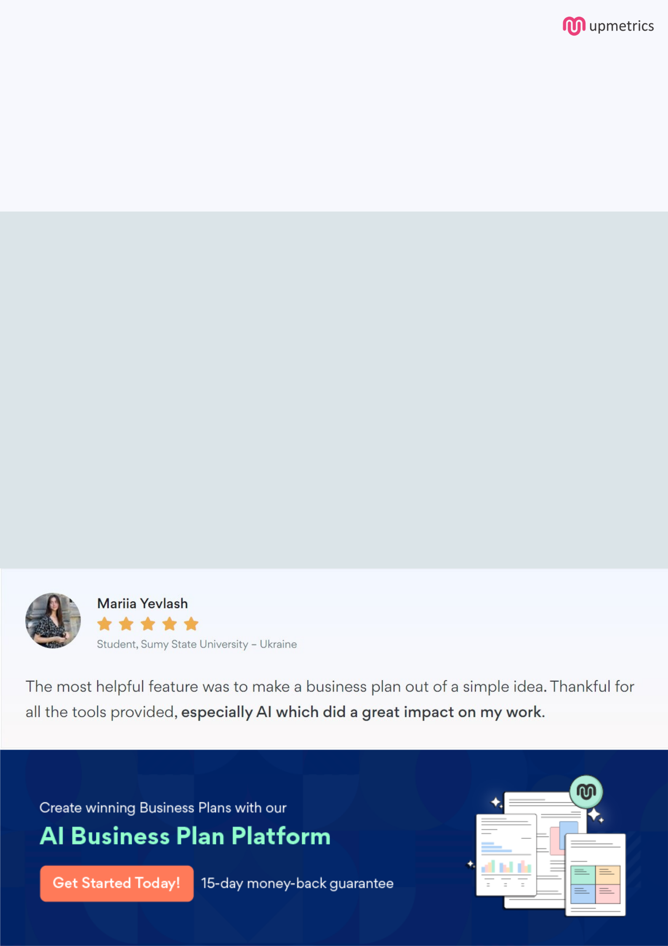
Create a winning business plan that gets you funded

Creating a stunning and investment-ready plan requires no writing, graphic designing, or financial planning expertise.

Upmetrics has all the features required to help you create a comprehensive business plan—from start to finish. Make no mistakes, it’s the modern way of planning to structure ideas, make plans, and create stunning pitch decks to awe investors.

Pitch decks that impress investors

Create pitch decks that provide a visual representation of your business, engage investors, and make them want to invest in your business idea.

Interactive plans in no time

Import business plan sections like—SWOT analysis, comparison tables, and others to create an interactive business plan. No designing skills are required.

Stunning cover page designs

With Upmetrics, you have the liberty to choose from multiple stunning cover page designs. Choose a creative design and make your plan stand out.

Online sharing made simple

Upmetrics makes online sharing quick and easier for users. Easily share your business plans with a link while tracking reader activity.

500+ sample business plans

Simply import a template from our library of sample plans into the editor and start customizing it to make it yours. It takes only a few clicks to get started.

Collaborate with team in real-time

Invite team members, initiate conversations, discuss ideas & strategies, share feedback, and work on a business plan in real-time.

