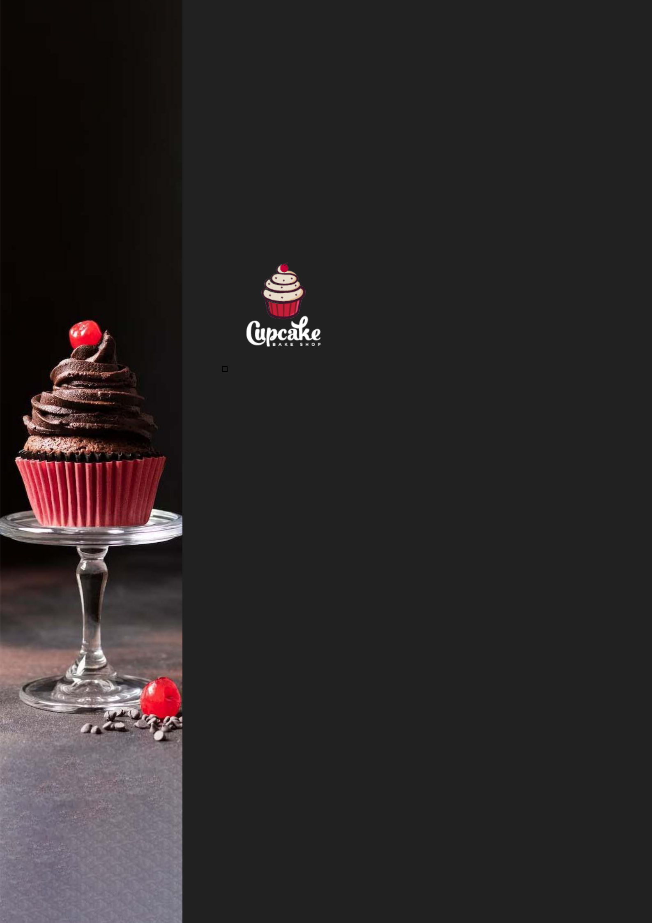
BUSINESS PLAN

2023

Cupcake Business Plan

Sweet Indulgences, Baked Bliss

John Doe

10200 Bolsa Ave, Westminster, CA, 92683

- 359-3153 info@example.com http://www.example.com

Information provided in this business plan is unique to this business and confidential; therefore, anyone reading this plan agrees not to disclose any of the information in this business plan without prior written permission of the company.
Table of Contents

Executive Summary | 6
Market opportunity | 6
Cupcake Menu | 6
Marketing & Sales Strategies | 7
Financial Highlights | 7
Units Sold v/s Revenue | 8

Company Overview | 9
Ownership | 9
Mission statement | 10
Business history | 10
Future goals | 10

Market Analysis | 11
Target Market | 11
Market size and growth potential | 11
Market Size | 12
Competitive analysis | 12
Sweet Moments Bakery | 12
Cupcake Chronicles | 13
Muffin Maven | 13
Market trends | 13
Regulatory environment | 14

Products and Services | 15
Products and Services | 15
Classic Vanilla Cupcake | 15
Chocolate Indulgence Cupcake | 17
Vegan Blueberry Bliss Cupcake | 17
Organic Coffee (Complementary Product) | 18
Local Delivery Service | 18
Additional Products | 19
Delivery and Shipping Services | 19
Quality Measures | 19

Sales And Marketing Strategies | 20
Unique Selling Proposition (USP) | 20
Pricing Strategy | 20
Marketing strategies | 21
Online | 21
Offline | 21
Sales strategies | 22
Customer retention | 22

Operations Plan | 23
Staffing & Training | 23
Operational Process | 23
Equipment & Machinery | 24

Management Team | 25
Key managers | 25
John Doe | 25
Jane Doe | 26
Alice Brown | 26
Robert Brown | 26
Organizational structure | 27
Organization chart | 27
Compensation plan | 27
Board of advisors | 28
Dr. Lucy White | 28
Mr. Robert Gray | 28
Financial Plan
Financial Plan | 29

Profit & loss statement 29

Cash flow statement | 32
Balance sheet | 34
Break-even Analysis | 36
Financing needs | 38
Appendix
Appendix | 40
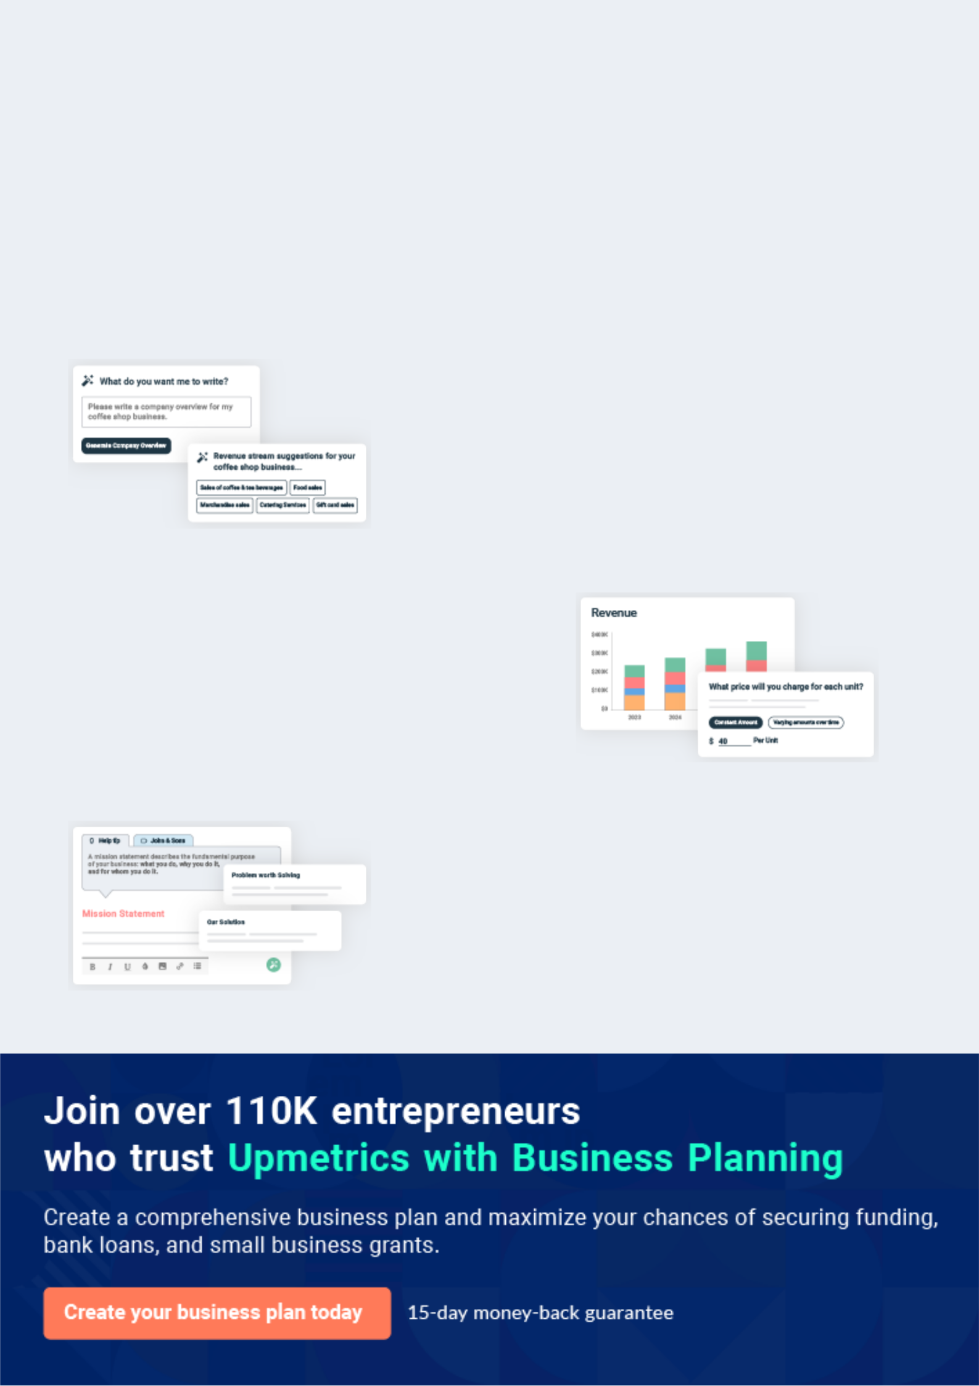
Business planning that’s simpler and faster than you think

Creating a business plan using Upmetrics to start and grow a business is literally the easiest thing in the World. Simply read the instructions and fill in the blanks. It’s as simple as that.

❛ | Upmetrics has everything you need to create a | ❜
❛ | comprehensive business plan. | ❜

AI-powered Upmetrics Assistant

AI-powered insights to streamline your plan

Not sure where to start? Upmetrics’ AI Assistant will automatically generate ideas for each section of your plan and offer improved versions of your writing, adjusting for tone, voice, and grammar or spelling errors.

Financial Forecasting Tool

All the financials are calculated for you

Forget the complex formulas and clumsy spreadsheets — with automatic financials and drag-and-drop forecasting, you can finish your plan faster and be confident that your numbers are accurate.

Business Plan Builder

Guides you like a business mentor

Upmetrics’ step-by-step instructions, prompts, and the library of 400+ sample business plans will guide you through each section of your plan as a business mentor.
Executive Summary


An executive summary is the first section of the business plan intended to provide an overview of the whole business plan.
To unlock help try Upmetrics! 

 Help tip  Cupcake Business Plan


Start your executive summary by briefly introducing your business to your readers.

This section may include the name of your cupcake business, its location, when it was founded,
To unlock help try Upmetrics! 

Start writing here..

Market opportunity

 Help tip  Cupcake Business Plan

Summarize your market research, including market size, growth potential, and marketing trends. Highlight the opportunities in the market and how your business will fit in to fill the gap.
To unlock help try Upmetrics! 

Start writing here..

Cupcake Menu

 Help tip  Cupcake Business Plan

Highlight the variety of cupcakes you offer to your customers. You may also mention any additional services you provide.
To unlock help try Upmetrics! 

Start writing here..

Marketing & Sales Strategies
To unlock help try Upmetrics!

 Help tip  Cupcake Business Plan

Outline your sales and marketing strategies—what marketing platforms you use, how you plan on acquiring customers, etc.
To unlock help try Upmetrics! 

Start writing here..

Financial Highlights

 Help tip  Cupcake Business Plan

Briefly summarize your financial projections for the initial years of business operations. Include any capital or investment requirements, associated startup costs, projected revenues, and profit forecasts.



Start writing here..
Units Sold v/s Revenue

 |  | Units Sold | Revenue
15.00k
10.00k
5.00k
0
Year 1 | Year 2 | Year 3


Financial Year |  |  | Units Sold | Revenue
Year 1 | 1,550 |  |  | $10,000
Year 2 | 1,800 |  |  | $12,000
Year 3 | 2,050 |  |  | $14,000
 Help tip |  |  Cupcake Business Plan


Summarize your executive summary section with a clear CTA, for example, inviting angel investors to discuss the potential business investment.
To unlock help try Upmetrics! 

Write a call to action for your business plan.
Company Overview

Depending on what details of your business are essential, you’ll need different elements in your business overview.
To unlock help try Upmetrics! 

 Help tip  Cupcake Business Plan

Describe your business in this section by providing all the basic information:

Describe what kind of cupcake shop or bakery you run and the name of it. You may specialize in
To unlock help try Upmetrics! 

Start writing here..

Ownership

 Help tip  Cupcake Business Plan

List the names of your cupcake business’s founders or owners. Describe what shares they own and their responsibilities for efficiently managing the business.
To unlock help try Upmetrics! 

Start writing here..
Mission statement

 Help tip  Cupcake Business Plan

Summarize your business’ objective, core principles, and values in your mission statement. This statement needs to be memorable, clear, and brief.
To unlock help try Upmetrics! 

❛ At [Cupcake Delight], we believe in crafting moments of joy, one cupcake at a time. Rooted in tradition but inspired by innovation, our commitment is to deliver unparalleled taste and a memorable experience for every customer. Our core values revolve around quality, community, and sustainability, as we strive to sprinkle

delight in every bite.
❜

Business history

 Help tip  Cupcake Business Plan

If you’re an established cupcake service provider, briefly describe your business history, like— when it was founded, how it evolved over time, etc.
To unlock help try Upmetrics! 

Start writing here..

Future goals

 Help tip  Cupcake Business Plan

It’s crucial to convey your aspirations and vision. Mention your short-term and long-term goals; they can be specific targets for revenue, market share, or expanding your services.
To unlock help try Upmetrics! 

Start writing here..

Market Analysis
To unlock help try Upmetrics!


 |  | Market analysis provides a clear understanding of the market in which your
 |  | printing business will run along with the target market, competitors, and
 |  | growth opportunities.
 |  |  |  | To unlock help try Upmetrics! 
 Help tip |  |  Cupcake Business Plan

To write the introduction section of your market analysis, start by clearly identifying your primary target market.
To unlock help try Upmetrics! 

Start writing here..

Target Market

 Help tip  Cupcake Business Plan

Start this section by describing your target market. Define your ideal customer and explain what types of services they prefer. Creating a buyer persona will help you easily define your target market to your readers.



Start writing here..

Market size and growth potential

 Help tip  Cupcake Business Plan

Describe your market size and growth potential and whether you will target a niche or a much broader market.
To unlock help try Upmetrics! 

Start writing here..

Market Size

Available Market

Total consumers in the region who 5M consume baked goods.

Served Market
Consumers actively buying cupcakes, 1M both traditional and specialty.

Target Market
Health-conscious buyers seeking vegan/ 350k gluten-free options.

 Help tip  Cupcake Business Plan

Identify and analyze your direct and indirect competitors. Identify their strengths and weaknesses, and describe what differentiates your cupcake services from them.
To unlock help try Upmetrics! 

Competitive analysis

Sweet Moments Bakery

A veteran in the cupcake industry, Sweet Moments Bakery has been serving the community for over a decade. They are known for their classic flavors and an ever-evolving seasonal menu.

Features | Strengths
Extensive range of traditional | Established brand reputation.
cupcake flavors. | Wide distribution network.
Seasonal offerings align with | Effective customer retention
festivals and holidays. | Effective customer retention
festivals and holidays. | through their loyalty program.
Loyalty program for repeat
customers.

Weaknesses

Limited dietary options, lacking in vegan or gluten-free offerings.

Lagging in digital presence; no online ordering or delivery system.

Cupcake Chronicles

A modern, tech-savvy bakery, Cupcake Chronicles capitalizes on online sales and quirky marketing strategies. They have a strong online presence and are known for their thematic cupcake boxes.

Features Strengths Weaknesses

Online ordering with home | Robust online presence and
delivery. | effective digital marketing.
Monthly subscription boxes | Innovative with their product
with curated flavors | offerings, such as themed
Interactive website with a | boxes.
cupcake customization tool. | Strong engagement with
 | younger demographics.

Limited physical store presence.

Inconsistent quality across their wide flavour range.

Muffin Maven

Muffin Maven, while primarily known for muffins, has recently ventured into the cupcake segment.

Their focus is on organic and natural ingredients.

Features

Farm-to-table ingredient sourcing, ensuring freshness.

Organic and health-focused cupcake line.

Eco-friendly packaging

Strengths

Strong emphasis on natural and organic ingredients resonates with health-conscious consumers.

Sustainable practices, both in baking and packaging, appeal to eco-conscious customers.

Weaknesses

New entrant in the cupcake segment; still establishing brand recognition.

Premium pricing due to organic sourcing might alienate certain customer segments.

Market trends

 Help tip  Cupcake Business Plan

Analyze emerging trends in the industry, such as technology disruptions, changes in customer behavior or preferences, etc. Explain how your business will cope with all the trends.
To unlock help try Upmetrics! 

Start writing here..

Regulatory environment
To unlock help try Upmetrics!

 Help tip  Cupcake Business Plan

List regulations and licensing requirements that may affect your cupcake business, such as business registration, insurance, food safety and handling, ingredient labeling, and zoning & land use regulations.



Start writing here..
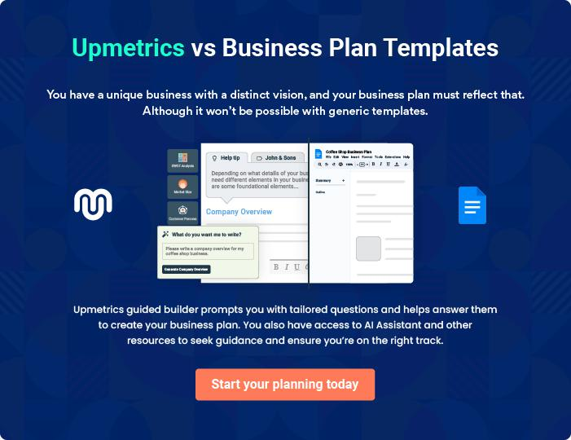
Products and Services
To unlock help try Upmetrics!

The product and services section of a cupcake business plan should describe the specific services and products that will be offered to customers. To write this section should include the following:



 Help tip  Cupcake Business Plan

To craft the introduction for your "Products and Services" chapter, begin by positioning your business within its industry, emphasizing its unique strengths or value proposition.
To unlock help try Upmetrics! 

Start writing here..

 Help tip


Start this section by describing the variety of cupcakes you will serve, including the information about the ingredients used. Mention if you have any specialty or vegetarian alternatives.
To unlock help try Upmetrics! 

Products and Services

Classic Vanilla Cupcake


Price: [$3.50] each

Our Classic Vanilla Cupcake is a timeless favorite, crafted with premium Madagascar vanilla beans, offering a delicate and aromatic flavor in every bite.
Product Specifications

- Size: 3 inches in diameter

- Ingredients: All-purpose flour, caster sugar, organic eggs, Madagascar vanilla extract, baking powder, and butter.

- Shelf life: 2 days (recommended consumption within 24 hours for best taste)

- Vegetarian: Yes

- Gluten-free variant: Available
Chocolate Indulgence Cupcake

Price: [$4.00] each

Dive into a world of rich cocoa with our Chocolate Indulgence Cupcake. Made with dark Belgian chocolate, it promises a dense, moist, and deeply chocolatey experience.

Product Specifications

- Size: 3 inches in diameter

- Ingredients: All-purpose flour, Belgian dark chocolate, organic eggs, brown sugar, baking powder, butter, and cocoa powder.

- Shelf life: 2 days (recommended consumption within 24 hours for best taste)

- Vegetarian: Yes

- Gluten-free variant: Available

Vegan Blueberry Bliss Cupcake

Price: [$4.50] each

Our Vegan Blueberry Bliss combines the tang of fresh blueberries with the moistness of a perfectly baked cupcake, ensuring a guilt-free treat without compromising on taste.

Product Specifications

- Size: 3 inches in diameter

- Ingredients: Whole wheat flour, fresh blueberries, almond milk, organic cane sugar, baking soda, and coconut oil.

- Shelf life: 2 days (recommended consumption within 24 hours for best taste)

- Vegan: Yes

- Gluten-free variant: Not Available
Organic Coffee (Complementary Product)

Price: [$2.50] per cup

Sourced from the highlands of Colombia, our Organic Coffee promises a robust flavor profile with subtle undertones of caramel and nuts, making it the perfect accompaniment to our cupcakes.

Product Specifications

- Size: 12 oz

- Ingredients: Organic Colombian coffee beans, water.

- Vegan options: Almond, Soy, and Oat milk available upon request

- Add-ons: Whipped cream, cinnamon, and cocoa powder are available for an additional $0.50.

Local Delivery Service

Price: [$5.00] (flat rate)

Ensuring timely delivery of your favorite cupcakes right to your doorstep within the Westminster region.

Service Specifications

- Service Area: Westminster and surrounding areas up to a 10-mile radius.

- Delivery Time: 10:00 AM - 8:00 PM

- Minimum Order: $20

- Advanced booking option: Available up to a week in advance
Additional Products

 Help tip  Cupcake Business Plan

Mention if your cupcake business offers any additional products. This may include related products like coffee, tea, specialty cupcakes, and complimentary baked goods.
To unlock help try Upmetrics! 

Start writing here..

Delivery and Shipping Services

 Help tip  Cupcake Business Plan

Describe if your business offers delivery or shipping services to your customers, including details about the areas you plan to serve.
To unlock help try Upmetrics! 

Start writing here..

Quality Measures

 Help tip  Cupcake Business Plan

This section should explain how you maintain quality standards and consistently provide the highest quality service.
To unlock help try Upmetrics! 

Start writing here..
Sales And Marketing Strategies
To unlock help try Upmetrics!

Writing the sales and marketing strategies section means a list of strategies you will use to attract and retain your clients.
To unlock help try Upmetrics! 

 Help tip  Cupcake Business Plan

To create an effective introduction for your "Sales and Marketing Strategies" chapter, start by setting the stage within your specific industry or market.
To unlock help try Upmetrics! 

Unique Selling Proposition (USP)

 Help tip  Cupcake Business Plan

Define your business’s USPs depending on the market you serve, the equipment you use, and the unique services you provide. Identifying USPs will help you plan your marketing strategies.
To unlock help try Upmetrics! 

Start writing here..

Pricing Strategy

 Help tip  Cupcake Business Plan

Describe your pricing strategy—how you plan to price your products and services and stay competitive in the local market. You can mention any discounts you plan on offering to attract new customers.



Start writing here..

 Help tip  Cupcake Business Plan
To unlock help try Upmetrics!

Discuss your marketing strategies to market your services. You may include some of these marketing strategies in your business plan—social media marketing, Google ads, brochures, email marketing, content marketing, and print marketing.



Marketing strategies

Online


Social Media

Active presence on platforms like Instagram, Facebook, and Pinterest, showcasing our cupcakes, customer testimonials, and behind-the-scenes content.

Content Marketing

Sharing blogs and articles on cupcake recipes, baking tips, and event ideas, positioning [Cupcake Delight] as an industry thought leader.

Email Marketing

Regular newsletters and promotional offers to our subscriber base, ensuring continuous engagement.

Google Ads

Leveraging paid ads to reach potential customers searching for premium bakery options in the region.

Offline

Brochures and Print Marketing

Distributing brochures in strategic locations, such as cafes, offices, and community centers.

 Help tip

Outline the strategies you’ll implement to maximize your sales. Your sales strategies may include establishing corporate partnerships, attending community events, providing online ordering and delivery services, and organizing sampling & tastings events.
To unlock help try Upmetrics! 

Sales strategies

Partner with Businesses

Collaborating with local businesses for event catering, employee benefits, and mutual promotions.

Community Engagement

Attending community events, fairs, and festivals, setting up stalls to introduce our products to a wider audience.

Online Ordering and Delivery Sampling & Tastings

Simplifying the purchase journey with a seamless online ordering system and prompt delivery services.

Organizing monthly events at our store, allowing customers to sample new flavors and provide feedback.

 Help tip

Describe your customer retention strategies and how you plan to execute them.

Your customer retention strategies include creating personalized customer experiences,
To unlock help try Upmetrics! 

Customer retention

Loyalty Programs

Offering points for every purchase, which can be redeemed for discounts or free products.

Exclusive Previews

Inviting our regular customers for exclusive previews of new flavors and seasonal specials.

Feedback Mechanism

Encouraging customers to provide

feedback and promptly addressing

any concerns or suggestions.

Operations Plan
To unlock help try Upmetrics!

 |  | When writing the operations plan section, it’s important to consider the
 |  | various aspects of your business operations.
 |  |  |  | To unlock help try Upmetrics! 
 Help tip |  |  Cupcake Business Plan


To create an effective introduction for your "Operational Plan" chapter, start by emphasizing the
pivotal role of efficient operations in the success of your business, underscoring how they
directly impact the quality of services delivered.
 |  |  |  | To unlock help try Upmetrics! 
Start writing here..
Staffing & Training
 Help tip |  |  Cupcake Business Plan

Mention your cupcake business’s staffing requirements, including the number of employees or
baking staff needed. Include their qualifications, the training required, and the duties they will
perform.
 |  |  |  | To unlock help try Upmetrics! 
Start writing here..
Operational Process
 Help tip |  |  Cupcake Business Plan

Outline the processes and procedures you will use to run your cupcake business. Your operational processes may include preparing ingredients and baking, decorations and packaging, inventory management, and cleaning & sanitization.



Start writing here..

Equipment & Machinery

 Help tip  Cupcake Business Plan

Include the list of equipment and machinery required for a cupcake business, such as commercial ovens, decorating tools, refrigeration equipment, and mixing equipment.
To unlock help try Upmetrics! 

Start writing here..
Management Team

The management team section provides an overview of the individuals responsible for running your business plan.
To unlock help try Upmetrics! 

 Help tip  Cupcake Business Plan

To craft an introduction for your "Management Team" chapter, begin by emphasizing the crucial role of leadership in the success of any business.
To unlock help try Upmetrics! 

Start writing here..

Key managers

 Help tip  Cupcake Business Plan

Introduce your management and key members of your team, and explain their roles and responsibilities.
To unlock help try Upmetrics! 

Start writing here..


JOHN DOE

CEO & Co-founder - john.doe@example.com

[John Doe] stands as the visionary pillar behind [Cupcake Delight].

With a Bachelor's degree in Business Administration from [University Name] and an MBA from [Prestigious Business School], John amalgamates over [X years] of experience in the bakery industry with sharp business acumen.


Prior to founding Cupcake Delight, John served as the [Senior Manager] at [Reputable Bakery Chain], where he honed his skills in bakery operations and business development.

As the CEO, he takes the lead in strategic planning, business expansion, and overseeing the overarching operations of Cupcake Delight.

JANE DOE

General Manager - jane.doe@example.com

A dynamic leader, [Jane Doe] holds a degree in Hospitality Management from [University Name] and a Master's in [Relevant Field] from [University Name].

With over [X years] of extensive experience in the food and hospitality industry, Jane previously managed operations at [Popular Restaurant Chain] before joining Cupcake Delight.


Her expertise in team management, operational efficiency, and customer experience makes her the linchpin of day-to-day activities at Cupcake Delight.


ALICE BROWN

Operations Manager - alice.brown@example.com

[Alice Brown] is the driving force behind the seamless operations at Cupcake Delight. A graduate in Supply Chain Management from [University Name] and an MBA from [Top Business School], Alice's professional journey of [X years] encompasses roles in logistics, procurement, and operations management.

Prior to joining Cupcake Delight, Alice served as the [Supply Chain Executive] at [Major Food Corporation].

Her meticulous approach ensures that from ingredient sourcing to the final product delivery, every process is streamlined and efficient.


ROBERT BROWN

Customer Services Manager - robert.brown@example.com

[Robert Brown] epitomizes the ethos of customer-first at [Cupcake Delight].

With a background in Consumer Relations from [University Name] and an MBA in Marketing from [Business School], Robert brings to the table [X years] of rich experience in customer service roles across industries.

His tenure as [Customer Relationship Manager] at [Reputed Company] equipped him with skills that he now applies to ensure every customer interaction at Cupcake Delight resonates with warmth, understanding, and professionalism.
Organizational structure

 Help tip  Cupcake Business Plan

Explain the organizational structure of your management team. Include the reporting line and decision-making hierarchy.
To unlock help try Upmetrics! 

Start writing here..

Organization chart


John Doe

CEO


 |  |  | Robert Brown
Jane Doe | Alice Brown |  | Customer Service
General Manager | Operations Manager |  | Manager

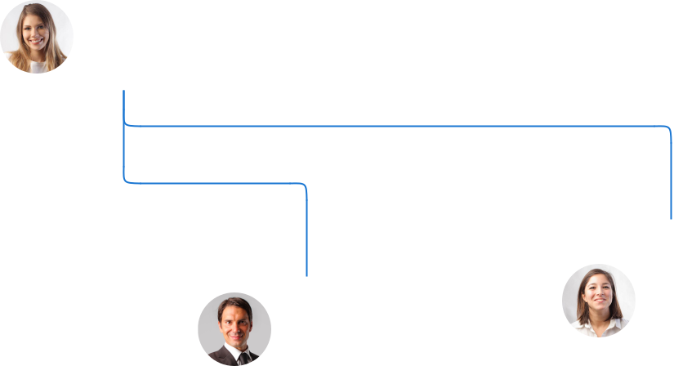

Emma White

Richard Gray Head Baker

Head of Sales

Compensation plan

 Help tip  Cupcake Business Plan

Describe your compensation plan for the management and staff. Include their salaries, incentives, and other benefits.
To unlock help try Upmetrics! 

Start writing here..

 Help tip

Mentioning advisors or consultants in your business plans adds credibility to your business idea.
To unlock help try Upmetrics! 

Board of advisors


DR. LUCY WHITE

Culinary Consultant

With [X years] of experience as a pastry chef and a Ph.D. in [Culinary Arts], Dr.

White advises on recipe innovations and industry trends.


MR. ROBERT GRAY

Business Development Advisor

Holding an MBA from [University Name] and boasting [X years] in the food industry, Mr. Gray offers strategic insights into business expansion and partnerships.
Financial Plan

When writing the financial plan section of a business plan, it’s important to provide a comprehensive overview of your financial projections for the first few years of your business, You may provide the following:
To unlock help try Upmetrics! 

 Help tip  Cupcake Business Plan


To create an effective introduction for your "Financial Plan" chapter, begin by stressing the critical role of a well-structured financial plan in the success of your venture.
To unlock help try Upmetrics! 

Start writing here..

 Help tip


Describe details such as projected revenue, operational costs, and service costs in your projected profit and loss statement. Make sure to include your business’s expected net profit or loss.
To unlock help try Upmetrics! 

Profit & loss statement

Revenue

Cost Of Sales

General Costs

Revenue Specific Costs

Personnel Costs (Direct

Labor)

Gross Margin

Gross Margin (%)

Operating Expense

Payroll Expense

(Indirect Labor)

General Expense

Bad Debt

Amortization of Current

Assets

2023-24 | 2024-25 | 2025-26 | 2026-27 | 2027-28
$0 | $0 | $0 | $0 | $0

$0 | $0 | $0 | $0 | $0
$0 | $0 | $0 | $0 | $0
$0 | $0 | $0 | $0 | $0
$0 | $0 | $0 | $0 | $0

$0 | $0 | $0 | $0 | $0
0% | 0% | 0% | 0% | 0%

$0 | $0 | $0 | $0 | $0
$0 | $0 | $0 | $0 | $0
$0 | $0 | $0 | $0 | $0
$0 | $0 | $0 | $0 | $0
$0 | $0 | $0 | $0 | $0

EBITDA

Additional Expense

Long Term

Depreciation

Gain or loss from Sale

of Assets

EBIT

Interest Expenses

EBT

Income Tax Expense

Total Expense

Net Income

Net Income (%)

2023-24 | 2024-25 | 2025-26 | 2026-27 | 2027-28
$0 | $0 | $0 | $0 | $0
$0 | $0 | $0 | $0 | $0
$0 | $0 | $0 | $0 | $0
$0 | $0 | $0 | $0 | $0
$0 | $0 | $0 | $0 | $0
$0 | $0 | $0 | $0 | $0
$0 | $0 | $0 | $0 | $0
$0 | $0 | $0 | $0 | $0
$0 | $0 | $0 | $0 | $0
$0 | $0 | $0 | $0 | $0
0% | 0% | 0% | 0% | 0%
 | 2023-24 | 2024-25 | 2025-26 | 2026-27 | 2027-28
Retained Earning | $0 | $0 | $0 | $0 | $0
Opening
Owner's Distribution | $0 | $0 | $0 | $0 | $0
Retained Earning | $0 | $0 | $0 | $0 | $0
Closing

 Help tip

The cash flow for the first few years of your operation should be estimated and described in this section. This may include billing invoices, payment receipts, loan payments, and any other cash flow statements.
To unlock help try Upmetrics! 

Cash flow statement

 | 2023-24 | 2024-25 | 2025-26 | 2026-27 | 2027-28
Cash Received | $0 | $0 | $0 | $0 | $0
Cash Paid | $0 | $0 | $0 | $0 | $0
COS & General Expenses | $0 | $0 | $0 | $0 | $0
Salary & Wages | $0 | $0 | $0 | $0 | $0
Interest | $0 | $0 | $0 | $0 | $0

Sales Tax

Income Tax

Net Cash From

Operations

Assets Sell

Assets Purchase

Net Cash From

Investments

Amount Received

Loan Received

Common Stock

Preferred Stock

Owner's Contribution

Amount Paid

2023-24 | 2024-25 | 2025-26 | 2026-27 | 2027-28
$0 | $0 | $0 | $0 | $0
$0 | $0 | $0 | $0 | $0
$0 | $0 | $0 | $0 | $0

$0 | $0 | $0 | $0 | $0
$0 | $0 | $0 | $0 | $0
$0 | $0 | $0 | $0 | $0

$0 | $0 | $0 | $0 | $0
$0 | $0 | $0 | $0 | $0

$0 | $0 | $0 | $0 | $0
$0 | $0 | $0 | $0 | $0
$0 | $0 | $0 | $0 | $0

Loan Capital $0 $0 $0 $0 $0

 | 2023-24 | 2024-25 | 2025-26 | 2026-27 | 2027-28
Dividends & Distributions | $0 | $0 | $0 | $0 | $0
Net Cash From | $0 | $0 | $0 | $0 | $0
Financing

Summary
Starting Cash | $0 | $0 | $0 | $0 | $0
Cash In | $0 | $0 | $0 | $0 | $0
Cash Out | $0 | $0 | $0 | $0 | $0
Change in Cash | $0 | $0 | $0 | $0 | $0
Ending Cash | $0 | $0 | $0 | $0 | $0

 Help tip

Create a projected balance sheet documenting your cupcake business’s assets, liabilities, and equity.

To unlock help try Upmetrics! 

Balance sheet

 | 2023-24 | 2024-25 | 2025-26 | 2026-27 | 2027-28
Assets | $0 | $0 | $0 | $0 | $0
Current Assets | $0 | $0 | $0 | $0 | $0
Cash | $0 | $0 | $0 | $0 | $0
Accounts Receivable | $0 | $0 | $0 | $0 | $0
Inventory | $0 | $0 | $0 | $0 | $0
Other Current Assets | $0 | $0 | $0 | $0 | $0
Long Term Assets | $0 | $0 | $0 | $0 | $0
Gross Long Term Assets | $0 | $0 | $0 | $0 | $0
Accumulated Depreciation | $0 | $0 | $0 | $0 | $0

Liabilities & Equity | $0 | $0 | $0 | $0 | $0
Liabilities | $0 | $0 | $0 | $0 | $0
Current Liabilities | $0 | $0 | $0 | $0 | $0
Accounts Payable | $0 | $0 | $0 | $0 | $0
Income Tax Payable | $0 | $0 | $0 | $0 | $0
Sales Tax Payable | $0 | $0 | $0 | $0 | $0
Short Term Debt | $0 | $0 | $0 | $0 | $0
 | 2023-24 | 2024-25 | 2025-26 | 2026-27 | 2027-28
Long Term Liabilities | $0 | $0 | $0 | $0 | $0
Long Term Debt | $0 | $0 | $0 | $0 | $0
Equity | $0 | $0 | $0 | $0 | $0
Paid-in Capital | $0 | $0 | $0 | $0 | $0
Common Stock | $0 | $0 | $0 | $0 | $0
Preferred Stock | $0 | $0 | $0 | $0 | $0
Owner's Contribution | $0 | $0 | $0 | $0 | $0
Retained Earnings | $0 | $0 | $0 | $0 | $0

Check | $0 |  |  | $0 | $0 | $0 | $0
 Help tip |  |  Example title..


Determine and mention your business’s break-even point—the point at which your business costs and revenue will be equal.

This exercise will help you understand how much revenue you need to generate to sustain or be profitable.
To unlock help try Upmetrics! 

Break-even Analysis

 | 2023-24 | 2024-25 | 2025-26 | 2026-27 | 2027-28
Starting Revenue | $0 | $0 | $0 | $0 | $0
Net Revenue | $0 | $0 | $0 | $0 | $0
Closing Revenue | $0 | $0 | $0 | $0 | $0

Starting Expense | $0 | $0 | $0 | $0 | $0
Net Expense | $0 | $0 | $0 | $0 | $0
Closing Expense | $0 | $0 | $0 | $0 | $0

Is Break Even? | 0 | 0 | 0 | 0 | 0
Break Even Month | 0 | 0 | 0 | 0 | 0
Days Required | 0 | 0 | 0 | 0 | 0
Break Even Revenue | $0 | $0 | $0 | $0 | $0
Break Even Units
Financing needs

 Help tip  Cupcake Business Plan

Calculate costs associated with starting a cupcake business, and estimate your financing needs and how much capital you need to raise to operate your business.
To unlock help try Upmetrics! 

Start writing here..
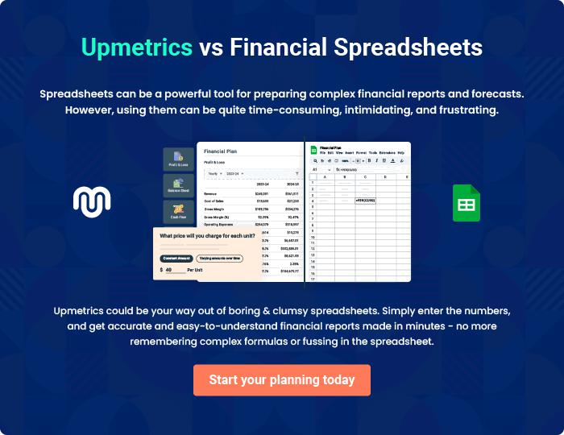
Appendix

When writing the appendix section, you should include any additional information that supports the main content of your plan. This may include financial statements, market research data, legal documents, and other
To unlock help try Upmetrics! 
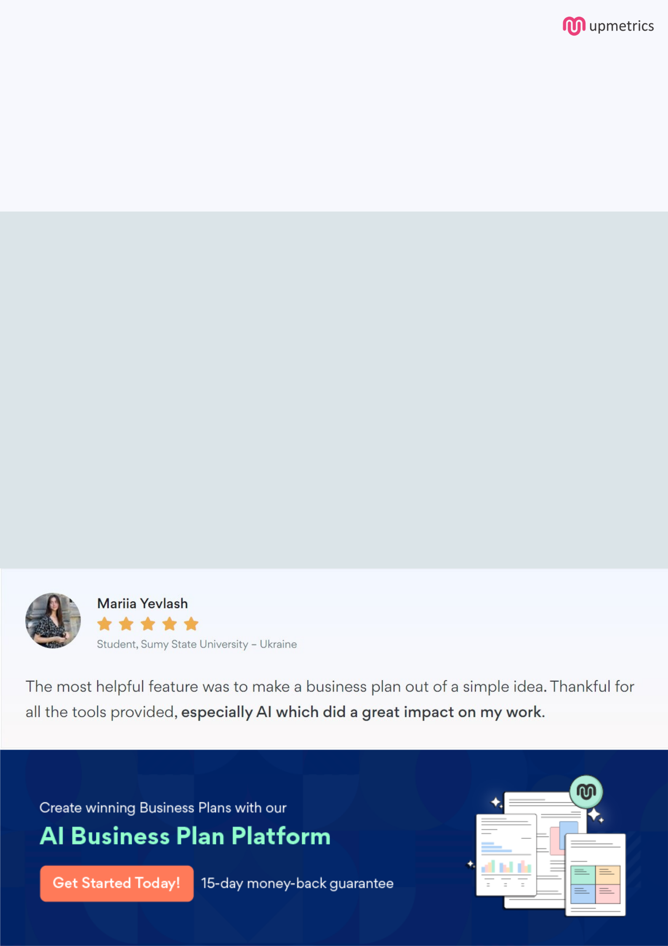
Create a winning business plan that gets you funded

Creating a stunning and investment-ready plan requires no writing, graphic designing, or financial planning expertise.

Upmetrics has all the features required to help you create a comprehensive business plan—from start to finish. Make no mistakes, it’s the modern way of planning to structure ideas, make plans, and create stunning pitch decks to awe investors.

Pitch decks that impress investors

Create pitch decks that provide a visual representation of your business, engage investors, and make them want to invest in your business idea.

Interactive plans in no time

Import business plan sections like—SWOT analysis, comparison tables, and others to create an interactive business plan. No designing skills are required.

Stunning cover page designs

With Upmetrics, you have the liberty to choose from multiple stunning cover page designs. Choose a creative design and make your plan stand out.

Online sharing made simple

Upmetrics makes online sharing quick and easier for users. Easily share your business plans with a link while tracking reader activity.

500+ sample business plans

Simply import a template from our library of sample plans into the editor and start customizing it to make it yours. It takes only a few clicks to get started.

Collaborate with team in real-time

Invite team members, initiate conversations, discuss ideas & strategies, share feedback, and work on a business plan in real-time.

