 Courier Business Plan


Business Plan

2023


Swift Deliveries, Reliable Service

Information provided in this business plan is unique to this business and confidential; therefore, anyone reading this plan agrees not to disclose any of the information in this business plan without prior written permission of the company.

Prepared By

John Doe

10200 Bolsa Ave, Westminster, CA, 92683

info@example.com

(650) 359-3153 http://www.example.com

Table of Contents

Executive Summary | 6
Market opportunity | 6
Services Offered | 6
Marketing & Sales Strategies | 7
Financial Highlights | 7
Units Sold v/s Revenue | 8

Company Overview | 9
Ownership | 9
Mission statement | 10
Business history | 10
Future goals | 10

Market Analysis | 11
Target Market | 11
Market size and growth potential | 11
Market Size | 12
Competitive analysis | 12
FedEx | 12
UPS (United Parcel Service) | 13
DHL | 13
Market trends | 13
Regulatory environment | 14

Products and Services | 15
Services | 15
Same-day Delivery Services | 15
Next-day Delivery Services | 16
International Delivery Services | 16
Specialized Personalized Delivery Services | 16

Packaging 17

Sales And Marketing Strategies | 18
Unique Selling Proposition (USP) | 18
Pricing Strategy | 18
Marketing strategies | 19
Online | 19
Offline | 19
Sales strategies | 20
Customer retention | 20

Operations Plan | 21
Staffing & Training | 21
Operational Process | 21
Technology | 22

Management Team | 23
Key managers | 23
John Doe | 23
Jane Doe | 24
Alice Brown | 24
Robert Brown | 24
Organizational structure | 24
Organization chart | 25
Compensation plan | 25
Board of advisors | 26
Sarah Green | 26
Michael White | 26

Financial Plan | 27
Profit & loss statement | 27
Cash flow statement | 30
Balance sheet | 32
Break-even Analysis | 34
Financing needs | 36
Appendix | 38
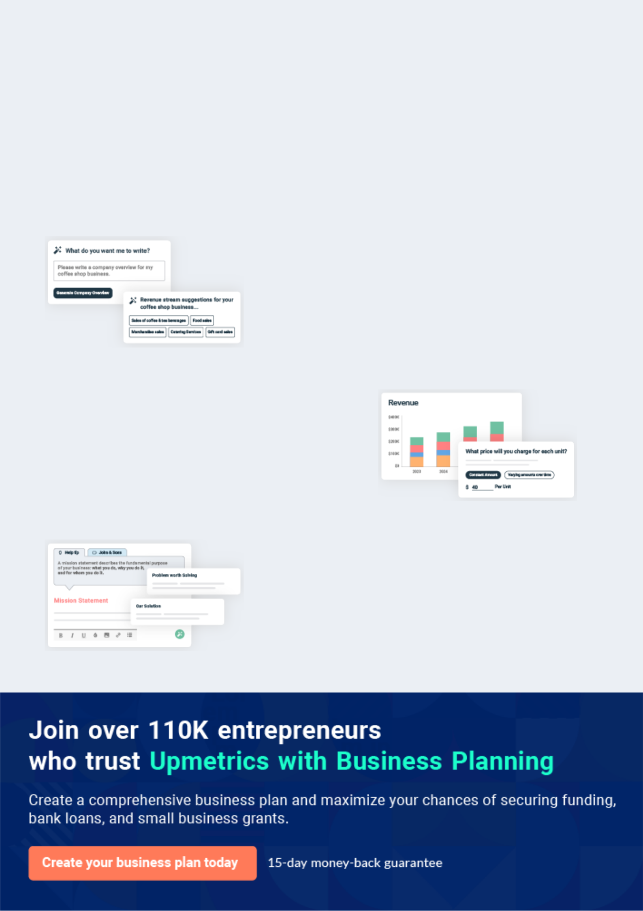
Business planning that’s simpler and faster than you think

Creating a business plan using Upmetrics to start and grow a business is literally the easiest thing in the World. Simply read the instructions and fill in the blanks. It’s as simple as that.

❛ | Upmetrics has everything you need to create a | ❜
❛ | comprehensive business plan. | ❜

AI-powered Upmetrics Assistant

AI-powered insights to streamline your plan

Not sure where to start? Upmetrics’ AI Assistant will automatically generate ideas for each section of your plan and offer improved versions of your writing, adjusting for tone, voice, and grammar or spelling errors.

Financial Forecasting Tool

All the financials are calculated for you

Forget the complex formulas and clumsy spreadsheets — with automatic financials and drag-and-drop forecasting, you can finish your plan faster and be confident that your numbers are accurate.

Business Plan Builder

Guides you like a business mentor

Upmetrics’ step-by-step instructions, prompts, and the library of 400+ sample business plans will guide you through each section of your plan as a business mentor.
Executive Summary


An executive summary is the first section of the business plan intended to provide an overview of the whole business plan.
To unlock help try Upmetrics! 

 Help tip  Courier Business Plan


Start your executive summary by briefly introducing your business to your readers. This section may include the name of your courier business, its location, when it was founded, etc.
To unlock help try Upmetrics! 

Start writing here..

Market opportunity

 Help tip  Courier Business Plan

Summarize your market research, including market size, growth potential, and marketing trends. Highlight the opportunities in the market and how your business will fit in to fill the gap.
To unlock help try Upmetrics! 

Start writing here..

Services Offered

 Help tip  Courier Business Plan

Highlight the courier services you offer your clients. The USPs and differentiators you offer are always a plus.
To unlock help try Upmetrics! 

Start writing here..

Marketing & Sales Strategies
To unlock help try Upmetrics!

 Help tip  Courier Business Plan

Outline your sales and marketing strategies—what marketing platforms you use, how you plan on acquiring customers, etc.
To unlock help try Upmetrics! 

Start writing here..

Financial Highlights

 Help tip  Courier Business Plan

Briefly summarize your financial projections for the initial years of business operations. Include any capital or investment requirements, associated startup costs, projected revenues, and profit forecasts.



Start writing here..
Units Sold v/s Revenue

 |  | Units Sold | Revenue
15.00k
10.00k
5.00k
0
Year 1 | Year 2 | Year 3


Financial Year |  |  | Units Sold | Revenue
Year 1 | 1,550 |  |  | $10,000
Year 2 | 1,800 |  |  | $12,000
Year 3 | 2,050 |  |  | $14,000
 Help tip |  |  Courier Business Plan


Summarize your executive summary section with a clear CTA, for example, inviting angel investors to discuss the potential business investment.
To unlock help try Upmetrics! 

Write a call to action for your business plan.
Company Overview

Depending on what details of your business are essential, you’ll need different elements in your business overview.
To unlock help try Upmetrics! 

 Help tip  Courier Business Plan

Describe what kind of courier company you run and the name of it. You may specialize in one of the following types:
To unlock help try Upmetrics! 

Start writing here..

Ownership

 Help tip  Courier Business Plan

Describe what shares they own and their responsibilities for efficiently managing the business.

To unlock help try Upmetrics! 

Start writing here..
Mission statement

 Help tip  Courier Business Plan

Summarize your business’ objective, core principles, and values in your mission statement. This statement needs to be memorable, clear, and brief.
To unlock help try Upmetrics! 

❛ At [Courier Express Solutions], our mission is to revolutionize the courier industry by providing fast, reliable, and cost-effective delivery solutions.

We are committed to exceeding customer expectations, upholding the highest standards of integrity, and contributing to the communities we serve.

❜

Business history

 Help tip  Courier Business Plan

If you’re an established courier service provider, briefly describe your business history, like— when it was founded, how it evolved over time, etc.
To unlock help try Upmetrics! 

Start writing here..

Future goals

 Help tip  Courier Business Plan

It’s crucial to convey your aspirations and vision. Mention your short-term and long-term goals; they can be specific targets for revenue, market share, or expanding your services.
To unlock help try Upmetrics! 

Start writing here..

Market Analysis
To unlock help try Upmetrics!


 |  | Market analysis provides a clear understanding of the market in which your
 |  | printing business will run along with the target market, competitors, and
 |  | growth opportunities.
 |  |  |  | To unlock help try Upmetrics! 
 Help tip |  |  Courier Business Plan

To write the introduction section of your market analysis, start by clearly identifying your primary target market.
To unlock help try Upmetrics! 

Start writing here..

Target Market

 Help tip  Courier Business Plan

Start this section by describing your target market. Define your ideal customer and explain what types of services they prefer. Creating a buyer persona will help you easily define your target market to your readers.



Start writing here..

Market size and growth potential

 Help tip  Courier Business Plan

Describe your market size and growth potential and whether you will target a niche or a much broader market.
To unlock help try Upmetrics! 

Start writing here..

Market Size

Available Market

Total global customers needing courier 50M services.

Served Market
Customers in our operational regions 15M seeking courier services.

Target Market
Small businesses and e-commerce 5M platforms in our service areas.

 Help tip  Courier Business Plan

Identify and analyze your direct and indirect competitors. Identify their strengths and weaknesses, and describe what differentiates your courier services from them.
To unlock help try Upmetrics! 

Competitive analysis

FedEx

FedEx is one of the leading global courier delivery services companies, with an extensive network spanning multiple countries. Founded in 1971, FedEx offers a wide range of services, from express parcel delivery to freight transportation.

Features Strengths

Weaknesses

International and domestic express deliveries

Freight and cargo services Supply chain solutions

E-commerce and return solutions

Real-time tracking and monitoring

Global reach with an expansive network

Trusted brand recognition

Comprehensive service portfolio catering to diverse client needs

Higher pricing in comparison to local courier services

Can be perceived as less flexible due to its large organizational structure

UPS (United Parcel Service)

Founded in 1907, UPS is a global leader in logistics, offering a broad spectrum of solutions including package delivery, freight transportation, and supply chain management.

Features

Domestic and international shipping services

Freight and cargo logistics

Supply chain and distribution solutions

Time-definite and day-definite deliveries

Strengths Weaknesses

Reputation for reliability and Relatively higher costs for

efficiency smaller shipments

Strong technological Some complaints about

infrastructure for real-time customer service responsiveness

tracking and processing

Established relationships with

businesses across various

sectors

DHL

DHL is a division of the German logistics company Deutsche Post DHL Group, offering international shipping and courier services. It has a dominant presence in many international markets.

Features | Strengths | Weaknesses
Express parcel and document | Strong global network, | Premium pricing for express
delivery services | especially in international | services
Freight transportation and | shipping | Limited domestic presence in
logistics | Renowned for rapid | certain regions compared to its
E-commerce solutions | international deliveries | international operations
International mail services | Sustainable shipping options
International mail services | and eco-conscious practices

Market trends

 Help tip  Courier Business Plan

Analyse emerging trends in the industry, such as technology disruptions, changes in customer behavior or preferences, etc. Explain how your business will cope with all the trends.
To unlock help try Upmetrics! 

Start writing here..

Regulatory environment

 Help tip  Courier Business Plan

List regulations and licensing requirements that may affect your courier company, such as licensing, safety, security, etc.
To unlock help try Upmetrics! 

Start writing here..
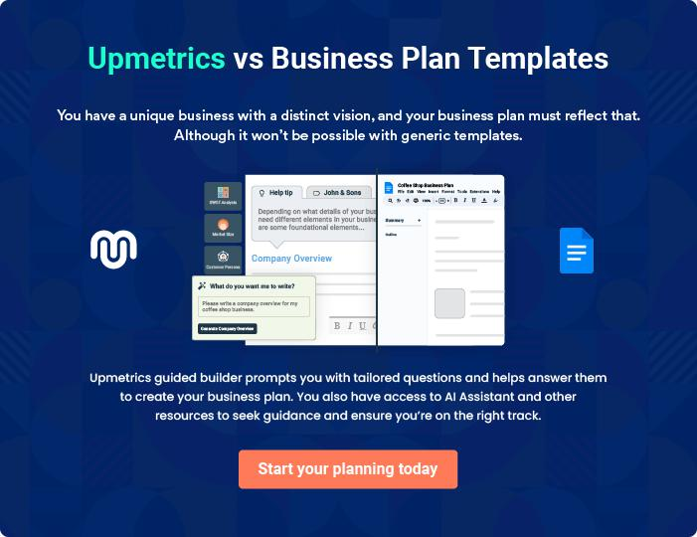
Products and Services

 |  | The product and services section of a courier business plan should describe
 |  | the specific services and products that will be offered to customers. To write
 |  | this section should include the following:
 |  |  |  | To unlock help try Upmetrics! 
 Help tip |  |  Courier Business Plan

To craft the introduction for your "Products and Services" chapter, begin by positioning your business within its industry, emphasizing its unique strengths or value proposition.
To unlock help try Upmetrics! 

Start writing here..

 Help tip


Mention the courier services your business will offer. This list may include services like,

• Same-day delivery services
To unlock help try Upmetrics! 

Services

Same-day Delivery Services


Price: [$25.00] per parcel (up to 5 lbs)

Expedited delivery services ensuring parcels reach their destination within the same business day.

Specifications

- Maximum weight: 5 lbs

- Delivery confirmation and real-time tracking included

- Available for local deliveries only
Next-day Delivery Services

Price: [$15.00] per parcel (up to 10 lbs)

Reliable next-day delivery services for timely yet cost-effective shipping.

Specifications

- Maximum weight: 10 lbs

- Delivery confirmation and real-time tracking included

- Available for local and regional deliveries

International Delivery Services

Price: Starting at [$50.00] per parcel (up to 5 lbs)

Comprehensive international delivery services with customs and regulations navigation.

Specifications

- Maximum weight: 5 lbs (additional charges for excess weight)

- Delivery confirmation and real-time tracking included

- Customized solutions for specific country regulations and requirements

Specialized Personalized Delivery Services

Price: Variable, depending on specific requirements

Tailored delivery solutions for unique, time-sensitive, or specific requirements.

Specifications

- Customizable options for temperature-sensitive deliveries, medical deliveries, perishable goods, and more

- Real-time tracking and dedicated customer service support
Packaging

 Help tip  Courier Business Plan

Talk about the various packaging choices that will be offered to buyers. Standard boxes, envelopes, or special packaging for fragile or big objects may be used in this.
To unlock help try Upmetrics! 

Start writing here..
Sales And Marketing Strategies

Writing the sales and marketing strategies section means a list of strategies you will use to attract and retain your clients.
To unlock help try Upmetrics! 

 Help Tip  Courier Business Plan


To create an effective introduction for your "Sales and Marketing Strategies" chapter, start by setting the stage within your specific industry or market.
To unlock help try Upmetrics! 

Start writing here..

Unique Selling Proposition (USP)

 Help tip  Courier Business Plan

Define your business’s USPs depending on the market you serve, the equipment you use, and the unique services you provide. Identifying USPs will help you plan your marketing strategies.
To unlock help try Upmetrics! 

Start writing here..

Pricing Strategy

 Help tip  Courier Business Plan

Describe your pricing strategy—how you plan to price your services and stay competitive in the local market. You can mention any discounts you plan on offering to attract new customers.
To unlock help try Upmetrics! 

Start writing here..

 Help tip
To unlock help try Upmetrics!

Discuss your marketing strategies to market your services. You may include some of these marketing strategies in your business plan—social media marketing, brochures, email marketing, content marketing, and print marketing.



Marketing strategies

Online


Social Media

We aim to harness the power of platforms such as [Facebook, Instagram, and LinkedIn], enhancing our online presence and engaging with our customer base directly.

Content Marketing

Through our [blog/website], we will produce articles, guides, and tips related to courier services, establishing ourselves as industry thought leaders.

Offline

Brochures

Eye-catching brochures at strategic locations will detail our services, ensuring potential clients understand our value proposition.

Email Marketing

Regular updates, discount codes, and newsletters will be sent to our subscribers, creating a sense of community and keeping them informed.

Print Marketing

Local newspaper advertisements and posters will help in reaching a broader local audience, emphasizing our community involvement.

 Help tip  Courier Business Plan

Outline the strategies you’ll implement to maximize your sales. Your sales strategies may include partnering with other local businesses, offering referral programs, etc.
To unlock help try Upmetrics! 

Sales strategies

Partnerships

Collaborating with local businesses to offer bundled services or exclusive discounts.

Referral Programs

Encouraging word-of-mouth marketing through incentivized referral programs for existing clients.

 Help tip  Courier Business Plan

Describe your customer retention strategies and how you plan to execute them. For instance, introducing loyalty programs, discounts on annual membership, personalized service, etc.
To unlock help try Upmetrics! 

Customer retention

Loyalty Programs Annual Membership Discounts

Rewarding frequent users with Offering reduced rates for

discounts or complimentary customers who commit to our

services. services on an annual basis.

Personalized Service

Catering to individual needs and

ensuring consistent quality across

all interactions.

Operations Plan

 |  | When writing the operations plan section, it’s important to consider the
 |  | various aspects of your business operations.
 |  |  |  | To unlock help try Upmetrics! 
 Help tip |  |  Courier Business Plan


To create an effective introduction for your "Operational Plan" chapter, start by emphasizing the
pivotal role of efficient operations in the success of your business, underscoring how they
directly impact the quality of services delivered.
 |  |  |  | To unlock help try Upmetrics! 
Start writing here..
Staffing & Training
 Help tip |  |  Courier Business Plan

Describe the personnel needed to manage your courier firm, along with their duties. Describe your strategy for employee hiring, training, and performance management.
To unlock help try Upmetrics! 

Start writing here..

Operational Process

 Help tip  Courier Business Plan

Describe how your courier company operates daily. It should include every aspect, from how purchases are received and fulfilled to how customer support inquiries are handled.
To unlock help try Upmetrics! 

Start writing here..

Technology

 Help tip  Courier Business Plan

Describe any technologies you’ll be utilizing to help your courier firm such as real-time delivery tracking and inventory management programs.
To unlock help try Upmetrics! 

Start writing here..
Management Team

The management team section provides an overview of the individuals responsible for running your business plan.
To unlock help try Upmetrics! 

 Help tip  Courier Business Plan

To craft an introduction for your "Management Team" chapter, begin by emphasizing the crucial role of leadership in the success of any business.
To unlock help try Upmetrics! 

Start writing here..

Key managers

 Help tip  Courier Business Plan

Introduce your management and key members of your team, and explain their roles and responsibilities.
To unlock help try Upmetrics! 

Start writing here..


JOHN DOE

CEO & Founder - john.doe@example.com

John has a Bachelor's degree in Business Management from [University Name].

He has over 15 years of experience in the courier and logistics industry, having worked with major companies such as [Previous Companies].


His vision for [Courier Express Solutions] is to provide fast, reliable, and innovative courier services that meet the evolving needs of businesses and individuals alike.

JANE DOE

Operations Manager - jane.doe@example.com

Jane holds a Master's degree in Operations Management from [University Name].

With over 10 years of experience in the courier industry, she specializes in optimizing operational processes to enhance efficiency and customer satisfaction.



ALICE BROWN

Marketing Manager - alice.brown@example.com

Alice graduated with an MBA in Marketing from [University Name]. She brings a fresh perspective to the marketing team, with innovative strategies that increase brand awareness and customer acquisition.

Her professional background includes roles at [Previous Companies], where she successfully led numerous marketing campaigns.


ROBERT BROWN

Finance Manager - robert.brown@example.com

Robert has a Bachelor’s in Accounting from [University Name] and is a certified public accountant (CPA).

He has over 12 years of experience managing financial operations for companies in the logistics sector, ensuring financial compliance and strategic budgeting.

Organizational structure

 Help tip  Courier Business Plan

Explain the organizational structure of your management team. Include the reporting line and decision-making hierarchy.
To unlock help try Upmetrics! 

Start writing here..

Organization chart


John Doe

CEO


Alice Brown

Jane Doe

Marketing

Manager


Operations

Manager


Sarah White | Emily Jones |  |  |  | Mike Smith
Sarah White |  |  | Robert Brown |  | Mike Smith
Sarah White | Customer |  |  |  | Mike Smith
Sales Lead |  |  |  |  | HR Manager
Sales Lead | Support Lead |  | Finance |  | HR Manager
 |  |  | Manager





Compensation plan

 Help tip  Courier Business Plan

Describe your compensation plan for the management and staff. Include their salaries, incentives, and other benefits.
To unlock help try Upmetrics! 

Start writing here..

 Help tip

Mentioning advisors or consultants in your business plans adds credibility to your business idea.
To unlock help try Upmetrics! 

Board of advisors


SARAH GREEN

Advisor 1 - sarah.green@example.com

Sarah has over 20 years of experience in the logistics and courier industry.

She has an MBA from [University Name] and has worked with several leading companies in the sector.

Her invaluable advice has helped shape the strategic direction of [Courier Express Solutions].


MICHAEL WHITE

Advisor 2 - michael.white@example.com

Michael is a logistics expert with a Ph.D. in Supply Chain Management from [University Name].

With over 25 years of experience, he brings a wealth of knowledge and insight to [Courier Express Solutions]. His expertise in market trends and operations has been vital in refining our processes.
Financial Plan

When writing the financial plan section of a business plan, it’s important to provide a comprehensive overview of your financial projections for the first few years of your business, You may provide the following:
To unlock help try Upmetrics! 

 Help tip  Courier Business Plan


To create an effective introduction for your "Financial Plan" chapter, begin by stressing the critical role of a well-structured financial plan in the success of your venture.
To unlock help try Upmetrics! 

Start writing here..

 Help tip  Courier Business Plan

Describe details such as projected revenue, operational costs, and service costs in your projected profit and loss statement. Make sure to include your business’s expected net profit or loss.
To unlock help try Upmetrics! 

Profit & loss statement

Revenue

Cost Of Sales

General Costs

Revenue Specific Costs

Personnel Costs (Direct

Labor)

Gross Margin

Gross Margin (%)

Operating Expense

Payroll Expense

(Indirect Labor)

General Expense

Bad Debt

Amortization of Current

Assets

2023-24 | 2024-25 | 2025-26 | 2026-27 | 2027-28
$0 | $0 | $0 | $0 | $0

$0 | $0 | $0 | $0 | $0
$0 | $0 | $0 | $0 | $0
$0 | $0 | $0 | $0 | $0
$0 | $0 | $0 | $0 | $0

$0 | $0 | $0 | $0 | $0
0% | 0% | 0% | 0% | 0%

$0 | $0 | $0 | $0 | $0
$0 | $0 | $0 | $0 | $0
$0 | $0 | $0 | $0 | $0
$0 | $0 | $0 | $0 | $0
$0 | $0 | $0 | $0 | $0

EBITDA

Additional Expense

Long Term

Depreciation

Gain or loss from Sale

of Assets

EBIT

Interest Expenses

EBT

Income Tax Expense

Total Expense

Net Income

Net Income (%)

2023-24 | 2024-25 | 2025-26 | 2026-27 | 2027-28
$0 | $0 | $0 | $0 | $0
$0 | $0 | $0 | $0 | $0
$0 | $0 | $0 | $0 | $0
$0 | $0 | $0 | $0 | $0
$0 | $0 | $0 | $0 | $0
$0 | $0 | $0 | $0 | $0
$0 | $0 | $0 | $0 | $0
$0 | $0 | $0 | $0 | $0
$0 | $0 | $0 | $0 | $0
$0 | $0 | $0 | $0 | $0
0% | 0% | 0% | 0% | 0%

 |  |  | 2023-24 |  | 2024-25 | 2025-26
Retained Earning |  |  | $0 |  | $0 | $0
Opening |  |  |  |  | $0 | $0
Owner's Distribution |  |  | $0 |  | $0 | $0
Retained Earning |  |  | $0 |  | $0 | $0
Closing |  |  |  |  | $0 | $0
 Help tip |  |  |  Courier Business Plan


The cash flow for the first few years of your operation should be estimated and described in this section.

This may include billing invoices, payment receipts, loan payments, and any other cash flow statements.
2026-27 2027-28

$0 $0

$0 $0

$0 $0

To unlock help try Upmetrics! 

Cash flow statement

 | 2023-24 | 2024-25 | 2025-26 | 2026-27 | 2027-28
Cash Received | $0 | $0 | $0 | $0 | $0
Cash Paid | $0 | $0 | $0 | $0 | $0
COS & General Expenses | $0 | $0 | $0 | $0 | $0
Salary & Wages | $0 | $0 | $0 | $0 | $0
Interest | $0 | $0 | $0 | $0 | $0

Sales Tax

Income Tax

Net Cash From

Operations

Assets Sell

Assets Purchase

Net Cash From

Investments

Amount Received

Loan Received

Common Stock

Preferred Stock

Owner's Contribution

Amount Paid

2023-24 | 2024-25 | 2025-26 | 2026-27 | 2027-28
$0 | $0 | $0 | $0 | $0
$0 | $0 | $0 | $0 | $0
$0 | $0 | $0 | $0 | $0

$0 | $0 | $0 | $0 | $0
$0 | $0 | $0 | $0 | $0
$0 | $0 | $0 | $0 | $0

$0 | $0 | $0 | $0 | $0
$0 | $0 | $0 | $0 | $0

$0 | $0 | $0 | $0 | $0
$0 | $0 | $0 | $0 | $0
$0 | $0 | $0 | $0 | $0

Loan Capital $0 $0 $0 $0 $0

 |  |  | 2023-24 | 2024-25 | 2025-26 | 2026-27 | 2027-28
Dividends & Distributions |  |  | $0 | $0 | $0 | $0 | $0
Net Cash From |  |  | $0 | $0 | $0 | $0 | $0
Financing
Summary
Starting Cash |  |  | $0 | $0 | $0 | $0 | $0
Cash In |  |  | $0 | $0 | $0 | $0 | $0
Cash Out |  |  | $0 | $0 | $0 | $0 | $0
Change in Cash |  |  | $0 | $0 | $0 | $0 | $0
Ending Cash |  |  | $0 | $0 | $0 | $0 | $0
 Help tip |  |  Courier Business Plan

Create a projected balance sheet documenting your courier business’s assets, liabilities, and equity.

To unlock help try Upmetrics! 

Balance sheet

 | 2023-24 | 2024-25 | 2025-26 | 2026-27 | 2027-28
Assets | $0 | $0 | $0 | $0 | $0
Current Assets | $0 | $0 | $0 | $0 | $0
Cash | $0 | $0 | $0 | $0 | $0
Accounts Receivable | $0 | $0 | $0 | $0 | $0
Inventory | $0 | $0 | $0 | $0 | $0
Other Current Assets | $0 | $0 | $0 | $0 | $0
Long Term Assets | $0 | $0 | $0 | $0 | $0
Gross Long Term Assets | $0 | $0 | $0 | $0 | $0
Accumulated Depreciation | $0 | $0 | $0 | $0 | $0

Liabilities & Equity | $0 | $0 | $0 | $0 | $0
Liabilities | $0 | $0 | $0 | $0 | $0
Current Liabilities | $0 | $0 | $0 | $0 | $0
Accounts Payable | $0 | $0 | $0 | $0 | $0
Income Tax Payable | $0 | $0 | $0 | $0 | $0
Sales Tax Payable | $0 | $0 | $0 | $0 | $0
Short Term Debt | $0 | $0 | $0 | $0 | $0
 | 2023-24 | 2024-25 | 2025-26 | 2026-27 | 2027-28
Long Term Liabilities | $0 | $0 | $0 | $0 | $0
Long Term Debt | $0 | $0 | $0 | $0 | $0
Equity | $0 | $0 | $0 | $0 | $0
Paid-in Capital | $0 | $0 | $0 | $0 | $0
Common Stock | $0 | $0 | $0 | $0 | $0
Preferred Stock | $0 | $0 | $0 | $0 | $0
Owner's Contribution | $0 | $0 | $0 | $0 | $0
Retained Earnings | $0 | $0 | $0 | $0 | $0

Check | $0 |  |  | $0 | $0 | $0 | $0
 Help tip |  |  Courier Business Plan

Determine and mention your business’s break-even point—the point at which your business costs and revenue will be equal.

This exercise will help you understand how much revenue you need to generate to sustain or be profitable.
To unlock help try Upmetrics! 

Break-even Analysis

 | 2023-24 | 2024-25 | 2025-26 | 2026-27 | 2027-28
Starting Revenue | $0 | $0 | $0 | $0 | $0
Net Revenue | $0 | $0 | $0 | $0 | $0
Closing Revenue | $0 | $0 | $0 | $0 | $0

Starting Expense | $0 | $0 | $0 | $0 | $0
Net Expense | $0 | $0 | $0 | $0 | $0
Closing Expense | $0 | $0 | $0 | $0 | $0

Is Break Even? | 0 | 0 | 0 | 0 | 0
Break Even Month | 0 | 0 | 0 | 0 | 0
Days Required | 0 | 0 | 0 | 0 | 0
Break Even Revenue | $0 | $0 | $0 | $0 | $0
Break Even Units
Financing needs

 Help tip  Courier Business Plan

Calculate costs associated with starting a courier business, and estimate your financing needs and how much capital you need to raise to operate your business.
To unlock help try Upmetrics! 

Start writing here..
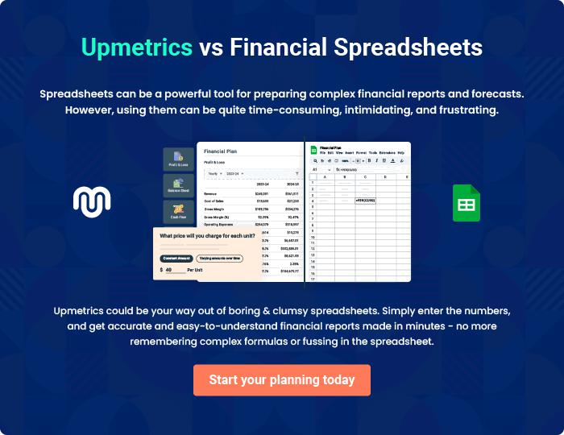
Appendix

When writing the appendix section, you should include any additional information that supports the main content of your plan. This may include financial statements, market research data, legal documents, and other
To unlock help try Upmetrics! 

Create a winning business plan that gets you funded

Creating a stunning and investment-ready plan requires no writing, graphic designing, or financial planning expertise.

Upmetrics has all the features required to help you create a comprehensive business plan—from start to finish. Make no mistakes, it’s the modern way of planning to structure ideas, make plans, and create stunning pitch decks to awe investors.

Pitch decks that impress investors

Create pitch decks that provide a visual representation of your business, engage investors, and make them want to invest in your business idea.

Interactive plans in no time

Import business plan sections like—SWOT analysis, comparison tables, and others to create an interactive business plan. No designing skills are required.

Stunning cover page designs

With Upmetrics, you have the liberty to choose from multiple stunning cover page designs. Choose a creative design and make your plan stand out.

Online sharing made simple

Upmetrics makes online sharing quick and easier for users. Easily share your business plans with a link while tracking reader activity.

500+ sample business plans

Simply import a template from our library of sample plans into the editor and start customizing it to make it yours. It takes only a few clicks to get started.

Collaborate with team in real-time

Invite team members, initiate conversations, discuss ideas & strategies, share feedback, and work on a business plan in real-time.

