

Counseling Private Practice Business Plan

Navigating Paths to Wellbeing

Business Plan

2023

John Doe

10200 Bolsa Ave, Westminster, CA, 92683

- 359-3153 info@example.com http://www.example.com

Information provided in this business plan is unique to this business and confidential; therefore, anyone reading this plan agrees not to disclose any of the information in this business plan without prior written permission of the company.
Table of Contents

Executive Summary | 6
Market opportunity | 6
Services Offered | 6
Marketing & Sales Strategies | 7
Financial Highlights | 7
Units Sold v/s Revenue | 8

Company Overview | 9
Ownership | 9
Mission statement | 10
Business history | 10
Future goals | 10

Market Analysis | 11
Target Market | 11
Market size and growth potential | 11
Market Size | 12
Competitive analysis | 12
Harmony Therapy Group | 12
Mindful Healing Clinic | 13
Limited offline presence with just one physical center | 13
Market trends | 14
Regulatory environment | 14

Products and Services | 16
Services | 16
Assessment and Evaluation | 16
Individual Therapy | 18
Couples Therapy | 18
Family Therapy | 19
Group Therapy | 19
Psychoeducation Workshop | 20
Additional Services | 20
Customized Approach | 20
Expertise or Specialization | 21

Sales And Marketing Strategies | 22
Unique Selling Proposition (USP) | 22
Pricing Strategy | 22
Marketing strategies | 23
Online | 23
Offline | 23
Sales strategies | 24
Customer retention | 24

Operations Plan | 25
Staffing & Training | 25
Operational Process | 25
Equipment & Software | 26

Management Team | 27
Key managers | 27
John Doe | 27
Jane Doe | 28
Alice Brown | 28
Robert Brown | 28
Linda Smith | 29
Organizational structure | 29
Organization chart | 29
Compensation plan | 30
Board of advisors | 30

Dr. Emily Clarke 30

Financial Plan | 31
Profit & loss statement | 31
Cash flow statement | 34
Balance sheet | 36
Break-even Analysis | 38
Financing needs | 40
Appendix
Appendix | 42
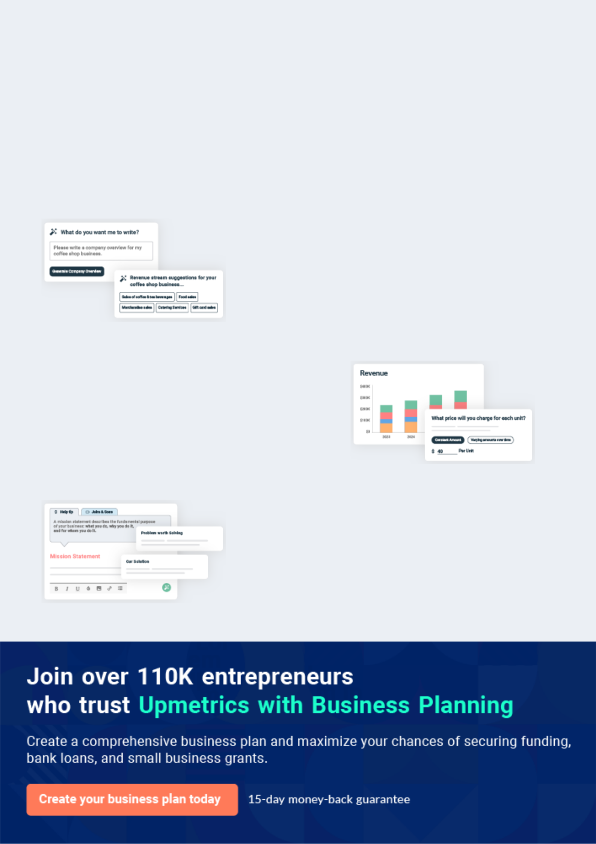
Business planning that’s simpler and faster than you think

Creating a business plan using Upmetrics to start and grow a business is literally the easiest thing in the World. Simply read the instructions and fill in the blanks. It’s as simple as that.

❛ | Upmetrics has everything you need to create a | ❜
❛ | comprehensive business plan. | ❜

AI-powered Upmetrics Assistant

AI-powered insights to streamline your plan

Not sure where to start? Upmetrics’ AI Assistant will automatically generate ideas for each section of your plan and offer improved versions of your writing, adjusting for tone, voice, and grammar or spelling errors.

Financial Forecasting Tool

All the financials are calculated for you

Forget the complex formulas and clumsy spreadsheets — with automatic financials and drag-and-drop forecasting, you can finish your plan faster and be confident that your numbers are accurate.

Business Plan Builder

Guides you like a business mentor

Upmetrics’ step-by-step instructions, prompts, and the library of 400+ sample business plans will guide you through each section of your plan as a business mentor.
Executive Summary


An executive summary is the first section of the business plan intended to provide an overview of the whole business plan.
To unlock help try Upmetrics! 

 Help tip  Counseling Private Practice Business Plan


Start your executive summary by briefly introducing your business to your readers.

This section may include the name of your counseling private practice business, its location,
To unlock help try Upmetrics! 

Start writing here..

Market opportunity

 Help tip  Counseling Private Practice Business Plan

Summarize your market research, including market size, growth potential, and marketing trends. Highlight the opportunities in the market and how your business will fit in to fill the gap.
To unlock help try Upmetrics! 

Start writing here..

Services Offered

 Help tip  Counseling Private Practice Business Plan

Highlight the counseling practice services you offer your clients. The USPs and differentiators you offer are always a plus.
To unlock help try Upmetrics! 

Start writing here..

Marketing & Sales Strategies
To unlock help try Upmetrics!

 Help tip  Counseling Private Practice Business Plan

Outline your sales and marketing strategies—what marketing platforms you use, how you plan on acquiring customers, etc.
To unlock help try Upmetrics! 

Start writing here..

Financial Highlights

 Help tip  Counseling Private Practice Business Plan

Briefly summarize your financial projections for the initial years of business operations. Include any capital or investment requirements, associated startup costs, projected revenues, and profit forecasts.



Start writing here..
Units Sold v/s Revenue

 |  | Units Sold | Revenue
15.00k
10.00k
5.00k
0
Year 1 | Year 2 | Year 3


Financial Year |  | Units Sold |  | Revenue
Year 1 | 1,550 |  |  | $10,000
Year 2 | 1,800 |  |  | $12,000
Year 3 | 2,050 |  |  | $14,000
 Help tip |  |  Counseling Private Practice Business Plan


Summarize your executive summary section with a clear CTA, for example, inviting angel investors to discuss the potential business investment.
To unlock help try Upmetrics! 

Write a call to action for your business plan.
Company Overview

Depending on what details of your business are essential, you’ll need different elements in your business overview.
To unlock help try Upmetrics! 

 Help tip  Counseling Private Practice Business Plan

Describe your business in this section by providing all the basic information:

Describe what kind of counseling practice you run and the name of it. You may specialize in
To unlock help try Upmetrics! 

Start writing here..

Ownership

 Help tip  Counseling Private Practice Business Plan

List the names of your counseling private practice business’s founders or owners. Describe what shares they own and their responsibilities for efficiently managing the business.
To unlock help try Upmetrics! 

Start writing here..
Mission statement

 Help tip  Counseling Private Practice Business Plan

If you’re an established counseling practice service provider, briefly describe your business history, like—when it was founded, how it evolved over time, etc.
To unlock help try Upmetrics! 

❛ At [JD Counseling], our mission is to provide transformative, compassionate, and personalized counselling services that empower individuals, couples, and families to navigate life's challenges and reach their fullest potential. Rooted in trust, respect, and confidentiality, we are dedicated to fostering growth,

healing, and lasting change.
❜

Business history

 Help tip  Counseling Private Practice Business Plan

Include an outline of the printing house’s history and how it came to be in its current position.

If you can, add some personality and intriguing details, especially if you got any achievements
To unlock help try Upmetrics! 

Start writing here..

Future goals

 Help tip  Counseling Private Practice Business Plan

It’s crucial to convey your aspirations and vision. Mention your short-term and long-term goals; they can be specific targets for revenue, market share, or expanding your services.
To unlock help try Upmetrics! 

Start writing here..

Market Analysis
To unlock help try Upmetrics!


 |  | Market analysis provides a clear understanding of the market in which your
 |  | printing business will run along with the target market, competitors, and
 |  | growth opportunities.
 |  |  |  | To unlock help try Upmetrics! 
 Help tip |  |  Counseling Private Practice Business Plan

To write the introduction section of your market analysis, start by clearly identifying your primary target market.
To unlock help try Upmetrics! 

Start writing here..

Target Market

 Help tip  Counseling Private Practice Business Plan

Start this section by describing your target market. Define your ideal customer and explain what types of services they prefer. Creating a buyer persona will help you easily define your target market to your readers.



Start writing here..

Market size and growth potential

 Help tip  Counseling Private Practice Business Plan

Describe your market size and growth potential and whether you will target a niche or a much broader market.
To unlock help try Upmetrics! 

Start writing here..

Market Size
To unlock help try Upmetrics!

Available Market

All individuals seeking counseling 5M services in the state.

Served Market
Individuals within the Westminster 1M region looking for therapy.

Target Market
Adults (25-45) in Westminster seeking 300k individual and family counseling.

 Help tip  Counseling Private Practice Business Plan

Identify and analyze your direct and indirect competitors. Identify their strengths and weaknesses, and describe what differentiates your counseling private practice business from them.



Competitive analysis

Harmony Therapy Group

Harmony Therapy Group, established in 2015, has made its mark as one of the leading counseling practices in the region. With a team of ten therapists, they cover a broad spectrum of counseling services.

Features

Individual therapy sessions Couples counseling

Online therapy via their proprietary platform

Self-help resources and workshops

Strengths

Strong online presence with a robust digital platform

Broad spectrum of services catering to a wide audience

Regular workshops and community engagement events

Weaknesses

Limited focus on specialized therapies like trauma counseling

Higher pricing model which might alienate cost-conscious clients

Wait times for appointments can be lengthy due to high demand

Mindful Healing Clinic

A relatively newer entrant, Mindful Healing Clinic focuses on holistic healing approaches. Founded in 2018, they've quickly built a reputation for their integrative methods combining traditional therapy with holistic wellness practices.

Features

Individual therapy

Individual therapy Group meditation and therapy sessions

Holistic wellness programs integrating yoga, meditation, and counselling Online resources and webinars

Strengths

Unique blend of traditional and holistic therapeutic methods

Strong emphasis on group sessions fostering community healing

Active online resource portal with webinars, blogs, and self-help tools

Weaknesses

Limited service offerings, lacking specialized services like family counseling

Relatively newer, hence might not have the depth of experience as some older practices

Limited offline presence with just one physical center

Limited offline presence with just one physical center

E-Therapy Connect is a digital-first platform, launched in 2019, connecting clients with therapists online. They've tapped into the growing demand for remote counseling services, especially post-pandemic.

Features

Online individual counseling

Couples therapy via video conferencing

Virtual group therapy sessions AI-driven self-help tools

Strengths

Flexibility of remote sessions, catering to a broader geographic clientele

Advanced use of AI tools for preliminary assessments

A diverse panel of therapists with varied specializations

Weaknesses

Lack of a physical presence might deter clients seeking face-to-face interactions

Dependency on technology might alienate non-tech-savvy clients

Quality of sessions might be variable due to a broad, diverse panel of therapists

Market trends
To unlock help try Upmetrics!

 Help tip  Counseling Private Practice Business Plan

Analyze emerging trends in the industry, such as technology disruptions, changes in customer behavior or preferences, etc. Explain how your business will cope with all the trends.
To unlock help try Upmetrics! 

Start writing here..

Regulatory environment

 Help tip  Counseling Private Practice Business Plan

List regulations and licensing requirements that may affect your counseling private practice business, such as licensing & certificate, ethical guidelines, privacy & confidentiality, insurance & billing, etc.



Start writing here..
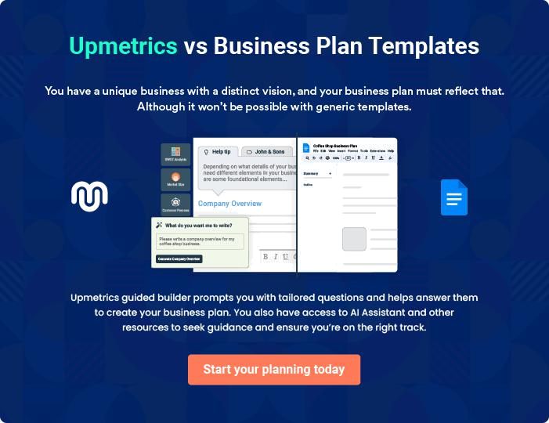
Products and Services

The product and services section of a counseling private practice business plan should describe the specific services and products that will be offered to customers. To write this section should include the following:
To unlock help try Upmetrics! 

 Help tip  Counseling Private Practice Business Plan

To craft the introduction for your "Products and Services" chapter, begin by positioning your business within its industry, emphasizing its unique strengths or value proposition.
To unlock help try Upmetrics! 

Start writing here..

 Help tip


Mention the counseling private practice services your business will offer. This list may include services like,
To unlock help try Upmetrics! 

Services

Assessment and Evaluation


Price: [$150] per session (60 minutes)

A comprehensive initial evaluation session aimed at understanding the client's specific needs, challenges, and therapeutic goals. It forms the foundation for crafting a customized therapeutic intervention plan.
Specifications

- Duration: 60 minutes

- Tools Used: Structured Questionnaires, Psychometric Testing (if required)

- Session Format: One-on-one in-person or virtual

- Follow-Up: Written summary and recommended therapeutic plan
Individual Therapy

Price: [$120] per session (50 minutes)

One-on-one sessions tailored to address personal challenges, emotional hurdles, and facilitate personal growth. Techniques are customized based on client needs and therapeutic goals.

Specifications

- Duration: 50 minutes

- Approaches: Cognitive Behavioral Therapy, Psychodynamic Therapy, etc.

- Session Format: One-on-one in-person or virtual

- Frequency: Typically weekly, but can be adjusted based on need

Couples Therapy

Price: [$175] per session (60 minutes)

Focused sessions designed to enhance relationship dynamics, resolve conflicts, and foster deeper connections between partners. Ideal for couples facing challenges or wanting to strengthen their relationship.

Specifications

- Duration: 60 minutes

- Techniques: Gottman Method, Emotionally Focused Therapy, etc.

- Session Format: In-person or virtual

- Frequency: Weekly or bi-weekly
Family Therapy

Price: [$200] per session (75 minutes)

Therapeutic sessions aimed at addressing family dynamics, improving communication, and fostering a harmonious living environment. Ideal for families undergoing transitions or facing internal conflicts.

Specifications

- Duration: 75 minutes

- Techniques: Structural Family Therapy, Systemic Family Therapy, etc.

- Session Format: In-person

- Participants: Entire family or specific members

Group Therapy

Price: [$50] per person per session (90 minutes)

Facilitated sessions allowing clients to share experiences, challenges, and growth in a community setting. Topics might range from stress management to navigating life transitions.

Specifications

- Duration: 90 minutes

- Techniques: Interactive discussions, group exercises, and feedback sessions

- Session Format: In-person or virtual

- Group Size: Typically 6-10 participants
Psychoeducation Workshop
- To unlock help try Upmetrics!

Price: [$75] per person (3-hour workshop)

Educative workshops covering various topics like stress management, mindfulness, and effective communication. Led by experienced therapists, they offer insights, strategies, and tools.

Specifications

- Duration: 3 hours

- Materials Provided: Handouts, resources, and tools

- Session Format: In-person or virtual

- Frequency: Monthly

Additional Services

 Help tip  Counseling Private Practice Business Plan

Include a separate section to describe your counseling practice’s other services if you provide any, such as workshops, group therapy, crisis intervention, or consultation, in addition to regular counseling.



Start writing here..

Customized Approach

 Help tip


_{Emphasize}Counseling_{how}Private_{dedicated}Practice_{your}Business_{practice}PlanAt_{is} the_{to providing}heartofJD_{individualized,}Counseling'sapproach_{client-centered}isthebelief_{service}thatevery. individual is u Highlight how you customize your services to each client’s unique demands, goals, and
preferences.
To unlock help try Upmetrics! 

Start writing here..

Expertise or Specialization

 Help tip

_{Highlight}Counseling_{any}Private_{areas} Practice_{ofspecialty}Business_{your}PlanAt_{practice}the _{has}heart_{or}of_{counselors}JDCounseling's_{who}approach_{haveexperience}isthebelief_{with}that every individual is u certain disorders (such as trauma, addiction, or anxiety).
To unlock help try Upmetrics! 

Start writing here..
Sales And Marketing Strategies

Writing the sales and marketing strategies section means a list of strategies you will use to attract and retain your clients.
To unlock help try Upmetrics! 

 Help tip  Counseling Private Practice Business Plan

To create an effective introduction for your "Sales and Marketing Strategies" chapter, start by setting the stage within your specific industry or market.
To unlock help try Upmetrics! 

Unique Selling Proposition (USP)

 Help tip  Counseling Private Practice Business Plan

Define your business’s USPs depending on the market you serve, the equipment you use, and the unique services you provide. Identifying USPs will help you plan your marketing strategies.
To unlock help try Upmetrics! 

Start writing here..

Pricing Strategy

 Help tip  Counseling Private Practice Business Plan

Describe your pricing strategy—how you plan to price your services and stay competitive in the local market. You can mention any discounts you plan on offering to attract new customers.
To unlock help try Upmetrics! 

Start writing here..

 Help tip  Counseling Private Practice Business Plan
To unlock help try Upmetrics!

Discuss your marketing strategies to market your services. You may include some of these marketing strategies in your business plan—social media marketing, Google ads, brochures, content marketing, and print marketing.



Marketing strategies

Online


Social Media Marketing

Leveraging platforms like Facebook and Instagram to share client testimonials, success stories, and informative content.

Google Ads

Targeted advertisements to capture potential clients actively seeking therapy services in the region.

Content Marketing

Regular blog posts, articles, and

videos focusing on mental health

awareness, self-help tips, and

insights into various therapeutic

modalities.

Offline

Brochures

Detailed brochures available both in our clinic and distributed in strategic locations, providing insights into our services and approach.

 Help tip
To unlock help try Upmetrics!

Outline the strategies you’ll implement to maximize your sales. Your sales strategies may include providing free consultations, offering packages and deals, partnering with businesses, offering referral programs, etc.



Sales strategies

Partner with Businesses

Collaborating with local businesses to offer employee wellness sessions and workshops.

Free Consultations

Offering initial 20-minute consultations free of charge to introduce clients to our therapeutic environment.

Therapy Packages Referral Programs

Bundled session packages available at discounted rates for committed therapy durations.

Incentivizing existing clients to refer others through discounts or complimentary sessions.

 Help tip  Counseling Private Practice Business Plan

Describe your customer retention strategies and how you plan to execute them. For instance, introducing loyalty programs, discounts on annual membership, personalized service, etc.
To unlock help try Upmetrics! 

Customer retention

Loyalty Programs

Clients who've been with us for extended periods are offered loyalty discounts or additional sessions at reduced rates.

Personalized Service

Regular feedback loops, adaptability in treatment plans, and ensuring each client feels heard, understood, and valued.

Annual Membership

Year-long memberships at discounted rates, ensuring long-term client commitment and consistent therapy.

Operations Plan
To unlock help try Upmetrics!

 |  | When writing the operations plan section, it’s important to consider the
 |  | various aspects of your business operations.
 |  |  |  | To unlock help try Upmetrics! 
 Help tip |  |  Counseling Private Practice Business Plan


To create an effective introduction for your "Operational Plan" chapter, start by emphasizing the
pivotal role of efficient operations in the success of your business, underscoring how they
directly impact the quality of services delivered.
 |  |  |  | To unlock help try Upmetrics! 
Start writing here..
Staffing & Training
 Help tip |  |  Counseling Private Practice Business Plan

Mention your business’s staffing requirements, including the number of employees, trainers, or counselors, needed.
To unlock help try Upmetrics! 

Start writing here..

Operational Process

 Help tip  Counseling Private Practice Business Plan

Outline the processes and procedures you will use to run your counseling private practice business. Your operational processes may include appointment scheduling, counseling sessions, treatment planning, billing & insurance, etc.



Start writing here..

Equipment & Software

 Help tip  Counseling Private Practice Business Plan

Include the list of equipment and software required for counseling private practice, such as furniture, therapeutic tools, teletherapy tools, etc.
To unlock help try Upmetrics! 

Start writing here..
Management Team

The management team section provides an overview of the individuals responsible for running your business plan.
To unlock help try Upmetrics! 

 Help tip  Counseling Private Practice Business Plan

To craft an introduction for your "Management Team" chapter, begin by emphasizing the crucial role of leadership in the success of any business.
To unlock help try Upmetrics! 

Start writing here..

Key managers

 Help tip  Counseling Private Practice Business Plan

Introduce your management and key members of your team, and explain their roles and responsibilities.
To unlock help try Upmetrics! 

Start writing here..


JOHN DOE

CEO & Co-founder - john.doe@example.com

A graduate of [University Name, e.g., "Harvard University"] with a Master's in Clinical Psychology, John has over [X years, e.g., "15 years"] of experience in the field of counselling.


Before founding JD Counseling, he worked at renowned institutions like [Institution Name, e.g., "WellMind Therapies"] in senior therapist roles.

John's vision for JD Counseling is to combine traditional therapeutic methods with innovative techniques to provide holistic care. As the CEO, John oversees the strategic direction, financial planning, and overall operations of the practice.

JANE DOE

Lead Therapist - jane.doe@example.com

Holding a Doctorate in Counseling Psychology from [University Name, e.g., "Stanford University"], Jane brings [X years, e.g., "10 years"] of hands-on therapeutic experience to JD Counseling.


She has been a vital part of institutions like [Institution Name, e.g., "Mindful Healing Center"], where she played pivotal roles in curating therapy modules.

At JD Counseling, Jane's primary role involves ensuring therapeutic quality, training junior therapists, and integrating novel methodologies into the practice.


ALICE BROWN

Clinical Director - alice.brown@example.com

Alice completed her Masters in Mental Health Counseling from [University Name, e.g., "Columbia University"] and has an illustrious career spanning over [X years, e.g., "12 years"] in clinical management.

She has been associated with organizations like [Institution Name, e.g., "Healers United"] in top-tier positions.

At JD Counseling, Alice oversees the entire clinical operations gamut, from ensuring compliance with industry regulations to optimizing clinical processes for better client care.


ROBERT BROWN

Operations Manager - robert.brown@example.com

With a degree in Healthcare Management from [University Name, e.g., "Yale University"], Robert's experience in healthcare operations spans over [X years, e.g., "8 years"].

He has served in healthcare establishments like [Institution Name, e.g., "HealthOps Group"], refining their administrative processes.

At JD Counseling, Robert is the linchpin ensuring smooth day-to-day administrative operations. His duties range from client coordination to handling the administrative team and support staff.

LINDA SMITH

Customer Services Manager - linda.smith@example.com

Linda boasts an MBA in Healthcare Services from [University Name, e.g., "Duke University"] and has been instrumental in shaping customer experiences in institutions like [Institution Name, e.g., "CareFirst Solutions"].

With [X years, e.g., "7 years"] under her belt in healthcare customer relations, Linda's role at JD Counseling ensures every client interaction is seamless, pleasant, and in line with the company's ethos.

Organizational structure

 Help tip  Counseling Private Practice Business Plan

Explain the organizational structure of your management team. Include the reporting line and decision-making hierarchy.
To unlock help try Upmetrics! 

Start writing here..

Organization chart


John Doe

CEO
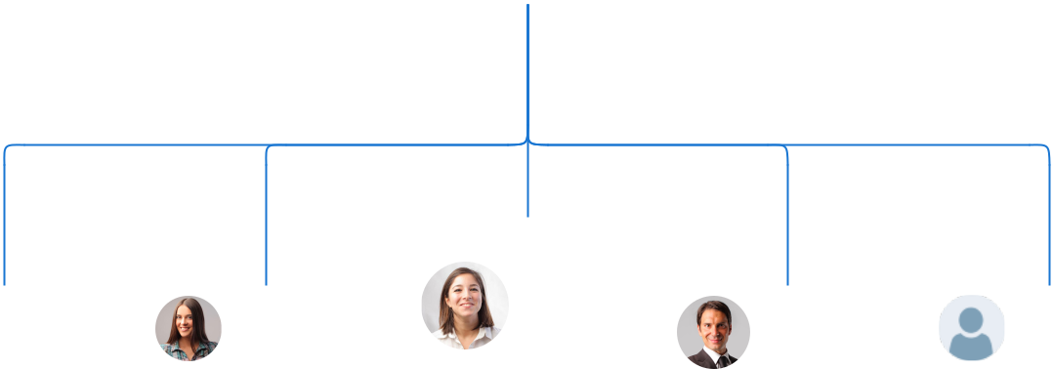

 |  | Linda Smith
Jane Doe | Alice | Customer Service | Robert | [Name 1]
Lead | Brown | Manager | Brown | [Designatio
Therapist | Clinical |  | Operations | n]
 | Director |  | Manager

Compensation plan

 Help tip  Counseling Private Practice Business Plan

Describe your compensation plan for the management and staff. Include their salaries, incentives, and other benefits.
To unlock help try Upmetrics! 

Start writing here..

 Help tip

Mentioning advisors or consultants in your business plans adds credibility to your business idea.
To unlock help try Upmetrics! 

Board of advisors

DR. EMILY CLARKE

Consultant

JD Counseling is privileged to have [Advisor Name, e.g., "Dr. Emily Clarke"], a renowned therapist with [X years, e.g., "20 years"] of experience, as an advisory consultant. Her insights into the evolving landscape of therapy have been invaluable in shaping our strategic direction.
Financial Plan

When writing the financial plan section of a business plan, it’s important to provide a comprehensive overview of your financial projections for the first few years of your business, You may provide the following:
To unlock help try Upmetrics! 

 Help tip  Counseling Private Practice Business Plan


To create an effective introduction for your "Financial Plan" chapter, begin by stressing the critical role of a well-structured financial plan in the success of your venture.
To unlock help try Upmetrics! 

Start writing here..

 Help tip


Describe details such as projected revenue, operational costs, and service costs in your projected profit and loss statement. Make sure to include your business’s expected net profit or loss.
To unlock help try Upmetrics! 

Profit & loss statement

Revenue

Cost Of Sales

General Costs

Revenue Specific Costs

Personnel Costs (Direct

Labor)

Gross Margin

Gross Margin (%)

Operating Expense

Payroll Expense

(Indirect Labor)

General Expense

Bad Debt

Amortization of Current

Assets

2023-24 | 2024-25 | 2025-26 | 2026-27 | 2027-28
$0 | $0 | $0 | $0 | $0

$0 | $0 | $0 | $0 | $0
$0 | $0 | $0 | $0 | $0
$0 | $0 | $0 | $0 | $0
$0 | $0 | $0 | $0 | $0

$0 | $0 | $0 | $0 | $0
0% | 0% | 0% | 0% | 0%

$0 | $0 | $0 | $0 | $0
$0 | $0 | $0 | $0 | $0
$0 | $0 | $0 | $0 | $0
$0 | $0 | $0 | $0 | $0
$0 | $0 | $0 | $0 | $0

EBITDA

Additional Expense

Long Term

Depreciation

Gain or loss from Sale

of Assets

EBIT

Interest Expenses

EBT

Income Tax Expense

Total Expense

Net Income

Net Income (%)

2023-24 | 2024-25 | 2025-26 | 2026-27 | 2027-28
$0 | $0 | $0 | $0 | $0
$0 | $0 | $0 | $0 | $0
$0 | $0 | $0 | $0 | $0
$0 | $0 | $0 | $0 | $0
$0 | $0 | $0 | $0 | $0
$0 | $0 | $0 | $0 | $0
$0 | $0 | $0 | $0 | $0
$0 | $0 | $0 | $0 | $0
$0 | $0 | $0 | $0 | $0
$0 | $0 | $0 | $0 | $0
0% | 0% | 0% | 0% | 0%
 | 2023-24 | 2024-25 | 2025-26 | 2026-27 | 2027-28
Retained Earning | $0 | $0 | $0 | $0 | $0
Opening
Owner's Distribution | $0 | $0 | $0 | $0 | $0
Retained Earning | $0 | $0 | $0 | $0 | $0
Closing

 Help tip

The cash flow for the first few years of your operation should be estimated and described in this section. This may include billing invoices, payment receipts, loan payments, and any other cash flow statements.
To unlock help try Upmetrics! 

Cash flow statement

 | 2023-24 | 2024-25 | 2025-26 | 2026-27 | 2027-28
Cash Received | $0 | $0 | $0 | $0 | $0
Cash Paid | $0 | $0 | $0 | $0 | $0
COS & General Expenses | $0 | $0 | $0 | $0 | $0
Salary & Wages | $0 | $0 | $0 | $0 | $0
Interest | $0 | $0 | $0 | $0 | $0

Sales Tax

Income Tax

Net Cash From

Operations

Assets Sell

Assets Purchase

Net Cash From

Investments

Amount Received

Loan Received

Common Stock

Preferred Stock

Owner's Contribution

Amount Paid

2023-24 | 2024-25 | 2025-26 | 2026-27 | 2027-28
$0 | $0 | $0 | $0 | $0
$0 | $0 | $0 | $0 | $0
$0 | $0 | $0 | $0 | $0

$0 | $0 | $0 | $0 | $0
$0 | $0 | $0 | $0 | $0
$0 | $0 | $0 | $0 | $0

$0 | $0 | $0 | $0 | $0
$0 | $0 | $0 | $0 | $0

$0 | $0 | $0 | $0 | $0
$0 | $0 | $0 | $0 | $0
$0 | $0 | $0 | $0 | $0

Loan Capital $0 $0 $0 $0 $0

 | 2023-24 | 2024-25 | 2025-26 | 2026-27 | 2027-28
Dividends & Distributions | $0 | $0 | $0 | $0 | $0
Net Cash From | $0 | $0 | $0 | $0 | $0
Financing

Summary
Starting Cash | $0 | $0 | $0 | $0 | $0
Cash In | $0 | $0 | $0 | $0 | $0
Cash Out | $0 | $0 | $0 | $0 | $0
Change in Cash | $0 | $0 | $0 | $0 | $0
Ending Cash | $0 | $0 | $0 | $0 | $0

 Help tip

Create a projected balance sheet documenting your counseling private practice business’s assets, liabilities, and equity.

To unlock help try Upmetrics! 

Balance sheet

 | 2023-24 | 2024-25 | 2025-26 | 2026-27 | 2027-28
Assets | $0 | $0 | $0 | $0 | $0
Current Assets | $0 | $0 | $0 | $0 | $0
Cash | $0 | $0 | $0 | $0 | $0
Accounts Receivable | $0 | $0 | $0 | $0 | $0
Inventory | $0 | $0 | $0 | $0 | $0
Other Current Assets | $0 | $0 | $0 | $0 | $0
Long Term Assets | $0 | $0 | $0 | $0 | $0
Gross Long Term Assets | $0 | $0 | $0 | $0 | $0
Accumulated Depreciation | $0 | $0 | $0 | $0 | $0

Liabilities & Equity | $0 | $0 | $0 | $0 | $0
Liabilities | $0 | $0 | $0 | $0 | $0
Current Liabilities | $0 | $0 | $0 | $0 | $0
Accounts Payable | $0 | $0 | $0 | $0 | $0
Income Tax Payable | $0 | $0 | $0 | $0 | $0
Sales Tax Payable | $0 | $0 | $0 | $0 | $0
Short Term Debt | $0 | $0 | $0 | $0 | $0
 | 2023-24 | 2024-25 | 2025-26 | 2026-27 | 2027-28
Long Term Liabilities | $0 | $0 | $0 | $0 | $0
Long Term Debt | $0 | $0 | $0 | $0 | $0
Equity | $0 | $0 | $0 | $0 | $0
Paid-in Capital | $0 | $0 | $0 | $0 | $0
Common Stock | $0 | $0 | $0 | $0 | $0
Preferred Stock | $0 | $0 | $0 | $0 | $0
Owner's Contribution | $0 | $0 | $0 | $0 | $0
Retained Earnings | $0 | $0 | $0 | $0 | $0

Check | $0 |  | $0 | $0 | $0 | $0
 Help tip |  |  Counseling Private Practice Business Plan


Determine and mention your business’s break-even point—the point at which your business costs and revenue will be equal.

This exercise will help you understand how much revenue you need to generate to sustain or be profitable.
To unlock help try Upmetrics! 

Break-even Analysis

 | 2023-24 | 2024-25 | 2025-26 | 2026-27 | 2027-28
Starting Revenue | $0 | $0 | $0 | $0 | $0
Net Revenue | $0 | $0 | $0 | $0 | $0
Closing Revenue | $0 | $0 | $0 | $0 | $0

Starting Expense | $0 | $0 | $0 | $0 | $0
Net Expense | $0 | $0 | $0 | $0 | $0
Closing Expense | $0 | $0 | $0 | $0 | $0

Is Break Even? | 0 | 0 | 0 | 0 | 0
Break Even Month | 0 | 0 | 0 | 0 | 0
Days Required | 0 | 0 | 0 | 0 | 0
Break Even Revenue | $0 | $0 | $0 | $0 | $0
Break Even Units
Financing needs

 Help tip  Counseling Private Practice Business Plan

Calculate costs associated with starting a counseling private practice business, and estimate your financing needs and how much capital you need to raise to operate your business.
To unlock help try Upmetrics! 

Start writing here..
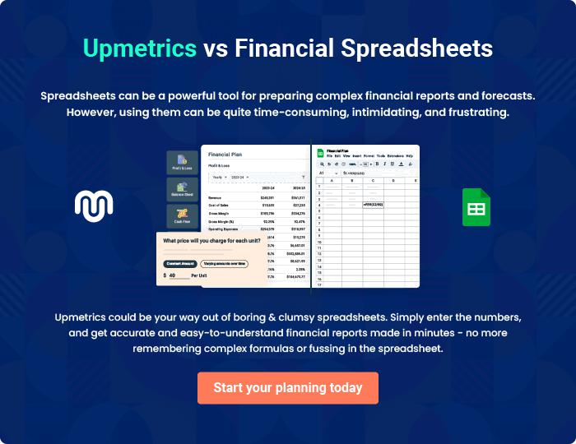
Appendix

When writing the appendix section, you should include any additional information that supports the main content of your plan. This may include financial statements, market research data, legal documents, and other
To unlock help try Upmetrics! 
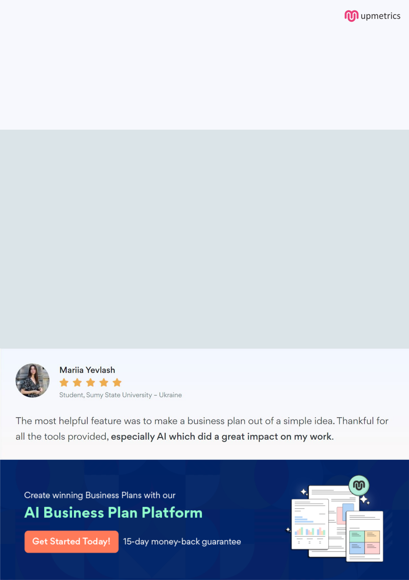
Create a winning business plan that gets you funded

Creating a stunning and investment-ready plan requires no writing, graphic designing, or financial planning expertise.

Upmetrics has all the features required to help you create a comprehensive business plan—from start to finish. Make no mistakes, it’s the modern way of planning to structure ideas, make plans, and create stunning pitch decks to awe investors.

Pitch decks that impress investors

Create pitch decks that provide a visual representation of your business, engage investors, and make them want to invest in your business idea.

Interactive plans in no time

Import business plan sections like—SWOT analysis, comparison tables, and others to create an interactive business plan. No designing skills are required.

Stunning cover page designs

With Upmetrics, you have the liberty to choose from multiple stunning cover page designs. Choose a creative design and make your plan stand out.

Online sharing made simple

Upmetrics makes online sharing quick and easier for users. Easily share your business plans with a link while tracking reader activity.

500+ sample business plans

Simply import a template from our library of sample plans into the editor and start customizing it to make it yours. It takes only a few clicks to get started.

Collaborate with team in real-time

Invite team members, initiate conversations, discuss ideas & strategies, share feedback, and work on a business plan in real-time.

