
Concierge Services Business Plan


Business
Plan

2023


Personalized Services, Your Way

Information provided in this business plan is unique to this business and confidential; therefore, anyone reading this plan agrees not to disclose any of the information in this business plan without prior written permission of the company.

 | Prepared By | 10200 Bolsa Ave, Westminster, CA, 92683
 | John Doe | info@example.com
 | (650) 359-3153 | http://www.example.com

Table of Contents

Executive Summary | 6
Market opportunity | 6
Services Offered | 6
Marketing & Sales Strategies | 7
Financial Highlights | 7
Units Sold v/s Revenue | 8

Company Overview | 9
Ownership | 9
Business Owners | 9
Mission statement | 10
Business history | 10
Future goals | 10

Market Analysis | 11
Target Market | 11
Market size and growth potential | 11
Market Size | 12
Competitive analysis | 12
LuxeLife Concierge Services | 12
AssistMe Concierge Solutions | 13
EliteAid Concierge | 13
Market trends | 13
Regulatory environment | 14

Products and Services | 15
Services | 15
Travel Assistance | 15
Personal Errands | 17
Event Planning | 17
Restaurant Reservations | 18
Home Services | 18
Additional Services | 19

Sales And Marketing Strategies | 20
Unique Selling Proposition (USP) | 20
Pricing Strategy | 20
Marketing strategies | 21
Online | 21
Sales strategies | 22
Customer retention | 22

Operations Plan | 23
Staffing & Training | 23
Operational Process | 23
Equipment & Software | 24

Management Team | 25
Key managers | 25
John Doe | 26
Jane Smith | 26
Robert Brown | 27
Alice Green | 28
Organizational structure | 28
Organization chart | 29
Compensation plan | 29
Board of advisors | 30
Dr. Emily White | 30
Mr. Liam Black | 30

Financial Plan | 31
Profit & loss statement | 31
Cash flow statement | 34
Balance sheet | 36
Break-even Analysis | 38
Financing needs | 40
Appendix
Appendix | 42
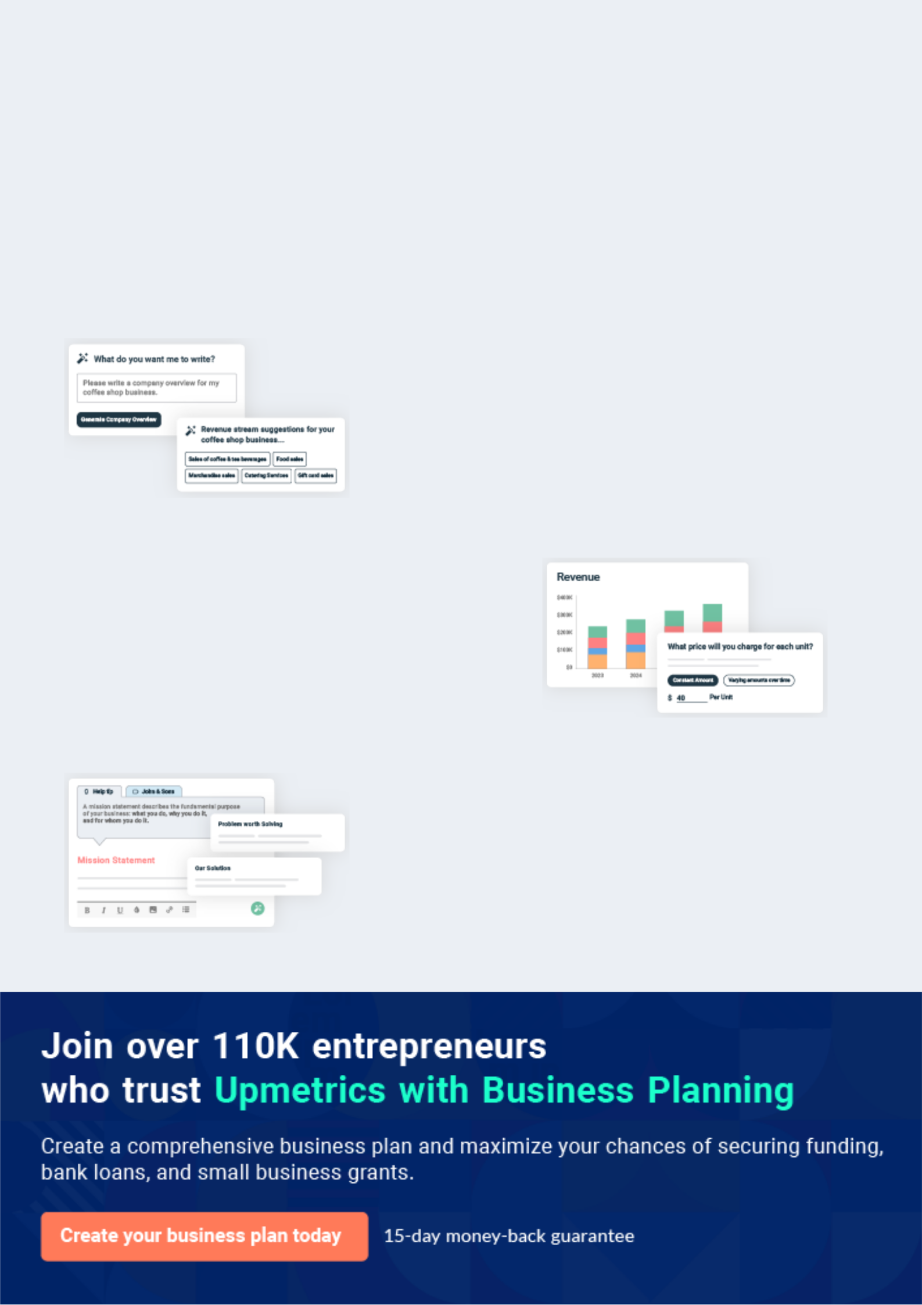
Business planning that’s simpler and faster than you think

Creating a business plan using Upmetrics to start and grow a business is literally the easiest thing in the World. Simply read the instructions and fill in the blanks. It’s as simple as that.

❛ | Upmetrics has everything you need to create a | ❜
❛ | comprehensive business plan. | ❜

AI-powered Upmetrics Assistant

AI-powered insights to streamline your plan

Not sure where to start? Upmetrics’ AI Assistant will automatically generate ideas for each section of your plan and offer improved versions of your writing, adjusting for tone, voice, and grammar or spelling errors.

Financial Forecasting Tool

All the financials are calculated for you

Forget the complex formulas and clumsy spreadsheets — with automatic financials and drag-and-drop forecasting, you can finish your plan faster and be confident that your numbers are accurate.

Business Plan Builder

Guides you like a business mentor

Upmetrics’ step-by-step instructions, prompts, and the library of 400+ sample business plans will guide you through each section of your plan as a business mentor.
Executive Summary


An executive summary is the first section of the business plan intended to provide an overview of the whole business plan.
To unlock help try Upmetrics! 

 Help tip  Concierge Services Business Plan


Start your executive summary by briefly introducing your business to your readers.

This section may include the name of your concierge services business, its location, when it
To unlock help try Upmetrics! 

Start writing here..

Market opportunity

 Help tip  Concierge Services Business Plan

Summarize your market research, including market size, growth potential, and marketing trends.
To unlock help try Upmetrics! 

Start writing here..

Services Offered

 Help tip  Concierge Services Business Plan

Highlight the concierge services you offer your clients. The USPs and differentiators you offer are always a plus.
To unlock help try Upmetrics! 

Start writing here..

Marketing & Sales Strategies
To unlock help try Upmetrics!

 Help tip  Concierge Services Business Plan

Outline your sales and marketing strategies—what marketing platforms you use, how you plan on acquiring customers, etc.
To unlock help try Upmetrics! 

Start writing here..

Financial Highlights

 Help tip  Concierge Services Business Plan

Briefly summarize your financial projections for the initial years of business operations. Include any capital or investment requirements, associated startup costs, projected revenues, and profit forecasts.



Start writing here..
Units Sold v/s Revenue

 |  | Units Sold | Revenue
15.00k
10.00k
5.00k
0
Year 1 | Year 2 | Year 3


Financial Year |  |  | Units Sold | Revenue
Year 1 | 1,550 |  |  | $10,000
Year 2 | 1,800 |  |  | $12,000
Year 3 | 2,050 |  |  | $14,000
 Help tip |  |  Concierge Services Business Plan


Summarize your executive summary section with a clear CTA, for example, inviting angel investors to discuss the potential business investment.
To unlock help try Upmetrics! 

Write a call to action for your business plan.
Company Overview

Depending on what details of your business are essential, you’ll need different elements in your business overview.
To unlock help try Upmetrics! 

 Help tip  Concierge Services Business Plan

Describe your business in this section by providing all the basic information:

Describe what kind of concierge services company you run and the name of it. You may
To unlock help try Upmetrics! 

Start writing here..

Ownership

 Help tip  Concierge Services Business Plan

List the names of your concierge services’ founders or owners. Describe what shares they own and their responsibilities for efficiently managing the business.
To unlock help try Upmetrics! 

Start writing here..

Business Owners



60% John Doe



40% Jane Doe
Mission statement

 Help tip  Concierge Services Business Plan

Summarize your business’ objective, core principles, and values in your mission statement. This statement needs to be memorable, clear, and brief.
To unlock help try Upmetrics! 

❛ At [Prestige Concierge Services], our mission is to redefine luxury and convenience. Driven by passion and guided by integrity, we commit to delivering unparalleled experiences, ensuring every

client feels valued, understood, and catered to.
❜

Business history

 Help tip  Concierge Services Business Plan

If you’re an established concierge services provider, briefly describe your business history, like— when it was founded, how it evolved over time, etc.
To unlock help try Upmetrics! 

Start writing here..

Future goals

 Help tip  Concierge Services Business Plan

It’s crucial to convey your aspirations and vision. Mention your short-term and long-term goals; they can be specific targets for revenue, market share, or expanding your services.
To unlock help try Upmetrics! 

Start writing here..

Market Analysis
To unlock help try Upmetrics!


 |  | Market analysis provides a clear understanding of the market in which your
 |  | printing business will run along with the target market, competitors, and
 |  | growth opportunities.
 |  |  |  | To unlock help try Upmetrics! 
 Help tip |  |  Concierge Services Business Plan

To write the introduction section of your market analysis, start by clearly identifying your primary target market.
To unlock help try Upmetrics! 

Start writing here..

Target Market

 Help tip  Concierge Services Business Plan

Start this section by describing your target market. Define your ideal customer and explain what types of services they prefer. Creating a buyer persona will help you easily define your target market to your readers.



Start writing here..

Market size and growth potential

 Help tip  Concierge Services Business Plan

Describe your market size and growth potential and whether you will target a niche or a much broader market.
To unlock help try Upmetrics! 

Start writing here..

Market Size

Available Market

Total individuals seeking concierge 50M services globally.

Served Market
Individuals in regions where concierge 10M services are accessible.

Target Market
Affluent professionals in metropolitan 1M areas aged 30-50.

 Help tip  Concierge Services Business Plan

Identify and analyze your direct and indirect competitors. Identify their strengths and weaknesses, and describe what differentiates your concierge services from them.
To unlock help try Upmetrics! 

Competitive analysis

LuxeLife Concierge Services

LuxeLife has been a staple in the industry for over a decade. With a robust presence both online and offline, they cater mainly to the elite clientele and corporate sectors

Features | Strengths
Dedicated account managers | Strong brand recognition.
for personalized service. | Established partnerships in the
24/7 availability through their | luxury sector
mobile app | Seamless digital experience via
Partnerships with luxury brands | their mobile application.
for exclusive client discounts.

Weaknesses

Premium pricing limits their audience to only the elite.

Service can occasionally be impersonal due to a large client base.

Limited attention to eco-friendly or sustainable solutions.

AssistMe Concierge Solutions

A newcomer to the market, AssistMe is tech-driven and appeals mainly to millennials and Gen-Z clients, providing virtual and remote services.

Features | Strengths | Weaknesses
AI-driven chatbot for instant | Attractive to a younger | Lacks the personal touch in
assistance. | demographic due to tech | services.
Subscription-based models for | integration. | Brand recognition is still in its
varied customer needs. | Flexible pricing models. | infancy.
Emphasis on eco-friendly and | Strong commitment to | Limited partnerships due to a
sustainable partners. | sustainability. | new entry into the market.

EliteAid Concierge

EliteAid prides itself on offering bespoke services, focusing extensively on personalized solutions for each client.

Features | Strengths | Weaknesses
Tailored packages for | High client satisfaction due to | Absence of a strong digital
individual client needs. | personalized services. | platform.
Personal concierge manager | Diverse service offerings | Limited scalability due to highly
for every account. | spanning various domains. | personalized services.
Focus on experiences – travel, | Strong reputation in the travel | Higher operational costs lead to
dining, and events. | and events sectors. | premium pricing.

Market trends

 Help tip  Concierge Services Business Plan

Analyze emerging trends in the industry, such as technology disruptions, changes in customer behavior or preferences, etc. Explain how your business will cope with all the trends.
To unlock help try Upmetrics! 

Start writing here..

Regulatory environment
To unlock help try Upmetrics!

 Help tip  Concierge Services Business Plan

List regulations and licensing requirements that may affect your concierge services company, such as business registration & licensing, employment laws, insurance, data privacy & security, etc.



Start writing here..
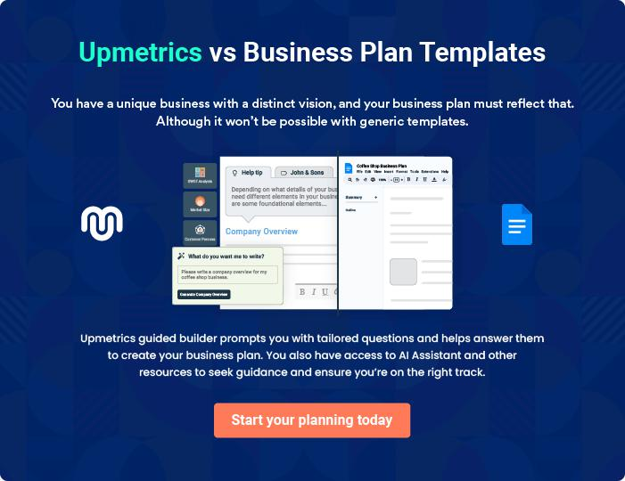
Products and Services

The product and services section of a concierge services business plan should describe the specific services and products that will be offered to customers. To write this section should include the following:
To unlock help try Upmetrics! 

 Help tip  Concierge Services Business Plan

To craft the introduction for your "Products and Services" chapter, begin by positioning your business within its industry, emphasizing its unique strengths or value proposition.
To unlock help try Upmetrics! 

Start writing here..

 Help tip


Give a detailed description of the procedure you use while working with clients.

Clarify how you will help them at every stage of the planning process, from the initial meeting
To unlock help try Upmetrics! 

Services

Travel Assistance


Price: [$100] per consultation

Comprehensive travel support to ensure a seamless experience from start to finish.
Specifications

- Ticket Reservation: Booking of flights, trains, or other transport modes, ensuring optimal rates and schedules.

- Itinerary Planning: Crafting personalized travel plans including accommodations, local transport, and attractions.

- Local Guidance: Insights into local cultures, best places to visit, dine, or shop.

- Advantage: Exclusive partnerships with premium travel brands, providing clients with special discounts and offers.
Personal Errands

Price: [$50] per hour

Efficient handling of daily errands, saving valuable time and energy for our clients.

Specifications

- Daily Tasks: Managing grocery shopping, banking chores, postal services, and more.

- Gift Shopping: Personalized gift recommendations, procurement, and wrapping for special occasions.

- Advantage: A dedicated account manager ensuring personalized and consistent service quality.

Event Planning

Price: Starting at [$500] per event

Organizing memorable events tailored to the unique requirements of each client.

Specifications

- Venue Selection: Scouting and booking the perfect venue as per event requirements.

- Coordination: Managing invitations, catering, entertainment, and ensuring smooth event execution.

- Post-Event Services: Assistance with thank-you notes, gift returns, or any post-event needs.

- Advantage: Access to a curated list of elite vendors ensuring premium quality at every event.
Restaurant Reservations

Price: [$20] per booking

Priority reservations at prime dining establishments, ensuring a delightful culinary experience.

Specifications

- Booking: Reservations tailored to client preferences, from cuisine to ambience.

- Exclusive Deals: Special offers and discounts at partner restaurants.

- Advantage: Priority reservations even during peak hours or special occasions, ensuring no waiting times.

Home Services

Price: Starting at [$150] per service

Keeping homes in pristine condition, be it through regular maintenance or cleaning.

Specifications

- Maintenance: Regular home check-ups, repairs, and maintenance services.

- Cleaning & Organizing: Professional cleaning services, organization of spaces, and decluttering.

- Advantage: Use of eco-friendly cleaning products and practices, ensuring health and sustainability.
Additional Services
- To unlock help try Upmetrics!

 Help tip  Concierge Services Business Plan

Mention if your concierge services company offers any additional services. You may include services like home management, pet care, personal fitness & wellness, technology assistance, event tickets & reservations, etc.



Start writing here..
Sales And Marketing Strategies

Writing the sales and marketing strategies section means a list of strategies you will use to attract and retain your clients.
To unlock help try Upmetrics! 

 Help tip  Concierge Services Business Plan

To create an effective introduction for your "Sales and Marketing Strategies" chapter, start by setting the stage within your specific industry or market.
To unlock help try Upmetrics! 

Unique Selling Proposition (USP)

 Help tip  Concierge Services Business Plan

Define your business’s USPs depending on the market you serve, the equipment you use, and the unique services you provide. Identifying USPs will help you plan your marketing strategies.
To unlock help try Upmetrics! 

Start writing here..

Pricing Strategy

 Help tip  Concierge Services Business Plan

Describe your pricing strategy—how you plan to price your services and stay competitive in the local market. You can mention any discounts you plan on offering to attract new customers.
To unlock help try Upmetrics! 

Start writing here..

 Help tip  Concierge Services Business Plan
To unlock help try Upmetrics!

Discuss your marketing strategies to market your services. You may include some of these marketing strategies in your business plan—social media marketing, email marketing, content marketing, etc.



Marketing strategies

Online


Social Media Marketing

Regular engagements on platforms like Instagram, Facebook, and LinkedIn, showcasing our services and sharing client testimonials.

Content Marketing

Blog posts, articles, and infographics that not only promote our services but also offer value to readers, positioning Prestige as a thought leader in the industry.

Email Marketing

Curated newsletters and updates, ensuring our clients are always in the know about our latest offerings and discounts.

 Help tip
To unlock help try Upmetrics!

Outline the strategies you’ll implement to maximize your sales. Your sales strategies may include partnering with other businesses, offering referral programs, influencer collaboration, etc.



Sales strategies

Partner with Businesses

Partnering with luxury brands, travel agencies, and other businesses to offer bundled services

Influencer Collaboration

Engaging with industry influencers to showcase our services, expanding our reach to their followers.

Referral Programs

Clients referring our services to

others can avail discounts or

complimentary services.

 Help tip

Describe your customer retention strategies and how you plan to execute them. For instance, introducing loyalty programs, discounts & offers, personalized service, etc
To unlock help try Upmetrics! 

Customer retention

Loyalty Programs

Repeat clients can earn points for each service availed, redeemable against future bookings

Exclusive Offers

Periodic discounts and offers exclusively for our longstanding clients.

Personalized Service

Maintaining detailed client profiles,

ensuring that every time they

engage with us, the experience is

tailored to their known preferences

Operations Plan

 |  | When writing the operations plan section, it’s important to consider the
 |  | various aspects of your business operations.
 |  |  |  | To unlock help try Upmetrics! 
 Help tip |  |  Concierge Services Business Plan


To create an effective introduction for your "Operational Plan" chapter, start by emphasizing the
pivotal role of efficient operations in the success of your business, underscoring how they
directly impact the quality of services delivered.
 |  |  |  | To unlock help try Upmetrics! 
Start writing here..
Staffing & Training
 Help tip |  |  Concierge Services Business Plan

Mention your business’s staffing requirements, including the number of employees or concierge
professionals needed. Include their qualifications, the training required, and the duties they will
perform.
 |  |  |  | To unlock help try Upmetrics! 
Start writing here..
Operational Process
 Help tip |  |  Concierge Services Business Plan

Outline the processes and procedures you will use to run your concierge services business.

Your operational processes may include client onboarding, service request management,
To unlock help try Upmetrics! 

Start writing here..

Equipment & Software
To unlock help try Upmetrics!

 Help tip  Concierge Services Business Plan

Include the list of equipment and software required for concierge services, such as communication devices, computer systems & software, office supplies, security equipment, technology gadgets, safety equipment, etc.



Start writing here..
Management Team

The management team section provides an overview of the individuals responsible for running your business plan.
To unlock help try Upmetrics! 

 Help tip  Concierge Services Business Plan

To craft an introduction for your "Management Team" chapter, begin by emphasizing the crucial role of leadership in the success of any business.
To unlock help try Upmetrics! 

Start writing here..

Key managers

 Help tip  Concierge Services Business Plan

Introduce your management and key members of your team, and explain their roles and responsibilities.
To unlock help try Upmetrics! 

Start writing here..

JOHN DOE

CEO & Co-founder - john.doe@example.com

John, as the Chief Executive Officer and co-founder of Prestige Concierge Services, is the driving force behind the company's strategic decisions.

Under his leadership, the company has witnessed significant growth and has cemented its place as a leader in the concierge service industry.


- Educational Background: John holds an MBA from Harvard Business School, where he graduated top of his class, and a Bachelor's degree in Hospitality Management from Cornell University.

- Professional Background: Before founding Prestige, John served as the Director of Guest Relations at The Ritz-Carlton, overseeing customer satisfaction across their global chain.

His deep insights into luxury services have been instrumental in shaping Prestige's offerings.


JANE SMITH

Operations Manager - jane.smith@example.com

Jane is the operational backbone of Prestige Concierge Services, ensuring every client request is executed with precision and efficiency.

Her meticulous nature and dedication have played a pivotal role in the company's consistent service delivery.

- Educational Background: Jane earned her Master's in Operations Management from Stanford University and a Bachelor's degree in Business Administration from New York University.

- Professional Background: With over 7 years at Four Seasons Hotels & Resorts as the Assistant Operations Manager, Jane brings a wealth of operational expertise to Prestige.

ROBERT BROWN

Customer Services Manager - robert.brown@example.com

Robert's unwavering commitment to ensuring customer satisfaction makes him an invaluable asset to Prestige.

He's constantly innovating to enhance the client experience, making him instrumental to the company's reputation for excellence.

- Educational Background: Robert holds a Master's degree in Customer Relations from the University of Chicago and a Bachelor's degree in Communication Studies from the University of California, Berkeley.

- Professional Background: Having previously led the customer service team at Mandarin Oriental, Robert's insights into customer-centric strategies have been a boon for Prestige.

ALICE GREEN

General Manager - alice.green@example.com

Alice's role at Prestige is multifaceted, ensuring synchronization across departments and optimizing internal communications.

Her leadership abilities have been pivotal in fostering a cohesive team environment.

- Educational Background: Alice graduated with an MBA from Wharton School of Business and holds a Bachelor's degree in Management Studies from the Massachusetts Institute of Technology.

- Professional Background: Prior to joining Prestige, Alice served as the Deputy General Manager at InterContinental Hotels Group, bringing with her a deep understanding of luxury service dynamics.

Organizational structure

 Help tip  Concierge Services Business Plan

Explain the organizational structure of your management team. Include the reporting line and decision-making hierarchy.
To unlock help try Upmetrics! 

Start writing here..
Organization chart


John Doe

CEO


Robert Brown
Customer Service | Jane Smith |  | Alice Green
Manager | Operations Manager |  | General Manager





Emily White

Mike Jones

Customer Support

Assistant Ops

Compensation plan

 Help tip  Concierge Services Business Plan

Describe your compensation plan for the management and staff. Include their salaries, incentives, and other benefits.
To unlock help try Upmetrics! 

Start writing here..

 Help tip

Mentioning advisors or consultants in your business plans adds credibility to your business idea.
To unlock help try Upmetrics! 

Board of advisors


DR. EMILY WHITE

Hospitality Consultant

With over [20] years in the hospitality sector, Dr. White's insights have been pivotal in shaping our service offerings


MR. LIAM BLACK

Business Strategist

A renowned name in business strategy, Mr. Black's guidance has been invaluable in our growth trajectory.
Financial Plan

When writing the financial plan section of a business plan, it’s important to provide a comprehensive overview of your financial projections for the first few years of your business, You may provide the following:
To unlock help try Upmetrics! 

 Help tip  Concierge Services Business Plan


To create an effective introduction for your "Financial Plan" chapter, begin by stressing the critical role of a well-structured financial plan in the success of your venture.
To unlock help try Upmetrics! 

Start writing here..

 Help tip


Describe details such as projected revenue, operational costs, and service costs in your projected profit and loss statement. Make sure to include your business’s expected net profit or loss.
To unlock help try Upmetrics! 

Profit & loss statement

Revenue

Cost Of Sales

General Costs

Revenue Specific Costs

Personnel Costs (Direct

Labor)

Gross Margin

Gross Margin (%)

Operating Expense

Payroll Expense

(Indirect Labor)

General Expense

Bad Debt

Amortization of Current

Assets

2023-24 | 2024-25 | 2025-26 | 2026-27 | 2027-28
$0 | $0 | $0 | $0 | $0

$0 | $0 | $0 | $0 | $0
$0 | $0 | $0 | $0 | $0
$0 | $0 | $0 | $0 | $0
$0 | $0 | $0 | $0 | $0

$0 | $0 | $0 | $0 | $0
0% | 0% | 0% | 0% | 0%

$0 | $0 | $0 | $0 | $0
$0 | $0 | $0 | $0 | $0
$0 | $0 | $0 | $0 | $0
$0 | $0 | $0 | $0 | $0
$0 | $0 | $0 | $0 | $0

EBITDA

Additional Expense

Long Term

Depreciation

Gain or loss from Sale

of Assets

EBIT

Interest Expenses

EBT

Income Tax Expense

Total Expense

Net Income

Net Income (%)

2023-24 | 2024-25 | 2025-26 | 2026-27 | 2027-28
$0 | $0 | $0 | $0 | $0
$0 | $0 | $0 | $0 | $0
$0 | $0 | $0 | $0 | $0
$0 | $0 | $0 | $0 | $0
$0 | $0 | $0 | $0 | $0
$0 | $0 | $0 | $0 | $0
$0 | $0 | $0 | $0 | $0
$0 | $0 | $0 | $0 | $0
$0 | $0 | $0 | $0 | $0
$0 | $0 | $0 | $0 | $0
0% | 0% | 0% | 0% | 0%
 | 2023-24 | 2024-25 | 2025-26 | 2026-27 | 2027-28
Retained Earning | $0 | $0 | $0 | $0 | $0
Opening
Owner's Distribution | $0 | $0 | $0 | $0 | $0
Retained Earning | $0 | $0 | $0 | $0 | $0
Closing

 Help tip

The cash flow for the first few years of your operation should be estimated and described in this section. This may include billing invoices, payment receipts, loan payments, and any other cash flow statements.
To unlock help try Upmetrics! 

Cash flow statement

 | 2023-24 | 2024-25 | 2025-26 | 2026-27 | 2027-28
Cash Received | $0 | $0 | $0 | $0 | $0
Cash Paid | $0 | $0 | $0 | $0 | $0
COS & General Expenses | $0 | $0 | $0 | $0 | $0
Salary & Wages | $0 | $0 | $0 | $0 | $0
Interest | $0 | $0 | $0 | $0 | $0

Sales Tax

Income Tax

Net Cash From

Operations

Assets Sell

Assets Purchase

Net Cash From

Investments

Amount Received

Loan Received

Common Stock

Preferred Stock

Owner's Contribution

Amount Paid

2023-24 | 2024-25 | 2025-26 | 2026-27 | 2027-28
$0 | $0 | $0 | $0 | $0
$0 | $0 | $0 | $0 | $0
$0 | $0 | $0 | $0 | $0

$0 | $0 | $0 | $0 | $0
$0 | $0 | $0 | $0 | $0
$0 | $0 | $0 | $0 | $0

$0 | $0 | $0 | $0 | $0
$0 | $0 | $0 | $0 | $0

$0 | $0 | $0 | $0 | $0
$0 | $0 | $0 | $0 | $0
$0 | $0 | $0 | $0 | $0

Loan Capital $0 $0 $0 $0 $0

 | 2023-24 | 2024-25 | 2025-26 | 2026-27 | 2027-28
Dividends & Distributions | $0 | $0 | $0 | $0 | $0
Net Cash From | $0 | $0 | $0 | $0 | $0
Financing

Summary
Starting Cash | $0 | $0 | $0 | $0 | $0
Cash In | $0 | $0 | $0 | $0 | $0
Cash Out | $0 | $0 | $0 | $0 | $0
Change in Cash | $0 | $0 | $0 | $0 | $0
Ending Cash | $0 | $0 | $0 | $0 | $0

 Help tip

Create a projected balance sheet documenting your concierge services business’s assets, liabilities, and equity.

To unlock help try Upmetrics! 

Balance sheet

 | 2023-24 | 2024-25 | 2025-26 | 2026-27 | 2027-28
Assets | $0 | $0 | $0 | $0 | $0
Current Assets | $0 | $0 | $0 | $0 | $0
Cash | $0 | $0 | $0 | $0 | $0
Accounts Receivable | $0 | $0 | $0 | $0 | $0
Inventory | $0 | $0 | $0 | $0 | $0
Other Current Assets | $0 | $0 | $0 | $0 | $0
Long Term Assets | $0 | $0 | $0 | $0 | $0
Gross Long Term Assets | $0 | $0 | $0 | $0 | $0
Accumulated Depreciation | $0 | $0 | $0 | $0 | $0

Liabilities & Equity | $0 | $0 | $0 | $0 | $0
Liabilities | $0 | $0 | $0 | $0 | $0
Current Liabilities | $0 | $0 | $0 | $0 | $0
Accounts Payable | $0 | $0 | $0 | $0 | $0
Income Tax Payable | $0 | $0 | $0 | $0 | $0
Sales Tax Payable | $0 | $0 | $0 | $0 | $0
Short Term Debt | $0 | $0 | $0 | $0 | $0
 | 2023-24 | 2024-25 | 2025-26 | 2026-27 | 2027-28
Long Term Liabilities | $0 | $0 | $0 | $0 | $0
Long Term Debt | $0 | $0 | $0 | $0 | $0
Equity | $0 | $0 | $0 | $0 | $0
Paid-in Capital | $0 | $0 | $0 | $0 | $0
Common Stock | $0 | $0 | $0 | $0 | $0
Preferred Stock | $0 | $0 | $0 | $0 | $0
Owner's Contribution | $0 | $0 | $0 | $0 | $0
Retained Earnings | $0 | $0 | $0 | $0 | $0

Check | $0 |  |  | $0 | $0 | $0 | $0
 Help tip |  |  Concierge Services Business Plan


Determine and mention your business’s break-even point—the point at which your business costs and revenue will be equal.

This exercise will help you understand how much revenue you need to generate to sustain or be profitable.
To unlock help try Upmetrics! 

Break-even Analysis

 | 2023-24 | 2024-25 | 2025-26 | 2026-27 | 2027-28
Starting Revenue | $0 | $0 | $0 | $0 | $0
Net Revenue | $0 | $0 | $0 | $0 | $0
Closing Revenue | $0 | $0 | $0 | $0 | $0

Starting Expense | $0 | $0 | $0 | $0 | $0
Net Expense | $0 | $0 | $0 | $0 | $0
Closing Expense | $0 | $0 | $0 | $0 | $0

Is Break Even? | 0 | 0 | 0 | 0 | 0
Break Even Month | 0 | 0 | 0 | 0 | 0
Days Required | 0 | 0 | 0 | 0 | 0
Break Even Revenue | $0 | $0 | $0 | $0 | $0
Break Even Units
Financing needs

 Help tip  Concierge Services Business Plan

Calculate costs associated with starting a concierge services business, and estimate your financing needs and how much capital you need to raise to operate your business.
To unlock help try Upmetrics! 

Start writing here..
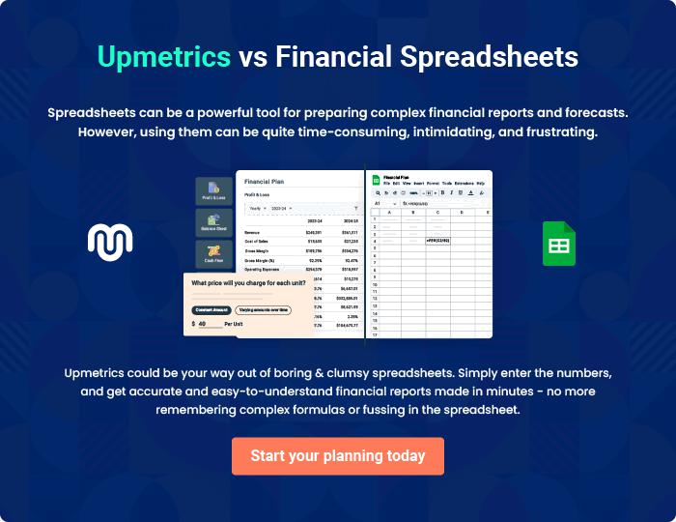
Appendix

When writing the appendix section, you should include any additional information that supports the main content of your plan. This may include financial statements, market research data, legal documents, and other
To unlock help try Upmetrics! 
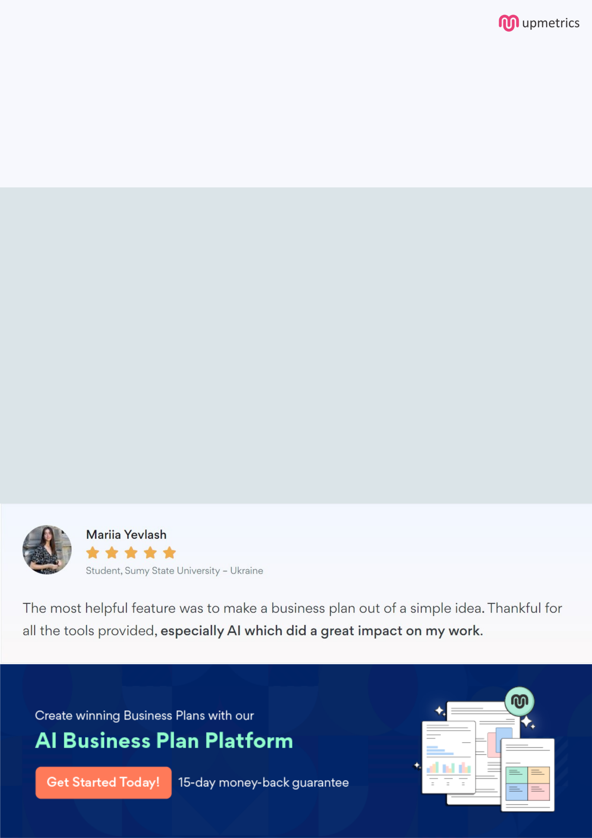
Create a winning business plan that gets you funded

Creating a stunning and investment-ready plan requires no writing, graphic designing, or financial planning expertise.

Upmetrics has all the features required to help you create a comprehensive business plan—from start to finish. Make no mistakes, it’s the modern way of planning to structure ideas, make plans, and create stunning pitch decks to awe investors.

Pitch decks that impress investors

Create pitch decks that provide a visual representation of your business, engage investors, and make them want to invest in your business idea.

Interactive plans in no time

Import business plan sections like—SWOT analysis, comparison tables, and others to create an interactive business plan. No designing skills are required.

Stunning cover page designs

With Upmetrics, you have the liberty to choose from multiple stunning cover page designs. Choose a creative design and make your plan stand out.

Online sharing made simple

Upmetrics makes online sharing quick and easier for users. Easily share your business plans with a link while tracking reader activity.

500+ sample business plans

Simply import a template from our library of sample plans into the editor and start customizing it to make it yours. It takes only a few clicks to get started.

Collaborate with team in real-time

Invite team members, initiate conversations, discuss ideas & strategies, share feedback, and work on a business plan in real-time.

