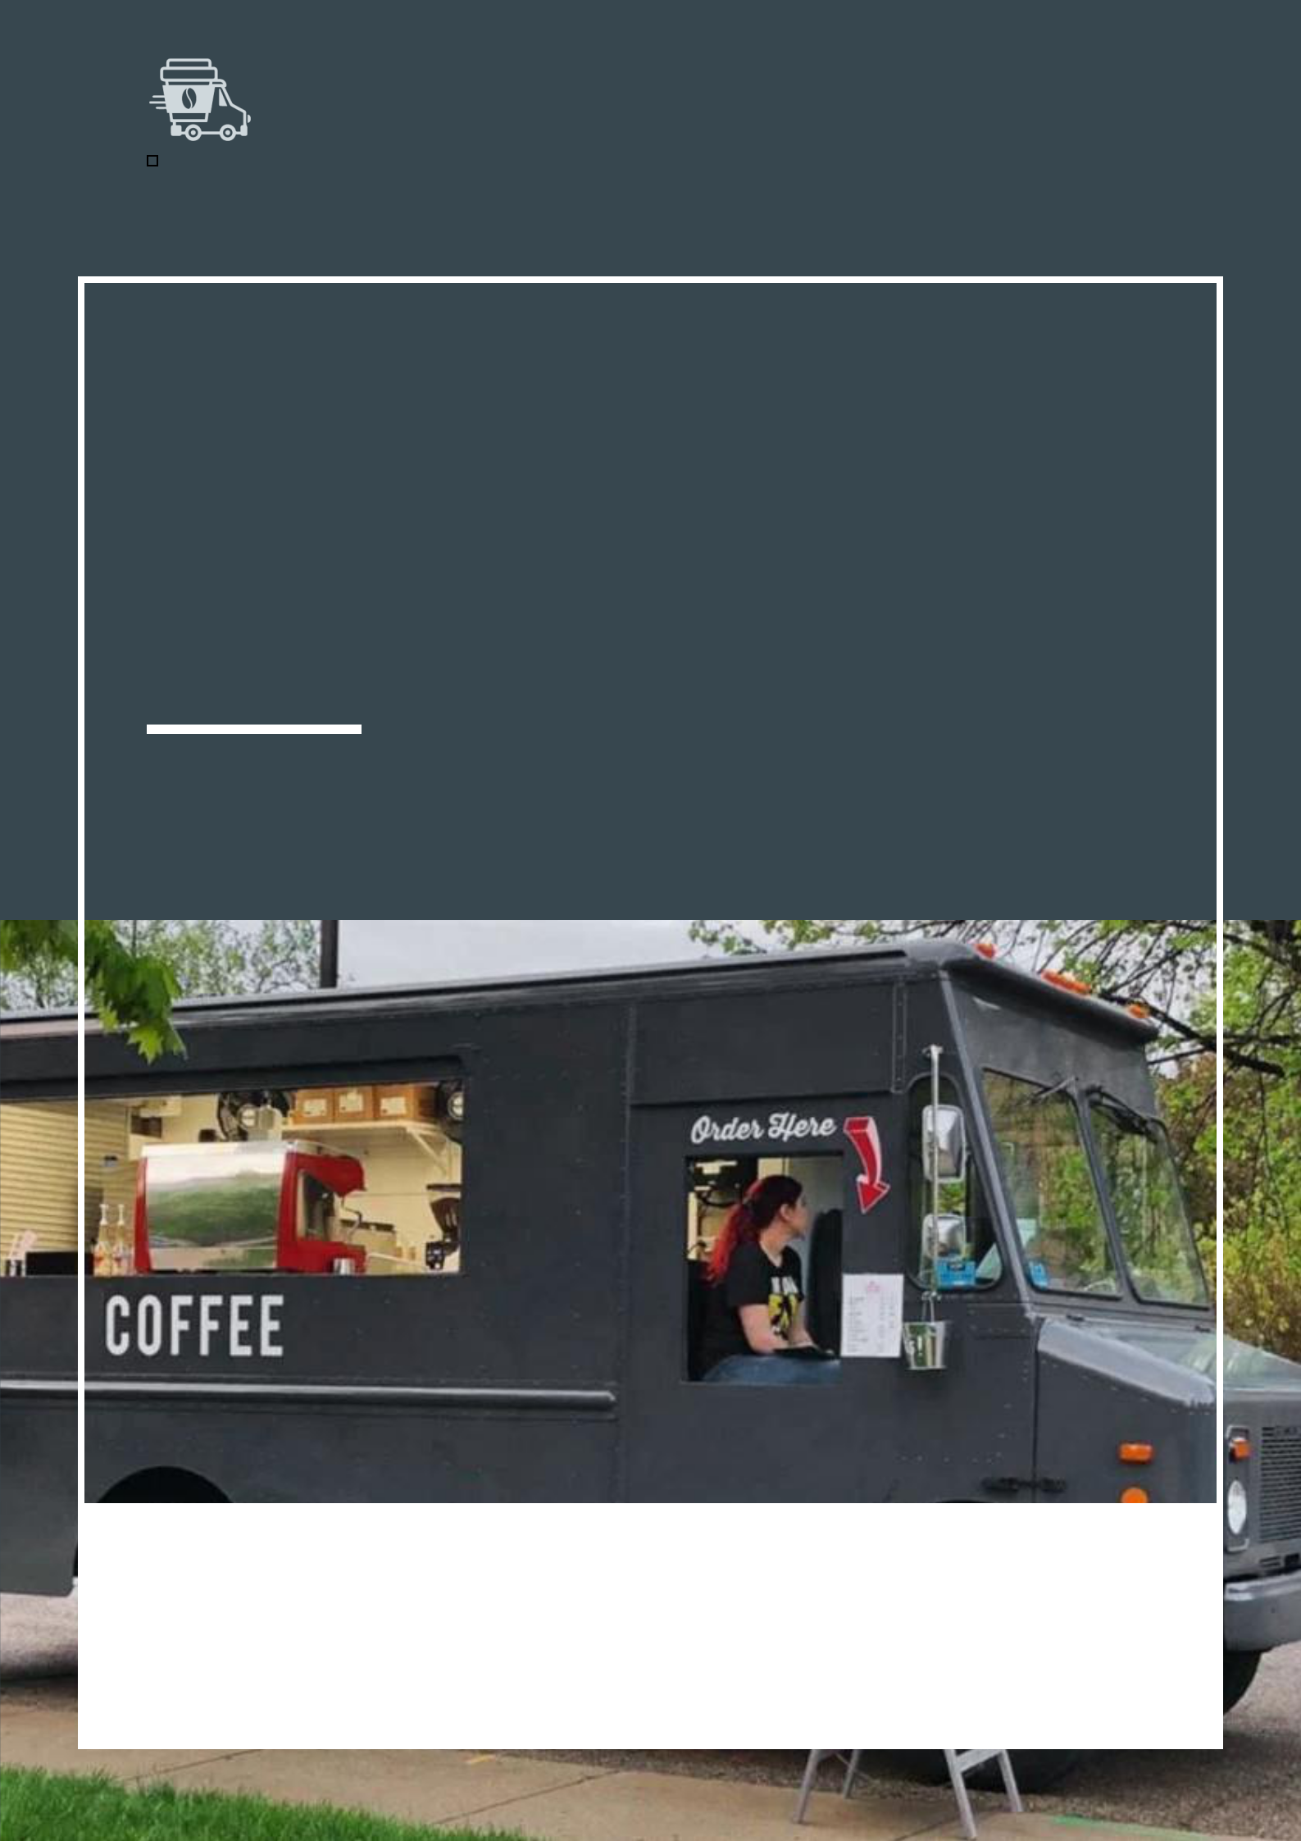
Coffee Truck Business Plan

BUSINESS PLAN

Coffee, Anywhere, Brewed

Prepared By

John Doe

10200 Bolsa Ave, Westminster, CA, 92683

info@example.com

(650) 359-3153 http://www.example.com

Table of Contents

Executive Summary | 6
Market opportunity | 6
Menu | 6
Marketing & Sales Strategies | 7
Financial Highlights | 7
Units Sold v/s Revenue | 8

Company Overview | 9
Ownership | 9
Business Owners | 9
Mission statement | 10
Business history | 10
Future goals | 10

Market Analysis | 11
Target Market | 11
Market size and growth potential | 11
Market Size | 12
Competitive analysis | 12
Java Journeys | 12
Wheels & Beans | 13
Market trends | 13
Regulatory environment | 13

Products and Services | 15
Products | 15
Classic Espresso | 15
Green Tea Infusion | 16
Iced Caramel Latte | 16
Vanilla Chai Latte | 17
Chocolate Chunk Muffin | 17
Cold Brew Coffee | 17
Quality Measures | 18
Highlight Customization | 18
Additional Services | 18

Sales And Marketing Strategies | 19
Unique Selling Proposition (USP) | 19
Pricing Strategy | 19
Marketing strategies | 20
Online | 20
Offline | 20
Sales strategies | 21
Customer retention | 21

Operations Plan | 22
Staffing & Training | 22
Operational Process | 22
Equipment & Machinery | 23

Management Team | 24
Key managers | 24
John Doe | 25
Alice Brown | 26
Robert Brown | 26
Organizational structure | 26
Organization chart | 27
Compensation plan | 27
Board of advisors | 28
James Brown | 28
Jane Doe | 28
Financial Plan
Financial Plan | 29

Profit & loss statement 29

Cash flow statement | 32
Balance sheet | 34
Break-even Analysis | 36
Financing needs | 38
Appendix
Appendix | 40
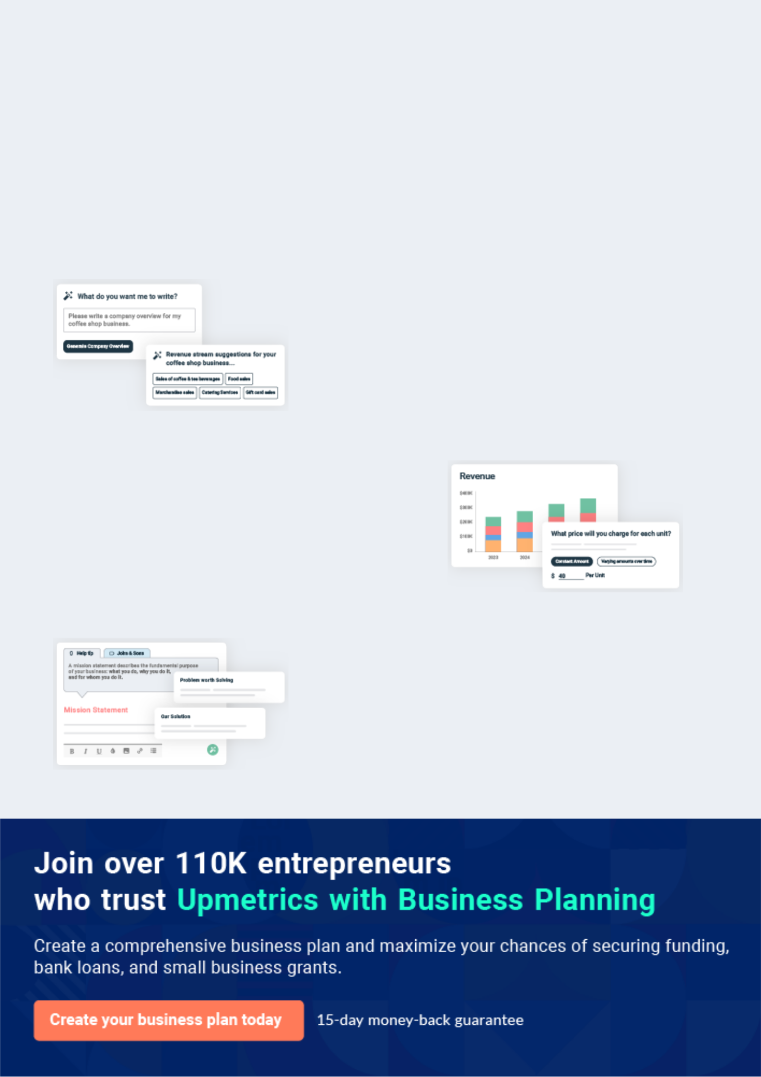
Business planning that’s simpler and faster than you think

Creating a business plan using Upmetrics to start and grow a business is literally the easiest thing in the World. Simply read the instructions and fill in the blanks. It’s as simple as that.

❛ | Upmetrics has everything you need to create a | ❜
❛ | comprehensive business plan. | ❜

AI-powered Upmetrics Assistant

AI-powered insights to streamline your plan

Not sure where to start? Upmetrics’ AI Assistant will automatically generate ideas for each section of your plan and offer improved versions of your writing, adjusting for tone, voice, and grammar or spelling errors.

Financial Forecasting Tool

All the financials are calculated for you

Forget the complex formulas and clumsy spreadsheets — with automatic financials and drag-and-drop forecasting, you can finish your plan faster and be confident that your numbers are accurate.

Business Plan Builder

Guides you like a business mentor

Upmetrics’ step-by-step instructions, prompts, and the library of 400+ sample business plans will guide you through each section of your plan as a business mentor.
Executive Summary


An executive summary is the first section of the business plan intended to provide an overview of the whole business plan.
To unlock help try Upmetrics! 

 Help tip  Coffee truck Business Plan


Start your executive summary by briefly introducing your business to your readers.

This section may include the name of your coffee truck, its location when it was founded, the
To unlock help try Upmetrics! 

Start writing here..

Market opportunity

 Help tip  Coffee truck Business Plan

Describe the target market in brief, and explain the demographics, geographic location, and psychographic attributes of your customer.
To unlock help try Upmetrics! 

Start writing here..

Menu

 Help tip  Coffee truck Business Plan

Highlight the coffee truck menu list you offer your clients. The USPs and differentiators you offer are always a plus.
To unlock help try Upmetrics! 

Start writing here..

Marketing & Sales Strategies
To unlock help try Upmetrics!

 Help tip  Coffee truck Business Plan

Outline your sales and marketing strategies—what marketing platforms you use, how you plan on acquiring customers, etc.
To unlock help try Upmetrics! 

Start writing here..

Financial Highlights

 Help tip  Coffee truck Business Plan

Briefly summarize your financial projections for the initial years of business operations. Include any capital or investment requirements, associated startup costs, projected revenues, and profit forecasts.



Start writing here..
Units Sold v/s Revenue

 |  | Units Sold | Revenue
15.00k
10.00k
5.00k
0
Year 1 | Year 2 | Year 3


Financial Year |  |  | Units Sold | Revenue
Year 1 | 1,550 |  |  | $10,000
Year 2 | 1,800 |  |  | $12,000
Year 3 | 2,050 |  |  | $14,000
 Help tip |  |  Coffee truck Business Plan


Summarize your executive summary section with a clear CTA, for example, inviting angel investors to discuss the potential business investment.
To unlock help try Upmetrics! 

Write a call to action for your business plan.
Company Overview

Depending on what details of your business are essential, you’ll need different elements in your business overview.
To unlock help try Upmetrics! 

 Help tip  Coffee truck Business Plan

Describe your business in this section by providing all the basic information:

Describe what kind of coffee truck you run and the name of it. You may specialize in one of the
To unlock help try Upmetrics! 

Start writing here..

Ownership

 Help tip  Coffee truck Business Plan

List the names of your coffee truck’s founders or owners. Describe what shares they own and their responsibilities for efficiently managing the business.
To unlock help try Upmetrics! 

Start writing here..

Business Owners



70% John Doe



30% Jane Doe
Mission statement

 Help tip  Coffee truck Business Plan

Summarize your business’ objective, core principles, and values in your mission statement. This statement needs to be memorable, clear, and brief.
To unlock help try Upmetrics! 

❛ At '[Brew on the Move],' our mission is to revitalize lives, one cup at a time. We are committed to delivering excellence in every sip by sourcing only the finest ingredients, promoting sustainability, and creating a mobile coffee experience that bridges

communities and spreads joy.
❜

Business history

 Help tip  Coffee truck Business Plan

If you’re an established coffee truck, briefly describe your business history, like—when it was founded, how it evolved over time, etc.
To unlock help try Upmetrics! 

Start writing here..

Future goals

 Help tip  Coffee truck Business Plan

It’s crucial to convey your aspirations and vision. Mention your short-term and long-term goals; they can be specific targets for revenue, market share, or expanding your services.
To unlock help try Upmetrics! 

Start writing here..

Market Analysis
To unlock help try Upmetrics!


 |  | Market analysis provides a clear understanding of the market in which your
 |  | printing business will run along with the target market, competitors, and
 |  | growth opportunities.
 |  |  |  | To unlock help try Upmetrics! 
 Help tip |  |  Coffee truck Business Plan

To write the introduction section of your market analysis, start by clearly identifying your primary target market.
To unlock help try Upmetrics! 

Start writing here..

Target Market

 Help tip  Coffee truck Business Plan

Start this section by describing your target market. Define your ideal customer and explain what types of services they prefer. Creating a buyer persona will help you easily define your target market to your readers.



Start writing here..

Market size and growth potential

 Help tip  Coffee truck Business Plan

Describe your market size and growth potential and whether you will target a niche or a much broader market.
To unlock help try Upmetrics! 

Start writing here..

Market Size

Available Market

Total individuals in the region who 10M consume coffee.

Served Market
People within the region reachable by 5M mobile coffee trucks.

Target Market
Morning commuters and business 1M professionals in urban hubs.

 Help tip  Coffee truck Business Plan

Identify and analyze your direct and indirect competitors. Identify their strengths and weaknesses, and describe what differentiates your coffee truck from them.
To unlock help try Upmetrics! 

Competitive analysis

Java Journeys

Java Journeys, established in 2018, has quickly become one of the favored mobile coffee solutions for many in Westminster, CA. With their fleet of three trucks, they've managed to establish a significant presence across major business hubs in the city.

Features

Extensive menu catering to both traditional coffee lovers and experimental enthusiasts.

Loyalty program with a mobile app for order-ahead services.

Environmentally-friendly, with a commitment to using compostable cups and lids.

Strengths

Broad menu offering catering to diverse tastes.

Technological integration through their mobile app enhances customer convenience.

A strong emphasis on sustainability resonates with eco-conscious consumers.

Weaknesses

Limited locations due to a focus on specific business hubs, missing out on other potential customer hotspots.

Dependence on the app may alienate non-tech-savvy patrons.

Wheels & Beans
To unlock help try Upmetrics!

A newcomer to the scene, Wheels & Beans has taken a niche approach, specializing in gourmet coffee blends. Founded in 2021, they operate two trucks and primarily target upscale neighborhoods and events.

Features

Curated gourmet coffee blends sourced from global roasters.

Occasional pop-up events featuring guest baristas.

Partnership with local bakeries to offer a selection of artisanal pastries.

Strengths

Unique gourmet offerings differentiate them in a saturated market.

Pop-up events generate buzz and attract a loyal community of coffee aficionados.

Local partnerships enhance their menu variety and support other local businesses.

Weaknesses

A higher price point might deter a section of the market from seeking affordable options.

Limited standard coffee offerings can alienate traditional coffee drinkers.

Market trends

 Help tip  Coffee truck Business Plan

Analyze emerging trends in the industry, such as changes in customer behavior or preferences, etc. Explain how your business will cope with all the trends.
To unlock help try Upmetrics! 

Start writing here..

Regulatory environment

 Help tip  Coffee truck Business Plan

List regulations and licensing requirements that may affect your coffee truck company, such as business licenses, food safety & handling, health inspections, permits & zoning laws, food labeling, etc.



Start writing here..

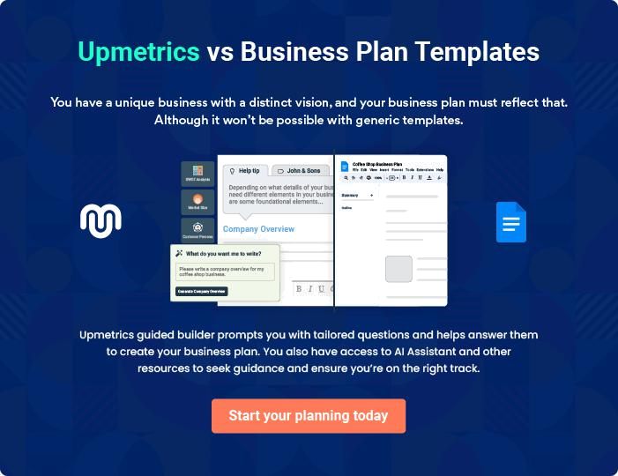
Products and Services
To unlock help try Upmetrics!

The product and services section of a coffee truck business plan should describe the specific services and products that will be offered to customers. To write this section should include the following:



 Help tip  Coffee truck Business Plan

To craft the introduction for your "Products and Services" chapter, begin by positioning your business within its industry, emphasizing its unique strengths or value proposition.
To unlock help try Upmetrics! 

Start writing here..

 Help tip


Mention the coffee truck servings your business will offer. This list may include:

• Coffee beverages
To unlock help try Upmetrics! 

Products

Classic Espresso


Price: [$3.00]

Our signature shot, crafted from the finest beans, delivers a rich and bold flavor.

Specifications

- Single Shot: 1 oz

- Bean Origin: Colombia

- Roast Level: Medium-Dark

- Caffeine: Approx. 63 mg
Green Tea Infusion

Price: [$2.50]

A soothing blend of premium green tea leaves, offering a delicate aroma and refreshing taste.

Specifications

- Serving Size: 8 oz

- Tea Origin: Japan

- Caffeine: Approx. 20 mg

- Additives: None

Iced Caramel Latte

Price: [$4.50]

A delightful mix of our classic espresso, cold milk, and rich caramel syrup, served over ice.

Specifications

- Serving Size: 12 oz

- Espresso Shot Count: 2

- Caramel Syrup: 1 oz

- Milk Choice: Whole (alternatives available)
Vanilla Chai Latte

Price: [$4.00]

A spicy, aromatic chai blend perfectly complemented by a hint of sweet vanilla.

Specifications

- Serving Size: 10 oz

- Chai Concentrate: 6 oz

- Vanilla Syrup: 0.5 oz

- Milk Choice: Whole (alternatives available)

Chocolate Chunk Muffin

Price: [$2.75]

A moist, fluffy muffin packed with generous chunks of rich chocolate.

Specifications

- Weight: 4 oz

- Ingredients: Flour, sugar, eggs, butter, cocoa, chocolate chunks

- Allergens: Gluten, dairy, eggs

Cold Brew Coffee

Price: [$4.00]

Smooth, robust, and brewed over 12 hours for a refreshing coffee experience.

Specifications

- Serving Size: 12 oz

- Bean Origin: Brazil

- Roast Level: Medium

- Caffeine: Approx. 100 mg
Quality Measures
- To unlock help try Upmetrics!

 Help tip  Coffee truck Business Plan


Talk about your commitment to employing premium, sustainable, or locally sourced items, as
well as the caliber of your ingredients. Mention any particular accreditations or affiliations that
show your commitment to excellence.
 |  |  |  | To unlock help try Upmetrics! 
Start writing here..
Highlight Customization
 Help tip |  |  Coffee truck Business Plan


If your coffee truck offers possibilities for customization, such as different milk selections,
flavor syrups, or add-ons, emphasize this adaptability to accommodate different consumer
tastes.
 |  |  |  | To unlock help try Upmetrics! 
Start writing here..
Additional Services
 Help tip |  |  Coffee truck Business Plan

Mention if your coffee truck company offers any additional services. You may include services like event catering, coffee workshops & tastings, mobile coffee bar rental, branded merchandise sales, etc.



Start writing here..
Sales And Marketing Strategies

Writing the sales and marketing strategies section means a list of strategies you will use to attract and retain your clients.
To unlock help try Upmetrics! 

 Help tip  Coffee truck Business Plan

To create an effective introduction for your "Sales and Marketing Strategies" chapter, start by setting the stage within your specific industry or market.
To unlock help try Upmetrics! 

Unique Selling Proposition (USP)

 Help tip  Coffee truck Business Plan

Define your business’s USPs depending on the market you serve, the equipment you use, and the unique services you provide. Identifying USPs will help you plan your marketing strategies.
To unlock help try Upmetrics! 

Start writing here..

Pricing Strategy

 Help tip  Coffee truck Business Plan

Describe your pricing strategy—how you plan to price your services and stay competitive in the local market. You can mention any discounts you plan on offering to attract new customers.
To unlock help try Upmetrics! 

Start writing here..

 Help tip  Coffee truck Business Plan
To unlock help try Upmetrics!

Discuss your marketing strategies to market your services. You may include some of these marketing strategies in your business plan—social media marketing, content marketing, and print marketing.



Marketing strategies

Online


Social Media

Harnessing the power of platforms like [e.g., "Instagram", "Facebook"], we aim to engage with our audience through interactive content, promotions, and real-time updates.

Content Marketing

Through our [e.g., "blog", "newsletter"], we'll share insights on coffee trends, and brewing techniques, and spotlight our unique offerings.

Offline

Print Marketing

Strategic placement of [e.g., "flyers", "posters", "coupons"] at local establishments and in community newspapers to enhance local visibility.

 Help tip
To unlock help try Upmetrics!

Outline the strategies you’ll implement to maximize your sales. Your sales strategies may include upselling & cross-selling, partnering with other businesses, offering referral programs, etc.



Sales strategies

Upselling & Cross-Selling

Training our staff to subtly recommend add-ons or complementary items, enhancing the customer's overall experience.

Partnerships

Collaborating with [e.g., "local bakeries", "event organizers"] to offer bundled deals or services.

Referral Programs

Rewarding our patrons for bringing

in new customers, fostering a

sense of community and loyalty.

 Help tip

Describe your customer retention strategies and how you plan to execute them. For instance, introducing loyalty programs, discounts on bulk purchases, personalized service, etc
To unlock help try Upmetrics! 

Customer retention

Loyalty Programs

Introducing a [e.g., "stamp card system"] where frequent purchases lead to complimentary items.

Bulk Order Discounts

Offering deals for larger orders, ideal for events or office gatherings.

Personalized Service

Recognizing regular customers

and their preferences, ensuring

they feel valued and understood.

Operations Plan
To unlock help try Upmetrics!

 |  | When writing the operations plan section, it’s important to consider the
 |  | various aspects of your business operations.
 |  |  |  | To unlock help try Upmetrics! 
 Help tip |  |  Coffee truck Business Plan

To create an effective introduction for your "Operational Plan" chapter, start by emphasizing the
pivotal role of efficient operations in the success of your business, underscoring how they
directly impact the quality of services delivered.
 |  |  |  | To unlock help try Upmetrics! 
Start writing here..
Staffing & Training
 Help tip |  |  Coffee truck Business Plan

Mention your business’s staffing requirements, including the number of employees or baristas needed. Include their qualifications, the training required, and the duties they will perform.
To unlock help try Upmetrics! 

Start writing here..

Operational Process

 Help tip  Coffee truck Business Plan

Outline the processes and procedures you will use to run your coffee truck. Your operational processes may include stocking inventory, preparing the coffee truck, setting up at the location, cleaning & maintenance, etc.



Start writing here..

Equipment & Machinery
To unlock help try Upmetrics!

 Help tip  Coffee truck Business Plan

Include the list of equipment and machinery required for a coffee truck, such as an espresso machine, coffee grinder, blender, hot water dispenser, water filtration system, or refrigeration unit, etc.



Start writing here..
Management Team

The management team section provides an overview of the individuals responsible for running your business plan.
To unlock help try Upmetrics! 

 Help tip  Coffee truck Business Plan

To craft an introduction for your "Management Team" chapter, begin by emphasizing the crucial role of leadership in the success of any business.
To unlock help try Upmetrics! 

Start writing here..

Key managers

 Help tip  Coffee truck Business Plan

Introduce your management and key members of your team, and explain their roles and responsibilities.
To unlock help try Upmetrics! 

Start writing here..

JOHN DOE

CEO & Co-founder - john.doe@example.com

John is the visionary behind "Brew on the Move." His passion for coffee combined with a keen business acumen has driven the company from a mere concept to a thriving enterprise.


John's leadership style fosters innovation and encourages a relentless pursuit of excellence across all facets of the business.

- Educational Background: John holds a Bachelor's degree in Business Administration from Stanford University and an MBA from Harvard Business School.

- Professional Background: With over 12 years in the coffee industry, John has worked with leading brands like Starbucks and Peet's Coffee, holding managerial roles and spearheading growth strategies.

ALICE BROWN

Operations Manager - alice.brown@example.com

Alice is the linchpin ensuring the seamless day-to-day operations of "Brew on the Move."

From inventory management to quality assurance, her meticulous nature ensures the company's operational efficiency remains unparalleled.

- Educational Background: Alice graduated with honors in Operations Management from the University of California, Berkeley.

- Professional Background: With a career spanning 8 years, Alice has managed operations for renowned establishments like Blue Bottle Coffee and Joe & The Juice, honing her skills and bringing best practices to our coffee truck.


ROBERT BROWN

Customer Services Manager - robert.brown@example.com

Robert's role is pivotal in shaping the customer experience at "Brew on the Move."

His dedication ensures that every customer interaction echoes our brand values, turning patrons into brand advocates.

- Educational Background: Robert holds a degree in Customer Relationship Management from New York University.

- Professional Background: With over 6 years in the service industry, Robert has been pivotal in roles at companies like Dunkin' and Tim Hortons, enhancing customer satisfaction and loyalty metrics.

Organizational structure

 Help tip  Coffee truck Business Plan

Explain the organizational structure of your management team. Include the reporting line and decision-making hierarchy.
To unlock help try Upmetrics! 

Start writing here..

Organization chart


John Doe

CEO


Robert Brown
Customer Services | Alice Brown |  | James Smith
Manager | Operations Manager |  | Marketing Manager



Peter Green

Customer Relation | Emily Clark
Specialist | Inventory Associate



Compensation plan

 Help tip  Coffee truck Business Plan

Describe your compensation plan for the management and staff. Include their salaries, incentives, and other benefits.
To unlock help try Upmetrics! 

Start writing here..
 Help tip

Mentioning advisors or consultants in your business plans adds credibility to your business idea.
To unlock help try Upmetrics! 

Board of advisors


JAMES BROWN

Advisor

An advisor with expertise in [e.g., "sustainable sourcing"], his guidance ensures our practices are both ethical and eco-friendly.


JANE DOE

Consultant

A consultant with over [e.g., "15 years"] in the mobile food industry, her insights have been invaluable in positioning "[Brew on the Move]" in the market.
Financial Plan

When writing the financial plan section of a business plan, it’s important to provide a comprehensive overview of your financial projections for the first few years of your business, You may provide the following:
To unlock help try Upmetrics! 

 Help tip  Coffee truck Business Plan


To create an effective introduction for your "Financial Plan" chapter, begin by stressing the critical role of a well-structured financial plan in the success of your venture.
To unlock help try Upmetrics! 

Start writing here..

 Help tip


Describe details such as projected revenue, operational costs, and service costs in your projected profit and loss statement. Make sure to include your business’s expected net profit or loss.
To unlock help try Upmetrics! 

Profit & loss statement

Revenue

Cost Of Sales

General Costs

Revenue Specific Costs

Personnel Costs (Direct

Labor)

Gross Margin

Gross Margin (%)

Operating Expense

Payroll Expense

(Indirect Labor)

General Expense

Bad Debt

Amortization of Current

Assets

2023-24 | 2024-25 | 2025-26 | 2026-27 | 2027-28
$0 | $0 | $0 | $0 | $0

$0 | $0 | $0 | $0 | $0
$0 | $0 | $0 | $0 | $0
$0 | $0 | $0 | $0 | $0
$0 | $0 | $0 | $0 | $0

$0 | $0 | $0 | $0 | $0
0% | 0% | 0% | 0% | 0%

$0 | $0 | $0 | $0 | $0
$0 | $0 | $0 | $0 | $0
$0 | $0 | $0 | $0 | $0
$0 | $0 | $0 | $0 | $0
$0 | $0 | $0 | $0 | $0

EBITDA

Additional Expense

Long Term

Depreciation

Gain or loss from Sale

of Assets

EBIT

Interest Expenses

EBT

Income Tax Expense

Total Expense

Net Income

Net Income (%)

2023-24 | 2024-25 | 2025-26 | 2026-27 | 2027-28
$0 | $0 | $0 | $0 | $0
$0 | $0 | $0 | $0 | $0
$0 | $0 | $0 | $0 | $0
$0 | $0 | $0 | $0 | $0
$0 | $0 | $0 | $0 | $0
$0 | $0 | $0 | $0 | $0
$0 | $0 | $0 | $0 | $0
$0 | $0 | $0 | $0 | $0
$0 | $0 | $0 | $0 | $0
$0 | $0 | $0 | $0 | $0
0% | 0% | 0% | 0% | 0%
 | 2023-24 | 2024-25 | 2025-26 | 2026-27 | 2027-28
Retained Earning | $0 | $0 | $0 | $0 | $0
Opening
Owner's Distribution | $0 | $0 | $0 | $0 | $0
Retained Earning | $0 | $0 | $0 | $0 | $0
Closing

 Help tip

The cash flow for the first few years of your operation should be estimated and described in this section. This may include billing invoices, payment receipts, loan payments, and any other cash flow statements.
To unlock help try Upmetrics! 

Cash flow statement

 | 2023-24 | 2024-25 | 2025-26 | 2026-27 | 2027-28
Cash Received | $0 | $0 | $0 | $0 | $0
Cash Paid | $0 | $0 | $0 | $0 | $0
COS & General Expenses | $0 | $0 | $0 | $0 | $0
Salary & Wages | $0 | $0 | $0 | $0 | $0
Interest | $0 | $0 | $0 | $0 | $0

Sales Tax

Income Tax

Net Cash From

Operations

Assets Sell

Assets Purchase

Net Cash From

Investments

Amount Received

Loan Received

Common Stock

Preferred Stock

Owner's Contribution

Amount Paid

2023-24 | 2024-25 | 2025-26 | 2026-27 | 2027-28
$0 | $0 | $0 | $0 | $0
$0 | $0 | $0 | $0 | $0
$0 | $0 | $0 | $0 | $0

$0 | $0 | $0 | $0 | $0
$0 | $0 | $0 | $0 | $0
$0 | $0 | $0 | $0 | $0

$0 | $0 | $0 | $0 | $0
$0 | $0 | $0 | $0 | $0

$0 | $0 | $0 | $0 | $0
$0 | $0 | $0 | $0 | $0
$0 | $0 | $0 | $0 | $0

Loan Capital $0 $0 $0 $0 $0

 | 2023-24 | 2024-25 | 2025-26 | 2026-27 | 2027-28
Dividends & Distributions | $0 | $0 | $0 | $0 | $0
Net Cash From | $0 | $0 | $0 | $0 | $0
Financing

Summary
Starting Cash | $0 | $0 | $0 | $0 | $0
Cash In | $0 | $0 | $0 | $0 | $0
Cash Out | $0 | $0 | $0 | $0 | $0
Change in Cash | $0 | $0 | $0 | $0 | $0
Ending Cash | $0 | $0 | $0 | $0 | $0

 Help tip

Create a projected balance sheet documenting your coffee truck’s assets, liabilities, and equity.

To unlock help try Upmetrics! 

Balance sheet

 | 2023-24 | 2024-25 | 2025-26 | 2026-27 | 2027-28
Assets | $0 | $0 | $0 | $0 | $0
Current Assets | $0 | $0 | $0 | $0 | $0
Cash | $0 | $0 | $0 | $0 | $0
Accounts Receivable | $0 | $0 | $0 | $0 | $0
Inventory | $0 | $0 | $0 | $0 | $0
Other Current Assets | $0 | $0 | $0 | $0 | $0
Long Term Assets | $0 | $0 | $0 | $0 | $0
Gross Long Term Assets | $0 | $0 | $0 | $0 | $0
Accumulated Depreciation | $0 | $0 | $0 | $0 | $0

Liabilities & Equity | $0 | $0 | $0 | $0 | $0
Liabilities | $0 | $0 | $0 | $0 | $0
Current Liabilities | $0 | $0 | $0 | $0 | $0
Accounts Payable | $0 | $0 | $0 | $0 | $0
Income Tax Payable | $0 | $0 | $0 | $0 | $0
Sales Tax Payable | $0 | $0 | $0 | $0 | $0
Short Term Debt | $0 | $0 | $0 | $0 | $0
 | 2023-24 | 2024-25 | 2025-26 | 2026-27 | 2027-28
Long Term Liabilities | $0 | $0 | $0 | $0 | $0
Long Term Debt | $0 | $0 | $0 | $0 | $0
Equity | $0 | $0 | $0 | $0 | $0
Paid-in Capital | $0 | $0 | $0 | $0 | $0
Common Stock | $0 | $0 | $0 | $0 | $0
Preferred Stock | $0 | $0 | $0 | $0 | $0
Owner's Contribution | $0 | $0 | $0 | $0 | $0
Retained Earnings | $0 | $0 | $0 | $0 | $0

Check | $0 |  |  | $0 | $0 | $0 | $0
 Help tip |  |  Coffee truck Business Plan


Determine and mention your business’s break-even point—the point at which your business costs and revenue will be equal.

This exercise will help you understand how much revenue you need to generate to sustain or be profitable.
To unlock help try Upmetrics! 

Break-even Analysis

 | 2023-24 | 2024-25 | 2025-26 | 2026-27 | 2027-28
Starting Revenue | $0 | $0 | $0 | $0 | $0
Net Revenue | $0 | $0 | $0 | $0 | $0
Closing Revenue | $0 | $0 | $0 | $0 | $0

Starting Expense | $0 | $0 | $0 | $0 | $0
Net Expense | $0 | $0 | $0 | $0 | $0
Closing Expense | $0 | $0 | $0 | $0 | $0

Is Break Even? | 0 | 0 | 0 | 0 | 0
Break Even Month | 0 | 0 | 0 | 0 | 0
Days Required | 0 | 0 | 0 | 0 | 0
Break Even Revenue | $0 | $0 | $0 | $0 | $0
Break Even Units
Financing needs

 Help tip  Coffee truck Business Plan

Calculate costs associated with starting a coffee truck, and estimate your financing needs and how much capital you need to raise to operate your business.
To unlock help try Upmetrics! 

Start writing here..
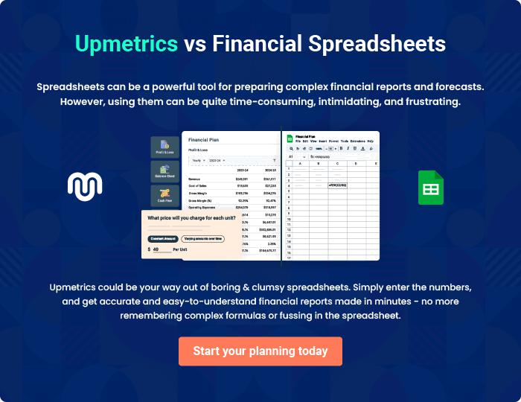
Appendix

When writing the appendix section, you should include any additional information that supports the main content of your plan. This may include financial statements, market research data, legal documents, and other
To unlock help try Upmetrics! 

Create a winning business plan that gets you funded

Creating a stunning and investment-ready plan requires no writing, graphic designing, or financial planning expertise.

Upmetrics has all the features required to help you create a comprehensive business plan—from start to finish. Make no mistakes, it’s the modern way of planning to structure ideas, make plans, and create stunning pitch decks to awe investors.

Pitch decks that impress investors

Create pitch decks that provide a visual representation of your business, engage investors, and make them want to invest in your business idea.

Interactive plans in no time

Import business plan sections like—SWOT analysis, comparison tables, and others to create an interactive business plan. No designing skills are required.

Stunning cover page designs

With Upmetrics, you have the liberty to choose from multiple stunning cover page designs. Choose a creative design and make your plan stand out.

Online sharing made simple

Upmetrics makes online sharing quick and easier for users. Easily share your business plans with a link while tracking reader activity.

500+ sample business plans

Simply import a template from our library of sample plans into the editor and start customizing it to make it yours. It takes only a few clicks to get started.

Collaborate with team in real-time

Invite team members, initiate conversations, discuss ideas & strategies, share feedback, and work on a business plan in real-time.

