

Coaching Business Plan

Inspiring Minds, Igniting Success


Business
Plan

2023

Prepared By

John Doe

10200 Bolsa Ave, Westminster, CA, 92683

info@example.com

(650) 359-3153 http://www.example.com

Table of Contents

Executive Summary | 6
Market opportunity | 6
Services Offered | 6
Marketing Strategy | 7
Financial Highlights | 7
Units Sold v/s Revenue | 8

Company Overview | 9
Ownership | 9
Business Owners | 9
Mission statement | 10
Business history | 10
Future goals | 10

Market Analysis | 11
Target Market | 11
Market size and growth potential | 11
Market Size | 12
Competitive analysis | 12
ABC Coaching Institute | 12
EduMentor Online Coaching | 13
Market trends | 13
Regulatory environment | 13

Products and Services | 15
Services | 15
Educational Coaching | 15
Corporate Training | 16
Business Consulting | 16
Executive Coaching | 17

Coaching Methodology 17

Sales And Marketing Strategies | 18
Unique Selling Proposition (USP) | 18
Pricing Strategy | 18
Marketing strategies | 19
Online | 19
Sales strategies | 20
Customer retention | 20

Operations Plan | 21
Hiring Plan | 21
Operational Process | 21
Facilities and Technology | 22

Management Team | 23
Key managers | 23
John Doe | 23
Jane Doe | 24
Alice Brown | 24
Robert Brown | 24
Organizational structure | 25
Organization chart | 25
Compensation plan | 25
Board of advisors | 26
Henry Wilson | 26
Linda Gray | 26

Financial Plan | 27
Profit & loss statement | 27
Cash flow statement | 30
Balance sheet | 32
Break-even Analysis | 34
Financing needs | 36
Appendix | 38
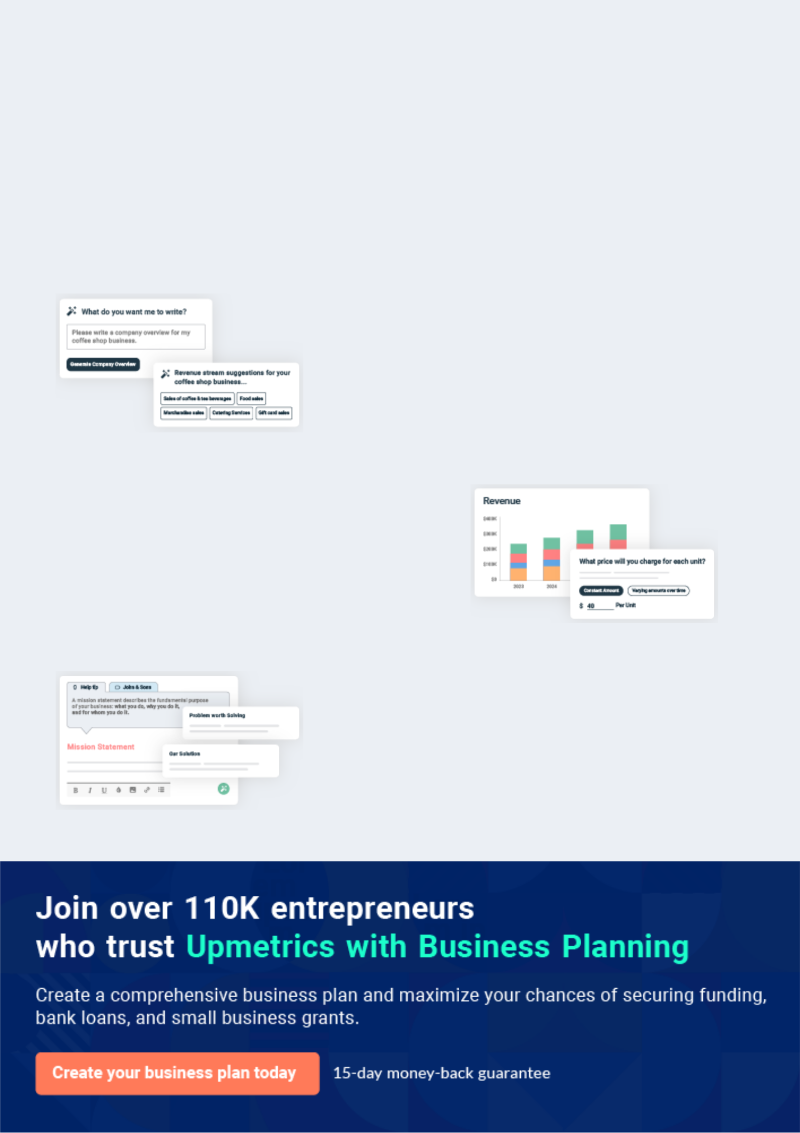
Business planning that’s simpler and faster than you think

Creating a business plan using Upmetrics to start and grow a business is literally the easiest thing in the World. Simply read the instructions and fill in the blanks. It’s as simple as that.

❛ | Upmetrics has everything you need to create a | ❜
❛ | comprehensive business plan. | ❜

AI-powered Upmetrics Assistant

AI-powered insights to streamline your plan

Not sure where to start? Upmetrics’ AI Assistant will automatically generate ideas for each section of your plan and offer improved versions of your writing, adjusting for tone, voice, and grammar or spelling errors.

Financial Forecasting Tool

All the financials are calculated for you

Forget the complex formulas and clumsy spreadsheets — with automatic financials and drag-and-drop forecasting, you can finish your plan faster and be confident that your numbers are accurate.

Business Plan Builder

Guides you like a business mentor

Upmetrics’ step-by-step instructions, prompts, and the library of 400+ sample business plans will guide you through each section of your plan as a business mentor.
Executive Summary
To unlock help try Upmetrics!


An executive summary is the first section of the business plan intended to provide an overview of the whole business plan.
To unlock help try Upmetrics! 

 Help tip  Coaching Business Plan


Start your executive summary by introducing your idea behind starting a coaching business and explaining what it does.
To unlock help try Upmetrics! 

Start writing here..

Market opportunity

 Help tip  Coaching Business Plan

Describe the target market in brief, and explain the demographics, geographic location, and psychographic attributes of your customer.
To unlock help try Upmetrics! 

Start writing here..

Services Offered

 Help tip  Coaching Business Plan

Describe in brief what services a customer can expect from your coaching center. Also, incorporate brief information mentioning the safety and security systems you implement, keeping consumer safety in mind.



Start writing here..

Marketing Strategy

 Help tip  Coaching Business Plan


Explain how you plan on marketing your services, including advertising, social media marketing,
public relations, promotions, etc. Define your target market and how you will execute the
marketing.
 |  |  |  | To unlock help try Upmetrics! 
Start writing here..
Financial Highlights
 Help tip |  |  Coaching Business Plan


Provide a summary of your financial projections for the center’s initial years of operation.

Include any capital or investment requirements, startup costs, projected revenues, and profits.
To unlock help try Upmetrics! 

Start writing here..
Units Sold v/s Revenue

 |  | Units Sold | Revenue
15.00k
10.00k
5.00k
0
Year 1 | Year 2 | Year 3


Financial Year |  |  | Units Sold | Revenue
Year 1 | 1,550 |  |  | $10,000
Year 2 | 1,800 |  |  | $12,000
Year 3 | 2,050 |  |  | $14,000
 Help tip |  |  Coaching Business Plan

After briefly explaining your business plan, end your summary with a call to action, inviting potential investors or readers to the next meeting if they are interested in your business.
To unlock help try Upmetrics! 

Write a call to action for your business plan.
Company Overview

Depending on what details of your business are essential, you’ll need different elements in your business overview.
To unlock help try Upmetrics! 

 Help tip  Coaching Business Plan

Provide all the basic information about your business in this section like:

• The name and type of your coaching center: mention whether you are a coaching center
To unlock help try Upmetrics! 

Start writing here..

Ownership

 Help tip  Coaching Business Plan

Describe the owners of your coaching center and mention their roles in running it. Who owns what shares in the corporation, and how each owner helps in the business?
To unlock help try Upmetrics! 

Start writing here..

Business Owners



60% John Doe



40% Jane Doe
Mission statement
To unlock help try Upmetrics!

 Help tip  Coaching Business Plan

Add a mission statement that sums up your coaching center’s objectives and core principles.

This statement needs to be memorable, clear, and brief.
To unlock help try Upmetrics! 

❛ [A memorable and concise statement, e.g., "Empowering Dreams, Sculpting Futures."]" At [XYZ Coaching Center], we believe in harnessing the innate potential of every individual. Our mission is to provide tailored coaching experiences that catalyze personal and professional growth, ensuring that our clients not only dream but achieve.

❜

Business history

 Help tip  Coaching Business Plan

Include an outline of your coaching center’s history and how it came to be in its current position.
To unlock help try Upmetrics! 

Start writing here..

Future goals

 Help tip  Coaching Business Plan

It’s crucial to convey your aspirations and your vision. Include the vision of where you see your business in the near future and if you plan to open a new business franchise in the same city or state.



Start writing here..

Market Analysis
To unlock help try Upmetrics!


 |  | Market analysis provides a clear understanding of the market in which your
 |  | printing business will run along with the target market, competitors, and
 |  | growth opportunities.
 |  |  |  | To unlock help try Upmetrics! 
 Help tip |  |  Coaching Business Plan

To write the introduction section of your market analysis, start by clearly identifying your primary target market.
To unlock help try Upmetrics! 

Start writing here..

Target Market

 Help tip  Coaching Business Plan

Identify your target market and define your ideal customer. Know more about your customers and which services they prefer: personal coaching, educational coaching, corporate training, business consulting, group coaching sessions, or anything else.



Start writing here..

Market size and growth potential

 Help tip  Coaching Business Plan

Provide an overview of the coaching industry. It will include market size, trends, growth potential, and regulatory considerations.
To unlock help try Upmetrics! 

Start writing here..

Market Size
To unlock help try Upmetrics!

Available Market

Total individuals seeking coaching 5M services in the U.S.

Served Market
Individuals in the U.S. currently using 1M coaching services.

Target Market
Professionals aged 25-45 in urban areas 500k seeking coaching.

 Help tip  Coaching Business Plan

Identify and analyze all other coaching centers in the local market, including direct and indirect competitors. Evaluate their strengths and weaknesses, and explain how your business can offer qualitative services.



Competitive analysis

ABC Coaching Institute

Established in [specific year, e.g., "2010"], ABC Coaching Institute has grown to be one of the prominent names in [specific type of coaching, e.g., "executive coaching"] in the region.

With a network of over [specific number, e.g., "50 certified coaches"], they have served over [specific number, e.g., "10,000 clients"] in the past decade.

Features Strengths

Weaknesses

Tailored one-on-one executive coaching

Group workshops on leadership and management

Online resource library for continuous learning

Strong brand recognition in the [specific location, e.g., "Westminster, CA"] market.

Extensive network of certified coaches.

A decade-long presence ensuring trust and reliability.

Limited digital presence with a dated online platform.

Predominantly focused on executive coaching, missing out on other niches.

Less emphasis on continuous post-coaching engagement.

EduMentor Online Coaching

EduMentor is a recent entrant, launched in [specific year, e.g., "2018"], focusing exclusively on online coaching solutions. Their platform connects learners with coaches across various domains, offering flexibility and convenience.

Features | Strengths | Weaknesses
AI-driven coach matching | Strong digital infrastructure | Lack of physical presence,
system for users. | offering seamless online | missing out on clients preferring
Diverse range of coaching | experiences. | face-to-face interactions.
modules from personal growth | Broad range of coaching | Relatively new in the market,
to corporate training. | niches addressed. | leading to lesser brand trust.
An interactive mobile app for | Flexibility in terms of timing | Dependent solely on technology,
on-the-go learning. | and accessibility. | potentially alienating non-tech-
 |  | savvy clients.

Market trends

 Help tip  Coaching Business Plan

Analyze current and emerging trends in your industry, such as technological changes or customer preferences. Explain how your business will cope with all the trends.
To unlock help try Upmetrics! 

Start writing here..

Regulatory environment

 Help tip  Coaching Business Plan

Describe any regulations or licensing requirements that affect coaching business, such as business registration, professional credentials, data privacy, business license, etc.
To unlock help try Upmetrics! 

Start writing here..

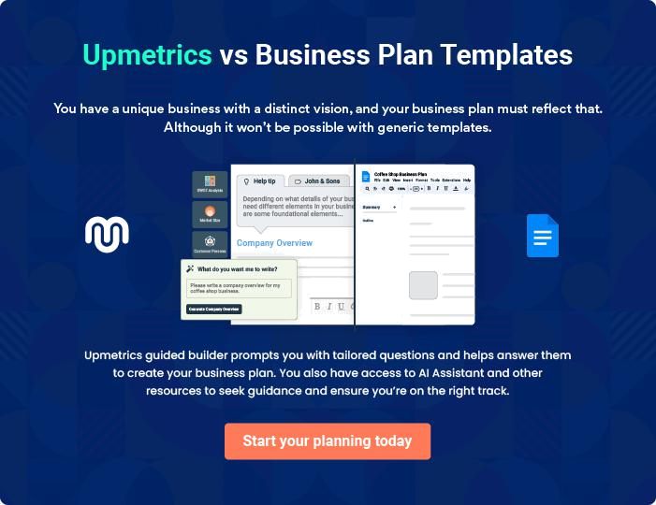
Products and Services
To unlock help try Upmetrics!

The product and services section of a coaching business plan should describe the specific services and products that will be offered to customers. To write this section should include the following:



 Help tip  Coaching Business Plan

To craft the introduction for your "Products and Services" chapter, begin by positioning your business within its industry, emphasizing its unique strengths or value proposition.
To unlock help try Upmetrics! 

Start writing here..

 Help tip


Create a list of the services your coaching business will offer, including educational coaching, corporate training, business consulting, executive coaching, etc.
To unlock help try Upmetrics! 

Services

Educational Coaching


Price: [$1,200] for an 8-week program

Personalized coaching tailored for students and learners, emphasizing academic success, learning strategies, and personal growth.

Specifications

- Eight 1-hour sessions (one per week)

- Personalized learning plan

- Access to online resources

- 24/7 email support for the duration of the program

- Final assessment report at the end of the course
Corporate Training

Price: [$5,000] for a 5-day workshop

Comprehensive training for corporate teams focusing on team building, leadership, and organizational development.

Specifications

- Five full-day sessions (8 hours each)

- Customized training materials provided

- Interactive team-building exercises

- Post-training feedback and report

- On-site or virtual delivery based on client preference

Business Consulting

Price: Starting at [$10,000] (variable based on project complexity)

Strategic consulting tailored for start-ups and established businesses, addressing areas like business growth, strategy formulation, and operational efficiency. Time Required: Variable based on the project

Specifications

- Initial 2-hour business assessment session

- Development of a tailored consulting plan

- Regular check-ins and updates with the client

- Final strategy presentation and report

- Three follow-up sessions after implementation
Executive Coaching
- To unlock help try Upmetrics!

Price: [$3,000] for a 12-week program

Exclusive coaching program for top-tier executives, emphasizing strategic leadership, decision-making, and personal growth at executive levels.

Specifications

- Twelve 1-hour sessions (one per week)

- Deep-dive into leadership styles and challenges

- Access to a curated list of leadership resources

- 24/7 email support for the duration of the program

- Personalized leadership development plan

Coaching Methodology

 Help tip  Coaching Business Plan

In all service descriptions, explain the methodology used. You should include information about the coaching process, how clients will be assessed, what techniques will be used, and how progress will be measured.



Start writing here..
Sales And Marketing Strategies

Writing the sales and marketing strategies section means a list of strategies you will use to attract and retain your clients.
To unlock help try Upmetrics! 

 Help tip  Coaching Business Plan

To create an effective introduction for your "Sales and Marketing Strategies" chapter, start by setting the stage within your specific industry or market.
To unlock help try Upmetrics! 

Unique Selling Proposition (USP)

 Help tip  Coaching Business Plan

Clearly define your coaching business’s unique selling propositions, which can be your services, expertise in the market, coaching methodology, online services, and so on.
To unlock help try Upmetrics! 

Start writing here..

Pricing Strategy

 Help tip  Coaching Business Plan

Develop a pricing strategy that is competitive and affordable yet profitable. Consider offering promotions, discounts, or packages for your coaching services to attract new customers.
To unlock help try Upmetrics! 

Start writing here..

 Help tip  Coaching Business Plan
To unlock help try Upmetrics!

Develop a marketing strategy that includes a mix of online and offline marketing tactics. Consider social media, email marketing, content marketing, brochures, print marketing, and events.



Marketing strategies

Online


Social Media

Platforms such as [specific platforms, e.g., "LinkedIn, Facebook, and Instagram"] will be used to engage our target audience, share success stories, and disseminate valuable content.

Content Marketing

Blogs, articles, and webinars on trending topics to position [XYZ Coaching Center] as a thought leader in the coaching space.

Email Marketing

Regular newsletters, insights, and updates will be shared with our subscriber base

 Help tip
To unlock help try Upmetrics!

Mention your sales strategy as in – creating referral programs for your existing customers, offering free trial or consultation, hosting events and workshops, incentive programs for brokers, etc.



Sales strategies

Events and Workshops

Hosting thematic events to attract and engage prospective clients.

Free Trials/Consultations

Offering potential clients a glimpse into our unique coaching methodology.

Referral Programs Broker Incentives

Incentivizing our existing clientele Collaborative programs with

to refer our services. brokers or consultants in the

industry, rewarding them for client referrals

 Help tip

Describe how your business will retain customers and build loyalty, such as through loyalty programs, special events, or personalized service.
To unlock help try Upmetrics! 

Customer retention

Loyalty Programs

Rewarding repeat clients with [specific rewards, e.g., "discounted sessions or exclusive materials"].

Special Events

Organizing member-exclusive webinars and sessions with industry experts

Personalized Service

Ensuring each client’s journey is

tailored, with regular check-ins and

feedback loops to enhance their

experience.

Operations Plan
To unlock help try Upmetrics!

 |  | When writing the operations plan section, it’s important to consider the
 |  | various aspects of your business operations.
 |  |  |  | To unlock help try Upmetrics! 
 Help tip |  |  Coaching Business Plan


To create an effective introduction for your "Operational Plan" chapter, start by emphasizing the
pivotal role of efficient operations in the success of your business, underscoring how they
directly impact the quality of services delivered.
 |  |  |  | To unlock help try Upmetrics! 
Start writing here..
Hiring Plan
 Help tip |  |  Coaching Business Plan

Tell the staffing requirements of your coaching business, including the number of teachers, trainers, and coaches needed, their qualifications, and the duties they will perform.
To unlock help try Upmetrics! 

Start writing here..

Operational Process

 Help tip  Coaching Business Plan

Outline the processes and procedures you will use to run your coaching center. It includes sales and marketing, staffing and management, curriculum and teaching methods, quality assurance and improvement, etc.



Start writing here..

Facilities and Technology
To unlock help try Upmetrics!

 Help tip  Coaching Business Plan

Describe all the facilities and Technology used in your business operations, including internet connectivity, learning management system, library and resource center, accounting systems, etc.



Start writing here..
Management Team

The management team section provides an overview of the individuals responsible for running your business plan.
To unlock help try Upmetrics! 

 Help tip  Coaching Business Plan

To craft an introduction for your "Management Team" chapter, begin by emphasizing the crucial role of leadership in the success of any business.
To unlock help try Upmetrics! 

Start writing here..

Key managers

 Help tip  Coaching Business Plan

Describe your management team’s key members, roles, and responsibilities.

It should include the owners, senior management, department manager, coaches, support staff,
To unlock help try Upmetrics! 

Start writing here..


JOHN DOE

CEO & Co-founder - john.doe@example.com

With over 15 years in the coaching realm, John has established himself as a respected name in executive coaching and leadership development.

Prior to founding [XYZ Coaching Center], he served as a senior consultant at [ABC Consulting Firm], where he spearheaded leadership programs for Fortune 500 companies.


JANE DOE

Chief Operating Officer (COO) - jane.doe@example.com

Jane is a graduate of Stanford University with a Master's in Business Administration.

Professional Background:


- Jane boasts a decade of experience in business operations and management.

- Her previous role as the Vice President of Operations at [DEF Corporation] has equipped her with a deep understanding of operational efficiencies, team management, and business scalability.


ALICE BROWN

Head of Curriculum Development - alice.brown@example.com

Alice earned her Master's degree in Educational Psychology from Yale University.

Professional Background:


- With her specialization in curriculum design and pedagogy, Alice has played instrumental roles in educational startups, designing courses that cater to varied learning needs.

- She previously headed the Curriculum Development team at [GHI E-Learning Platform].


ROBERT BROWN

Senior Coach - robert.brown@example.com

Robert is an alum of Princeton University, where he specialized in Personal Development Psychology.

Professional Background:

- Robert's coaching journey spans over a decade, during which he has catered to a diverse clientele, from young professionals to senior executives.

- His previous tenure as Lead Coach at [JKL Life Coaching] saw him mentoring individuals towards personal and professional growth.
Organizational structure

 Help tip  Coaching Business Plan

Describe the organizational structure of the management team, including reporting lines and how decisions will be made.
To unlock help try Upmetrics! 

Start writing here..

Organization chart


John Doe

CEO




Alice Brown Jane Smith

Head of Curriculum Development Director of Sales


Emily White

Operations Manager Robert Green

Sales Associate

Compensation plan

 Help tip  Coaching Business Plan

Describe your compensation plan for the management team and staff, including salaries, bonuses, and other benefits.
To unlock help try Upmetrics! 

Start writing here..

 Help tip

If you have a board of advisors for your business, then mention them along with their roles and experience.
To unlock help try Upmetrics! 

Board of advisors


HENRY WILSON

Advisor

A stalwart in [specific field, e.g., "educational strategies"], Dr. Wilson's insights have been invaluable in shaping our approach.


LINDA GRAY

Consultant

With her vast experience in [specific field, e.g., "business operations and growth strategies"], Ms. Gray has been pivotal in our expansion endeavors.
Financial Plan

When writing the financial plan section of a business plan, it’s important to provide a comprehensive overview of your financial projections for the first few years of your business, You may provide the following:
To unlock help try Upmetrics! 

 Help tip  Coaching Business Plan


To create an effective introduction for your "Financial Plan" chapter, begin by stressing the critical role of a well-structured financial plan in the success of your venture.
To unlock help try Upmetrics! 

Start writing here..

 Help tip


Create a projected profit & loss statement that describes the expected revenue, cost of products sold, and operational costs. Your business’s anticipated net profit or loss should be computed and included.
To unlock help try Upmetrics! 

Profit & loss statement

Revenue

Cost Of Sales

General Costs

Revenue Specific Costs

Personnel Costs (Direct

Labor)

Gross Margin

Gross Margin (%)

Operating Expense

Payroll Expense

(Indirect Labor)

General Expense

Bad Debt

Amortization of Current

Assets

2023-24 | 2024-25 | 2025-26 | 2026-27 | 2027-28
$0 | $0 | $0 | $0 | $0

$0 | $0 | $0 | $0 | $0
$0 | $0 | $0 | $0 | $0
$0 | $0 | $0 | $0 | $0
$0 | $0 | $0 | $0 | $0

$0 | $0 | $0 | $0 | $0
0% | 0% | 0% | 0% | 0%

$0 | $0 | $0 | $0 | $0
$0 | $0 | $0 | $0 | $0
$0 | $0 | $0 | $0 | $0
$0 | $0 | $0 | $0 | $0
$0 | $0 | $0 | $0 | $0

EBITDA

Additional Expense

Long Term

Depreciation

Gain or loss from Sale

of Assets

EBIT

Interest Expenses

EBT

Income Tax Expense

Total Expense

Net Income

Net Income (%)

2023-24 | 2024-25 | 2025-26 | 2026-27 | 2027-28
$0 | $0 | $0 | $0 | $0
$0 | $0 | $0 | $0 | $0
$0 | $0 | $0 | $0 | $0
$0 | $0 | $0 | $0 | $0
$0 | $0 | $0 | $0 | $0
$0 | $0 | $0 | $0 | $0
$0 | $0 | $0 | $0 | $0
$0 | $0 | $0 | $0 | $0
$0 | $0 | $0 | $0 | $0
$0 | $0 | $0 | $0 | $0
0% | 0% | 0% | 0% | 0%
 | 2023-24 | 2024-25 | 2025-26 | 2026-27 | 2027-28
Retained Earning | $0 | $0 | $0 | $0 | $0
Opening
Owner's Distribution | $0 | $0 | $0 | $0 | $0
Retained Earning | $0 | $0 | $0 | $0 | $0
Closing

 Help tip

Estimate your cash inflows and outflows for the first few years of operation. It should include client cash receipts, vendor payments, loan payments, and other cash inflows and outflows.
To unlock help try Upmetrics! 

Cash flow statement

 | 2023-24 | 2024-25 | 2025-26 | 2026-27 | 2027-28
Cash Received | $0 | $0 | $0 | $0 | $0
Cash Paid | $0 | $0 | $0 | $0 | $0
COS & General Expenses | $0 | $0 | $0 | $0 | $0
Salary & Wages | $0 | $0 | $0 | $0 | $0
Interest | $0 | $0 | $0 | $0 | $0

Sales Tax

Income Tax

Net Cash From

Operations

Assets Sell

Assets Purchase

Net Cash From

Investments

Amount Received

Loan Received

Common Stock

Preferred Stock

Owner's Contribution

Amount Paid

2023-24 | 2024-25 | 2025-26 | 2026-27 | 2027-28
$0 | $0 | $0 | $0 | $0
$0 | $0 | $0 | $0 | $0
$0 | $0 | $0 | $0 | $0

$0 | $0 | $0 | $0 | $0
$0 | $0 | $0 | $0 | $0
$0 | $0 | $0 | $0 | $0

$0 | $0 | $0 | $0 | $0
$0 | $0 | $0 | $0 | $0

$0 | $0 | $0 | $0 | $0
$0 | $0 | $0 | $0 | $0
$0 | $0 | $0 | $0 | $0

Loan Capital $0 $0 $0 $0 $0

 | 2023-24 | 2024-25 | 2025-26 | 2026-27 | 2027-28
Dividends & Distributions | $0 | $0 | $0 | $0 | $0
Net Cash From | $0 | $0 | $0 | $0 | $0
Financing

Summary
Starting Cash | $0 | $0 | $0 | $0 | $0
Cash In | $0 | $0 | $0 | $0 | $0
Cash Out | $0 | $0 | $0 | $0 | $0
Change in Cash | $0 | $0 | $0 | $0 | $0
Ending Cash | $0 | $0 | $0 | $0 | $0

 Help tip

Prepare a projected balance sheet, which shows the business’s assets, liabilities, and equity.

To unlock help try Upmetrics! 

Balance sheet

 | 2023-24 | 2024-25 | 2025-26 | 2026-27 | 2027-28
Assets | $0 | $0 | $0 | $0 | $0
Current Assets | $0 | $0 | $0 | $0 | $0
Cash | $0 | $0 | $0 | $0 | $0
Accounts Receivable | $0 | $0 | $0 | $0 | $0
Inventory | $0 | $0 | $0 | $0 | $0
Other Current Assets | $0 | $0 | $0 | $0 | $0
Long Term Assets | $0 | $0 | $0 | $0 | $0
Gross Long Term Assets | $0 | $0 | $0 | $0 | $0
Accumulated Depreciation | $0 | $0 | $0 | $0 | $0

Liabilities & Equity | $0 | $0 | $0 | $0 | $0
Liabilities | $0 | $0 | $0 | $0 | $0
Current Liabilities | $0 | $0 | $0 | $0 | $0
Accounts Payable | $0 | $0 | $0 | $0 | $0
Income Tax Payable | $0 | $0 | $0 | $0 | $0
Sales Tax Payable | $0 | $0 | $0 | $0 | $0
Short Term Debt | $0 | $0 | $0 | $0 | $0
 | 2023-24 | 2024-25 | 2025-26 | 2026-27 | 2027-28
Long Term Liabilities | $0 | $0 | $0 | $0 | $0
Long Term Debt | $0 | $0 | $0 | $0 | $0
Equity | $0 | $0 | $0 | $0 | $0
Paid-in Capital | $0 | $0 | $0 | $0 | $0
Common Stock | $0 | $0 | $0 | $0 | $0
Preferred Stock | $0 | $0 | $0 | $0 | $0
Owner's Contribution | $0 | $0 | $0 | $0 | $0
Retained Earnings | $0 | $0 | $0 | $0 | $0

Check | $0 |  |  | $0 | $0 | $0 | $0
 Help tip |  |  Coaching Business Plan


Determine the point at which your coaching business will break even or generate enough revenue to cover its operating costs. This will help you understand how much revenue you need to generate to make a profit.
To unlock help try Upmetrics! 

Break-even Analysis

 | 2023-24 | 2024-25 | 2025-26 | 2026-27 | 2027-28
Starting Revenue | $0 | $0 | $0 | $0 | $0
Net Revenue | $0 | $0 | $0 | $0 | $0
Closing Revenue | $0 | $0 | $0 | $0 | $0

Starting Expense | $0 | $0 | $0 | $0 | $0
Net Expense | $0 | $0 | $0 | $0 | $0
Closing Expense | $0 | $0 | $0 | $0 | $0

Is Break Even? | 0 | 0 | 0 | 0 | 0
Break Even Month | 0 | 0 | 0 | 0 | 0
Days Required | 0 | 0 | 0 | 0 | 0
Break Even Revenue | $0 | $0 | $0 | $0 | $0
Break Even Units
Financing needs

 Help tip  Coaching Business Plan

Estimate how much financing you will need to start and operate your coaching business. It should include short-term and long-term financing needs, such as loans or investment capital.
To unlock help try Upmetrics! 

Start writing here..
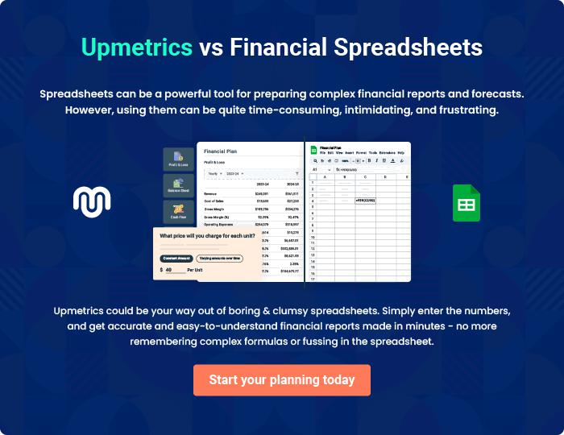
Appendix

When writing the appendix section, you should include any additional information that supports the main content of your plan. This may include financial statements, market research data, legal documents, and other
To unlock help try Upmetrics! 
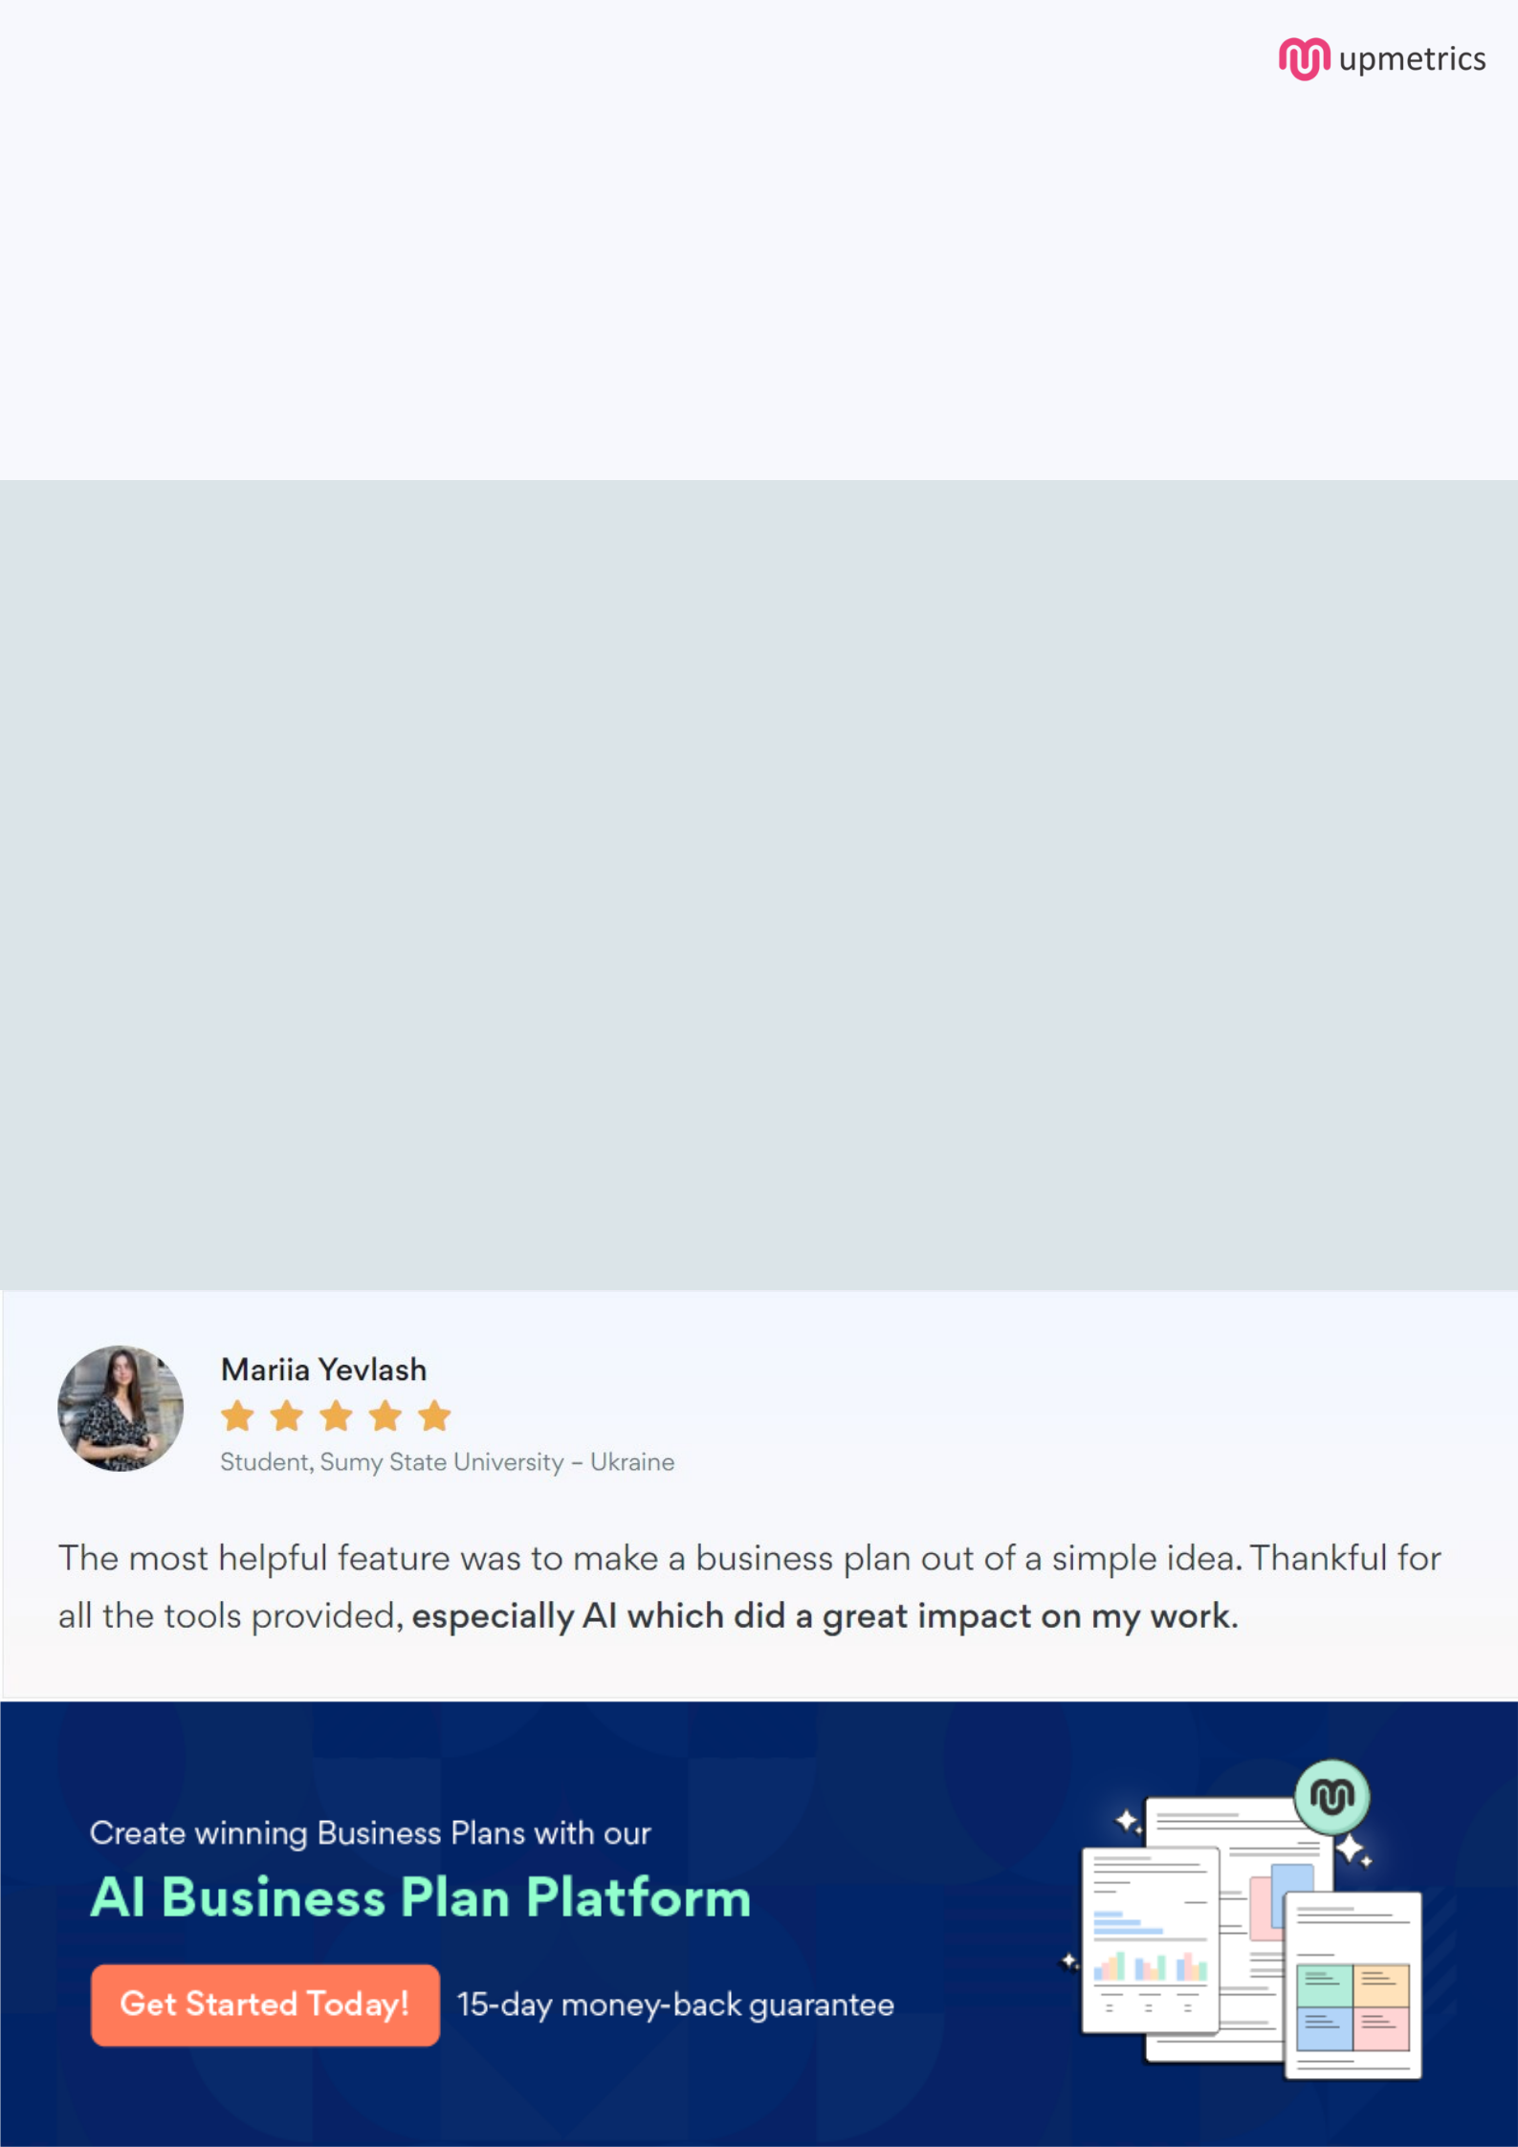
Create a winning business plan that gets you funded

Creating a stunning and investment-ready plan requires no writing, graphic designing, or financial planning expertise.

Upmetrics has all the features required to help you create a comprehensive business plan—from start to finish. Make no mistakes, it’s the modern way of planning to structure ideas, make plans, and create stunning pitch decks to awe investors.

Pitch decks that impress investors

Create pitch decks that provide a visual representation of your business, engage investors, and make them want to invest in your business idea.

Interactive plans in no time

Import business plan sections like—SWOT analysis, comparison tables, and others to create an interactive business plan. No designing skills are required.

Stunning cover page designs

With Upmetrics, you have the liberty to choose from multiple stunning cover page designs. Choose a creative design and make your plan stand out.

Online sharing made simple

Upmetrics makes online sharing quick and easier for users. Easily share your business plans with a link while tracking reader activity.

500+ sample business plans

Simply import a template from our library of sample plans into the editor and start customizing it to make it yours. It takes only a few clicks to get started.

Collaborate with team in real-time

Invite team members, initiate conversations, discuss ideas & strategies, share feedback, and work on a business plan in real-time.

